Postcard activity
Match each postcard invitation’s text to the correct image by writing the number on the picture.
Postcard number | Text
1 | たかこさんへ  あついですね。すいかをたべたいです。日よう日にうみにいきましょうか。  ひみこより
2 | わかなさんへ  土よう日にじんじゃでまめまきをしましようか。おにをみたいです。こわいとおもいます。えほうまきもたべたいです。  あきらより
3 | ちひろさんへ  夏です。ぼんおどりをしたいです。だから、ゆかたをかいたいです。金よう日にまちでかいものをしましょう。そして、土よう日にぼんおどりにいきましょうか。  あずみより
4 | だいすけくんへ  さむいですね。うちでココアをのみましょうか。おいしいとおもいます。  さとしより
5 | さきこさんへ  木よう日につきをみたいです。だから、やまにいきましょうか。だんごをたべましょう。  しげこより
6 | よしゆきくんへ  ほしがすきですか。まちですごいふきながしをみましょうか。たんざくをかきたいです。おもしろいとおもいます。  ゆうじより
7 | ゆきおくんへ  金よう日です。だから、こうえんでカラオケをしたいです。さくらはきれいだとおもいます。ピックニックをしましょうか。  ゆたかより
8 | みちこさんへ  あめがすきです。かわでしゃしんをとりたいです。まちでかさをかいましょう。  ななこより
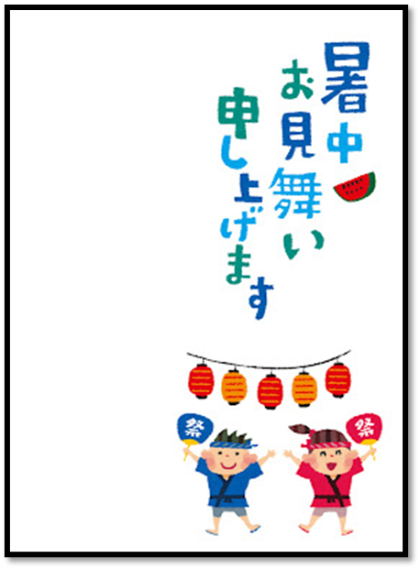 | 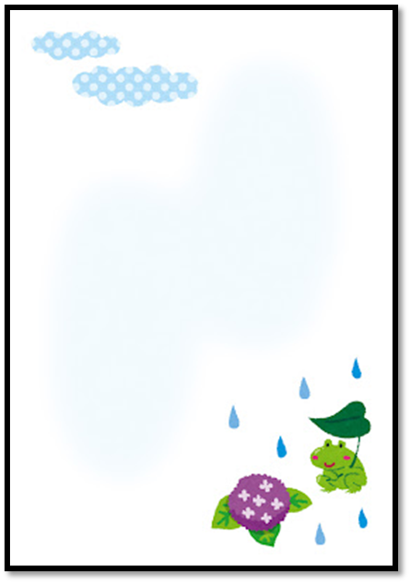
 | 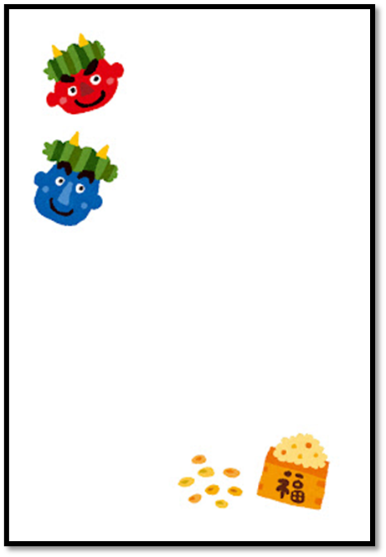
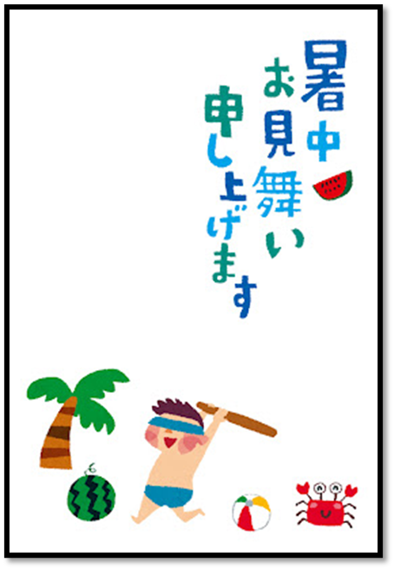 | 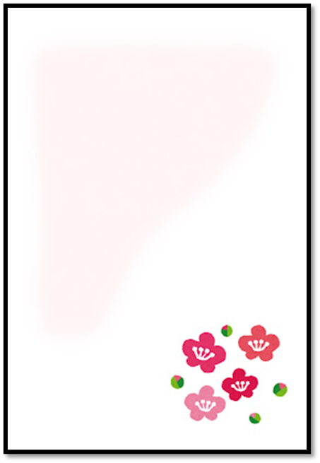
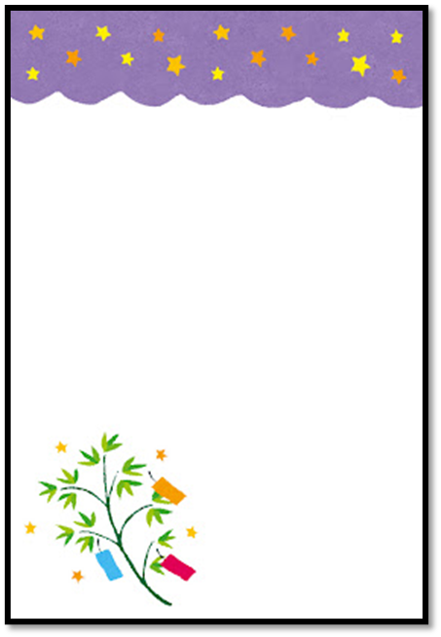 | 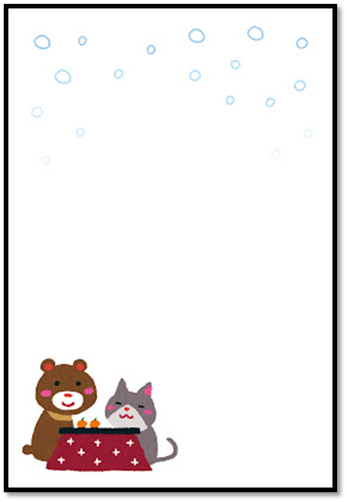
Images by Takashi Mifune are licensed under Irasutoya’s terms of use.

Comprehension questions
Answer each question in English, using the information from the invitations.
- What does the sender want to eat because it’s hot? Where do they suggest going on Sunday?
- What day, and where, is the sender suggesting to do mamemaki? What do they want to see and eat?
- What are the 3 reasons the sender suggests for going to the Obon festival?
- What is delicious? Why does the sender make this suggestion?
- What does the sender want to do on Thursday?
- Where can you see fukinagashi? Why does the sender want to see it?
- What festival do you think is taking place on Friday? Justify your answer with reference to the text.
- Why does the sender suggest buying an umbrella?

© State of New South Wales (Department of Education), 2023
The copyright material published in this resource is subject to the Copyright Act 1968 (Cth) and is owned by the NSW Department of Education or, where indicated, by a party other than the NSW Department of Education (third-party material).
Copyright material available in this resource and owned by the NSW Department of Education is licensed under a Creative Commons Attribution 4.0 International (CC BY 4.0) licence.
This licence allows you to share and adapt the material for any purpose, even commercially.
Attribution should be given to © State of New South Wales (Department of Education), 2023.
Material in this resource not available under a Creative Commons licence:
- the NSW Department of Education logo, other logos and trademark-protected material
- material owned by a third party that has been reproduced with permission. You will need to obtain permission from the third party to reuse its material.
Links to third-party material and websites
Please note that the provided (reading/viewing material/list/links/texts) are a suggestion only and implies no endorsement, by the New South Wales Department of Education, of any author, publisher, or book title. School principals and teachers are best placed to assess the suitability of resources that would complement the curriculum and reflect the needs and interests of their students.
If you use the links provided in this document to access a third-party's website, you acknowledge that the terms of use, including licence terms set out on the third-party's website apply to the use which may be made of the materials on that third-party website or where permitted by the Copyright Act 1968 (Cth). The department accepts no responsibility for content on third-party websites.

