Es más…que

Activity 1
Complete the table below. In column B, write a sentence in Spanish which describes the taste of the item in column A. In column D, write a second sentence to compare the item in column C with the item in column A. The first row has been completed for you as an example.
A | B | C | D
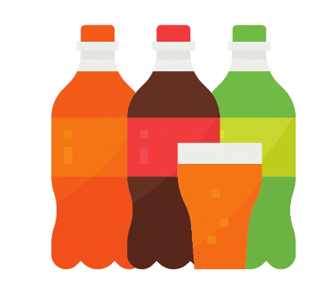 | Los refrescos son dulces. | 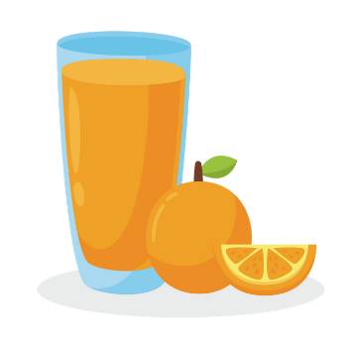 | Los refrescos son más dulces que el zumo de naranja.
 |  | 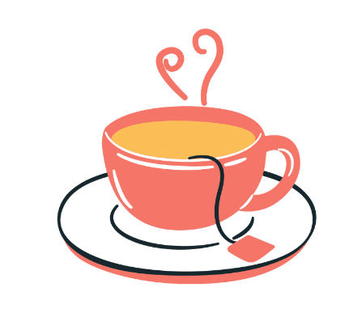
 |  | 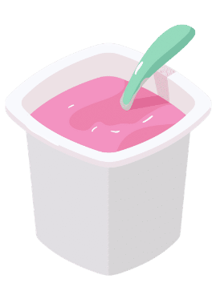
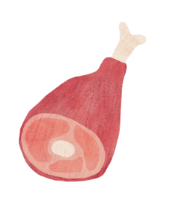 |  | 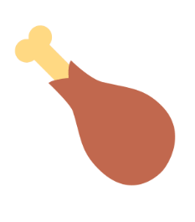
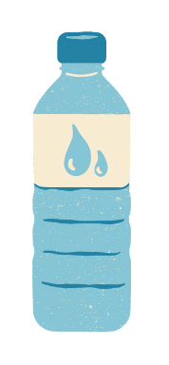 |  | 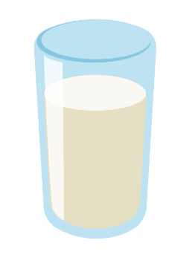
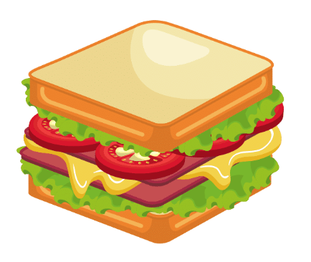 |  | 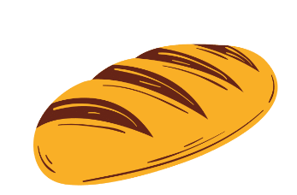
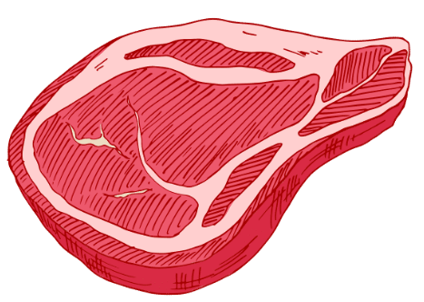 |  | 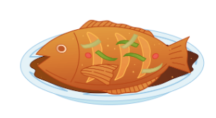
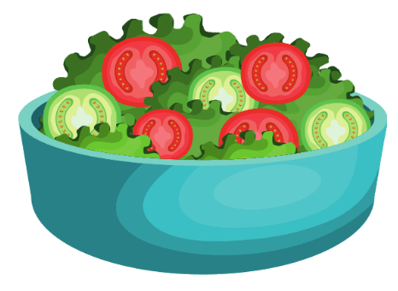 |  | 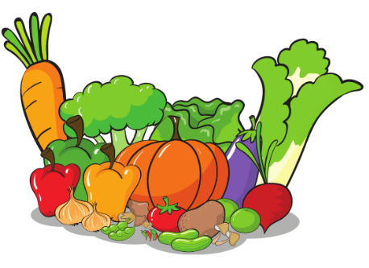
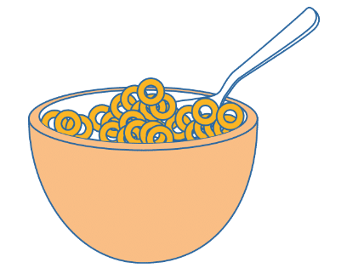 |  | 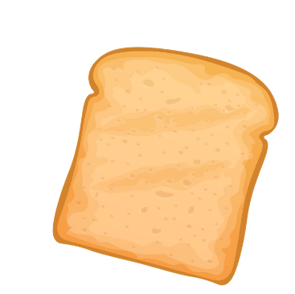

Activity 2
Choose 2 foods or drinks to compare. Draw or write them (in English) in the table below, in columns A and B. Then write the question using the structure ¿Prefieres [item A] o [item B]? When you are ready, find a partner and ask them each of your questions, ticking the food or drink they prefer. Each time, ask them ¿Por qué? and write their response in Spanish in the space provided. The first row has been completed for you as an example. Make sure each of you has asked and answered all your questions.
A | B | ¿Prefieres [A] o [B]? | ¿Por qué?
 |  | ¿Prefieres el helado o el jamón? | Porque el helado es más dulce que el jamón.

For the teacher
The following are sample responses. There is more than one possibility for each response.
A | B | C | D
 | Los refrescos son dulces. |  | Los refrescos son más dulces que el zumo de naranja.
 | El café es sabroso. |  | El café es más sabroso que el té.
 | El helado es dulce. |  | El helado es más dulce que el yogur.
 | El jamón es salado. |  | El jamón es más salado que el pollo.
 | El agua es sosa. |  | El agua es más sosa que la leche.
 | El bocadillo es rico. |  | El bocadillo es más rico que el pan.
 | La carne es sabrosa. |  | La carne es más sabrosa que el pescado.
 | La ensalada es sosa. |  | La ensalada es más sosa que las verduras.
 | Los cereales son sabrosos. |  | Los cereales son más sabrosos que la tostada.

© State of New South Wales (Department of Education), 2023
The copyright material published in this resource is subject to the Copyright Act 1968 (Cth) and is owned by the NSW Department of Education or, where indicated, by a party other than the NSW Department of Education (third-party material).
Copyright material available in this resource and owned by the NSW Department of Education is licensed under a Creative Commons Attribution 4.0 International (CC BY 4.0) license.
This license allows you to share and adapt the material for any purpose, even commercially.
Attribution should be given to © State of New South Wales (Department of Education), 2023.
Material in this resource not available under a Creative Commons license:
- the NSW Department of Education logo, other logos and trademark-protected material
- material owned by a third party that has been reproduced with permission. You will need to obtain permission from the third party to reuse its material.
Links to third-party material and websites
Please note that the provided (reading/viewing material/list/links/texts) are a suggestion only and implies no endorsement, by the New South Wales Department of Education, of any author, publisher, or book title. School principals and teachers are best placed to assess the suitability of resources that would complement the curriculum and reflect the needs and interests of their students.
If you use the links provided in this document to access a third-party's website, you acknowledge that the terms of use, including licence terms set out on the third-party's website apply to the use which may be made of the materials on that third-party website or where permitted by the Copyright Act 1968 (Cth). The department accepts no responsibility for content on third-party websites.

