Food and drink

Activity 1
Use the anchor chart in the classroom or your books to correctly label each of the items in Spanish, including the correct article (el, la, las, los).
Food or drink | Spanish
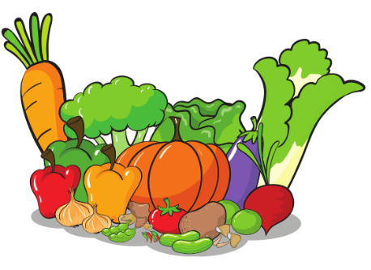
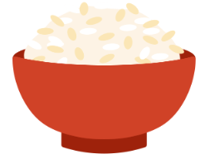
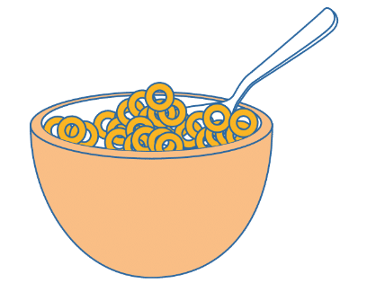
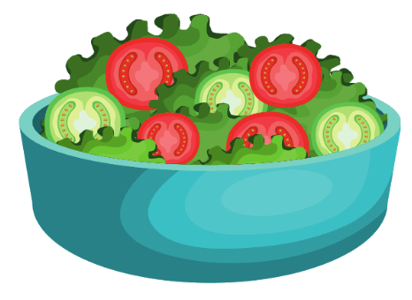
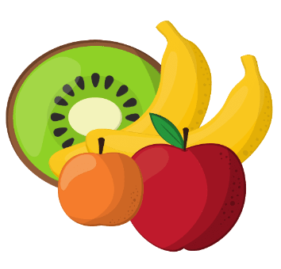
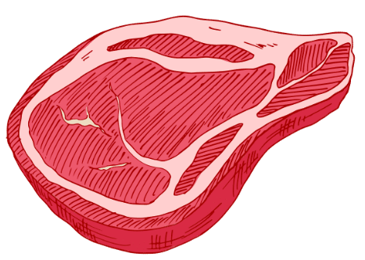
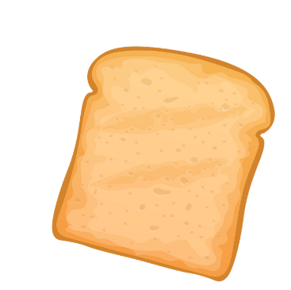
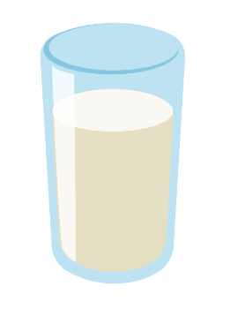
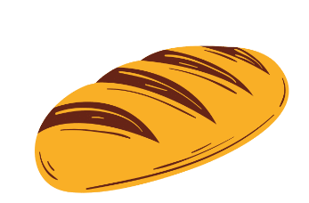
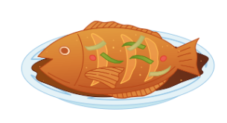
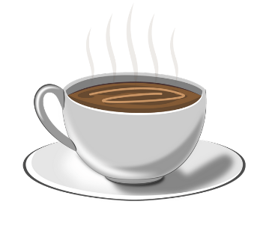
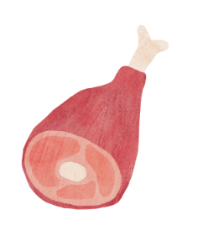
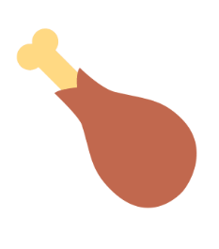
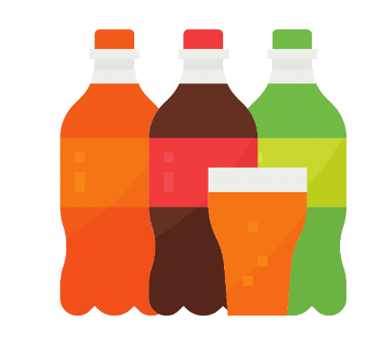
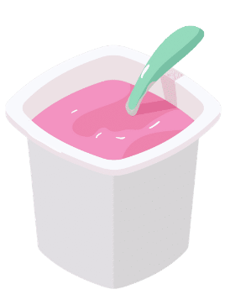
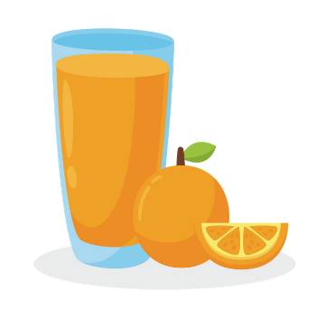
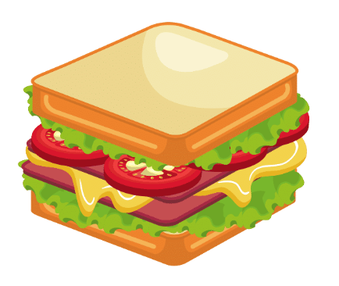
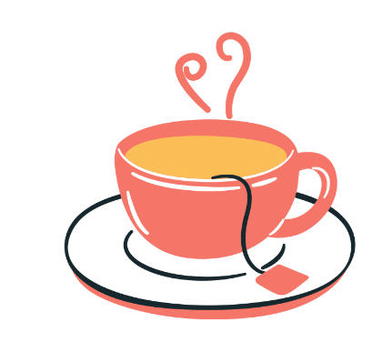
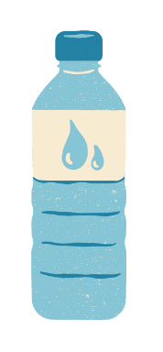

Activity 2
Put the foods from the table above into the correct category, including the article each time.
el | la | los | las

For the teacher

Activity 1 – answers
Food or drink | Spanish
 | las verduras
 | el arroz
 | los cereales
 | la ensalada
 | la fruta
 | la carne
 | la tostada
 | la leche
 | el pan
 | el pescado
 | el café
 | el jamón
 | el pollo
 | el helado
 | los refrescos
 | el yogur
 | el zumo de naranja
 | el bocadillo
 | el té
 | el agua

Activity 2 – answers
el | la | los | las
el pollo  el café  el pescado  el jamón  el pan  el agua*  el té  el zumo de Naranja  el helado  el yoghur  el bacadillo  el arroz  *agua is actually feminine however it has ‘el’ as its article because it starts with a vowel. | la tostada  la fruta  la leche  la carne  la ensalada | los cereales  los refrescos | las verduras

© State of New South Wales (Department of Education), 2023
The copyright material published in this resource is subject to the Copyright Act 1968 (Cth) and is owned by the NSW Department of Education or, where indicated, by a party other than the NSW Department of Education (third-party material).
Copyright material available in this resource and owned by the NSW Department of Education is licensed under a Creative Commons Attribution 4.0 International (CC BY 4.0) license.
This license allows you to share and adapt the material for any purpose, even commercially.
Attribution should be given to © State of New South Wales (Department of Education), 2023.
Material in this resource not available under a Creative Commons license:
- the NSW Department of Education logo, other logos and trademark-protected material
- material owned by a third party that has been reproduced with permission. You will need to obtain permission from the third party to reuse its material.
Links to third-party material and websites
Please note that the provided (reading/viewing material/list/links/texts) are a suggestion only and implies no endorsement, by the New South Wales Department of Education, of any author, publisher, or book title. School principals and teachers are best placed to assess the suitability of resources that would complement the curriculum and reflect the needs and interests of their students.
If you use the links provided in this document to access a third-party's website, you acknowledge that the terms of use, including licence terms set out on the third-party's website apply to the use which may be made of the materials on that third-party website or where permitted by the Copyright Act 1968 (Cth). The department accepts no responsibility for content on third-party websites.

