Restaurant relay

Student instructions
Work in teams of 3–5. One student plays the role of restaurant server, the remainder of the group are customers. Your teacher represents the kitchen staff on the other side of the room. The server must memorise the customer’s orders and write them on the order forms in the kitchen.
The server asks each customer what they would like to drink and eat for entrée, main course and dessert. They then memorise the responses to take them back to the kitchen staff to write on the order form. The server can memorise as many items as they like, remembering that it is a race, but the orders must also be accurate.
Useful phrases:
¡Oiga camarero/camarera! Hey waitperson!
¿Qué quiere para beber? What do you want to drink?
¿Qué quiere para comer de primer plato/de segundo plato/de postre? What do you want to eat for entrée/main/dessert?
Once the server has written all the items on the order form, the kitchen staff (teacher) will check against the order cards from your table. The first team to provide a correct order wins the round.

For the teacher
Print a copy of the tables below and cut them into strips to provide an order for each ‘customer’.
Print multiple copies of the order form to provide an order form for each table that their ‘waitperson’ must complete.
Set the classroom up with a table at the front (the ‘kitchen’), with an order form and a pen for each team, and a table at the back where the ‘customers’ are sitting with their orders.
The ‘waitperson’ interacts with their customers in Spanish to take their orders. They go to the ‘kitchen’ and write the order down on the team’s order form. They can memorise as many items as they like, remembering that it is a race but that it also requires accuracy. There may be more than one of the same item in each category.
When the first order is completely filled, the ‘waitperson’ submits it to the kitchen (the teacher). All students must stop where they are. Check the listed items with the orders from the table to ensure the correct items have been added to the order form. If there is an error, continue the game for the next fastest team to complete their order. The fastest correct submission wins the point. Redistribute order cards and switch the roles at the end of each round so all students have a turn at being the ‘waitperson’. The first team to score 4 points (or a number as determined by the teacher) wins.

Order 1:  Para beber | Order 2:  Para beber | Order 3:  Para beber | Order 4:  Para beber | Order 5:  Para beber | Order 6:  Para beber
De primero plato | De primero plato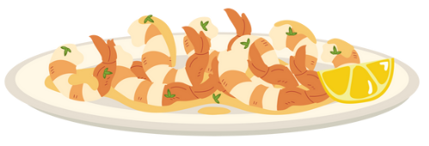 | De primero plato | De primero plato | De primero plato | De primero plato
De segundo plato  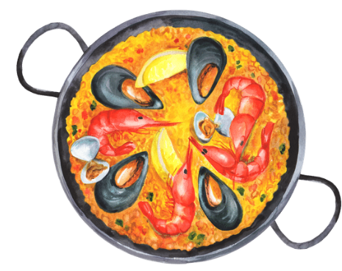 | De segundo plato | De segundo plato  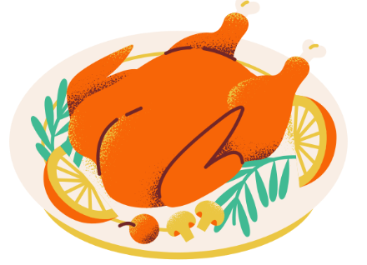 | De segundo plato | De segundo plato  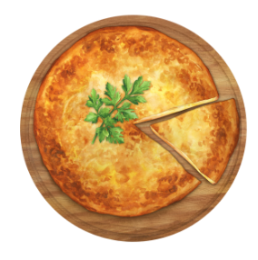 | De segundo plato
De postre | De postre | De postre | De postre  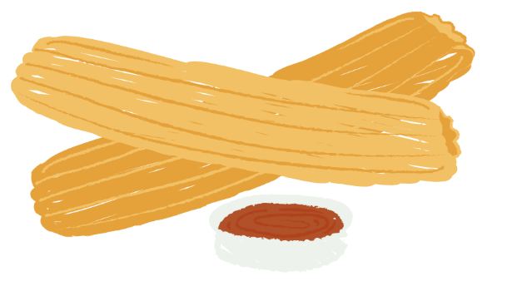 | De postre | De postre
Order 7:  Para beber | Order 8:  Para beber | Order 9:  Para beber | Order 10:  Para beber | Order 11:  Para beber | Order 12:  Para beber
De primero plato | De primero plato | De primero plato | De primero plato | De primero plato | De primero plato
De segundo plato | De segundo plato | De segundo plato | De segundo plato | De segundo plato | De segundo plato
De postre | De postre | De postre | De postre | De postre | De postre
Order 13:  Para beber | Order 14:  Para beber | Order 15:  Para beber | Order 16:  Para beber | Order 17:  Para beber | Order 18:  Para beber
De primero plato | De primero plato | De primero plato | De primero plato | De primero plato | De primero plato
De segundo plato | De segundo plato | De segundo plato | De segundo plato | De segundo plato | De segundo plato
De postre | De postre | De postre | De postre | De postre | De postre
Order 19:  Para beber | Order 20:  Para beber | Order 21:  Para bebe | Order 22:  Para beber | Order 23:  Para beber | Order 24:  Para beber
De primero plato | De primero plato | De primero plato | De primero plato | De primero plato | De primero plato
De segundo plato | De segundo plato | De segundo plato | De segundo plato | De segundo plato | De segundo plato
De postre | De postre | De postre | De postre | De postre | De postre

Table number | Table number | Table number | Table number | Table number | Table number
drinks | drinks | drinks | drinks | drinks | drinks
entrées | entrées | entrées | entrées | entrées | entrées
main courses | main courses | main courses | main courses | main courses | main courses
desserts | desserts | desserts | desserts | desserts | desserts

© State of New South Wales (Department of Education), 2023
The copyright material published in this resource is subject to the Copyright Act 1968 (Cth) and is owned by the NSW Department of Education or, where indicated, by a party other than the NSW Department of Education (third-party material).
Copyright material available in this resource and owned by the NSW Department of Education is licensed under a Creative Commons Attribution 4.0 International (CC BY 4.0) license.
This license allows you to share and adapt the material for any purpose, even commercially.
Attribution should be given to © State of New South Wales (Department of Education), 2023.
Material in this resource not available under a Creative Commons license:
- the NSW Department of Education logo, other logos and trademark-protected material
- material owned by a third party that has been reproduced with permission. You will need to obtain permission from the third party to reuse its material.
Links to third-party material and websites
Please note that the provided (reading/viewing material/list/links/texts) are a suggestion only and implies no endorsement, by the New South Wales Department of Education, of any author, publisher, or book title. School principals and teachers are best placed to assess the suitability of resources that would complement the curriculum and reflect the needs and interests of their students.
If you use the links provided in this document to access a third-party's website, you acknowledge that the terms of use, including licence terms set out on the third-party's website apply to the use which may be made of the materials on that third-party website or where permitted by the Copyright Act 1968 (Cth). The department accepts no responsibility for content on third-party websites.

