Story cubes

For the teacher
Use the story cubes provided (editable version on Canva), or create your own using the template in this document.
Organise students into groups of 3–4, providing each group with a set of cubes.
With students, identify the questions they could ask about each cube, for example:
Cube 1: ¿Qué es esto?
Cube 2: ¿Cuándo comes esto?
Cube 3: ¿Cuándo bebes esto?
Cube 4: ¿Te gusta(n)? ¿Por qué o por qué no?
Using the samples above as a scaffold, students interact to share details about their food preferences, mealtimes and descriptions of foods or drinks by asking questions and answering them using the prompts on the cubes. Students take turns to ask the questions each time, choosing another student to answer.
For students requiring additional support, consider including the Spanish vocabulary on the cube, as well as providing the following scaffold:
Cubes 1 and 2: ¿Qué es esto? Esto es [name of food or drink].
Cube 3: ¿Cuándo comes esto? Como [name of food] para [name of mealtime] OR ¿Cuándo bebes esto? Bebo [name of drink] para [name of mealtime].
Cube 4: ¿Te gusta(n)? Sí, me gusta(n) OR No, no me gusta(n).
Cube 5: Porque es/son [adjective describing taste].
For high potential and gifted students, or students with advanced proficiency, allow students to create their own sentences based on the prompts each time. Students may want to also design their own competition, for example:
- whose cubes are the most accurate, when compared to the student’s own mealtime preferences
- whose cubes make the silliest sentence.

Blank template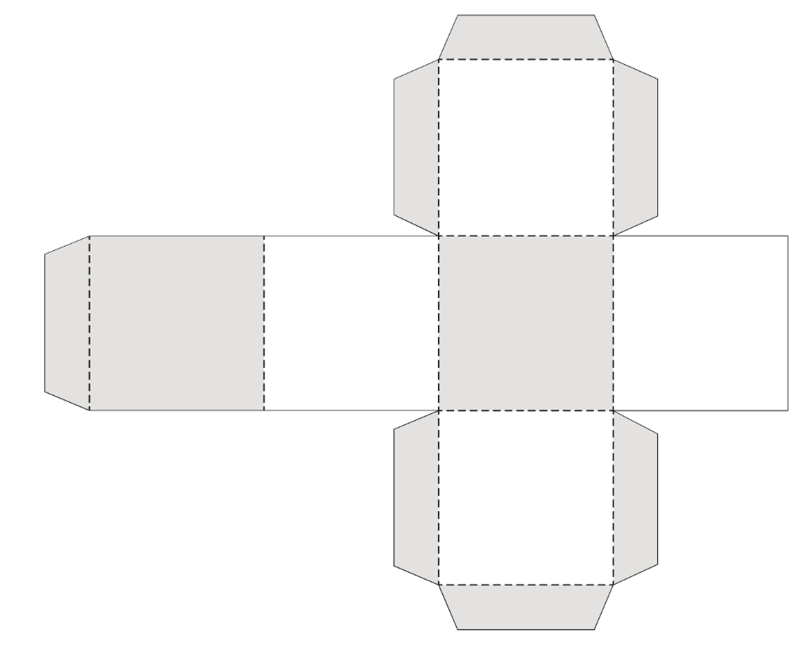

© State of New South Wales (Department of Education), 2023
The copyright material published in this resource is subject to the Copyright Act 1968 (Cth) and is owned by the NSW Department of Education or, where indicated, by a party other than the NSW Department of Education (third-party material).
Copyright material available in this resource and owned by the NSW Department of Education is licensed under a Creative Commons Attribution 4.0 International (CC BY 4.0) license.
This license allows you to share and adapt the material for any purpose, even commercially.
Attribution should be given to © State of New South Wales (Department of Education), 2023.
Material in this resource not available under a Creative Commons license:
- the NSW Department of Education logo, other logos and trademark-protected material
- material owned by a third party that has been reproduced with permission. You will need to obtain permission from the third party to reuse its material.
Links to third-party material and websites
Please note that the provided (reading/viewing material/list/links/texts) are a suggestion only and implies no endorsement, by the New South Wales Department of Education, of any author, publisher, or book title. School principals and teachers are best placed to assess the suitability of resources that would complement the curriculum and reflect the needs and interests of their students.
If you use the links provided in this document to access a third-party's website, you acknowledge that the terms of use, including licence terms set out on the third-party's website apply to the use which may be made of the materials on that third-party website or where permitted by the Copyright Act 1968 (Cth). The department accepts no responsibility for content on third-party websites.

