La fête de la musique

Activity 1
View the poster. Identify key information, ready to answer questions from your teacher in French.
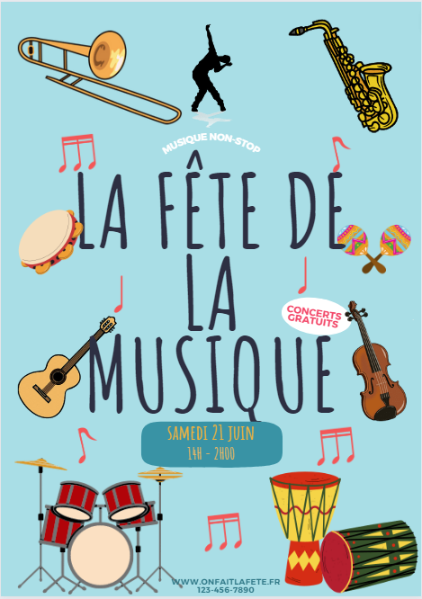
Images sourced from Canva and used in accordance with the Canva Content License Agreement.

Activity 2
Listen to 2 teenagers having a phone conversation about the upcoming music festival and answer questions in English.
- What can you do at the festival?
- How long does it go for?
- How much are the tickets?
- How are they going to get there? Why did they choose this mode of transport?
- What was their other option for getting to the festival?
- What is Paul excited about?
- What time are they meeting and where?

Activity 3
Listen again, and complete the table with French phrases used in the dialogue.
French | English
 | Are you coming?
 | What time is it on?
 | Is it expensive?
 | It’s free!
 | I hope there will be …
 | … my dad can take us.
 | Will we go by train?
 | What time do you want to meet?

For the teacher

Activity 1
Have a discussion with the students about the poster, to prepare them for Activity 2. Ask key questions in French about the poster, for example:
Le festival commence à quelle heure ? À quatorze heures/deux heures de l’après-midi.
C’est quand ? C’est le vingt-et-un juin.
C’est combien ? C’est gratuit.

Activity 2

Audio file
Play the audio file for students.
La fête de la musique.mp3 (1:30)

Transcript of audio
Magalie: Salut Paul ! Ce weekend, c’est la Fête de la musique. On peut danser, chanter, faire de la musique … Il y a un grand concert ! Tu viens ? C’est super, non ?
Paul: Salut Magalie, la fête de la musique ? C’est pour quelle heure ? J’ai un match de foot samedi matin.
Magalie: C’est de deux heures de l’après-midi à deux heures du matin !
Paul: Oh là là ! C’est long. Est-ce que c’est cher ?
Magalie: Non, c’est gratuit ! Et il y a beaucoup de musique et de musiciens différents qui jouent pendant 12 heures.
Paul: Vraiment ?
Magalie: Oui, c’est super bien, hein ?
Paul: Oui, j’espère qu’il va y avoir des rappeurs. J’adore ça. On y va en train ?
Magalie: Oui, ou alors si tu préfères mon père nous emmène ?
Paul: Non, en train c’est bien et c’est plus facile qu’en voiture.
Magalie: D’accord. On se retrouve à quelle heure ?
Paul: Alors, la fête commence à 2 heures. On se retrouve à la gare à midi ?
Magalie: OK, devant la gare à midi, c’est ça ?
Paul: Oui, c’est ça. Alors à samedi Magalie.
Magalie: Salut Paul.

Responses
- What can you do at the festival? Dance, sing, play music and there is a huge concert.
- How long does it go for? It goes for 12 hours.
- How much are the tickets? It’s free.
- How are they going to get there? Why did they choose this mode of transport? By train because it’s easier than going by car.
- What was their other option for getting to the festival? Magalie’s dad would have taken them.
- What is Paul excited about? He is hoping to see rappers because he loves that.
- What time are they meeting and where? At midday in front of the train station.

Activity 3
Provide the transcript, depending on student ability.
French | English
Tu viens ? | Are you coming?
C’est pour quelle heure ? | What time is it on?
Est-ce que c’est cher ? | Is it expensive?
C’est gratuit ! | It’s free!
J’espère qu’il va y avoir… | I hope there will be…
On y va en train ? | Will we go by train?
…mon père nous emmène ? | … my dad can take us?
On se retrouve à quelle heure ? | What time do you want to meet?

© State of New South Wales (Department of Education), 2023
The copyright material published in this resource is subject to the Copyright Act 1968 (Cth) and is owned by the NSW Department of Education or, where indicated, by a party other than the NSW Department of Education (third-party material).
Copyright material available in this resource and owned by the NSW Department of Education is licensed under a Creative Commons Attribution 4.0 International (CC BY 4.0) license.
This license allows you to share and adapt the material for any purpose, even commercially.
Attribution should be given to © State of New South Wales (Department of Education), 2023.
Material in this resource not available under a Creative Commons license:
- the NSW Department of Education logo, other logos and trademark-protected material
- material owned by a third party that has been reproduced with permission. You will need to obtain permission from the third party to reuse its material.
Links to third-party material and websites
Please note that the provided (reading/viewing material/list/links/texts) are a suggestion only and implies no endorsement, by the New South Wales Department of Education, of any author, publisher, or book title. School principals and teachers are best placed to assess the suitability of resources that would complement the curriculum and reflect the needs and interests of their students.
If you use the links provided in this document to access a third-party's website, you acknowledge that the terms of use, including licence terms set out on the third-party's website apply to the use which may be made of the materials on that third-party website or where permitted by the Copyright Act 1968 (Cth). The department accepts no responsibility for content on third-party websites.

