Les sports d’hiver et d’été

Part A
Listen to the audio file. Complete the table with a tick for winter or summer sports, add the name of the sport and any extra details you hear such as an expression of frequency, an opinion of the activity or an adjective to describe the activity.
Name | Winter sports | Summer sports | Name of sport | Extra details
Nicole
Sébastien
Lucas
Lucie
Mathilde

Part B
Read the information in the image below and complete the table with the activities each person usually does and the activities they would like to do.
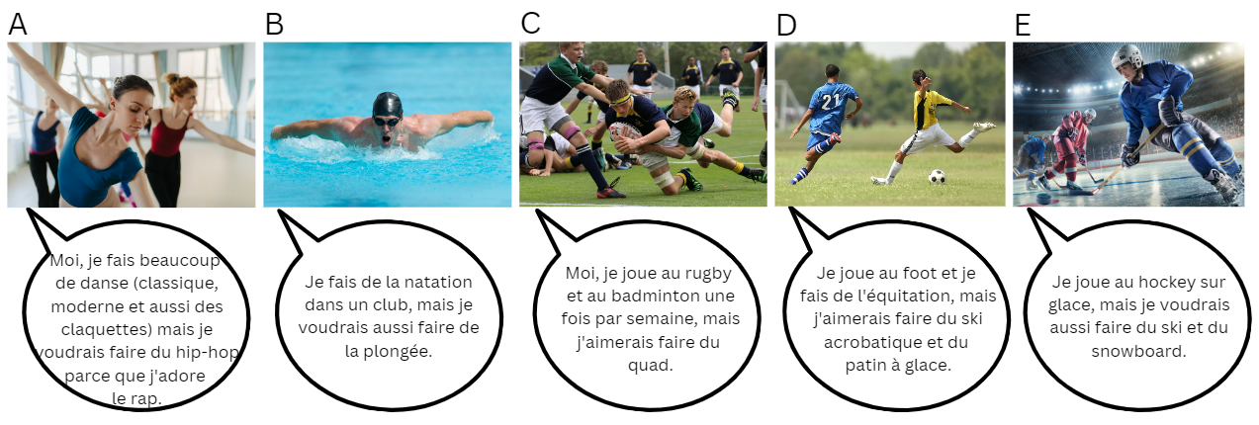
Expression | A | B | C | D | E
Usually does
Would like to do

Part C
You and your partner will play a card game (your teacher will provide the cards).
The first player draws a card and shows their partner. The partner must identify the sport on the card and give as much detail about the sport as possible. If necessary, the first player can guide the interaction using questions from the following options:
- What is this? Qu’est-ce que c’est ?
- Is it a summer or winter sport? C’est un sport d’été ou d’hiver ?
- Do you like [activity]? Tu aimes [activity] ?
- Why/why not? Pourquoi/Pourquoi pas ?
- Do you do [activity]? Tu fais/joues [activity] ?
- How long have you done [activity]? Depuis quand est-ce que tu fais/joues [activity] ?
- Where/when did you do [activity]? Où/quand est-ce que tu as fait [activity] ?
- Would you like to play/do [activity]? Tu voudrais/aimerais faire/jouer [activity] ?
- Why/why not? Pourquoi/Pourquoi pas ?
Take turns to draw a card.

For the teacher

Part A

Audio
Les sports d’été et d’hiver.mp3 (1:19)

Transcript of audio
Nicole, qu’est-ce que tu préfères, les sports d’été ou d’hiver ?
J’adore faire du ski donc je préfère les sports d’hiver. Je fais du ski avec ma famille tous les ans.
Sebastien, qu’est-ce que tu aimes ?
Je déteste le froid et la neige donc moi, j’aime les sports d’été. En particulier, j’adore faire de la voile.
Lucas, qu’est-ce que tu aimes faire ?
J’adore faire du sport en été. Je fais du canoë-kayak avec mon père. On aime aussi faire du VTT mais c’est très fatigant.
Lucie ?
J’adore le soleil, la plage aussi, alors moi je préfère les sports d’été comme faire de la plongée. J’adore la mer.
Et enfin, Mathilde ?
Je fais du snowboard tous les hivers dans les Alpes avec ma famille. J’adore les sports d’hiver.

Responses

Part A
Name | Winter sports | Summer sports | Name of sport | Extra details
Nicole |  |  | Skiing | Goes skiing with family every year
Sébastien |  |  | Sailing | Hates the cold
Lucas |  |  | Canoeing, kayaking, mountain bike riding | Goes canoeing with his dad, mountain biking is very tiring
Lucie |  |  | Diving | Loves the sea
Mathilde |  |  | Snowboarding | Goes snowboarding every winter in the alps with her family

Part B
Expression | A | B | C | D | E
Usually does | Classical, modern and tap dancing | Swimming in a club | Rugby and badminton | Soccer and horse riding | Ice hockey
Would like to do | Hip hop | Diving | Quad biking | Acrobatic skiing and ice skating | Skiing and snowboarding

Part C
Print and cut out the cards to use as a stimulus for an interaction in pairs or groups of 3. Change the images to match the vocabulary the students have already identified in previous activities, if necessary. One student draws a card and shows their partner. The partner must identify the sport on the card and give as much detail about the sport as possible. If necessary, the student who holds the card can guide the interaction using questions from the following options:
- What is this? Qu’est-ce que c’est ?
- Is it a summer or winter sport? C’est un sport d’été ou d’hiver ?
- Do you like [activity]? Tu aimes [activity] ?
- Why/why not? Pourquoi/Pourquoi pas ?
- Do you do [activity]? Tu fais/joues [activity] ?
- How long have you done [activity]? Depuis quand est-ce que tu fais/joues [activity] ?
- Where/when did you do [activity]? Où/quand est-ce que tu as fait [activity] ?
- Would you like to play/do [activity]? Tu voudrais/aimerais faire/jouer [activity] ?
- Why/why not? Pourquoi/Pourquoi pas ?

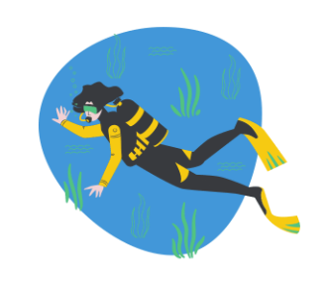 | 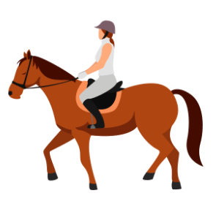 | 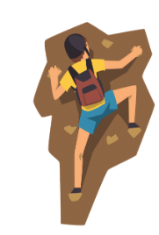
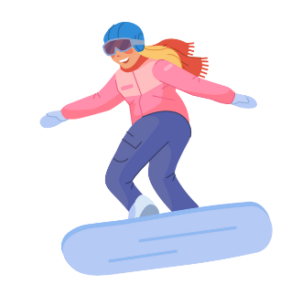 | 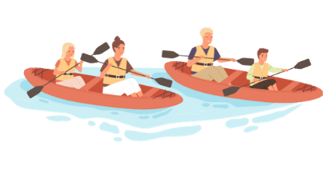 | 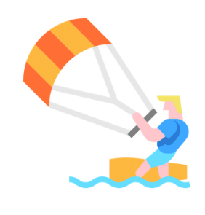
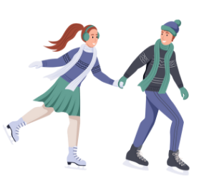 | 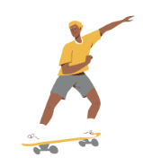 | 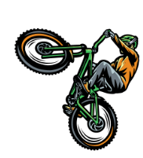
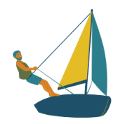 | 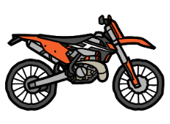 | 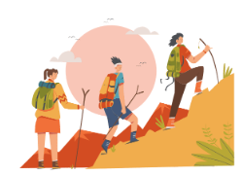
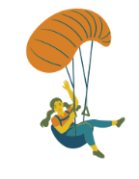 | 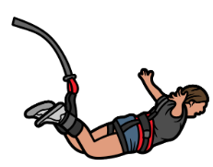 | 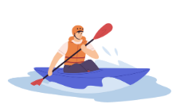
Images sourced from Canva and used in accordance with the Canva Content License Agreement.
© State of New South Wales (Department of Education), 2023
The copyright material published in this resource is subject to the Copyright Act 1968 (Cth) and is owned by the NSW Department of Education or, where indicated, by a party other than the NSW Department of Education (third-party material).
Copyright material available in this resource and owned by the NSW Department of Education is licensed under a Creative Commons Attribution 4.0 International (CC BY 4.0) license.
This license allows you to share and adapt the material for any purpose, even commercially.
Attribution should be given to © State of New South Wales (Department of Education), 2023.
Material in this resource not available under a Creative Commons license:
- the NSW Department of Education logo, other logos and trademark-protected material
- material owned by a third party that has been reproduced with permission. You will need to obtain permission from the third party to reuse its material.
Links to third-party material and websites
Please note that the provided (reading/viewing material/list/links/texts) are a suggestion only and implies no endorsement, by the New South Wales Department of Education, of any author, publisher, or book title. School principals and teachers are best placed to assess the suitability of resources that would complement the curriculum and reflect the needs and interests of their students.
If you use the links provided in this document to access a third-party's website, you acknowledge that the terms of use, including licence terms set out on the third-party's website apply to the use which may be made of the materials on that third-party website or where permitted by the Copyright Act 1968 (Cth). The department accepts no responsibility for content on third-party websites.

