Les stars du sport
Read the texts and answer the questions in English.

Article
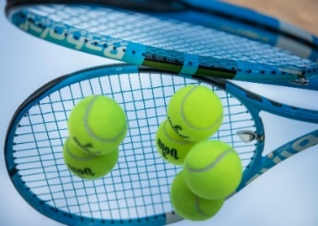 | Rafaël Nadal est espagnol. Il est né le 3 juin 1986. Il a une sœur qui s’appelle Maria. Il aime le football et le basket mais son sport préféré, c’est le tennis. À treize ans, il a gagné le championnat du monde des 13-14 ans ! Maintenant, c’est un grand champion de tennis.
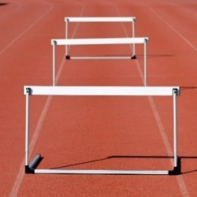 | Jessica Ennis-Hill est née le 28 janvier 1986 à Sheffield, en Angleterre. Sa mère est anglaise et son père est jamaïcain. Elle fait de l’athlétisme depuis l’âge de dix ans. Elle a participé aux Jeux olympiques de 2012 et elle a gagné la médaille d’or de l’heptathlon (sept épreuves).
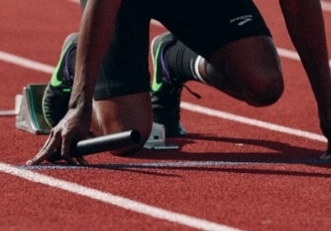 | Usain Bolt est né le 21 août 1986 en Jamaïque. Il a commencé l’athlétisme à six ans. Il a joué aussi au football et au cricket. Il a gagné seize médailles aux Jeux olympiques de Londres de 2012.
Images licensed under Unsplash License.
- How old was Nadal when he won his first world championship?
- What is Nadal’s nationality?
- For what event has Jessica Ennis-Hill won a gold medal?
- What is Jessica’s heritage?
- How old is she?
- How old was Usain Bolt when he began his training?
- What other sports has he played?
- How many gold medals did he win at the London Olympics in 2012?

For the teacher
- How old was Nadal when he won his first world championship? 13
- What is Nadal’s nationality? Spanish
- For what event has Jessica Ennis-Hill won a gold medal? Heptathlon
- What is Jessica’s heritage? Her mother is English and her father is Jamaican
- How old is she? 37
- How old was Usain Bolt when he began his training? 6
- What other sports has he played? Soccer and cricket
- How many gold medals did he win at the London Olympics in 2012? 16

© State of New South Wales (Department of Education), 2023
The copyright material published in this resource is subject to the Copyright Act 1968 (Cth) and is owned by the NSW Department of Education or, where indicated, by a party other than the NSW Department of Education (third-party material).
Copyright material available in this resource and owned by the NSW Department of Education is licensed under a Creative Commons Attribution 4.0 International (CC BY 4.0) license.
This license allows you to share and adapt the material for any purpose, even commercially.
Attribution should be given to © State of New South Wales (Department of Education), 2023.
Material in this resource not available under a Creative Commons license:
- the NSW Department of Education logo, other logos and trademark-protected material
- material owned by a third party that has been reproduced with permission. You will need to obtain permission from the third party to reuse its material.
Links to third-party material and websites
Please note that the provided (reading/viewing material/list/links/texts) are a suggestion only and implies no endorsement, by the New South Wales Department of Education, of any author, publisher, or book title. School principals and teachers are best placed to assess the suitability of resources that would complement the curriculum and reflect the needs and interests of their students.
If you use the links provided in this document to access a third-party's website, you acknowledge that the terms of use, including licence terms set out on the third-party's website apply to the use which may be made of the materials on that third-party website or where permitted by the Copyright Act 1968 (Cth). The department accepts no responsibility for content on third-party websites.

