Japanese – Stage 5 – sample unit of work

Japanese travels – 日本のりょこう
Contents
Japanese travels – 日本のりょこう 0
Unit description and duration 3
Student prior learning 4
Syllabus outcomes and content 5
Summative assessment task – end of unit 6
Learning sequence 8
Weeks 1–2 – sightseeing in Kyoto 8
Weeks 3–4 – describing places and sightseeing activities 12
Weeks 5–6 – accommodation 19
Weeks 7–8 – transport and travel 26
Week 9 – directions 31
Week 10 – summative assessment task and virtual tour of Japan 35
Evaluation and variation 39
Registration 39
Appendix A 40
Sample summative assessment task 40
Appendix B – unit of work infographic for students 53
About this resource 54
How to use this resource 54
Supporting students with disability 54
Evidence base 56
Further information 56
References 57

Unit description and duration
This 10-week (25-hour) unit introduces students to travelling through Japan. Japanese people love to travel and welcome tourists to Japan, a country where ancient traditions and modern life are seamlessly fused. Understanding Japanese culture and etiquette when travelling and visiting popular sightseeing venues adds depth to the experience of visiting Japan. Students will develop language skills and intercultural capability related to travel in and around Japan, including places of interest, experiences, travel etiquette, accommodation and making comparisons to recommend best options. Students will share information about travel experiences they have had and make plans to travel around Japan, including locations, accommodation and transport.
In this unit, students are provided with opportunities to:
- make plans to go on a trip, referencing accommodation, transport, locations and experiences
- use conjunctions and て (いadjectives and verbs) and で (なadjectives and nouns) to join sentences
- use や___や___や___などがありますto list things at places
- discuss places visited and justify preferences of locations and activities using past tense of adjectives, verbs and だから
- access information to compare prices and experiences at various locations
- create text to engage an audience and encourage them to visit selected places in Japan using opinions and reasons
- make comparisons using [A]は[B]より___です.

Student prior learning
Before engaging in this unit, students would benefit from prior experience with:
- times and dates you can do activities
- shopping
- places you can visit, に行きます
- activities you can do at places, [place]で[activity]を[verb]
- てform of verb
- い and なadjectives including linking
- opinions（だ）と思います
- giving reasons using だから
- past tense ～ました and want to ～たい verb forms.

Syllabus outcomes and content
This unit addresses the following outcomes.
- ML5-INT-01 exchanges information, ideas and perspectives in a range of contexts by manipulating culturally appropriate language
- ML5-UND-01 analyses and responds to information, ideas and perspectives in a range of texts to demonstrate understanding
- ML5-CRT-01 creates a range of texts for diverse communicative purposes by manipulating culturally appropriate language
The relevant syllabus content is embedded throughout the unit, aligned with teaching and learning activities. These are suggested only, and may vary according to how you use and/or adapt each activity for your context.
Modern Languages K–10 Syllabus © NSW Education Standards Authority (NESA) for and on behalf of the Crown in right of the State of New South Wales, 2022.

Summative assessment task – end of unit
This is an overview only. Further details, including related content dot points and marking guidelines, can be found at Appendix A.
Outcome: ML5-CRT-01 creates a range of texts for diverse communicative purposes by manipulating culturally appropriate language
You have just returned from one week in Japan. Create 3 posts for an online travel blog to share with Japanese speakers.
Include:
- one post about a full day of sightseeing in the city
- one post about a full day of sightseeing in a rural setting
- one post about the accommodation you stayed in.
Encourage the audience to consider these as options for a future trip in Japan, by giving recommendations with reasons.
In your blog:
- include a range of activities, transport options to each destination, prices and places to eat that you enjoyed, relevant to each experience, and where they are located
- include the accommodation you stayed in and the location, price, inclusions, how to get there and your opinion about it, with reasons
- describe what you recommend about each experience, including activities (where relevant), and explain why
- reflect on what was special about the experience from a cultural or historical perspective, for example, etiquette or significance to Japanese people when choosing the places, activities and accommodation to include
- use blog formatting such as the title of your blog, date of each post, a catchy title for each post, emojis and at least 3 engaging and relevant images with captions or supporting text.

Learning sequence
The information below outlines sample learning sequences for this unit of work. Timeframes, formative and summative assessment tasks, teaching and learning activities and reflection and feedback opportunities should be adjusted to suit your context, including the specific strengths and needs of students.

Weeks 1–2 – sightseeing in Kyoto
The table below contains suggested learning intentions and success criteria. These are best co-constructed with students.
Table 1 – learning intentions and success criteria for Weeks 1–2
Learning intentions | Success criteria
Students are learning that:  - a trip to Japan requires planning to identify places and experiences that interest them and that are culturally specific to Japan  - there are socially-accepted etiquette rules in Japanese society  - listing an unlimited amount of places in a city has a particular grammatical structure. | Students can:  - identify and name cultural places they would like to visit and stay at, and which cultural experiences they would like to have when visiting Japan  - identify behaviour and language that are acceptable used when visiting Japan and explain why they exist  - use the structure ___や___や___などがあります to list sightseeing places that exist in Kyoto.
Suggested vocabulary and grammatical structures:
Places and focus on Kyoto: じんじゃ、おてら、びじゅつかん、こうえん、はくぶつかん、しか、にわ、はし、いわ、みせ、レストラン、おしろ、とりい、いけ、こい、たけ、きっさてん、さくらのき、やま、みずうみ、えき、くうこう、うみ
Grammar: や___や___や___などがあります、[place]になにがありますか
Consider introducing the following kanji:
店 (stroke order), 木 (stroke order), 山 (stroke order), 水 (stroke order), 海 (stroke order), 駅 (stroke order)

Introduction to Japan and general travel etiquette
- Introduce the final summative assessment task which students will do at the end of term. Explain that all activities completed this term will build the students’ skills to help them complete the task.
- As a hook into the unit, introduce students to the wonders of Japan from a tourist perspective to generate an awareness of places and culture. Students use the think, puzzle, explore routine to activate their prior knowledge, generate ideas and curiosity, and prepare them for deeper engagement with the introductory video, Japan Travel Guide – How to travel Japan (19:59). Before playing the video, ask students to record what they think they know about travelling in Japan, for example places of interest, accommodation, transport and food, using known Japanese vocabulary, where possible. Share and discuss some of these as a class, using familiar Japanese phrases and vocabulary such as Have you been to Tokyo? Do you like Japanese food? What is your favourite food? Do you like miso soup? Have you been to Harajuku? In the video, what did they eat in Tokyo? Adjust and adapt language that is appropriate to cultural practices, values and perspectives to interact (ML5-INT-01)
- Next, students watch and listen to the video, noting things that interest them or that they would like to know more about. Finally, after the video, students compare the video content with their initial thoughts to see what is the same or different, and then come up with their puzzle questions about what they would like to explore about travel in Japan during the unit. With each question in the routine, give students adequate time to think about and identify their ideas. Encourage students to think about things that are truly puzzling or interesting to them and document them to revisit as the unit progresses.
- Exit ticket – students give exit ticket to teacher with what they would like to explore about travel in Japan during the unit.
- Students complete the Wizer interactive worksheet about general travel etiquette related to Japan. It embeds the following websites: 7 etiquette tips for travel in Japan, No eating and walking in Japanese city, Japan etiquette rules for tourists: 17 things you need to know and the YouTube video 10 must know Japan travel tips no one talks about (14:51). Students learn about social customs, compare them to their own context and reflect on why these rules exists and how they feel about them. Students can type in or voice record responses on the Wizer worksheet.

Places you can find in Japan – focus on Kyoto
- Focusing on things to do and see in Kyoto, introduce vocabulary relating to places to go and things you typically find in Japanese sightseeing venues. Using flashcards or student-preferred communication modes, teach new vocabulary, paying attention to pronunciation and honorific お. Students and the teacher ask questions and respond to each other using previous learning, such as Did you go to Kyoto last year? What season did you go? How do you travel from Kyoto to Tokyo? What do you do there? Would you like to see a deer? Do you like castles? Would you like to go to Kyoto?, using the new vocabulary words. Brainstorm with students what structures and adjectives which could be used with the new vocabulary. Students record these words to start a bank of travel vocabulary to be built on throughout the unit. Use a wide range of features of the sound system in spoken interactions; Adjust and adapt vocabulary from a wide range of themes to interact (ML5-INT-01)
- Students play Quizlet and Quizlet Live – sightseeing in Kyoto to practise sightseeing vocabulary and to focus on places in Kyoto presented in the next video activity. Students can also print the list as mini flashcards for personal study.
- Print the vocabulary list from Quizlet as mini flashcards for students to play vocab games like matching grab game, sorting games and to question each other. Students use Japanese during game play, for example つぎ, おわり, はじめて, がんばれ. Socialise with peers to build and maintain relationships (ML5-INT-01)
- Students engage with the Kyoto vacation travel guide (7:15) video and record in books or devices the places they observe from the vocabulary list as well as anything of interest to them. These can be written or recorded in Japanese or in English, and translated using dictionaries. After engaging with the video, give students time to share their list with a small group and add to their bank of travel vocabulary. In their small group, students make their best 3 sentences using these words and grammar from prior learning in Japanese. Adjust and adapt vocabulary from a wide range of themes to create texts (ML5-CRT-01)
- Introduce linking nouns for places when sightseeing with や and など, discussing differences between や and と by engaging with the following 2 videos: Japanese particle ya (10:28) and Japanese grammar: How to use Noun 1 や Noun 2 などがあります (5:04). Students make notes with several example sentences.
- Exit ticket – students write and hand in, or say to the teacher, on the way out of the classroom a sentence using ___や___や___などがあります.
- Using the vocabulary, content and inspiration from the Kyoto video, Quizlet and structure videos, students create a short paragraph in Japanese about what there is to see and what they like in Kyoto. Provide students with the ‘Scaffold – what to see and what I like in Kyoto’ resource [DOCX 62KB], to support students to scaffold and expand on their sentences to include more complex structures and information. Use a wide range of sound–symbol correspondences to create written texts; Control and manipulate a range of structures and features of the grammatical system to create texts (ML5-CRT-01)

Weeks 3–4 – describing places and sightseeing activities
The table below contains suggested learning intentions and success criteria. These are best co-constructed with students.
Table 2 – learning intentions and success criteria for Weeks 3–4
Learning intentions | Success criteria
Students are learning that:  - adjectives have different forms for tense and for joining  - adverbs support authentic communication  - expressing an opinion uses a particular grammatical structure  - there is a simple phrase to give a reason. | Students can:  - use い and なadjectives in various forms to describe places to visit/they have visited/their own town  - use the adverbs とても, あまり, すごく, ちょっとwith adjectives in sentences to describe places  - give their opinion about a place using （だ）と思います  - use だから to express a reason for liking a place.

Suggested vocabulary and grammatical structures:
Describing places: でんとうてき（な）、うつくしい、きれい（な）、ふるい、モダン（な）、しぜん（な）、あかるい、にぎやか（な）、こんでいます、にんきがあります、きょうみがあります、ゆうめい（な）、しずか（な）
Adjectives – past tense: おもしろかったです、たのしかったです、きれいでした、うつくしかったです、しぜんでした、あかるかったです、こんでいました、しずかでした
Adverbs: とても、あまり、すごく、ちょっと
Sightseeing activities: かんこうします、はなみにいきます、やまにのぼります、おこのみやきをたべます、さんぽします、えいがをみます、おみやげをかいます、しかにえさをやります、きもの/ゆかたをきます、カラオケをします、こうようをみます、はなびをみます
Grammar: （だ）と思います、どうですか、どんなところですか、[place]でなにをしますか
Consider introducing the following kanji:
見 (stroke order), 行 (stroke order)

Describing places
- Revise い and なadjectives, asking students to write or record as many as they can think of on their mini whiteboards or devices. Revise conjunctions for joining adjectives using てform by referring to Japanese Grammar – Using てform to Connect Adjectives (2:57) and the ‘Changing adjectives’ resource [DOCX 79KB]. Students join 6 of the adjectives they brainstormed together in a sentence. Control and manipulate a range of structures and features of the grammatical system to create texts (ML5-CRT-01)
- Introduce past tense of adjectives by engaging with the video How to make past tense – いadjectives (6:07). Students record in books or devices and change 3 of the adjectives they brainstormed into past form and put them into a sentence. Control and manipulate a range of structures and features of the grammatical system to create texts; Use a wide range of sound–symbol correspondences to create written texts (ML5-CRT-01)
- Students create questions and sentences with adjectives in joined and past forms, using themes from prior learning. Students form pairs to extend their sentences, then ask and respond to each other’s questions. Plan, construct and edit texts (ML5-CRT-01)
- Ask students to consider the places they explored in the Kyoto activity and identify 2–3 adjectives for 2 places in Kyoto. Students refer to the vocabulary list and the dictionary, along with the ‘Changing adjectives’ resource [DOCX 57KB] to create sentences describing these places using linking devices for adjectives. Use a range of structures and features of the target language writing system to create written texts (ML5-CRT-01).
- Students use the vocabulary for adjectives and places to create their best paragraph, using linking devices for adjectives and listing with ___や___や___などがあります, about features of their own local area. Create 3 questions in Japanese about their local area. Control and manipulate a range of structures and features of the grammatical system to create texts; Use a wide range of sound–symbol correspondences to create written texts (ML5-CRT-01)
- In pairs, students use their paragraph and questions as prompts to talk to each other for 2 minutes about their local area. Give students the ‘Conversation prompt cards’ resource [DOCX 89KB] to support spontaneous conversation. Understand and reciprocate detailed information about their own and others’ personal worlds (ML5-INT-01)
- Students practise vocabulary related to describing sightseeing places through Quizlet or Quizlet Live – describing sightseeing places in Japanese. Students add new words and phrases to their bank of travel vocabulary.
- Students make 5 sentences about Kyoto using known and new language, with adjective linking devices and past form of adjectives. Support students to identify adverbs they can use with adjectives, to use language more authentically. Adverbs of degree contains a useful vocabulary list. Students revisit sentences from previous activity to add adverbs. Control and manipulate a range of structures and features of the grammatical system to create texts (ML5-CRT-01)
- Describing places, with an opinion: Revise structure ‘I think …’ – ___（だ）と思います to express opinions by engaging with the Puni Puni clip (3:36) and referencing their website. Remind students how い and なadjectives change with this structure. Using the sentences from the previous activity, and だから from prior learning, ask students to change their sentences to opinion statements. Students practise 思 stroke order. Control and manipulate a range of structures and features of the grammatical system to create texts; Use a wide range of sound–symbol correspondences to create written texts (ML5-CRT-01)
- Exit ticket – students create and submit a sentence giving their opinion about a place in Kyoto with reasons, including linking adjectives, （だ）と思います and だから.
- Students engage with the podcast How to talk about your hometown in Japanese (16:27) and identify key information, including the gist, new words and/or structures they can add to their bank of travel vocabulary. Students may also consult the PDF notes [PDF 336KB] (available in rōmaji and English) to highlight language features such as particles, nouns, adjectives. Use comprehension strategies to interpret and analyse information, ideas and perspectives in texts; Use knowledge of a wide range of features of the sound system to understand texts (ML5-UND-01)
- Using the modelled podcast in the PDF notes from the above activity, students work in small groups to discuss a town they would like to travel to, anywhere in the world. Understand and reciprocate detailed information about their own and others’ personal worlds; Adjust and adapt vocabulary from a wide range of themes to interact (ML5-INT-01)

Activities you can do when sightseeing
- Revise verbs with students by creating a collective Mentimeter word cloud. Discuss the verbs students recall, the forms of verbs they have learnt (past form, negative) and identify which of these verbs could be useful when discussing travel plans. Remind students of particle use in sentences with verbs, を and で.
- Ask students to think back to the Kyoto vacation travel guide (7:15) from a previous lesson and choose 3 activities they could do in Kyoto. Students then write or record sentences for their chosen activities, with an opinion about them using と思います and だから, and linking devices for adjectives and verbs. Students share their sentences with another student to ‘explode’ each sentence, expanding them to incorporate more complexity such as adjectives, reasons, adverbs, sentence starters and conjunctions. Control and manipulate a range of structures and features of the grammatical system to create texts (ML5-CRT-01)
- Exit ticket – students submit a response to a whole class Padlet to the questions, What would you like to do in Kyoto? Why? 京都でなにをしたいですか。どうしてですか。
- Students brainstorm a list of activities they would like to do in Japan and use dictionaries or online translators to create personalised lists in Japanese. Students then create their own Quizlet or Anki lists to practise vocabulary. Students can also print the list as mini flashcards for personal study.
- Students complete the reading comprehension What did you do on the holidays? [DOCX 206KB] to practise script, vocabulary and structures. Use comprehension strategies and online and print dictionaries to identify unknown script or vocabulary. Use comprehension strategies to interpret and analyse information, ideas and perspectives in texts (ML5-UND-01)

Differentiation examples
The following strategies provide a starting point for how you can differentiate some of the teaching and learning activities in this lesson sequence for a range of learners. Adapt or design alternatives, to meet the needs of students in your class.
High potential and gifted students – students negotiate their own activities with the teacher. Students use past, negative past and negative conjugations of adjectives to include in their responses. Students use more kanji in their script.
Students requiring additional support – students use scaffolds to describe a place in Japan, and use simple Japanese without conjugations to express a like or dislike about a place or what occurs there. Students are given an image of a place in Japan to label with adjectives and verbs, for example あきはばらはモダンなまちです, きょうとででんとうてきなおしろをみます.
Advanced proficiency – students create a video for the class, introducing their favourite city in Japan, in Japanese with English subtitles, including:
- significant historical and cultural information about places of interest
- Japanese specific activities and omiyage.
Students also create a Kahoot for the class to play about the presentation to help deepen their understanding.

Mini task – progress checkpoint
Table 3 – mini task – progress checkpoint 1
Mini task – Tripadvisor review
As a formative assessment task, to ensure students are on track to succeed in the final summative assessment task, students complete the ‘Tripadvisor activity’ resource [DOCX 299KB] in which they engage with a simple Tripadvisor review of Tokyo Skytree (also available in rōmaji and English) and complete activities such as highlighting travel-related structures and words, and creating a review of a place in Australia in simple Japanese. Students should consult the marking guidelines for the final assessment of learning task, to check for understanding of language and expectations and apply these to the mini task, as well as identify future learning goals. Create informative texts to describe experiences and share information about their own and others’ personal worlds; Control and manipulate a range of structures and features of the grammatical system to create texts; Adjust and adapt language that is appropriate to cultural practices, values and perspectives to create texts (ML5-CRT-01)
Peer feedback – students swap their reviews to check for understanding, discuss areas that need further clarification and explore additional language which can be used. Students can also give feedback using the stars and stairs technique (stars – where the review meets the criteria; stairs – suggestions for making improvements to the review). Students should consider describing places, use of adjectives and adverbs and joining adjectives, activities that can be done at places and verb conjugations.
Student reflection – students complete a learning reflection journal entry, digitally or on paper (see sample, or students could use their own format), reflecting on their learning progress and setting new learning goals.
Reflection questions:
- How could this learning be applied to the final summative assessment task? Write specific examples in Japanese that can be used in the task.
- What did I do well? Write specific detail and how it can be applied to future language use or learning.
- What am I still unsure about? Write specific detail and an action plan of how to get help and by when.
Teacher reflection and evaluation – reflect on the unit of work to this point, along with student data such as formative assessment and feedback through exit tickets. Use this space to add any adjustments made to the unit or that will be made to the next stage of the learning sequence.

Weeks 5–6 – accommodation
The table below contains suggested learning intentions and success criteria. These are best co-constructed with students.
Table 4 – learning intentions and success criteria Weeks 5–6
Learning intentions | Success criteria
Students are learning that:  - there are various styles of accommodation in Japan  - there is a structure used to express staying overnight at a place  - they can compare places with a comparison structure  - different accommodation styles have different inclusions. | Students can:  - identify and describe traditional and modern accommodation in Japan  - express where they will stay using [place]で[accommodation]にとまります with a reason why  - compare accommodation types using the [accommodation A]は[accommodation B]より[adjective]です  - identify and name in Japanese inclusions in different accommodation styles, that appeal to them, using ___や___や___などがあります for unlimited lists of items.
Suggested vocabulary and grammatical structures:
Accommodation: ホテル、ビジネスホテル、りょかん、みんしゅく、カプセルホテル、ペンション、ユースホステル
Inclusions: プール、ふとん、エアコン、おふろ、たたみ、ベッド、れいぞうこ、ジム、おんせん、Wi-Fi、じどうはんばいき、テレビ、ネットフリックス
Grammar: [place]で[accommodation]にとまります、[accommodation A]は[accommodation B]より[adjective]です、なにがありますか、placeでどこにとまりますか
- Teach vocabulary for types of accommodation, for example using flashcards. Allow students to practise first, to become familiar with the vocabulary. Pay attention to pronunciation and ask students to read the flashcards for character reading practice. Introduce the structure [place]で[accommodation]にとまります and practise with the vocabulary. Students and the teacher then ask each other questions about the vocabulary, such as Do you like hotels? Do you stay in Airbnbs? Have you stayed in a ryōkan? What accommodation is in your town? Ask questions, make requests and explain actions (ML5-INT-01)
- Students make note of this vocabulary in their bank of travel vocabulary and then play Quizlet or Quizlet Live – accommodation in Japan to practise vocabulary. Students can also print the list as mini flashcards for personal study.
- Students engage with the Where to stay in Japan (24:26) video (until 17:03). While engaging with the video, students complete the What makes you say that? [PDF 179KB] thinking routine, which supports students to describe what each accommodation type is like and to create an explanation for it, in Japanese. As a class, discuss what each type of accommodation is like and the adjectives that convey this, as well as share opinions on which ones students would prefer and why. Express and compare emotions and personal preferences (ML5-INT-01)
- Introduce comparison sentence [accommodation A]は[accommodation B]より[adjective]です. Depending on context, you may also consider including an adverb before the adjective. Students make note of this structure in books or devices, then create 3 comparison sentences about accommodation using different adjectives. Encourage students to extend themselves by using adverbs and different adjective forms. Control and manipulate a range of structures and features of the grammatical system to create texts (ML5-CRT-01)
- Students select 2–3 websites to find 3 different styles of accommodation in Japan and their inclusions, for example Tripadvisor or Booking.com. Ask students to use the change language function between Japanese and English to compare inclusions and prices, making note of the places that appeal to them, their location, the inclusions that are important to them and what these are in Japanese. For example, wi-fi, shower, air conditioning. Students create a message to a friend, in Japanese, comparing the accommodations they have chosen and which one they like the most. Use knowledge of a range of structures and features of the target language writing system to understand and respond to texts; Respond to texts by reflecting on the relationship between language and culture in communication (ML5-UND-01)
- Exit ticket – put 3 pictures up on the wall: a room in a Japanese traditional inn, a space in a capsule hotel and a room in an Australian hotel. Students write, on a sticky note, their best sentence using 2 adjectives comparing the accommodation that appeals to them the most to the one that appeals to them the least. Students stick their note under the picture of their favourite choice on the way out of the classroom.
- Students engage with the Staying at a traditional Japanese inn – ryokan and onsen etiquette (9:55) video and identify the etiquette and cultural features of staying in a Japanese inn and using the baths or hot springs. As a class, discuss observations and thoughts, and the history behind these cultural practices. The articles A brief history of Japanese bathing culture and Origins and history of the Japanese ryokan [PDF 974KB] may be used to support discussion. Research the appropriate Japanese terms for cultural features of an onsen and Japanese inn and create a multimodal infographic, labelling the feature in Japanese and writing a brief description of the etiquette associated with it in English. Adjust and adapt language that is appropriate to cultural practices, values and perspectives to create texts (ML5-CRT-01)

Differentiation examples
The following strategies provide a starting point for how you can differentiate some of the teaching and learning activities in this lesson sequence for a range of learners. Adapt or design alternatives, to meet the needs of students in your class.
High potential and gifted students – students view the video clip How to make a hotel reservation in Japanese (4:20), repeating after the speakers and stopping to discuss the meaning of each part and noting key phrases. The video includes rōmaji, hiragana and English. Individually or in pairs, students use the information they identified from the previous accommodation website activity to create a short dialogue, making a booking at a venue of their choice. Students perform these dialogues for the class or record them to share. Encourage students to add in other details and questions to their dialogue to make them more complex or interesting.
Students requiring additional support – students use scaffolds to describe a place they would like to stay in Japan, using simple Japanese without conjugations to express a like or dislike about a place or what can be found there. Give students an image of a Japanese traditional inn room and label it with a range of items with adjectives found in the room, in Japanese and English.
Advanced proficiency – students research accommodation options in Kyoto for a future class trip and compile a report, in Japanese and English, for the class teacher to consider. The report could include:
- a range of options including ryōkan and hotels
- location, nearby facilities for convenience such as transport, stores and eateries and nearby attractions
- inclusions that students would find comfortable, interesting and enjoyable
- advice for teachers and students on Japanese etiquette that would need to be followed at the locations
- provisions for people with disabilities.

Mini task – progress checkpoint
Table 5 – mini task – progress checkpoint 2
Mini task – SMS message to a friend
As a formative assessment task, to ensure students are on track to succeed in the final summative assessment task, students create a short blog post, in Japanese, commenting on a place they stayed at on a past holiday. Students choose an accommodation venue in a city of their choice, comment on the type of place it is, their opinion of it based on the inclusions and what it was like. Blog post features such as a catchy title, the date, 2 images with captions, tags and emojis should be included. For ideas on Japanese blog formats see The 9 best blogs in Japanese about travel, food, culture and lifestyle. Students should consult the marking guidelines for the final assessment of learning task, to check for understanding of language and expectations and apply these to the mini task, as well as identify future learning goals. Use a range of structures and features of the target language writing system to create written texts; Use a wide range of sound–symbol correspondences to create written texts (ML5-CRT-01)
Teacher feedback – once students have written their blog posts, explore an example of ‘what a good one looks like’ (WAGOLL) with them, asking students to highlight features such as the details in the comment about the place, and an opinion justified with details describing the inclusions and what the place is like. The teacher can then discuss with the class features and details that made it a WAGOLL for students to consider in their own responses in the future.
Student reflection – students complete a learning reflection journal entry, digitally or on paper (see sample, or students could use their own format), reflecting on their learning progress and setting new learning goals.
Reflection questions:
- How could this learning be applied to the final summative assessment task? Write specific examples in Japanese that can be used in the task.
- What did I do well? Write specific detail and how it can be applied to future language use or learning.
- What am I still unsure about? Write specific detail and an action plan of how to get help and by when.
Teacher reflection and evaluation – reflect on the unit of work to this point, along with student data such as formative assessment and feedback through exit tickets. Use this space to add any adjustments made to the unit or that will be made to the next stage of the learning sequence.

Weeks 7–8 – transport and travel
The table below contains suggested learning intentions and success criteria. These are best co-constructed with students.
Table 6 – learning intentions and success criteria Weeks 7–8
Learning intentions | Success criteria
Students are learning that:  - there is a variety of transport types in Japan  - train travel is the most popular means of travel in Japan and has specific cultural etiquette  - various online tools exist to support making travel plans in Japan. | Students can:  - identify and name different means of transport and express how they will travel to a place using [transport]で[place]に行きます  - describe the etiquette and cultural aspects to follow as a visitor when travelling by train in Japan  - access online tools to plan a trip and make travel arrangements with a friend.
Suggested vocabulary and grammatical structures:
Transport: くるま、でんしゃ、あるいて、タクシー、バス、しんかんせん、ふね、ひこうき、ちかてつ、フェリー
Grammar: [transport]で[place]に行きます、なんで___に行きますか
Consider introducing the following kanji:
車 (stoke order), 何 (stroke order)

Task board
To give students choice, autonomy and ownership of their learning, the next 2 weeks of activities are provided via the ‘Travel time task board’ resource [DOCX 93KB]. Students complete mandatory tasks, then select and complete optional ones, to engage in language and cultural learning about travelling in Japan, focusing on train travel. Activities on the task board are outlined below. Teachers should use this time to move between groups and individual students, discussing ideas and choices and giving informal feedback and interacting with students.
- Teacher feedback – while students are engaging with the task board, engage in group and individual discussions to support ideas, encourage deep thinking about the learning of the unit and give advice to students needing support.
- Exit ticket (to complete at any point, or several times, during this 2-week period) – give students, in small groups, a blank piece of paper or an online shared document and prompt them to discuss and record key things they discovered about travelling in Japan.
Mandatory activities
- As a class, revise transport vocabulary by playing Quizlet/Quizlet Live – Japanese transport.
- Students engage with the article The amazing psychology of Japanese train stations and make note of the ‘behavioural tricks’ mentioned, to share with the class. Remind students to engage with the station jingles. Respond to texts by reflecting on how identity is shaped by language(s), culture(s), practices, values and perspectives (ML5-UND-01)
- Students visit the Japan Guide website to engage with the article Taking the train and engage with the video How to use trains in Japan (8:51) included. Students make notes of the key points to remember and share with the class.
- Students complete the ‘Travelling between places in Japan’ resource [DOCX 60KB]. This activity builds the skills to work out the best way to travel around Japan using Japan Transit Planner and Google Maps. Students will determine where places are located, closest transport stations and airports, work out the routes, times and costs associated with each of these journeys using a JR Pass.
- Students practise phrases for making travel plans at Quizlet – negotiating travel plans. Using the information from the ‘Travelling between places in Japan’ resource [DOCX 60KB] and the Quizlet set, students engage in a role play negotiating travel plans for a day in Japan. Include cost, time it takes, types of tickets, what platform numbers, best way to travel. Make arrangements with peers; Use a wide range of features of the sound system in spoken interactions (ML5-INT-01)
Optional activities
- Students complete the Travel agent activity in pairs, exchanging information from prompt and question cards about how to travel to places and what they can find in those places. Ask questions, make requests and explain actions; Control and manipulate a range of structures and features of the grammatical system to interact (ML5-INT-01)
- Students play the Going Places Bingo Game in small groups, practising transport, past tense of verbs, places and time words.
- Students engage with the YouTube video A Seven-Minute Miracle! The Shinkansen Cleaning Theater (3:26) and the rush hour People stuffed onto a train in Tokyo (1:05) video.
- Students complete the Travel agent activity in a small group. They use simple sentences to talk about places they would like to go and make decisions about 4 travel destinations.
- Students play the Travel game [DOCX 617KB] in a small group, saying a sentence in Japanese about each place that they land on. Students should include time words, activities, opinions and adjectives. If the group understands the sentence, the student can stay on the square. If not, the student must move back a space. Socialise with peers to build and maintain relationships; Adjust and adapt vocabulary from a wide range of themes to interact (ML5-INT-01)
- Students play the Kumo game [DOCX 114KB] (like Battleship) by placing a dot in 10 random coordinates, then taking turns to say coordinates by making sentences in Japanese, for example, あねとしんかんせんでまちにいきます. The first student to have all 10 crossed off, wins. Socialise with peers to build and maintain relationships (ML5-INT-01)
- Students look up the kanji for these popular cities found along the shinkansen lines throughout Japan – Tokyo, Osaka, Hiroshima, Shizuoka and Shinagawa, writing the name of the city, its kanji and what the kanji means. Students then explain why these kanji were chosen for each city. For example, Kyoto 京都 means ‘capital city’ – it was the old capital of Japan.
Differentiation examples
The following strategies provide a starting point for how you can differentiate some of the teaching and learning activities in this lesson sequence for a range of learners. Adapt or design alternatives, to meet the needs of students in your class.
High potential and gifted students – students identify and negotiate activities of their own design to complete, including ways they can extend themselves through further manipulation of language learnt or text types they can use when completing the tasks.
Students requiring additional support – provide students with scaffolds to support them to discuss transport they would take from place A to place B in Japan, using simple Japanese. Give students a simple map of Japan and label it with transport phrases that show what transport can be used to travel between cities. Students could also complete fewer mandatory activities and be supported to choose the most appropriate activities for their needs.
Advanced proficiency – students create a guide (digital/video or handwritten) in Japanese and English for visitors from Japan visiting Australia, comparing transportation in Japan and Australia.
The guide could include:
- recommendations for travelling around Australia
- recommendations for travelling around major cities
- ticket purchase procedures/OPAL cards
- etiquette/procedures
- signs and announcements
Student reflection – students complete a learning reflection journal entry, digitally or on paper (see sample, or students could use their own format), reflecting on their learning progress and setting new learning goals.
Reflection questions:
- How could this learning be applied to the final summative assessment task? Write specific examples in Japanese that can be used in the task.
- What did I do well? Write specific detail and how it can be applied to future language use or learning.
- What am I still unsure about? Write specific detail and an action plan of how to get help and by when.

Week 9 – directions
The table below contains suggested learning intentions and success criteria. These are best co-constructed with students.
Table 7 – learning intentions and success criteria Week 9
Learning intentions | Success criteria
Students are learning that:  - asking and giving directions is a useful and social communication skill that requires polite language  - there is specific language used for asking and giving directions. | Students can:  - understand the polite language used when interacting to ask and give directions in Japanese  - use polite language structures to ask and give directions to a place.
Suggested vocabulary and grammatical structures:
Directions: まっすぐ行って、みぎにまがって、ひだりにまがって、はしをわたって、しんごうのところをみぎにまがって、５００メートルぐらい、___ください、つぎのかどをひだりにまがってください、えきはどこですか、かど、つぎの、～から～まで
Consider introducing the following kanji:
右 (stroke order), 左 (stoke order)
- Teach direction words, for example with flashcards, paying attention to pronunciation and discussing ways to use them. Kanji for left and right can also be included for recognition. Students make note of this vocabulary in their bank of travel vocabulary and then play Quizlet or Quizlet Live – accommodation in Japan to practise vocabulary. Students can also print the list as mini flashcards for personal study.
- Prepare the Directions around town activity and explain to students how to do the activity. Each pair of students is given a mystery sentence slip and a map with the starting points marked. The object of the activity is to work out the mystery sentence. Students do this by looking at their map and the 4 sets of directions which have been displayed around the room. Each set of directions will lead them to a place on their map, and this word will help to complete the mystery sentence. Use knowledge of a wide range of sound–symbol correspondences to understand and respond to texts (ML5-UND-01)
- Exit ticket – students create a sticky note mosaic of responses. Give students 3 different coloured sticky notes and ask them to write responses to: colour 1 – What is one real-life application for this learning? 2 – What is one accomplishment from your learning on directions? 3 – How confident are you in using directions in Japanese, on a scale of 1 (low) to 10 (high). Why?
- Give students a map of Miyajima and direct them to work out the directions to 3 places. In pairs students take turns giving directions to a place on the map and finding where to go. Students should ask clarifying questions if they are not sure (for example Please say it again, Where is it?, Do I turn right?) and thank them. Ask questions, make requests and explain actions (ML5-INT-01)
Differentiation examples
The following strategies provide a starting point for how you can differentiate some of the teaching and learning activities in this lesson sequence for a range of learners. Adapt or design alternatives, to meet the needs of students in your class.
High potential and gifted students – students create an ‘Amazing Race’-style activity of the school, in Japanese, for the class to play to practise directions. This could be a physical race around the school. The race should include:
- directions to at least 5 locations
- clues or puzzles to solve at each location.
Emphasise it is not the fastest players who win, but those who complete the race in the correct order and solve all the puzzles. The activity can be created digitally with QR codes, Adobe Express or Google Forms, or in print form.
Students requiring additional support – provide scaffolds to students for conversation and a simplified map with less details and streets. Students may use a map of a location familiar to them, such as a town in Australia, to complete the directions activity.
Advanced proficiency – students create an ‘Amazing Race’-style activity of their favourite city or place in Japan, in Japanese, for the class to play to practise directions. This could be a virtual race around a city, online. The race should include:
- directions to at least 5 locations
- clues or puzzles to solve at each location that relate to the culture of the city.
The activity can be created digitally with QR codes, Adobe Express or Google Forms, or in print form.

Mini task – progress checkpoint
Table 8 – mini task – progress checkpoint 3
Mini task – message to a friend arranging a place to meet
As a formative assessment task, to ensure students are on track to succeed in the final assessment of learning task, students compose a short message in Japanese to a friend arranging to meet up somewhere after school, giving location, directions and transport to get there. Students swap their messages with a classmate to see if they can understand the directions and plans. Students should consult the marking guidelines for the final assessment of learning task, to check for understanding of language and expectations and apply these to the mini task, as well as identify future learning goals. Control and manipulate a range of structures and features of the grammatical system to create texts; Adjust and adapt language that is appropriate to cultural practices, values and perspectives to create texts (ML5-CRT-01)
Peer feedback – students swap their messages to check for understanding, discuss areas that need further clarification and the language that can be used. Students can also give feedback using the 3-2-1 technique, 3 details or language use they liked in the message and why, 2 language features they would add to the message to add meaning or complexity and one thing they would like to see added to the message.

Week 10 – summative assessment task and virtual tour of Japan
The table below contains suggested learning intentions and success criteria. These are best co-constructed with students.
Table 9 – learning intentions and success criteria Week 10
Learning intentions | Success criteria
Students are learning that:  - all learning during the unit or work can be applied to the final blog task  - Japan has a diverse range of cultural, traditional and modern places to experience both in person and online. | Students can:  - manipulate structures and vocabulary learnt to create a travel blog post about things they like about Japan encouraging people to experience them  - access various virtual travel experiences in different cities in Japan that appeal to them.
- Students review learning from the unit of work and consider how they can manipulate and extend on their learning to complete their assessment task. Students consult the final task marking guidelines to check for understanding of language and expectations and apply these to the task and identify areas they need to develop and seek support.
- Provide students with the ‘Assessment planning scaffold’ resource [DOCX 95KB] to support them to complete the task, using a wide variety of content, vocabulary and structures.
- Students complete task. Create informative texts to describe experiences and share information about their own and others’ personal worlds; Use a wide range of sound–symbol correspondences to create written texts; Adjust and adapt vocabulary from a wide range of themes to create texts; Control and manipulate a range of structures and features of the grammatical system to create texts; Use a range of structures and features of the target language writing system to create written texts; Adjust and adapt language that is appropriate to cultural practices, values and perspectives to create texts (ML5-CRT-01)
- Teacher feedback – while students are finalising their summative tasks, engage in group and individual discussions to support ideas, encourage deep thinking about learning of the unit that can be included and give advice to students needing support.
Differentiation examples
The following strategies provide a starting point for how you can differentiate some of the teaching and learning activities in this lesson sequence for a range of learners. Adapt or design alternatives, to meet the needs of students in your class.
Students requiring additional support – provide scaffolds for creating blogs using examples of simple Japanese.
Advanced proficiency – encourage students to explore different authentic text types, such as travel magazine articles and web ads to persuade people to visit places they found interesting in Japan or Australia to visit.
- Students choose one of the following activities to complete:
- compile a class playlist of experiences they enjoyed the most, with recommendations and reasonings in Japanese, for others to enjoy and for consideration by the teacher for future Japan tours. This list could be shared through a collaborative online document. Adjust and adapt vocabulary from a wide range of themes to create texts; Control and manipulate a range of structures and features of the grammatical system to create texts (ML5-CRT-01)
- take a virtual trip to Japan to visit places explored throughout the unit of work. Students can choose from suggestions below or find their own. Students take note of places in Japan and activities they might like to experience on a future trip to Japan.
Note: If your school does not have VR headsets, the VR tours can be watched on computers and phones without the need for a headset, though the headsets make for a more immersive experience.
Japan (general)
- https://360-panorama.jp/work/japan-vr-tour/
- https://360-panorama.jp/work_list/
- https://youtu.be/OR_Y7vj66PU
- https://www.jrailpass.com/blog/japan-virtual-travel
Tokyo
- https://360-panorama.jp/japan_ui/tokyo/
- https://www.tohokuandtokyo.org/route_3/
Kyoto
- https://360-panorama.org/kyoto_ui/

Osaka
- https://www.youtube.com/watch?v=HPZ5qAkovIw
Miyajima
- https://www.youtube.com/watch?v=khgn-72vGOg

Evaluation and variation
Record any variations you implemented, including extensions and adjustments implemented to support student learning. For example, adjustments for students with special education needs. The evaluation can include feedback from students.

Registration
Teacher name:
Teacher signature:
Date:

Appendix A

Sample summative assessment task

Outcomes and content
ML5-CRT-01 creates a range of texts for diverse communicative purposes by manipulating culturally appropriate language
- Create informative texts to describe experiences and share information about their own and others’ personal worlds
- Plan, construct and edit texts
- Use a wide range of sound–symbol correspondences to create written texts
- Adjust and adapt vocabulary from a wide range of themes to create texts
- Control and manipulate a range of structures and features of the grammatical system to create texts
- Use a range of structures and features of the target language writing system to create written texts
- Adjust and adapt language that is appropriate to cultural practices, values and perspectives to create texts

Task
You have just returned from one week in Japan. Create 3 posts for an online travel blog to share with Japanese speakers.
Include:
- one post about a full day of sightseeing in the city
- one post about a full day of sightseeing in a rural setting
- one post about the accommodation you stayed in.
Encourage the audience to consider these as options for a future trip in Japan, by giving recommendations with reasons.
In your blog:
- include a range of activities, transport options to each destination, prices and places to eat that you enjoyed, relevant to each experience, and where they are located
- include the accommodation you stayed in and the location, price, inclusions, how to get there and your opinion about it, with reasons
- describe what you recommend about each experience, including activities (where relevant), and explain why
- reflect on what was special about the experience from a cultural or historical perspective, for example, etiquette or significance to Japanese people when choosing the places, activities and accommodation to include
- use blog formatting such as the title of your blog, date of each post, a catchy title for each post, emojis and at least 3 engaging and relevant images with captions or supporting text.

Sample differentiation
The following strategy provides a starting point for how you can differentiate this task for a range of learners. Adapt or design alternatives, to meet the needs of students in your class.
Students requiring additional support – provide students with a more detailed scaffold, including a range of sentence starters in simple Japanese.
Advanced proficiency – students give further recommendations on the suitability of the places visited for a person in a wheelchair and include food options for vegetarians.

Marking guidelines
Table 10 – marking guidelines for summative assessment task
Outcome and content | A – extensive | B – thorough | C – sound | D – basic | E – elementary
ML5-CRT-01  - Create informative texts to describe experiences and share information about their own and others’ personal worlds | Conveys an extensive range of information and opinions relating to:  - places to eat  - activities  - sightseeing experiences  - accommodation  - recommendations, with reasoning. | Conveys a thorough range of information and opinions relating to:  - places to eat  - activities  - sightseeing experiences  - accommodation  - recommendations, with reasoning. | Conveys a range of information and opinions relating to:  - places to eat  - activities  - sightseeing experiences  - accommodation  - recommendations, with reasoning. | Conveys some information relating to:  - places to eat  - activities  - sightseeing experiences  - accommodation  - a comment about the experiences. | Attempts to convey some relevant information about a few experiences when travelling in Japan.
ML5-CRT-01  - Plan, construct and edit texts | Applies the features and structure of the travel blog text type, with accuracy.  Includes all of the following:  - a blog title  - engaging post titles  - dates, tags, emojis  - relevant images with captions/supporting text. | Applies the features and structure of the travel blog text type, with minor errors.  Includes all of the following:  - a blog title  - engaging post titles  - dates, tags, emojis  - relevant images with captions/supporting text. | Applies the features and structure of the travel blog text type, with some errors.  Includes most of the following:  - a blog title  - engaging post titles  - dates, tags, emojis  - relevant images with captions/supporting text. | Applies some features and/or structure of the travel blog text type, with frequent errors.  Includes some of the following:  - a blog title  - engaging post titles  - dates, tags, emojis  - relevant images with captions/supporting text. | Attempts to incorporate some features and/or structure of the travel blog text type.
ML5-CRT-01  - Adjust and adapt vocabulary from a wide range of themes to create texts  - Control and manipulate a range of structures and features of the grammatical system to create texts | Manipulates an extensive range of appropriate grammatical structures and vocabulary, with accuracy.  Includes all of the following:  - conjunctions  - verb and adjective conjugations  - comparisons  - opinions and reasoning. | Manipulates a thorough range of appropriate grammatical structures and vocabulary, with minor errors.  Includes all of the following:  - conjunctions  - verb and adjective conjugations  - comparisons  - opinions and reasoning. | Manipulates a range of appropriate grammatical structures and vocabulary, with some errors.  Includes all of the following:  - conjunctions  - verb and adjective conjugations  - comparisons  - opinions and reasoning. | Applies learned grammatical structures and vocabulary, with frequent errors.  May include the following:  - conjunctions  - verb and adjective conjugations  - comparisons  - opinions and reasoning. | Attempts to apply grammatical structures and vocabulary.  May include the following:  - conjunctions  - verb and adjective conjugations  - comparisons  - opinions and reasoning.
ML5-CRT-01  - Use a wide range of sound–symbol correspondences to create written texts  - Use a range of structures and features of the target language writing system to create written texts | Composes Japanese script with a high level of accuracy, appropriately using hiragana, katakana and an extensive range of kanji.  Selects correct input method and rōmaji to accurately type in Japanese. | Composes Japanese script with accuracy, appropriately using hiragana, katakana and a thorough range of kanji.  Selects correct input method and rōmaji to type in Japanese with minimal errors. | Composes Japanese script with some degree of accuracy, using hiragana and katakana appropriately. Uses limited kanji.  Selects correct input method and rōmaji to type in Japanese with some errors. | Composes Japanese script with, using rōmaji and hiragana, with frequent errors.  Selects correct input method and rōmaji to type in Japanese with frequent errors. | Attempts to compose some script, often using rōmaji in place of script.
ML5-CRT-01  - Adjust and adapt language that is appropriate to cultural practices, values and perspectives to create texts | Demonstrates extensive development of intercultural capability by including all of the following:  - language to reflect respect in Japanese, including softening of tone and correct terminology for Japanese places, activities and items  - references to relevant etiquette or culture  - historical and/or cultural references. | Demonstrates thorough development of intercultural capability by including most of the following:  - language to reflect respect in Japanese, including softening of tone and correct terminology for Japanese places, activities and items  - references to relevant etiquette or culture  - historical and/or cultural references. | Demonstrates sound development of intercultural capability by including some of the following:  - language to reflect respect in Japanese, including softening of tone and correct terminology for Japanese places, activities and items  - references to relevant etiquette or culture  - historical and/or cultural references. | Demonstrates some evidence of developing intercultural capability by attempting to include 1–2 of the following:  - language to reflect respect in Japanese, including softening of tone and correct terminology for Japanese places, activities and items  - references to relevant etiquette or culture  - historical and/or cultural references. | Demonstrates limited evidence of developing intercultural capability.

Sample student response
This sample is provided as a guide to demonstrate the intentions of the task aligned to the unit and the marking guidelines. Responses will vary and the task, marking guidelines and sample may be adjusted to suit your context.
This is an example of a Grade A response.

Travelling in Tokyo
27 March
A lively, fun day – sightseeing in Tokyo
Today was really fun. At 8 am I walked from the hotel to the cat café next to Akihabara Station and ate breakfast. It was cute and fun. Then, I went by train to Harajuku Station, it was 300 yen. In the morning it is very crowded! In front of Harajuku Station is the famous Takeshita Street. From 10–11:30 am I bought clothes and souvenirs at the trendy shops. Compared to Australian shops, Harajuku shops are expensive, but fun! After that I ate udon at a restaurant next to the station. I think Harajuku is great because there are places such as clothes shops, souvenir shops, cafes and so on. #loveharajuku #catcafe

Lots of cute cats | Takeshita Street is busy but fun
 | 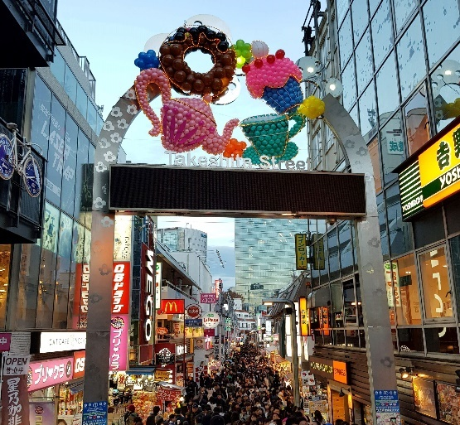
Image sourced from Canva and used in accordance with the  Canva Pro Content License Agreement. | ‘Takeshita Street in December 2018’ by Intforce is  licensed under CC BY-SA 4.0.
After lunch I walked to Meiji Shrine. It is behind Harajuku Station. Meiji Shrine is famous, traditional and extremely old. I think it is beautiful. There are many cherry blossom trees and a big torii gate. I went flower viewing. Meiji Shrine was peaceful and quiet therefore I think it is the best shrine in Tokyo.
At 5 pm I went by subway to Akihabara Station, it cost 500 yen. At night Akihabara is bright and lively and very popular. You can do karaoke and read anime in Akihabara. I like it but I think it is a bit busy. #livelyakihabaraatnight #beautifulmeijishrine

Bright, lively Akihabara at night
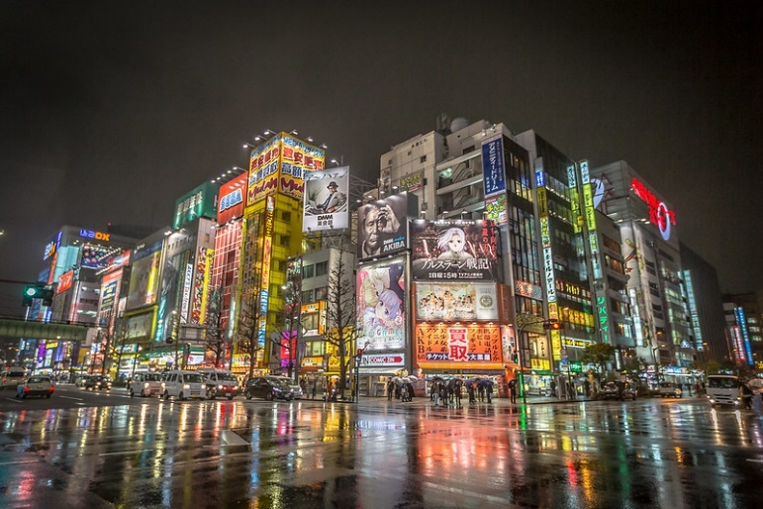
‘Akihabara District at Night’ by IQRemix is licensed under CC BY-SA 2.0.
I love Tokyo. Compared to Sydney, Tokyo is lively, bright and fun. I think everyone wants to go to Tokyo.
30 March
Beautiful, peaceful Nikko – the best place in Japan
Wow! How beautiful is Nikko! At 7:30 am I caught the bullet train from Ueno Station to Utsunomiya Station. The bullet train is fast, clean and very quiet. It cost 4,500 yen. Bullet trains are very convenient compared to trains in Australia. I love them.

Fast and quiet shinkansen | Beautiful, peaceful Nikko
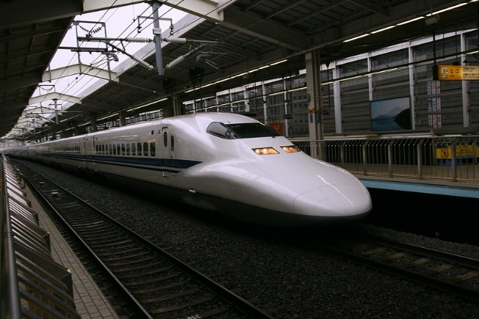 | 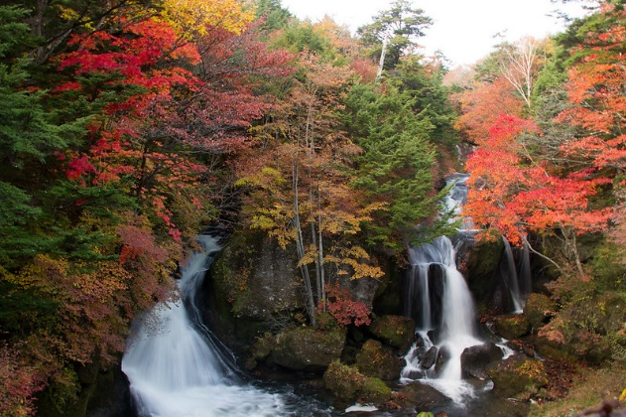
‘Shinkansen’ by Bistrosavage is licensed under CC BY 2.0.‘ | Ryuzu Waterfall’ by bomb.strike is licensed under CC BY-SA 2.0.
From Utsunomiya Station to Nikko Station you take a train. Compared to the bullet train it is a little bit slow but it is still clean and quiet. #lovefastshinkansen
From Nikko Station I went sightseeing by bus. Oh, Nikko is the best. From the bus I saw lots of cherry blossom trees, waterfalls and Lake Chūzenji. Because it is spring you can go flower viewing. It is very popular. If you go in autumn, the autumn colours are also beautiful. I like walking at the lake. You can take the bus from Nikko Station to Mount Nantai and climb the mountain.

Climbing Mount Nantai, So high!
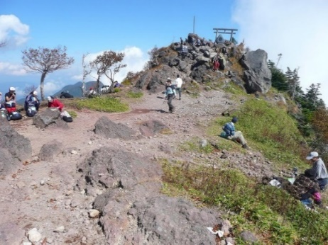
Mount Nantai summit by purplesage is licensed under CC BY 3.0.
From Nikko Station walk to the famous Tōshō-gū Shrine. Turn right, walk straight ahead for 2 kilometres and cross the Shinkyo Bridge, then turn right. The Shinkyo Bridge is over the Daiya River. Tōshō-gū Shrine is traditional and famous. Shinkyo Bridge is red and bright. I took many photos. #nikkoisbeautiful #famousshrines
Beautiful Shinkyo Bridge | Traditional Tōshō-gū Shrine
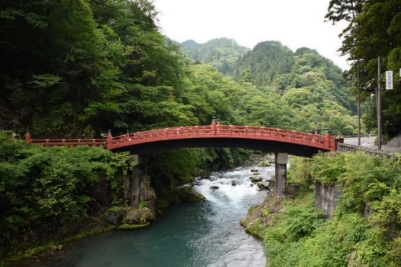 | 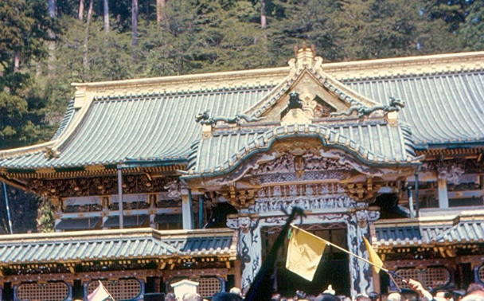
‘The Sacred Bridge (Shinkyo Bridge), Futarasan jinja, Nikko’  by Francisco Antunes is licensed under CC BY 2.0. | ‘Nikko - Toshogu Shrine’ by roger4336 is licensed  under CC BY-SA 2.0.
There are many onsen in Nikko. You can wear a yukata and go to an onsen. How cool! I think they are peaceful and interesting. The best restaurant in Nikko is Gyoza no Umechan. Everyone was friendly and the ramen and gyoza was delicious.
I love Nikko. #relaxingonsen
3 April
Ryōkan – my favourite Japanese accommodation
In Tokyo, on Friday night I stayed at Ryōkan Asakusa Shigetsu. It is near Asakusa Station. At Nakamise-dōri, walk straight to Sensōji Temple, turn left at the shoe shop and it is on the left. The ryōkan is very traditional and beautiful. The cost was 23,000 yen.
In the room there were things like tatami, futon, a fridge, television, air conditioner and so on. The ryōkan has a lift, restaurant and bath. There is also free wi-fi. Compared to a hotel the ryōkan is traditional, quiet and peaceful. Compared to hotels, I think ryōkan are best. I think I always want to stay in a ryōkan! #tradtionalryokan #traditionalJapan #iloveasakusa
Isn’t this a beautiful ryōkan! | The bath is very traditional | Sleeping on futons – fun!
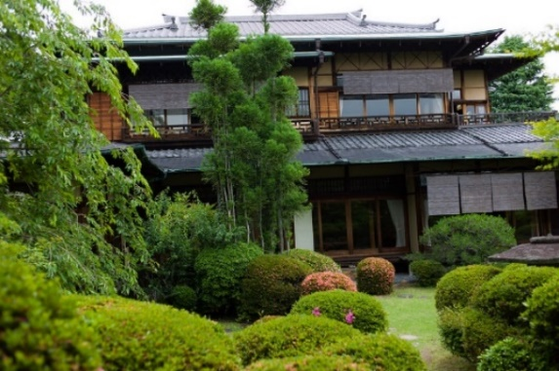 | 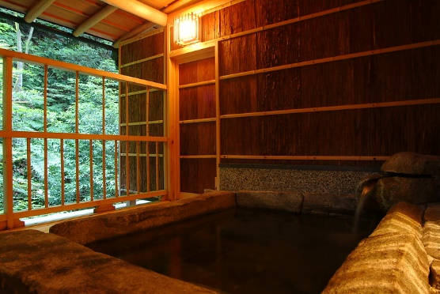 | 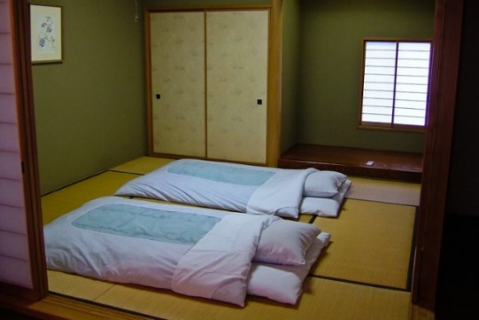
‘Ryokan Yoshida-sanso’ by mkorcuska is licensed  under CC BY-SA 2.0. | ‘Japanese-style Superior Room with Open-Air Bath’ by nishimuraya.kinosakionsen is licensed under CC BY 2.0. | ‘Futon’ by Mr Wabu is licensed under CC BY-SA 2.0.

Appendix B – unit of work infographic for students
To support student engagement in the unit, the Stage 5 Japanese – ‘Japanese travels’ infographic gives students a visual guide of the unit’s learning pathway. Using visual learning journeys also supports Embedding Aboriginal pedagogies in language teaching through Learning Maps – explicitly mapping/visualising processes.
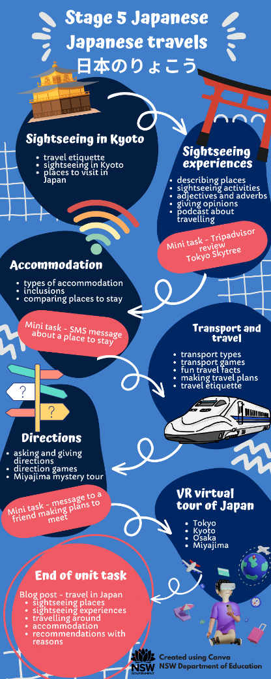

About this resource
- The target audience for this resource is teachers of Stage 5 Japanese.
- Email questions and feedback about this resource to languagesnsw@det.nsw.edu.au using the subject line ‘Stage 5 Japanese’.
- This resource will be reviewed in 12 months’ time as part of ongoing internal evaluation.
- Created/last updated: June 2023
Please complete the feedback form to help us improve our resources and support.

How to use this resource
This 10-week (25-hour) unit of work can be modified to suit the needs of your learners, including adding your own resources, modifying content or duration and differentiating for learning needs and learner groups. You can learn more about differentiation by accessing the department’s Differentiation Adjustment Tool. Accessing the microlearning series Curriculum planning for every student in every classroom will support you to plan for the diversity of student need. The learning, teaching and assessment strategies and assessment task are suggestions only.

Supporting students with disability
When using this unit of work, the assessment task with embedded scaffold, planners and teaching and learning activities consider the needs of students with disability to ensure inclusivity for student access, engagement and expression in lessons.
Considerations may include:
- providing scaffolds as an option for all students to use when needed to guide their response
- providing a visual list of key vocabulary and phrases
- providing options for student expression using their preferred mode of communication
- using closed captions (with English translation setting where appropriate) and/or provide transcripts for deaf or hard of hearing students
- providing documents digitally and/or orally as well as on paper so that they may be accessed by means such as screen readers
- advising students of accessibility options for websites used in the unit such as Quizlet such as large font and voice over options.
Adjustments are recommended to cater to your class’s learning needs. This could include how students will present their work and communicate their understanding.
Appropriate adjustments may include:
- use of explicit instructions and defining key terms or concepts
- simplified or modified practical activities
- use of pictures and diagrams, clearly labelled to support students to access the tasks
- speech-to-text or augmentative communication devices.
Tailoring the mini task – progress checkpoints should provide an equitable opportunity for all students to demonstrate their understanding and receive quality feedback to improve learning outcomes.

Evidence base
This unit of work supports the following themes from ‘What works best’ 2020 update:
- high expectations
- explicit teaching
- effective feedback
- use of data to inform practice
- assessment.

Further information
- Aligned to system priorities and/or needs: NSW Department of Education 2018-2022 Strategic Plan – academic achievement
- Aligned to School Excellence Framework [PDF 291KB]: Learning domains – curriculum; assessment; Teaching domain – effective classroom practice
- Consultation: Inclusive Education

References
This resource contains NSW Curriculum and syllabus content. The NSW Curriculum is developed by the NSW Education Standards Authority. This content is prepared by NESA for and on behalf of the Crown in right of the State of New South Wales. The material is protected by Crown copyright.
Please refer to the NESA Copyright Disclaimer for more information https://educationstandards.nsw.edu.au/wps/portal/nesa/mini-footer/copyright.
NESA holds the only official and up-to-date versions of the NSW Curriculum and syllabus documents. Please visit the NSW Education Standards Authority (NESA) website https://educationstandards.nsw.edu.au/ and the NSW Curriculum website https://curriculum.nsw.edu.au/home.
Modern Languages K–10 Syllabus © 2022 NSW Education Standards Authority (NESA) for and on behalf of the Crown in right of the State of New South Wales.

© State of New South Wales (Department of Education), 2023
The copyright material published in this resource is subject to the Copyright Act 1968 (Cth) and is owned by the NSW Department of Education or, where indicated, by a party other than the NSW Department of Education (third-party material).
Copyright material available in this resource and owned by the NSW Department of Education is licensed under a Creative Commons Attribution 4.0 International (CC BY 4.0) licence.
This licence allows you to share and adapt the material for any purpose, even commercially.
Attribution should be given to © State of New South Wales (Department of Education), 2023.
Material in this resource not available under a Creative Commons licence:
- the NSW Department of Education logo, other logos and trademark-protected material
- material owned by a third party that has been reproduced with permission. You will need to obtain permission from the third party to reuse its material.
Links to third-party material and websites
Please note that the provided (reading/viewing material/list/links/texts) are a suggestion only and implies no endorsement, by the New South Wales Department of Education, of any author, publisher, or book title. School principals and teachers are best placed to assess the suitability of resources that would complement the curriculum and reflect the needs and interests of their students.
If you use the links provided in this document to access a third-party's website, you acknowledge that the terms of use, including licence terms set out on the third-party's website apply to the use which may be made of the materials on that third-party website or where permitted by the Copyright Act 1968 (Cth). The department accepts no responsibility for content on third-party websites.

To support students with completing the task, provide them with a digital or paper copy of the ‘Assessment planning scaffold’ resource [DOCX 95KB].
To support students with completing the task, provide them with a digital or paper copy of the ‘Assessment planning scaffold’ resource [DOCX 95KB].

