¿Cuál prefieres?

Activity 1
Give your opinion on the items of clothing in the table below, using an adverb (un poco, demasiado, muy, bastante) and an adjective. Make sure your adjective ‘agrees with’ the noun. The first one has been done for you as an example.
Clothing item | Description
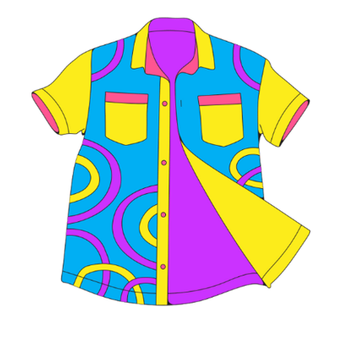 | La camisa es bastante fea.
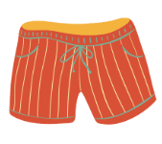
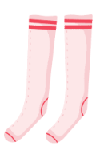
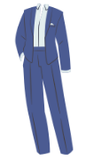
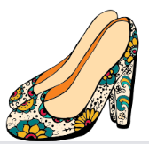
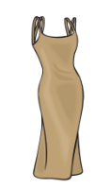
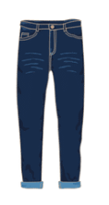
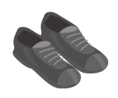
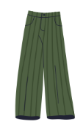
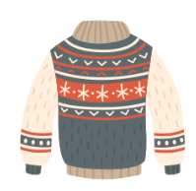

Activity 2
In the second column in the table below, express your preference for one of the items shown. Include an adverb (un poco, demasiado, muy, bastante) with your adjective.
Justify your opinion in the next column and complete your sentence with a full stop.
Working with a partner, ask them which item they prefer, ¿Cuál prefieres? and write down their response in the third person (he or she form) of the verb.
Ask your partner to justify their choice by asking ¿Por qué? and complete the table with their response, adding a full stop to complete the sentence.
The first one has been done as an example only.
Items | Prefiero [item] | porque es [adverb] [adjective]. | ¿Cuál prefieres? | ¿Por qué?
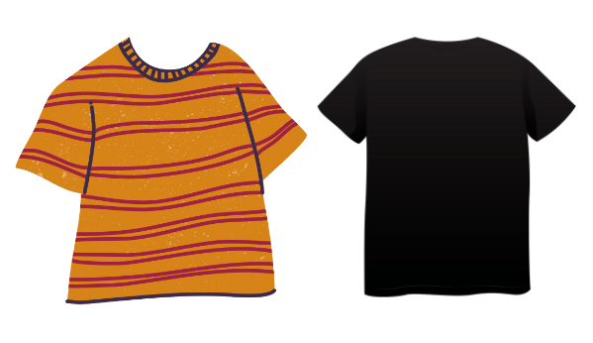 | Prefiero la camiseta negro | porque es muy lisa. | Anna prefiere la camiseta a rayas | porque es bastante bonita.
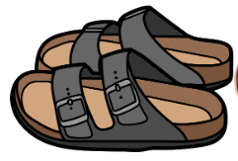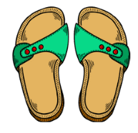
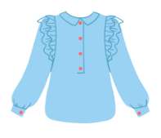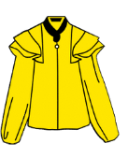
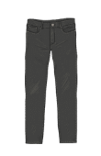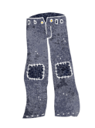
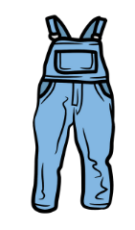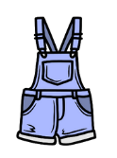

For the teacher
Answers have not been provided, as they will vary from student to student.
Differentiation examples
The following strategies provide a starting point for how you can differentiate the teaching and learning activities in this resource for a range of learners. Adapt or design alternatives, to meet the needs of students in your class.
High potential and gifted students – design a clothing catalogue with descriptions of the items to entice buyers. Encourage students to use additional vocabulary not used in this unit.
Advanced proficiency – students find an online clothing catalogue for a Spanish clothing company. They identify unfamiliar vocabulary for clothing and accessories and write descriptions of the items in Spanish, including how frequently they wear the item and their opinion of it.
Students requiring additional support – provide student with the sentences describing the clothing item in Spanish. Students can draw a picture of the item. Provide student with the sentences and the pictures for students to match.

© State of New South Wales (Department of Education), 2023
The copyright material published in this resource is subject to the Copyright Act 1968 (Cth) and is owned by the NSW Department of Education or, where indicated, by a party other than the NSW Department of Education (third-party material).
Copyright material available in this resource and owned by the NSW Department of Education is licensed under a Creative Commons Attribution 4.0 International (CC BY 4.0) license.
This license allows you to share and adapt the material for any purpose, even commercially.
Attribution should be given to © State of New South Wales (Department of Education), 2023.
Material in this resource not available under a Creative Commons license:
- the NSW Department of Education logo, other logos and trademark-protected material
- material owned by a third party that has been reproduced with permission. You will need to obtain permission from the third party to reuse its material.
Links to third-party material and websites
Please note that the provided (reading/viewing material/list/links/texts) are a suggestion only and implies no endorsement, by the New South Wales Department of Education, of any author, publisher, or book title. School principals and teachers are best placed to assess the suitability of resources that would complement the curriculum and reflect the needs and interests of their students.
If you use the links provided in this document to access a third-party's website, you acknowledge that the terms of use, including licence terms set out on the third-party's website apply to the use which may be made of the materials on that third-party website or where permitted by the Copyright Act 1968 (Cth). The department accepts no responsibility for content on third-party websites.

