Fiestas y actividades

Activity 1
Identify the activity in the table below and write it in its infinitive form. The first one has been done for you as an example.
Activity | Verb
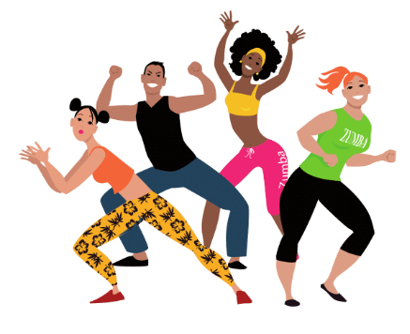 | bailar
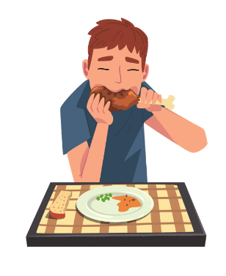
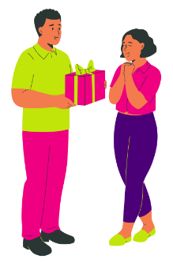
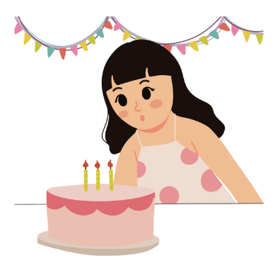
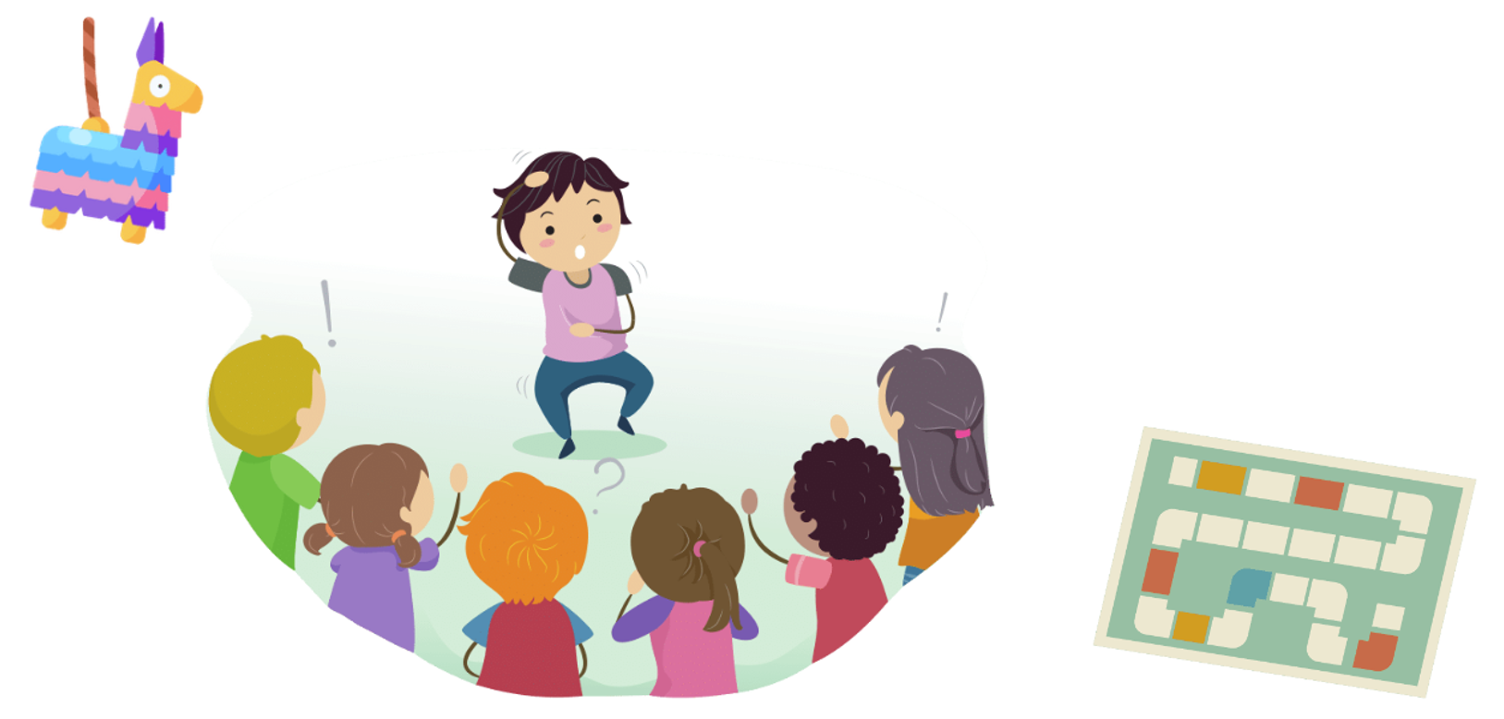
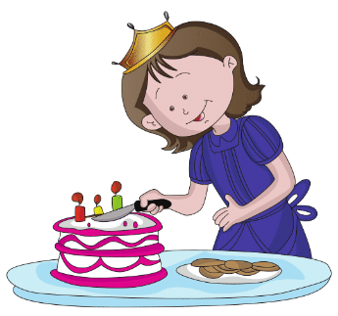
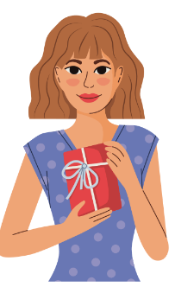
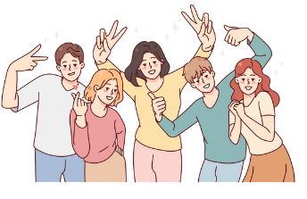

Activity 2
Complete the table below, writing the present tense for each verb.
 | bailar | comer | recibir
yo
tú
él/ella/usted
nosotros
vosotros
ellos/ella/ustedes

Activity 3
Complete the table below with the correct form of the -ir, -er and -ar verb conjugations as indicated. The first one has been done for you as an example.
Verb in infinitive | Conjugated verb
bailar (nosotros) | bailamos
comer (yo)
cortar (tú)
beber (ella)
pasar (ellos)
recibir (ellas)
llevar (ustedes)
jugar (nosotros)
cantar (yo)
soplar (ella)
celebrar (él)
bailar (vosotros)
comer (ellos)
cortar (usted)
beber (ellas)
recibir (yo)
llevar (usted)
ven (ellos)
cantar (nosotros)
soplar (ellas)
celebrar (vosotros)

Activity 4
Use the prompts in the table below to create a sentence to include the event and what happens there. Draw on your prior learning to include as much detail as possible. Start each sentence with either En el festejo (for a festival or celebration), or En la fiesta (for a party). The first one has been done for you as an example.
Event | Pronoun | Activity | Sentence
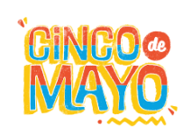 | nosotros |  | En la fiesta de Cinco de Mayo (nosotros) bailamos y celebramos.
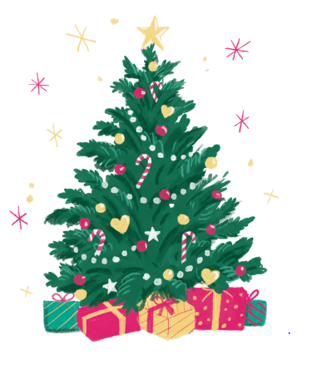 | ellas | 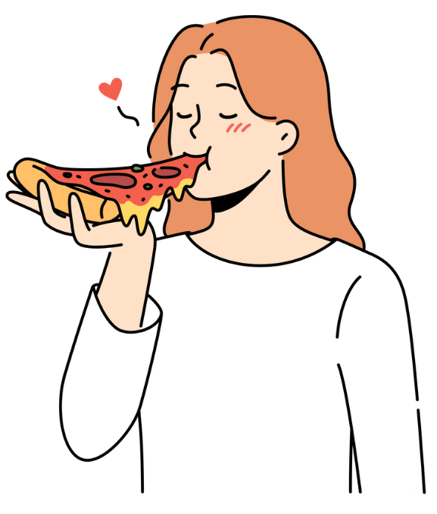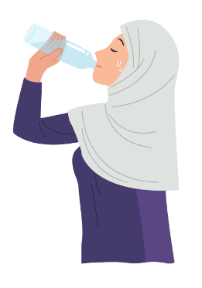
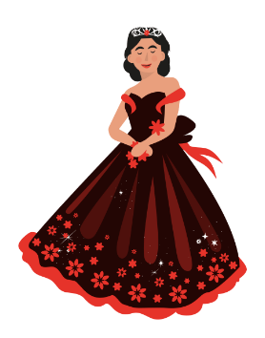 | yo
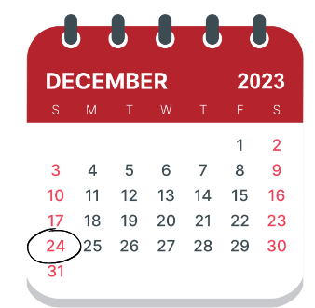 | vosotros
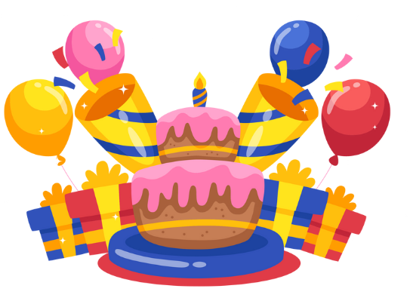 | ella
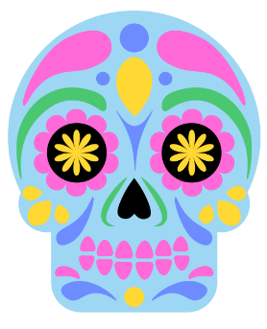 | tú | 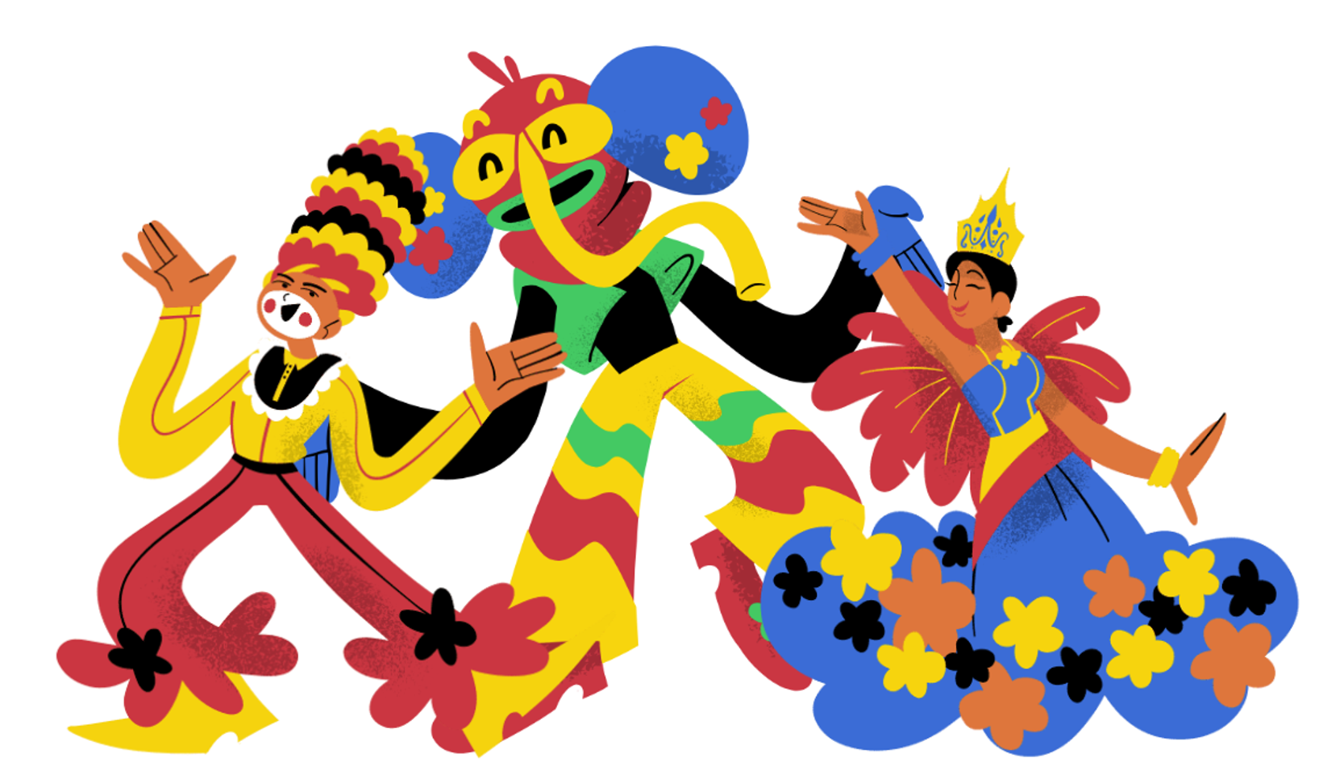
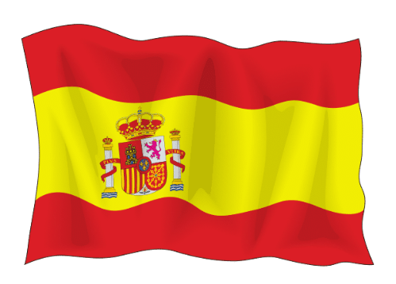 | ellas
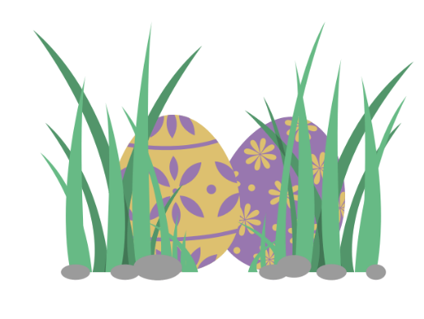 | yo | 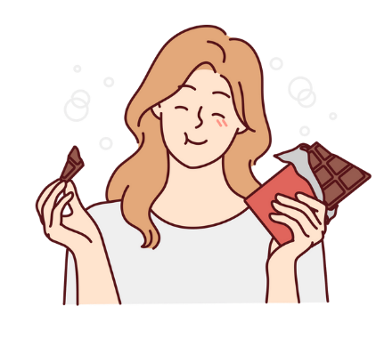
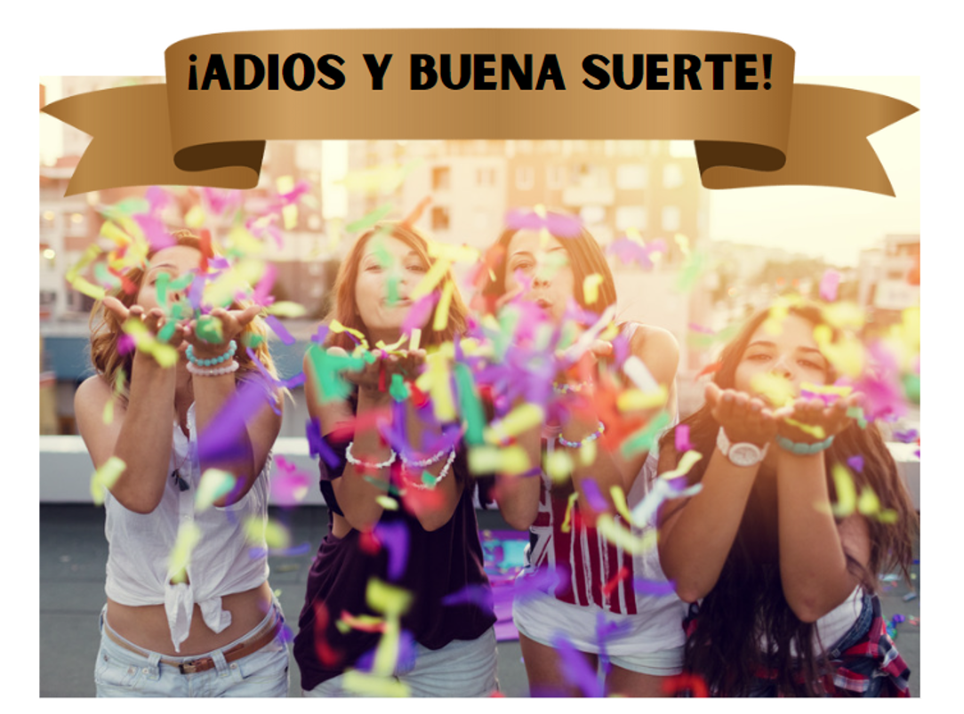 | nosotros | 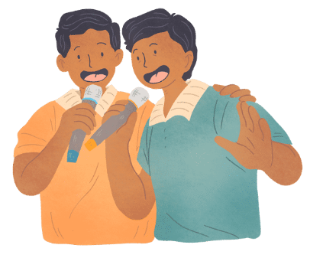
 | nosotros

Activity 5
Choose 4 celebrations and create a detailed sentence which includes at least 2 activities you do at the celebration. For example, En la fiesta de Navidad llevo y recibo los regalos, como mucha comida y celebro con mi familia.

Activity 6
Ask 4 different people in the class what they are celebrating ¿Qué celebras? and what they do there ¿Qué haces? Write their answers in a sentence in Spanish in the table below.
The first one has been done for you as an example.
Nombre | Celebración/actividad
Shaun | En la fiesta de la Noche Vieja, ve los fuegos artificiales.

For the teacher

Activity 1
Activity | Verb
 | bailar
 | celebrar
 | comer
 | llevar un regalo
 | soplar las velas
 | jugar a juegos
 | cortar el pastel
 | recibir un regalo
 | pasarlo bien

Activity 2
 | bailar | comer | recibir
yo | bailo | como | recibo
tú | bailas | comes | recibes
él/ella/usted | baila | come | recibe
nosotros | bailamos | comemos | recibimos
vosotros | bailáis | coméis | recibís
ellos/ella/ustedes | bailan | comen | reciben

Activity 3
Verb in infinitive | Conjugated verb
bailar (nosotros) | bailamos
comer (yo) | como
cortar (tú) | cortas
beber (ella) | bebe
pasar (ellos) | pasan
recibir (ellas) | reciben
llevar (ustedes) | llevan
jugar (nosotros) | jugamos
cantar (yo) | canto
soplar (ella) | sopla
celebrar (él) | celebra
bailar (vosotros) | bailáis
comer (ellos) | comen
cortar (usted) | corta
beber (ellas) | beben
recibir (yo) | reciben
llevar (usted) | lleva
ver (ellos) | ven
cantar (nosotros) | cantamos
soplar (ellas) | soplan
celebrar (vosotros) | celebráis

Activity 4
Answers provided are samples only. Students may have other options.
Event | Pronoun | Activity | Sentence
 | nosotros |  | En la fiesta de Cinco de Mayo (nosotros) bailamos y celebramos.
 | ellas |  | En el festejo de Navidad (ellas) comen y beben.
 | yo |  | En la fiesta de quinceañera (ella) sopla las velas y baila con amigas.
 | vosotros |  | En el festejo de Noche Buena (vosotros) lleváis y recibís los regalos.
 | ella |  | En la fiesta de cumpleaños (ella) juega juegos y sopla las velas.
 | tú |  | En el festejo de Día de los Muertos (tú) ves el desfile.
 | ellas |  | En el festejo de Día Nacional (ellas) ven los fuegos artificiales.
 | yo |  | En el festejo de Pasqua (yo) como chocolate.
 | nosotros |  | En la fiesta de despedida, cantamos y llevamos los regalos.
 | nosotros |  | En la fiesta de graduación celebramos.

© State of New South Wales (Department of Education), 2023
The copyright material published in this resource is subject to the Copyright Act 1968 (Cth) and is owned by the NSW Department of Education or, where indicated, by a party other than the NSW Department of Education (third-party material).
Copyright material available in this resource and owned by the NSW Department of Education is licensed under a Creative Commons Attribution 4.0 International (CC BY 4.0) license.
This license allows you to share and adapt the material for any purpose, even commercially.
Attribution should be given to © State of New South Wales (Department of Education), 2023.
Material in this resource not available under a Creative Commons license:
- the NSW Department of Education logo, other logos and trademark-protected material
- material owned by a third party that has been reproduced with permission. You will need to obtain permission from the third party to reuse its material.
Links to third-party material and websites
Please note that the provided (reading/viewing material/list/links/texts) are a suggestion only and implies no endorsement, by the New South Wales Department of Education, of any author, publisher, or book title. School principals and teachers are best placed to assess the suitability of resources that would complement the curriculum and reflect the needs and interests of their students.
If you use the links provided in this document to access a third-party's website, you acknowledge that the terms of use, including licence terms set out on the third-party's website apply to the use which may be made of the materials on that third-party website or where permitted by the Copyright Act 1968 (Cth). The department accepts no responsibility for content on third-party websites.

