La ropa

Activity 1
Identify each item in the table below in Spanish. The first one has been done for you.
Clothing | Description
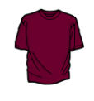 | Es una camiseta marrón.
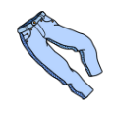
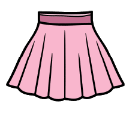
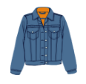
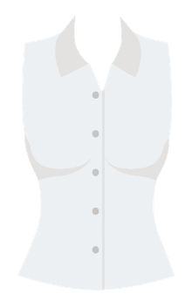
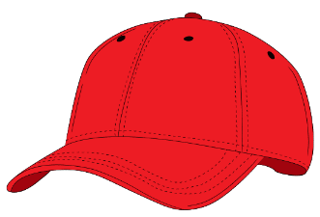
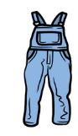
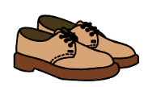
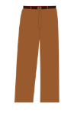
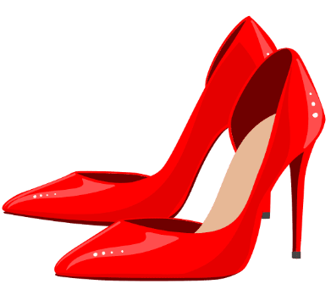
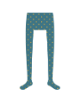
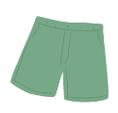
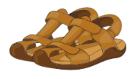
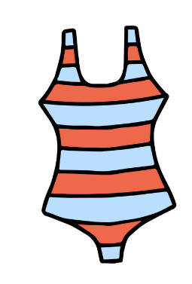
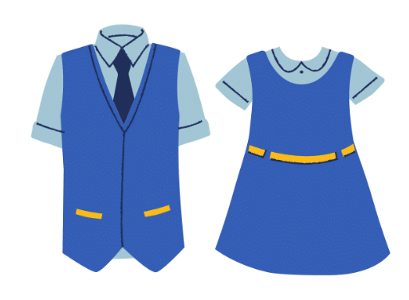
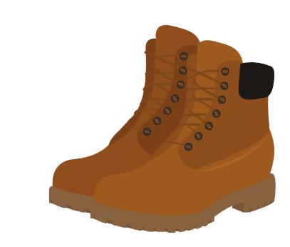

Activity 2
Categorise the vocabulary from the table above into the correct column below according to the article used with each item.
masculine | feminine | masculine plural | feminine plural
 | una gorra

Activity 3
Create sentences using the prompts in the table below, and using the structure Para ir a…llevo… The first one has been done for you as an example.
Location prompt | Clothing prompts | Spanish sentence
 |  | Para ir al cine llevo unos vaqueros y una camiseta.
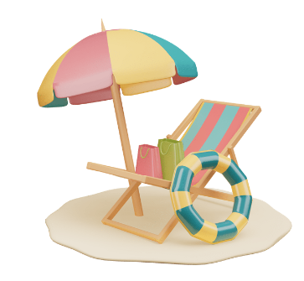
 | 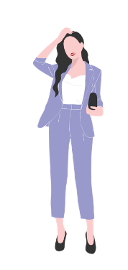
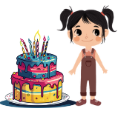 | 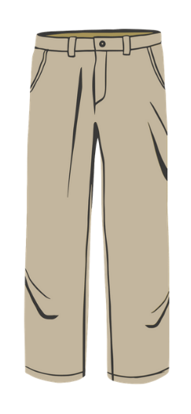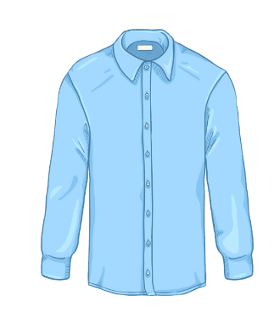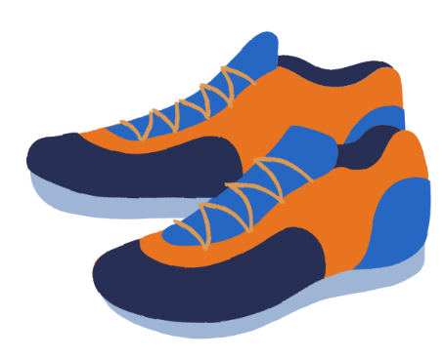

Activity 4
Choose 10 items from the table in Activity 1. Identify the item in the table below as ropa formal or ropa casual and name an event, celebration or place where you could wear the item in the third column. There can be more than one answer for each item.
ropa | casual o formal | evento/lugar
un vestido | formal | una fiesta de cumpleaños  al restaurante

Activity 5
In the table below, list the items worn by each person using the structure Lleva (he or she is wearing) then complete the sentence Es apropiado llevar a [place or event] beneath each image. The first one has been done for you as an example.
Outfit | Description of clothing
Lleva una corbata, un traje, una camisa y unos zapatos.
Es apropiado llevar a la oficina.
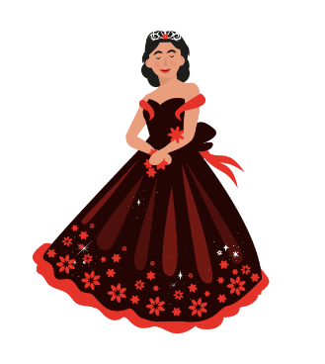
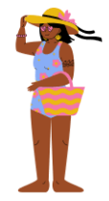

Activity 6
Your teacher will provide you with a set of cards with clothing items. Work in pairs or small groups, taking turns to ask information about each item.
For example:
Student A draws a card and shows it to Student B.
Student B must identify the item in Spanish.
Student A asks ¿Es ropa casual o ropa formal?
Student B responds as appropriate.
Student A asks Student B if it is appropriate to wear to an event of their choosing using the phrase, for example, ¿Es apropiado para ir a [una fiesta de cumpleaños]?
Student B responds with either Sí, es apropiado or No, no es apropiado and gives a reason using an adverb and an adjective. No, no es apropiado, es muy/demasiado/un poco formal.
Student B draws a card and begins the interaction again by reversing roles.

For the teacher

Activity 1
Clothing | Description
 | Es una camiseta marrón.
 | Son unos vaqueros azules.
 | Es una falda rosa.
 | Es una chaqueta azul.
 | Es una camisa amarilla.
 | Es una blusa blanca.
 | Es una gorra roja.
 | Es una corbata azul.
 | Es un vestido negro.
 | Es un suéter violeta.
 | Es un mono azul.
 | Es un traje azul.
 | Son unos zapatos marrones.
 | Son unos pantalones marrones.
 | Son unos tacones rojos.
 | Son unas mallas azules.
 | Son unos shorts verdes.
 | Son unas sandalias marrones.
 | Son unas chancletas azules y violetas.
 | Es un traje de baño naranja y azul.
 | Es un uniforme azul.
 | Son unas botas marrones.

Activity 2
masculine | feminine | masculine plural | feminine plural
un uniforme  un traje de baño | una gorra  una blusa  una camisa  una chaqueta  una falda  una camiseta | unos vaqueros | unas botas  unas chancletas

Activity 3
Location prompt | Clothing prompts | Spanish sentence
 |  | Para ir al cine llevo unos vaqueros y una camiseta.
 |  | Para ir al restaurant llevo un vestido y unos tacones.
 |  | Para ir a la playa llevo unos shorts y unas chancletas.
 |  | Para ir a la escuela llevo un uniforme.
 |  | Para ir al campo (el parque) llevo un mono y unas botas.
 |  | Para ir a la graduación llevo un traje.
 |  | Para ir a la fiesta de cumpleaños llevo unos pantalones, una camisa y unas zapatillas de deporte.

Activity 5
Other options are possible for where the outfit may be worn.
Outfit | Description
Lleva una corbata, un traje, una camisa y unos zapatos.
Es apropiado llevar a la oficina.
Lleva un uniforme, una falda, una camisa, una corbata y unos zapatos.
Es apropiado llevar a la escuela.
Lleva un vestido y una corona.
Es apropiado llevar a la fiesta de quinceañera.
Lleva unos shorts, una camiseta, unas zapatillas de deporte.
Es apropiado llevar al polideportivo.
Lleva un traje de baño y una gorra.
Es apropiado llevar a la playa.

Activity 6
Copy and cut up the cards in the table below. Students work in pairs or small groups. Provide each pair or group with a deck of cards. Students take turns to ask information about each item.
For example:
Student A draws a card and shows it to Student B.
Student B must identify the item in Spanish.
Student A asks ¿Es ropa casual o ropa formal?
Student B responds as appropriate.
Student A asks Student B if it is appropriate to wear to an event of their choosing using the phrase, for example, ¿Es apropiado para ir a [una fiesta de cumpleaños]?
Student B responds with either Sí, es apropiado or No, no es apropiado and gives a reason using an adverb and an adjective. No, no es apropiado, es muy/demasiado/un poco formal.
Student B draws a card and begins the interaction again by reversing roles.

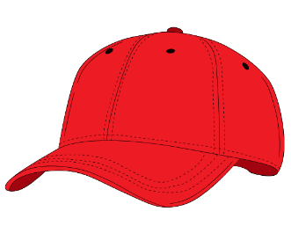

© State of New South Wales (Department of Education), 2023
The copyright material published in this resource is subject to the Copyright Act 1968 (Cth) and is owned by the NSW Department of Education or, where indicated, by a party other than the NSW Department of Education (third-party material).
Copyright material available in this resource and owned by the NSW Department of Education is licensed under a Creative Commons Attribution 4.0 International (CC BY 4.0) license.
This license allows you to share and adapt the material for any purpose, even commercially.
Attribution should be given to © State of New South Wales (Department of Education), 2023.
Material in this resource not available under a Creative Commons license:
- the NSW Department of Education logo, other logos and trademark-protected material
- material owned by a third party that has been reproduced with permission. You will need to obtain permission from the third party to reuse its material.
Links to third-party material and websites
Please note that the provided (reading/viewing material/list/links/texts) are a suggestion only and implies no endorsement, by the New South Wales Department of Education, of any author, publisher, or book title. School principals and teachers are best placed to assess the suitability of resources that would complement the curriculum and reflect the needs and interests of their students.
If you use the links provided in this document to access a third-party's website, you acknowledge that the terms of use, including licence terms set out on the third-party's website apply to the use which may be made of the materials on that third-party website or where permitted by the Copyright Act 1968 (Cth). The department accepts no responsibility for content on third-party websites.

