Summative assessment task – text messages
You and your visiting exchange student have been exchanging text messages about an upcoming celebration. To help your parent or carer understand the details of the event, answer a series of questions in English relating to what to wear, and where, when and with whom the celebration will take place.

Messages
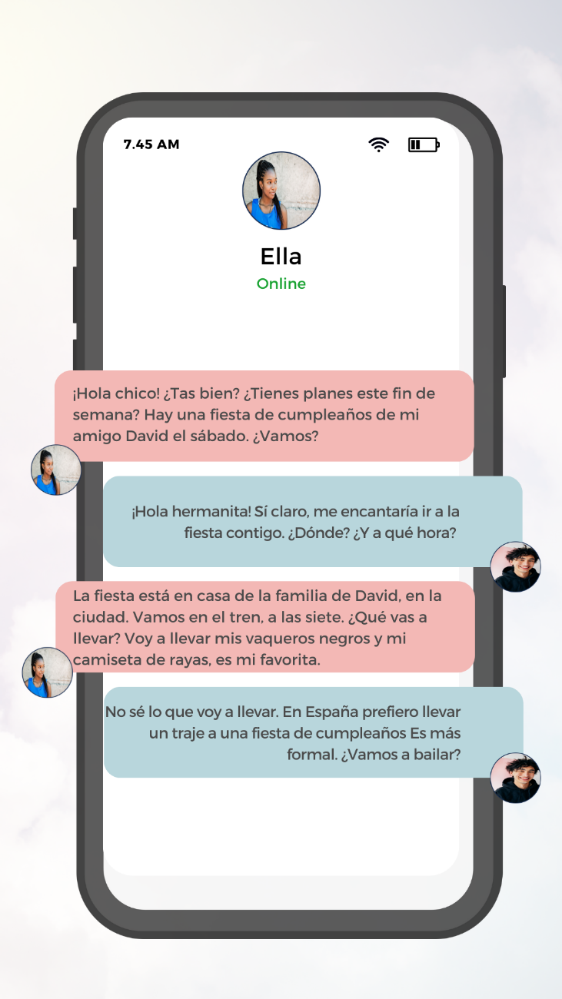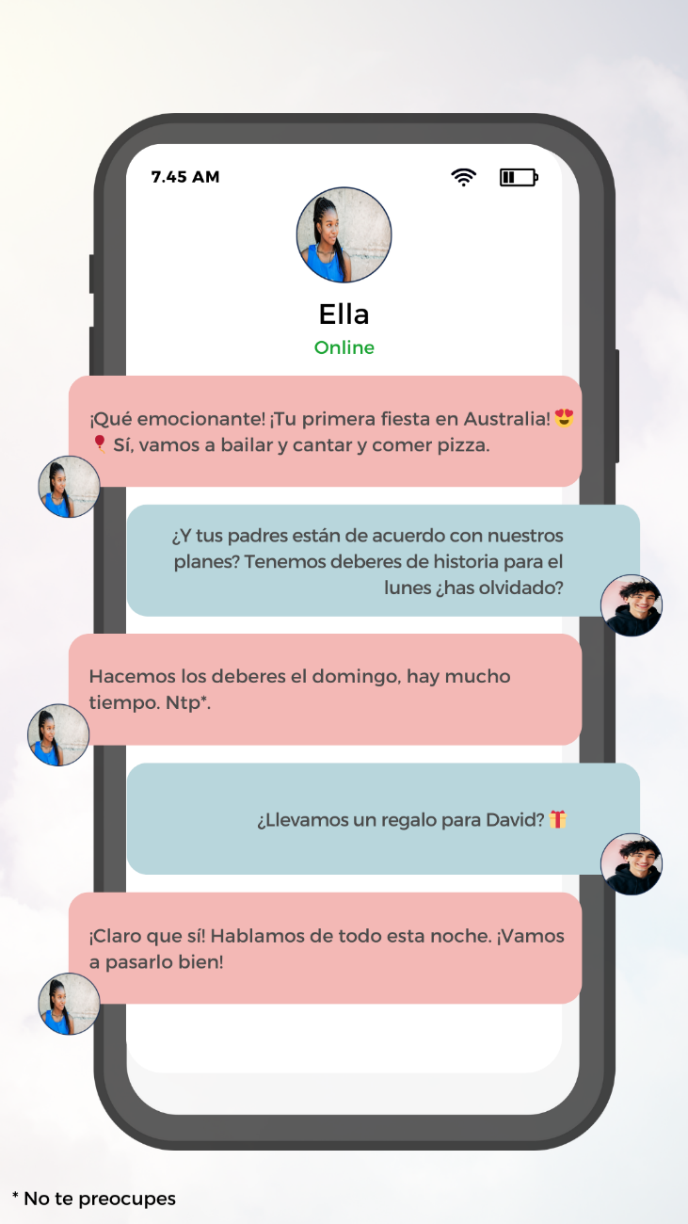

Questions
Choose the role of one of the people in the conversation.
- Summarise the details for your parent/carer, including where, when and with whom the celebration will take place, and what you plan to wear.
- Describe how this event is different to a similar event in Spain.
- Do you think your parent/carer will let you attend? Justify your response with reference to the text.

For the teacher
Below are accessible versions of the text messages to support students who use screen readers.
You can also edit the text messages in Canva, to include your own choices.

Text 1
¡Hola chico! ¿Tas bien? ¿Tienes planes este fin de semana? Hay una fiesta de cumpleaños de mi amigo David el sábado. ¿Vamos?

Text 2
¡Hola hermanita! Sí claro, me encantaría ir a la fiesta contigo. ¿Dónde? ¿Y a qué hora?

Text 3
La fiesta está en casa de la familia de David, en la ciudad. Vamos en el tren, a las siete. ¿Qué vas a llevar? Voy a llevar mis vaqueros negros y mi camiseta de rayas, es mi favorita.

Text 4
No sé lo que voy a llevar. En España prefiero llevar un traje a una fiesta de cumpleaños Es más formal. ¿Vamos a bailar?

Text 5
¡Qué emocionante! ¡Tu primera fiesta en Australia! 😍🎈 Sí, vamos a bailar y cantar y comer pizza.

Text 6
¿Y tus padres están de acuerdo con nuestros planes? Tenemos deberes de historia para el lunes ¿has olvidado?

Text 7
Hacemos los deberes el domingo, hay mucho tiempo. Ntp.*

Text 8
¿Llevamos un regalo para David? 🎁

Text 9
¡Claro que sí! Hablamos de todo esta noche. ¡Vamos a pasarlo bien!

* No te preocupes

English translation
For support teachers of other languages to understand the nature of the task, a translation is provided below.
Text 1: Hello, mate! Are you doing well? Do you have plans for this weekend? There's a birthday party for my friend David on Saturday. Shall we go?
Text 2: Hello, little sister! Yes, of course, I'd love to go to the party with you. Where is it? What time? We have history homework due on Monday, have you forgotten?
Text 3: The party is at David's family's house in the city. We're taking the train at seven. What are you going to wear? I'm wearing my black jeans and my striped shirt; it's my favourite.
Text 4: I'm not sure what I'm going to wear. In Spain, I prefer to wear a suit to a birthday party; it's more formal. Are we going to dance?
Text 5: How exciting! Your first party in Australia! 😍🎈 Yes, we're going to dance, sing, and eat pizza.
Text 6: And are your parents okay with our plans? We have history homework due on Monday, have you forgotten?
Text 7: We'll do the homework on Sunday; there's plenty of time. Don't worry.
Text 8: Should we bring a gift for David? 🎁
Text 9: Of course! We’ve talked about everything tonight. Let's have a good time!

© State of New South Wales (Department of Education), 2023
The copyright material published in this resource is subject to the Copyright Act 1968 (Cth) and is owned by the NSW Department of Education or, where indicated, by a party other than the NSW Department of Education (third-party material).
Copyright material available in this resource and owned by the NSW Department of Education is licensed under a Creative Commons Attribution 4.0 International (CC BY 4.0) license.
This licence allows you to share and adapt the material for any purpose, even commercially. Attribution should be given to © State of New South Wales (Department of Education), 2023.
Material in this resource not available under a Creative Commons licence:
- the NSW Department of Education logo, other logos and trademark-protected material
- material owned by a third party that has been reproduced with permission. You will need to obtain permission from the third party to reuse its material.
Links to third-party material and websites
Please note that the provided (reading/viewing material/list/links/texts) are a suggestion only and implies no endorsement, by the New South Wales Department of Education, of any author, publisher, or book title. School principals and teachers are best placed to assess the suitability of resources that would complement the curriculum and reflect the needs and interests of their students.
If you use the links provided in this document to access a third-party's website, you acknowledge that the terms of use, including licence terms set out on the third-party's website apply to the use which may be made of the materials on that third-party website or where permitted by the Copyright Act 1968 (Cth). The department accepts no responsibility for content on third-party websites.

