# Mathematics 3-6 multi-age – Year A – Unit 1



Contents

Unit description and duration 4

Syllabus outcomes 4

Working mathematically 5

Student prior learning 6

Lesson overview and resources 7

Lesson 1 13

Daily number sense: Mastermind – 10 minutes 13

Core lesson 1: Ordering large numbers – 30 minutes 15

Core lesson 2: Naming large numbers – 15 minutes 18

Discuss and connect the mathematics – 10 minutes 19

Lesson 2 21

Daily number sense: Ordering numbers – 15 minutes 21

Core lesson: Representing numbers – 40 minutes 23

Discuss and connect the mathematics – 10 minutes 26

Lesson 3 28

Daily number sense: Climb the ladder – 10 minutes 28

Core lesson – 45 minutes 30

Consolidation and meaningful practice – 10 minutes 35

Lesson 4 37

Daily number sense – 10 minutes 37

Core lesson – 45 minutes 37

Discuss and connect the mathematics – 10 minutes 41

Lesson 5 43

Daily number sense: Missing number patterns – 10 minutes 43

Core lesson – 35 minutes 46

Discuss and connect the mathematics – 15 minutes 51

Lesson 6 54

Daily number sense: 101 and you’re not out – 10 minutes 54

Core lesson – 40 minutes 57

Consolidation and meaningful practice – 15 minutes 63

Lesson 7 67

Daily number sense: Dicey addition – 15 minutes 67

Core lesson – 40 minutes 69

Discuss and connect the mathematics – 10 minutes 73

Lesson 8 75

Daily number sense – 15 minutes 75

Core lesson – 40 minutes 75

Discuss and connect the mathematics – 10 minutes 81

Resource 1: Place value houses 83

Resource 2: Number cards 84

Resource 3: 100 dots 85

Resource 4: 1000 dots 86

Resource 5: 10 000 dots 87

Resource 6: Number expander 88

Resource 7: Number line 89

Resource 8: Nutrition information label 90

Resource 9: Nutrition levels in food 91

Resource 10: Number chart 92

Resource 11: Prime numbers chart 93

Resource 12: Multiplication toss gameboard 94

Resource 13: What’s my number? 95

Resource 14: Number cards 2 96

Syllabus outcomes and content 97

Stage 2 97

Stage 3 101

References 107

Further reading 109

## Unit description and duration

This unit develops the big idea that our number system extends infinitely to very large and very small numbers.

In this 2-week unit students are provided opportunities to:

* name, rename, represent and order numbers
* compare, order and represent decimals
* explore the link between multiplicative thinking and place value.

This multi-age unit is informed by the lessons in Stage 2 Year A Unit 1 and Stage 3 Year A Unit 1. Please refer to these units for additional lesson guidance.

### Syllabus outcomes

* **MAO-WM-01** develops understanding and fluency in mathematics through exploring and connecting mathematical concepts, choosing and applying mathematical techniques to solve problems, and communicating their thinking and reasoning coherently and clearly

#### Stage 2

* **MA1-RWN-01 applies an understanding of place value and the role of zero to read, write and order two- and three-digit numbers**
* **MA1-RWN-02 reasons about representations of whole numbers to 1000, partitioning numbers to use and record quantity values**
* **MA2-RN-01 applies an understanding of place value and the role of zero to represent numbers to at least tens of thousands**
* **MA2-AR-01** selects and uses mental and written strategies for addition and subtraction involving 2- and 3-digit numbers
* **MA2-MR-01 represents and uses the structure of multiplicative relations to 10 × 10 to solve problems**

#### Stage 3

* **MA2-RN-01 applies an understanding of place value and the role of zero to represent numbers to at least tens of thousands**
* **MA2-RN-02 represents and compares decimals up to 2 decimal places using place value**
* **MA2-AR-01 selects and uses mental and written strategies for addition and subtraction involving 2- and 3-digit numbers**
* **MA3-RN-01 applies an understanding of place value and the role of zero to represent the properties of numbers**
* **MA3-RN-02 compares and orders decimals up to 3 decimal places**
* **MA3-MR-01 selects and applies appropriate strategies to solve multiplication and division problems**

### Working mathematically

In the Mathematics K–10 Syllabus, there is one overarching Working mathematically outcome (**MAO-WM-01**). The Working mathematically processes should be embedded within the concepts being taught. The Working mathematically processes present in the Mathematics K–10 Syllabus are:

* communicating
* understanding and fluency
* reasoning
* problem solving.

[Mathematics K–10 Syllabus](https://curriculum.nsw.edu.au/learning-areas/mathematics/mathematics-k-10) © NSW Education Standards Authority (NESA) for and on behalf of the Crown in right of the State of New South Wales, 2022.

### Student prior learning

Before engaging in these teaching and learning activities, students would benefit from prior experience with:

* reading, representing and ordering numbers
* reading, representing and writing tenths and hundredths in decimal notation
* creating and representing multiplicative structures.

In NSW classrooms there is a diverse range of students, including Aboriginal and Torres Strait Islander students, students learning English as an additional language or dialect, high potential and gifted students and students with disability. Some students may identify with more than one of these groups or possibly all of them. Refer to [Advice on curriculum planning for every student](https://education.nsw.gov.au/teaching-and-learning/curriculum/planning-programming-and-assessing-k-12/advice-on-curriculum-planning-for-every-student-k-12) for further information.

## Lesson overview and resources

To cover the content of the syllabus across Stage 2 and Stage 3, some core lessons in the unit contain both a Stage 2 and a Stage 3 task. Teachers are encouraged to adapt and contextualise the units to meet the needs of their students.

The table below outlines the sequence and approximate timing of lessons, learning intentions and resources.

|  |  |  |
| --- | --- | --- |
| Lesson | Content | Duration and resources |
| **Lesson 1**  **Daily number sense**  **Stage 2:**   * **Representing whole numbers B**: Form, regroup, and rename three-digit numbers   **Stage 3:**   * **Representing numbers using place value B**: Whole numbers: Apply place value to partition, regroup and rename numbers up to 6 digits | **Lesson core concept**: reading and representing large numbers is a key component of place value.  **Stage 2:**   * **Representing numbers using place value B**: Whole numbers: Order numbers in the thousands   **Stage 3:**   * **Represents numbers A**: Whole numbers: Recognise, represent and order numbers in the millions | **Lesson duration**: 65 minutes   * Resource 1: Place value houses * Resource 2: Number cards * Resource 3: Number expander100 dots * Resource 4: 1000 dots * Resource 5: 10 000 dots * Individual whiteboards * Sticky notes * Writing materials |
| **Lesson 2**  **Daily number sense**  **Stage 2:**   * **Representing whole numbers B**: Form, regroup, and rename three-digit numbers   **Stage 3:**   * **Representing numbers using place value B**: Whole numbers: Apply place value to partition, regroup and rename numbers up to 6 digits | **Lesson core concept**: numbers can be renamed equivalent ways using place value  **Stage 2:**   * **Representing numbers using place value A**: Whole numbers: Apply place value to partition and regroup numbers up to 4 digits   **Stage 3:**   * **Represents numbers A**: Whole numbers: Recognise, represent and order numbers in the millions | **Lesson duration**: 65 minutes   * Resource 6: Number expander * 0–9 dice * 9-sided dice * MAB materials * Sticky notes * Writing materials |
| **Lesson 3**  **Daily number sense**  **Stage 2:**   * **Representing whole numbers B**: Form, regroup, and rename three-digit numbers   **Stage 3:**   * **Representing numbers using place value B**: Whole numbers: Apply place value to partition, regroup and rename numbers up to 6 digits | **Lesson core concept**: reading, recording and extending numbers are key components of place value.  **Stage 2:**   * **Representing numbers using place value B**: Whole numbers: Recognise and represent numbers that are 10, 100 or 1000 times as large   **Stage 3:**   * **Represents numbers A:** Decimals and percentages: Recognise that the place value system can be extended beyond hundredths | **Lesson duration**: 65 minutes   * Resource 1: Place value houses * 9-sided dice * Cardboard * Cups (6 per Stage 2 student) * MAB materials * Metre rulers * Small wooden sticks or toothpicks * Writing materials |
| **Lesson 4**  **Daily number sense**   * teacher-identified task based on student needs | **Lesson core concept**: the position of each digit in a number corresponds to its size  **Stage 2:**   * **Representing numbers using place value A**: Whole numbers: Read, represent and order numbers to thousands   **Stage 3:**   * **Represents numbers A:** Decimals and percentages: Compare, order and represent decimals | **Lesson duration**: 65 minutes   * Resource 7: Number line * Resource 8: Nutrition information label * Resource 9: Nutrition levels in food * 9-sided dice * Sticky notes * Writing materials |
| **Lesson 5**  **Daily number sense**  **Stage 2:**   * **Multiplicative relations A:** Generate and describe patterns   **Stage 3:**   * **Multiplicative relations B**: Represent and describe number patterns formed by multiples | **Lesson core concept**: multiplicative thinking is based on patterns.  **Stage 2:**   * **Multiplicative relations A:** Generate and describe patterns   **Stage 3:**   * **Multiplicative relations A:** Determine products and factors | **Lesson duration**: 60 minutes   * Resource 10: Number chart * Resource 11: Prime numbers chart * Counters * [Digital hundreds chart](https://toytheater.com/hundreds-chart/) * Square tiles or pattern blocks * Writing materials |
| **Lesson 6**  **Daily number sense**  **Stage 2:**   * **Additive relations B:** Apply addition and subtraction to familiar contexts, including money and budgeting   **Stage 3:**   * **Additive relations B:** Apply addition and subtraction to familiar contexts, including money and budgeting | **Lesson core concept**: structures can support multiplicative thinking.  **Stage 2:**   * **Multiplicative relations A:** Use arrays to establish multiplication facts from multiples of 2 and 4, 5 and 10   **Stage 3:**   * **Multiplicative relations A:** Use partitioning and place value to multiply 2-, 3- and 4-digit numbers by one-digit numbers | **Lesson duration**: 65 minutes   * Resource 12: Multiplication toss gameboard * 0–9-sided dice or spinners * 9-sided dice * 12-sided dice * Counters or tiles * MAB materials * Student workbooks * [Virtual manipulatives](https://mathigon.org/polypad) * Writing materials |
| **Lesson 7**  **Daily number sense**  **Stage 2:**   * **Additive relations B:** Apply addition and subtraction to familiar contexts, including money and budgeting   **Stage 3:**   * **Additive relations B:** Apply addition and subtraction to familiar contexts, including money and budgeting | **Lesson core concept**: zeros in numbers can have different roles.  **Stage 2:**   * **Representing numbers using place value A**: Whole numbers: Read, represent and order numbers to thousands   **Stage 3:**   * **Multiplicative relations A:** Use partitioning and place value to multiply 2-, 3- and 4-digit numbers by one-digit numbers | **Lesson duration**: 65 minutes   * Resource 13: What’s my number? * 0–9-sided dice or spinners * Individual whiteboards * Tape * Writing materials |
| **Lesson 8**  **Daily number sense**   * teacher-identified task based on student needs | **Lesson core concept**: known number facts and strategies support multiplicative understanding.  **Stage 2:**   * **Multiplicative relations A:** Recall multiplication facts of 2 and 4, 5 and 10 and related division facts   **Stage 3:**   * **Multiplicative relations A:** Use partitioning and place value to multiply 2-, 3- and 4-digit numbers by one-digit numbers | **Lesson duration**: 65 minutes   * Resource 14: Number cards 2 * 1–10-spinners or 10-sided dice * Cup or box * Individual whiteboards * [Interactive random number generator](https://mathigon.org/polypad#random) * Writing materials |

## Lesson 1

**Core concept**: reading and representing large numbers is a key component of place value.

### Daily number sense: Mastermind – 10 minutes

Daily number sense activities for Lessons 1 to 3 ‘activate’ prior number knowledge and support the learning of new content in the unit. These activities can also assist teachers to identify the starting points for learning by revealing the extent of students’ existing knowledge.

The table below contains a suggested learning intention and success criteria. These are best co-constructed with students.

|  |  |
| --- | --- |
| Daily number sense learning intention | Daily number sense success criteria |
| All students are learning to:   * read and represent numbers. | All students can:   * read and write 3- to 5-digit numbers. |

This activity is an adaptation of [Mastermind (7:43)](https://education.nsw.gov.au/teaching-and-learning/curriculum/mathematics/mathematics-curriculum-resources-k-12/mathematics-k-6-resources/mastermind) from [Mathematics K-6 resources](https://education.nsw.gov.au/teaching-and-learning/curriculum/mathematics/mathematics-curriculum-resources-k-12/mathematics-k-6-resources) by State of New South Wales (Department of Education).

1. Students play in pairs with another student who is playing the game using the same number of digits. Each player records a number (3- to 5-digit number) with no repeated digits, on a sticky note.
2. Students draw up their gameboard on an individual whiteboard (see Figure 1).

Figure 1 – Mastermind gameboard

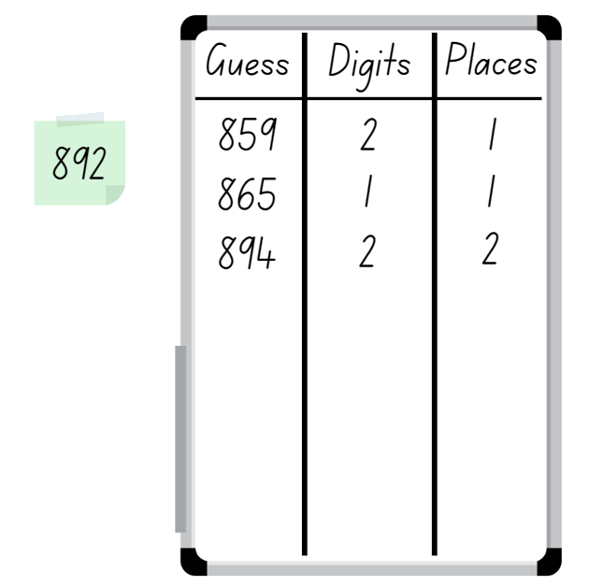

1. Students take turns to guess their partner’s number. Partners record the guess, the number of digits that are correct and the number of digits that are in the right place (see Figure 1). Students then use this information to refine their guesses.
2. The first student to correctly guess their partner’s number is the winner.
3. After the game, ask questions such as:

* How many guesses did it take to get the correct number?
* What could you do to make it difficult for your opponent?
* How could you make this game easier or harder?

This table details opportunities for assessment.

|  |  |
| --- | --- |
| Assessment opportunities | Links |
| What to look for:   * Can Stage 2 students read and write numbers with 3-digits? **[MAO-WM-01, MA1-RWN-01]** * Can Stage 3 students read and write numbers with 3- to 5-digits? **[MAO-WM-01, MA2-RN-01]** | Links to [National Numeracy Learning Progressions](https://www.australiancurriculum.edu.au/resources/national-literacy-and-numeracy-learning-progressions/version-3-of-national-literacy-and-numeracy-learning-progressions/) (NNLP):   * Stage 2 – NPV5 * Stage 3 – NPV7.   Links to suggested [Interview for Student Reasoning](https://education.nsw.gov.au/teaching-and-learning/curriculum/literacy-and-numeracy/assessment-resources/ifsr) (IfSR) tasks:   * **Stage 2 – IfSR-NP**: 4B.2, 4B.3 * **Stage 3 – IfSR-NP**: 4B.2, 4B.3, 4B.5. |

### Core lesson 1: Ordering large numbers – 30 minutes

The table below contains suggested learning intentions and success criteria. These are best co-constructed with students.

|  |  |
| --- | --- |
| Core concept learning intentions | Core concept success criteria |
| All students are learning to:   * arrange numbers in ascending and descending order * name numbers using place value grouping of ones, tens and hundreds. | All students can:   * arrange sets of place value variation cards in ascending order * write large numbers and read them out loud. |

This activity is an adaptation of [Place value with whole numbers](https://nzmaths.co.nz/resource/place-value-whole-numbers) from [NZ Maths](https://nzmaths.co.nz/) by New Zealand Ministry of Education.

1. Discuss big numbers with the class. Ask students:

* Where do you see big numbers?
* Why are they useful?
* Where are large numbers used in real life?
* How do we name them?
* How do we write them?

1. Display Resource 1: Place value houses and explain the purpose of the place value houses is to assist students to read larger numbers in their groups. Each house highlights the place value structure of ones, tens and hundreds. Each house contains a group of 3 digits (see Figure 2).

Figure 2 – Place value houses

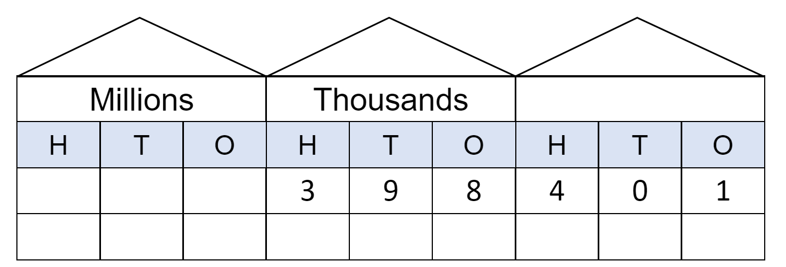

1. Record the number 398 401 onto Resource 1: Place value houses and explain that the number has been partitioned into each of its place values. It is read as ‘three hundred and ninety-eight thousand, four hundred and one’.
2. Using the place value houses, write examples of numbers in the millions and model how they are named. Students repeat the numbers out loud. For example, 2 438 395 is read as ‘two million, four hundred and thirty-eight thousand, three hundred and ninety-five’.
3. Repeat the process, asking students to write and name the numbers on Resource 1: Place value houses.
4. Ask students to identify the place value parts in a number in the millions. For example, in the number 3 491 587, the 3 represents 3 millions, the one represents 1 thousand and the 9 represents 90 thousands.

**Multi-age**: to support students working towards Stage 2 outcomes, write examples of numbers in the thousands and model how they are named. Students repeat the numbers out loud. Ask students to identify the place value parts in a number in the thousands.

1. Give pairs of students a set of 24 numbers from Resource 2: Number cards, depending on whether they are working with numbers in the thousands or millions. Students cut out the cards and arrange them in ascending order, reading each number aloud as they work. Have students share their thinking when ordering the set of cards.
2. Students move to another group and check if their cards are ordered correctly.
3. As a class, students share the strategies they used when ordering their cards. Record the ideas on the board.

This table details opportunities for differentiation.

|  |  |
| --- | --- |
| Too hard? | Too easy? |
| Students cannot arrange numbers in ascending order.   * Offer sets of cards with smaller numbers. | Students can arrange numbers in ascending order.   * Students create a set of 8 cards with larger numbers and place these in ascending order. |

### Core lesson 2: Naming large numbers – 15 minutes

This activity is an adaptation of [Place value with whole numbers](https://nzmaths.co.nz/resource/place-value-whole-numbers) from [NZ Maths](https://nzmaths.co.nz/) by New Zealand Ministry of Education.

1. Write a 6-digit number on Resource 1: Place value houses and read it together, pointing out the hundreds, tens and ones. Repeat several times with numbers that have zeros in them to emphasise the zero as a place holder.
2. In pairs, students make 4- to 6-digit numbers, including at least one zero, using the place value houses for their partners, who read the number in turn. Students then swap over and repeat several times.

This table details opportunities for differentiation

|  |  |
| --- | --- |
| Too hard? | Too easy? |
| Students cannot name large numbers.   * Model making smaller numbers on the place value houses starting with hundreds. Students read these out loud. | Students can name large numbers in the thousands.   * Students write larger numbers and read them out loud. |

### Discuss and connect the mathematics – 10 minutes

1. Show students Resource 3: 100 dots. Ask what they see using words and numbers and record on the board. Answers may include 10 groups of 100, 100 lots of 10 and one hundred groups of one.
2. Ask students to [turn and talk](https://education.nsw.gov.au/teaching-and-learning/curriculum/literacy-and-numeracy/teaching-and-learning-resources/numeracy/talk-moves) and discuss what a thousand dots would look like.
3. Show students Resource 4: 1000 dots. Ask students what they see using words and numbers and write this on the board.
4. Ask students to turn and talk about what 10 000 dots would look like.
5. Show students Resource 5: 10 000 dots. Ask students what they see using words and numbers and write this on the board.
6. Explain that in each case, the number is 10 times as large.
7. Summarise the lesson, drawing out key mathematical ideas about ordering numbers in ascending and descending order and naming large numbers. Ask:

* Were there any challenges when naming large numbers?
* Were there any challenges when ordering numbers in ascending order?
* What strategies worked best?

This table details opportunities for assessment.

|  |  |
| --- | --- |
| Assessment opportunities | Links |
| What to look for:   * Can students arrange sets of place value variation cards in ascending order? **[MAO-WM-01, MA2-RN-01, MA3-RN-01]** * Can students name numbers using the place value groupings of ones, tens and hundreds? **[MAO-WM-01, MA2-RN-01, MA3-RN-01]** | Links to [National Numeracy Learning Progressions](https://www.australiancurriculum.edu.au/resources/national-literacy-and-numeracy-learning-progressions/version-3-of-national-literacy-and-numeracy-learning-progressions/) (NNLP):   * Stage 2 – NPV6, NPV7 * Stage 3 – NPV7. |

## Lesson 2

**Core concept**: numbers can be renamed equivalent ways using place value.

### Daily number sense: Ordering numbers – 15 minutes

The table below contains a suggested learning intention and success criteria. These are best co-constructed with students.

|  |  |
| --- | --- |
| Daily number sense learning intention | Daily number sense success criteria |
| All students are learning to:   * order large numbers. | All students can:   * order 4- and 5-digit numbers. |

This activity is an adaptation of [Order! Order! (four-digit numbers)](https://education.nsw.gov.au/teaching-and-learning/curriculum/mathematics/mathematics-curriculum-resources-k-12/mathematics-k-6-resources/order-order-four-digit-numbers) from [K-6 Mathematics resources](https://education.nsw.gov.au/teaching-and-learning/curriculum/mathematics/mathematics-curriculum-resources-k-12/mathematics-k-6-resources) by State of New South Wales (Department of Education).

1. This game may be played individually, in pairs or in small groups. Students use a 0–9 die, spinner or playing cards to provide 4 or 5 digits. The digits are then combined in any order to create a 4-digit number, which students record on a sticky note.
2. This process is repeated 3 times to give four 4- or 5-digit numbers (see Figure 3).

Figure 3 – Ordering numbers example

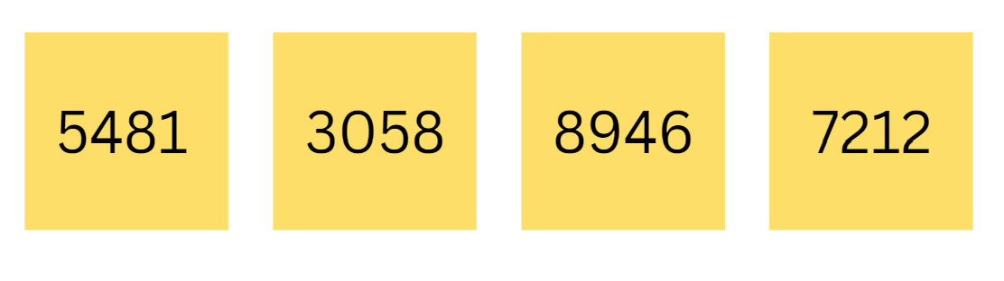

1. The aim of the game is to rearrange the sticky notes so the numbers are in ascending order in the fewest moves possible, moving adjacent sticky notes only and recording the number of moves required.
2. Replay the game with new numbers, arranging the sticky notes so the numbers are in descending order.
3. Observe students and ask questions, such as:

* What will your next move be? Why?
* What is the largest number?
* What is the smallest number?
* How many moves have you made so far?

1. After the game, students [turn and talk](https://education.nsw.gov.au/teaching-and-learning/curriculum/literacy-and-numeracy/teaching-and-learning-resources/numeracy/talk-moves) to compare how many moves they took.
2. Students repeat the game. The level of difficulty can be changed by using numbers with more or fewer digits.

This table details an opportunity for assessment.

|  |  |
| --- | --- |
| Assessment opportunity | Links |
| What to look for:   * Can students order large numbers? **[MAO-WM-01, MA2-RN-01, MA3-RN-01]** | Links to [National Numeracy Learning Progressions](https://www.australiancurriculum.edu.au/resources/national-literacy-and-numeracy-learning-progressions/version-3-of-national-literacy-and-numeracy-learning-progressions/) (NNLP):   * Stage 2 – NPV5, NPV6 * Stage 3 – NPV6, NPV7. |

### Core lesson: Representing numbers – 40 minutes

The table below contains a suggested learning intention and success criteria. These are best co-constructed with students.

|  |  |
| --- | --- |
| Core concept learning intention | Core concept success criteria |
| All students are learning to:   * represent large numbers in different forms. | All students can:   * name and represent numbers using numerals, words and MAB materials * represent and rename large numbers flexibly using standard and non-standard form. |

This activity is an adaptation of [Place value with whole numbers](https://nzmaths.co.nz/resource/place-value-whole-numbers) from [NZ Maths](https://nzmaths.co.nz/) by New Zealand Ministry of Education.

1. Roll four 9-sided dice. Select one student to arrange the dice to make a 4-digit number and another student to write this number. Ask:

* Are there other ways to represent the number? How can we record the number so we can see the value of each digit?
* How could we represent the number with MAB?
* Why would using the number house model be useful when representing this number?

1. Record students’ ideas. Highlight ideas that involve expanded notation. For example, if the number is 6425, students could record it as 6 thousands, 4 hundreds, 2 tens and 5 ones. Students could also record it as 6000 + 400 + 20 + 5 or six thousand four hundred and twenty-five.
2. Explain that numbers can be represented in standard ways using place value and in non-standard ways, for example, 64 hundreds and 25 ones.
3. Model standard and non-standard forms of 6425 with MAB materials and have students say each one out loud. For example:

* 64 hundreds and 25 ones
* 63 hundreds and 125 ones
* 5 thousands, 14 hundreds, 2 tens and 5 ones.

1. Explain to students that even though 6425 has been regrouped into different forms, its value remains the same.

**Note:** it is important that students have opportunities to establish the relationship between ones, tens and hundreds before progressing to non-standard forms of partitioning. The relationship between ones, tens and hundreds is the basis of the place value grouping structure.

1. Introduce Resource 6: Number expander. Model how to close the expander to show a number written as students would usually see it and then open it to see the number written in expanded notation.
2. Ask a Stage 2 student to write the numbers from the 4-digit number into the correct places on the number expander. For example, 6 in the thousands, a 4 in the hundreds, a 2 in the tens and a 5 in the ones.
3. Show students that they now have 4 different ways of recording the number (see Figure 4).

Figure 4 – Recording 4-digit numbers a variety of ways

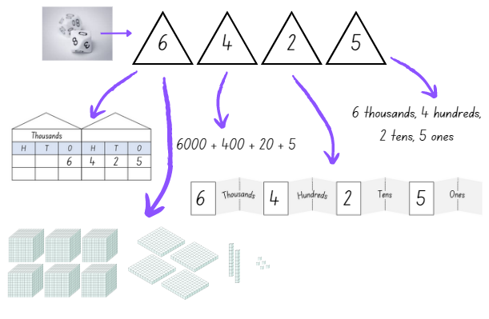

1. Stage 2 students use four 9-sided dice to make a 4-digit number and record it the 4 different ways. This work can be done individually or in pairs.
2. Write eight 4-digit numbers on the board for Stage 3 students. Students work in pairs or small groups to write each number out in standard form and then as many non-standard ways as they can. Use MAB materials to model the non-standard partitioning.

This table details opportunities for differentiation.

|  |  |
| --- | --- |
| Too hard? | Too easy? |
| Stage 2 students cannot rename and record a 4-digit number using standard partitioning.   * Support students by modelling the use of concrete materials such as MAB, to help represent their number. * Assist students by reducing their number to a 2- or 3-digit number.   Stage 3 students cannot model or write numbers in non-standard form.   * Model non-standard forms with 2-digit numbers using interlocking cubes and have students say each one out loud. * Students transfer this knowledge to 3- and 4-digit numbers. | Stage 2 students can rename and record a 4-digit number using standard partitioning.   * With a partner, students roll four 9-sided dice. Students challenge their partner to rename and record the number 100 more or less than the number rolled, using the different methods introduced during the lesson.   Stage 3 students can model and write numbers in non-standard form.   * Students model and write non-standard forms of 5-digit numbers and explain their reasoning. * Write non-standard forms of 5-digit numbers and greater in a systematic way, looking for number patterns. |

### Discuss and connect the mathematics – 10 minutes

1. Summarise the lesson, drawing out key mathematical ideas about place value partitioning and representing numbers in standard and non-standard forms. Display the number 7389 for students to see. Ask:

* Can you tell me more about how the position of a digit within a number impacts its value?
* How does knowing a digit’s position help you to read that number?
* Does representing the same number in different ways change the value of the number?

This table details opportunities for assessment.

|  |  |
| --- | --- |
| Assessment opportunities | Links |
| What to look for:   * Can Stage 2 students name and represent numbers using numerals, words, standard partitioning and manipulatives? **[MAO-WM-01, MA2-RN-01]** * Can Stage 3 students partition numbers in non-standard form? **[MAO-WM-01, MA3-RN-01]** | Links to [National Numeracy Learning Progressions](https://www.australiancurriculum.edu.au/resources/national-literacy-and-numeracy-learning-progressions/version-3-of-national-literacy-and-numeracy-learning-progressions/) (NNLP):   * Stage 2 – NPV4, NPV5, NPV6 * Stage 3 – NPV7.   Links to suggested [Interview for Student Reasoning](https://education.nsw.gov.au/teaching-and-learning/curriculum/literacy-and-numeracy/assessment-resources/ifsr) (IfSR) tasks:   * **Stage 2 – IfSR-AT**: **3B.1, 3B.2, 3B.4** * **Stage 3 – IfSR-NP**: **4B.5.** |

## Lesson 3

**Core concept**: reading, recording and extending numbers are key components of place value.

### Daily number sense: Climb the ladder – 10 minutes

The table below contains a suggested learning intention and success criteria. These are best co-constructed with students.

|  |  |
| --- | --- |
| Daily number sense learning intention | Daily number sense success criteria |
| All students are learning to:   * understand the value of a digit in a number by identifying its position. | All students can:   * make, record and state the value of digits in 3- to 5-digit numbers. |

1. Explain that the aim of the game is to position digit numbers in sequence on the ladder rungs.
2. Draw a ladder with 5 rungs on the board. Roll three 9-sided dice and form a 3-digit number. State the value of each digit, for example, 7 hundreds, 4 tens and 1 ones = 741 or one hundred, 7 tens and 4 ones = 174. Record the chosen 3-digit number on one of the ladder rungs (see Figure 5).

Figure 5 – Climb the ladder

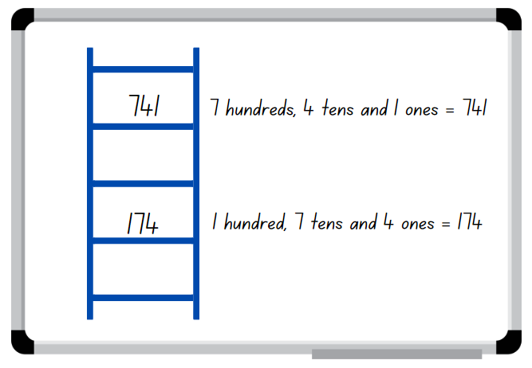

1. Select a student to roll the 3 dice again and form another 3-digit number to place on a rung of the ladder. Ask the student to explain and justify why they selected the 3-digit number, which rung they nominated to place it on and to state the value of the digits, before recording it on the ladder (see Figure 5).
2. Continue the game until a player is unable to place their number on the ladder, then the game is over. Discuss if there were any other possible combinations that could have helped a player win.

**Note**: the game can be played as whole class or in pairs. Use three to five 9-sided dice and group students according to their understanding of 3- to 5-digit numbers.

This table details an opportunity for assessment.

|  |  |
| --- | --- |
| Assessment opportunity | Links |
| What to look for:   * Can students make, record and state the value of digits in 3-to 5-digit numbers? **[MAO-WM-01, MA1-RWN-01, MA2-RN-01]** | Links to [National Numeracy Learning Progressions](https://www.australiancurriculum.edu.au/resources/national-literacy-and-numeracy-learning-progressions/version-3-of-national-literacy-and-numeracy-learning-progressions/) (NNLP):   * Stage 2 – NPV5 * Stage 3 – NPV7.   Links to suggested [Interview for Student Reasoning](https://education.nsw.gov.au/teaching-and-learning/curriculum/literacy-and-numeracy/assessment-resources/ifsr) (IfSR) tasks:   * **Stage 2 – IfSR-NP**: **4B.1, 4B.3, 4B.4** * **Stage 3 – IfSR-NP**: 4B.5. |

### Core lesson – 45 minutes

#### Stage 2 task: Read and record numbers

The table below contains suggested a learning intention and success criteria. These are best co-constructed with students.

|  |  |
| --- | --- |
| Core concept learning intention | Core concept success criteria |
| Students working towards Stage 2 outcomes are learning to:   * read and record numbers up to and including thousands. | Students working towards Stage 2 outcomes can:   * read and record 4-digit numbers |

1. Show students a MAB one, a MAB 10 and a MAB 100. Ask:

* When I am making numbers, what is the value of each of these blocks?
* How do you know?

1. Highlight the connection to ‘10 of these makes one of those’ from Stage 1; 10 ones make a 10 block and 10 tens make a hundred block. Demonstrate this using 10 ones blocks along a tens block and 10 tens blocks along a hundred block.
2. Ask students to think about what could come next if they follow the pattern. Allow students to [turn and talk](https://education.nsw.gov.au/teaching-and-learning/curriculum/literacy-and-numeracy/teaching-and-learning-resources/numeracy/talk-moves) with a partner before sharing their ideas with the class.
3. Write nine 4-digit numbers on the board. Choose one number and ask students to consider how they would read this number aloud.
4. Students turn and talk before sharing their ideas with the class.
5. Choose another number and model how to read the number aloud and record it using Resource 1: Place value houses.
6. Students make place value cups to make a number model (see Figure 6).

Figure 6 – Place value cups

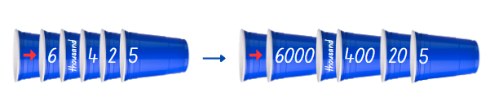

1. Model making a number using the place value cups. Read the number aloud and record it using Resource 1: Place value houses.
2. Working in pairs, students take turns to make a number using the place value cups. Students read the number aloud to their partner and record their number using Resource 1: Place value houses.

This table details opportunities for differentiation.

|  |  |
| --- | --- |
| Too hard? | Too easy? |
| Stage 2 students cannot read and record 4-digit numbers.   * Support students to use concrete materials such as MAB, to help read their number. * Reduce students’ number to a 2- or 3-digit number. | Stage 2 students can read and record 4-digit numbers.   * Challenge students to read, make and record numbers 10, 100 or 1000 more or less than their original number. |

#### Stage 3 task: Dividing one

The table below contains suggested learning intentions and success criteria. These are best co-constructed with students.

|  |  |
| --- | --- |
| Core concept learning intentions | Core concept success criteria |
| Students working towards Stage 3 outcomes are learning to:   * divide one whole into smaller parts * express decimals as linear models. | Students working towards Stage 3 outcomes can:   * divide a metre into tenths, hundredths and thousandths * express decimals using a linear model made from one metre of cardboard. |

1. Show students a strip of cardboard one metre in length and ask how it could be divided into equal parts. Explain that the whole length of the cardboard is equal to one.
2. Students turn and talk, sharing their suggestions with the class. Record these on the board.
3. Using a metre ruler and a marker, divide the cardboard into 10 equal lengths and cut. Explain that each of these pieces is one tenth. One tenth is recorded as 0.1. Each piece is 10 cm in length.
4. Ask students what they would name the pieces if they were to divide one piece (one tenth) into 10 equal parts.
5. Divide one tenth into 10 equal lengths and cut.
6. Explain that each of the new pieces is one hundredth. One hundredth is recorded as 0.01. Each piece is one centimetre in length.
7. Show students the small wooden sticks or toothpicks and explain that, because the one-centimetre piece of cardboard is too small to cut into 10 pieces, they will use small wooden sticks or toothpicks to represent thousandths. One thousandth is recorded as 0.001.
8. Provide pairs of students with a one metre piece of cardboard and a metre ruler. Students cut this piece into tenths and hundredths (see Figure 7). Please note that this example is not proportional.

**Note**: the best way to cut the cardboard up is to cut it into tenths then take one of the tenths and cut that into hundredths. Thousandths should be represented by small wooden sticks or toothpicks as the cardboard is too difficult to cut up into 1 mm pieces.

Figure 7 – Dividing one cardboard example

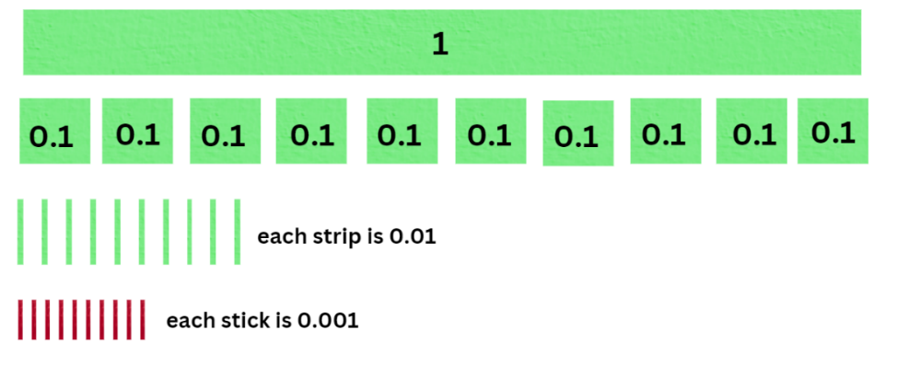

1. Use the tenths, hundredths and thousandths to represent a decimal. Students write the number and say it out loud (see Figure 8). The decimal 0.332 is read as ‘three hundred and thirty-two thousandths’.

Figure 8 – 0.332 representation

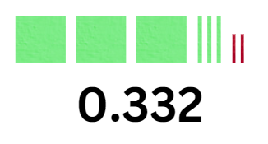

1. Reverse the process, writing a decimal number and have the students form this number using their cardboard pieces.
2. Students repeat this exercise with their partners, taking turns to create and read decimal numbers.

**Note**: to support place value conceptual understanding, 6.132 would be read as **six and one-hundred and thirty-two thousandths**. The word **and** connects the decimal fraction with the whole number and makes a link with common fractions.

This table details opportunities for differentiation.

|  |  |
| --- | --- |
| Too hard? | Too easy? |
| Stage 3 students cannot create and name decimal numbers.   * Model numbers with one decimal place at first (tenths), working up to hundredths and thousandths. * Students make decimal numbers with tenths then working their way up to hundredths and thousandths. | Stage 3 students can create and name decimal numbers.   * Students write all the decimal numbers they have created on pieces of cardboard and place them on a number line from zero to one. * Students create more decimal numbers and have a peer place them on a number line from zero to one. |

### Consolidation and meaningful practice – 10 minutes

1. Create 2 blank number lines. Students place a selection of whole numbers on one number line and decimals on the other number line.
2. Conclude the lesson by having the students write reflections on what they have learnt today. Discuss the challenges they encountered when trying to place the numbers on the number line.

This table details opportunities for assessment.

|  |  |
| --- | --- |
| Assessment opportunities | Links |
| What to look for:   * Can Stage 2 students read and record 4-digit numbers? **[MAO-WM-01, MA2-RN-01]** * Can Stage 3 students explain the relationship between tenths, hundredths and thousandths as parts of the whole? **[MAO-WM-01, MA3-RN-02]** | Links to [National Numeracy Learning Progressions](https://www.australiancurriculum.edu.au/resources/national-literacy-and-numeracy-learning-progressions/version-3-of-national-literacy-and-numeracy-learning-progressions/) (NNLP):   * Stage 2 – NPV5, NPV6 * Stage 3 – NPV7, NPV8.   Links to suggested [Interview for Student Reasoning](https://education.nsw.gov.au/teaching-and-learning/curriculum/literacy-and-numeracy/assessment-resources/ifsr) (IfSR) tasks:   * **Stage 2 – IfSR-NP**: 4B.2, 4C.5. |

## Lesson 4

**Core concept**: the position of each digit in a number corresponds to its size.

### Daily number sense – 10 minutes

1. From a class need surfaced through formative assessment data, identify a short, focused activity that targets students’ knowledge, understanding and skills. Example activities may be drawn from the following resources:

* [Mathematics K-6 resources](https://education.nsw.gov.au/teaching-and-learning/curriculum/mathematics/mathematics-curriculum-resources-k-12/mathematics-k-6-resources.main-education--category---catalogue---key-learning-area---mathematics---thinking-mathematically.nameAsc.1.grid)
* [Universal Resources Hub](https://resources.education.nsw.gov.au/home).

### Core lesson – 45 minutes

#### Stage 2 task: Numbers order

The table below contains suggested a learning intention and success criteria. These are best co-constructed with students.

|  |  |
| --- | --- |
| Core concept learning intention | Core concept success criteria |
| Students working towards Stage 2 outcomes are learning to:   * compare and order numbers up to and including thousands. | Students working towards Stage 2 outcomes can:   * arrange numbers in ascending or descending order * determine a number’s position on a number line by its size * apply knowledge of place value to compare and order numbers correctly. |

1. Provide pairs of students with two 9-sided dice. Students take turns to roll one dice each, read their number aloud and record the number on a coloured sticky note.
2. Students repeat this step so that each student records 3 numbers.
3. Students place their sticky notes, in order of smallest to largest, along Resource 7: Number line (see Figure 9).

Figure 9 – Numbers placed on number line



1. The student with the smallest number goes first and places their number on the Resource 7: Number line. The student must convince their partner why they should go first and how they know their number is the smallest.
2. The student places their sticky note on the number line and explains why they have placed it in that particular position.
3. The student with the next biggest number goes next. Before placing their number on the Resource 7: Number line, they must convince their partner how they know their number goes next. The student then explains why they have placed their number at that particular point on the number line.
4. Repeat this process until all numbers are placed on the Resource 7: Number line.
5. Regroup as a class and ask:

* How did you know who should go first?
* How did you use the numbers on the number line to guide where you put your numbers?
* What sort of things did you say to your partner to convince them that your number was next?

This table details opportunities for differentiation.

|  |  |
| --- | --- |
| Too hard? | Too easy? |
| Stage 2 students cannot determine a number’s position on a number by its size.   * Support students by supplying a number line with more reference numbers to help identify where to place their number. | Stage 2 students can determine a number’s position on a number by its size.   * Increase the number size to 3-digit numbers and have students complete the same activity using three 9-sided dice. |

#### Stage 3 task: Plotting decimals on a number line

The table below contains suggested learning intentions and success criteria. These are best co-constructed with students.

|  |  |
| --- | --- |
| Core concept learning intentions | Core concept success criteria |
| Students working towards Stage 3 outcomes are learning to:   * compare and order decimals up to 3 decimal places * plot decimal numbers up to 3 decimal places on a number line. | Students working towards Stage 3 outcomes can:   * order decimals from one decimal place up to 3 decimal places in the correct order * draw number lines and plot values of nutrients in ascending order. |

1. Write 0.190 and 0.19 on the board and ask students if these 2 decimals have the same value. Students [turn and talk](https://education.nsw.gov.au/teaching-and-learning/curriculum/literacy-and-numeracy/teaching-and-learning-resources/numeracy/talk-moves) and share thoughts with the class. Explain that these 2 decimals have the same value and that dropping the zero or zeros at the end of a decimal does not change its value.
2. Display Resource 8: Nutrition information label and ask students to turn and talk about what they see. Students share their ideas with the class. Explain that food contains nutrients such as protein, fat, sugars and sodium.
3. Display Resource 9: Nutrient levels in food, explaining that the table shows the sodium, sugar and potassium levels of 10 different types of foods. Discuss the different foods and levels of nutrients in each one.
4. In pairs, students draw a number line for each of the different nutrients on Resource 9: Nutrient levels in food and plot the values. Prompt students to carefully consider the starting point and ending values on the number lines.

This table details opportunities for differentiation.

|  |  |
| --- | --- |
| Too hard? | Too easy? |
| Stage 3 students cannot create and name decimal numbers.   * Students make decimal numbers with tenths then working their way up to hundredths and thousandths. | Stage 3 students can create and name decimal numbers.   * Students create more decimal numbers and have a peer place them on a number line from zero to one. |

### Discuss and connect the mathematics – 10 minutes

1. Conduct a [gallery walk](https://education.nsw.gov.au/teaching-and-learning/learning-from-home/teaching-at-home/expectations/contemporary-learning-and-teaching-from-home/learning-from-home--teaching-strategies/gallery-walk). Ask:

* Who had the smallest number that was plotted on a number line? (Stage 2)
* Who had the biggest number that was plotted on a number line? (Stage 2)
* Which 2 numbers, plotted on a number line, had the smallest difference? (Stage 2)
* What were some of the more challenging decimals to plot on the number line? Why? (Stage 3)
* How did you know what the starting and ending values of the number line should be? (Stage 3)
* How can you be sure that the decimals have been placed in the correct position on the number line? Explain. (Stage 3)
* Are decimals with 3 decimal places larger than decimals with 2 decimal places? (Stage 3)

This table details opportunities for assessment.

|  |  |
| --- | --- |
| Assessment opportunities | Links |
| What to look for:   * Can Stage 2 students arrange numbers in ascending or descending order? **[MAO-WM-01, MA2-RN-01]** * Can Stage 2 students determine a number’s position on a number line by its size**? [MAO-WM-01, MA2-RN-01]** * Can Stage 3 students plot decimals with 3 decimal places on a number line? **[MAO-WM-01, MA3-RN-02]** * Can Stage 3 students interpret the digit ‘zero’ at the end of a decimal number? **[MAO-WM-01, MA3-RN-02]** | Links to [National Numeracy Learning Progressions](https://www.australiancurriculum.edu.au/resources/national-literacy-and-numeracy-learning-progressions/version-3-of-national-literacy-and-numeracy-learning-progressions/) (NNLP):   * Stage 2 – NPV4, NPV5, NPV6 * Stage 3 – NPV8.   Links to suggested [Interview for Student Reasoning](https://education.nsw.gov.au/teaching-and-learning/curriculum/literacy-and-numeracy/assessment-resources/ifsr) (IfSR) tasks:   * **Stage 2 – IfSR-NP:** 4B.2 * **Stage 3 – IfSR-PT**: 1A.5, 1A.6, 1A.7. |

## Lesson 5

**Core concept**: multiplicative thinking is based on patterns.

### Daily number sense: Missing number patterns – 10 minutes

Daily number sense activities for Lessons 5 to 7 ‘loop’ back to concepts and procedures covered in previous units to assist students to build an increasingly connected network of ideas. These concepts may differ from the core concepts being covered by the unit.

The table below contains a suggested learning intention and success criteria. These are best co-constructed with students.

|  |  |
| --- | --- |
| Daily number sense learning intention | Daily number sense success criteria |
| All students are learning to:   * generate and describe number patterns. | Students working towards Stage 2 outcomes can:   * create and continue increasing and decreasing number patterns * determine missing numbers in a pattern.   Students working towards Stage 3 outcomes can:   * determine a rule describing the relationship between the bottom number and the top number in a table. |

1. Write the number sequence 61, 65, _, 73, 77, _, _, _ on the board and ask students to determine the missing numbers in the pattern.
2. In pairs, students use their individual whiteboard to record the number pattern showing the pattern and the missing numbers (see Figure 10).

Figure 10 – Student work sample

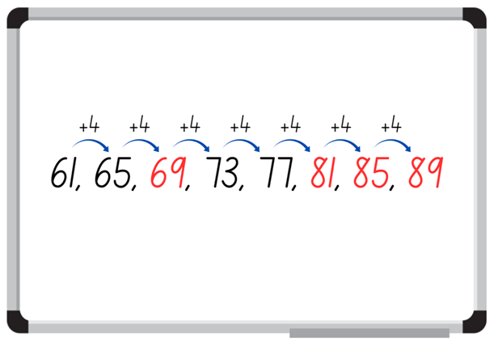

1. Choose students to demonstrate their working, explaining how they determined the missing number. Select a student to identify the next 3 numbers in the pattern and record.

**Multi-age**: students working towards Stage 3 outcomes draw their numbers in a table. They add a bottom row and number each step in the sequence.

1. Write the number sequence _, 123, 118, _, _, _, 98, _. Students repeat the process with their partner to generate and describe patterns.

This table details opportunities for assessment.

|  |  |
| --- | --- |
| Assessment opportunities | Links |
| What to look for:   * Can Stage 2 students create and continue an increasing and decreasing number pattern? **[MAO-WM-01, MA2-MR-01]** * Can Stage 2 students determine missing numbers in a pattern? **[MAO-WM-01, MA2-MR-01]** * Can Stage 3 students determine a rule describing the relationship between the bottom number and the top number in a table? **[MAO-WM-01, MA3-MR-01]** | Links to [National Numeracy Learning Progressions](https://www.australiancurriculum.edu.au/resources/national-literacy-and-numeracy-learning-progressions/version-3-of-national-literacy-and-numeracy-learning-progressions/) (NNLP):   * Stage 2 – NPA3 * Stage 3 – NPA5.   Links to suggested [Interview for Student Reasoning](https://policies.education.nsw.gov.au/teaching-and-learning/curriculum/literacy-and-numeracy/assessment-resources/ifsr) (IfSR) tasks:   * **Stage 2 – IfSR-NP**: 4A.1, 4A.2, 4A.3. |

### Core lesson – 35 minutes

#### Stage 2 task: Patterns in the hundred chart

The table below contains suggested a learning intention and success criteria. These are best co-constructed with students.

|  |  |
| --- | --- |
| Core concept learning intention | Core concept success criteria |
| Students working towards Stage 2 outcomes are learning to:   * generate and describe multiplicative patterns. | Students working towards Stage 2 outcomes can:   * record and describe patterns on a number chart * create, continue and describe pattern that increase by a constant amount. |

This activity is an adaptation of ‘Skipping across the Hundred Chart’ from Mindset Mathematics: Visualizing and Investigating Big Ideas, Grade 1 by Boaler et al.

1. Display a [digital hundreds chart](https://toytheater.com/hundreds-chart/). Skip count by twos, saying and highlighting each number. When 20 is highlighted, ask if Stage 2 students can see a pattern and select students to continue filling in the number chart, skip counting by 2.
2. Once the pattern is complete, explain that the highlighted numbers are multiples of 2 and that a number chart can help locate multiples of other numbers.

**Multiples:** products formed using the same base number multiplied by different whole numbers, for example, 3, 6, 9, 12 and so on.

1. Explain that Stage 2 students are going to skip count by fives, highlighting the numbers using a coloured marker or pencil, then by tens, recording in a different colour.
2. Students think and then [turn and talk](https://education.nsw.gov.au/teaching-and-learning/curriculum/literacy-and-numeracy/teaching-and-learning-resources/numeracy/talk-moves) to discuss what they think will happen and what the pattern will look like.
3. Provide students with Resource 10: Number chart and coloured markers or pencils to work independently.
4. While students are working, ask:

* What patterns can you see?
* Is there anything interesting about these 2 patterns?
* What does that pattern tell us?

1. Once students have skip counted and recorded by fives and tens, explain that they will now skip count by fours and record in a different coloured marker or pencil to the previous multiples.
2. Select students to share their patterns and anything that they noticed. Ask:

* Did you notice anything interesting about the patterns?
* Were there any numbers that you highlighted more than once?
* How do you think these patterns could help in multiplication?

This table details opportunities for differentiation.

|  |  |
| --- | --- |
| Too hard? | Too easy? |
| Stage 2 students cannot create and continue multiple patterns on the number chart.   * Assist students to create and continue a pattern by highlighting the first 4 numbers in the pattern when skip counting. | Stage 2 students can create and continue patterns on the number chart.   * Challenge students to create a pattern using the multiples of 4, 5 and 10 without using a number chart for reference. Students record the pattern in their workbook. |

#### Stage 3 task: Prime numbers

The table below contains suggested learning intentions and success criteria. These are best co-constructed with students.

|  |  |
| --- | --- |
| Core concept learning intentions | Core concept success criteria |
| Students working towards Stage 3 outcomes are learning to:   * model different ways to show a number as a product * determine prime and composite numbers. | Students working towards Stage 3 outcomes can:   * rearrange tiles to show different ways of finding a product * identify the factors of a given number and use that information to determine whether it is prime, composite or neither. |

1. Provide groups of students with 24 counters. Ask students to arrange them in 2 rows of 12. Explain that this is a visual representation of 2 twelves and that the product is 24.
2. Ask students to rearrange the counters into 3 rows of 8. Explain that this is a visual representation of 3 eights and that the product is also 24.
3. Ask students to rearrange the counters into different arrays, showing a product of 24. For example, 4 rows of 6, 4 sixes.
4. Select students to explain their thinking.
5. Repeat using a different product.

This activity is an adaptation of [Prime Numbers](https://nzmaths.co.nz/resource/prime-numbers) from [NZ Maths](https://nzmaths.co.nz/) by New Zealand Ministry of Education.

1. Provide groups of students with square tiles or pattern blocks. Ask groups to predict how many rectangles they could build using only 6 tiles. Groups test their predictions and record their solutions.
2. Ask selected groups to share their solutions.
3. Show students that they can make 2 rectangles, one row of 6 and 2 rows of 3 (see Figure 11). Explain that this is a visual representation of the factors of 6. That is, one, 6, 2 and 3. The rectangles can also be rotated, which might lead some students to think they can make 4 rectangles (see Figure 11).

Figure 11 – 6 tile rectangles

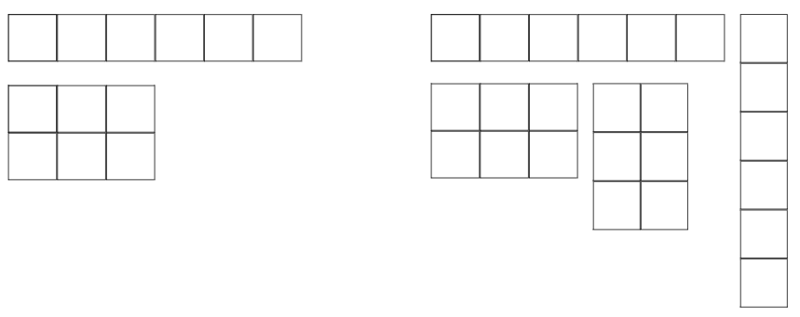

1. Provide further examples if required, ensuring that students are familiar with the term ‘factor’ and how to use tiles to represent them.
2. Ask students to repeat the task using 7 tiles. Explain that only one rectangle can be made (see Figure 12). Explain that this is because 7 is a prime number and that a prime number has exactly 2 factors, itself and one. Tell students that numbers which have more than 2 factors are called composite numbers.

Figure 12 – 7 tile rectangle

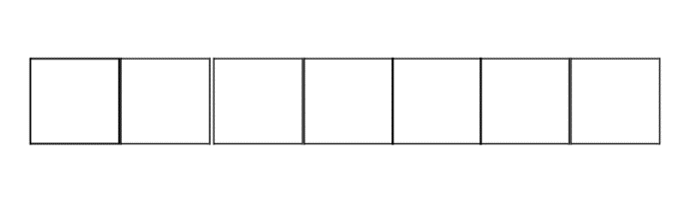

**Prime number**: a prime number is a positive integer that has exactly 2 distinct factors, itself and one. Modelled as an array, it has only one row.

**Composite number**: a non-zero natural number that has a factor other than one and itself. For example, all even numbers besides 2 are composite numbers. Some odd numbers are composite (for example, 21) but not all are composite (for example, 11).

**Factor**: a number which divides another number without a remainder. For example, one, 2, 3 and 6 are factors of 6, but 4 and 5 are not.

1. Ask students to predict which other numbers are prime numbers and to test their predictions using tiles. Students record which numbers are prime and which are composite.
2. Ask groups to share their findings and make a class list of prime and composite numbers. Ask students what prime numbers have in common. If the number 2 has not been listed, ask students to predict if it is prime or composite and to test their predictions. Discuss the number one and zero and whether they are prime or composite. You may also choose to discuss square numbers at this point.

**Note**: prime numbers are the building blocks we rely on when thinking about the product of whole numbers. Every whole number is either a prime or the product of primes. This property is the basis of providing security on the internet. When you multiply 2 prime numbers together, the result is a number that can only be broken down into those primes. For example, the product of the first 2 primes is 6 and the only prime factors of 6 are 3 and 2.

This table details opportunities for differentiation.

|  |  |
| --- | --- |
| Too hard? | Too easy? |
| Stage 3 students cannot identify the factors of a given number and use that information to determine whether it is prime, composite or neither.   * Assist students by providing a number chart with prime, composite or neither marked on it. | Stage 3 students can identify the factors of a given number and use that information to determine whether it is prime, composite or neither.   * Challenge students with 3-digit numbers and see if they can determine whether it is prime, composite or neither. |

### Discuss and connect the mathematics – 15 minutes

1. Ask Stage 2 students to bring their number chart as you regroup the class.
2. While displaying the class list of prime and composite numbers Stage 3 compiled, display Resource 11: Prime numbers chart.
3. Partner up a Stage 2 student with a Stage 3 student and ask them to compare the skip counting number chart with the prime numbers chart.
4. While students turn and talk to compare the number charts, ask:

* Are there any prime numbers that are in the fours, fives or tens skip counting patterns?
* When we were skip counting by 2 were any numbers in that counting patterns prime numbers? (Stage 2)
* Why do you think the skip counting patterns don’t contain many prime numbers?
* Most of the prime numbers in the number chart are odd numbers. How many more even numbers are in the skip counting patterns?
* Can you think of any other skip counting patterns that would include any of the prime numbers marked on the number chart?

1. Select students to share their findings.

This table details opportunities for assessment.

|  |  |
| --- | --- |
| Assessment opportunities | Links |
| What to look for:   * Can Stage 2 students record and describe patterns on a number chart? **[MAO-WM-01, MA2-MR-01]** * Can Stage 2 students create, continue and describe pattern that increase by a constant amount? **[MAO-WM-01, MA2-MR-01]** * Can Stage 3 students rearrange tiles to show different ways of finding a product? **[MAO-WM-01, MA3-MR-01]** * Can Stage 3 students determine factors for a given whole number? **[MAO-WM-01, MA3-MR-01]** * Can Stage 3 students explain why a given whole number is prime, composite or neither? **[MAO-WM-01, MA3-MR-01]** | Links to [National Numeracy Learning Progressions](https://www.australiancurriculum.edu.au/resources/national-literacy-and-numeracy-learning-progressions/version-3-of-national-literacy-and-numeracy-learning-progressions/) (NNLP):   * Stage 2 – NPA3, NPA4 * Stage 3 – MuS6, MuS7.   Links to suggested [Interview for Student Reasoning](https://education.nsw.gov.au/teaching-and-learning/curriculum/literacy-and-numeracy/assessment-resources/ifsr) (IfSR) tasks:   * **Stage 2 – IfSR-NP:** 4A**.**1, 4A.2, 4A.3. |

## Lesson 6

**Core concept**: structures can support multiplicative thinking.

### Daily number sense: 101 and you’re not out – 10 minutes

The table below contains a suggested learning intention and success criteria. These are best co-constructed with students.

|  |  |
| --- | --- |
| Daily number sense learning intention | Daily number sense success criteria |
| All students are learning to:   * use mental strategies for addition. | All students can:   * use mental strategies to add 2- and 3-digit numbers. |

This activity is an adaptation of [101 and you're out (2-digit-addition)](https://education.nsw.gov.au/teaching-and-learning/curriculum/mathematics/mathematics-curriculum-resources-k-12/mathematics-k-6-resources/101-and-youre-out) from [K-6 Mathematics resources](https://education.nsw.gov.au/teaching-and-learning/curriculum/mathematics/mathematics-curriculum-resources-k-12/mathematics-k-6-resources) by State of New South Wales (Department of Education).

1. In pairs, students make a game board by drawing a table with 4 columns and 7 rows. Label the columns from left to right as ‘tens’, ‘ones, ‘number’ and ‘total’ (see Figure 13).

Figure 13 – 101 and you're out example

Student gameboard example. 
Four columns with headings Tens, Ones, Number and Total.

1. The winner is the player whose sum is closest to 100 without going over. The game concludes after 6 rolls or spins.
2. Using a 0–9 die or spinner, players take turns to roll or spin.
3. After every roll, each player decides whether to write the number in the tens or ones column. For example, if a 4 is rolled, players can either write it in the tens column to indicate 40 or in the ones column to indicate 4.

**Multi-age**: students working towards Stage 3 outcomes include a thousands column and aim to get to a total of 1000.

1. Players take turns to roll the die or spin the spinner and decide where to write that digit on the gameboard.
2. Each player will have 6 turns.
3. As a class, discuss questions, such as:

* Were there any challenges?
* Did you use a written or mental strategy to work out the sum of your numbers?
* Why did you choose that strategy?
* Are there any other ways you could have done it?
* How could you make the game easier?
* How could you make the game harder?

This table details opportunities for assessment.

|  |  |
| --- | --- |
| Assessment opportunities | Links |
| What to look for:   * Can Stage 2 students use mental strategies to add 2-digit numbers? **[MAO-WM-01, MA2-AR-01]** * Can Stage 3 students use mental strategies to add 3-digit numbers? **[MAO-WM-01, MA2-AR-01]** | Links to [National Numeracy Learning Progressions](https://www.australiancurriculum.edu.au/resources/national-literacy-and-numeracy-learning-progressions/version-3-of-national-literacy-and-numeracy-learning-progressions/) (NNLP):   * Stage 2 – AdS7 * Stage 3 – AdS8.   Links to suggested [Interview for Student Reasoning](https://education.nsw.gov.au/teaching-and-learning/curriculum/literacy-and-numeracy/assessment-resources/ifsr) (IfSR) tasks:   * **Stage 2 – IfSR-AT**: 2A.2 * **Stage 3 – IfSR-AT**: 3A.2. |

### Core lesson – 40 minutes

#### Stage 2 task: Array busting

The table below contains suggested a learning intention and success criteria. These are best co-constructed with students.

|  |  |
| --- | --- |
| Core concept learning intention | Core concept success criteria |
| Students working towards Stage 2 outcomes are learning to:   * use arrays to represent multiplication facts. | Students working towards Stage 2 outcomes can:   * represent various multiplication facts using arrays * create the array structure using rows and columns and name the array correctly * recognise and represent smaller array hiding inside larger arrays. |

1. Display an array of 5 tens using counters or tiles where all students can see.

**Note**: concrete materials will enable the array to be manipulated to clearly show the smaller arrays hiding inside.

1. Ask students if they can name the array correctly. Once students have named the array correctly, explain that the array can be busted to find smaller arrays hiding inside of 5 tens.

**Array**: an array is made by arranging a set of objects, such as counters, into columns and rows. Each column must contain the same number of objects as the other columns and each row must contain the same number of objects as the other rows.

1. Students think and then [turn and talk](https://education.nsw.gov.au/teaching-and-learning/curriculum/literacy-and-numeracy/teaching-and-learning-resources/numeracy/talk-moves) to discuss the smaller arrays that could be hiding inside of 5 tens.
2. Select students to share and explain their ideas. Test students’ ideas as they are shared and record (see Figure 14).

Figure 14 – Array busting recording

5 x 10 array with text 5 tens is....
5 fours + 5 fours+ 5 twos
5 fives + 5 fives
3 tens+ 2 tens.

1. Provide students with their workbook and explain that they will work independently or with a partner to first create a given array (no larger than 10 tens) using concrete materials, such as counters or tiles. Students then bust and record as many smaller arrays as they can find in their workbook. Ensure that students are naming and recording the arrays correctly as they complete the activity (see Figure 20).
2. Students display their work and go on a [gallery walk](https://app.education.nsw.gov.au/digital-learning-selector/LearningActivity/Card/555), looking for different and similar smaller arrays found with the larger array.
3. Regroup as class and select students to share what they found interesting during the gallery walk.

This table details opportunities for differentiation.

|  |  |
| --- | --- |
| Too hard? | Too easy? |
| Stage 2 students cannot recognise smaller arrays inside a larger array.   * Provide students with counters to use to find smaller numbers hiding inside of bigger numbers. * Students count out at least 14 counters and then find and record as many smaller numbers as they can. | Stage 2 students can recognise smaller arrays inside a larger array.   * Provide students with an array of 12 twelves and challenge them to find all the smaller arrays within. |

#### Stage 3 task: The area model

The table below contains suggested learning intentions and success criteria. These are best co-constructed with students.

|  |  |
| --- | --- |
| Core concept learning intentions | Core concept success criteria |
| Students working towards Stage 3 outcomes are learning to:   * use the area model to solve multiplication problems * use the distributive property to partition numbers when multiplying. | Students working towards Stage 3 outcomes can:   * use MAB materials to demonstrate the area model when multiplying a 2-digit number by a one-digit number * use partitioning and number facts to multiply a 2-digit number by a one-digit number. |

1. Introduce the area model of multiplication by demonstrating with MAB materials or [virtual manipulatives](https://mathigon.org/polypad). For example, model 2 × 10 and 2 × 100 (see Figure 15).
2. Explain that 2 × 10 is represented by 2 tens and 2 × 100 is represented by 2 hundreds.
3. Emphasise that this representation is to scale and note the difference in size. Explain that 2 × 100 is 10 times larger than 2 × 10.
4. Ask how students could prove this. Demonstrate, if necessary, by placing the 2 tens on top of the 2 hundreds and counting how many times it can be moved from left to right to cover another 2 tens.
5. Emphasise the link to place value and the concept of ‘10 of these is one of those’.

Figure 15 – Area model multiplication example

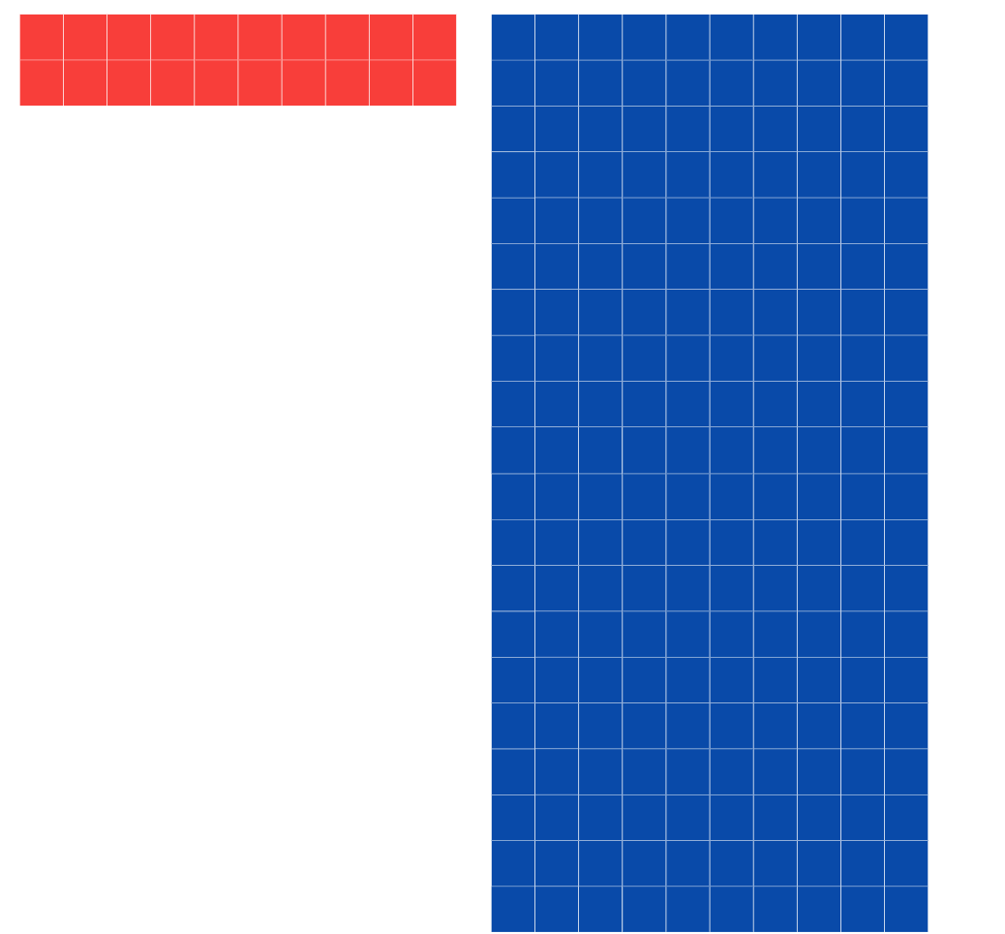

1. Provide groups of students with MAB materials or [virtual manipulatives](https://mathigon.org/polypad). Students explore this concept by representing and recording answers to questions that promote the distributive property, such as:

* 3 × 50 =
* 5 × 30 =
* 4 × 60 =
* 6 × 40 =
* 3 × 300 =
* 3 × 200 =
* 2 × 400 =
* 4 × 200 =

1. Select groups to share their thinking.
2. Reflect on the activity by discussing questions, such as:

* How did you record your answers?
* How did your knowledge of multiplication facts help?
* Was renaming necessary? Why?
* What did you notice about your answers?
* Can you explain why 3 by 5 tens is the same as 5 by 3 tens?
* How is knowing this (the distributive property) helpful?

1. Using MAB materials or [virtual manipulatives](https://mathigon.org/polypad), demonstrate that the area model can also be used to multiply 2-digit numbers that are not multiples of 10 by one-digit numbers. For example, 23 × 3 (see Figure 16). Explain that it is easier to partition 23 into tens and ones than think of 3 twenty-threes. Remind students that their knowledge of multiplication facts can be extended to multiply multiples of 10 (and 100). For example, 3 twos are 6, so 3 by 2 tens is 6 tens.

Figure 16 – 23 x 3 area model

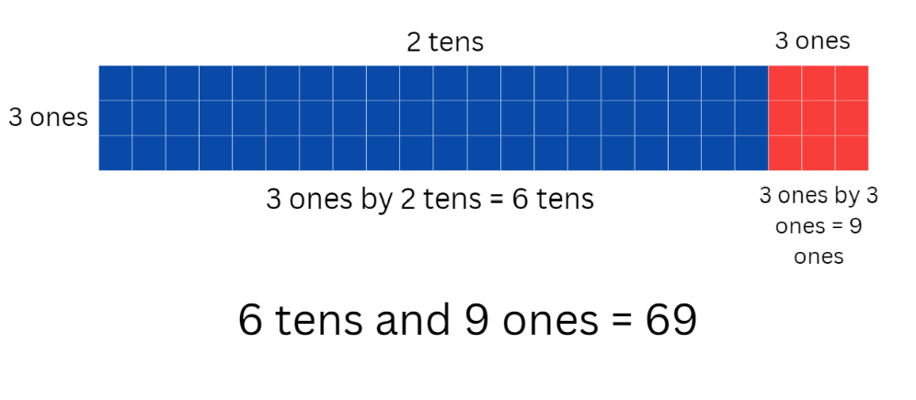

1. Provide groups of students with MAB materials or [virtual manipulatives](https://mathigon.org/polypad). Students explore this concept by representing and recording answers to questions, such as:

* 3 × 23 =
* 4 × 32 =
* 2 × 44 =
* 5 × 38 =
* 7 × 27 =
* 6 × 28 =
* 5 × 46 =
* 8 × 26 =

1. Students can create their own examples to represent their thinking.
2. Select groups to share their thinking and explain their solutions.
3. Reflect on the activity by discussing questions, such as:

* How did you record your answers?
* How did your knowledge of multiplication facts help?
* How did partitioning the 2-digit number help?
* Was renaming necessary? Why?
* Could the area model be used to multiply three-digit numbers? Why or why not?

This table details opportunities for differentiation.

|  |  |
| --- | --- |
| Too hard? | Too easy? |
| Stage 3 students cannot multiply 2-digit numbers by one-digit numbers.   * Link the area model to arrays and skip counting. | Stage 3 students can multiply 2-digit numbers by one-digit numbers.   * Students create word problems that require 2-digit by one-digit multiplication for other students to solve. |

### Consolidation and meaningful practice – 15 minutes

This activity is an adaptation of ‘Multiplication Toss’ from Teaching Mathematics: Foundations to Middle Years by Siemon et al.

1. Demonstrate how to play ‘Multiplication Toss’ by playing against the class. Use and display one gameboard from Resource 12: Multiplication toss gameboard, two 9-sided dice (Stage 2) or two 12-sided dice (Stage 3) and 2 different coloured markers.
2. Player 1 rolls the dice and uses the numbers rolled to create an array. For example, if students roll 3 and 5, they can make either 3 fives or 5 threes. The player decides which array they will use, draws an outline of the array around the correct number of rows and columns and writes the name of the array in the middle (see Figure 17).

Figure 17 – Multiplication toss gameplay

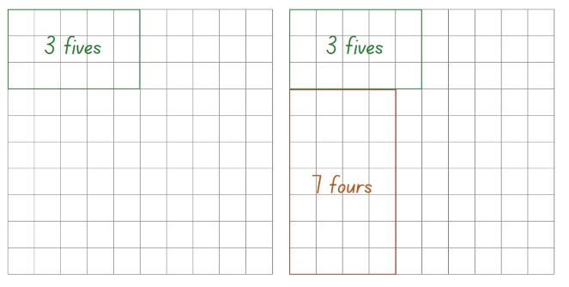

1. Player 2 then rolls the dice and uses the numbers rolled to create an array that will fit without overlapping. For example, if Player 2 rolls a 4 and 7 and chooses 7 fours, Player 2 then draws an outline of the array around the correct number of rows and columns and writes the name of the array in the middle (see Figure 23).
2. If a player rolls an array that does not fit without overlapping, it is the other player’s turn. Players continue to take turns until there is no more room for either player. The player with the most squares covered is the winner.
3. Once students are confident with the game, provide pairs with one gameboard from Resource 12: Multiplication toss gameboard, two 9-sided dice and 2 different coloured markers. Students take turns playing multiple rounds.

This table details opportunities for differentiation.

|  |  |
| --- | --- |
| Too hard? | Too easy? |
| Students cannot create and name arrays.   * Provide students with two 6-sided dice (Stage 2) or two 9-sided dice (Stage 3) and support them to use concrete materials to create and correctly name arrays according to the number of rows and how many in each row. | Students can create and name simple arrays.   * Students can partition the number of groups to form 2 separate outlines. For example, 6 eights could be split into 4 eights and 2 eights. |

This table details opportunities for assessment.

|  |  |
| --- | --- |
| Assessment opportunities | Links |
| What to look for:   * Can Stage 2 students represent various multiplication facts using arrays? **[MAO-WM-01, MA2-MR-01]** * Can Stage 2 students create the array structure using rows and columns and name the array correctly? **[MAO-WM-01, MA2-MR-01]** * Can Stage 2 students recognise and represent smaller arrays hiding inside larger arrays? **[MAO-WM-01, MA2-MR-01]** * Can Stage 3 students use MAB materials to demonstrate the area model when multiplying a 2-digit number by a one-digit number? **[MAO-WM-01, MA3-MR-01]** * Can Stage 3 students partition a 2-digit number into tens and ones when multiplying by a one-digit number? **[MAO-WM-01, MA3-MR-01]** | Links to [National Numeracy Learning Progressions](https://www.australiancurriculum.edu.au/resources/national-literacy-and-numeracy-learning-progressions/version-3-of-national-literacy-and-numeracy-learning-progressions/) (NNLP):   * Stage 2 – MuS5 * Stage 3 – MuS6, MuS7.   Links to suggested [Interview for Student Reasoning](https://education.nsw.gov.au/teaching-and-learning/curriculum/literacy-and-numeracy/assessment-resources/ifsr) (IfSR) tasks:   * **Stage 3 – IfSR-MT**: 3A.1, 3A.2, 3A.3. |

## Lesson 7

**Core concept**: zeros in numbers can have different roles.

### Daily number sense: Dicey addition – 15 minutes

The table below contains a suggested learning intention and success criteria. These are best co-constructed with students.

|  |  |
| --- | --- |
| Daily number sense learning intention | Daily number sense success criteria |
| All students are learning to:   * flexibly select strategies to solve addition and subtraction problems. | All students can:   * flexibly select strategies to solve addition and subtraction problems of up to 3 digits. |

This activity is an adaptation of [Dicey addition (3-digit addition)](https://education.nsw.gov.au/teaching-and-learning/curriculum/mathematics/mathematics-curriculum-resources-k-12/mathematics-k-6-resources/dicey-addition) from [K-6 Mathematics resources](https://education.nsw.gov.au/teaching-and-learning/curriculum/mathematics/mathematics-curriculum-resources-k-12/mathematics-k-6-resources) by State of New South Wales (Department of Education).

1. The aim of the game is to roll 9 numbers and use them to create a number sentence that is closest to a total of 1000.
2. Ensure that each pair has a 0–9 die or spinner. In pairs, students draw an identical gameboard for each player (see Figure 18).

Figure 18 – Dicey addition gameboard

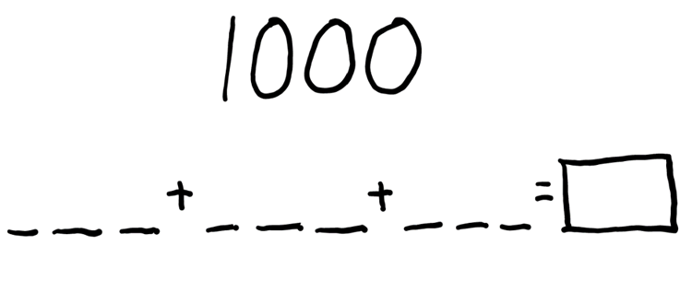

1. Players take turns to roll the die or spin the spinner and decide where to write that digit in the number sentence.
2. Each player will have 9 turns.
3. The player whose sum is closest to 1000 is the winner.

**Multi-age**: students working towards Stage 2 outcomes use 6 digits to create 3 numbers that are close to a total of 100.

1. As a class, discuss questions, such as:

* Were there any challenges?
* Did you use a written or mental strategy to work out the sum of your numbers?
* Why did you choose that strategy?
* Are there any other ways you could have done it?
* How could you make the game easier?
* How could you make the game harder?

This table details an opportunity for assessment.

|  |  |
| --- | --- |
| Assessment opportunity | Links |
| What to look for:   * Can students select strategies flexibly to solve addition and subtraction problems of up to 3 digits? **[MAO-WM-01, MA2-AR-01]** | Links to [National Numeracy Learning Progressions](https://www.australiancurriculum.edu.au/resources/national-literacy-and-numeracy-learning-progressions/version-3-of-national-literacy-and-numeracy-learning-progressions/) (NNLP):   * Stage 2 – AdS7, AdS8 * Stage 3 – AdS7, AdS8.   Links to suggested [Interview for Student Reasoning](https://education.nsw.gov.au/teaching-and-learning/curriculum/literacy-and-numeracy/assessment-resources/ifsr) (IfSR) tasks:   * **Stage 2 – IfSR-AT**: 3A.2 * **Stage 3 – IfSR-AT**: 3A.2. |

### Core lesson – 40 minutes

#### Stage 2 task: The role of zero in numbers

The table below contains a suggested learning intention and success criteria. These are best co-constructed with students.

|  |  |
| --- | --- |
| Core concept learning intention | Core concept success criteria |
| Students working towards Stage 2 outcomes are learning to:   * understand the role of zero in large numbers. | Students working towards Stage 2 outcomes can:   * read and name numbers with internal zeros * explain the role played by a zero in a 4-digit number. |

This activity is an adaptation of [Place value and modelling numbers](https://fuse.education.vic.gov.au/Resource/LandingPage?ObjectId=5801fadc-dba8-4df1-87f6-4d77506498f7&SearchScope=All) from [FUSE](https://fuse.education.vic.gov.au/) by State of Victoria (Department of Education and Training).

**Note**: Zero is a symbol, a number, a magnitude and a place holder in a positional number system. Zeros in numerals can have 2 different roles – to name the number and/or as place holders to partition the number into its component parts. Students need opportunities to learn to read and name the component parts of numbers with internal zeros.

1. Prior to the lesson, prepare the numeral cards from Resource 13: What’s my number? by printing and cutting them out.
2. Stick a numeral card on the back of each student using tape. Explain that students will move around the classroom, asking each of their classmates one question about their number. The question must only require a yes or no answer. For example, students could ask if their number has a 4 in the hundreds place.
3. Each student records notes and ideas on a whiteboard as they move around the room. Discuss what information will be helpful for students to determine their number and what the best way to record this information would be. Encourage students to use number houses if they do not suggest it.
4. Allow students time to move around the room and ask questions of their peers.
5. Once a student has determined their number, they must return to their seat.
6. While waiting for their classmates to complete the task, students ensure they can read their number. Students could also practise different ways of recording their number. For example, words, expanded notation or using MAB materials.
7. Regroup students on the floor with their resources.
8. Have students [turn and talk](https://education.nsw.gov.au/teaching-and-learning/curriculum/literacy-and-numeracy/teaching-and-learning-resources/numeracy/talk-moves) to a partner, taking turns to read their number and check if they correctly identified their number. Ask:

* Were you able to determine your number?
* What strategies or questions were most helpful?
* How did you record your information?
* Would you do things the same way or differently if we were to do the same activity again? Why?

1. Using the number 4073, have students identify the number before and the number after their number.
2. Students share their answers with a partner, justifying how they know they are correct.
3. As a class, discuss how to deal with a number when one of the digits is a zero. Ask students how they know what to change or what strategies they can use to ensure they are correct.

#### Stage 3 task: Multiplying multiples

The table below contains a suggested learning intention and success criteria. These are best co-constructed with students.

|  |  |
| --- | --- |
| Core concept learning intention | Core concept success criteria |
| Students working towards Stage 3 outcomes are learning to:   * demonstrate place value understanding by using mental strategies to multiply one-digit numbers by multiples of 10 and 100. | Students working towards Stage 3 outcomes can:   * use mental strategies to multiply one-digit numbers by multiples of 10 and 100. |

1. Demonstrate the link between place value and multiplicative thinking by using a number slide to multiply single digit numbers by multiples of 10 and 100. Use several examples. To aid student understanding, use language such as ‘2 by 4 tens is 8 tens’ and record the answer as 8 tens and zero ones.

**Note**: it is a common misconception that multiplying by 10 can be done by simply ‘adding a zero’ and multiplying by 100 can be done by ‘adding 2 zeros’. This should be avoided because it detracts from a deeper understanding of place value, multiplicative thinking and the link between them.

1. Display _0 × _ = _0 × _. Explain that each _ represents a missing digit and that students need to work out different ways to balance the equation. For example, 10 × 2 = 20 × 1.
2. Students work in groups and record as many possible solutions as they can.
3. As students are working, remind them that both sides of the equation must balance. Ask how students can use their knowledge of multiplication facts to help them, for example, 2 × 4 = 8 so 2 × 40 = 80. Ask students to explore other possible strategies, such as place value partitioning, factorising and halving. Evaluate strategies by asking questions, such as:

* Which strategy or strategies did you prefer? Why?
* Which strategy was the most efficient? Why?
* Did certain strategies work better for different equations? Why?

1. Select groups to share how they recorded their answers. Encourage students to record their answers systematically so that they can look for patterns and make predictions. Working systematically might involve starting with the lowest values possible, for example, 10 × 1 = 10 × 1. Decide as a group if this example should be included as both sides of the equation are identical. Then move on to 10 × 2 = 20 × 1.
2. Ask students if there is another way of making 20. Then try 10 × 3, 10 × 4 and so on. Alternatively, encourage groups to work through all the options for 10 x and then move on to 20 × 1, 20 × 2, 20 × 3 and so on. Organising results according to how many ways the equation can be balanced will support students to notice patterns and make conjectures (see Figure 19).

Figure 19 – Balancing equations example

60. 10 times 6 equals 60 times 1. 10 times 6 equals 30 times 2. 10 times 6 equals 20 times 3.
70. 10 times 7 equals 70 times 1.
80. 10 times 8 equals 80 times 1. 10 times 8 equals 40 times 2. 10 times 8 equals 20 times 4. 
90. 10 times 9 equals 90 times 1.

### Discuss and connect the mathematics – 10 minutes

1. Regroup as a class and summarise the lesson together drawing out key mathematical ideas.
2. Discuss the role of zero in numbers. Ask:

* What are internal zeros and why are they important? (Stage 2)
* What was the role of zero in balancing the equations? (Stage 3)

1. Conclude the lesson by having the students write reflections on what they have learnt. Discuss the challenges they encountered when trying to determine their number (Stage 2) and trying to balance their equations (Stage 3).

This table details opportunities for assessment.

|  |  |
| --- | --- |
| Assessment opportunities | Links |
| What to look for:   * Can Stage 2 students read and name numbers with internal zeros? **[MAO-WM-01, MA2-RN-01]** * Can Stage 2 students explain the role played by a zero in a four-digit number? **[MAO-WM-01, MA2-RN-01]** * Can Stage 3 students use mental strategies to multiply one-digit numbers by multiples of 10 and 100? **[MAO-WM-01, MA3-MR-01]** | Links to [National Numeracy Learning Progressions](https://www.australiancurriculum.edu.au/resources/national-literacy-and-numeracy-learning-progressions/version-3-of-national-literacy-and-numeracy-learning-progressions/) (NNLP):   * Stage 2 – NPV5 * Stage 3 – MuS6, MuS7.   Links to suggested [Interview for Student Reasoning](https://education.nsw.gov.au/teaching-and-learning/curriculum/literacy-and-numeracy/assessment-resources/ifsr) (IfSR) tasks:   * **Stage 3 – IfSR-MT**: 3A.1, 3A.2, 3A.3. |

## Lesson 8

**Core concept**: known number facts and strategies support multiplicative understanding.

### Daily number sense – 15 minutes

1. From a class need surfaced through formative assessment data, identify a short, focused activity that targets students’ knowledge, understanding and skills. Example activities may be drawn from the following resources:

* [Mathematics K-6 resources](https://education.nsw.gov.au/teaching-and-learning/curriculum/mathematics/mathematics-curriculum-resources-k-12/mathematics-k-6-resources.main-education--category---catalogue---key-learning-area---mathematics---thinking-mathematically.nameAsc.1.grid)
* [Universal Resources Hub](https://resources.education.nsw.gov.au/home).

### Core lesson – 40 minutes

#### Stage 2 task: Doubling

The table below contains a suggested learning intention and success criteria. These are best co-constructed with students.

|  |  |
| --- | --- |
| Core concept learning intention | Core concept success criteria |
| Students working towards Stage 2 outcomes are learning to:   * use doubling as an efficient strategy to solve simple multiplication problems. | Students working towards Stage 2 outcomes can:   * solve simple multiplication problems involving multiples of 2 and 4 * recognise the relationship between one multiple and its double. |

This activity is an adaptation of ‘Double magic’ from Primary and Middle Years Mathematics: Teaching Developmentally, 1st edn by Van de Walle et al.

1. Display Figure 20 and provide students with an individual whiteboard. Ask students to record the answers on the whiteboard.

Figure 20 – Doubling

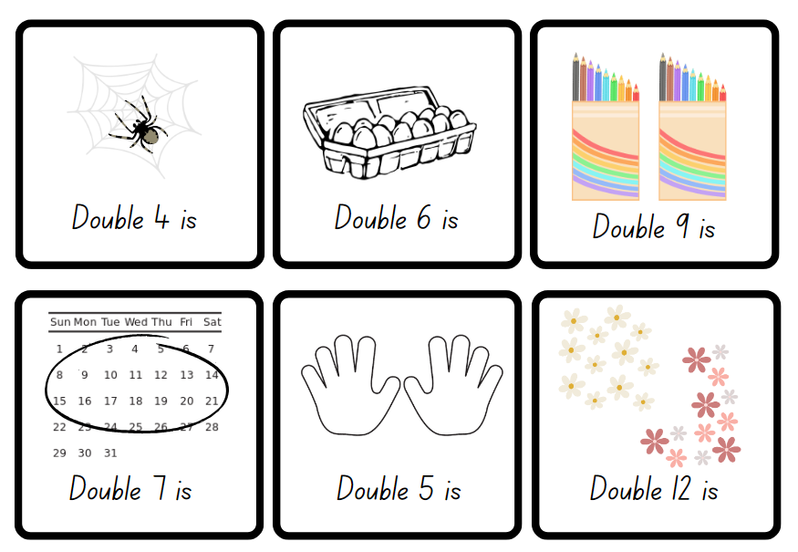

1. Select students to share and explain the strategy they used to find the answers. If not identified by students, highlight doubling as an efficient strategy to find the answers.
2. Display a cup or box and explain that the cup or box is a magic pot and that each time a card comes out of it, the number doubles.
3. Use Resource 14: Number cards 2 to place in the magic pot. Select one number at a time and ask students to record the doubled number on their whiteboard.
4. Choose students to share their and answers and strategies they used.

The table below outlines a stimulus prompt to generate conversation about the topic, along with anticipated responses from students.

|  |  |
| --- | --- |
| Prompt | Anticipated student responses |
| * What strategy did you use to double the number? | * I used 5 or 10 as a reference. * I counted by that number again to get the double. * I used counters and counted by ones. |

**Multiples**: products formed using the same base number multiplied by different whole numbers, for example, 3, 6, 9, 12 and so on.

1. Continue until all number cards have been selected.
2. Highlight the fact that doubling a number is the same as 2 times. For example, double 3 is 6, which is the same as 2 times 3 is 6.
3. Write ‘4 multiples of 3 = ?’ on the board. Ask students to think and then [turn and talk](https://education.nsw.gov.au/teaching-and-learning/curriculum/literacy-and-numeracy/teaching-and-learning-resources/numeracy/talk-moves) to discuss what strategies they could use to solve the problem.
4. Select students to share and explain their strategies to solve the problem. Highlight, if not already identified, that the problem can be solved using double and double again, which is also the same as 4 times. Solve the problem for the class using a think aloud (see Figure 21).

Figure 21 – Double and double again

4 multiples of 3 = think aloud.
I know double 3 is 6 and double again is 12. double 3 is 6 and double 3 is 6.

1. Continue writing multiples of 4 problems for students to solve independently using the double and double again strategy.
2. Choose students to share and justify the answers to the problems with the class.

This table details opportunities for differentiation.

|  |  |
| --- | --- |
| Too hard? | Too easy? |
| Stage 2 students cannot find the double of a given number.   * Provide students with concrete materials, for example, counters to manipulate when solving double problems. * Support students to count the total number to find the double fact. | Stage 2 students can find the double of a given number.   * Challenge students to double, double and double again. * Ask students to explain and justify what multiplication facts the strategy shows. |

#### Stage 3 task: Make 1000

The table below contains a suggested learning intention and success criteria. These are best co-constructed with students.

|  |  |
| --- | --- |
| Core concept learning intention | Core concept success criteria |
| Students working towards Stage 3 outcomes are learning to:   * demonstrate a deep understanding of place value by using mental strategies to multiply one-digit numbers by multiples of 10 and 100. | Students working towards Stage 3 outcomes can:   * use mental strategies to multiply one-digit numbers by multiples of 10 and 100. |

1. Explain that students will play a game where the goal is to make 1000. In this game, students will practise multiplying one-digit numbers by multiples of 10. A 1–10 spinner will be used to determine the one-digit number. Players then multiply that number by a multiple of 10 of their choice. The multiple of 10 can be no lower than 10 and no higher than 60. Players record the equation and product, then repeat the process another 6 times, adding the products each time to get a progressive total (see Figure 22). The winner is the player whose total is closest to 1000 after 7 spins.

Figure 22 – Make 1000 example

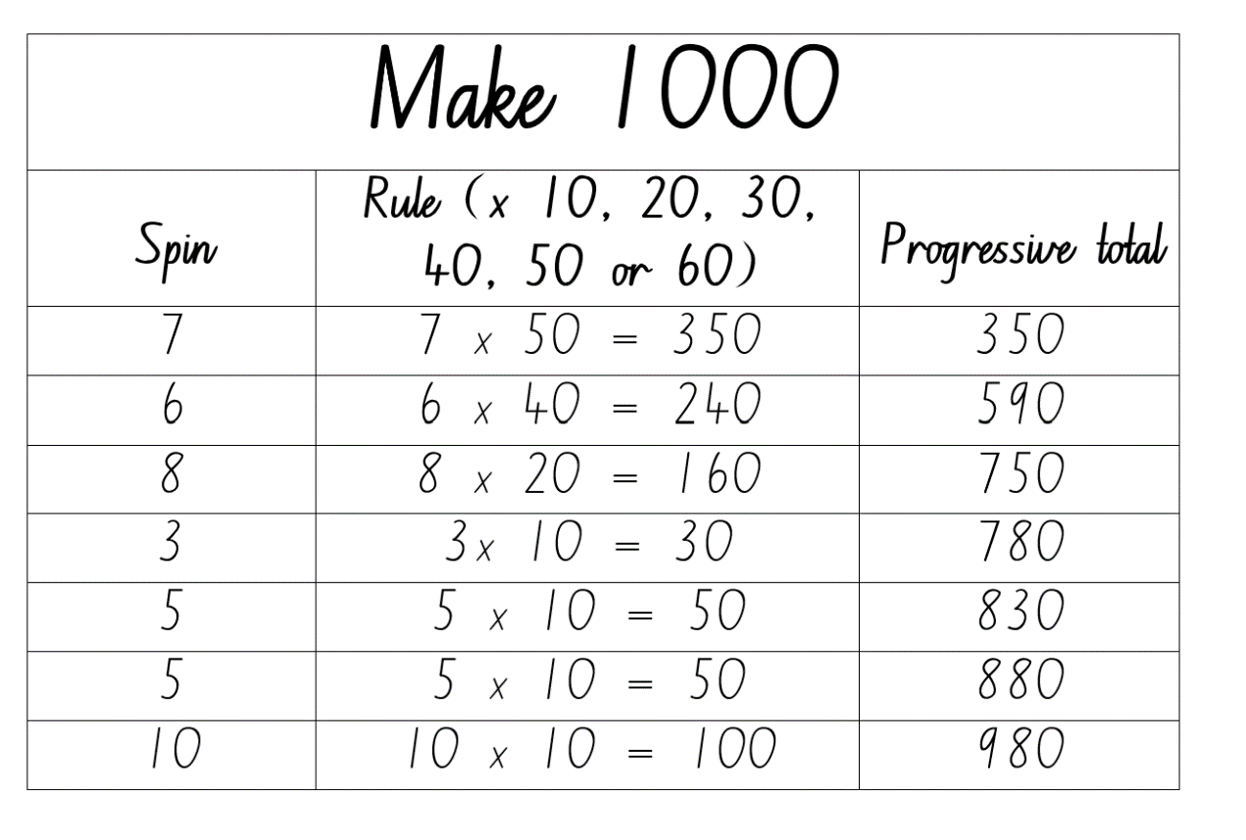

1. Model the game with students. Discuss options after each spin, demonstrating strategies to determine the product for each option before deciding which rule to apply. Ensure students understand the progressive total and how to calculate it.
2. After the final total has been determined, discuss decisions made during the game and different strategies that could lead to a total closer to 1000. Remind students that the winner is the player with the total closest to 1000 and explain that sometimes the closest total might be higher than 1000.
3. Students draw their own gameboard (see Figure 22). Play the game again as a class, allowing students to make their own choices and record their equations and progressive totals.
4. After the first 5 spins, select students to explain their thinking and justify their choices.
5. After the sixth spin, select students to share what equation would give them a final total close to 1000.
6. After the seventh spin, students record their final total and work out how close they are to 1000. Select students to share their totals.
7. Ask students to turn and talk and discuss choices that had a significant impact on their final total.
8. Provide pairs with a 1–10 spinner or 10-sided die. Alternatively, students can use an [interactive random number generator](https://mathigon.org/polypad#random). Students create another gameboard and play in pairs.

This table details opportunities for differentiation.

|  |  |
| --- | --- |
| Too hard? | Too easy? |
| Stage 3 students cannot multiply by multiples of 10.   * Provide multiplication grids and model using the link between multiplication facts and multiplying by multiples of 10. | Stage 3 students can multiply by multiples of 10.   * Increase or decrease the target number. |

### Discuss and connect the mathematics – 10 minutes

1. As a class, discuss questions, such as:

* We have looked at the doubling and double and double again strategies today. What do you think the double, double and double again strategy might look like? (Stage 2)
* Do you think there is a strategy where you can double, double, double and double again? (Stage 2)
* What advice would you give to someone playing the game for the first time? (Stage 3)
* How could you make the game easier or harder? (Stage 3)
* What strategies did you use when multiplying by multiples of 10? (Stage 3)

This table details opportunities for assessment.

|  |  |
| --- | --- |
| Assessment opportunities | Links |
| What to look for:   * Can Stage 2 students solve simple multiplication problems involving multiples of 2 and 4? **[MAO-WM-01, MA2-MR-01]** * Can Stage 2 students recognise the relationship between one multiple and its double? **[MAO-WM-01, MA2-MR-01]** * Can Stage 3 students multiply one-digit numbers by multiples of 10? **[MAO-WM-01, MA3-MR-01]** | Links to [National Numeracy Learning Progressions](https://www.australiancurriculum.edu.au/resources/national-literacy-and-numeracy-learning-progressions/version-3-of-national-literacy-and-numeracy-learning-progressions/) (NNLP):   * Stage 2 – CPr6, NPA4, MuS6 * Stage 3 – MuS6, MuS7.   Links to suggested [Interview for Student Reasoning](https://education.nsw.gov.au/teaching-and-learning/curriculum/literacy-and-numeracy/assessment-resources/ifsr) (IfSR) tasks:   * **Stage 3 – IfSR-/MT**: 3A.1, 3A.2, 3A.3. |

## Resource 1: Place value houses

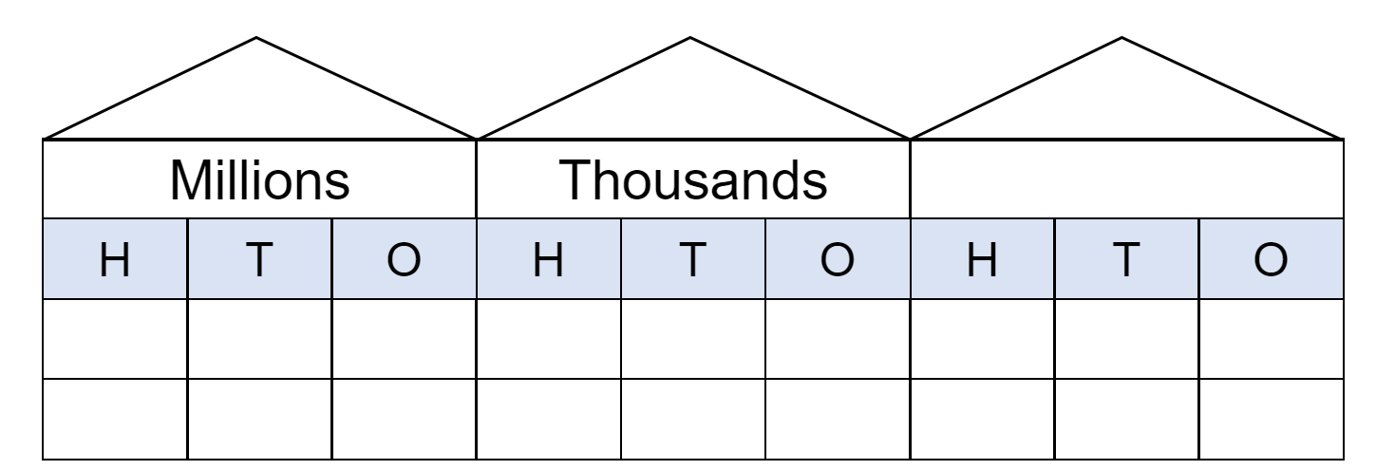

## Resource 2: Number cards

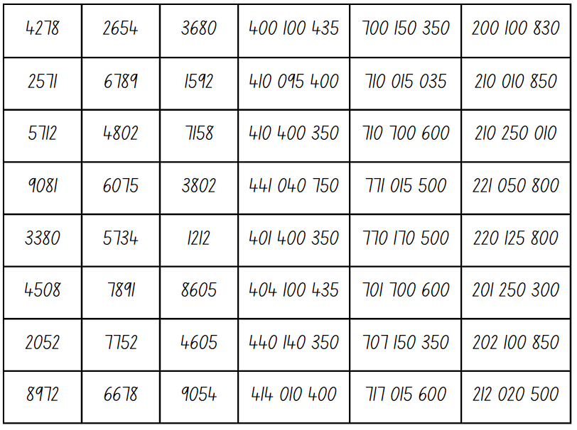

## Resource 3: 100 dots



## Resource 4: 1000 dots

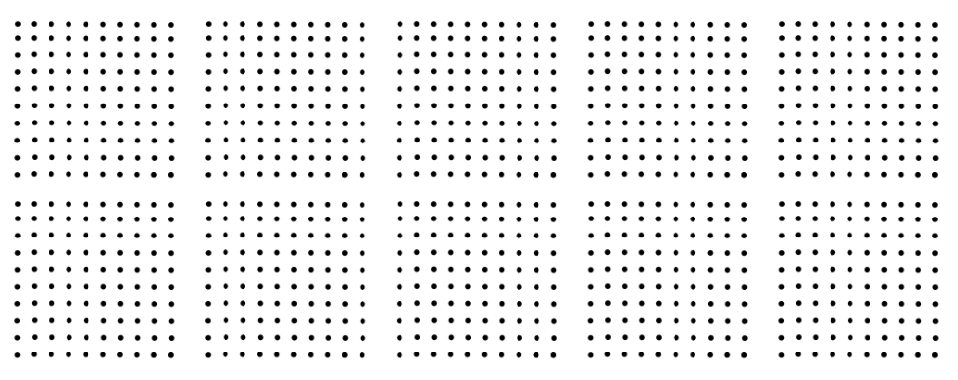

## Resource 5: 10 000 dots

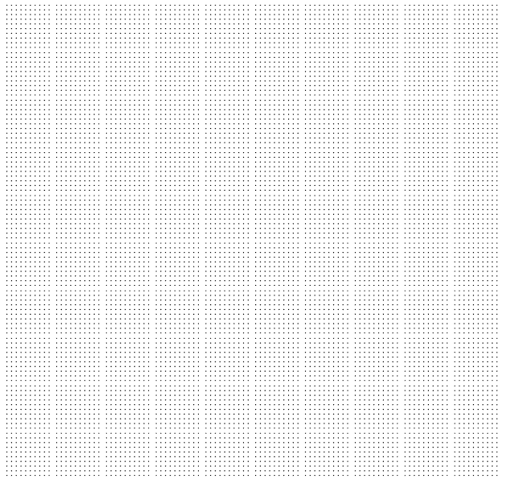

## Resource 6: Number expander

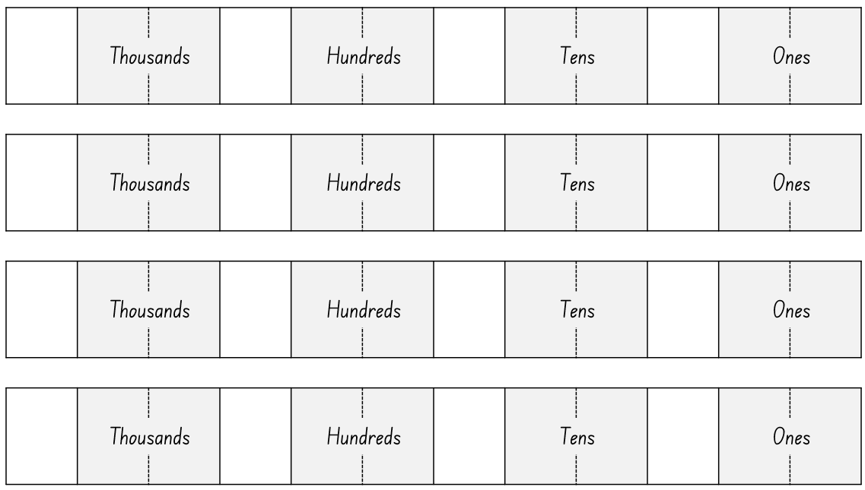

## Resource 7: Number line



## Resource 8: Nutrition information label

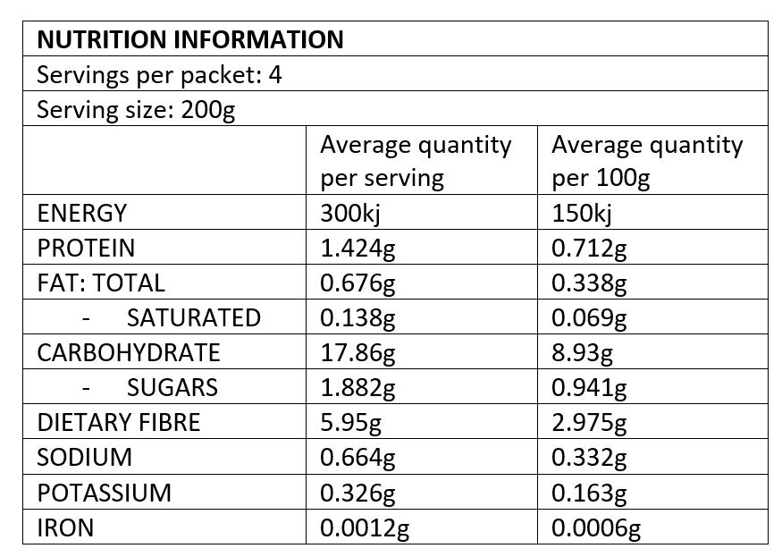

## Resource 9: Nutrition levels in food

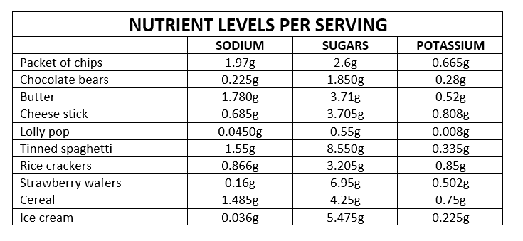

## Resource 10: Number chart

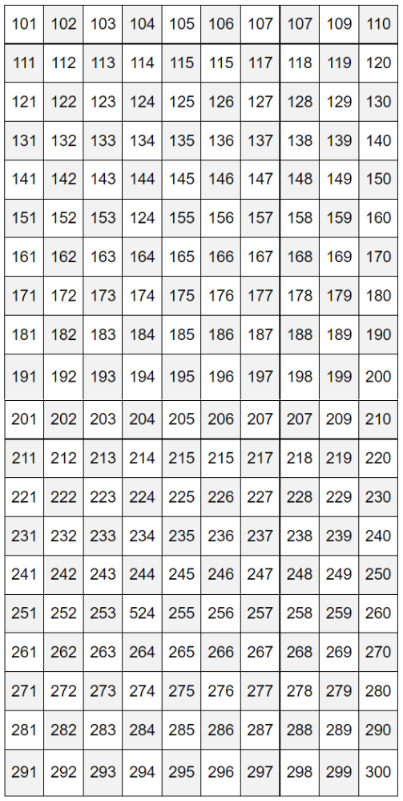

## Resource 11: Prime numbers chart

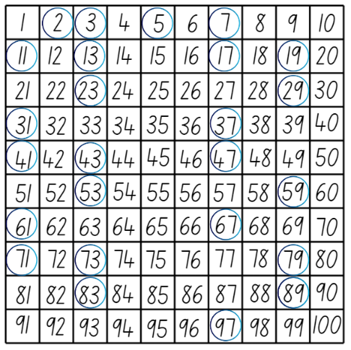

## Resource 12: Multiplication toss gameboard

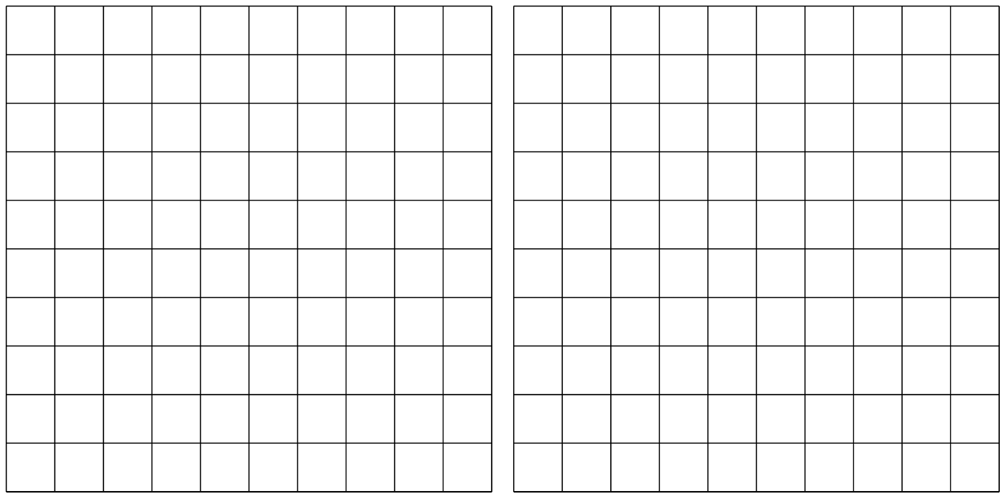

## Resource 13: What’s my number?

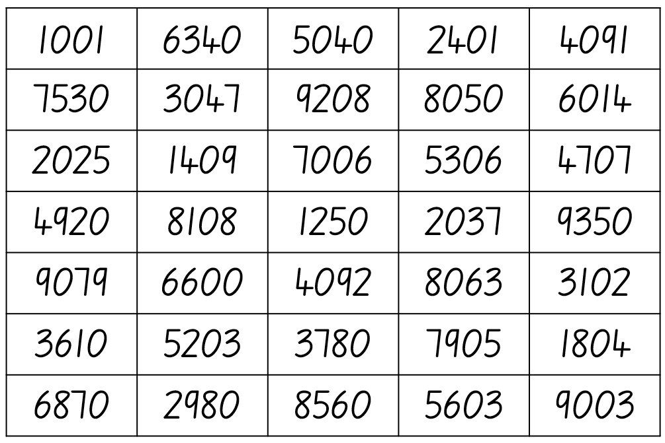

## Resource 14: Number cards 2

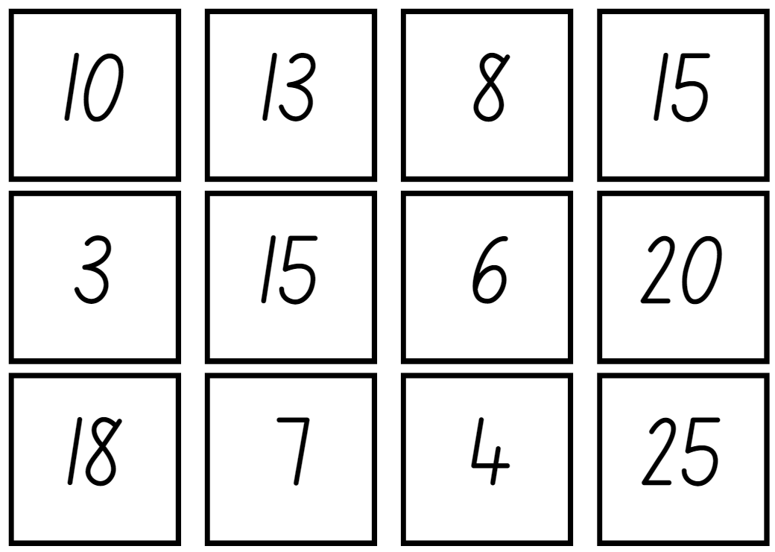

## Syllabus outcomes and content

### Stage 2

The table below outlines the [syllabus outcomes](https://curriculum.nsw.edu.au/learning-areas/mathematics/mathematics-k-10-2022) and range of relevant syllabus content covered in this unit. Content is linked to [National Numeracy Learning Progression](https://www.australiancurriculum.edu.au/resources/national-literacy-and-numeracy-learning-progressions/version-3-of-national-literacy-and-numeracy-learning-progressions/) version (3).

|  |  |  |  |  |  |  |  |  |
| --- | --- | --- | --- | --- | --- | --- | --- | --- |
| Outcomes and content | 1 | 2 | 3 | 4 | 5 | 6 | 7 | 8 |
| **Representing whole numbers B:** Form, regroup, and rename three-digit numbers  **MAO-WM-01, MA1-RWN-01, MA1-RWN-02** |  |  |  |  |  |  |  |  |
| * State the quantity value of digits in numbers of up to three digits (Reasons about quantity) | x |  | x |  |  |  |  |  |
| **Representing numbers using place value A:** Whole numbers: Read, represent and order numbers to thousands  **MAO-WM-01, MA2-RN-01** |  |  |  |  |  |  |  |  |
| * Group physical or virtual objects to show the structure of tens, hundreds and a thousand |  | x | x |  |  |  |  |  |
| * Regroup numbers flexibly, recognising one thousand as 10 hundreds and one hundred as 10 tens or 100 ones |  |  | x |  |  |  |  |  |
| * Compare and describe the relative size of numbers by positioning numbers on a number line (Reasons about quantity) |  |  |  | x |  |  |  |  |
| * Represent numbers up to and including thousands using physical or virtual manipulatives, words, numerals, diagrams and digital displays | x | x | x |  |  |  |  |  |
| * Read and order numbers of up to at least 4 digits | x |  |  | x |  |  |  |  |
| * Identify the number before and after a number with an internal zero digit |  |  |  |  |  |  | x |  |
| **Representing numbers using place value A:** Whole numbers: Apply place value to partition and regroup numbers up to 4 digits  **MAO-WM-01, MA2-RN-01** |  |  |  |  |  |  |  |  |
| * Record numbers using standard place value form | x | x | x |  |  |  |  |  |
| **Representing numbers using place value B:** Whole numbers: Order numbers in the thousands  **MAO-WM-01, MA2-RN-01** |  |  |  |  |  |  |  |  |
| * Arrange numbers in the thousands in ascending and descending order |  | x |  |  |  |  |  |  |
| **Representing numbers using place value B:** Whole numbers: Recognise and represent numbers that are 10, 100 or 1000 times as large  **MAO-WM-01, MA2-RN-01** |  |  |  |  |  |  |  |  |
| * Recognise the number of tens, hundreds or thousands in a number | x | x | x |  |  |  |  |  |
| **Multiplicative relations A:** Generate and describe patterns  **MAO-WM-01, MA2-MR-01** |  |  |  |  |  |  |  |  |
| * Model, describe and record patterns of multiples |  |  |  |  | x |  |  |  |
| * Create and continue a variety of number patterns that increase or decrease by a constant amount |  |  |  |  | x |  |  |  |
| **Multiplicative relations A:** Use arrays to establish multiplication facts from multiples of 2 and 4, 5 and 10  **MAO-WM-01, MA2-MR-01** |  |  |  |  |  |  |  |  |
| * Create and represent multiplicative structure, using the term multiples when connecting grouping to arrays |  |  |  |  |  | x |  |  |
| * Use the array structure to coordinate the number of groups with the number in each group |  |  |  |  |  | x |  |  |
| * Record the first 10 multiples formed by counting by twos, fours, fives and tens |  |  |  |  | x |  |  |  |
| * Relate doubling to multiplication facts for multiples of 2 |  |  |  |  |  |  |  | x |
| * Recognise that doubling is multiplying by 2 and halving is dividing by 2 (Reasons about relations) |  |  |  |  |  |  |  | x |
| * Recognise the relationship between one multiple and its double (Reasons about relations) |  |  |  |  |  |  |  | x |
| **Multiplicative relations A:** Recall multiplication facts of 2 and 4, 5 and 10 and related division facts  **MAO-WM-01, MA2-MR-01** |  |  |  |  |  |  |  |  |
| * Recognise and use the symbols for multiplied by (×), divided by (÷) and equals (=) |  |  |  |  |  |  | x | x |
| * Model and apply the commutative property of multiplication |  |  |  |  |  | x |  |  |
| **Additive relations A:** Select strategies flexibly to solve addition and subtraction problems of up to 3 digits  **MAO-WM-01, MA2-AR-01** |  |  |  |  |  |  |  |  |
| * Apply known mental strategies that use partitioning to add and subtract, such as bridging the decades |  |  |  |  |  | x | x |  |
| * Compare and evaluate strategies used to solve addition and subtraction problems, reasoning which strategy may be the most efficient |  |  |  |  |  | x | x |  |

[Mathematics K–10 Syllabus](https://curriculum.nsw.edu.au/learning-areas/mathematics/mathematics-k-10) © NSW Education Standards Authority (NESA) for and on behalf of the Crown in right of the State of New South Wales, 2022.

### Stage 3

The table below outlines the [syllabus outcomes](https://curriculum.nsw.edu.au/learning-areas/mathematics/mathematics-k-10-2022) and range of relevant syllabus content covered in this unit. Content is linked to [National Numeracy Learning Progression](https://www.australiancurriculum.edu.au/resources/national-literacy-and-numeracy-learning-progressions/version-3-of-national-literacy-and-numeracy-learning-progressions/) version (3).

|  |  |  |  |  |  |  |  |  |
| --- | --- | --- | --- | --- | --- | --- | --- | --- |
| Outcomes and content | 1 | 2 | 3 | 4 | 5 | 6 | 7 | 8 |
| **Representing numbers using place value A:** Whole numbers: Read, represent and order numbers to thousands  **MAO-WM-01, MA2-RN-01** |  |  |  |  |  |  |  |  |
| * Represent numbers up to and including thousands using physical or virtual manipulatives, words, numerals, diagrams and digital displays | x | x | x |  |  |  |  |  |
| * Read and order numbers of up to at least 4 digits | x | x |  |  |  |  |  |  |
| **Representing numbers using place value B:** Whole numbers: Order numbers in the thousands  **MAO-WM-01, MA2-RN-01** |  |  |  |  |  |  |  |  |
| * Arrange numbers in the thousands in ascending and descending order |  | x |  |  |  |  |  |  |
| **Representing numbers using place value B:** Decimals: Make connections between fractions and decimal notation  **MAO-WM-01, MA2-RN-02** |  |  |  |  |  |  |  |  |
| * Make connections between fractions and decimal notation for key benchmark values (Reasons about relations) |  |  | x |  |  |  |  |  |
| **Additive relations A:** Select strategies flexibly to solve addition and subtraction problems of up to 3 digits  **MAO-WM-01, MA2-AR-01** |  |  |  |  |  |  |  |  |
| * Apply known mental strategies that use partitioning to add and subtract, such as bridging the decades |  |  |  |  |  | x |  |  |
| * Compare and evaluate strategies used to solve addition and subtraction problems, reasoning which strategy may be most efficient |  |  |  |  |  | x |  |  |
| **Additive relations B:** Partition, rearrange and regroup numbers to at least 1000 to solve additive problems  **MAO-WM-01, MA2-AR-01** |  |  |  |  |  |  |  |  |
| * Model addition with and without regrouping and record the method used |  |  |  |  |  |  | x |  |
| * Use an algorithm with understanding to record addition and subtraction calculations, where efficient, involving 3-digit numbers |  |  |  |  |  |  | x |  |
| **Represents numbers A:** Whole numbers: Recognise, represent and order numbers in the millions  **MAO-WM-01, MA3-RN-01, MA3-RN-02** |  |  |  |  |  |  |  |  |
| * Name millions using the place value grouping of ones, tens and hundreds | x |  |  |  |  |  |  |  |
| * Arrange numbers in the millions in ascending and descending order using place value round numbers to a specified place value | x |  |  |  |  |  |  |  |
| **Represents numbers A:** Whole numbers: Apply place value to partition, regroup and rename numbers to 1 billion  **MAO-WM-01, MA3-RN-01, MA3-RN-02** |  |  |  |  |  |  |  |  |
| * Recognise 1000 thousands is 1 million and 1000 millions is 1 billion |  | x |  |  |  |  |  |  |
| * Regroup numbers in different forms (Reasons about quantity) |  | x |  |  |  |  |  |  |
| * Partition numbers to 1 billion in non-standard forms |  | x |  |  |  |  |  |  |
| **Represents numbers A:** Decimals and percentages: Recognise that the place value system can be extended beyond hundredths  **MAO-WM-01, MA3-RN-01, MA3-RN-02** |  |  |  |  |  |  |  |  |
| * Express thousandths as decimals |  |  | x |  |  |  |  |  |
| * Interpret decimal notation for thousandths |  |  | x |  |  |  |  |  |
| * Indicate the place value of digits in decimal numbers of up to 3 decimal places |  |  | x |  |  |  |  |  |
| * Use place value to partition decimals |  |  | x |  |  |  |  |  |
| **Represents numbers A:** Decimals and percentages: Compare, order and represent decimals  **MAO-WM-01, MA3-RN-01, MA3-RN-02** |  |  |  |  |  |  |  |  |
| * Compare and order decimal numbers of up to 3 decimal places |  |  |  | x |  |  |  |  |
| * Interpret zero digit(s) at the end of a decimal |  |  |  | x |  |  |  |  |
| * Place decimal numbers of up to 3 decimal places on a number line |  |  |  | x |  |  |  |  |
| **Multiplicative relations A:** Determine products and factors  **MAO-WM-01, MA3-MR-01** |  |  |  |  |  |  |  |  |
| * Use the term product to describe the result of multiplying 2 or more numbers |  |  |  |  | x |  |  |  |
| * Model different ways to show a whole number as a product (Reasons about structure) |  |  |  |  | x |  |  |  |
| * Determine factors for a given whole number |  |  |  |  | x |  |  |  |
| * Determine whether a number is prime, composite or neither (0 or 1) |  |  |  |  | x |  |  |  |
| **Multiplicative relations A:** Use partitioning and place value to multiply 2-, 3- and 4-digit numbers by one-digit numbers  **MAO-WM-01, MA3-MR-01** |  |  |  |  |  |  |  |  |
| * Use mental strategies to multiply one-digit numbers by 10, 100, 1000 and their multiples |  |  |  |  |  |  | x | x |
| * Estimate the product of 2 numbers (one-digit by 2- or 3-digit numbers) using multiples of 10 or 100 |  |  |  |  |  |  | x |  |
| * Use informal written strategies such as the area model to solve multiplication and division problems |  |  |  |  |  | x |  |  |
| * Use the distributive property with the area model to partition numbers in representing multiplication problems |  |  |  |  |  | x |  |  |
| * Use the distributive property with partial products to solve problems by multiplying the hundreds, then the tens and then the ones |  |  |  |  |  | x |  |  |
| **Multiplicative relations B:** Represent and describe number patterns formed by multiples  **MAO-WM-01, MA3-MR-01** |  |  |  |  |  |  |  |  |
| * Determine a rule describing the relationship between the bottom number and the top number in a table (algebraic reasoning) |  |  |  |  | x |  |  |  |

[Mathematics K–10 Syllabus](https://curriculum.nsw.edu.au/learning-areas/mathematics/mathematics-k-10) © NSW Education Standards Authority (NESA) for and on behalf of the Crown in right of the State of New South Wales, 2022.

## References

This resource contains NSW Curriculum and syllabus content. The NSW Curriculum is developed by the NSW Education Standards Authority. This content is prepared by NESA for and on behalf of the Crown in right of the State of New South Wales. The material is protected by Crown copyright.

Please refer to the NESA Copyright Disclaimer for more information <https://educationstandards.nsw.edu.au/wps/portal/nesa/mini-footer/copyright>.

NESA holds the only official and up-to-date versions of the NSW Curriculum and syllabus documents. Please visit the NSW Education Standards Authority (NESA) website <https://educationstandards.nsw.edu.au/> and the NSW Curriculum website <https://curriculum.nsw.edu.au/home>.

[Mathematics K–10 Syllabus](https://curriculum.nsw.edu.au/learning-areas/mathematics/mathematics-k-10-2022) © NSW Education Standards Authority (NESA) for and on behalf of the Crown in right of the State of New South Wales, 2022.

[National Numeracy Learning Progression](https://www.australiancurriculum.edu.au/resources/national-literacy-and-numeracy-learning-progressions/version-3-of-national-literacy-and-numeracy-learning-progressions/) © Australian Curriculum, Assessment and Reporting Authority (ACARA) 2010 to present, unless otherwise indicated. This material was downloaded from the [Australian Curriculum](http://www.australiancurriculum.edu.au/) website (National Literacy Learning Progression) (accessed 29 August 2023) and was not modified.

Amplify Education, Inc (2022) [*Polypad*](https://mathigon.org/polypad), Mathigon website, accessed 19 May 2023.

Boaler J, Munson J and Williams C (2021) Mindset Mathematics: Visualizing and Investigating Big Ideas, Grade 1, Jossey-Bass, New Jersey.

New Zealand Ministry of Education (n.d.) ‘[Place value with whole numbers](https://nzmaths.co.nz/resource/place-value-whole-numbers)’, Resource, NZ Maths website, accessed 18 May 2023.

New Zealand Ministry of Education (n.d.) ‘[Prime Numbers](https://nzmaths.co.nz/resource/prime-numbers)’, Resource, NZ Maths website, accessed 18 May 2023.

Siemon D, Warren E, Beswick K, Faragher R, Miller J, Horne M, Jazby D, Breed M, Clark J and Brady K (2020) Teaching Mathematics: Foundations to Middle Years, 3rd edn, Oxford University Press Australia and New Zealand.

State of New South Wales (Department of Education) (2023) ‘[101 and you’re out (2-digit-addition)](https://education.nsw.gov.au/teaching-and-learning/curriculum/mathematics/mathematics-curriculum-resources-k-12/mathematics-k-6-resources/101-and-youre-out)’, Mathematics K-6 resources, NSW Department of Education website, accessed 18 May 2023.

State of New South Wales (Department of Education) (2023) *‘*[Dicey addition (3-digit addition)](https://education.nsw.gov.au/teaching-and-learning/curriculum/mathematics/mathematics-curriculum-resources-k-12/mathematics-k-6-resources/dicey-addition)’, Mathematics K-6 resources, NSW Department of Education website, accessed 18 May 2023.

State of New South Wales (Department of Education) (2023) ‘[Mastermind](https://education.nsw.gov.au/teaching-and-learning/curriculum/mathematics/mathematics-curriculum-resources-k-12/mathematics-k-6-resources/mastermind)’, Mathematics K-6 resources, NSW Department of Education website, accessed 18 May 2023.

State of New South Wales (Department of Education) (2023) ‘[Order! Order! (four-digit numbers)](https://education.nsw.gov.au/teaching-and-learning/curriculum/mathematics/mathematics-curriculum-resources-k-12/mathematics-k-6-resources/order-order-four-digit-numbers)’, Mathematics K-6 resources, NSW Department of Education website, accessed 18 May 2023.

State of Victoria (Department of Education and Training) (2018) ‘[Place value and modelling numbers](https://fuse.education.vic.gov.au/Resource/LandingPage?ObjectId=5801fadc-dba8-4df1-87f6-4d77506498f7&SearchScope=All)’, Victorian Curriculum: Maths, FUSE website, accessed 19 May 2023.

Toy Theater (2001–2023*)* [Hundreds Chart](https://toytheater.com/hundreds-chart/), Number Chart Manipulatives, Toy Theater website, accessed 19 May 2023.

Van de Walle J, Karp K, Bay-Williams JM, Brass A, Bentley B, Ferguson S, Goff W, Livy S, Marshman M, Martin D, Pearn C, Prodromou T, Symons D and Wilkie K (2019) Primary and Middle Years Mathematics: Teaching Developmentally, 1st Australian edn, Pearson Education Australia, Melbourne.

### Further reading

New Zealand Ministry of Education (n.d.) ‘[Place value with whole numbers and decimals](https://nzmaths.co.nz/resource/place-value-whole-numbers-and-decimals)’, Resource, NZ Maths website, accessed 18 May 2023.

Siemon D, Warren E, Beswick K, Faragher R, Miller J, Horne M, Jazby D, Breed M, Clark J and Brady K (2020) Teaching Mathematics: Foundations to Middle Years, 3rd edn, Oxford University Press Australia and New Zealand.

University of Cambridge (Faculty of Mathematics) (1997–2023) [*Factors and Multiples Game*](https://nrich.maths.org/factorsandmultiples),NRICH website, accessed 18 May 2023.

University of Cambridge (Faculty of Mathematics) (1997–2023) [*Multiply Multiples 1*](https://nrich.maths.org/10421/note), NRICH website, accessed 18 May 2023.

University of Cambridge (Faculty of Mathematics) (1997–2023) [*Multiply Multiples 2*](https://nrich.maths.org/10424), NRICH website, accessed 18 May 2023.

**© State of New South Wales (Department of Education), 2023**

The copyright material published in this resource is subject to the Copyright Act 1968 (Cth) and is owned by the NSW Department of Education or, where indicated, by a party other than the NSW Department of Education (third-party material).

Copyright material available in this resource and owned by the NSW Department of Education is licensed under a [Creative Commons Attribution 4.0 International (CC BY 4.0) license](https://creativecommons.org/licenses/by/4.0/).

[](https://creativecommons.org/licenses/by/4.0/)

This license allows you to share and adapt the material for any purpose, even commercially.

Attribution should be given to © State of New South Wales (Department of Education), 2023.

Material in this resource not available under a Creative Commons license:

* the NSW Department of Education logo, other logos and trademark-protected material
* material owned by a third party that has been reproduced with permission. You will need to obtain permission from the third party to reuse its material.

**Links to third-party material and websites**

Please note that the provided (reading/viewing material/list/links/texts) are a suggestion only and implies no endorsement, by the New South Wales Department of Education, of any author, publisher, or book title. School principals and teachers are best placed to assess the suitability of resources that would complement the curriculum and reflect the needs and interests of their students.

If you use the links provided in this document to access a third-party's website, you acknowledge that the terms of use, including licence terms set out on the third-party's website apply to the use which may be made of the materials on that third-party website or where permitted by the Copyright Act 1968 (Cth). The department accepts no responsibility for content on third-party websites.