# Mathematics 3-6 multi-age – Year A – Unit 2



Contents

Unit description and duration 4

Syllabus outcomes 4

Working mathematically 5

Student prior learning 6

Lesson overview and resources 7

Lesson 1 18

Daily number sense: Order! Order! – 15 minutes 18

Core lesson: Partitioning – 45 minutes 20

Discuss and connect the mathematics – 10 minutes 24

Lesson 2 26

Daily number sense: Place value game – 15 minutes 26

Core lesson: Models help solve problems – 45 minutes 28

Consolidation and meaningful practice – 10 minutes 32

Lesson 3 34

Daily number sense: True or False? – 10 minutes 34

Core lesson – 45 minutes 35

Discuss and connect the mathematics – 5 minutes 44

Lesson 4 46

Daily number sense – 15 minutes 46

Core lesson – 40 minutes 46

Discuss and connect the mathematics – 5 minutes 55

Lesson 5 56

Daily number sense: Strike it out! – 15 minutes 56

Core lesson – 45 minutes 59

Discuss and connect the mathematics –5 minutes 69

Lesson 6 70

Daily number sense: Colour in fractions – 15 minutes 70

Core lesson – 45 minutes 72

Discuss and connect the mathematics – 5 minutes 80

Lesson 7 81

Daily number sense: Nicole’s walk – 15 minutes 81

Core lesson: Solving problems – 25 minutes 82

Consolidation and meaningful practice – 25 minutes 85

Lesson 8 87

Daily number sense – 15 minutes 87

Core lesson: More problems – 40 minutes 87

Discuss and connect the mathematics – 10 minutes 91

Resource 1: Sara’s challenge 92

Resource 2: Place value game 93

Resource 3: Subtraction problem 94

Resource 4: Word problems 95

Resource 5: Consolidation task 97

Resource 6: True or false? 98

Resource 7: Chess pieces 99

Resource 8: Chess chart 1 100

Resource 9: Chess chart 2 101

Resource 10: Empty chart 102

Resource 11: Chess chart 3 103

Resource 12: Race car rumble 104

Resource 13: 119 number chart 105

Resource 14: Trading 106

Resource 15: Spinner 107

Resource 16: Fraction wall 108

Resource 17: Nicole’s walk 109

Syllabus outcomes and content 110

Stage 2 110

Stage 3 114

References 117

## Unit description and duration

This unit introduces the big idea that addition and subtraction problems can be solved by using a variety of strategies.

In this 2-week unit students are provided opportunities to:

* apply place value to partition and regroup numbers for addition and subtraction problem solving
* explore the connection between additive relations and place value
* recognise and explain the connection between addition and subtraction
* select and explain efficient flexible strategies when solving problems.

This multi-age unit is informed by the lessons in Stage 2 Year A Unit 2 and Stage 3 Year A Unit 2. Please refer to these units for additional lesson guidance.

### Syllabus outcomes

* **MAO-WM-01** develops understanding and fluency in mathematics through exploring and connecting mathematical concepts, choosing and applying mathematical techniques to solve problems, and communicating their thinking and reasoning coherently and clearly

#### Stage 2

* **MA2-RN-01** applies an understanding of place value and the role of zero to represent numbers to at least tens of thousands **MA2-AR-01** selects and uses mental and written strategies for addition and subtraction involving 2- and 3-digit numbers
* **MA2-AR-02** completes number sentences involving addition and subtraction by finding missing values
* **MA2-PF-01** represents and compares halves, quarters, thirds and fifths as lengths on a number line and their related fractions formed by halving (eighths, sixths and tenths)

#### Stage 3

* **MA2-PF-01** represents and compares halves, quarters, thirds and fifths as lengths on a number line and their related fractions formed by halving (eighths, sixths and tenths)
* **MA3-RN-01** applies an understanding of place value and the role of zero to represent the properties of numbers
* **MA3-AR-01** selects and applies appropriate strategies to solve addition and subtraction problems

### Working mathematically

In the Mathematics K–10 Syllabus, there is one overarching Working mathematically outcome (**MAO-WM-01**). The Working mathematically processes should be embedded within the concepts being taught. The Working mathematically processes present in the Mathematics K–10 Syllabus are:

* communicating
* understanding and fluency
* reasoning
* problem solving.

[Mathematics K–10 Syllabus](https://curriculum.nsw.edu.au/learning-areas/mathematics/mathematics-k-10) © NSW Education Standards Authority (NESA) for and on behalf of the Crown in right of the State of New South Wales, 2022.

### Student prior learning

Before engaging in these teaching and learning activities, students would benefit from prior experience with:

* partitioning, rearranging and regrouping numbers to solve additive problems
* completing number sentences involving additive relations to find unknown quantities
* solving addition and subtraction problems using written and mental strategies.

In NSW classrooms there is a diverse range of students, including Aboriginal and Torres Strait Islander students, students learning English as an additional language or dialect, high potential and gifted students and students with disability. Some students may identify with more than one of these groups or possibly all of them. Refer to [Advice on curriculum planning for every student](https://education.nsw.gov.au/teaching-and-learning/curriculum/planning-programming-and-assessing-k-12/advice-on-curriculum-planning-for-every-student-k-12) for further information.

## Lesson overview and resources

To cover the content of the syllabus across Stage 2 and Stage 3, some core lessons in the unit contain both a Stage 2 and a Stage 3 task. Teachers are encouraged to adapt and contextualise the units to meet the needs of their students.

The table below outlines the sequence and approximate timing of lessons, learning intentions and resources.

|  |  |  |
| --- | --- | --- |
| Lesson | Content | Duration and resources |
| **Lesson 1**  **Daily number sense**  **Stage 2:**   * **Representing numbers using place value A**: Whole numbers: Read, represent and order numbers to thousands   **Stage 3**:   * **Represents numbers A**: Whole numbers: Recognise, represent and order numbers in the millions | **Lesson core concept**: place value understanding helps solve addition and subtraction problems.  **Stage 2**:   * **Representing numbers using place value A**:Whole numbers: Read, represent and order numbers to thousands * **Representing numbers using place value A**: Whole numbers: Apply place value to partition and regroup numbers up to 4 digits * **Additive relations A:** Selects strategies flexibly to solve addition and subtraction problems of up to 3 digits * **Additive relations B**: Partition, rearrange and regroup numbers to at least 1000 to solve additive problems   **Stage 3**:   * **Additive relations A**:Apply efficient mental and written strategies to solve addition and subtraction problems * **Additive relations B**: Choose and use efficient strategies to solve addition and subtraction problems | **Lesson duration**: 70 minutes   * Resource 1: Sara’s challenge * 0–9 dice * Individual whiteboards * Sticky notes * Writing materials |
| **Lesson 2**  **Daily number sense**  **Stage 2:**   * **Representing numbers using place value A**: Whole numbers: Read, represent and order numbers to thousands   **Stage 3**:   * **Represents numbers A**: Whole numbers: recognise, represent and order numbers in the millions | **Lesson core concept**: addition can help solve subtraction problems.  **Stage 2**:   * **Representing numbers using place value A**:Whole numbers: Read, represent and order numbers to thousands * **Representing numbers using place value A**: Whole numbers: Apply place value to partition and regroup numbers up to 4 digits * **Representing numbers using place value B**: Whole numbers: Apply place value to partition, regroup and rename numbers up to 6 digits * **Additive relations A**: Recognise and explain the connection between addition and subtraction * **Additive relations A**: Select strategies flexibly to solve addition and subtraction problems of up to 3 digits * **Additive relations B**: Partition, rearrange and regroup numbers to at least 1000 to solve additive problems   **Stage 3**:   * **Additive relations A**: Use estimation and place value understanding to determine the reasonableness of solutions * **Additive relations B**: Choose and use efficient strategies to solve addition and subtraction problems | **Lesson duration**: 70 minutes   * Resource 2: Place value game * Resource 3: Subtraction problem * Resource 4: Word problems * Resource 5: Consolidation task * 9-sided dice (6 per pair) * Individual whiteboards * Writing materials |
| **Lesson 3**  **Daily number sense**  **Stage 2**:   * **Additive relations A**: Use the principle of equality   **Stage 3**:   * **Additive relations A**: Apply efficient mental and written strategies to solve addition and subtraction problems | **Lesson core concept**: there is a connection between place value and additive thinking.  **Stage 2:**   * **Representing numbers using place value A**: Whole numbers: Read, represent and order numbers to thousands * **Representing numbers using place value A**: Whole numbers: Apply place value to partition and regroup numbers up to 4 digits * **Additive relations A**: Select strategies flexibly to solve addition and subtraction problems of up to 3 digits * **Additive relations B**: Partition, rearrange and regroup numbers to at least 1000 to solve additive problems   **Stage 3:**   * **Additive relations A**: Apply efficient mental and written strategies to solve addition and subtraction problems | **Lesson duration**: 60 minutes   * Resource 6: True or false? * Resource 7: Chess pieces * Resource 8: Chess chart 1 * Resource 9: Chess chart 2 * Resource 10: Empty chart * Resource 11: Chess chart 3 * Decks of cards (one per 4 students) * Individual whiteboards * Writing materials |
| **Lesson 4**  **Daily number sense**   * teacher-identified task based on student needs | **Lesson core concept**: mathematicians use a variety of strategies to solve addition and subtraction problems.  **Stage 2**:   * **Additive relations A**: Select strategies flexibly to solve addition and subtraction problems of up to 3 digits * **Additive relations B**: Partition, rearrange and regroup numbers to at least 1000 to solve additive problems   **Stage 3**:   * **Additive relations A**:Apply efficient mental and written strategies to solve addition and subtraction problems | **Lesson duration**: 60 minutes   * Resource 12: Race car rumble * 0–9 dice * 6-sided dice * 9-sided dice * Calculators * Counters * Student workbooks * Individual whiteboards * Writing materials |
| **Lesson 5**  **Daily number sense**  **Stage 2**:   * **Additive relations A**: Select strategies flexibly to solve addition and subtraction problems of up to 3 digits   **Stage 3**:   * **Additive relations A**: Apply efficient mental and written strategies to solve addition and subtraction problems | **Lesson core concept**: mathematicians use a variety of strategies to solve addition and subtraction problems.  **Stage 2**:   * **Additive relations A:** Select strategies flexibly to solve addition and subtraction problems of up to 3 digits * **Additive relations B:** Partition, rearrange and regroup numbers to at least 1000 to solve additive problems   **Stage 3**:   * **Represents numbers A**: Whole numbers: Apply place value to partition, regroup and rename numbers to 1 billion * **Additive relations A**: Apply efficient mental and written strategies to solve addition and subtraction problems | **Lesson duration**: 65 minutes   * Resource 13: 119 number chart * Resource 14: Trading * 0–9 deck of cards * 9-sided die * Counters * Deck of cards * Individual whiteboards * Student workbooks * Writing materials |
| **Lesson 6**  **Daily number sense**  **Stage 2**:   * **Partitioned fractions A**: Model and represent unit fractions, and their multiples, to a complete whole on a number line   **Stage 3:**   * **Representing quantity fractions A**: Compare and order common unit fractions | **Lesson core concept**: flexibility and efficiency are important considerations in addition and subtraction.  **Stage 2**:   * **Additive relations A**: Select strategies flexibly to solve addition and subtraction problems of up to 3 digits * **Additive relations B**: Partition, rearrange and regroup numbers to at least 1000 to solve additive problems   **Stage 3**:   * **Additive relations A**: Apply efficient mental and written strategies to solve addition and subtraction problems * **Additive relations A**: Use estimation and place value understanding to determine the reasonableness of solutions | **Lesson duration**: 65 minutes   * Resource 15: Spinner * Resource 16: Fraction wall * Dice * Individual whiteboards * Student workbooks * Writing materials |
| **Lesson 7**  **Daily number sense**  **Stage 2**:   * **Partitioned fractions A**: Model and represent unit fractions, and their multiples, to a complete whole on a number line   **Stage 3**:   * **Representing quantity fractions A**: Compare and order common unit fractions | **Lesson core concept**: mathematicians compare and evaluate strategies used to solve addition and subtraction problems, which can involve multiple steps.  **Stage 2**:   * **Additive relations A**: Select strategies flexibly to solve addition and subtraction problems of up to 3 digits * **Additive relations B**: Partition, rearrange and regroup numbers to at least 1000 to solve additive problems   **Stage 3**:   * **Additive relations A**: Apply efficient mental and written strategies to solve addition and subtraction problems * **Additive relations A**: Use estimation and place value understanding to determine the reasonableness of solutions * **Additive relations B**: Choose and use efficient strategies to solve addition and subtraction problems | **Lesson duration**: 65 minutes   * Resource 17: Nicole’s walk * Writing materials |
| **Lesson 8**  **Daily number sense**   * teacher-identified task based on student needs | **Lesson core concept**: mathematicians compare and evaluate strategies used to solve addition and subtraction problems, reasoning which strategy may be most efficient.  **Stage 2**:   * **Additive relations A**: Select strategies flexibly to solve addition and subtraction problems of up to 3 digits * **Additive relations B**: Partition, rearrange and regroup numbers to at least 1000 to solve additive problems   **Stage 3:**   * **Additive relations A**: Apply efficient mental and written strategies to solve addition and subtraction problems * **Additive relations B**: Choose and use efficient strategies to solve addition and subtraction problems | **Lesson duration**: 65 minutes   * Writing materials |

## Lesson 1

**Core concept**: place value understanding helps solve addition and subtraction problems.

### Daily number sense: Order! Order! – 15 minutes

Daily number sense activities for Lessons 1 to 3 ‘activate’ prior number knowledge and support the learning of new content in the unit. These activities can also assist teachers to identify the starting points for learning by revealing the extent of students’ existing knowledge.

The table below contains a suggested learning intention and success criteria. These are best co-constructed with students.

|  |  |
| --- | --- |
| Daily number sense learning intention | Daily number sense success criteria |
| All students are learning to:   * record and order numbers. | All students can:   * read, represent and order numbers in ascending order. |

This activity is an adaptation of [Order! Order! (four-digit numbers)](https://education.nsw.gov.au/teaching-and-learning/curriculum/mathematics/mathematics-curriculum-resources-k-12/mathematics-k-6-resources/order-order-four-digit-numbers) from [Mathematics K-6 resources](https://education.nsw.gov.au/teaching-and-learning/curriculum/mathematics/mathematics-curriculum-resources-k-12/mathematics-k-6-resources) by State of New South Wales (Department of Education).

1. Provide pairs of students with markers, sticky notes and three, four or five 0–9 dice.
2. Students take turns rolling the dice and creating a 3-, 4- or 5-digit number which is recorded on a sticky note. Repeat the process until students have formed 4 numbers (see Figure 1).

Figure 1 – Sample sticky notes

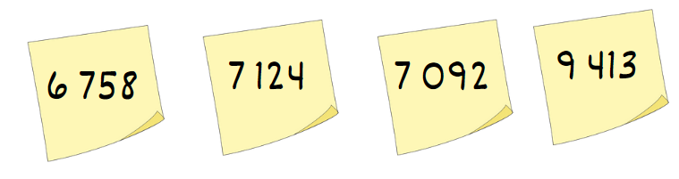

1. Ask students to order the numbers from smallest to largest (ascending order) in the fewest moves possible.
2. Observe students and regroup as a class. Ask:

* What was your least number of moves?
* What strategies did you use for ordering your numbers?
* How would you place the numbers in descending order?
* Were you presented with any challenges? How did you overcome them?

1. Repeat the process, adjusting the level of difficulty if required by increasing or decreasing the number of digits.

This table details opportunities for assessment.

|  |  |
| --- | --- |
| Assessment opportunities | Links |
| What to look for:   * Can students arrange numbers in ascending order? **[MAO-WM-01, MA2-RN-01, MA3-RN-01]** | Links to [National Numeracy Learning Progressions](https://www.australiancurriculum.edu.au/resources/national-literacy-and-numeracy-learning-progressions/version-3-of-national-literacy-and-numeracy-learning-progressions/) (NNLP):   * Stage 2 – NPV6 * Stage 3 – NPV6.   Links to suggested [Interview for Student Reasoning](https://education.nsw.gov.au/teaching-and-learning/curriculum/literacy-and-numeracy/assessment-resources/ifsr) (IfSR) tasks:   * **Stage 2 – IfSR-NP**: 4B.2 * **Stage 3 – IfSR-NP**: 4B.2. |

### Core lesson: Partitioning – 45 minutes

The table below contains a suggested learning intention and success criteria. These are best co-constructed with students.

|  |  |
| --- | --- |
| Core concept learning intention | Core concept success criteria |
| All students are learning to:   * apply efficient mental strategies to solve addition and subtraction problems. | All students can:   * partition numbers into place value * add and subtract numbers using place value. |

This activity is an adaptation of [*Coordinating groups: Snake eyes* [PDF 8.0 MB]](https://education.nsw.gov.au/content/dam/main-education/teaching-and-learning/curriculum/key-learning-areas/mathematics/media/documents/mathematics-s2-part-3-dens.pdf) from Developing efficient numeracy strategies (DENS) by State of New South Wales (Department of Education).

1. Display the addition symbol on the board (+) and students [turn and talk](https://education.nsw.gov.au/teaching-and-learning/curriculum/literacy-and-numeracy/teaching-and-learning-resources/numeracy/talk-moves) and discuss the following questions:

* What does this symbol represent?
* What are some of the different words we can use to describe this symbol?

**Note**: encourage students to share different mathematical vocabulary. For example, add, addition, increase, plus and so on.

1. Display the subtraction symbol on the board (−) and students turn and talk and discuss the following questions:

* What does this symbol represent?
* What are some of the different words we can use to describe this symbol?

**Note**: encourage students to share different mathematical vocabulary. For example, decrease, minus, subtract, subtraction, the difference between.

1. Display the equation 362 + 426 = ? on the board and ask students to identify some strategies they could use to solve the equation. Record students’ strategies on the board.
2. Explain that partitioning can be used to add and subtract numbers as a mental strategy. Model partitioning 426 into 400 + 20 + 6. Explain that each of these numbers can be added to 362 to find the solution (see Figure 2).

Figure 2 – Addition partitioning

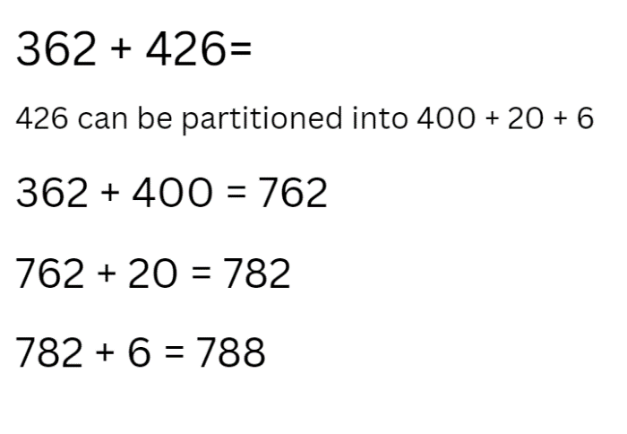

1. Introduce the game ‘Snake eyes’ and explain that students will be using partitioning to add numbers. The aim of the game is to get to 10 000.
2. Provide pairs of students with three 9-sided dice to make a 3-digit number and a whiteboard to record their work. On the first throw, the player states and records the number formed by the dice. On each subsequent throw, the player states their 3-digit number then adds the hundreds, then the tens and then the ones to their previous number. Players then record this on their whiteboard.

**Note**: model the game, demonstrating how to use partitioning to add each new number.

1. Explain to students that for each game, there is a ’venomous’ number chosen, for example, 6. If the ‘venomous’ number is rolled on any of the dice, the player forfeits the points rolled for that turn and it is the next player’s turn.
2. Explain that if students roll a ‘triple one’ (snake eyes), that player loses all their points and returns to zero.
3. After one round of the task, regroup as class and ask students:

* What worked well when using partitioning to add the numbers?
* What was challenging about using partitioning to add the numbers? How did you overcome it?

1. Display the equation 586 − 279 = ? and ask students to identify strategies to solve this equation. Record students’ strategies on the board.
2. Explain how partitioning can be used to subtract numbers.

**Note**: model that ‘279’ can be partitioned into 200 + 70 + 9. Each of these numbers can be subtracted from 586 to find the solution (see Figure 3).

Figure 3 – Subtraction partitioning

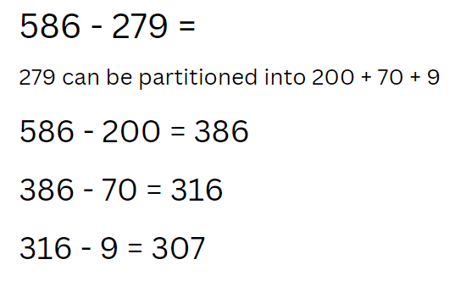

1. Explain that students will be using their knowledge of partitioning to subtract numbers while playing ‘Snake eyes’. The aim of the game this time is to get from 9999 back to zero. Students will start at 9999. On each throw, students state their 3-digit number and subtract the hundreds, then the tens and then the ones. Players record this on their whiteboard.
2. Students need to choose a new ‘venomous’ number for this round. The ‘triple one’ (snake eyes) rule still applies; if a student rolls this, they move back to start at 9999.
3. Model the game, demonstrating how to use partitioning to subtract each new number.
4. After round of ‘subtraction Snake eyes’, regroup as a class and ask:

* What worked well when using partitioning to subtract numbers?
* What was challenging when using partitioning to subtract numbers? How did you overcome it?

This table details opportunities for differentiation.

|  |  |
| --- | --- |
| Too hard? | Too easy? |
| Students cannot use partitioning to solve addition and subtraction questions.   * Students create 2-digit numbers. * Students add and subtract from 1000. | Students can use partitioning to solve addition and subtraction questions.   * Students create 4-digit numbers and try to reach 100 000. * Change the subtraction number to race back from 99 999 using 4-digit numbers. |

### Discuss and connect the mathematics – 10 minutes

1. Display Resource 1: Sara’s challenge and ask:

* What do you notice about Sara’s calculation?
* Do you have a different solution?
* Can you share your thinking?
* Have you thought of another way this could have been done?
* How did partitioning help you solve this number sentence?
* What is the correct answer?
* Could this be calculated using non-standard partitioning? For example, 3256 + 4002 = 3000 + 4000 + 258 = ?

This table details opportunities for assessment.

|  |  |
| --- | --- |
| Assessment opportunities | Links |
| What to look for:   * Can students apply place value partitioning to solve addition problems? **[MAO-WM-01, MA2-RN-01, MA2-AR-01, MA3-RN-01, MA3-AR-01]** * Can students apply place value partitioning to solve subtraction problems? **[MAO-WM-01, MA2-RN-01, MA2-AR-01, MA3-RN-01, MA3-AR-01]** | Links to [National Numeracy Learning Progressions](https://www.australiancurriculum.edu.au/resources/national-literacy-and-numeracy-learning-progressions/version-3-of-national-literacy-and-numeracy-learning-progressions/) (NNLP):   * Stage 2 – NPV6, AdS7, AdS8 * Stage 3 – NPV6, AdS7, AdS8.   Links to suggested [Interview for Student Reasoning](https://education.nsw.gov.au/teaching-and-learning/curriculum/literacy-and-numeracy/assessment-resources/ifsr) (IfSR) tasks:   * **Stage 2 – IfSR-AT**: 3A.4 * **Stage 3 – IfSR-AT**: 3A.4. |

## Lesson 2

**Core concept**: addition can help solve subtraction problems.

### Daily number sense: Place value game – 15 minutes

The table below contains a suggested learning intention and success criteria. These are best co-constructed with students.

|  |  |
| --- | --- |
| Daily number sense learning intention | Daily number sense success criteria |
| Students are learning to:   * use place value to form and order numbers in sequence. | Students can:   * recognise, represent and order numbers up to the millions. |

This activity is an adaptation of [Place value game (5:29)](https://education.nsw.gov.au/teaching-and-learning/curriculum/mathematics/mathematics-curriculum-resources-k-12/mathematics-k-6-resources/place-value-game) from [Mathematics K-6 resources](https://education.nsw.gov.au/teaching-and-learning/curriculum/mathematics/mathematics-curriculum-resources-k-12/mathematics-k-6-resources) by State of New South Wales (Department of Education).

1. Build student understanding of place value by forming and ordering 3-, 4-, 5- or 6-digit numbers in sequence.
2. Explain the aim of the game is to position numbers in sequence on a gameboard. Provide pairs with six 9-sided dice and Resource 2: Place value game to each player.

**Note**: Resource 2: Place value game will need to be modified if students are forming numbers that have less than 6 digits.

1. Students roll the dice and create a 6-digit number. For example, 1, 5, 6, 6, 2 and a 9 could be recorded as 156 629, 692 615, 296 156, 165 269 and so on. Players record their chosen number in the most appropriate position between 100 000 and 999 999 (see Figure 4).

Figure 4 – Sample gameboard

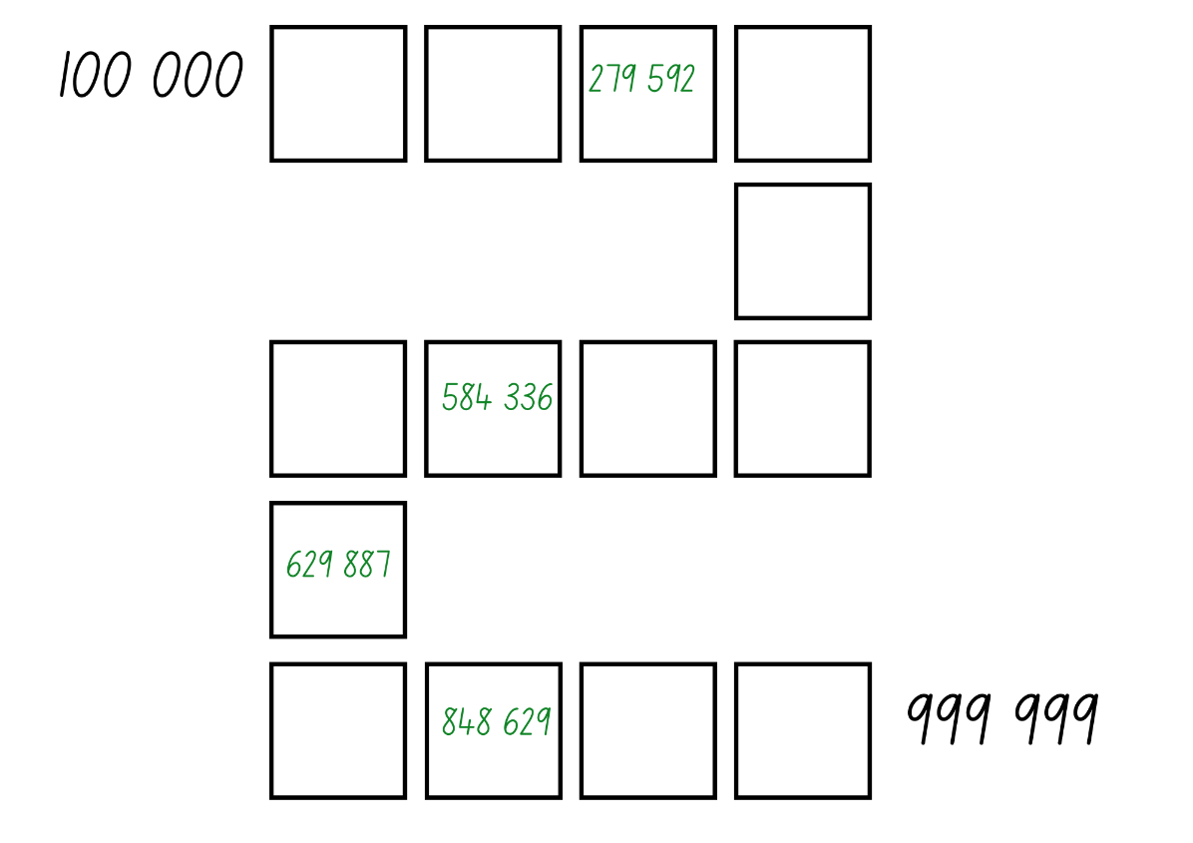

1. If numbers cannot be placed, students miss their turn. Play continues until all boxes are filled.
2. The level of difficulty can change by increasing or decreasing the number of digits.

**Note**: the game can also be played as whole class. Use dice that have a zero, as it is important to understand that the zero is a placeholder and does not have a value. Using a reusable sleeve for the gameboard will allow students to play multiple games.

This table details opportunities for assessment.

|  |  |
| --- | --- |
| Assessment opportunities | Links |
| What to look for:   * Can students recognise, represent and order numbers up to millions? **[MAO-WM-01, MA2-RN-01, MA3-RN-01]** | Links to [National Numeracy Learning Progressions](https://www.australiancurriculum.edu.au/resources/national-literacy-and-numeracy-learning-progressions/version-3-of-national-literacy-and-numeracy-learning-progressions/) (NNLP):   * Stage 2 – NPV6, NPV7 * Stage 3 – NPV6, NPV7. |

### Core lesson: Models help solve problems – 45 minutes

The table below contains suggested learning intentions and success criteria. These are best co-constructed with students.

|  |  |
| --- | --- |
| Core concept learning intentions | Core concept success criteria |
| All students are learning to:   * connect addition and subtraction number sentences * apply efficient mental and written strategies to solve addition and subtraction problems. | All students can:   * demonstrate how addition and subtraction are inverse operations * apply the complement principle of addition and subtraction * explain and justify responses by using by using the inverse operation. * represent a problem on a tape or bar model * solve word problems relating to addition and subtraction. |

1. Write an addition equation on the board, for example, 127 + 13 = ? Ask students what strategies they could use to solve the equation. Explain to students that a bar model can be used to represent this equation. Discuss and demonstrate using a bar model. Using their whiteboards, have students calculate then discuss the correct answer (see Figure 5).

Figure 5 – Bar model

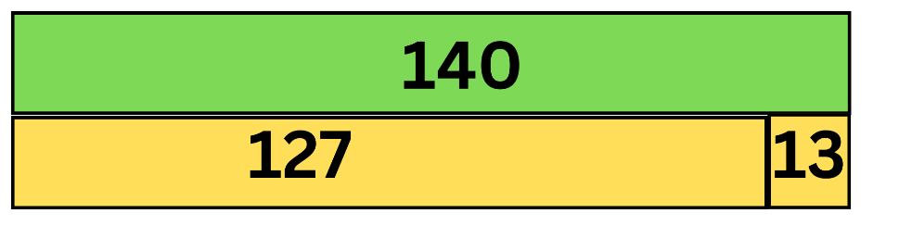

1. Explain that parts on the bar model should be to scale in the diagram. It shows the whole value at the top and the parts below.
2. Display the equation 140 − 127 = ? Ask students to identify how they can work out the answer. Discuss the complement principle.

**Note**: the complement principle highlights the inverse relation between addition and subtraction. That is, 3 + 4 = 7 implies 7 − 4 = 3, 7 − 3 = 4 using the complement principle. This use of the complement principle requires recognising that, when 2 numbers are added, subtracting either number from the total produces its complement; that is, the number required to make a group complete.

The table below outlines stimulus prompts to generate conversation about the topic, along with anticipated responses from students.

|  |  |
| --- | --- |
| Prompts | Anticipated student responses |
| * What similarities do you notice between the 2 number sentences? * What connection do you notice between addition and subtraction? * Could you demonstrate the subtraction equation in another way? * What are you wondering? | * All the same numbers are used in the number sentence, just different positions. * The number sentences are equivalent. * Addition and subtraction are opposites. There are 2 parts to making the whole number. * 140 − 127 = 13. |

1. Ask students to write another subtraction sentence on their whiteboards, using the same numbers 140 − 13 = 127. Discuss how they created the number sentence using the complement principle.
2. Display the problem: A store had 315 cans of soup. They received a delivery of 421 more cans. Ask:

* What is the problem asking you to find? (How many cans of soup there are in total)
* What operation should you be using? (addition)

1. Model solving the equation and representing it using a tape model.
2. Ask students to record equations for the soup problem using the complement principle. For example, 421 + 315 = 736, 736 − 315 = 421, 736 − 421 = 315 (see Figure 6).

Figure 6 – Complement principle

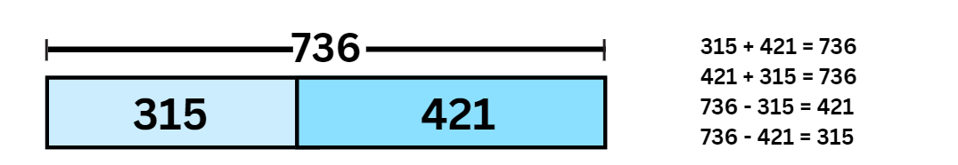

1. Display Resource 3: Subtraction problem. Ask students:

* What is the problem asking?
* What operation should be used to solve this problem?
* What are the parts that make up the whole?
* What parts do you already know?
* What equation can be used to represent this problem?
* What strategies can be used to solve this problem?
* What should be recorded in the missing part of the bar model?
* How would the bar model change if it were raining? Draw a bar model to explain your thinking.

1. Give students time to answer the question and record equations, then regroup as a class and discuss findings.
2. Display Resource 4: Word problems. Ask students to select 4 problems to solve. Remind students to represent the problems using the bar or tape model, then select an appropriate strategy to solve the problem.

This table details opportunities for differentiation.

|  |  |
| --- | --- |
| Too hard? | Too easy? |
| Students cannot apply addition and subtraction strategies to solve problems.   * Provide students with word problems involving 2 digits. * Provide students with MAB materials to model the problem. | Students can apply addition and subtraction strategies to solve problems.   * Students solve the problem using more than one strategy and justify which strategy is more efficient. * Provide students with multistep problems that require addition and subtraction. |

### Consolidation and meaningful practice – 10 minutes

1. Display Resource 5: Consolidation task. In pairs, students share their explanations to the following questions:

* How does this bar or tape model differ from the one you have looked at before?
* How does this bar or tape model help you find the answer to the question?
* What equation would match this model?

This table details opportunities for assessment.

|  |  |
| --- | --- |
| Assessment opportunities | Links |
| What to look for:   * Can students represent a problem on a tape or bar model? **[MAO-WM-01, MA2-AR-01, MA3-AR-01]** * Can students solve word problems relating to addition and subtraction? **[MAO-WM-01, MA2-AR-01, MA3-AR-01]** | Links to [National Numeracy Learning Progressions](https://www.australiancurriculum.edu.au/resources/national-literacy-and-numeracy-learning-progressions/version-3-of-national-literacy-and-numeracy-learning-progressions/) (NNLP):   * Stage 2 – AdS7, AdS8 * Stage 3 – AdS7, AdS8. |

## Lesson 3

**Core concept**: there is a connection between place value and additive thinking.

### Daily number sense: True or False? – 10 minutes

The table below contains a suggested learning intention and success criteria. These are best co-constructed with students.

|  |  |
| --- | --- |
| Daily number sense learning intention | Daily number sense success criteria |
| Students are learning to:   * use the principle of equality. | Students can:   * solve equivalent addition and subtraction number sentences. |

This activity is an adaptation of [True or False?](https://nrich.maths.org/14797) from [NRICH](https://nrich.maths.org/) by University of Cambridge (Faculty of Mathematics).

1. Students need to decide whether the number sentences in Resource 6: True or false? are true or false. Students [turn and talk](https://education.nsw.gov.au/teaching-and-learning/curriculum/literacy-and-numeracy/teaching-and-learning-resources/numeracy/talk-moves) to share their ideas and record their answers on a white board.
2. Regroup as a class and ask:

* Which are true? Which are false? How do you know?
* What strategies did you use to find the answer without doing any calculating?

**Note**: the activity can be adapted by using 3-digit number sentences.

This table details opportunities for assessment.

|  |  |
| --- | --- |
| Assessment opportunities | Links |
| What to look for:   * Can students solve equivalent addition and subtraction number sentences? **[MAO-WM-01, MA2-AR-01, MA3-AR-01]** | Links to [National Numeracy Learning Progressions](https://www.australiancurriculum.edu.au/resources/national-literacy-and-numeracy-learning-progressions/version-3-of-national-literacy-and-numeracy-learning-progressions/) (NNLP):   * Stage 2 – AdS7 * Stage 3 – AdS7.   Links to suggested [Interview for Student Reasoning](https://policies.education.nsw.gov.au/teaching-and-learning/curriculum/literacy-and-numeracy/assessment-resources/ifsr) (IfSR) tasks:   * **Stage 2 – IfSR-AT**: 2A.1 * **Stage 3 – IfSR-AT:** 2A.1. |

### Core lesson – 45 minutes

#### Stage 2 task: Decades as landmarks

The table below contains a suggested learning intention and success criteria. These are best co-constructed with students.

|  |  |
| --- | --- |
| Core concept learning intention | Core concept success criteria |
| Students working towards Stage 2 outcomes are learning to:   * select strategies to solve addition and subtraction problems. | Students working towards Stage 2 outcomes can:   * use partitioning to add and subtract numbers * count forwards and backwards by 10 on and off the decade. |

This activity is an adaptation of [Addition: Chess – The Rook](https://www.resolve.edu.au/addition-chess-rook) from [reSolve: Maths by Inquiry](https://www.resolve.edu.au/) by Australian Government Department of Education.

1. Display Resource 7: Chess pieces and introduce the rook in chess. Explain that on a 100 number chart chessboard, when the rook moves along a row, the value of numbers increases or decreases by one. When it moves up and down a column, the value increases or decreases by 10 (see Figure 7).

Figure 7 – The Rook's moves

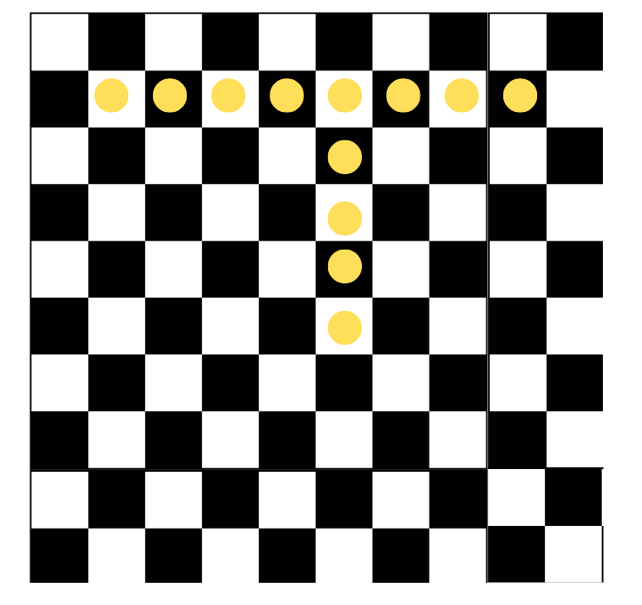

1. Display Resource 8: Chess chart 1. Explain that the rook starts at 14 and wants to move 32 places. Ask:

* How could you move the rook?
* Can you partition the number 32 to help solve this?
* How does partitioning this number help the rook move places?

1. Model how to partition the number 32, separating it into 30 + 2 and how to move places by using the partitioned number. Start at 14 on the chart, add 10 + 10 + 10 by moving down 3 rows and then add 1 + 1 by moving 2 spaces to the right on the chessboard, ending on the number 46. Ask students:

* What number sentence could you use to show what we did in the display?
* Is there another way to demonstrate this number problem? For example, a blank number line or a bar model.

1. Display Resource 9: Chess chart 2. Provide students with individual whiteboards and Resource 10: Empty chart. In pairs, students [brainstorm](https://app.education.nsw.gov.au/digital-learning-selector/LearningActivity/Card/542) responses to the problem: the rook starts at 23 and moves to 78. Ask:

* What different ways can the rook get from 23 to 78?
* How many ways can you find?
* Can it also be represented on a number line? (See Figure 8).

Figure 8 – Sample responses

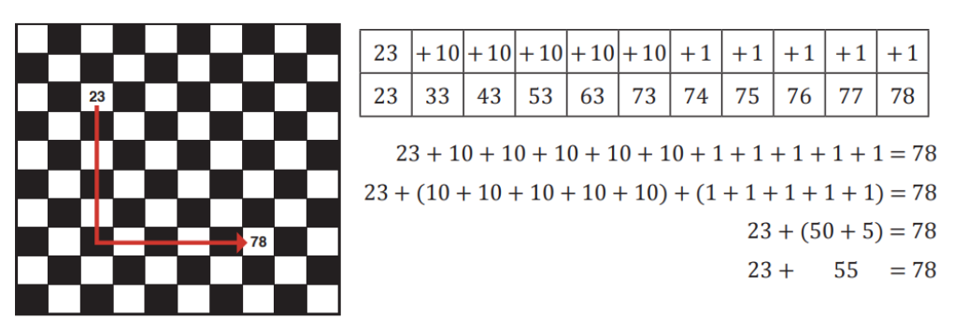

1. Record responses on the board. Model how the number sentence can be represented as 23 + 55 = 78 or 55 + 23 = 78 (see Figure 9).

Figure 9 – Number sentence model

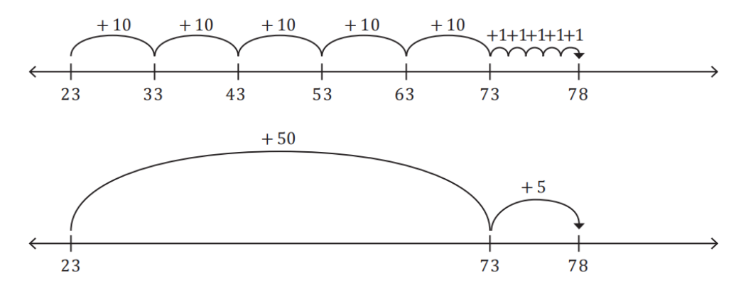

**Note:** this illustrates the commutative property of addition. When 2 numbers are added, their order can be changed without affecting the sum.

1. Display Resource 11: Chess chart 3. Explain that the rook starts at 52 and moves to 18. In pairs, students brainstorm responses to the problem. Ask:

* What are the different ways the rook can get from 52 to 18?
* How many ways could you find?

1. Explain there are 2 ways for the rook to move from 52 to 18. For example, model 52 − 10 − 10 − 10 − 1 − 1 − 1 − 1 = 18 and 52 − 1 − 1 − 1 − 1 − 10 − 10 − 10 = 18. Ask students how these can be represented as a number sentence or on a number line. Record responses on the board (see Figure 10).

Figure 10 – Student samples

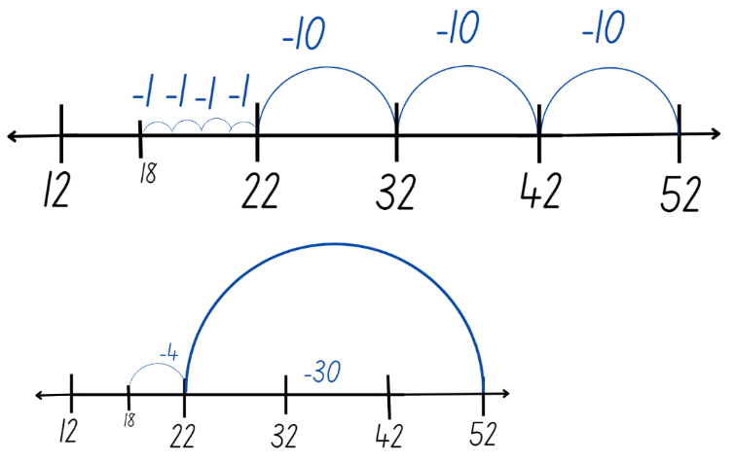

1. Display the following problems and ask students to select 2 of the problems to solve:

* The rook starts at 16 and moves to 28.
* The rook starts at 34 and moves to 11.
* The rook starts at 56 and moves to 82.
* The rook starts at 91 and moves to 57.

1. Provide students with their own copy of Resource 10: Empty chart to help solve the problem. Students record responses.

This table details opportunities for differentiation.

|  |  |
| --- | --- |
| Too hard? | Too easy? |
| Students cannot partition numbers to solve addition and subtraction problems.   * Provide students with a labelled hundreds chart chessboard Resource 10: Empty chart. * Use concrete materials to model addition and subtraction. | Students can partition numbers to solve addition and subtraction problems.   * Ask students to play the game again, bridging to the nearest 10 first. Ask students how it changes the number of moves they make and if it is an efficient strategy. * Students create a path for a partner to follow. Students explain their moves using the number line. |

This table details opportunities for assessment.

|  |  |
| --- | --- |
| Assessment opportunities | Links |
| What to look for:   * Can students partition numbers when adding and subtracting? **[MAO-WM-01, MA2-AR-01]** * Can students count forwards and backwards on and off the decade? **[MAO-WM-01, MA2-RN-01]** | Links to [National Numeracy Learning Progressions](https://www.australiancurriculum.edu.au/resources/national-literacy-and-numeracy-learning-progressions/version-3-of-national-literacy-and-numeracy-learning-progressions/) (NNLP):   * Stage 2 – AdS7, CPr6, CPr7.   Links to suggested [Interview for Student Reasoning](https://education.nsw.gov.au/teaching-and-learning/curriculum/literacy-and-numeracy/assessment-resources/ifsr) (IfSR) tasks:   * **Stage 2 – IfSR-NP**: 4C.2, 4C.3, 4C.6, 4C.7. |

#### Stage 3 task: Levelling

The table below contains a suggested learning intention and success criteria. These are best co-constructed with students.

|  |  |
| --- | --- |
| Core concept learning intention | Core concept success criteria |
| Students working towards Stage 3 outcomes are learning to:   * apply efficient mental and written strategies to solve addition and subtraction problems. | Students working towards Stage 3 outcomes can:   * apply the strategy of levelling to addition problems * use estimation and place value understanding to solve addition problems. |

This activity is an adaptation of [Additive strategies: Closest to 100 (Task 5)](https://education.nsw.gov.au/teaching-and-learning/curriculum/literacy-and-numeracy/teaching-and-learning-resources/numeracy/explicit-teaching-strategies/stage-3/numbers-and-algebra/additive) from Stage 3 numbers and algebra by State of New South Wales (Department of Education).

1. Display the equation 4988 + 955 and ask students what some of the strategies are that they can use to solve this equation. Record student responses.
2. Model the levelling strategy and ask:

* What worked well with this strategy?
* Why is levelling an efficient strategy?

1. Explain to students that having a number on the decade is easier to solve – it makes levelling a useful strategy (see Figure 11).

Figure 11 – Levelling

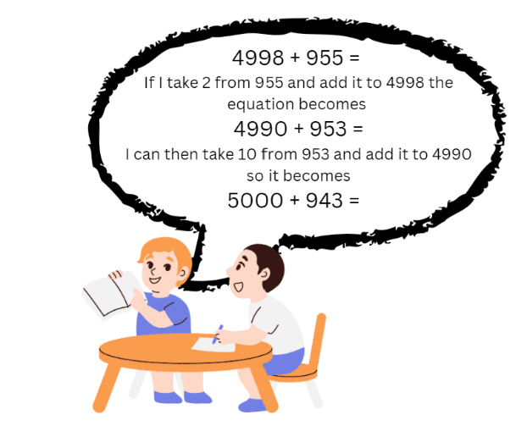

1. Inform students they will be using levelling and estimating to solve addition equations in the game ‘Closest to 1000’. Students work in pairs against another pair of students to allow for mathematical conversations.
2. Students use the numbers to form a 2-digit number, for example, 26. The aim is to calculate the amount to add to a given number to reach the next multiple of 10.
3. Provide players with a deck of cards and put them in a central pile. One player takes 6 cards and places them face up for everyone to see.
4. With their partner, students record the number sentence with the missing element to reach the next multiple of 10. For example, 26 + ? = 30. Students work with their partner to calculate the missing number. Discuss strategies.
5. The goal is to make two 3-digit numbers that when added together get as close to a total of 1000 as possible. Each card can only be used once.
6. Highlight to students that they should think about which number they use in which place value. For example, using the digits 123 + 456 will not get them as close to 1000 as 612 + 354. Students can also use estimation to check validity of solutions to addition and subtraction problems.
7. Players score zero points if they can reach exactly 1000. Otherwise, they work out their points based on the difference between their total and 1000. For example, if a team created a total of 912, they would score 88 points.
8. Players record their working out and the cumulative total of their difference to 1000 in their workbook. The winner is the team with the lowest points score at the end.
9. Model the game for students using levelling to solve the equations.
10. Regroup students and ask:

* What did you notice when you were playing ‘Closest to 1000’?
* What were some of the challenges?
* How did estimation help the placement of the digits?

This table details opportunities for differentiation.

|  |  |
| --- | --- |
| Too hard? | Too easy? |
| Students cannot use levelling to solve addition.   * Change the target number to a smaller number. For example, 100. * Students create 2-digit numbers to add. * Use a bead string, number line or hundreds chart to empower students into the task. | Students can use levelling to solve addition.   * Change the target number to a value off the decade. For example, 956. * Students create 4-digit numbers to add and work towards a target number of 10 000. |

This table details opportunities for assessment.

|  |  |
| --- | --- |
| Assessment opportunities | Links |
| What to look for:   * Can students apply the strategy of levelling to addition problems? **[MAO-WM-01, MA3-AR-01]** * Can students use estimation and place value understanding to solve addition problems? **[MAO-WM-01, MA3-AR-01]** | Links to [National Numeracy Learning Progressions](https://www.australiancurriculum.edu.au/resources/national-literacy-and-numeracy-learning-progressions/version-3-of-national-literacy-and-numeracy-learning-progressions/) (NNLP):   * Stage 3 – AdS7. |

### Discuss and connect the mathematics – 5 minutes

1. As a class, reflect on learning and ask questions, such as:

* What are some advantages and disadvantages of the strategy you used?
* When might you use this strategy again?
* If you were teaching this strategy to a classmate, what is the most important thing to explain?

## Lesson 4

**Core concept**: mathematicians use a variety of strategies to solve addition and subtraction problems.

### Daily number sense – 15 minutes

1. From a class need surfaced through formative assessment data, identify a short, focused activity that targets students’ knowledge, understanding and skills. Example activities may be drawn from the following resources:

* [Mathematics K-6 resources](https://education.nsw.gov.au/teaching-and-learning/curriculum/mathematics/mathematics-curriculum-resources-k-12/mathematics-k-6-resources#catalogue_auto)
* [Universal Resources Hub](https://resources.education.nsw.gov.au/home).

### Core lesson – 40 minutes

#### Stage 2 task: Compensation strategy

The table below contains a suggested learning intention and success criteria. These are best co-constructed with students.

|  |  |
| --- | --- |
| Core concept learning intention | Core concept success criteria |
| Students working towards Stage 2 outcomes are learning to:   * select strategies to solve addition and subtraction problems. | Students working towards Stage 2 outcomes can:   * use partitioning of numbers to add and subtract numbers * use the compensation strategy. |

This activity is an adaptation of [Dicey Addition](https://nrich.maths.org/11863) from [NRICH](https://nrich.maths.org/) by University of Cambridge (Faculty of Mathematics).

1. Draw Figure 12 on the board and provide a [9-sided die](https://nrich.maths.org/6717). Explain that the aim of the activity is to make an addition number sentence with an answer as close to 100 as possible. Students will roll the die 4 times to make two 2-digit numbers. After each throw of the die, students will make a decision about which box to place the number in. Ask students what they need to think about before putting a number in a box if the goal is to get as close to 100 as possible.

Figure 12 – Addition grid

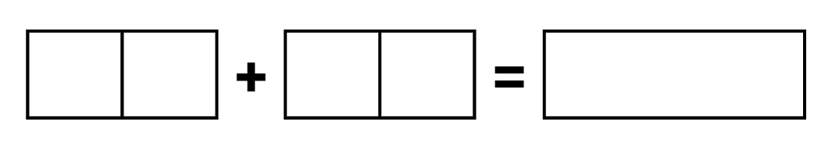

1. After each roll of the die, decide which of the squares to put that number in. Roll the die 4 times until all cells are full and ask students to model the best placement of digits in the boxes.

The table below outlines stimulus prompts to generate conversation about the topic, along with anticipated responses from students.

|  |  |
| --- | --- |
| Prompts | Anticipated student responses |
| * If a 9 is rolled, should it be put in the tens column or the ones column? * If a one is rolled, should it be put it in the tens column or the ones column? * If 5 is rolled, should it be put it in the tens column or the ones column? | * The ones column because if it is put in the tens column, it will make the number in the nineties. That is very close to 100. Unless I roll a one on my next turn, it will be quite far over 100. * The ones column because if it is put it in the tens column, it will make my number less than 20. That is not close to 100 unless I roll a very large number next time. * The tens column because it makes a number around halfway to 100. There is a good chance of getting close to 100 with whatever number is roll next. |

1. Model and discuss solving the addition number sentence using the compensation strategy. For example, 28 + 35 is the same as 30 + 35 = 65, subtract 2 to obtain 63 (see Figure 13).

Figure 13 – Compensation strategy

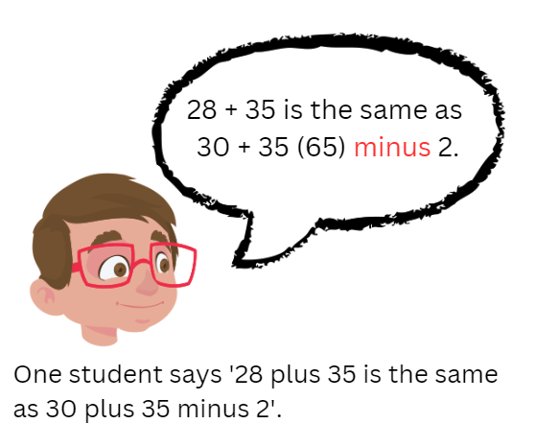

1. Draw Figure 14 on the board. Explain that the aim of this activity is to make a subtraction number sentence with an answer that is the smallest value possible from 100. Roll a 9-sided die to make a 2-digit number. After each throw of the die, students decide about what box the number is placed in. Explain the goal is to make the smallest number possible. Ask students what they need to think about before putting a number in a box and why.

Figure 14 – Subtraction grid

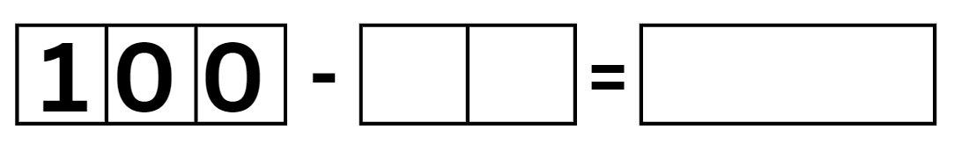

1. Model and discuss solving the subtraction number sentence using the compensation strategy. For example, 100 minus 78 is the same as 100 minus 80 is 20, plus 2 makes 22 (see Figure 15).

Figure 15 – Compensation strategy subtraction

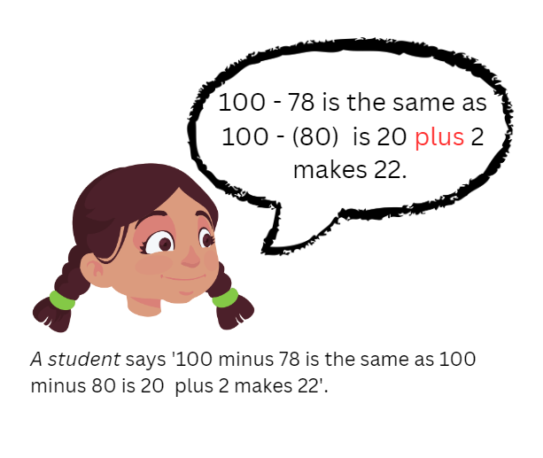

1. In pairs, provide students with a 9-sided die each. Students roll the dice to create their own addition number sentence and record it in their workbook. Students solve the addition number sentence using the compensation strategy. The student with the closest sum to 100 wins a point. Repeat this 3 times with their partner.
2. In pairs, students roll the dice to create their own subtraction number sentence and record it in their workbook. Students solve the subtraction number sentence using the compensation strategy. The student that has the solution with the smallest value wins a point.
3. Repeat several times and discuss findings.

This table details opportunities for differentiation.

|  |  |
| --- | --- |
| Too hard? | Too easy? |
| Students cannot apply the compensation strategy to addition and subtraction.   * Students add a 2-digit and one-digit number. * Provide students with concrete materials such as MAB materials to solve the number sentences. | Students can apply the compensation strategy to addition and subtraction.   * For addition, students roll 3-digit numbers with the goal of creating the number closest to 1000. * For subtraction, students roll a 4-digit and 3-digit number with the goal of creating the smallest value possible. |

This table details opportunities for assessment.

|  |  |
| --- | --- |
| Assessment opportunities | Links |
| What to look for:   * Can students solve addition and subtraction problems using the compensation strategy? **[MAO-WM-01, MA2-AR-01, MA2-AR-02]** * Can students use partitioning to add and subtract numbers? **[MAO-WM-01, MA2-AR-01]** | Links to [National Numeracy Learning Progressions](https://www.australiancurriculum.edu.au/resources/national-literacy-and-numeracy-learning-progressions/version-3-of-national-literacy-and-numeracy-learning-progressions/) (NNLP):   * Stage 2 – AdS7.   Links to suggested [Interview for Student Reasoning](https://education.nsw.gov.au/teaching-and-learning/curriculum/literacy-and-numeracy/assessment-resources/ifsr) (IfSR) tasks:   * **Stage 2 – IfSR-AT**: 2A.2, 2A.3. |

#### Stage 3 task: Constant difference

The table below contains a suggested learning intention and success criteria. These are best co-constructed with students.

|  |  |
| --- | --- |
| Core concept learning intention | Core concept success criteria |
| Students working towards Stage 3 outcomes are learning to:   * apply efficient mental and written strategies to solve addition and subtraction problems. | Students working towards Stage 3 outcomes can:   * apply constant difference to subtraction problems. |

1. Display the equation 5009 − 3997 = ? Ask students what strategies they can use to solve this equation. Record responses on the board (see Figure 16).
2. Model the strategy of constant difference and ask:

* What worked well with this strategy?
* Why is this an efficient strategy?
* When wouldn’t this be the most efficient strategy? Can you provide an example?

Figure 16 – Constant difference

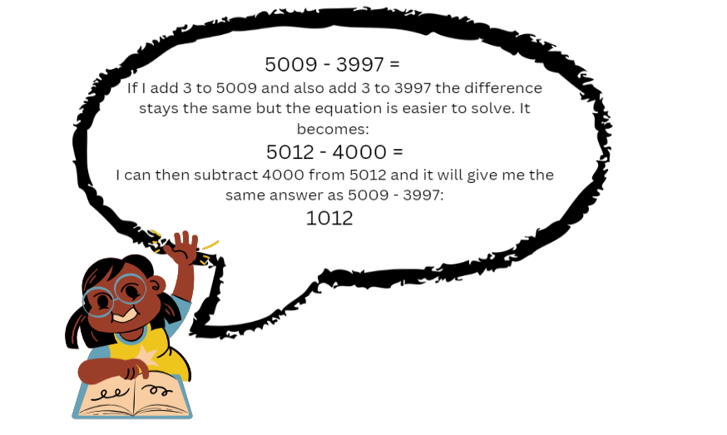

**Note**: explain that subtracting numbers on the decade makes the numbers easier to work with. Students can use constant difference to help create numbers on the decade that are easier to subtract.

1. Provide pairs of students with Resource 12: Race car rumble, a 6-sided dice, 2 counters, whiteboard and calculator.
2. Players take turns rolling the dice. They move forward the number of spaces on the dice. Players then solve the subtraction problem displayed on their whiteboard. Students use a calculator to check their partner’s answer. If correct, that player remains in their place. If incorrect, they move back to their previous place.
3. Model the game using constant difference to solve the equations. Players continue taking turns. The first player to reach the end of the board is the winner.
4. Regroup students and ask:

* What works well when using constant difference?
* What was challenging?
* Why is constant difference an efficient strategy?

This table details opportunities for differentiation.

|  |  |
| --- | --- |
| Too hard? | Too easy? |
| Students cannot use constant difference to solve subtraction.   * Students solve subtraction questions involving a 3-digit and a 2-digit number. * Provide students with a two-hundred chart to support calculations. | Students can use constant difference to solve subtraction.   * Students write a word problem to be solved using constant difference. * Students create their own gameboard. |

This table details opportunities for assessment.

|  |  |
| --- | --- |
| Assessment opportunities | Links |
| What to look for:   * Can students apply efficient mental and written strategies to solve addition and subtraction problems? **[MAO-WM-01, MA3-AR-01]** | Links to [National Numeracy Learning Progressions](https://www.australiancurriculum.edu.au/resources/national-literacy-and-numeracy-learning-progressions/version-3-of-national-literacy-and-numeracy-learning-progressions/) (NNLP):   * Stage 3 – AdS8.   Links to suggested [Interview for Student Reasoning](https://education.nsw.gov.au/teaching-and-learning/curriculum/literacy-and-numeracy/assessment-resources/ifsr) (IfSR) tasks:   * **Stage 3 – IfSR-AT**: 3A.4, 3A.5. |

### Discuss and connect the mathematics – 5 minutes

1. Reflect on learning by asking questions, such as, ‘Can you share something that you found:

* enjoyable?
* challenging?
* interesting?’

## Lesson 5

**Core concept**: mathematicians use a variety of strategies to solve addition and subtraction problems.

### Daily number sense: Strike it out! – 15 minutes

Daily number sense activities for Lessons 5 to 7 ‘loop’ back to concepts and procedures covered in previous units to assist students to build an increasingly connected network of ideas. These concepts may differ from the core concepts being covered by the unit.

The table below contains a suggested learning intention and success criteria. These are best co-constructed with students.

|  |  |
| --- | --- |
| Daily number sense learning intention | Daily number sense success criteria |
| Students are learning to:   * recall number bonds. | Students can:   * identify and evaluate various strategies to solve addition and subtraction facts. |

This activity is an adaptation of [Strike it out (addition and subtraction to 20)](https://education.nsw.gov.au/teaching-and-learning/curriculum/mathematics/mathematics-curriculum-resources-k-12/mathematics-k-6-resources/strike-it-out-addition-and-subtraction-to-20) from [Mathematics K-6 resources](https://education.nsw.gov.au/teaching-and-learning/curriculum/mathematics/mathematics-curriculum-resources-k-12/mathematics-k-6-resources) by State of New South Wales (Department of Education).

1. In pairs, provide students with paper and writing materials. Students create a number line from 0–20.

**Multi-age: to support students working towards Stage 3 outcomes, have them create a number line that covers twenty 3-digit numbers, for example, 130 to 150.**

1. The first player chooses 2 numbers from the number line and crosses them out. The same player then circles the sum or difference of the numbers and records the calculation. For example, 5 + 10 = 15 (see Figure 17).

Figure 17 – Strike it out 1

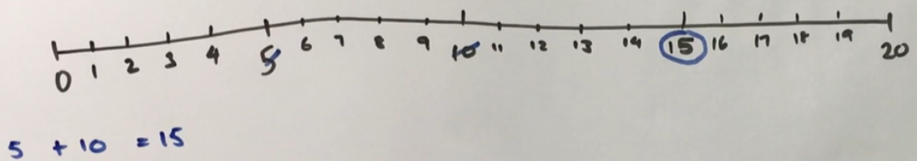

1. The second player must start their turn by crossing out the number circled by the first player. The second player then crosses out a second number not already used. Player 2 then circles the sum or difference of the numbers and records the calculation. For example, 15 + 4 = 19 (see Figure 18).

Figure 18 – Strike it out 2

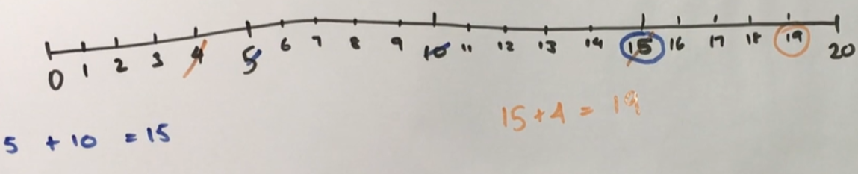

1. Play continues until one player is no longer able to make a valid move (see Figure 19). The player who stops their opponent from being able to take a turn is the winner.

Figure 19 – Strike it out 3

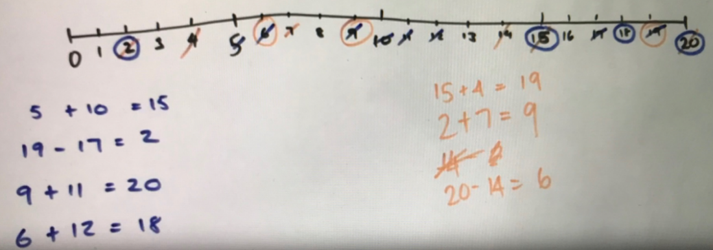

1. Play the game again, swapping roles so that the other student starts.
2. As a class, discuss and reflect on the activity by asking questions, such as:

* How did you know when the game was over?
* Can you share the strategy that you used to try to win the game? Was it successful? Why or why not?
* Which addition and subtraction strategies did you find useful?
* When adding, did it matter which way you added the numbers? Why not? (Commutative property).
* Can you think of any ways to make the game easier or harder?

This table details opportunities for assessment.

|  |  |
| --- | --- |
| Assessment opportunities | Links |
| What to look for:   * Can students identify and evaluate various strategies to solve addition and subtraction facts? **[MAO-WM-01, MA2-AR-01, MA3-AR-01]** | Links to [National Numeracy Learning Progressions](https://www.australiancurriculum.edu.au/resources/national-literacy-and-numeracy-learning-progressions/version-3-of-national-literacy-and-numeracy-learning-progressions/) (NNLP):   * Stage 2 – AdS7 * Stage 3 – AdS7. |

### Core lesson – 45 minutes

#### Stage 2 task: Levelling and constant difference

The table below contains a suggested learning intention and success criteria. These are best co-constructed with students.

|  |  |
| --- | --- |
| Core concept learning intention | Core concept success criteria |
| Students are working towards Stage 2 outcomes learning to:   * select strategies to solve addition and subtraction problems. | Students working towards Stage 2 outcomes can:   * apply the levelling strategy to addition problems * apply the constant difference strategy to subtraction problems. |

This activity is an adaptation of [Race to zero (subtracting tens and ones)](https://education.nsw.gov.au/teaching-and-learning/curriculum/mathematics/mathematics-curriculum-resources-k-12/mathematics-k-6-resources/race-to-zero-subtracting-tens-and-ones) from [Mathematics K-6 resources](https://education.nsw.gov.au/teaching-and-learning/curriculum/mathematics/mathematics-curriculum-resources-k-12/mathematics-k-6-resources) by State of New South Wales (Department of Education)

1. Display the number sentence 28 + 35. Ask students to identify strategies they could use to solve this problem. Record responses on the board, highlighting previously discussed strategies.
2. Introduce the levelling strategy for addition. Demonstrate that 28 + 35 is the same as 30 + 33, where 2 has been taken from 35 and added to 28 to make 30. Ask students how this helps to solve the number sentence.

**Note:** discuss the concept of partitioning or regrouping numbers. Start with 28 + 35 and partition 35 into 2 parts, 2 and 33. Add the partitioned parts to 28, 28 + 2 = 30 and 33 remains the same. Explain that you now have 30 + 33, which is the same as 28 + 35. By partitioning 35 into 2 and 33 and adding those parts to 28, students can see that 28 + 35 is equal to 30 + 33 (see Figure 20).

Figure 20 – Stage 2 Levelling

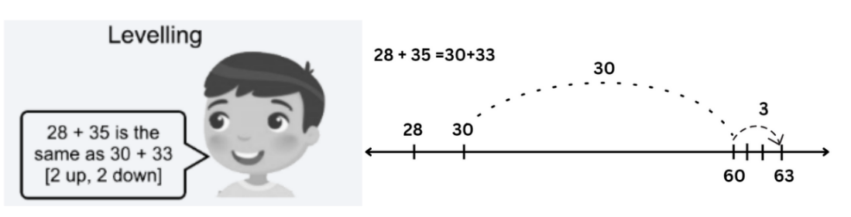

© NSW Education Standards Authority (NESA) for and on behalf of the Crown in right of the State of New South Wales, 2022.

1. Model solving the number sentence 30 + 33.

**Note:** explain that having a number on the decade makes the number sentence easier to solve because students can use their knowledge of place value.

1. In pairs, provide students Resource 13: 119 number chart, a 9-sided die, counters and an individual whiteboard. Students start at zero, placing their counter to show their position. Students roll the die twice to create a 2-digit number. Students repeat this to create a second 2-digit number. Students record the addition number sentence on whiteboards.
2. Before the students start, model solving the addition number sentence using levelling and record thinking on the board. For example, 23 + 45 is the same as 20 + 48. Students need to explain their thinking and, if their partner agrees, they move their counter to that value on Resource 13: 119 number chart.
3. Explain that students need to think about creating numbers that when added will get them as close to 119 as possible. If a student’s roll means they would move beyond 119, they need to go back to 90 for their next turn. Ask students what they need to think about when forming numbers.

**Note:** highlight the connection to place value. For example, if a one and 7 are rolled, creating 17 would be better than creating 71.

1. Regroup and introduce the constant difference for subtraction strategy. Demonstrate that 85 – 58 is the same as 87 – 60, where 2 has been added to both numbers, keeping a constant difference between them. Discuss how this helps to solve the number sentence.

**Note:** the strategy of constant difference for subtraction involves manipulating the numbers in a subtraction problem by adding or subtracting the same value to both numbers to ensure one number is on the decade. The key idea behind this strategy is that even though 2 is added to both numbers, the difference between them remains the same (see Figure 21).

Figure 21 – Constant difference

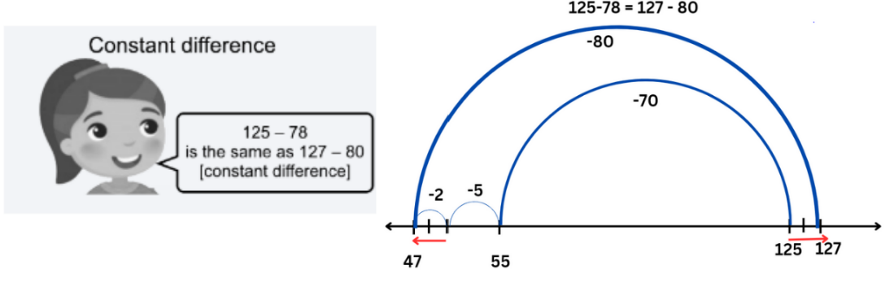

© NSW Education Standards Authority (NESA) for and on behalf of the Crown in right of the State of New South Wales, 2022.

1. Model solving the number sentence 87 − 60. Explain having a number on the decade makes the number sentence easier to solve.
2. Introduce the activity ‘Race to zero’. Students start at 119, placing their counter to show their position. Students roll the die twice and use the 2 numbers to create a 2-digit number. Students record the subtraction number sentence on whiteboards.

**Note:** discuss connection to place value. For example, if a 5 and a 2 are rolled, ask if it would be better to make 25 or 52.

1. Model solving the subtraction number sentence using constant difference. For example, 119 − 23 is the same as 120 − 24. Students need to explain their thinking and if their partner agrees they move their counter to the that value on Resource 13: 119 number chart.
2. Explain that students need to think about creating numbers that will help get as close to zero as possible. If a students’ roll means they would move below zero into negative numbers, they must move their counter back to 25 for their next turn. Students take turns until someone has been able to land exactly on zero.

This table details opportunities for differentiation.

|  |  |
| --- | --- |
| Too hard? | Too easy? |
| Students cannot use the levelling or constant difference strategies.   * Provide students with MAB materials to represent the number sentence. * Students use Resource 13: 119 number chart to assist with adding and subtracting. | Students can use the levelling and constant difference strategies.   * Students play ‘Race to 1000’ using 3-digit numbers. * Students play ‘Race to zero’ from 1000 using 3-digit numbers. |

This table details opportunities for assessment.

|  |  |
| --- | --- |
| Assessment opportunities | Links |
| What to look for:   * Can students apply the levelling strategy to addition problems? **[MAO-WM-01, MA2-AR-01, MA2-AR-02]** * Can students apply the constant difference strategy to subtraction problems? **[MAO-WM-01, MA2-AR-01, MA2-AR-02]** | Links to [National Numeracy Learning Progressions](https://www.australiancurriculum.edu.au/resources/national-literacy-and-numeracy-learning-progressions/version-3-of-national-literacy-and-numeracy-learning-progressions/) (NNLP):   * Stage 2 – AdS7. |

#### Stage 3 task: Algorithms

The table below contains a suggested learning intention and success criteria. These are best co-constructed with students.

|  |  |
| --- | --- |
| Core concept learning intention | Core concept success criteria |
| Students working towards Stage 3 outcomes are learning to:   * apply efficient mental and written strategies to solve addition and subtraction problems. | Students working towards Stage 3 outcomes can:   * demonstrate place value to partition and regroup numbers to solve problems * identify efficient and inefficient multidigit subtraction strategies. |

1. Display the equation 1286 + 437 on the board and ask students to identify some strategies that can be used to solve the problem. Record strategies on the board.
2. Introduce an algorithm for addition. Model setting up an algorithm for the equation 1286 + 437. Demonstrate that the numbers in the equation are lined up according to place value. Explain that if the numbers are not correctly aligned, it will significantly change the answer. For example, if not correctly aligned, the ones in 437 could sit in the tens column – 7 tens are worth significantly more than 7 ones and would provide an incorrect answer.
3. Explain that, when a vertical algorithm for addition is solved, students begin by finding the sum of the ones. They should then find the sum of the tens, followed by the sum of the hundreds and the sum of the thousands. The sum of 13 ones, 110 tens, 600 hundreds and 1000 thousands is equal to 1723 (see Figure 22).

Figure 22 – Long addition algorithm

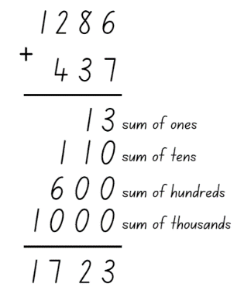

1. Model and explain how to solve the algorithm using a shorter method by recording the exchange in the ones, to tens, to hundreds column during the addition to get a final answer of 723 (see Figure 23).

Figure 23 – Addition algorithm

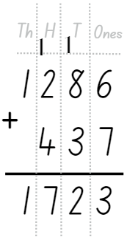

**Note:** explain that the exchange across each of the place value columns is recorded as a one at the top of the column.

1. Introduce the activity ‘Race to 5000’. Provide pairs of students with a deck of 0–9 cards and their workbook. The first player turns over 6 cards. Players need to make two 3-digit numbers and record them as an addition equation in their workbook. Players solve the addition equation using an algorithm in their workbook.
2. Players need to explain their thinking as they solve the equation. If their partner agrees that answer becomes the new total. On their next go, students turn over 3 cards to make a 3-digit number to add to their previous total. Players continue taking turns until someone reaches 5000.
3. Students play ‘Race to 5000’ and then regroup as a class to discuss the following questions:

* What worked well when using an algorithm for addition?
* What was challenging about using an algorithm for addition?

1. Display the equation 1286 − 439 and ask students to identify some of the strategies that can be used to solve this problem. Record these on the board.
2. Introduce an algorithm for subtraction. Model setting up an algorithm for the equation 1286 − 439 and demonstrate that the numbers are aligned correctly according to their place value. Explain when a vertical algorithm is used for subtraction, sometimes, students need to exchange and regroup across the place value columns to solve the equation.

**Note:** solving a subtraction algorithm requires ‘trading units’, which involves partitioning and regrouping. To subtract 439 from 1286 using an algorithm, the 1286 is thought of as being decomposed into 1 thousand, 2 hundreds, 8 tens and 6 ones. Then one 10 is traded for 10 ones so that 1286 is represented as 1 thousand, 2 hundreds, 7 tens and 16 ones.

1. Model solving the algorithm (see Figure 24).

Figure 24 – Long subtraction algorithm

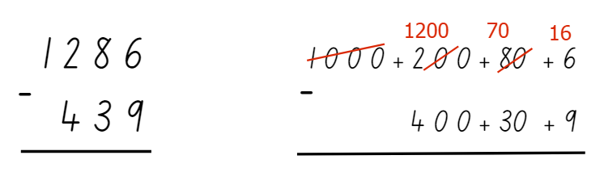

1. Display Resource 14: Trading and ask the students to justify their reasoning to the following questions:

* Does the one in the working out for these problems represent the same amount?
* In problem A, why is the one added to the 5, but in problem B, the 10 is added to the 2?

1. Provide pairs of students with a deck of cards and their workbook to play ‘Race back to 10’. The first player starts at 4999, then turns over 3 cards. Player 1 needs to make a 3-digit number and record it as a subtraction equation in their workbook, for example, 4999 − (the 3-digit number). Player 1 solves the problem using an algorithm and, if correct, they will begin their next turn with the new number. For example, if the problem was 4999 − 321 = 4678, the player would start their next turn at number 4678.
2. Player 2 repeats this process.

**Note:** highlight the importance of placing the larger number on the top line of the algorithm and ensuring the numbers are aligned correctly according to their place value.

1. The aim of the game is to reach number 10. Explain that, as the numbers get smaller, students will need to create smaller numbers with the cards. For example, when the numbers become 2 digits, students will not be able to subtract a 3-digit number. Players choose 2 cards and order them to create a 2-digit number that gets them to zero the quickest. The game ends when one player reaches or passes 10.
2. Regroup and ask:

* What worked well when using an algorithm for subtraction?
* What was challenging about using an algorithm for subtraction?
* Do you think an algorithm is an efficient strategy? Why or why not?

This table details opportunities for differentiation.

|  |  |
| --- | --- |
| Too hard? | Too easy? |
| Students cannot add or subtract 3- to 4-digit numbers using an algorithm.   * Provide students with 2-digit numbers and a starting number of 99. * Provide students with MAB materials to model the calculations. | Students can add and subtract algorithms with numbers of any size.   * Provide a starting number of 10 000 and have students create 4-digit numbers with cards. * Provide cryptarithms for students to manipulate. |

This table details opportunities for assessment.

|  |  |
| --- | --- |
| Assessment opportunities | Links |
| What to look for:   * Can students apply efficient mental and written strategies to solve addition and subtraction problems? **[MAO-WM-01, MA2-RN-01, MA3-AR-01]** * Can students demonstrate place value to partition and regroup numbers to solve problems? **[MAO-WM-01, MA2-RN-01, MA3-AR-01]** | Links to [National Numeracy Learning Progressions](https://www.australiancurriculum.edu.au/resources/national-literacy-and-numeracy-learning-progressions/version-3-of-national-literacy-and-numeracy-learning-progressions/) (NNLP):   * Stage 3 – AdS7, AdS8. |

### Discuss and connect the mathematics –5 minutes

1. As a class, reflect on learning and ask questions, such as:

* What are some advantages and disadvantages of the strategy you used?
* When might you use this strategy again?
* If you were teaching this strategy to a classmate, what is the most important thing to explain?

## Lesson 6

**Core concept**: flexibility and efficiency are important considerations in addition and subtraction.

### Daily number sense: Colour in fractions – 15 minutes

The table below contains a suggested learning intention and success criteria. These are best co-constructed with students.

|  |  |
| --- | --- |
| Daily number sense learning intention | Daily number sense success criteria |
| Students are learning to:   * model and represent fractions on a number line. | Students can:   * model fractions on strips for halves, quarters and thirds * represent fraction families by dividing a whole into equal parts. |

This activity is an adaptation of [Colour in fractions](https://education.nsw.gov.au/teaching-and-learning/curriculum/mathematics/mathematics-curriculum-resources-k-12/mathematics-k-6-resources/colour-in-fractions) from [K-6 Mathematics resources](https://education.nsw.gov.au/teaching-and-learning/curriculum/mathematics/mathematics-curriculum-resources-k-12/mathematics-k-6-resources) by State of New South Wales (Department of Education).

1. Provide students with one die labelled 1, 2, 2, 3, 3, 4 in one colour and another die labelled $\frac{1}{2}$, $\frac{1}{3}$, $\frac{1}{4}$, $\frac{1}{6}$, $\frac{1}{8}$, $\frac{1}{12}$ in a different colour or use Resource 15: Spinner, Resource 16: Fraction wall and coloured pencils or markers.
2. Players take turns to throw both dice or have a spin on their spinners. Students make a fraction, using the first die or spinner as the numerator. Students then colour the equivalent of the fraction shown. For example, if a player spins 2 and quarters, they can colour in:

* $\frac{2}{4}$ of one line
* $\frac{4}{8}$ of one line
* $\frac{1}{4}$ of one line and $\frac{2}{8}$ of another line
* any other combination that is the same as $\frac{2}{4}$.

1. For each roll or spin, students should use a different colour pencil or marker. If a player is unable to use their turn, they ‘pass’.
2. Players take turns to roll or spin and make fractions, marking them on their fraction wall. If the fraction rolled or its equivalent cannot be shaded, that player misses a turn. This becomes more frequent later in the game.
3. Players are not allowed to break up a ‘brick’ on the fraction wall. To finish the game, a player must have had 18 turns or have filled their wall. A larger fraction is not acceptable to finish.
4. The first player to colour in their whole wall is the winner. They should encourage the other player to keep filling their fraction wall or make the greatest number of wholes. If after 18 turns neither player has coloured in their whole wall, the player with the greatest number wins.

This table details opportunities for assessment.

|  |  |
| --- | --- |
| Assessment opportunities | Links |
| What to look for:   * Can students model fractions on strips? **[MAO-WM-01, MA2-PF-01]** * Can students represent fraction families by dividing a whole into equal parts? **[MAO-WM-01, MA2-PF-01]** | Links to [National Numeracy Learning Progressions](https://www.australiancurriculum.edu.au/resources/national-literacy-and-numeracy-learning-progressions/version-3-of-national-literacy-and-numeracy-learning-progressions/) (NNLP):   * Stage 2 – InF2, InF3, InF4 * Stage 3 – InF2, InF3, InF4. |

### Core lesson – 45 minutes

#### Stage 2 task: Tape and bar

The table below contains a suggested learning intention and success criteria. These are best co-constructed with students.

|  |  |
| --- | --- |
| Core concept learning intention | Core concept success criteria |
| Students working towards Stage 2 outcomes are learning to:   * select strategies to solve addition and subtraction problems. | Students working towards Stage 2 outcomes can:   * represent word problems in a tape diagram * solve word problems using addition and subtraction strategies. |

1. Display the word problem: ‘A farmer had 17 cows in one field and 53 cows in another field. How many cows does the farmer have in total?’ Share and discuss the following:

* What do you notice?
* What is this question asking you to find?
* Do you need to use addition or subtraction to find the answer? How do you know?

1. Introduce the tape diagram to students as a way of representing word problems. Display the problem using a tape diagram (see Figure 25). Explain that a tape diagram helps show the part-part-whole relationship when students add numbers together.

Figure 25 – Tape diagram 1

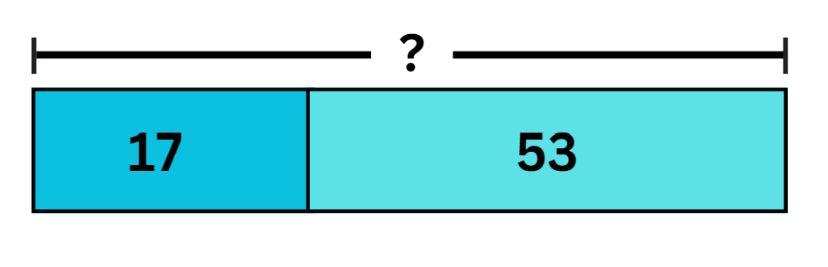

1. Demonstrate how to divide the tape into 2 sections to show each of the parts that you are adding together. The line at the top shows what the whole value of the numbers added together equals. Show students that, when creating a tape diagram, students need to think about the size of the numbers they are representing. For example, 53 is much larger than 17 so it is shown by a larger section of the diagram. Ask students how they can write the problem as a number sentence. For example, 17 + 53.
2. Model writing the number sentence 17 + 53 =? for students, demonstrating that the 2 parts of the tape diagram are added together to make the whole which is represented by the line at the top. Ask students what strategy they could use to find the answer or whole. For example, compensation, bridging the decade, levelling.
3. Record the response on the board. Model using the different strategies to find the solution. Display the solution 17 + 53 = 70 using the tape diagram.
4. Display the word problem: ‘Hannah had 62 stickers, but she uses 27 stickers to decorate her notebook. How many stickers does she have left?’ Ask:

* What do you notice? (How many stickers she has, you need to use subtraction)
* What is this question asking you to find? (How many stickers does she have left after using some of them)
* Do you need to use addition or subtraction to find the answer? (Subtraction)

1. Record responses on the board. Remind students that a tape diagram can be used to represent word problems. Explain again that a tape diagram helps show the part-part-whole relationship when subtracting numbers (see Figure 26).

Figure 26 – Tape diagram 2

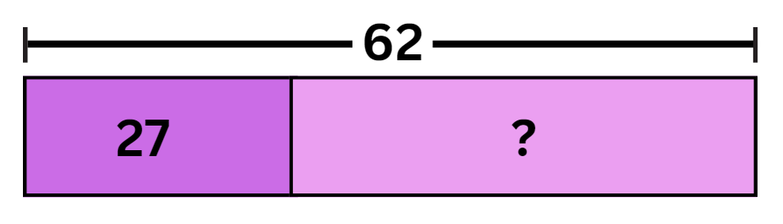

1. Demonstrate that the line at the top shows the whole that is being subtracting from. The tape shows the parts that make up the whole. The first part of the tape diagram is what is subtracted from the whole. The second part is the answer.
2. Show students that, when creating a tape diagram, they need to think about the size of the numbers they are representing.
3. Ask students how they can write the problem as a number sentence (62 − 27).
4. Model writing the number sentence 62 – 27 = ?, demonstrating that 62 is the total number of stickers so it should be shown at the top as a whole. For example, Hannah used 27 so this is one of the parts and students need to work out how many are left, which is what makes up the other part.
5. Ask students what strategy they can use to find the answer, for example, compensation, bridging the decade, constant difference. Record responses and model using different strategies to find the solutions.
6. Display the following word problems and discuss possible strategies students could use, such as bridging the decade, compensation, levelling and constant distance:

* Lisa had 72 lollies, but she gave 33 lollies to her brother. She believes she has 39 lollies left. Is she correct?
* Sarah had 87 marbles, but she accidentally threw 63 in the bin. When she looks at the ones she has left, she thinks she has 24. Is she correct?
* There are 23 children playing in the park. Another 44 come to join. There are now 67 children in the park. Is this correct?
* A bakery sold 53 cupcakes in the morning and 37 cupcakes in the afternoon. The bakers think they sold 80 cupcakes altogether. Are they correct?

1. Tell students that 3 of the problems are correct and one of the word problems is incorrect. The aim is to identify which are correct and which is incorrect.
2. In pairs, students represent the information in each word problem as a tape diagram in their workbook. Explain that they need to discuss and select an appropriate strategy to solve the word problems. Students then record which are correct and which is incorrect.

This table details opportunities for differentiation.

|  |  |
| --- | --- |
| Too hard? | Too easy? |
| Students cannot use the tape or bar model independently.   * Provide students with concrete materials, such as interlocking cubes, to support solving the problem. * Students answer problems involving single digits. | Students can solve questions without using a tape diagram.   * Provide students with addition and subtraction problems involving more than one step. * Provide students word problems involving 3-digit numbers. |

This table details opportunities for assessment.

|  |  |
| --- | --- |
| Assessment opportunities | Links |
| What to look for:   * Can students represent word problems in a tape diagram?? **[MAO-WM-01, MA2-AR-01, MA2-AR-02]** * Can students select appropriate strategies to solve addition and subtraction questions? **[MAO-WM-01, MA2-AR-01, MA2-AR-02]** | Links to [National Numeracy Learning Progressions](https://www.australiancurriculum.edu.au/resources/national-literacy-and-numeracy-learning-progressions/version-3-of-national-literacy-and-numeracy-learning-progressions/) (NNLP):   * Stage 2 – AdS6, AdS7. |

#### Stage 3 task: Estimating and rounding

The table below contains a suggested learning intention and success criteria. These are best co-constructed with students.

|  |  |
| --- | --- |
| Core concept learning intention | Core concept success criteria |
| Students working towards Stage 3 outcomes are learning to:   * use estimation and place value understanding to determine the reasonableness of solutions. | Students working towards Stage 3 outcomes can:   * round numbers appropriately when obtaining estimates. * use place value to add or subtract numbers with different numbers of digits. |

This activity is an adaptation of [Additive strategies: Four strikes and you’re out! (Task 7)](https://education.nsw.gov.au/teaching-and-learning/curriculum/literacy-and-numeracy/teaching-and-learning-resources/numeracy/explicit-teaching-strategies/stage-3/numbers-and-algebra/additive) from Stage 3 numbers and algebra by State of New South Wales (Department of Education).

1. Display the equation 1438 + 129. Ask students what strategies can be used to solve the equation. Record strategies on the board and find the solution to the equation.
2. Ask if there is a way to make a quick estimate of the answer to this question to check the reasonableness of students’ answer. (Yes, rounding to the nearest 10 or hundred and then adding).
3. Explain that rounding is when a number moves up or down to the nearest 10, 100, 1000 and so on.
4. Explain how rounding helps with estimating. For example, when applying rounding to the nearest 10, students can say 1438 + 129 is about 1570 because 1440 + 130 = 1570. Or, when applying rounding to the nearest 100, students can say 1438 + 129 is about 1500 because 1400 + 100 = 1500.
5. Highlight the importance of place value in rounding. The chosen place value determines the estimate’s accuracy. Rounding to the nearest 10 is a more precise estimate since it is close to the actual answer. Rounding to the nearest 100 provides a less accurate estimate, but it helps verify answer reasonableness.
6. Model rounding and solving the equation 1438 + 129. Check if the answer to the equation is reasonable (1438 + 129 = 1567).
7. Display the equation 1682 – 427 = ? Record students’ strategies of rounding on the board and find the solution to the equation.
8. Introduce the game ‘Four strikes and you're out!’ Display a blank equation showing a 4-digit number plus a 4-digit number equals a 4-digit number (see Figure 27). Conceal the fact that the blank equation represents 2465 + 1232 = 3697.

Figure 27 – Four strikes

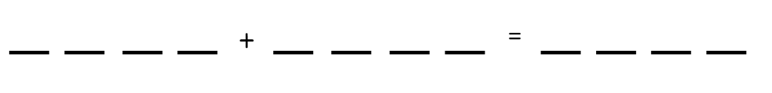

1. Explain that students will take turns guessing a number between zero and 9. If the number is within the problem (2465 + 1232 = 3697), it will be written in the corresponding space in the blank equation. If the number is not in the problem, it will be a ‘strike’. To win, students need to determine all the numbers before they get 4 strikes.
2. Encourage students to think about rounding and estimating when making their guesses. For example, if presented with 3_ + _ _ = 7 _, it would be reasonable to estimate that there could be a 4 in the tens place of the second number.
3. Model the game, allowing students to guess numbers from zero to 9. Encourage students to explain their reason for selecting that number.
4. In pairs, provide students with a whiteboard each. One student will be the game host and will record the equation on their whiteboard, keeping it hidden from their partner. The other will be the player and will draw the problem frame on their whiteboard. Students play ‘Four strikes and you’re out!’ Encourage students to form both addition and subtraction equations.
5. Regroup and ask:

* What did you notice?
* Did you have any challenges and how did you overcome them?
* When can rounding and estimating be used?

This table details opportunities for differentiation.

|  |  |
| --- | --- |
| Too hard? | Too easy? |
| Students cannot use estimation and place value understanding to determine the reasonableness of solutions.   * Provide MAB materials to model the potential equation. * Provide equations where there is no regrouping involved. | Students can use estimation and place value to determine the reasonableness of solutions.   * Students use a 5-digit number to solve the equation. * Provide both addition and subtraction (multistep) in the one equation. |

This table details opportunities for assessment.

|  |  |
| --- | --- |
| Assessment opportunities | Links |
| What to look for:   * Can students round numbers appropriately when obtaining estimates? **[MAO-WM-01, MA3-AR-01]** * Can students use place value to add or subtract numbers with different numbers of digits? **[MAO-WM-01, MA3-AR-01]** | Links to [National Numeracy Learning Progressions](https://www.australiancurriculum.edu.au/resources/national-literacy-and-numeracy-learning-progressions/version-3-of-national-literacy-and-numeracy-learning-progressions/) (NNLP):   * Stage 3 – NPV6, NPV7. |

### Discuss and connect the mathematics – 5 minutes

1. Reflect on learning by asking questions such as, ‘Can you share something that you found:

* enjoyable?
* challenging?
* interesting?’

## Lesson 7

**Core concept**: mathematicians compare and evaluate strategies used to solve addition and subtraction problems, which can involve multiple steps.

### Daily number sense: Nicole’s walk – 15 minutes

The table below contains a suggested learning intention and success criteria. These are best co-constructed with students.

|  |  |
| --- | --- |
| Daily number sense learning intention | Daily number sense success criteria |
| Students are learning to:   * model and represent fractions to complete a whole on a number line. | Students can:   * model fractions with fraction strips * identify the complementary fractional part needed to complete one whole. |

This activity is an adaptation of ‘How far did Nicole go?’ from *Primary and Middle Years Mathematics: Teaching Developmentally, 1st edn* by Van De Walle et al.

1. Display Resource 17: Nicole’s walk and explain Nicole is walking to school and the 3 number lines represent the distance she has travelled. The aim of the task is to model and describe fractions with partitions of an object (number line).
2. Give students time to discuss the 3 number lines and questions. Students record their fractions and reasoning. Ask:

* How far has Nicole gone?
* How do you know?
* What parts of the number line helped you answer the questions?
* Which number line represents the furthest distance travelled? How do you know?
* How far as a fraction does Nicole need to travel to get to school on each number line? (Determine the complement fractional part of each number line).

This table details opportunities for assessment.

|  |  |
| --- | --- |
| Assessment opportunities | Links |
| What to look for:   * Can students model fractions with fraction strips? **[MAO-WM-01, MA2-PF-01]** * Can students identify the complementary fractional part needed to complete one whole? **[MAO-WM-01, MA2-PF-01]** | Links to [National Numeracy Learning Progressions](https://www.australiancurriculum.edu.au/resources/national-literacy-and-numeracy-learning-progressions/version-3-of-national-literacy-and-numeracy-learning-progressions/) (NNLP):   * Stage 2 – InF2, InF3, InF4 * Stage 3 – InF2, InF3, InF4. |

### Core lesson: Solving problems – 25 minutes

The table below contains a suggested learning intention and success criteria. These are best co-constructed with students.

|  |  |
| --- | --- |
| Core concept learning intention | Core concept success criteria |
| All students are learning to:   * select and apply efficient strategies to solve addition and subtraction problems. | All students can:   * solve problems using addition and subtraction strategies * explain which strategy is more efficient.   Students working towards Stage 3 outcomes can:   * solve problems with multiple steps. |

1. Explain that students will be solving problems in pairs, using at least 3 different strategies. For example, levelling, constant difference, partitioning or an algorithm (Stage 3).
2. Provide the following problems for Stage 2:

* There is a very old lady who lives on a hill. She is 94 years old. She is married to a very old man. He is 78 years old. How many years older is the lady than her husband?
* The old lady and old man have 2 great-grandchildren, Josh and Jill. Josh is 12 years older than Jill. How old might Josh and Jill be? Provide at least 3 possible solutions.

1. Provide the following problems for Stage 3:

* Green Paddock Public School holds their school fair every year in December. They like to record how many people attend the fair at different times, so they know how popular each of the activities are. An hour after the fair began, there were 3827 people there. A bit later, 1625 more people had arrived at the fair in time to watch the clown show. After the clown show, the jumping castle deflated so 2964 people left the fair to go home. How many people were still at the fair?
* Blue Pond Public School also holds their school fair every year in December. Last year’s attendance was 2567 higher than the year before. If both years’ attendances were over 4500, how many people might have attended in each year? Provide at least 3 possible solutions.

1. As a class, discuss the activity by asking questions, such as:

* Which strategies did you use?
* Which strategy did you prefer? Why?
* Were your answers the same with each strategy? Why or why not?
* Could you use rounding and estimation to check the reasonableness of your answers? Why or why not? (Stage 3)

This table details opportunities for differentiation.

|  |  |
| --- | --- |
| Too hard? | Too easy? |
| Students cannot select, apply and evaluate addition and subtraction strategies.   * Provide single-step problems with smaller numbers. * Provide concrete materials. * Specify a single strategy to use. | Students can select, apply and evaluate addition and subtraction strategies.   * Provide problems with additional steps and larger numbers. * Students create a [Plus, Minus, Interesting (PMI) chart](https://app.education.nsw.gov.au/digital-learning-selector/LearningActivity/Card/551) for each strategy. * Create a real-world problem using your school context for students to solve, for example, canteen sales, school enrolments, extra-curricular activity numbers, school resources and so on. |

### Consolidation and meaningful practice – 25 minutes

1. Ask pairs of students to create their own problem that is best solved by a particular strategy. Ensure that pairs do not disclose the recommended strategy at this point.
2. Pairs swap problems to solve using multiple strategies and identify which strategy they think is the most efficient for the problem they are solving.
3. Pairs compare their answers and their recommended the strategy with the writers.
4. As a class, discuss the activity by asking questions, such as:

* Which strategy did you think was the most efficient? Justify your answer.
* Was it the same strategy that was recommended by the writers? Why or why not?
* Can you think of another time when the strategy that you chose would have been the most efficient? Justify your answer.

This table details opportunities for assessment.

|  |  |
| --- | --- |
| Assessment opportunities | Links |
| What to look for:   * Can students solve problems using addition and subtraction strategies? **[MAO-WM-01, MA2-AR-01, MA3-AR-01]** * Can students explain which strategy is more efficient? **[MAO-WM-01, MA2-AR-01, MA3-AR-01]** * Can Stage 3 students solve problems with multiple steps? **[MAO-WM-01, MA3-AR-01]** | Links to [National Numeracy Learning Progressions](https://www.australiancurriculum.edu.au/resources/national-literacy-and-numeracy-learning-progressions/version-3-of-national-literacy-and-numeracy-learning-progressions/) (NNLP):   * Stage 2 – AdS6, AdS7, AdS8 * Stage 3 – AdS6, AdS7, AdS8.   Links to suggested [Interview for Student Reasoning](https://education.nsw.gov.au/teaching-and-learning/curriculum/literacy-and-numeracy/assessment-resources/ifsr) (IfSR) tasks:   * **Stage 2 – IfSR-AT**: 2A.2, 3A.2, 3A.4, 3A.5 * **Stage 3 – IfSR-AT**: 2A.2, 3A.2, 3A.4, 3A.5. |

## Lesson 8

**Core concept**: mathematicians compare and evaluate strategies used to solve addition and subtraction problems, reasoning which strategy may be most efficient.

### Daily number sense – 15 minutes

1. From a class need surfaced through formative assessment data, identify a short, focused activity that targets students’ knowledge, understanding and skills. Example activities may be drawn from the following resources:

* [Mathematics K-6 resources](https://education.nsw.gov.au/teaching-and-learning/curriculum/mathematics/mathematics-curriculum-resources-k-12/mathematics-k-6-resources#catalogue_auto)
* [Universal Resources Hub](https://resources.education.nsw.gov.au/home).

### Core lesson: More problems – 40 minutes

The table below contains a suggested learning intention and success criteria. These are best co-constructed with students.

|  |  |
| --- | --- |
| Core concept learning intention | Core concept success criteria |
| All students are learning to:   * select and apply efficient strategies to solve addition and subtraction problems. | All students can:   * solve problems using addition and subtraction strategies * explain which strategy is more efficient.   Students working towards Stage 3 outcomes can:   * solve problems with multiple steps. |

1. Demonstrate how to create a Frayer Model template (see Figure 28). Tell students they will be using this model to show their thinking when solving problems. Explain that the problem being solved is recorded in the centre box. In the strategy boxes, students use 3 different strategies to solve the problem, then circle the strategy that was most efficient. In the final box, students explain their reasoning to support why the circled strategy was the most efficient.

Figure 28 – Frayer model

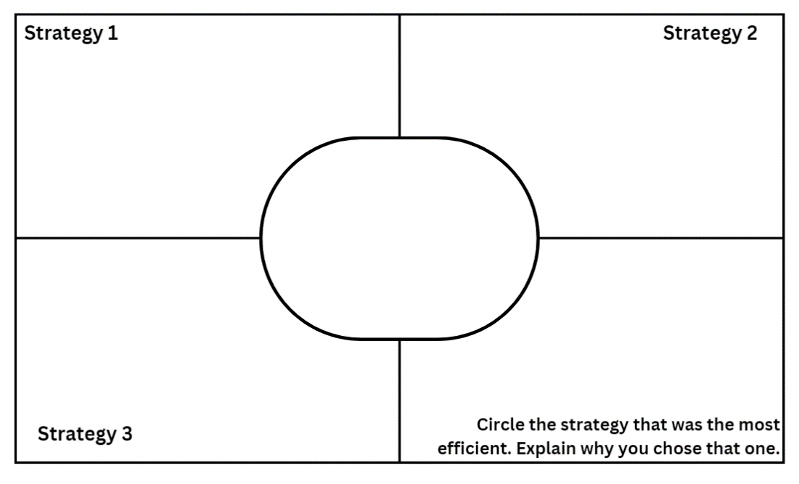

1. Explain that students will be solving problems using the Frayer Model in pairs.
2. Ask pairs to create their own copies of the Frayer Model template.
3. Provide the following problems for Stage 2:

* Mr Barnes had 52 pencils in his classroom. Mr Farnham borrowed some for his class. Mr Barnes kept 27 pencils for his class. How many pencils did Mr Farnham borrow?
* Chrissy read 44 books this year. Her brother Bon read 68. How many books did Chrissy and Bon read in total, and how many more will they need to read to reach a combined total of 150?
* Reyne Public School has 191 students. 97 students are in years K-2. The rest are in Years 3-6. How many students are in Years 3-6?
* There are 73 students in Years 3 and 4. How many students might be in Year 3 and how many might be in Year 4? Give 3 possible solutions.

1. Provide the following problems for Stage 3:

* The attendance at each day of the test cricket was: 42 472, 35 516, 23 597, 20 989, 10 027. How many more people attended the first 3 days than the last 2 days?
* Three primary schools had a competition to see how many books students at each school could read during August. They were hoping to reach a combined total of 10 000. The students at Ocean Public School read 2583 books, the students at Lake Public School read 1679 books and the students at River Public School read 2894 books. How many books did they read altogether and how many books short of their goal were they?
* A bakery made 1368 cupcakes in June, 1738 in July and 2308 in August. In June, July and August, they sold a combined total of 4995 cupcakes. How many cupcakes were left unsold?
* The bakery made 4572 cupcakes in September, October and November combined. How many cupcakes might they have made in each month? Give 3 possible solutions.

This table details opportunities for differentiation.

|  |  |
| --- | --- |
| Too hard? | Too easy? |
| Students cannot apply and evaluate strategies to solve addition and subtraction problems.   * Provide single-step problems with smaller numbers. * Provide concrete materials. * Specify a single strategy to use. | Students can apply and evaluate strategies to solve addition and subtraction problem.   * Provide problems with additional steps and larger numbers. * Students create their own problem that is best solved using an allocated strategy. |

This table details opportunities for assessment.

|  |  |
| --- | --- |
| Assessment opportunities | Links |
| What to look for:   * Can students solve problems using addition and subtraction strategies? **[MAO-WM-01, MA2-AR-01, MA3-AR-01]** * Can students explain which strategy is more efficient? **[MAO-WM-01, MA2-AR-01, MA3-AR-01]** * Can Stage 3 students solve problems with multiple steps? **[MAO-WM-01, MA3-AR-01]** | Links to [National Numeracy Learning Progressions](https://www.australiancurriculum.edu.au/resources/national-literacy-and-numeracy-learning-progressions/version-3-of-national-literacy-and-numeracy-learning-progressions/) (NNLP):   * Stage 2 – AdS6, AdS7 * Stage 3 – AdS6, AdS7.   Links to suggested [Interview for Student Reasoning](https://education.nsw.gov.au/teaching-and-learning/curriculum/literacy-and-numeracy/assessment-resources/ifsr) (IfSR) tasks:   * **Stage 2 – IfSR-AT**: 2A.2, 3A.2, 3A.4, 3A.5 * **Stage 3 – IfSR-AT**: 2A.2, 3A.2, 3A.4, 3A.5. |

### Discuss and connect the mathematics – 10 minutes

1. Discuss and reflect on the activity by asking questions such as:

* Which problem was the easiest? Why?
* Which problem was the hardest? Why?
* Was the same strategy the most efficient for each problem? Why or why not?

1. Ask another pair to check your 3 solutions for the final question.

## Resource 1: Sara’s challenge

Sara's challenge shows a chalkboard with a hand having written 3 algorithms.
Text reads: Sara is trying to solve the subtraction problem below using partitioning. Can you spot the error in her solution? 742 - 338 = 40
Chalkboard underneath contains: 742 - 300 = 442, 442 - 40 = 402, 442 - 402 = 40

## Resource 2: Place value game

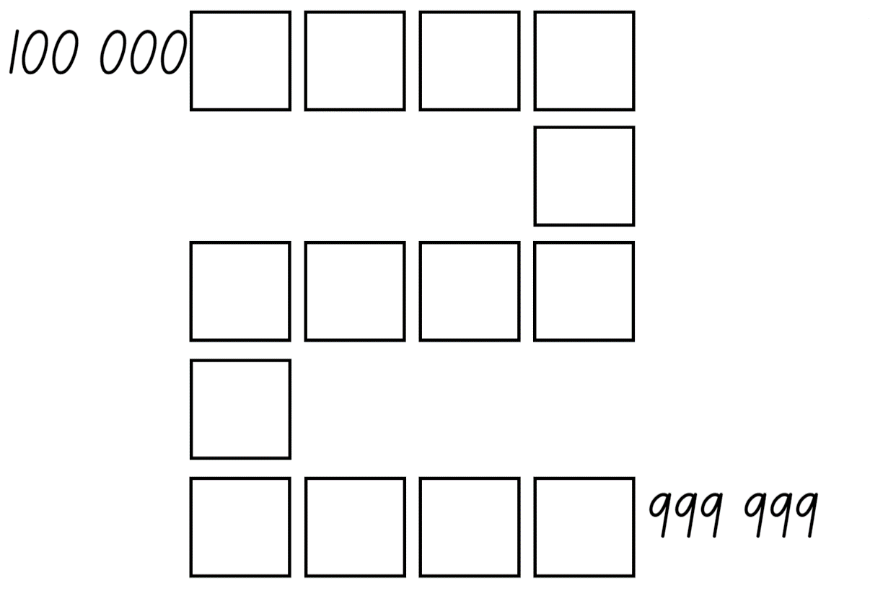

## Resource 3: Subtraction problem

A group of people walking next to a bus. Text reads: There are 776 students in a school. 212 students take the bus, some walk and some ride their bike. Look at the bar model below to help you work out how many students catch the bus, walk and ride to school.
Bar model with 776 across the top, 212, 263 and ? underneath.

## Resource 4: Word problems

First problem: A bakery sold cupcakes on Monday, Tuesday and Wednesday. How many cupcakes did the bakery sell in total over the three days? Monday cupcake 324, Tuesday cupcake 267, Wednesday cupcake 198. 
A basketball team scored 146 points in the first season, 522 points in the second season, and lost 318 points in the third season. How many points did the team score in total over the three seasons?
A school organised two excursions. The first excursion had 182 students and the second excursion had double the number of students. How many students went on the field trips in total?

Sarah has 764 stickers. She gave away half stickers to her sister and bought 341 new stickers from her friend. How many stickers does she have altogether?
There were 956 books in the library. Over the weekend, half the books were borrowed. How many books are still in the library?
Rima had 618 toy cars, but she sold 173 toy cars at a garage sale. She then accidentally put 212 in the rubbish during the clean up.
How many toy cars does Rima have now?

## Resource 5: Consolidation task

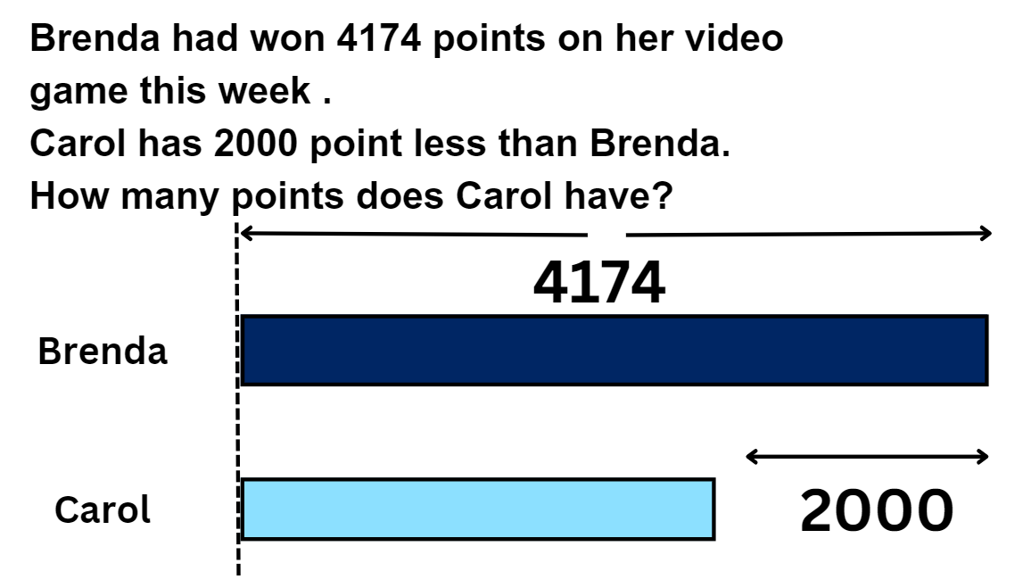

## Resource 6: True or false?

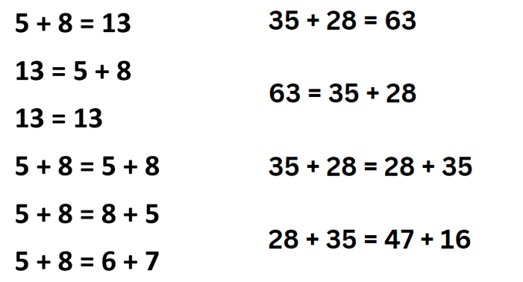

## Resource 7: Chess pieces

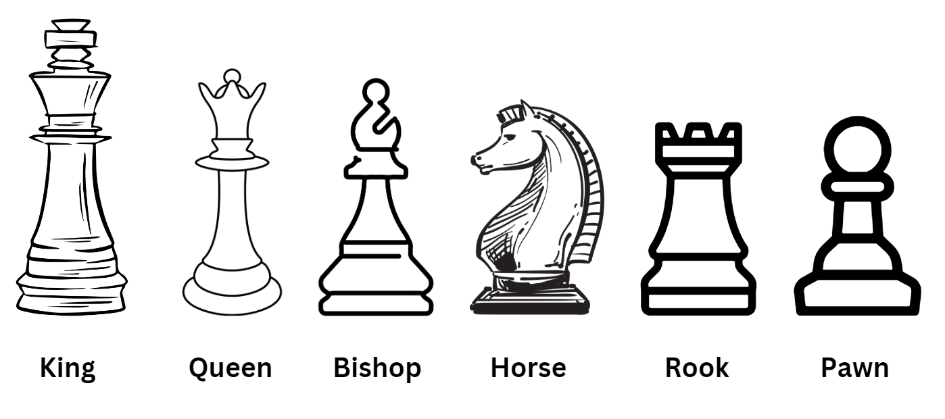

## Resource 8: Chess chart 1

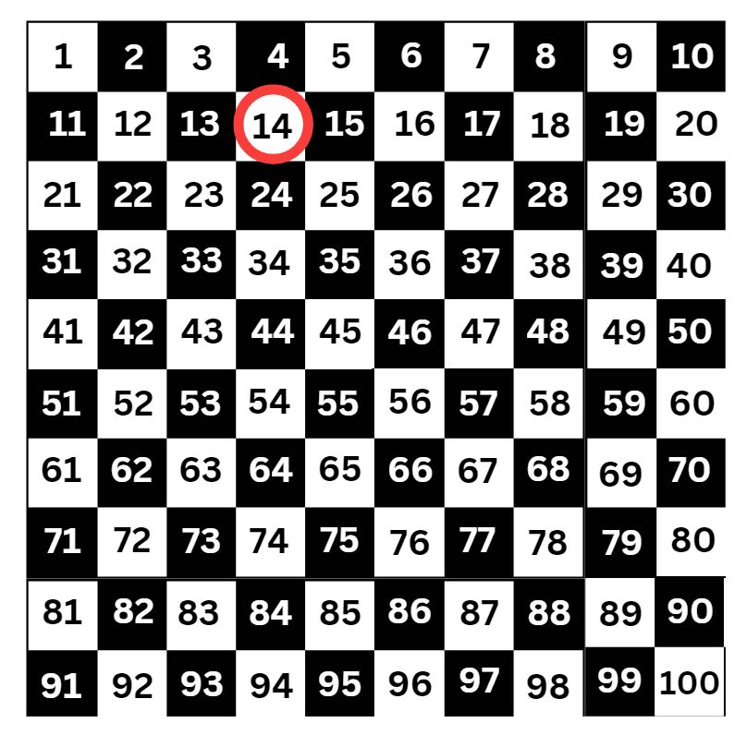

## Resource 9: Chess chart 2

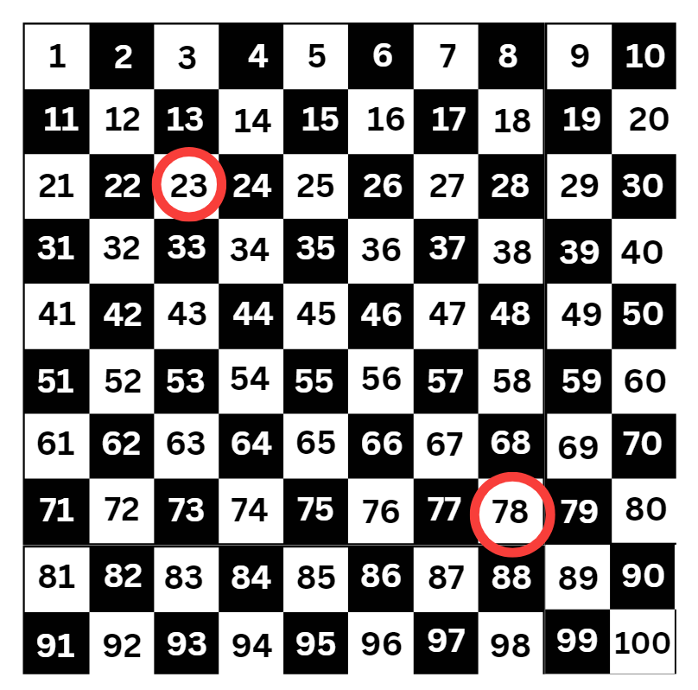

## Resource 10: Empty chart

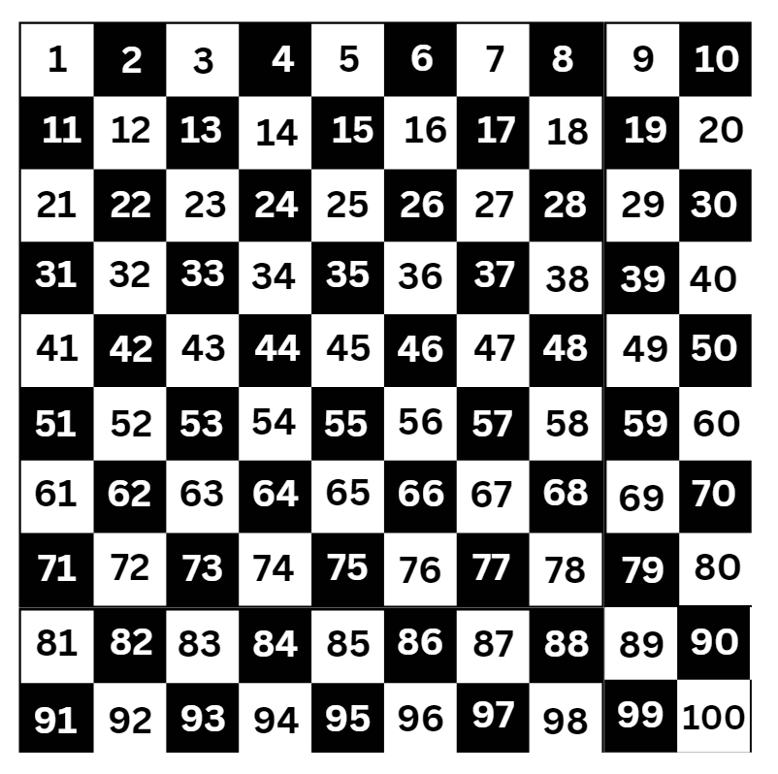

## Resource 11: Chess chart 3

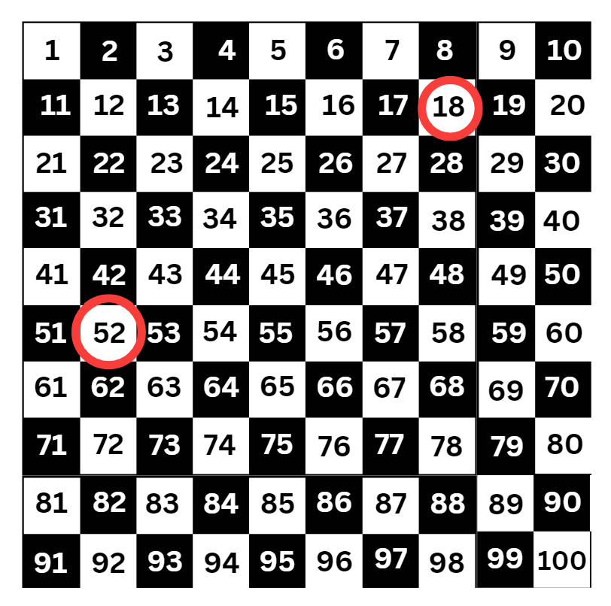

## Resource 12: Race car rumble

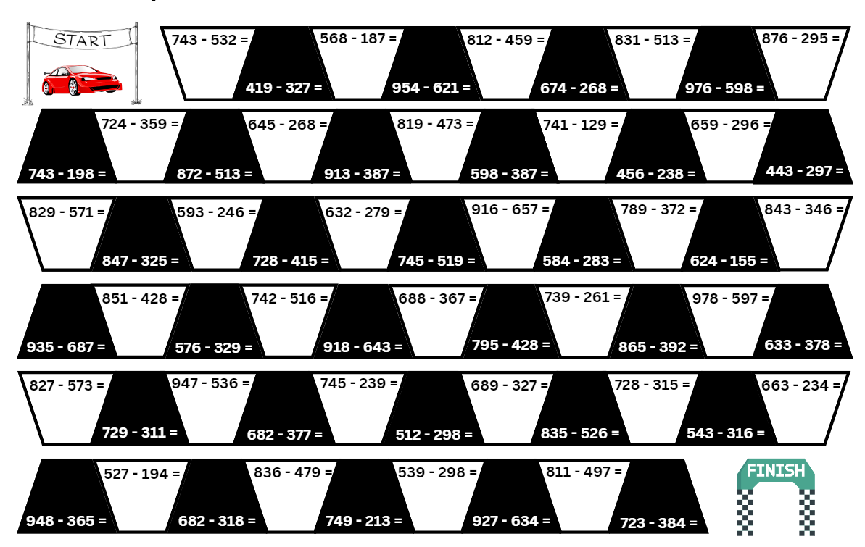

## Resource 13: 119 number chart

Access a high resolution copy of Resource 13 from [*0-119 hundreds chart* [PDF 128 KB]](https://education.nsw.gov.au/content/dam/main-education/teaching-and-learning/curriculum/key-learning-areas/mathematics/media/documents/mathematics-s2-race-to-zero-0-119-hundreds-chart.pdf).

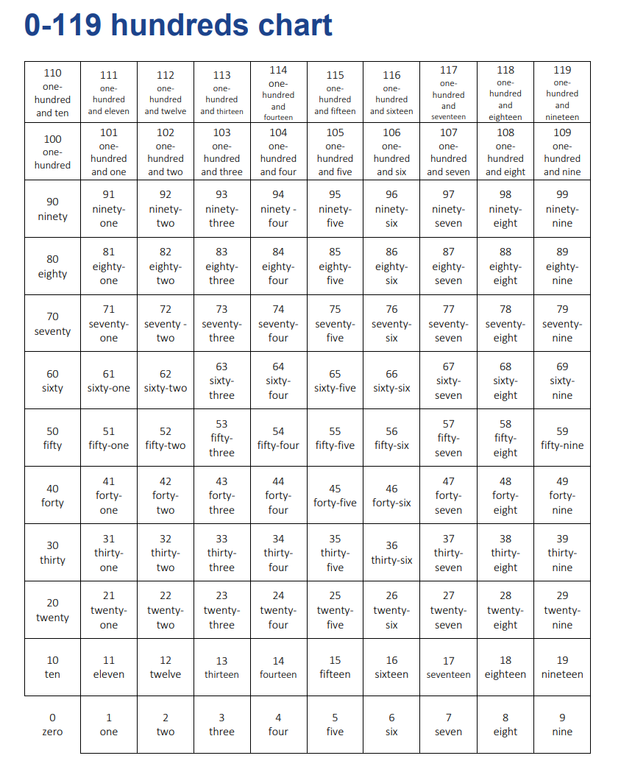

## Resource 14: Trading

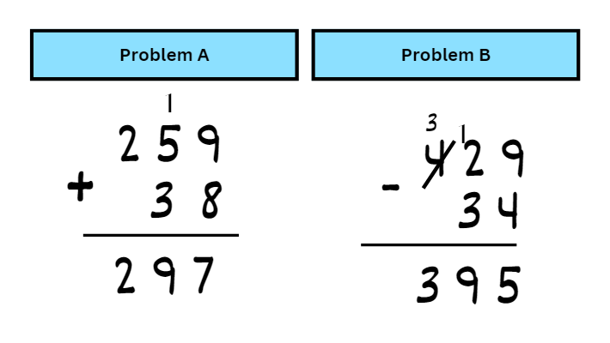

## Resource 15: Spinner

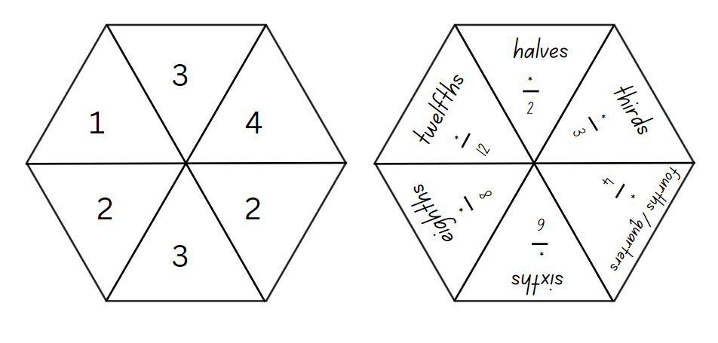

## Resource 16: Fraction wall

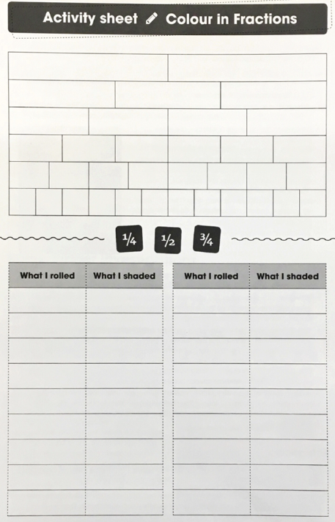

## Resource 17: Nicole’s walk

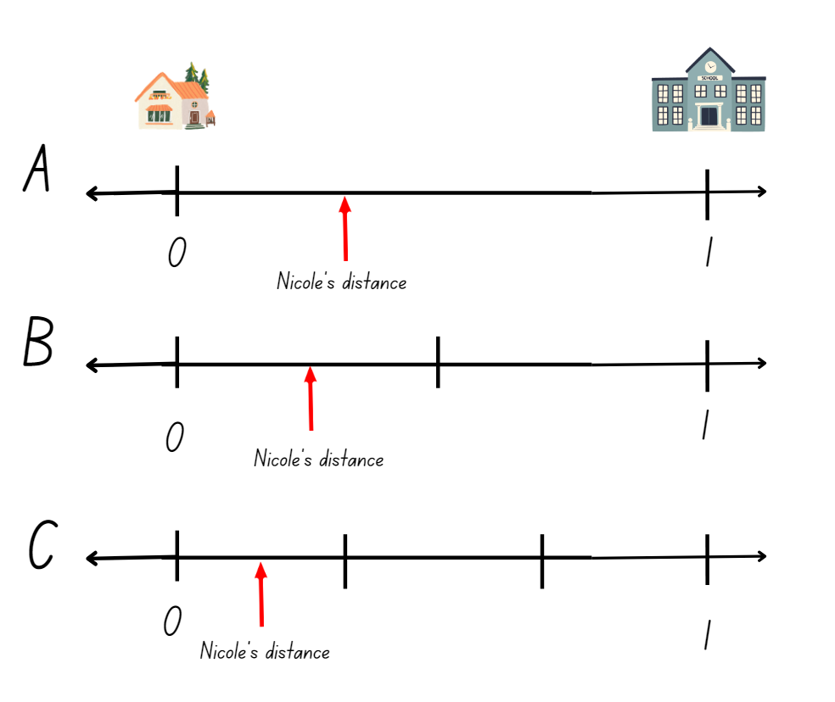

## Syllabus outcomes and content

### Stage 2

The table below outlines the [syllabus outcomes](https://curriculum.nsw.edu.au/learning-areas/mathematics/mathematics-k-10-2022) and range of relevant syllabus content covered in this unit. Content is linked to [National Numeracy Learning Progression](https://www.australiancurriculum.edu.au/resources/national-literacy-and-numeracy-learning-progressions/version-3-of-national-literacy-and-numeracy-learning-progressions/) version (3).

|  |  |  |  |  |  |  |  |  |
| --- | --- | --- | --- | --- | --- | --- | --- | --- |
| Outcomes and content | 1 | 2 | 3 | 4 | 5 | 6 | 7 | 8 |
| **Representing numbers using place value A:** Whole numbers: Read, represent and order numbers to thousands  **MAO-WM-01, MA2-RN-01** |  |  |  |  |  |  |  |  |
| * Count forwards and backwards by tens and hundreds on and off the decade |  |  | x |  |  |  |  |  |
| * Read and order numbers of up to at least 4 digits | x | x |  |  |  |  |  |  |
| **Representing numbers using place value A:** Whole numbers: Apply place value to partition and regroup numbers up to 4 digits  **MAO-WM-01, MA2-RN-01** |  |  |  |  |  |  |  |  |
| * Record numbers using standard place value form | x | x | x |  |  |  |  |  |
| * Partition numbers of up to 4 digits in non-standard forms (Reasons about quantity) | x |  | x |  |  |  |  |  |
| **Representing numbers using place value B:** Whole numbers: Apply place value to partition, regroup and rename numbers up to 6 digits  **MAO-WM-01, MA2-RN-01** |  |  |  |  |  |  |  |  |
| * Name thousands using the place value grouping of ones, tens and hundreds of thousands |  | x |  |  |  |  |  |  |
| **Additive relations A:** Use the principle of equality  **MAO-WM-01, MA2-AR-01, MA2-AR-02** |  |  |  |  |  |  |  |  |
| * Use the equals sign to mean 'the same as', rather than to perform an operation |  |  | x |  |  |  |  |  |
| **Additive relations A:** Recognise and explain the connection between addition and subtraction  **MAO-WM-01, MA2-AR-01, MA2-AR-02** |  |  |  |  |  |  |  |  |
| * Use number relation principles to solve related problems (Reasons about relations) |  | x | x |  |  |  |  |  |
| * Demonstrate how addition and subtraction are inverse operations |  | x |  |  |  |  |  |  |
| * Use the complement principle of addition and subtraction (Reasons about relations) |  | x |  |  |  |  |  |  |
| * Explain and check solutions to problems, including by using the inverse operation |  | x |  |  |  |  |  |  |
| **Additive relations A:** Select strategies flexibly to solve addition and subtraction problems of up to 3 digits  **MAO-WM-01, MA2-AR-01, MA2-AR-02** |  |  |  |  |  |  |  |  |
| * Apply known mental strategies that use partitioning to add and subtract, such as bridging the decades |  | x | x | x | x |  | x | x |
| * Use the compensation strategy to add and subtract (Reasons about relations) |  | x |  | x |  |  |  |  |
| * Apply the levelling and constant difference strategies (Reasons about relations) |  | x |  |  | x |  | x | x |
| * Represent solutions to addition and subtraction problems, including word problems, using an empty number line or bar model |  | x | x |  |  | x | x | x |
| * Compare and evaluate strategies used to solve addition and subtraction problems, reasoning which strategy may be most efficient |  | x |  | x | x | x | x | x |
| **Additive relations B:** Partition, rearrange and regroup numbers to at least 1000 to solve additive problems  **MAO-WM-01, MA2-AR-01, MA2-AR-02** |  |  |  |  |  |  |  |  |
| * Use quantity values and non-standard partitioning to solve addition and subtraction problems | x | x | x | x | x | x | x | x |
| **Partitioned fractions A:** Model and represent unit fractions, and their multiples, to a complete whole on a number line  **MAO-WM-01, MA2-PF-01** |  |  |  |  |  |  |  |  |
| * Model fractions with fraction strips and diagrams for halves, quarters, eighths, thirds |  |  |  |  |  | x | x |  |
| * Determine the complementary fractional part needed to complete one whole (halves, quarters, eighths, thirds) (Reasons about relations) |  |  |  |  |  | x | x |  |

[Mathematics K–10 Syllabus](https://curriculum.nsw.edu.au/learning-areas/mathematics/mathematics-k-10) © NSW Education Standards Authority (NESA) for and on behalf of the Crown in right of the State of New South Wales, 2022.

### Stage 3

The table below outlines the [syllabus outcomes](https://curriculum.nsw.edu.au/learning-areas/mathematics/mathematics-k-10-2022) and range of relevant syllabus content covered in this unit. Content is linked to [National Numeracy Learning Progression](https://www.australiancurriculum.edu.au/resources/national-literacy-and-numeracy-learning-progressions/version-3-of-national-literacy-and-numeracy-learning-progressions/) version (3).

|  |  |  |  |  |  |  |  |  |
| --- | --- | --- | --- | --- | --- | --- | --- | --- |
| Outcomes and content | 1 | 2 | 3 | 4 | 5 | 6 | 7 | 8 |
| **Represents numbers A:** Whole numbers: Recognise, represent and order numbers in the millions  **MAO-WM-01, MA3-RN-01** |  |  |  |  |  |  |  |  |
| * Name millions using the place value grouping of ones, tens and hundreds |  | x |  |  |  |  |  |  |
| * Arrange numbers in the millions in ascending and descending order using place value |  | x |  |  |  |  |  |  |
| **Represents numbers A:** Whole numbers: Apply place value to partition, regroup and rename numbers to 1 billion  **MAO-WM-01, MA3-RN-01** |  |  |  |  |  |  |  |  |
| * Regroup numbers in different forms (Reasons about quantity) |  |  |  |  | x |  |  |  |
| **Additive relations A:** Apply efficient mental and written strategies to solve addition and subtraction problems  **MAO-WM-01, MA3-AR-01** |  |  |  |  |  |  |  |  |
| * Solve word problems, including multistep problems |  | x |  | x |  |  | x |  |
| * Apply known strategies such as levelling, addition for subtraction, using constant difference, and bridging (Reasons about relations) |  | x | x | x | x |  | x | x |
| * Use place value to add or subtract 3 or more numbers with different numbers of digits | x |  |  |  | x | x |  |  |
| * Identify efficient and inefficient multidigit subtraction strategies |  | x | x | x | x | x | x | x |
| **Additive relations A:** Use estimation and place value understanding to determine the reasonableness of solutions  **MAO-WM-01, MA3-AR-01** |  |  |  |  |  |  |  |  |
| * Round numbers appropriately when obtaining estimates to numerical calculations |  |  |  |  |  | x | x |  |
| * Use place value understanding to check for errors in calculations |  |  |  |  |  | x |  |  |
| * Use estimation to check the reasonableness of solutions to addition and subtraction calculations |  |  |  |  |  | x | x |  |
| **Additive relations B:** Choose and use efficient strategies to solve addition and subtraction problems  **MAO-WM-01, MA3-AR-01** |  |  |  |  |  |  |  |  |
| * Solve multistep word problems, including problems that require more than one operation |  | x |  |  |  |  | x | x |
| * Compare, evaluate and communicate strategies used to solve addition and subtraction problems |  | x |  |  |  |  | x | x |

[Mathematics K–10 Syllabus](https://curriculum.nsw.edu.au/learning-areas/mathematics/mathematics-k-10) © NSW Education Standards Authority (NESA) for and on behalf of the Crown in right of the State of New South Wales, 2022.

## References

This resource contains NSW Curriculum and syllabus content. The NSW Curriculum is developed by the NSW Education Standards Authority. This content is prepared by NESA for and on behalf of the Crown in right of the State of New South Wales. The material is protected by Crown copyright.

Please refer to the NESA Copyright Disclaimer for more information <https://educationstandards.nsw.edu.au/wps/portal/nesa/mini-footer/copyright>.

NESA holds the only official and up-to-date versions of the NSW Curriculum and syllabus documents. Please visit the NSW Education Standards Authority (NESA) website <https://educationstandards.nsw.edu.au/> and the NSW Curriculum website <https://curriculum.nsw.edu.au/home>.

[Mathematics K–10 Syllabus](https://curriculum.nsw.edu.au/learning-areas/mathematics/mathematics-k-10-2022) © NSW Education Standards Authority (NESA) for and on behalf of the Crown in right of the State of New South Wales, 2022.

[National Numeracy Learning Progression](https://www.australiancurriculum.edu.au/resources/national-literacy-and-numeracy-learning-progressions/version-3-of-national-literacy-and-numeracy-learning-progressions/) © Australian Curriculum, Assessment and Reporting Authority (ACARA) 2010 to present, unless otherwise indicated. This material was downloaded from the [Australian Curriculum](http://www.australiancurriculum.edu.au/) website (National Literacy Learning Progression) (accessed 30 August 2023) and was not modified.

Australian Government Department of Education (2020) ‘[Addition: Chess – The Rook](https://www.resolve.edu.au/addition-chess-rook)’, *Teaching resources*, reSolve: Maths by Inquiry website, accessed 28 July 2023.

State of New South Wales (Department of Education) (n.d.) [*Coordinating groups: Snake eyes* [PDF 8.0 MB]](https://education.nsw.gov.au/content/dam/main-education/teaching-and-learning/curriculum/key-learning-areas/mathematics/media/documents/mathematics-s2-part-3-dens.pdf), Developing efficient numeracy strategies (DENS): Stage 2, NSW Department of Education, accessed 28 July 2023.

State of New South Wales (Department of Education) (2023) ‘[Additive strategies: Closest to 100 (Task 5)](https://education.nsw.gov.au/teaching-and-learning/curriculum/literacy-and-numeracy/teaching-and-learning-resources/numeracy/explicit-teaching-strategies/stage-3/numbers-and-algebra/additive)’, Stage 3 numbers and algebra, NSW Department of Education website, accessed 28 July 2023.

State of New South Wales (Department of Education) (2023) ‘[Additive strategies: Four strikes and you’re out! (Task 7)](https://education.nsw.gov.au/teaching-and-learning/curriculum/literacy-and-numeracy/teaching-and-learning-resources/numeracy/explicit-teaching-strategies/stage-3/numbers-and-algebra/additive)’, Stage 3 numbers and algebra, NSW Department of Education website, accessed 28 July 2023.

State of New South Wales (Department of Education) (2023) ‘[Colour in fractions](https://education.nsw.gov.au/teaching-and-learning/curriculum/mathematics/mathematics-curriculum-resources-k-12/mathematics-k-6-resources/colour-in-fractions)’, Mathematics K-6 resources, NSW Department of Education website, accessed 28 July 2023.

State of New South Wales (Department of Education) (2023) ‘[Order! Order! (four-digit numbers)](https://education.nsw.gov.au/teaching-and-learning/curriculum/mathematics/mathematics-curriculum-resources-k-12/mathematics-k-6-resources/order-order-four-digit-numbers)’, Mathematics K-6 resources, NSW Department of Education website, accessed 28 July 2023.

State of New South Wales (Department of Education) (2023) ‘[Place value game](https://education.nsw.gov.au/teaching-and-learning/curriculum/mathematics/mathematics-curriculum-resources-k-12/mathematics-k-6-resources/place-value-game)’, Mathematics K-6 resources, NSW Department of Education website, accessed 28 July 2023.

State of New South Wales (Department of Education) (2023) ‘[Race to zero (subtracting tens and ones)](https://education.nsw.gov.au/teaching-and-learning/curriculum/mathematics/mathematics-curriculum-resources-k-12/mathematics-k-6-resources/race-to-zero-subtracting-tens-and-ones)’, *Mathematics K-6 resources*, NSW Department of Education website, accessed 28 July 2023

State of New South Wales (Department of Education) (2023) ‘[Strike it out (addition and subtraction to 20)](https://education.nsw.gov.au/teaching-and-learning/curriculum/mathematics/mathematics-curriculum-resources-k-12/mathematics-k-6-resources/strike-it-out-addition-and-subtraction-to-20)’, *Mathematics K-6 resources*, NSW Department of Education website, accessed 28 July 2023.

University of Cambridge (Faculty of Mathematics) (1997–2023) [*Dicey Addition*](https://nrich.maths.org/11863), NRICH website, accessed 26 June 2023.

University of Cambridge (Faculty of Mathematics) (1997–2023) [*True or False?*](https://nrich.maths.org/14797), NRICH website, accessed 26 June 2023.

Van de Walle J, Karp K, Bay-Williams JM, Brass A, Bentley B, Ferguson S, Goff W, Livy S, Marshman M, Martin D, Pearn C, Prodromou T, Symons D and Wilkie K (2019) *Primary and Middle Years Mathematics: Teaching Developmentally*, 1st Australian edn, Pearson Education Australia, Melbourne.

**© State of New South Wales (Department of Education), 2023**

The copyright material published in this resource is subject to the Copyright Act 1968 (Cth) and is owned by the NSW Department of Education or, where indicated, by a party other than the NSW Department of Education (third-party material).

Copyright material available in this resource and owned by the NSW Department of Education is licensed under a [Creative Commons Attribution 4.0 International (CC BY 4.0) license](https://creativecommons.org/licenses/by/4.0/).

[](https://creativecommons.org/licenses/by/4.0/)

This license allows you to share and adapt the material for any purpose, even commercially.

Attribution should be given to © State of New South Wales (Department of Education), 2023.

Material in this resource not available under a Creative Commons license:

* the NSW Department of Education logo, other logos and trademark-protected material
* material owned by a third party that has been reproduced with permission. You will need to obtain permission from the third party to reuse its material.

**Links to third-party material and websites**

Please note that the provided (reading/viewing material/list/links/texts) are a suggestion only and implies no endorsement, by the New South Wales Department of Education, of any author, publisher, or book title. School principals and teachers are best placed to assess the suitability of resources that would complement the curriculum and reflect the needs and interests of their students.

If you use the links provided in this document to access a third-party's website, you acknowledge that the terms of use, including licence terms set out on the third-party's website apply to the use which may be made of the materials on that third-party website or where permitted by the Copyright Act 1968 (Cth). The department accepts no responsibility for content on third-party websites.