# Mathematics 3-6 multi-age – Year A – Unit 3



Contents

Unit description and duration 5

Syllabus outcomes 5

Working mathematically 6

Student prior learning 7

Lesson overview and resources 8

Lesson 1 16

Daily number sense: Back and forth – 10 minutes 16

Core lesson 1: Towering metres – 20 minutes 18

Core lesson 2: Larger and smaller than a metre – 35 minutes 21

Discuss and connect the mathematics – 5 minutes 26

Lesson 2 27

Daily number sense: Closest to – 10 minutes 27

Core lesson: Tiny town – 55 minutes 29

Discuss and connect the mathematics – 5 minutes 35

Lesson 3 37

Daily number sense: Addition and subtraction problems – 10 minutes 37

Core lesson: Benchmarks – 50 minutes 40

Discuss and connect the mathematics – 10 minutes 45

Lesson 4 47

Daily number sense – 10 minutes 47

Core lesson 1: The power of 10 – 30 minutes 47

Consolidation and meaningful practice – 20 minutes 52

Lesson 5 56

Daily number sense: Where do you fit? – 10 minutes 56

Core lesson: Measuring perimeter – 50 minutes 58

Discuss and connect the mathematics – 10 minutes 62

Lesson 6 64

Daily number sense: Representing numbers – 10 minutes 64

Core lesson: Shape and perimeter – 40 minutes 67

Discuss and connect the mathematics – 20 minutes 70

Lesson 7 72

Daily number sense: From here to there – 10 minutes 72

Core lesson – 40 minutes 75

Discuss and connect the mathematics – 10 minutes 82

Lesson 8 83

Daily number sense – 10 minutes 83

Core lesson – 45 minutes 83

Discuss and connect the mathematics – 5 minutes 90

Resource 1: One kilometre investigation 92

Resource 2: 4.75 km annotated 93

Resource 3: Stage 2 Tiny town recording 94

Resource 4: Stage 3 Tiny town recording 95

Resource 5: Landmarks 96

Resource 6: Millimetre ruler 97

Resource 7: Student conversion table 98

Resource 8: Measuring with millimetres 99

Resource 9: Who is winning? 100

Resource 10: Flip and describe cards 103

Resource 11: Perimeters 104

Resource 12: Two-dimensional quadrilaterals 105

Resource 13: Perimeters 2 106

Resource 14: Measure perimeter 107

Resource 15: Time memory 108

Resource 16: Clock 110

Resource 17: am and pm 111

Resource 18: Time matching cards 112

Resource 19: Numeral cards 113

Resource 20: Circular number line 115

Resource 21: 12-hour timetable 116

Resource 22: 24-hour timetable 117

Resource 23: Dream school day 118

Syllabus outcomes and content 119

Stage 2 119

Stage 3 123

References 128

## Unit description and duration

This unit introduces the big idea that what needs to be measured determines the unit of measurement.

In this 2-week unit students are provided opportunities to:

* measure and compare lengths of objects using kilometres (Stage 3), metres, centimetres and millimetres
* compare and describe features of two-dimensional shapes
* measure, create and compare perimeters of two-dimensional shapes (Stage 3)
* represent and read analog time (Stage 2)
* represent and read digital, 12-hour and 24-hour time (Stage 3).

This multi-age unit is informed by the lessons in Stage 2 Year A Unit 3 and Stage 3 Year A Unit 3. Please refer to these units for additional lesson guidance.

### Syllabus outcomes

* **MAO-WM-01** develops understanding and fluency in mathematics through exploring and connecting mathematical concepts, choosing and applying mathematical techniques to solve problems, and communicating their thinking and reasoning coherently and clearly

#### Stage 2

* **MA2-AR-01** select and uses mental and written strategies for addition and subtraction involving 2- and 3-digit numbers
* **MA2-GM-02** measures and estimates lengths in metres, centimetres and millimetres
* **MA2-2DS-01** compares two-dimensional shapes and describes their features
* **MA2-NSM-02** represents and interprets analog and digital time in hours, minutes and seconds

#### Stage 3

* **MA3-RN-01** applies an understanding of place value and the role of zero to represent the properties of numbers
* **MA3-AR-01** selects and applies appropriate strategies to solve addition and subtraction problems
* **MA3-GM-02** selects and uses the appropriate unit and device to measure lengths and distances including perimeters
* **MA3-2DS-01** investigates and classifies two-dimensional shapes, including triangles and quadrilaterals based on their properties
* **MA3-NSM-02** measures and compares duration, using 12- and 24-hour time and am and pm notation

### Working mathematically

In the Mathematics K–10 Syllabus, there is one overarching Working mathematically outcome (**MAO-WM-01**). The Working mathematically processes should be embedded within the concepts being taught. The Working mathematically processes present in the Mathematics K–10 Syllabus are:

* communicating
* understanding and fluency
* reasoning
* problem solving.

[Mathematics K–10 Syllabus](https://curriculum.nsw.edu.au/learning-areas/mathematics/mathematics-k-10) © NSW Education Standards Authority (NESA) for and on behalf of the Crown in right of the State of New South Wales, 2022.

### Student prior learning

Before engaging in these teaching and learning activities, students would benefit from prior experience with:

* measuring and comparing lengths of objects with informal and formal units
* naming and classifying two-dimensional shapes
* reading and representing analog clocks.

In NSW classrooms there is a diverse range of students, including Aboriginal and Torres Strait Islander students, students learning English as an additional language or dialect, high potential and gifted students and students with disability. Some students may identify with more than one of these groups or possibly all of them. Refer to [Advice on curriculum planning for every student](https://education.nsw.gov.au/teaching-and-learning/curriculum/planning-programming-and-assessing-k-12/advice-on-curriculum-planning-for-every-student-k-12) for further information.

## Lesson overview and resources

To cover the content of the syllabus across Stage 2 and Stage 3, some core lessons in the unit contain both a Stage 2 and a Stage 3 task. Teachers are encouraged to adapt and contextualise the units to meet the needs of their students.

The table below outlines the sequence and approximate timing of lessons, learning intentions and resources.

|  |  |  |
| --- | --- | --- |
| Lesson | Content | Duration and resources |
| **Lesson 1**  **Daily number sense**  **Stage 2:**   * **Additive relations A**: Select strategies flexibly to solve addition and subtraction problems of up to 3 digits   **Stage 3:**   * **Additive relations A**: Apply efficient mental and written strategies to solve addition and subtraction problems | **Lesson core concept**: context determines the most suitable standard unit.  **Stage 2:**   * **Geometric measure A:** Length:Measure and compare objects using metres, centimetres and millimetres * **Geometric measure B:** Length: Use scaled instruments to measure and compare lengths   **Stage 3:**   * **Geometric measure A:** Length: Use metres and kilometres for lengths and distances * **Geometric measure B:** Length: Connect decimal representations to the metric system | **Lesson duration**: 70 minutes   * Resource 1: One kilometre investigation * 30 cm rulers * 6-sided dice * 9-sided dice * A3 paper * Building materials. For example, MAB materials, blocks or pencil tins * Coloured counters * Metre rulers * Student workbooks * Trundle wheels * Writing materials |
| **Lesson 2**  **Daily number sense**  **Stage 2:**   * **Additive relations A**: Select strategies flexibly to solve addition and subtraction problems of up to 3 digits   **Stage 3:**   * **Additive relations A**: Apply efficient mental and written strategies to solve addition and subtraction problems | **Lesson core concept**: context determines the most suitable standard unit.  **Stage 2:**   * **Geometric measure A: Length:** Measure and compare objects using metres, centimetres and millimetres * **Geometric measure B:** Length: Use scaled instruments to measure and compare lengths   **Stage 3:**   * **Geometric measure A:** Length: Use metres and kilometres for lengths and distances * **Geometric measure B:** Length: Connect decimal representations to the metric system | **Lesson duration**: 70 minutes   * Resource 2: 4.75 km annotated * Resource 3: Stage 2 Tiny town recording * Resource 4: Stage 3 Tiny town recording * 30 cm rulers * 6-sided dice * A3 paper * Individual whiteboards * MAB materials * Whiteboard markers * Writing materials |
| **Lesson 3**  **Daily number sense**  **Stage 2:**   * **Additive relations A**: Select strategies flexibly to solve addition and subtraction problems of up to 3 digits   **Stage 3:**   * **Additive relations A**: Apply efficient mental and written strategies to solve addition and subtraction problems | **Lesson core concept**: estimating length can be guided by using known lengths as benchmarks.  **Stage 2:**   * **Geometric measure A:** Length:Measure and compare objects using metres, centimetres and millimetres * **Geometric measure B:** Length: Use scaled instruments to measure and compare lengths   **Stage 3:**   * **Geometric measure A:** Length: Use metres and kilometres for lengths and distances * **Geometric measure B:** Length: Connect decimal representations to the metric system | **Lesson duration**: 70 minutes   * Resource 5: Landmarks * 30 cm rulers * Individual whiteboards * Student workbooks * Trundle wheels or metre rulers * Whiteboard markers * Writing materials |
| **Lesson 4**  **Daily number sense**   * teacher-identified task based on student needs | **Lesson core concept**: metric units of measurement relate to the base-10 place value system.  **Stage 2:**   * **Geometric measure A:** Length:Measure and compare objects using metres, centimetres and millimetres. * **Geometric measure B:** Length: Use scaled instruments to measure and compare lengths   **Stage 3:**   * **Geometric measure A:** Length: Use metres and kilometres for lengths and distances * **Geometric measure B:** Length: Connect decimal representations to the metric system | **Lesson duration**: 60 minutes   * Resource 6: Millimetre ruler * Resource 7: Student conversion table * Resource 8: Measuring with millimetres * Resource 9: Who is winning? * 30 cm rulers with mm clearly marked |
| **Lesson 5**  **Daily number sense**  **Stage 2:**   * **Representing numbers using place value A:** Whole numbers: Read, represent and order numbers to thousands   **Stage 3:**   * **Represents numbers A:** Whole numbers: Recognise, represent and order numbers in the millions | **Lesson core concept**: perimeters of 2D shapes are calculated by finding the total length of the sides.  **Stage 2:**   * **Geometric measure A:** Length:Measure and compare objects using metres, centimetres and millimetres * **Geometric measure B:** Length: Use scaled instruments to measure and compare lengths * **Two-dimensional spatial structure A:** 2D shapes: Compare and describe features of two-dimensional shapes   **Stage 3:**   * **Geometric measure A:** Length: Measure lengths to find perimeters. * **Geometric measure B:** Length: Connect decimal representations to the metric system | **Lesson duration**: 70 minutes   * Resource 10: Flip and describe cards * Resource 11: Perimeters * Resource 12: Two-dimensional quadrilaterals * Resource 13: Perimeters 2 * 10-sided dice * 30 cm rulers * Sticky notes * Student workbooks * Trundle wheels or metre rulers * Writing materials |
| **Lesson 6**  **Daily number sense**  **Stage 2:**   * **Representing numbers using place value A:** Whole numbers: Read, represent and order numbers to thousands   **Stage 3:**   * **Represents numbers A:** Whole numbers: Recognise, represent and order numbers in the millions | **Lesson core concept**: shapes can be classified and compared based on the length of their sides.  **Stage 2:**   * **Geometric measure A:** Length:Measure and compare objects using centimetres and millimetres * **Geometric measure B: Length:** Use scaled instruments to measure and compare lengths * **Two-dimensional spatial structure A:** 2D shapes: Compare and describe features of two-dimensional shapes   **Stage 3:**   * **Geometric measure A:** Length:Measure lengths to find perimeters * **Two-dimensional spatial structure A:** 2D shapes: Classify two-dimensional shapes and describe their properties | **Lesson duration**: 60 minutes   * Resource 14: Measure perimeter * 10-sided dice * 30 cm rulers * Individual whiteboards * Quadrilateral concrete materials such as pattern blocks or attribute shapes * Sticky putty * String tied into 16 cm loops * Student workbooks * Whiteboard markers * Writing materials |
| **Lesson 7**  **Daily number sense**  **Stage 2:**   * **Representing numbers using place value A:** Whole numbers: Read, represent and order numbers to thousands   **Stage 3:**   * **Represents numbers A:** Whole numbers: Recognise, represent and order numbers in the millions | **Lesson core concept**: standard units are an efficient way to communicate and compare lengths of time.  **Stage 2:**   * **Non-spatial measure A:** Time: Represent and read analog time   **Stage 3:**   * **Non-spatial measure A:** Time: Compare 12- and 24-hour time systems and convert between them | **Lesson duration**: 60 minutes   * Resource 15: Time memory * Resource 16: Clock * Resource 17: am and pm * Resource 18: Time matching cards * 10-sided dice * Analog clocks * Individual whiteboards * Stopwatch * Whiteboard markers * Writing materials |
| **Lesson 8**  **Daily number sense**   * teacher-identified task based on student needs | **Lesson core concept**: standard units are an efficient way to communicate and compare lengths of time.  **Stage 2:**   * **Non-spatial measure A: Time:** Represent and read analog time   **Stage 3:**   * **Non-spatial measure A:** Time: Compare 12- and 24-hour time systems and convert between them * **Non-spatial measure B: Time:** Solve problems involving duration, using 12- and 24-hour time | **Lesson duration**: 60 minutes   * Resource 19: Numeral cards * Resource 20: Circular number line * Resource 21: 12-hr timetable * Resource 22: 24-hour timetable * Resource 23: Dream school day * Skipping rope * Sticky notes * Pegs * Scissors * Glue * Writing materials |

## Lesson 1

**Core concept**: context determines the most suitable standard unit.

### Daily number sense: Back and forth – 10 minutes

Daily number sense activities for Lessons 1 to 3 ‘activate’ prior number knowledge and support the learning of new content in the unit. These activities can also assist teachers to identify the starting points for learning by revealing the extent of students’ existing knowledge.

The table below contains a suggested learning intention and success criteria. These are best co-constructed with students.

|  |  |
| --- | --- |
| Daily number sense learning intention | Daily number sense success criteria |
| All students are learning to:   * select efficient strategies to solve addition and subtraction problems. | Students working towards Stage 2 outcomes can:   * represent addition and subtraction problems on a number line.   Students working towards Stage 3 outcomes can:   * add and subtract one-, 2- and 3-digit numbers using mental strategies. |

This activity is an adaptation of [Tug of War](https://nrich.maths.org/5897/index) from [NRICH](https://nrich.maths.org/) by University of Cambridge (Faculty of Mathematics).

1. Provide pairs of students an A3 piece of paper, ruler and a coloured counter. Give pairs of Stage 2 students two 6-sided dice and pairs of Stage 3 students three 9-sided dice.
2. Stage 2 students draw a number line that starts at zero and ends at 100 (see Figure 1). Stage 3 students draw a number line that starts at 400 and ends at 600 (see Figure 2).

Figure 1 – Stage 2 number line

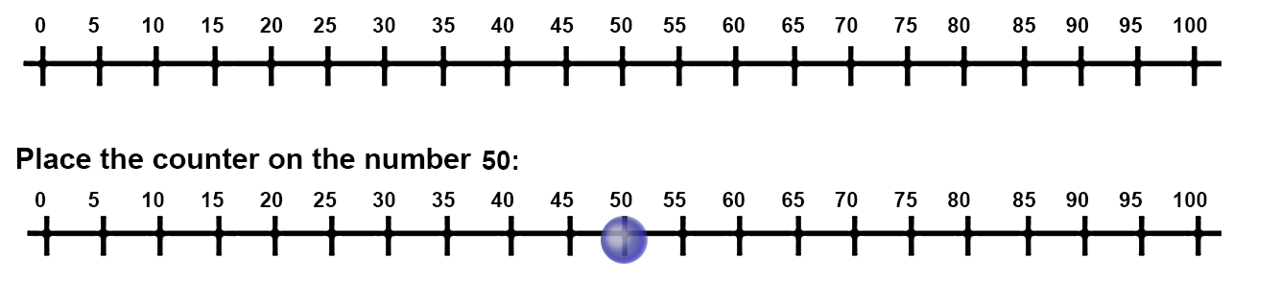

Figure 2 – Stage 3 number line

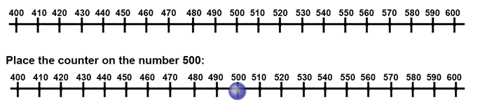

1. In each pair, one student is the ‘Plus’ and the other student is the ‘Minus’. The Plus will move right and the Minus will move left.
2. Stage 2 students place the counter on the number 50 and Stage 3 students place the counter on the number 500.
3. Pairs of students take turns to roll the dice.
4. Students add the numbers rolled and move the counter as many places left or right depending on whose turn it is.

**Note:** students estimate where the counter will be placed on the number line.

1. Students keep rolling the dice and moving until the counter either reaches zero or 100 (Stage 2) or 400 or 600 (Stage 3). If it gets to zero or 400, Minus wins and if it gets to 100 or 600, Plus wins.

This table details opportunities for assessment.

|  |  |
| --- | --- |
| Assessment opportunities | Links |
| What to look for:   * Can Stage 2 students represent addition and subtraction problems on a number line? **[MAO-WM-01, MA2-AR-01]** * Can Stage 3 students add and subtract numbers one-, 2- and 3-digit numbers using mental strategies? **[MAO-WM-01, MA3-AR-01]** | Links to [National Numeracy Learning Progressions](https://www.australiancurriculum.edu.au/resources/national-literacy-and-numeracy-learning-progressions/version-3-of-national-literacy-and-numeracy-learning-progressions/) (NNLP):   * Stage 2 – AdS7 * Stage 3 – AdS7, AdS8. |

### Core lesson 1: Towering metres – 20 minutes

The table below contains suggested learning intentions and success criteria. These are best co-constructed with students.

|  |  |
| --- | --- |
| Core concept learning intentions | Core concept success criteria |
| Students working towards Stage 2 outcomes are learning to:   * measure and compare objects using metres and centimetres.   Students working towards Stage 3 outcomes are learning to:   * connect decimal representations to the metric system * determine when a kilometre is the most appropriate unit of measurement. | Students working towards Stage 2 outcomes can:   * estimate and measure lengths in metres and centimetres * label and record lengths using the abbreviation of m and cm.   Students working towards Stage 3 outcomes can:   * recognise the equivalence of whole-number and decimal representations of measurements of length * explain that 1000 metres is equivalent to one kilometre * estimate and measure lengths that total one kilometre. |

This activity is an adaptation of ‘Towering metres’ from [*Teaching measurement Stages 2 and 3*](https://education.nsw.gov.au/teaching-and-learning/curriculum/mathematics/mathematics-curriculum-resources-k-12/mathematics-k-6-resources/teaching-measurement) by State of New South Wales (Department of Education).

1. [Brainstorm](https://app.education.nsw.gov.au/digital-learning-selector/LearningActivity/Card/542) all the units used to measure length and distance. Record answers on an anchor chart.
2. Discuss formal units of measurement that students have suggested and highlight the metre as a standard unit to measure length.
3. Ask students:

* Why is it important to have a formal unit of measurement?
* What equipment is used to measure length with a formal unit?
* Can you see items in the room that are about one metre in length?
* Where do you think one metre would reach on your body, if measured from the floor?

1. Use a metre ruler to demonstrate the length and height of a metre. Compare a metre ruler to the height of a student and the width of the door.
2. Explain to students that they are going to build a tower that is one metre in length.

**Note:** towers can be built either vertically or horizontally along the ground.

1. Provide small groups with materials that can be used to build a tower. For example, MAB materials, blocks or pencil tins. Groups build their tower until students estimate that it measures one metre, then check the length with a metre ruler.
2. Students draw a representation of their tower and record the measurement, using the abbreviation 1 m.
3. Students display their tower and go on a [gallery walk](https://app.education.nsw.gov.au/digital-learning-selector/LearningActivity/Card/555), looking at other groups’ estimations of one metre. As students are walking around, ask:

* What made you decide to do it that way?
* How close was your estimation to one metre? How do you know?
* Did you use anything to help you estimate one metre? Explain.
* Would you change anything if you had to build your tower again? Why or why not?

1. Stage 3 students calculate the difference between their estimated length and one metre. Students should represent the difference in centimetres, metres and kilometres using the abbreviations of cm, m and km and decimal parts where appropriate.

This table details opportunities for differentiation.

|  |  |
| --- | --- |
| Too hard? | Too easy? |
| Students cannot estimate one metre.   * Support students to build a tower horizontally with 10 long MAB or 100 cm cubes. | Students can estimate one metre.   * Challenge students to estimate and measure the length of their bodies. For example, fingertips to their nose or arm spans. * Challenge students to build their tower both vertically and horizontally and measure to see if the towers are the same. |

### Core lesson 2: Larger and smaller than a metre – 35 minutes

The Stage 2 activity is an adaptation of ‘Any three items’ from [*Teaching measurement Stages 2 and 3*](https://education.nsw.gov.au/teaching-and-learning/curriculum/mathematics/mathematics-curriculum-resources-k-12/mathematics-k-6-resources/teaching-measurement) by State of New South Wales (Department of Education).

1. Discuss objects or locations that can and cannot be measured using metres. Ask:

* What happens if an object or length is too small to be measured in metres? What unit is used?
* What happens if an object or length is too large to be measured in metres? What unit is used? (Stage 3)

1. Display a pen or pencil and ask Stage 2 students what the most appropriate formal unit of measurement would be to measure the item. Highlight the formal unit ‘centimetre’ and discuss why it is the most appropriate unit of measurement.

**Note:** this offers a learning opportunity to explore the meaning of the prefix ‘centi’ with students.

1. Explain to Stage 3 students that objects or distances that are greater than 1000 m require a formal unit longer than the metre for measuring distance, that unit of measurement is called a kilometre. 1000 m is equivalent to one kilometre.
2. Take the class outside, into the school playground.
3. Provide pairs of Stage 2 students with a 30 cm ruler. Ask students to examine the ruler and think of how they would use the ruler to measure an item.
4. Select Stage 2 students to share and justify their ideas. Guide the discussion toward 2 important concepts, to measure from the zero point and to read whole centimetres.
5. Demonstrate measuring an item that is 25 cm long.
6. Explain that in pairs, Stage 2 students will find 3 objects that have a total length of 25 cm. For example, see Figure 3.

Figure 3 – 25 cm total

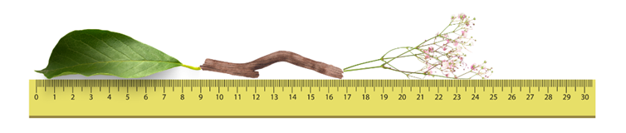

1. Stage 2 students explain how they will know the total length of the 3 objects and which objects could be combined to measure 25 cm. Encourage students to look at their rulers and estimate the length of the proposed objects.
2. Stage 2 students collect 3 objects that total 25 cm and confirm by using a ruler to measure the objects.
3. Stage 2 students draw, label and record their objects in their workbooks.
4. Ask Stage 3 students:

* Could a ruler be used to measure one kilometre? Why or why not?
* Why do you think a unit of measurement larger than a metre is required?
* How many kilometres is 3000 m? How do you know?
* Can you identify objects or distances that would be best measured with kilometres?

1. Display Resource 1: One kilometre investigation to Stage 3 students. Ask them to draw the table in their workbooks and explain that they will be measuring the distances of a location in the school using a trundle wheel.
2. Ask Stage 3 students:

* What do you know about a trundle wheel?
* How does a trundle wheel work?
* What specific unit of measurement does a trundle wheel measure?

1. Explain that, before measuring, Stage 3 students must estimate how many lengths of their location they will need to reach one kilometre. Ask:

* How will you use a trundle wheel to measure one kilometre?
* How many metre measurements will you see on the trundle wheel when you reach one kilometre?

1. Demonstrate that the trundle wheel must keep moving forward so that the mechanism clicks in order to measure length.
2. Stage 3 students measure one length of their chosen location using a trundle wheel and record the length. For example, see Figure 4.

Figure 4 – One kilometre investigation completed

A 2 row, 4 column table with column headings Locations 'Where will you measure?', Estimation 'How many single lengths do you estimate to make one km?', Length 'What is the distance of one length of your location?' and Answer 'How many lengths equal one km?'. 
Row 2 has students answers inserted.
Location = Basketball court 
Estimation = 50
Length = 25 m
Answer = 40 lengths of 25 m is 1 km

1. Instruct Stage 3 students to measure the location as many times as possible until they reach one kilometre and place their results in their table under the heading ‘Answer’.

**Note:** the purpose of this task is for students to recognise that measuring by metres for an extended distance is inefficient, sometimes a metre is too small. Facilitate the productive struggle.

This table details opportunities for differentiation.

|  |  |
| --- | --- |
| Too hard? | Too easy? |
| Stage 2 students cannot identify objects that total 25 cm.   * Support students to build a tower out of interlocking cubes that is 25 cm long and measure with their ruler.   Stage 3 students cannot use kilometres to measure lengths.   * Support students by adapting the activity to measure the location and find how many lengths make 100 metres instead of one kilometre. | Stage 2 students can identify objects that total 25 cm.   * Challenge students to use their knowledge of 25 cm to measure longer distances. For example, the classroom or desk. * Students identify how many lots of 25 cm are needed to measure the distance.   Stage 3 students can use kilometres to measure lengths.   * Challenge students by asking how many lengths of their chosen location in the school would be required to make 2, 5 and 10 kilometres. |

This table details opportunities for assessment.

|  |  |
| --- | --- |
| Assessment opportunities | Links |
| What to look for:   * Can Stage 2 students estimate and measure lengths in metres and centimetres? **[MAO-WM-01, MA2-GM-02]** * Can Stage 2 students label and record lengths using the abbreviation of m and cm? **[MAO-WM-01, MA2-GM-02]** * Can Stage 3 students recognise the equivalence of whole-number and decimal representations of measurements of length? **[MAO-WM-01, MA3-GM-02]** * Can Stage 3 students explain that 1000 metres is equivalent to one kilometre? **[MAO-WM-01, MA3-GM-02]** * Can Stage 3 students estimate and measure lengths that total one kilometre? **[MAO-WM-01, MA3-GM-02]** | Links to [National Numeracy Learning Progressions](https://www.australiancurriculum.edu.au/resources/national-literacy-and-numeracy-learning-progressions/version-3-of-national-literacy-and-numeracy-learning-progressions/) (NNLP):   * Stage 2 – UuM6 * Stage 3 – UuM6, NPV8, NPV9. |

### Discuss and connect the mathematics – 5 minutes

1. Regroup as a class and summarise the lesson together drawing out key mathematical ideas. Ask:

* How did you identify objects that combined to measure 25 cm? (Stage 2)
* Did your estimation match the number of lengths? (Stage 3)
* Was it efficient measuring one kilometre with a trundle wheel? (Stage 3)
* Can you suggest any other strategies that would be more efficient? (Stage 3)
* What advice would you give someone doing this task?
* How did you solve any challenges in this task?

## Lesson 2

**Core concept**: context determines the most suitable standard unit.

### Daily number sense: Closest to – 10 minutes

The table below contains a suggested learning intention and success criteria. These are best co-constructed with students.

|  |  |
| --- | --- |
| Daily number sense learning intention | Daily number sense success criteria |
| All students are learning to:   * solve addition problems. | Students working towards Stage 2 outcomes can:   * use the compensation strategy to add 2-digit numbers.   Students working towards Stage 3 outcomes can:   * add 3-digit numbers using mental or written strategies. |

This activity is an adaptation of [Dicey Operations in Line](https://nrich.maths.org/13261) by [NRICH](https://nrich.maths.org/) by University of Cambridge (Faculty of Mathematics).

1. Provide pairs of students with a 6-sided die, 2 individual whiteboards and whiteboard markers.
2. Stage 2 students roll the die 4 times to make two 2-digit numbers and Stage 3 students roll the die 9 times to make three 3-digit numbers. Students to record the numbers in a number sentence (see Figure 5).

Figure 5 – Stage 2 and Stage 3 number sentence layout

Blank boxes for digits in number sentences. Stage 2 - 2 digit number + 2 digit number = 
Stage 3 - 3 digit number + 3 digit number + 3 digit number =

1. After each throw of the die, students decide whether the number is placed in the ones or tens column (Stage 2) or ones, tens or hundreds column (Stage 3).
2. For Stage 2, model solving the addition number sentence using the compensation strategy. For example, 28 + 35 is the same as 30 + 35 = 65, subtract 2 to obtain 63 (see Figure 6).

Figure 6 – Compensation strategy

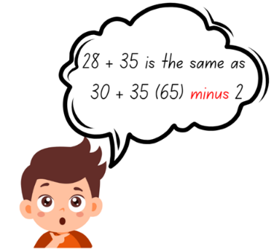

1. Students add the numbers using mental or written strategies. For Stage 2, the winner is the student whose total is closest to 100 without going higher. For Stage 3, the winner is the student whose total is closest to 1000 without going higher.
2. Students play multiple rounds.

**Note:** this activity can be adapted to allow students to solve subtraction problems.

This table details opportunities for assessment.

|  |  |
| --- | --- |
| Assessment opportunities | Links |
| What to look for:   * Can Stage 2 students use the compensation strategy to add 2-digit numbers? **[MAO-WM-01, MA2-AR-01]** * Can Stage 3 students add 3-digit numbers using mental or written strategies? **[MAO-WM-01, MA3-AR-01]** | Links to [National Numeracy Learning Progressions](https://www.australiancurriculum.edu.au/resources/national-literacy-and-numeracy-learning-progressions/version-3-of-national-literacy-and-numeracy-learning-progressions/) (NNLP):   * Stage 2 – AdS7 * Stage 3 – AdS8.   Links to suggested [Interview for Student Reasoning](https://policies.education.nsw.gov.au/teaching-and-learning/curriculum/literacy-and-numeracy/assessment-resources/ifsr) (IfSR) tasks:   * **Stage 2 – [IfSR-NP/AT/MT**: 2A.1 * **Stage 3 – IfSR-AT**: 3A.2. |

### Core lesson: Tiny town – 55 minutes

The table below contains suggested learning intentions and success criteria. These are best co-constructed with students.

|  |  |
| --- | --- |
| Core concept learning intentions | Core concept success criteria |
| Students working towards Stage 2 outcomes are learning to:   * measure and record lengths using centimetres.   Students working towards Stage 3 outcomes are learning to:   * apply their knowledge of kilometres and metres in different contexts. | Students working towards Stage 2 outcomes can:   * use a ruler to measure lengths and distances in centimetres.   Students working towards Stage 3 outcomes can:   * use MAB materials to represent kilometres and measure distances * record distances using the abbreviations m and km * recognise that 10 times 100 metres is one kilometre. |

1. Ask Stage 2 students how objects could be measured if they are smaller than one metre.
2. Using an MAB unit block, demonstrate the size of a centimetre to Stage 2 students (see Figure 7).

Figure 7 – Measuring MAB material

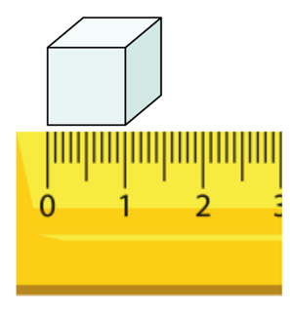

1. Provide Stage 2 students with a 30 cm ruler and two 6-sided dice. Students roll the dice, add the numbers rolled together and draw a line representing the number with their ruler in their workbook. Students repeat this step 4 more times until they have 5 ruled lines.
2. Stage 2 students swap books with a partner to measure and record the length of the 5 lines, checking for accuracy (see Figure 8).

Figure 8 – Measured lines

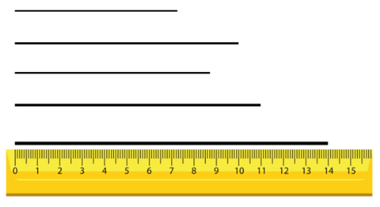

1. As Stage 2 students are drawing and measuring their lines, write 4.75 km on the board. Ask Stage 3 students to [Think-Pair-Share](https://app.education.nsw.gov.au/digital-learning-selector/LearningActivity/Card/645) what they notice and what they know. Ask:

* What do you notice about the decimal representation?
* Can you identify how metres are represented?
* Can you identify how many kilometres are represented?
* What is something you know that would be roughly the distance of 4.75 km?
* How many more metres would be required to make 5 km?

1. Display Resource 2: 4.75 km annotated and discuss similarities and differences between Stage 3 student responses.
2. Write 6.35 km, 12.36 km, 1.06 km and 4.35 km on the board and ask Stage 3 students:

* What value is being represented by the 5 in 6.35?
* What value is being represented by the 12 in 12.36?
* What value is being represented by the 0 in 1.06?
* What value is being represented by the 3 in 4.35?

1. Regroup as a class and explain that students will be designing their own tiny town on A3 paper. In the tiny towns, students must have a school, pool, shopping centre, post office, hospital, sporting complex, a house and roads. For example, see Figure 9.

Figure 9 – Tiny town example

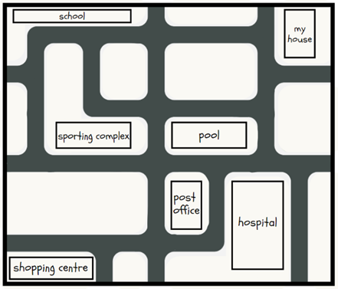

**Note:** emphasise to students to draw a simple design and not to spend too much time with details.

1. When Stage 2 students have designed their tiny town, model correct use of a 30 cm ruler. Highlight the importance of beginning measurements at the zero-line marked on the ruler.
2. Stage 2 students record the actual distances between the buildings in their tiny town and record them on Resource 3: Stage 2 Tiny town recording. Students must record the distances using the correct cm abbreviation.
3. Ask Stage 2 students about objects they know that may be similar to the distances they have measured.
4. When Stage 3 students have designed their tiny town, explain that the MAB unit will be used to represent 100 metres and the MAB long will be used to represent one kilometre (see Figure 10). Ask Stage 3 students:

* Why do you think MAB material will be used for this activity to represent kilometres and metres?
* Are the MAB units actually 100 m in length?
* If a unit block is used to represent 100 m, why is a tens block used to represent one kilometre?
* How would 4.6 km be represented with MAB?
* How many tens blocks would be needed to represent 7 kilometres?

Figure 10 – MAB unit representing 100 m

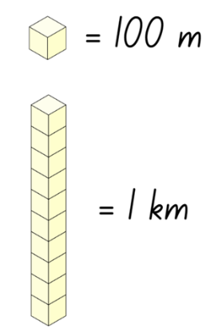

**Note:** it is essential that Stage 3 students have a clear understanding that the MAB materials being used are a representation only and that they are not actually those lengths.

1. Provide Stage 3 students with Resource 4: Stage 3 Tiny town recording and MAB materials. Students measure the distances between the buildings using the MAB materials and record the distances in kilometres and meters. Students must record the distances using the correct m and km abbreviations.

**Multi-age:** when all students are measuring distances between buildings, highlight that there are 2 ways to measure. In a direct line or by following the roads. It should be made clear that Stage 2 students are measuring the actual distances and Stage 3 students are using the tiny town as a scaled model.

This table details opportunities for differentiation.

|  |  |
| --- | --- |
| Too hard? | Too easy? |
| Stage 2 students cannot measure and record lengths using centimetres.   * Students measure the distances between the buildings in a straight line only and record. * Support students by providing MAB unit blocks to measure lines. For example, 10 MAB unit blocks are equal to 10 cm.   Stage 3 students cannot apply their knowledge of kilometres and metres in different contexts.   * Students measure the distances between the buildings in a straight line only and record. | Stage 2 students can measure and record lengths using centimetres.   * Challenge students to order their distances in descending order.   Stage 3 students can apply their knowledge of kilometres and metres in different contexts.   * Challenge students to convert the recorded distances into cm and mm. |

### Discuss and connect the mathematics – 5 minutes

1. Regroup as a class and summarise the lesson drawing out key mathematical ideas. Ask:

* Why is it important to measure accurately?
* What was your longest distance?
* What was your shortest distance?
* What instrument did you use to measure your distances and why was it the most appropriate for the task? (Stage 2)
* Could you have used a different instrument to measure the distances? Justify your response. (Stage 2)
* Why is 2.4 km equal to 2400 m? How do you know? (Stage 3)
* Do you have any further questions around converting? (Stage 3)
* What was challenging about this activity? How did you overcome these challenges?

This table details opportunities for assessment.

|  |  |
| --- | --- |
| Assessment opportunities | Links |
| What to look for:   * Can Stage 2 students use a ruler to measure lengths and distances in centimetres? **[MAO-WM-01, MA2-GM-02]** * Can Stage 3 students use MAB materials to represent kilometres and measure distances? **[MAO-WM-01, MA3-GM-02]** * Can Stage 3 students record distances using the abbreviation m and km? **[MAO-WM-01, MA3-GM-02]** * Can Stage 3 students recognise that 10 times 100 metres is one kilometre? **[MAO-WM-01, MA3-GM-02]** | Links to [National Numeracy Learning Progressions](https://www.australiancurriculum.edu.au/resources/national-literacy-and-numeracy-learning-progressions/version-3-of-national-literacy-and-numeracy-learning-progressions/) (NNLP):   * Stage 2 – UuM6 * Stage 3 – UuM6, UuM8. |

## Lesson 3

**Core concept**: estimating length can be guided by using known lengths as benchmarks.

### Daily number sense: Addition and subtraction problems – 10 minutes

The table below contains a suggested learning intention and success criteria. These are best co-constructed with students.

|  |  |
| --- | --- |
| Daily number sense learning intention | Daily number sense success criteria |
| All students are learning to:   * solve addition and subtraction problems. | Students working towards Stage 2 outcomes can:   * represent addition and subtraction problems on an empty number line.   Students working towards Stage 3 outcomes can:   * apply known strategies such as levelling, addition for subtraction, using constant difference, and bridging to solve addition and subtraction problems. * use place value to add or subtract 3 or more numbers with different numbers of digits. |

1. Distribute a 30 cm ruler (Stage 2 students only), mini whiteboard and whiteboard marker to each student.
2. Write 84 − 68 = _ on the board and ask students to record their thinking on their whiteboards.
3. Stage 2 students to use an empty number line to solve the problem (see Figure 11).

Figure 11 – Number line

84 - 68 = 
There is a number line labelled with 16, 20, 80 and 84 with jumps of 4, 60 and 4.

1. Select students to share and justify their ideas.

**Multi-age:** Stage 2 students should use an empty number line while Stage 3 students should use known strategies such as levelling, addition for subtraction, using constant difference, and bridging to solve the problems.

1. Display 38 + 43 = _ and have students record and solve the problem on their whiteboard. Students share and demonstrate their working.
2. Repeat multiple times with other addition and subtraction problems.

**Multi-age:** Stage 2 students should solve 2- and 3-digit problems while Stage 3 students should experience solving problems with 3 or more numbers with different numbers of digits.

This table details opportunities for assessment.

|  |  |
| --- | --- |
| Assessment opportunities | Links |
| What to look for:   * Can Stage 2 students represent addition and subtraction problems on an empty number line? **[MAO-WM-01, MA2-AR-01]** * Can Stage 3 students apply known strategies such as levelling, addition for subtraction, using constant difference, and bridging to solve addition and subtraction problems? **[MAO-WM-01, MA3-AR-01]** * Can Stage 3 students use place value to add or subtract 3 or more numbers with different numbers of digits? **[MAO-WM-01, MA3-AR-01]** | Links to [National Numeracy Learning Progressions](https://www.australiancurriculum.edu.au/resources/national-literacy-and-numeracy-learning-progressions/version-3-of-national-literacy-and-numeracy-learning-progressions/) (NNLP):   * Stage 2 – AdS7 * Stage 3 – AdS8.   Links to suggested [Interview for Student Reasoning](https://www.ofai.edu.au/media/iiwbecoj/national-numeracy-progression-v3.pdf) (IfSR) tasks:   * **Stage 3 – IfSR-AT**: 3A.2. |

### Core lesson: Benchmarks – 50 minutes

The table below contains a suggested learning intention and success criteria. These are best co-constructed with students.

|  |  |
| --- | --- |
| Core concept learning intentions | Core concept success criteria |
| All students are learning to:   * estimate, measure and record lengths and distances. | All students can:   * estimate lengths and distances using known benchmarks * measure and record lengths in metres.   Students working towards Stage 3 outcomes can:   * measure and record lengths using kilometres. |

1. Write the word ‘estimation’ on the board and ask students to think of what they know about estimation. Provide students time to think and then [turn and talk](https://education.nsw.gov.au/teaching-and-learning/curriculum/literacy-and-numeracy/teaching-and-learning-resources/numeracy/talk-moves) to discuss their prior knowledge. Ask:

* What is estimation?
* Why is estimation important?
* What is an example of where an estimation could be used?
* When would it not be appropriate to use estimation? Explain your answer.

1. Display Resource 5: Landmarks and ask students to [Think-Pair-Share](https://app.education.nsw.gov.au/digital-learning-selector/LearningActivity/Card/645) about their estimations of the length of the Eiffel Tower (Stage 2 and 3) and Uluru (Stage 3).
2. Ask students:

* What is your estimate for the location?
* How did you estimate the length or height of the location?

1. Explain that the Eiffel Tower is 300 m in height and Uluru is 3.6 km in length. Students discuss and compare their estimations with the provided measurements, sharing what they notice.
2. Explain to students that they will estimate lengths and distances in the school before measuring and recording them.

**Multi-age:** Stage 2 students are to estimate lengths and distances in metres and centimetres. Stage 3 students are to estimate lengths and distances using metres and kilometres.

1. Explain that a personal benchmark is an informal unit of measurement. For example, one full step may be close to one metre in length.

**Note:** a benchmark is a standard against which something can be compared or measured. Students need to develop personal benchmarks with which to estimate lengths and other measures.

1. Discuss how benchmarks may be used for estimating.
2. Explain to students that using known lengths is also an efficient way to estimate. For example, using the known length of a rugby league football field (100 metres) or swimming pool (25 or 50 metres), students may be able to estimate other distances.
3. Reproduce Figure 12 and Figure 13 on the board and ask students to draw the respective tables in their workbooks.

Figure 12 – Stage 2 recording table

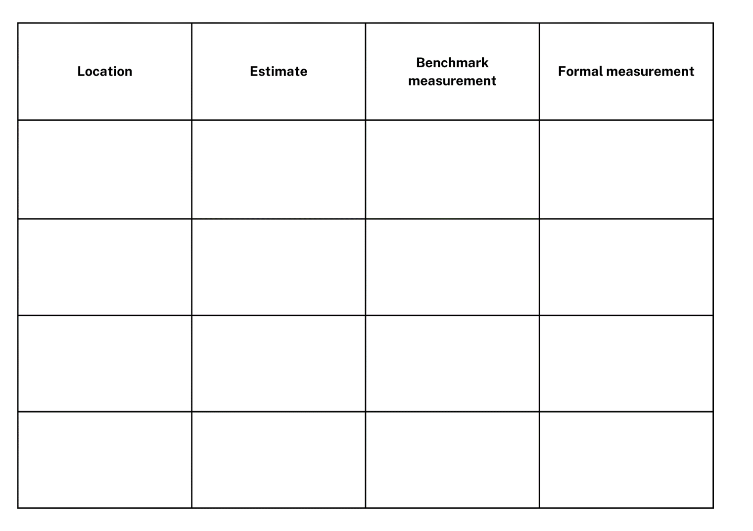

Figure 13 – Stage 3 recording table

Table with headings location, estimate, formal measurement (metres) and kilometres. 
Example showing:
Location = length of field, 
Estimate = 40 m 
Formal measurement (Metres) = 42 m
Kilometres = 0.042 km.

1. Explain that students will be estimating lengths around the school. Stage 2 students will be using their own personal benchmark and Stage 3 students are to use known lengths to estimate.
2. Stage 2 students share and justify a personal benchmark that they will use to complete the activity.

**Note:** if students share personal benchmarks that are not practical for measuring, use this opportunity to refine their benchmark.

1. Take students outside and assign locations to be recorded. Based off sight, students write their estimation of length for each location in their table.
2. Stage 2 students measure the locations using personal benchmarks and record results in the table (see Figure 14).

Figure 14 – Stage 2 recording table completed

Table with 4 columns titled Location, Estimate, Benchmark measurement and Formal measurement. Basketball court - 50m, 31m, 28m. 
Soccer field - 50m, 64m, 100m. 
Classroom - 20m, 15m, 12m. 
Hall - 30m, 35m, 42m.

1. Display a trundle wheel and revise students’ knowledge. Ask:

* What is this tool called?
* What do you know about a trundle wheel?
* How does a trundle wheel measure length?
* What are some important considerations to remember when using a trundle wheel?

**Note:** students need to understand and be convinced that one rotation of a trundle wheel is 1 m. If there is not access to enough metre rules or trundle wheels, consider measuring and pre-cutting string or ribbon to one metre.

1. Using a trundle wheel or another formal measuring tool, such as a metre ruler, students measure the length of each location and record results in the table. Stage 2 students record measurements in full metres and then centimetres if needed. For example, 30 m and 20 cm. Stage 3 students record the length in metres and convert the measurements to kilometres.

This table details opportunities for differentiation.

|  |  |
| --- | --- |
| Too hard? | Too easy? |
| Students cannot estimate, measure and record lengths.   * Provide a one metre ruler to reference when estimating and measuring distances or support students to identify locations with smaller distances to be measured. For example, desks or the width of a classroom. | Students can estimate, measure and record lengths.   * Challenge Stage 2 students to order their results in descending order. * Challenge Stage 3 students by providing them an opportunity to estimate, measure and record an additional location in the school of their choosing. |

### Discuss and connect the mathematics – 10 minutes

1. Regroup as a class and summarise the lesson drawing out key mathematical ideas. Ask:

* How close were your estimations?
* How easy or hard was it to measure using your personal benchmark? Why? (Stage 2)
* Was it easier to use your benchmark or the formal tool provided? Why or why not? (Stage 2)
* How did you convert the measurements from metres to kilometres? (Stage 3)
* What is a job that might use benchmarks to estimate measurement?
* If you were to start this activity again, would you use the same benchmark? Explain your reasoning.
* What challenges did you face? How did you overcome them?

This table details opportunities for assessment.

|  |  |
| --- | --- |
| Assessment opportunities | Links |
| What to look for:   * Can students estimate lengths and distances using known benchmarks? **[MAO-WM-01, MA3-GM-02, MA2-GM-02]** * Can students measure and record lengths in metres? **[MAO-WM-01, MA3-GM-02, MA2-GM-02]** * Can Stage 3 students measure and record lengths using kilometres? **[MAO-WM-01, MA3-GM-02]** | Links to [National Numeracy Learning Progressions](https://www.australiancurriculum.edu.au/resources/national-literacy-and-numeracy-learning-progressions/version-3-of-national-literacy-and-numeracy-learning-progressions/) (NNLP):   * Stage 2 – UuM6 * Stage 3 – UuM6. |

## Lesson 4

**Core concept**: metric units of measurement relate to the base-10 place value system.

### Daily number sense – 10 minutes

1. From a class need surfaced through formative assessment data, identify a short, focused activity that targets students’ knowledge, understanding and skills. Example activities may be drawn from the following resources:

* [Mathematics K-6 resources](https://education.nsw.gov.au/teaching-and-learning/curriculum/mathematics/mathematics-curriculum-resources-k-12/mathematics-k-6-resources.main-education--category---catalogue---key-learning-area---mathematics---thinking-mathematically.nameAsc.1.grid)
* [Universal Resources Hub](https://resources.education.nsw.gov.au/home).

### Core lesson 1: The power of 10 – 30 minutes

The table below contains a suggested learning intention and success criteria. These are best co-constructed with students.

|  |  |
| --- | --- |
| Core concept learning intentions | Core concept success criteria |
| All students are learning to:   * recognise how the base-10 number system relates to length. | Students working towards Stage 2 outcomes can:   * identify that there are 10 millimetres in one centimetre * use millimetres to measure lengths with a ruler * record lengths using the abbreviation mm for millimetres.   Students working towards Stage 3 outcomes can:   * identify that there are 1000 metres in one kilometre * recognise the equivalence of whole-number and decimal representations of measurements of length. |

1. Ask students:

* What do you know about the number 10?
* What is so important about the number 10?
* Why is our number system called the base-10 system?
* How is the number 10 important in everyday life?

**Note:** guide student understanding that the base-10 system has emerged from humans having 10 fingers.

1. Display Resource 6: Millimetre ruler and students [Think-Pair-Share](https://app.education.nsw.gov.au/digital-learning-selector/LearningActivity/Card/645) discussing what they notice about the image.
2. Select students to share and justify responses.

**Note:** this resource has been created and enlarged to support students when viewing the small components on the ruler. This is not to scale and should not be used as an ongoing point of reference when students are exploring millimetres.

1. Explain to students that 10 mm is equivalent to one centimetre. Ask:

* What items would be best measured in millimetres?
* What items would not be best measured in millimetres?
* Why are millimetres an important unit of measurement?
* How many millimetres are in a centimetre? How do you know?

1. Reproduce Figure 15 on the board.

Figure 15 – Metric units

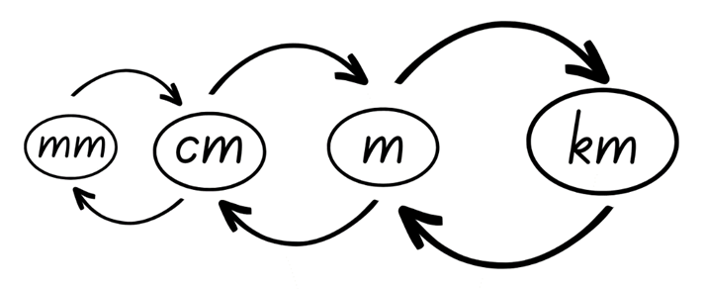

1. Ask students:

* What do you notice?
* What is the relationship between each unit of measure?
* How does this connect to the base-10 number system?
* Why is it important to understand the base-10 number system when measuring lengths?
* How can this display help us to convert between different units of length?

**Multi-age:** with Stage 2 students, use the language of ‘10 of those is one of those’ or ‘100 of those is one of those’. For example, ‘10 mm is 1 cm’ or ‘100 cm is 1 m’. Stage 2 students do not need to work with kilometres. Encourage Stage 3 students to recognise that all conversions between units in the metric system involve factors and powers of 10 (see Figure 16).

Figure 16 – Metric conversion display

Metric system conversion with units of measure for length (mm, cm, m and km) with arrows to and from each showing mm divided by 10 = cm, cm divided by 100 = m, m divided by 1000 = km.
Also showing km x 1000 = m, m x 100 = cm and cm x 10 = mm

1. Write the following lengths of the board:

* 3 cm
* 30 cm
* 8 cm
* 18 cm
* 9 cm
* 29 cm

1. Stage 2 students convert the lengths to millimetres and record them in their workbooks using the abbreviation of mm.
2. Reproduce Figure 17 on the board for Stage 3 students and complete using a think aloud. Explicitly show students how to convert between metres and kilometres.

Figure 17 – Teacher model

Table with headings Metres (m) and kilometres (km) and examples of conversion with missing values.
The first example is complete with Metres = 4500m and Kilometres = 45km
The second example is 7000m with kilometres left blank for working out.
The third example is 2325km with the metres left blank for working out.
The fourth example is 13, 350m with kilometres left blank for working out.

1. Provide each Stage 3 students with Resource 7: Student conversion table to complete by converting between metres and kilometres.

This table details opportunities for differentiation.

|  |  |
| --- | --- |
| Too hard? | Too easy? |
| Stage 2 students cannot convert between centimetres and millimetres.   * Support students by only using one-digit lengths.   Stage 3 students cannot convert between kilometres and metres.   * Support students by providing a completed version of Resource 7: Student conversion table pre-cut out for students to match. | Stage 2 students can convert between centimetres and millimetres.   * Challenge students by using lengths with decimal parts.   Stage 3 students can convert between kilometres and metres.   * Challenge students to add to their table showing the measurements in centimetres and millimetres. |

### Consolidation and meaningful practice – 20 minutes

#### Stage 2 task: Exploring millimetres

1. Model measuring a familiar item using the think aloud strategy, emphasising that 10 mm is equivalent to 1 cm and this can be used to accurately measure objects.
2. Provide students with Resource 8: Measuring with millimetres.
3. Students measure the images and record their measurements using the abbreviation of mm.

**Note:** this activity may also be completed with concrete classroom materials.

1. Ask students:

* What measurements did you record for each object?
* How many millimetres are in one centimetre?
* Can you make a connection between measurement and our place value system? Explain your thinking.
* Was the millimetre an accurate form of measurement? Why?
* What are some other objects in the classroom that are best suited to measure in millimetres?
* How many millimetres are in 6 cm? How do you know?

This table details opportunities for differentiation.

|  |  |
| --- | --- |
| Too hard? | Too easy? |
| Students cannot measure and compare objects using millimetres.   * Support students by measuring to the nearest centimetre and assist them to count on in millimetres. | Students can measure and compare objects using millimetres.   * Challenge students to record their responses in centimetres and millimetres. For example, 41 mm or 4 cm and 1 mm. |

#### Stage 3 task: Who is winning?

1. Demonstrate how to play ‘Who is winning?’ by playing against a student.
2. Students shuffle the cards, and each student draws a card from the pile. Students then compare their 2 lengths.
3. The student with the greater length keeps both cards. If they draw the same length, each player keeps their card.
4. Repeat steps until all cards have been used. The winner is the student with the most cards in their pile.
5. Provide pairs of students Resource 9: Who is winning? to play the game.
6. Students play multiple rounds.

This table details opportunities for differentiation.

|  |  |
| --- | --- |
| Too hard? | Too easy? |
| Students cannot recognise that 10 times 100 metres is one kilometre.   * Support students by providing them with only sheet one of Resource 9: Who is winning? | Students can recognise that 10 times 100 metres is one kilometre.   * Challenge students to record how much bigger their winning length was than their opponent’s card or challenge students to place their collected cards into ascending and descending order. |

This table details opportunities for assessment.

|  |  |
| --- | --- |
| Assessment opportunities | Links |
| What to look for:   * Can Stage 2 students identify that there are 10 millimetres in one centimetre? **[MAO-WM-01, MA2-GM-02]** * Can Stage 2 students use millimetres to measure lengths with a ruler? **[MAO-WM-01, MA2-GM-02]** * Can Stage 2 students record lengths using the abbreviation mm for millimetres? **[MAO-WM-01, MA2-GM-02]** * Can Stage 3 students identify that there are 1000 metres in one kilometre? **[MAO-WM-01, MA3-GM-02]** * Can Stage 3 students recognise the equivalence of whole-number and decimal representations of measurements of length? **[MAO-WM-01, MA3-GM-02]** | Links to [National Numeracy Learning Progressions](https://www.australiancurriculum.edu.au/resources/national-literacy-and-numeracy-learning-progressions/version-3-of-national-literacy-and-numeracy-learning-progressions/) (NNLP):   * Stage 2 – UuM6 * Stage 3 – UuM6, NPV8. |

## Lesson 5

**Core concept:** perimeters of 2D shapes are calculated by finding the total length of the sides.

### Daily number sense: Where do you fit? – 10 minutes

Daily number sense activities for Lessons 5 to 7 ‘loop’ back to concepts and procedures covered in previous units to assist students to build an increasingly connected network of ideas. These concepts may differ from the core concepts being covered by the unit.

The table below contains a suggested learning intention and success criteria. These are best co-constructed with students.

|  |  |
| --- | --- |
| Daily number sense learning intention | Daily number sense success criteria |
| All students are learning to:   * read, represent and order numbers. | All students can:   * arrange numbers in ascending or descending order.   Students working towards Stage 2 outcomes can:   * read numbers to thousands.   Students working towards Stage 3 outcomes can:   * name millions using the place value grouping of ones, tens and hundreds. |

1. Group students into groups of 4–6. Ensure Stage 2 students are in groups together and Stage 3 students are in groups together.
2. Provide each Stage 2 group with four 10-sided dice and each Stage 3 group with seven 10-sided dice.
3. Stage 2 students take turns rolling the dice to create a 4-digit number. Stage 3 students take turns rolling the dice to create a 7-digit number.
4. Students record the number on a sticky note and one by one, read their number aloud. Encourage Stage 3 students to use the place value grouping of ones, tens and hundreds.
5. Students in each group place themselves in order from smallest to largest.
6. When each group has all members in order, have 2 Stage 2 groups combine and have 2 Stage 3 groups combine. Group members need to adjust their order to ensure they are still in order from smallest to largest.
7. Continue to combine Stage 2 and Stage 3 groups and adjust placements until all Stage 2 and Stage 3 students are in order.

**Note:** this activity can be adapted by using fewer numbers of a 10-sided dice.

This table details opportunities for assessment.

|  |  |
| --- | --- |
| Assessment opportunities | Links |
| What to look for:   * Can students arrange numbers in ascending or descending order? **[MAO-WM-01, MA2-RN-01, MA3-RN-01]** * Can Stage 2 students read numbers to thousands? **[MAO-WM-01, MA2-RN-01]** * Can Stage 3 students name millions using the place value grouping of ones, tens and hundreds? **[MAO-WM-01, MA3-RN-01]** | Links to [National Numeracy Learning Progressions](https://www.australiancurriculum.edu.au/resources/national-literacy-and-numeracy-learning-progressions/version-3-of-national-literacy-and-numeracy-learning-progressions/) (NNLP):   * Stage 2 – NPV5, NPV6 * Stage 3 – NPV7.   Links to suggested [Interview for Student Reasoning](https://education.nsw.gov.au/teaching-and-learning/curriculum/literacy-and-numeracy/assessment-resources/ifsr) (IfSR) tasks:   * **Stage 2 – [IfSR-NP/AT/MT**: 4B.2, 4C.5. |

### Core lesson: Measuring perimeter – 50 minutes

The table below contains suggested learning intentions and success criteria. These are best co-constructed with students.

|  |  |
| --- | --- |
| Core concept learning intentions | Core concept success criteria |
| Students working towards Stage 2 outcomes are learning to:   * compare and describe features of two-dimensional shapes * use scaled instruments to measure and compare lengths.   Students working towards Stage 3 outcomes are learning to:   * apply their knowledge of length to calculate the perimeter of common two-dimensional shapes. | Students working towards Stage 2 outcomes can:   * describe and compare squares, rhombuses, triangles, hexagons, octagons and pentagons * use the term perimeter to describe the distance around the boundary * measure the perimeter of quadrilaterals.   Students working towards Stage 3 outcomes can:   * define the term perimeter * use efficient strategies to calculate the perimeter of common two-dimensional shapes * recognise that rotations change the position and orientation but not the perimeter |

1. Use Resource 10: Flip and describe cards to play ‘flip and describe’.
2. Flip a card. Challenge Stage 2 students to name the two-dimensional shape and Stage 3 students to describe the shape.
3. Play until the class is confident with each of the shapes.

**Note:** two-dimensional shapes have been placed on the cards in various orientations to generate student thinking.

1. Display Resource 11: Perimeters and ask Stage 3 students to [brainstorm](https://app.education.nsw.gov.au/digital-learning-selector/LearningActivity/Card/542) what they know about the term. Ask:

* What do you notice about the shapes?
* What do the lines on the shapes represent?
* How would you find the missing lengths of the shapes sides?
* How would you calculate the perimeter of the shapes, with some measurements being in metres and some in kilometres?

1. Students record their ideas on an anchor chart to be displayed around the room and added to throughout the learning process.

**Multi-age:** Stage 3 students create a group anchor chart while the teacher guides Stage 2 students.

1. Display Figure 18 and ask Stage 2 students to discuss what they know about rectangles and squares. Help students to record their thinking on an anchor chart.

Figure 18 – 2 rectangles

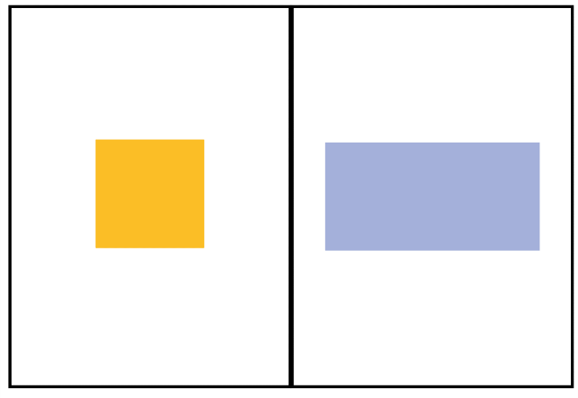

1. Bring the whole class together and select students from each stage to share the key ideas from their respective anchor charts. Stage 2 students discuss two-dimensional shapes and Stage 3 students discuss the perimeter using terms such as equal lengths and total distance. If not identified from students, explain that perimeter is the total distance around an object. Discuss the term ‘perimeter’. Explain to students that ‘perimeter’is the outer edge of a flat shape or area and is from the meaning of the Latin word peri meaning around and metron meaning measure.
2. Model measuring the perimeter of a rectangle and recording the measurements on all 4 sides and adding the numbers together.

**Note:** students need opportunities to interpret length as pertaining to a boundary as well as the straight-line distance between 2 points.

1. Provide Stage 2 students with Resource 12: Two-dimensional quadrilaterals and 30 cm rulers to measure and record the perimeter of each shape. Students can record the length of the sides in either cm or mm.
2. Provide Stage 3 students with Resource 13: Perimeters 2 and have them use their knowledge and understanding of perimeters to find the perimeter of the two-dimensional shapes.
3. Bring the class together and have select students share and justify their answers with the class. Ask:

* Why is one shape a rectangle and the other a square? (Stage 2)
* Why are all the shapes called quadrilaterals? (Stage 2)
* Is that the most efficient way to calculate the perimeter? (Stage 3)
* What would be a more efficient approach? Why? (Stage 3)
* Can you think of any real-life locations or objects that are similar to the shapes explored?

**Multi-age:** guide Stage 2 students to notice that a rectangle’s sides are different lengths, while a square’s sides are all equal. The rectangle has been intentionally designed to be equivalent to 2 of the squares.Emphasise to Stage 3 students that a working out column has been provided so that problem solving can be reviewed and discussed.

1. Take students outside. Stage 2 students identify and measure small quadrilateral shapes and Stage 3 students measure the perimeter of school areas or locations. For example, Stage 2 students may explore bricks or signs, while Stage 3 students use a trundle wheel or metre ruler to measure perimeters of basketball courts or seating areas. Students record their measurements in their workbooks.

This table details opportunities for differentiation.

|  |  |
| --- | --- |
| Too hard? | Too easy? |
| Stage 2 students cannot measure and compare two-dimensional shapes.   * Provide hands-on materials such as MAB materials to support measuring and comparing shapes.   Stage 3 Students cannot calculate the perimeter of common two-dimensional shapes.   * Support students by providing the missing value for two-dimensional shapes in Resource 13: Perimeters 2. * Support students by adjusting measurements in Resource 13: Perimeters 2 to simpler two-digit numbers. | Stage 2 students can measure and compare two-dimensional shapes.   * Challenge students to draw as many regular two-dimensional shapes and record their properties. * Challenge students to use millimetres when measuring and record results using the abbreviation mm.   Stage 3 students can calculate the perimeter of common two-dimensional shapes.   * Challenge students to provide their answers in centimetres, metres and kilometres. |

### Discuss and connect the mathematics – 10 minutes

1. Discuss the similarities and differences between the shapes and perimeters that were identified outside. Ask:

* What did you notice about the different rectangles? (Stage 2)
* Which area or location of the school had the largest perimeter? (Stage 3)
* What strategy did you use to find the perimeter of the shapes?
* Was this strategy efficient? Why?
* What is another strategy that you could use? (Stage 3)
* What did you find challenging about this activity? Why?

This table details opportunities for assessment.

|  |  |
| --- | --- |
| Assessment opportunities | Links |
| What to look for:   * Can students use the term perimeter? **[MAO-WM-01, MA2-GM-02, MAO-WM-01, MA3-GM-02]** * Can Stage 2 students describe and compare squares, rhombuses, triangles, hexagons, octagons and pentagons? **[MAO-WM-01, MA2-2DS-01]** * Can Stage 2 students measure the perimeter of quadrilaterals? **[MAO-WM-01, MA2-GM-02]** * Can Stage 3 students use efficient strategies to calculate the perimeter of common two-dimensional shapes? **[MAO-WM-01, MA3-GM-02]** | Links to [National Numeracy Learning Progressions](https://www.australiancurriculum.edu.au/resources/national-literacy-and-numeracy-learning-progressions/version-3-of-national-literacy-and-numeracy-learning-progressions/) (NNLP):   * Stage 2 – UGP2, UGP3, UGP4, UuM7 * Stage 3 – UuM5, UuM7, UuM8. |

## Lesson 6

**Core concept**: shapes can be classified and compared based on the length of their sides.

### Daily number sense: Representing numbers – 10 minutes

The table below contains a suggested learning intention and success criteria. These are best co-constructed with students.

|  |  |
| --- | --- |
| Daily number sense learning intention | Daily number sense success criteria |
| All students are learning to:   * read and represent numbers. | Students working towards Stage 2 outcomes can:   * read and represent numbers to thousands * identify the number before and after a number.   Students working towards Stage 3 outcomes can:   * name millions using the place value grouping of ones, tens and hundreds * round numbers to a specified place value. |

1. Provide students with a 10-sided die, individual whiteboard and whiteboard marker each.
2. Stage 2 students roll the die 4 times to create a 4-digit number and record it in the middle of their whiteboard. Stage 3 students roll the die 7 times to create a 7-digit number and record it on their whiteboard.

**Note:** using a 10-sided die with 0–9 will allow Stage 2 students to use and understand the role of the internal zero.

1. Students read their number to a partner.
2. Stage 2 students identify and record the number before and the number after their 4-digit number (see Figure 19).

Figure 19 – Number before and after

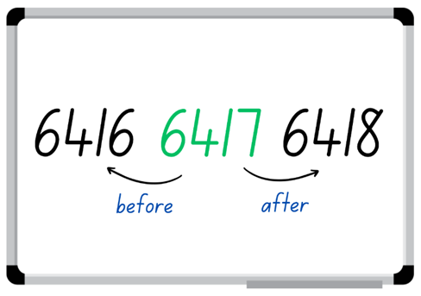

1. Select Stage 2 students to share their working and justify how they know the number is more or less than their number.
2. Stage 3 students to round and record their number to the nearest hundred thousand, ten thousand and thousand on their whiteboard.
3. Select Stage 3 students to share their working and justify how they know they are correct.
4. Students repeat the above steps with other numbers.

This table details opportunities for assessment.

|  |  |
| --- | --- |
| Assessment opportunities | Links |
| What to look for:   * Can Stage 2 students read and represent numbers to thousands? **[MAO-WM-01, MA2-RN-01]** * Can Stage 2 students identify the number before and after a number? **[MAO-WM-01, MA2-RN-01]** * Can Stage 3 students name millions using the place value grouping of ones, tens and hundreds? **[MAO-WM-01, MA3-RN-01]** * Can Stage 3 students round numbers to a specified place value? **[MAO-WM-01, MA3-RN-01]** | Links to [National Numeracy Learning Progressions](https://www.australiancurriculum.edu.au/resources/national-literacy-and-numeracy-learning-progressions/version-3-of-national-literacy-and-numeracy-learning-progressions/) (NNLP):   * Stage 2 – NPV4, NPV5, NPV6 * Stage 3 – NPV6, NPV7.   Links to suggested [Interview for Student Reasoning](https://education.nsw.gov.au/teaching-and-learning/curriculum/literacy-and-numeracy/assessment-resources/ifsr) (IfSR) tasks:   * **Stage 2 – IfSR-NP**: 4B.5. |

### Core lesson: Shape and perimeter – 40 minutes

The table below contains suggested learning intentions and success criteria. These are best co-constructed with students.

|  |  |
| --- | --- |
| **Core concept learning intentions** | **Core concept success criteria** |
| Students working towards Stage 2 outcomes are learning to:   * compare and describe features of two-dimensional shapes * use scaled instruments to measure and compare lengths.   Students working towards Stage 3 outcomes are learning to:   * understand that different shapes can have the same perimeter. | Students working towards Stage 2 outcomes can:   * describe and compare two dimensional shapes * use the term perimeter to describe the boundary of a shape * measure the perimeter of quadrilaterals.   Students working towards Stage 3 outcomes can:   * use criteria to create different two-dimensional shapes with the same perimeter * check and measure the perimeter of two-dimensional shapes using set criteria. |

1. Refer to the anchor charts from Lesson 5 and revise two-dimensional shapes, their features and perimeters. Add any new information and clarify terms.
2. Provide clues to regular two-dimensional shapes and have students name and describe the shape. For example, for a square, say:

* I have 4 sides and all my sides are equal. (Stage 2)
* My sides are 3 km long. What is my perimeter? (Stage 3)

1. Continue playing with other regular two-dimensional shapes and use perimeters that Stage 3 students can calculate easily. For example, a triangle with 3 equal sides of 5 cm, an octagon with sides of 2 cm.
2. Provide all students with a mini whiteboard and whiteboard marker or their workbook and ask them to draw a rectangle with the perimeter of 40 cm.
3. Ask students to rotate their shape to a different orientation and discuss whether the perimeter has changed. Identify with students that changing the rotation of the shape does not change the perimeter.
4. Select students to share and explain their rectangles with the class and ask:

* Are all the rectangles the same? Why?
* What is different about the rectangles?
* How do you know your rectangle has a perimeter of 40 cm?
* Why is it important to understand that shapes can have the same perimeter but look different?
* How many different variations of a rectangle with the perimeter of 40 cm do you think you could make?

1. Provide Stage 2 students with 30 cm rulers and quadrilateral concrete material, for example, pattern blocks or attribute shapes. Supply students with only quadrilaterals.
2. Display Resource 14: Measure perimeter for Stage 2 students and demonstrate how to measure and record the lengths (perimeter) and properties.
3. Provide small groups of Stage 3 students a 30 cm ruler, a piece of string tied into a loop and a small quantity of sticky putty.

**Note:** use a 20 cm loop of string and tie the loop so that 16 cm of the string forms the loop. This will become a constant 16 cm perimeter for the shapes that students create.

1. Stage 3 students use the string to form a square, rectangle, triangle, trapezium and an octagon. Explain how to form the shapes by arranging the string and sticking corners to the surface of the desk.
2. Stage 3 students measure and record the shape name, length of sides and perimeter in their workbooks.
3. Regroup as a class and ask:

* What was something that all shapes had in common? (Stage 2)
* What was different? (Stage 2)
* What did you notice about the lengths on each shape? (Stage 2)
* What unit of measurement did you use to measure the shapes? Why? (Stage 2)
* How do you know your shapes have a perimeter of 16 cm? (Stage 3)
* Do you think all your shapes will look like other groups? Explain your thinking. (Stage 3)

This table details opportunities for differentiation.

|  |  |
| --- | --- |
| Too hard? | Too easy? |
| Stage 2 students cannot describe two-dimensional shapes.   * Support Stage 2 students by providing Resource 14: Measure perimeter with shapes drawn or names of shaped added to the table.   Stage 3 students cannot understand that different shapes can have the same perimeter.   * Support students by drawing 3 different rectangles that have the same perimeter. Have students replicate this and confirm the perimeter by measuring the sides. | Stage 2 students can describe two-dimensional shapes.   * Challenge students to group quadrilaterals using one or more attribute. * Challenge students by drawing the provided shapes in different orientations and measuring their sides.   Stage 3 students can understand that different shapes can have the same perimeter.   * Challenge students to discover the total perimeter of all created shapes. * Challenge students to record the perimeters of the 3 shapes in millimetres, centimetres and kilometres. |

### Discuss and connect the mathematics – 20 minutes

1. All students display their work and go on a [gallery walk.](https://app.education.nsw.gov.au/digital-learning-selector/LearningActivity/Card/555)
2. Stage 2 students check the names of shapes and use rulers to check the perimeter of the shapes that Stage 3 students have created.
3. Stage 3 students use a ruler to measure the drawings and check whether the other Stage 3 students have met the criteria (that each shape has a perimeter of 16 cm).

**Note:** Stage 2 are focussing on quadrilaterals so ask them to check the squares first, then explore the other shapes.

1. Regroup students and ask:

* What did you notice about the perimeters of the different shapes?
* What did you find challenging about this activity?
* How is it possible for triangles, rectangles and squares to have the same perimeter? (Stage 3)
* Why is it important to understand that different two-dimensional shapes can have the same perimeter? (Stage 3)

This table details opportunities for assessment.

|  |  |
| --- | --- |
| **Assessment opportunities** | **Links** |
| What to look for:   * Can Stage 2 students describe and compare two-dimensional shapes? **[MAO-WM-01, MA2-2DS-01]** * Can Stage 2 students use the term perimeter to describe the distance around the boundary of a shape? **[MAO-WM-01, MA2-GM-02]** * Can Stage 2 students measure the perimeter of quadrilaterals? **[MAO-WM-01, MA2-GM-02]** * Can Stage 3 students use criteria to create different two-dimensional shapes with the same perimeter? **[MAO-WM-01, MA3-GM-02, MA3-2DS-01]** * Can Stage 3 students check and measure the perimeter of two-dimensional shapes using set criteria? **[MAO-WM-01, MA3-GM-02, MA3-2DS-01]** | Links to [National Numeracy Learning Progressions](https://www.australiancurriculum.edu.au/resources/national-literacy-and-numeracy-learning-progressions/version-3-of-national-literacy-and-numeracy-learning-progressions/) (NNLP):   * Stage 2 – UGP2, UGP3, UGP4, UuM7 * Stage 3 – UGP5, UGP6, UuM5, Uum6, UuM7. |

## Lesson 7

**Core concept**: standard units are an efficient way to communicate and compare lengths of time.

### Daily number sense: From here to there – 10 minutes

The table below contains a suggested learning intention and success criteria. These are best co-constructed with students.

|  |  |
| --- | --- |
| Daily number sense learning intention | Daily number sense success criteria |
| Students are learning to:   * read, represent and order numbers. | Students can:   * arrange numbers in ascending or descending order.   Students working towards Stage 2 outcomes can:   * read numbers to thousands.   Students working towards Stage 3 outcomes can:   * name millions using the place value grouping of ones, tens and hundreds. |

This activity is an adaptation of ‘From here to there’ from Dice Dazzlers by Swan.

1. Provide pairs of students a 10-sided die, individual whiteboard and whiteboard marker.
2. Students draw a gameboard on their whiteboard with 12 squares. Together they set the starting and finishing numbers and write them on the gameboard. Stage 2 students can choose numbers between zero and 9999, Stage 3 students can choose numbers between zero and 9 999 999.
3. The first Stage 2 player rolls the die 4 times to form a 4-digit number. The first Stage 3 player rolls the die 7 times to form a 7-digit number.
4. The player must decide where to place the number on the gameboard so that the sequence of numbers remains in order (see Figure 20).

Figure 20 – Example of Stage 2 play

Game board, Start 2538, blank, 3246, blank, blank, 5271, blank, 6024, 6589, blank, blank and 7930, finish. Dice images to make the numbers 8756 and 7658.
The number 8756 has text which reads: Can no be used Above 7930.
The number 7658 has text which reads: Can be used. Fits between 6589 and 7930. Player chooses where to place their number.

1. The next player rolls and places their number on the same game board. If a number cannot be placed, the player misses their turn.
2. The winner is the player who completes the sequence of numbers from the starting to the finishing number.

**Note:** different dice can be used for this activity. If so, guide the students to understand the starting and finishing numbers. For example, if students use 6-sided dice, Stage 2 must choose start and finish numbers between 1111 and 6666. Stage 3 students must choose start and finish numbers between 1 111 111 and 6 666 666.

This table details opportunities for assessment.

|  |  |
| --- | --- |
| Assessment opportunities | Links |
| What to look for:   * Can students arrange numbers in ascending or descending order? **[MAO-WM-01, MA3-RN-01, MA2-RN-01]** * Can Stage 2 students read numbers to thousands? **[MAO-WM-01, MA2-RN-01]** * Can Stage 3 students name millions using the place value grouping of ones, tens and hundreds? **[MAO-WM-01, MA3-RN-01]** | Links to [National Numeracy Learning Progressions](https://www.australiancurriculum.edu.au/resources/national-literacy-and-numeracy-learning-progressions/version-3-of-national-literacy-and-numeracy-learning-progressions/) (NNLP):   * Stage 2 – NPV5, NPV6 * Stage 3 – NPV7.   Links to suggested [Interview for Student Reasoning](https://education.nsw.gov.au/teaching-and-learning/curriculum/literacy-and-numeracy/assessment-resources/ifsr) (IfSR) tasks:   * **Stage 2 – IfSR-NP**: 4B.2, 4C.5. |

### Core lesson – 40 minutes

#### Stage 2 task: Time facts and time memory

The table below contains a suggested learning intention and success criteria. These are best co-constructed with students.

|  |  |
| --- | --- |
| Core concept learning intentions | Core concept success criteria |
| Students are learning to:   * represent and read analog time. | Students can:   * use minutes to describe the duration of different events * identify 30 minutes as half-hour and 60 minutes as an hour * read analog time. |

1. Display a one-minute stopwatch or timer and ask students to close their eyes. When they think a minute has elapsed, students put their hands on their head.
2. Choose students to share how they knew the minute was up.

**Note:** use this activity to gauge students’ understanding of a minute and how they calculated a minute.

1. Display the word ‘time’ on the board. Ask students to consider what they know about the concept, then [turn and talk](https://education.nsw.gov.au/teaching-and-learning/curriculum/literacy-and-numeracy/teaching-and-learning-resources/numeracy/talk-moves) to discuss their prior knowledge. Ask:

* What is time?
* Why is time important?
* Where is time used?
* How is time measured?
* What would happen if we did not measure time?

1. Ask students to identify events that are shorter than one minute and events that are longer than one minute.
2. Explain that an hour is 60 minutes and that half an hour is 30 minutes.
3. Provide students with an analog clock each and have them position the hands at half past and o’clock. Once students are confident, ask them to represent different times on the clock by moving the hands to the correct positions.
4. After each time, select students to share their clock and justify how they represented the time.
5. Provide pairs of students with Resource 15: Time memory. Students shuffle and place the cards face down.
6. Students take turns flipping 2 cards over at a time, attempting to match cards that represent the same duration.
7. If a student finds a pair, they keep the cards. If not, the cards are flipped back over and the game continues until all pairs have been discovered.
8. The student with the most pairs wins the game.
9. Repeat the game multiple times.

This table details opportunities for differentiation.

|  |  |
| --- | --- |
| Too hard? | Too easy? |
| Students cannot identify that 30 minutes is a half-hour and 60 minutes is an hour.   * Support students by providing only the 60-minute cards to complete the matching activity. * Adjust the activity so that students view the cards face up and sort under the headings 30 minutes and 60 minutes. | Students can identify that 30 minutes is a half-hour and 60 minutes is an hour.   * Challenge students to create a list of activities that take 30 minutes and a list of activities that take 60 minutes. * Challenge students to represent the duration of 30 minutes on an analog clock in as many ways as possible. |

This table details opportunities for assessment.

|  |  |
| --- | --- |
| Assessment opportunities | Links |
| What to look for:   * Can students use minutes to describe the duration of different events? [MAO-WM-01, MA2-NSM-02] * Can students identify that 30 minutes is half-hour and 60 minutes is an hour? [MAO-WM-01, MA2-NSM-02] | Links to [National Numeracy Learning Progressions](https://www.australiancurriculum.edu.au/resources/national-literacy-and-numeracy-learning-progressions/version-3-of-national-literacy-and-numeracy-learning-progressions/) (NNLP):   * Stage 2 – MeT2, MeT3 * Stage 3 – MeT2, MeT3. |

#### Stage 3 task: 12-hour and 24-hour time

The table below contains suggested learning intentions and success criteria. These are best co-constructed with students.

|  |  |
| --- | --- |
| Core concept learning intentions | Core concept success criteria |
| Students are learning to:   * understand the relationship between 12-hour and 24-hour time. | Students can:   * explain the difference between 12-hour time and 24-hour time * match 12-hour times with their 24-hour representations * identify that 24-hour time is a more precise method for measuring time. |

1. Display Resource 16: Clock and ask:

* What do you notice about this clock?
* What do you wonder about the green numbers?
* What is the relationship between the black numbers and the green numbers?
* What is the purpose of this clock?

1. Explain to students that time can be measured in 2 formats, 12-hour and twenty-four-hour time. Ask:

* What do you know about 12-hour and 24-hour time?
* Can you think of any examples where 12-hour time is used?
* Can you think of any examples where 24-hour time is used?
* Why do you think that there are 2 different formats for measuring time?

1. Explain to students that when reading time, the abbreviations ‘am’ and ‘pm’ are used. The term ‘am’ is associated with the morning and is an abbreviation of the Latin phrase *ante merīdiem,* meaning before midday. The term ‘pm’ is an abbreviation for *post merīdiem*, meaning after midday.
2. Display Resource 17: am and pm and ask students to [Think-Pair-Share](https://app.education.nsw.gov.au/digital-learning-selector/LearningActivity/Card/645) what they notice about the image. Ask:

* Can you identify where it changes from am to pm?
* What do you notice about 24-hour time?
* Which format for measuring time do you think is most accurate? Why?

1. Highlight to students that 24-hour time is used to avoid confusion between am and pm. For example, schedules for airplanes at airports, buses, ferries and the armed forces.
2. Display Resource 18: Time matching cards and model how each card has a matching 12 and 24-hour time. For example, 15:30 hours is matched to 3:30 pm.
3. Provide students with one card each from Resource 18: Time matching cards and tell them to keep their card face down.
4. Set a timer for students to turn their card over, find their corresponding card and then sit down. Record the time that it took for all students to sit down with their partners. Students play multiple rounds with different cards each time aiming to get faster each round.
5. Play a variation of time matching by having students that are holding a 12-hour card organise themselves in ascending or descending order line on the left of the room and any student holding a 24-hour card organise themselves in ascending or descending order line on the right of the room.

This table details opportunities for differentiation.

|  |  |
| --- | --- |
| Too hard? | Too easy? |
| Students cannot understand the relationship between 12-hour and 24-hour time.   * Support students by displaying Resource 17: am and pm clearly in the room for students to reference throughout the lesson. | Students can understand the relationship between 12-hour and 24-hour time.   * Challenge students to find the difference between their pair’s timecards and the pair’s timecards next to them. * Challenge students to identify an activity that commonly happens at their allocated time of the day. For example, 1:00 pm is lunch. |

This table details opportunities for assessment.

|  |  |
| --- | --- |
| Assessment opportunities | Links |
| What to look for:   * Can students explain the difference between 12-hour time and 24-hour time? **[MAO-WM-01, MA3-NSM-02]** * Can students match 12-hour times with their 24-hour representations? **[MAO-WM-01, MA3-NSM-02]** * Can students identify that 24-hour time is a more precise method for measuring time? **[MAO-WM-01, MA3-NSM-02]** | Links to [National Numeracy Learning Progressions](https://www.australiancurriculum.edu.au/resources/national-literacy-and-numeracy-learning-progressions/version-3-of-national-literacy-and-numeracy-learning-progressions/) (NNLP):   * Stage 2 – MeT5 * Stage 3 – MeT5. |

### Discuss and connect the mathematics – 10 minutes

1. Regroup as a class and summarise the lesson drawing out key mathematical ideas. Ask:

* What are some familiar events that take 30 minutes or 60 minutes? (Stage 2)
* Was this lesson closer to half an hour or an hour? (Stage 2)
* What time is shown on our class clock now and what will the time be in half an hour? (Stage 2)
* Which format of time is less confusing for communication, 12-hour or 24-hour? Why? (Stage 3)
* What are the acronyms am and pm for? (Stage 3)
* Can you think of examples where 24-hour time is used? (Stage 3)
* Did you face any challenges today? How did you overcome these?

## Lesson 8

**Core concept**: standard units are an efficient way to communicate and compare lengths of time.

### Daily number sense – 10 minutes

1. From a class need surfaced through formative assessment data, identify a short, focused activity that targets students’ knowledge, understanding and skills. Example activities may be drawn from the following resources:

* [Mathematics K-6 resources](https://education.nsw.gov.au/teaching-and-learning/curriculum/mathematics/mathematics-curriculum-resources-k-12/mathematics-k-6-resources.main-education--category---catalogue---key-learning-area---mathematics---thinking-mathematically.nameAsc.1.grid)
* [Universal Resources Hub](https://resources.education.nsw.gov.au/home).

### Core lesson – 45 minutes

#### Stage 2: Circular number line activity

The table below contains a suggested learning intention and success criteria. These are best co-constructed with students.

|  |  |
| --- | --- |
| Core concept learning intentions | Core concept success criteria |
| Students are learning to:   * represent and read analog time. | Students can:   * identify 15 minutes is a quarter-hour * identify 30 minutes is a half-hour * identify 60 minutes is an hour * explain that a clock is a circular 60-minute number line. |

1. Display the terms hour and half-hour. Ask students to [Think-Pair-Share](https://app.education.nsw.gov.au/digital-learning-selector/LearningActivity/Card/645) about the concepts and record student responses on an anchor chart (see Figure 21). Ask:

* What do you predict the heading of the final column on the anchor chart may be?
* What is the difference between the headings?
* Do you notice a pattern?
* Can you continue this pattern?

Figure 21 – Anchor chart

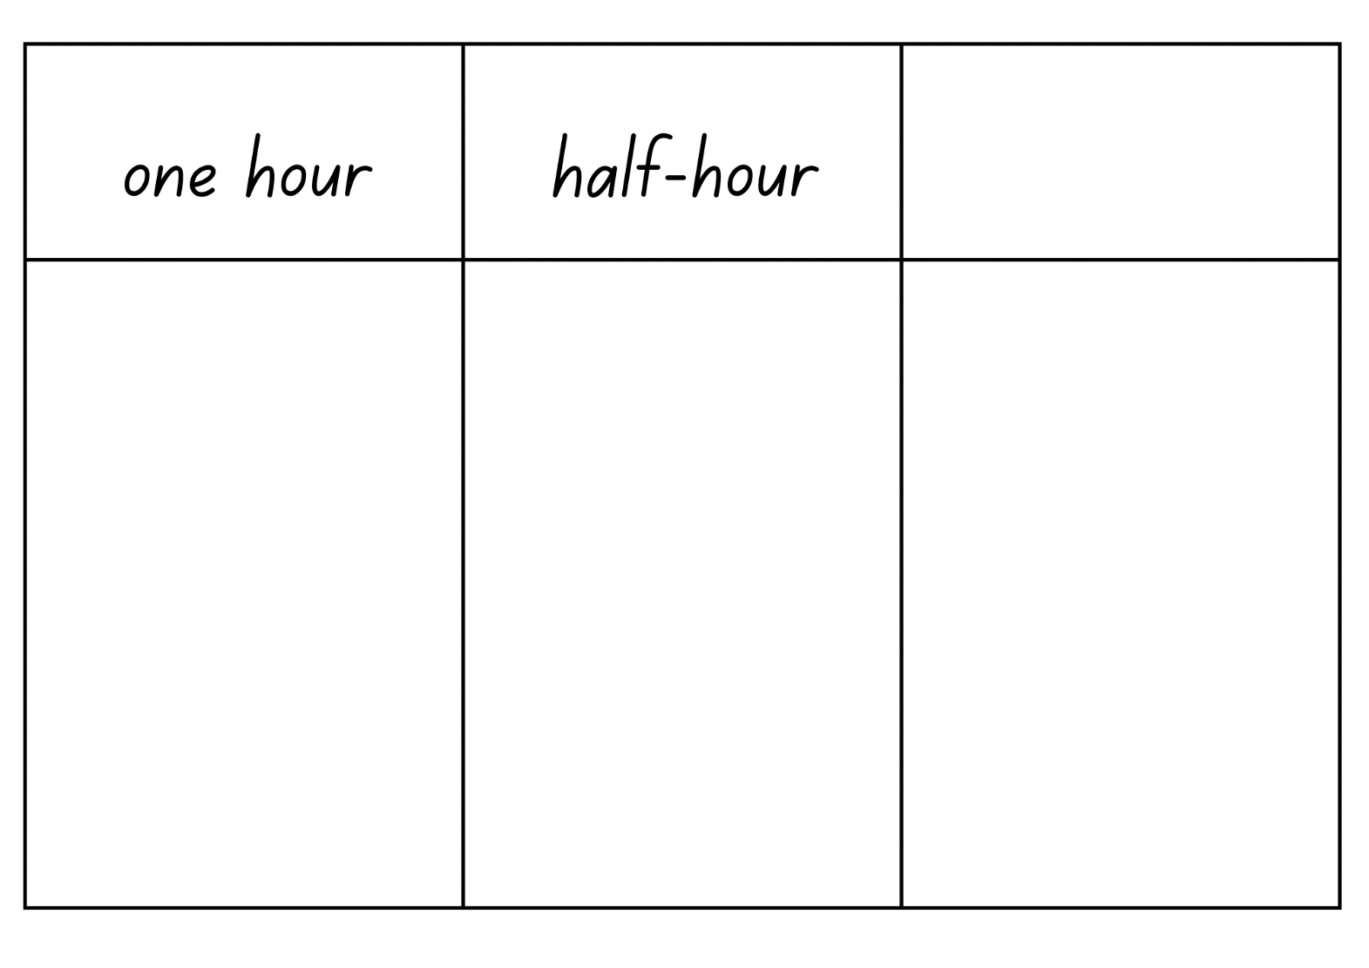

1. Explain to students that a quarter-hour is 15 minutes. Ask students to think, then [turn and talk](https://education.nsw.gov.au/teaching-and-learning/curriculum/literacy-and-numeracy/teaching-and-learning-resources/numeracy/talk-moves) to discuss what they know about a quarter-hour.
2. Add student responses to the anchor chart.
3. Display a skipping rope, stretched out and held up by volunteer students.
4. Place sticky notes with zero, 15, 30, 45 and 60 onto the skipping rope, using pegs (see Figure 22).

Figure 22 – Numbers on skipping rope

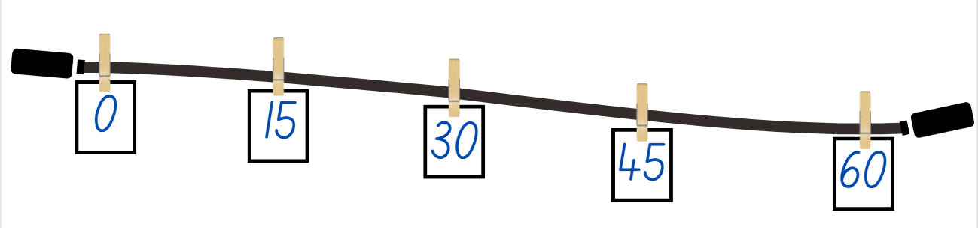

1. Ask questions, such as:

* What do you notice?
* Why have these numbers been placed on the skipping rope?
* What does this remind you of?
* How could you fill in the spaces?

**Note:** this activity could be completed outside, or in a larger open indoor learning space.

1. Provide students with cards from Resource 19: Numeral cards and have them peg the numeral cards on the skipping rope.
2. Explain that the skipping rope represents a number line.
3. Instruct students holding the skipping rope to place the rope down and join their ends together creating a circle. Ask:

* What do you now notice about the number line?
* Why are the sticky notes with zero, 15, 30, 45 and 60 a different size to the other cards?
* What does the number line remind you of?

1. Explain to students that a clock face is a circular 0–60 number line that is used to measure time. Ask:

* Starting from zero, where is the 30-minute mark on the circular number line?
* Starting from zero, where is the 15-minute mark on the circular number line?
* Starting from zero, where is the 45-minute mark on the circular number line?
* Starting from zero, where is the 60-minute mark on the circular number line?

This table details opportunities for differentiation.

|  |  |
| --- | --- |
| Too hard? | Too easy? |
| Students cannot identify quarter-hour, half-hour or hour.   * Support students by providing them with a model clock to refer to during the lesson. * Support students by providing them with a smaller number of cards to place on the skipping rope. | Students can identify quarter-hour, half-hour or hour.   * Challenge students to demonstrate on the circular number line where a 15-minute duration would be after the 30-minute mark. |

1. Provide Stage 2 students with Resource 20: Circular number line and model how to cut out and glue it into a circle.

**Note:** the resource has been designed so that the 15, 30, 45 and 60 sections fold in to create a clock face. This resource can be used to explore time in the future using toothpicks or paper clips as the hands.

1. Students create their own circular number line from Resource 20: Circular number line and place the number line on top of a mini whiteboard.
2. Students draw hands on the whiteboard inside the circular number line to represent the current time.
3. Call out various times for students to mark on their whiteboards using quarter- and half-hour times.

#### Stage 3: Timetables

The table below contains a suggested learning intention and success criteria. These are best co-constructed with students.

|  |  |
| --- | --- |
| Core concept learning intentions | Core concept success criteria |
| Students are learning to:   * apply knowledge of 12-hour and 24-hour time to read and interpret timetables. | Students can:   * read and interpret timetables involving 12-hour and 24-hour time * create a timetable using 12-hour and 24-hour time. |

1. Display Resource 21: 12-hr timetable and ask:

* What do you notice about the image?
* Have you seen a timetable like this before? Where?
* What makes timetables an efficient way to communicate information?
* What time does Mathematics begin on Tuesday?
* How long does the lunch break last?
* What is the duration of the Visual Arts lesson on Friday?
* How many minutes of English lessons are there in a week?

1. Display Resource 22: 24-hour timetable and ask:

* Can you notice any differences between this timetable and the previous timetable?
* Can you notice any similarities between the 2 timetables?
* What time (in 24-hour time) does PDHPE begin on Tuesday?
* What time (in 24-hour time) does recess finish?
* What time (in 12-hour time) does Mathematics begin on Friday?
* What is the combined duration of all Science lessons throughout the week?
* Which timetable can be more effectively communicated? Why?

1. Distribute Resource 23: Dream school day and explain that students will create their own dream school day timetable using 12-hour and 24-hour time.
2. Students label Resource 23: Dream school day correctly with 12-hour and 24-hour times before adding activities and colouring the duration. For example, see Figure 23.

Figure 23 – Dream school day example

Dream school day timetable example with 12- hour and 24-hour times. Activities are listed and colour coded.
12:00am or 0000 lists 'sleep'
6.00am or 0600 lists 'Wake up'
7:00am or 0700 lists 'Breakfast and shower'
8.00am or 0800 lists 'Get on the bus and travel to school'
9.00am or 0900 lists 'Roll call'
10:00am or 1000 lists 'Visual arts'
12:00pm or 1200 lists 'Lunch'
1:00pm or 1300 lists 'Mathematics'
2:00pm or 1400 lists 'Recess'
3:00pm or 1500 lists 'Reading'
4:00pm or 1600 lists 'Netball practice'
5:00pm or 1700 lists 'Skipping with the neighbours'
6:00pm or 1800 lists 'Watch television'
7:00pm or 1900 lists 'Read a book'
8:00pm or 2000 lists 'Bedtime'
9:00pm or 2100 lists 'Sleep'

1. Students display their dream school day and go on a [gallery walk](https://app.education.nsw.gov.au/digital-learning-selector/LearningActivity/Card/555) to look at the various timetables created.

This table details opportunities for differentiation.

|  |  |
| --- | --- |
| Too hard? | Too easy? |
| Students cannot apply knowledge of 12-hour and 24-hour time to read and represent timetables.   * Support students by printing Resource 17: am and pm for students to reference while creating their timetable. | Students can apply knowledge of 12-hour and 24-hour time to read and represent timetables.   * Challenge students to solve the following problem: ‘One afternoon, Teneile noticed the time that had elapsed since midday was equal to half the time remaining until midnight’. Ask what the time is. * Challenge students to write elapsed time questions for a partner to solve in 12-hour and 24-hour time. |

### Discuss and connect the mathematics – 5 minutes

1. Regroup as a class and ask:

* What did you notice about the number line and the clock? (Stage 2)
* Why do we use ‘half-past’ or a ‘quarter to’? (Stage 2)
* If you had to communicate an activity on your timetable to a friend, would you explain it using 12-hour or 24-hour time? Why? (Stage 3)
* Why are timetables an effective form of communication? (Stage 3)
* When would a timetable not be an effective form of communication? (Stage 3)

This table details opportunities for assessment.

|  |  |
| --- | --- |
| Assessment opportunities | Links |
| What to look for:   * Can Stage 2 students identify 15 minutes is a quarter-hour? **[MAO-WM-01, MA2-NSM-02]** * Can Stage 2 students identify 30 minutes is a half-hour? **[MAO-WM-01, MA2-NSM-02]** * Can Stage 2 students identify 60 minutes is an hour? **[MAO-WM-01, MA2-NSM-02]** * Can Stage 3 students read and interpret timetables involving 12-hour and 24-hour time? **[MAO-WM-01, MA3-NSM-02]** * Can Stage 3 students create a timetable using 12-hour and 24-hour time? **[MAO-WM-01, MA3-NSM-02]** | Links to [National Numeracy Learning Progressions](https://www.australiancurriculum.edu.au/resources/national-literacy-and-numeracy-learning-progressions/version-3-of-national-literacy-and-numeracy-learning-progressions/) (NNLP):   * Stage 2 – MeT3 * Stage 3 – MeT4, MeT5. |

## Resource 1: One kilometre investigation

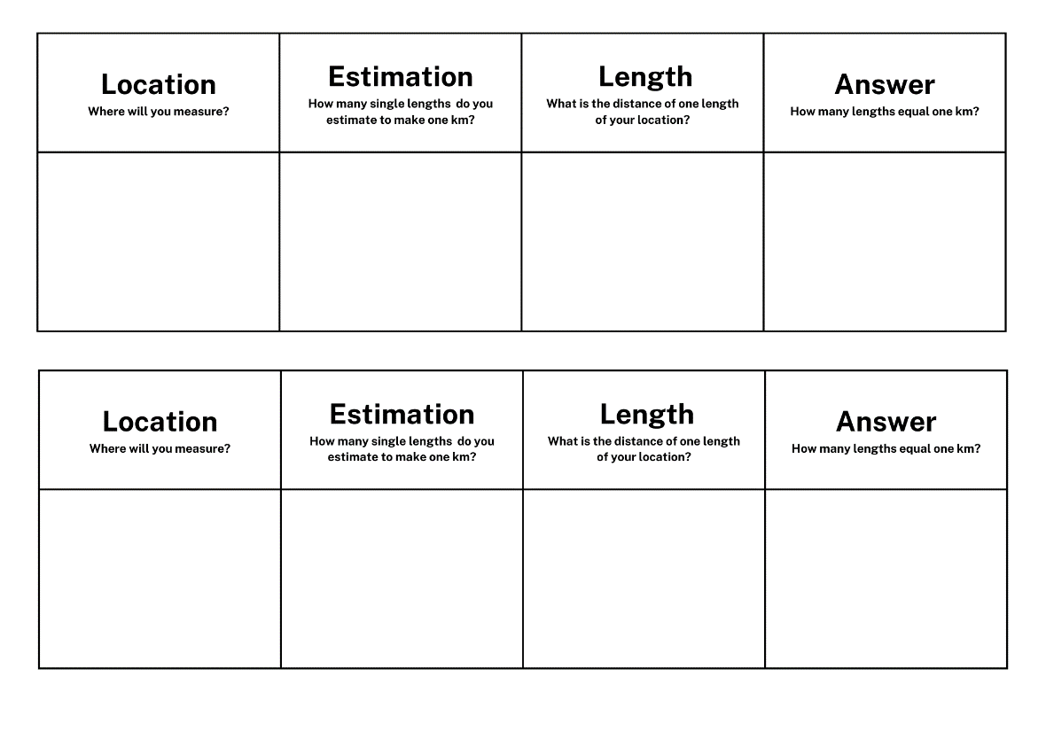

## Resource 2: 4.75 km annotated

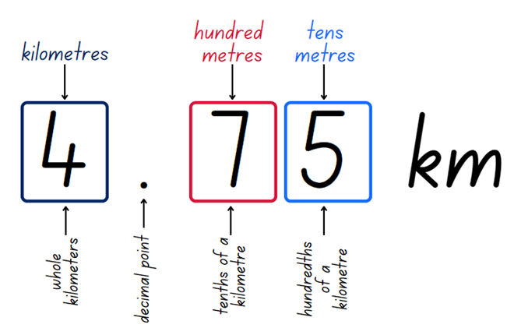

## Resource 3: Stage 2 Tiny town recording

Table with heading 'Your Tiny Town must include':
A school
A local pool,
A sporting complex
A post office
Your house
A shopping centre
A hospital. There is a column to check off each of these points.
A second 2 column table with headings 'Distance from...to...' and 'Centimetres' is positioned to the left.
The examples in the first column 'Distance from...to.. are as follows::
School to your house
The shopping centre to school
Your house to the local pool
The sporting complex to the local pool
The hospital to your house.


## Resource 4: Stage 3 Tiny town recording

Table with heading 'Your Tiny Town must include':
A school
A local pool,
A sporting complex
A post office
Your house
A shopping centre
A hospital.
There is a column to check off each of these points.

A second 4 column table with headings 'Distance from...to...', 'Kilometres and metres', 'Kilometres' and 'Meters' is on the left.
The examples in the first column 'Distance from...to.. are:
School to your house
The shopping centre to school
Your house to the local pool
The sporting complex to the local pool
The hospital to your house
There is an image of a MAB unit block indicating it is equal to 100m
Image of a MAB ten block indicating it is equal to 1km.

## Resource 5: Landmarks

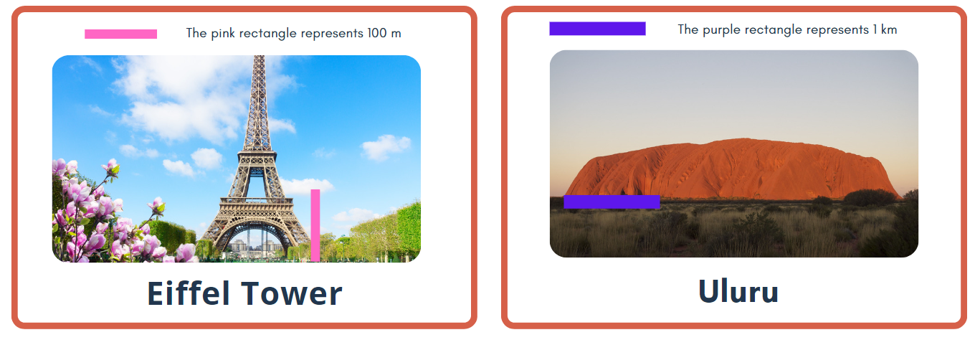

## Resource 6: Millimetre ruler

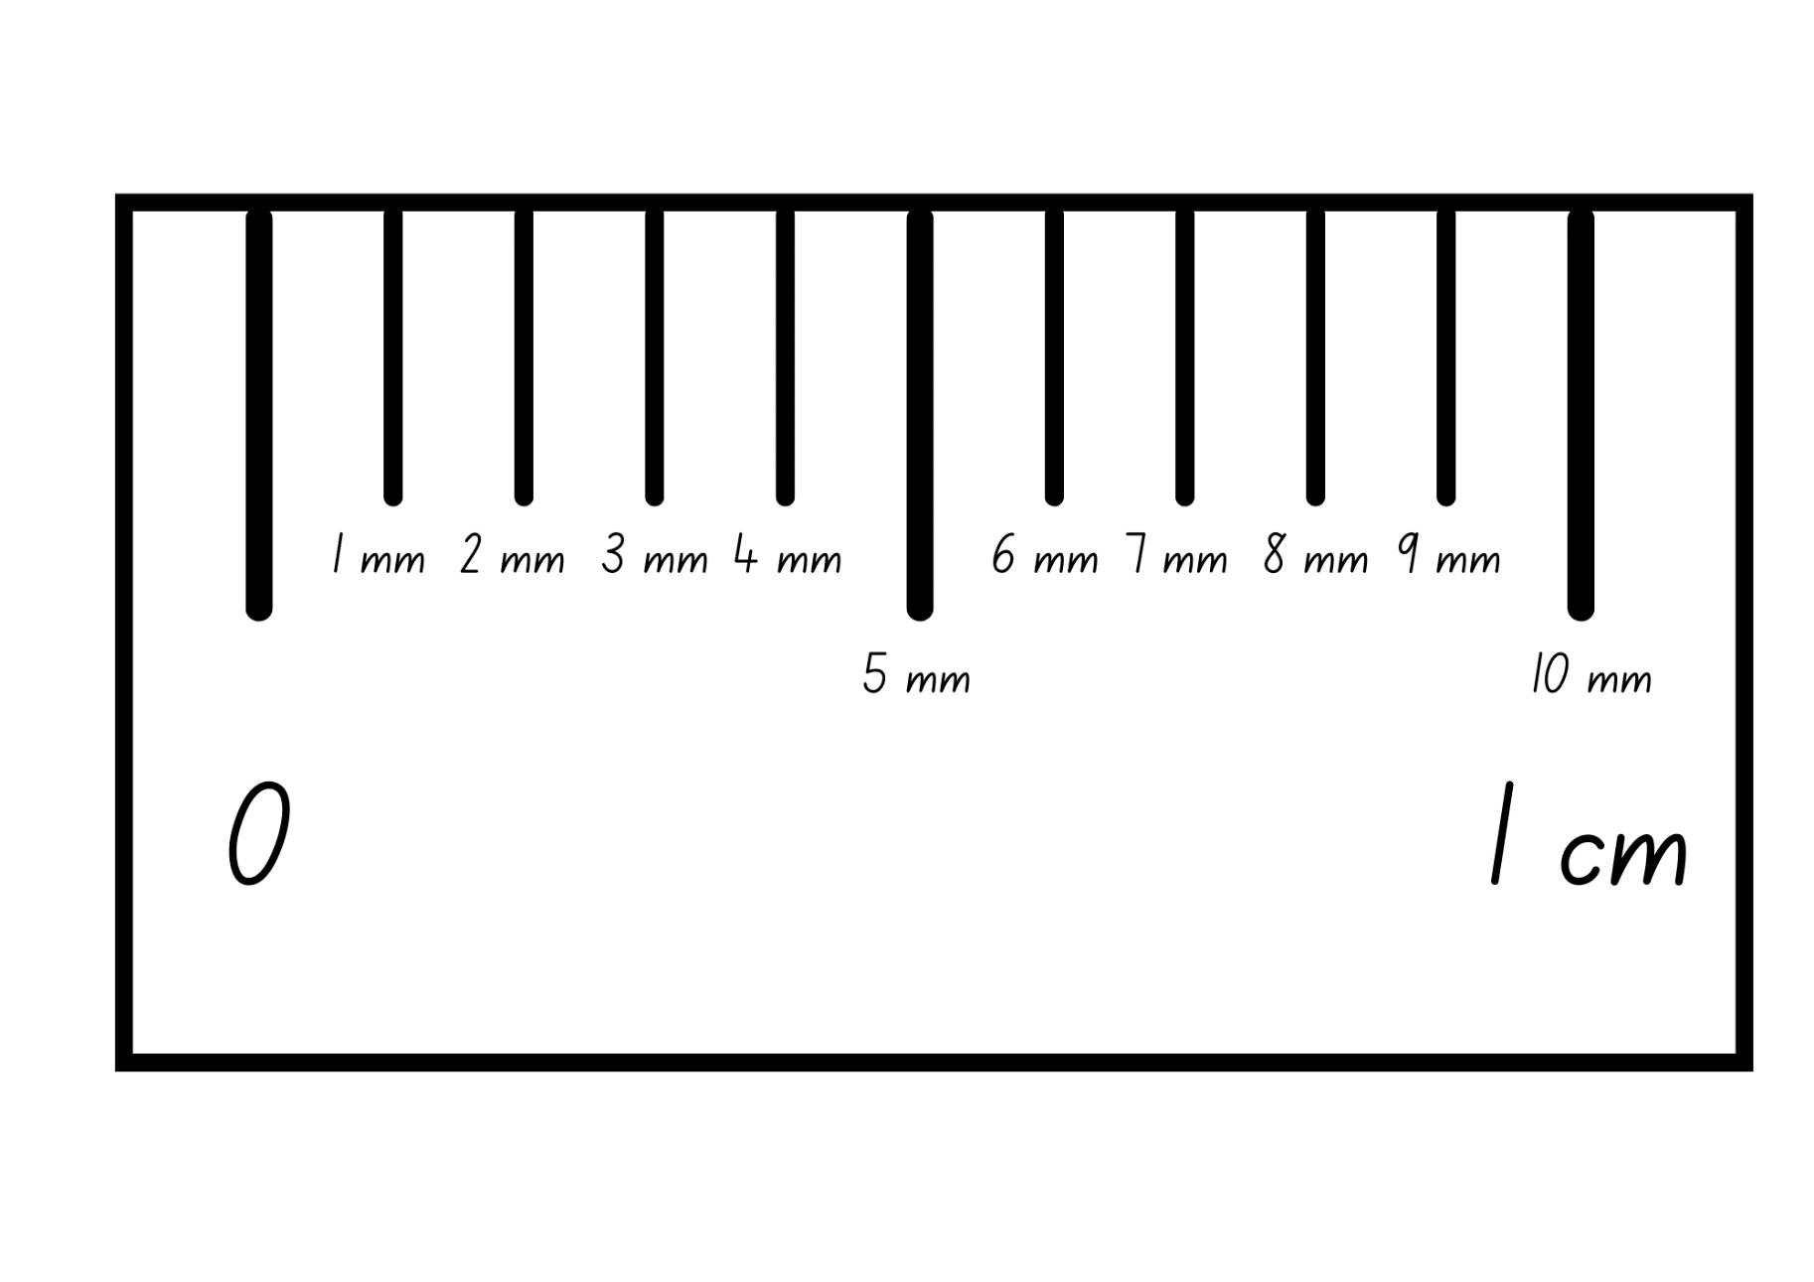

## Resource 7: Student conversion table

Table with headings Metres (m) and Kilometres (km) and examples of conversion with missing values.
First example is 2250 m with Kilometres left blank for working out.
Second example is 8.75 km with the Metres left blank for working out.
Third example is 16 500 m with the Kilometres left blank for working out. 
The fourth example is 97.25 km with the Metres left blank for working out.

## Resource 8: Measuring with millimetres

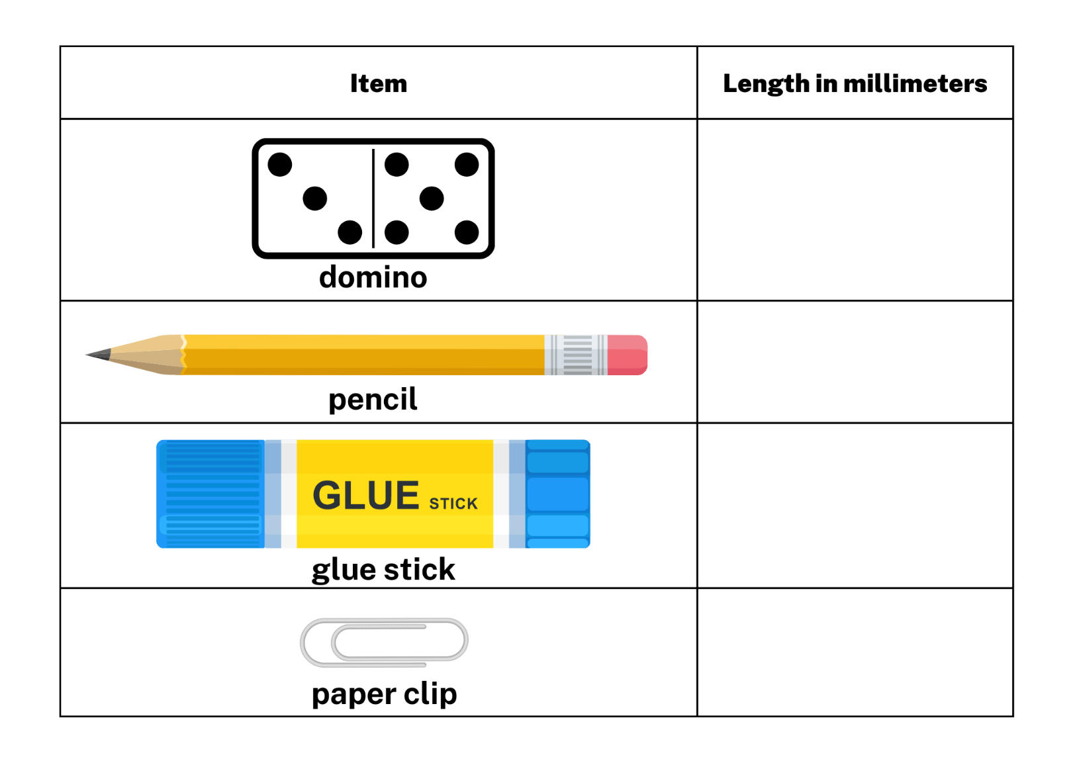

## Resource 9: Who is winning?

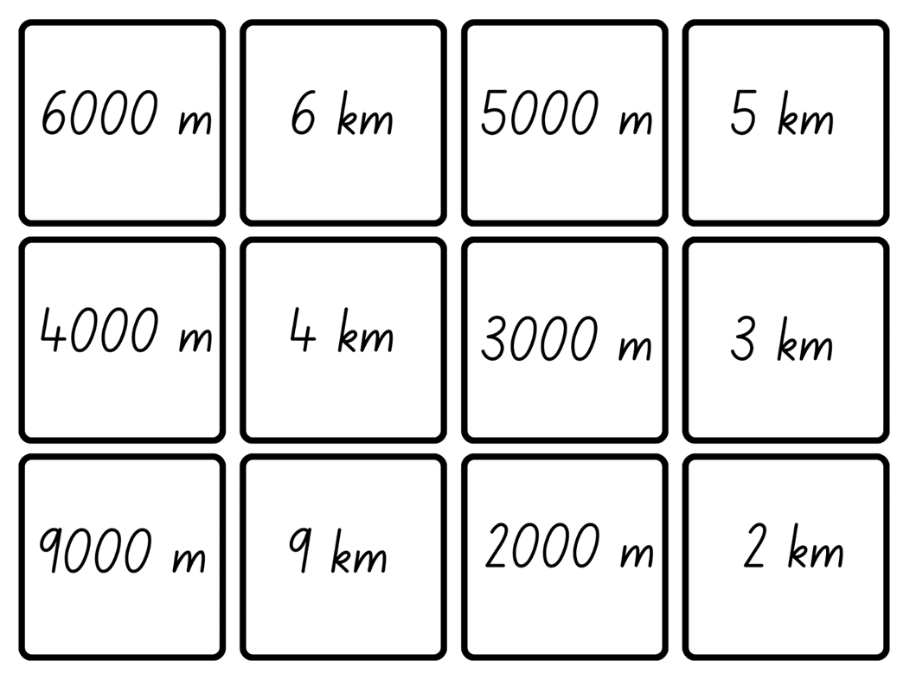

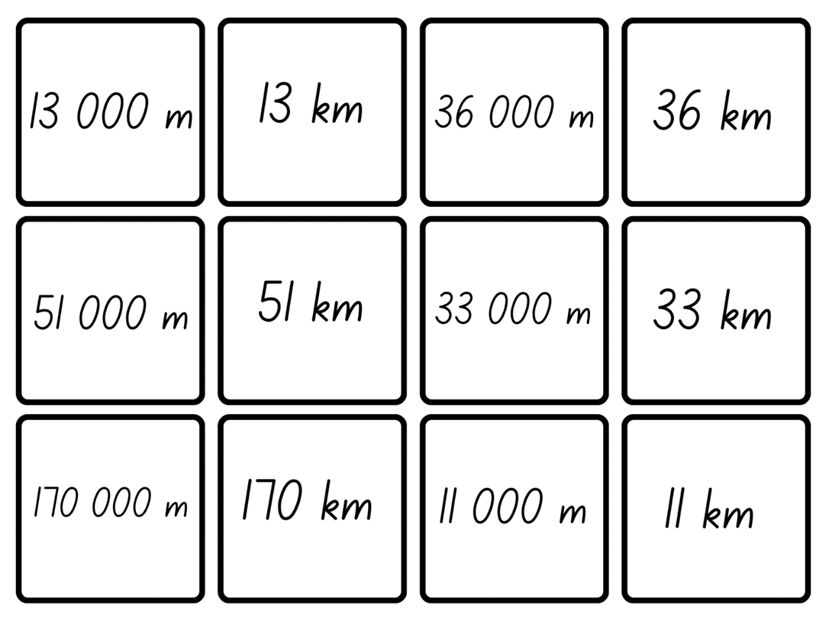

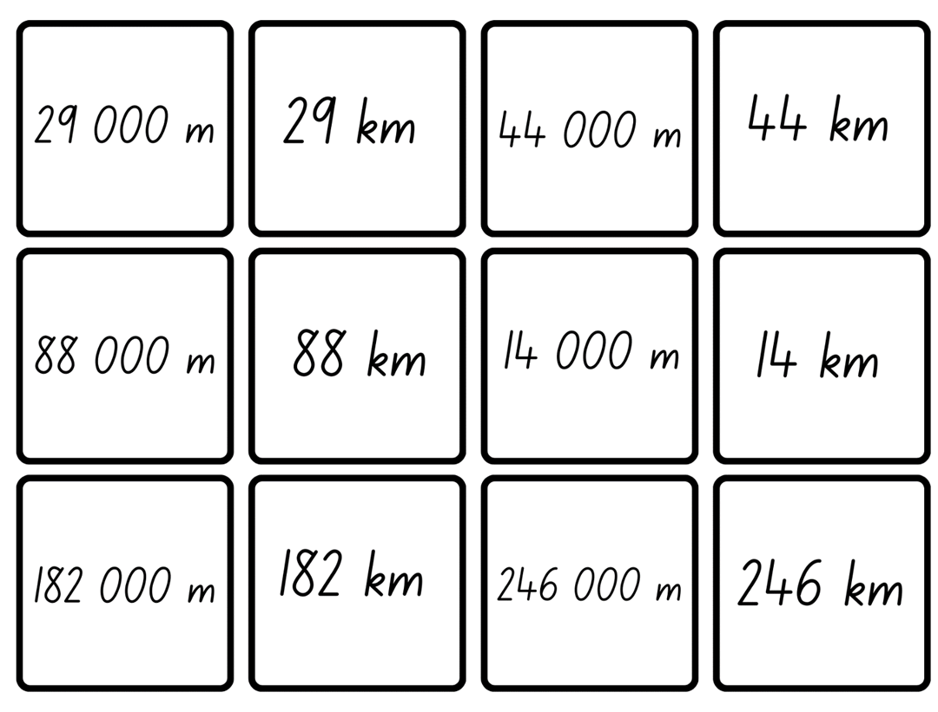

## Resource 10: Flip and describe cards

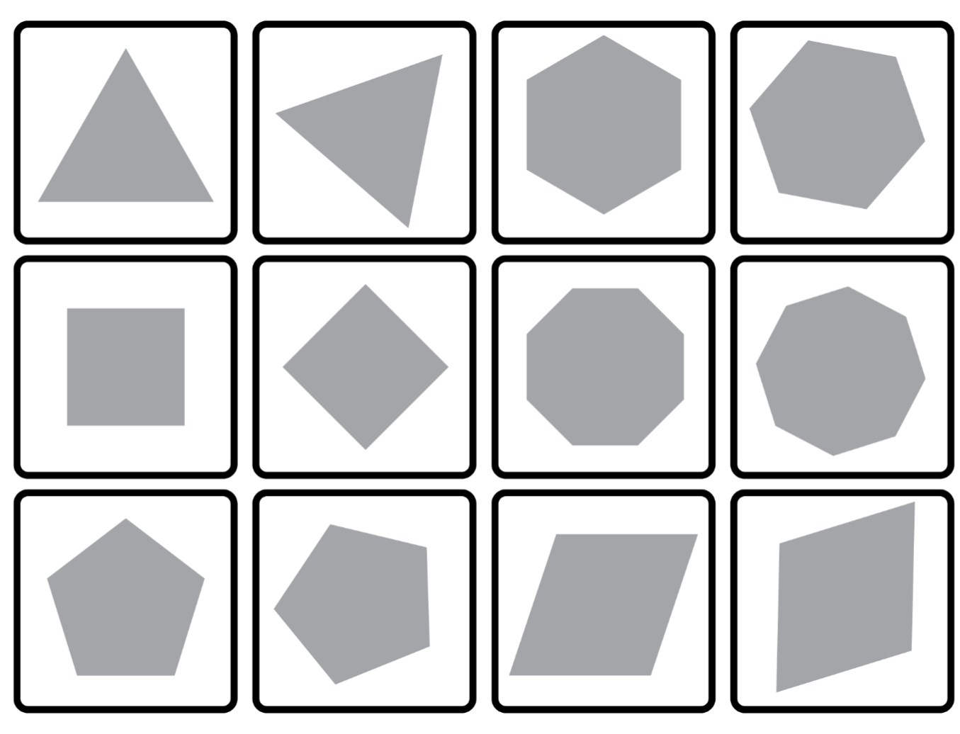

## Resource 11: Perimeters

Square with side length of 250 cm. Rectangle with sides 1.5 km and 2500 m. Triangle with a side 450 m long.
Text reads 'The perimeter of the triangle is 1200 m. What are the lengths of the remaining sides?'

## Resource 12: Two-dimensional quadrilaterals

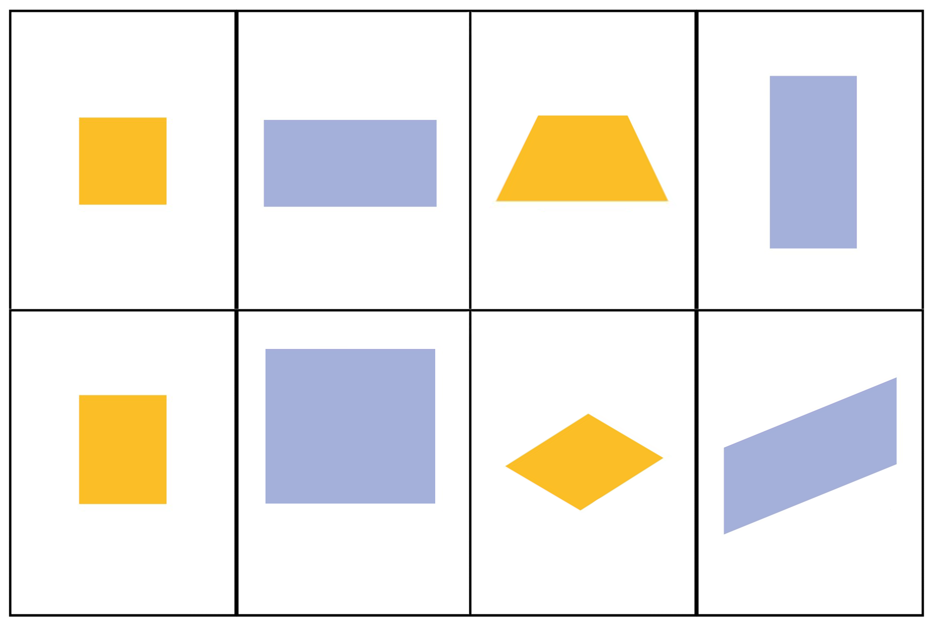

## Resource 13: Perimeters 2

Table with two-dimensional shapes. Length of sides labelled and perimeter lengths. 
Shapes include a triangle with a 22cm side and a 44cm base.
A square with text that reads 'The perimeter of this square is 1600 m. What is the length of each side?
A rhombus with a 34 m side.
A rectangle with sides of 8400 m and 2.4km
A trapezium with sides labelled 780m, 360m, 0.36km and 1000m
A triangle with text that reads 'The perimeter of this triangle is 900m. What is the length of each side?' There is space for students to record their working out.

## Resource 14: Measure perimeter

A table for students to add names of shapes, perimeter lengths and number of sides.
The first row has a picture of a trapezium with all other columns blank.
The second row has the number of sides as '4' with all other columns blank.
The third row has the name 'Rhombus' with all other columns blank and the fourth row is completely blank.

## Resource 15: Time memory

Time memory game. 12 cards with time represented in multiple ways.
1. 1 hour
2. A clock face with 12, 3, 6 and 9 marked with a 60 minute period marked on the clock face
3. thirty minutes
4. A clock face with 12, 3, 6 and 9 marked with a 30 minute period marked on the clock face.
5. 60 minutes
6. one hour
7. 30 minutes
8. half an hour
9. A clock face showing the time 1:00
10. A different clock face showing the time 1:00
11. A clock face showing the time 6:30
12: A different clock face showing the time 6:30

Time memory game. 12 cards with time represented in multiple ways.
1. 7 o'clock
2. A clock face showing the time 7:00
3. nine thirty
4. A clock face showing the time 9:30
5. 2 o'clock
6. A clock face showing the time 2:00
7. eleven thirty
8. A clock face showing the time 11:30
9. three thirty
10. A clock face showing the time 3:30
11. 5 o'clock
12: A clock face showing the time 5:00

## Resource 16: Clock

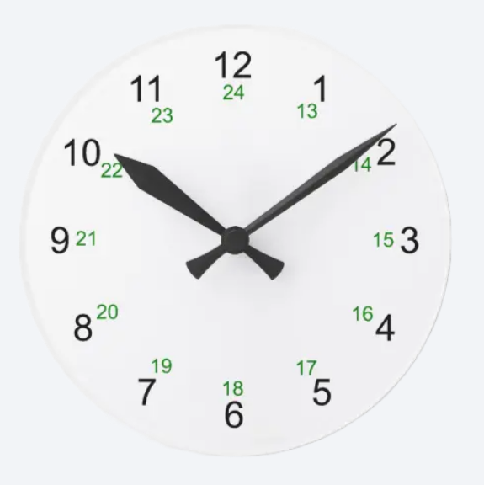

## Resource 17: am and pm

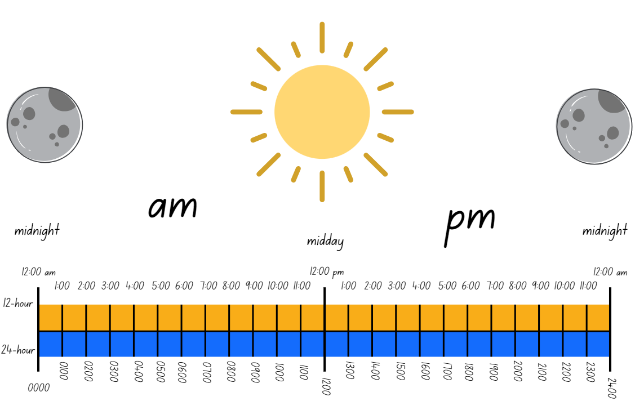

## Resource 18: Time matching cards

12 Cards showing a variety of times and time formats including:
0000 hours, 12:00 am, 0030 hours, 12:30 am, 0100 hours, 1:00 am, 0430 hours, 4:30 am, 0600 hours, 6:00 am, 1130 hours, 11:30 am

## Resource 19: Numeral cards

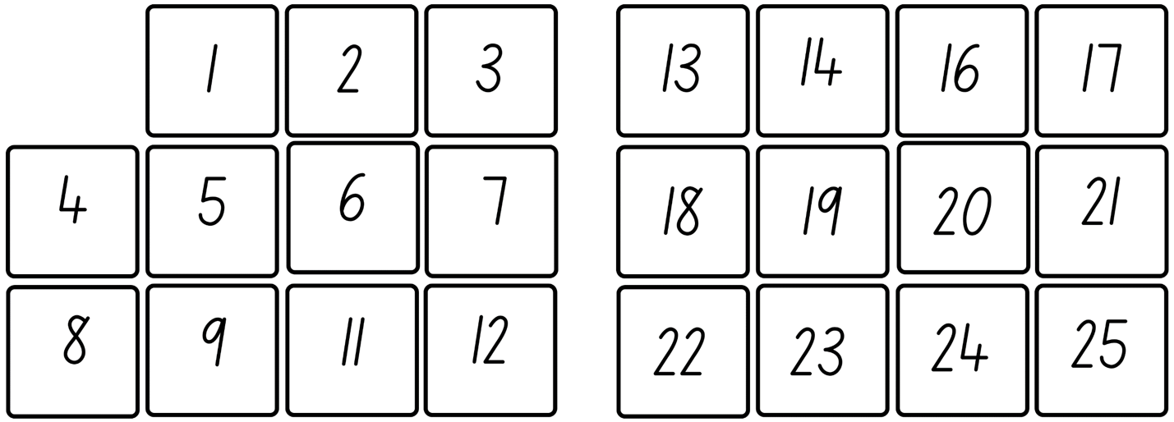

26 to 59 numeral cards


## Resource 20: Circular number line

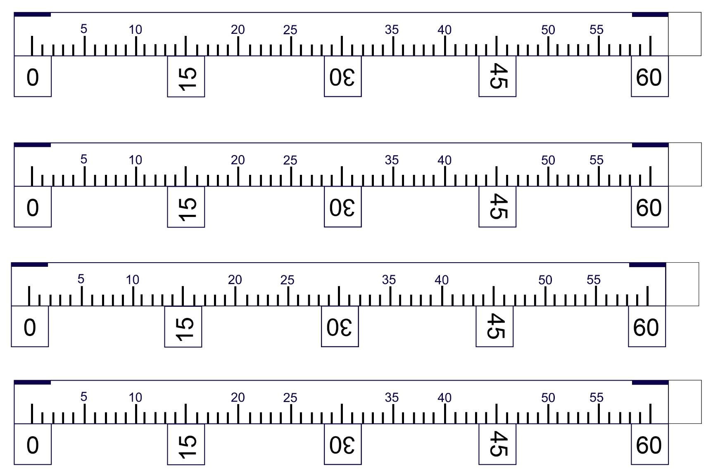

## Resource 21: 12-hour timetable

|  |  |  |  |  |  |
| --- | --- | --- | --- | --- | --- |
| **Time** | **Monday** | **Tuesday** | **Wednesday** | **Thursday** | **Friday** |
| **8:30 am** | **Before school** | **Before school** | **Before school** | **Before school** | **Before school** |
| **9:00 am** | **Lesson 1 English** | **Lesson 1 Design and Technology** | **Lesson 1 Study Lesson** | **Lesson 1 Mathematics** | **Lesson 1 Visual Arts** |
| **9:55 am** | **Lesson 2 English** | **Lesson 2 Design and Technology** | **Lesson 2 Study Lesson** | **Lesson 2 Mathematics** | **Lesson 2 Visual Arts** |
| **10:55 am** | **Lesson 3 English** | **Lesson 3 Design and Technology** | **Lesson 3 Study Lesson** | **Lesson 3 Mathematics** | **Lesson 3 Visual Arts** |
| **11:00 am** | **Recess** | **Recess** | **Recess** | **Recess** | **Recess** |
| **11:20 am** | **Lesson 4 Mathematics** | **Lesson 4 Mathematics** | **Lesson 4 Mathematics** | **Lesson 4 Science** | **Lesson 4 PDHPE** |
| **12:15 pm** | **Lesson 5 Mathematics** | **Lesson 5 Mathematics** | **Lesson 5 Mathematics** | **Lesson 5 Science** | **Lesson 5 PDHPE** |
| **1:05 pm** | **Lunch 1** | **Lunch 1** | **Lunch 1** | **Lunch 1** | **Lunch 1** |
| **1:25 pm** | **Lunch 2** | **Lunch 2** | **Lunch 2** | **Lunch 2** | **Lunch 2** |
| **1:45 pm** | **Lesson 6 Science** | **Lesson 6 PDHPE** | **Lesson 6 Visual Arts** | **Lesson 6 English** | **Lesson 6 Mathematics** |
| **2:40 pm** | **Lesson 7 Science** | **Lesson 7 PDHPE** | **Lesson 7 Visual Arts** | **Lesson 7 English** | **Lesson 7 Mathematics** |
| **3:30 pm** | **After school** | **After school** | **After school** | **After school** | **After school** |

## Resource 22: 24-hour timetable

|  |  |  |  |  |  |
| --- | --- | --- | --- | --- | --- |
| **Time** | **Monday** | **Tuesday** | **Wednesday** | **Thursday** | **Friday** |
| **0830** | **Before school** | **Before school** | **Before school** | **Before school** | **Before school** |
| **0900** | **Lesson 1 English** | **Lesson 1 Design and Technology** | **Lesson 1 Study Lesson** | **Lesson 1 Mathematics** | **Lesson 1 Visual Arts** |
| **0955** | **Lesson 2 English** | **Lesson 2 Design and Technology** | **Lesson 2 Study Lesson** | **Lesson 2 Mathematics** | **Lesson 2 Visual Arts** |
| **1055** | **Lesson 3 English** | **Lesson 3 Design and Technology** | **Lesson 3 Study Lesson** | **Lesson 3 Mathematics** | **Lesson 3 Visual Arts** |
| **1100** | **Recess** | **Recess** | **Recess** | **Recess** | **Recess** |
| **1120** | **Lesson 4 Mathematics** | **Lesson 4 Mathematics** | **Lesson 4 Mathematics** | **Lesson 4 Science** | **Lesson 4 PDHPE** |
| **1215** | **Lesson 5 Mathematics** | **Lesson 5 Mathematics** | **Lesson 5 Mathematics** | **Lesson 5 Science** | **Lesson 5 PDHPE** |
| **1305** | **Lunch 1** | **Lunch 1** | **Lunch 1** | **Lunch 1** | **Lunch 1** |
| **1325** | **Lunch 2** | **Lunch 2** | **Lunch 2** | **Lunch 2** | **Lunch 2** |
| **1345** | **Lesson 6 Science** | **Lesson 6 PDHPE** | **Lesson 6 Visual Arts** | **Lesson 6 English** | **Lesson 6 Mathematics** |
| **1440** | **Lesson 7 Science** | **Lesson 7 PDHPE** | **Lesson 7 Visual Arts** | **Lesson 7 English** | **Lesson 7 Mathematics** |
| **1530** | **After school** | **After school** | **After school** | **After school** | **After school** |

## Resource 23: Dream school day

|  |  |  |
| --- | --- | --- |
| **12-hour** | **24-hour** | **Activity** |
| **12:00 am** |  |  |
|  | **0100** |  |
| **2:00 am** |  |  |
| **3:00 am** |  |  |
| **4:00 am** |  |  |
|  | **0500** |  |
|  | **0600** |  |
| **7:00 am** |  |  |
|  | **0800** |  |
|  | **0900** |  |
| **10:00am** |  |  |
| **11:00 am** |  |  |
|  | **1200** |  |
| **1:30 pm** |  |  |
| **2:30 pm** |  |  |
|  | **1500** |  |
|  | **1600** |  |
| **5:00 pm** |  |  |
|  | **1800** |  |
|  | **1900** |  |
| **8:00 pm** |  |  |
| **9:00 pm** |  |  |
| **10:00 pm** |  |  |
| **11:00pm** |  |  |
| **12:00 am** |  |  |

## Syllabus outcomes and content

### Stage 2

The table below outlines the [syllabus outcomes](https://curriculum.nsw.edu.au/learning-areas/mathematics/mathematics-k-10-2022) and range of relevant syllabus content covered in this unit. Content is linked to [National Numeracy Learning Progression](https://www.australiancurriculum.edu.au/resources/national-literacy-and-numeracy-learning-progressions/version-3-of-national-literacy-and-numeracy-learning-progressions/) version (3).

|  |  |  |  |  |  |  |  |  |
| --- | --- | --- | --- | --- | --- | --- | --- | --- |
| Outcomes and content | 1 | 2 | 3 | 4 | 5 | 6 | 7 | 8 |
| **Representing numbers using place value A:** Whole numbers: Read, represent and order numbers to thousands  **MAO-WM-01, MA2-RN-01** |  |  |  |  |  |  |  |  |
| * Represent numbers up to and including thousands using physical or virtual manipulatives, words, numerals, diagrams and digital displays |  |  |  |  | x | x | x |  |
| * Read and order numbers of up to at least 4 digits |  |  |  |  | x | x | x |  |
| * Identify the number before and after a number with an internal zero digit |  |  |  |  |  | x |  |  |
| **Additive relations A:** Select strategies flexibly to solve addition and subtraction problems of up to 3 digits  **MAO-WM-01, MA2-AR-01** |  |  |  |  |  |  |  |  |
| * Apply known mental strategies that use partitioning to add and subtract, such as bridging the decades |  |  | x |  |  |  |  |  |
| * Use the compensation strategy to add and subtract (Reasons about relations) |  | x |  |  |  |  |  |  |
| * Represent solutions to addition and subtraction problems, including word problems, using an empty number line or bar model | x |  | x |  |  |  |  |  |
| **Geometric measure A:** Length: Measure and compare objects using metres, centimetres and millimetres  **MAO-WM-01, MA2-GM-02** |  |  |  |  |  |  |  |  |
| * Measure and record lengths and distances using a combination of metres and centimetres | x | x | x |  | x | x |  |  |
| * Estimate lengths and distances using known lengths as benchmarks, in metres and centimetres and check by measuring |  |  | x |  |  |  |  |  |
| * Compare and order lengths and distances using metres and centimetres | x | x |  |  |  |  |  |  |
| * Recognise the need for a formal unit smaller than the centimetre to measure length |  |  |  | x |  |  |  |  |
| * Identify that there are 10 millimetres in one centimetre |  |  |  | x |  |  |  |  |
| * Use the millimetre as a unit to measure lengths with a ruler |  |  |  | x |  |  |  |  |
| * Record lengths using the abbreviation for millimetres (mm) |  |  |  | x |  |  |  |  |
| **Geometric measure B:** Length: Use scaled instruments to measure and compare lengths  **MAO-WM-01, MA2-GM-02** |  |  |  |  |  |  |  |  |
| * Select and use an appropriate scaled instrument to measure lengths and distances | x | x | x | x | x | x |  |  |
| * Use the term perimeter to describe the distance around the boundary |  |  |  |  | x | x |  |  |
| * Estimate and measure the perimeters of quadrilaterals |  |  |  |  | x | x |  |  |
| **Two-dimensional spatial structure A:** 2D shapes: Compare and describe features of two-dimensional shapes  **MAO-WM-01, MA2-2DS-01** |  |  |  |  |  |  |  |  |
| * Describe and compare two-dimensional shapes, including parallelograms, rectangles, rhombuses, squares, trapeziums and kites |  |  |  |  | x | x |  |  |
| * Identify quadrilaterals that have all sides equal in length |  |  |  |  | x | x |  |  |
| **Non-spatial measure A:** Time: Represent and read analog time  **MAO-WM-01, MA2-NSM-02** |  |  |  |  |  |  |  |  |
| * Use minutes to describe the duration of events |  |  |  |  |  |  | x | x |
| * Identify 30 minutes as being a half-hour and 60 minutes as an hour |  |  |  |  |  |  | x | x |
| * Connect the quarter-hour to 15 minutes |  |  |  |  |  |  |  | x |
| * Recognise that the position of the numerals on an analog timepiece often represents 2 different values |  |  |  |  |  |  |  | x |
| * Recognise that 5-minute intervals (corresponding to the hour markers) are used as benchmarks to read time on an analog clock |  |  |  |  |  |  |  | x |
| * Read time as past the hour to half-past and then towards the hour |  |  |  |  |  |  |  | x |
| * Read analog clocks to the minute |  |  |  |  |  |  | x |  |

[Mathematics K–10 Syllabus](https://curriculum.nsw.edu.au/learning-areas/mathematics/mathematics-k-10) © NSW Education Standards Authority (NESA) for and on behalf of the Crown in right of the State of New South Wales, 2022.

### Stage 3

The table below outlines the [syllabus outcomes](https://curriculum.nsw.edu.au/learning-areas/mathematics/mathematics-k-10-2022) and range of relevant syllabus content covered in this unit. Content is linked to [National Numeracy Learning Progression](https://www.australiancurriculum.edu.au/resources/national-literacy-and-numeracy-learning-progressions/version-3-of-national-literacy-and-numeracy-learning-progressions/) version (3).

|  |  |  |  |  |  |  |  |  |
| --- | --- | --- | --- | --- | --- | --- | --- | --- |
| Outcomes and content | 1 | 2 | 3 | 4 | 5 | 6 | 7 | 8 |
| **Represents numbers A:** Whole numbers: Recognise, represent and order numbers in the millions  **MAO-WM-01, MA3-RN-01** |  |  |  |  |  |  |  |  |
| * Name millions using the place value grouping of ones, tens and hundreds |  |  |  |  | x | x | x |  |
| * Arrange numbers in the millions in ascending and descending order using place value |  |  |  |  | x |  | x |  |
| * Round numbers to a specified place value |  |  |  |  |  | x |  |  |
| **Additive relations A:** Apply efficient mental and written strategies to solve addition and subtraction problems  **MAO-WM-01, MA3-AR-01** |  |  |  |  |  |  |  |  |
| * Apply known strategies such as levelling, addition for subtraction, using constant difference, and bridging (Reasons about relations) | x | x | x |  |  |  |  |  |
| * Use place value to add or subtract 3 or more numbers with different numbers of digits |  | x | x |  |  |  |  |  |
| **Geometric measure A:** Length: Use metres and kilometres for length and distances  **MAO-WM-01, MA3-GM-02** |  |  |  |  |  |  |  |  |
| * Recognise the need for a formal unit longer than the metre for measuring distance | x |  |  |  |  |  |  |  |
| * Measure 100 metres and recognise that 10 times 100 metres is one kilometre, ie 1000 metres = 1 kilometre | x | x |  | x |  |  |  |  |
| * Estimate lengths and distances using an appropriate unit | x |  | x |  |  |  |  |  |
| * Record distances using the abbreviation for kilometres (km) | x | x | x | x |  |  |  |  |
| * Use a variety of measuring devices to measure lengths and distances in different contexts | x | x | x |  |  |  |  |  |
| **Geometric measure A:** Length: Measure lengths to find perimeters  **MAO-WM-01, MA3-GM-02** |  |  |  |  |  |  |  |  |
| * Calculate perimeters of common two-dimensional shapes, including squares, rectangles and triangles |  |  |  |  | x | x |  |  |
| * Determine which side lengths are needed to find the perimeter of a shape (Reasons about relations) |  |  |  |  | x | x |  |  |
| * Recognise that rectangles with the same perimeter may have different dimensions (Spatial reasoning) |  |  |  |  | x | x |  |  |
| **Geometric measure B:** Length: Connect decimal representations to the metric system  **MAO-WM-01, MA3-GM-02** |  |  |  |  |  |  |  |  |
| * Recognise the equivalence of whole-number and decimal representations of measurements of length | x | x |  | x |  |  |  |  |
| * Interpret decimal notation for lengths and distances |  | x |  | x |  |  |  |  |
| * Record lengths and distances using decimal notation | x | x | x |  |  |  |  |  |
| **Geometric measure B:** Length: Solve problems involving the comparison of lengths using appropriate units  **MAO-WM-01, MA3-GM-02** |  |  |  |  |  |  |  |  |
| * Investigate and compare perimeters of rectangles with the same area |  |  |  |  |  | x |  |  |
| * Solve a variety of problems involving length and perimeter, including problems involving different units of length |  |  |  |  | x | x |  |  |
| **Two-dimensional spatial structure A:** 2D shapes: Classify two-dimensional shapes and describe their properties  **MAO-WM-01, MA3-2DS-01** |  |  |  |  |  |  |  |  |
| * Recognise that triangles and quadrilaterals can be classified in more than one way (Reasons about spatial relations) |  |  |  |  |  | x |  |  |
| * Compare side and angle properties of triangles and quadrilaterals using measurement and symmetry |  |  |  |  |  | x |  |  |
| **Two-dimensional spatial structure B:** Dissect two-dimensional shapes and rearrange them using translations, reflections and rotations  **MAO-WM-01, MA3-2DS-01** |  |  |  |  |  |  |  |  |
| * Recognise that translations, reflections or rotations change the position and orientation but not the size of shapes (Reasons about spatial orientation) |  |  |  |  | x |  |  |  |
| **Non-spatial measure A:** Time: Compare 12- and 24-hour time systems and convert between them  **MAO-WM-01, MA3-NSM-02** |  |  |  |  |  |  |  |  |
| * Recognise that 24-hour time is used to avoid confusion between am and pm |  |  |  |  |  |  | x | x |
| * Read time using appropriate 24-hour time language |  |  |  |  |  |  | x | x |
| * Convert between 24-hour time and 12-hour time using am or pm notation |  |  |  |  |  |  | x | x |
| * Read, interpret and use timetables from real-life situations, involving 12- and 24-hour time |  |  |  |  |  |  |  | x |
| **Non-spatial measure B:** Time: Solve problems involving duration, using 12- and 24-hour time  **MAO-WM-01, MA3-NSM-02** |  |  |  |  |  |  |  |  |
| * Use start and finish times to calculate the elapsed time of events |  |  |  |  |  |  |  | x |
| * Solve a variety of problems involving duration, including where times are expressed in 12-hour and 24-hour notation |  |  |  |  |  |  |  | x |

[Mathematics K–10 Syllabus](https://curriculum.nsw.edu.au/learning-areas/mathematics/mathematics-k-10) © NSW Education Standards Authority (NESA) for and on behalf of the Crown in right of the State of New South Wales, 2022.

## References

This resource contains NSW Curriculum and syllabus content. The NSW Curriculum is developed by the NSW Education Standards Authority. This content is prepared by NESA for and on behalf of the Crown in right of the State of New South Wales. The material is protected by Crown copyright.

Please refer to the NESA Copyright Disclaimer for more information <https://educationstandards.nsw.edu.au/wps/portal/nesa/mini-footer/copyright>.

NESA holds the only official and up-to-date versions of the NSW Curriculum and syllabus documents. Please visit the NSW Education Standards Authority (NESA) website <https://educationstandards.nsw.edu.au/> and the NSW Curriculum website <https://curriculum.nsw.edu.au/home>.

[Mathematics K–10 Syllabus](https://curriculum.nsw.edu.au/learning-areas/mathematics/mathematics-k-10-2022) © NSW Education Standards Authority (NESA) for and on behalf of the Crown in right of the State of New South Wales, 2022.

[National Numeracy Learning Progression](https://www.australiancurriculum.edu.au/resources/national-literacy-and-numeracy-learning-progressions/version-3-of-national-literacy-and-numeracy-learning-progressions/) © Australian Curriculum, Assessment and Reporting Authority (ACARA) 2010 to present, unless otherwise indicated. This material was downloaded from the [Australian Curriculum](http://www.australiancurriculum.edu.au/) website (National Literacy Learning Progression) (accessed 28 August 2023) and was not modified.

State of New South Wales (Department of Education) (2017) [*Teaching measurement Stages 2 and 3*](https://education.nsw.gov.au/teaching-and-learning/curriculum/mathematics/mathematics-curriculum-resources-k-12/mathematics-k-6-resources/teaching-measurement), NSW Department of Education Learning and Teaching Directorate, NSW Department of Education, accessed 16 August 2023.

Swan P (2003) *Dice Dazzlers (From Here to There)*, A-Z Type, Australia.

University of Cambridge (Faculty of Mathematics) (n.d.) [*Dicey Operations in Line*](https://nrich.maths.org/13261), NRICH website, accessed 18 July 2023.

University of Cambridge (Faculty of Mathematics) (2022) [*Tug of War*](https://nrich.maths.org/5897), NRICH website, accessed 19 July 2023

**© State of New South Wales (Department of Education), 2023**

The copyright material published in this resource is subject to the Copyright Act 1968 (Cth) and is owned by the NSW Department of Education or, where indicated, by a party other than the NSW Department of Education (third-party material).

Copyright material available in this resource and owned by the NSW Department of Education is licensed under a [Creative Commons Attribution 4.0 International (CC BY 4.0) license](https://creativecommons.org/licenses/by/4.0/).

[](https://creativecommons.org/licenses/by/4.0/)

This license allows you to share and adapt the material for any purpose, even commercially.

Attribution should be given to © State of New South Wales (Department of Education), 2023.

Material in this resource not available under a Creative Commons license:

* the NSW Department of Education logo, other logos and trademark-protected material
* material owned by a third party that has been reproduced with permission. You will need to obtain permission from the third party to reuse its material.

**Links to third-party material and websites**

Please note that the provided (reading/viewing material/list/links/texts) are a suggestion only and implies no endorsement, by the New South Wales Department of Education, of any author, publisher, or book title. School principals and teachers are best placed to assess the suitability of resources that would complement the curriculum and reflect the needs and interests of their students.

If you use the links provided in this document to access a third-party's website, you acknowledge that the terms of use, including licence terms set out on the third-party's website apply to the use which may be made of the materials on that third-party website or where permitted by the Copyright Act 1968 (Cth). The department accepts no responsibility for content on third-party websites.