Mathematics 3-6 multi-age – Year B – Unit 3
Contents
Unit description and duration 5
Syllabus outcomes 5
Working mathematically 6
Student prior learning 7
Lesson overview and resources 8
Lesson 1 17
Daily number sense: Adding to 150 – 10 minutes 17
Core lesson: The right tool for the job – 40 minutes 19
Discuss and connect the mathematics – 10 minutes 24
Lesson 2 26
Daily number sense: Distance word problems – 10 minutes 26
Core lesson: Base-10 – 40 minutes 27
Discuss and connect the mathematics – 10 minutes 33
Lesson 3 35
Daily number sense: Travel plans – 10 minutes 35
Core lesson: Converting between units – 40 minutes 38
Consolidation and meaningful practice – 20 minutes 41
Lesson 4 44
Daily number sense – 10 minutes 44
Core lesson: Length investigation – 40 minutes 44
Discuss and connect the mathematics – 10 minutes 48
Lesson 5 51
Daily number sense: Climb the ladder – 10 minutes 51
Core lesson: Shapes and perimeters – 40 minutes 54
Discuss and connect the mathematics – 10 minutes 59
Lesson 6 61
Daily number sense: Where do you fit? – 10 minutes 61
Core lesson – 40 minutes 63
Discuss and connect the mathematics – 15 minutes 67
Lesson 7 70
Daily number sense: Ordering game – 10 minutes 70
Core lesson: Digital time and duration – 40 minutes 72
Discuss and connect the mathematics – 10 minutes 77
Lesson 8 80
Daily number sense – 10 minutes 80
Core lesson – 30 minutes 80
Consolidation and meaningful practice – 15 minutes 86
Resource 1: Measurement tools 88
Resource 2: Distance word problems 89
Resource 3: Place value chart 90
Resource 4: Converting sheet 91
Resource 5: Travel plans 92
Resource 6: Full conversion chart 93
Resource 7: Measuring and converting 94
Resource 8: Number slider 95
Resource 9: Converting lengths table 96
Resource 10: Conversion bingo 97
Resource 11: Teacher cards 98
Resource 12: Length can measure 99
Resource 13: Measurement hunt 100
Resource 14: Recording lengths 101
Resource 15: Boundary and perimeter 102
Resource 16: Perimeters 103
Resource 17: Measuring perimeters 104
Resource 18: Duration cards 105
Resource 19: 24-hour time 106
Resource 20: School timetable 107
Resource 21: Ordering gameboard 108
Resource 22: Time matching cards 109
Resource 23: The ZOOM strategy 111
Resource 24: Everyday digital clocks 112
Resource 25: Elapsed timecards 113
Resource 26: Midday and midnight 114
Resource 27: Time representation 115
Resource 28: Using Google Maps 116
Resource 29: Time race 117
Syllabus outcomes and content 118
Stage 2 118
Stage 3 122
References 128

Unit description and duration
This unit develops the big idea that what needs to be measured determines the unit of measurement.
In this 2-week unit students are provided opportunities to:
- measure and compare lengths of objects and locations using kilometres (Stage 3), metres, centimetres and millimetres
- identify and measure the perimeter of shapes, objects and locations
- read and represent analog and digital time.
This multi-age unit is informed by the lessons in Stage 2 Year B Unit 23 and Stage 3 Year B Unit 23. Please refer to these units for additional lesson guidance.

Syllabus outcomes
- MAO-WM-01 develops understanding and fluency in mathematics through exploring and connecting mathematical concepts, choosing and applying mathematical techniques to solve problems, and communicating their thinking and reasoning coherently and clearly

Stage 2
- MA2-RN-01 applies an understanding of place value and the role of zero to represent numbers to at least tens of thousands
- MA2-AR-01 selects and uses mental and written strategies for addition and subtraction involving 2- and 3-digit numbers
- MA2-GM-02 measures and estimates lengths in metres, centimetres and millimetres
- MA2-2DS-01 compares two-dimensional shapes and describes their features
- MA2-NSM-02 represents and interprets analog and digital time in hours, minutes and seconds

Stage 3
- MA3-RN-01 applies an understanding of place value and the role of zero to represent the properties of numbers
- MA3-AR-01 selects and applies appropriate strategies to solve addition and subtraction problems
- MA3-GM-02 selects and uses the appropriate unit and device to measure lengths and distances including perimeters
- MA3-2DS-01 investigates and classifies two-dimensional shapes, including triangles and quadrilaterals based on their properties
- MA3-NSM-02 measures and compares duration, using 12- and 24-hour time and am and pm notation

Working mathematically
In the Mathematics K–10 Syllabus, there is one overarching Working mathematically outcome (MAO-WM-01). The Working mathematically processes should be embedded within the concepts being taught. The Working mathematically processes present in the Mathematics K–10 Syllabus are:
- communicating
- understanding and fluency
- reasoning
- problem solving.
Mathematics K–10 Syllabus © NSW Education Standards Authority (NESA) for and on behalf of the Crown in right of the State of New South Wales, 2022.

Student prior learning
Before engaging in these teaching and learning activities, students would benefit from prior experience with:
- measuring and comparing lengths with different formal units of measurement
- identifying and classifying features of two-dimensional shapes
- reading and representing analog time
In NSW classrooms there is a diverse range of students, including Aboriginal and Torres Strait Islander students, students learning English as an additional language or dialect, high potential and gifted students and students with disability. Some students may identify with more than one of these groups or possibly all of them. Refer to Advice on curriculum planning for every student for further information.

Lesson overview and resources
To cover the content of the syllabus across Stage 2 and Stage 3, some core lessons in the unit contain both a Stage 2 and a Stage 3 task. Teachers are encouraged to adapt and contextualise the units to meet the needs of their students.
The table below outlines the sequence and approximate timing of lessons, learning intentions and resources.
Lesson | Content | Duration and resources
Lesson 1  Daily number sense  Stage 2:  - Additive relations A: Select strategies flexibly to solve addition and subtraction problems of up to 3 digits  Stage 3:  - Additive relations B: Choose and use efficient strategies to solve addition and subtraction problems | Lesson core concept: the context determines the most suitable measuring device.  Stage 2:  - Geometric measure A: Length: Measure and compare objects using metres, centimetres and millimetres  - Geometric measure B: Length: Use scaled instruments to measure and compare lengths  Stage 3:  - Geometric measure A: Length: Use metres and kilometres for length and distances  - Geometric measure A: Length: Measure lengths to find perimeters | Lesson duration: 60 minutes  - Resource 1: Measurement tools  - 30 cm rulers  - Metre rulers  - Trundle wheels  - Tape measures  - Writing materials
Lesson 2  Daily number sense  Stage 2:  - Additive relations A: Select strategies flexibly to solve addition and subtraction problems of up to 3 digits  Stage 3:  - Additive relations B: Choose and use efficient strategies to solve addition and subtraction problems | Lesson core concept: metric units of measurement relate to the base-10 place value system.  Stage 2:  - Geometric measure A: Length: Measure and compare objects using metres, centimetres and millimetres  - Geometric measure B: Length: Use scaled instruments to measure and compare lengths  Stage 3:  - Geometric measure A: Length: Use metres and kilometres for length and distances  - Geometric measure B: Length: Connect decimal representation to the metric system  - Geometric measure B: Length: Convert between common metric units of length | Lesson duration: 60 minutes  - Resource 2: Distance word problems  - Resource 3: Place value chart  - Resource 4: Converting sheet  - 10-sided dice  - 30 cm rulers displaying millimetres  - Metre rulers displaying centimetres  - Reusable plastic sleeves  - Writing materials
Lesson 3  Daily number sense  Stage 2:  - Additive relations A: Select strategies flexibly to solve addition and subtraction problems of up to 3 digits  Stage 3:  - Additive relations B: Choose and use efficient strategies to solve addition and subtraction problems | Lesson core concept: metric units of measurement can be described using the decimal place value system.  Stage 2:  - Geometric measure A: Length: Measure and compare objects using metres, centimetres and millimetres  - Geometric measure B: Length: Use scaled instruments to measure and compare lengths  Stage 3:  - Geometric measure A: Length: Use metres and kilometres for length and distances  - Geometric measure B: Length: Connect decimal representation to the metric system  - Geometric measure B: Length: Convert between common metric units of length | Lesson duration: 70 minutes  - Resource 5: Travel plans  - Resource 6: Full conversion chart  - Resource 7: Measuring and converting  - Resource 8: Number slider  - Resource 9: Converting length table  - Resource 10: Conversion bingo  - Resource 11: Teacher cards  - 30 cm rulers  - Scissors  - Writing materials
Lesson 4  Daily number sense  - teacher-identified task based on student needs | Lesson core concept: a straight line, a boundary or an edge can be measured.  Stage 2:  - Geometric measure A: Length: Measure and compare objects using metres, centimetres and millimetres  - Geometric measure B: Length: Use scaled instruments to measure and compare lengths  Stage 3:  - Geometric measure A: Length: Use metres and kilometres for length and distances  - Geometric measure A: Length: Measure lengths to find perimeters  - Geometric measure B: Length: Connect decimal representation to the metric system  - Geometric measure B: Length: Convert between common metric units of length | Lesson duration: 60 minutes  - Resource 12: Length can measure  - Resource 13: Measurement hunt  - Resource 14: Recording lengths  - 30 cm rulers  - Metre rulers  - Trundle wheels  - Writing materials
Lesson 5  Daily number sense  Stage 2:  - Representing numbers using place value B: Whole numbers: Order numbers in the thousands  Stage 3:  - Represents numbers A: Whole numbers: Recognise, represent and order numbers in the millions | Lesson core concept: perimeter is the distance around the boundary of a two-dimensional shape.  Stage 2:  - Geometric measure B: Length: Use scaled instruments to measure and compare lengths  - Two-dimensional spatial structure B: 2D shapes: Create two-dimensional shapes that result from combining and splitting common shapes  Stage 3:  - Geometric measure A: Length: Measure lengths to find perimeters  - Two-dimensional spatial structure A: 2D shapes: Classify two-dimensional shapes and describe their properties | Lesson duration: 60 minutes  - Resources 15: Boundary and perimeter  - Resources 16: Perimeters  - Resource 17: Measuring perimeters  - 9-sided dice  - 30 cm rulers  - Writing materials
Lesson 6  Daily number sense  Stage 2:  - Representing numbers using place value B: Whole numbers: Order numbers in the thousands  Stage 3:  - Represents numbers A: Whole numbers: Recognise, represent and order numbers in the millions | Lesson core concept: standard units are an efficient way to communicate and compare lengths of time.  Stage 2:  - Non-spatial measure A: Time: Represent and read analog time  - Non-spatial measure B: Time: Represent and interpret digital time displays  Stage 3:  - Non-spatial measure A: Time: Compare 12- and 24-hour time systems and convert between them  - Non-spatial measure B: Time: Solve problems involving duration, using 12- and 24-hour time | Lesson duration: 65 minutes  - Resource 18: Duration cards  - Resource 19: 24-hour time  - Resource 20: School timetable  - 10-sided dice  - Analog clock  - Sticky notes  - Stopwatch  - Writing materials
Lesson 7  Daily number sense  Stage 2:  - Representing numbers using place value B: Whole numbers: Order numbers in the thousands  Stage 3:  - Represents numbers A: Whole numbers: Recognise, represent and order numbers in the millions | Lesson core concept: lengths of time can be calculated and represented in different ways.  Stage 2:  - Non-spatial measure B: Time: Represent and interpret digital time displays  - Non-spatial measure B: Time: Use am and pm notation  Stage 3:  - Non-spatial measure A: Time: Compare 12- and 24-hour time systems and convert between them  - Non-spatial measure B: Time: Solve problems involving duration, using 12- and 24-hour time | Lesson duration: 60 minutes  - Resource 21: Ordering gameboard  - Resource 22: Time matching cards  - Resource 23: The zoom strategy  - Resource 24: Everyday digital clocks  - Resource 25: Elapsed timecards  - 10-sided dice  - Reusable sleeves  - Scissors  - Writing materials
Lesson 8  Daily number sense  - teacher-identified task based on student needs | Lesson core concept: representing time helps us make sense of the world.  Stage 2:  - Non-spatial measure B: Time: Represent and interpret digital time displays  - Non-spatial measure B: Time: Use am and pm notation  Stage 3:  - Geometric measure A: Length: Use metres and kilometres for length and distances  - Geometric measure B: Length: Connect decimal representations to the metric system  - Geometric measure B: Length: Convert between common metric units of length  - Non-spatial measure B: Time: Solve problems involving duration, using 12- and 24-hour time | Lesson duration: 55 minutes  - Resource 26: Midday and midnight  - Resource 27 Time representation  - Resource 28: Using Google Maps  - Resource 29: Time race  - Devices to access Google Maps  - Plastic sleeves  - Writing materials

Lesson 1
Core concept: the context determines the most suitable measuring device.

Daily number sense: Adding to 150 – 10 minutes
Daily number sense activities for Lessons 1 to 3 ‘activate’ prior number knowledge and support the learning of new content in the unit. These activities can also assist teachers to identify the starting points for learning by revealing the extent of students’ existing knowledge.
The table below contains a suggested learning intention and success criteria. These are best co-constructed with students.
Daily number sense learning intention | Daily number sense success criteria
Students are learning to:  - use efficient strategies to solve addition problems. | Students can:  - apply and explain addition strategies used to find the sum of four 2-digit numbers.
This activity is an adaptation of Reach 100 from NRICH by the University of Cambridge (Faculty of Mathematics).
- Draw a 2 by 2 grid. Choose 4 different digits from 1–9 and put one in each box. For example, see Figure 1.
Figure 1 – 2 by 2 grid
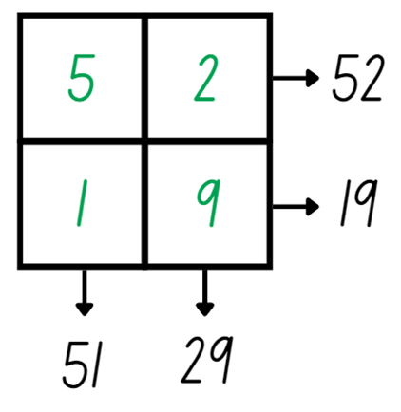
- Reading the grid across and down gives four 2-digit numbers: 52, 19, 51 and 29. Ask students what strategies they could use to find the sum of these numbers.
- Students share and explain their strategies. For example, one student levels the numbers to make the algorithm 50 + 50 + 3 + 40 + 8. Agree that the sum of the numbers is 151.
- Explain that the challenge is to find 4 different digits that give four 2-digit numbers which add up to exactly 150.
- Provide small groups with an individual whiteboard and marker to draw their grid and solve the problem.
- Select groups to share their numbers and check.
This table details opportunities for assessment.
Assessment opportunities | Links
What to look for:  - Can students apply and explain addition strategies used to find the sum of four 2-digit numbers? [MAO-WM-01, MA2-AR-01, MA3-AR-01] | Links to National Numeracy Learning Progressions (NNLP):  - Stage 2 – AdS7  - Stage 3 – AdS7, AdS8.

Core lesson: The right tool for the job – 40 minutes
The table below contains suggested learning intentions and success criteria. These are best co-constructed with students.
Core concept learning intentions | Core concept success criteria
Students are learning to:  - understand that different units of measurement require different instruments. | Students can:  - select an appropriate unit of measurement for a given context  - match units of measurement with appropriate measuring instruments  - record measurements of objects or locations using appropriate measuring instruments.
- Write the words ‘measuring instruments’ on the board and ask students to brainstorm what they know about the terms, recording ideas on an anchor chart. The anchor chart should be displayed around the room and added to throughout the learning sequence.
- Ask students:
- Can you name some common measuring instruments?
- Why are measuring instruments useful?
- Can you think of a profession where measuring instruments are used?
- What would happen if we did not have measuring instruments?
- Can you think of any digital measuring instruments?
Note: digital measuring instruments may include lasers, GPS tracking and Google maps.
- Revise units of measurement for length.
Multi-age: Stage 2 students have experience with millimetres, centimetres and meters. Additionally, Stage 3 students have experience working with kilometres.
- Display Resource 1: Measurement tools and ask students to match the measuring instruments with their appropriate unit of measurement and justify why they have made their choice. Some measuring tools may match multiple units of measurement. For example, a metre ruler can measure metres while also being used to measure centimetres.
- Ask students to record appropriate instruments for measuring the following items:
- length of a fingernail
- width of a desk
- height of the classroom
- perimeter of a sports field
- As a class share students’ responses and ask:
- What instrument did you select and why?
- What other measuring instruments could you use to measure the object or location?
- Which unit of measurement would be used for each object or location?
- Which units of measurement would not be appropriate for measuring each object or location? Why not?
- Model drawing a table for students to record in their workbooks, see Figure 2. Explain that Stage 3 students will select 3 different objects or locations to measure and that each must be measured using either mm, cm or m. Ensure one of the locations that Stage 3 students measure is the perimeter of a large rectangular area in the school. Stage 3 students must justify their choice of objects and locations.
Figure 2 – Measuring with tools
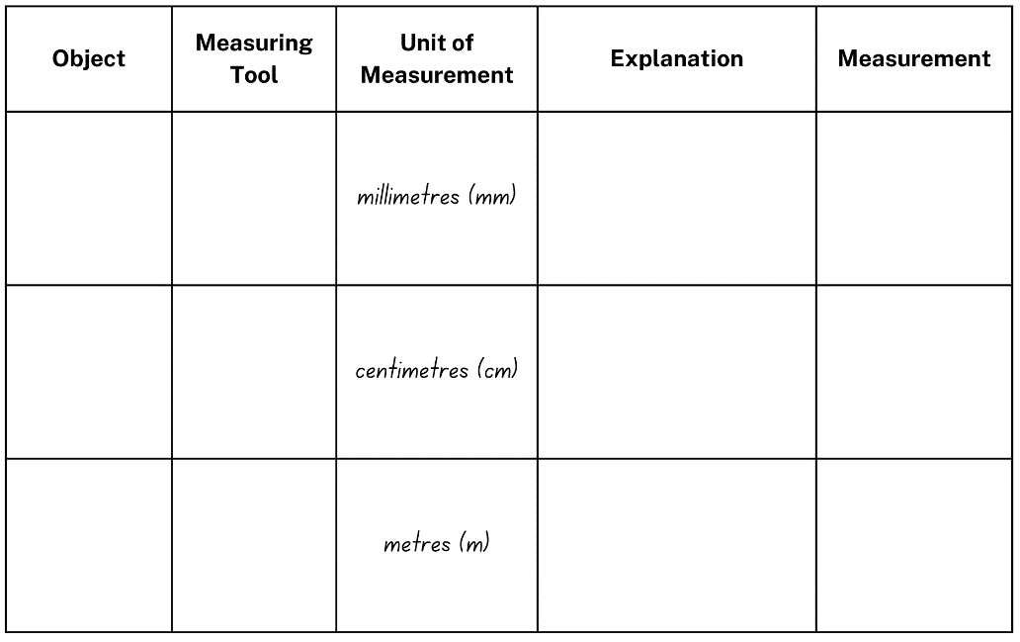
- Select appropriate objects or locations for Stage 2 students to measure. Ensure that students are provided with an opportunity to measure in millimetres, centimetres and metres.
- For each object or location, students select an appropriate measuring instrument and justify their selection. Provide students with a selection of measuring devices to measure their chosen objects. For example, 30 cm rulers, metre rulers, trundle wheels, tape measures.
- Ask students:
- What measuring instrument would be most efficient for each object or location?
- How will you measure each object or location?
- What are some important skills to remember when measuring? For example, start the measurement at zero with a ruler.
- What are your estimations for each of the objects or locations?
- Students draw the table in their workbook, measure the identified objects and locations, then record. For example, see Figure 3.
Figure 3 – Measuring table example
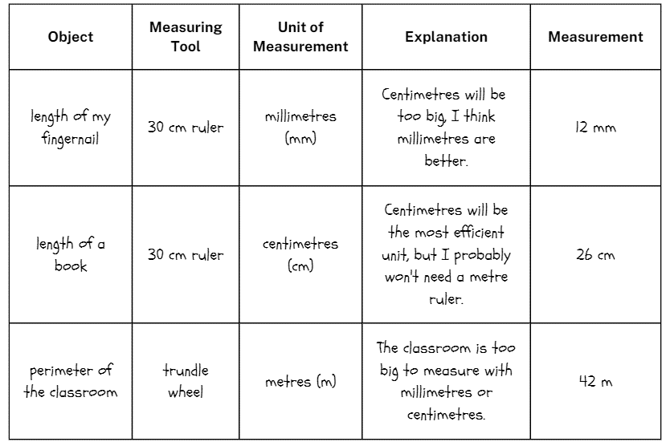
This table details opportunities for differentiation.
Too hard? | Too easy?
Students cannot record measurements of objects or locations using appropriate measuring instruments and units.  - Provide a list of objects that could be measured using each unit and instruments for students to select from.  - Provide an estimate of each length being measured as a point of reference when completing the activity. | Students can record measurements of objects or locations using appropriate measuring instruments and units.  - Challenge students to measure additional objects or locations that require different measurement tools.  - Challenge students to convert each of their recorded measurements to a different unit.

Discuss and connect the mathematics – 10 minutes
- As a class, summarise the lesson drawing out key mathematical ideas. Ask:
- Why did you select those specific objects or locations to measure? (Stage 3)
- What measurement did you record for each object or location?
- Which instrument did you use to measure each object or location? How did you decide it was the most appropriate?
- Was the instrument you used effective? Why or why not?
- How did you justify your selection of specific units and devices when measuring?
- What challenges did you face during the activity? How did you overcome them?
This table details opportunities for assessment.
Assessment opportunities | Links
What to look for:  - Can students select an appropriate unit of measurement for a given context? [MAO-WM-01, MA3-GM-02, MA2-GM-02]  - Can students match units of measurement with appropriate measuring instruments? [MAO-WM-01, MA3-GM-02, MA2-GM-02]  - Can students record measurements of objects or locations using appropriate measuring instruments? [MAO-WM-01, MA3-GM-02, MA2-GM-02] | Links to National Numeracy Learning Progressions (NNLP):  - Stage 2 – UuM6  - Stage 3 – UuM6.

Lesson 2
Core concept: metric units of measurement relate to the base-10 place value system.

Daily number sense: Distance word problems – 10 minutes
The table below contains a suggested learning intention and success criteria. These are best co-constructed with students.
Daily number sense learning intention | Daily number sense success criteria
Students are learning to:  - use efficient strategies to solve addition and subtraction problems. | Students working towards Stage 2 outcomes can:  - represent solutions to addition and subtraction word problems using an empty number line.  Students working towards Stage 3 outcomes can:  - solve multistep word problems involving addition and subtraction.
- Display Resource 2: Distance word problems. Ask students to solve the problems using an efficient strategy and record their working out in their workbooks.
- Stage 2 students to solve questions 1 and 2, Stage 3 students to solve questions 3 and 4.
Multi-age: Stage 2 students to use an empty number line to represent their solution. Stage 3 students to choose an efficient strategy and record their answers in kilometres using the abbreviation km.
- Select students to share and explain the strategy and answers.
This table details opportunities for assessment.
Assessment opportunities | Links
What to look for:  - Can Stage 2 students represent solutions to addition and subtraction word problems using an empty number line? [MAO-WM-01, MA2-AR-01]  - Can Stage 3 students solve multistep word problems involving addition and subtraction? [MAO-WM-01, MA3-AR-01] | Links to National Numeracy Learning Progressions (NNLP):  - Stage 2 – AdS6, AdS7  - Stage 3 – AdS8.

Core lesson: Base-10 – 40 minutes
The table below contains suggested learning intentions and success criteria. These are best co-constructed with students.
Core concept learning intentions | Core concept success criteria
Students are learning to:  - recognise how the base-10 number system helps when measuring and recording length. | All students can:  - record lengths and distances using decimal notation.  Students working towards Stage 2 outcomes can:  - measure lengths and distances using cm and m  - convert between metres and centimetres.  Students working towards Stage 3 outcomes can:  - recognise and interpret whole-number and decimal representations of length  - use decimal place value system to convert between metres and kilometres.
- Display Resource 3: Place value chart and ask:
- What do you know about the base-10 number system?
- What do you notice about the value of each place value column?
- Can you see any patterns or connections between the place value columns?
- Are all place value columns shown? How do you know?
- How does this image relate to what we know about measurement?
Multi-age: Stage 2 students only need to record length using decimal notation to 2 decimal places. As Stage 3 students convert between m and km, they record length to 3 decimal places.
- Write 4.25 m on the board. Allow students to Think-Pair-Share what they notice. Ask:
- What place values are represented in the image?
- What does the .25 m represent in hundredths?
- What does the .25 represent in cm?
- Why is it important to understand place value when measuring lengths?
- If you were to measure 4.25 m with a metre ruler, how many rulers would you need?
- Using your estimation skills, what is something that would be approximately 4.25 m long?
- Display a 30 cm and a metre ruler and ask Stage 2 students:
- What do the small lines on the 30 cm ruler measure?
- How many millimetres are in a centimetre?
- What do the small lines on the metre ruler measure?
- How many centimetres are in a metre?
- How can we use these lines to ensure we are measuring accurately?
- Model drawing a table for students to record in their workbooks (see Figure 4). Explain to Stage 2 students that they will measure 3 different objects in the classroom using either a 30 cm ruler or a metre ruler. Students to record the length in centimetres and metres.
Figure 4 – Measuring table
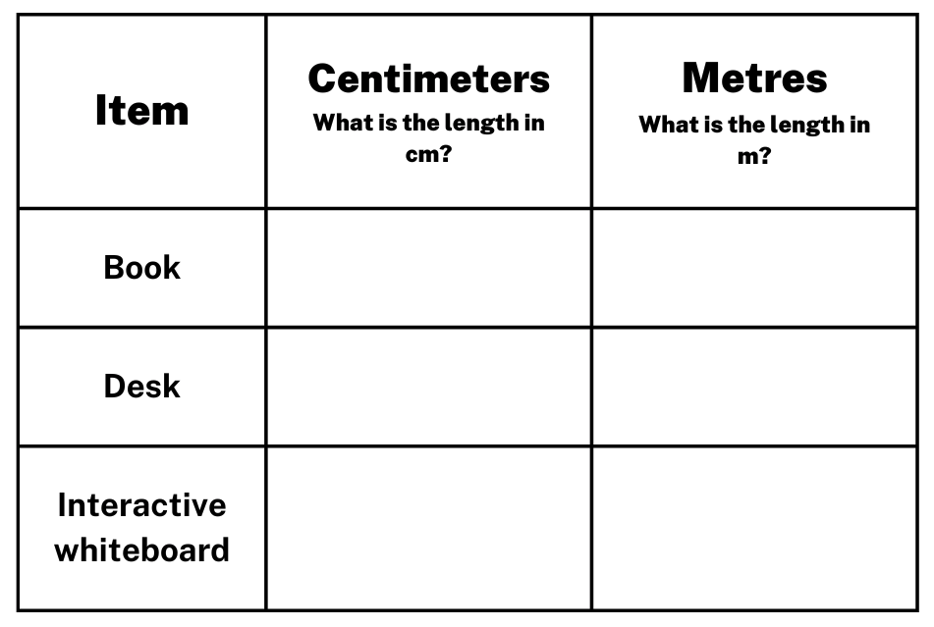
- Ask Stage 2 students how they will ensure they accurately measure objects longer than their measuring instrument.
- Provide Stage 2 students with metre and 30 cm rulers to complete the activity independently and record the lengths in their workbook.
- While Stage 2 students are working independently, have Stage 3 students turn and talk with a partner about how to convert between metres and kilometres. Ask:
- How would you know to choose between multiplication and division when converting between metre and kilometres?
- What do you expect to happen to a number when you multiply by 1000?
- What do you expect to happen to a number when you divide by 1000?
- What is a strategy for multiplying and dividing numbers by 1000?
- Model a conversion chart on the board (see Figure 5).
Figure 5 – Partial conversion chart
- Distribute Resource 4: Converting sheet to Stage 3 students and explain that they will be converting between metres and kilometres.
- Demonstrate how to convert between metres and kilometres by rolling four 10-sided dice and recording the number rolled in the kilometre squares. Then, convert the recorded number to metres and record the number in the corresponding boxes. For example, see Figure 6.
Figure 6 – Kilometres to metres
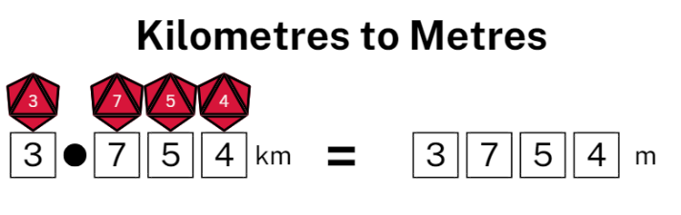
- Provide pairs of Stage 3 students with four 10-sided dice.
Note: it is recommended to use dice that have a zero as it is important that students understand the role of zero in changing the value of the numbers created. Place Resource 4: Converting sheet in a reusable sleeve or laminate so students can use it multiple times.
- Stage 3 students take turns rolling the dice for their partner. Partners records the number rolled in the kilometres section and then convert to metres. Begin the activity with students converting kilometres to metres for 5 minutes. After 5 minutes, students switch to converting metres to kilometres. Play the game for a further 5 minutes.
This table details opportunities for differentiation.
Too hard? | Too easy?
Stage 2 students cannot measure and record lengths to 2 decimal places.  - Support students by adjusting the objects so they are shorter than the measuring instruments.  Stage 3 students cannot convert between metres and kilometres.  - Provide students a number slider to assist with their conversions.  - Allow students to continue converting kilometres to metres without swapping after 5 minutes to minimise confusion. | Stage 2 students can measure and record lengths to 2 decimal places.  - Challenge students to measure additional objects in the classroom, recording their lengths in millimetres and centimetres.  Stage 3 students can convert between metres and kilometres.  - Challenge students to roll the dice and record the metre and kilometre forms of their numbers without the scaffold.  - Challenge students to arrange their recorded lengths in ascending or descending order.

Discuss and connect the mathematics – 10 minutes
- Regroup as a class and summarise the lesson together drawing out key mathematical ideas. Ask:
- What measurements did you have for each item in centimetres? (Stage 2)
- What measurements did you have for each item in metres? (Stage 2)
- Did you have to measure the objects in centimetres and then again in metres? Why or why not? (Stage 2)
- How did you convert the lengths?
- How did you use your knowledge of the base-10 number system to convert the lengths?
- What strategy did you use when converting the lengths?
- Can you think of any shortcuts for converting between different units of length? (Stage 3)
- What challenges did you face during this activity? How did you overcome them?
This table details opportunities for assessment.
Assessment opportunities | Links
What to look for:  - Can students record lengths and distances using decimal notation? [MAO-WM-01, MA2-GM-02, MA3-GM-02]  - Can Stage 2 students measure lengths and distances using cm and m? [MAO-WM-01, MA2-GM-02]  - Can Stage 2 students convert between metres and centimetres? [MAO-WM-01, MA2-GM-02]  - Can Stage 3 students recognise and interpret whole-number and decimal representations of length? [MAO-WM-01, MA3-GM-02]  - Can Stage 3 students use decimal place value system to convert between metres and kilometres? [MAO-WM-01, MA3-GM-02] | Links to National Numeracy Learning Progressions (NNLP):  - Stage 2 – UuM6, UuM8  - Stage 3 – NPV7, NPV8, NPV9, UuM8.

Lesson 3
Core concept: metric units of measurement can be described using the decimal place value system.

Daily number sense: Travel plans – 10 minutes
The table below contains a suggested learning intention and success criteria. These are best co-constructed with students.
Daily number sense learning intention | Daily number sense success criteria
Students are learning to:  - use efficient strategies to solve addition problems. | Students working towards Stage 2 outcomes can:  - represent solutions to addition and subtraction word problems using a bar model.  Students working towards Stage 3 outcomes can:  - solve multistep word problems involving addition.
This activity is an adaptation of ‘Travel Plans’ from Mathematics Assessment for Learning: Rich Tasks & Work Samples, 3rd edn by Downton et al.
- Display Resource 5: Travel plans and explain to Stage 2 students that it takes 280 minutes to drive from Griffith to Dubbo and 195 minutes to drive from Griffith to Parkes.
- Stage 2 students must calculate how many minutes it takes to drive from Parkes to Dubbo and represent the solution in their workbooks using a bar model (see Figure 7).
Figure 7 – Travel plans bar model
- Distribute Resource 5: Travel plans to Stage 3 students and explain that they need to plan where the fuel stops will be from Melbourne to Brisbane on the Newell Highway. Explain that the car can travel up to 300 km on one tank of petrol.
- Stage 3 students need to calculate the possible fuels stops, distances between fuel stops and then the total distance for the trip.
- Students record the travel plans in their workbooks, showing their calculations. For example, see Figure 8.
Figure 8 – Travel plans example
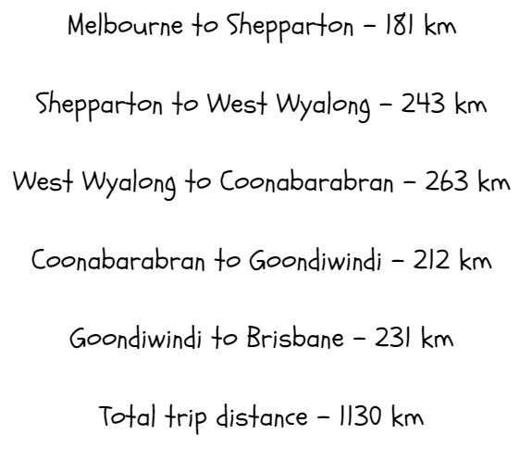
- Select Stage 2 and 3 students to share and explain their strategy and answer.
This table details opportunities for assessment.
Assessment opportunities | Links
What to look for:  - Can Stage 2 students represent solutions to addition and subtraction word problems using a bar model? [MAO-WM-01, MA2-AR-01]  - Can Stage 3 students solve multistep word problems involving addition? [MAO-WM-01, MA3-AR-01] | Links to National Numeracy Learning Progressions (NNLP):  - Stage 2 – AdS6  - Stage 3 – AdS8.

Core lesson: Converting between units – 40 minutes
The table below contains suggested learning intentions and success criteria. These are best co-constructed with students.
Core concept learning intentions | Core concept success criteria
All students are learning to:  - convert between common metric units of length. | Students working towards Stage 2 outcomes can:  - measure lengths using centimetres and millimetres  - convert between metres and centimetres, and between centimetres and millimetres.  Students working towards Stage 3 outcomes can:  - use the decimal place value system to convert between units of length  - convert measurements to the same unit to compare lengths and distances.
- Display Resource 6: Full conversion chart.
Multi-age: only Stage 3 students need to work with kilometres.
- Ask students:
- What do you notice about the difference between these units of length?
- Why are some arrows shorter and longer than others?
- Can you see any connection or pattern in the way the units relate to each other?
- How does this connect to the base-10 number system?
- Why is it important to understand the base-10 number system when measuring and converting lengths?
- How can this display help us to convert between units of length?
- Write ‘A length can be renamed using different units of measurement’ on a large whiteboard. Allow students thinking time, before they turn and talk to discuss their ideas.
- Select students to share and explain their ideas.
- Explain to students that converting is when the unit of measurement changes. For example, 23 cm can be converted to 230 mm. Explain that Stage 2 students will be converting measurements between millimeters to centimeters and Stage 3 students will be converting measurements between centimeters, meters and kilometers.
Note: emphasise that the length does not change, only the unit of measurement.
- Distribute Resource 7: Measuring and converting to Stage 2 students and demonstrate how to measure, record and convert each answer.
- Provide Stage 2 students with a 30 cm ruler to measure the items in mm and convert each length to cm.
- While Stage 2 students are working independently, provide Stage 3 students with Resource 8: Number slider to make their own number slider following the instructions.
- Provide Stage 3 students with Resource 9: Converting length table. Demonstrate how to convert between the units of length using the number slider as a reference. Encourage students to use their number slider during the explanation.
- Once Stage 3 students are confident using the number slider, they complete the table.
- Ask Stage 3 students:
- How does understanding the decimal place value system support us to convert between units of length?
- How does converting lengths to the same unit allow us to compare and order measurements?
- How does the size of the unit change the number of units used when measuring?
This table details opportunities for differentiation.
Too hard? | Too easy?
Students cannot convert between common metric units of length.  - Support Stage 2 students to measure the object in centimetres and then again in millimetres (without converting). Then, guide students to observe the pattern between the centimetre and millimetre measurements.  - Provide Stage 3 students with simplified conversion tasks, mainly converting between millimetres and centimetres to reinforce multiplying and dividing by 10. | Students can convert between common metric units of length.  - Challenge Stage 2 students to convert their item lengths to metres.  - Challenge Stage 3 students to find the sum of a single column of their completed table.

Consolidation and meaningful practice – 20 minutes
- Explain that students will use their knowledge of the base-10 number system to play conversion bingo.
- Provide each student with Resource 10: Conversion bingo. Students pre-select 9 different lengths for the game.
- Read out cards from Resource 11: Teacher cards. If students have the converted length, they mark the box with the corresponding conversion. For example, see Figure 9.
Figure 9 – Conversion bingo recording
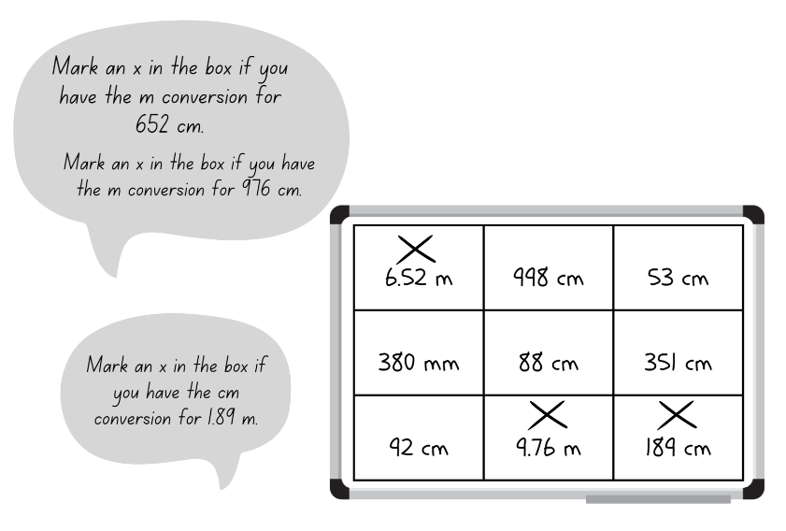
- The first student to have all 9 of their selected lengths marked off is the winner.
This table details opportunities for assessment.
Assessment opportunities | Links
What to look for:  - Can Stage 2 students measure lengths using centimetres and millimetres? [MAO-WM-01, MA2-GM-02]  - Can Stage 2 students convert between metres and centimetres, and between centimetres and millimetres? [MAO-WM-01, MA2-GM-02]  - Can Stage 3 students use the decimal place value system to convert between units of length? [MAO-WM-01, MA3-GM-02]  - Can Stage 3 students convert measurements to the same unit to compare lengths and distances? [MAO-WM-01, MA3-GM-02] | Links to National Numeracy Learning Progressions (NNLP):  - Stage 2 – UuM6, UuM8  - Stage 3 – NPV8, UuM8.

Lesson 4
Core concept: a straight line, a boundary or an edge can be measured.

Daily number sense – 10 minutes
- From a class need surfaced through formative assessment data, identify a short, focused activity that targets students’ knowledge, understanding and skills. Example activities may be drawn from the following resources:
- Mathematics K-6 resources
- Universal Resources Hub.

Core lesson: Length investigation – 40 minutes
The table below contains suggested learning intentions and success criteria. These are best co-constructed with students.
Core concept learning intentions | Core concept success criteria
All students are learning to:  - measure various lengths and boundaries of objects or locations  - convert between common metric units of length. | Students working towards Stage 2 outcomes can:  - estimate and measure the boundary of objects or locations  - recognise and measure the length of features of three-dimensional objects  - convert between metres and centimetres, and between centimetres and millimetres.  Students working towards Stage 3 outcomes can:  - use a variety of measuring devices to measure lengths and distances in different contexts  - use efficient strategies to calculate the perimeter of a large rectangular area in metres  - use decimal place value system to convert between metres and kilometres  - understand that increasing the size of a unit results in a lower recorded measurement.
- Write ‘What can length measure?’ and ask students to brainstorm, recording student ideas on an anchor chart.
- Display Resource 12: Length can measure and highlight that length can be used to measure straight lines, boundaries and edges.
Multi-age: Stage 2 students are measuring boundaries before exploring the term ‘perimeter’ in Lesson 5. Stage 3 students have experience measuring and using the term perimeter.
- Ask students:
- What units of measurement are used when measuring length?
- What are some of the measuring instruments used to measure length?
- Can you identify any straight lines, boundaries or edges that you have measured before?
- What is the term used to describe the distance around a boundary? (Stage 3)
- Can length be used to measure curved or jagged lines?
Note: explain to students that length can also be used to measure curved and jagged lines, but these can be more challenging to measure.
- Explain the definition of a straight line, boundary and edge and demonstrate how to measure each on classroom objects.
- Display Resource 13: Measurement hunt for students to copy into their workbooks.
- Explain that students will identify objects or locations in their school and measure a straight line, a boundary and an edge. Ensure Stage 3 students measure the boundary of a large rectangular area and record the measurement using metres.
- Ask students:
- What measuring instruments could be used to measure straight lines, boundaries and edges?
- Would each location or object require the same measuring instrument?
- What are some straight lines, boundaries and edges in the school context that could be measured?
- How will you measure the locations and objects accurately?
- Display 30 cm rulers, trundle wheels and metre rulers. Ask:
- How can these instruments be used to measure length?
- How do you ensure these instruments are used accurately?
- Are some instruments better suited for different objects or locations? Why?
- Students estimate and then measure the object or location and record the measurement.
- Discuss with Stage 3 students the expectations for recording using decimal notations. For example, one metre and 72 centimetres should be recorded in the table as 1.72 m, while 12 centimetres and 4 millimetres should be recorded as 12.4 cm.
Multi-age: Stage 2 students measure and record their chosen objects or locations using cm and/or mm, Stage 3 students measure and record their chosen objects or locations using cm or m.
- Stage 2 students to convert and record each of their measurements using a different unit of measurement. For example, converting centimetres to millimetres. Stage 3 students to convert each of their measurements to metres and then kilometres.
- Display Resource 14: Recording lengths for Stage 3 students. Highlight that, when the length is the same, the larger the unit used means the smaller the recorded measure. For example, 4 km is the same length as 4000 m, but the unit km is larger than the unit m, which produces a smaller recorded measure.
- Invite individual Stage 3 students to use their converted measurements as evidence to support the statement ‘The larger the unit, the smaller the measure’.
This table details opportunities for differentiation.
Too hard? | Too easy?
Students cannot measure straight lines, boundaries and edges by recognising the features of shapes and objects.  - Support students to select classroom objects that are familiar three-dimensional shapes. Assist students to identify the edges that can measured. | Students can measure straight lines, boundaries and edges by recognising the features of shapes and objects.  - Challenge students to measure additional locations and objects from around the classroom or school.  - Challenge students to convert their measurements to a different unit.

Discuss and connect the mathematics – 10 minutes
- As a class, summarise the lesson drawing out key mathematical ideas. Ask:
- What object or location did you choose to measure for your straight lines, boundaries and edges? Why?
- What measurements did you record for each of the locations or objects?
- What was the difference between your estimation and the recorded length?
- What is another way you can describe the term boundary?
- What strategy did you use to calculate the perimeter of a large rectangular area? Was it the most efficient method? (Stage 3)
- Which measurement did you find easiest to convert to another unit of measurement? Why?
- Can you describe relationship between the size of the unit and the number of units needed? (Stage 3)
- What challenges did you face during this activity? How did you overcome them?
This table details opportunities for assessment.
Assessment opportunities | Links
What to look for:  - Can Stage 2 students estimate and measure the boundary of objects or locations? [MAO-WM-01, MA2-GM-02]  - Can Stage 2 students recognise and measure the length of features of three-dimensional objects? [MAO-WM-01, MA2-GM-02]  - Can Stage 2 students convert between metres and centimetres, and between centimetres and millimetres? [MAO-WM-01, MA2-GM-02]  - Can Stage 3 students use a variety of measuring devices to measure lengths and distances in different contexts? [MAO-WM-01, MA3-GM-02]  - Can Stage 3 students use efficient strategies to calculate the perimeter of a large rectangular area in metres? [MAO-WM-01, MA3-GM-02]  - Can Stage 3 students use decimal place value system to convert between metres and kilometres? [MAO-WM-01, MA3-GM-02]  - Can Stage 3 students understand that increasing the size of a unit results in a lower recorded measurement? [MAO-WM-01, MA3-GM-02] | Links to National Numeracy Learning Progressions (NNLP):  - Stage 2 – UuM7, UuM8  - Stage 3 – NPV8, UuM5, UuM6, UuM7, UuM8.

Lesson 5
Core concept: perimeter is the distance around the boundary of a two-dimensional shape.

Daily number sense: Climb the ladder – 10 minutes
Daily number sense activities for Lessons 5 to 7 ‘loop’ back to concepts and procedures covered in previous units to assist students to build an increasingly connected network of ideas. These concepts may differ from the core concepts being covered by the unit.
The table below contains a suggested learning intention and success criteria. These are best co-constructed with students.
Daily number sense learning intention | Daily number sense success criteria
Students are learning to:  - read, represent and order numbers. | Students working towards Stage 2 outcomes can:  - arrange numbers in the thousands in ascending and descending order.  Students working towards Stage 3 outcomes can:  - name numbers in the millions using the place value grouping of ones, tens and hundreds  - arrange numbers in the millions in ascending and descending order.
- Distribute an individual whiteboard, whiteboard marker and 9-sided die to pairs of students.
- Students draw a ladder with 5 rungs on their whiteboard.
- Explain the aim of the game is to position numbers in sequence on the ladder rungs. Stage 2 students order 4-digit numbers and Stage 3 students order 7-digit numbers.
- Stage 2 students roll the dice 4 times to form a 4-digit number. Stage 3 students roll the dice 7 times to form a 7-digit number. Students read their number aloud and record it on one of the ladder rungs. Encourage Stage 3 students to use the place value grouping of ones, tens and hundreds when reading their numbers aloud.
- The other student in each pair rolls the dice again to form another 4-digit number (Stage 2) or 7-digit number (Stage 3). Students to place their number on a rung on the ladder. For example, see Figure 10.
Figure 10 – Stage 2 ‘Climb the ladder’ example
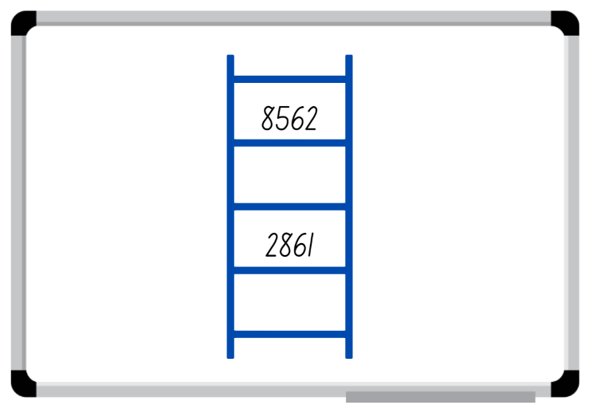
- Pairs of students continue the game until a player is unable to place their number on the ladder, then the game is over.
- As they are playing, ask students to explain and justify which rung they have nominated to place the number on before recording it on the ladder.
Note: use dice that have a zero as it is important to understand that the zero is a placeholder and does not have a value.
This table details opportunities for assessment.
Assessment opportunities | Links
What to look for:  - Can Stage 2 students arrange numbers in the thousands in ascending and descending order? [MAO-WM-01, MA2-RN-01]  - Can Stage 3 students name numbers in the millions using the place value grouping of ones, tens and hundreds? [MAO-WM-01, MA3-RN-01]  - Can Stage 3 students arrange numbers in the millions in ascending and descending order? [MAO-WM-01, MA3-RN-01] | Links to National Numeracy Learning Progressions (NNLP):  - Stage 2 – NPV5, NPV6  - Stage 3 – NPV6, NPV7.  Links to suggested Interview for Student Reasoning (IfSR) tasks:  - Stage 2 – IfSR-NP/AT/MT: 4B.2.

Core lesson: Shapes and perimeters – 40 minutes
The table below contains suggested learning intentions and success criteria. These are best co-constructed with students.
Core concept learning intentions | Core concept success criteria
Students working towards Stage 2 outcomes are learning to:  - identify and measure the perimeter of shapes.  Students working towards Stage 3 outcomes are learning to:  - recognise that different shapes can have the same perimeter. | Students working towards Stage 2 outcomes can:  - use the term perimeter to describe the distance around the boundary of shapes  - estimate and measure the perimeters of quadrilaterals in cm and mm.  Students working towards Stage 3 outcomes can:  - draw shapes and measure lengths to find the perimeter  - identify and explain that different shapes can have the same perimeter  - recognise rotations change the position and orientation but not the size of shapes
- Display Resource 15: Boundary and perimeter and ask Stage 2 students to examine the boundary of the airport, then look at the outline of all the shapes in the image. Explain that the perimeter of an object, shape or location is the same as the boundary. Perimeter is the length around an object, shape or location. Perimeter is calculated by combining the length of all the sides.
- Ask Stage 2 students:
- Can you think of any examples of perimeter in everyday life?
- Why is it important to understand perimeter?
Note: connect Stage 2 students’ thinking about perimeter to a fence around a boundary.
- Ask Stage 3 students to search for the following shapes in the image:
- A regular quadrilateral and hexagon
- An irregular quadrilateral, triangle, pentagon and octagon.
- Ask Stage 3 students to identify the location of shapes and name them using words such as regular shape, irregular shape, quadrilateral, pentagon, octagon and triangle.
- Select students to share their ideas and responses.
- Explain to Stage 3 students that different shapes can have the same perimeters.
- Display Resource 16: Perimeters. Ask Stage 2 to look at the image on the left and Stage 3 to look at the images on the right.
- Ask Stage 3 students to think and then turn and talk to discuss what they notice about the shapes and the perimeter of the 2 shapes on the right.
- As Stage 3 students turn and talk, ask Stage 2 students:
- What do you notice about the image?
- How would you find the missing lengths on the image?
- What is the perimeter of the image?
- What strategy did you use to find the perimeter of the diagram? Why?
- Regroup with all students and model identifying the missing lengths of the left-side image, using known information. For example, there are lengths of 52 m and 30 m on one side of the diagram. Adding the lengths together means the total length of the remaining side is 82 m.
- Label the missing lengths on the diagram and demonstrate how to calculate the perimeter of the image.
- Ask Stage 3 students to share what they noticed about the right-hand side shapes and the perimeters. If not noted by students, highlight the fact that all the shapes have the same perimeter even though they are different.
- Provide all students with Resource 17: Measuring perimeters and 30 cm rulers.
- Model measuring the perimeter of various shapes in Resource 17: Measuring perimeters using the terms regular and irregular shape.
- Stage 2 students find the length of the sides of the two-dimensional shapes and then calculate the perimeter.
- Stage 3 students re-create the shapes in their workbooks so that each shape has a perimeter of 24 cm. Students show their working as shown in Figure 25.
Note: the example shown in the lower right corner of Figure 11 displays a new shape as suggested in the ‘Too Hard’ challenge. The square and triangle form part of a shape from Resource 17: Measuring perimeters.
Figure 11 – Calculating perimeter examples
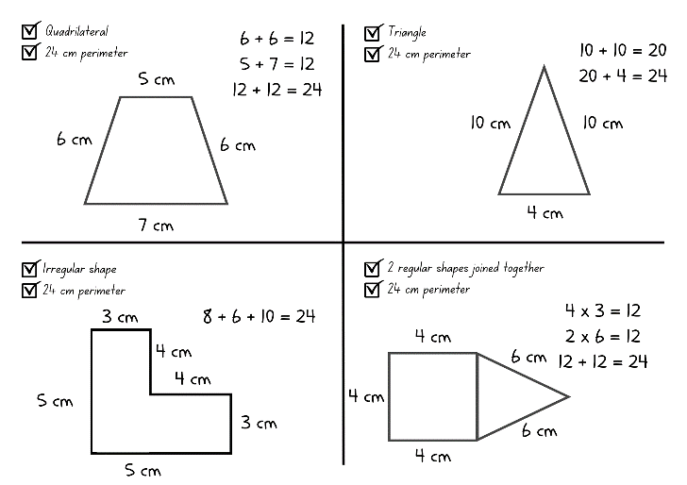
- Ask students to rotate one of the shapes and identify what is different. Discuss with students that the orientation and position changes, however the perimeter remains the same.
This table details opportunities for differentiation.
Too hard? | Too easy?
Stage 2 students cannot identify and measure the perimeter of shapes.  - Support students to measure and calculate the perimeter of the regular two-dimensional shapes from Resource 17: Measuring perimeters.  - Provide the side measurements of the regular shapes and students only calculate the perimeter.  Stage 3 students cannot create shapes and measure lengths to find perimeters.  - Suggest the length of each side of the regular shapes and support students to draw and measure the shapes.  - Provide some lengths of irregular shape sides and support students to calculate and measure the remaining sides to find the perimeter. | Stage 2 students can identify and measure the perimeter of shapes.  - Challenge students to convert their measurements and perimeters from centimetres to millimetres.  - Challenge students to place the perimeters in ascending and descending order.  Stage 3 students can create shapes and measure lengths to find perimeters.  - Challenge students to repeat the task with a perimeter of 36 cm.  - Challenge students to use the regular shapes from Resource 17: Measuring perimeters to create new shapes with a perimeter of 24 cm.

Discuss and connect the mathematics – 10 minutes
- Regroup as a class and summarise the lesson together drawing out key mathematical ideas. Ask:
- What unit of measurement was best suited to measure each shape? Why?
- What strategy did you use to calculate the perimeters of each shape?
- Did you see a different shape that still fit the criteria? What was it? (Stage 3)
- How is it possible for different shapes to have the same perimeter? (Stage 3)
- Can 2 of the same shape have different perimeters? (Stage 3)
- What were challenges you faced during this activity? How did you overcome them?
This table details opportunities for assessment.
Assessment opportunities | Links
What to look for:  - Can Stage 2 students use the term perimeter to describe the distance around the boundary of shapes and estimate and measure the perimeters of quadrilaterals in cm and mm? [MA2-GM-02, MA2-2DS-01]  - Can Stage 3 students draw shapes and measure lengths to find the perimeter and identify and explain that different shapes can have the same perimeter? [MA3-GM-02, MA3-2DS-01] | Links to National Numeracy Learning Progressions (NNLP):  - Stage 2 – UuM7  - Stage 3 – UuM7.

Lesson 6
Core concept: standard units are an efficient way to communicate and compare lengths of time.

Daily number sense: Where do you fit? – 10 minutes
The table below contains a suggested learning intention and success criteria. These are best co-constructed with students.
Daily number sense learning intention | Daily number sense success criteria
Students are learning to:  - read, represent and order numbers. | Students working towards Stage 2 outcomes can:  - arrange numbers in the thousands in ascending and descending order.  Students working towards Stage 3 outcomes can:  - name numbers in the millions using the place value grouping of ones, tens and hundreds  - arrange numbers in the millions in ascending and descending order.
- Organise students into small groups and provide each Stage 2 group with four 10-sided dice and each Stage 3 group with seven 10-sided dice.
- Stage 2 students take turns rolling the dice to create a 4-digit number. Stage 3 students take turns rolling the dice to create a 7-digit number.
- Students read their number aloud, record it on a sticky note and, one by one, place themselves in order from smallest to largest.
- When each group has all members in order, combine 2 Stage 2 groups and 2 Stage 3 groups. Group members need to adjust their order to ensure they are still in order from smallest to largest.
- Continue to combine groups and adjust placements until all Stage 2 students and all Stage 3 students are in order.
This table details opportunities for assessment.
Assessment opportunities | Links
What to look for:  - Can Stage 2 students arrange numbers in the thousands in ascending and descending order? [MAO-WM-01, MA2-RN-01]  - Can Stage 3 students name numbers in the millions using the place value grouping of ones, tens and hundreds? [MAO-WM-01, MA3-RN-01]  - Can Stage 3 students arrange numbers in the millions in ascending and descending order? [MAO-WM-01, MA3-RN-01] | Links to National Numeracy Learning Progressions (NNLP):  - Stage 2 – NPV5, NPV6  - Stage 3 – NPV6, NPV7.

Core lesson – 40 minutes
The table below contains suggested learning intentions and success criteria. These are best co-constructed with students.
Core concept learning intentions | Core concept success criteria
Students working towards Stage 2 outcomes are learning to:  - represent and read analog time  - compare duration of time in seconds and minutes.  Students working towards Stage 3 outcomes are learning to:  - understand how timetables can be used to efficiently to organise time. | Students working towards Stage 2 outcomes can:  - recognise and compare durations of time in seconds and minutes  - read analog clocks to the minute  - determine the time remaining until the next hour.  Students working towards Stage 3 outcomes can:  - convert between 12- and 24-hour time  - create a timetable using set criteria.

Stage 2 task: Time is ticking
- Explain that students will be playing the game ‘Time is Ticking’.
- Have students sit with their eyes closed and say a duration of time. For example, one minute.
- Explain that students will place their hands on their head when they think that length of time has passed.
Note: use a stopwatch and ensure the stopwatch is not visible to students.
- Begin the stopwatch. At the exact point of one minute pause the stopwatch and ask students how they estimated the minute and if they used a strategy that helped to accurately estimate the minute.
- Repeat the game with different durations, for example, 30 seconds, 45 seconds, 15 seconds, 5 seconds, 2 minutes.
- Display an analog clock and ask:
- How many seconds are in a minute? How do you know?
- How many minutes are in an hour? How do you know?
- What is the difference between the minute and the hour hands? At what speed do they move?
- What do the small strokes between the numerals on the clock represent?
- What is an efficient way of calculating time, without having to count singular minutes? What benchmarks do you know? Record students answers on an anchor chart for easy reference as the lesson progresses.
Note: guide students to explain the concept of quarter past, half past, quarter to and that between each numeral on the clock is a 5-minute interval.
- Adjust the clock to show 7:45 and ask students to Think-Pair-Share what time is displayed. Ask:
- What will the time be in 10 minutes from the time shown?
- What will the time be in half an hour?
- How many minutes until the next hour?
- Repeat the process with different time on the clock. For example, 3:58 and 4:08.
- Discuss how to describe the duration of time, highlighting the importance of using the most efficient unit. For example, the activity takes one hour, recess goes for 25 minutes.
- Give pairs of students a card from Resource 18: Duration cards, and ask them to debate and justify whether the description of time duration is communicated effectively. Ensure pairs suggest reasons why or why not.
This table details opportunities for differentiation.
Too hard? | Too easy?
Students cannot represent and read analog time and compare duration of time in seconds and minutes.  - Support students by providing them with a hands-on clock and manipulating the hands to show the same time as the displayed clock.  - Support students by showing a range of equivalent times, such as 60 seconds = 1 minute, 15 minutes = one quarter of an hour, 24 hours = one day. | Students can represent and read analog time and compare duration of time in seconds and minutes.  - Challenge students to convert the scenarios that are measured inefficiently to an efficient unit of time.

Stage 3 task: A day at school
- Ask students to think about the words ‘time management’ then discuss the following:
- What does time management mean?
- Can you think of any situations where time management is needed? Why?
- Can you think of any professions that require time management skills?
- Can you list any resources that help us to manage time? For example, bus timetables, flight itineraries and school timetables.
- Display Resource 19: 24-hour time and discuss why 24-hour time is an efficient way to read and write time. Revise students’ knowledge that 24-hour time is used to avoid confusion between am and pm.
- Provide students with Resource 20: School timetable and explain how the school timetable is used to manage time.
- Ask students to create a school timetable using the given criteria using the 12- and 24-hour times.
Note: students will have remaining time sections of their timetable once completing the criteria. Direct students to fill these sections with subjects of their choosing.
- Students display their timetables and go on a gallery walk to compare timetables.
This table details opportunities for differentiation.
Too hard? | Too easy?
Students cannot understand how timetables can be used to efficiently organise time.  - Provide students with recess and lunch times for their timetable.  - Support students by writing the hour conversions for the criteria. For example, 240 minutes is 4 hours. | Students can understand how timetables can be used to efficiently organise time.  - Challenge students by providing additional criteria. For example, 120 minutes of science and technology.  - Challenge students to write questions that relate to their timetable for a peer to solve. For example, students could ask how many minutes there are between Monday’s maths lesson and lunch.

Discuss and connect the mathematics – 15 minutes
- Regroup as a class and discuss the scenarios presented. Ask:
- Why is it important to communicate time durations effectively? (Stage 2)
- When would you describe a time in seconds, minutes, hours, days? (Stage 2)
- Could schools function without timetables? Why or why not? (Stage 3)
- How did your timetable help you to organise the week? (Stage 3)
- Provide small blank pieces of paper for Stage 2 students to use as exit tickets. Students describe 2 activities that are measured efficiently and one activity that is measured inefficiently, as suggested in Figure 12.
Figure 12 – Exit ticket example
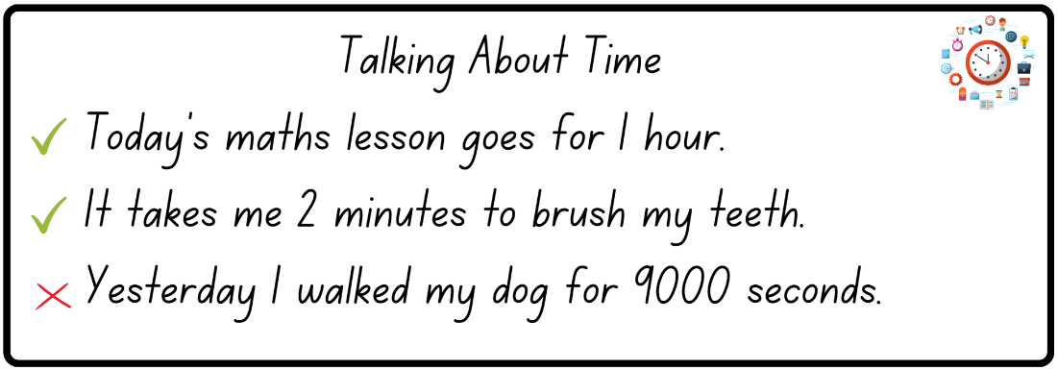
- Continue the discussion with Stage 3 students by asking:
- Were there any timetables that were easier or harder to read than others? Why?
- Why is 24-hour time important?
- Was it easier to read the time in 12-hour or 24-hour time? Why?
- Why are timetables an efficient way to communicate and organise lengths of time?
This table details opportunities for assessment.
Assessment opportunities | Links
What to look for:  - Can Stage 2 students recognise and compare durations of time in seconds and minutes? [MAO-WM-01, MA2-NSM-02]  - Can Stage 2 students read analog clocks to the minute? [MAO-WM-01, MA2-NSM-02]  - Can Stage 2 students determine the time remaining until the next hour? [MAO-WM-01, MA2-NSM-02]  - Can Stage 3 students convert between 12- and 24-hour time? [MAO-WM-01, MA3-NSM-02]  - Can Stage 3 students create a timetable using set criteria? [MAO-WM-01, MA3-NSM-02] | Links to National Numeracy Learning Progressions (NNLP):  - Stage 2 – MeT3  - Stage 3 – MeT5.

Lesson 7
Core concept: lengths of time can be calculated and represented in different ways.

Daily number sense: Ordering game – 10 minutes
The table below contains a suggested learning intention and success criteria. These are best co-constructed with students.
Daily number sense learning intention | Daily number sense success criteria
Students are learning to:  - read, represent and order numbers. | Students working towards Stage 2 outcomes can:  - arrange numbers in the thousands in ascending and descending order.  Students working towards Stage 3 outcomes can:  - name numbers in the millions using the place value grouping of ones, tens and hundreds.  - arrange numbers in the millions in ascending and descending order.
- Provide pairs of students with Resource 21: Ordering gameboard and explain that the aim of the game is to position numbers in sequence on the gameboard. Stage 2 students position 4-digit numbers in order between 1000 and 9999. Stage 3 students position 7-digit numbers in order between 1 000 000 and 9 999 999. Students to record start and finish numbers on their gameboard.
- Provide pairs of Stage 2 students with four 10-sided dice and pairs of Stage 3 students with seven 10-sided dice.
- Students take turns rolling the dice to create a 4-digit number (Stage 2) or a 7-digit number (Stage 3). For example, 4, 6, 9 and zero could be recorded as 4609, 6490 or 9604. Players record their chosen number in the most appropriate place on the gameboard. For example, see Figure 13.
Figure 13 – Stage 2 gameboard example
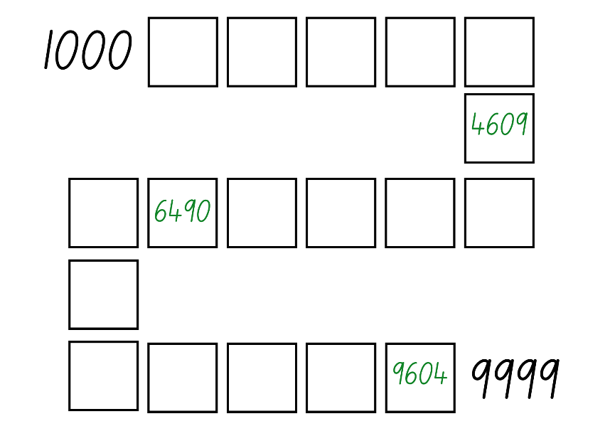
- If numbers cannot be placed, students miss their turn. Play continues until all boxes are filled.
Note: use dice that have a zero as it is important to understand that the zero is a placeholder and does not have a value. Using a reusable sleeve for the gameboard will allow students to play multiple games.
This table details opportunities for assessment.
Assessment opportunities | Links
What to look for:  - Can Stage 2 students arrange numbers in the thousands in ascending and descending order? [MAO-WM-01, MA2-RN-01]  - Can Stage 3 students name numbers in the millions using the place value grouping of ones, tens and hundreds? [MAO-WM-01, MA3-RN-01]  - Can Stage 3 students arrange numbers in the millions in ascending and descending order? [MAO-WM-01, MA3-RN-01] | Links to National Numeracy Learning Progressions (NNLP):  - Stage 2 – NPV5, NPV6  - Stage 3 – NPV6, NPV7.

Core lesson: Digital time and duration – 40 minutes
The table below contains suggested learning intentions and success criteria. These are best co-constructed with students.
Core concept learning intentions | Core concept success criteria
Students working towards Stage 2 outcomes are learning to:  - read analog and digital time.  Students working towards Stage 3 outcomes are learning to:  - represent and solve problems involving duration. | Students working towards Stage 2 outcomes can:  - recognise that the hour is read first in a digital clock  - determine the time remaining until the next hour on a digital clock  - relate analog to digital time.  Students working towards Stage 3 outcomes can:  - use start and finish times to calculate the duration of events  - explain that elapsed time is the amount of time between the start and the end of an activity or event  - use the zoom strategy to calculate elapsed time.
- Explain to Stage 2 students that digital time and analog time are 2 ways to represent time.
- Ask Stage 2 students to think about where they see digital time being used, why they think digital time is used and how is digital time different from analog time.
- Provide Stage 2 students with Resource 22: Time matching cards. Students cut out the cards and may attempt to match the cards to corresponding analog and digital time.
Note: Stage 2 students cut out the cards while Stage 3 students are set up for work. Once Stage 3 are working, you will model reading digital time for Stage 2 students. Resource 22: Time matching cards has been designed so that a variety of additional activities can be played with the cards, such as snap or memory.
- Explain to Stage 3 students that duration is the amount of time something takes. For example, recess is 20 minutes long, which means it has a duration of 20 minutes.
- Introduce Stage 3 students to the term ‘elapsed time’ and explain that elapsed time is connected to duration. Explain that elapsed means something that has passed, so elapsed time means time that has passed.
Elapsed time: the amount of time that has passed between the start of an event and the end.
- Ask Stage 3 students:
- Can you think of examples of elapsed time?
- Is elapsed time only measured with minutes and hours?
- By the end of a school day, how much time has elapsed? How do you know?
- Provide Stage 3 students with Resource 23: The ZOOM strategy (either laminated or in a reusable sleeve) and explain it is a strategy that can be used to calculate elapsed time.
- Model using the zoom strategy to Stage 3 students:
- Identify the start time and the end time.
- Bridge to the closest hour. Then, identify how many hours until the finish time.
- Identify how many minutes (if any) remain until the finish time.
- Add the hours and minutes together to find the total time. For example, see Figure 14.
Figure 14 – ZOOM strategy example
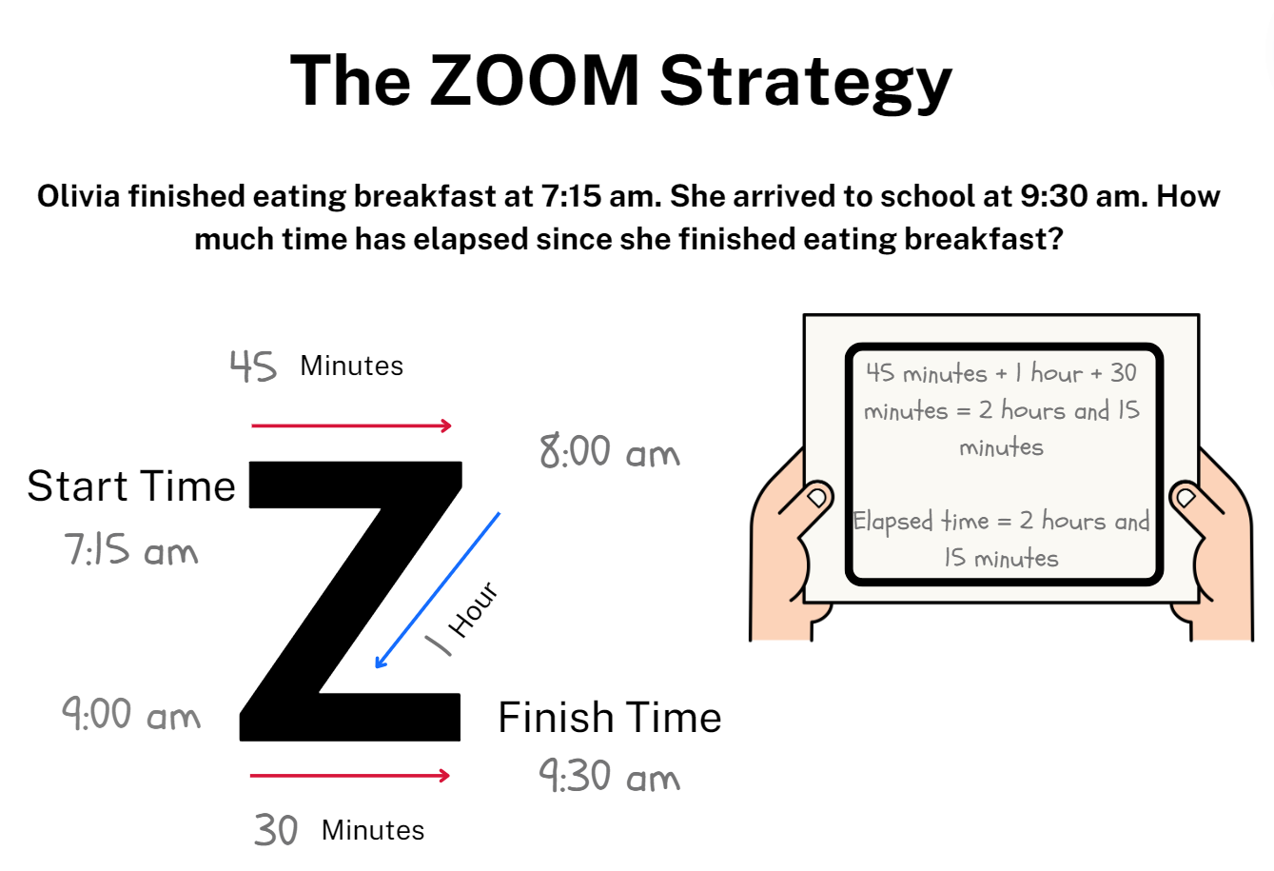
Note: if the elapsed time has a finish time that is on the hour, students will not need to use the final line of the zoom model as there are no remaining minutes to add.
- Provide Stage 3 students with Resource 25: Elapsed timecards and their workbook.
- Stage 3 students use the ZOOM strategy to find the elapsed time for each card and record working and answers in their workbook.
- Display Resource 24: Everyday digital clocks. Stage 2 students view the images and discuss the relevance to everyday life. Ask:
- Can you think of additional scenarios where you would see digital time represented?
- Why do you think digital time is being used in these scenarios?
- How many minutes are there until the next hour in each scenario?
- Model to Stage 2 students how to read digital time, using a variety of digital times as seen in Figure 15.
Figure 15 – Digital clocks
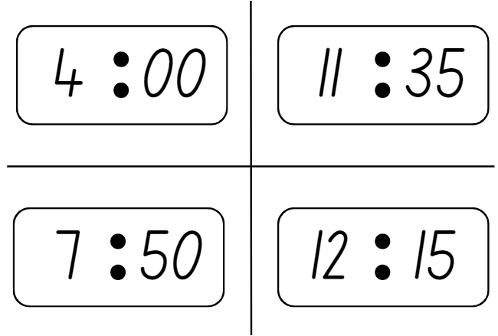
Note: when reading digital time, 4:00 is read as 4 o’clock not ‘four zero zero’. Emphasise to students that, when reading digital time, the hour is read first.
- Stage 2 students to use their cards from Resource 22: Time matching cards and match the analog and digital times.
This table details opportunities for differentiation.
Too hard? | Too easy?
Stage 2 students cannot read analog and digital time.  - Provide students with only 4 sets of cards to match.  - Support students by providing them with a model analog clock to move and manipulate when matching cards.  Stage 3 students cannot solve problems involving duration.  - Support students by providing them with only the top row of Resource 25: Elapsed timecards to complete.  - Support students by providing them with a hands-on clock that can be used to visually model the elapsed time. | Stage 2 students can read analog and digital time.  - Challenge students to find how long until the next hour for each matching pair  - Challenge students to arrange the matching pairs in order they occur during the day.  Stage 3 students can solve problems involving duration.  - Challenge students to arrange the cards from Resource 25: Elapsed timecards in ascending elapsed time order  - Challenge students to create their own elapsed time question for a partner to solve using the zoom strategy.

Discuss and connect the mathematics – 10 minutes
- Regroup as a class and discuss the activity. Ask:
- Is analog or digital time easier to read? Why? (Stage 2)
- Which part of the digital time is said first? (Stage 2)
- If the clock says 3:46, how many minutes are there until the next hour? (Stage 2)
- Did you find the zoom strategy successful for calculating elapsed time? Why or why not? (Stage 3)
- Can you think of any other strategies you could use to calculate elapsed time? (Stage 3)
- Why is solving elapsed time a useful skill? (Stage 3)
- What did you find challenging about this activity? Why? How did you overcome the challenges?
This table details opportunities for assessment.
Assessment opportunities | Links
What to look for:  - Can Stage 2 students recognise that the hour is read first in a digital clock? [MAO-WM-01, MA2-NSM-02]  - Can Stage 2 students determine the time remaining until the next hour on a digital clock? [MAO-WM-01, MA2-NSM-02]  - Can Stage 2 students relate analog to digital time? [MAO-WM-01, MA2-NSM-02]  - Can Stage 3 students use start and finish times to calculate the duration of events? [MAO-WM-01, MA3-NSM-02]  - Can Stage 3 students explain that elapsed time is the amount of time between the start and the end of an activity or event? [MAO-WM-01, MA3-NSM-02]  - Can Stage 3 students use the zoom strategy to calculate elapsed time? [MAO-WM-01, MA3-NSM-02] | Links to National Numeracy Learning Progressions (NNLP):  - Stage 2 – MeT3  - Stage 3 – MeT4, MeT5.

Lesson 8
Core concept: representing time helps us make sense of the world.

Daily number sense – 10 minutes
- From a class need surfaced through formative assessment data, identify a short, focused activity that targets students’ knowledge, understanding and skills. Example activities may be drawn from the following resources:
- Mathematics K-6 resources
- Universal Resources Hub.

Core lesson – 30 minutes
The table below contains suggested learning intentions and success criteria. These are best co-constructed with students.
Core concept learning intentions | Core concept success criteria
Stage 2 students are learning to:  - read and represent analog and digital time.  Stage 3 students are learning to:  - compare and convert units of length and time. | Stage 2 students can:  - relate the terms midday, noon and midnight to am and pm  - relate analog notation to digital notation for time  - represent time on analog and digital clocks.  Stage 3 students can:  - use Google Maps to measure distances  - correctly record distances and durations  - convert between metres and kilometres.

Stage 2 task: Representing time
This activity is an adaptation of ‘Time Words’ from Challenging Mathematical tasks: Unlocking the potential of all students by Sullivan.
- Display Resource 26: Midday and midnight and ask students to Think-Pair-Share. Ask:
- What do you notice?
- What do the terms ‘midday’ and ‘midnight’ mean?
- How do the terms ‘midday’ and ‘midnight’ help us understand time?
- Explain to students that there are a range of terms used to describe times of the day. For example, morning is used to describe the part of the day before midday. Ask:
- Can you think of any other terms used to describe parts of the day?
- Can you describe where the terms would be placed on the resource?
- Why do you think we use different terms to describe different parts of the day?
- Can you identify specific events that happen during the day?
- Where would these events be placed on the resource and how would you show their duration?
- Display Resource 27: Time representation and explain that the diagram represents sunrise, lunchtime and morning as key parts of the day. Ask:
- How have sunrise, lunchtime and morning been represented on the diagram?
- What other parts of the day could be represented on the diagram?
- How would you show these parts of the day on the diagram?
- How would you show the duration of these parts of the day accurately on the diagram?
- Provide students with Resource 26: Midday and midnight to label the different parts of their day using arrows and words.
- Select students to share and explain their time presentations with the class.
This table details opportunities for differentiation.
Too hard? | Too easy?
Students cannot read and represent analog and digital time.  - Support students by listing common parts of the day for reference during the activity. For example, morning, afternoon, recess and lunch. | Students can read and represent analog and digital time.  - Challenge students to identify and record the duration of the parts of their day.  - Challenge students to describe parts of the day with different words. For example, dawn, dusk, evening, noon.

Stage 3 task: Measurement investigation
- Explain to students that technological advancements have made measuring larger distances easier and more accessible. Ask:
- Can you think of any digital devices that are used to measure larger distances?
- How have technological advancements impacted the way distances are measured?
- Are measurements that use digital instruments more accurate?
- Where have you seen someone use a physical map? Suggest places that do not have internet service.
- Explain to students that the acronym GPS stands for Global Positioning System and that GPS is used to measure distances via information gathered by satellites. Ask:
- Have you ever heard of the term GPS before?
- Why would GPS be used for larger measurements?
- Can you think of any applications or programs that use GPS?
- Ask students to set up the connected device to access Google Maps.
- Open Google Maps on the Interactive Whiteboard and explain the features as highlighted in Figure 16.
Figure 16 – Google Maps
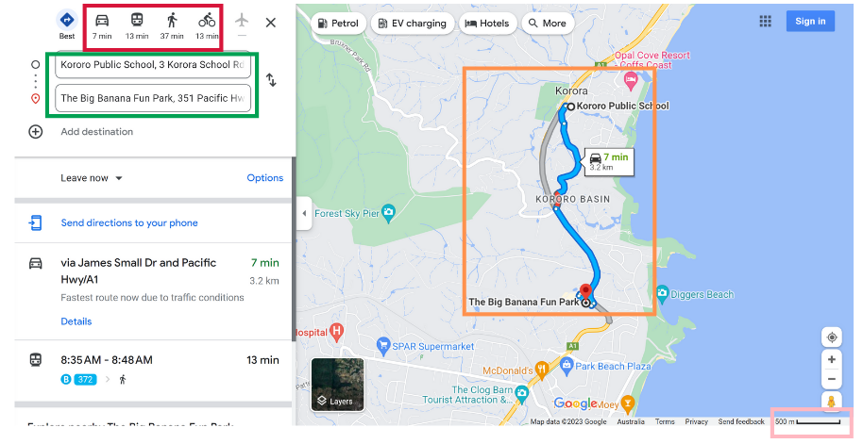
Map data ©2023 Google
- Show students the ‘Directions’ field (green rectangle) that accepts a start and finish location.
- Students enter locations such as the school’s location, familiar towns, landmarks or tourist attractions.
- Once a start and finish location are entered, explain to students the different modes of transport and their times (red rectangle), the suggested route and alternative routes (orange rectangle). Help students identify the times attached to each route.
- Ask students to click on the modes of transport to explore how the travel times change.
- Draw attention to the scale (pink rectangle) when the user zooms in and out with the plus and minus buttons.
- Provide Resource 28: Using Google Maps and ask Stage 3 students to use Google Maps to investigate and record the distances and duration of time to travel from their school to the specified locations.
- The final row in the Resource 28: Using Google Maps has been left blank. Student should select a significant landmark in Australia, then record the distance and duration of time it would take to travel to the landmark from school.
Note: complete the activity on the interactive whiteboard if there are not enough devices to complete the activity in pairs or small groups.
- Ask students:
- What information do you need to enter into Google Maps to find the distance from school to The Big Banana?
- Where will you see the distance from school to The Big Banana in kilometres?
- How would you convert this measurement to metres?
- How will you identify the duration of time it would take to drive to The Big Banana in a car?
- How would you identify the duration of time it would take to walk to The Big Banana?
This table details opportunities for differentiation.
Too hard? | Too easy?
Students cannot use Google Maps to solve problems.  - Provide students with the information completed for The Big Banana to reference while completing the other locations. | Students can use Google Maps to solve problems.  - Challenge students to arrange their locations in ascending order based on their distances.  - Challenge students to find the total distance and duration from school to the provided locations and back again.

Consolidation and meaningful practice – 15 minutes
- Regroup as a class and ask Stage 3 students:
- Was Google Maps an effective tool for this activity? Why or why not?
- What distances and durations did you record for each location?
- Provide pairs of Stage 2 students with a whiteboard marker and Resource 29: Time race, which has been placed inside a plastic sleeve.
- Explain to Stage 2 students that you will call out a 12-hour time. Students will then race to write the stated time in analog and digital representations. Once all components are completed, students place their hands on their heads.
- Ask Stage 3 students to use Google Maps to find the distance and time between 2 locations. Explain to Stage 3 students that you will call out one location. Students then race to find the distance between the location and their school.
- The first student in each stage with their hands on their head and correct answers is the winner of the round.
- Alternate between stages and repeat the game with different times for Stage 2 and locations for Stage 3.
This table details opportunities for assessment.
Assessment opportunities | Links
What to look for:  - Can Stage 2 students relate the terms midday or noon and midnight to am and pm? [MAO-WM-01, MA2-NSM-02]  - Can Stage 2 students relate analog notation to digital notation for time? [MAO-WM-01, MA2-NSM-02]  - Can Stage 2 students represent time on analog and digital clocks? [MAO-WM-01, MA2-NSM-02]  - Can Stage 3 students use Google Maps to measure distances? [MAO-WM-01, MA3-GM-02]  - Can Stage 3 students correctly record distances and durations? [MAO-WM-01, MA3-NSM-02, MA3-GM-02]  - Can Stage 3 students convert between metres and kilometres? [MAO-WM-01, MA3-GM-02] | Links to National Numeracy Learning Progressions (NNLP):  - Stage 2 – MeT3, MeT4  - Stage 3 – UuM8, MeT5, PrT4.

Resource 1: Measurement tools
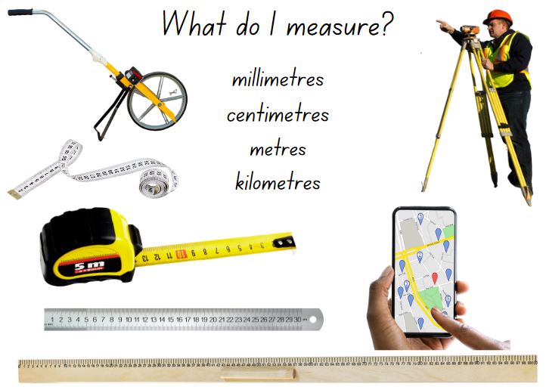

Resource 2: Distance word problems
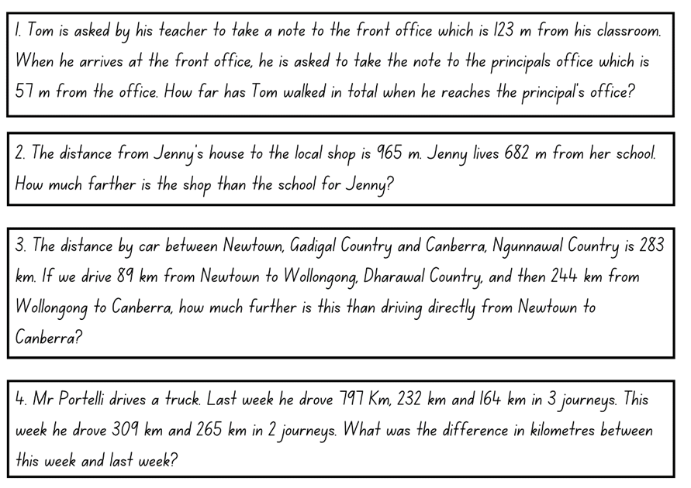

Resource 3: Place value chart
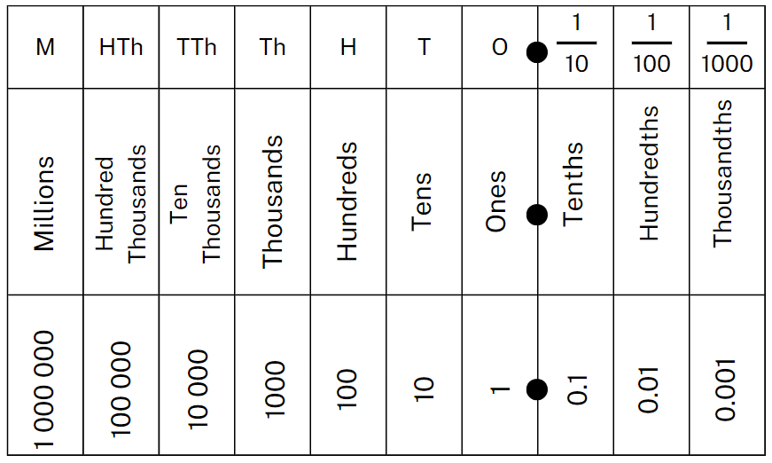

Resource 4: Converting sheet
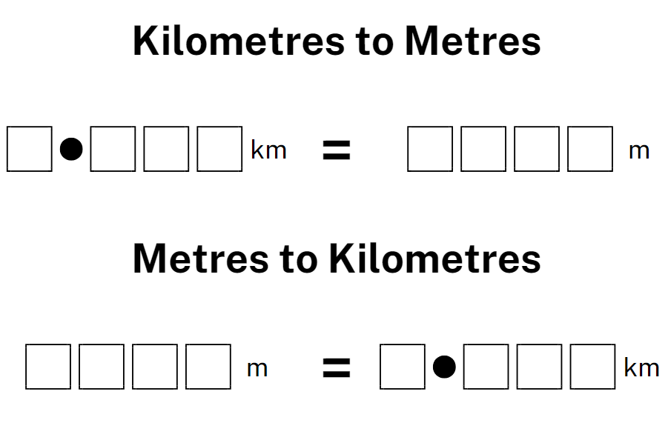

Resource 5: Travel plans
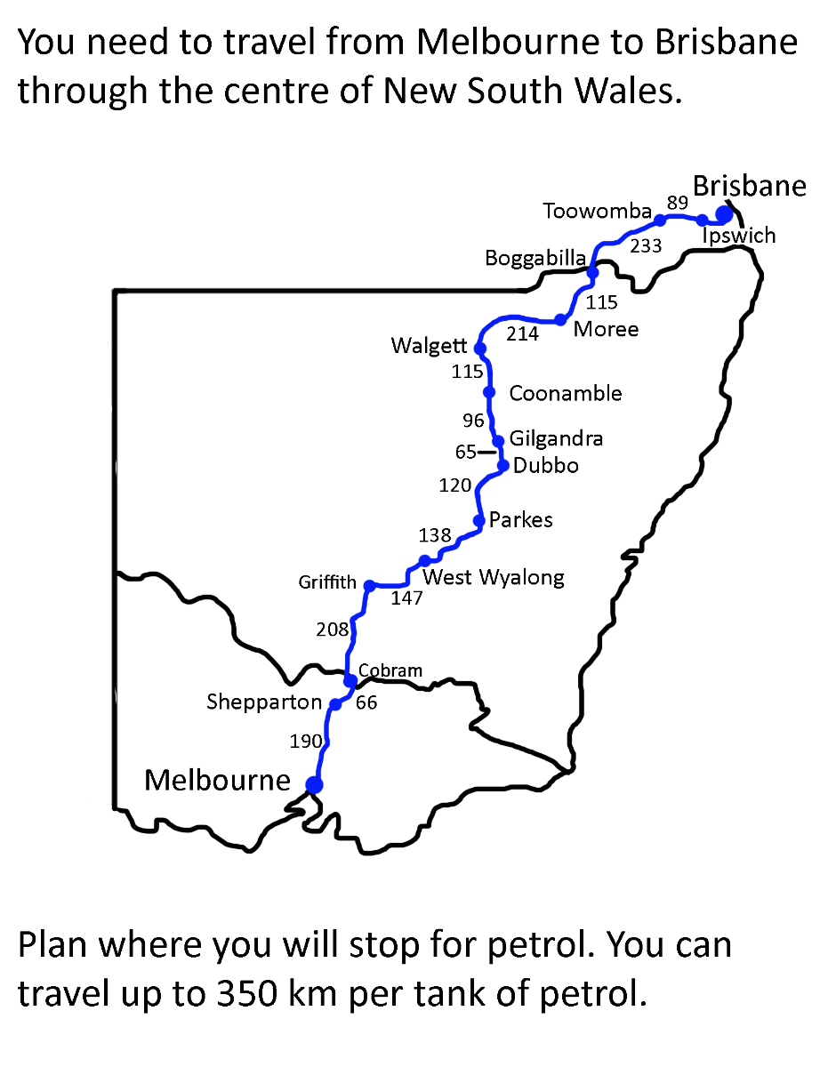

Resource 6: Full conversion chart
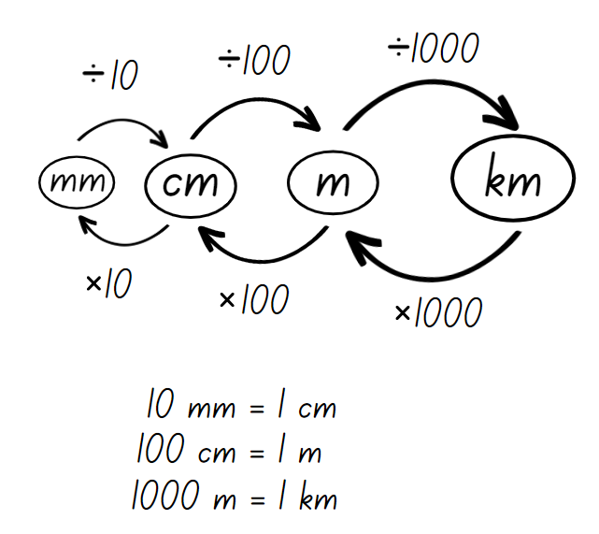

Resource 7: Measuring and converting
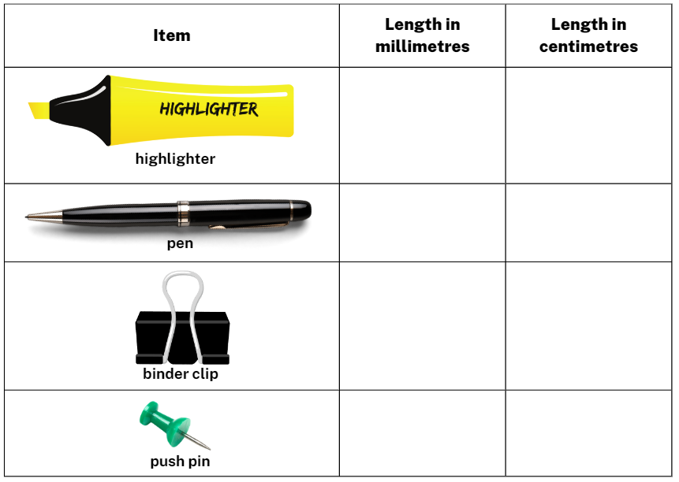

Resource 8: Number slider
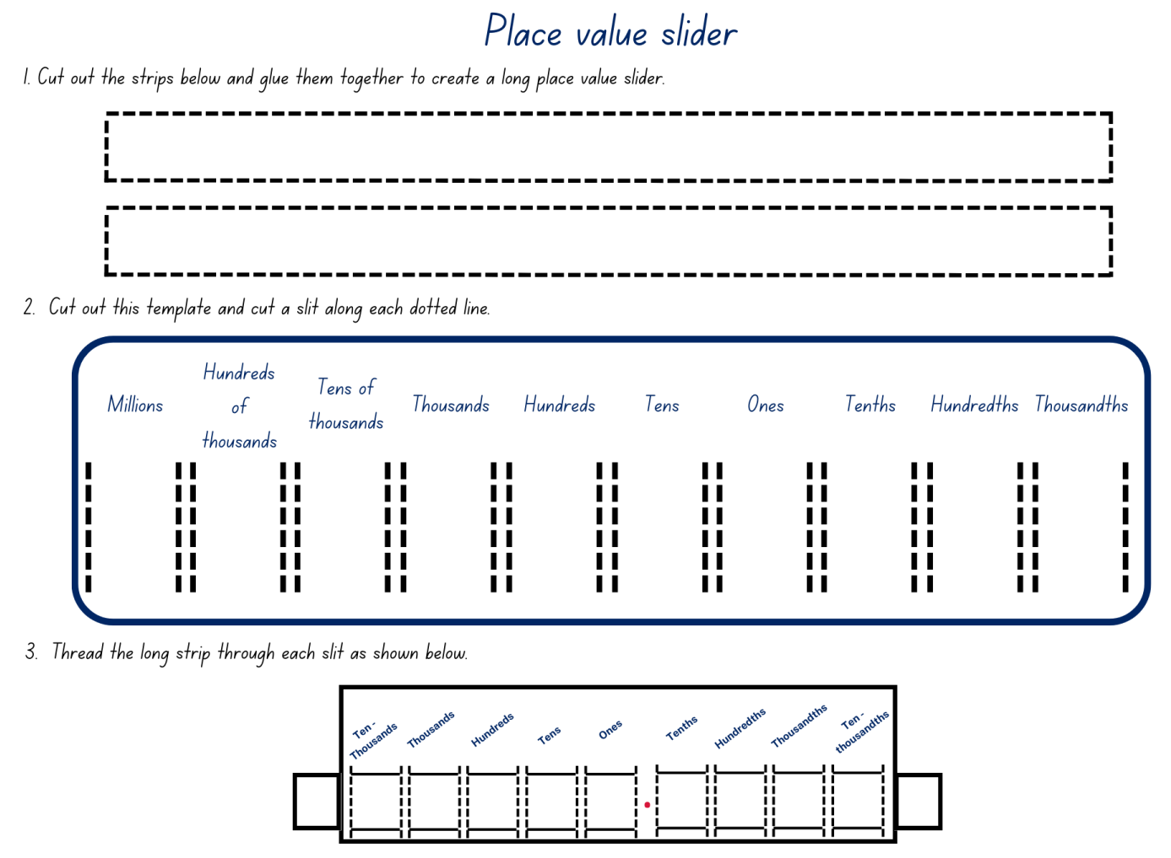

Resource 9: Converting lengths table
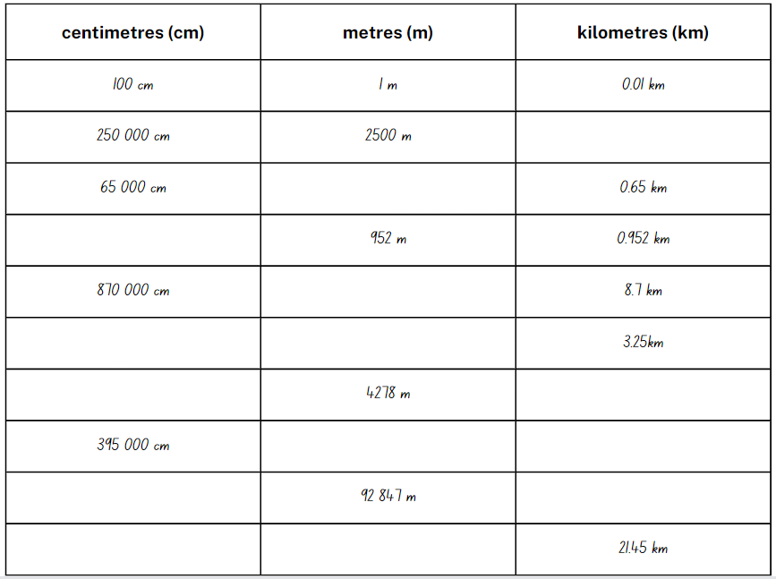

Resource 10: Conversion bingo
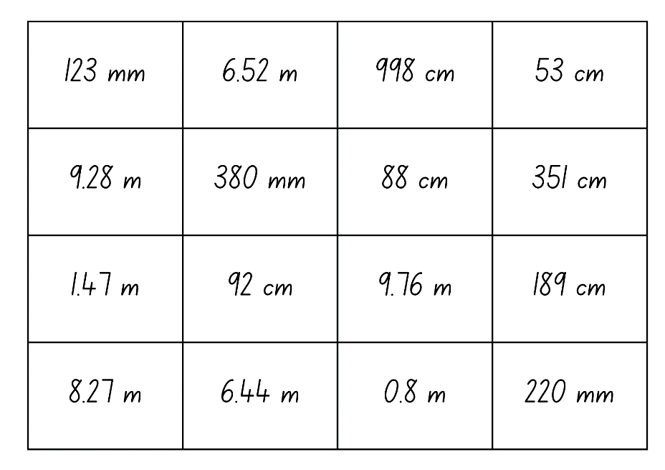

Resource 11: Teacher cards
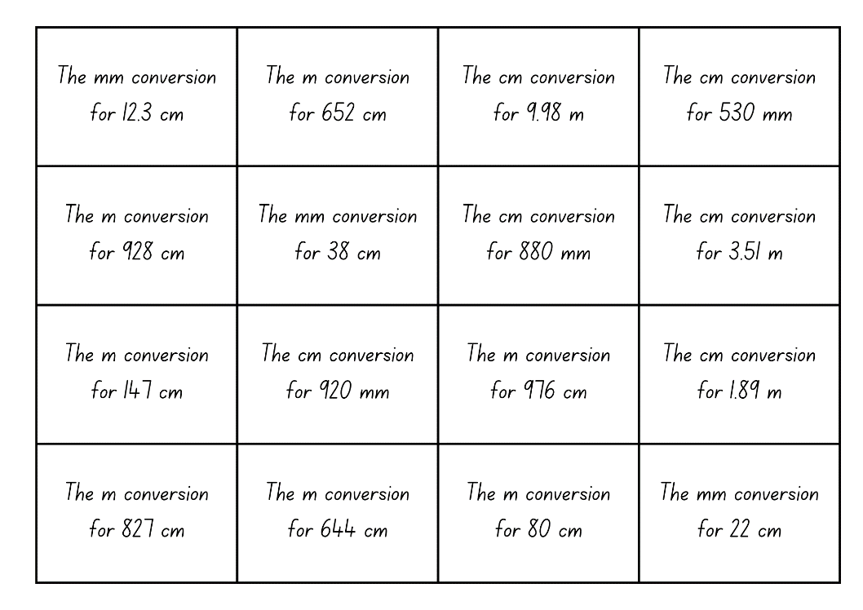

Resource 12: Length can measure
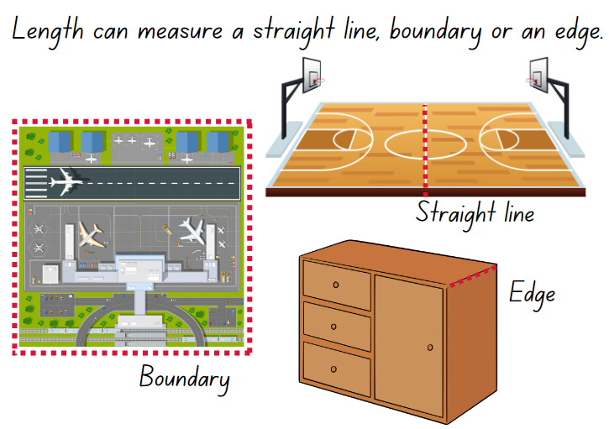

Resource 13: Measurement hunt
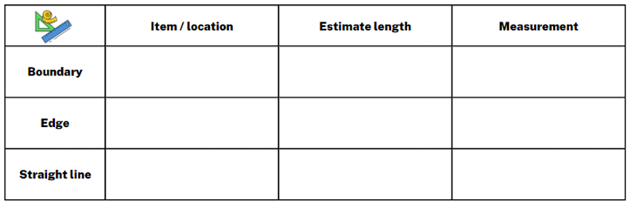

Resource 14: Recording lengths
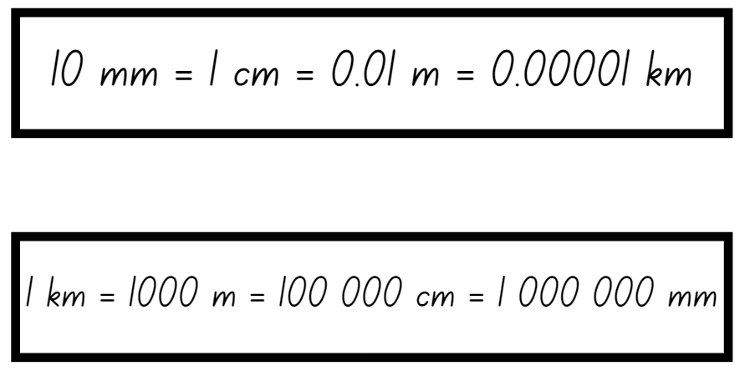

Resource 15: Boundary and perimeter
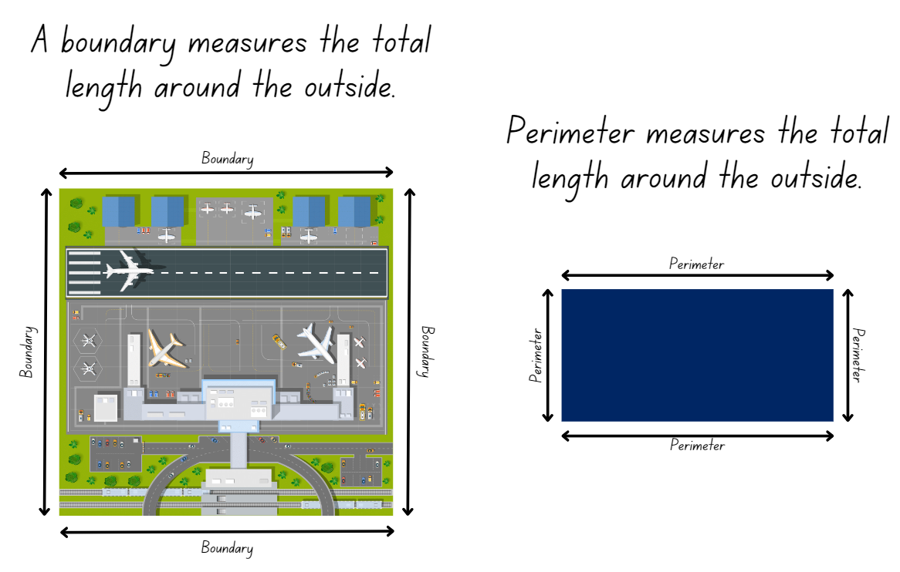

Resource 16: Perimeters
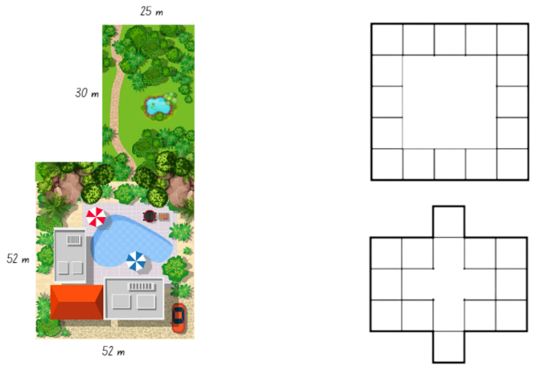

Resource 17: Measuring perimeters
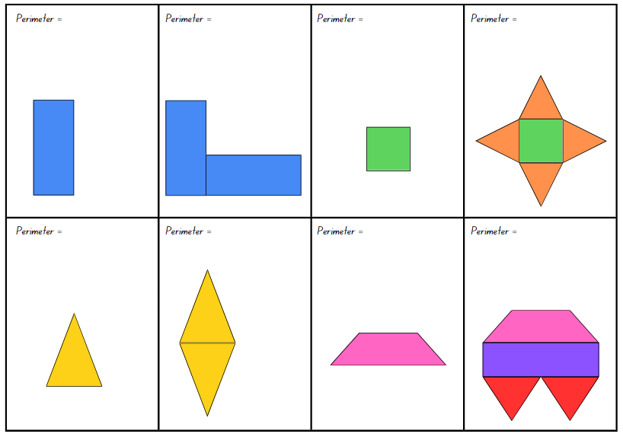

Resource 18: Duration cards
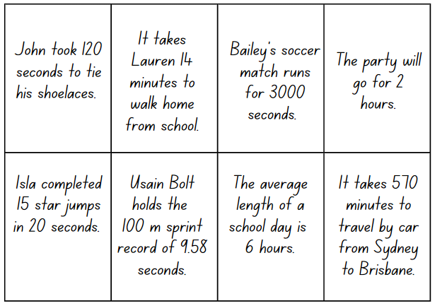

Resource 19: 24-hour time
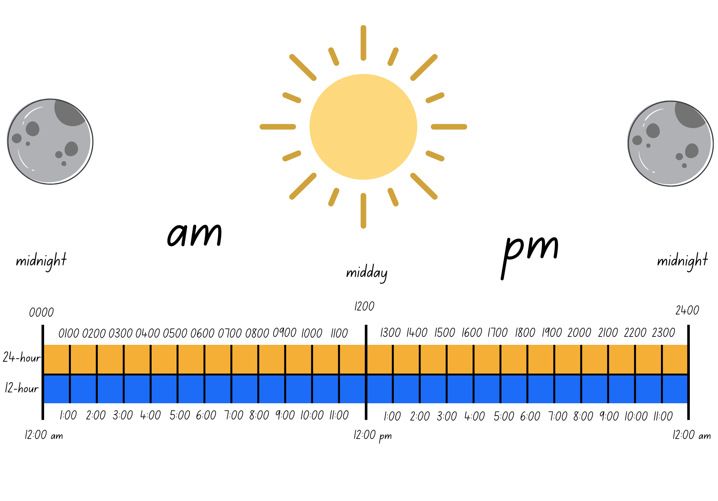

Resource 20: School timetable
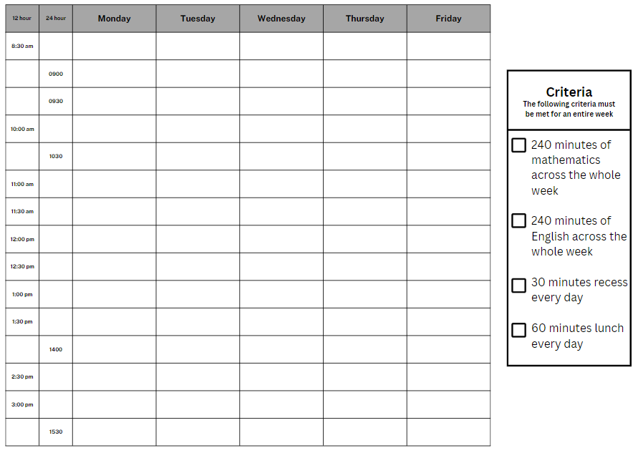

Resource 21: Ordering gameboard
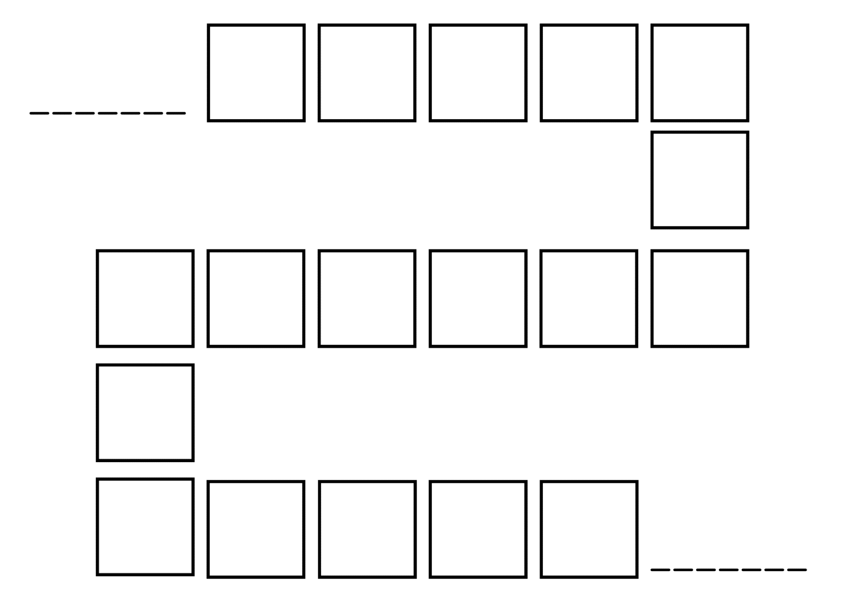

Resource 22: Time matching cards
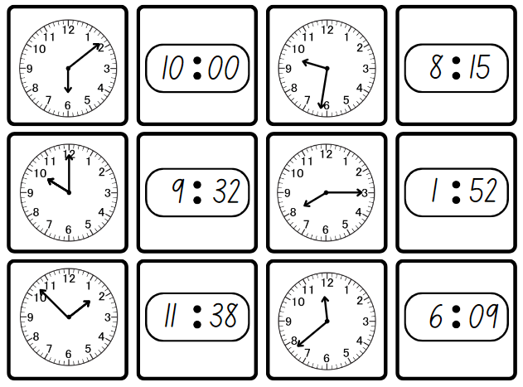
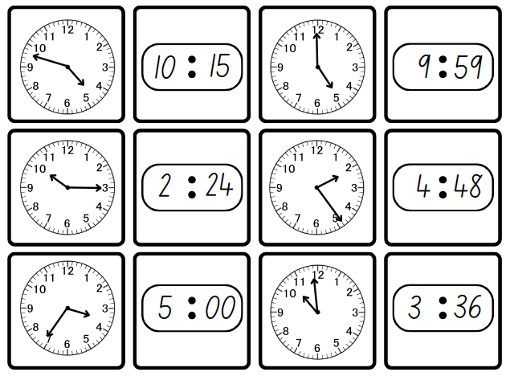

Resource 23: The ZOOM strategy
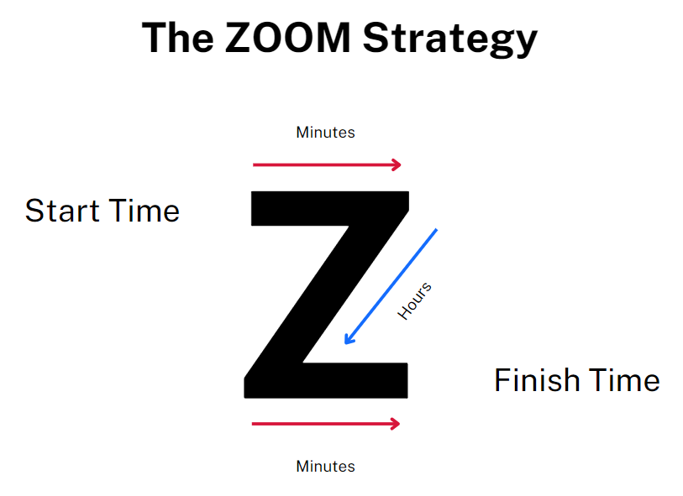

Resource 24: Everyday digital clocks
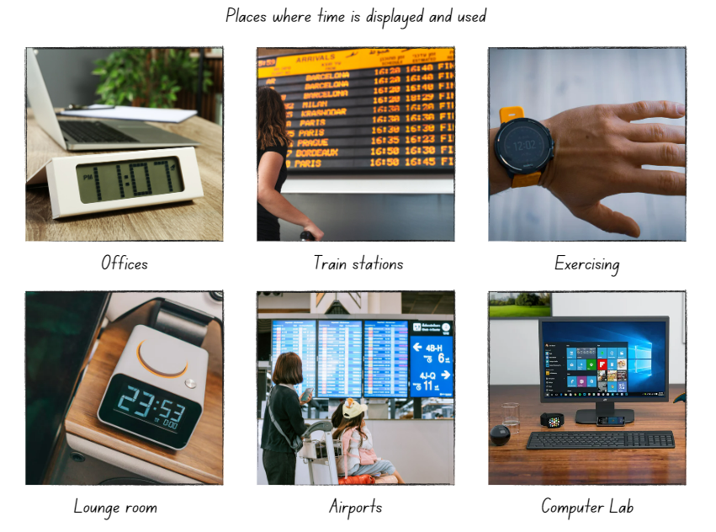

Resource 25: Elapsed timecards
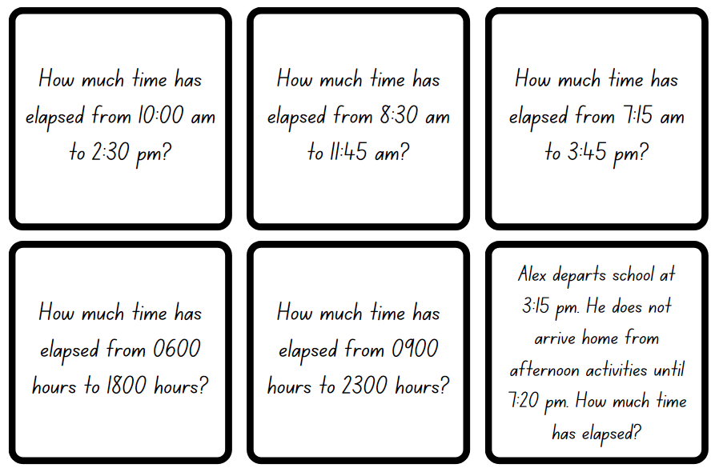

Resource 26: Midday and midnight
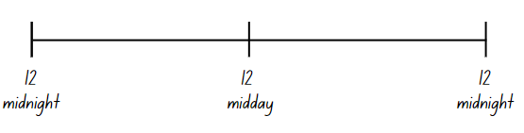

Resource 27: Time representation
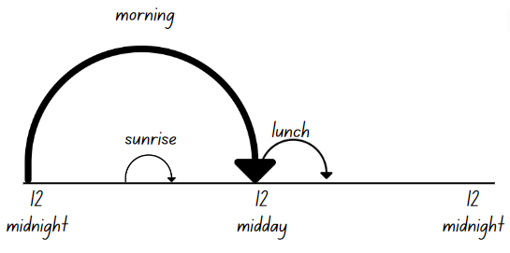

Resource 28: Using Google Maps
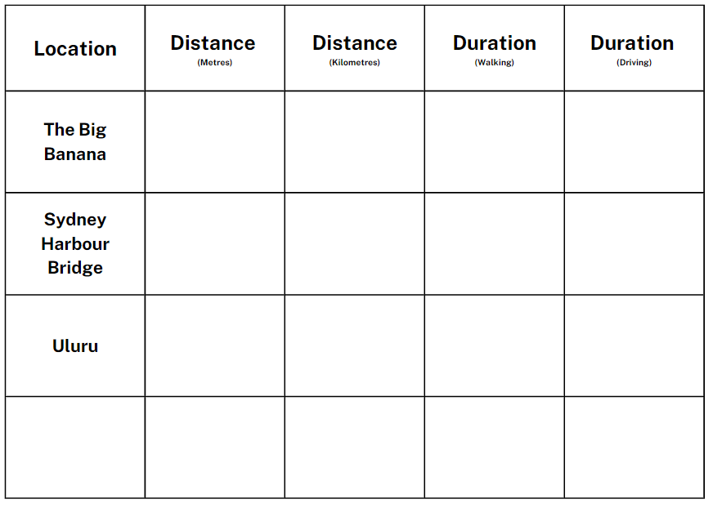

Resource 29: Time race
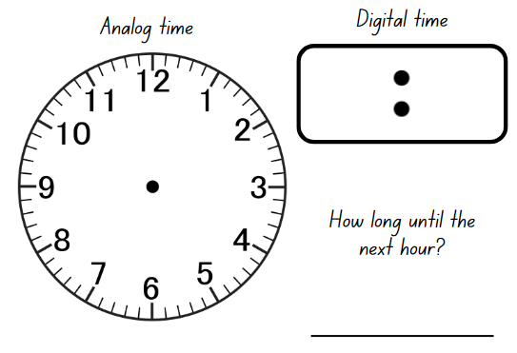

Syllabus outcomes and content

Stage 2
The table below outlines the syllabus outcomes and range of relevant syllabus content covered in this unit. Content is linked to National Numeracy Learning Progression version (3).
Outcomes and content | 1 | 2 | 3 | 4 | 5 | 6 | 7 | 8
Representing numbers using place value B: Whole numbers: Order numbers in the thousands
MAO-WM-01, MA2-RN-01
- Arrange numbers in the thousands in ascending and descending order |  |  |  |  | x | x | x
- Recognise and describe how rearranging digits changes the size of a number (Reasons about relations) |  |  |  |  |  |  | x
Additive relations A: Select strategies flexibly to solve addition and subtraction problems of up to 3 digits
MAO-WM-01, MA2-AR-01
- Apply known mental strategies that use partitioning to add and subtract, such as bridging the decades | x
- Use the compensation strategy to add and subtract (Reasons about relations) | x
- Apply the levelling and constant difference strategies (Reasons about relations) | x
- Represent solutions to addition and subtraction problems, including word problems, using an empty number line or bar model |  | x | x
Geometric measure A: Length: Measure and compare objects using metres, centimetres and millimetres
MAO-WM-01, MA2-GM-02
- Measure and record lengths and distances using a combination of metres and centimetres | x | x |  | x | x
- Estimate lengths and distances using known lengths as benchmarks, in metres and centimetres and check by measuring |  |  |  | x
- Compare and order lengths and distances using metres and centimetres |  | x
- Recognise the need for a formal unit smaller than the centimetre to measure length |  |  | x
- Identify that there are 10 millimetres in one centimetre |  |  | x
- Use the millimetre as a unit to measure lengths with a ruler |  |  | x
- Record lengths using the abbreviation for millimetres (mm) |  |  | x
Geometric measure B: Length: Use scaled instruments to measure and compare lengths
MAO-WM-01, MA2-GM-02
- Select and use an appropriate scaled instrument to measure lengths and distances | x | x | x | x | x
- Select and use an appropriate unit to estimate, measure and compare lengths and distances | x | x | x | x | x
- Recognise the features of a three-dimensional object associated with length that can be measured |  |  |  | x
- Use the term perimeter to describe the distance around the boundary |  |  |  |  | x
- Estimate and measure the perimeters of quadrilaterals |  |  |  |  | x
- Convert between metres and centimetres, and between centimetres and millimetres |  | x | x | x
- Record lengths and distances using decimal notation to 2 decimal places |  | x | x | x
Two-dimensional spatial structure B: 2D shapes: Create two-dimensional shapes that result from combining and splitting common shapes
MAO-WM-01, MA2-2DS-01
- Combine common two-dimensional shapes, including quadrilaterals, to form other common shapes or designs |  |  |  |  | x
Non-spatial measure B: Time: Represent and interpret digital time displays
MAO-WM-01, MA2-NSM-02
- Identify situations where duration is measured in seconds |  |  |  |  |  | x
- Read or set the time on digital devices to the minute or second, recognising there are 60 seconds in one minute |  |  |  |  |  | x | x | x
- Recognise that the hour is read first in a digital display |  |  |  |  |  |  | x
- Determine the time remaining until the next hour on a digital clock |  |  |  |  |  | x | x | x
Non-spatial measure B: Time: Use am and pm notation
MAO-WM-01, MA2-NSM-02
- Record times using the colon notation with am and pm to distinguish between morning and evening |  |  |  |  |  |  |  | x
- Relate the terms midday or noon and midnight to am and pm |  |  |  |  |  |  |  | x
- Relate analog notation to digital notation for time |  |  |  |  |  |  | x | x

Stage 3
The table below outlines the syllabus outcomes and range of relevant syllabus content covered in this unit. Content is linked to National Numeracy Learning Progression version (3).
Outcomes and content | 1 | 2 | 3 | 4 | 5 | 6 | 7 | 8
Represents numbers A: Whole numbers: Recognise, represent and order numbers in the millions
MAO-WM-01, MA3-RN-01
- Name millions using the place value grouping of ones, tens and hundreds |  |  |  |  | x | x | x
- Arrange numbers in the millions in ascending and descending order using place value |  |  |  |  | x | x | x
Additive relations B: Choose and use efficient strategies to solve addition and subtraction problems
MAO-WM-01, MA3-AR-01
- Solve multistep word problems, including problems that require more than one operation | x | x | x
- Compare, evaluate and communicate strategies used to solve addition and subtraction problems |  | x | x
Geometric measure A: Length: Use metres and kilometres for length and distances
MAO-WM-01, MA3-GM-02
- Recognise the need for a formal unit longer than the metre for measuring distance |  | x | x |  |  |  |  | x
- Estimate lengths and distances using an appropriate unit | x |  |  | x
- Record distances using the abbreviation for kilometres (km) |  | x | x |  |  |  |  | x
- Use a variety of measuring devices to measure lengths and distances in different contexts | x |  |  | x |  |  |  | x
Geometric measure A: Length: Measure lengths to find perimeters
MAO-WM-01, MA3-GM-02
- Use efficient strategies to calculate the perimeter of a large rectangular area in metres | x |  |  | x | x
- Calculate perimeters of common two-dimensional shapes, including squares, rectangles and triangles | x |  |  |  | x
- Determine which side lengths are needed to find the perimeter of a shape (Reasons about relations) |  |  |  |  | x
- Recognise that rectangles with the same perimeter may have different dimensions (Spatial reasoning) |  |  |  |  | x
Geometric measure B: Length: Connect decimal representations to the metric system
MAO-WM-01, MA3-GM-02
- Recognise the equivalence of whole-number and decimal representations of measurements of length |  | x | x | x
- Interpret decimal notation for lengths and distances |  | x | x |  |  |  |  | x
- Record lengths and distances using decimal notation |  | x | x | x |  |  |  | x
Geometric measure B: Length: Convert between common metric units of length
MAO-WM-01, MA3-GM-02
- Use decimal place value system to convert between metres and kilometres |  | x | x | x |  |  |  | x
- Convert measurements to the same unit to compare lengths and distances |  |  | x |  |  |  |  | x
- Explain and use the relationship between the size of a unit and the number of units needed |  |  |  | x |  |  |  | x
Geometric measure B: Length: Solve problems involving the comparison of lengths using appropriate units
MAO-WM-01, MA3-GM-02
- Investigate and compare perimeters of rectangles with the same area |  |  |  |  | x
- Solve a variety of problems involving length and perimeter, including problems involving different units of length |  |  |  |  | x
Two-dimensional spatial structure A: 2D shapes: Classify two-dimensional shapes and describe their properties
MAO-WM-01, MA3-2DS-01
- Identify and classify triangles as equilateral, isosceles or scalene triangles |  |  |  |  | x
- Recognise that triangles and quadrilaterals can be classified in more than one way (Reasons about spatial relations) |  |  |  |  | x
- Identify regular and irregular polygons |  |  |  |  | x
Two-dimensional spatial structure B: 2D shapes: Dissect two-dimensional shapes and rearrange them using translations, reflections and rotations
MAO-WM-01, MA3-2DS-01
- Recognise that translations, reflections or rotations change the position and orientation but not the size of shapes (Reasons about spatial orientation) |  |  |  |  | x
Non-spatial measure A: Time: Compare 12- and 24-hour time systems and convert between them
MAO-WM-01, MA3-NSM-02
- Recognise that 24-hour time is used to avoid confusion between am and pm |  |  |  |  |  | x | x
- Read time using appropriate 24-hour time language |  |  |  |  |  | x | x
- Convert between 24-hour time and 12-hour time using am or pm notation |  |  |  |  |  | x
- Read, interpret and use timetables from real-life situations, involving 12- and 24-hour time |  |  |  |  |  | x
Non-spatial measure B: Time: Solve problems involving duration, using 12- and 24-hour time
MAO-WM-01, MA3-NSM-02
- Use start and finish times to calculate the elapsed time of events |  |  |  |  |  | x | x | x
- Add and subtract time mentally using bridging strategies |  |  |  |  |  |  | x
- Round answers to time calculations to the nearest minute or hour |  |  |  |  |  |  | x
- Solve a variety of problems involving duration, including where times are expressed in 12-hour and 24-hour notation |  |  |  |  |  |  | x
Mathematics K–10 Syllabus © NSW Education Standards Authority (NESA) for and on behalf of the Crown in right of the State of New South Wales, 2022.

References
This resource contains NSW Curriculum and syllabus content. The NSW Curriculum is developed by the NSW Education Standards Authority. This content is prepared by NESA for and on behalf of the Crown in right of the State of New South Wales. The material is protected by Crown copyright.
Please refer to the NESA Copyright Disclaimer for more information https://educationstandards.nsw.edu.au/wps/portal/nesa/mini-footer/copyright.
NESA holds the only official and up-to-date versions of the NSW Curriculum and syllabus documents. Please visit the NSW Education Standards Authority (NESA) website https://educationstandards.nsw.edu.au/ and the NSW Curriculum website https://curriculum.nsw.edu.au/home.
Mathematics K–10 Syllabus © NSW Education Standards Authority (NESA) for and on behalf of the Crown in right of the State of New South Wales, 2022.
National Numeracy Learning Progression © Australian Curriculum, Assessment and Reporting Authority (ACARA) 2010 to present, unless otherwise indicated. This material was downloaded from the Australian Curriculum website (National Literacy Learning Progression) (accessed 30 August 2023) and was not modified.
Downton A, Knight R, Clarke D, Lewis G (2015) Mathematics Assessment for Learning: Rich Tasks & Work Samples, 3rd edn, Downton, Clark and Knight.
Google Maps (n.d.) Koror Public School to The Big Banana [Google Maps], accessed 9 August 2023.
Sullivan P (2018) Challenging Mathematical tasks: Unlocking the potential of all students, Oxford University Press Australia and New Zealand.
University of Cambridge (Faculty of Mathematics) (2022) Reach 100, NRICH website, accessed 15 August 2023.

© State of New South Wales (Department of Education), 2023
The copyright material published in this resource is subject to the Copyright Act 1968 (Cth) and is owned by the NSW Department of Education or, where indicated, by a party other than the NSW Department of Education (third-party material).
Copyright material available in this resource and owned by the NSW Department of Education is licensed under a Creative Commons Attribution 4.0 International (CC BY 4.0) license.
This license allows you to share and adapt the material for any purpose, even commercially.
Attribution should be given to © State of New South Wales (Department of Education), 2023.
Material in this resource not available under a Creative Commons license:
- the NSW Department of Education logo, other logos and trademark-protected material
- material owned by a third party that has been reproduced with permission. You will need to obtain permission from the third party to reuse its material.
Links to third-party material and websites
Please note that the provided (reading/viewing material/list/links/texts) are a suggestion only and implies no endorsement, by the New South Wales Department of Education, of any author, publisher, or book title. School principals and teachers are best placed to assess the suitability of resources that would complement the curriculum and reflect the needs and interests of their students.
If you use the links provided in this document to access a third-party's website, you acknowledge that the terms of use, including licence terms set out on the third-party's website apply to the use which may be made of the materials on that third-party website or where permitted by the Copyright Act 1968 (Cth). The department accepts no responsibility for content on third-party websites.

