Mathematics – K-2 multi-age – Year B – Unit 20
Contents
Unit description and duration 5
Student prior learning 5
Lesson overview and resources 6
Lesson 1: Calendar calculations 16
Daily number sense: Place value game – 10 minutes 16
Calendar investigations – 40 minutes 18
Consolidation and meaningful practice – 10 minutes 20
Lesson 2: Duration and time 22
Daily number sense: Busting numbers – 10 minutes 22
How long will it take? – 30 minutes 23
Consolidation and meaningful practice – 20 minutes 26
Lesson 3: Subtraction 29
Daily number sense: Flexibly renaming – 10 minutes 29
Race to zero – 30 minutes 30
Consolidation and meaningful practice: Tug of war – 20 minutes 34
Lesson 4: Multiplication bingo 36
Daily number sense: 10 minutes 36
Rolling groups bingo – 30 minutes 37
Word problems – 20 minutes 39
Lesson 5: Division 41
Daily number sense: Maths tipping – 15 minutes 41
Sharing counters – 25 minutes 42
Division word problems – 20 minutes 45
Lesson 6: Let’s celebrate 48
Daily number sense: Find the next multiple of 10 – 10 minutes 48
Party investigation: Part 1 – 40 Minutes 51
Discuss and connect the mathematics – 10 minutes 54
Lesson 7: Celebrate! 57
Daily number sense: From here to there – 15 minutes 58
Party investigation: Part 2 – 35 minutes 59
Discuss and connect the mathematics – 10 minutes 61
Lesson 8: Final countdown 64
Daily number sense: 10 minutes 65
Party time (Early Stage 1) – 50 minutes 65
Part-whole triangles 65
10 or bust 67
Party time (Stage 1) – 50 minutes 67
Battleships 67
Five steps to 100 or 500 69
Resource 1: Early Stage 1 place value gameboard 71
Resource 2: Stage 1 place value gameboard 72
Resource 3: I wonder... 73
Resource 4: Child brushing their teeth 74
Resource 5: Images of events 75
Resource 6: Before and after 76
Resource 7: Calendar 77
Resource 8: Calendar problems 79
Resource 9: Comparing events 81
Resource 10: Time memory game 82
Resource 11: How long does it take? 85
Resource 12: Matching memory 86
Resource 13: Race from 30 88
Resource 14: Race from 200 89
Resource 15: 200 number chart 90
Resource 16: 30 number chart 91
Resource 17: Number chart 92
Resource 18: Bingo gameboard 93
Resource 19: Game cards 95
Resource 20: Multiplication problems 96
Resource 21: Sharing worksheets 97
Resource 22: Number cards 99
Resource 23: Recording sheet 100
Resource 24: Division problems 101
Resource 25: Decorations catalogue 102
Resource 26: Costing worksheet 103
Resource 27: Placemat catalogue 104
Resource 28: Party food catalogue 105
Resource 29: Party food recording 106
Resource 30: Lolly bag catalogue 107
Resource 31: Lolly bag recording 108
Resource 32: Ten-frame 109
Resource 33: Battleship gameboards 110
Resource 34: Number line Zero to 100 115
Resource 35: Number line Zero to 500 116
Resource 36: Number cards 117
Syllabus outcomes and content 118
References 128

Unit description and duration
This two-week unit develops student knowledge, understanding and skills to solve mathematical problems using critical and strategic thinking. Students are provided opportunities to:
- sequence events using a range of methods
- solve time and duration problems using calendars and clocks
- solve and record addition and subtraction problems using objects, diagrams and images
- record answers to multiplication and division problems (including those with remainders) using drawings, words and numerals.
Mathematics K–10 Syllabus © 2022 NSW Education Standards Authority (NESA) for and on behalf of the Crown in right of the State of New South Wales.

Student prior learning
Before engaging in these teaching and learning activities, students would benefit from prior experience with:
- using the language of time to describe the duration and sequence of events
- opportunities to use a calendar including days of the week and the months of the year
- applying efficient strategies to solve addition and subtraction problems
- opportunities to solve multiplication and division problems.

Lesson overview and resources
The table below outlines the sequence and approximate timing of lessons; syllabus focus areas and content groups; and resources.
Lesson | Syllabus focus area and content groups | Resources
Lesson 1: Calendar calculations  60 minutes  The duration of 2 events can be measured and compared. A calendar is a system of organising and measuring time. | Representing whole numbers  Early Stage 1  - Use the counting sequence of ones flexibly  - Connect counting and numerals to quantities  Stage 1 – Part B  - Form, regroup, and rename three-digit numbers  Non-spatial measure  Early Stage 1  - Time: Compare and order the duration of events using the language of time  Stage 1 – Part B  - Time: Describe duration using units of time | - Resource 1: Early Stage 1 place value gameboard  - Resource 2: Stage 1 place value gameboard  - Resource 3: I wonder...  - Resource 4: Child brushing their teeth  - Resource 5: Images of events  - Resource 6: Before and after  - Resource 7: Calendar  - Resource 8: Calendar problems  - Resource 9: Comparing events  - 9-sided dice  - 20-sided dice  - Writing materials
Lesson 2: Duration and time  60 minutes  Duration is how long something lasts or a particular time interval, for example an hour. | Representing whole numbers  Early Stage 1  - Connect counting and numerals to quantities  Stage 1 – Part B  - Form, regroup, and rename three-digit numbers  Non-spatial measure  Early Stage 1  - Time: Compare and order the duration of events using the language of time  - Time: Tell time on the hour on analog and digital clocks  Stage 1 – Part B  - Time: Describe duration using units of time | - Resource 10: Time memory game  - Resource 11: How long does it take?  - Resource 12: Matching memory  - Class set of analog and digital clocks  - Elastic bands  - Large collection of craft sticks or interlocking cubes  - Writing materials
Lesson 3: Subtraction  60 minutes  A collection can be changed by taking some away. | Representing whole numbers  Early Stage 1  - Connect counting and numerals to quantities  Stage 1 – Part B  - Form, regroup, and rename three-digit numbers  Combining and separating quantities  Early Stage 1  - Model additive relations and compare quantities  - Identify part–whole relationships in numbers up to 10  Stage 1 – Part A  - Use advanced count-by-one strategies to solve addition and subtraction problems  - Use flexible strategies to solve addition and subtraction problems  Stage 1 – Part B  - Represent and reason about additive relations  - Form multiples of ten when adding and subtracting two-digit numbers  - Use knowledge of equality to solve related problems | - Resource 13: Race from 30  - Resource 14: Race from 200  - Resource 15: 200 number chart  - Resource 16: 30 number chart  - Resource 17: Number chart  - 6-sided dice  - 9-sided dice  - Counters  - Interlocking blocks  - Large collection of MAB blocks  - Writing materials
Lesson 4: Multiplication bingo  60 minutes  Multiplying numbers in any order results in the same answer. | Forming groups  Early Stage 1  - Investigate and form equal groups by sharing  - Record grouping and sharing  Stage 1 – Part A  - Model and use equal groups of objects to represent multiplication  Stage 1 – Part B  - Represent and explain multiplication as the combining of equal groups  - Represent multiplication and division problems | - Resource 18: Bingo gameboard  - Resource 19: Game cards  - Resource 20: Multiplication problems  - 6-sided dice  - Counters  - Writing materials
Lesson 5: Division  60 minutes  A collection can be partitioned into equal or unequal parts. | Representing whole numbers  Early Stage 1  - Use the counting sequence of ones flexibility  - Connect counting and numerals to quantities  Stage 1 – Part B  - Use counting sequences of ones and tens flexibly  Forming groups  Early Stage 1  - Investigate and form equal groups by sharing  - Record grouping and sharing  Stage 1 – Part A  - Recognise and represent division  Forming groups B  - Represent multiplication and division problems | - Resource 21: Sharing worksheets  - Resource 22: Number cards  - Resource 23: Recording sheet  - Resource 24: Division problems  - One Hundred Hungry Ants by Elinor J Pinczes  - 6-sided die  - Counters  - Writing materials
Lesson 6: Let’s celebrate  60 minutes  Mathematicians use a range of representations to communicate ideas. | Representing whole numbers  Early Stage 1  - Use the counting sequence of ones flexibly  - Connect counting and numerals to quantities  Stage 1 – Part B  - Use counting sequences of ones and tens flexibly  Combining and separating quantities  Early Stage 1  - Model additive relations and compare quantities  - Identify part–whole relationships in numbers up to 10  Stage 1 – Part A  - Use flexible strategies to solve addition and subtraction problems  Forming groups  Early Stage 1  - Record grouping and sharing  Stage 1 – Part A  - Model and use equal groups of objects to represent multiplication  - Recognise and represent division  Forming groups  Stage 1 – Part B  - Represent and explain multiplication as the combining of equal groups  - Represent multiplication and division problems  Non-spatial measure  Early Stage 1  - Time: Tell time on the hour on analog and digital clocks  Stage 1 – Part B  - Time: Describe duration using units of time | - Resource 25: Decorations catalogue  - Resources 26: Costing worksheet  - Resource 27: Placemat catalogue  - Craft materials  - 9-sided dice  - 20-sided dice  - A3 paper  - Individual whiteboards  - Writing materials
Lesson 7: Celebrate!  60 minutes  Mathematicians use evidence to make mathematical arguments and justify their thinking. | Representing whole numbers  Early Stage 1  - Use the counting sequence of ones flexibly  - Connect counting and numerals to quantities  Stage 1 – Part A  - Use counting sequences of ones with two-digit numbers and beyond  Combining and separating quantities  Early Stage 1  - Model additive relations and compare quantities  - Identify part–whole relationships in numbers up to 10  Stage 1 – Part A  - Use flexible strategies to solve addition and subtraction problems  Forming groups  Early Stage 1  - Investigate and form equal groups by sharing  - Record grouping and sharing  Stage 1 – Part A  - Model and use equal groups of objects to represent multiplication  - Recognise and represent division  Stage 1 – Part B  - Represent and explain multiplication as the combining of equal groups  - Represent multiplication and division problems | - Resource 28: Party food catalogue  - Resource 29: Party food recording  - Resource 30: Lolly bag catalogue  - Resource 31: Lolly bag recording  - Individual whiteboards  - Interlocking cubes  - 9-sided dice  - 20-sided dice  - Writing materials
Lesson 8: Final countdown  60 minutes  Mathematicians reason and make conjectures when solving problems. | Representing whole numbers  Early Stage 1  - Use the counting sequence of ones flexibly  - Connect counting and numerals to quantities  Stage 1 – Part A  - Use counting sequences of ones with two-digit numbers and beyond  - Represent the structure of groups of ten in whole numbers  Combining and separating quantities  Early Stage 1  - Identify part-whole relationship in numbers up to 10  Stage 1 – Part A  - Use advanced count-by-one strategies to solve addition and subtraction problems  - Use flexible strategies to solve addition and subtraction problems  Stage 1 – Part B  - Represent and reason about additive relations  - Form multiples of ten when adding and subtracting two-digit numbers  - Use knowledge of equality to solve related problems  Geometric measure  Stage 1 – Part A  - Position: Follow directions to familiar locations | - Resource 32: Ten-frame  - Resource 33: Battleship gameboards  - Resource 34: Number line zero to 100  - Resource 35: Number line zero to 500  - Resource 36: Number cards  - 6-sided dice  - 9-sided dice  - Barrier  - Counters  - Deck of playing cards  - Individual whiteboards  - Writing materials

Lesson 1: Calendar calculations
Core concept: The duration of 2 events can be measured and compared. A calendar is a system of organising and measuring time.
The table below contains suggested learning intentions and success criteria. These are best co-constructed with students.
Learning intentions | Success criteria
Students working towards Early Stage 1 outcomes are learning that the duration of an event can be measured and compared using informal methods.  Students working towards Stage 1 outcomes are learning that calendars are an organised system to measure time. | Students working towards Early Stage 1 outcomes can:  - accurately sequence events in time  - use the language of time to compare the duration of 2 events.  Students working towards Stage 1 outcomes can:  - use a calendar to calculate the number of weeks or days until upcoming events  - solve problems related to the calendar.

Daily number sense: Place value game – 10 minutes
This activity has been adapted from Place value game (5:29) by Mathematics K-6 resources.
- Build student understanding of place value by forming and ordering one-, two- and three-digit numbers in sequence.
- Explain that the aim of the game is to position the numbers in sequence on the gameboard.
- Provide pairs of Early Stage 1 students with a 20-sided die and a copy of Resource 1: Early Stage 1 place value gameboard for each player. Provide Stage 1 students with three 9-sided dice and a copy of Resource 2: Stage 1 place value gameboard for each player.
- Early Stage 1 students roll the die and place the number in the correct sequence. See Figure 1. There is one square for each number in the sequence.
- Stage 1 students roll the dice and create a three-digit number. For example, a 6, 2 and a 9 could be recorded as 629, 692, 296, 269, 962 or 926. Players record their chosen number in the most appropriate position between 100 and 1000, see Figure 1.
Figure 1 – Place value gameboard
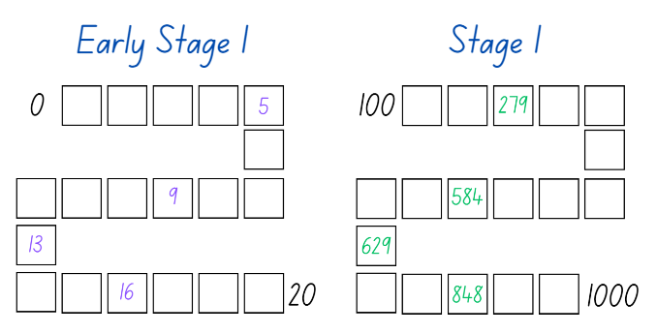
- If numbers cannot be placed, students miss their turn. Play continues until all boxes are filled.
Note: It is recommended to include dice that have zero as it is important that students understand the role of zero in the three-digit numbers created.

Calendar investigations – 40 minutes
This lesson has been adapted from Notice and Wonder by Numeracy Teachers Academy.
- Display Resource 3: I wonder... and ask students to look closely at the images. Students turn and talk about what they notice and then select a student to share and explain what they noticed.
- Students turn and talk again about any wonderings they have about the images. Choose students to share their wonderings.
- Ask students to think about which mathematical concepts the images are all related to.
Note: Through class discussion and questioning, students should be able to notice that all the images are related to time.
- Explain to Early Stage 1 students that they will be exploring the order of events, including before and after. Display Resource 4: Child brushing their teeth and ask the students to explain and justify what they could do before and then after brushing their teeth. Provide students with their workbook, Resource 5: Images of events and Resource 6: Before and after. Students complete independently.
Note: Students need to make careful consideration of the time of day when looking at the images.
- While Early Stage 1 students are working independently, display Resource 7: Calendar to Stage 1 students and discuss key features. For example, dates, months, weeks, holidays, seasons and cultural events.
- Provide students with Resource 8: Calendar problems and their workbook. Students glue Resource 8: Calendar problems into their book, then solve the problems and record their answers.
- Regroup as a class and select students to share their answers and explain the strategies they used.
This table details assessment opportunities and differentiation ideas.
Assessment opportunities | Too hard? | Too easy?
What to look for:  - Can students accurately sequence events in time? (MAO-WM-01, MAE-NSM-02)  - Can students use the language of time to compare the duration of 2 events? (MAO-WM-01, MAE-NSM-02)  - Can Stage 1 students use a calendar to calculate the number of weeks or days until upcoming events? (MAO-WM-01, MA1-NSM-02)  - Can Stage 1 students solve problems related to the calendar? (MAO-WM-01, MA1-NSM-02)  What to collect:  - observational data (MAO-WM-01, MA1-NSM-02)  - student work samples. (MAO-WM-01, MA1-NSM-02) | Students are unable to accurately sequence events in time.  - Provide students with an example of events sequenced in logical order, including the language associated with it. For example, first, next and then.  - Provide real life examples to help students see the importance of sequencing events in their daily lives. For example, cooking a meal or getting ready for school.  Students are unable to use a calendar to solve problems related to weeks or days.  - Support students to name and order days of the week on a blank calendar.  - Students identify events on a given week within the calendar and count the days between the events. | Students can accurately sequence events in time.  - Students estimate and compare an additional event against the 2 completed events.  - Challenge students to create narratives for their peers to order and justify their sequence.  Students can use a calendar to solve problems related to weeks or days.  - Challenge students to fill a blank calendar and create problems for their peers to solve.  - Students keep a diary and record upcoming events for December.

Consolidation and meaningful practice – 10 minutes
- Provide Early Stage 1 students with Resource 9: Comparing events. Early Stage 1 students compare the time it takes to complete 2 events. For example, comparing the time it takes to eat dinner with the time it takes to brush your teeth. Students record their responses on their worksheet.
- While Early Stage 1 students are comparing events, ask Stage 1 students to create a problem related to the calendar that has not been asked. Once students have created the problem, they swap with a peer, solve and record in their workbooks.
- Regroup and choose students to share their problems. Ask:
- What is the purpose of a calendar?
- How many days are in a week?
- How many months are in a year? Do you know all their names?
- What is your favourite month and why?
- Which takes longer, brushing your teeth or combing your hair? (Early Stage 1)
- Which takes longer, tying your shoes or putting on your socks? (Early Stage 1)
- Which takes longer, making your bed or putting away your toys? (Early Stage 1)
- Which takes longer, reading a short book or watching a TV show? (Early Stage 1)
- Which takes longer, taking a bath or taking a shower? (Early Stage 1)

Lesson 2: Duration and time
Core concept: Duration is how long something lasts or a particular time interval, for example, an hour.
The table below contains suggested learning intentions and success criteria. These are best co-constructed with students.
Learning intentions | Success criteria
Students working towards Early Stage 1 outcomes are learning that time can be represented and read to the hour on a digital or analog clock.  Students working towards Stage 1 outcomes are learning that duration is how long something lasts, measured in units of time. | Students working towards Early Stage 1 outcomes can:  - read analog and digital clocks  - accurately use language terms of time when describing an event.  Students working towards Stage 1 outcomes can:  - solve time problems involving hours and minutes  - explain various strategies to measure the duration of events using time.

Daily number sense: Busting numbers – 10 minutes
This activity has been adapted from Number busting – number talk (renaming 26) (2:00) by Mathematics K-6 resources.
- Build student understanding of counting and place value by partitioning and renaming two- and three-digit numbers.
- Have students sit in a circle and display 2 groups of 10 and 6 ones using craft sticks, interlocking cubes or other materials. Tell students you have 26 craft sticks. Students turn and talk to share ideas on how they can prove there are 26 sticks.
Note: Bundles of 10 can be made with craft sticks, interlocking cubes or straws or something similar that can be separated. In Early Stage 1 and Stage 1, it is preferable to use materials that can be joined together and pulled apart, prior to introducing MAB blocks. Before the lesson, watch Number busting – number talk (renaming 26) (2:00).
- Early Stage 1 students prove there are 26 craft sticks using counting strategies. Students select another number (up to 30) and count out that number of craft sticks, showing and explaining how they keep track of the count.
- Invite Stage 1 students to number bust 26 with you. Model how to use the collection to partition 26 in different ways. Record some of the different ways to rename 26. Invite other students to share their ideas. Demonstrate ideas students may not think of, such as unbundling the collections to show 26 is one 10 and 16 ones.
- Repeat and model the above steps with Stage 1 students using a different two- or three-digit number.

How long will it take? – 30 minutes
This activity has been adapted from Clock wise (time) by NZ Maths.
- Revise the language of time. For example, o’clock, quarter to or half past, six thirty, hours, minutes and seconds.
- Display a digital and analog clock or an interactive clock.
The table below outlines stimulus prompts to generate conversation about the topic, along with anticipated responses from students.
Prompts | Anticipated student responses
- What does an analog clock have that a digital clock does not have?  - How many hands does an analog clock have?  - What is the job of the short hand on the clock?  - Which hand on the clock is the minute hand?  - Why do we call it the minute hand?  - What does the first and second number of the digital clock show? | - An analog clock has hands that move around a face, while a digital clock displays the time using numbers.  - An analog clock has 2 or 3 hands.  - The short hand travels from one number to the next number in an hour.  - The longer hand on the clock is the minute hand.  - We call it the minute hand because it moves every minute.  - The first number shows hours, and the second number shows the number of minutes past that hour.
- Provide Early Stage 1 pairs with Resource 10: Time memory game. Explain that the students need to read and match the analog clock, the digital clock and the written form of o’clock time in a game of memory. Students place all the cards face down and take turns flipping 3 cards over. The matching cards are kept, and non-matching cards are turned back over. The player with the most cards wins. See Figure 2.
Figure 2 – Memory gameplay
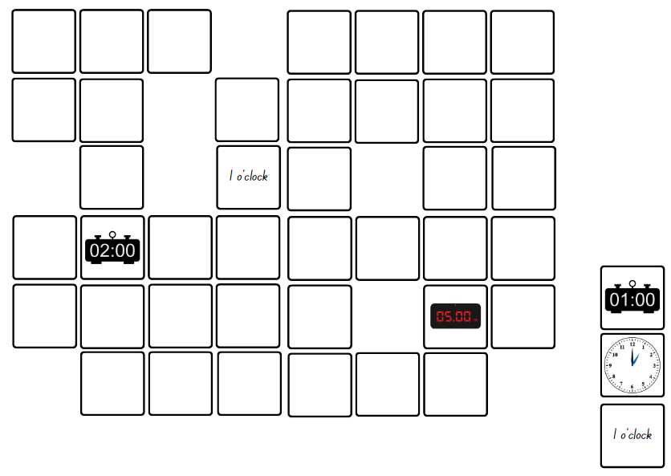
Images sourced from Canva and used in accordance with the Canva Content License Agreement.
- While Early Stage 1 students are working in pairs, provide Stage 1 students an analog clock to help solve the following problems:
- Joseph started swimming at 4 o'clock and finished at 5 o'clock. How long did he swim for?
- It takes half an hour to walk from home to school. What is the total time required to walk to school and back home again?
- Nicola’s dentist appointment was at half past 3, but she arrived at 4 o'clock. How late was she for the appointment?
- The movie started at 6 o'clock and ended at half past 7. What was the duration of the movie?
- If a batch of muffins is placed in the oven at half past 5, at what time will the muffins be ready if they take half an hour to cook?
- Sally left to play netball at 4:00 and returned home at 5:30. What was the duration of her absence?
- It takes 60 minutes to walk from home to the beach. What is the total time required to walk to the beach and back home again?
- Alex’s TV programme started at 7:00 and ended at 8:30. What was the duration of the programme?
- Marco arrived at his grandma’s house at 2:00 and stayed there for 6 hours. What time did he leave?
- Potatoes take 30 minutes to boil. If Dad wants them to be ready by 5:30, at what time should he put them in the boiling water?
- As a group, discuss the problems and select students to share and explain their reasoning and answers.

Consolidation and meaningful practice – 20 minutes
This activity has been adapted from How long does it take? by NZ Maths.
- Regroup as a class, activities students do and record in a list. For example, sleep, brush their teeth, sport training, shower, dance class, homework and eating. Once the list is compiled, discuss how often the events occur. For example, discuss whether the activities are daily, just on school days or weekly.
- In small groups, provide Stage 1 students with Resource 11: How long does it take? Students select 2 or 3 events from the class list and record the time they spend on each event each week. Students share their answers and the strategies they used to find their solutions.
- While Stage 1 students are working in groups, provide Early Stage 1 students with Resource 12: Matching memory. Students match tasks to the appropriate terms such as daytime, night-time, morning, afternoon, today, tomorrow and yesterday.
- Regroup as a class and choose students to share their working. Ask:
- What event did you spend the most time on? Why do you think that is? (Stage 1)
- Were there any surprises in the amount of time you spent on each activity? (Stage 1)
- Did you find it easy or challenging to keep track of your time? Why or why not? (Stage 1)
- Did you find that certain events were more enjoyable than others? How did that impact the time you spent on them? (Stage 1)
- Is it important to keep track of your time? Why or why not? (Stage 1)
- What did you discover about yourself from this activity? (Stage 1)
- If you went to the park on Sunday, what day is it 2 days later? (Early Stage 1)
- If today is Monday, what day was it 2 days ago? (Early Stage 1)
- What time of day is it when you eat dinner? (Early Stage 1)
This table details assessment opportunities and differentiation ideas.
Assessment opportunities | Too hard? | Too easy?
What to look for:  - Can students read analog and digital clocks? (MAO-WM-01, MAE-NSM-02)  - Can students use the accurate language terms of time when describing an event? (MAO-WM-01, MAE-NSM-02)  - Can students solve time problems involving hours and minutes? (MAO-WM-01, MA1-NSM-02)  - Can students explain various strategies to measure the duration of events in a week? (MAO-WM-01, MA1-NSM-02)  What to collect:  - observational data (MAO-WM-01, MA1-NSM-02)  - student work samples. (MAO-WM-01, MA1-NSM-02) | Students are unable to read analog and digital clocks.  - Provide students an interactive clock made from a hoop and ask students to position the numeral cards around the hoop. Discuss how to read hours.  - Select 2 events that occur during the school day and provide the hour time that these events occur. Ask students to create the time on an individual interactive clock at the correct point in time during the day.  Students are unable to solve time problems involving hours and minutes.  - Provide students with materials (single hand clock – hour hand only) or diagrams to support their thinking.  - Select 3 events that are very different in duration and ask students to compare and order them from shortest time to longest time. | Students can read analog and digital clocks.  - Challenge students by providing word problems using hour time and identifying the duration between 2 events.  - Students draw daily events and then match the hour time to their pictures.  Students can solve time problems involving hours and minutes.  - Challenge students to convert events into minutes from hours, and hours from minutes.  - Provide students with more challenging problems involving larger numbers that add to more than an hour.

Lesson 3: Subtraction
Core concept: A collection can be changed by taking some away.
The table below contains suggested learning intentions and success criteria. These are best co-constructed with students.
Learning intentions | Success criteria
Students working towards Early Stage 1 outcomes are learning that number relations of addition and subtraction can be modelled by combining, separating and comparing collections.  Students working towards Stage 1 outcomes are learning that addition and subtraction problems can be solved using various strategies. | Students working towards Early Stage 1 outcomes can use concrete materials and the backwards counting sequence to solve subtraction problems.  Students working towards Stage 1 outcomes can:  - use non count-by-one strategies to solve addition and subtraction problems  - select and apply strategies to solve subtraction problems.

Daily number sense: Flexibly renaming – 10 minutes
- Build Stage 1 student understanding of place value by partitioning and renaming two- and three-digit numbers in different ways. Early Stage 1 students will manipulate objects to help them count efficiently.
- Explain to Stage 1 students that the aim of the task is to flexibly partition three-digit numbers and that Early Stage 1 students will be arranging numbers in a way that is easy to count.
- Write 34 on the board for Early Stage 1 students. Ask students to collect 34 interlocking blocks and arrange them in a way that is easy to count. After students count to find the total, encourage them to make towers of tens to reinforce that collections of 10 are useful. Continue the task by providing various two-digit numbers to collect, arrange and count.
- Write 627 on the board for Stage 1 students. Ask the students to flexibly rename 627 as many ways as they can. Students record their answers on individual whiteboards. For example:
- 6 hundreds + 2 tens + 7 ones
- 62 tens + 7 ones
- 627 ones
- 3 hundreds + 32 tens + 7 ones.
Note: Concrete materials such as craft sticks or MAB blocks can be used for support.
- Ask Early Stage 1 students to explain their results when forming towers of 10. Demonstrate that 34 is 3 tens and 4 ones, however, it is not an expectation for Early Stage 1 students to use this language.
- Select Stage 1 students to share and justify their different ways of renaming.

Race to zero – 30 minutes
This activity has been adapted from Race to 200 by Developing Efficient Numeracy Strategies.
- Display Resource 13: Race from 30 for Early Stage 1 students and demonstrate how to play by playing against the class.
- Player A rolls a 6-sided die and takes that number away from 30, placing a counter on the correct number. Player B then rolls and takes their number away from 30 and places their counter on the correct number. Players take turns, aiming for zero. See Figure 3.
Figure 3 – Race from 30 gameplay
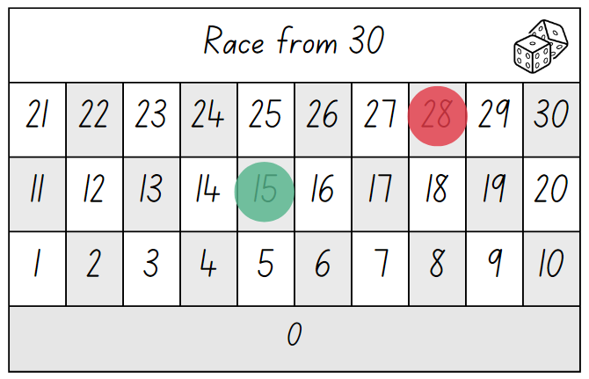
Images sourced from Canva and used in accordance with the Canva Content License Agreement.
- Once Early Stage 1 students are confident, provide pairs with Resource 13: Race from 30, a 6-sided die and a counter each. The winner is the first player to reach zero.
Note: The game can be adapted using addition and students Race to 30.
- Display Resource 14: Race from 200 for Stage 1 students and demonstrate how to play Race from 200 by playing against Stage 1 students.
- Player A rolls four 9-sided dice and adds the numbers together using known strategies. For example, doubles, near doubles or number bonds. Once player A has found the answer, they subtract that from 200 recording on Resource 14: Race from 200. See Figure 4.
Figure 4 – Race from 200 gameplay
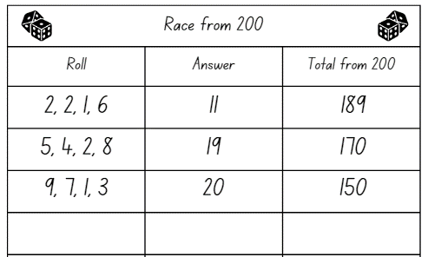
Images sourced from Canva and used in accordance with the Canva Content License Agreement.
- Player B then follows the same steps above. Players take turns, aiming for zero.
Note: Highlight the use of efficient strategies when adding the rolled numbers and taking away from 200.
- Once Stage 1 students are confident in playing, provide pairs with four 9-sided dice and each student a copy of Resource 14: Race from 200. The winner is the first player to reach zero.
- Regroup as a class and select students to share their strategies during the game. Ask:
- What known facts did you use to add your rolled numbers? (Stage 1)
- How did you subtract your number from the total?
- Is there a strategy that you are more confident using? Why?
- What challenges did you face? How did you overcome them?
- What questions do you still have?
This table details assessment opportunities and differentiation ideas.
Assessment opportunities | Too hard? | Too easy?
What to look for:  - Can students use concrete materials and the backwards counting sequence to solve subtraction problems? (MAO-WM-01, MAE-CSQ-01, MAE-CSQ-02)  - Can students use non count-by-one strategies to solve addition problems? (MAO-WM-01, MA1-CSQ-01)  - Can students select and apply strategies to solve subtraction problems? (MAO-WM-01, MA1-CSQ-01)  What to collect:  - student work samples. (MAO-WM-01, MAE-CSQ-01, MAE-CSQ-02, MA1-CSQ-01) | Students are unable to subtract from 30.  - Provide students with a filled number line to help visualise the subtraction process.  - Provide students with concrete materials such as, counters or blocks to see how many objects are left when subtracting from 30.  Students are unable to subtract a quantity from 200.  - Provide students with Resource 15: 200 number chart to reference as they subtract.  - Students play Race from 100 with two 9-sided dice, consolidating their counting strategies. Provide students with a number chart to reference as they play the game. | Students can subtract from 30.  - Challenge students to roll two 6-sided dice, add the numbers together and then subtract from 30. Students need to reach zero in 5 turns or less.  - Challenge students to play Race from 50 or 100 with two 6-sided dice.  Students can subtract a quantity from 200.  - Challenge students to consider if it would be possible to win Race from 200 with only 3 moves or 4 moves.  - In pairs play Strike it Out using a number line from zero to 20 on an individual whiteboard.

Consolidation and meaningful practice: Tug of war – 20 minutes
- Display Resource 16: 30 number chart for Early Stage 1 students and Resource 17: Number chart for Stage 1 students. Explain that students are going to play a game called tug of war, where the first student that gets to 15 for Early Stage 1 and 50 for Stage 1 wins.
- Provide Early Stage 1 pairs with Resource 16: 30 number chart, one different coloured counter each and a 6-sided die. Provide Stage 1 pairs with Resource 17: Number chart, one different coloured counter each and a 9-sided die.
- Students start the game by deciding which player will begin on zero and which player will begin on 30 for Early Stage 1, and 100 for Stage 1. Students then place their counter on their starting number.
- The player starting on zero will add the quantity rolled to zero and begin to move up towards 15 or 50. The player starting on 30 or 100 will subtract the quantity rolled from 30 or 100 and start moving towards 15 or 50.
- Play continues until one player reaches 15 or 50. If a player is near 15 or 50 and rolls a quantity that does not allow them to land on 15 or 50, for example, the quantity goes beyond 50, they do not move from their previous number and miss their turn. They continue rolling on their next turn, until they get the quantity needed. Students swap starting positions and repeat the game.
Note: The game can be adapted so the objective is to reach the other end of the number chart first using only addition.

Lesson 4: Multiplication bingo
Core concept: Multiplying numbers in any order results in the same answer.
The table below contains suggested learning intentions and success criteria. These are best co-constructed with students.
Learning intentions | Success criteria
Students working towards Early Stage 1 outcomes are learning that objects can be shared and grouped using various methods.  Students working towards Stage 1 outcomes are learning that multiplication problems can be solved using various strategies. | Students working towards Early Stage 1 outcomes can distribute a group of objects into smaller groups and recognise whether the number in each group is equal or not.  Students working towards Stage 1 outcomes can:  - use objects, diagrams, drawings or actions to solve multiplication problems  - justify their reasoning when solving mathematical problems.

Daily number sense: 10 minutes
- From a class need surfaced through formative assessment data, identify a short, focused activity that targets students’ knowledge, understanding and skills. Example activities may be drawn from the following resources:
- Mathematics K-6 resources
- Universal Resources Hub.

Rolling groups bingo – 30 minutes
This activity has been adapted from Rolling groups by Developing Efficient Numeracy Strategies.
- Provide Stage 1 students with one 6-sided die, Resource 18: Bingo gameboard, Resource 19: Game cards and a large collection of counters.
- Students roll the die and select a number card from Resource 19: Game cards. Students skip count or use a repeated addition strategy to solve the multiplication problem and find the total. Place a counter on the corresponding number on the gameboard. If a number is already covered, that player misses a turn. Students continue to take turns with the first player to cover the board and call out ‘Bingo!’ being the winner.
Note: If required, students can use counters to model all items to show multiplication as accumulating equal groups. It is preferable for students to make and use arrays rather than ‘groups of’ by the end of Stage 1.
- While Stage 1 students are playing bingo, demonstrate to Early Stage 1 students how to share a collection of counters into equal groups. For example, 10 counters can form 2 equal groups of 5, 5 equal groups of 2, one group of 10 or 10 groups of one.
- Explain to Early Stage 1 students that they will be working in pairs to share a collection of objects into equal groups. Each pair will receive 20 counters to share into equal groups. Students record or draw all their results in their workbooks. Repeat the task with different sets of collections such as 18, 15 and 12 counters. See Figure 5.
Figure 5 – Equal grouping
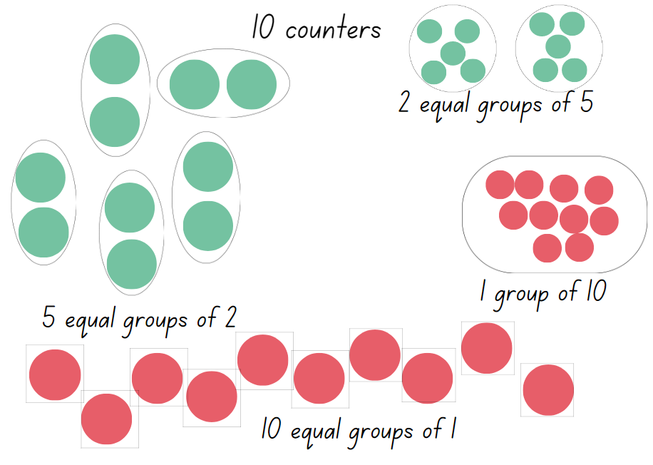
Images sourced from Canva and used in accordance with the Canva Content License Agreement.
- Regroup as a class and choose students to share the strategies they used to solve the problems. For example, repeated addition, arrays, doubles, or forming groups. Ask:
- What strategies did you use to solve the problems?
- Is there a strategy you are more comfortable with? Why?
- Did you notice any patterns while playing?
- Do you have any questions?
- What strategies did you use to share the objects equally? (Early Stage 1)
- Were there any challenges? How did you overcome them?

Word problems – 20 minutes
- Write or display the following problem on the board: If each person at a party eats 5 cookies, and there are 8 people at the party, how many cookies will be eaten in total? Ask students what the question is asking and what strategies they could use to solve it. Demonstrate how to solve the problem using an efficient strategy with a think aloud.
- Provide Stage 1 students with Resource 20: Multiplication problems and workbooks to record their solutions.
- While Stage 1 students work independently, Early Stage 1 students look for groupings in the classroom environment, recording and drawing their findings in their workbook. For example, class tables, pencil tins, book boxes and so on. Students identify groups as equal or not equal when identifying groupings around the room.
- Regroup as a class and choose students to share the strategies they used to solve the problems. Ask:
- What strategies did you use to solve the problems?
- Did you break the problems down into smaller parts? What steps did you take to solve it?
- Did you use any diagrams, drawings or models to help you understand or solve the problems?
- Is there another way to solve the problem?
- What types of objects did you find in the class environment? (Early Stage 1)
- Did you notice any patterns or similarities among the groups you found? (Early Stage 1)
- How can grouping objects into equal sets be useful in other areas? (Early Stage 1)
This table details assessment opportunities and differentiation ideas.
Assessment opportunities | Too hard? | Too easy?
What to look for:  - Can Early Stage 1 students distribute a group of objects into smaller groups and recognise whether the number in each group is equal or not? (MAO-WM-01, MAE-FG-01, MAE-FG-02)  - Can Stage 1 students use objects, diagrams, drawings or actions to solve multiplication problems? (MAO-WM-01, MA1-FG-01)  - Can students justify their reasoning when solving mathematical problems? (MAO-WM-01, MA1-FG-01)  What to collect:  - student work samples (MAO-WM-01, MAE-FG-01, MAE-FG-02, MA1-FG-01)  - observational data. (MAO-WM-01, MAE-FG-01, MAE-FG-02, MA1-FG-01) | Students are unable to distribute a group of objects into smaller groups.  - Provide students with paper to draw circles that represent the groups.  - Students start with smaller numbers such as 6 or 8 and distribute into 2 groups only.  Students are unable to solve multiplication problems.  - Provide students with concrete materials to form equal groups and modify the bingo game by drawing the equal groups on the game card.  - Students cover the array they have made and try to work out the total using rhythmic or skip counting. | Students can distribute a group of objects into smaller groups.  - Students distribute larger quantities beyond 20 into various sized groups.  - Provide the students a mix of concrete materials box and ask students to group the objects and arrange them in different ways.  Students can use various strategies to solve multiplication problems.  - Students create their own multiplication word problems for a peer to solve.  - Provide students with a 10-sided dice and a blank game card. Ask them to create their own gameboard to play with their peers.

Lesson 5: Division
Core concept: A collection can be partitioned into equal or unequal parts.
The table below contains suggested learning intentions and success criteria. These are best co-constructed with students.
Learning intentions | Success criteria
Students working towards Early Stage 1 outcomes are learning that objects can be divided using various methods.  Students working towards Stage 1 outcomes are learning that division problems can be solved using various strategies. | Students working towards Early Stage 1 outcomes can form equal groups using objects, diagrams, or drawings and explain their thinking by using numerals and words.  Students working towards Stage 1 outcomes can:  - use objects, diagrams, drawings or actions to solve division problems including remainders  - justify their reasoning when solving division problems.

Daily number sense: Maths tipping – 15 minutes
This lesson has been adapted from Maths tipping by Developing Efficient Numeracy Strategies.
- Build student understanding of the sequence of numbers by counting forwards and backwards by ones or tens on and off the decade with one-, two- and three-digit numbers.
- Stand students in a circle with Early Stage 1 students on one side and Stage 1 students on the other side.
- Early Stage 1 students count forwards by ones within a range to 30, or backwards by ones within a range from 20. For example, counting forwards by ones from 11 up to 23. Alternate with the Stage 1 students counting.
- Stage 1 students count forwards or backwards by tens on or off the decade from a given two- or three-digit number until they reach a target number. For example, counting forwards by tens from 26 to 156. Alternate with the Early Stage 1 students counting for a few rounds with different numbers.
- Students then stand in different spaces around the room.
- Say a number and have an Early Stage 1 student say the number that is ‘one less’ and ‘one more’ than the given number. Stage 1 students say the number that is 10 more and 10 less than the given number.
- Students must answer within a designated amount of time, for example, 5 seconds. If the student is correct, they can take one step in any direction to attempt to tip another student on the shoulder. If tipped, the student must sit down. If a student states the incorrect answer, they also must sit down.
- Continue until one student remains standing.

Sharing counters – 25 minutes
This lesson is adapted from Share it out by Developing Efficient Numeracy Strategies.
- Provide Early Stage 1 students with Resource 21: Sharing worksheets and explain to students that they need to share and draw the correct sharing from the given objects and number of groups. See Figure 6.
Figure 6 – Student sharing
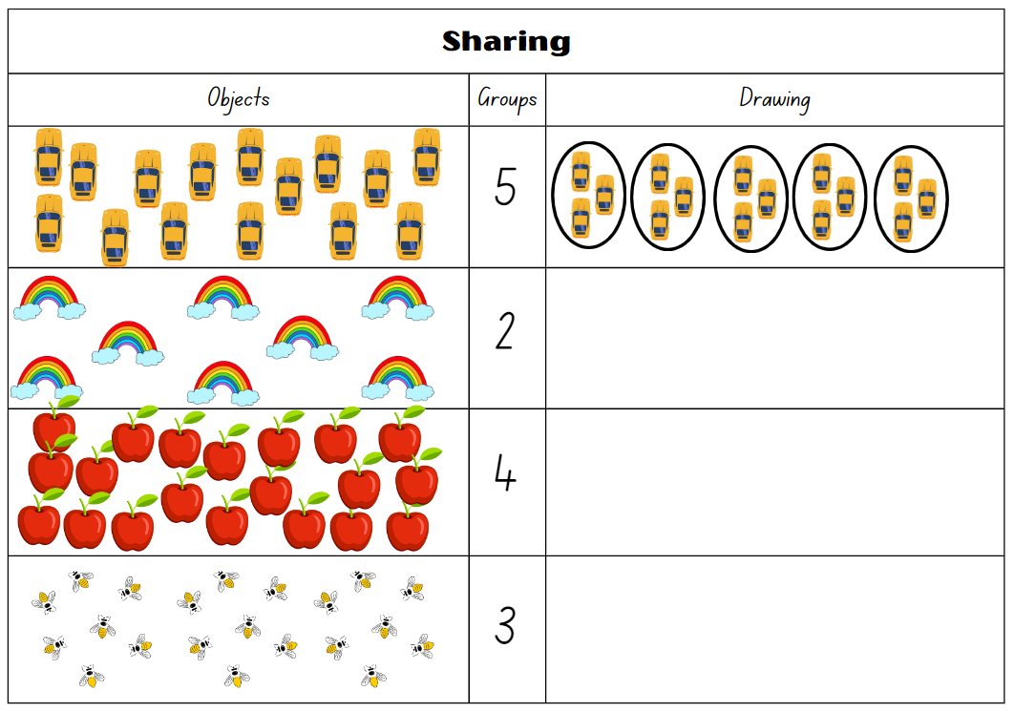
Images sourced from Canva and used in accordance with the Canva Content License Agreement.
- While Early Stage 1 students are working independently on forming and sharing groups, provide Stage 1 pairs with Resource 22: Number cards, a 6-sided die and a large collection of counters. Explain that the die represents the number of groups, and the cards represent the number of items.
- Students take turns to roll the die, select a number card and use the counters to find the answer. Player A explains their thinking to Player B, who records their work on Resource 23: Recording sheet. See Figure 7. Any remainder counters are collected by Player A.
Remainder: The part ‘left over’ when dividing a number into equal groups.
- The students swap roles and play multiple rounds. The player with the smallest number of remainders at the end is the winner. See Figure 7.
Figure 7 – Recording sheet example
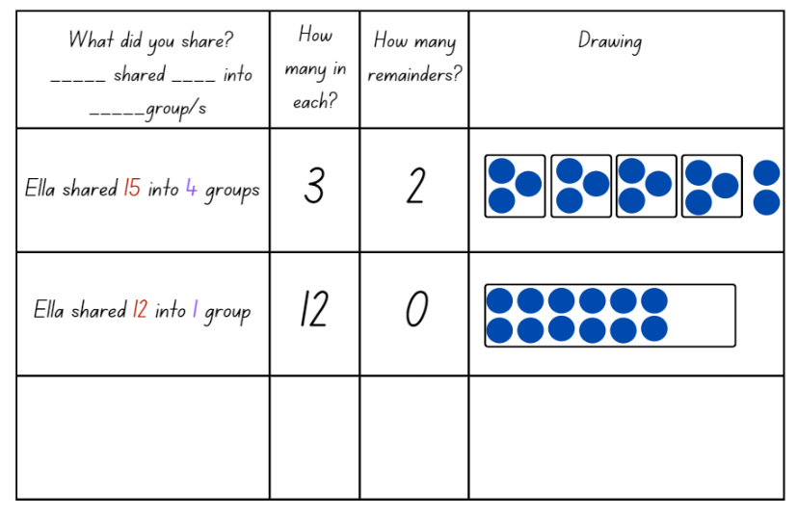
Images sourced from Canva and used in accordance with the Canva Content License Agreement.
- Regroup as a class and discuss the various strategies students used to share the counters. For example, repeated subtraction, arrays, rows and columns or forming groups. Ask:
- What strategies did you use to solve the problems?
- Is there a strategy you are more comfortable with? Why?
- Did you notice any patterns while playing?
- Do you have any questions about the remainders?

Division word problems – 20 minutes
- Read One Hundred Hungry Ants by Elinor J Pinczes to the class. In small groups, Early Stage 1 students draw the different groups of ants formed in the story and label their drawings using numerals and words.
- While Early Stage 1 students are working in small groups, write or display the following problem on the board for Stage 1 students: Jonathon has 43 baseball cards that he wants to divide equally among his 5 friends. How many baseball cards will each friend get, and how many will be left over? Prompt students to explain what the question is asking and what strategies they could use to solve it. Demonstrate how to solve the problem using an efficient strategy with a think aloud.
- Provide Stage 1 students with Resource 24: Division problems and their workbook to record their solutions.
- Regroup as a class and choose students to share the groupings they drew and the strategies they used to solve the problems. Ask:
- Did you find all the groups formed in the story? (Early Stage 1)
- Did your group find a grouping that no other group found? (Early Stage 1)
- Can you explain the problem in your own words?
- What strategies did you use to solve the problem?
- Did you break the problem down into smaller parts? What steps did you take to solve it?
- Did you use any diagrams, drawings or models to help you understand or solve the problem?
- Is there a different way to solve the problem?
- Were there any remainders in your solutions?
This table details assessment opportunities and differentiation ideas.
Assessment opportunities | Too hard? | Too easy?
What to look for:  - Can students form equal groups using objects, diagrams, or drawings and explain their thinking by using numerals and words? (MAO-WM-01, MAE-FG-02)  - Can students use objects, diagrams, drawings or actions to solve division problems? (MAO-WM-01, MA1-FG-01)  - Can students justify their reasoning when solving division problems? (MAO-WM-01, MA1-FG-01)  What to collect:  - student work samples (MAO-WM-01, MAE-FG-02, MA1-FG-01)  - observational data. (MAO-WM-01, MAE-FG-02, MA1-FG-01) | Students are unable to use objects, diagrams or drawings to form equal groups.  - Provide students with concrete materials and support students to distribute all items by ones until all items are used. Students then count the number in each group.  - Support students to share items into 2 equal groups using one-to-one correspondence.  Students are unable to solve division problems including remainders.  - Provide even number cards for students to form 2 equal groups with no remainders.  - Students represent authentic situations involving equal sharing and equal grouping by drawings the objects, for example, representing 8 people sitting at 2 tables. Students then use counters to represent the sharing. | Students can use objects, diagrams, or drawings to form equal groups.  - Students create their own grouping and sharing stories using numerals and words.  - Challenge students to find all the equal groups that can be made using the provided number of items on Resource 21: Sharing worksheets.  Students can use various strategies to solve division problems.  - Students create their own division word problems for a peer to solve.  - Provide pairs of students with a 10-sided die and additional number cards. Ask students to share larger quantities of counters and record their solutions.  - Challenge students to form arrays when solving sharing counters problems.

Lesson 6: Let’s celebrate
Core concept: Mathematicians use a range of representations to communicate ideas.
The table below contains suggested learning intentions and success criteria. These are best co-constructed with students.
Learning intentions | Success criteria
Students working towards Early Stage 1 outcomes are learning that number questions can be solved using diagrams, words and numerals.  Students working towards Stage 1 outcomes are learning that problems can be solved using various strategies. | Students working towards Early Stage 1 outcomes can:  - record grouping and sharing using diagrams, words or numerals and explain their thinking  - use concrete materials to model and solve addition and subtraction questions.  Students working towards Stage 1 outcomes can:  - solve and record answers using objects, diagrams, images and actions.  - apply reasoning for the method they used to solve problems.

Daily number sense: Find the next multiple of 10 – 10 minutes
- Build student understanding of the sequence of numbers by identifying numbers before and after a given number and the next multiple of 10.
- Provide Early Stage 1 students with a 20-sided die and an individual whiteboard. Students roll the die and record the numbers one less and one more. See Figure 8
Figure 8 – One less and one more
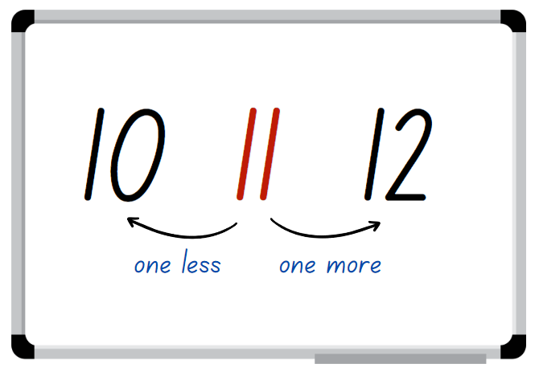
Images sourced from Canva and used in accordance with the Canva Content License Agreement.
- Provide Stage 1 students with three 9-sided dice. Explain that they need to roll the dice to create and record a three-digit number on an individual whiteboard. Students then state the number and record how many more to the next multiple of 10, see Figure 9.
Figure 9 – Next multiple of 10
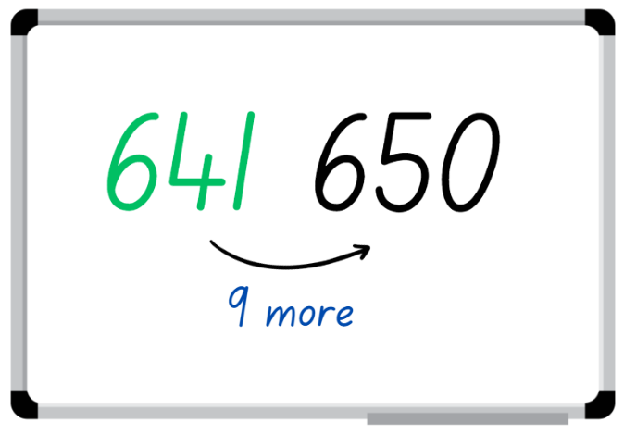
Images sourced from Canva and used in accordance with the Canva Content License Agreement.
Note: This activity focuses on identifying the next multiple of 10, not the closest multiple of 10.
- Stage 1 students roll again to make a different three-digit number and record. State the number and how many more to the next multiple of 10.
Note: The activity can be adapted by using two 9-sided dice and creating two-digit numbers.
- All students repeat activity multiple times.

Party investigation: Part 1 – 40 Minutes
Note: Lessons 6-8 follow a theme of planning a maths party to celebrate the student’s learning. These have been adapted from the reSolve resource, ‘Tea party’. The maths celebration could include revisiting the mathematical games that were popular in previous lessons.
- Begin by brainstorming what the whole class knows about parties. Ask what people do at parties and what things are usually at parties. Record student ideas on the whiteboard or an anchor chart.
- Explain to students that they will be organising a party for their class. Ask them to think about what they might need at the party.
- If not already identified by students, highlight that parties need invitations. Discuss key features of an invitation, for example, type of event, date, time, duration, location, dress code, RSVP and any additional information required for the party. Provide students with various writing materials and craft materials to create an invitation for the class party. See Figure 10.
Figure 10 – Invitation example
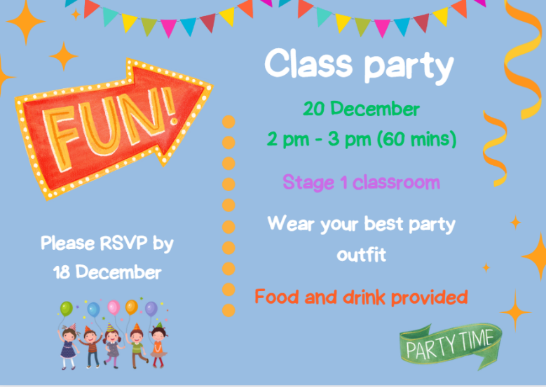
Images sourced from Canva and used in accordance with the Canva Content License Agreement.
- Regroup Stage 1 students and explain that they now need to design a seating plan for the class party to ensure there are enough seats and tables for everyone. Students use the total number of students in the class to organise possible seating arrangements in groups. Students then write number sentences to demonstrate their mathematical thinking and record their seating plan.
- While Stage 1 students are creating seating plans, Early Stage 1 students design and make a placemat on A3 paper to represent their setting at a party. Discuss the various items that could be included, for example, plates, cups, spoons, knives.
- Early Stage 1 students decide what items they will include on the placemat and then draw their placemat. See Figure 11.
Figure 11 – Placemat example
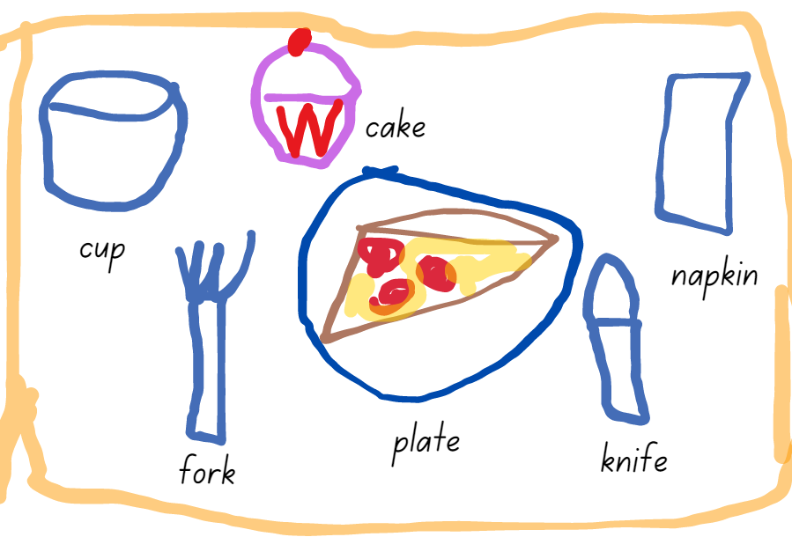
Images sourced from Canva and used in accordance with the Canva Content License Agreement.
- Regroup Early Stage 1 students to count the items on their placemats and compare these numbers to others in their group. Ask:
- How many total items are there in your placemat?
- Which placemat has the most items and which one has the least?
- If you were to add one more item to each placemat, how many items would there be in total?
- If you were to remove one item from each placemat, how many items would there be in total?
- How many items did you include that are edible or drinkable?
- How many items did you include that are specific to your culture or background?
- What strategies did you use to calculate the total of items on your mat?
- Display Resource 25: Decorations catalogue for Stage 1 students and explain that they will need to buy decorations for the party, but they cannot spend more than $30. Select students to choose which decorations they would pick and demonstrate how to record the cost on Resource 26: Costing worksheet. See Figure 12.
Figure 12 – Decoration costing example
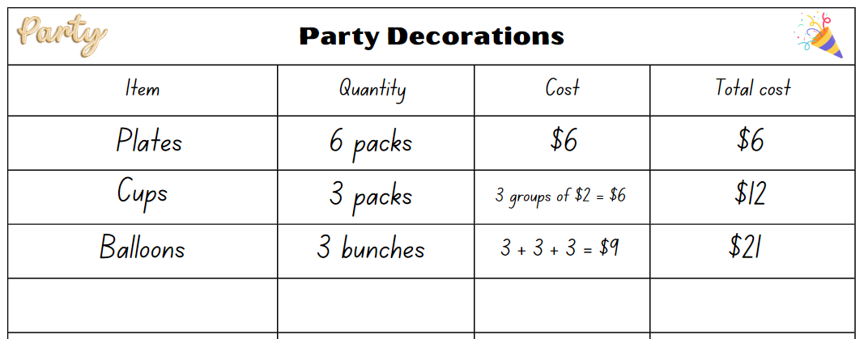
Images sourced from Canva and used in accordance with the Canva Content License Agreement.
- Display Resource 27: Placemat catalogue the Early Stage 1 students to calculate the cost of some of the items on their placemat. Students record their results and discuss their results with their peers.

Discuss and connect the mathematics – 10 minutes
- Regroup as a class and summarise the lesson together drawing out key mathematical ideas. Ask:
- What were some of the creative ideas that you came up with for your party invitations?
- Have you allowed enough time for party activities?
- Will there be specific time for lunch? If so, for how long?
- What strategy did you use to create the seating plan?
- Did you face any challenges when organising the seating plan?
- What were some of the decorations that you wanted to buy but could not? Why did you make that decision?
- Did you stay within your budget for decorations? If not, what caused you to go over budget?
- How did you calculate the total cost of your placemat?
- Can you explain some of the different types of mathematics used for your investigation?
- What would you do differently if you were to plan a party again?
This table details assessment opportunities and differentiation ideas.
Assessment opportunities | Too hard? | Too easy?
What to look for:  - Can students record grouping and sharing using diagrams, words and numerals and explain their thinking? (MAO-WM-01, MAE-FG-01, MAE-FG-02)  - Can students use concrete materials to model and solve addition and subtraction questions? (MAO-WM-01, MAE-CSQ-01)  - Can students solve a range of problems and record answers using objects, diagrams, images and actions? (MAO-WM-01, MA1-CSQ-01, MA1-FG-01, MA1-NSM-02)  - Can students apply reasoning for the method they used to solve problems? (MAO-WM-01, MA1-CSQ-01, MA1-FG-01, MA1-NSM-02)  What to collect:  - observational data (MAO-WM-01, MAE-CSQ-01, MAE-FG-01, MAE-FG-02, MA1-CSQ-01, MA1-FG-01, MA1-NSM-02)  - student work samples. (MAO-WM-01, MAE-CSQ-01, MAE-FG-01, MAE-FG-02, MA1-CSQ-01, MA1-FG-01, MA1-NSM-02) | Students are unable to record grouping and sharing using diagrams, words and numerals.  - Provide students visual aids such as pictures or party items to support concrete representation of the placemat and the decorations.  - Provide students with a template of a placemat.  Students are unable to solve problems related to the seating plan and decorations.  - Provide students with concrete materials to represent the items on the catalogue to support them as they calculate the budget.  - Provide students with grid paper to support them as they design the seating arrangements. | Students can record grouping and sharing using diagrams, words and numerals.  - Challenge the students to determine the total of items and cost for their table teams.  - Once students have determined the total cost of their placemats, ask them to determine the change provided if they paid with a $10, $20 or $50 note.  Students can solve problems related to the seating plan and decorations.  - Challenge students to create an activities schedule for the party including the duration of each task.  - Students create a list of decorations that adds up to exactly $30.  - Challenge students to explain and justify the most appropriate seating arrangement that suits the class numbers.

Lesson 7: Celebrate!
Core concept: Mathematicians use evidence to make mathematical arguments and justify their thinking.
The table below contains suggested learning intentions and success criteria. These are best co-constructed with students.
Learning intention | Success criteria
All students are learning that different strategies can be used to find solutions to problems. | Students working towards Early Stage 1 outcomes can:  - identify situations in which addition and subtraction may be applied  - distribute objects one by one or using another method when grouping or sharing.  Students working towards Stage 1 outcomes can:  - solve problems by using addition and subtraction  - solve problems by using multiplication and division  - justify their reasoning when solving mathematical problems.

Daily number sense: From here to there – 15 minutes
This lesson has been adapted from Dice Dazzlers (From Here to There) by Swan (2003).
- Build student understanding of the sequence of numbers by making and ordering numbers.
- Provide each pair with an individual whiteboard. Early Stage 1 students will need a 9-sided die and interlocking cubes and Stage 1 students will need two 9-sided dice.
- One student draws a gameboard on the whiteboard. Early Stage 1 students need to make sure they have 11 boxes.
- Early Stage 1 students write zero in the first box and 10 in the last box. Stage 1 pairs set their own starting and finishing numbers and write them on the gameboard.
Note: Early Stage 1 students can use a 20-sided die and choose a number range between zero and 20. Stage 1 can use different dice, however, guide the students in understanding the finishing number. For example, if two 6-sided dice are used the maximum finishing number will be 66.
- The first Early Stage 1 player rolls the die and works out where to write the number on the gameboard. Once they have added the number, they construct the representation of the number using interlocking cubes, see Figure 13.
- The first Stage 1 player rolls both dice and uses the 2 dice to form a number. The player must decide where to place the number on the game board so that the sequence of numbers remains in order, Figure 13. The next player rolls and places their number on the same game board. If a number cannot be placed, the player misses their turn.
Figure 13 – Example of play
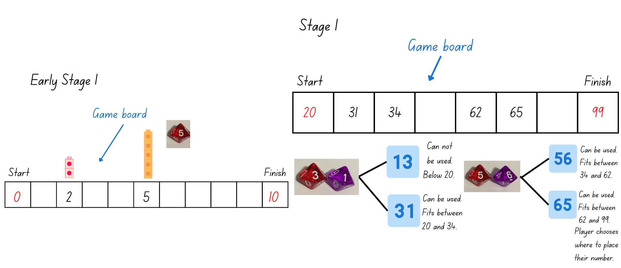
Images sourced from Canva and used in accordance with the Canva Content License Agreement.
- The winner is the person who completes the sequence of numbers from the starting to the finishing number.

Party investigation: Part 2 – 35 minutes
- Explain that students will be organising the party food for the upcoming class party.
- Display Resource 28: Party food catalogue for the students and explain that they will need to buy food for the party and cannot spend more than $15 for Early Stage 1 students and $50 for Stage 1 students. Select students to share which food they would buy and demonstrate how to record the cost on Resource 29: Party food recording. See Figure 14.
Figure 14 – Party food recording
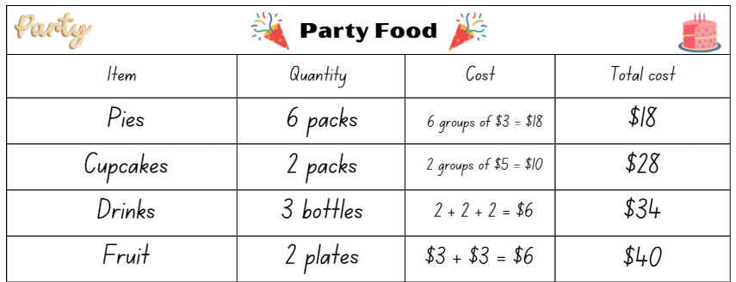
Images sourced from Canva and used in accordance with the Canva Content License Agreement.
- Provide pairs of students with Resource 28: Party food catalogue and Resource 29: Party food recording. Students decide what items they want to buy, how much each item costs and the total cost of all the food they choose. Remind students that they need to stay within their budget of $15 or $50.
- Select students to share the food they have selected and the total cost. Ask:
- What was the most challenging part of creating your party menu?
- Looking back on your menu, is there anything you would have done differently? Why?
- How could you apply the skills you learned in this activity to real-life situations?
- Provide all students with Resource 30: Lolly bag catalogue and Resource 31: Lolly bag recording. Students select items to create a party bag for each student in the class. Each bag must have a minimum of 3 items and maximum of 4 items in the bag and must not cost more than $5. Students record they selection on Resource 31: Lolly bag recording. See Figure 15.
Figure 15 – Lolly bag example
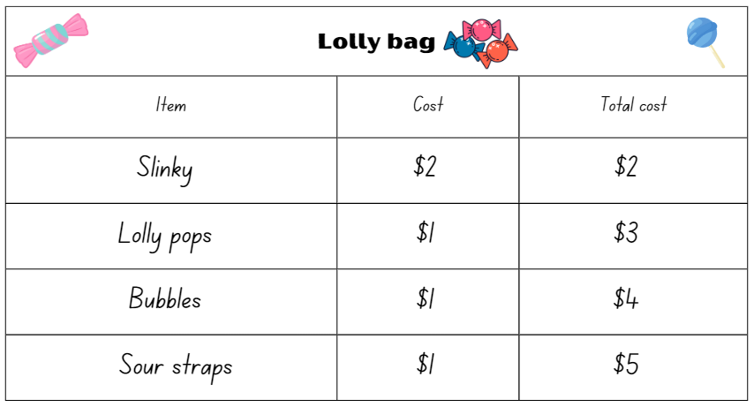
Images sourced from Canva and used in accordance with the Canva Content License Agreement.

Discuss and connect the mathematics – 10 minutes
- Regroup as a class and summarise the lesson together drawing out key mathematical ideas. Ask:
- How did you decide how many of each item to include in the lolly bags? What strategies did you use to make these decisions?
- Did you face any challenges when using multiplication and division to create the lolly bags? How did you overcome them?
- Did you learn anything new about using multiplication and division to organise and divide items through this activity? What was it?
- Are you happy with your planned party? If not, what would you change?
This table details assessment opportunities and differentiation ideas.
Assessment opportunities | Too hard? | Too easy?
What to look for:  - Can students identify situations in which addition and subtraction may be applied? (MAO-WM-01, MAE-CSQ-01)  - Can students distribute objects one by one or using another method when grouping and sharing? (MAO-WM-01, MAE-FG-02)  - Can students solve problems by using addition and subtraction? (MAO-WM-01, MA1-CSQ-01)  - Can students solve problems by using multiplication and division? (MAO-WM-01, MA1-FG-01)  - Can students justify their reasoning when solving mathematical problems? (MAO-WM-01, MA1-CSQ-01, MA1-FG-01)  What to collect:  - observational data (MAO-WM-01, MAE-CSQ-01, MAE-FG-02, MA1-CSQ-01, MA1-FG-01)  - student work samples. (MAO-WM-01, MAE-CSQ-01, MAE-FG-02, MA1-CSQ-01, MA1-FG-01) | Students are unable to identify situations in which addition and subtraction may be applied.  - Provide concrete materials to represent the items in the catalogue and a number line to support solving the number problems.  - Provide real life problems. For example, going to the shops and calculating the total.  Students are unable to solve mathematical problems and justify their reasoning.  - Provide students with concrete materials to represent the items on the catalogues to support the calculations of the budgets.  - Support students to solve the party problems for a class of 10 students. | Students can identify situations in which addition and subtraction may be applied.  - Challenge the students by increasing their budget.  - Ask students to design a party game that involves adding and subtracting, which will allow their peers to apply their skills in an engaging way.  Students can solve mathematical problems and justify their reasoning.  - Challenge students to create their own catalogue for party toys or games. In groups, students price items then ask peers to cost items within a provided budget.  - Challenge students to organise another event and list what items need to be purchased. Students research items and costs and create a budget.

Lesson 8: Final countdown
Core concept: Mathematicians reason and make conjectures when solving problems.
The table below contains suggested learning intentions and success criteria. These are best co-constructed with students.
Learning intentions | Success criteria
Students working towards Early Stage 1 outcomes are learning that they can recognise, recall and record combinations of numbers that add up or bond to form a given number.  Students working towards Stage 1 outcomes are learning that:  Battleships  - positional language is used to describe the location of an object.  Five steps to 100 or 500  - using place value helps to partition and rename three-digit numbers  - mathematicians use tools, such as number lines, to solve problems. | Students working towards Early Stage 1 outcomes can create, model and recognise number combinations for numbers up to 10.  Students working towards Stage 1 outcomes can:  Battleships  - describe the location of objects using positional language.  Five steps to 100 or 500  - count forwards and backwards by fives, tens and hundreds from any three-digit number  - use effective counting strategies and a number line to find solutions.

Daily number sense: 10 minutes
- From a class need surfaced through formative assessment data, identify a short, focused activity that targets students’ knowledge, understanding and skills. Example activities may be drawn from the following resources:
- Mathematics K-6 resources
- Universal Resources Hub.

Party time (Early Stage 1) – 50 minutes
- The class party is an optional event with mathematical party games on offer. The following activities are a selection of popular mathematics games sourced from a variety of Early Stage 1 and Stage 1 sample units. Students can participate in these activities either in pairs or small groups.

Part-whole triangles
This activity has been adapted from Short Activity: Part-Whole Triangles by Russo (2020).
- Build student understanding of part-whole relationships by playing part-whole triangles.
- Provide pairs with a deck of playing cards ace to 10 and an individual whiteboard to record on. Tell students that the aces and jokers are ones.
- Each player gets dealt 7 cards and the remaining cards are placed in a pile in the middle, which is the communal pile. See Figure 16.
Figure 16 – Gameplay
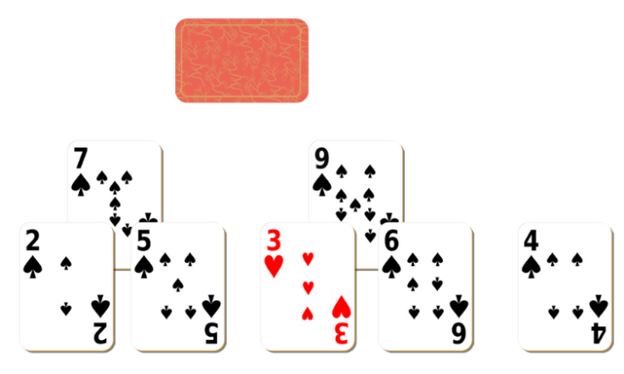
Images sourced from Canva and used in accordance with the Canva Content License Agreement.
- Before starting the game, players attempt to make part-whole triangles from the cards they have been dealt. Part-whole triangles are made by 2 cards on the base, adding to equal the card at the top of the triangle. For example, 2 and 4 on the base of the triangle add to make 6 on the top of the triangle.
- Any unused cards that each player has can be placed in a pile next to each player.
- Players then take turns in trying to make part-whole triangles. Players take a card from their opponent’s unused pile or from the pile in the middle.
- The winner is the person to make 6 part-whole triangles or the person with the largest number of triangles once all the cards have been used.

10 or bust
This activity has been adapted from 10 or bust (additive strategies) (6:23) from Mathematics K-6 resources.
- Provide pairs of students with Resource 32: Ten-frame, dice and a collection of coloured counters. Students have up to 3 rolls each to try and fill their ten-frame. Each player uses different coloured counters to represent each roll. After students have placed their counters on the ten-frame, they count how many more are needed to make 10 before the next player has their turn. Students can choose to pass on their third roll, roll and possibly win, or go bust by having more than 10 counters.

Party time (Stage 1) – 50 minutes
- The class party is an optional event with mathematical games on offer. The following activities are a selection of popular mathematics games sourced from a variety of Stage 1 sample units. Students can participate in these activities either in pairs or small groups.

Battleships
- Provide Stage 1 pairs with Resource 33: Battleship gameboards, a barrier and 3 counters each. Students set up the gameboards by placing 3 counters (ships) on Resource 33: Battleship gameboards so that the opponents cannot see each other’s gameboard. See Figure 17.
Figure 17 – Battleship gameplay
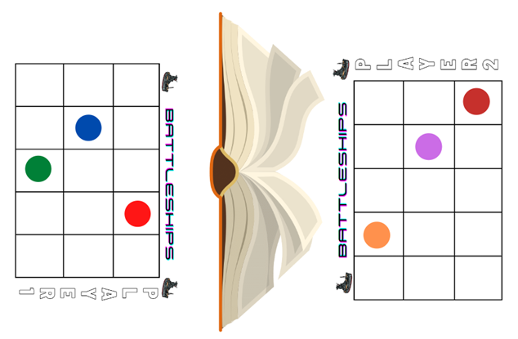
Images sourced from Canva and used in accordance with the Canva Content License Agreement.
- Students take turns guessing the location of each of the counters. The player not guessing responds with ‘miss’ or ‘hit’. The first player to ‘hit’ all ships belonging to their opponent wins. Players may only ask one question each turn and must use positional language. For example, players could ask if there is a counter on the top left, if there a counter on the square below the last hit or if there is a counter on the middle of the bottom row.
- Students play multiple rounds.

Five steps to 100 or 500
This activity has been adapted from Five Steps to 50 from NRICH.
- Provide Stage 1 pairs of students with Resource 34: Number line zero to 100 and two 9-sided dice.
- Explain that students will be playing with a partner and the objective of the game is to be the player to get on or closest to 100 in 5 moves, by counting on or counting back from the number rolled.
- Player 1 rolls the 2 dice, identifies the smallest two-digit number that can be made and circles that number on the number line. Player 1 must decide how to jump to 100 in 5 jumps by using a combination of adding and/or subtracting fives, tens and ones. See Figure 18.
Figure 18 – Examples of Five Steps to 100
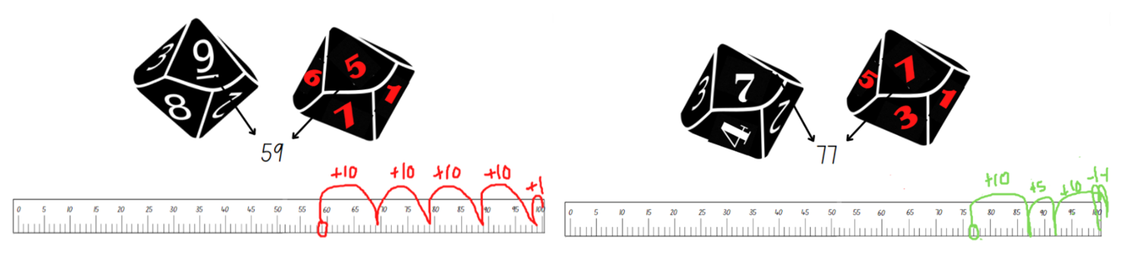
Images sourced from Canva and used in accordance with the Canva Content License Agreement.
- Ensure that students are recording their strategies for each round. For example, 59 + 10 + 10 + 10 + 10 + 1 = 100.
- If students are confident playing to 100, provide each pair of students with Resource 35: Number line zero to 500 and Resource 36: Number cards. Explain that this time, they need to reach 500 using 5 steps by counting on or back using combinations of fives, tens and hundreds.
- Each player turns over a number card from the pile. They read the three-digit number and identify where that number is on the number line. Students then take 5 steps forwards or backwards in an attempt to land on 500.
- Ensure that students record their strategies for later discussions.
- Provide time for students to play multiple rounds. Observe strategies and listen to discussions as students' reason and problem-solve.

Resource 1: Early Stage 1 place value gameboard
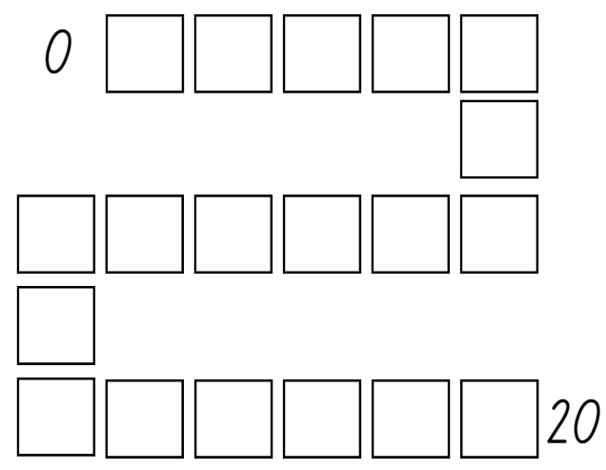

Resource 2: Stage 1 place value gameboard
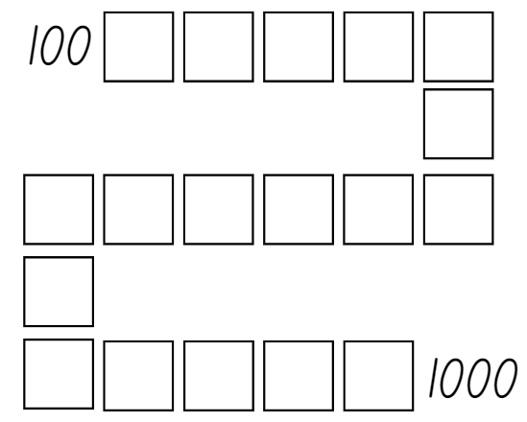

Resource 3: I wonder...
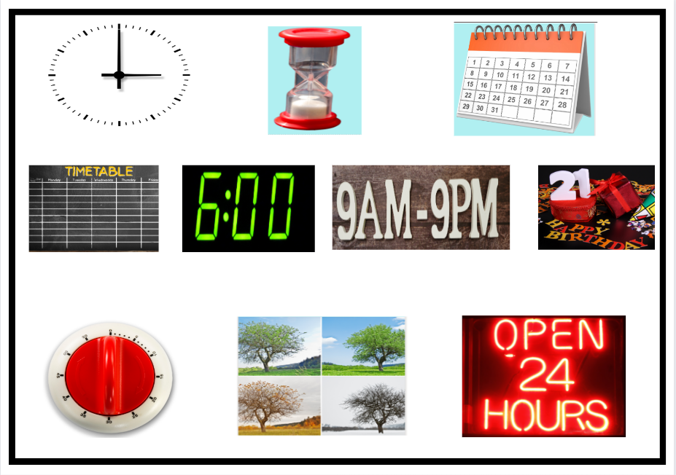
Images sourced from Canva and used in accordance with the Canva Content License Agreement.

Resource 4: Child brushing their teeth
‘Cheerful Child while Cleaning teeth’ by RODNAE Productions sourced from Canva and used in accordance with the Canva Content License Agreement.

Resource 5: Images of events
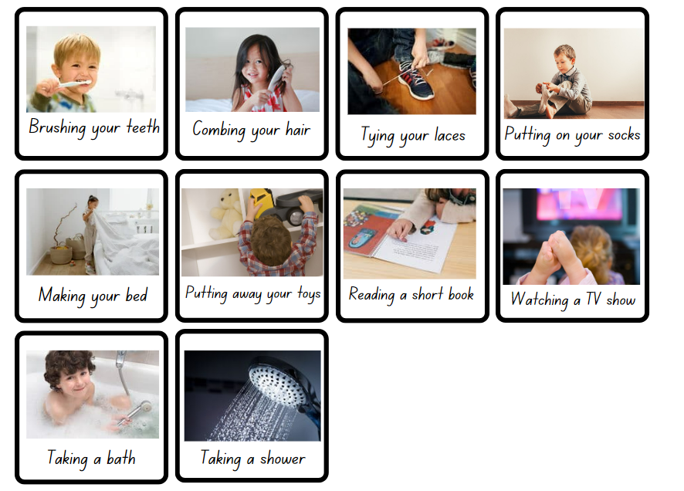
Images sourced from Canva and used in accordance with the Canva Content License Agreement.

Resource 6: Before and after
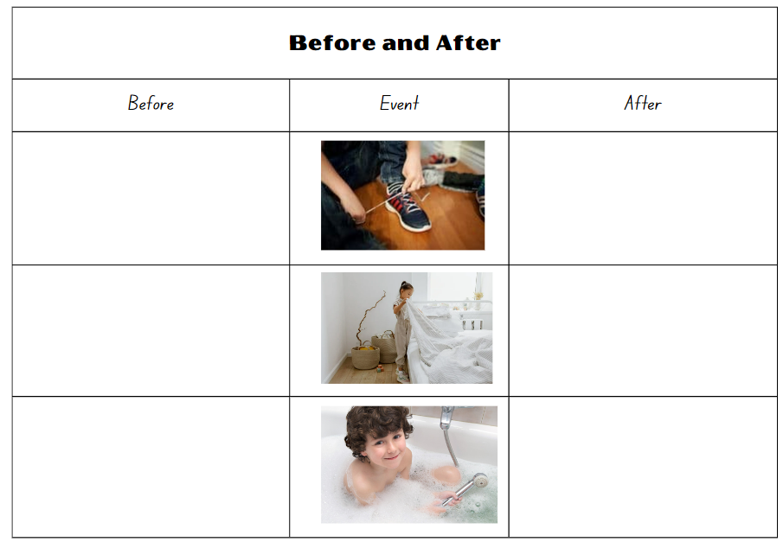
Images sourced from Canva and used in accordance with the Canva Content License Agreement.

Resource 7: Calendar
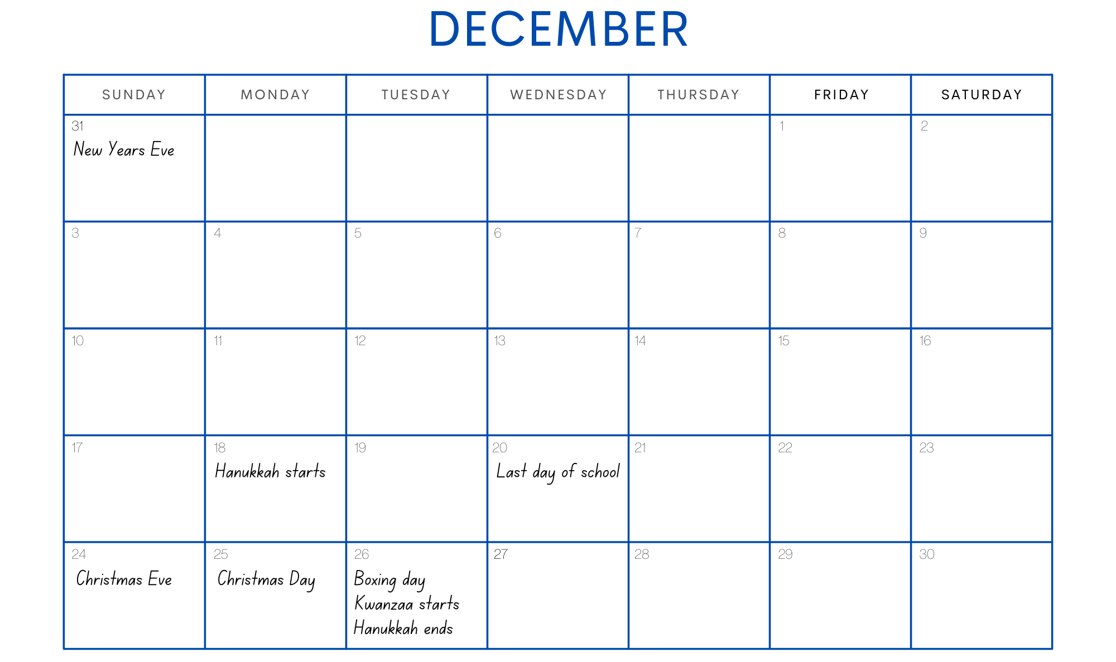
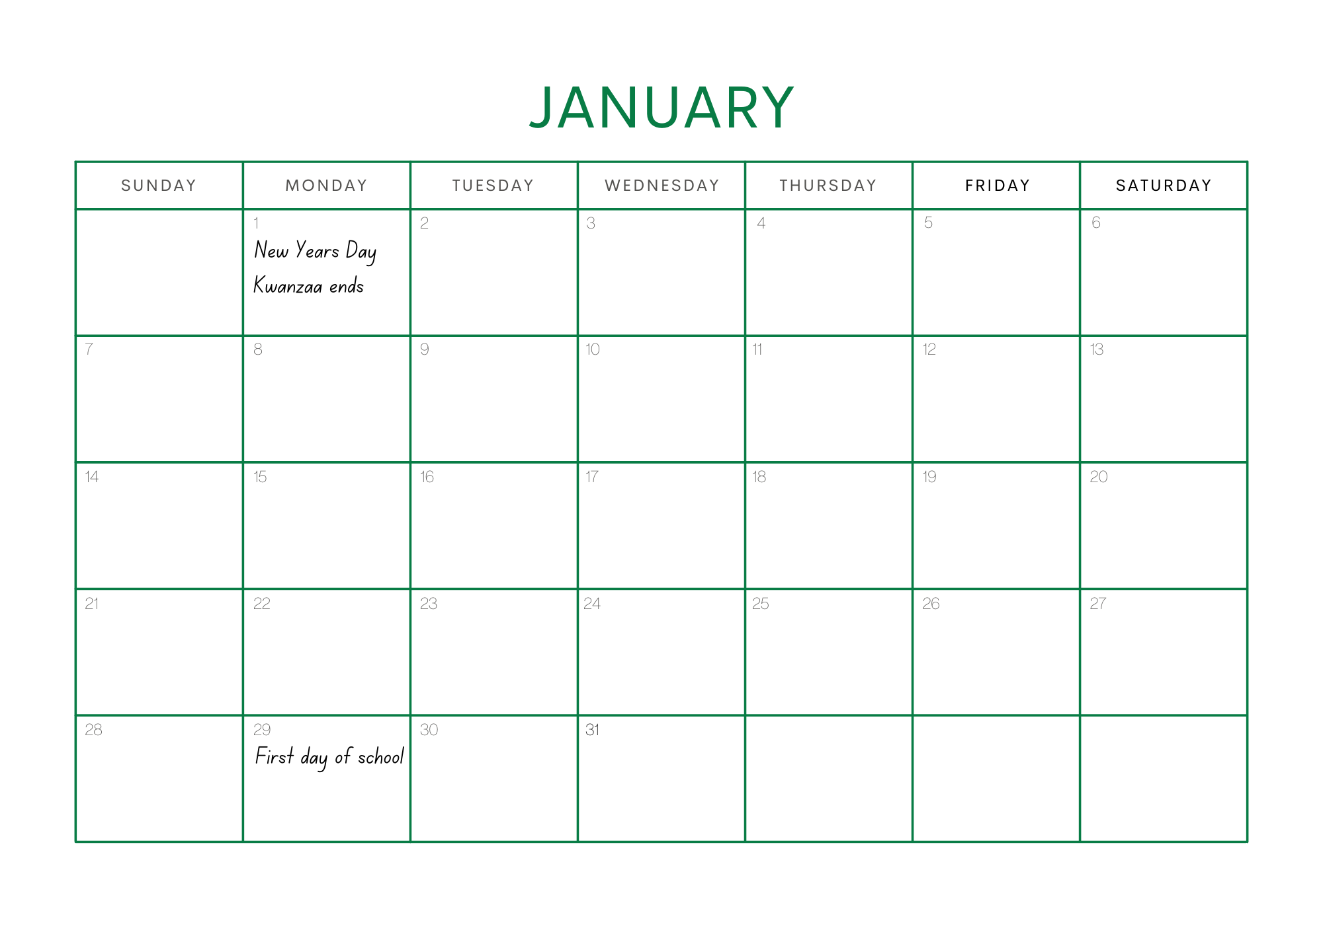

Resource 8: Calendar problems
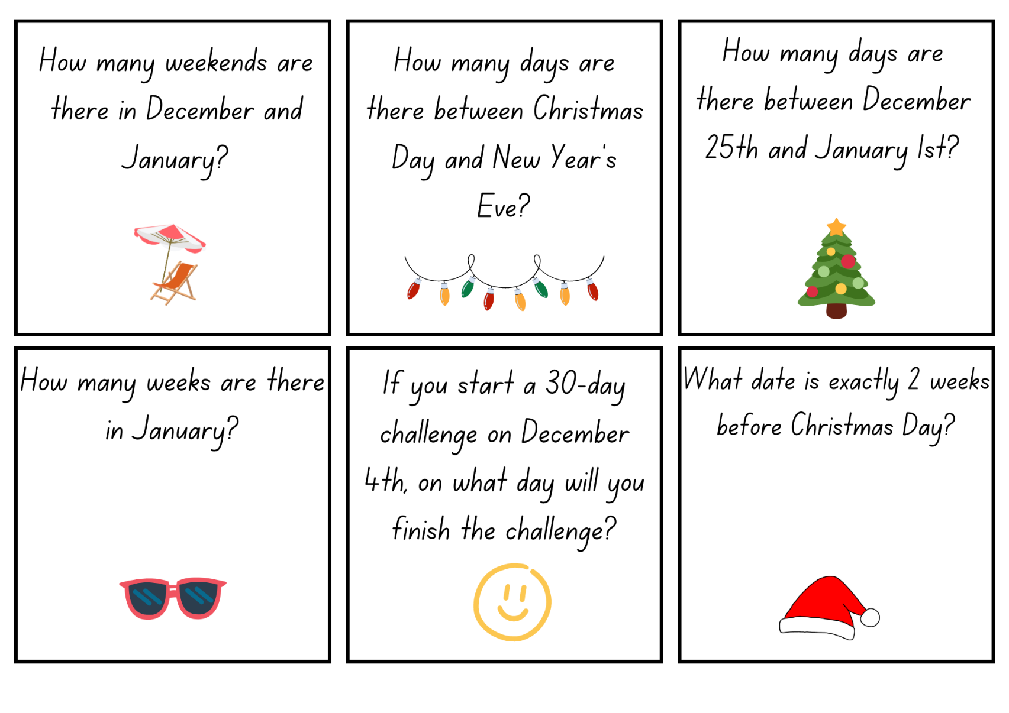
Images sourced from Canva and used in accordance with the Canva Content License Agreement.
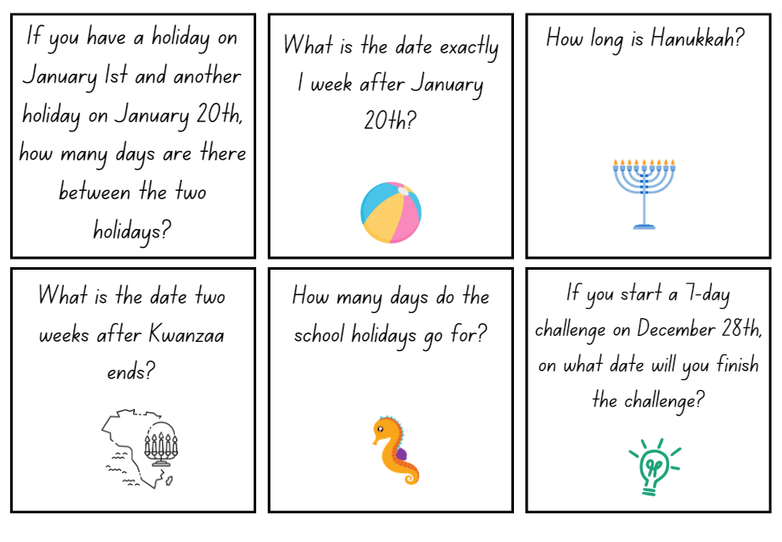
Images sourced from Canva and used in accordance with the Canva Content License Agreement.

Resource 9: Comparing events
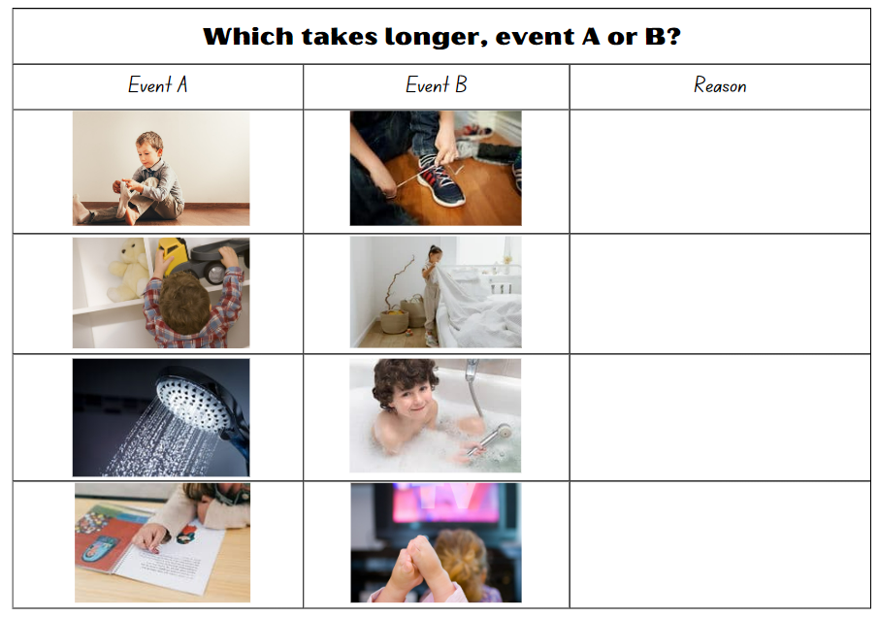
Images sourced from Canva and used in accordance with the Canva Content License Agreement.

Resource 10: Time memory game
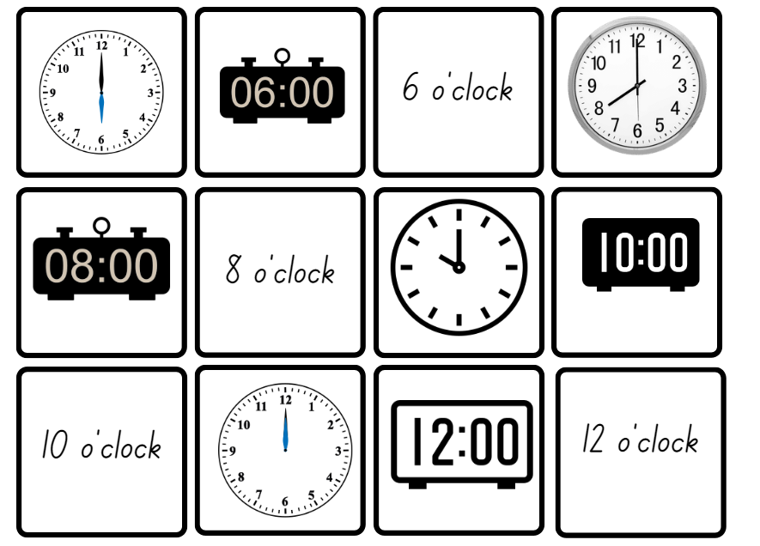
Images sourced from Canva and used in accordance with the Canva Content License Agreement.
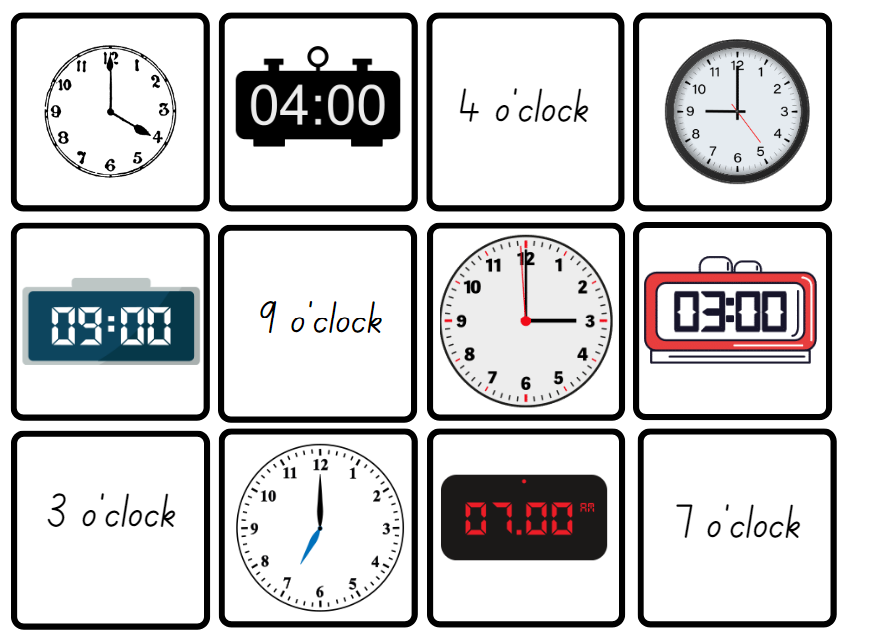
Images sourced from Canva and used in accordance with the Canva Content License Agreement.
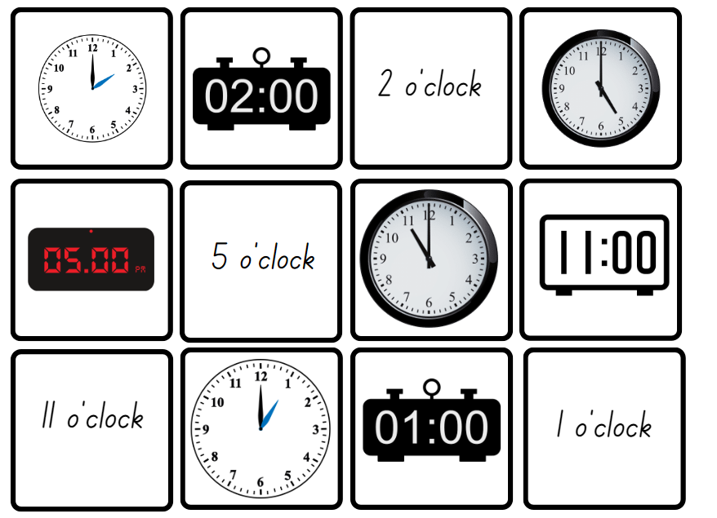
Images sourced from Canva and used in accordance with the Canva Content License Agreement.

Resource 11: How long does it take?
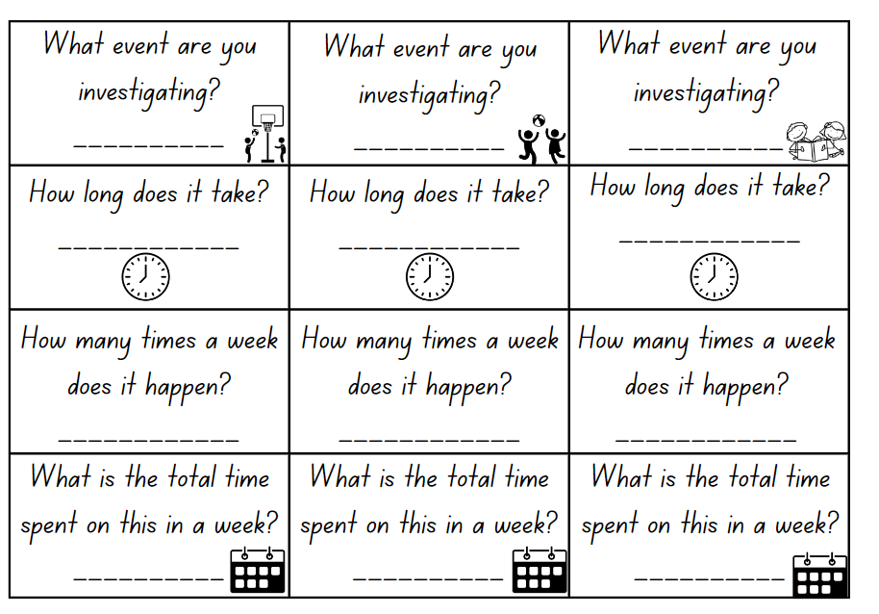
Images sourced from Canva and used in accordance with the Canva Content License Agreement.

Resource 12: Matching memory
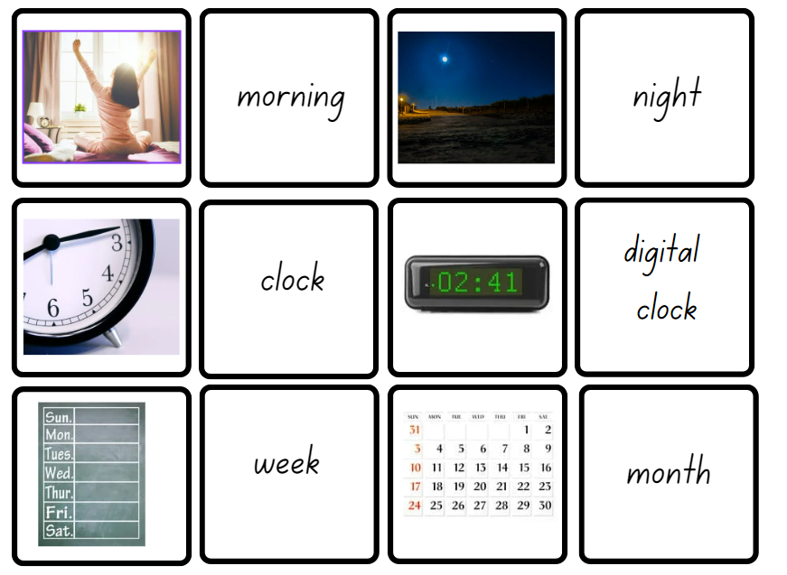
Images sourced from Canva and used in accordance with the Canva Content License Agreement.
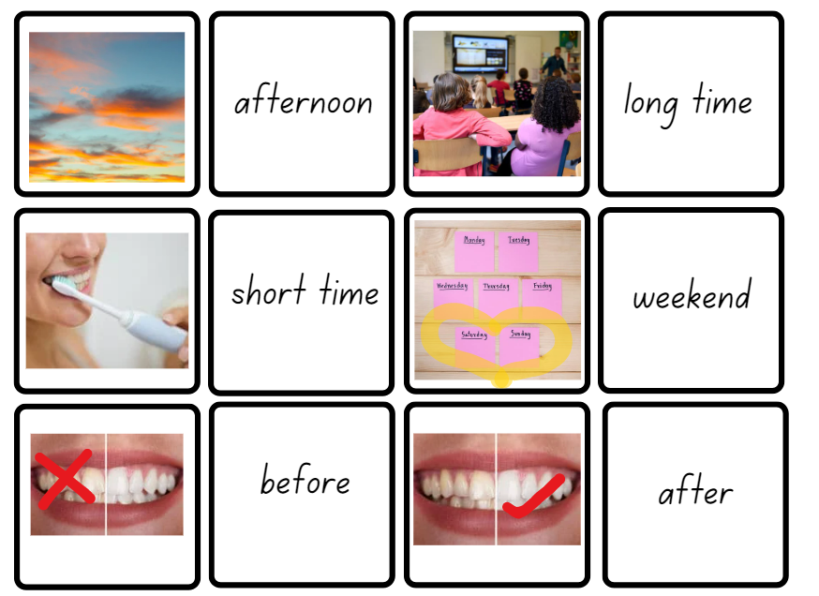
Images sourced from Canva and used in accordance with the Canva Content License Agreement.

Resource 13: Race from 30
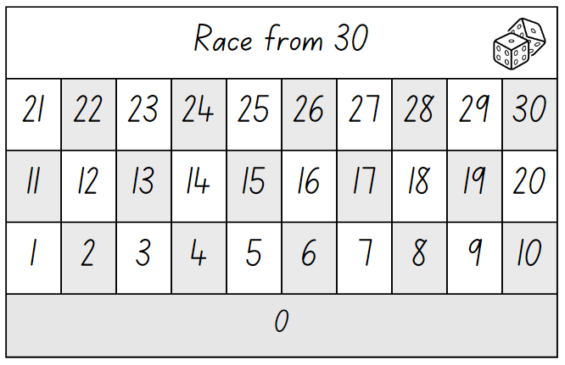
Images sourced from Canva and used in accordance with the Canva Content License Agreement.

Resource 14: Race from 200
Images sourced from Canva and used in accordance with the Canva Content License Agreement.

Resource 15: 200 number chart
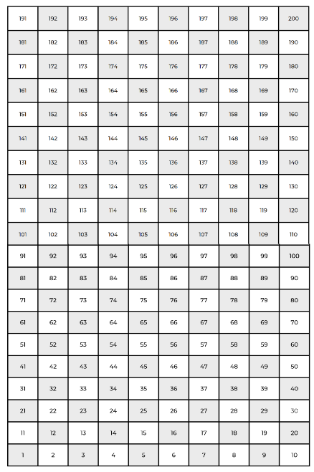

Resource 16: 30 number chart
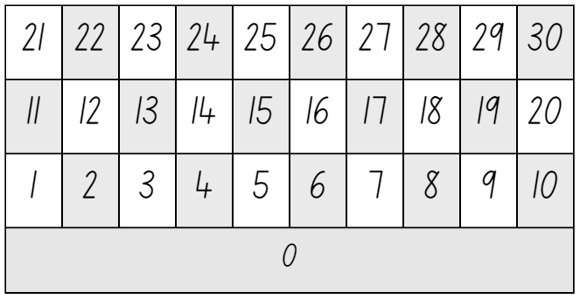

Resource 17: Number chart
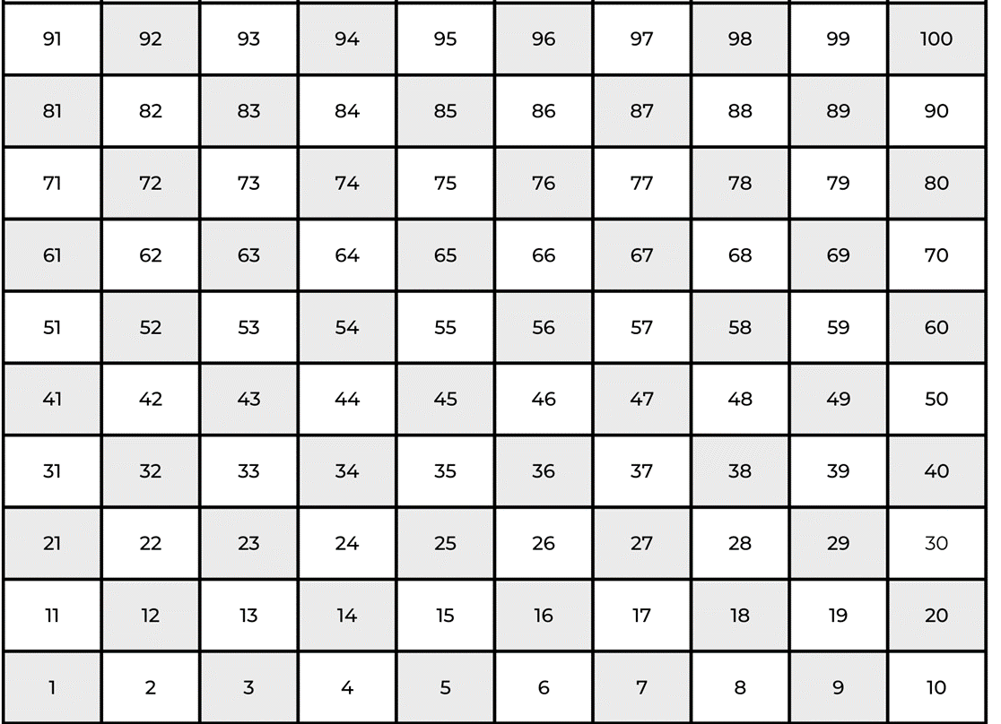

Resource 18: Bingo gameboard
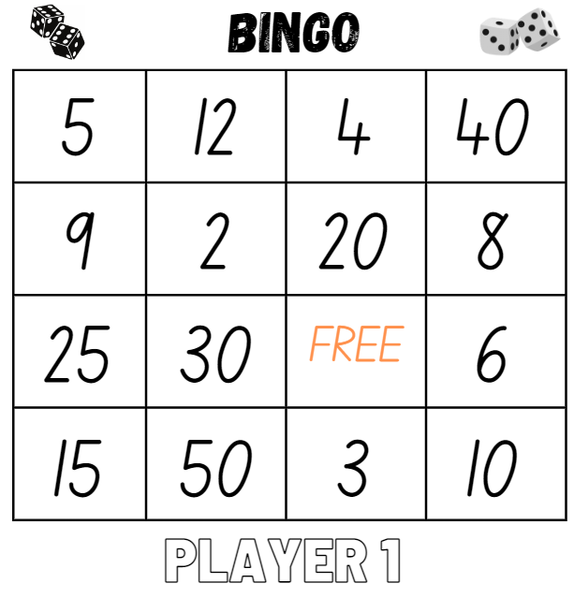
Images sourced from Canva and used in accordance with the Canva Content License Agreement.
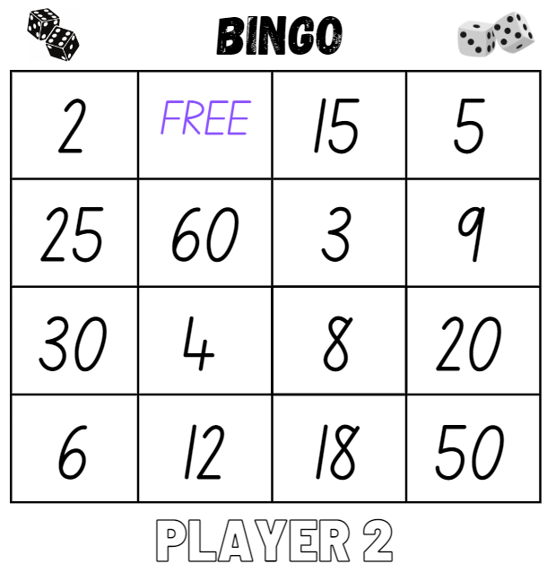
Images sourced from Canva and used in accordance with the Canva Content License Agreement.

Resource 19: Game cards
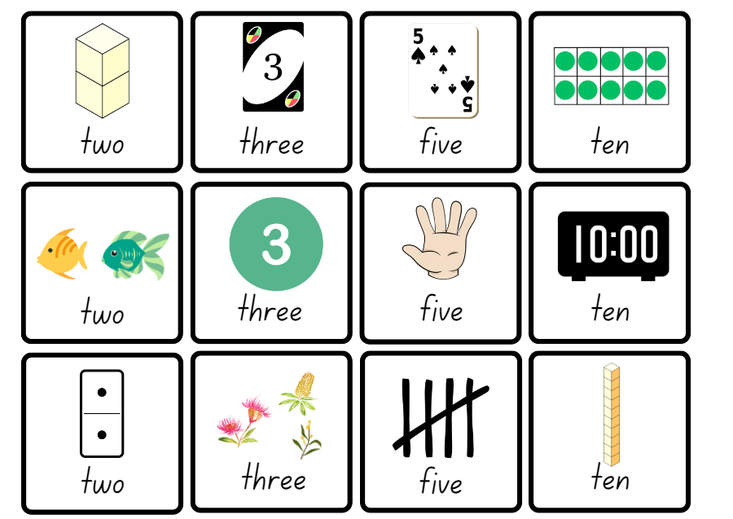
Images sourced from Canva and used in accordance with the Canva Content License Agreement.

Resource 20: Multiplication problems
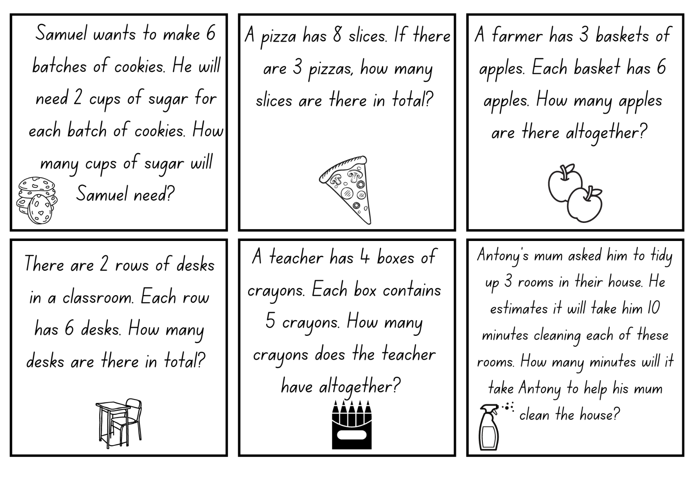
Images sourced from Canva and used in accordance with the Canva Content License Agreement.

Resource 21: Sharing worksheets
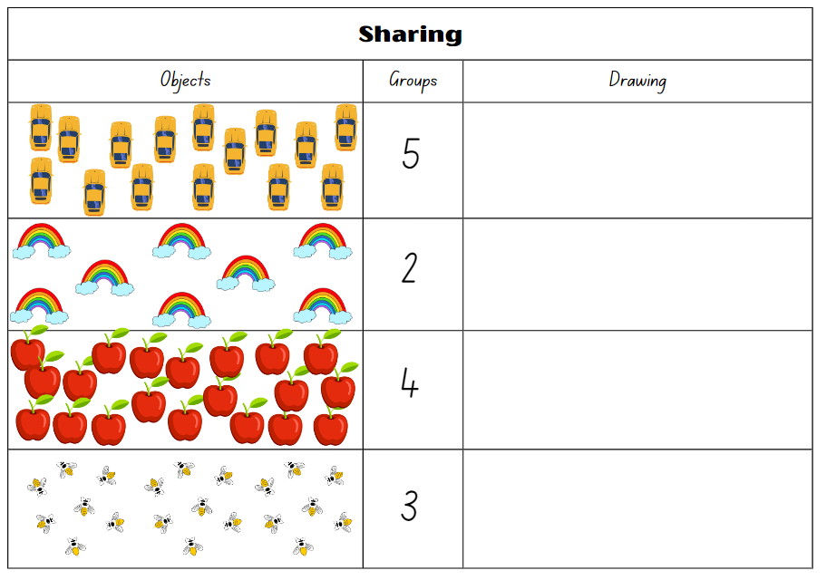
Images sourced from Canva and used in accordance with the Canva Content License Agreement.
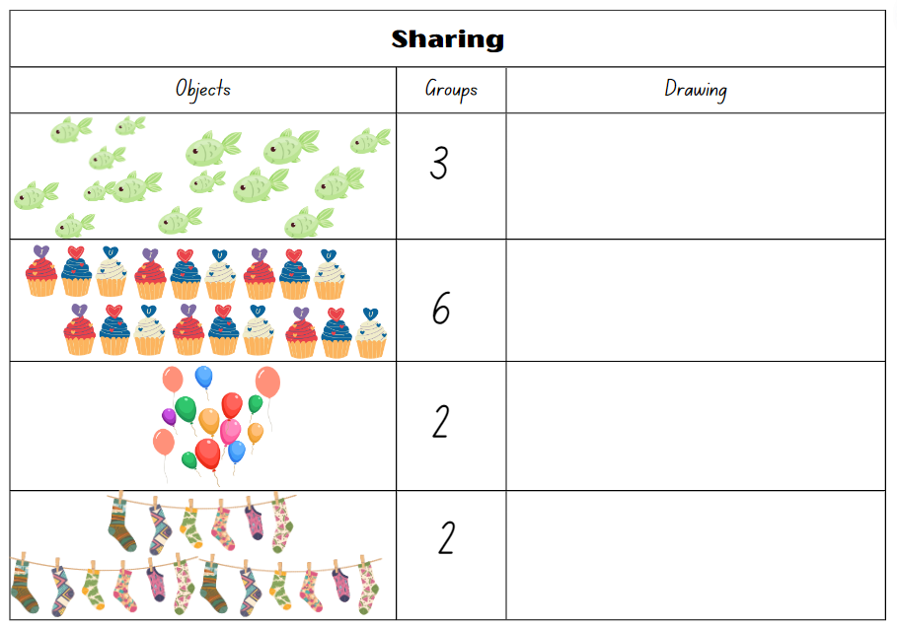
Images sourced from Canva and used in accordance with the Canva Content License Agreement.

Resource 22: Number cards
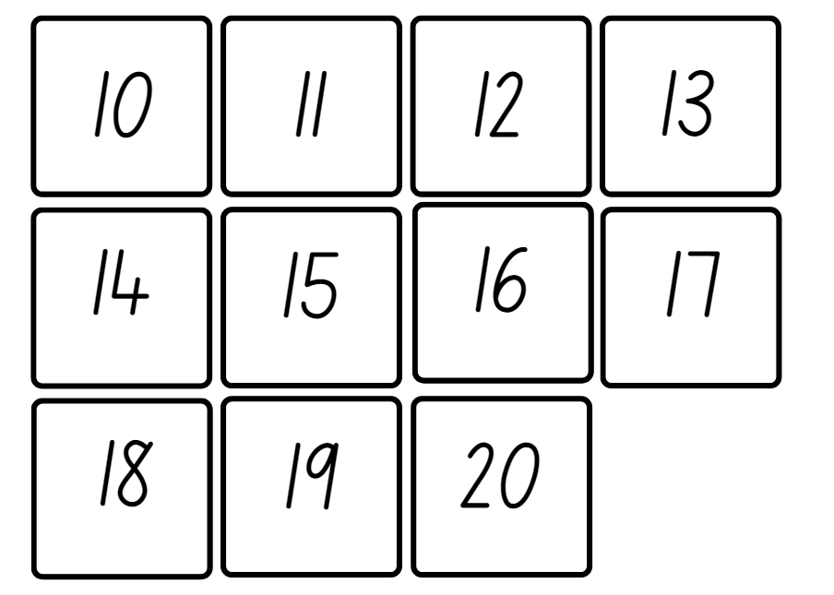

Resource 23: Recording sheet
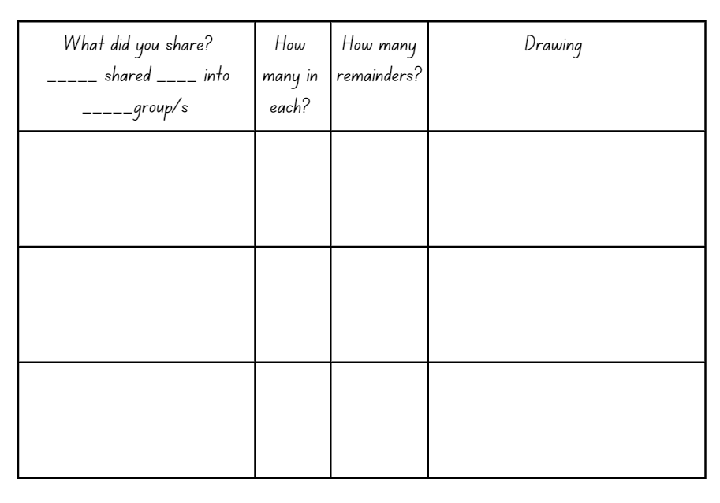

Resource 24: Division problems
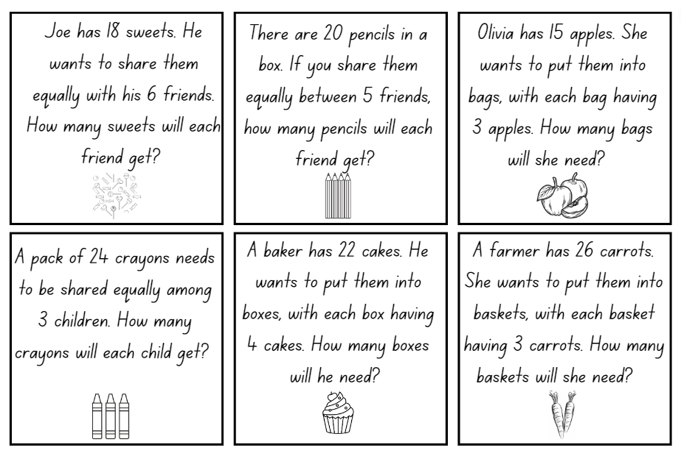
Images sourced from Canva and used in accordance with the Canva Content License Agreement.

Resource 25: Decorations catalogue
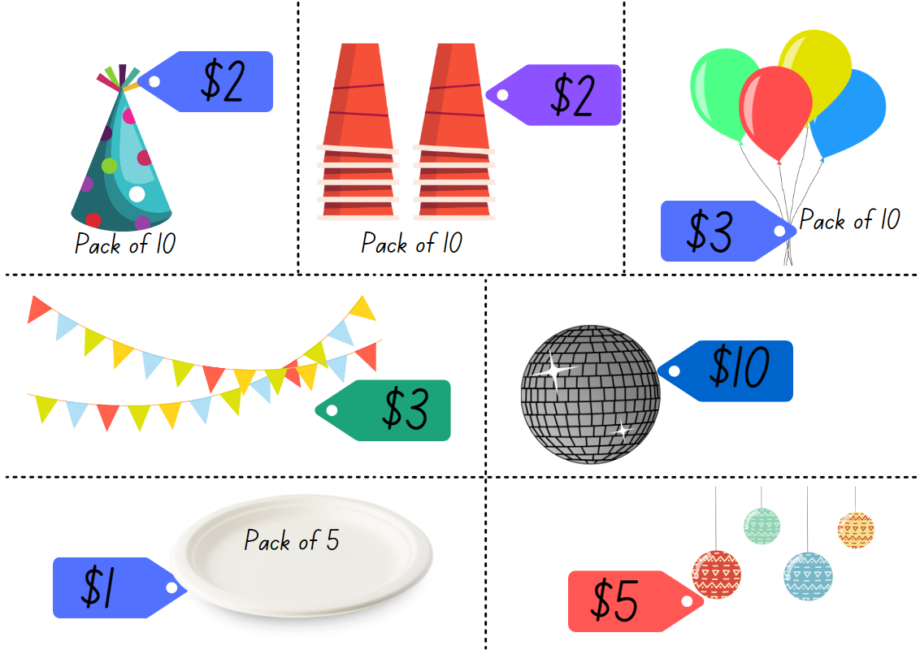
Images sourced from Canva and used in accordance with the Canva Content License Agreement.

Resource 26: Costing worksheet
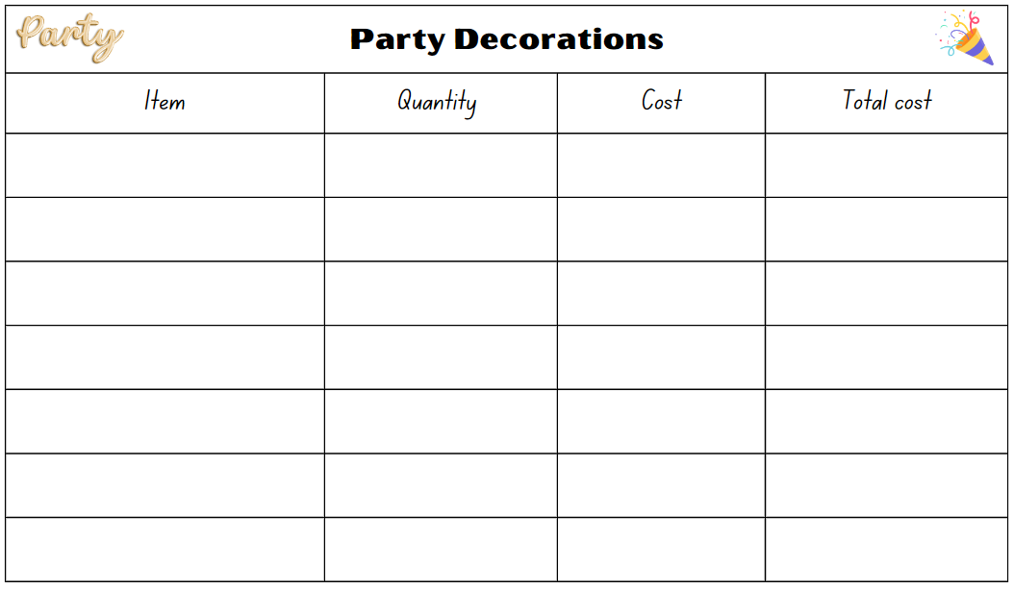
Images sourced from Canva and used in accordance with the Canva Content License Agreement.

Resource 27: Placemat catalogue
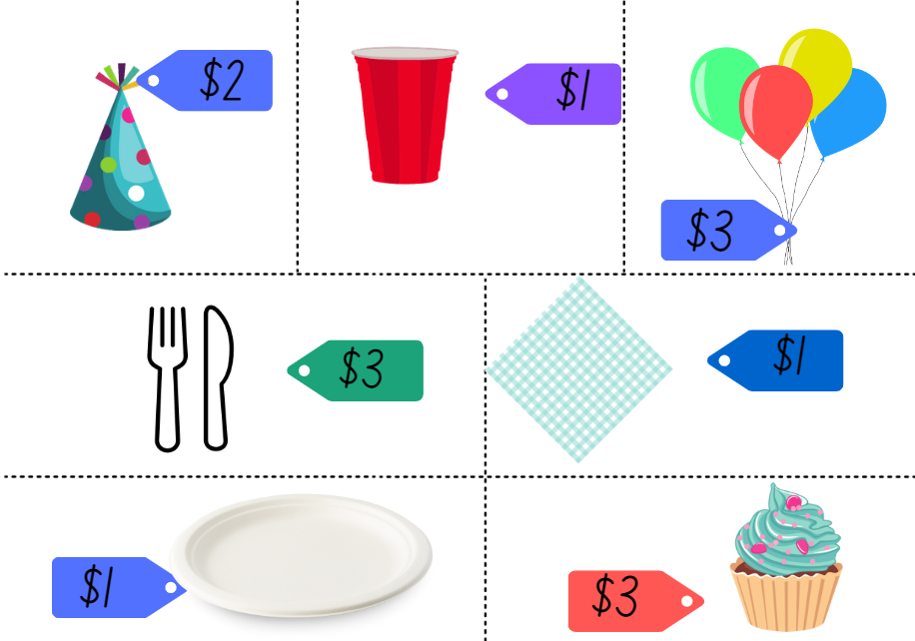
Images sourced from Canva and used in accordance with the Canva Content License Agreement.

Resource 28: Party food catalogue
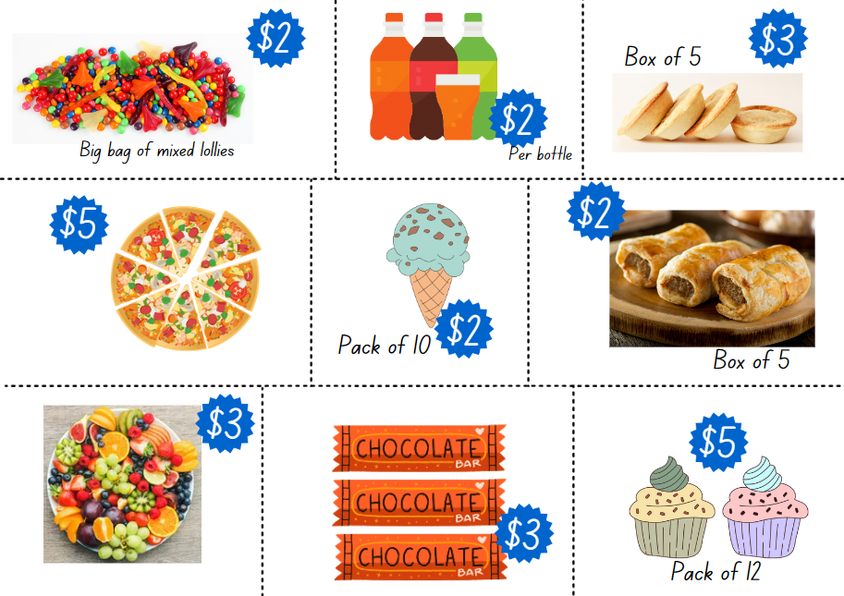
Images sourced from Canva and used in accordance with the Canva Content License Agreement.

Resource 29: Party food recording
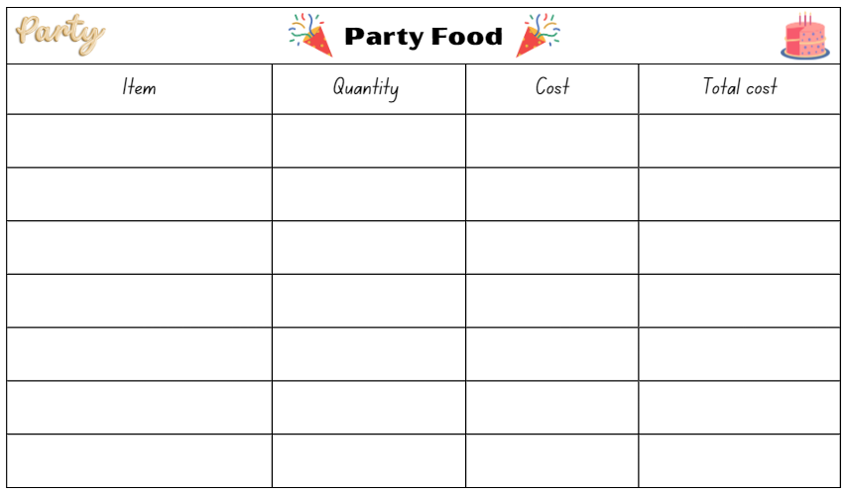
Images sourced from Canva and used in accordance with the Canva Content License Agreement.

Resource 30: Lolly bag catalogue
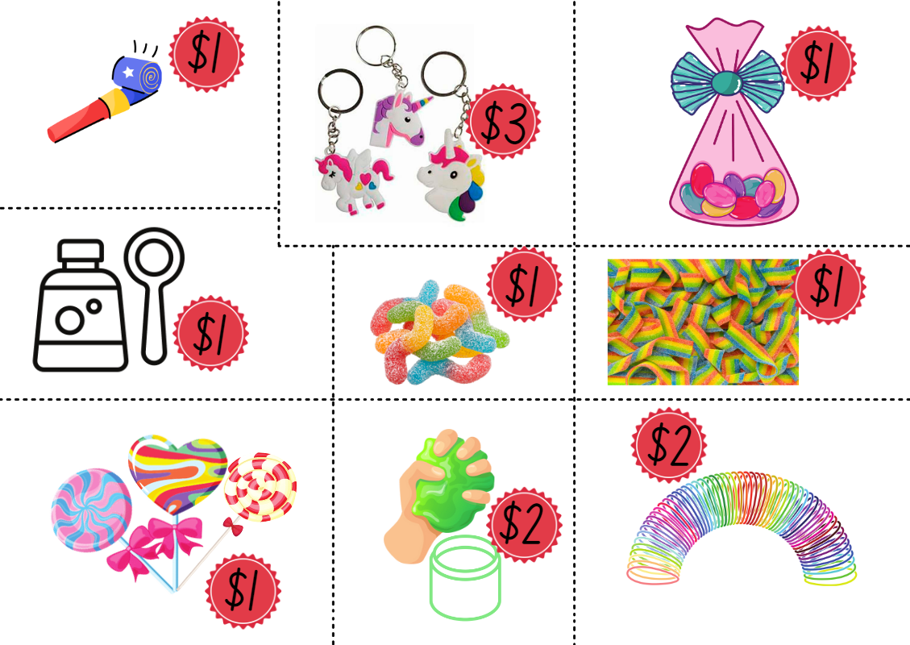
Images sourced from Canva and used in accordance with the Canva Content License Agreement.

Resource 31: Lolly bag recording
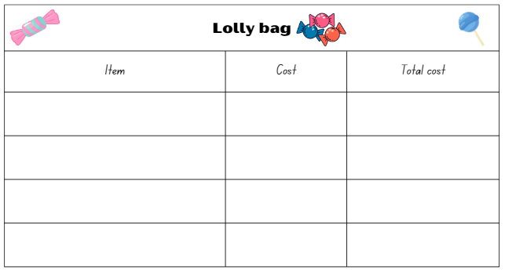
Images sourced from Canva and used in accordance with the Canva Content License Agreement.

Resource 32: Ten-frame
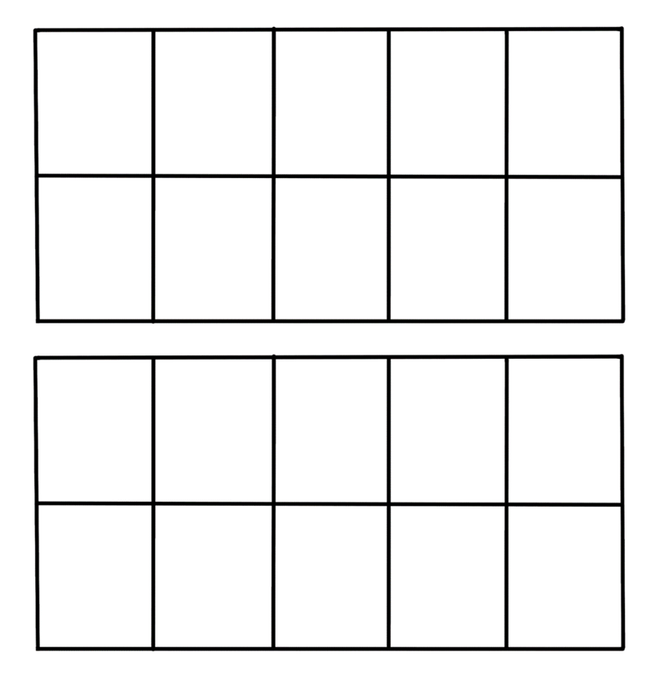

Resource 33: Battleship gameboards
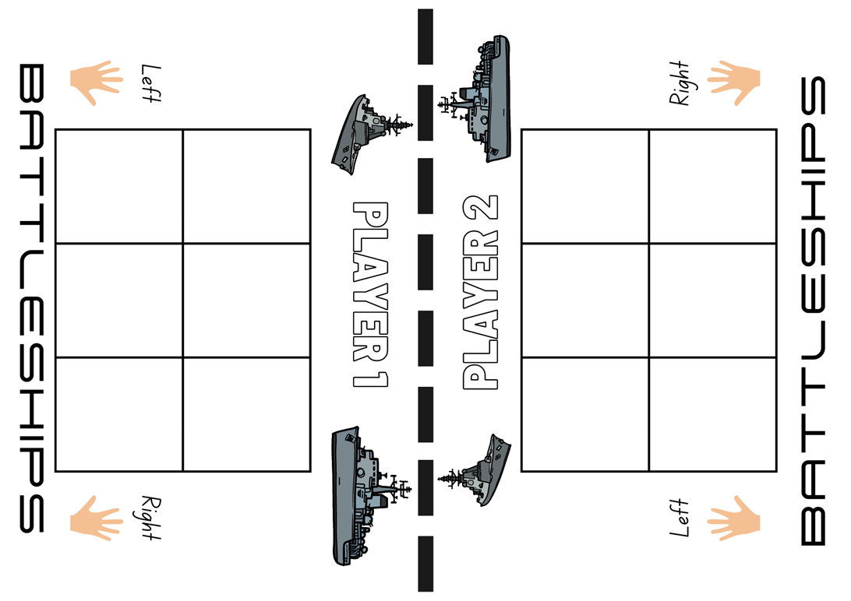
Images sourced from Canva and used in accordance with the Canva Content License Agreement.
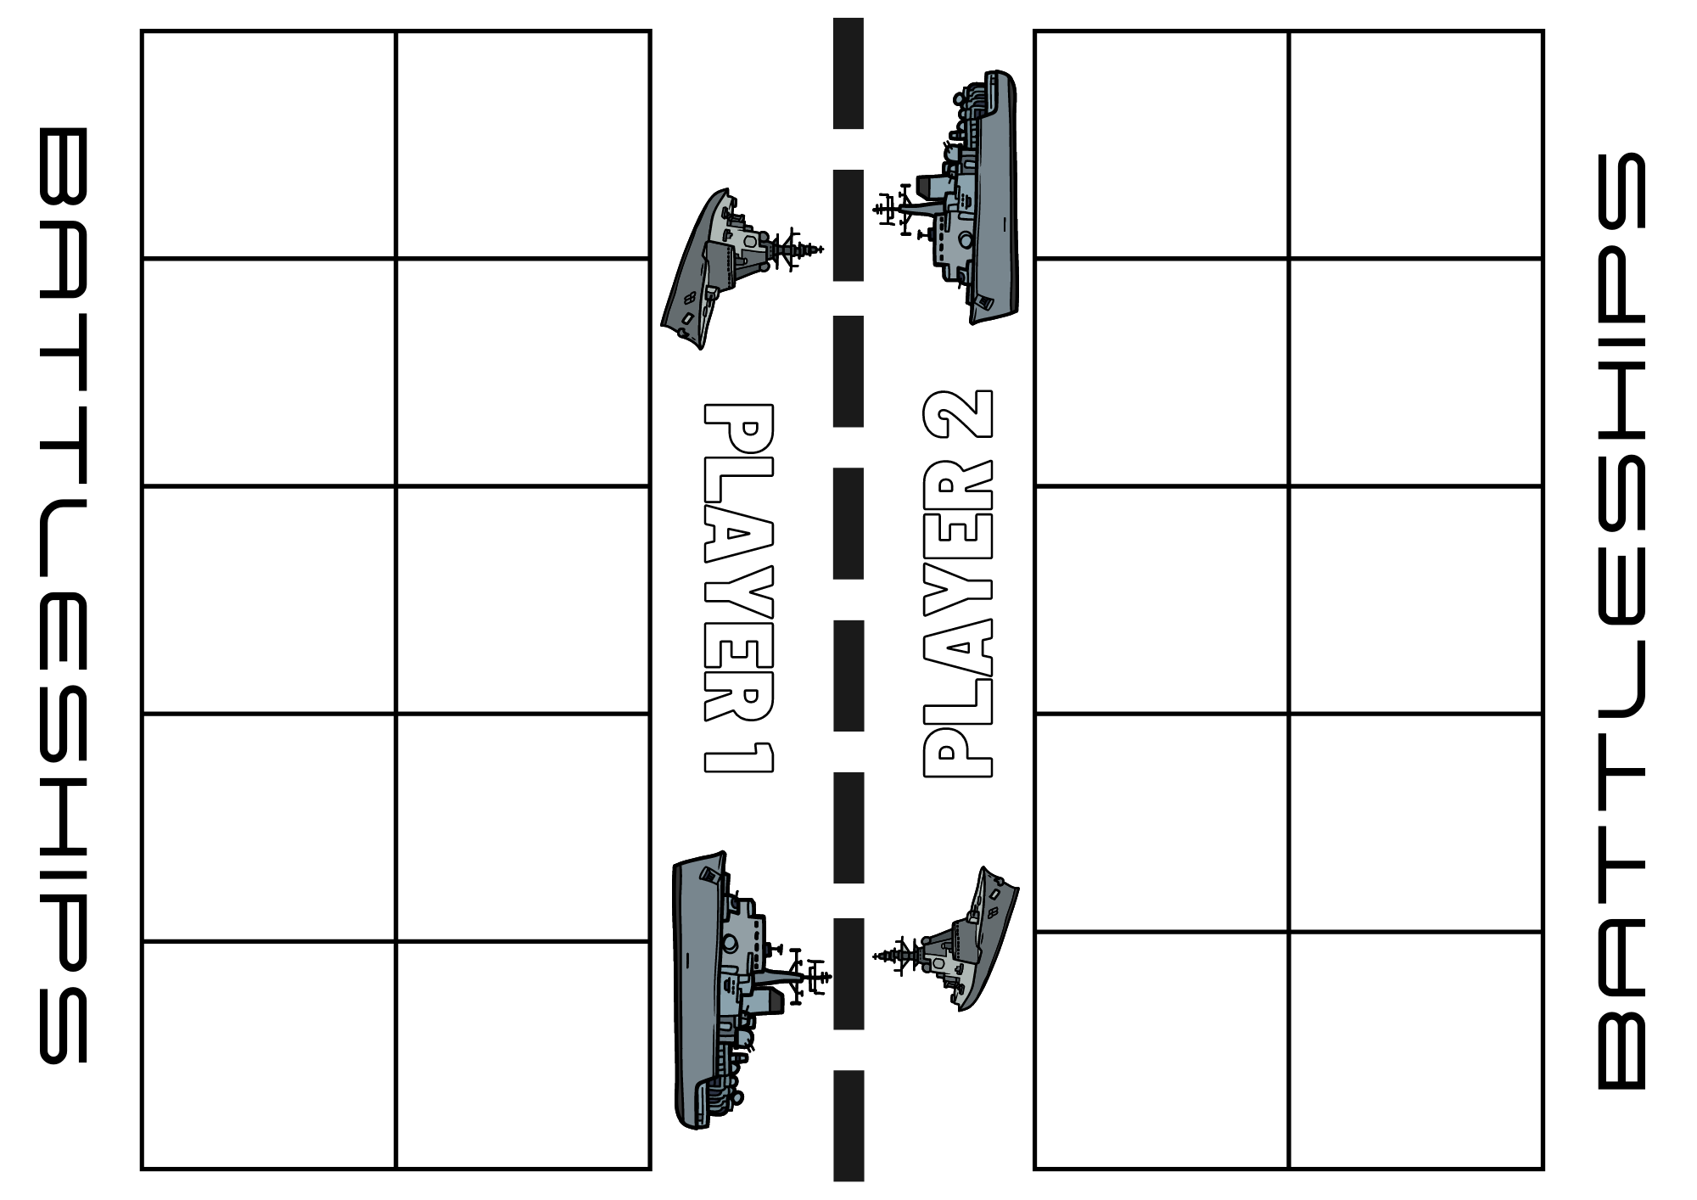
Images sourced from Canva and used in accordance with the Canva Content License Agreement.
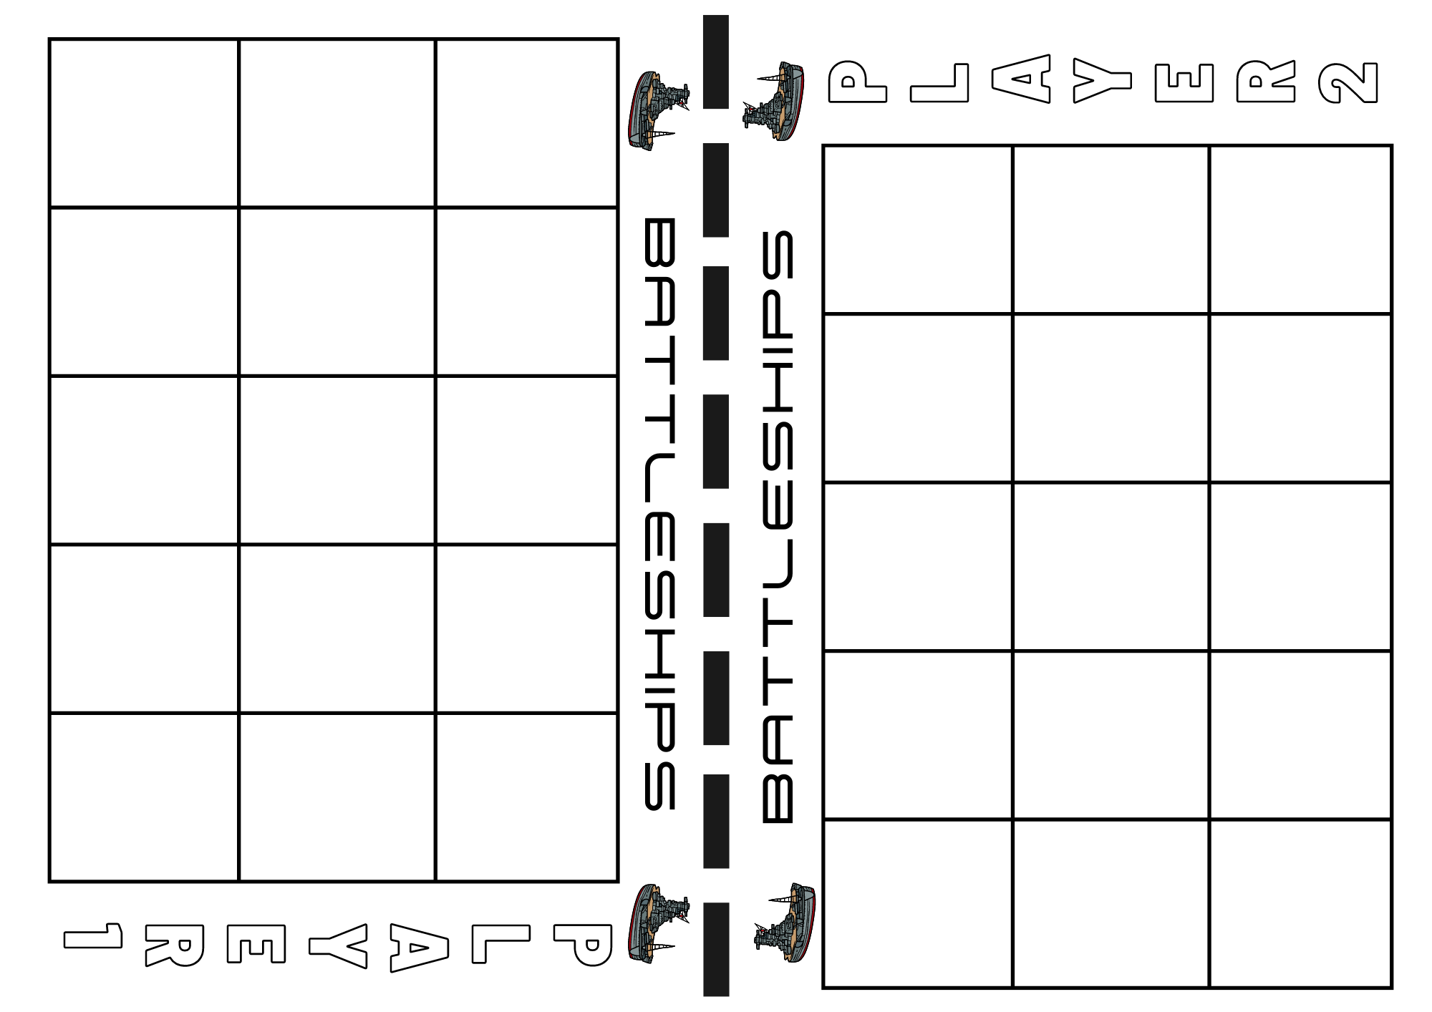
Images sourced from Canva and used in accordance with the Canva Content License Agreement.
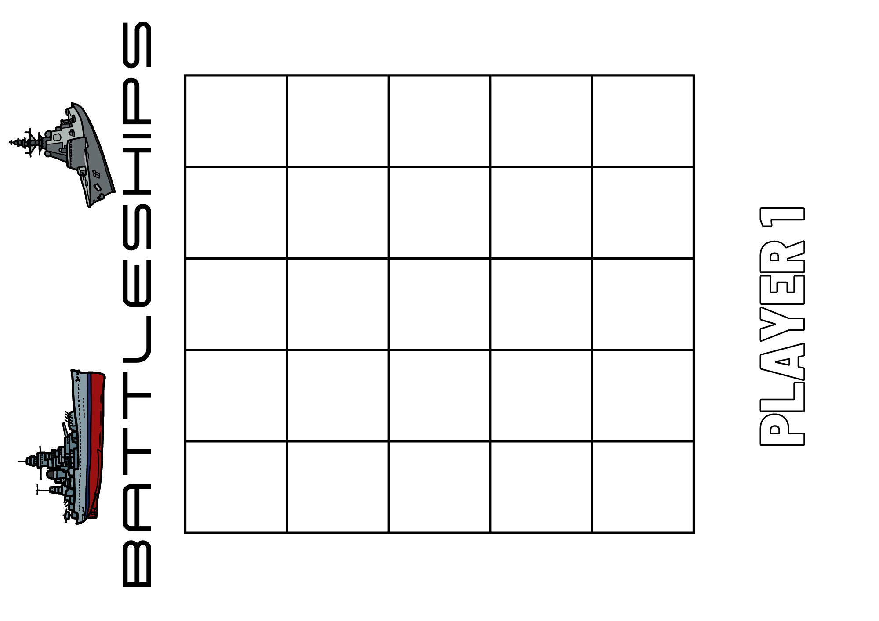
Images sourced from Canva and used in accordance with the Canva Content License Agreement.
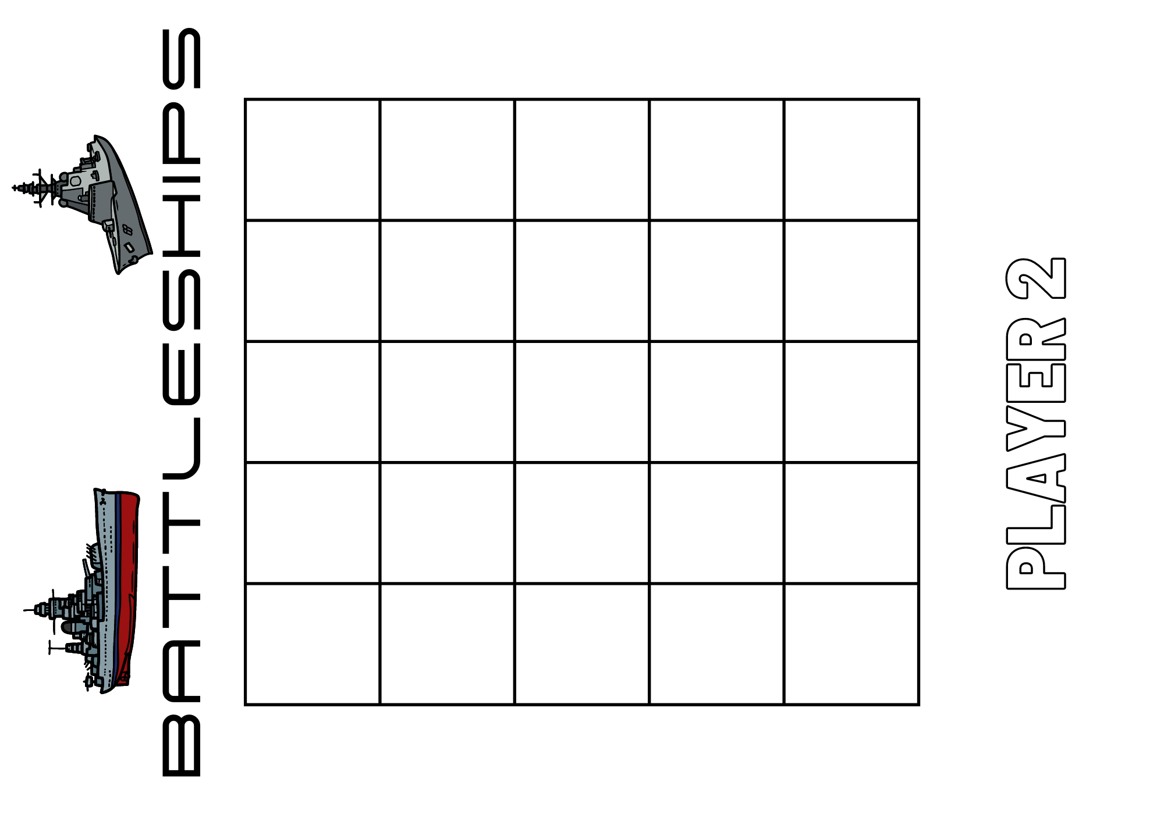
Images sourced from Canva and used in accordance with the Canva Content License Agreement.

Resource 34: Number line Zero to 100
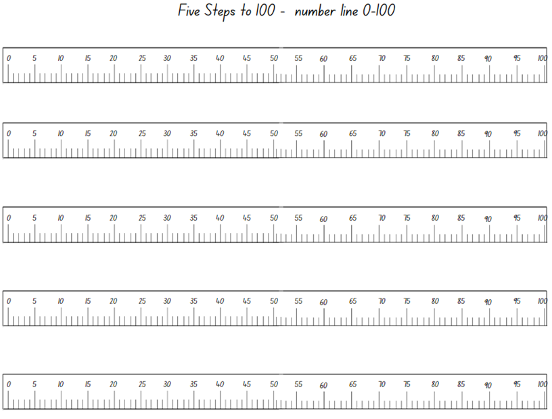
Images sourced from Canva and used in accordance with the Canva Content License Agreement.

Resource 35: Number line Zero to 500
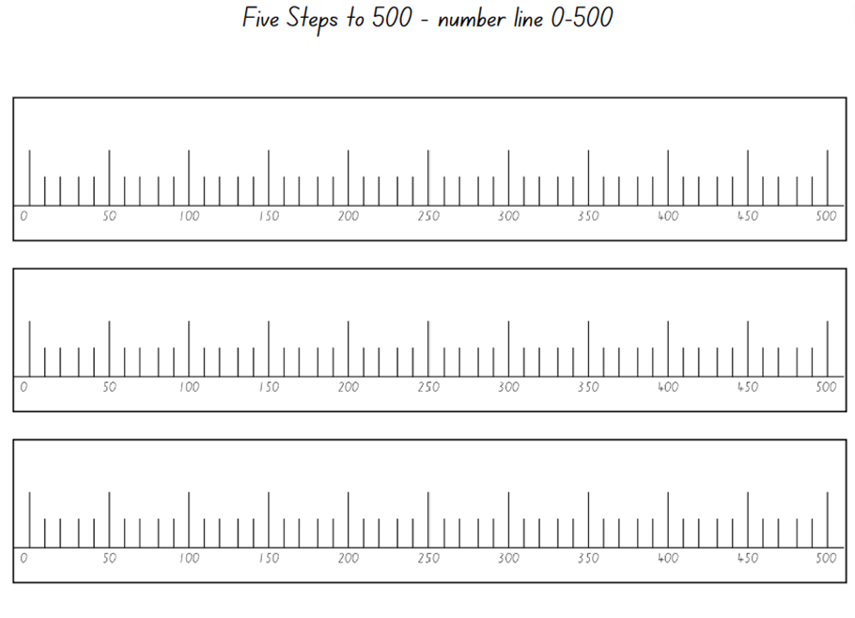
Images sourced from Canva and used in accordance with the Canva Content License Agreement.

Resource 36: Number cards
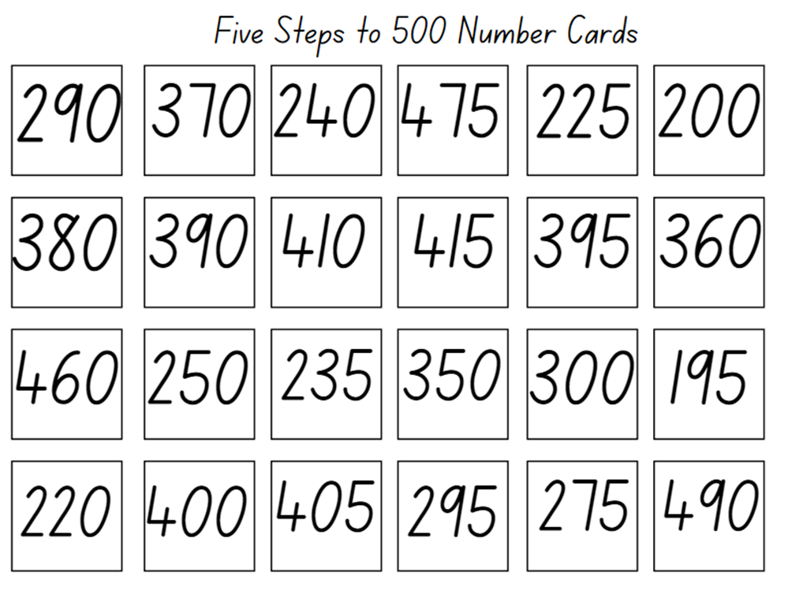

Syllabus outcomes and content
The table below outlines the syllabus outcomes and range of relevant syllabus content covered in this unit. Content is linked to National Numeracy Learning Progression version (3).
Focus area and outcomes | Content groups and content points | Lessons
Representing whole numbers  MAO-WM-01  MAE-RWN-01, MA1-RWN-01  MAE-RWN-02, MA1-RWN-02 | Early Stage 1  Use the counting sequence of ones flexibly  - Count forwards to at least 30 and state the number after or before a given number, without needing to count from one (CPr4)  - Count backwards from a given number 20 or less (CPr5)  - Identify the number before as 'one less' and the number after as 'one more’ than a given number | 1, 5–8
Representing whole numbers  (cont) | Connect counting and numerals to quantities  - Count with one-to-one correspondence, recognising that the last number name represents the total number in the collection (CPr3, Cpr5)  - Count out a specified number of objects (from 5 to 20) from a larger collection, keeping track of the count (CPr4, CpP5)  - Make correspondences between collections (Reasons about quantity)  - Read numerals to at least 20, including zero (NPV3)  - Represent numbers as quantities to at least 20 using objects (such as fingers), number words and numerals (NPV2, NPV3, NPV4, CPr3)  - Compare and order numbers to 20 (NPV2, NPV3) | 1–3, 5–8
Representing whole numbers A  (cont) | Stage 1  Use counting sequences of ones with two-digit numbers and beyond  - Identify the number before and after a given two-digit number (CPr5)  - Count forwards and backwards by ones from a given number to at least 120 (CPr6) | 7–8
Representing whole numbers A  (cont) | Represent the structure of groups of ten in whole numbers  - Recognise that ten ones is the same as one ten (NPV2, NPV4) | 8
Representing whole numbers B  (cont) | Stage 1  Use counting sequences of ones and tens flexibly  - Identify the number before and after a given three-digit number  - Count forwards and backwards by tens, on and off the decade, with two- and three-digit numbers (CPr7)  - Identify how many more to the next multiple of ten within two- and three-digit numbers | 5–6
Representing whole numbers B  (cont) | Form, regroup, and rename three-digit numbers  - State the quantity value of digits in numbers of up to three digits (Reasons about quantity) (NPV5)  - Use place value to partition and rename three-digit numbers in different ways (Reasons about relations) (NPV5) | 1–3
Combining and separating quantities  MAO-WM-01  MAE-CSQ-01, MA1-CSQ-01  MAE-CSQ-02 | Early Stage 1  Model additive relations and compare quantities  - Identify situations in which addition and subtraction may be applied (AdS1, AdS2)  - Separate and take away part of a group of objects to model subtraction (AdS1, AdS2)  - Use concrete materials or fingers to model and solve addition and subtraction questions, counting forwards or backwards by ones as necessary (AdS1, AdS2, NPV3) | 3, 6–7
Combining and separating quantities  (cont) | Identify part–whole relationships in numbers up to 10  - Use visual representations of numbers to assist with combining and separating quantities, identifying the relationship between the quantities (NPV2, NPA2, AdS2, AdS3)  - Use drawings, words and numerals to record addition and subtraction, and explain their thinking (Reasons about relations) (AdS2) | 3, 6–8
Combining and separating quantities A  (cont) | Stage 1  Use advanced count-by-one strategies to solve addition and subtraction problems  - Record number sentences in a variety of ways using drawings, words, numerals and symbols (AdS6)  - Fluently use advanced count-by-one strategies including counting on and counting back to solve addition and subtraction problems involving one- and two-digit numbers (Reasons about relations) (AdS3, AdS4, AdS5) | 3, 8
Combining and separating quantities A  (cont) | Use flexible strategies to solve addition and subtraction problems  - Use non-count-by-one strategies such as using doubles for near doubles and combining numbers that add to ten (AdS6)  - Select and apply strategies using number bonds to solve addition and subtraction problems with one- and two-digit numbers by partitioning numbers using quantity value and bridging to 10 (Reasons about relations) (AdS6, AdS7) | 3, 6–8
Combining and separating quantities B  (cont) | Stage 1  Represent and reason about additive relations  - Create, model and solve word problems, using number sentences  - Recall and use related addition and subtraction number facts to at least 20 (AdS7) | 3, 8
Combining and separating quantities B  (cont) | Form multiples of ten when adding and subtracting two-digit numbers  - Add two-digit numbers by building to multiples of ten (AdS7)  - Add and subtract from a two-digit number and record on an empty number line (AdS6, AdS7, AdS8)  - Use quantity values to separate tens and ones for addition (only) (AdS7, AdS8) | 3, 8
Combining and separating quantities B  (cont) | Use knowledge of equality to solve related problems  - Use number knowledge to solve related problems (Reasons about relations) (AdS7, NPA4)  - Use a variety of ways of writing number sentences (NPA3, NPA4) | 3, 8
Forming groups  MAO-WM-01  MAE-FG-01, MA1-FG-01  MAE-FG-02 | Early Stage 1  Investigate and form equal groups by sharing  - Distribute a group of familiar objects into smaller groups and recognise whether the number in each group is equal or not (MuS1, MuS2)  - Group and share concrete materials by distributing objects one by one or using another method (MuS1, MuS2) | 4, 5, 7
Forming groups  (cont) | Record grouping and sharing  - Label the number of objects in a group  - Record grouping and sharing using drawings, words and numerals, and explain their thinking (Reasons about relations) (MuS2) | 4–7
Forming groups A  (cont) | Stage 1  Model and use equal groups of objects to represent multiplication  - Model and describe collections of objects as groups of (MuS2)  - Determine and distinguish between the number of groups and the number in each group when describing collections of objects (Reasons about relations)  - Find the total number of objects using skip counting of equal groups of a known size (MuS2, MuS3) | 4, 6–7
Forming groups A  (cont) | Recognise and represent division  - Model sharing division by distributing a collection of objects equally into a given number of groups to determine how many in each group (InF2, MuS5)  - Model grouping division by determining the number of groups of a given size that can be formed (MuS5)  - Describe the part left over when a collection cannot be distributed equally using the given group size (MuS6) | 5–7
Forming groups B  (cont) | Stage 1  Represent and explain multiplication as the combining of equal groups  - Use objects, diagrams, images or actions to model multiplication as accumulating equal groups (MuS4)  - Solve multiplication problems using repeated addition (MuS4)  - Form arrays of equal rows and equal columns (MuS5)  - Determine and distinguish between the number of rows/columns and the number in each row/column when describing collections of objects (MuS5)  - Model the commutative property of multiplication, using an array (Reasons about relations) (MuS6) | 4, 6–7
Forming groups B  (cont) | Represent multiplication and division problems  - Solve multiplication and division problems using objects, diagrams, images and actions (MuS6, MuS7)  - Record answers to multiplication and division problems (including those with remainders) using drawings, words and numerals (MuS6) | 4–7
Geometric measure A  MA1-GM-01 | Stage 1  Position: Follow directions to familiar locations  - Give and follow instructions to position objects in models and drawings (PoL2) | 8
Non-spatial measure  MAE-NSM-01, MA1-NSM-02  MAE-NSM-02 | Early Stage 1  Time: Compare and order the duration of events using the language of time  - Use terms such as 'daytime', 'night-time', 'morning', 'afternoon', 'today', 'tomorrow', 'yesterday', 'before', 'after' and 'next' (MeT1)  - Sequence events in time (MeT1)  - Compare the duration of two events (MeT1) | 1–2
Non-spatial measure  (cont) | Time: Tell time on the hour on analog and digital clocks  - Create the layout of an analog clock (MeT2)  - Read analog and digital clocks to the hour using the term ‘o'clock’ (MeT2, MeT3)  - Describe the position of the hour and minute hands on an analog clock when reading hour time (MeT2) | 2, 6
Non-spatial measure B  (cont) | Stage 1  Time: Describe duration using units of time  - Use a calendar to calculate the number of months, weeks or days until an upcoming event (MeT3)  - Use the terms ‘hour’, ‘minute’ and ‘second’ (MeT2, MeT3)  - Compare the duration of standard time units (MeT2, MeT3)  - Make predictions about the time remaining until a particular event starts or finishes (Reasons about relations) | 1–2, 6

References
Links to third-party material and websites
Please note that the provided (reading/viewing material/list/links/texts) are a suggestion only and implies no endorsement, by the New South Wales Department of Education, of any author, publisher, or book title. School principals and teachers are best placed to assess the suitability of resources that would complement the curriculum and reflect the needs and interests of their students.
If you use the links provided in this document to access a third-party's website, you acknowledge that the terms of use, including licence terms set out on the third-party's website apply to the use which may be made of the materials on that third-party website or where permitted by the Copyright Act 1968 (Cth). The department accepts no responsibility for content on third-party websites.
Except as otherwise noted, all material is © State of New South Wales (Department of Education), 2023 and licensed under the Creative Commons Attribution 4.0 International License. All other material (third-party material) is used with permission or under licence. Where the copyright owner of third-party material has not licensed their material under a Creative Commons or similar licence, you should contact them directly for permission to reuse their material.
Mathematics K–10 Syllabus © 2022 NSW Education Standards Authority (NESA) for and on behalf of the Crown in right of the State of New South Wales.
© 2022 NSW Education Standards Authority. This document contains NSW Curriculum and syllabus content. The NSW Curriculum is developed by the NSW Education Standards Authority. This content is prepared by NESA for and on behalf of the Crown in right of the State of New South Wales. The material is protected by Crown copyright.
Please refer to the NESA Copyright Disclaimer for more information.
NESA holds the only official and up-to-date versions of the NSW Curriculum and syllabus documents. Please visit the NSW Education Standards Authority (NESA) website and the NSW Curriculum website.
National Numeracy Learning Progression © Australian Curriculum, Assessment and Reporting Authority (ACARA) 2010 to present, unless otherwise indicated. This material was downloaded from the Australian Curriculum website (National Numeracy Learning Progression) (accessed 30 March 2023) and was not modified. The material is licensed under CC BY 4.0. Version updates are tracked in the ‘Curriculum version history’ section on the 'About the Australian Curriculum' page of the Australian Curriculum website.
ACARA does not endorse any product that uses the Australian Curriculum or make any representations as to the quality of such products. Any product that uses material published on this website should not be taken to be affiliated with ACARA or have the sponsorship or approval of ACARA. It is up to each person to make their own assessment of the product, taking into account matters including, but not limited to, the version number and the degree to which the materials align with the content descriptions and achievement standards (where relevant). Where there is a claim of alignment, it is important to check that the materials align with the content descriptions and achievement standards (endorsed by all education Ministers), not the elaborations (examples provided by ACARA).
This resource contains images and content obtained from Canva, and their use outside of this resource is subject to Canva’s Content License Agreement. If you wish to use them separately from the resource, please go to Canva.
Australian Government Department of Education (2018) Authentic Problems: Tea Party, Mathematical Inquiry into Authentic Problems, reSolve: Maths by Inquiry website, accessed 26 April 2023.
New Zealand Ministry of Education (n.d.) ‘Clock wise (time)’, Resource, NZ Maths website, accessed 26 April 2023.
New Zealand Ministry of Education (n.d.) ‘How long does it take?’, Resource, NZ Maths website, accessed 26 April 2023.
Rogers A (3 August 2022) ‘Notice and Wonder’, Numeracy Teachers Academy: Dr Ange's Blog, accessed 26 April 2023.
Russo J (2020) ‘Short Activity: Part-Whole Triangles’, Australian Primary Mathematics Classroom, 25(3):16–17, accessed 26 April 2023.
State of New South Wales (Department of Education) (2023) ‘10 or bust (additive strategies)’, Mathematics K-6 resources, NSW Department of Education website, accessed 16 May 2023.
State of New South Wales (Department of Education) (2023) ‘Number busting – number talk (renaming 7 and 8)’, Mathematics K-6 resources, NSW Department of Education website, accessed 16 May 2023.
State of New South Wales (Department of Education) (2023) ‘Place value game’, Mathematics K-6 resources, NSW Department of Education website, accessed 16 May 2023.
State of New South Wales, Department of Education (n.d.) ‘Activities to Support Multiplication and Division: Maths tipping’, Counting on-and-back Strategies, Developing Efficient Numeracy Strategies One website, accessed 26 April 2023.
State of New South Wales, Department of Education (n.d.) ‘Activities to Support Early Arithmetical Strategies: Race to 200’, Counting on-and-back Strategies, Developing Efficient Numeracy Strategies One website, accessed 26 April 2023.
State of New South Wales, Department of Education (n.d.) ‘Activities to Support Multiplication and Division: Rolling groups’, Counting on-and-back Strategies, Developing Efficient Numeracy Strategies One website, accessed 26 April 2023.
State of New South Wales, Department of Education (n.d.) ‘Activities to Support Multiplication and Division: Share it out’, Counting on-and-back Strategies, Developing Efficient Numeracy Strategies One website, accessed 26 April 2023.
State of Victoria (Department of Education and Training) (n.d) One Hundred Hungry Ants by Elinor J Pinczes, FUSE website, accessed 26 April 2023.
Swan P (2003) Dice Dazzlers (From Here to There), A-Z Type, Australia.
Toy Theater (2001–2023) Interactive Clock | Telling Time, Time Manipulatives, Toy Theater website, accessed 26 April 2023.
University of Cambridge (Faculty of Mathematics) (1997–2023) Five Steps to 50, NRICH website, accessed 26 April 2023.
University of Cambridge (Faculty of Mathematics) (1997–2023) Snail One Hundred, NRICH website, accessed 26 April 2023.
University of Cambridge (Faculty of Mathematics) (1997–2023) Strike it Out, NRICH website, accessed 26 April 2023.

