Mathematics – Stage 1 – Unit 18
Contents
Unit description and duration 4
Student prior learning 4
Lesson overview and resources 5
Lesson 1: Building bricks! 13
Daily number sense: Sorting building bricks – 10 minutes 13
Building bricks! – 40 minutes 14
Consolidation and meaningful practice: Building bricks! – 15 minutes 18
Lesson 2: Planning playgrounds – Part 1 19
Daily number sense: Counting fives – 10 minutes 19
Let’s collect data! – 40 minutes 20
Consolidation and meaningful practice: What were the most popular? – 10 minutes 23
Lesson 3: Planning playgrounds – Part 2 24
Daily number sense: Data talk – 10 minutes 25
Asking others – 40 minutes 25
Consolidation and meaningful practice: Playground preferences – 10 minutes 28
Lesson 4: Planning playgrounds – Part 3 29
Daily number sense: Number talk – 10 minutes 29
Perfect playgrounds – 40 minutes 31
Consolidation and meaningful practice: Problem solved! – 20 minutes 33
Lesson 5: Sort the Street 34
Daily number sense: Data talk– 10 minutes 34
Sort the Street – 45 minutes 36
Consolidation and meaningful practice: Re-think and reflect – 10 minutes 41
Lesson 6: Making robots 42
Daily number sense: Data talk – 10 minutes 43
Making robots – 50 minutes 44
Consolidation and meaningful practice: – 10 minutes 51
Lesson 7: What rubbish is in my lunch box? 53
Daily number sense: What number could this be? – 15 minutes 53
What rubbish is in my lunch box? – 30 minutes 55
Consolidation and meaningful practice: What helped us read the data? – 15 minutes 60
Lesson 8: What bin do we need? 62
Daily number sense: Favourite season data talk – 15 minutes 62
What bin do we need the most? – 40 minutes 63
Consolidation and meaningful practice: Gallery walk – 15 minutes 67
Resource 1: Hundreds chart 68
Resource 2: Playgrounds 69
Resource 3: Playground equipment 70
Resource 4: Playground tally chart 71
Resource 5: Column graph 72
Resource 6: Popular fruit graph 73
Resource 7: Data talk 1 74
Resource 8: House cards 75
Resource 9: N.W.L. (Notice Wonder Learnt) chart 76
Resource 10: Data talk 2 77
Resource 11: Robot body parts 78
Resource 12: Robots template 81
Resource 13: Number line 82
Resource 14: Lunch box images 83
Resource 15: Graph template 84
Resource 16: Favourite season graph 85
Resource 17: Tally mark table 86
Resource 18: Recycling graph 87
Syllabus outcomes and content 88
References 92

Unit description and duration
This two-week unit develops student knowledge, understanding and skills of data. Students are provided opportunities to:
- conduct surveys to collect data and use data to solve problems
- recognise and describe the element of chance in everyday events
- gather, organise, and represent data in effective and accurate ways
- interpret a data display and describe information using comparative language.
Mathematics K–10 Syllabus © 2022 NSW Education Standards Authority (NESA) for and on behalf of the Crown in right of the State of New South Wales.

Student prior learning
Before engaging in these teaching and learning activities, students would benefit from prior experience with:
- responding to questions, collecting information, and discussing possible outcomes of activities
- organising objects into simple data displays and interpreting the displays.

Lesson overview and resources
The table below outlines the sequence and approximate timing of lessons; syllabus focus areas and content groups; and resources.
Lesson | Syllabus focus area and content groups | Resources
Lesson 1: Building bricks!  65 minutes  Data can be sorted and represented in different ways. | Representing whole numbers A  - Use counting sequences of ones with two-digit numbers and beyond  Data A  - Ask questions and gather data  - Represent data with objects and drawings and describe the displays  Data B  - Identify a question of interest and gather relevant data  Chance A  - Identify and describe possible outcomes | - Video: Brick data (9:48)  - Building bricks  - Concealed bag containing loose building bricks  - Large sheet of paper or cardboard (to create anchor chart)  - Writing materials
Lesson 2: Planning playgrounds – Part 1  60 minutes  Data can be collected and represented in graphs. | Representing whole numbers A  - Use counting sequences of ones with two-digit numbers and beyond  Data A  - Ask questions and gather data  - Represent data with objects and drawings and describe the displays  Data B  - Identify a question of interest and gather relevant data  Chance A  - Identify and describe possible outcomes  Chance B  - Identify and describe activities that involve chance | - Resource 1: Hundreds chart  - Resource 2: Playgrounds or own images of local playgrounds  - Resource 3: Playground equipment  - Resource 4: Playground tally chart  - Resource 5: Column graph  - Interlocking cubes  - Writing materials
Lesson 3: Planning playgrounds – Part 2  60 minutes  Data can be used to answer questions and make informed decisions. | Representing whole numbers A  - Use counting sequences of ones with two-digit numbers and beyond  Data A  - Ask questions and gather data  - Represent data with objects and drawings and describe the displays  Data B  - Identify a question of interest and gather relevant data  Chance A  - Identify and describe possible outcomes  Chance B  - Identify and describe activities that involve chance | - Resource 6: Popular fruit graph  - Resource 4: Playground tally chart  - Resource 5: Column graph  - Sticky notes
Lesson 4: Planning playgrounds – Part 3  70 minutes  Organising data helps find solutions to problems. | Representing whole numbers A  - Use counting sequences of ones with two-digit numbers and beyond  Data A  - Ask questions and gather data  - Represent data with objects and drawings and describe the displays  Data B  - Identify a question of interest and gather relevant data  Chance A  - Identify and describe possible outcomes  Chance B  - Identify and describe activities that involve chance | - Resource 5: Column graph  - 12 building bricks matching the colours in Figure 3  - Class surveys from Lesson 3  - Drawing materials  - Building bricks or interconnecting blocks
Lesson 5: Sort the Street  65 minutes  Data helps make sense of our world. | Representing whole numbers A  - Use counting sequences of ones with two-digit numbers and beyond  Data A  - Ask questions and gather data  - Represent data with objects and drawings and describe the displays  Data B  - Identify a question of interest and gather relevant data  Chance A  - Identify and describe possible outcomes  Chance B  - Identify and describe activities that involve chance | - Resource 7: Data talk 1  - Resource 8: House cards – one per pair of students  - Resource 9: N.W.L. (Notice Wonder Learnt) chart  - A3 paper
Lesson 6: Making robots  70 minutes  Thinking about the data can help make predictions about the future. | Representing whole numbers A  - Use counting sequences of ones with two-digit numbers and beyond  Data A  - Ask questions and gather data  - Represent data with objects and drawings and describe the displays  Data B  - Identify a question of interest and gather relevant data  Chance A  - Identify and describe possible outcomes  Chance B  - Identify and describe activities that involve chance | - Resource 10: Data talk 2  - Resource 11: Robot body parts  - Resource 12: Robots template
Lesson 7: What rubbish is in my lunch box?  60 minutes  Data can be collected and displayed to investigate a topic or answer a question. | Representing whole numbers A  - Use counting sequences of ones with two-digit numbers and beyond  Data A  - Ask questions and gather data  - Represent data with objects and drawings and describe the displays  Data B  - Identify a question of interest and gather relevant data  Chance A  - Identify and describe possible outcomes  Chance B  - Identify and describe activities that involve chance | - Resource 13: Number line  - Resource 14: Lunch box images  - Resource 15: Graph template  - A3 paper
Lesson 8: What bin do we need?  70 minutes  The same data can be used to answer different questions. | Representing whole numbers A  - Use counting sequences of ones with two-digit numbers and beyond  Non-spatial measure A  - Time: Name and order the cycle of months  Data A  - Ask questions and gather data  - Represent data with objects and drawings and describe the displays  Data B  - Identify a question of interest and gather relevant data  Chance A  - Identify and describe possible outcomes  Chance B  - Identify and describe activities that involve chance | - Resource 16: Favourite season graph  - Resource 17: Tally mark table  - Resource 18: Recycling graph  - Data displays from Lesson 7

Lesson 1: Building bricks!
Core concept: Data can be sorted and represented in different ways.
The table below contains suggested learning intentions and success criteria. These are best co-constructed with students.
Learning intentions | Success criteria
Students are learning that:  - graphs organise data in an efficient way  - objects can be sorted into categories by their attributes  - possible outcomes can be described and predicted. | Students can:  - organise building bricks into categories or groups  - arrange building brick categories into columns in a graph  - describe information presented in one-to-one data displays  - describe possible outcomes  - use comparative language to describe their display, such as ‘more than' and ‘less than’.

Daily number sense: Sorting building bricks – 10 minutes
- Build student understanding of chance and data by predicting colours and organising building bricks efficiently.
- Show a pile of building bricks in a concealed bag. Ask students to predict the colours they could get, then have students collect a handful at random.
- Students compare their predictions to the colours they received. Explain that students are now going to organise their pile in an efficient way. You may need to explain that, in this activity, the word ‘efficient’ means organised in a way that their building bricks can be seen easily.
- Discuss student thinking with the class.
The table below outlines stimulus prompts to generate conversation about the topic, along with anticipated responses from students.
Prompts | Anticipated student responses
- How did you organise your pieces?  - What is the same or different?  - What are you wondering? | - I grouped them in colours first.  - I organised them into colours, then lined them up neatly in columns to count them easily.  - I used number combinations when they were organised into colours. For example, I counted by twos, fives and so on.

Building bricks! – 40 minutes
- Watch Brick data (9:48) and ask students:
- What was the most efficient way to show the building bricks?
- What was the least efficient way to show the building bricks?
- Is it easier to look at graphs that have gaps or no gaps?
- What would be the best graph to show your answers?
- Create a data anchor chart to display ways to represent data using column graphs, picture graphs and tally marks. For example, see Figure 1.
Figure 1 – Types of Graphs anchor chart
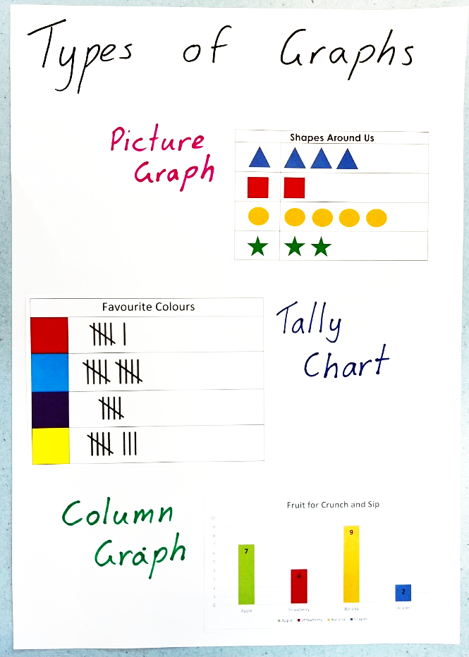
- Draw attention to the common features of these graphs including the titles, columns, number, and so on.
- Briefly discuss that graphs can show different kinds of data. For example, tally charts can show how many cars and buses drive past, and column graphs can be used to show your class’s favourite ice cream flavour. Ask students if they can think of any other topics to gather different types of data.
- Use these examples to create an anchor chart about data and graphs to display in the classroom. This can be referred to throughout the unit.
- Discuss ‘chance’ and ‘data’ using the prompts below. Student responses can be added to the anchor chart throughout the lesson.
The table below outlines stimulus prompts to generate conversation about the topic, along with anticipated responses from students.
Prompts | Anticipated student responses
- What does chance describe?  - What is data?  - Why do we have data?  - Who uses data?  - What are some examples of data?  - How do people show data? | - Chance describes how likely something is to happen.  - Data is information.  - We collect data to share information about different things.  - Everyone uses data.  - People show data through different types of graphs, pictures, and numbers.
- Students sort and organise their building bricks from the Daily number sense activity in an efficient way. Students share their data sorts with the class and explain how they organised their categories.
- If time allows, students can show their data in another way. For example, sorting into rows or building towers.
This table details assessment opportunities and differentiation ideas.
Assessment opportunities | Too hard? | Too easy?
What to look for:  - Can students describe the chance of an event occurring? (MA1-CHAN-01)  - Are students able to organise their building bricks into categories without leaving gaps? (MA1-DATA-01, MA1-DATA-02)  - Can students explain their sort? For example, 'I organised my building bricks into colour groups.’ (MAO-WM-01, MA1-DATA-01, MA1-DATA-02)  - Can students collect and answer questions about data collected? (MA1-DATA-01, MA1-DATA-02)  What to collect:  - photos of students’ work and work samples as evidence of learning (MAO-WM-01, MA1-DATA-01, MA1-DATA-02) | Students cannot identify an attribute, such as colour, to sort their objects.  - Support students to identify one attribute to sort their objects, for example, sorting by colour.  - Model how to arrange the objects into distinct categories that makes it clear how many there are in each group. | Students can sort their objects by an identified attribute.  - Provide students with additional building bricks and ask them to complete another attribute sort.  - Students look for as many different attributes to sort their building bricks by.

Consolidation and meaningful practice: Building bricks! – 15 minutes
- Students go on a data gallery walk around the classroom, comparing different ways to organise and represent data. If needed, refer to the data sense activity video Brick data (9:48) and revise how to represent efficiently.
- As a class, students turn and talk to share their data organisation and representations with one another. Ask students:
- What are some similarities that you noticed in the ways groups organised their data?
- What are some differences you found?
- Did anyone organise their building bricks differently to someone else?
- Were your predictions about the colours accurate or not?
- Is there anything that you are still wondering?
- A summary of student learning can be added to the data anchor chart.

Lesson 2: Planning playgrounds – Part 1
Core concept: Data can be collected and represented in graphs.
This lesson has been adapted from Statistics: Planning Playgrounds from reSolve (2020).
The table below contains suggested learning intentions and success criteria. These are best co-constructed with students.
Learning intentions | Success criteria
Students are learning that:  - data can be represented in different ways  - possible outcomes in activities and events can be described as likely or unlikely to happen  - topics of interest can be investigated by choosing suitable questions. | Students can:  - describe possible outcomes in the survey as likely or unlikely  - gather data on playground facilities  - explain how to read different types of graphs  - use information in graphs to answer questions  - use tally marks to gather and track what has been counted.

Daily number sense: Counting fives – 10 minutes
- Build student understanding of the importance of skip counting by identifying patterns of 5.
- Students are provided with a copy of Resource 1: Hundreds chart or use the Interactive hundreds chart, with the fives and tens columns highlighted. As a class, ask students to identify the pattern they see on the hundreds chart provided.
- Discuss with students the importance of skip counting. For example, you could ask students when they think skip counting by fives might be useful or to share when they have used skip counting. Practise skip counting by fives as a whole class.
- Explain that we can identify the number 5 in different ways other than numerals, for example:
- tallies
- hands
- groups of
- half the decade.
- Write 23 on the board in tally marks. Highlight the use of tally marks to represent the number 5 and ask:
- Why is there a strike for the fifth tally?
- Is it easier to keep track of numbers by using tally marks?
- How can we add on the last 3 tallies?
- Demonstrate a non-example by drawing 10 lines when counting to 10 with no strikes. Repeat using the tally method, then talk about which way is more efficient and why.

Let’s collect data! – 40 minutes
- Explain that words such as ‘might’, ‘possible’, ‘less likely’, ‘more likely’ or ‘equally likely’ describe the chance of something happening. Use examples of the weather for students to practise using these words in a familiar context.
- Revise the data anchor chart and learning from the previous lesson. Use Resource 2: Playgrounds, or your own local images, to introduce a discussion of playground equipment.
- Students share problems they may have faced when trying to use playground equipment, for example, not having enough of the popular equipment. Use this discussion to decide on a question to be asked and solved throughout the ‘Planning playgrounds’ lessons, for example:
- What equipment should every playground include?
- How many of each equipment type should the playground have?
- What equipment should a playground include to accommodate an age/ability group?
- Ask students how likely they think it is that the swings will be the most popular equipment, then record some predictions. Explain that we can use data to know for certain what the answer will be.
- Use the images from Resource 3: Playground equipment on an A3 piece of paper or whiteboard as a survey, to collect data from students in the class. Each student places an interlocking cube on the image of their preferred equipment. See Figure 2.
Figure 2 – Playground data towers
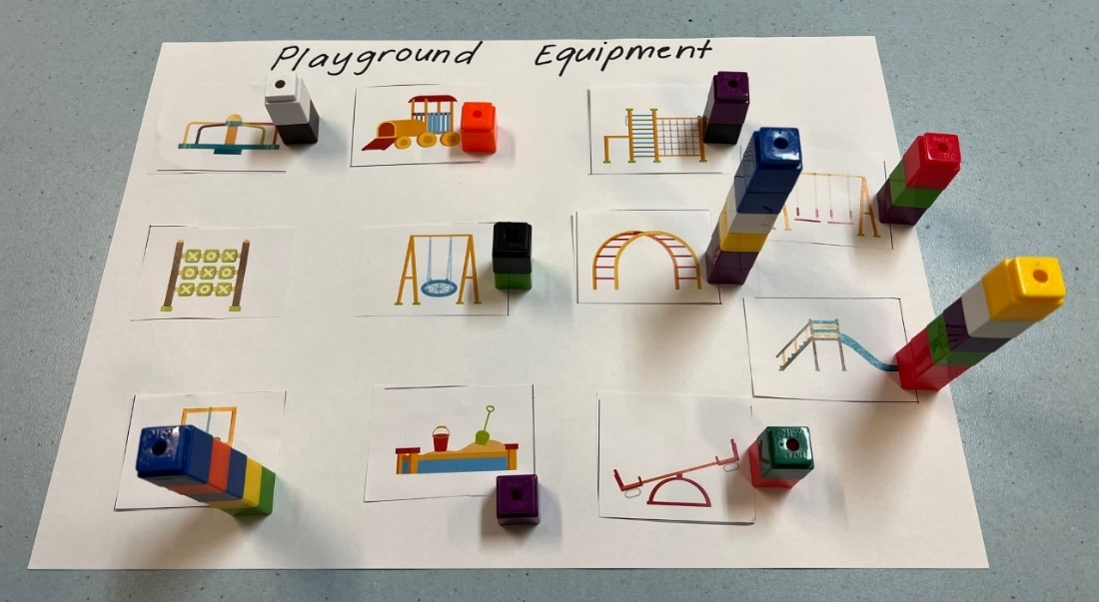
- Use the results to demonstrate how to convert into tally marks using Resource 4: Playground tally chart.
- Ask students if the tally marks made it easier to count the results, and if the results were what they predicted they would be.
- Draw students’ attention to the information shown in the tally chart. For example, most students wanted more slides, but only a few students wanted more sandpits in the playground.
- Demonstrate how to record one piece of playground equipment on Resource 5: Column graph. Students then record the remaining responses on their own copy of the graph.
This table details assessment opportunities and differentiation ideas.
Assessment opportunities | Too hard? | Too easy?
What to look for:  - Can students describe the chance of an event occurring? (MA1-CHAN-01)  - Are students able to interpret the information collected from a survey? (MA1-DATA-02)  - Can students use data to create a simple column graph? (MA1-DATA-01)  What to collect:  - student work samples and images of the completed graph (MA1-DATA-01) | Students are having difficulty presenting the data as a column graph.  - Support students by counting the tallies to find the total amounts.  - Remind students about the question that this data is being collected to answer.  - Support students to construct their graph from the data collected. | Students are confident using the data to create the graphs.  - Ask students to find other ways to present the data. For example, students could create a bar graph or picture graph.  - Ask students to show how this graph would change if each block represented a different value, for example, with one block equalling 2 students.

Consolidation and meaningful practice: What were the most popular? – 10 minutes
- Prompt students to turn and talk about the following questions, referring to the completed class graph from activity 11:
- Which playground equipment was the most popular?
- Which playground equipment was the least popular?
- If we interviewed another class, would we have the same results? Why do you think this?
- Students share their thinking about how we can collect and share data clearly, for example:
- Mathematicians use tally marks to record results so they can be counted efficiently.
- We compare the columns and blank spaces to determine the popularity and gaps that are in the data we collected.
- To summarise the lesson, include on the data anchor chart any important mathematical language and the focus that data can be collected and represented in graphs.

Lesson 3: Planning playgrounds – Part 2
Core concept: Data can be used to answer questions and make informed decisions.
Note: In this lesson students will have the opportunity to survey other students in the school to collect their own data set. This may need to be negotiated with other teachers to determine an appropriate time and format.
The table below contains suggested learning intentions and success criteria. These are best co-constructed with students.
Learning intentions | Success criteria
Students are learning that:  - data can be collected by surveying  - data needs to be represented accurately  - possible outcomes of familiar activities and events can be described. | Students can:  - ask questions and record data in an effective way, for example, by using tally marks  - represent data in a picture graph using a baseline, equal spacing and same-sized symbols  - identify possible outcomes of familiar activities and events.

Daily number sense: Data talk – 10 minutes
- Build student understanding of different types of data displays by interpreting the visual display on Popular Fruits [PDF 311KB] from Youcubed.
- Show Resource 6: Popular fruit graph. Ask students what they notice and what they wonder.
- In pairs, students record their thinking on sticky notes and place them around the display.
- Ask students to explain their thinking. Possible discussion prompts include:
- What do you think this data display is communicating?
- What do you think the sizes of the pictures represent?
- Can we rearrange this graph to compare popularity in another way?

Asking others – 40 minutes
This lesson has been adapted from Statistics: Planning Playgrounds from reSolve (2020).
- As a class, revise the playground problem posed in Lesson 2. Encourage students to use mathematical language to respond to the discussion prompts below.
The table below outlines stimulus prompts to generate conversation about the topic, along with anticipated responses from students.
Prompts | Anticipated student responses
- What were our original predictions about the playground equipment?  - Did we find out from our data if our predictions were accurate?  - Is there enough data to create a solution to our problem?  - If we asked another class, or somewhere else in NSW, would we get the same results?  - What if they are an older or younger class? | - Our original prediction was…  - Our predictions were/weren’t accurate because…  - The most popular was…  - There were twice as many…  - There were __ more people who liked __ than __.
- Explain that students are going to interview another class of a different age group to answer the question posed in Lesson 2. Prompt students to prepare questions, such as ‘Which is your favourite type of playground equipment?’ Ask students if they predict that the responses will be similar or different and why.
- Organise students into small groups and visit classes that you have negotiated with prior to the lesson.
- Provide a copy of Resource 4: Playground tally chart for each group to record their responses as tally marks. Decide as a class the types of equipment to include in the survey.
- Remind students of the appropriate way to move around the school and approach other classes. Students then survey other classes.
- Students present their findings in Resource 5: Column graph once they return.
This table details assessment opportunities and differentiation ideas.
Assessment opportunities | Too hard? | Too easy?
What to look for:  - Can students describe the chance of an event occurring? (MA1-CHAN-01)  - Are students able to track the data collected using tally marks? (MA1-DATA-01)  - Can students convert tally marks into a graph? (MA1-DATA-01)  What to collect:  - observations of students’ chance predictions (MA1-CHAN-01)  - student work samples, including survey results and graphs (MA1-DATA-01) | Students have difficulty tracking tally marks. Support students by practising counting by fives and counting on.  Students are having difficulty converting tally marks into a column graph.  - Model transferring one tally mark to one unit in the column graph.  - Support students by completing the graph as a group. | Students are confident representing the data in a column graph.  - Revise the variety of graphs for students to select from in the class constructed data anchor chart in Lesson 1.  - Students choose a different style of graph to present their findings.

Consolidation and meaningful practice: Playground preferences – 10 minutes
- As a class, discuss the results of the data collected from other classes. Students make inferences by comparing the graph they created and the original class graph.
The table below outlines stimulus prompts to generate conversation about the topic, along with anticipated responses from students.
Prompts | Anticipated student responses
- What did you notice about the data from the different classes? Were your predictions accurate?  - Were there any similarities or differences?  - Why do you think there are differences between the 2 graphs?  - Can you use both sets of data to predict how many students will use the playground equipment each day?  - Is there anything you are still wondering? | - Some students liked the same equipment as us, but some students had different choices.  - Not every student wants the same equipment as we did.  - Older students might have preferred climbing equipment over swings.  - Younger students might like equipment that appears safer.
- Summarise the lesson by reminding students that data can be used to answer questions and make informed decisions.

Lesson 4: Planning playgrounds – Part 3
Core concept: Organising data helps find solutions to problems.
The table below contains suggested learning intentions and success criteria. These are best co-constructed with students.
Learning intentions | Success criteria
Students are learning that:  - possible outcomes can be predicted and described  - graphs can be read and interpreted  - data can be used to find answers and solve problems. | Students can:  - predict and describe possible outcomes  - describe information presented in one-to-one data displays  - use graphs to answer questions, make choices and justify their decisions.

Daily number sense: Number talk – 10 minutes
- Build student understanding of interpreting data by noticing and wondering about the information in an image.
- Arrange 12 building bricks as seen in Figure 3 and ask students what they notice.
Figure 3 – Building bricks number talk
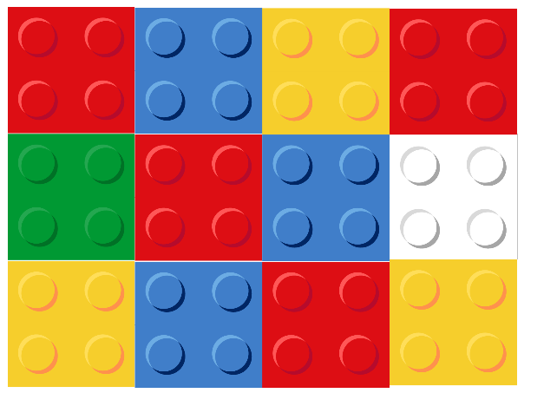
Images sourced from Canva and used in accordance with the Canva Content License Agreement.
- Some student responses could be:
- I noticed that there were 3 blue blocks.
- I saw 3 rows of 4 blocks.
- All the blocks have 4 studs.
- Together there are 12 blocks.
- Ask if there is a more efficient way to arrange the building bricks. For example, organising the bricks by students’ favourite colour.
- Once arranged into the colour groupings, ask students what they notice and what they wonder.
- Prompt students to notice that each piece has 4 studs. Each stud could represent one person. Ask if this changes what students notice; for example, do 3 people like blue or 12 people?

Perfect playgrounds – 40 minutes
This lesson has been adapted from Statistics: Planning Playgrounds from reSolve (2020). Refer to the class problem from Lesson 2.
- Explain that in this lesson students will look at both sets of data, including from the classes surveyed in Lesson 3.
- Ask students to predict how likely it is that the swings will be the most popular, giving reasons for their predictions.
- Model how to combine the class data with the results from another class surveyed into the one graph, using Resource 5: Column graph. See Figure 4.
Figure 4 – Example data and playground design
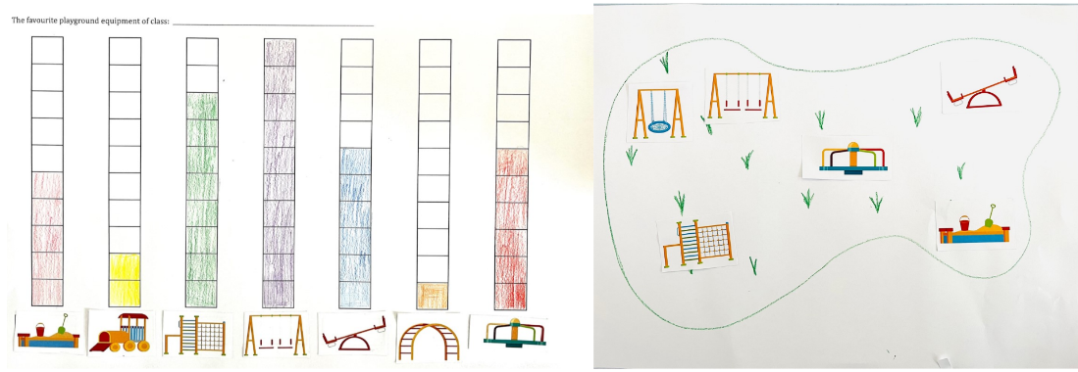
- Discuss how the data from this new graph could be used to design a playground that provides greater access to the most popular equipment. For example:
- Only one person liked monkey bars, so I didn’t include one.
- The swings were the most popular, so I included 3 swings.
- In their groups, students discuss their combined data and make decisions about the playground equipment to include in their design. Students will need to justify their decisions.
- Students create a playground design using building bricks, as a drawing or digitally.
This table details assessment opportunities and differentiation ideas.
Assessment opportunities | Too hard? | Too easy?
What to look for:  - Can students describe the chance of an event occurring? (MA1-CHAN-01)  - Are students able to interpret a data display and use it to make informed decisions? (MA1-DATA-02)  - Do the students’ playground models reflect their data? (MA1-DATA-02)  What to collect:  - photo evidence or work samples of data displays and playground designs (MA1-DATA-02) | Students are having difficulty making decisions regarding playground choices.  - Support students by looking at the graph as a small group and identifying the most popular equipment.  - Support students by using questioning to guide their decisions. For example, prompt students to look at the graph and ask if they can see whether children want swings in their playground. Encourage students to explain how they know. | Students consistently make informed decisions about the types of equipment.  - Prompt students to consider how the difference between 2 columns could affect the quantity of equipment. For example, if the popularity of the swings was double that of the slide, they might double the amount of swing equipment.  - Students compare the results across classes and consider how they could cater to different age groups. For example, 2 slides of varying difficulty could be included.

Consolidation and meaningful practice: Problem solved! – 20 minutes
- Each group displays their playground designs alongside their data displays.
- Facilitate a guided gallery walk. Groups take turns to present their playground designs, justifying their equipment choices by referring to their data display.
- Tell students you are looking for people who can give constructive feedback using mathematical language. For example, I can see that you used only one seesaw because the data shows it wasn’t very popular.
- Revisit the initial problem. Ask if students have used the data to find a solution to their problem. Prompt students to explain how they know.
- Highlight how organising data helps find solutions to problems. A summary of student learning can be added to the data anchor chart.

Lesson 5: Sort the Street
Core concept: Data helps make sense of our world.
The table below contains suggested learning intentions and success criteria. These are best co-constructed with students.
Learning intentions | Success criteria
Students are learning that:  - organising objects by attributes enables data to be sorted efficiently  - data can be represented by objects and pictures, where one object or picture represents one data value  - possible outcomes can be predicted and described. | Students can:  - identify and sort items based on categories such as colour, shape, and size  - show information in a data display that can be easily understood by using pictures, columns, rows, or arrays  - predict and describe possible outcomes.

Daily number sense: Data talk– 10 minutes
- Build student understanding of interpreting a data display by engaging in observations and conversations about data.
- Show Resource 7: Data talk 1 and ask students about their noticings and wonderings.
The table below outlines stimulus prompts to generate conversation about the topic, along with anticipated responses from students.
Prompts | Anticipated student responses
- What do you notice?  - What do you wonder?  - What question do you think this graph is trying to answer? What makes you think that? | - I noticed that there are numbers at the end of each line, and I think that they represent how many people play the sports.  - I notice that it looks like a graph and the heading tells me that it is about school sports.  - I wonder if the graph is about how many people play each type of sport.  - I wonder why there is only one picture next to each sport, but the value is more than one in all but basketball.
This table details assessment opportunities and differentiation ideas.
Assessment opportunities | Too hard? | Too easy?
What to look for:  - Are students able to interpret information presented in the graph? (MAO-WM-01)  - Can students provide reasons for their thinking? (MAO-WM-01)  What to collect:  - observations of students responding to ‘noticing’ and ‘wondering’ questions (MA1-DATA-02) | Students are unable to interpret information presented in the graph.  - Support students to focus their attention on 2 rows by covering the other rows.  - Ask them what information they think each row shows. | Students can interpret information presented in the graph.  - Extend students’ thinking by asking if 8 people liked handball, where would it fit on this graph? Why would you put it there?  - Further extend students’ thinking by asking if they think the categories would change in different parts of the world. Why?

Sort the Street – 45 minutes
This lesson has been adapted from Sort the Street from NRICH (2022).
- Explain to students that they will work in pairs to sort and organise some data. Show students Resource 8: House cards and provide each pair a copy of the 12 cards.
- Students sort the 12 houses in a way of their choosing. Explain that mathematicians always share their thinking and encourage students to discuss with their partners their reasoning for their sorting decisions.
Note: This is an opportunity for students to engage in mathematical reasoning, so don’t tell them how to sort their houses.
- Allow students time to explore the sort, monitoring and observing them. For example, Figure 5 shows how houses might be sorted. Instead, some might be sorted by 2 attributes, as in Figure 6.
Figure 5 – Houses sorted by roof colour
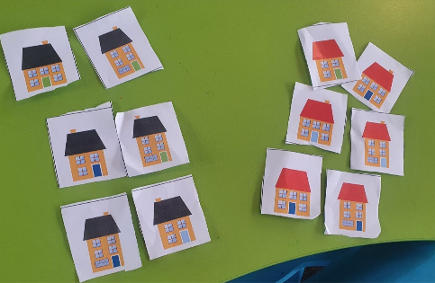
Figure 6 – Houses sorted by roof colour and door colour
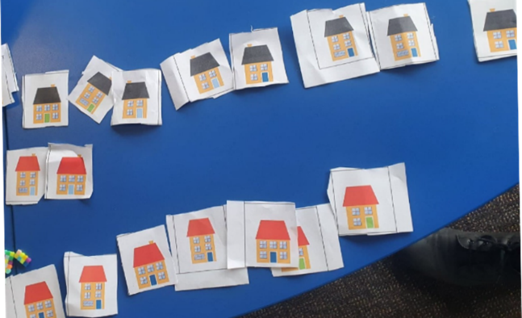
- As students arrange the sort, observe if they are providing their reasoning. Prompt students to identify the attributes that are similar and different and use this reasoning in their discussions.
- Students decide how to display their sorts, for example, in groups, piles or lines. Strategically select a pair that has organised their houses in a way that is easy to read and most represents a picture graph.
- Bring students together, leaving their data sort to return to later. Display Resource 8: House cards and ask what they notice about the 12 houses. Prompt students to turn and talk, asking the following questions:
- What do you notice about the houses?
- What is the same about the houses?
- What is different about the houses?
- What do you wonder?
- Use ‘Talk moves’ and strategically select students to share their thinking. Use Resource 9: N.W.L. (Notice Wonder Learnt) chart to record their responses on the Notice and Wonder parts of the chart. Figure 7 is an example of a partially completed N.W.L. chart.
Figure 7 – A Notice, Wonder, Learnt chart
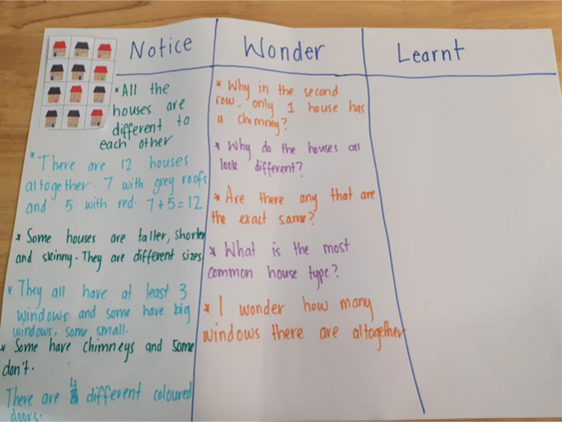
The table below outlines stimulus prompts to generate conversation about the topic, along with anticipated responses from students.
Prompts | Anticipated student responses
- What do you notice about the houses?  - What is the same about the houses?  - What is different about the houses?  - What do you wonder? | - There are 12 houses altogether because there are 5 with red roofs and 7 with black roofs. Five plus 7 equals 12.  - The houses are different sizes, some are larger, and some are smaller.  - The houses can be sorted by how many windows they have.
- Explain that the purpose for sorting the data is so it can be easily understood and to answer any questions about the houses.
- Prompt students to think about how to display their data so that it can be easily read. Take students on a gallery walk to observe how other groups have organised their houses. Encourage students to give feedback to each other on their sort, by asking the following questions:
- What do you notice about how the houses have been sorted?
- Is it similar or different to your own sort? How?
- Which displays make it easier to see how the houses have been sorted? What makes it easier?
- Highlight groups that have sorted the houses in an efficient way. For example, bring attention to a sort where the houses have been lined up in an array or rows. If there are sorts that have been chunked together or piled on top of each other explain that this method makes it difficult to see all the data.
- Explain that the data can be organised by first choosing at least one attribute to sort. Ask students to choose an attribute to model for the display.
- Model how this can be done by showing that houses can be sorted into those with red roofs and those with black roofs. Display the houses in 2 rows, a row with red roofs and a row with black roofs.
- Ask students what they notice when the data is sorted and presented like this. Prompt students to consider whether the rows look like a graph or an array. Some students might notice that it is now easier to see the different attributes of the houses.
- Model how to provide reasoning behind the way the data was sorted. For example, ‘I organised the data based on the different roof colours,’ or ‘I organised the data into how many windows each house had’, or ‘If I wanted to know how many red-roofed houses there were, then this is a good way to organise them’.
- Encourage students to consider what other attributes the houses have and give students time to revise their initial sort using the following prompts:
- How did you organise your data?
- What attribute did you choose to sort your data by?
- Can you re-sort your data using a different attribute? Does it look different now? Why?
- How many ways can you sort the data?
- In pairs, students share their revised sort, explaining their reasoning and receiving feedback from their peers. Students can revise their thinking based on this feedback and make any last changes to their sort, before formally recording it.
- Students formally record their data sort by gluing the houses on A3 paper to create their own data display. They label their display, identifying the attributes that were used for the sort. Display each pair’s data display ready for another gallery walk.
This table details assessment opportunities and differentiation ideas.
Assessment opportunities | Too hard? | Too easy?
What to look for:  - Can students describe the chance of an event occurring? (MA1-CHAN-01)  - Do students organise their data into a display that represents a graph, or table? (MA1-DATA-01)  - Can students provide reasons for how they have represented their data? (MAO-WM-01)  What to collect:  - work samples of student data displays showing how they sorted their houses (MA1-DATA-01) | Students cannot label their display with reference to characteristics or identify one attribute to sort the houses by.  - Work with students to complete their final data sort. They can assist with labelling the display, by counting the houses in each collection.  - Model that one way to sort the houses is by taking 2 houses and asking what is the same about them. Students then add more houses to the pair by looking for those that match the attribute. For example, the houses have 5 windows. | Students who can sort the houses by one attribute will have more of a challenge finding 2 or more attributes to sort by. For example, these houses have 5 windows, red roofs and are taller than the others.  - Students display their houses with several attributes in a picture graph, using a baseline to compare them accurately.  - Students identify the attributes used for each of their combined sorts, using tally marks to record their findings.

Consolidation and meaningful practice: Re-think and reflect – 10 minutes
- Take students on a gallery walk to look, compare and think about what they notice about the houses. Prompt students to consider what they have learnt about organising data and record their responses on the ‘Learnt’ part of Resource 9: N.W.L. (Notice Wonder Learnt) chart. Ask the following questions:
- Is it easier to identify different attributes of the houses now that the data has been sorted? Why?
- What is different about the sorts? What is similar?
- What did you learn from the data?
- What questions could we ask about the data?
- Explain to students that by sorting and organising the houses by their attributes, it makes it easier to notice and wonder things about the data.

Lesson 6: Making robots
Core concept: Thinking about the data can help make predictions about the future.
The table below contains suggested learning intentions and success criteria. These are best co-constructed with students.
Learning intentions | Success criteria
Students are learning that:  - data can be sorted into categories to solve a problem  - data can be collected and shown in arrays, lists and tables  - the chance of possible outcomes of events can be described. | Students can:  - sort and classify their robot cards according to the body parts  - explain why some robots may be missing or haven’t been made yet  - estimate possible outcomes of the number of different robot combinations that can be created.

Daily number sense: Data talk – 10 minutes
- Build student understanding of interpreting data displays and proportional reasoning, by locating approximate positions of numbers on a number line.
- Students are provided with a copy of Resource 10: Data talk 2. This builds on the previous data talk activity but adds an ‘Other’ column.
- Ask students, what they notice and what they think the category ‘other’ means.
- Ask how many children they think play ‘other’ sports, encouraging students to explain how they know. Students use Think-Pair-Share with a partner, then share their thinking with a class. Record their responses on a T-chart, as in Figure 8.
Figure 8 – Sample T-chart
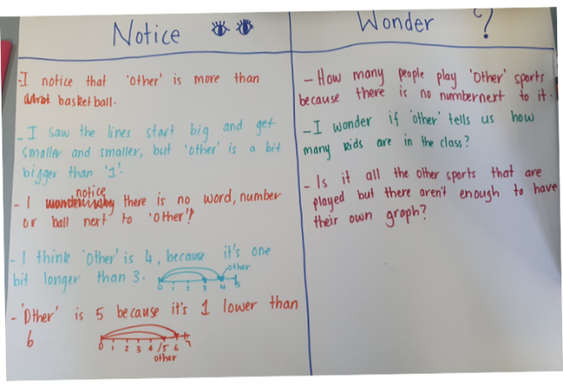
The table below outlines stimulus prompts to generate conversation about the topic, along with anticipated responses from students.
Prompts | Anticipated student responses
- What do you notice about this data display?  - What do you wonder?  - What do you think the category ‘other’ means?  - How many children do you think play ‘other’ sports? How do you know? | - I noticed that the ‘other’ is less than rugby league and soccer.  - I think that ‘other’ is 4, because it is one unit longer than 3.  - I think ‘other’ is 5 because it is one unit lower than 6.  - I think 4 or 5 people play other sports because the bar is less than 6, but more than 3.  - I wonder how many people play ‘other’ sports because there is no number next to it?  - I wonder if ‘other’ is only one sport, or if it means there are lots of sports that are represented?

Making robots – 50 minutes
This lesson has been adapted from Multiplication: Making Robots from reSolve (2020).
- Introduce the lesson by telling students that they will be helping a robot factory to build robots, by showing Resource 11: Robot body parts. Explain that there are many orders for different robots and the factory manager needs help. Each robot must have a head, a body, and legs. Using the parts, students need to work out how many different robots can be made.
- Provide students with a copy of Resource 11: Robot body parts. They will need access to multiple copies of the 9 parts, so they have options to create a variety of robots.
- Students construct 3 different robots from the body parts and glue them onto a copy of Resource 12: Robots template. Explain that they can use any combination of parts, as long as each robot has a head, body, and legs. Once students have made 3 different robots, they cut them out from the template. For example, see Figure 9.
Figure 9 – Student work sample of 3 robots
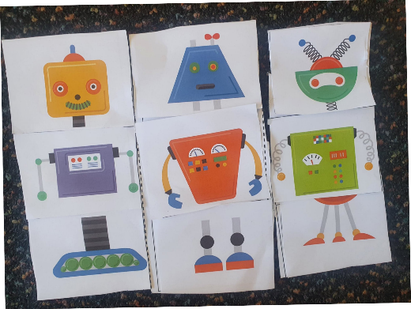
- Students form groups of 3 or 4 and compare their robots. Prompt them to identify attributes that are similar and different.
- Explain that they are going to sort their robots into categories within their group, before the robots are added to a class data display. Students sort their robots and provide reasoning for their decisions.
Note: Students are likely to sort based on one specific body part. For example, they might sort the robots into groups that have the same head, as in Figure 10. Monitor for student language and reasoning as they engage in discussion with their peers.
Figure 10 – Robots sorted by heads
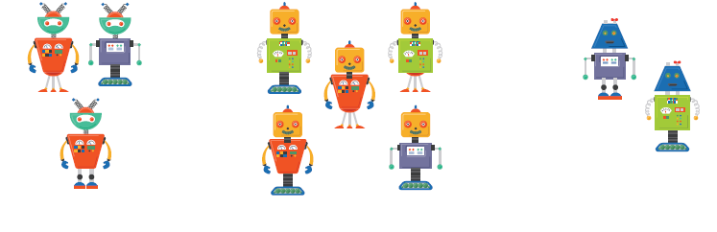
Image adapted from ‘1a Robot Parts Pictures’ by reSolve and is licensed under CC-BY-NC-SA 4.0
- As a class, discuss the ways students have sorted their robots. Identify that sorting by a body part (head, body, or legs) creates 3 groups. Allow students to re-sort their robots if needed.
- Ask students to pick one of the smaller groups created from a sort, for example, the blue heads in Figure 10.
- Students explore their smaller group of robots and make any new robots they identify as missing. Ask students how they could organise the robots to show which combinations are missing. For example, Figure 11, shows that organising an initial group (head colour) a second time (by body colour) shows that there is a robot missing. This robot should have a yellow head, purple body and 3 legs.
- Explain that students are going to see if they have found all the ways the robots in this category could be made. Students estimate how many different robots it might be possible to make out of the parts. Ask:
- Have you made all the possible robots for the group you have selected? How do you know?
- Which robots are missing?
Figure 11 – Robots sorted by their body colour
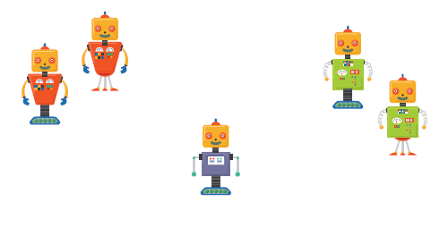
Image adapted from ‘1a Robot Parts Pictures’ by reSolve and is licensed under CC-BY-NC-SA 4.0
- Explain that students are going to create a class data display to work out what robots are missing.
- Clarify what data is being displayed and the purpose for organising it. Explain that the robots are the data, and the goal is to display them in a way that shows the different combinations that have been made and those that are missing.
- As a class, students consider their robot sort and choose an attribute group to display. For example, students may choose to collect and display all the robots that have an orange head.
- Students who have a robot with the same attribute place their robot on a blank whiteboard or data display space. As they place their robots on the data display, monitor how and where students place their robot. Some students might automatically place their robot in a row or column to create an array, whereas others might place it in a random position. Use this opportunity to question how to place the data in a row to make it easier to read.
- Redirect students if necessary and remind them that focusing on a particular group, such as robot head colours, can make it easier and help solve the larger problem.
- Students select a robot with a different coloured head to collect and organise, following the same process as the activity above. For example, ask students with robots that have a blue head to add their robots to the data display. Encourage students to create a new row for robots that have blue heads.
- Explain that mathematicians always revise their thinking. Ask students:
- What do you notice and what do you wonder about the data display so far?
- Do you think your estimate from the beginning of the lesson is accurate or needs to be revised?
- How likely is it that there are more robots than you originally estimated and how do you know?
- Do you think the data display could be improved and if so, how?
- Remind students that the purpose of organising the data is to see how many ways a robot can be made.
- Explain that any robot that is exactly the same as another should be collected and placed on top of each other, so that only new combinations will be displayed. Explain that organising the data like this makes it easier to understand, as shown in Figure 12.
Figure 12 – Duplicate robot stacks to identify missing combinations
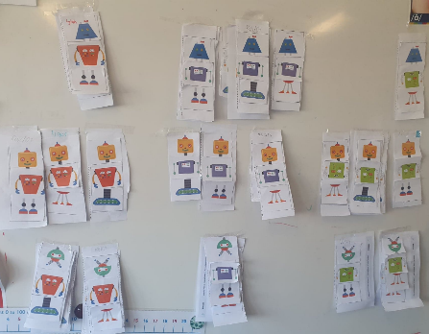
Note: There are 9 possible combinations for each coloured head, body, or legs combination. This means that there are 27 different robots that could be created in total.
- To see if all possible combinations have been made for robot head colours, prompt students to rearrange the robots in an array. For example, Figure 13 shows how robots have been rearranged into rows to show the same type of body while the columns show the same type of legs. If students have less than 9, prompt them to keep investigating combinations.
Figure 13 – Robots organised into arrays
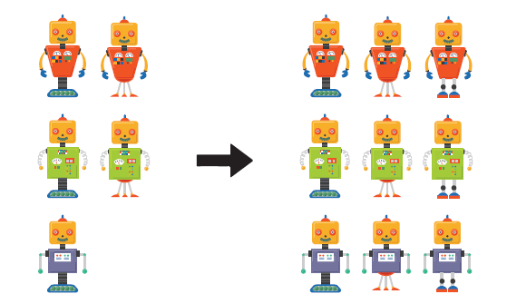
Image adapted from ‘1a Robot Parts Pictures’ by reSolve and is licensed under CC-BY-NC-SA 4.0
- Ask students what they notice now that the robots have been sorted into an array. Identify that for each head, 9 different robots can be made.
- Students create a tally each time a new robot is made in an array. Explain that this will help track each robot that has been counted.
- Ask students to consider how many robots can be made in total, if 9 can be made for each head/body/legs. Repeat this process until there are 3 sets of arrays, with one for each coloured head.
- Students identify any robots that are not displayed by describing them by the attributes that are missing. For example, students might find they are missing a robot that has a green head and a purple body with 3 legs. Give students time to create any missing robots and add these to the data display.
This table details assessment opportunities and differentiation ideas.
Assessment opportunities | Too hard? | Too easy?
What to look for:  - Do students organise and explain their data sort, by focusing on smaller groups of data within the bigger data set? (MAO-WM-01, MA1-DATA-02)  - Are students identifying possible outcomes and revising their estimates throughout the problem-solving process? (MA1-CHAN-01)  What to collect:  - pictures of student sorts before they add them to class data display (MA1-DATA-02) | Students find it difficult to identify and sort the robots by a particular category.  - Model that one way to approach this activity is by taking 2 robots and asking what is the same about them. Students then add more robots to the pair by looking for those with matching attributes.  - Support students to organise their groups of robots in ways that make it easier to see. For example, stacking robots that are the same.  - Model how to use the data display to answer questions, such as how many different robots can be made? | Students can identify and sort the robots by more than one category.  - Record how many different combinations can be made using tallies and represent this in a different data display. For example, create a picture or column graph.  - Prompt students to create their own head, body, or legs. For example, investigate how many different robots can be made with 3 heads, 3 bodies and 4 sets of legs.

Consolidation and meaningful practice: – 10 minutes
- Ask students what they notice about the data display now that all the data has been collected, organised, and displayed. Record their responses on a T-chart.
The table below outlines stimulus prompts to generate conversation about the topic, along with anticipated responses from students.
Prompts | Anticipated student responses
- What do you notice about this data display?  - Have all the possible combinations been made and how do you know?  - Why is the answer the same regardless of the way they are ordered?  - How many robots are there all together and how do you know? | - The pictures are grouped by the same attribute.  - The display is an array with rows and columns.  - For each head there are 3 bodies and 3 sets of legs.  - For each body there are 3 heads and 3 sets of legs.  - For each set of legs there are 3 bodies and 3 heads.  - There are 27 different robots altogether, which can be found by multiplying the 3 arrays by the 9 robots in each array.  - 9 + 9 + 9 = 3 × 9.
- Identify how organising the data into an array helped to see the different chunks of data. Remind students that to solve the big problem, which was finding out all the combinations, smaller problems needed to be solved first.

Lesson 7: What rubbish is in my lunch box?
Core concept: We can collect and display data to investigate a topic of interest or answer a question.
The table below contains suggested learning intentions and success criteria. These are best co-constructed with students.
Learning intentions | Success criteria
Students are learning that:  - data can be collected and displayed to answer a question or to investigate a topic of interest  - picture graphs can display data  - the chance of possible outcomes of events can be described. | Students can:  - collect data to answer a question of interest  - use symbols to represent concrete materials in a picture graph  - estimate possible outcomes of events.

Daily number sense: What number could this be? – 15 minutes
- Build student understanding of number sense by asking them to identify a missing value on a number line, using other numbers as a reference guide.
- Show Resource 13: Number line and ask students about their noticings and wonderings. Give students time to think, then share with a partner.
The table below outlines stimulus prompts to generate conversation about the topic, along with anticipated responses from students.
Prompts | Anticipated student responses
- What do you notice? What do you wonder?  - What number could the question mark represent?  - Can you explain why you think that?  - Do you think it is likely that your prediction will be correct? Why? | - I noticed that there is a number line starting at 0 and ending at 100.  - I wonder why the question mark is in that location.  - I think it is less than 50 because the halfway mark would be 50.
This table details assessment opportunities and differentiation ideas.
Assessment opportunities | Too hard? | Too easy?
What to look for:  - Can students describe the chance of an event occurring? (MA1-CHAN-01)  - Do students consider order and size of numbers when sequencing and arranging numbers on a number line? (MA1-RWN-01)  - Can students justify their reasoning? (MAO-WM-01)  What to collect:  - observations of student reasoning during whole-class discussions (MAO-WM-01, MA1-RWN-01) | Students find it difficult to work with numbers in the range 0-100.  - Change the number line to be between 0-20.  - Use a number track with missing numbers instead of a number line. | - Students can track numbers on a line beyond 100.  - Extend the number line to have students work beyond 100.  - Use a number line that shows 150-250, or numbers off the decade.

What rubbish is in my lunch box? – 30 minutes
This task has been adapted from What A Load Of Rubbish! from reSolve (2020).
- Students sit in a circle with their lunch box open. Ask them to look in their lunch box and imagine that they saved their rubbish in it all day. Ask students what rubbish they would be left with and how much of it would be plastic or food scraps.
- Discuss what they notice about the properties of rubbish that they will be left with at the end of the day. For example, plastic, foil, paper, cardboard, and food scraps.
- Students cut out a picture from the rubbish images on Resource 14: Lunch box images to match each piece of rubbish they have. For example, if students have a sandwich wrapped in plastic wrap, they choose a picture of plastic wrap. See Figure 14.
Figure 14 – Images matched to foods
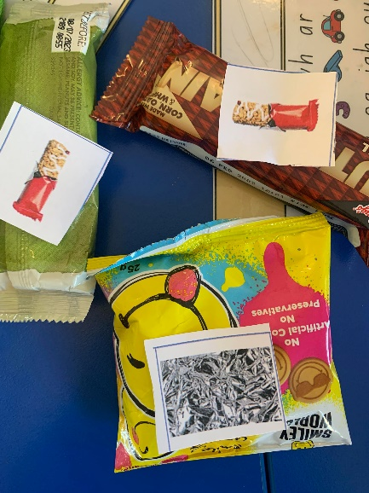
- If students have a different type of fruit food scrap, they can use the picture of the apple core or banana peel to represent what they will be left with, or they can draw their own picture to represent that piece of rubbish.
- Show students a pile of rubbish pictures and ask the following questions:
- Is it easy to see the different types of rubbish?
- Is there another way we can display the rubbish data?
- Explain that students have collected data about their lunch box and now they will organise it to make the data easier to see. They will organise the pictures into similar groups to answer the question ‘What sort of rubbish is in my lunch box?’
- Model how a single piece of rubbish will represent one piece of data on a picture graph. Students join a group to create a combined picture graph of their lunch box images on A3 paper, based on their sorting.
- Students discuss how they will sort their data on the page to display the information that they have collected. Allow students time to experience productive struggle.
- If needed, prompt students to recognise that the data can be displayed by placing the representations of rubbish in columns or rows and using a baseline.
- Monitor for student representations that demonstrate columns, evenly spaced pictures, and a baseline. Strategically select student work to highlight and display to the class.
- Ask students to consider the placement of the rubbish, ensuring rows and columns are aligned so the data can be easily read. Prompt students to notice that all the images of the rubbish are the same size and need to be equally spaced. See Figure 15.
Figure 15 – An example graph
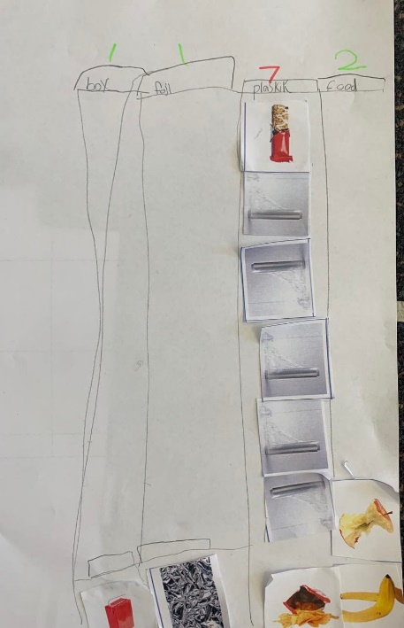
- If students are struggling to find a way to display their data, give them the option of using Resource 15: Graph template on A3 paper, as in Figure 16.
Figure 16 – Graph template with rubbish sort
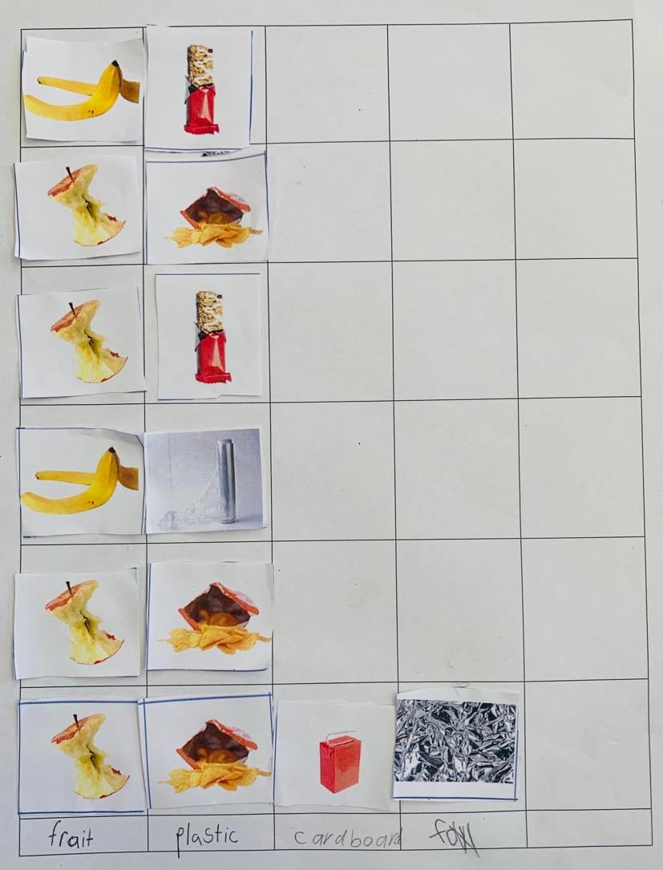
- Share examples of student data displays. Compare 2 examples that show a display with labels and one without labels and ask the following questions:
- What is the same about these data displays?
- What is different about them?
- How do you know these types of rubbish go together?
- What part of the display tells you how it has been sorted?
- Prompt students to notice and wonder about aspects of their graphs. Ask the following questions:
- Do all categories have the same number of pieces of rubbish?
- What type of rubbish has the largest number/the smallest number?
- Why do you think that some types of rubbish are more common than others?
- Are each of the student groups’ picture graphs similar?
This table details assessment opportunities and differentiation ideas.
Assessment opportunities | Too hard? | Too easy?
What to look for:  - Can students use pictures of objects as symbols to create data displays where one picture represents one data value? (MA1-DATA-01)  - Are students able to align the picture representations into columns and rows to easily read their data display? (MA1-DATA-02)  - Do students choose and apply efficient techniques to solve the problem? (MAO-WM-01)  What to collect:  - students’ picture graphs and observations of student responses to data questions (MAO-WM-01, MA1-DATA-02) | Students are unable to organise the data so that it can be read by others.  - Support students as they work in a group to contribute to the collection of data rather than doing it independently.  - Provide students with a copy of Resource 15: Graph template. Students use the pre-prepared spaces to glue the pictures into and label each column.  - Ask why this might help. | Students are confident working with data and displaying it in a picture graph.  - Ask students to use the data from 2 groups to create a new data display, combining the totals for both groups.  - These results may be difficult to fit on one graph using the images and a 1:1 scale, so students may need to find another way to represent the data. For example, they might decide to have each image represent 2 pieces of rubbish.

Consolidation and meaningful practice: What helped us read the data? – 15 minutes
- Place the completed data display next to a pile of unsorted lunch box images, as in Figure 17. Explain to students that the display and the pile both show data, but only one has been organised. Ask the following questions:
- What display makes it easier to see the different types of rubbish?
- What features of the display make it easier?
- Is there anything in the organised data display that you are still wondering about?
- Have our data displays answered the question ‘What sort of rubbish is in my lunch box?’
Figure 17 – Data display alongside an unsorted pile
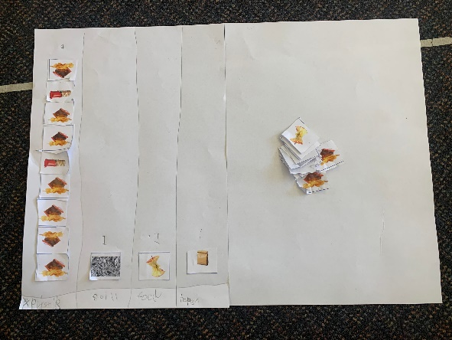
The table below outlines stimulus prompts to generate conversation about the topic, along with anticipated responses from students.
Prompts | Anticipated student responses
- I wonder if it would have been as easy for us to see the types of rubbish if we left them in a group instead of using rows and columns. Why? Why not?  - What helped us to understand the types of rubbish that were in our lunch boxes?  - I wonder if there is another way we could display the same data. | - No, because we can’t see what’s underneath the top ones.  - The pictures that matched the rubbish. One for each type.  - We sorted them into groups.  - Yes, we could draw pictures instead.  - We could display the groups in rows and columns.

Lesson 8: What bin do we need?
Core concept: The same data can be used to answer different questions.
The table below contains suggested learning intentions and success criteria. These are best co-constructed with students.
Learning intentions | Success criteria
Students are learning that:  - data can be reorganised to answer different questions  - data can be represented in a variety of ways  - the chance of possible outcomes of events can be described. | Students can:  - use tally marks and a graph to represent collected data  - use data to answer a given question  - describe possible outcomes for different events.

Daily number sense: Favourite season data talk – 15 minutes
- Build student understanding of interpreting data displays, based on the Youcubed resource ‘Favourite Season’.
- Display Resource 16: Favourite season graph and use the prompts below to facilitate a data talk.
- Provide students with thinking time, as well as the opportunity to turn and talk. Record responses using ‘Talk moves’.
The table below outlines stimulus prompts to generate conversation about the topic, along with anticipated responses from students.
Prompts | Anticipated student responses
- What do you notice about this image?  - What are you wondering?  - What question do you think was asked?  - If we asked our class this question, would the data look the same? Why/why not?  - Could we further label the seasons to show which months are in each season? | - There is one tree, it has all the seasons, autumn has the most, winter has the least.  - The numbers add up to 100.  - I wonder where the people who answered the questions live. Why is it in a circle? What do the numbers and the percentage symbol mean?  - What is your favourite season? What season do you like the most?  - Students may explain the data would be different because different people like different seasons.

What bin do we need the most? – 40 minutes
This task has been adapted from What A Load Of Rubbish! from reSolve (2020).
- Revise the completed data displays from the previous lesson that answered the question ‘What sort of rubbish is in my lunch box?’ Ask students to share what they noticed and learned from their data display. For example, students might notice that plastic is the most common type of rubbish and food scraps are the least common.
- Ask students if the data collected in Lesson 7 could be used to answer different questions. Students share their thinking with a partner.
- Explain that data can be reorganised to help answer different questions. As a class, consider other questions that could be asked to show different information. Use the prompts box below, then share and record responses.
The table below outlines stimulus prompts to generate conversation about the topic, along with anticipated responses from students.
Prompts | Anticipated student responses
- What else might you want to find out about the rubbish?  - What other questions could we ask about our rubbish?  - What do we do with our rubbish?  - Can we ask a question about recycling or composting? | - What type of bins do we need to put each different type of rubbish in?  - What bin would we need the most? For example, if we have lots of compost, maybe we need lots of compost bins.  - Is there more compost waste or packaging waste?
- Select a question to investigate further or suggest ‘What type of bin do we need the most at our school?’ Prompt students to consider how the data on their picture graphs created in the previous lesson can help answer the question.
- In the same groups from the previous lesson, give students time to review their data to see how they can reorganise it to answer the above question.
- Discuss how each group has reorganised their data to answer the new question. Strategically select groups that have organised their data according to rubbish type to show the class.
- Display Resource 17: Tally mark table. Explain how data can be organised into the different categories of rubbish. For example, the rubbish can be sorted into recycling, rubbish, REDcycle and compost. Give examples of what goes into each.
- Show students how to complete the tally table. Remind students that one tally mark represents one piece of data. Explain to students that mathematicians revise their thinking. Give time for groups to reorganise their data into the rubbish categories and complete the tally table.
- Students share their completed tables. Ask the following questions:
- Which bin do you predict we will need the most? Why?
- Can you describe how likely you think it is that we will need each type of bin?
- How do you know?
- Ask students whether tally marks are the most effective way to display their data, or if they could represent their data using a different way. Allow students the chance to share their ideas and suggestions for alternative methods.
- Show Resource 18: Recycling graph and ask students to independently represent their group’s tally marks data in a picture or column graph.
This table details assessment opportunities and differentiation ideas.
Assessment opportunities | Too hard? | Too easy?
What to look for:  - Do students describe the chance of events occurring? (MA1-CHAN-01)  - Do students use tally marks to represent their data and convert the collected data into a graph? (MA1-DATA-01)  - Can students recategorise their data? (MA1-DATA-02)  - Are students able to demonstrate their understanding of their data and how it answers their questions? (MAO-WM-01)  What to collect:  - observations of students’ discussions and sorting to answer the class data question (MA1-DATA-01, MA1-DATA-02)  - completed Resource 17: Tally mark table and graphs, where students have recategorised their data from the previous lesson (MA1-DATA-01, MA1-DATA-02) | Students find it difficult to independently create picture or column graph.  - Support students to complete the graph as a group. Explain that they are using data from the previous lesson in a different way, to answer a new question, such as ‘What type of bin do you need the most at your school?’  - Provide a copy of Resource 18: Recycling graph to students to scaffold their new sort.  Students find it difficult to transfer their organised data into the tally mark table. Support students to use the lunch box images from the previous lesson to create the tally mark table. Emphasise that each image is represented by one tally mark. | Students independently use tally marks and graphs to represent their data.  - Students write a short response to the class question, referring to data in their graph to justify their response.  - Ask students to consider if there are any other questions that their data could answer. Students re-sort their data into a graph to find an answer to their new question.

Consolidation and meaningful practice: Gallery walk – 15 minutes
- Complete a gallery walk of the tally mark tables and column graphs. Ask the following questions:
- What do you notice about the different graphs?
- Is everyone's data the same? How do you know?
- Can you identify which bin is most needed in each group? Explain your thinking.
- Could you use the data again to answer a different question? How?
- Can we use this data to help us make changes that are more environmentally friendly?
- Explain this lesson showed how the same data can be used to answer different questions. To conclude the unit of learning revisit the data anchor chart and Resource 9: N.W.L. (Notice Wonder Learnt) chart. Use this as an opportunity to celebrate the students’ learning growth as mathematicians.

Resource 1: Hundreds chart
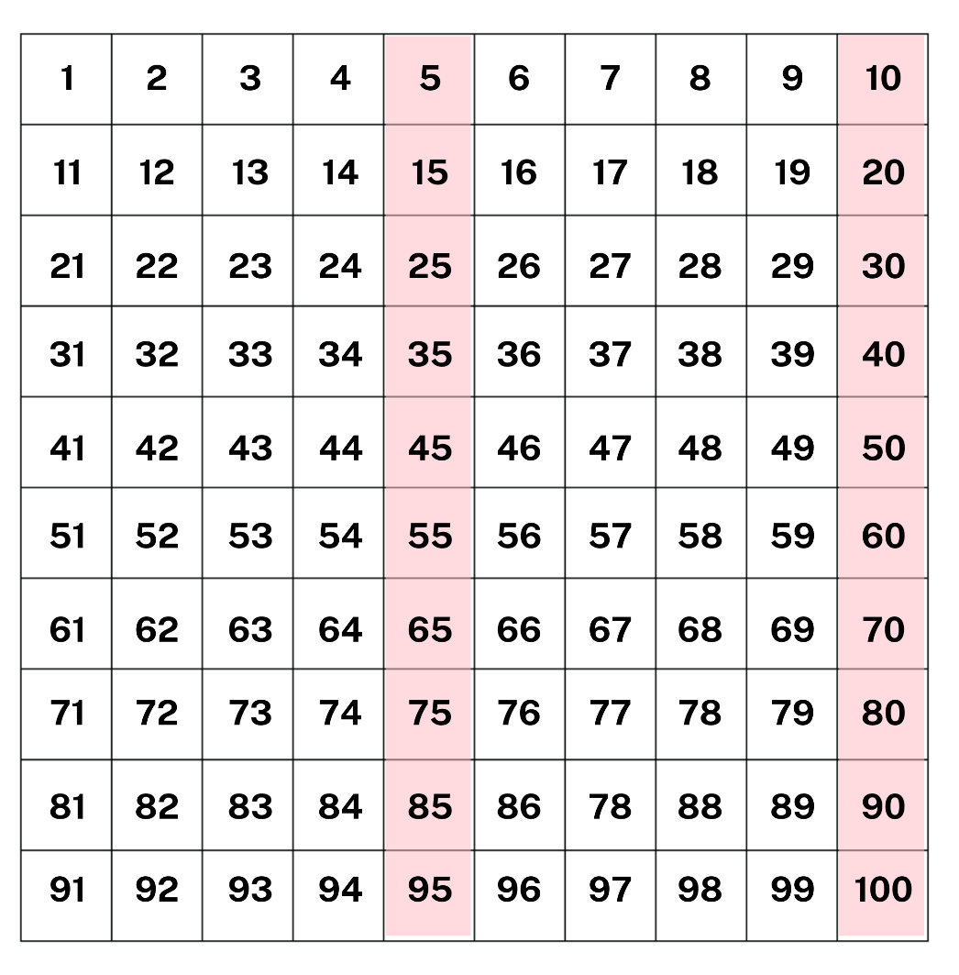

Resource 2: Playgrounds
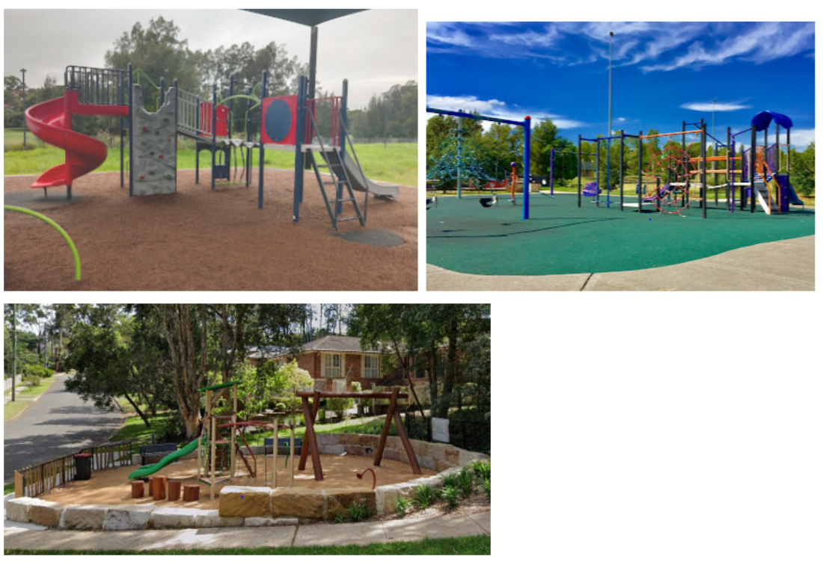

Resource 3: Playground equipment
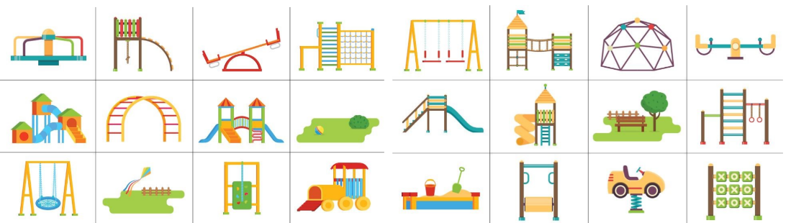
‘1a Playground Equipment’ by reSolve is licensed under CC-BY-NC-SA 4.0.

Resource 4: Playground tally chart
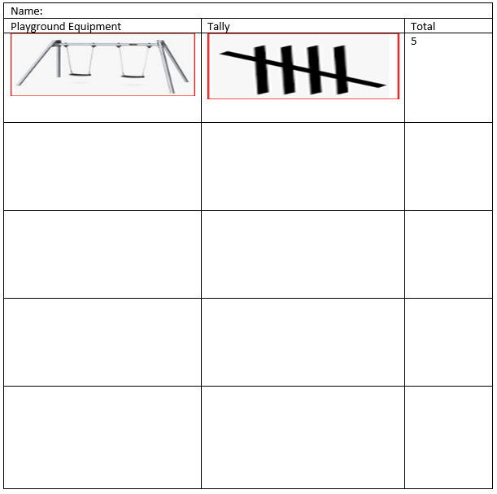
Images sourced from Canva and used in accordance with the Canva Content License Agreement.

Resource 5: Column graph
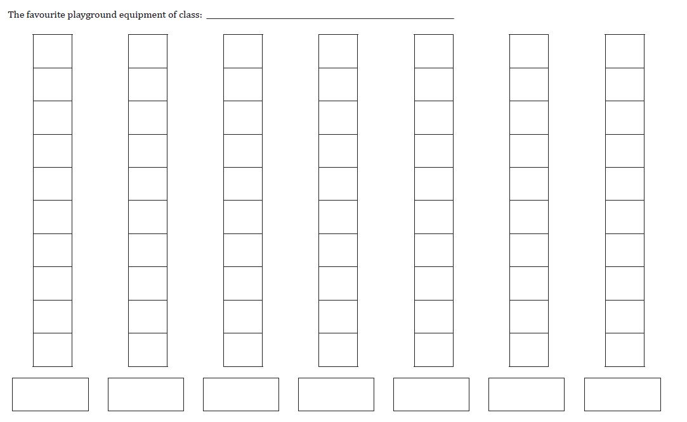
‘Lesson 3 Student Sheet: Other Class Graph’ by reSolve is licensed under CC-BY-NC-SA 4.0.

Resource 6: Popular fruit graph
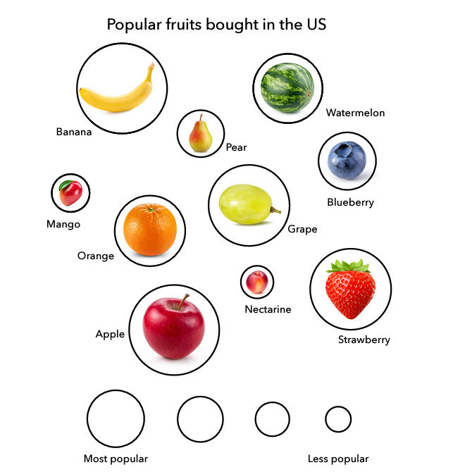
‘Popular Fruits’ by Youcubed is licensed under CC BY 4.0.

Resource 7: Data talk 1
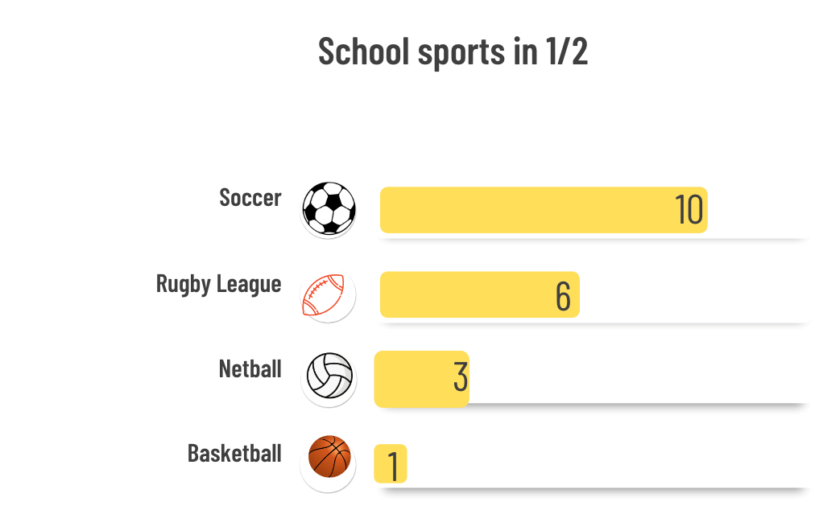
Images sourced from Canva and used in accordance with the Canva Content License Agreement.

Resource 8: House cards
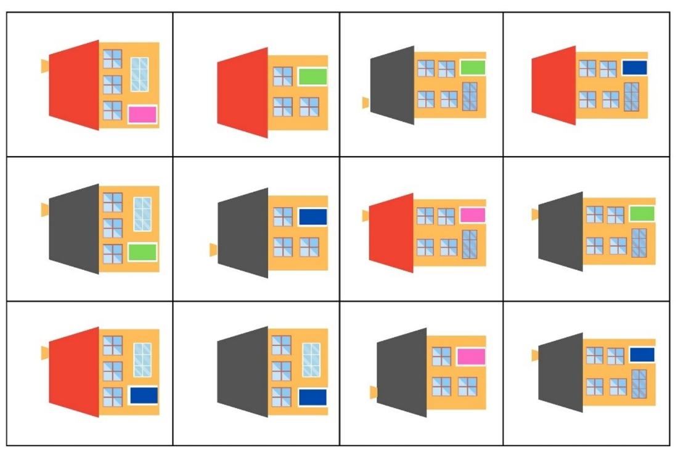
Adapted from ‘Sort the Street’ by University of Cambridge (Faculty of Mathematics).

Resource 9: N.W.L. (Notice Wonder Learnt) chart
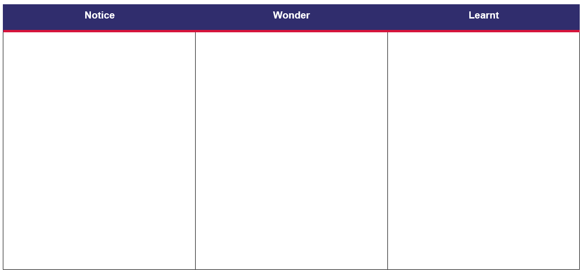

Resource 10: Data talk 2
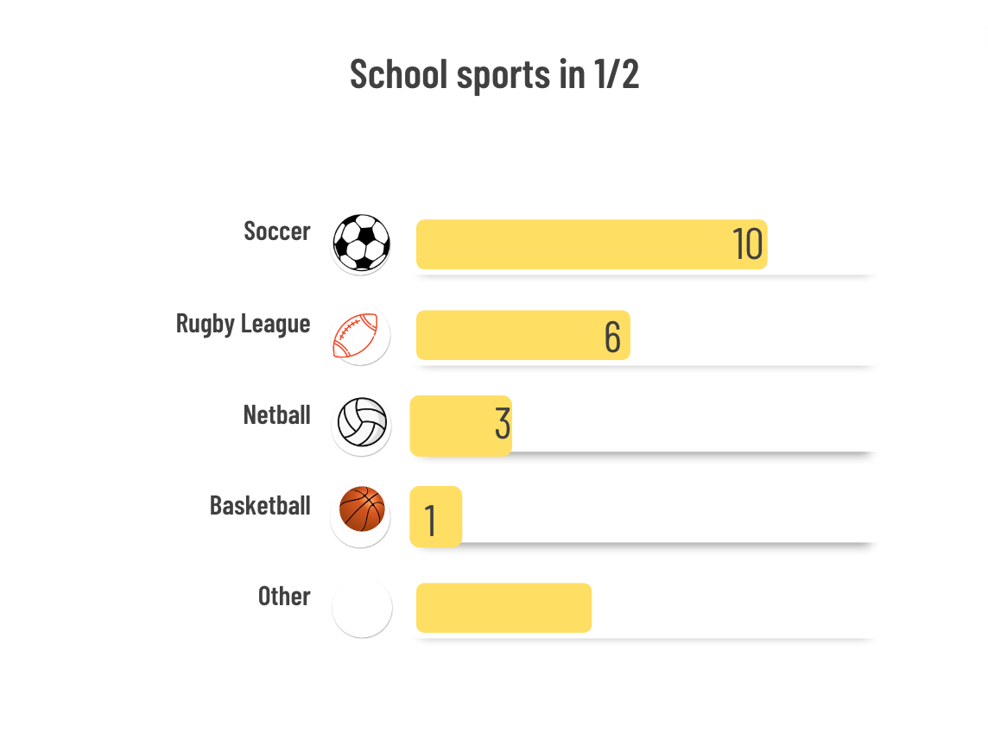
Images sourced from Canva and used in accordance with the Canva Content License Agreement.

Resource 11: Robot body parts
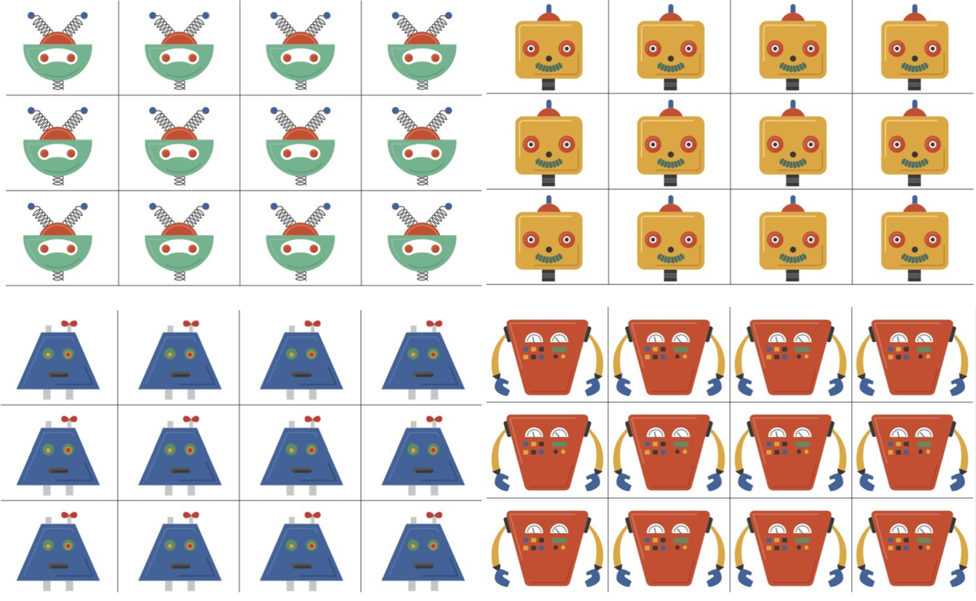
‘1a Robot Parts Pictures’ by reSolve is licensed under CC-BY-NC-SA 4.0
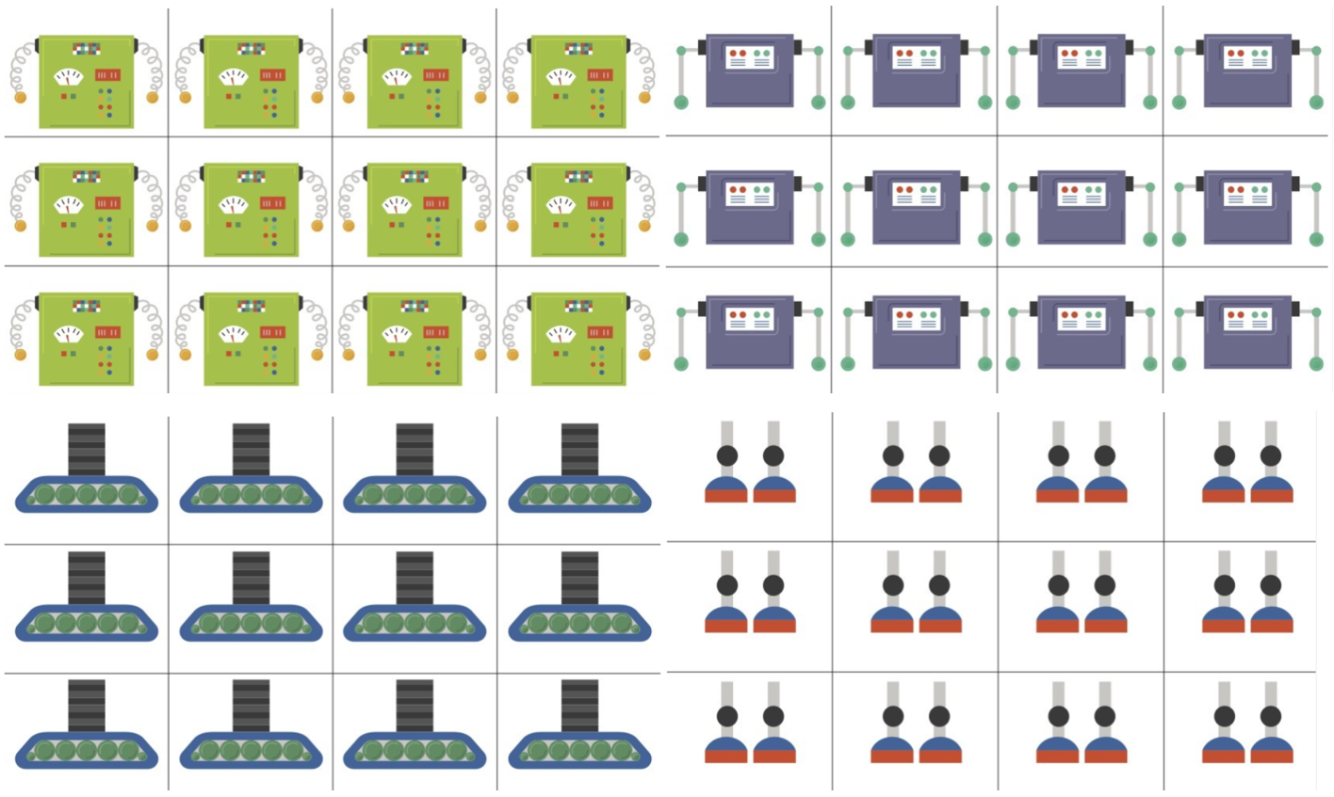
‘1a Robot Parts Pictures’ by reSolve is licensed under CC-BY-NC-SA 4.0
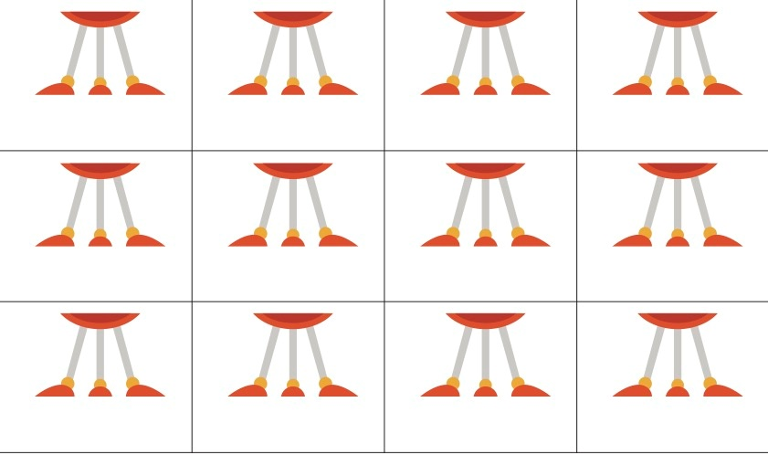
‘1a Robot Parts Pictures’ by reSolve is licensed under CC-BY-NC-SA 4.0

Resource 12: Robots template
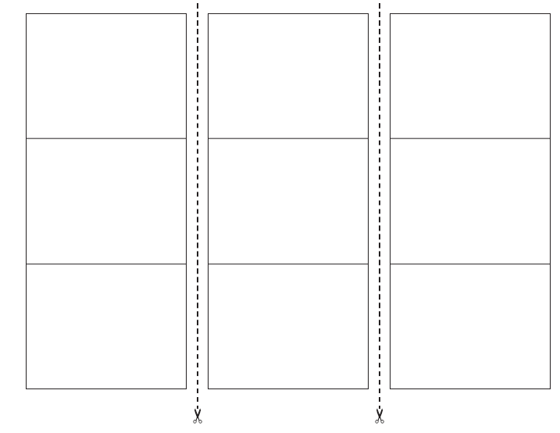
‘1b Robot Template’ by reSolve is licensed under CC-BY-NC-SA 4.0.

Resource 13: Number line
Images sourced from Canva and used in accordance with the Canva Content License Agreement.

Resource 14: Lunch box images
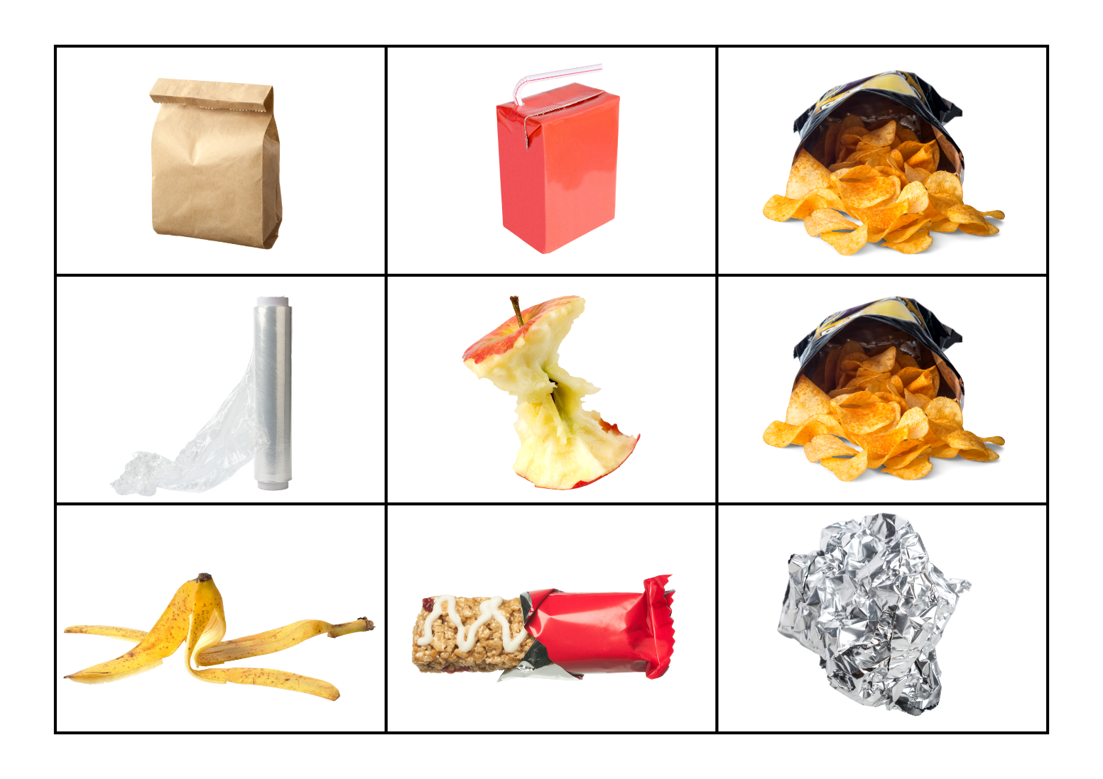
Images sourced from Canva and used in accordance with the Canva Content License Agreement.

Resource 15: Graph template

Resource 16: Favourite season graph
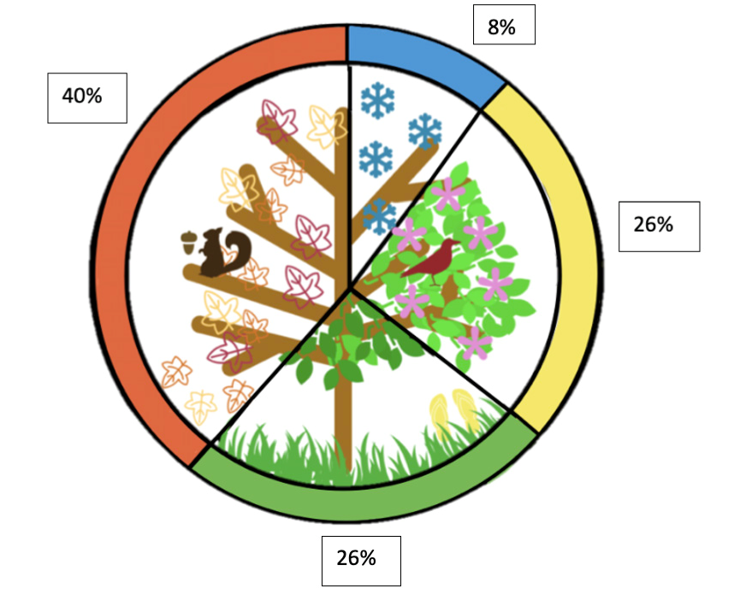
‘Favorite Season’ by Youcubed is licensed under CC BY 4.0.

Resource 17: Tally mark table
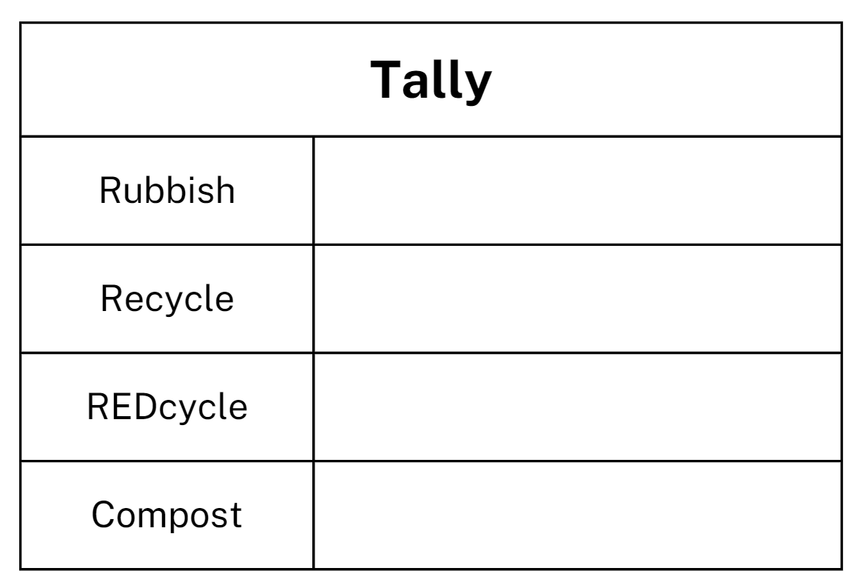

Resource 18: Recycling graph
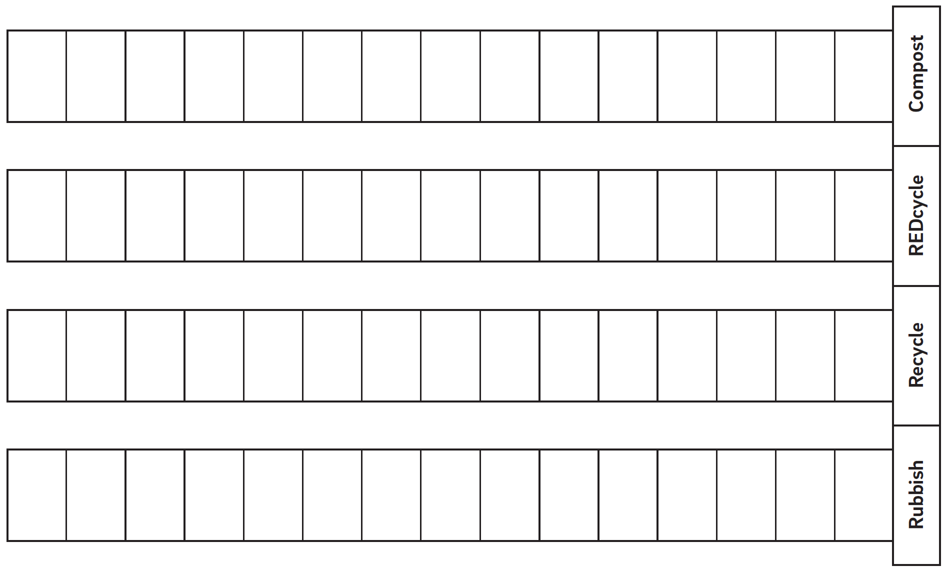
‘Lesson 2 Student Sheet: Recycling Graph’ by reSolve is licensed under CC-BY-NC-SA 4.0.

Syllabus outcomes and content
The table below outlines the syllabus outcomes and range of relevant syllabus content covered in this unit. Content is linked to National Numeracy Learning Progression version (3).
Focus area and outcomes | Content groups and content points | Lessons
Representing whole numbers A  MAO-WM-01  MA1-RWN-01  MA1-RWN-02 | Use counting sequences of ones with two-digit numbers and beyond  - identify the number before and after a given two-digit number (CPr5)  Represent numbers on a line  - sequence numbers and arrange them on a line by considering the order and size of those numbers (CPr5) | 1–8
Non-spatial measure A  MAO-WM-01  MA1-NSM-01 | Time: Name and order the cycle of months  - name and order the months of the year (MeT2)  - recognise monthly and annual cycles | 8
Data A  MAO-WM-01  MA1-DATA-01  MA1-DATA-02 | Ask questions and gather data  - investigate a topic of interest by choosing suitable questions to obtain appropriate data (IRD2)  - gather data and track what has been counted by using concrete materials, tally marks, lists or symbols (IRD3)  Represent data with objects and drawings and describe the displays  - use concrete materials or pictures of objects as symbols to create data displays where one object or picture represents one data value (IRD2)  - describe information presented in one-to-one data displays (Reasons about relations) (IRD2)  - use comparative language to describe information presented in a display, such as ‘more than' and ‘less than’  - interpret a data display and identify the biggest or smallest values (IRD2) | 1–8
Data B  MAO-WM-01  MA1-DATA-01  MA1-DATA-02 | Identify a question of interest and gather relevant data  - pose suitable questions where the answers form categories, and predict the likely responses (IRD2)  - collect data on familiar topics (IRD2)  - sort data into relevant categories (IRD2)  Create displays of data and interpret them  - organise collected data into lists and tables to display information (IRD2)  - represent data in a picture graph using a baseline, equal spacing and same-sized symbols (IRD2)  - give reasons why some representations of data are misleading (Reasons about relations)  - interpret information presented in tables and picture graphs (Reasons about relations) (IRD2)  - record answers to questions using the information in tables and picture graphs (IRD2) | 1–8
Chance A  MAO-WM-01  MA1-CHAN-01 | Identify and describe possible outcomes  - identify possible outcomes of familiar activities and events (UnC1)  - describe the chance of possible outcomes for familiar activities and events (UnC1) | 1–8
Chance B  MAO-WM-01  MA1-CHAN-01 | Identify and describe activities that involve chance  - describe possible outcomes in everyday activities and events as being likely or unlikely to happen (UnC2)  - compare familiar activities and events and describe them as being more or less likely to happen (Reasoning about relations) (UnC2)  - describe familiar events as being possible (UnC2) | 1–8

References
Links to third-party material and websites
Please note that the provided (reading/viewing material/list/links/texts) are a suggestion only and implies no endorsement, by the New South Wales Department of Education, of any author, publisher, or book title. School principals and teachers are best placed to assess the suitability of resources that would complement the curriculum and reflect the needs and interests of their students.
If you use the links provided in this document to access a third-party's website, you acknowledge that the terms of use, including licence terms set out on the third-party's website apply to the use which may be made of the materials on that third-party website or where permitted by the Copyright Act 1968 (Cth). The department accepts no responsibility for content on third-party websites.
Except as otherwise noted, all material is © State of New South Wales (Department of Education), 2023 and licensed under the Creative Commons Attribution 4.0 International License. All other material (third-party material) is used with permission or under licence. Where the copyright owner of third-party material has not licensed their material under a Creative Commons or similar licence, you should contact them directly for permission to reuse their material.
Mathematics K–10 Syllabus © 2022 NSW Education Standards Authority (NESA) for and on behalf of the Crown in right of the State of New South Wales.
© 2022 NSW Education Standards Authority. This document contains NSW Curriculum and syllabus content. The NSW Curriculum is developed by the NSW Education Standards Authority. This content is prepared by NESA for and on behalf of the Crown in right of the State of New South Wales. The material is protected by Crown copyright.
Please refer to the NESA Copyright Disclaimer for more information.
NESA holds the only official and up-to-date versions of the NSW Curriculum and syllabus documents. Please visit the NSW Education Standards Authority (NESA) website and the NSW Curriculum website.
National Numeracy Learning Progression © Australian Curriculum, Assessment and Reporting Authority (ACARA) 2010 to present, unless otherwise indicated. This material was downloaded from the Australian Curriculum website (National Numeracy Learning Progression) (accessed 4 October 2022) and was not modified. The material is licensed under CC BY 4.0. Version updates are tracked in the ‘Curriculum version history’ section on the 'About the Australian Curriculum' page of the Australian Curriculum website.
ACARA does not endorse any product that uses the Australian Curriculum or make any representations as to the quality of such products. Any product that uses material published on this website should not be taken to be affiliated with ACARA or have the sponsorship or approval of ACARA. It is up to each person to make their own assessment of the product, taking into account matters including, but not limited to, the version number and the degree to which the materials align with the content descriptions and achievement standards (where relevant). Where there is a claim of alignment, it is important to check that the materials align with the content descriptions and achievement standards (endorsed by all education Ministers), not the elaborations (examples provided by ACARA).
This resource contains images and content obtained from Canva, and their use outside of this resource is subject to Canva’s Content License Agreement. If you wish to use them separately from the resource, please go to Canva.
Australian Government Department of Education (2020) ‘Statistics: Planning Playgrounds’, Teaching resources, reSolve website, accessed 4 October 2022.
Australian Government Department of Education, Skills and Employment (2020) ‘Multiplication: Making Robots’, Teaching resources, reSolve website, accessed 4 October 2022.
Australian Government Department of Education, Skills and Employment (2020) ‘What A Load Of Rubbish!’, Teaching resources, reSolve website, accessed 18 August 2022.
Australian Government Department of Education, Skills and Employment (2020) ReSolve [website], accessed 4 October 2022.
Math Playground LLC (2022) Interactive Hundreds Chart, Maths Playground website, accessed 4 October 2022.
RG Programs & Services Pty Ltd (2021) REDcycle [website], accessed 4 October 2022.
Stanford University (n.d.) ‘Favourite Season’, Data talks, youcubed website, accessed 4 October 2022.
Stanford University (n.d.) ‘Popular Fruits’, Data talks, youcubed website, accessed 4 October 2022.
University of Cambridge (Faculty of Mathematics) (2022) Sort the Street, NRICH website, accessed 4 October 2022.

