Mathematics Stage 2 – Unit 1
Contents
Unit description and duration 4
Syllabus outcomes 4
Working mathematically 5
Student prior learning 5
Lesson overview and resources 7
Lesson 1 11
Daily number sense: Busting 3-digit numbers – 10 minutes 11
Core lesson 1: Place value number patterns – 15 minutes 13
Core lesson 2: Read and record numbers – 30 minutes 15
Discuss and connect the mathematics – 5 minutes 18
Lesson 2 20
Daily number sense: Mastermind – 10 minutes 20
Core lesson: Make and represent 4-digit numbers – 45 minutes 22
Consolidation and meaningful practice – 15 minutes 25
Lesson 3 27
Daily number sense: Climb the ladder – 10 minutes 27
Core lesson 1: Where do you fit? – 15 minutes 29
Core lesson 2: Number order – 25 minutes 30
Consolidation and meaningful practice – 10 minutes 31
Lesson 4 32
Daily number sense – 10 minutes 33
Core lesson 1: Misconceptions about zero – 10 minutes 33
Core lesson 2: The role of zero in numbers – 30 minutes 35
Consolidation and meaningful practice – 20 minutes 36
Lesson 5 39
Daily number sense: Skip counting – 10 minutes 39
Core lesson: Representing numbers – 40 minutes 41
Discuss and connect the mathematics – 10 minutes 45
Lesson 6 46
Daily number sense: Number patterns – 10 minutes 46
Core lesson: Patterns in the hundred chart – 35 minutes 48
Consolidation and meaningful practice – 15 minutes 50
Lesson 7 53
Daily number sense: Missing number patterns – 10 minutes 53
Core lesson: Array busting – 30 minutes 55
Consolidation and meaningful practice – 20 minutes 57
Lesson 8 62
Daily number sense – 10 minutes 62
Core lesson: Doubling – 30 minutes 62
Consolidation and meaningful practice – 20 minutes 66
Resource 1: Number chart 68
Resource 2: What could it be? 69
Resource 3: MAB understandings 70
Resource 4: Reading numbers 71
Resource 5: Number houses 72
Resource 6: Place value cups 73
Resource 7: Where do you fit? 74
Resource 8: Number line 75
Resource 9: Misconceptions – Zero 76
Resource 10: What’s my number? 77
Resource 11: Number expander 78
Resource 12: Number chart puzzle 79
Resource 13: Number patterns 80
Resource 14: Multiplication toss gameboard 82
Resource 15: Doubling 83
Resource 16: Number cards 84
Resource 17: Doubles memory 85
Syllabus outcomes and content 87
References 92

Unit description and duration
This unit introduces the big idea that our number system extends infinitely to very large and very small numbers.
In this 2-week unit students are provided opportunities to:
- read, represent and order numbers to thousands
- apply place value to partition numbers up to 4-digits
- generate and describe patterns to develop knowledge of multiplicative relations.

Syllabus outcomes
- MAO-WM-01 develops understanding and fluency in mathematics through exploring and connecting mathematical concepts, choosing and applying mathematical techniques to solve problems, and communicating their thinking and reasoning coherently and clearly
- MA1-RWN-01 applies an understanding of place value and the role of zero to read, write and order two- and three-digit numbers
- MA1-RWN-02 reasons about representations of whole numbers to 1000, partitioning numbers to use and record quantity values
- MA2-RN-01 applies an understanding of place value and the role of zero to represent numbers to at least tens of thousands
- MA2-MR-01 represents and uses the structure of multiplicative relations to 10 × 10 to solve problems

Working mathematically
In the Mathematics K–10 Syllabus, there is one overarching Working mathematically outcome (MAO-WM-01). The Working mathematically processes should be embedded within the concepts being taught. The Working mathematically processes present in the Mathematics K–10 Syllabus are:
- communicating
- understanding and fluency
- reasoning
- problem solving.
Mathematics K–10 Syllabus © NSW Education Standards Authority (NESA) for and on behalf of the Crown in right of the State of New South Wales, 2022.

Student prior learning
Before engaging in these teaching and learning activities, students would benefit from prior experience with:
- reading, representing and ordering numbers up to 3-digits
- partitioning 2- and 3-digit numbers
- skip counting by twos, fives and tens.
In NSW classrooms there is a diverse range of students including Aboriginal and Torres Strait Islander students, students learning English as an additional language or dialect, high potential and gifted students and students with disability. Some students may identify with more than one of these groups, or possibly all of them. Refer to Advice on curriculum planning for every student for further information.

Lesson overview and resources
The table below outlines the sequence and approximate timing of lessons, learning intentions and resources.
Lesson | Content | Duration/Resources
Lesson 1  Daily number sense learning intention:  - partition and rename 3-digit numbers | Lesson core concept: reading and recording large numbers is a key component of place value.  Core concept learning intention:  - read and record numbers up to and including thousands | Lesson duration: 60 minutes  - Resource 1: Number chart  - Resource 2: What could it be?  - Resource 3: MAB understandings  - Resource 4: Reading numbers  - Resource 5: Number houses  - Large collection of craft sticks and elastic bands or interlocking cubes  - MAB materials  - Writing materials
Lesson 2  Daily number sense learning intention:  - understand the value of a digit in a number by identifying its position | Lesson core concept: collections of 10, hundreds and thousands are really useful.  Core concept learning intention:  - name thousands using the place value groupings of ones, tens, hundreds and thousands | Lesson duration: 60 minutes  - Resource 5: Number houses  - Resource 6: Place value cups  - Cups (6 per student)  - Counters  - Cups (4 per pair of students)  - MAB materials  - Sticky notes  - Writing materials
Lesson 3  Daily number sense learning intention:  - understand the value of a digit in a number by identifying its position | Lesson core concept: the position of each digit in a number corresponds to its size.  Core concept learning intention:  - compare and order numbers up to and including thousands | Lesson duration: 60 minutes  - Resource 7: Where do you fit?  - Resource 8: Number line printed A3  - 9-sided dice  - Playing cards  - Sticky tape  - Sticky notes  - Writing materials
Lesson 4  Daily number sense learning intention:  - teacher identified task based on student needs | Lesson core concept: zeros in numbers can have different roles.  Core concept learning intention:  - understand the role of zero in large numbers | Lesson duration: 60 minutes  - Resource 9: Misconceptions – Zero  - Resource 10: What’s my number?  - Green, red, yellow and blue counters  - Sticky tape  - Writing materials
Lesson 5  Daily number sense learning intention:  - generate and describe patterns | Lesson core concept: numbers can be renamed in equivalent ways using place value.  Core concept learning intentions:  - make and represent numbers up to and including thousands  - represent numbers using standard partitioning | Lesson duration: 60 minutes  - Resource 11: Number expander  - Number cards (2, 4, 5 and 10)  - 9-sided dice  - MAB materials  - Writing materials
Lesson 6  Daily number sense learning intention:  - generate and describe patterns | Lesson core concept: Multiplicative thinking is based on patterns.  Core concept learning intention:  - generate and describe multiplicative patterns | Lesson duration: 60 minutes  - Resource 1: Number chart  - Resource 12: Number chart puzzle printed A3  - Writing materials
Lesson 7  Daily number sense learning intention:  - generate and describe patterns | Lesson core concept: structures can support multiplicative thinking.  Core concept learning intention:  - use arrays to represent multiplication facts | Lesson duration: 60 minutes  - Resource 13: Number patterns  - Resource 14: Multiplication toss gameboard  - 9-sided dice  - Counters or tiles  - Writing materials
Lesson 8  Daily number sense learning intention:  - teacher identified task based on student needs | Lesson core concept: doubling is a powerful strategy.  Core concept learning intention:  - use doubling as an efficient strategy to solve simple multiplication problem | Lesson duration: 60 minutes  - Resource 15: Doubling  - Resource 16: Number cards  - Resource 17: Doubles memory  - Cups or boxes  - Writing materials

Lesson 1
Core concept: reading and recording large numbers is a key component of place value.

Daily number sense: Busting 3-digit numbers – 10 minutes
Daily number sense activities for Lessons 1 to 3 ‘activate’ prior number knowledge and support the learning of new content in the unit. These activities can also assist teachers to identify the starting points for learning by revealing the extent of students’ existing knowledge.
The table below contains a suggested learning intention and success criteria. These are best co-constructed with students.
Daily number sense learning intention | Daily number sense success criteria
Students are learning to:  - partition and rename 3-digit numbers. | Students can:  - regroup and rename 3-digit numbers.
This activity is an adaptation of Number busting – number talk (renaming 26) from Mathematics K-6 resources by State of New South Wales (Department of Education).
- Sit in a circle and display 15 groups of 10 and 7 ones using craft sticks or other materials. Tell students you have 157 craft sticks. Students turn and talk to share ideas on how they can prove there are 157 sticks.
Note: bundles of 10 can be made with craft sticks, interlocking cubes, straws, or something similar that can be separated. Before the lesson, watch Number busting – number talk (renaming 26) (2:00).
- Model how to use the collection to partition 157 in different ways by number busting and physically moving the craft sticks.
- Ask pairs to Think-Pair-Share and draw on mental computation to identify ways to number bust 157.
- Invite students to share their ideas. Encourage students to undo the craft sticks bundles to check and prove this.
- Record some of the students’ suggestions of how to bust the number. Demonstrate ideas students may not think of, such as 157 is 11 tens and 47 ones.
This table details opportunities for assessment.
Assessment opportunities | Links
What to look for:  - Can students regroup and rename 3-digit numbers? [MAO-WM-01, MA1-RWN-01] | Links to National Numeracy Learning Progressions (NNLP):  - NPV5.  Links to suggested Interview for Student Reasoning (IfSR) tasks:  - IfSR-NP: 3B.5, 3B.6, 3B.8, 3B.9  - IfSR-NP: 4B.1, 4B.3, 4B.4.

Core lesson 1: Place value number patterns – 15 minutes
The table below contains a suggested learning intention and success criteria. These are best co-constructed with students.
Core concept learning intention | Core concept success criteria
Students are learning to:  - read and record numbers up to and including thousands. | Students can:  - read and record 3-digit numbers  - count forwards and backwards by tens on and off the decade.
This activity is an adaptation of ‘Patterns on the hundreds chart’ from Challenging Mathematical Tasks: Unlocking the potential of all students by Sullivan.
- Display Resource 1: Number chart. Ask:
- What do you know about the numbers on the chart?
- What patterns can you see?
- What do you notice about the chart?
- Students turn and talk, sharing observations and prior knowledge.
- Select students to share their thinking regarding the patterns they see, what they notice and wonder.
- State that the number above another number is always 10 more. Ask:
- How can we check if this is true?
- Is it always true or just sometimes?
- What is the pattern?
- How can you describe it?
- How can we find the number that is 100 more or 100 less?
- Is there are a pattern?
- Choose students to read a number from the chart aloud. Have other students identify the number before, the number after, the numbers 10 more or 10 less and the number 100 more and 100 less than each of the numbers.
- Display Resource 2: What could it be? Ask what the students can see on the partial number chart and what numbers could be on the L-shaped piece.
- Students discuss in small groups and record ideas on whiteboards using numerals, words or diagrams. Each group shares their ideas with the class.
- Identify which ideas are similar and which ideas are different but still correct. Highlight the fact that there was more than one correct answer to the question. Ask:
- Are these the only correct answers for what numbers could be found on the L-shaped piece?
- If I know that one of the numbers on the L-shaped piece is 65, what might the other numbers on the L-shaped piece be?
- In their small groups, allow students time to come up with different possibilities for what the other numbers on the L-shaped piece may be and record on a whiteboard using words, numbers or diagrams.
- Select groups to share their solutions with the class and model the strategy they used.
This table details opportunities for differentiation.
Too hard? | Too easy?
Students cannot count forwards and backwards by tens on and off the decade.  - Support students by providing them with a hundred chart and the L-shaped piece for them to manipulate.  - Assist students by writing one number on the L-shaped piece and support students to find the number before, after or 10 more or 10 less. | Students can count forwards and backwards by tens on and off the decade.  - Challenge students to identify numbers 100 more and 100 less than the given number.  - Ask students to create a similar problem for a peer by designing a different shaped piece that must be placed into the number chart and have a student solve the problem.

Core lesson 2: Read and record numbers – 30 minutes
- Show students a one MAB. Ask:
- When I am making numbers, what is this block’s value?
- How do you know?
- Provide students with time to think, then turn and talk. Select students to share their ideas with the class.
- Show students a 10 MAB. Ask:
- When I am making numbers, what is this blocks value?
- How do you know?
- Provide students with time to think and then turn and talk with a different partner. Select students to share their ideas and with the class.
- Highlight that 10 one blocks make a tens block. Demonstrate this by placing 10 one blocks along a tens block.
- Show students a 100 MAB. Ask:
- When I am making numbers, what is this blocks value?
- How do you know?
- Provide students with time to think and then turn and talk with a different partner. Select students to share their ideas and with the class.
- Highlight that 10 tens make a 100 block. Demonstrate this using 10 tens blocks along a 100 block.
- Ask students to think about what could come next if they follow the pattern. Allow students the chance to turn and talk with a partner before sharing their ideas with the class.
- Highlight answers that make the connection ‘10 of these makes one of those’. Explain that this follows the pattern, making the answer ‘10 hundreds block makes a 1000 block’, so thousands come next in the counting system.
- Display Resource 3: MAB understandings and ask students whether this representation is accurate. Encourage students to provide reasons as to why or why not the display represents the ‘10 of these makes one of those’ pattern.
Note: it is important that students have opportunities to establish the relationship between ones, tens and hundreds before progressing to non-standard forms of partitioning. The relationship between ones, tens and hundreds is the basis of the place value grouping structure.
- Display Resource 4: Reading numbers. Choose one number and ask students to consider how they would read this number aloud.
- Students turn and talk before sharing their ideas with the class.
- Display Resource 5: Number houses and explain that it is as a way of recording numbers to highlight the place value structure of ones, tens and hundreds.
- Demonstrate using Resource 5: Number houses to record 2–3 of the numbers from Resource 4: Reading numbers.
Note: the purpose of the place value houses is to assist students to read larger number in their groups. For example, 32 658 is read as thirty-two thousand, six hundred and fifty-eight.
- Provide pairs with a copy of Resource 4: Reading numbers and Resource 5: Number houses. Ask student one to read a number aloud and have student 2 record the number on Resource 5: Number houses.
This table details opportunities for differentiation.
Too hard? | Too easy?
Students cannot read and record 4-digit numbers.  - Support students to use concrete materials such as MAB materials, to help read their number.  - Assist students by reducing their number to a 2- or 3-digit number. | Students can read and record 4-digit numbers.  - Challenge students to read, make and record numbers 10, 100 or 1000 more or less than their original number.  - Working in pairs, ask students to write a 4-digit number on their number houses, without showing their partner. Students take it in turns to ask questions about their partner's number. For example, ask if their number has a 4 in the hundreds place, or if the numeral in the tens place is higher than 5. When they think they have enough information, students can try to guess their partner’s number.

Discuss and connect the mathematics – 5 minutes
- Regroup as a class and summarise the lesson together drawing out key mathematical ideas. Ask:
- Why is it important to understand the difference between a 5 in the ones place and a 5 in the hundreds place?
- How would you explain the value of each position of a 4-digit number to someone who had never seen one before? What things would you use to help you explain it?
- Can you give an example of a real-life situation in which it is important to be able to read and understand large numbers accurately?
This table details opportunities for assessment.
Assessment opportunities | Links
What to look for:  - Can students read and record 4-digit numbers? [MAO-WM-01, MA2-RN-01]  - Can students count forwards and backwards by tens on and off the decade? [MAO-WM-01, MA2-RN-01] | Links to National Numeracy Learning Progressions (NNLP):  - NPV5, NPV6  - CPr6, CPr7.  Links to suggested Interview for Student Reasoning (IfSR) tasks:  - IfSR-NP: 4B.2, 4C.5  - IfSR-NP: 4C.2, 4C.3, 4C.6, 4C.7.

Lesson 2
Core concept: collections of 10, hundreds and thousands are really useful.

Daily number sense: Mastermind – 10 minutes
The table below contains a suggested learning intention and success criteria. These are best co-constructed with students.
Daily number sense learning intention | Daily number sense success criteria
Students are learning to:  - understand the value of a digit in a number by identifying its position | Students can:  - make, record and state the value of digits in 3-digit numbers.
This activity is an adaptation of Mastermind (7:43) from Mathematics K-6 resources by State of New South Wales (Department of Education).
- In pairs, each student records a 3-digit number, with no repeated digits, on a sticky note. Students draw up their gameboard on a mini whiteboard.
- Students take turns to guess their partner’s 3-digit number. Partners record the guess, the number of digits that are correct and the number of digits that are in the right place (see Figure 1). Students then use this information to refine their guesses.
Figure 1 – Mastermind gameboard
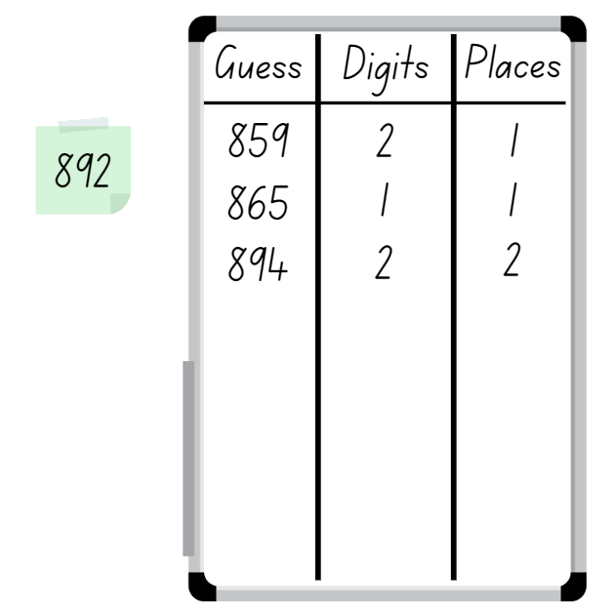
- The first student to correctly guess their partner’s number is the winner.
- Ask students to discuss the strategies they used to determine the correct answer.
Note: this activity can be adapted by using 2-, 4- or 5-digit numbers.
This table details opportunities for assessment.
Assessment opportunities | Links
What to look for:  - Can students make, record and state the value of digits in 3-digit numbers? [MAO-WM-01, MA1-RWN-01] | Links to National Numeracy Learning Progressions (NNLP):  - NPV5.  Links to suggested Interview for Student Reasoning (IfSR) tasks:  - IfSR-NP: 4B.2, 4B.3.

Core lesson: Make and represent 4-digit numbers – 45 minutes
The table below contains a suggested learning intention and success criteria. These are best co-constructed with students.
Core concept learning intention | Core concept success criteria
Students are learning to:  - name thousands using the place value groupings of ones, tens, hundreds and thousands. | Students can:  - read and record 4-digit numbers  - represent numbers up to and including thousands  - use manipulatives to represent 4-digit numbers.
Note: understanding place value requires more than naming the ones place, tens place and hundreds place. Students may need multiple opportunities to establish the relationship between the place value of digits in various numerals. For example, the '5' in 35 represents 5 ones, but the '5' in 53 represents 50 or 5 tens. That is, the '5' in 53 represents 10 times the value of the '5' in 35. Students often initially view each digit in a 2-digit number as representing ones.
- In small groups, students follow the instructions on Resource 6: Place value cups, to make a set of place value cups (see Figure 2).
Figure 2 – Place value cups
- In small groups, ask students to make a 4-digit number on their place value cups.
- Students read this number aloud and then represent this number using the appropriate number of MAB materials (see Figure 3).
Figure 3 – Place value cups and MAB materials
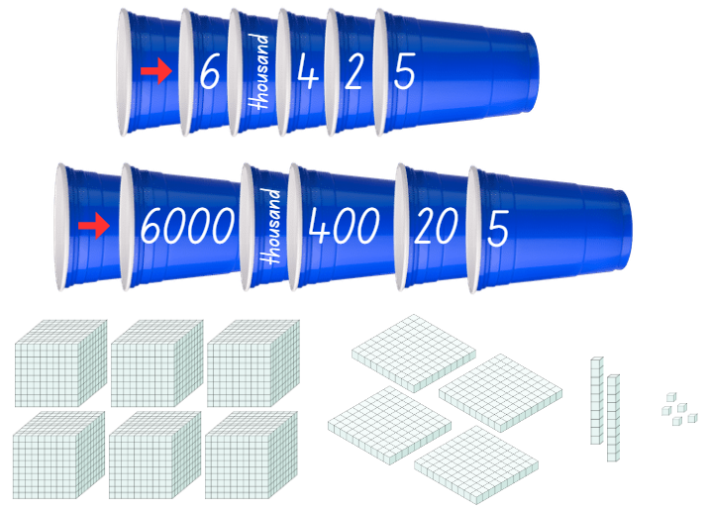
- Once students have made the number using the MAB materials, they record the number on Resource 5: Number houses or on their whiteboards. Ask:
- What is the value of the 5 in the number?
- What is the value of the 4 in the number?
- What MAB material did you use to represent the 6 in the number? Why?
- Students repeat these steps by creating a new number on their place value cups. Have different members of the group play different roles each time. For example, the student who creates the number can read it aloud, another student can make the number using the MAB materials and another student can record the number. Students swap roles for each new number.
This table details opportunities for differentiation.
Too hard? | Too easy?
Students cannot use manipulatives to represent 4-digit numbers.  - Assist students by reducing their number to a 2- or 3- digit number.  - Model how to use MAB materials to represent a 2- or 3-digit number. | Students can use manipulatives to represent 4-digit numbers.  - Challenge students to investigate how to make the number 1356 using MAB materials if they didn’t have:  - a thousands block  - hundreds blocks  - tens blocks  - ones blocks  - With a partner, one student makes a 4-digit number. They read it to their partner and instruct their partner to make the number with 100 more or 100 less. The partner must make the number using MAB materials. Variations include 10 more or 10 less.

Consolidation and meaningful practice – 15 minutes
- Provide pairs with 4 cups labelled thousands, hundreds, tens, and ones and 9 counters each.
- Place the cups on the floor in order of highest to lowest, left to right. Students stand 2 or 3 steps away from the cups.
- Each student has 9 counters that are a different colour to their partner. Students take it in turns to toss one counter at a time into one of the cups.
- When all counters have been tossed, students count how many counters were in each cup and formulate a 4-digit number. For example, if a student had 4 counters in the thousands cup, 2 counters in the hundreds cup, zero counters in the tens cup and 3 counters in the ones cup, their number would be 4203. Counters that do not land in a cup are not counted.
- Students read their number aloud. The student with the highest number wins.
Note: the game can be amended by changing the target number to the lowest number, the closest to a chosen number or the furthest away from a chosen number.
This table details opportunities for assessment.
Assessment opportunities | Links
What to look for:  - Can students read, record and represent numbers up to and including thousands? [MAO-WM-01, MA2-RN-01]  - Can students use manipulatives to represent 4-digit numbers? [MAO-WM-01, MA2-RN-01] | Links to National Numeracy Learning Progressions (NNLP):  - NPV4, NPV5, NPV6.  Links to suggested Interview for Student Reasoning (IfSR) tasks:  - IfSR-NP: 4B.2, 4B.5, 4C.5.

Lesson 3
Core concept: the position of each digit in a number corresponds to its size.

Daily number sense: Climb the ladder – 10 minutes
The table below contains a suggested learning intention and success criteria. These are best co-constructed with students.
Daily number sense learning intention | Daily number sense success criteria
Students are learning to:  - understand the value of a digit in a number by identifying its position | Students can:  - make, record and state the value of digits in 3-digit numbers.
- Explain the aim of the game is to position 3-digit numbers in sequence on the ladder rungs.
- Draw a ladder with 5 rungs on the board. Roll three 9-sided dice and form a 3-digit number. State the value of each digit, for example, 7 hundreds, 4 tens and one ones = 741; or one hundred, 7 tens and 4 ones = 174. Record the chosen 3-digit number on one of the ladder rungs.
- Select a student to roll the 3 dice again and form another 3-digit number to place on a rung of the ladder. Ask the student to explain and justify why they selected the 3-digit number, which rung they nominated to place it on, and to state the value of the digits before recording it on the ladder (see Figure 4).
Figure 4 – Climb the ladder
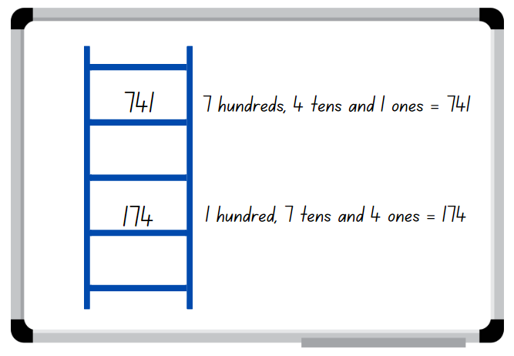
- Continue the game until a player is unable to place their number on the ladder, at which point the game is over. Discuss if there were any other possible combinations that could have helped a player win.
Note: the game can be played as whole class or in pairs.
This table details opportunities for assessment.
Assessment opportunities | Links
What to look for:  - Can students make, record and state the value of digits in 3-digit numbers? [MAO-WM-01, MA1-RWN-01] | Links to National Numeracy Learning Progressions (NNLP):  - NPV5.  Links to suggested Interview for Student Reasoning (IfSR) tasks:  - IfSR-NP: 4B.1, 4B.3, 4B.4.

Core lesson 1: Where do you fit? – 15 minutes
The table below contains a suggested learning intention and success criteria. These are best co-constructed with students.
Core concept learning intentions | Core concept success criteria
Students are learning to:  - compare and order numbers up to and including thousands. | Students can:  - arrange numbers in ascending or descending order  - determine a numbers position on a number line by its size  - apply knowledge of place value to compare and order numbers correctly.
Prior to the lesson, prepare the numeral cards from Resource 7: Where do you fit? By printing and cutting them out.
- Groups students into groups of 4–6 and provide each student a number card to attach to their shirt with tape.
- One by one, have each student read their number aloud and then place themselves in order from smallest to largest.
- When each group has all members in order, have 2 groups combine. Group members need to adjust their order to ensure they are still in order from smallest to largest.
- Continue to combine groups and adjust placements until the whole class is in order.

Core lesson 2: Number order – 25 minutes
- Provide pairs with two 9-sided dice. Students take it in turns to roll one die, read their number aloud and record this number on a coloured sticky note.
- Students then roll two 9-sided dice, read their number aloud and record it on a sticky note.
- Students repeat this step so that each student has 3 numbers recorded.
- Students place their sticky notes, in order of smallest to largest, along Resource 8: Number line (see Figure 5).
Figure 5 – Numbers placed on a number line
- The student with the smallest number goes first to place their number on the Resource 8: Number line. The student must convince their partner why they should go first and how they know their number is the smallest.
- The student places their sticky note onto the number line and explains why they have placed it in that particular position.
- The student with the next biggest number goes next. Before placing their number on the Resource 8: Number line, they must convince their partner how they know their number goes next. Students explain their reasoning for the position they place their number on the number line.
- Repeat this process until all numbers are placed on the Resource 8: Number line.
This table details opportunities for differentiation.
Too hard? | Too easy?
Students cannot determine a numbers position on a number by its size.  - Support students by supplying a number line with more reference numbers to help identify where to place their number.  - Assist students by reducing the amount of numbers they need to place along the number line. | Students can determine a numbers position on a number by its size.  - With a partner, students draw their own number line, placing a zero and another benchmark number. Take turns challenging each other to place a number or determine what number could be indicated by a mark on the number line.  - Increase the number size to 3-digit numbers and have students complete the same activity using three 9-sided dice.

Consolidation and meaningful practice – 10 minutes
- Regroup as a class and ask:
- How did you know who should go first?
- How did you use the numbers on the number line to guide where you put your numbers?
- Why was it useful to have the halfway point of the line marked?
- What sort of things did you say to your partner to convince them that your number was next?
- Ask students to sit in a circle and create a blank number line from 0-100 on the classroom floor. Use 2 pair’s sticky notes to model placing 12 numbers on the number line. Select 12 students to each place a number on the number line, justifying why they are placing the number in that position on the line.
This table details opportunities for assessment.
Assessment opportunities | Links
What to look for:  - Can students arrange numbers in ascending or descending order? [MAO-WM-01, MA2-RN-01]  - Can students determine a numbers position on a number line by its size? [MAO-WM-01, MA2-RN-01] | Links to National Numeracy Learning Progressions (NNLP):  - NPV4, NPV5, NPV6.  Links to suggested Interview for Student Reasoning (IfSR) tasks:  - IfSR-NP: 4B.2.

Lesson 4
Core concept: zeros in numbers can have different roles.

Daily number sense – 10 minutes
- From a class need surfaced through formative assessment data, identify a short, focused activity that targets students’ knowledge, understanding and skills. Example activities may be drawn from the following resources:
- Mathematics K-6 resources
- Universal Resources Hub.

Core lesson 1: Misconceptions about zero – 10 minutes
The table below contains a suggested learning intention and success criteria. These are best co-constructed with students.
Core concept learning intentions | Core concept success criteria
Students are learning to:  - understand the role of zero in large numbers. | Students can:  - read and name numbers with internal zeros  - identify the number before and after a number with an internal zero.  - explain the role played by a zero in a 4-digit number.
- Display and read Resource 9: Misconceptions – Zero. Explain that the class needs to decide which of the students from the display has written the correct answer. Students must be able to justify their choice.
- Students turn and talk to a partner to share and discuss their choices.
- As a class, choose students to justify their choice and explain why the other students in Resource 9: Misconceptions – Zero were incorrect.
- When students have had an opportunity to discuss their ideas for each student, explain why that student has the correct or incorrect answer. For example, ‘Sam’s answer is incorrect as he has not used a zero to indicate there are no hundreds in this number.’
Note: zero is a symbol, a number, a magnitude and a place holder in a positional number system. Zeros in numerals can have 2 different roles – to name the number and/or as place holders to parse the number into its component parts. Students need opportunities to learn to read and name the component parts of numbers with internal zeros.

Core lesson 2: The role of zero in numbers – 30 minutes
This activity is an adaptation of Place value and modelling numbers from FUSE by State of Victoria (Department of Education and Training).
Prior to the lesson, prepare the numeral cards from Resource 10: What’s my number? by printing and cutting them out.
- Stick a number card on the back of each student using tape. Explain that students will move around the classroom asking each of their classmates one question about their number. The question must only require a yes or no answer. For example, students could ask if their number has a 4 in the hundreds place.
- Each student can record notes and ideas on a whiteboard as they move around the room. With the class, discuss what information will be helpful to determine their number and what would be the best way to record this information. Encourage the use of number houses if not suggested by the students.
- Allow students time to move around the room asking questions of their peers.
- Once a student has determined their number, they must return to their seat.
- While waiting for their classmates to complete the task, each student must ensure they are able to read their number. They could also practise different ways of recording their number. For example, words, expanded notation or MAB materials.
- Regroup students on the floor.
- Have students turn to a partner and take turns reading their number and checking if they were able to correctly identify their number. Ask:
- Were you able to determine your number?
- What strategies or questions were most helpful?
- How did you record your information?
- Would you do things the same way or differently if we were to do the same activity again? Why?
- As a class, discuss how the students deal with a number when one of the digits is a zero. Ask them how they know what to change or what strategies they use to ensure they are correct.

Consolidation and meaningful practice – 20 minutes
- Provide groups of students with a handful of green, red, yellow and blue counters.
- Create a simple chart showing the counters assigned to place-value headings. For example, green counters are ones, red are tens, yellow are hundreds and blue are thousands (see Figure 6).
Figure 6 – Counters key
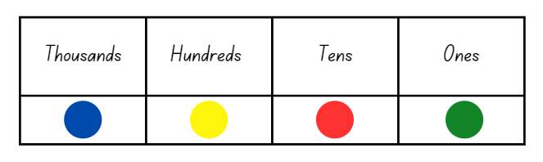
- Groups use the chart to work out their number and record on an individual whiteboard. Once all groups have recorded their number, ask a representative from each group to stand at the front with their whiteboard. Ask students to arrange themselves to order the numbers from smallest to largest. Ask?
- What would happen if the colours were assigned a different value?
- What number would be recorded if you had no red counters?
- If there were no yellow counters, would the order of numbers change?
- What number would be recorded if you were given another red counter?
- What number would be recorded if one yellow counter was removed?
This table details opportunities for assessment.
Too hard? | Too easy?
Students cannot read and name numbers with an internal zero.  - Support students to use concrete materials such as MAB, to help read their number.  - Assist students by reducing their number to a 2- or 3-digit number.  Students cannot identify the number before and after a number with an internal zero.  - Support students by giving them a hundred chart or number line to help highlight the change of digits.  - Assist students by reducing their number to a 2- or 3-digit number. | Students can read and name numbers with an internal zero.  - Challenge students to represent their number a variety of other ways.  - Ask students to identify the number before or after a number with an internal zero. They could also identify the number 10 more or 10 less than a number with an internal zero.  Students can identify the number before and after a number with an internal zero.  - Students identify the number 10 or 100 more or less than their number.  - Challenge students to identify the number 50 more or less than their number.

Assessment opportunities | Links
What to look for:  - Can students read and name numbers with internal zeros? [MAO-WM-01, MA2-RN-01]  - Can students explain the role played by a zero in a four-digit number? [MAO-WM-01, MA2-RN-01] | Links to National Numeracy Learning Progressions (NNLP):  - NPV4, NPV5, NPV6.

Lesson 5
Core concept: numbers can be renamed in equivalent ways using place value.

Daily number sense: Skip counting – 10 minutes
Daily number sense activities for Lessons 5 to 7 ‘loop’ back to concepts and procedures covered in previous units to assist students to build an increasingly connected network of ideas. These concepts may differ from the core concepts being covered by the unit.
The table below contains a suggested learning intention and success criteria. These are best co-constructed with students.
Daily number sense learning intention | Daily number sense success criteria
Students are learning to:  - generate and describe patterns. | Students can:  - model, describe and record patterns of multiples for 2 and 4, 5 and 10.
This activity is an adaptation of Number line jumps from Developing Efficient Numeracy Strategies by State of New South Wales (Department of Education).
- Have a collection of 2, 4, 5 and 10 number cards and draw a blank number line.
- Turn over a number card to identify the focus multiple, for example, if a 5 is turned over students are identifying multiples of 5. Write a multiple of 5 at the start of the number line and students use their individual whiteboard to draw a number line and record the next 6 multiples (see Figure 7).
Figure 7 – Example of student recordings
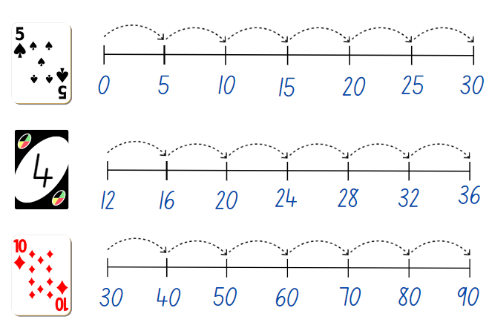
- Choose students to demonstrate and explain their number line after each card has been turned.
Note: not all number lines need to start from zero.
This table details opportunities for assessment.
Assessment opportunities | Links
What to look for:  - Can students' model, describe and record patterns of multiples for 2 and 4, 5 and 10? [MAO-WM-01, MA2-MR-01] | Links to National Numeracy Learning Progressions (NNLP):  - NPA3, NPA4.  Links to suggested Interview for Student Reasoning (IfSR) tasks:  - IfSR- AT: 3A.1

Core lesson: Representing numbers – 40 minutes
The table below contains suggested learning intentions and success criteria. These are best co-constructed with students.
Core concept learning intentions | Core concept success criteria
Students are learning to:  - make and represent numbers up to and including thousands  - represent numbers using standard partitioning. | Students can:  - name and represent numbers using numerals, words and MAB materials  - represent 4-digit numbers using standard partitioning.
- Roll four 9-sided dice. Select one student to arrange the dice to make a 4-digit number and another student to write this number. Ask:
- Are there other ways to represent the number?
- How can we record the number so we can see the value of each digit?
- How could we represent the number with MAB?
- Why would using the number house model be useful when representing this number?
- Record students’ ideas. Highlight ideas that involve expanded notation. For example, if the number is 6425, students could record it as 6 thousands, 4 hundreds, 2 tens and 5 ones. Students could also record it as 6000 + 400 + 20 + 5 or six thousand four hundred and twenty-five.
- Introduce Resource 11: Number expander. Model how to close the expander to show a number written as students would usually see it and then open it to see the number written in expanded notation.
- Ask a student to write the numbers from the 4-digit number into the correct places on the number expander. For example, a 6 in the thousands, a 4 in the hundreds, a 2 in the tens and a 5 in the ones.
- Show students that they now have 4 different ways of recording our number (see Figure).
Figure 8 – Recording 4-digit numbers in a variety of ways
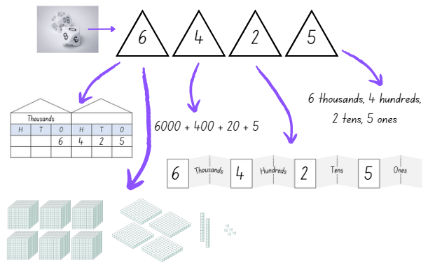
- Provide pairs with MAB, a copy of Resource 11: Number expander and Resource 5: Number houses, dice and writing materials. Students use four 9-sided dice to make a 4-digit number and record it the 4 different ways. Repeat to represent 3–4 different numbers.
This table details opportunities for differentiation.
Too hard? | Too easy?
Students cannot name and record a 4-digit number using standard partitioning.  - Support students by modelling the use of concrete materials such as MAB, to help represent their number.  - Assist students by reducing their number to a 2- or 3-digit number. | Students can name and record a 4-digit number using standard partitioning.  - With a partner, one student makes a 4-digit number on the number expander. They read it to their partner and instruct their partner to make the number using MAB materials, however they can only use one type. For example, make the number 2547 using only tens. Ask students:  - Is it possible to make your number this way?  - What problems will you encounter when trying to make the number using the one type of block?  - How would you record your number after making it this way?  - With a partner, students roll four 9-sided dice. Students challenge their partner to rename and record the number 100 more or less than the number rolled, using the different methods introduced during the lesson.

Discuss and connect the mathematics – 10 minutes
- Regroup as a class and display the number 7389 for students to see. Ask:
- Can you explain how the position of a number impacts its value?
- How does knowing a digit's position help you to read that number?
- Does representing the same number different ways change the value of the number? Explain your thinking.
This table details opportunities for assessment.
Assessment opportunities | Links
What to look for:  - Can students name and represent numbers using numerals, words and manipulatives? [MAO-WM-01, MA2-RN-01]  - Can students name and represent a 4-digit number using standard partitioning? [MAO-WM-01, MA2-RN-01] | Links to National Numeracy Learning Progressions (NNLP):  - NPV4, NPV5, NPV6.  Links to suggested Interview for Student Reasoning (IfSR) tasks:  - IfSR-AT: 3B.1, 3B.2, 3B.4  - IfSR-NP: 4B.5.

Lesson 6
Core concept: multiplicative thinking is based on patterns.

Daily number sense: Number patterns – 10 minutes
The table below contains a suggested learning intention and success criteria. These are best co-constructed with students.
Daily number sense learning intention | Daily number sense success criteria
Students are learning to:  - generate and describe patterns. | Students can:  - create, describe and record patterns of multiples for 2, 3 and 5.
- Demonstrate how to create an increasing or decreasing number pattern and show the increasing or decreasing pattern (see Figure 9). Select a student to identify the next 3 numbers in the pattern and record them.
Figure 9 – Number patterns
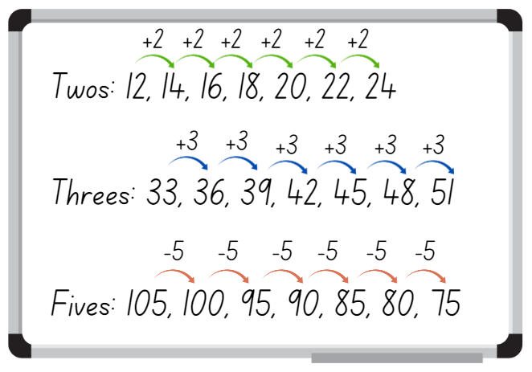
- Challenge students to create 3 different forwards or backwards number patterns that increase or decrease by twos, threes and fives. Students use their individual whiteboard to record their patterns (see Figure 8).
- Choose different students to share and justify their number patterns.
Note: number patterns can be adapted to increase or decrease by any number under 12.
This table details opportunities for assessment.
Assessment opportunities | Links
What to look for:  - Can students create, describe and record patterns of multiples for 2, 3 and 5? [MAO-WM-01, MA2-MR-01] | Links to National Numeracy Learning Progressions (NNLP):  - NPA3, NPA4.

Core lesson: Patterns in the hundred chart – 35 minutes
The table below contains a suggested learning intention and success criteria. These are best co-constructed with students.
Core concept learning intention | Core concept success criteria
Students are learning to:  - generate and describe multiplicative patterns. | Students can:  - record and describe patterns on a number chart  - create, continue and describe pattern that increase by a constant amount.
This activity is an adaptation of ‘Skipping across the hundred chart’ from Mindset Mathematics: Visualising and Investigating Big Ideas, Grade 1 by Boaler et al.
- Display a digital number chart. Skip count by twos, saying and highlighting each number. When 20 is highlighted, ask if students can see a pattern and select students to continue filling in the number chart, skip counting by 2.
- Once the pattern is complete, explain that the highlighted numbers are multiples of 2 and that a number chart can help locate multiples of other numbers.
Multiples: products formed using the same base number multiplied by different whole numbers, for example, 3, 6, 9, 12…
- Explain that students are going to skip count by fives, highlighting the numbers using a coloured marker or pencil, then by tens, recording in a different colour.
- Students think and then turn and talk to discuss what they think will happen and what the pattern will look like.
- Provide students with Resource 1: Number chart and coloured markers or pencils to work independently.
- While students are working, ask:
- What patterns are you seeing?
- Is there anything interesting about these 2 patterns?
- What does that pattern tell us?
- Once students have skip counted and recorded by fives and tens, explain that they will now skip count by fours and record in a different coloured marker or pencil to the previous multiples.
- Select students to share their patterns and anything that they noticed. Ask:
- Did you notice anything interesting about the patterns?
- Were there any numbers that you highlighted more than once?
- How do you think these patterns could help in multiplication?
This table details opportunities for differentiation.
Too hard? | Too easy?
Students cannot create and continue multiple patterns on the number chart.  - Assist students to create and continue a pattern by highlighting the first 4 numbers in the pattern when skip counting.  - Support students to only find the pattern for multiples of twos on the number chart. | Students can create and continue patterns on the number chart.  - Ask students to skip count by threes and record the pattern on their number chart.  - Challenge students to create a pattern using the multiples of 4, 5 and 10 without using a number chart for reference. Students record the pattern in their workbook.

Consolidation and meaningful practice – 15 minutes
This activity is an adaptation of ‘Patterns in the hundred chart’ from Mindset Mathematics: Visualising and Investigating Big Ideas, Grade 1 by Boaler et al.
- Display Resource 12: Number chart puzzles. Using their individual whiteboard, students draw and fill in the missing numbers, focusing on any patterns they know or find.
Note: students may need Resource 12: Number chart puzzles printed for support.
- As students are solving each puzzle, ask:
- How did you figure out the missing numbers? How do you know they are correct?
- How does knowing the position of numbers help you fill in the missing numbers?
- Did you need to use the number chart to help?
- What patterns did you find and/or use?
- Select students to share and justify their working.
This table details opportunities for differentiation.
Too hard? | Too easy?
Students cannot sequence and identify missing numbers.  - Provide students with number cards to sequence in ascending order.  - Provide students with number chart puzzles that use numbers below 50.  - Provide students with a completed number chart to reference. | Students can sequence and identify missing numbers.  - Challenge students with more complex puzzle pieces where only part of the number is represented. For example, 6_.  - Students sequence 4-digit number chart puzzles.
This table details opportunities for assessment.
Assessment opportunities | Links
What to look for:  - Can students record and describe patterns on a number chart? [MAO-WM-01, MA2-MR-01]  - Can students create, continue and describe pattern that increase by a constant amount? [MAO-WM-01, MA2-MR-01] | Links to National Numeracy Learning Progressions (NNLP):  - NPA3, NPA4.  Links to suggested Interview for Student Reasoning (IfSR) tasks:  - IfSR-NP: 4A.1, 4A.2, 4A.3.

Lesson 7
Core concept: structures can support multiplicative thinking.

Daily number sense: Missing number patterns – 10 minutes
The table below contains a suggested learning intention and success criteria. These are best co-constructed with students.
Daily number sense learning intention | Daily number sense success criteria
Students are learning to:  - generate and describe patterns. | Students can:  - create and continue increasing and decreasing number patterns  - determine missing numbers in a pattern.
- Display Resource 13: Number patterns and ask students to determine the missing numbers in the pattern. Students use their individual whiteboard to record the number pattern showing the rule and the missing numbers (see Figure 10).
Figure 10 – Student work sample
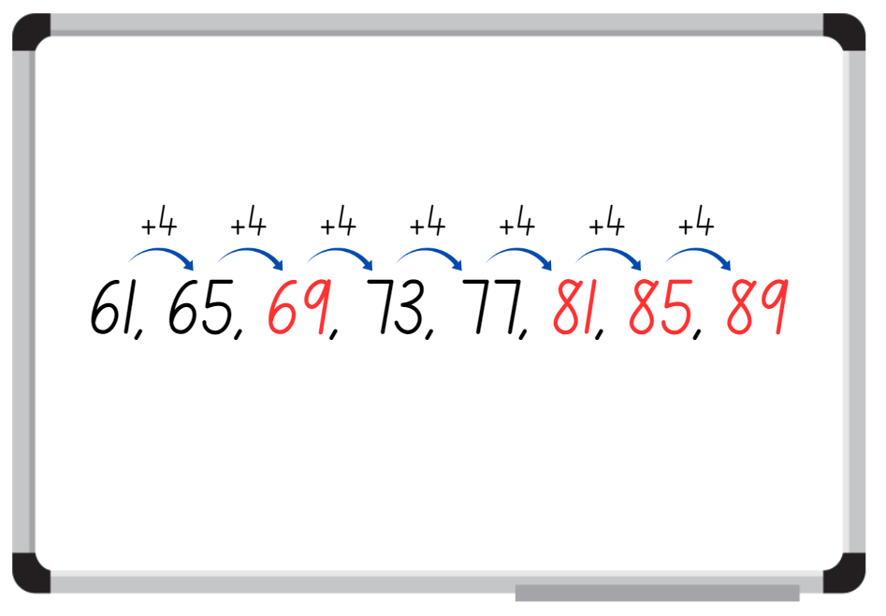
- Choose students to demonstrate their working, explaining how they determined the missing number. Select a student to identify the next 3 numbers in the pattern and record.
- Display Resource 13: Number patterns 2 and follow the above steps.
This table details opportunities for assessment.
Assessment opportunities | Links
What to look for:  - Can students create and continue an increasing and decreasing number pattern? [MAO-WM-01, MA2-MR-01]  - Can students determine missing numbers in a pattern? [MAO-WM-01, MA2-MR-01] | Links to National Numeracy Learning Progressions (NNLP):  - NPA3.  Links to suggested Interview for Student Reasoning (IfSR) tasks:  - IfSR-NP: 4A.1, 4A.2, 4A.3.

Core lesson: Array busting – 30 minutes
The table below contains a suggested learning intention and success criteria. These are best co-constructed with students.
Core concept learning intentions | Core concept success criteria
Students are learning to:  - use arrays to represent multiplication facts. | Students can:  - represent various multiplication facts using arrays  - create the array structure using rows and columns and name the array correctly  - recognise and represent smaller array hiding inside larger arrays.
- Display an array of 5 tens using counters or tiles where all students can see.
Note: concrete materials will enable the array to by manipulated to clearly show the smaller arrays hiding inside.
- Ask students what they notice about the way the counters have been arranged. If students can name the array correctly, ask what they know about arrays and why they are useful.
- Explain that the array of 5 tens can be busted to find smaller arrays hiding inside of 5 tens.
Array: an array is made by arranging a set of objects, such as counters, into columns and rows. Each column must contain the same number of objects as the other columns, and each row must contain the same number of objects as the other rows.
- Students think and then turn and talk to discuss the smaller arrays that could be hiding inside of 5 tens.
- Select students to share and explain their ideas. Test students’ ideas as they are shared and record (see Figure 11).
Figure 11 – Array busting recording
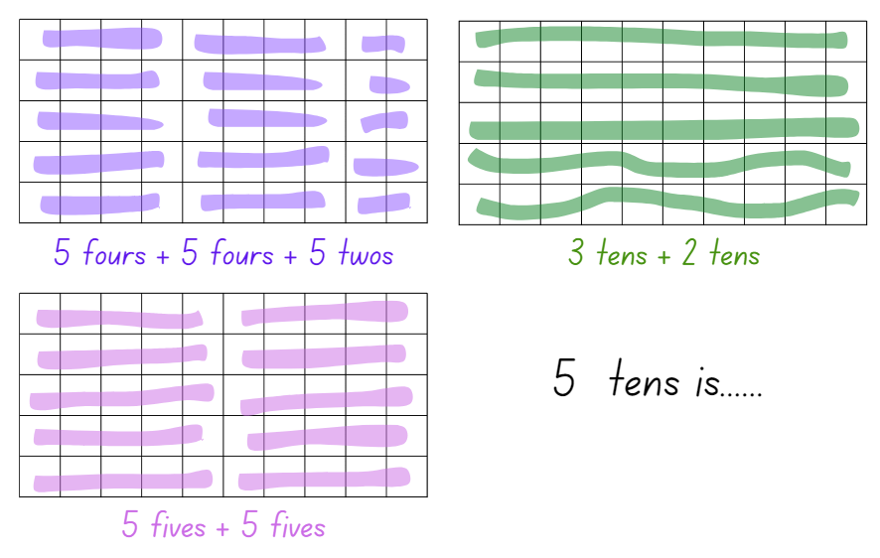
- Provide students with their workbook and explain that they will work either independently or with a partner to first create a given array (no larger than 10 tens) using concrete materials, such as counters or tiles. Students then bust and record as many smaller arrays they can find in their grid book. Ensure that students are naming and recording the arrays correctly as they complete the activity (see Figure 9).
- Students display their work and go on a gallery walk, looking for different and similar smaller arrays found with the larger array.
- Regroup as class and select students to share what they found interesting during the gallery walk.
This table details opportunities for differentiation.
Too hard? | Too easy?
Students cannot recognise smaller arrays inside a larger array.  - Provide students with an array no larger than 3 threes and support them to find at least 2 smaller arrays hiding within.  - Provide students with counters to use to find smaller numbers hiding inside of bigger numbers. Students count out at least 14 counters and then find and record as many smaller numbers as they can. | Students can recognise smaller arrays inside a larger array.  - Challenge students to find as many smaller arrays as possible without concrete materials to manipulate.  - Provide students with an array of 12 twelves and challenge them to find all the smaller arrays within.

Consolidation and meaningful practice – 20 minutes
This activity is an adaptation of ‘Multiplication Toss’ from Teaching Mathematics: Foundations to Middle Years, 3rd edn by Siemon et al.
- Demonstrate how to play multiplication toss by playing against the class. Use and display one gameboard from Resource 14: Multiplication toss gameboard, two 9-sided dice and 2 different coloured makers.
- Player 1 rolls the dice and uses the numbers rolled to create an array. For example, if they roll 3 and 5, they can make either 3 fives or 5 threes. The player decides which array they will use, draws an outline of the array around the correct number of rows and columns and writes the name of the array in the middle (see Figure 12).
Figure 12 – Multiplication toss gameplay
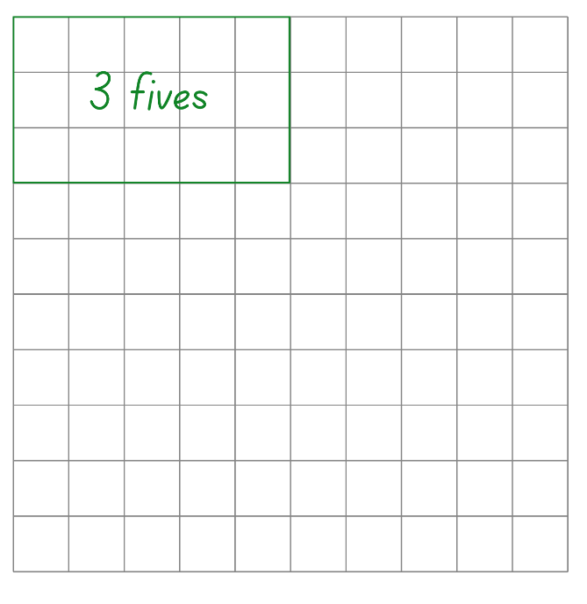
- Player 2 then rolls the dice and uses the numbers rolled to create an array that will fit without overlapping. For example, if Player 2 rolls a 4 and 7 and chooses 7 fours. Player 2 draws an outline of the array around the correct number of rows and columns and writes the name of the array in the middle (see Figure 13).
Figure 13 – Gameplay
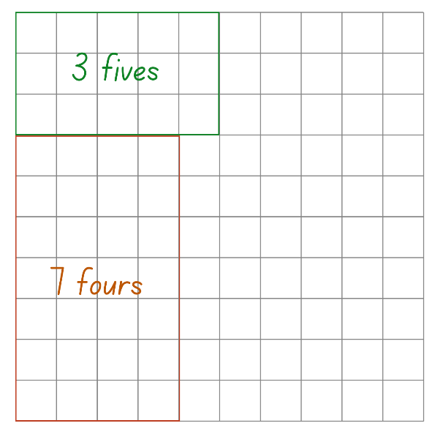
- If a player rolls an array that does not fit without overlapping, it is the other players turn. Players continue to take turns until there is no more room for either player. The player with the most squares covered is the winner.
- Once students are confident with the game, provide pairs with one gameboard from Resource 14: Multiplication toss gameboard, two 9-sided dice and 2 different coloured markers. Students take turns playing multiple rounds.
Note: place Resource 14: Multiplication toss gameboard in a reusable sleeve to play multiple rounds or students can use their grid workbook. Students can also record the total in the middle of their array, for example, 7 fours = 28.
This table details opportunities for differentiation.
Too hard? | Too easy?
Students cannot create and name arrays.  - Provide students with two 6-sided dice and support them to use concrete materials to create and correctly name arrays according to the number of rows and how many are in each row.  - Print Resource 14: Multiplication toss gameboard on A3 paper and provide students with counters to place on the grid and then draw an outline around the counters. | Students can create and name simple arrays  - Challenge students to create arrays using 12-sided dice.  - Students can partition the number of groups to form 2 separate outlines. For example, 6 eights could be split into 4 eights and 2 eights.
This table details opportunities for assessment.
Assessment opportunities | Links
What to look for:  - Can students represent various multiplication facts using arrays? [MAO-WM-01, MA2-MR-01]  - Can students create the array structure using rows and columns and name the array correctly? [MAO-WM-01, MA2-MR-01]  - Can students recognise and represent smaller array hiding inside larger arrays? [MAO-WM-01, MA2-MR-01] | Links to National Numeracy Learning Progressions (NNLP):  - MUS5.

Lesson 8
Core concept: doubling is a powerful strategy.

Daily number sense – 10 minutes
- From a class need surfaced through formative assessment data, identify a short, focused activity that targets students’ knowledge, understanding and skills. Example activities may be drawn from the following resources:
- Mathematics K-6 resources
- Universal Resources Hub.

Core lesson: Doubling – 30 minutes
The table below contains a suggested learning intention and success criteria. These are best co-constructed with students.
Core concept learning intentions | Core concept success criteria
Students are learning to:  - use doubling as an efficient strategy to solve simple multiplication problem. | Students can:  - solve simple multiplication problem involving multiples of 2 and 4  - recognise the relationship between one multiple and its double.
This activity is an adaptation of ‘Double magic’ from Primary and Middle Years Mathematics: Teaching Developmentally, 1st edn by Van de Walle et al.
- Display Resource 15: Doubling and provide students with an individual whiteboard. Ask students to record the answers on the whiteboard.
- Select students to share and explain the strategy they used to find the answers.
Note: if not identified by students, highlight the efficient strategy of doubling to find the answers.
- Display a cup or box and explain to students the cup or box is a magic pot and that each time a card comes out of it, the number doubles.
- Use Resource 16: Number cards to place in the magic pot. Select one number at a time and ask students to record the doubled number on their whiteboard.
- Choose students to share their and answers and strategies they used.
The table below outlines stimulus prompts to generate conversation about the topic, along with anticipated responses from students.
Prompts | Anticipated student responses
- What strategy did you use to double the number? | - I used 5 or 10 as a reference.  - I counted on by that number again to get the double.  - I used counters and counted by ones.
- Continue until all number cards have been selected.
- Highlight the fact that doubling a number is the same as 2 times. For example, double 3 is 6, which is the same as 2 times 3 is 6.
- Write ‘4 multiples of 3 = ?’ on the board. Ask students to think and then turn and talk to discuss what strategies they could use to solve the problem.
- Select students to share and explain their strategies to solve the problem. Highlight, if not already identified, that the problem can be solved using double and double again, which is also the same as 4 times. Solve the problem for the class using a think aloud (see Figure 14).

Figure 14 – Double and double again
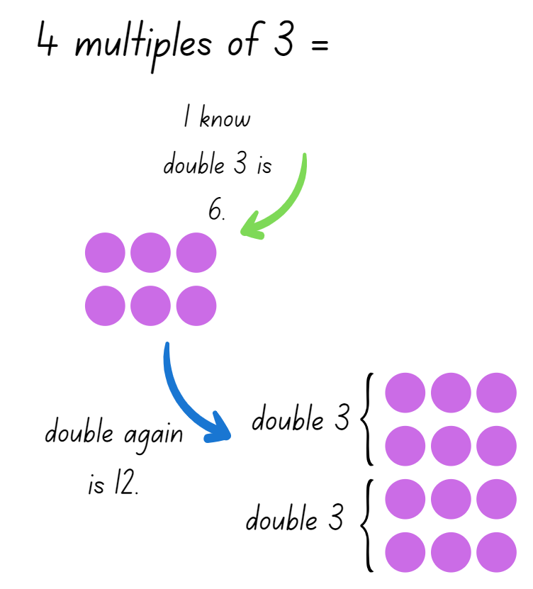
- Continue writing multiples of 4 problems for students to solve independently using the double and double again strategy.
- Choose students to share and justify their answers with the class.
This table details opportunities for differentiation.
Too hard? | Too easy?
Students cannot find the double of a give number.  - Provide students with concrete materials, for example, counters to manipulate when solving double problems. Support students to count the total to number to find the double fact.  - Provide students with a number line and support them to count on as they double and then double again. | Students can find the double of a given number.  - Challenge students to find the multiples of 3 using double and double half as the strategy. Students record their answers in their workbook.  - Challenge students to double, double and double again. Ask students to explain and justify what multiplication facts the strategy shows.

Consolidation and meaningful practice – 20 minutes
This activity is an adaptation of Memory Doubles from NZ Maths by New Zealand Ministry of Education.
- Provide pairs with Resource 17: Doubles memory. One student places the cards face down.
- Students take turns flipping over 2 cards. If the cards match, players get to keep the pair. For example, 4 + 4 and 8 are a matching pair. If the cards don’t match, players replace the cards face down.
- The winner is the player with the most pairs at the end of the game.
This table details opportunities for assessment.
Assessment opportunities | Links
What to look for:  - Can students solve simple multiplication problem involving multiples of 2 and 4? [MAO-WM-01, MA2-MR-01]  - Can students recognise the relationship between one multiple and its double? [MAO-WM-01, MA2-MR-01] | Links to National Numeracy Learning Progressions (NNLP):  - CPr6  - NPA4  - MuS6.

Resource 1: Number chart

Resource 2: What could it be?
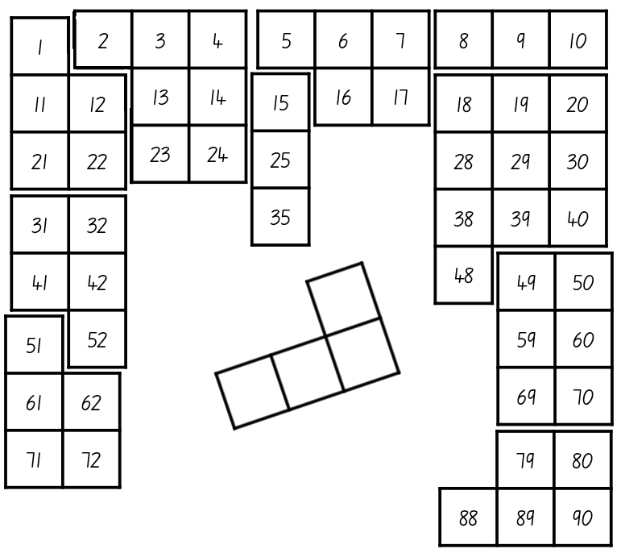

Resource 3: MAB understandings
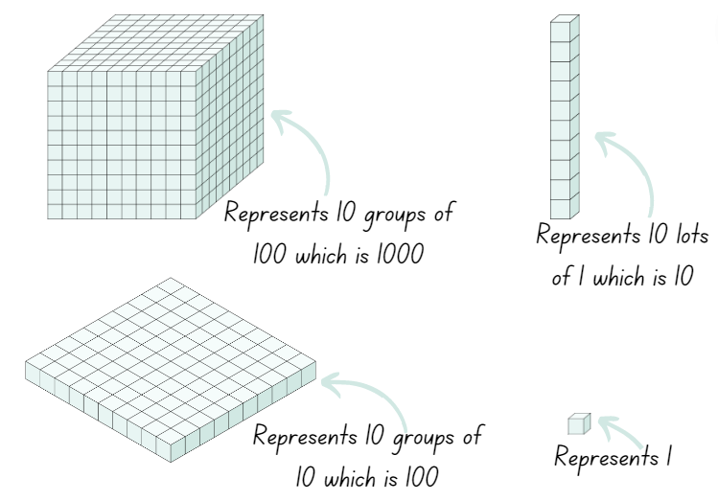

Resource 4: Reading numbers
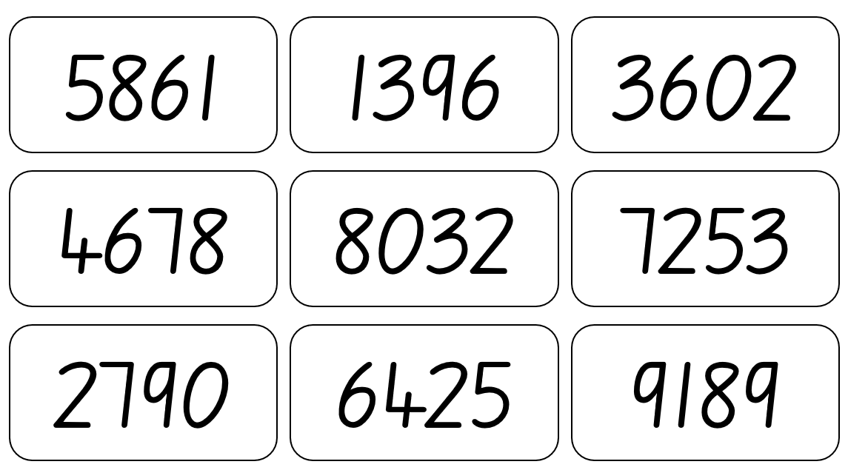

Resource 5: Number houses
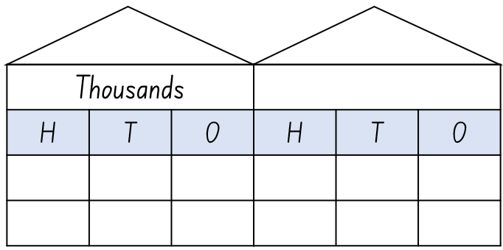

Resource 6: Place value cups
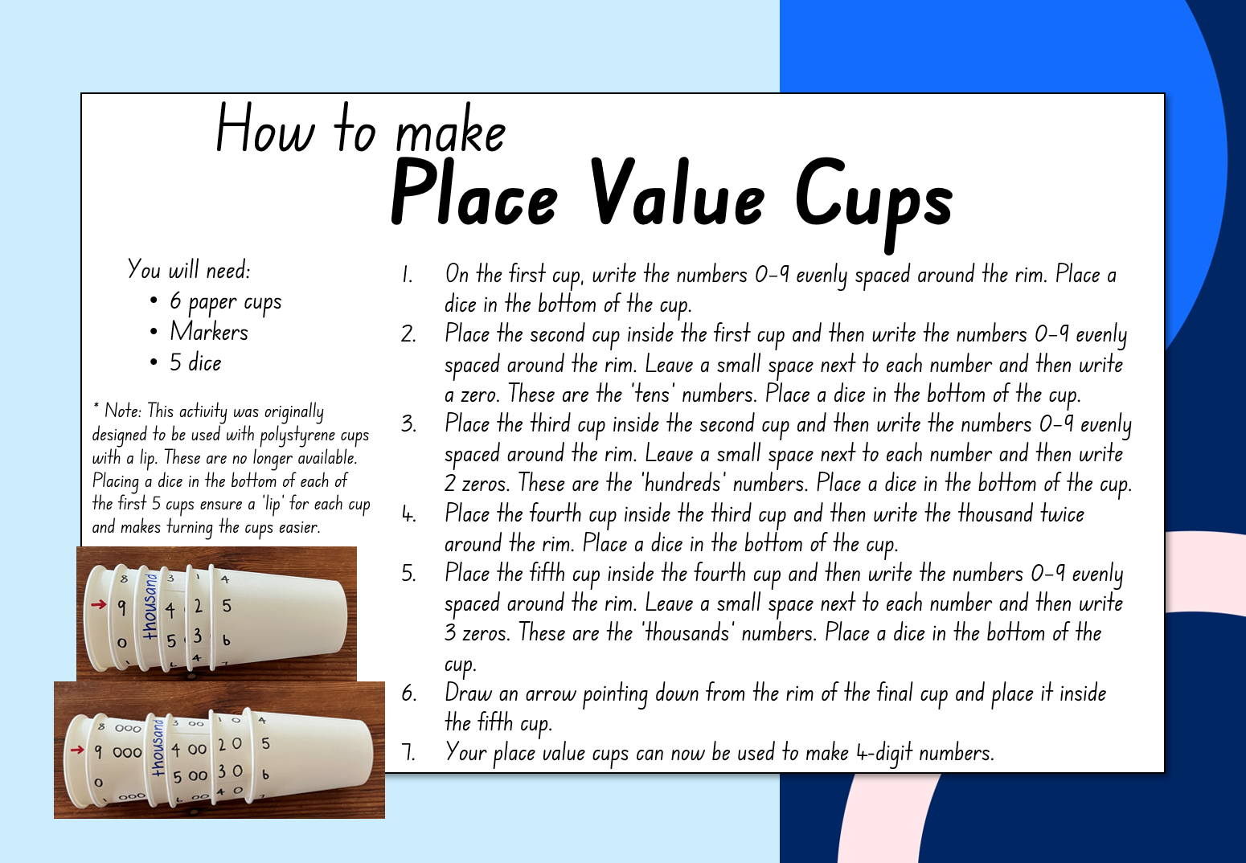

Resource 7: Where do you fit?
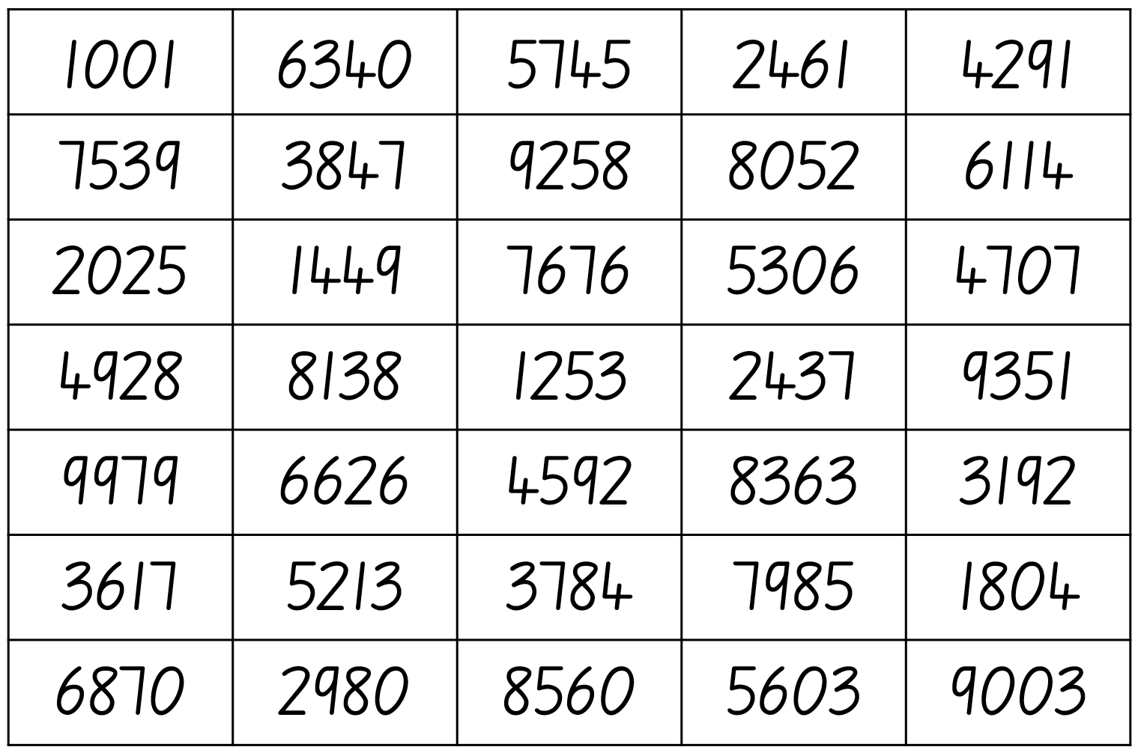

Resource 8: Number line

Resource 9: Misconceptions – Zero
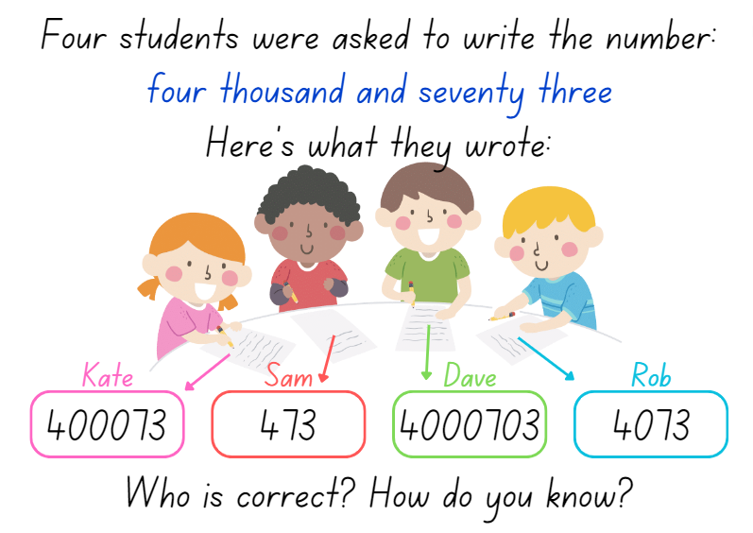

Resource 10: What’s my number?
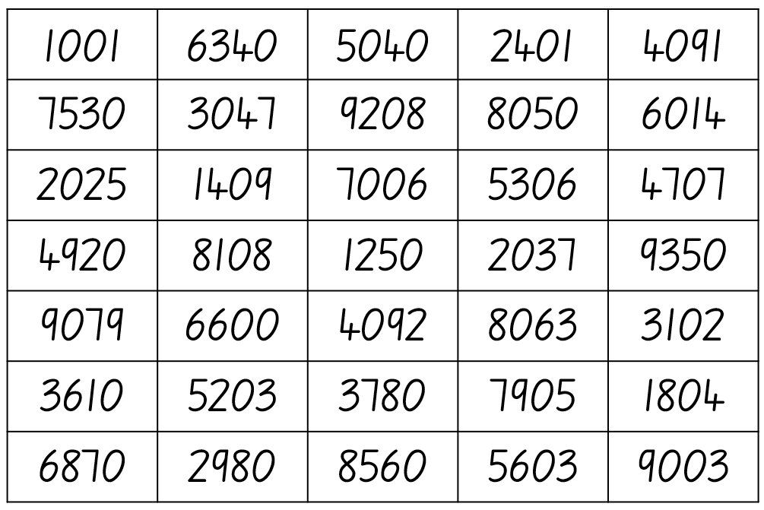

Resource 11: Number expander
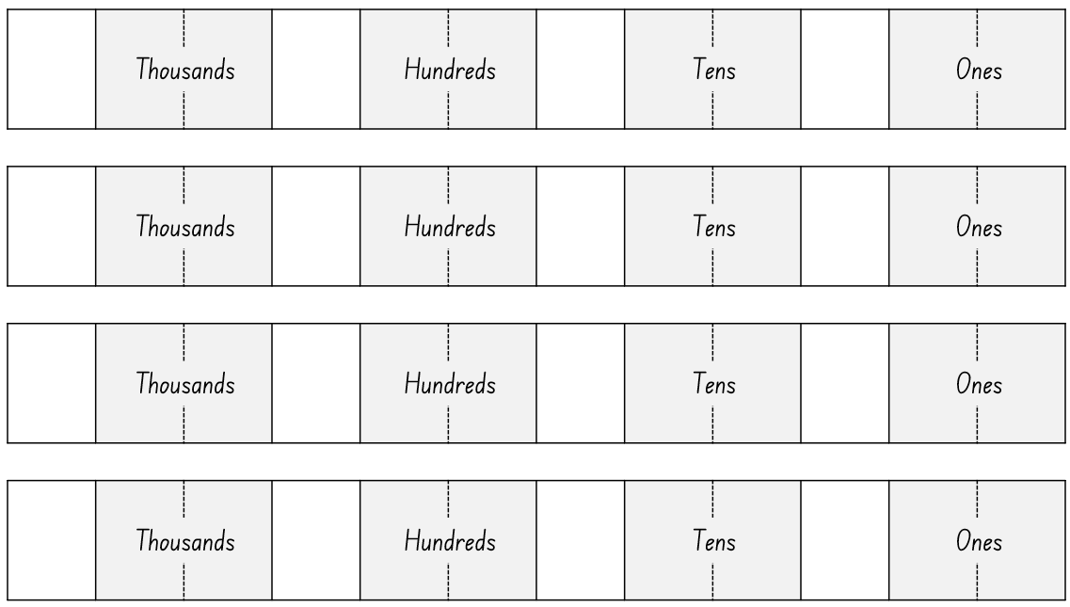

Resource 12: Number chart puzzle
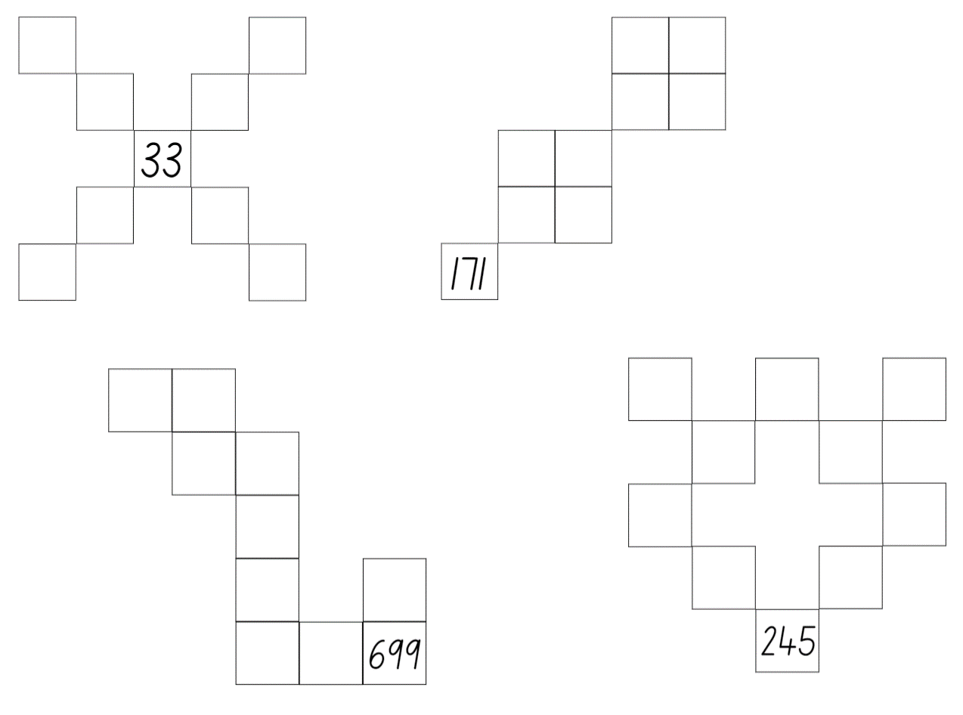

Resource 13: Number patterns
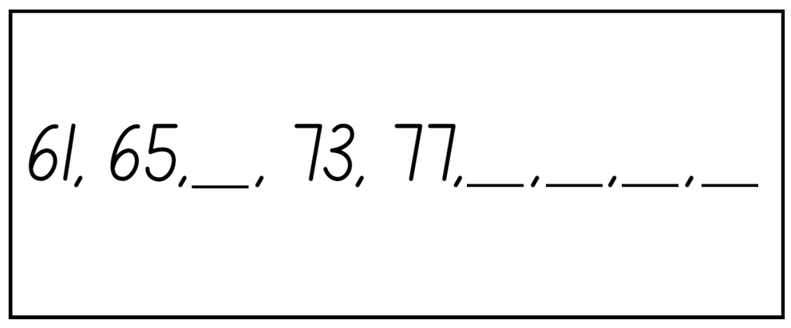
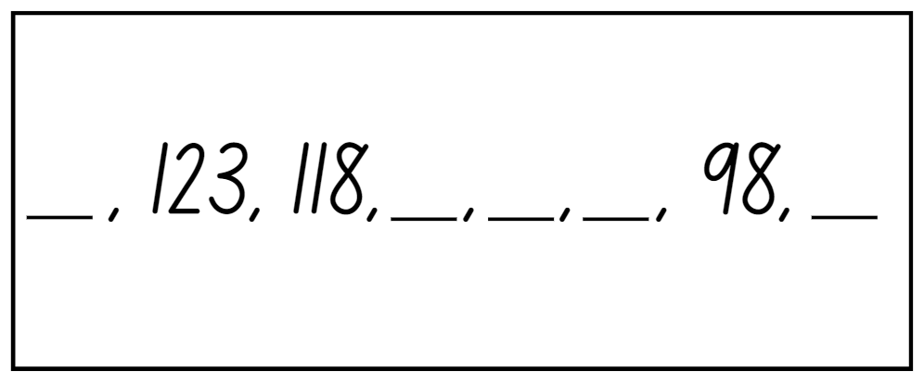

Resource 14: Multiplication toss gameboard
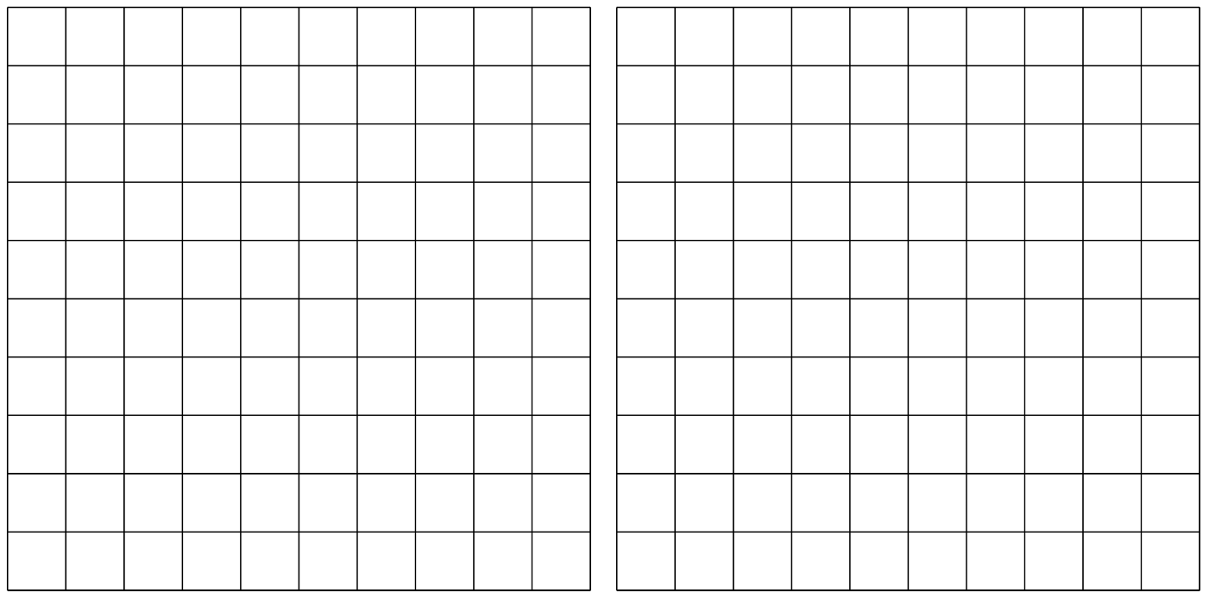

Resource 15: Doubling
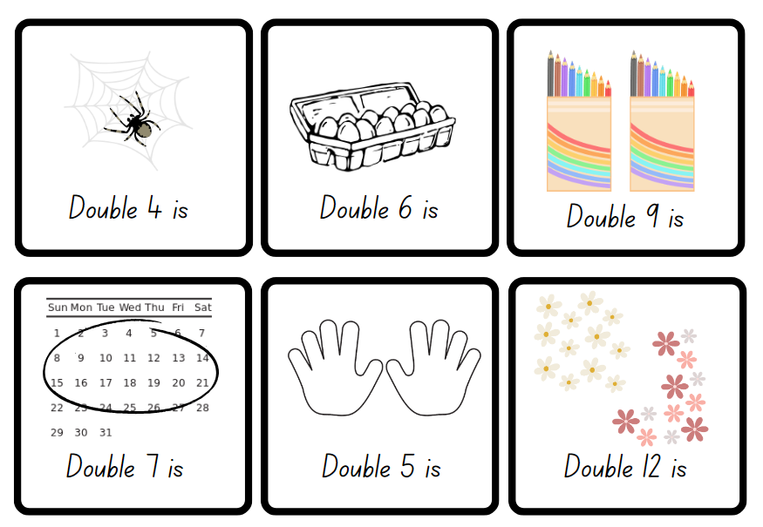

Resource 16: Number cards
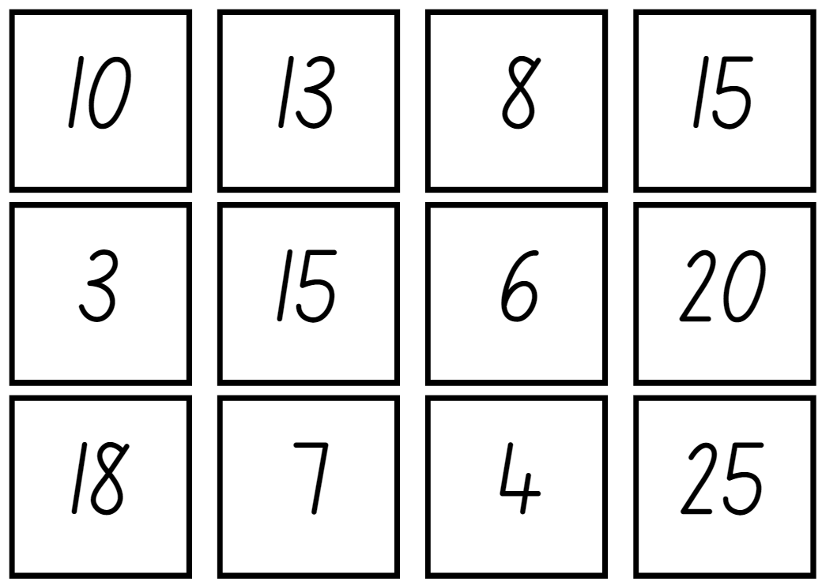

Resource 17: Doubles memory
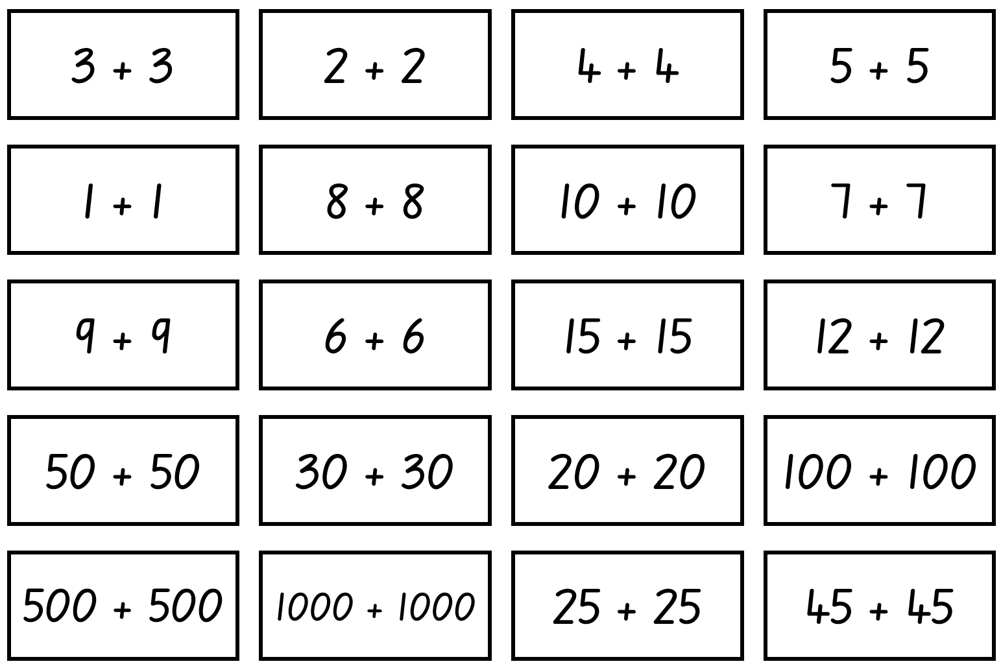
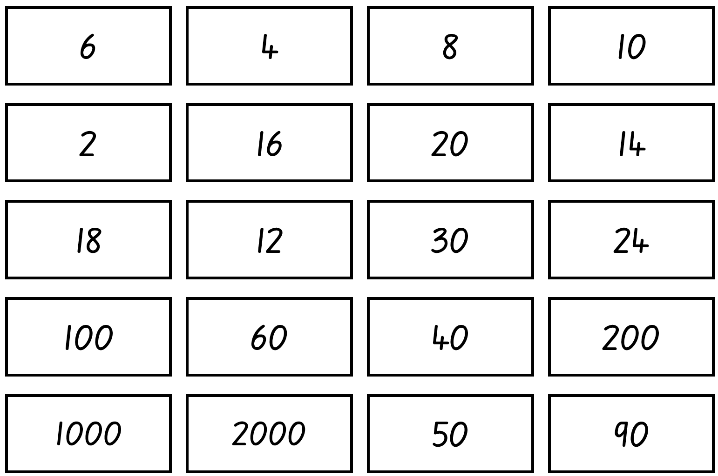

Syllabus outcomes and content
The table below outlines the syllabus outcomes and range of relevant syllabus content covered in this unit. Content is linked to National Numeracy Learning Progression version (3).
Outcomes and content | 1 | 2 | 3 | 4 | 5 | 6 | 7 | 8
Representing whole numbers B: Form, regroup, and rename three-digit numbers
MAO-WM-01, MA1-RWN-01, MA1-RWN-02
- State the quantity value of digits in numbers of up to three digits (Reasons about quantity) | x | x | x
- Use place value to partition and rename three-digit numbers in different ways (Reasons about relations) | x
- Estimate, to the nearest hundred, the number of objects in a collection and check by grouping and counting | x
Representing numbers using place value A: Whole numbers: Read, represent and order numbers to thousands
MAO-WM-01, MA2-RN-01
- Group physical or virtual objects to show the structure of tens, hundreds and a thousand | x | x |  |  | x
- Regroup numbers flexibly, recognising one thousand as 10 hundreds and one hundred as 10 tens or 100 ones |  | x
- Compare and describe the relative size of numbers by positioning numbers on a number line (Reasons about quantity) |  |  | x
- Count forwards and backwards by tens and hundreds on and off the decade | x
- Represent numbers up to and including thousands using physical or virtual manipulatives, words, numerals, diagrams and digital displays | x | x |  |  | x
- Read and order numbers of up to at least 4 digits | x | x |  | x | x
- Identify the number before and after a number with an internal zero digit |  |  |  | x
Representing numbers using place value A: Whole numbers: Apply place value to partition and regroup numbers up to 4 digits
MAO-WM-01, MA2-RN-01
- Record numbers using standard place value form | x | x |  |  | x
Representing numbers using place value B: Whole numbers: Order numbers in the thousands
MAO-WM-01, MA2-RN-01
- Arrange numbers in the thousands in ascending and descending order |  |  | x
- Recognise and describe how rearranging digits changes the size of a number (Reasons about relations) |  |  | x
Representing numbers using place value B: Whole numbers: Recognise and represent numbers that are 10, 100 or 1000 times as large
MAO-WM-01, MA2-RN-01
- Recognise the number of tens, hundreds or thousands in a number | x | x |  | x
Multiplicative relations A: Generate and describe patterns
MAO-WM-01, MA2-MR-01
- Model, describe and record patterns of multiples |  |  |  |  |  | x
- Create and continue a variety of number patterns that increase or decrease by a constant number |  |  |  |  |  | x
Multiplicative relations A: Use arrays to establish multiplication facts from multiples of 2 and 4, 5 and 10
MAO-WM-01, MA2-MR-01
- Create and represent multiplicative structure, using the term multiples when connecting grouping to arrays |  |  |  |  |  |  | x
- Use the array structure to coordinate the number of groups with the number in each group |  |  |  |  |  |  | x
- Record the first 10 multiples formed by counting by twos, fours, fives and tens |  |  |  |  |  | x
- Relate doubling to multiplication facts for multiples of 2 |  |  |  |  |  |  |  | x
- Recognise that doubling is multiplying by 2 and halving is dividing by 2 (Reasons about relations) |  |  |  |  |  |  |  | x
- Recognise the relationship between one multiple and its double (Reasons about relations) |  |  |  |  |  |  |  | x
Multiplicative relations A: Recall multiplication facts of 2 and 4, 5 and 10 and related division facts
MAO-WM-01, MA2-MR-01
- Recognise and use the symbols for multiplication by (×), divided by (÷) and equals (=) |  |  |  |  |  |  | x | x
- Model and apply the commutative property of multiplication |  |  |  |  |  |  | x
Mathematics K–10 Syllabus © NSW Education Standards Authority (NESA) for and on behalf of the Crown in right of the State of New South Wales, 2022.

References
This resource contains NSW Curriculum and syllabus content. The NSW Curriculum is developed by the NSW Education Standards Authority. This content is prepared by NESA for and on behalf of the Crown in right of the State of New South Wales. The material is protected by Crown copyright.
Please refer to the NESA Copyright Disclaimer for more information https://educationstandards.nsw.edu.au/wps/portal/nesa/mini-footer/copyright.
NESA holds the only official and up-to-date versions of the NSW Curriculum and syllabus documents. Please visit the NSW Education Standards Authority (NESA) website https://educationstandards.nsw.edu.au/ and the NSW Curriculum website https://curriculum.nsw.edu.au/home.
Mathematics K–10 Syllabus © NSW Education Standards Authority (NESA) for and on behalf of the Crown in right of the State of New South Wales, 2022.
National Numeracy Learning Progression © Australian Curriculum, Assessment and Reporting Authority (ACARA) 2010 to present, unless otherwise indicated. This material was downloaded from the Australian Curriculum website (National Literacy Learning Progression) (accessed 24 August 2023) and was not modified.
Boaler J, Munson J, and Williams C (2021) Mindset Mathematics: Visualising and Investigating Big Ideas, Grade 1, Jossey-Bass Inc., US.
New Zealand Ministry of Education (n.d) Memory Doubles, NZ Maths website, accessed 19 May 2023.
Siemon D, Warren E, Beswick K, Faragher R, Miller J, Horne M, Jazby D, Breed M, Clark J and Brady K (2021) Teaching Mathematics: Foundations to Middle Years, 3rd edn, Oxford University Press ANZ, Australia.
Stanford University (n.d.) ‘Pig’, Tasks, youcubed website, accessed 19 May 2023.
State of New South Wales (Department of Education) (2023) ‘Mastermind’, Mathematics K-6 resources, NSW Department of Education website, accessed 19 May 2023.
State of New South Wales (Department of Education) (2023) ‘Number busting – number talk (renaming 26)’, Mathematics K-6 resources, NSW Department of Education website, accessed 19 May 2023.
State of New South Wales (Department of Education) (n.d) Number line jumps, Developing Efficient Numeracy Strategies website, accessed 19 May 2023.
State of Victoria (Department of Education and Training) (2018) Place value and modelling numbers, FUSE website, accessed 19 May 2023.
Sullivan P (2018) Challenging Mathematical Tasks: Unlocking the potential of all students, Oxford University Press ANZ, Great Britain.
Toy Theater (2001–2023) Hundreds chart, Toy Theater website, accessed 19 May 2023.
Van de Walle J, Karp K, Bay-Williams JM, Brass A, Bentley B, Ferguson S, Goff W, Livy S, Marshman M, Martin D, Pearn C, Prodromou T, Symons D and Wilkie K (2019) Primary and Middle Years Mathematics: Teaching Developmentally, 1st edn, Pearson Education Australia, Melbourne.

© State of New South Wales (Department of Education), 2023
The copyright material published in this resource is subject to the Copyright Act 1968 (Cth) and is owned by the NSW Department of Education or, where indicated, by a party other than the NSW Department of Education (third-party material).
Copyright material available in this resource and owned by the NSW Department of Education is licensed under a Creative Commons Attribution 4.0 International (CC BY 4.0) license.
This license allows you to share and adapt the material for any purpose, even commercially.
Attribution should be given to © State of New South Wales (Department of Education), 2023.
Material in this resource not available under a Creative Commons license:
- the NSW Department of Education logo, other logos and trademark-protected material
- material owned by a third party that has been reproduced with permission. You will need to obtain permission from the third party to reuse its material.
Links to third-party material and websites
Please note that the provided (reading/viewing material/list/links/texts) are a suggestion only and implies no endorsement, by the New South Wales Department of Education, of any author, publisher, or book title. School principals and teachers are best placed to assess the suitability of resources that would complement the curriculum and reflect the needs and interests of their students.
If you use the links provided in this document to access a third-party's website, you acknowledge that the terms of use, including licence terms set out on the third-party's website apply to the use which may be made of the materials on that third-party website or where permitted by the Copyright Act 1968 (Cth). The department accepts no responsibility for content on third-party websites.

