# Mathematics Stage 2 – Unit 2



Contents

Unit description and duration 4

Syllabus outcomes 4

Working mathematically 5

Student prior learning 5

Lesson overview and resources 7

Lesson 1 11

Daily number sense: Decade dash – 10 minutes 11

Core lesson: Equals – 35 minutes 12

Consolidation and meaningful practice – 15 minutes 15

Lesson 2 17

Daily number sense: The same as – 15 minutes 17

Core lesson: Inverse and complement – 35 minutes 20

Discuss and connect the mathematics – 10 minutes 24

Lesson 3 26

Daily number sense: True or False? – 10 minutes 26

Core lesson: Decades as landmarks – 40 minutes 27

Discuss and connect the mathematics – 10 minutes 33

Lesson 4 35

Daily number sense – 10 minutes 35

Core lesson: Compensation strategy – 40 minutes 35

Discuss and connect the mathematics – 15 minutes 39

Lesson 5 41

Daily number sense: Strike it out – 15 minutes 41

Core lesson: Levelling and constant difference – 45 minutes 44

Discuss and connect the mathematics – 10 minutes 48

Lesson 6 50

Daily number sense: Closest to 100 – 15 minutes 50

Core lesson: Tape and bar – 40 minutes 51

Discuss and connect the mathematics – 10 minutes 54

Lesson 7 55

Daily number sense: Double or halve – 15 minutes 55

Core lesson: Solving problems – 35 minutes 57

Consolidation and meaningful practice – 15 minutes 60

Lesson 8 62

Daily number sense – 10 minutes 62

Core lesson: More problems – 35 minutes 62

Consolidation and meaningful practice – 20 minutes 64

Resource 1: Calculator 66

Resource 2: Number sentence board 67

Resource 3: Bar model 68

Resource 4: True or False? 69

Resource 5: Chess pieces 70

Resource 6: Chess chart 1 71

Resource 7: Chess chart 2 72

Resource 8: Empty chart 73

Resource 9: Chess chart 3 74

Resource 10: Addition grid 75

Resource 11: Subtraction grid 76

Resource 12: 119 number chart 77

Resource 13: Tape diagram 1 78

Resource 14: Tape diagram 2 79

Resource 15: Mistake 80

Resource 16: Grid 81

Resource 17: The old couple 82

Resource 18: Great grandchildren 83

Resource 19: Maze 100 84

Resource 20: Frayer model 85

Resource 21: Mr Frizzle’s pencils 86

Resource 22: Problems 87

Syllabus outcomes and content 88

References 93

## Unit description and duration

This unit introduces the big idea that addition and subtraction problems can be solved using a variety of strategies.

In this 2-week unit students are provided opportunities to:

* apply place value to partition and regroup numbers for addition and subtraction problem solving
* recognise and explain the connection between addition and subtraction
* select efficient strategies when solving problems.

Additional lessons on this big idea can be found in Unit 15 and Unit 35.

### Syllabus outcomes

* **MAO-WM-01** develops understanding and fluency in mathematics through exploring and connecting mathematical concepts, choosing and applying mathematical techniques to solve problems, and communicating their thinking and reasoning coherently and clearly
* **MA1-CSQ-01** uses number bonds and the relationship between addition and subtraction to solve problems involving partitioning
* **MA2-RN-01** applies an understanding of place value and the role of zero to represent numbers to at least tens of thousands
* **MA2-AR-01** selects and uses mental and written strategies for addition and subtraction involving 2- and 3-digit numbers

### Working mathematically

In the Mathematics K–10 Syllabus, there is one overarching Working mathematically outcome (**MAO-WM-01**). The Working mathematically processes should be embedded within the concepts being taught. The Working mathematically processes present in the Mathematics K–10 Syllabus are:

* communicating
* understanding and fluency
* reasoning
* problem solving.

[Mathematics K–10 Syllabus](https://curriculum.nsw.edu.au/learning-areas/mathematics/mathematics-k-10) © NSW Education Standards Authority (NESA) for and on behalf of the Crown in right of the State of New South Wales, 2022.

### Student prior learning

Before engaging in these teaching and learning activities, students would benefit from prior experience with:

* collections of 10
* equal means equivalent
* changing collections of objects by adding more (combining) or taking away (separating).

In NSW classrooms there is a diverse range of students, including Aboriginal and Torres Strait Islander students, students learning English as an additional language or dialect, high potential and gifted students and students with disability. Some students may identify with more than one of these groups or possibly all of them. Refer to [Advice on curriculum planning for every student](https://education.nsw.gov.au/teaching-and-learning/curriculum/planning-programming-and-assessing-k-12/advice-on-curriculum-planning-for-every-student-k-12) for further information.

## Lesson overview and resources

The table below outlines the sequence and approximate timing of lessons, learning intentions and resources.

|  |  |  |
| --- | --- | --- |
| Lesson | Content | Duration and resources |
| **Lesson 1**  **Daily number sense learning intention**:   * use addition to form the next multiple of 10 | **Lesson core concept**: the equal sign identifies a relationship in mathematics.  **Core concept learning intention**:   * use the principle of equality | **Lesson duration**: 60 minutes   * Resource 1: Calculator * 2 large coloured dice * Counters or concrete materials * [Digital arm balance](https://www.didax.com/apps/math-balance/) * Individual whiteboards * Writing materials |
| **Lesson 2**  **Daily number sense learning intention**:   * use the principle of equality | **Lesson core concept**: addition and subtraction are connected.  **Core concept learning intention**:   * connect addition and subtraction number sentences | **Lesson duration**: 60 minutes   * Resource 2: Number sentence board * Resource 3: Bar model * Deck of playing cards * Individual whiteboards * Writing materials |
| **Lesson 3**  **Daily number sense learning intention**:   * use the principle of equality | **Lesson core concept**: place value understanding helps solve addition and subtraction problems.  **Core concept learning intention**:   * select strategies to solve addition and subtraction problems | **Lesson duration**: 60 minutes   * Resource 4: True or false? * Resource 5: Chess pieces * Resource 6: Chess chart 1 * Resource 7: Chess chart 2 * Resource 8: Empty chart * Resource 9: Chess chart 3 * Individual whiteboards * Student workbooks * Writing materials |
| **Lesson 4**  **Daily number sense learning intention**:   * teacher-identified task based on student needs | **Lesson core concept**: numbers can be built up or taken apart in a variety of ways to make the numbers easier to work with.  **Core concept learning intention**:   * select strategies to solve addition and subtraction problems | **Lesson duration**: 65 minutes   * Resource 10: Addition grid * Resource 11: Subtraction grid * 9-sided dice * Student workbooks * Writing materials |
| **Lesson 5**  **Daily number sense learning intention**:   * recall number bonds up to 20 | **Lesson core concept**: flexible methods of addition and subtraction involve decomposing and composing numbers  **Core concept learning intention**:   * select strategies to solve addition and subtraction problems | **Lesson duration**: 70 minutes   * Resource 12: 119 number chart * Paper * Writing materials * 9-sided dice * Counters * Individual whiteboards |
| **Lesson 6**  **Daily number sense learning intention**:   * recall and recognise combinations of 2 numbers that add up or bond to form 10 | **Lesson core concept**: models help solve addition and subtraction problems.  **Core concept learning intention**:   * select strategies to solve addition and subtraction problems | **Lesson duration**: 65 minutes   * Resource 13: Tape diagram 1 * Resource 14: Tape diagram 2 * Resource 15: Mistake * Cards A–10 * Individual whiteboards * Student workbooks * Writing materials |
| **Lesson 7**  **Daily number sense learning intention**:   * use flexible addition strategies | **Lesson core concept**: mathematicians compare and evaluate strategies used to solve addition and subtraction problems, reasoning which strategy may be most efficient.  **Core concept learning intention**:   * select strategies to solve addition and subtraction problems | **Lesson duration**: 65 minutes   * Resource 16: Grid * Resource 17: The old couple * Resource 18: Great grandchildren * Resource 19: Maze 100 * 6-sided dice * Coloured pencils * Student workbooks * Writing materials |
| **Lesson 8**  **Daily number sense learning intention**:   * teacher-identified task based on student needs | **Lesson core concept**: mathematicians select the most efficient strategies when solving problems.  **Core concept learning intention**:   * select efficient strategies when solving problems | **Lesson duration**: 65 minutes   * Resource 20: Frayer model * Resource 21: Mr Frizzle’s pencils * Resource 22: Problems * Student workbooks * Writing materials |

## Lesson 1

**Core concept**: the equal sign identifies a relationship in mathematics.

### Daily number sense: Decade dash – 10 minutes

Daily number sense activities for Lessons 1 to 3 ‘activate’ prior number knowledge and support students to learn new content in the unit. These activities can also assist teachers to identify the starting points for learning by revealing the extent of students’ existing knowledge.

The table below contains a suggested learning intention and success criteria. These are best co-constructed with students.

|  |  |
| --- | --- |
| Daily number sense learning intention | Daily number sense success criteria |
| Students are learning to:   * use addition to form the next multiple of 10. | Students can:   * find the sum of numbers to reach the next multiple of 10. |

1. Provide each student with an individual whiteboard. Working in pairs, students roll 2 different large, coloured dice.
2. Students use the numbers rolled to form a 2-digit number, for example 26. The aim is to calculate the amount to add to a given number to reach the next multiple of 10.
3. With their partner, students record the number sentence with the missing element to reach the next multiple of 10. For example, 26 + ? = 30. Students work with their partner to calculate the missing number. Discuss strategies used as a class.
4. Have students reverse the number, for example 62, and work out how many to add to reach the multiple of 10 (62 + ? = 70).
5. Roll the dice several times, repeating the above steps.

**Note**: the activity can be adapted by using 3 dice and creating 3-digit numbers.

This table details opportunities for assessment.

|  |  |
| --- | --- |
| Assessment opportunities | Links |
| What to look for:   * Can students add numbers to find the sum to form the next multiple of 10? **[MAO-WM-01, MA2-AR-01]** | Links to [National Numeracy Learning Progressions](https://www.australiancurriculum.edu.au/resources/national-literacy-and-numeracy-learning-progressions/version-3-of-national-literacy-and-numeracy-learning-progressions/) (NNLP):   * AdS7. |

### Core lesson: Equals – 35 minutes

The table below contains a suggested learning intention and success criteria. These are best co-constructed with students.

|  |  |
| --- | --- |
| Core concept learning intentions | Core concept success criteria |
| Students are learning to:   * use the principle of equality. | Students can:   * use the equals sign to mean 'the same as', rather than to perform an operation * identify the equals sign indicates a relationship of equivalence in addition and subtraction * compare and explain strategies used to solve addition and subtraction problems. |

1. Display the equals sign (=) on the board. Ask students what it represents and record the class responses around the display.

The **equals sign** (=) represents balance and equivalence. It is used to show the relationship between 2 quantities or expressions that have the same value.

1. Display the following question: 13 = 22 − 9 on the board. Ask students if it is true or false, and to explain how they know.
2. Students work in small groups to answer the following true or false questions, justifying and explaining their thinking.

* 13 + 8 = 9 + 12
* 25 − 6 = 10 + 9
* 8 + 8 − 4 = 5 + 7
* 15 = 15

1. Discuss and record the students’ strategies on the board. Display a [digital arm balance](https://www.didax.com/apps/math-balance/) and place the equals sign in the middle. Explain that the equals sign indicates that the equal-arm balance is level and both sides have the same value.
2. Display the following questions on the board and ask students to select 2 of the missing number problems to solve. Provide counters or other concrete materials for students to use to solve the missing number problems. Students record their working out on an individual whiteboard.

* 9 = 6 + ___
* 7 + 21 = ___ + 11
* 17 + 24 = ____ + 21
* 22 + ____ = 45 + 37

1. Regroup as a class and ask:

* What did you notice?
* How can you prove your answer?
* Is there another way to find the answer?
* Which strategy would be the most helpful to solve the answer?

1. Record the various strategies used on the board for students to refer to when solving other number problems.
2. Display Resource 1: Calculator. Tell the students that the answer 19 is on display. Students use the following calculator keys: +, −, = and any of the digit keys to record number sentences that equal 19 in their workbooks.
3. In pairs provide time for students to share their results and consider the following questions:

* What is the same?
* What is different?
* How many ways can you make 19?
* Is there a special example? Why?
* Is there an example that doesn’t belong? Why?

This table details opportunities for differentiation.

|  |  |
| --- | --- |
| Too hard? | Too easy? |
| Students cannot identify the equals sign as a relational symbol of equivalence in addition and subtraction.   * Provide concrete materials such as counters and blocks to solve number combinations to 10. * Provide an empty number line to add and subtract from a 2-digit number. * Students can create their own true or false questions. | Students can identify the equals sign as a relational symbol of equivalence in addition and subtraction.   * Use + and − in the same number sentence * Use more than 2 numbers for example, 6 + 10 + 3 = 19 or 25 − 3 − 3 = 19. * Provide number sentences with missing values on both sides of the equals sign, such as __ + 3 = __ + 2. Challenge students to find the missing values to balance the number sentence. |

### Consolidation and meaningful practice – 15 minutes

1. Explain that some frogs were swimming in a pond and 4 frogs were sitting on lily-pads. Ask how many frogs were swimming if there were 16 frogs total. Provide thinking time then have students record their results on individual whiteboards. Ask:

* Which number sentences are possible to use for the unknown missing number?
* What strategies did you use to find the answer?

1. Refer to class notes from the core lesson or add new strategies for solving number problems.
2. Explain that some frogs were swimming and some frogs were sitting on lily-pads. There were more frogs swimming than sitting. Ask how many frogs were swimming and how many were frogs were sitting, if there were 16 frogs altogether.
3. Ask students:

* What was different about this question?
* What are some of the possible solutions? For example, 7 + 9 = 16, 16 = 10 + 6 or 15 + 1 = 9 + 7.

This table details opportunities for assessment.

|  |  |
| --- | --- |
| Assessment opportunities | Links |
| What to look for:   * Can students identify the equals sign as a relational symbol of equivalence in addition and subtraction? **[MAO-WM-01, MA2-AR-01]** * Can students compare and explain strategies used to solve addition and subtraction problems? **[MAO-WM-01, MA2-AR-01]** | Links to [National Numeracy Learning Progressions](https://www.australiancurriculum.edu.au/resources/national-literacy-and-numeracy-learning-progressions/version-3-of-national-literacy-and-numeracy-learning-progressions/) (NNLP):   * ADS3, ADS7.   Links to suggested [Interview for Student Reasoning](https://education.nsw.gov.au/teaching-and-learning/curriculum/literacy-and-numeracy/assessment-resources/ifsr) (IfSR) tasks:   * **IfSR-AT**: 2A.1. |

## Lesson 2

**Core concept**: addition and subtraction are connected.

### Daily number sense: The same as – 15 minutes

The table below contains a suggested learning intention and success criteria. These are best co-constructed with students.

|  |  |
| --- | --- |
| Daily number sense learning intention | Daily number sense success criteria |
| Students are learning to:   * use the principle of equality. | Students can:   * recognise and record equal number sentences. |

This activity is an adaptation of ‘The Same as’ from [Let’s Play: Number Sentences](https://www.researchgate.net/publication/350965251_Let%27s_Play_Number_Sentences) by Russo.

1. In pairs, provide students with a deck of cards (Jack = 11, Queen = 12, King = 12 and Joker = 14).
2. Display Resource 2: Number sentence board and turn over 4 cards face up, as shown in Figure 1.

Figure 1 – Sample 1

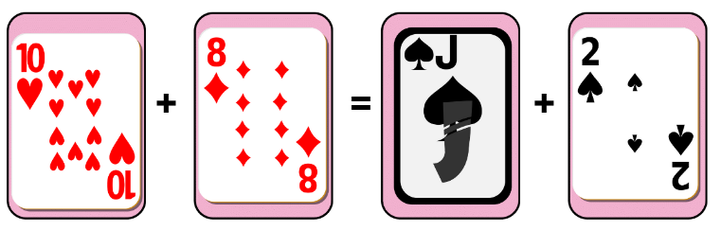

1. Player 1 picks up a card from the centre pile and decides which of the 4 slots to place the card. For example, Player 1 picks up a 12 and places it in one of the slots and reads out the number sentence stating whether it is true or not. For example, ‘ten plus eight is not the same as twelve plus two’ (see Figure 2).

Figure 2 – Sample 2

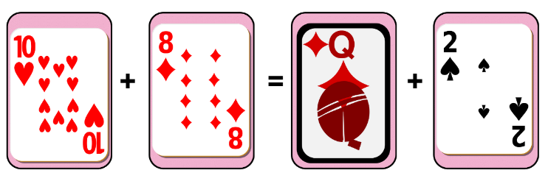

1. Player 2 picks up a card and places it in one of the slots. For example, player 2 picks up a 7 and reads out the number sentence stating if it is true or not (see Figure 3).

Figure 3 – Sample 3

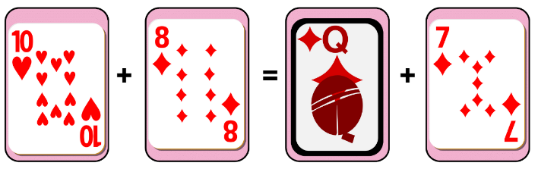

1. Play continues until a player selects a card that makes a true statement. For example, Player 1 picks up a 9 and places it in a slot and reads ‘ten plus nine is the same as twelve plus seven.’ See Figure 4.

Figure 4 – Sample 4

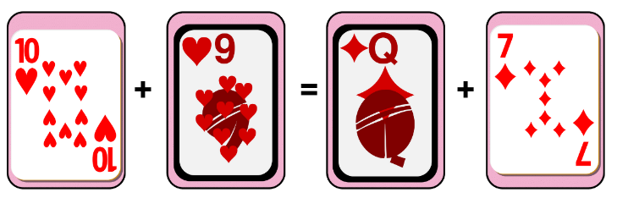

1. Player 1 records the number sentences on their whiteboard and that is the end of a round. The cards on the game board are placed at the bottom of the pile, 4 new cards are dealt and play starts again. The game ends once a player has 5 accurate number sentences.

This table details opportunities for assessment.

|  |  |
| --- | --- |
| Assessment opportunities | Links |
| What to look for:   * Can students recognise and record equal number sentences? **[MAO-WM-01, MA2-AR-01]** | Links to [National Numeracy Learning Progressions](https://www.australiancurriculum.edu.au/resources/national-literacy-and-numeracy-learning-progressions/version-3-of-national-literacy-and-numeracy-learning-progressions/) (NNLP):   * ADS7.   Links to suggested [Interview for Student Reasoning](https://education.nsw.gov.au/teaching-and-learning/curriculum/literacy-and-numeracy/assessment-resources/ifsr) (IfSR) tasks:   * **IfSR-AT**: 2A.1. |

### Core lesson: Inverse and complement – 35 minutes

The table below contains a suggested learning intention and success criteria. These are best co-constructed with students.

|  |  |
| --- | --- |
| Core concept learning intentions | Core concept success criteria |
| Students are learning to:   * connect addition and subtraction number sentences. | Students can:   * demonstrate how addition and subtraction are inverse operations * apply the complement principle of addition and subtraction * explain and justify responses by using by using the inverse operation. |

1. Display the symbols for addition (+) and subtraction (−). Brainstorm all the different words that those symbols represent.
2. Write an addition sum on the board, for example, 27 + 13 = ? Ask students what strategies they could use to solve the number sentence (see Figure 5).

Figure 5 – Bar model

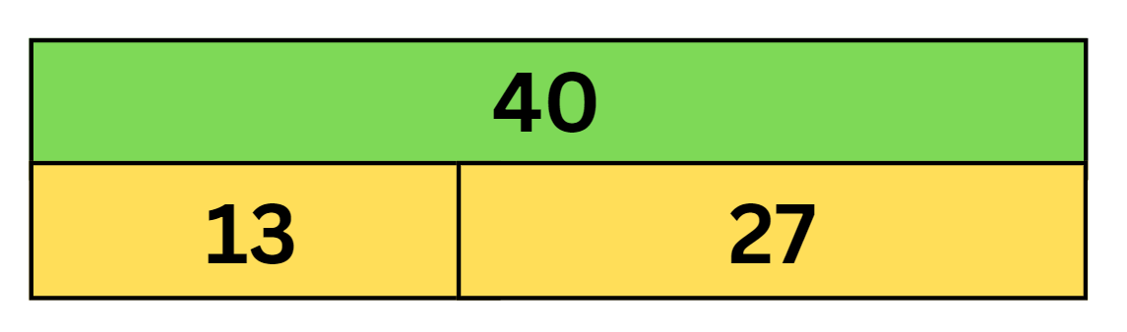

1. Record student strategies on the board. Have students calculate and discuss the correct answer 27 + 13 = 40.
2. Write the corresponding number sentence, 40 − 13 = 27. Ask students what they notice and what they wonder, using the prompts below for guidance.

The table below outlines stimulus prompts to generate conversation about the topic, along with anticipated responses from students.

|  |  |
| --- | --- |
| Prompts | Anticipated student responses |
| * What similarities do you notice between the 2 number sentences? * What connection do you notice between addition and subtraction? * Could you demonstrate the subtraction equation in another way? * What are you wondering? | * All the same numbers are used in the number sentence, just different positions. * The number sentences are equivalent. * Addition and subtraction are opposites. There are 2 parts to making the whole number. * 40 − 27 = 13. |

1. Model the complement principle by writing the number sentence 40 − 27 = 13.

The **complement principle** highlights the inverse relation between addition and subtraction. That is, 3 + 4 = 7 implies 7 − 4 = 3, 7 − 3 = 4 using the complement principle. This use of the complement principle requires recognising that when 2 numbers are added, subtracting either number from the total produces its complement; that is, the number required to make a group complete.

1. Display Resource 3: Bar model. Model the equation represented using a bar model. Explain to students that a bar model can be used to represent this number sentence. Ask students:

* What strategies could you use to find the missing value?
* Can you change the number sentence to make it easier to solve?

**Note**: a bar model is made up of 3 rectangles, representing the part-part-whole relationship between 50, 38 and 12. One on top is labelled 50, and 2 rectangles below are labelled 38 and 12. The rectangles below are collectively the same length as the first rectangle, but in proportion to their value.

1. Demonstrate how to use the inverse operation, 50 − 38 = ? to solve the equation. Explain that the connection between addition and subtraction means that subtraction can be used to solve the problem. Students record their strategies to solve the missing element on a whiteboard. Solve the equation and record the answer 50 − 38 = 12 on the board. Ask students:

* Could you write this subtraction equation in a different way?
* How many ways can you write it?

1. Display the following equations and provide students with an individual whiteboard. In pairs, ask students to select 3 of the equations and create a bar model to represent each equation. Students calculate the missing value in each number sentence and share their solutions.

* 37 + ? = 57
* 58 = 70 − ?
* 72 = ? + 15
* 94 − ? = 23
* 44 = ? + 27

This table details opportunities for differentiation.

|  |  |
| --- | --- |
| Too hard? | Too easy? |
| Students cannot determine how to apply the inverse operation.   * Students solve using single-digit numbers. * Students use concrete materials such as MAB to model the number sentence. | Students can apply the inverse operation.   * Students solve 3-digit number sentences using the bar model. * Challenge students to create their own number sentences with a missing element. |

### Discuss and connect the mathematics – 10 minutes

1. Display 97 − ? = 35. Students work in pairs to represent number sentences using the bar model. Ask:

* What are some of the equations you made?
* What operation did you use to find the missing numbers?
* How did the inverse operation help you to solve the equation?
* Can you think of any real-life examples where inverse operations are used to solve problems? For example, buying or returning items, recipe adjustments, time calculations, financial transactions.

This table details opportunities for assessment.

|  |  |
| --- | --- |
| Assessment opportunities | Links |
| What to look for:   * Can students recognise and explain the connection between addition and subtraction? **[MAO-WM-01, MA2-AR-01, MA2-AR-02]** * Can students explain and justify their responses by using the inverse operation? **[MAO-WM-01, MA2-AR-01, MA2-AR-02]** | Links to [National Numeracy Learning Progressions](https://www.australiancurriculum.edu.au/resources/national-literacy-and-numeracy-learning-progressions/version-3-of-national-literacy-and-numeracy-learning-progressions/) (NNLP):   * AdS7. |

## Lesson 3

**Core concept**: place value understanding helps solve addition and subtraction problems.

### Daily number sense: True or False? – 10 minutes

The table below contains a suggested learning intention and success criteria. These are best co-constructed with students.

|  |  |
| --- | --- |
| Daily number sense learning intention | Daily number sense success criteria |
| Students are learning to:   * use the principle of equality. | Students can:   * solve equivalent addition and subtraction number sentences. |

This activity is an adaptation of [True or False?](https://nrich.maths.org/14797) from [NRICH](https://nrich.maths.org/) by University of Cambridge (Faculty of Mathematics).

1. Students need to decide whether each of the number sentences in Resource 4: True or false? are true or false. Students [turn and talk](https://education.nsw.gov.au/teaching-and-learning/curriculum/literacy-and-numeracy/teaching-and-learning-resources/numeracy/talk-moves) to share their ideas and record their answers on a white board.
2. Regroup as a class and ask:

* Which are true? Which are false? How do you know?
* What strategies did you use to find the answer without doing any calculating?

**Note**: the activity can be adapted by using 3-digit number sentences.

This table details opportunities for assessment.

|  |  |
| --- | --- |
| Assessment opportunities | Links |
| What to look for:   * Can students solve equivalent addition and subtraction number sentences? **[MAO-WM-01, MA2-AR-01]** | Links to [National Numeracy Learning Progressions](https://www.australiancurriculum.edu.au/resources/national-literacy-and-numeracy-learning-progressions/version-3-of-national-literacy-and-numeracy-learning-progressions/) (NNLP):   * AdS7.   Links to suggested [Interview for Student Reasoning](https://education.nsw.gov.au/teaching-and-learning/curriculum/literacy-and-numeracy/assessment-resources/ifsr) (IfSR) tasks:   * **IfSR-AT**: 2A.1. |

### Core lesson: Decades as landmarks – 40 minutes

The table below contains a suggested learning intention and success criteria. These are best co-constructed with students.

|  |  |
| --- | --- |
| Core concept learning intentions | Core concept success criteria |
| Students are learning to:   * select strategies to solve addition and subtraction problems. | Students can:   * use partitioning to add and subtract numbers * counting forwards and backwards by 10 on and off the decade |

This activity is an adaptation of [Addition: Chess – The Rook](https://www.resolve.edu.au/addition-chess-rook) from [reSolve: Maths by Inquiry](https://www.resolve.edu.au/) by Australian Government Department of Education.

1. Display Resource 5: Chess pieces and introduce the rook in chess. Explain that on a 100 number chart chessboard, when the rook moves along a row, the value of numbers increases or decreases by one and when it moves up and down a column, the value increases or decreases by 10 (see Figure 6).

Figure 6 – The Rook's moves

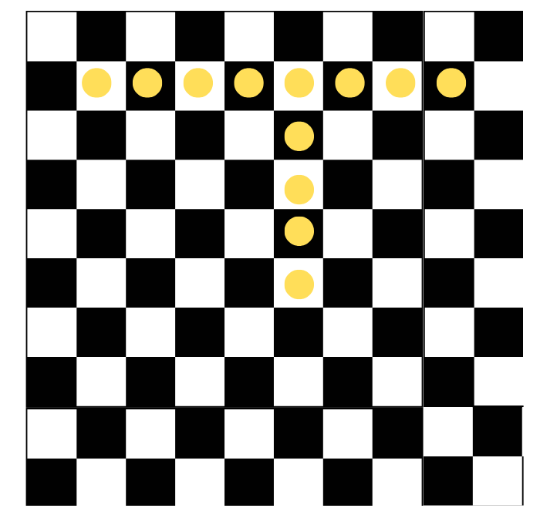

1. Display Resource 6: Chess chart 1. Explain that the rook starts at 14 and wants to move 32 places. Ask:

* How could you move the rook?
* Can you partition the number 32 to help solve this?
* How does partitioning this number help the rook move places?

1. Model how to partition the number 32, separating it into 30 + 2 and how to move places by using the partitioned number. Start at 14 on the chart, add 10 + 10 + 10 by moving down 3 rows and then add 1 + 1 by moving 2 spaces to the right on the chessboard, ending on the number 46. Ask students:

* What number sentence could you use to show what we did in the display?
* Is there another way to demonstrate this number problem? For example, a blank number line or a bar model.

1. Display Resource 7: Chess chart 2. Provide students with individual whiteboards and Resource 8: Empty chart. In pairs, students brainstorm responses to the problem: the rook starts at 23 and moves to 78. Ask:

* What different ways can the rook get from 23 to 78?
* How many ways can you find?
* Can it also be represented on a number line? (see Figure 8).

Figure 7 – Sample responses

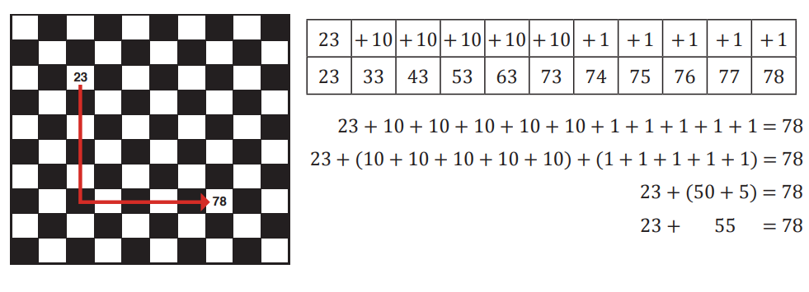

‘[Addition: Chess – The Rook](https://www.resolve.edu.au/addition-chess-rook)’ by [reSolve: Maths by Inquiry](https://www.resolve.edu.au/) is licensed under [CC BY-NC-SA 4.0](https://creativecommons.org/licenses/by-nc-sa/4.0/).

Figure – Number line

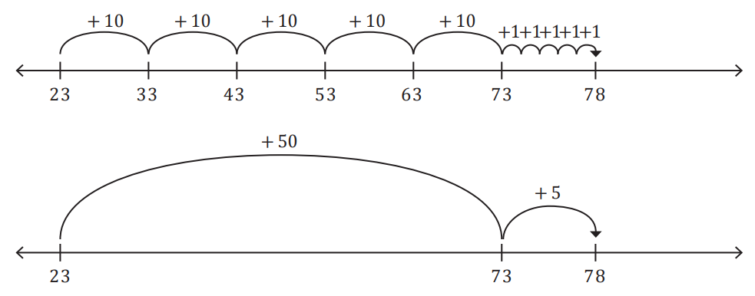

1. Record responses on the board. Model how the number sentence can be represented as 23 + 55 = 78 or 55 + 23 = 78.

**Note**: this illustrates the commutative property of addition. When 2 numbers are added, their order can be changed without affecting the sum.

1. Display Resource 9: Chess chart 3. In pairs, students brainstorm responses to the problem: the rook starts at 52 and moves to 18. Ask:

* What are the different ways the rook can get from 52 to 18?
* How many ways could you find?

1. Explain there are 2 ways for the rook to move from 52 to 18. For example: Model 52 − 10 − 10 − 10 − 1 − 1 − 1 − 1 = 18 and 52 − 1 − 1 − 1 − 1 − 10 − 10 − 10 = 18. Ask students how these can be represented as a number sentence or on a number line. Record responses on the board (see Figure 9).

Figure 9 – Student sample responses

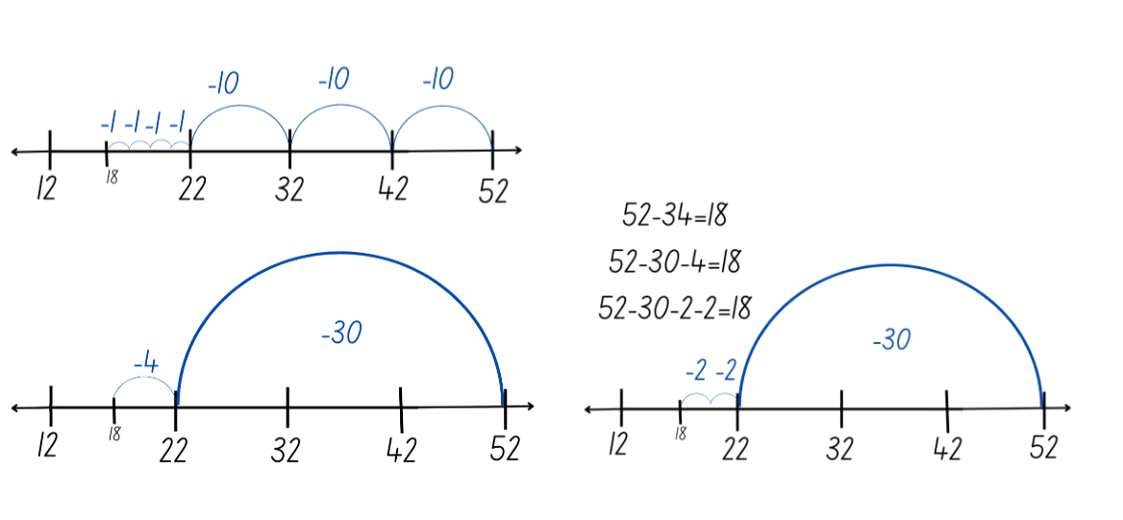

1. Display the following problems on the board and ask students to select 2 of the problems to solve. Provide students with their own copy of Resource 8: Empty chart to help solve the problem. Students record responses in their workbook.

* The rook starts at 16 and moves to 28.
* The rook starts at 34 and moves to 11.
* The rook starts at 56 and moves to 82.
* The rook starts at 91 and moves to 57.

This table details opportunities for differentiation.

|  |  |
| --- | --- |
| Too hard? | Too easy? |
| Students cannot partition numbers to solve addition and subtraction problems.   * Provide students with a labelled hundreds chart chess board Resource 8: Empty chart. * Use concrete materials to model addition and subtraction. | Students can partition numbers to solve addition and subtraction problems.   * Ask students to play the game again bridging to the nearest 10 first. Ask students how the bridging to 10 strategy changes the number of moves and if this is an effective strategy. Ask students to explain their thinking. * Students create a path for a partner to follow. Have students explain their moves using the number line. |

### Discuss and connect the mathematics – 10 minutes

1. Summarise the lesson, drawing out key mathematical ideas about addition and subtraction. Focus the discussion on how moving in +10 and +1 highlights the place-value parts of the numbers and how partitioning by place value assists in adding and subtracting. Ask:

* What did you discover?
* Can you identify any patterns on the game board?
* How does the number line help to solve addition and subtraction problems? When would you use this approach?
* Have you thought of another strategy to move the rook forward and back? Explain your strategy.

This table details opportunities for assessment.

|  |  |
| --- | --- |
| Assessment opportunities | Links |
| What to look for:   * Can students partition numbers when adding and subtracting? **[MAO-WM-01, MA2-AR-01]** * Can students count forwards and backwards on and off the decade? **[MAO-WM-01, MA2-RN-01]** | Links to [National Numeracy Learning Progressions](https://www.australiancurriculum.edu.au/resources/national-literacy-and-numeracy-learning-progressions/version-3-of-national-literacy-and-numeracy-learning-progressions/) (NNLP):   * AdS7 * CPr6, CPr7.   Links to suggested [Interview for Student Reasoning](https://education.nsw.gov.au/teaching-and-learning/curriculum/literacy-and-numeracy/assessment-resources/ifsr) (IfSR) tasks:   * **IfSR-NP**: 4C.2, 4C.3, 4C.6, 4C.7. |

## Lesson 4

**Core concept**: numbers can be built up or taken apart in a variety of ways to make the numbers easier to work with.

### Daily number sense – 10 minutes

1. From a class need surfaced through formative assessment data, identify a short, focused activity that targets students’ knowledge, understanding and skills. Example activities may be drawn from the following resources:

* [Mathematics K-6 resources](https://education.nsw.gov.au/teaching-and-learning/curriculum/mathematics/mathematics-curriculum-resources-k-12/mathematics-k-6-resources#catalogue_auto)
* [Universal Resources Hub](https://resources.education.nsw.gov.au/home).

### Core lesson: Compensation strategy – 40 minutes

The table below contains a suggested learning intention and success criteria. These are best co-constructed with students.

|  |  |
| --- | --- |
| Core concept learning intentions | Core concept success criteria |
| Students are learning to:   * select strategies to solve addition and subtraction problems. | Students can:   * use partitioning of numbers to add and subtract numbers * use the compensation strategy. |

This activity is an adaptation of [Dicey Addition](https://nrich.maths.org/11863) from [NRICH](https://nrich.maths.org/) by University of Cambridge (Faculty of Mathematics).

1. Display Resource 10: Addition grid and provide a [9-sided die](https://nrich.maths.org/6717). The aim of the activity is to make an addition number sentence with an answer as close to 100 as possible. Roll the die 4 times to make two 2-digit numbers. After each throw of the die, a decision will need to be made about what box the number is placed in. Ask students that if the goal is to get as close to 100 as possible, what they need to think about before putting a number in a box.

The table below outlines stimulus prompts to generate conversation about the topic, along with anticipated responses from students.

|  |  |
| --- | --- |
| Prompts | Anticipated student responses |
| * If a 9 is rolled, should it be put in the tens column or ones column? * If a one is rolled, should it put it in the tens column or ones column? * If 5 is rolled, should it be put it in the tens column or the ones column? | * The ones column because if it is put in the tens column it will make the number in the nineties. That is very close to 100. Unless I roll a one on my next turn, it will be quite far over 100. * The ones column because if it is put it in the tens column it will make my number less than 20. That is not close to 100 unless I roll a very large number next time. * The tens column because it makes a number around halfway to 100. There is a good chance of getting close to 100 with whatever number is roll next. |

1. Model and discuss solving the addition number sentence using the compensation strategy. For example, 28 + 35 is the same as 30 + 35 = 65, subtract 2 to obtain 63 (see Figure 10).

Figure 10 – Compensation strategy

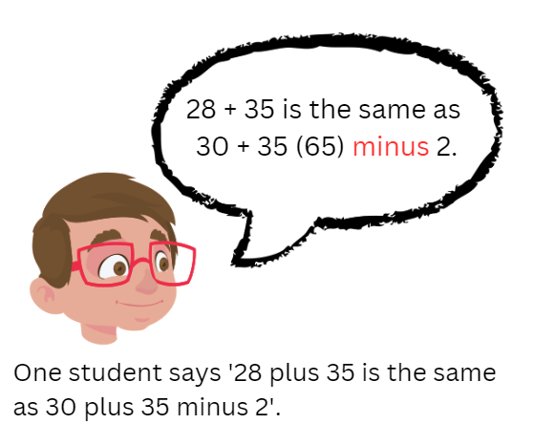

1. Display Resource 11: Subtraction grid. Explain that this time the aim of the activity is to make a subtraction number sentence with an answer with the smallest value possible from 100. Roll a 9-sided die to make a 2-digit number. After each throw of the die, students decide about what box the number is placed in. Explain that the goal is to make the smallest number possible. Ask students what they need to think about before putting a number in a box and why.
2. Model and discuss solving the subtraction number sentence using the compensation strategy. For example, 100 − 78 is the same as 100 − 80 is 20 + 2 makes 22 (see Figure 11).

Figure 11 – Compensation strategy subtraction

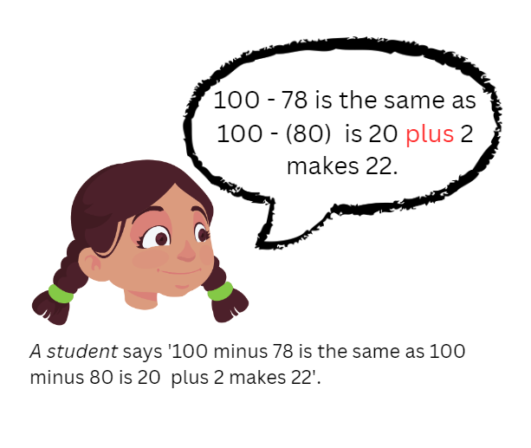

1. In pairs, provide students with a 9-sided die each. Students roll the dice to create their own addition number sentence and record it in their workbook. Students solve the addition number sentence using the compensation strategy. The child with the closest sum to 100 wins a point. Repeat this 3 times with their partner.
2. In pairs, students roll the dice to create their own subtraction number sentence and record it in their workbook. Students solve the subtraction numbers sentence using the compensation strategy. The student that has the solution with the smallest value wins a point.
3. Repeat several times and discuss findings.

This table details opportunities for differentiation.

|  |  |
| --- | --- |
| Too hard? | Too easy? |
| Students cannot apply the compensation strategy to addition and subtraction.   * Students add a 2-digit and one-digit number. * Provide students with concrete materials such as MAB to solve the number sentences. | Students can apply the compensation strategy to addition and subtraction.   * For addition students roll 3-digit numbers with the goal to create a number closest to 1000. * For subtraction students roll a 4-digit and 3-digit number with the goal to create the smallest value possible. |

### Discuss and connect the mathematics – 15 minutes

1. Display the word problem: Liam has a collection of 75 books. He decides to give away 43 of them to his friends. How many books does Liam have left? Explain that students need to solve this problem using the compensation strategy.
2. Regroup as a class and discuss:

* What was the first step you took to solve this problem?
* How did you decide which operation to use?
* How did adjusting one number make solving the problem easier?
* Can you think of a different way to solve this problem?
* When is the compensation strategy and efficient strategy to use? Explain your thinking.
* Can you give an example of when the compensation strategy isn’t the most efficient?

This table details opportunities for assessment.

|  |  |
| --- | --- |
| Assessment opportunities | Links |
| What to look for:   * Can students solve addition and subtraction problems using the compensation strategy? **[MAO-WM-01, MA2-AR-01, MA2-AR-02]** * Can students use partitioning to add and subtract numbers? **[MA2-AR-01]** | Links to [National Numeracy Learning Progressions](https://www.australiancurriculum.edu.au/resources/national-literacy-and-numeracy-learning-progressions/version-3-of-national-literacy-and-numeracy-learning-progressions/) (NNLP):   * AdS7, AdS8.   Links to suggested [Interview for Student Reasoning](https://education.nsw.gov.au/teaching-and-learning/curriculum/literacy-and-numeracy/assessment-resources/ifsr) (IfSR) tasks:   * **IfSR-AT**: 3A.2. |

## Lesson 5

**Core concept**: flexible methods of addition and subtraction involve decomposing and composing numbers.

### Daily number sense: Strike it out – 15 minutes

Daily number sense activities for Lessons 5 to 7 ‘loop’ back to concepts and procedures covered in previous units to assist students to build an increasingly connected network of ideas. These concepts may differ from the core concepts being covered by the unit.

The table below contains a suggested learning intention and success criteria. These are best co-constructed with students.

|  |  |
| --- | --- |
| Daily number sense learning intention | Daily number sense success criteria |
| Students are learning to:   * recall number bonds up to 20. | Students can:   * identify various strategies to solve addition and subtraction facts to 20. |

This activity has been adapted from [Strike it out (addition and subtraction to 20) (7:44)](https://education.nsw.gov.au/teaching-and-learning/curriculum/mathematics/mathematics-curriculum-resources-k-12/mathematics-k-6-resources/strike-it-out-addition-and-subtraction-to-20) from [Mathematics K-6 resources](https://education.nsw.gov.au/teaching-and-learning/curriculum/mathematics/mathematics-curriculum-resources-k-12/mathematics-k-6-resources) by NSW Department of Education.

1. In pairs, provide students with paper and writing materials. Students create a number line from 0–20.
2. The first player chooses 2 numbers from the number line and crosses them out. The same player then circles the sum or difference of the numbers and records the calculation. For example, 5 + 10 = 15 (see Figure 12).

Figure 12 – Strike it out 1

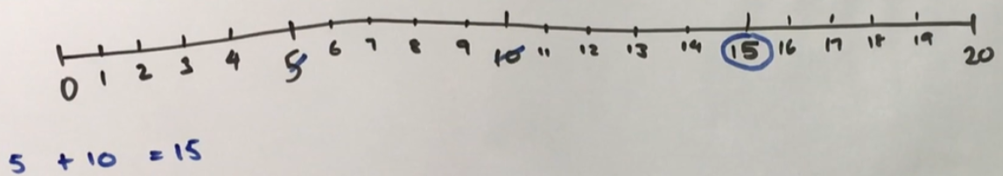

1. The second player must start their turn by crossing out the number circled by the first player. The second player then crosses out a second number not already used. Player 2 then circles the sum or difference of the numbers and records the calculation. For example, 15 + 4 = 19 (see Figure 13).

Figure 13 – Strike it out 2

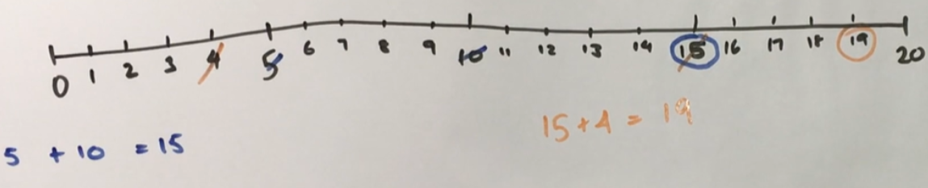

1. Play continues until one player is no longer able to make a valid move (see Figure 14). The player who stops their opponent from being able to take a turn is the winner.

Figure 14 – Strike it out 3

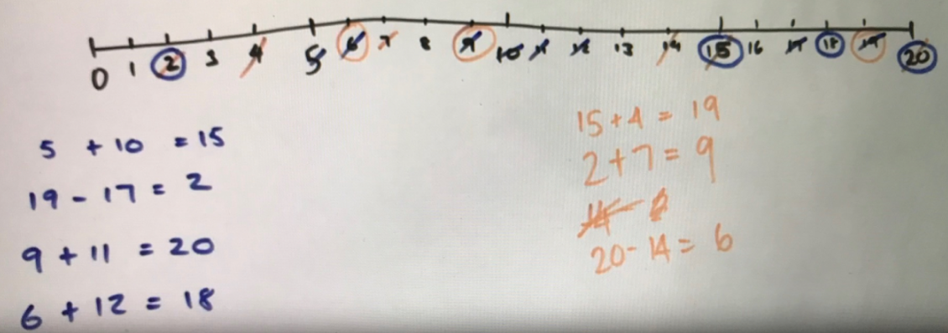

1. Play the game again, with the second player starting first.
2. As a class, discuss and reflect on the activity by asking questions such as:

* How did you know when the game was over?
* Share the strategy that you used to try to win the game. Was it successful? Why?
* What addition and subtraction strategies did you find useful?
* When adding, did it matter which way you added the numbers? Why not? (Commutative property).
* Can you think of any ways to make the game easier or harder?

This table details opportunities for assessment.

|  |  |
| --- | --- |
| Assessment opportunities | Links |
| What to look for:   * Can students identify various strategies to solve addition and subtraction facts to 20? **[MAO-WM-01, MA1-CSQ-01]** | Links to [National Numeracy Learning Progressions](https://www.australiancurriculum.edu.au/resources/national-literacy-and-numeracy-learning-progressions/version-3-of-national-literacy-and-numeracy-learning-progressions/) (NNLP):   * AdS7. |

### Core lesson: Levelling and constant difference – 45 minutes

The table below contains a suggested learning intention and success criteria. These are best co-constructed with students.

|  |  |
| --- | --- |
| Core concept learning intentions | Core concept success criteria |
| Students are learning to:   * select strategies to solve addition and subtraction problems. | Students can:   * apply the levelling strategy to addition problems. * apply the constant difference strategy to subtraction problems. |

This activity is an adaptation of [Race to zero (subtracting tens and ones)](https://education.nsw.gov.au/teaching-and-learning/curriculum/mathematics/mathematics-curriculum-resources-k-12/mathematics-k-6-resources/race-to-zero-subtracting-tens-and-ones) from [Mathematics K-6 resources](https://education.nsw.gov.au/teaching-and-learning/curriculum/mathematics/mathematics-curriculum-resources-k-12/mathematics-k-6-resources) by NSW Department of Education.

1. Display the number sentence 28 + 35. Ask students to identify some strategies they could use to solve this problem. Record responses on the board, highlighting previously discussed strategies.
2. Introduce the levelling strategy for addition. Demonstrate that 28 + 35 is the same as 30 + 33, where 2 has been taken from 35 and added to 28 to make 30. Ask students how this helps to solve the number sentence.

**Note**: discuss the concept of partitioning or regrouping numbers. Start with 28 + 35 and partition 35 into 2 parts, 2 and 33. Add the partitioned parts to 28, 28 + 2 = 30, and 33 remains the same. Explain that you now have 30 + 33, which is the same as 28 + 35. By partitioning 35 into 2 and 33 and adding those parts to 28, students can see that 28 + 35 is equal to 30 + 33 (see Figure 15).

Figure 15 – Levelling

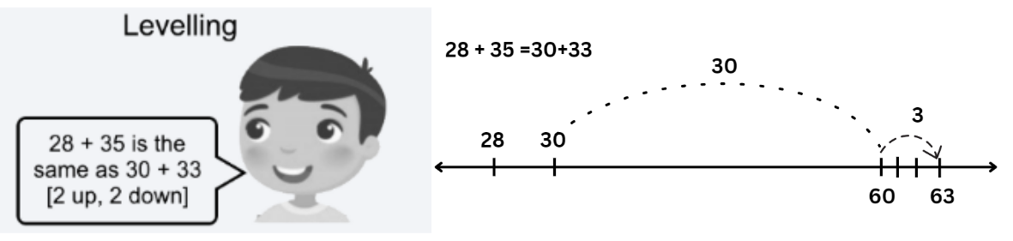

© NSW Education Standards Authority (NESA) for and on behalf of the Crown in right of the State of New South Wales, 2022.

1. Model solving the number sentence 30 + 33.

**Note**: explain that having a number on the decade makes the number sentence easier to solve because you can use your knowledge of place value.

1. In pairs, provide students Resource 12: 119 number chart, a 9-sided die, counters and an individual whiteboard. Students start at zero, placing their counter to show their position. Roll the die twice to create a 2-digit number. Students repeat this to create a second 2-digit number. Students record the addition number sentence on whiteboards.
2. Before the students start, model solving the addition number sentence using levelling and record thinking on the board. For example, 23 + 45 is the same as 20 + 48. Students need to explain their thinking and if their partner agrees, they move their counter to that value on Resource 12: 119 number chart.
3. Explain that students need to think about creating numbers that when added, will get them as close to 119 as possible. If a student’s roll means they would move beyond 119, they need to go back to 90 for their next turn. Ask students what they need to think about when forming numbers.

**Note**: highlight the connection to place value. For example, if a one and 7 are rolled, creating 17 would be better than creating 71.

1. Regroup as a class and introduce the constant difference for subtraction strategy. Demonstrate that 85 − 58 is the same as 87 − 60, where 2 has been added to both numbers thus keeping a constant difference between them. Discuss how this helps to solve the number sentence.

The strategy of **constant difference** for subtraction involves manipulating the numbers in a subtraction problem by adding or subtracting the same value to both numbers to ensure one number is on the decade. The key idea behind this strategy is that even though 2 is added to both numbers, the difference between them remains the same (see Figure 16).

Figure 16 – Constant difference

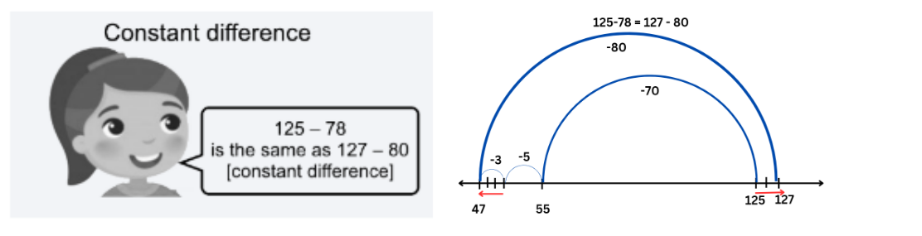

© NSW Education Standards Authority (NESA) for and on behalf of the Crown in right of the State of New South Wales, 2022.

1. Model solving the number sentence 87 − 60. Explain that having a number on the decade makes the number sentence easier to solve.
2. Introduce the activity ‘Race to Zero’. Students start at 119, placing their counter to show their position. Students roll the die twice and use the 2 numbers to create a 2-digit number. Students record the subtraction number sentence on whiteboards.

**Note**: discuss connection to place value. For example, if a 5 and a 2 are rolled, would it be better to make 25 or 52?

1. Model solving the subtraction number sentence using constant difference. For example, 119 − 23 is the same as 120 − 24. Students need to explain their thinking and if their partner agrees they move their counter to the that value on Resource 12: 119 grid.
2. Explain that students need to think about creating numbers that will help get as close to zero as possible. If a student roll means they would move below zero into negative numbers, they must move their counter back to 25 for their next turn. Students take turns until someone has been able to land exactly on zero.

This table details opportunities for differentiation.

|  |  |
| --- | --- |
| Too hard? | Too easy? |
| Students cannot use the levelling or constant difference strategy.   * Provide students with MAB materials to represent the number sentence. * Students use Resource 12: 119 grid to assist with adding and subtracting. | Students can use levelling and constant difference strategy.   * Students play ‘Race to 1000’ using 3-digit numbers. * Students play ‘Race to zero from 1000’ using 3-digit numbers. |

### Discuss and connect the mathematics – 10 minutes

1. Display the problem 133 + 41 = ? and ask:

* How does an understanding of the levelling strategy help solve this number sentence?
* How would you explain levelling to someone else?
* Is there more than one way you can level this problem? Explain your thinking.
* When is this an efficient strategy to use? When is this not an efficient strategy to use?

This table details opportunities for assessment.

|  |  |
| --- | --- |
| Assessment opportunities | Links |
| What to look for:   * Can students apply the levelling strategy to addition problems? **[MAO-WM-01, MA2-AR-01, MA2-AR-02]** * Can students apply the constant difference strategy to subtraction problems? **[MAO-WM-01, MA2-AR-01, MA2-AR-02]** | Links to [National Numeracy Learning Progressions](https://www.australiancurriculum.edu.au/resources/national-literacy-and-numeracy-learning-progressions/version-3-of-national-literacy-and-numeracy-learning-progressions/) (NNLP):   * AdS7. |

## Lesson 6

**Core concept**: models help us solve addition and subtraction problems.

### Daily number sense: Closest to 100 – 15 minutes

The table below contains a suggested learning intention and success criteria. These are best co-constructed with students.

|  |  |
| --- | --- |
| Daily number sense learning intention | Daily number sense success criteria |
| Students are learning to:   * recall and recognise combinations of 2 numbers that add up or bond to form 10. | Students can:   * select and apply strategies using number bonds to solve addition and subtraction problems. |

This activity is an adaptation of [Additive strategies: Closest to 100 (Task 5)](https://education.nsw.gov.au/teaching-and-learning/curriculum/literacy-and-numeracy/teaching-and-learning-resources/numeracy/explicit-teaching-strategies/stage-3/numbers-and-algebra/additive) from Stage 3 numbers and algebra by State of New South Wales (Department of Education).

1. In pairs, provide students with a whiteboard and a pack of cards from A–10. Player 1 shuffles the cards and puts them in a central pile. Player 2 takes 6 cards and places them face up for everyone to see.
2. The aim of the game is to use addition or subtraction to get close to a total of 100. Each card can only be used once and can be used to form a one- or 2-digit number. Not all cards need to be used.
3. Players score zero points if they are able to make a total of exactly 100. Points are allocated based on the difference between the total and 100. For example, if a team created a total of 94, they would score 6 points.
4. Students record their number sentence and score on their whiteboard. The pair with the lowest score at the end wins.

This table details opportunities for assessment.

|  |  |
| --- | --- |
| Assessment opportunities | Links |
| What to look for:   * Can students select and apply strategies using number bonds to solve addition and subtraction problems? **[MAO-WM-01, MA1-CSQ-01]** | Links to [National Numeracy Learning Progressions](https://www.australiancurriculum.edu.au/resources/national-literacy-and-numeracy-learning-progressions/version-3-of-national-literacy-and-numeracy-learning-progressions/) (NNLP):   * AdS6, AdS7. |

### Core lesson: Tape and bar – 40 minutes

The table below contains a suggested learning intention and success criteria. These are best co-constructed with students.

|  |  |
| --- | --- |
| Core concept learning intentions | Core concept success criteria |
| Students are learning to:   * select strategies to solve addition and subtraction problems. | Students can:   * represent word problems in a tape diagram * solve word problems using addition and subtraction strategies. |

1. Display the word problem: A farmer had 17 cows in one field and 53 cows in another field. How many cows does the farmer have in total? Share and discuss the following:

* What do you notice?
* What is this question asking you to find?
* Do you need to use addition or subtraction to find the answer? How do you know?

1. Introduce the tape diagram to students as a way of representing word problems. Display Resource 13: Tape diagram 1. Explain that a tape diagram helps show the part-part-whole relationship when students add numbers together.
2. Demonstrate that you divide the tape into 2 sections to show each of the parts that you are adding together. The line at the top shows what the whole value of the numbers added together equals. Show students that, when creating a tape diagram, students need to think about the size of the numbers they are representing. For example, 53 is much larger than 17 so it is shown by a larger section of the diagram. Ask students how can write the problem as a number sentence. For example, 17 + 53.
3. Model writing the number sentence 17 + 53 =? for students, demonstrating that the 2 parts of the tape diagram are added together to make the whole which is represented by the line at the top. Ask students what strategy they could use to find the answer or whole. For example, compensation, bridging the decade, levelling.
4. Record responses on the board. Model using the different strategies to find the solution. Display the solution 17 + 53 = 70 on Resource 13: Tape diagram 1.
5. Display the word problem: Hannah had 62 stickers, but she uses 27 stickers to decorate her notebook. How many stickers does she have left? Ask:

* What do you notice? (How many stickers she has, you need to use subtraction)
* What is this question asking you to find? (How many stickers she has left after using some of them)
* Do you need to use addition or subtraction to find the answer? (Subtraction)

1. Record responses on the board. Remind students that a tape diagram can be used to represent word problems. Display Resource 14: Tape diagram 2. Explain again that a tape diagram helps show the part-part-whole relationship when subtracting numbers.
2. Demonstrate that the line at the top shows the whole that is being subtracting from. The tape shows the parts that make up the whole. The first part of the tape diagram is what is subtracted from the whole. The second part is the answer.

**Note**: show students that when creating a tape diagram, students need to think about the size of the numbers they are representing.

1. Ask students how they can write the problem as a number sentence (62 − 27).
2. Model writing the number sentence 62 − 27 = ?, demonstrating that 62 is the total number of stickers so this should be shown at the top as a whole. For example, Hannah used 27 stickers, so this is one of the parts and students need to work out how many stickers are left, which is what makes up the other part.
3. Ask students what strategy they can use to find the answer, for example, compensation, bridging the decade, constant difference. Record responses and model using different strategies to find the solutions.
4. Display the 4 word problems below and discuss possible strategies students could use, such as bridging the decade, compensation, levelling and constant difference:

* Lisa had 72 lollies, but she gave 33 lollies to her brother. She believes she has 39 lollies left. Is she correct?
* Sarah had 87 marbles, but she accidentally threw 63 in the bin. When she looks at the ones she has left, she thinks she has 24. Is she correct?
* There are 23 children playing in the park. Another 44 come to join. There are now 67 children in the park. Is this correct?
* A bakery sold 53 cupcakes in the morning and 37 cupcakes in the afternoon. The bakers think they sold 80 cupcakes altogether. Are they correct?

1. Tell students that 3 of the problems are true and correct. One of the word problems is incorrect and is a lie. The aim is to identify which are true and which is the lie.
2. In pairs, students represent the information in each word problem as a tape diagram in their workbook. Explain that they need to discuss and select an appropriate strategy to solve the word problems. Students then record which are true and which is a lie.

This table details opportunities for differentiation.

|  |  |
| --- | --- |
| Too hard? | Too easy? |
| Students cannot use the tape or bar model independently.   * Provide students with concrete materials, such as interlocking cubes, to support solving the problem. * Students answer problems involving single digits. | Students can solve questions without using a tape diagram.   * Provide students with addition and subtraction problems involving more than one step. * Provide students word problems involving 3-digit numbers. |

### Discuss and connect the mathematics – 10 minutes

1. Display Resource 15: Mistake and ask students what they can see on this tape model. Lead students towards identifying the inaccuracy of the tape model 52 + 34 = 86 not 96. Elements potentially identified, part-part-whole relationship, visual representation of quantities, connection between addition and subtraction. Ask students what word problem this tape diagram could represent.

This table details opportunities for assessment.

|  |  |
| --- | --- |
| Assessment opportunities | Links |
| What to look for:   * Can students represent word problems in a tape diagram? **[MAO-WM-01, MA2-AR-01, MA2-AR-02]** * Can students select appropriate strategies to solve addition and subtraction questions? **[MAO-WM-01, MA2-AR-01, MA2-AR-02]** | Links to [National Numeracy Learning Progressions](https://www.australiancurriculum.edu.au/resources/national-literacy-and-numeracy-learning-progressions/version-3-of-national-literacy-and-numeracy-learning-progressions/) (NNLP):   * AdS6, AdS7. |

## Lesson 7

**Core concept**: mathematicians compare and evaluate strategies used to solve addition and subtraction problems, reasoning which strategy may be most efficient.

### Daily number sense: Double or halve – 15 minutes

The table below contains a suggested learning intention and success criteria. These are best co-constructed with students.

|  |  |
| --- | --- |
| Daily number sense learning intention | Daily number sense success criteria |
| Students are learning to:   * use flexible addition strategies. | Students can:   * use the doubling and halving strategy to solve number problems. |

This lesson has been adapted from [Double or Halve](https://education.nsw.gov.au/teaching-and-learning/curriculum/mathematics/mathematics-curriculum-resources-k-12/mathematics-k-6-resources/double-or-halve-stage-1) from [Mathematics K-6 resources](https://education.nsw.gov.au/teaching-and-learning/curriculum/mathematics/mathematics-curriculum-resources-k-12/mathematics-k-6-resources) by NSW Department of Education.

1. Provide pairs with Resource 16: Grid, 2 different coloured pencils and a 6-sided die.
2. Students choose a target number between 10 and 30, write it on the side of their grid and on the correct grid square.
3. The first player rolls the die and chooses to either double or halve the number. The player records their choice on the grid by shading the correct number of squares. Players record a running total on the side of their grid.
4. Players take turns to roll the die and record their chosen number. If a player cannot go, they miss a turn. The winner is the player who reaches the target number exactly (see Figure 17).

Figure 17 – Double or halve gameplay

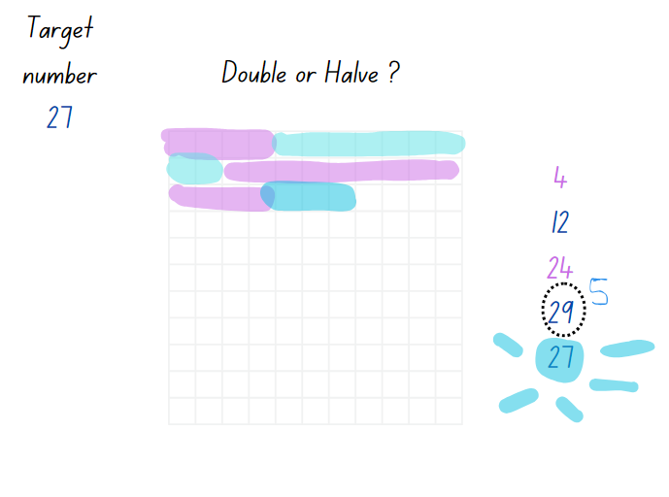

1. While students are playing, ask:

* If you play the game again are there any moves you would change?
* Is there a number you should have halved instead of doubled? Why?
* If you play the game again and the rules changed so you can double, halve or keep your roll, do you think this might make it easier to reach the target number?

This table details opportunities for assessment.

|  |  |
| --- | --- |
| Assessment opportunities | Links |
| What to look for:   * Can students use the doubling and halving strategy to solve number problems? **[MAO-WM-01, MA1-CSQ-01]** | Links to [National Numeracy Learning Progressions](https://www.australiancurriculum.edu.au/resources/national-literacy-and-numeracy-learning-progressions/version-3-of-national-literacy-and-numeracy-learning-progressions/) (NNLP):   * AdS6. |

### Core lesson: Solving problems – 35 minutes

The table below contains a suggested learning intention and success criteria. These are best co-constructed with students.

|  |  |
| --- | --- |
| Core concept learning intentions | Core concept success criteria |
| Students are learning to:   * select strategies to solve addition and subtraction problems. | Students can:   * solve problems using addition and subtraction strategies * explain which strategy is more efficient. |

This activity is an adaptation of ‘[The Old Couple](https://www.researchgate.net/publication/344399189_Approaches_to_a_challenging_task_involving_subtraction)’ from [Approaches to a challenging task involving subtraction](https://www.researchgate.net/publication/344399189_Approaches_to_a_challenging_task_involving_subtraction) by Russo.

1. Display Resource 17: The old couple. Explain that there is a very old lady who lives on a hill. She is 94 years old. She is married to a very old man, who is 78 years old. How many years older is the lady than her husband?
2. In pairs, students solve the problem using at least 3 different strategies. Students record working out and answers in their workbook.
3. Regroup and ask:

* What is the number sentence that represents this problem?
* What strategies did you use?

1. Record student responses on the board. Model each strategy on the board highlighting the steps to achieve the correct solution. Ask:

* Did you get the same answer using a different strategy?
* If not, why?

**Note**: if students did not find the correct solution using one of the strategies, guide them to find the mistake in their work and identify how they could find the correct solution.

1. Ask pairs of students to discuss which strategy they think is the most efficient and why.
2. Students justify and explain why they think one strategy is more efficient than another.
3. Display the following word problem Resource 18: Great grandchildren: The old couple have 2 great-grandchildren, Josh and Jill. Josh is 34 years old and Jill is 18 years old. How much older Josh is than Jill? Ask students to use 2 different strategies to solve the problem and record their working in their workbooks.
4. Regroup as a class, share and discuss the following questions:

* Did you get the same answer?
* Which strategy do you think is most efficient?

This table details opportunities for differentiation.

|  |  |
| --- | --- |
| Too hard? | Too easy? |
| Students cannot select an appropriate strategy to solve addition and subtraction.   * Provide students with an alternate problem using numbers 0–50. * Provide students with concrete materials such as MAB blocks. | Students can select and apply appropriate strategies for addition and subtraction.   * Provide students with alternate problem: The Prime Minister gives a basket of fruit to every old couple that lives to be 250 years old in total. How much less than 250 years old is the combined age of the old lady and man? How much longer would they have to live in order to get their basket of fruit? * In pairs, challenge students to create their own problems. |

### Consolidation and meaningful practice – 15 minutes

This activity is an adaptation of [Maze 100](https://nrich.maths.org/91) from [NRICH](https://nrich.maths.org/) by University of Cambridge (Faculty of Mathematics).

1. Display Resource 19: Maze 100. Explain that there are numbers in each of the cells that make up the maze. Students go through adding all the numbers they pass. They may not go through any cell more than once. Provide pairs of students with a copy of Resource 19: Maze 100 and ask them to find a path through the maze. Ask:

* Can you find a way through in which the numbers add to exactly 100?
* What is the lowest number you can make going through the maze?
* What is the highest number you can make going through the maze?

1. Regroup and have students share their reasoning and justification for why their path is correct. Ask:

* What did you notice?
* What was the correct path?
* Can you be sure you found the path with the lowest number?
* Can you be sure you found the path with the highest number?
* Are there any other possibilities? How do you know?

This table details opportunities for assessment.

|  |  |
| --- | --- |
| Assessment opportunities | Links |
| What to look for:   * Can students use strategies to solve addition and subtraction problems? **[MAO-WM-01, MA2-AR-01, MA2-AR-02]** * Can students' reason which strategy may be most efficient to solve a problem? **[MAO-WM-01, MA2-AR-01, MA2-AR-02]** | Links to [National Numeracy Learning Progressions](https://www.australiancurriculum.edu.au/resources/national-literacy-and-numeracy-learning-progressions/version-3-of-national-literacy-and-numeracy-learning-progressions/) (NNLP):   * AdS6, AdS7.   Links to suggested [Interview for Student Reasoning](https://education.nsw.gov.au/teaching-and-learning/curriculum/literacy-and-numeracy/assessment-resources/ifsr) (IfSR) tasks:   * **IfSR-AT**: 2A.2. |

## Lesson 8

**Core concept**: mathematicians select the most efficient strategies when solving problems.

### Daily number sense – 10 minutes

1. From a class need surfaced through formative assessment data, identify a short, focused activity that targets students’ knowledge, understanding and skills. Example activities may be drawn from the following resources:

* [Mathematics K-6 resources](https://education.nsw.gov.au/teaching-and-learning/curriculum/mathematics/mathematics-curriculum-resources-k-12/mathematics-k-6-resources#catalogue_auto)
* [Universal Resources Hub](https://resources.education.nsw.gov.au/home).

### Core lesson: More problems – 35 minutes

The table below contains a suggested learning intention and success criteria. These are best co-constructed with students.

|  |  |
| --- | --- |
| Core concept learning intentions | Core concept success criteria |
| Students are learning to:   * select efficient strategies when solving problems. | Students can:   * solve problems using addition and subtraction strategies * reason which strategy is more efficient. |

1. Display Resource 20: Frayer Model. Tell students they will be using this model to show their thinking when solving problems.
2. Explain that the problem being solved goes in the centre box. In the strategy boxes, students use 3 different strategies to solve the problem, then circle the strategy that was most efficient. In the final box, students explain their reasoning to support why the circled strategy was the most efficient.
3. Provide each student Resource 20: Frayer Model and display Resource 21: Mr Frizzle’s pencils. In pairs, students work to solve the problem, recording their strategies and thinking on the Frayer Model.
4. Regroup students. Ask:

* What solution did you find?
* What strategy did you find most efficient? Why?
* What strategy did you find least efficient? Why?

**Note:** encourage students to share reasoning for their ideas. Highlight different ideas that promote the understanding that different strategies can be more effective for different problems.

1. Display Resource 22: Problems. Provide each student with 2 printed copies of Resource 20: Frayer Model. Students work independently to solve the 2 problems and demonstrate their understanding in the Frayer Model.

This table details opportunities for differentiation.

|  |  |
| --- | --- |
| Too hard? | Too easy? |
| Students cannot apply a strategy to solve addition and subtraction problems.   * Provide students with MAB materials or counters. * Provide students with problems involving single digit numbers. * Students model 2 strategies. | Students can apply many strategies to solve addition and subtraction problems.   * Provide students with problems involving 3-digit numbers. * Students model more than 3 strategies. |

### Consolidation and meaningful practice – 20 minutes

1. Regroup and explain that students will create an addition or subtraction word problem for their peer to solve. Ask:

* What should we include when writing a word problem?
* Record student responses and explain their problem must be written in clear sentences use numbers of an appropriate size.

1. In pairs, students write a word problem to solve.
2. Students switch word problems with another pair. Solve the word problem with their partner in their workbook. Tell students to solve the problem using more than one strategy.
3. Regroup students. Ask:

* What did you find challenging about creating a word problem?
* What would you do differently next time?

This table details opportunities for assessment.

|  |  |
| --- | --- |
| Assessment opportunities | Links |
| What to look for:   * Can students solve problems using addition and subtraction strategies? **[MAO-WM-01, MA2-AR-01, MA2-AR-02]** * Can students' reason which strategy is most efficient? **[MAO-WM-01, MA2-AR-01, MA2-AR-02]** | Links to [National Numeracy Learning Progressions](https://www.australiancurriculum.edu.au/resources/national-literacy-and-numeracy-learning-progressions/version-3-of-national-literacy-and-numeracy-learning-progressions/) (NNLP):   * AdS6, AdS7.   Links to suggested [Interview for Student Reasoning](https://education.nsw.gov.au/teaching-and-learning/curriculum/literacy-and-numeracy/assessment-resources/ifsr) (IfSR) tasks:   * **IfSR-AT**: 2A.2. |

## Resource 1: Calculator

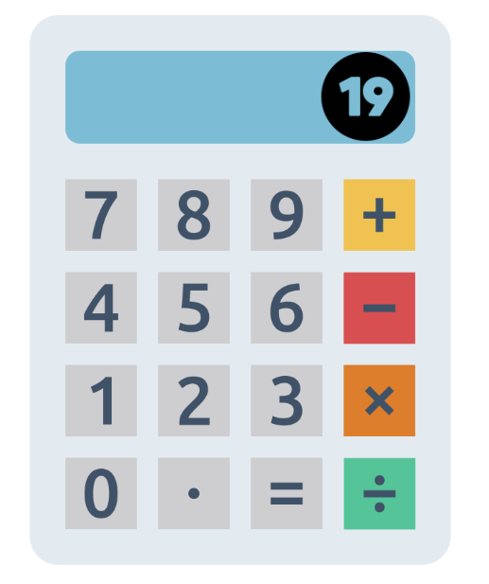

## Resource 2: Number sentence board

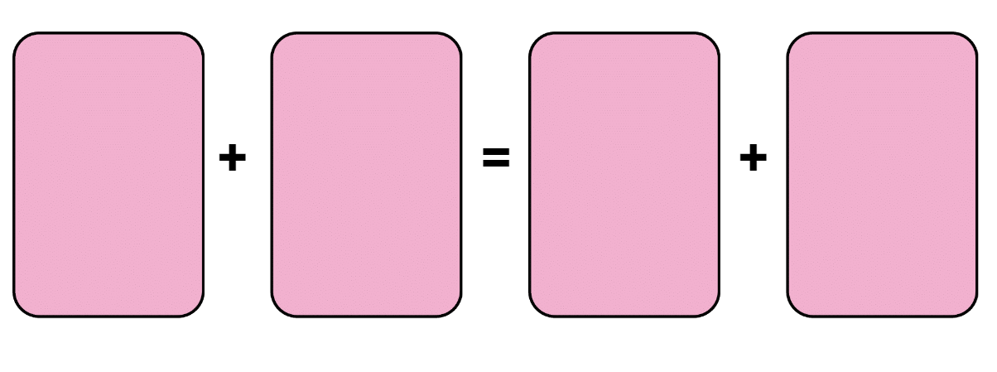

## Resource 3: Bar model

A bar model with a large rectangle across the top with the number 50. Two smaller rectangles are displayed underneath with the number 38 in one and a question mark in the other.


## Resource 4: True or False?

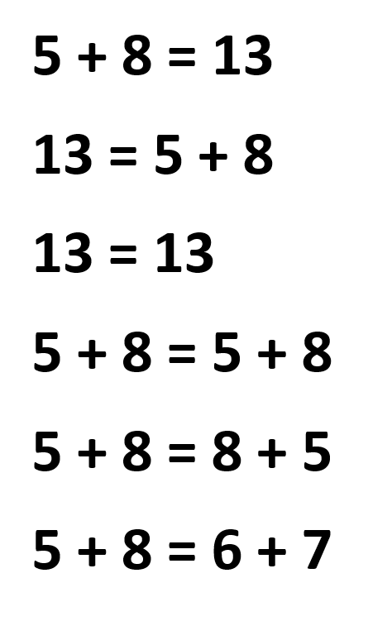

## Resource 5: Chess pieces

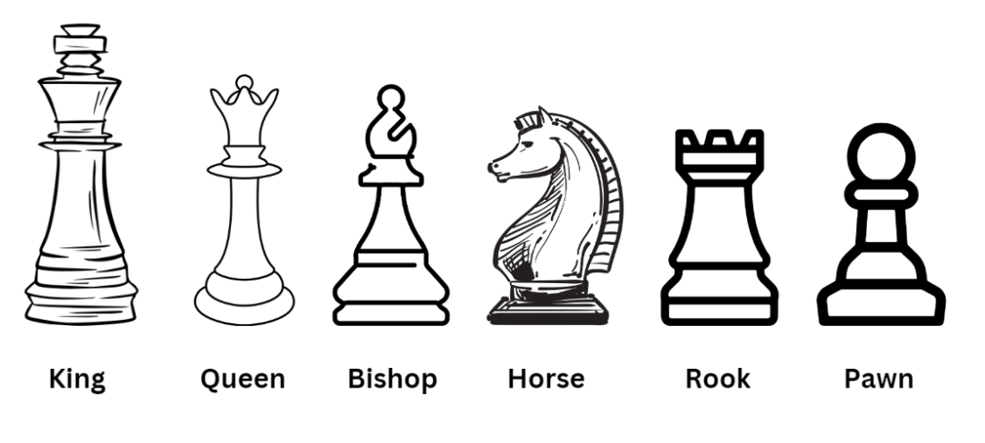

## Resource 6: Chess chart 1

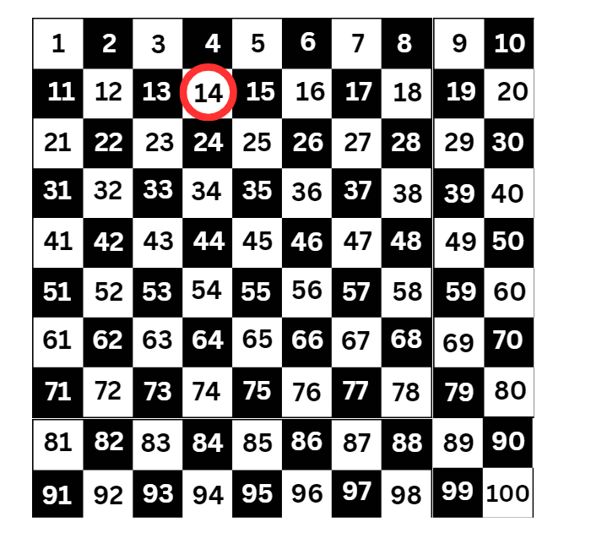

## Resource 7: Chess chart 2

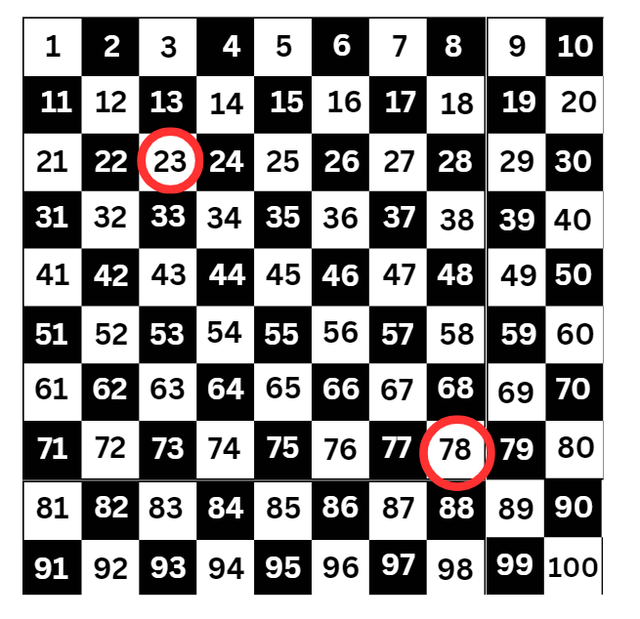

## Resource 8: Empty chart

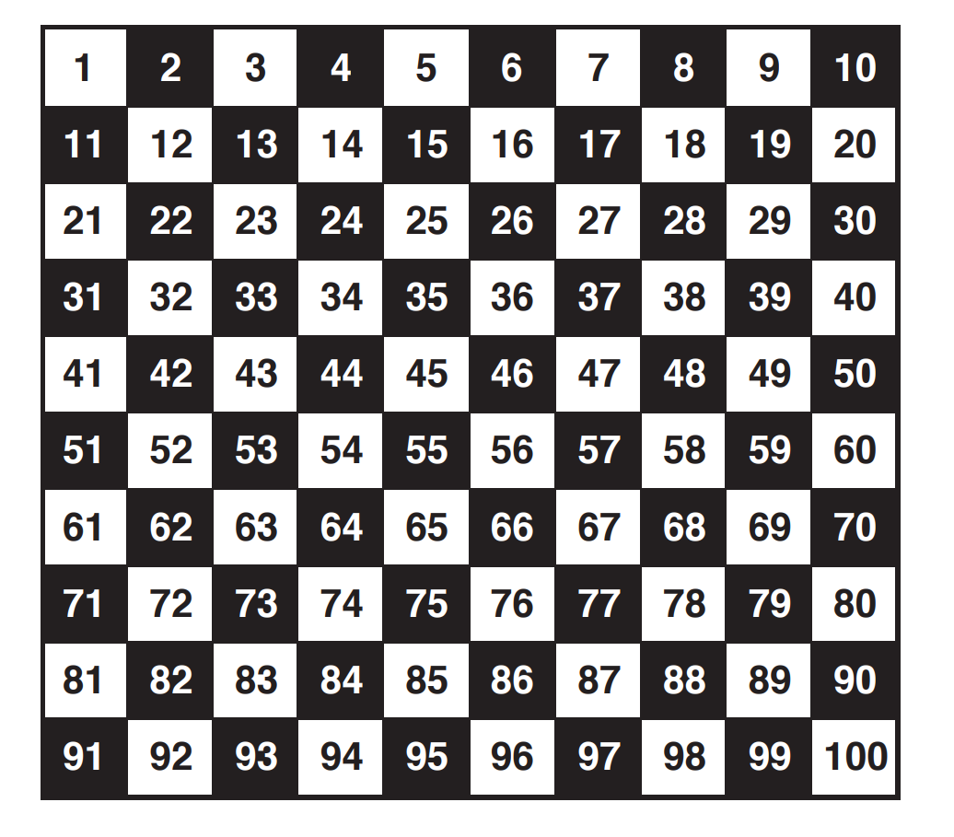

## Resource 9: Chess chart 3

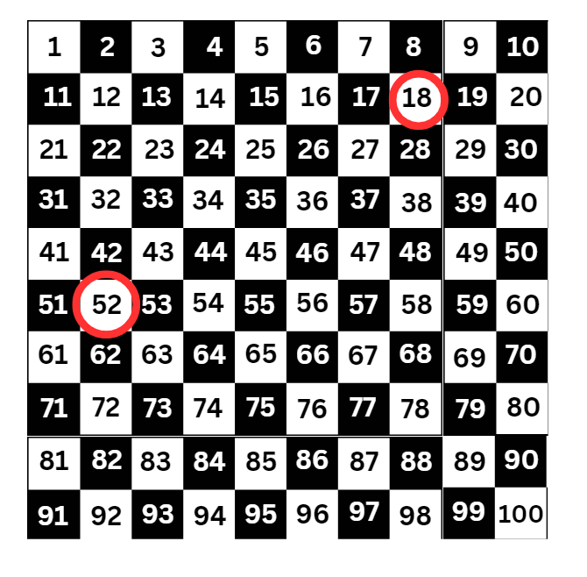

## Resource 10: Addition grid

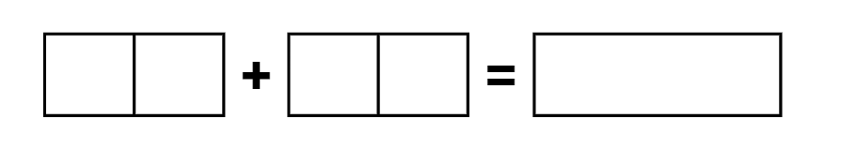

## Resource 11: Subtraction grid



## Resource 12: 119 number chart

Access a high resolution copy of Resource 12 from [*0-119 hundreds chart* [PDF 128 KB]](chrome-extension://efaidnbmnnnibpcajpcglclefindmkaj/https:/education.nsw.gov.au/content/dam/main-education/teaching-and-learning/curriculum/key-learning-areas/mathematics/media/documents/mathematics-s2-race-to-zero-0-119-hundreds-chart.pdf).

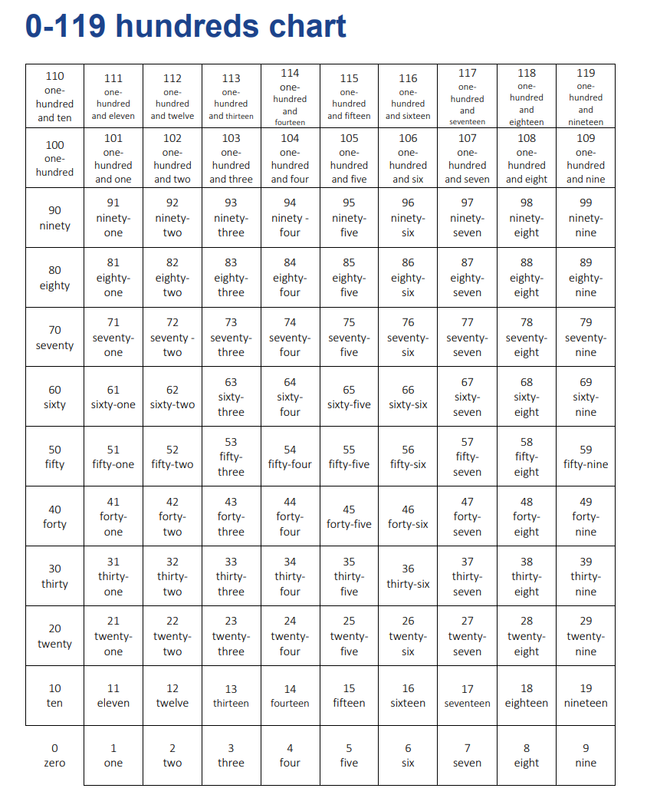

## Resource 13: Tape diagram 1

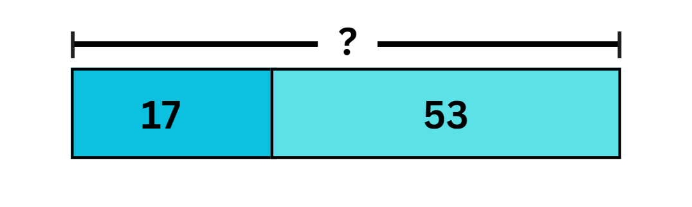

## Resource 14: Tape diagram 2

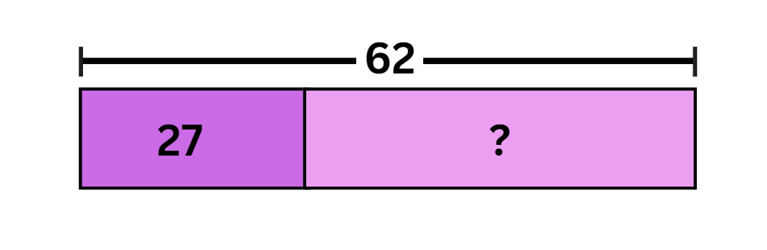

## Resource 15: Mistake

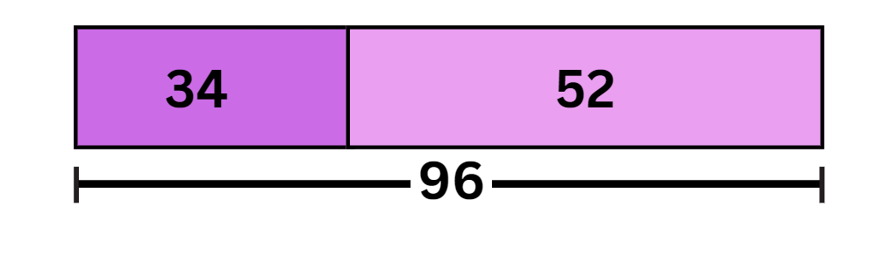

## Resource 16: Grid

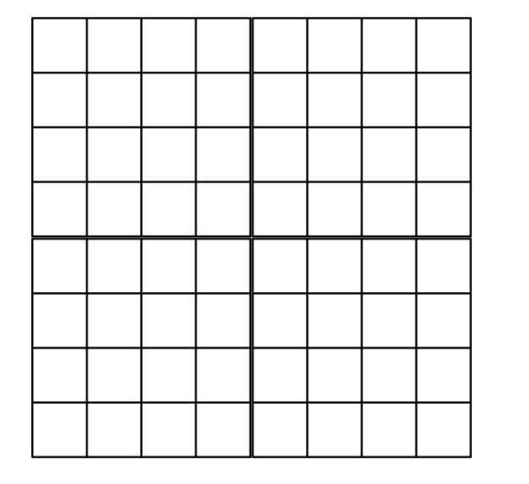

## Resource 17: The old couple

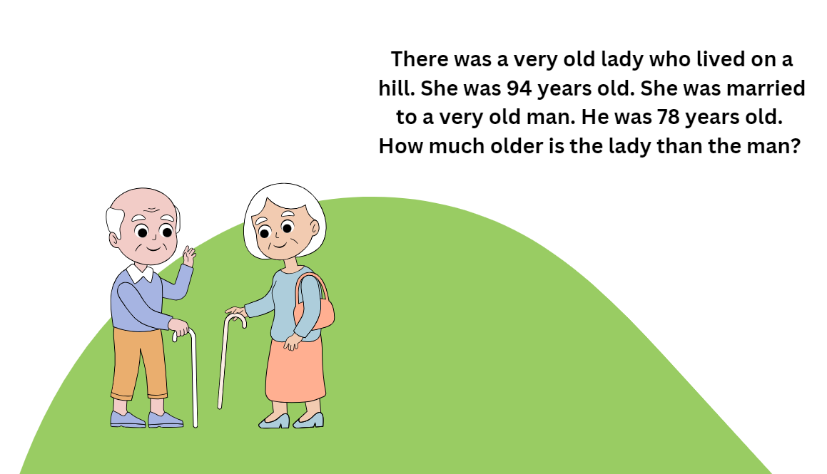

## Resource 18: Great grandchildren

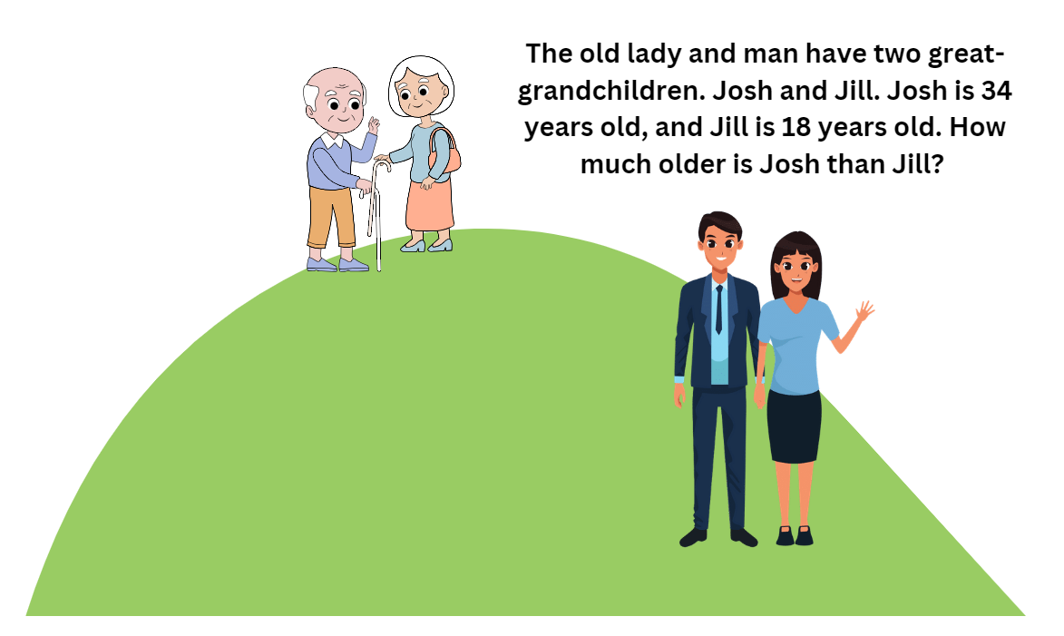

## Resource 19: Maze 100

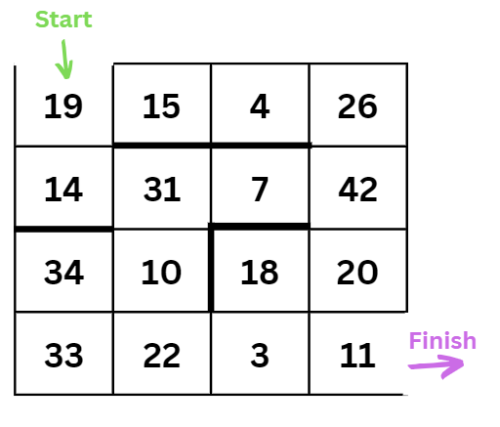

## Resource 20: Frayer model

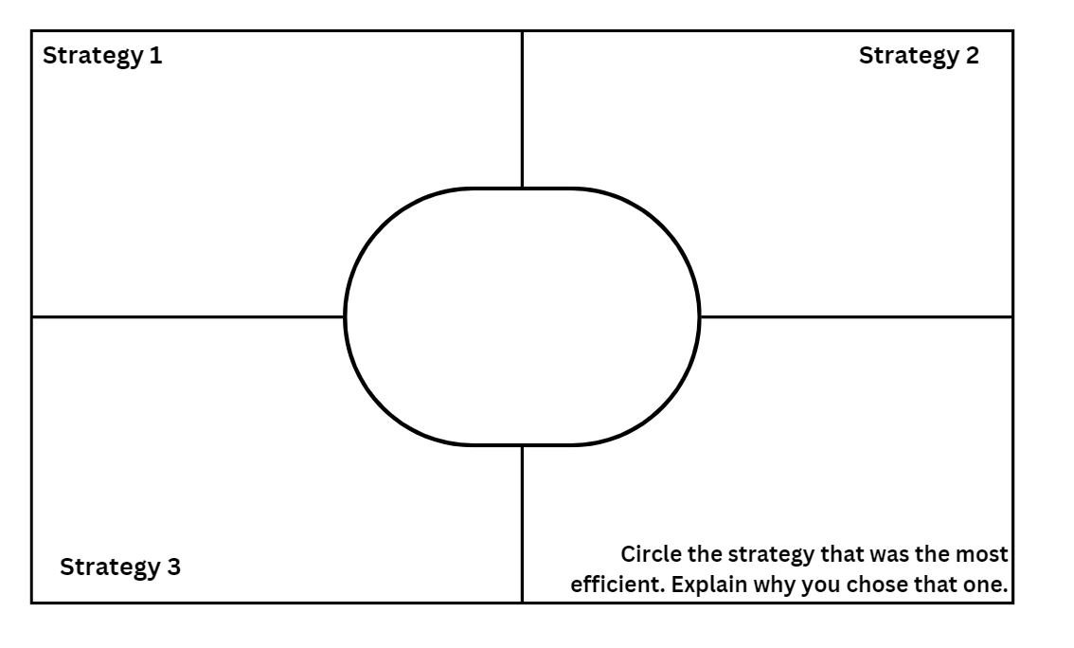

## Resource 21: Mr Frizzle’s pencils

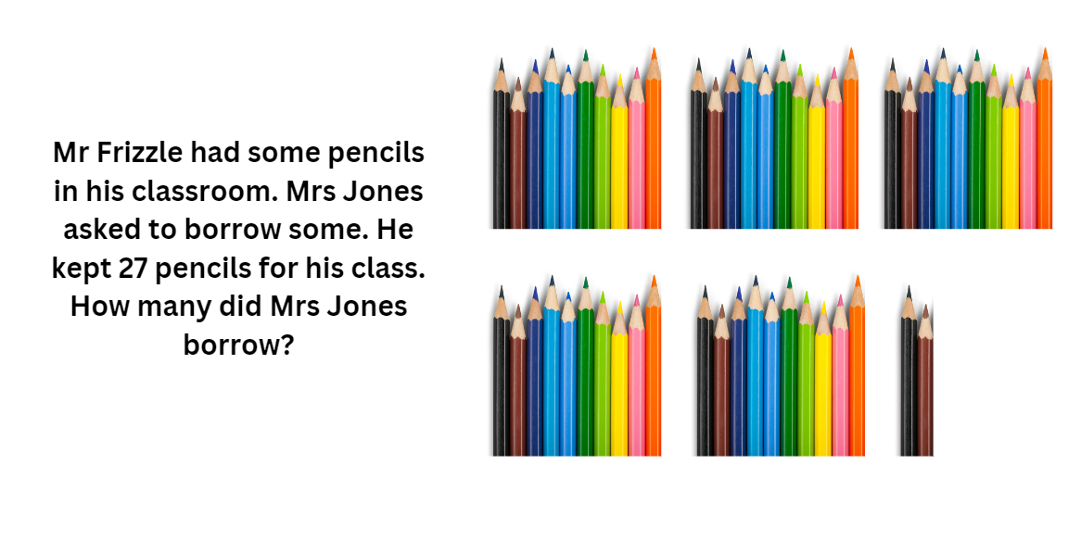

## Resource 22: Problems

Two children with a stack of books next to each child. Text reads: Katie read 44 books this year. Her brother Blake read 68. How many books did Katie and Blake read in total?
Below there is an image of a  farmer, cow and chicken. Text reads: Farmer Ben had 91 animals on his farm. 37 of the animals were chickens. The rest were cows. How many cows did Farmer Ben have?

## Syllabus outcomes and content

The table below outlines the [syllabus outcomes](https://curriculum.nsw.edu.au/learning-areas/mathematics/mathematics-k-10-2022) and range of relevant syllabus content covered in this unit. Content is linked to [National Numeracy Learning Progression](https://www.australiancurriculum.edu.au/resources/national-literacy-and-numeracy-learning-progressions/version-3-of-national-literacy-and-numeracy-learning-progressions/) version (3).

|  |  |  |  |  |  |  |  |  |
| --- | --- | --- | --- | --- | --- | --- | --- | --- |
| Outcomes and content | 1 | 2 | 3 | 4 | 5 | 6 | 7 | 8 |
| **Combining and separating quantities B:** Use knowledge of equality to solve related problems  **MA1-CSQ-01** |  |  |  |  |  |  |  |  |
| * Use number bonds to determine a missing number |  |  |  |  |  | x | x |  |
| * Use number knowledge to solve related problems (Reasons about relations) |  |  |  |  | x | x |  |  |
| * Use a variety of ways of writing number sentences |  |  |  |  | x |  |  |  |
| * Use number bonds to solve equality problems |  |  |  |  | x |  | x |  |
| **Representing numbers using place value A:** Whole numbers: Read, represent and order numbers to thousands  **MA2-RN-01** |  |  |  |  |  |  |  |  |
| * Group physical or virtual objects to show the structure of tens, hundreds and a thousand | x |  |  | x |  |  |  |  |
| * Regroup numbers flexibly, recognising one thousand as 10 hundreds and one hundred as 10 tens or 100 ones | x |  |  | x |  |  |  |  |
| * Compare and describe the relative size of numbers by positioning numbers on a number line (Reasons about quantity) | x |  |  | x |  |  |  |  |
| **Representing numbers using place value A:** Whole numbers: Apply place value to partition and regroup numbers up to 4 digits  **MA2-RN-01** |  |  |  |  |  |  |  |  |
| * Record numbers using standard place value form | x | x | x |  |  |  |  |  |
| * Partition numbers of up to 4 digits in non-standard forms (Reasons about quantity) | x | x | x |  |  |  |  |  |
| **Representing numbers using place value B:** Whole numbers: Apply place value to partition, regroup and rename numbers up to 6 digits  **MA2-RN-01** |  |  |  |  |  |  |  |  |
| * Name thousands using the place value grouping of ones, tens and hundreds of thousands |  |  |  |  |  |  | x | x |
| * Use place value to expand the number notation |  |  |  |  |  |  | x | x |
| * Partition numbers of up to 6 digits in non-standard forms |  |  |  |  |  |  | x |  |
| **Additive relations A:** Use the principle of equality  **MA2-AR-01** |  |  |  |  |  |  |  |  |
| * Use the equals sign to mean ‘the same as’, rather than to perform an operation |  | x | x |  |  |  |  |  |
| * Apply the associative property of addition to forming multiples of 10 (reasons about relations) | x |  |  |  |  |  |  |  |
| **Additive relations A:** Recognise and explain the connection between addition and subtraction  **MA2-AR-01** |  |  |  |  |  |  |  |  |
| * Use number relation principles to solve related problems (Reasons about relations) |  | x |  |  |  |  |  |  |
| * Demonstrate how addition and subtraction are inverse operations |  | x |  |  |  |  |  |  |
| * Use the complement principle of addition and subtraction (Reasons about relations) |  | x |  |  |  |  |  |  |
| * Explain and check solutions to problems, including by using the inverse operation |  | x |  |  |  |  |  |  |
| **Additive relations A:** Select strategies flexibly to solve addition and subtraction problems of up to 3 digits  **MA2-AR-01** |  |  |  |  |  |  |  |  |
| * Apply known mental strategies that use partitioning to add and subtract, such as bridging the decades |  |  | x | x | x |  |  | x |
| * Use the compensation strategy to add and subtract (Reasons about relations) |  |  |  | x |  |  |  |  |
| * Apply the levelling and constant difference strategies (Reasons about relations) |  |  |  |  | x |  |  |  |
| * Represent solutions to addition and subtraction problems, including word problems, using an empty number line or bar model |  |  |  |  |  | x | x | x |
| * Compare and evaluate strategies used to solve addition and subtraction problems, reasoning which strategy may be most efficient | x |  | x | x | x | x | x | x |
| **Additive relations A:** Represent money values in multiple ways  **MA2-AR-01** |  |  |  |  |  |  |  |  |
| * Recognise the relationship between dollars and cents |  |  |  |  |  |  |  | x |
| * Represent equivalent amounts of money using different denominations |  |  |  |  |  |  |  | x |
| * Perform calculations with money, including finding change |  |  |  |  |  |  |  | x |

[Mathematics K–10 Syllabus](https://curriculum.nsw.edu.au/learning-areas/mathematics/mathematics-k-10) © NSW Education Standards Authority (NESA) for and on behalf of the Crown in right of the State of New South Wales, 2022.

## References

This resource contains NSW Curriculum and syllabus content. The NSW Curriculum is developed by the NSW Education Standards Authority. This content is prepared by NESA for and on behalf of the Crown in right of the State of New South Wales. The material is protected by Crown copyright.

Please refer to the NESA Copyright Disclaimer for more information <https://educationstandards.nsw.edu.au/wps/portal/nesa/mini-footer/copyright>.

NESA holds the only official and up-to-date versions of the NSW Curriculum and syllabus documents. Please visit the NSW Education Standards Authority (NESA) website <https://educationstandards.nsw.edu.au/> and the NSW Curriculum website <https://curriculum.nsw.edu.au/home>.

[Mathematics K–10 Syllabus](https://curriculum.nsw.edu.au/learning-areas/mathematics/mathematics-k-10-2022) © NSW Education Standards Authority (NESA) for and on behalf of the Crown in right of the State of New South Wales, 2022.

[National Numeracy Learning Progression](https://www.australiancurriculum.edu.au/resources/national-literacy-and-numeracy-learning-progressions/version-3-of-national-literacy-and-numeracy-learning-progressions/) © Australian Curriculum, Assessment and Reporting Authority (ACARA) 2010 to present, unless otherwise indicated. This material was downloaded from the [Australian Curriculum](http://www.australiancurriculum.edu.au/) website (National Literacy Learning Progression) (accessed 28 August 2023) and was not modified.

Australian Government Department of Education (2020) ‘[Addition: Chess – The Rook](https://www.resolve.edu.au/addition-chess-rook)’, *Teaching resources*, reSolve: Maths by Inquiry website, accessed 26 June 2023.

Russo J (2020) ‘[Approaches to a challenging task involving subtraction](https://www.researchgate.net/publication/350965251_Let%27s_Play_Number_Sentences)’, *Prime Number* 35(4):16–18, accessed 3 July 2023.

Russo J (2021) ‘[Let’s Play: Number Sentences](https://www.researchgate.net/publication/350965251_Let%27s_Play_Number_Sentences)’, *Prime Number* 36(2):4–5, accessed 3 July 2023.

Siemon D, Warren E, Beswick K, Faragher R, Miller J, Horne M, Jazby D, Breed M, Clark J and Brady K (2021) *Teaching Mathematics: Foundations to Middle Years*, 3rd edn, Oxford University Press Australia and New Zealand.

State of New South Wales (Department of Education) (2023) ‘[Additive strategies: Closest to 100 (Task 5)](https://education.nsw.gov.au/teaching-and-learning/curriculum/literacy-and-numeracy/teaching-and-learning-resources/numeracy/explicit-teaching-strategies/stage-3/numbers-and-algebra/additive)’, Stage 3 numbers and algebra, NSW Department of Education website, accessed 3 July 2023.

State of New South Wales (Department of Education) (n.d.) ‘[Double or halve? – Stage 1](https://education.nsw.gov.au/teaching-and-learning/curriculum/mathematics/mathematics-curriculum-resources-k-12/mathematics-k-6-resources/double-or-halve-stage-1)’, *Mathematics K-6 resources*, NSW Department of Education website, accessed 3 July 2023.

State of New South Wales (Department of Education) (n.d.) ‘[Race to zero (subtracting tens and ones)](https://education.nsw.gov.au/teaching-and-learning/curriculum/mathematics/mathematics-curriculum-resources-k-12/mathematics-k-6-resources/race-to-zero-subtracting-tens-and-ones)’, *Mathematics K-6 resources*, NSW Department of Education website, accessed 3 July 2023.

State of New South Wales (Department of Education) (n.d.) ‘[Strike it out (addition and subtraction to 20)](https://education.nsw.gov.au/teaching-and-learning/curriculum/mathematics/mathematics-curriculum-resources-k-12/mathematics-k-6-resources/strike-it-out-addition-and-subtraction-to-20)’, *Mathematics K-6 resources*, NSW Department of Education website, accessed 3 July 2023.

Sullivan P and Lilburn P (2017) *Open-Ended Maths Activities*, 2nd edn, Oxford University Press Australia and New Zealand.

University of Cambridge (Faculty of Mathematics) (1997–2023) [*Dicey Addition*](https://nrich.maths.org/11863), NRICH website, accessed 26 June 2023.

University of Cambridge (Faculty of Mathematics) (1997–2023) [*Maze 100*](https://nrich.maths.org/91), NRICH website, accessed 26 June 2023.

University of Cambridge (Faculty of Mathematics) (1997–2023) [*True or False?*](https://nrich.maths.org/14797), NRICH website, accessed 26 June 2023.

Van de Walle J, Karp K, Bay-Williams JM, Brass A, Bentley B, Ferguson S, Goff W, Livy S, Marshman M, Martin D, Pearn C, Prodromou T, Symons D and Wilkie K (2019) *Primary and Middle Years Mathematics: Teaching Developmentally*, 1st Australian edn, Pearson Education Australia, Melbourne.

**© State of New South Wales (Department of Education), 2023**

The copyright material published in this resource is subject to the *Copyright Act 1968* (Cth) and is owned by the NSW Department of Education or, where indicated, by a party other than the NSW Department of Education (third-party material).

Copyright material available in this resource and owned by the NSW Department of Education is licensed under a [Creative Commons Attribution 4.0 International (CC BY 4.0) license](https://creativecommons.org/licenses/by/4.0/).

[](https://creativecommons.org/licenses/by/4.0/)

This license allows you to share and adapt the material for any purpose, even commercially.

Attribution should be given to © State of New South Wales (Department of Education), 2023.

Material in this resource not available under a Creative Commons license:

* the NSW Department of Education logo, other logos and trademark-protected material
* material owned by a third party that has been reproduced with permission. You will need to obtain permission from the third party to reuse its material.

**Links to third-party material and websites**

Please note that the provided (reading/viewing material/list/links/texts) are a suggestion only and implies no endorsement, by the New South Wales Department of Education, of any author, publisher, or book title. School principals and teachers are best placed to assess the suitability of resources that would complement the curriculum and reflect the needs and interests of their students.

If you use the links provided in this document to access a third-party's website, you acknowledge that the terms of use, including licence terms set out on the third-party's website apply to the use which may be made of the materials on that third-party website or where permitted by the *Copyright Act 1968* (Cth). The department accepts no responsibility for content on third-party websites.