Mathematics Stage 2 – Unit 22

Contents

Unit description and duration 5

Syllabus outcomes 5

Working mathematically 6

Student prior learning 6

Lesson overview and resources 8

Lesson 1 13

Daily number sense: Solve it – 10 minutes 13

Core lesson: Regrouping addition – 40 minutes 14

Consolidation and meaningful practice – 10 minutes 16

Lesson 2 18

Daily number sense: Balance to 100 – 10 minutes 18

Core lesson: Regrouping subtraction – 40 minutes 20

Consolidation and meaningful practice – 15 minutes 23

Lesson 3 24

Daily number sense: Equal differences – 10 minutes 24

Core lesson: Grocery shopping – 40 minutes 25

Discuss and connect the mathematics – 10 minutes 28

Lesson 4 30

Daily number sense – 10 minutes 30

Core lesson: Using inverse operations – 40 minutes 30

Consolidation and meaningful practice – 15 minutes 33

Lesson 5 35

Daily number sense: How many ways – 10 minutes 35

Core lesson: Using models – 40 minutes 37

Discuss and connect the mathematics – 10 minutes 42

Lesson 6 44

Daily number sense: Two truths and a lie – 15 minutes 44

Core lesson: Addition algorithms – 35 minutes 46

Consolidation and meaningful practice – 15 minutes 49

Lesson 7 51

Daily number sense: Partitioning – 10 minutes 51

Core lesson: Subtraction algorithms – 40 minutes 53

Consolidation and meaningful practice – 10 minutes 57

Lesson 8 59

Daily number sense – 10 minutes 59

Core lesson: Maths investigation – 45 minutes 59

Consolidation and meaningful practice – 15 minutes 61

Resource 1: Solve it cards 63

Resource 2: Create 1000 65

Resource 3: Take the plunge! 66

Resource 4: Take a plunge! 67

Resource 5: Broken calculator 68

Resource 6: Equal differences 69

Resource 7: Grocery shopping 70

Resource 8: Question 71

Resource 9: Challenges 72

Resource 10: How many trees? 73

Resource 11: Eucalypt trees 74

Resource 12: Wattle trees 75

Resource 13: The number… 76

Resource 14: True or False 77

Resource 15: Solving addition 78

Resource 16: Addition 79

Resource 17: Consolidation 80

Resource 18: Empty algorithm 81

Resource 19: Maths investigation 82

Resource 20: Frayer model 83

Syllabus outcomes and content 84

References 90

# Unit description and duration

This unit develops the big idea that addition and subtraction problems can be solved using a variety of strategies.

In this 2-week unit students are provided opportunities to:

* apply place value understanding to solve addition and subtraction problems
* identify the connection between addition and subtraction
* select and explain efficient flexible strategies when solving problems.

## Syllabus outcomes

* **MAO-WM-01** develops understanding and fluency in mathematics through exploring and connecting mathematical concepts, choosing and applying mathematical techniques to solve problems, and communicating their thinking and reasoning coherently and clearly
* **MA2-RN-01** applies an understanding of place value and the role of zero to represent numbers to at least tens of thousands
* **MA2-AR-01** selects and uses mental and written strategies for addition and subtraction involving 2- and 3-digit numbers
* **MA2-AR-02** completes number sentences involving addition and subtraction by finding missing values

## Working mathematically

In the Mathematics K–10 Syllabus, there is one overarching Working mathematically outcome (**MAO-WM-01**). The Working mathematically processes should be embedded within the concepts being taught. The Working mathematically processes present in the Mathematics K–10 Syllabus are:

* communicating
* understanding and fluency
* reasoning
* problem solving.

[Mathematics K–10 Syllabus](https://curriculum.nsw.edu.au/learning-areas/mathematics/mathematics-k-10-2022/overview) © NSW Education Standards Authority (NESA) for and on behalf of the Crown in right of the State of New South Wales, 2022.

## Student prior learning

Before engaging in these teaching and learning activities, students would benefit from prior experience with:

* partitioning, rearranging and regrouping numbers for solving addition and subtraction problems
* identifying unknown quantities in number sentences involving addition and subtraction
* solving addition and subtraction problems using written and mental calculations.

In NSW classrooms there is a diverse range of students, including Aboriginal and Torres Strait Islander students, students learning English as an additional language or dialect, high potential and gifted students and students with disability. Some students may identify with more than one of these groups or possibly all of them. Refer to [Curriculum planning for every student – advice](https://education.nsw.gov.au/teaching-and-learning/curriculum/planning-programming-and-assessing-k-12/advice-on-curriculum-planning-for-every-student-k-12) for further information.

## Lesson overview and resources

The table below outlines the sequence and approximate timing of lessons, learning intentions and resources.

|  |  |  |
| --- | --- | --- |
| Lesson | Content | Duration and resources |
| **Lesson 1**  **Daily number sense learning intention**:   * use the principle of equality | **Lesson core concept**: numbers can be built up or taken apart in a variety of ways to make the numbers easier to work with.  **Core concept learning intention**:   * partition, rearrange and regroup numbers up to at least 1000 to solve addition problems | **Lesson duration**: 60 minutes   * Resource 1: Solve it cards * Resource 2: Create 1000 * Counters * Student workbooks * Writing materials |
| **Lesson 2**  **Daily number sense learning intention**:   * use the principle of equality | **Lesson core concept**: flexible methods of addition and subtraction involve decomposing and composing numbers.  **Core concept learning intention**:   * partition, rearrange and regroup numbers for addition and subtraction | **Lesson duration**: 65 minutes   * Resource 3: Take the plunge! * Resource 4: Take a plunge! * Resource 5: Broken calculator * Class set of calculators * Counters * Individual whiteboards * Writing materials |
| **Lesson 3**  **Daily number sense learning intention**:   * use the principle of equality | **Lesson core concept**: place value understanding helps solve addition and subtraction problems.  **Core concept learning intention**:   * partition, rearrange and regroup numbers for addition and subtraction problems | **Lesson duration**:60 minutes   * Resource 6: Equal differences * Resource 7: Grocery shopping * Student workbooks * Writing materials |
| **Lesson 4**  **Daily number sense learning intention**:   * teacher-identified task based on student needs | **Lesson core concept**: addition can help solve subtraction problems.  **Core concept learning intention**:   * recognise and explain the connection between addition and subtraction | **Lesson duration**: 65 minutes   * Resource 8: Question * Resource 9: Challenges * Student workbooks * Individual whiteboards * Writing materials |
| **Lesson 5**  **Daily number sense learning intention**:   * rename numbers up to 4 digits | **Lesson core concept**: models help us solve addition and subtraction problems.  **Core concept learning intention**:   * use models to solve addition and subtraction problems | **Lesson duration**: 60 minutes   * Resource 10: How many trees? * Resource 11: Eucalypt trees * Resource 12: Wattle trees * MAB materials * Student workbooks * Individual whiteboards * Writing materials |
| **Lesson 6**  **Daily number sense learning intention**:   * apply place value to partition and regroup numbers | **Lesson core concept**: mathematicians understand how to use algorithms to solve addition problems.  **Core concept learning intention**:   * partition, rearrange and regroup numbers to solve additive problems | **Lesson duration**: 65 minutes   * Resource 13: The number... * Resource 14: True or False * Resource 15: Solving addition * Resource 16: Addition * Resource 17: Consolidation * MAB materials * Student workbooks * Writing materials |
| **Lesson 7**  **Daily number sense learning intention**:   * apply place value to partition and regroup numbers | **Lesson core concept**: mathematicians understand how to use algorithms to solve subtraction problems.  **Core concept learning intention**:   * partition, rearrange and regroup numbers to solve subtraction problems | **Lesson duration**: 60 minutes   * Resource 18: Empty algorithm * Student workbooks * Individual whiteboards * Writing materials |
| **Lesson 8**  **Daily number sense learning intention**:   * teacher-identified task based on student needs | **Lesson core concept**: mathematicians compare and evaluate strategies used to solve addition and subtraction problems, reasoning which strategy is the most efficient.  **Core concept learning intention**:   * apply addition and subtraction to familiar contexts | **Lesson duration**: 70 minutes   * Resource 19: Maths investigation * Resource 20: Frayer model * Student workbooks * Writing materials |

# Lesson 1

**Core concept**: numbers can be built up or taken apart in a variety of ways to make the numbers easier to work with.

## Daily number sense: Solve it – 10 minutes

Daily number sense activities for Lessons 1 to 3 ‘activate’ prior number knowledge and support the learning of new content in the unit. These activities can also assist teachers to identify the starting points for learning by revealing the extent of students’ existing knowledge.

The table below contains a suggested learning intention and success criteria. These are best co-constructed with students.

|  |  |
| --- | --- |
| Daily number sense learning intention | Daily number sense success criteria |
| Students are learning to:   * use the principle of equality. | Students can:   * use the equals sign to mean 'the same as' to solve addition and subtraction problems. |

1. Display the number sentence 24 + 11 = 23 + 12 and ask the students if the statement is correct and have them explain their thinking.
2. Display Resource 1: Solve it cards. Students individually solve the cards in their workbooks.
3. In pairs, students share their answers and justify their responses.
4. Regroup and ask students how they would explain the concept of equality to someone who is just beginning to learn about number sentences and the equals sign.

This table details opportunities for assessment.

|  |  |
| --- | --- |
| Assessment opportunities | Links |
| What to look for:   * Can students use the equals sign to mean 'the same as' to solve addition and subtraction problems? **[MAO-WM-01, MA2-AR-01, MA2-AR-02]** | Links to [National Numeracy Learning Progressions](https://www.australiancurriculum.edu.au/resources/national-literacy-and-numeracy-learning-progressions/version-3-of-national-literacy-and-numeracy-learning-progressions/) (NNLP):   * NPA3, NPA7.   Links to suggested [Interview for Student Reasoning](https://education.nsw.gov.au/teaching-and-learning/curriculum/literacy-and-numeracy/assessment-resources/ifsr) (IfSR) tasks:   * **IfSR-AT**: 2A.1, 2A.5. |

## Core lesson: Regrouping addition – 40 minutes

The table below contains a suggested learning intention and success criteria. These are best co-constructed with students.

|  |  |
| --- | --- |
| Core concept learning intentions | Core concept success criteria |
| Students are learning to:   * partition, rearrange and regroup numbers up to at least 1000 to solve addition problems. | Students can:   * model addition with and without regrouping and record the method used * partition numbers of up to 5-digits using non-standard form. |

This activity is an adaptation of [*Create 5000* [PDF 352 KB]](https://nzmaths.co.nz/sites/default/files/family/y4tasks/Create5000.pdf) from [NZ Maths](https://nzmaths.co.nz/) by New Zealand Ministry of Education.

1. Display the number sentence 281 + 309 = ? and ask students to identify the strategies that can be used to solve this number sentence. Record student suggestions on the board.
2. Model using regrouping to solve the number sentence using standard and non-standard partitioning. For example, 281 + 309 is easier to solve by 200 + 300 + 81 + 9 = 500 + 90 = 590.
3. Provide pairs or small groups with a copy of Resource 2: Create 1000 and each student with a counter and their workbook.
4. First, each player chooses a number to place their counter on. Students take turns moving their counter to another number by moving along the lines. They then add the new number to their total. In the next move, players cannot go back to where they came from, they must go to a different number. The first player to make it to 1000 or the closest to 1000 is the winner.
5. Encourage students to use regrouping when adding numbers. Students record their calculations in their workbook.

This table details opportunities for differentiation.

|  |  |
| --- | --- |
| Too hard? | Too easy? |
| Students cannot use regrouping to model addition.   * Provide MAB materials to support regrouping. * Provide a target number that is 2 digits. | Students can use regrouping to model addition.   * Challenge students to reach 5000 and in the fewest turns and explain their strategy to a partner. * Alternate between addition and subtraction. For the first move, students add the numbers, the second move would then subtract, the third move would add, the fourth would subtract. The process continues until a player passes 5000. |

## Consolidation and meaningful practice – 10 minutes

1. Display the problem that in Stage 2 there are 467 students. There are more girls than boys. How many girls could there be? How many boys could there be?
2. Students work in pairs to find solutions.
3. Share student responses and record them on the board and ask:

* How did you solve the problem?
* What made you decide to do it that way?
* What strategies did you use?
* Is there more than one solution?

This table details opportunities for assessment.

|  |  |
| --- | --- |
| Assessment opportunities | Links |
| What to look for:   * Can students solve addition problems with and without regrouping and record the method used? **[MAO-WM-01, MA2-RN-01, MA2-AR-01]** * Can students partition numbers of up to 5-digits using non-standard form? **[MAO-WM-01, MA2-RN-01, MA2-AR-01]** | Links to [National Numeracy Learning Progressions](https://www.australiancurriculum.edu.au/resources/national-literacy-and-numeracy-learning-progressions/version-3-of-national-literacy-and-numeracy-learning-progressions/) (NNLP):   * AdS8NPV5, NPV6, NPV7.   Links to suggested [Interview for Student Reasoning](https://education.nsw.gov.au/teaching-and-learning/curriculum/literacy-and-numeracy/assessment-resources/ifsr) (IfSR) tasks:   * **IfSR-AT**: 3A.2, 3B4. |

# Lesson 2

**Core concept**: flexible methods of addition and subtraction involve decomposing and composing numbers.

## Daily number sense: Balance to 100 – 10 minutes

The table below contains a suggested learning intention and success criteria. These are best co-constructed with students.

|  |  |
| --- | --- |
| Daily number sense learning intention | Daily number sense success criteria |
| Students are learning to:   * use the principle of equality. | Students can:   * use the equals sign to mean ‘the same as’ to solve addition and subtraction problems * apply the associative property of addition to form multiples of 10. |

This activity is an adaptation of [Reach 100](https://nrich.maths.org/1130) from [NRICH](https://nrich.maths.org/) by University of Cambridge (Faculty of Mathematics).

1. Students draw a square and divide it into quarters. They choose 4 different digits from one to 9 and put them in each box. The aim is to find 4 different digits that give four 2-digit numbers which add or balance to a total of 100 (see Figure 1).

Figure 1 – Example

Square divided into quarters with numbers in each quarter: 5,2,1,9. Text: This gives four two-digit numbers: 52 (reading along the 1st row)
19 (reading along the 2nd row)
51 (reading down the left column)
29 (reading down the right column)
In this case their sum is 151.

1. Explain that using associative property of addition to form multiples of 10 is a useful strategy. For example, 52 + 19 + 51 + 29 = 51 + 19 + 52 + 29. Explain that using place value understanding flexibly makes it is easier to solve 51 +19 = 70 and then add on 52 + 29 (see Figure 2).

**Associative law:** when more than 2 numbers are added or multiplied, the result is unchanged regardless of how they are grouped or associated. For example, 22 + 13 + 8 = 22 + 8 + 13 = 30 + 13 = 43.

1. In pairs, students try to solve the challenge and record all the solutions they can find on a whiteboard.
2. Regroup as a class and discuss the different strategies students used to find balancing equations to 100.

This table details opportunities for assessment.

|  |  |
| --- | --- |
| Assessment opportunities | Links |
| What to look for:   * Can students use the equals sign to mean 'the same as' to solve addition and subtraction problems? **[MAO-WM-01, MA2-AR-01, MA2-AR-02]** | Links to [National Numeracy Learning Progressions](https://www.australiancurriculum.edu.au/resources/national-literacy-and-numeracy-learning-progressions/version-3-of-national-literacy-and-numeracy-learning-progressions/) (NNLP):   * NPA3, NPA7.   Links to suggested [Interview for Student Reasoning](https://education.nsw.gov.au/teaching-and-learning/curriculum/literacy-and-numeracy/assessment-resources/ifsr) (IfSR) tasks:   * **IfSR-AT**: 2A.1, 2A.5. |

## Core lesson: Regrouping subtraction – 40 minutes

The table below contains a suggested learning intention and success criteria. These are best co-constructed with students.

|  |  |
| --- | --- |
| Core concept learning intentions | Core concept success criteria |
| Students are learning to:   * partition, rearrange and regroup numbers for addition and subtraction. | Students can:   * model subtraction with and without regrouping and record the method used * partition numbers of up to 5-digits using non-standard form. |

1. Display the problem: 653 students were surveyed to ask whether they lived in a house or an apartment. 227 students responded that they lived in an apartment. How many students live in a house? Ask:

* What number sentence can be used to represent this problem?
* How can we use what we know about regrouping to solve this number sentence?

1. Model using regrouping to solve the number sentence. Demonstrate to students that the numbers can also be separated using standard and non-standard partitioning (see Figure 2).

Figure 2 – Regrouping non-standard partitioning

653 - 227 =  on the first line. 
expanded notation (600 + 40 + 13) - (200 + 20 + 7) = 
Simple notation 400 + 20 + 6 = 426 

1. Provide pairs of students with 10 counters, a calculator, a copy of Resource 3: Take the plunge! and an individual whiteboard each.
2. Introduce the game ‘Take the plunge!’. Explain that the aim of the game is to move from one yellow donut to the one on the other side of the pool. One player begins on the left-hand side of the gameboard and the other starts on the right-hand side of the gameboard. Players choose the path they take and can move in any direction.
3. Players take turns moving one donut at a time. They solve the number sentence on their whiteboard. Encourage students to use regrouping to solve the subtraction question. The other player uses the calculator to check their partner’s answer. If the answer is correct, the player places one of their counters on the number sentence and this donut is out of play.
4. Players continue taking turns. The first player to reach the yellow donut on the other side is the winner.

This table details opportunities for differentiation.

|  |  |
| --- | --- |
| Too hard? | Too easy? |
| Students cannot use regrouping to model subtraction.   * Provide students with Resource 4: Take a Plunge! using smaller numbers. * Provide students with concrete materials, such as MAB blocks, to model the number sentence. | Students can use regrouping to model subtraction.   * Students create their own game in pairs with additional rules to challenge others. * Include word problems to challenge students for additional points. |

## Consolidation and meaningful practice – 15 minutes

This activity is an adaptation of [*Problems to solve* [PDF 559 KB]](https://nzmaths.co.nz/sites/default/files/family/y4tasks/ProblemsToSolve.pdf) from [NZ Maths](https://nzmaths.co.nz/) by the New Zealand Ministry of Education.

1. Display Resource 5: Broken calculator. Before completing the question, ask:

* How might you approach this task?
* How can partitioning this number in non-standard form help in finding a solution?
* Is there more than one way to solve this problem?
* Why is it important to use a calculator to check your answer?

1. In pairs students respond to the questions and record their working out on individual whiteboards.

This table details opportunities for assessment.

|  |  |
| --- | --- |
| Assessment opportunities | Links |
| What to look for:   * Can students use regrouping to solve subtraction problems? **[MAO-WM-01, MA2-RN-01, MA2-AR-01, MA2-AR-02]** | Links to [National Numeracy Learning Progressions](https://www.australiancurriculum.edu.au/resources/national-literacy-and-numeracy-learning-progressions/version-3-of-national-literacy-and-numeracy-learning-progressions/) (NNLP):   * AdS8. |

# Lesson 3

**Core concept**: place value understanding helps solve addition and subtraction problems.

## Daily number sense: Equal differences – 10 minutes

The table below contains a suggested learning intention and success criteria. These are best co-constructed with students.

|  |  |
| --- | --- |
| Daily number sense learning intention | Daily number sense success criteria |
| Students are learning to:   * use the principle of equality. | Students can:   * recognise equal differences and record them in number sentences. |

1. Display Resource 6: Equal differences. In pairs students solve and record the subtraction number sentences in their workbook to support their understanding of the solution.
2. Regroup as a class and ask:

* What does it mean for the differences to be equal?
* What strategies did you use to solve the problems?
* Did you use any visual support to find the answers?
* What strategies did you learn from your partner that you can use next time?
* Did you use addition to help solve any of the number sentences?
* Did you have any challenges while solving the problems? How did you resolve them?

This table details opportunities for assessment.

|  |  |
| --- | --- |
| Assessment opportunities | Links |
| What to look for:   * Can students recognise equal differences and record them in number sentences? **[MAO-WM-01, MA2-AR-01, MA2-AR-02]** | Links to [National Numeracy Learning Progressions](https://www.australiancurriculum.edu.au/resources/national-literacy-and-numeracy-learning-progressions/version-3-of-national-literacy-and-numeracy-learning-progressions/) (NNLP):   * AdS7.   Links to suggested [Interview for Student Reasoning](https://education.nsw.gov.au/teaching-and-learning/curriculum/literacy-and-numeracy/assessment-resources/ifsr) (IfSR) tasks:   * **IfSR-AT**: 2A.5. |

## Core lesson: Grocery shopping – 40 minutes

The table below contains a suggested learning intention and success criteria. These are best co-constructed with students.

|  |  |
| --- | --- |
| Core concept learning intentions | Core concept success criteria |
| Students are learning to:   * partition, rearrange and regroup numbers for addition and subtraction problems. | Students can:   * identify the place value of numbers * use non-standard partitioning to solve addition and subtraction problems. |

This activity is an adaptation of [*Problems to solve* [PDF 559 KB]](https://nzmaths.co.nz/sites/default/files/family/y4tasks/ProblemsToSolve.pdf) from [NZ Maths](https://nzmaths.co.nz/) by New Zealand Ministry of Education.

1. Display Resource 7: Grocery shopping and ask how many combinations of these groceries could be put in a bag if you can only carry 1000 grams.
2. Provide students with their workbook and in pairs find different combinations of items that could add to a total weight of 1000 grams. Encourage students to use their knowledge of non-standard partitioning to find different combinations.
3. Students experiment with different combinations, recording their responses in their workbooks.
4. Regroup students and ask:

* What different combinations did you find?
* What was the closest combination of items you found to equal 1000 g?

**Note**: model how non-standard partitioning can be used to solve different combinations. For example, finding the total weight of 196 g of ham and a 23 g tea bag. 196 can be partitioned into 190 + 6, and 23 can be partitioned into 10 + 10 + 3, then 190 + 10 + 10 = 210, then 210 + 6 + 3 = 219.

1. Using the same shopping, list tell students they now need to work with their partner to see what combination of groceries they can find that weighs closest to 1000 g carrying the least number of items.
2. Regroup students and share different solutions.
3. Tell students that the bag is too heavy at 1000 g. Ask them what can be removed to make the bag under 500 g. Students work with their partner to find possible combinations of groceries that can be removed.

This table details opportunities for differentiation.

|  |  |
| --- | --- |
| Too hard? | Too easy? |
| Students cannot use place value to solve addition and subtraction questions.   * Provide students with concrete materials such as MAB materials to model solving the problem. * Alter the task so students work to find combinations of groceries to put in a bag with a weight limit of 500 g. | Students can use place value to solve addition and subtraction questions.   * Provide students with the additional problems. For example, someone wants to take home all the groceries available in the list, so they brought a second bag to the shop to help carry them. Ask how students could fit all the items in the bags, if each bag has a weight limit of 1000 g. * Explain that you want the bags to be as even in weight as possible. Ask what combination of groceries you could put in the 2 bags to make their weight as close as possible. |

## Discuss and connect the mathematics – 10 minutes

1. Regroup students and share possible solutions. Ask:

* Were there any challenges when finding different combinations?
* Were some tasks easier than others? Why?
* What strategies did you find most efficient? Why?
* If Joey brought home 3 items in a paper bag and the weight totaled over 200 g, what items might he have in the bag?

This table details opportunities for assessment.

|  |  |
| --- | --- |
| Assessment opportunities | Links |
| What to look for:   * Can students partition, rearrange and regroup numbers to at least 1000 to solve additive problems? **[MAO-WM-01, MA2-AR-01]** | Links to [National Numeracy Learning Progressions](https://www.australiancurriculum.edu.au/resources/national-literacy-and-numeracy-learning-progressions/version-3-of-national-literacy-and-numeracy-learning-progressions/) (NNLP):   * NPV5, NPV6 * AdS7.   Links to suggested [Interview for Student Reasoning](https://education.nsw.gov.au/teaching-and-learning/curriculum/literacy-and-numeracy/assessment-resources/ifsr) (IfSR) tasks:   * **IfSR-AT**: 3A.3, 3B.2, 3B.4. |

# Lesson 4

**Core concept**: addition can help solve subtraction problems.

## Daily number sense – 10 minutes

1. From a class need, surfaced through formative assessment data, identify a short, focused activity that targets students’ knowledge, understanding and skills. Example activities may be drawn from the following resources:

* [Mathematics K-6 resources](https://education.nsw.gov.au/teaching-and-learning/curriculum/mathematics/mathematics-curriculum-resources-k-12/mathematics-k-6-resources#catalogue_auto)
* [Universal Resources Hub](https://resources.education.nsw.gov.au/home).

## Core lesson: Using inverse operations – 40 minutes

The table below contains a suggested learning intention and success criteria. These are best co-constructed with students.

|  |  |
| --- | --- |
| Core concept learning intentions | Core concept success criteria |
| Students are learning to:   * recognise and explain the connection between addition and subtraction. | Students can:   * use the inverse relationship to solve problems * check the solution of their problem using the inverse operation. |

This activity is an adaptation of [*Maths games* [PDF 529 KB]](https://apsmo.edu.au/wp-content/uploads/2023/01/MGJ-Paper-1-2022.pdf) and [*Maths explorer* [PDF 530 KB]](https://apsmo.edu.au/wp-content/uploads/2023/01/ME-Paper-5-2022.pdf) from [APSMO](https://apsmo.edu.au/) and *Open-Ended Maths Activities* by Sullivan and Lilburn.

1. Display Resource 8: Question and provide students with individual whiteboards.
2. In pairs, students solve the problem.
3. Regroup students and ask:

* What was the question asking?
* What is the number sentence you used to represent the problem?
* What strategies did you use to solve the problem?
* How did the tape model help you solve the problem?

**Note**: highlight inverse operations and model how the number sentence can be written in different ways. Discuss the connection between addition and subtraction. Explain that students can also use this relationship to check their answers to problems (see Figure 3).

Figure 3 – Inverse operations

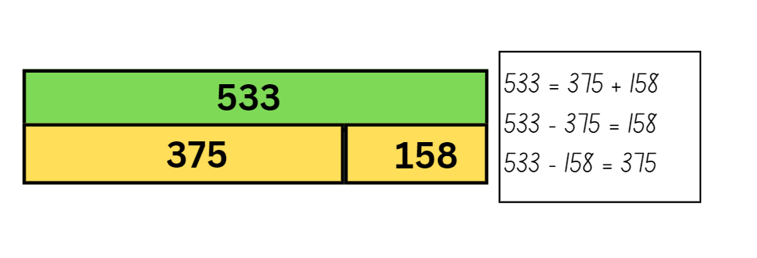

1. Display Resource 9: Challenges and provide students with their workbooks.
2. Students work in pairs to solve the problems. Encourage students to create a model, such as the bar or tape model, to help them solve the problems and use the inverse relationship to check their solution. All working out should be recorded in their workbooks.

This table details opportunities for differentiation.

|  |  |
| --- | --- |
| Too hard? | Too easy? |
| Students cannot use the inverse operation to solve addition and subtraction.   * Provide students with MAB materials to model solutions. * Provide students with models, such as a bar or tape model, to help visualise the problem. | Students can use the inverse operation to solve addition and subtraction.   * Students create their own word problems to share with peers. * Create bar models with missing quantities for peers to solve or create a problem. |

## Consolidation and meaningful practice – 15 minutes

This activity is an adaptation of *Challenging Mathematical Tasks: Unlocking the potential of all students* by Sullivan.

1. Regroup students and display the word problem: In a garden there are tomato, cucumber and capsicum plants. There are 487 plants in total and 143 of them are tomato plants. How many cucumber and capsicum plants could there be?
2. Students record their solutions on individual whiteboards and ask:

* Would you use addition or subtraction to solve this number sentence? Why?
* How did you use addition to solve this number sentence? Was this strategy efficient?
* How did you use subtraction to solve this number sentence? Was this strategy efficient?
* How can you use addition or subtraction to check your answers?
* Is there more than one solution?
* Is there a more efficient strategy you could use?

This table details opportunities for assessment.

|  |  |
| --- | --- |
| Assessment opportunities | Links |
| What to look for:   * Can students use the inverse relationship to solve problems? **[MAO-WM-01, MA2-AR-01]** * Can students check the solution of their problem using the inverse operation? **[MAO-WM-01, MA2-AR-01]** | Links to [National Numeracy Learning Progressions](https://www.australiancurriculum.edu.au/resources/national-literacy-and-numeracy-learning-progressions/version-3-of-national-literacy-and-numeracy-learning-progressions/) (NNLP):   * AdS7. |

# Lesson 5

**Core concept**: models help us solve addition and subtraction problems.

## Daily number sense: How many ways – 10 minutes

Daily number sense activities for Lessons 5 to 7 ‘loop’ back to concepts and procedures covered in previous units to assist students to build an increasingly connected network of ideas. These concepts may differ from the core concepts being covered by the unit.

The table below contains a suggested learning intention and success criteria. These are best co-constructed with students.

|  |  |
| --- | --- |
| Daily number sense learning intention | Daily number sense success criteria |
| Students are learning to:   * rename numbers up to 4 digits. | Students can:   * record numbers in standard form * record numbers in non-standard form * justify partitions for non-standard form. |

This activity is an adaptation of ‘Place value tasks’ from *Open-ended maths activities* by Sullivan and Lilburn.

1. Provide students with an individual whiteboard and ask how many ways they can rename 1265.
2. Students record responses using thousands, hundreds, tens and ones, for example, 1000 + 200 + 60 + 5, 1000 + 100 + 150 + 15 and so on.
3. After giving students time to respond, provide students with MAB materials to test out the conjectures and swap the MAB materials to make the number.
4. Regroup as a class and ask:

* Which answer did you find the easiest to check? Why?
* Which answer did you find the hardest to check? Why?
* What strategies did you use to answer the question, and how effective were they?
* How does understanding standard form assist in performing mathematical operations?
* In what situations might non-standard form be used?

This table details opportunities for assessment.

|  |  |
| --- | --- |
| Assessment opportunities | Links |
| What to look for:   * Can students record numbers in standard and non-standard forms? **[MAO-WM-01, MA2-RN-01]** * Can students justify partitions for non-standard form? **[MAO-WM-01, MA2-RN-01]** | Links to [National Numeracy Learning Progressions](https://www.australiancurriculum.edu.au/resources/national-literacy-and-numeracy-learning-progressions/version-3-of-national-literacy-and-numeracy-learning-progressions/) (NNLP):   * NPV5, NPV6.   Links to suggested [Interview for Student Reasoning](https://education.nsw.gov.au/teaching-and-learning/curriculum/literacy-and-numeracy/assessment-resources/ifsr) (IfSR) tasks:   * **IfSR-AT**: 3B.2, 3B.4. |

## Core lesson: Using models – 40 minutes

The table below contains a suggested learning intention and success criteria. These are best co-constructed with students.

|  |  |
| --- | --- |
| Core concept learning intentions | Core concept success criteria |
| Students are learning to:   * use models to solve addition and subtraction problems. | Students can:   * represent a problem on a bar model * solve addition and subtraction problems using a number line. |

This activity is an adaptation of *Challenging Mathematical Tasks: Unlocking the potential of all students* by Sullivan.

1. Display the following problem: On Joe's farm, there are 311 white chickens and 112 brown chickens. How many chickens are there altogether? Ask:

* What is the problem asking you to find?
* What operation should you use to solve this problem?

1. Inform students that they can use a tape model to represent problems and to help find the solution. Explain that the tape model helps represent the part-part-whole relationship in addition and subtraction.
2. Show that the tape model displays parts that make up the whole (see Figure 4).

Figure 4 – Sample bar model

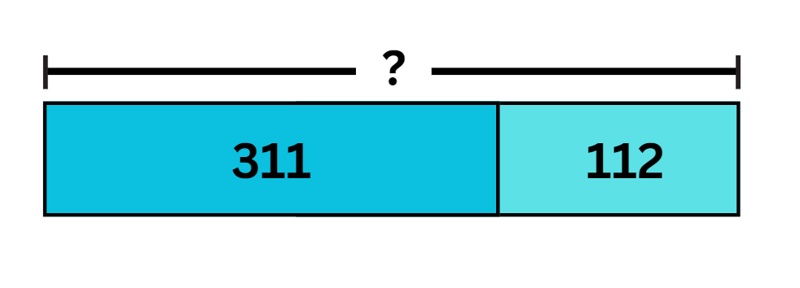

**Note**: identify the importance of identifying where the bar is divided to represent the size of the numbers. This helps students visualise and represent the part-part-whole relationship in addition and subtraction.

1. Ask and discuss:

* What makes up the parts?
* What will be the whole?
* What number sentence can represent this problem?
* What strategies can you use to solve this number sentence?

1. Model solving the number sentence using a number line. Explain the value being added is partitioned into hundreds, tens and ones. Partitioned numbers are then added using jumps along the number line (see Figure 5).

Figure 5 – Sample number line

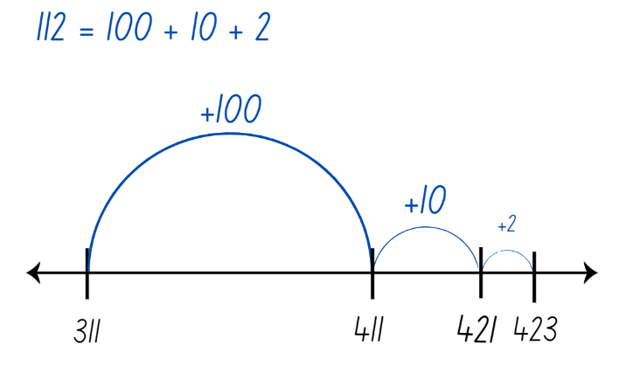

1. Display the following problem: On Barbara's farm, there are 116 chickens. How many more chickens does she need if she wants a total of 411? Ask:

* What is the problem asking you to find?
* What operation should be used to solve this problem?

1. Provide students with their workbooks to solve the problem, using a model or MAB materials to demonstrate their understanding.
2. Regroup and ask students to share their solutions and models to the following questions:

* What is the whole?
* What makes up the parts?
* What number sentence can we use to represent this problem?
* What strategies can we use to solve this problem?

1. Students model solving the number sentence using a number line and bar model (see Figure 6).

Figure 6 – Examples

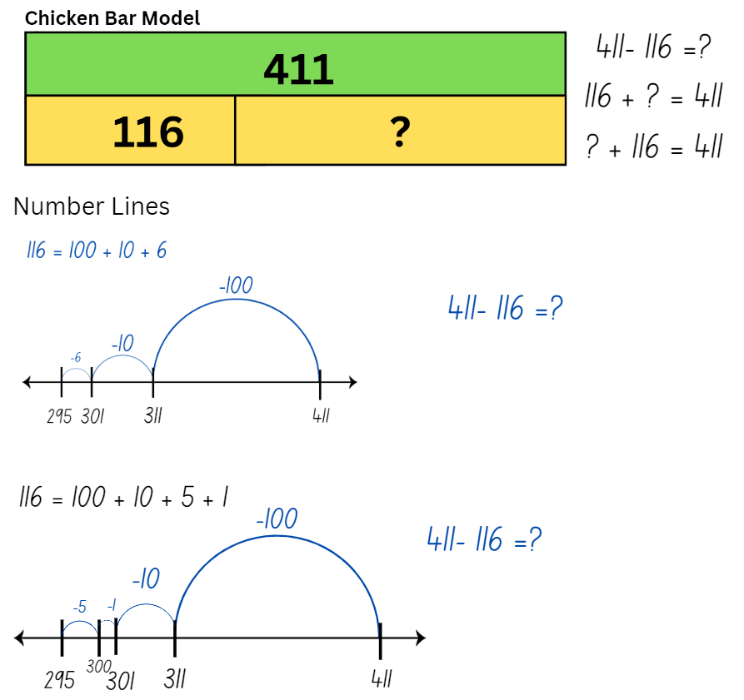

1. Display Resource 10: How many trees? Students solve problems using a model in their workbook.
2. Regroup students and share their responses.

This table details opportunities for differentiation.

|  |  |
| --- | --- |
| Too hard? | Too easy? |
| Students cannot use models to solve addition or subtraction problems.   * Provide students with Resource 11: Eucalypt trees, involving questions with smaller numbers. * Provide students with MAB materials to assist in solving problems. | Students can use models to solve addition or subtraction problems.   * Provide students with Resource 12: Wattle trees, involving questions with larger numbers. * Explain that, in a plantation, there are 167 more wattle trees than eucalyptus trees. There are 523 trees altogether. Ask how many eucalyptus trees there are. Ask if there is more than one correct answer. |

## Discuss and connect the mathematics – 10 minutes

1. Students do a [gallery walk](https://app.education.nsw.gov.au/digital-learning-selector/LearningActivity/Card/555) to share their solutions on the tree task.
2. Regroup and ask:

* What did you notice about the questions? How are they the same and different?
* What was helpful about using these models?
* What was challenging when solving the problems?
* Which model do you prefer using and why?

This table details opportunities for assessment.

|  |  |
| --- | --- |
| Assessment opportunities | Links |
| What to look for:   * Can students represent a problem in a bar or tape model? **[MAO-WM-01, MA2-AR-01]** * Can students use a number line to solve addition and subtraction problems? **[MAO-WM-01, MA2-AR-01]** | Links to [National Numeracy Learning Progressions](https://www.australiancurriculum.edu.au/resources/national-literacy-and-numeracy-learning-progressions/version-3-of-national-literacy-and-numeracy-learning-progressions/) (NNLP):   * AdS6. |

# Lesson 6

**Core concept**: mathematicians understand how to use algorithms to solve addition problems.

## Daily number sense: Two truths and a lie – 15 minutes

The table below contains a suggested learning intention and success criteria. These are best co-constructed with students.

|  |  |
| --- | --- |
| Daily number sense learning intention | Daily number sense success criteria |
| Students are learning to:   * apply place value to partition and regroup numbers. | Students can:   * record numbers using standard place value form * partition numbers using non-standard place value form. |

This activity is an adaptation of ‘Two truths and one lie’ from *Mini Lessons: Maths –* [*Series 1 Episode 15 Years 3-4: Partitioning Numbers Using Efficient Strategies (10:50)*](https://iview.abc.net.au/video/ED2003V015S00) by ABC iview.

1. Display the following statements that are 2 truths and a lie. The number:

* 32 can be represented with 5 MAB materials.
* 68 can be represented with 41 MAB materials.
* 145 can be represented with 25 MAB materials.

1. Students read each statement and then test using MAB materials to identify which are the truths or the lie.
2. Provide small groups of students with one copy of Resource 13: The number... and MAB materials. Students test each statement and record the representation of MAB materials on Resource 13: The number...
3. Students work together to identify which statement is the lie by proving the accuracy of all 3 statements.
4. Regroup as a class and ask:

* How did you decide which MAB materials to choose for each statement?
* Were there any statements that were particularly challenging to determine as truth or lie? Why?
* Did you rely on any specific strategies to make your choices?
* Did you notice any surprises or unexpected findings during the activity?
* Can you identify any common patterns that helped you make your decisions?

This table details opportunities for assessment.

|  |  |
| --- | --- |
| Assessment opportunities | Links |
| What to look for:   * Can students record numbers using standard place value form? **[MAO-WM-01, MA2-RN-01]** * Can students partition numbers using non-standard place value form? **[MAO-WM-01, MA2-RN-01]** | Links to [National Numeracy Learning Progressions](https://www.australiancurriculum.edu.au/resources/national-literacy-and-numeracy-learning-progressions/version-3-of-national-literacy-and-numeracy-learning-progressions/) (NNLP):   * NPV4, NPV5, NPV6.   Links to suggested [Interview for Student Reasoning](https://education.nsw.gov.au/teaching-and-learning/curriculum/literacy-and-numeracy/assessment-resources/ifsr) (IfSR) tasks:   * **IfSR-AT**: 3B.2, 3B.4. |

## Core lesson: Addition algorithms – 35 minutes

The table below contains a suggested learning intention and success criteria. These are best co-constructed with students.

|  |  |
| --- | --- |
| Core concept learning intentions | Core concept success criteria |
| Students are learning to:   * partition, rearrange and regroup numbers to solve additive problems. | Students can:   * recognise the number of tens, hundreds or thousands in a number * use an algorithm to record addition calculations * calculate missing numbers by completing number sentences involving addition. |

This activity is an adaptation of [Equivalent number sentences](https://resources.education.nsw.gov.au/detail/A-39) from [Universal Resource Hub](https://resources.education.nsw.gov.au/home) by State of New South Wales (Department of Education).

1. Display the number sentence 286 + 437 and ask students to identify strategies they can use to solve the problem. Record responses on the board.
2. Model setting up an algorithm for the equation 286 + 437. Demonstrate that the numbers in the equation are lined up according to place value. Explain that if the numbers are not correctly aligned it will significantly change the answer. Model solving the algorithm alongside the use of MAB materials (see Figure 7).

Figure 7 – Addition algorithm

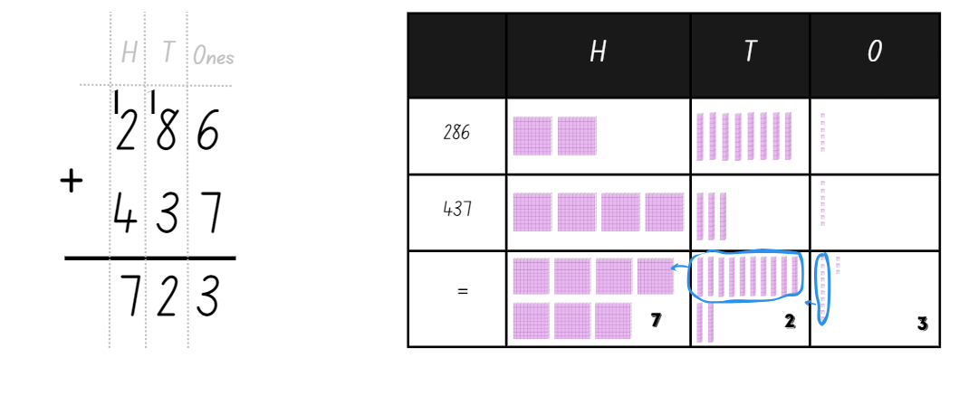

1. Explain that the exchange across each of the place value columns is recorded as a one at the top of the column. Students need to add this one when adding the numbers in that place value column.
2. Introduce students to a game called ‘True or False’. They will look at number sentences and decide if they are true or false, using an algorithm to check.
3. Display the number sentence 356 + 475 = 284 + 647. Ask students to share their responses (number sentence is incorrect).

**Note**: highlight that the equals sign represents equivalence. This means that the total of the left-hand side of the number sentence is equal to the total of the right-hand side of the number sentence.

1. Model setting up and solving an algorithm for 356 + 475 =. Then, model setting up and solving an algorithm for 284 + 647. Students identify if the number sentence is true or false (see Figure 8).

Figure 8 – Sample

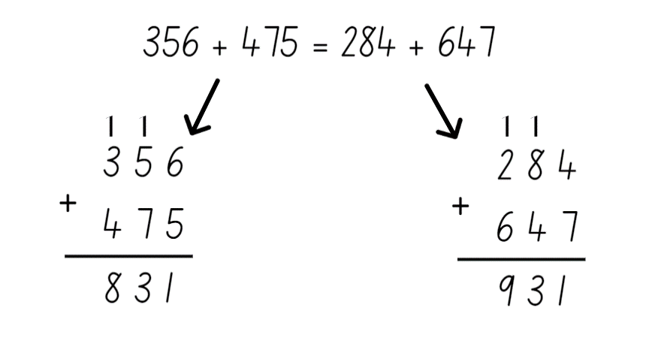

1. Provide students with a copy of Resource 14: True or False, their workbooks and MAB materials to solve the number sentences.

This table details opportunities for differentiation.

|  |  |
| --- | --- |
| Too hard? | Too easy? |
| Students cannot use an algorithm to solve addition calculations.   * Provide students with Resource 15: Solving addition, solving 2-digit calculations. * Provide students with MAB materials to model solving the addition algorithm. | Students can use an algorithm to solve addition calculations.   * Provide students with Resource 16: Addition, solving 4-digit calculations. * Ask students to balance each false number sentence by adding another value to one side so they become equivalent. |

## Consolidation and meaningful practice – 15 minutes

1. Display Resource 17: Consolidation and ask:

* What numbers could go inside the boxes?
* Is there more than one solution?
* Can the tens be exchanged for hundreds?
* When do you think it is better to use an algorithm instead of using mental strategies to solve a problem?

This table details opportunities for assessment.

|  |  |
| --- | --- |
| Assessment opportunities | Links |
| What to look for:   * Can students recognise the number of tens, hundreds or thousands in a number? **[MAO-WM-01, MA2-RN-01]** * Can students use an algorithm to record addition calculations? **[MAO-WM-01, MA2-AR-01, MA2-AR-02]** * Can students calculate missing numbers by completing number sentences involving addition? **[MAO-WM-01, MA2-AR-02]** | Links to [National Numeracy Learning Progressions](https://www.australiancurriculum.edu.au/resources/national-literacy-and-numeracy-learning-progressions/version-3-of-national-literacy-and-numeracy-learning-progressions/) (NNLP):   * NPV7 * AdS8 * NPA3, NPA4.   Links to suggested [Interview for Student Reasoning](https://education.nsw.gov.au/teaching-and-learning/curriculum/literacy-and-numeracy/assessment-resources/ifsr) (IfSR) tasks:   * **IfSR-AT**: 3A.3. |

# Lesson 7

**Core concept**: mathematicians understand how to use algorithms to solve subtraction problems.

## Daily number sense: Partitioning – 10 minutes

The table below contains a suggested learning intention and success criteria. These are best co-constructed with students.

|  |  |
| --- | --- |
| Daily number sense learning intention | Daily number sense success criteria |
| Students are learning to:   * apply place value to partition and regroup numbers. | Students can:   * record numbers using standard place value form * partition numbers using non-standard place value form. |

1. In pairs students shuffle game cards numbered zero to 9 and place them face down in a stack.
2. Each player takes turns drawing 4 cards from the stack to form a 4-digit number.
3. Each player records the 4-digit number formed on their whiteboard, the standard place value form and a non-standard place value representation (see Figure 9).

Figure 9 – Student sample

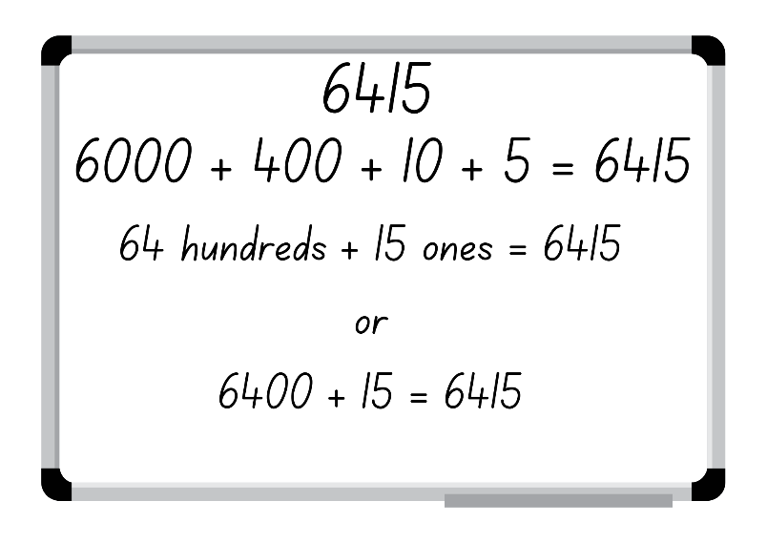

1. Each player swaps their whiteboard and checks their peer’s standard and non-standard representations.
2. If the representation is correct, the student gets a point.
3. Player 2 selects 4 cards to form a new 4-digit number and repeats the process.
4. Repeat the process for 5 rounds.
5. Regroup and ask students to identify the strategies they used and to justify their answers when identifying the place value in non-standard form.

**Note**: number expanders can assist students to understand place value and renaming numbers into non-standard forms.

This table details opportunities for assessment.

|  |  |
| --- | --- |
| Assessment opportunities | Links |
| What to look for:   * Can students record numbers using standard place value form? **[MAO-WM-01, MA2-RN-01]** * Can students partition numbers using non-standard place value form? **[MAO-WM-01, MA2-RN-01]** | Links to [National Numeracy Learning Progressions](https://www.australiancurriculum.edu.au/resources/national-literacy-and-numeracy-learning-progressions/version-3-of-national-literacy-and-numeracy-learning-progressions/) (NNLP):   * NPV4, NPV5, NPV6.   Links to suggested [Interview for Student Reasoning](https://education.nsw.gov.au/teaching-and-learning/curriculum/literacy-and-numeracy/assessment-resources/ifsr) (IfSR) tasks:   * **IfSR-AT**: 3B.2, 3B4. |

## Core lesson: Subtraction algorithms – 40 minutes

The table below contains a suggested learning intention and success criteria. These are best co-constructed with students.

|  |  |
| --- | --- |
| Core concept learning intentions | Core concept success criteria |
| Students are learning to:   * partition, rearrange and regroup numbers to solve subtraction problems. | Students can:   * use an algorithm to solve unknown numbers of addition and subtraction problems * recognise how hundreds are exchanged in subtraction algorithms requiring regrouping * recognise when mental strategies would be more efficient than a vertical algorithm for subtraction. |

1. Display the equation 528 – 43 on the board and ask students to identify strategies that can be used to solve the problem. Record student responses on the board.
2. Model setting up an algorithm for the equation 528 – 43. Explain that, when a vertical algorithm is used for subtraction, students may need to exchange and regroup across the place value columns to solve the equation.

**Note**: solving a subtraction algorithm requires ‘trading units’, which involves partitioning and regrouping. To subtract 43 from 528 using an algorithm, the 528 is thought of as being decomposed into 5 hundreds, 2 tens and 8 ones. Then one hundred is traded for 10 tens so that 528 is represented as 4 hundreds, 12 tens and 8 ones (see Figure 10).

Figure 10 – Subtraction algorithm

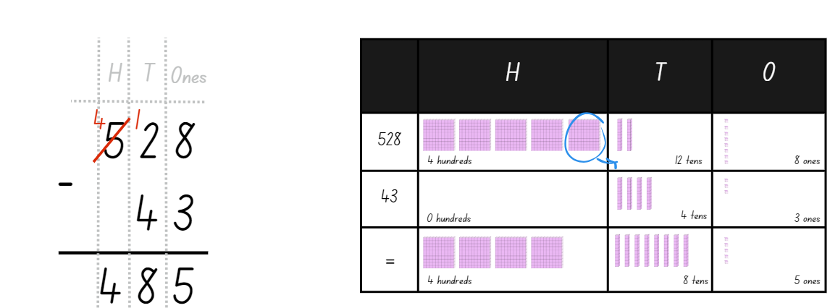

**Note**: one of the most common misconceptions associated with the subtraction algorithm is known as the ‘smaller-from-larger error’. This error occurs when students only consider the values of the digits involved in the subtraction and attempt to simplify the process by always subtracting the smaller value from the larger digit.

1. Tell students they are going to play a game called ‘King of Cards’. In pairs, students will need a deck of cards numbered zero to 9 and their workbook.
2. Player A turns over 5 cards and places them down to form a subtraction algorithm with a 3-digit number on top and a 2-digit number beneath (see Figure 11).

Figure 11 – Sample cards

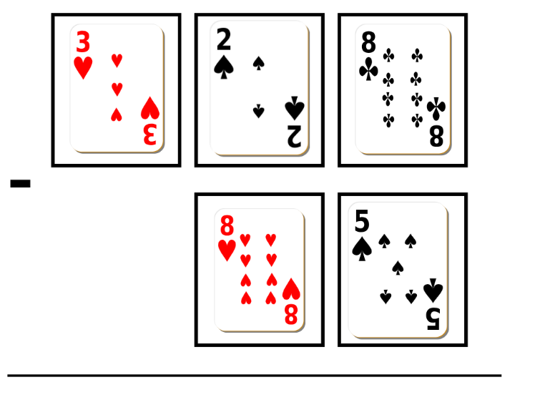

1. Each player records and solves the subtraction algorithm in their workbook.

This table details opportunities for differentiation.

|  |  |
| --- | --- |
| Too hard? | Too easy? |
| Students cannot solve subtraction questions using an algorithm.   * Provide students with MAB materials to model solving the subtraction algorithm. * Students solve 2-digit and one-digit questions. | Students can solve subtraction questions using an algorithm.   * Students solve questions involving larger numbers. * Students leave one digit out of the algorithm and include the answer. Their partner solves the missing digit. |

## Consolidation and meaningful practice – 10 minutes

1. Display Resource 18: Empty algorithm and ask:

* What numbers could go inside the boxes?
* Is there more than one solution?
* Can the tens be exchanged for hundreds?
* What did you think about when determining the 3-digit number?
* Is there a rule or pattern with subtraction? How would you explain this to a friend?
* What if we added a zero to the answer box in the ones column? How would that change your thinking?
* When are mental strategies more efficient than a vertical algorithm for subtraction?

**Note**: another common challenge with learning to use the vertical subtraction algorithm is dealing with zeros. Sometimes students believe that zero means ‘nothing’, so it can be ignored.

This table details opportunities for assessment.

|  |  |
| --- | --- |
| Assessment opportunities | Links |
| What to look for:   * Can students recognise how hundreds are exchanged in subtraction algorithms requiring regrouping? **[MAO-WM-01, MA2-RN-01, MA2-AR-01, MA2-AR-02]** * Can students use an algorithm to solve unknown numbers of addition and subtraction problems? **[MAO-WM-01, MA2-AR-01, MA2-AR-02]** * Can students recognise when mental strategies would be more efficient than a vertical algorithm for subtraction? **[MAO-WM-01, MA2-RN-01, MA2-AR-01, MA2-AR-02]** | Links to [National Numeracy Learning Progressions](https://www.australiancurriculum.edu.au/resources/national-literacy-and-numeracy-learning-progressions/version-3-of-national-literacy-and-numeracy-learning-progressions/) (NNLP):   * AdS8. |

# Lesson 8

**Core concept**: mathematicians compare and evaluate strategies used to solve addition and subtraction problems, reasoning which strategy may be most efficient.

## Daily number sense – 10 minutes

1. From a class need surfaced through formative assessment data, identify a short, focused activity that targets students’ knowledge, understanding and skills. Example activities may be drawn from the following resources:

* [Mathematics K-6 resources](https://education.nsw.gov.au/teaching-and-learning/curriculum/mathematics/mathematics-curriculum-resources-k-12/mathematics-k-6-resources#catalogue_auto)
* [Universal Resources Hub](https://resources.education.nsw.gov.au/home).

## Core lesson: Maths investigation – 45 minutes

The table below contains a suggested learning intention and success criteria. These are best co-constructed with students.

|  |  |
| --- | --- |
| Core concept learning intentions | Core concept success criteria |
| Students are learning to:   * apply addition and subtraction to familiar contexts. | Students can:   * select appropriate strategies for addition and subtraction problems * reflect on a chosen strategy for solving a problem, considering whether it can be improved. |

1. Display Resource 19: Maths investigation. Students read the task and ask if they have any questions.
2. Provide small groups of students with their workbooks to record their calculations.
3. After some time regroup students and ask:

* What solutions did you find?
* What strategies did you use?
* What strategy did you find most efficient?
* What was your total cost?
* How much budget did you have left?
* What challenges did you find? How did you overcome them?
* Did you use a model to help you solve the investigation?

This table details opportunities for differentiation.

|  |  |
| --- | --- |
| Too hard? | Too easy? |
| Students cannot apply addition and subtraction to problems.   * Provide students with concrete materials such as MAB materials to model addition and subtraction. * Students work to find the solution for furnishing one class with a budget of $5,000. | Students can apply addition and subtraction to problems.   * Modify school details to: Total classrooms – 14, Kindergarten to Year 2 – 7 classes, Year 3 to Year 6 – 5 classes. * Students work with a budget of $60,000. |

## Consolidation and meaningful practice – 15 minutes

This activity is an adaptation of *Challenging Mathematical Tasks: Unlocking the potential of all students* by Sullivan.

1. Display the problem: The school purchased some new basketballs and soccer balls. The total cost of all the balls was $447. The soccer balls cost at least $80 more than the basketballs. What might the cost of the basketballs be? What might the cost of the soccer balls be?
2. Students work individually to find 3 different strategies to the problem and record them on Resource 20: Frayer model.
3. Regroup, share responses and strategies.

This table details opportunities for assessment.

|  |  |
| --- | --- |
| Assessment opportunities | Links |
| What to look for:   * Can students apply addition and subtraction to familiar contexts? **[MAO-WM-01, MA2-AR-01]** * Can students reflect on a chosen strategy for solving a problem, considering whether it can be improved? **[MAO-WM-01, MA2-AR-01, MA2-AR-02]** | Links to [National Numeracy Learning Progressions](https://www.australiancurriculum.edu.au/resources/national-literacy-and-numeracy-learning-progressions/version-3-of-national-literacy-and-numeracy-learning-progressions/) (NNLP):   * AdS8. |

# **Resource 1: Solve it cards**

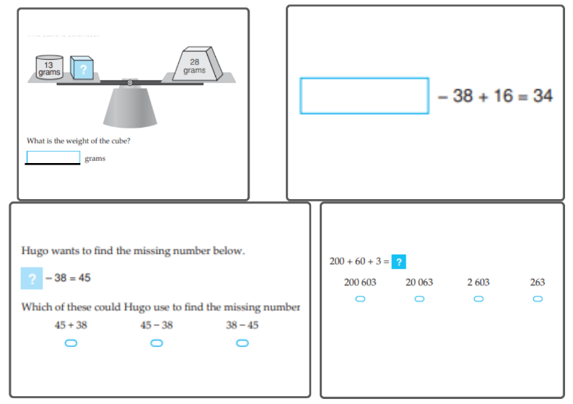

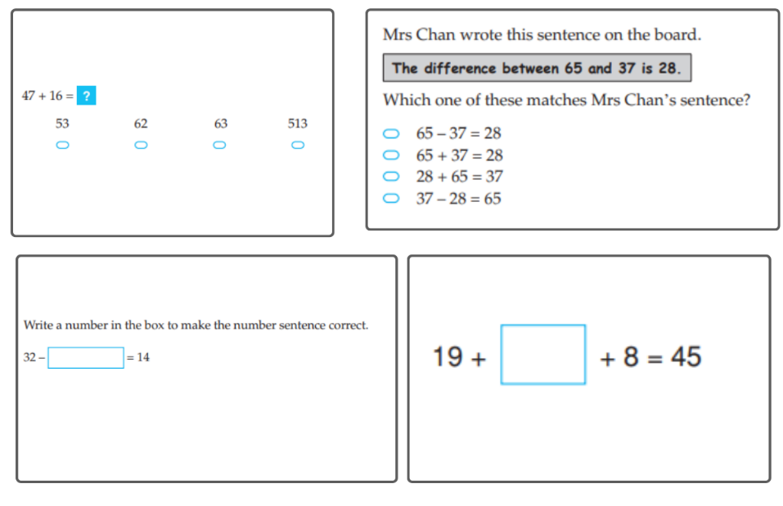

Images sourced from [NAPLAN 2012-2016 test papers (acara.edu.au)](https://www.acara.edu.au/assessment/naplan/naplan-2012-2016-test-papers) are licensed under ACARA.

# **Resource 2: Create 1000**

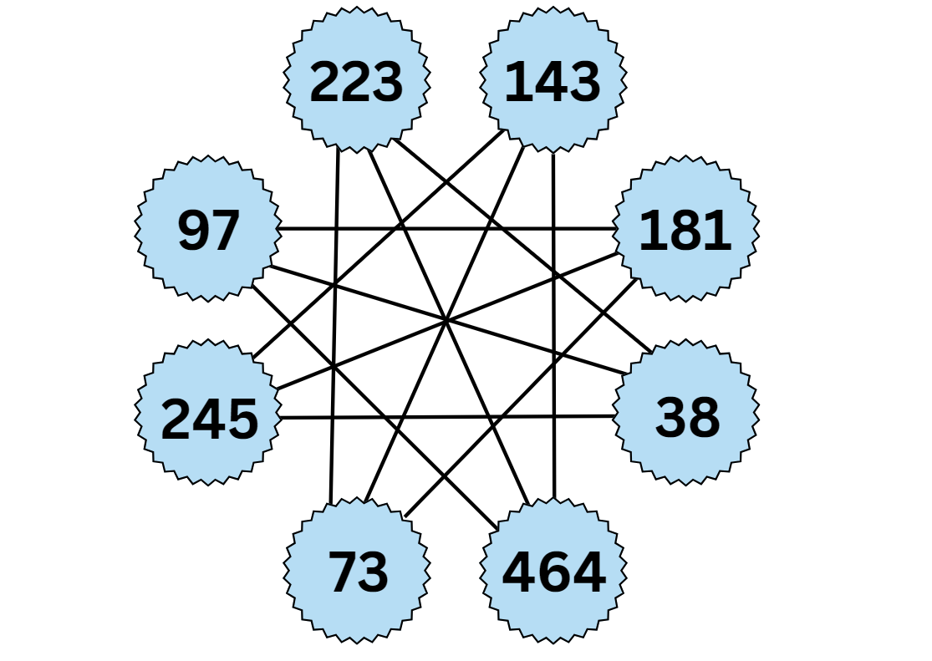

# **Resource 3: Take the plunge!**

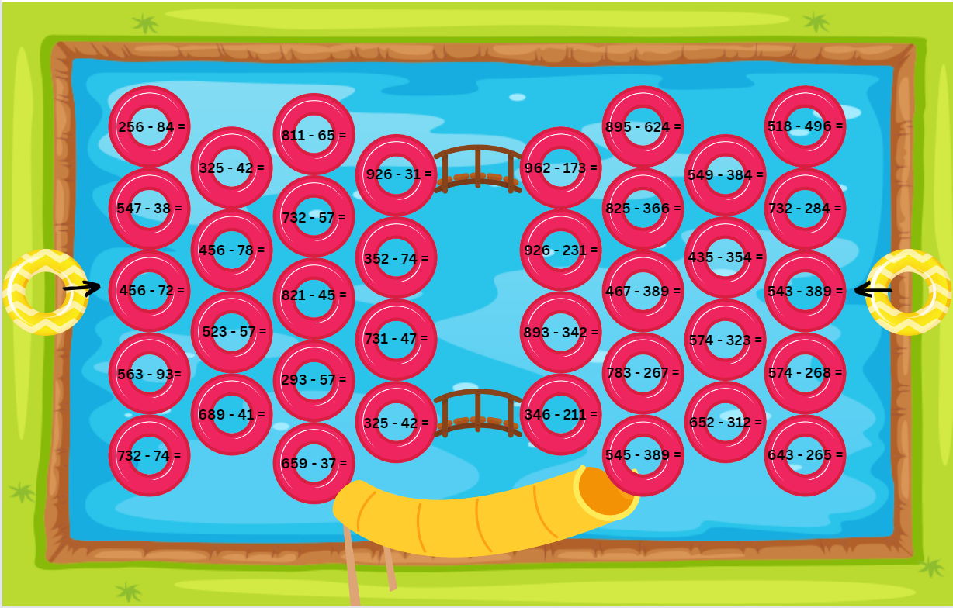

# **Resource 4: Take a plunge!**

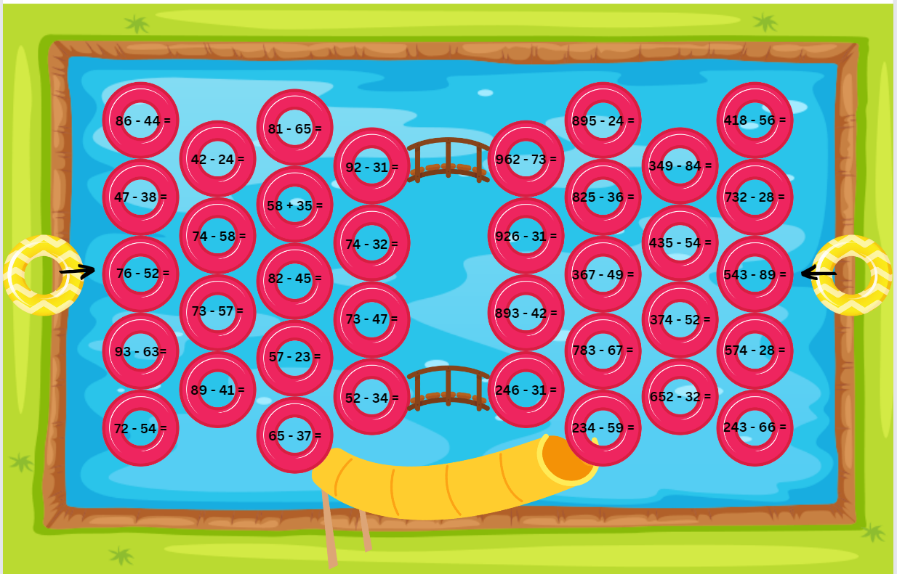

# **Resource 5: Broken calculator**

Problem: You want to use the calculator to check your answer to 164 - 45. Unfortunately the 4 and 6 buttons aren’t working.
Suggest several ways you could still use the calculator. There is an image of calculator with the 4 and 6 buttons crossed out.

# Resource 6: Equal differences

Subtraction number sentences for students to solve.
?-3=72-7
63-13=?-16
39-15=48-?
72-?=67-12
85-?=45-23
?-21=52-32
76-17=?-23

# **Resource 7: Grocery shopping**

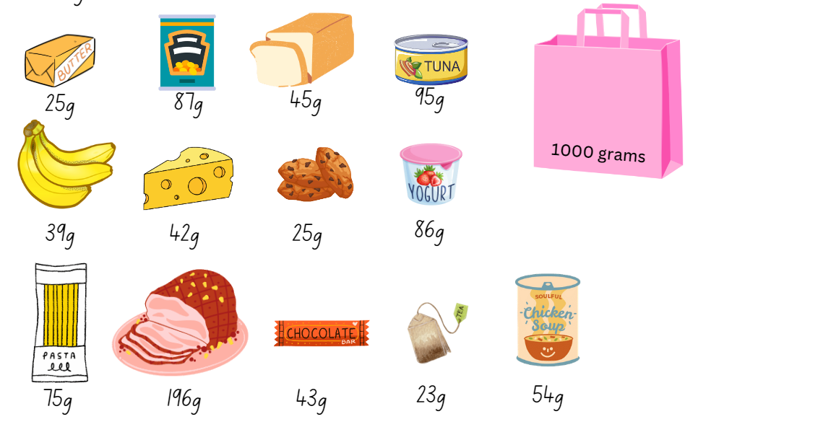

# **Resource 8: Question**

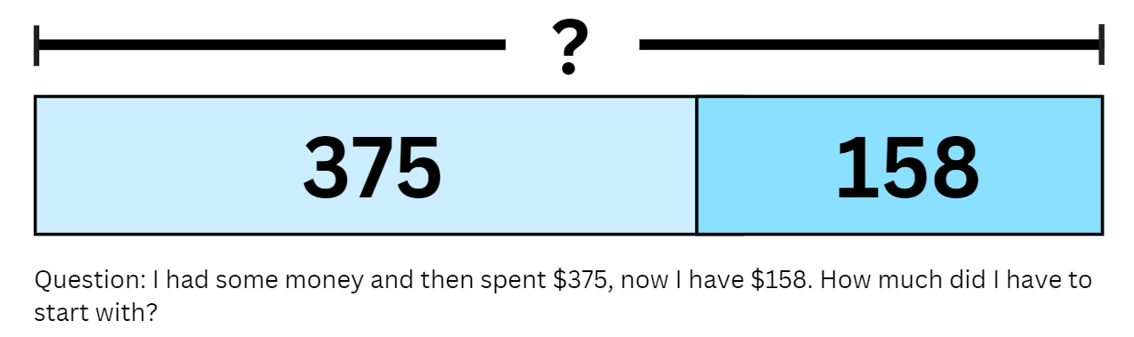

# **Resource 9: Challenges**

1. Callum has 473 nails. He used 127 of them to build a fence. How many nails does he have left? 
2. Liam and Ethan had 364 football cards. If Liam had 242 football cards, how many did Ethan have?
3. Peter made 473 marmalade sandwiches and honey sandwiches. He made 281 marmalade sandwiches. How many sandwiches were honey?
Challenge Problem 1: Mikaela did a subtraction task and the answer was 215 but she cannot remember the other numbers. Find as many solutions to this subtraction as possible. 
Challenge Problem 2: Uncle Norm cannot subtract numbers in his head. He does not have a pen or paper but he does have a calculator. Unfortunately, the 5 and 7 buttons are broken. How could Uncle Norm use the calculator to find 75-56?

# **Resource 10: How many trees?**

In a plantation, there are 294 eucalypt trees and 377 wattle trees. How many trees are there altogether? 

In a plantation, there are 576 trees, some are eucalypts, and some are wattles. If I have 379 eucalypt trees, how many of my trees are wattles? 

In a plantation, there are 207 eucalypt trees and 683 trees altogether. If the rest of the trees are wattles, how many wattle trees are there? 

# **Resource 11: Eucalypt trees**

In a plantation, there are 94 eucalypt trees and 77 wattle trees. How many trees are there altogether? 
In a plantation, there are 94 trees, some are eucalypts, and some are wattles. If I have 79 eucalypt trees, how many of my trees are wattles? 
In a plantation, there are 57 eucalypt trees and 93 trees altogether. If the rest of the trees are wattles, how many wattle trees are there? 

# **Resource 12: Wattle trees**

In a plantation, there are 2294 eucalypt trees and 3377 wattle trees. How many trees are there altogether? 

In a plantation, there are 2576 trees, some are eucalypts, and some are wattles. If I have 1479 eucalypt trees, how many of my trees are wattles? 

In a plantation, there are 2407 eucalypt trees and 5683 trees altogether. If the rest of the trees are wattles, how many wattle trees are there? 

# Resource 13: The number…

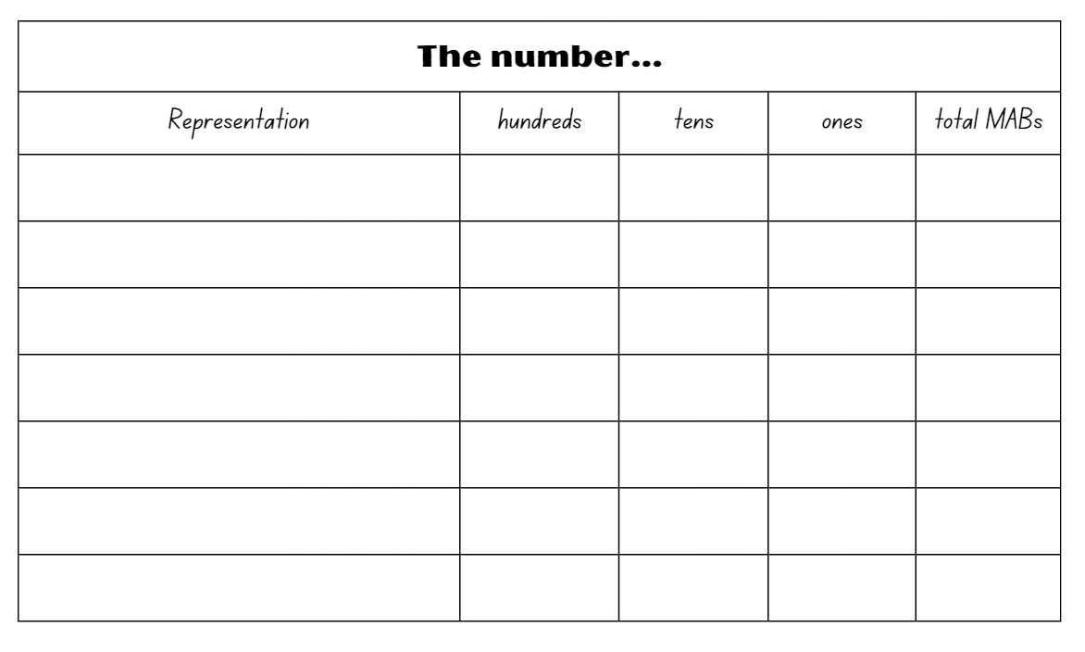

# **Resource 14: True or False**

True or false cards with equations for students to establish their accuracy.
157+233=252+138 
364+433=336+451 
549+641=462+717 
666+188=428+438 
401+632=448+585 
480+365=657+188 

# **Resource 15: Solving addition**

True or false cards with equations for students to establish their accuracy.
48+65=57+88 
42+56=37+61
38+75=48+64 
47+36=59+23 
73+24=64+31 
53+75=63+65 

# **Resource 16: Addition**

3480+4365=2657+5188 True or false
2364+5433=3336+5451 True or false
True or false cards with equations for students to establish their accuracy.
5549+3641=3463+5717 
2666+4188=3428+3438 
5401+3632=6448+2585 
3666+4188=5428+2438 

# **Resource 17: Consolidation**

Number problems for students to solve.
?72+6?5=31? in vertical algorithm
5?6+43?=1?25  in vertical algorithm

# **Resource 18: Empty algorithm**

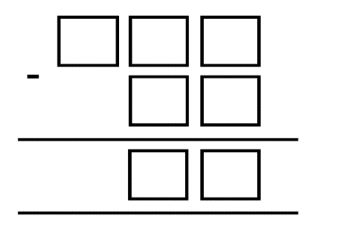

# **Resource 19: Maths investigation**

Challenge: Furnish 1 new classroom within the allocated budget. Budget: $1000. Each K-2 class has a maximum of 20 students. Each 3-6 class has a maximum of 25 students. List of items: Chairs $11, Desk $10, Chalkboard $54, Whiteboard $83, Interactive Board $280, Sports Pack $35, Pencils $8, Workbook $2 and Class library $48. 
Brief: Purchase a minimum of 1 chair for every student in both classrooms and one desk for every 2 students. Each class needs 1 interactive whiteboard and EITHER a chalkboard or a whiteboard. 1 sports pack per class. Include some classroom equipment within the budget. What is the total cost? How much of the budget do you have left over?

# **Resource 20: Frayer model**

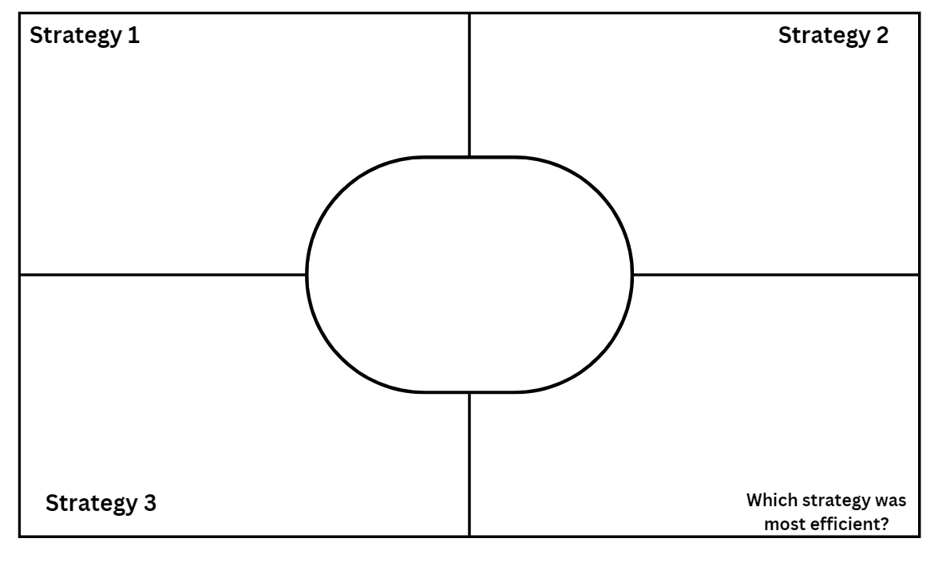

# Syllabus outcomes and content

The table below outlines the [syllabus outcomes](https://curriculum.nsw.edu.au/learning-areas/mathematics/mathematics-k-10-2022) and range of relevant syllabus content covered in this unit. Content is linked to [National Numeracy Learning Progression](https://www.australiancurriculum.edu.au/resources/national-literacy-and-numeracy-learning-progressions/version-3-of-national-literacy-and-numeracy-learning-progressions/) version (3).

|  |  |  |  |  |  |  |  |  |
| --- | --- | --- | --- | --- | --- | --- | --- | --- |
| Outcomes and content | 1 | 2 | 3 | 4 | 5 | 6 | 7 | 8 |
| **Representing numbers using place value A:** Whole numbers: Read, represent and order numbers to thousands  **MAO-WM-01, MA2-RN-01** |  |  |  |  |  |  |  |  |
| * Group physical or virtual objects to show the structure of tens, hundreds and a thousand |  | x | x |  | x | x | x |  |
| * Regroup numbers flexibly, recognising one thousand as 10 hundreds and one hundred as 10 tens or 100 ones |  | x | x |  | x | x | x |  |
| **Representing numbers using place value A:** Apply place value to partition and regroup numbers up to 4 digits  **MAO-WM-01, MA2-RN-01** |  |  |  |  |  |  |  |  |
| * Record numbers using standard place value form |  |  |  |  | x | x | x |  |
| * Partition numbers of up to 4 digits in non-standard forms (Reasons about quantity) | x | x | x |  | x | x | x |  |
| **Representing numbers using place value B:** Whole numbers: Apply place value to partition, regroup and rename numbers up to 6 digits  **MAO-WM-01, MA2-RN-01** |  |  |  |  |  |  |  |  |
| * Name thousands using the place value grouping of ones, tens and hundreds of thousands | x | x | x |  | x | x |  |  |
| * Use place value to expand the number notation |  |  |  |  | x |  |  |  |
| * Partition numbers of up to 6 digits in non-standard forms | x | x | x |  | x | x | x |  |
| **Representing numbers using place value B:** Whole numbers: Recognise and represent numbers that are 10, 100 or 1000 times as large  **MAO-WM-01, MA2-RN-01** |  |  |  |  |  |  |  |  |
| * Recognise the number of tens, hundreds or thousands in a number | x | x |  |  | x | x | x |  |
| **Additive relations A:** Use the principle of equality  **MAO-WM-01, MA2-AR-01** |  |  |  |  |  |  |  |  |
| * Recognise equal differences and record them in number sentences |  |  | x |  |  |  |  |  |
| * Use the equals sign to mean 'the same as', rather than to perform an operation | x | x |  |  |  |  |  |  |
| * Apply the associative property of addition to forming multiples of 10 (Reasons about relations) |  | x |  |  |  |  |  |  |
| **Additive relations A:** Recognise and explain the connection between addition and subtraction  **MAO-WM-01, MA2-AR-01** |  |  |  |  |  |  |  |  |
| * Use number relation principles to solve related problems (Reasons about relations) |  |  |  | x |  |  |  |  |
| * Demonstrate how addition and subtraction are inverse operations |  |  |  | x |  |  |  |  |
| * Explain and check solutions to problems, including by using the inverse operation |  |  |  | x |  |  |  |  |
| **Additive relations A:** Select strategies flexibly to solve addition and subtraction problems of up to 3 digits  **MAO-WM-01, MA2-AR-01** |  |  |  |  |  |  |  |  |
| * Represent solutions to addition and subtraction problems, including word problems, using an empty number line or bar model |  |  |  |  | x |  |  | x |
| * Compare and evaluate strategies used to solve addition and subtraction problems, reasoning which strategy may be most efficient |  |  |  |  | x |  |  | x |
| **Additive relations B:** Partition, rearrange and regroup numbers to at least 1000 to solve additive problems  **MAO-WM-01, MA2-AR-01, MA2-AR-02** |  |  |  |  |  |  |  |  |
| * Use quantity values and non-standard partitioning to solve addition and subtraction problems | x | x | x |  |  |  |  | x |
| * Model addition with and without regrouping and record the method used | x |  | x |  |  |  |  | x |
| * Model subtraction with and without regrouping and record the method used |  | x | x |  |  |  |  |  |
| * Use an algorithm with understanding to record addition and subtraction calculations, where efficient, involving 3-digit numbers |  |  |  |  |  | x | x | x |
| * Recognise how hundreds are exchanged in subtraction algorithms requiring regrouping |  |  |  |  |  |  | x | x |
| * Recognise when mental strategies would be more efficient than a vertical algorithm for subtraction (Reasons about relations) |  |  |  |  |  |  | x | x |
| * Solve subtraction questions with missing digits given the difference (Reasons about relations) |  |  |  | x |  |  | x |  |
| **Additive relations B:** Apply addition and subtraction to familiar contexts, including money and budgeting  **MAO-WM-01, MA2-AR-01, MA2-AR-02** |  |  |  |  |  |  |  |  |
| * Use estimation to check the validity of solutions to addition and subtraction problems, including those involving money |  |  |  |  |  |  |  | x |
| * Reflect on a chosen strategy for solving a problem, considering whether it can be improved | x | x | x | x | x | x | x | x |
| * Interpret problems involving money as requiring either addition or subtraction |  |  |  |  |  |  |  | x |
| **Additive relations B:** Complete number sentences involving additive relations to find unknown quantities  **MAO-WM-01, MA2-AR-01, MA2-AR-02** |  |  |  |  |  |  |  |  |
| * Calculate missing numbers by completing number sentences involving addition and subtraction (Algebraic reasoning) |  |  |  | x |  | x |  | x |

[Mathematics K–10 Syllabus](https://curriculum.nsw.edu.au/learning-areas/mathematics/mathematics-k-10-2022/overview) © NSW Education Standards Authority (NESA) for and on behalf of the Crown in right of the State of New South Wales, 2022.

# References

This resource contains NSW Curriculum and syllabus content. The NSW Curriculum is developed by the NSW Education Standards Authority. This content is prepared by NESA for and on behalf of the Crown in right of the State of New South Wales. The material is protected by Crown copyright.

Please refer to the NESA Copyright Disclaimer for more information <https://educationstandards.nsw.edu.au/wps/portal/nesa/mini-footer/copyright>.

NESA holds the only official and up-to-date versions of the NSW Curriculum and syllabus documents. Please visit the NSW Education Standards Authority (NESA) website <https://educationstandards.nsw.edu.au/> and the NSW Curriculum website <https://curriculum.nsw.edu.au/home>.

[Mathematics K–10 Syllabus](https://curriculum.nsw.edu.au/learning-areas/mathematics/mathematics-k-10-2022/overview) © NSW Education Standards Authority (NESA) for and on behalf of the Crown in right of the State of New South Wales, 2022.

[National Numeracy Learning Progression](https://www.australiancurriculum.edu.au/resources/national-literacy-and-numeracy-learning-progressions/version-3-of-national-literacy-and-numeracy-learning-progressions/) © Australian Curriculum, Assessment and Reporting Authority (ACARA) 2010 to present, unless otherwise indicated. This material was downloaded from the [Australian Curriculum](http://www.australiancurriculum.edu.au/) website (National Numeracy Learning Progression) (accessed 28 August 2023) and was not modified.

ABC iview (2021) ‘Mini Lessons: Maths – [Series 1 Episode 15 Years 3-4: Partitioning Numbers Using Efficient Strategies’](https://iview.abc.net.au/show/mini-lessons-maths/series/1/video/ED2003V015S00), ABC iview, accessed 26 June 2023.

Australasian Problem-Solving Mathematical Olympiads (APSMO) (2022) [*Maths games* [PDF 529 KB]](https://apsmo.edu.au/wp-content/uploads/2023/01/MGJ-Paper-1-2022.pdf)*,* APSMO website, accessed 26 June 2023.

Australasian Problem-Solving Mathematical Olympiads (APSMO) (2022) [*Maths explorer* [PDF 530 KB]](https://apsmo.edu.au/wp-content/uploads/2023/01/ME-Paper-5-2022.pdf), APSMO website, accessed 26 June 2023.

New Zealand Ministry of Education (n.d) [*Create 5000* [PDF 352 KB]](https://nzmaths.co.nz/sites/default/files/family/y4tasks/Create5000.pdf), NZ Maths website, accessed 26 June 2023.

New Zealand Ministry of Education (n.d) [*Problems to solve*](https://nzmaths.co.nz/sites/default/files/family/y4tasks/ProblemsToSolve.pdf), NZ Maths website, accessed 26 June 2023.

State of New South Wales (Department of Education) (2023) [*Equivalent number sentences*,](https://resources.education.nsw.gov.au/detail/A-39) Universal Resource Hub website, accessed 26 June 2023.

Sullivan P (2018) *Challenging Mathematical Tasks: Unlocking the potential of all students*, Oxford University Press, Australia and New Zealand.

Sullivan P and Lilburn P (2017) *Open-Ended Maths Activities*, 2nd edn, Oxford University Press, Australia and New Zealand.

University of Cambridge (Faculty of Mathematics) (2023) [*Reach 100*](https://nrich.maths.org/1130), NRICH website, accessed 26 June 2023.

**© State of New South Wales (Department of Education), 2023**

The copyright material published in this resource is subject to the *Copyright Act 1968* (Cth) and is owned by the NSW Department of Education or, where indicated, by a party other than the NSW Department of Education (third-party material).

Copyright material available in this resource and owned by the NSW Department of Education is licensed under a [Creative Commons Attribution 4.0 International (CC BY 4.0) license](https://creativecommons.org/licenses/by/4.0/).

[](https://creativecommons.org/licenses/by/4.0/)

This license allows you to share and adapt the material for any purpose, even commercially.

Attribution should be given to © State of New South Wales (Department of Education), 2023.

Material in this resource not available under a Creative Commons license:

* the NSW Department of Education logo, other logos and trademark-protected material
* material owned by a third party that has been reproduced with permission. You will need to obtain permission from the third party to reuse its material.

**Links to third-party material and websites**

Please note that the provided (reading/viewing material/list/links/texts) are a suggestion only and implies no endorsement, by the New South Wales Department of Education, of any author, publisher, or book title. School principals and teachers are best placed to assess the suitability of resources that would complement the curriculum and reflect the needs and interests of their students.

If you use the links provided in this document to access a third-party's website, you acknowledge that the terms of use, including licence terms set out on the third-party's website apply to the use which may be made of the materials on that third-party website or where permitted by the *Copyright Act 1968* (Cth). The department accepts no responsibility for content on third-party websites.