# Mathematics Stage 2 – Unit 23



Contents

Unit description and duration 4

Syllabus outcomes 4

Working mathematically 5

Student prior learning 5

Lesson overview and resources 7

Lesson 1 11

Daily number sense: 10 times bigger – 10 minutes 11

Core lesson: The right tool for the job – 40 minutes 12

Discuss and connect the mathematics – 10 minutes 16

Lesson 2 18

Daily number sense: Place value houses – 10 minutes 18

Core lesson: Converting between units – 40 minutes 20

Discuss and connect the mathematics – 10 minutes 23

Lesson 3 25

Daily number sense: 10, 100 and 1000 times bigger – 10 minutes 25

Core lesson: Using measuring instruments accurately – 30 minutes 27

Consolidation and meaningful practice – 20 minutes 30

Lesson 4 33

Daily number sense –10 minutes 33

Core lesson: Length investigation – 40 minutes 33

Discuss and connect the mathematics – 10 minutes 36

Lesson 5 37

Daily number sense: Climb the ladder – 10 minutes 37

Core lesson: Finding the perimeter of different shapes – 40 minutes 39

Discuss and connect the mathematics – 10 minutes 41

Lesson 6 43

Daily number sense: Where do you fit? – 10 minutes 43

Core lesson: Time is Ticking – 40 minutes 44

Discuss and connect the mathematics – 15 minutes 47

Lesson 7 49

Daily number sense: Ordering game – 10 minutes 49

Core lesson: Matching time – 40 minutes 51

Discuss and connect the mathematics – 10 minutes 53

Lesson 8 55

Daily number sense – 10 minutes 55

Core lesson: Representing time – 30 minutes 55

Consolidation and meaningful practice – 20 minutes 58

Resource 1: 10s, 100s and 1000s 60

Resource 2: Measurement tools 61

Resource 3: Measuring with tools 62

Resource 4: Converting units 63

Resource 5: Measuring and converting 64

Resource 6: Labelled distance 65

Resource 7: Measuring a desk 66

Resource 8: Measuring objects 67

Resource 9: Conversion bingo 68

Resource 10: Bingo teacher cards 69

Resource 11: Length can measure 70

Resource 12: Measurement hunt 71

Resource 13: Boundary and perimeter 72

Resource 14: Perimeter 73

Resource 15: Measuring perimeter 74

Resource 16: Duration cards 75

Resource 17: Fast facts 76

Resource 18: Exit ticket 77

Resource 19: Ordering gameboard 78

Resource 20: Digital clocks 79

Resource 21: Everyday digital clocks 80

Resource 22: Time matching cards 81

Resource 23: Midday and midnight 83

Resource 24: Time representation 84

Resource 25: Time race 85

Syllabus outcomes and content 86

References 90

Further reading 91

## Unit description and duration

This unit develops the big idea that what needs to be measured determines the unit of measurement.

In this 2-week unit students are provided opportunities to:

* measure and compare lengths of objects and locations using metres, centimetres and millimetres
* identify and measure the perimeter of shapes, objects and locations
* represent and read analog and digital time.

### Syllabus outcomes

* **MAO-WM-01** develops understanding and fluency in mathematics through exploring and connecting mathematical concepts, choosing and applying mathematical techniques to solve problems, and communicating their thinking and reasoning coherently and clearly
* **MA2-RN-01** applies an understanding of place value and the role of zero to represent numbers to at least tens of thousands
* **MA2-GM-02** measures and estimates lengths in metres, centimetres and millimetres
* **MA2-2DS-01** compares two-dimensional shapes and describes their features
* **MA2-NSM-02** represents and interprets analog and digital time in hours, minutes and seconds

### Working mathematically

In the Mathematics K–10 Syllabus, there is one overarching Working mathematically outcome (**MAO-WM-01**). The Working mathematically processes should be embedded within the concepts being taught. The Working mathematically processes present in the Mathematics K–10 Syllabus are:

* communicating
* understanding and fluency
* reasoning
* problem solving.

[Mathematics K–10 Syllabus](https://curriculum.nsw.edu.au/learning-areas/mathematics/mathematics-k-10) © NSW Education Standards Authority (NESA) for and on behalf of the Crown in right of the State of New South Wales, 2022.

### Student prior learning

Before engaging in these teaching and learning activities, students would benefit from prior experience with:

* measuring and comparing lengths of objects with formal units
* identifying features of two-dimensional and three-dimensional shapes that can be measured
* reading and representing analog time.

In NSW classrooms there is a diverse range of students, including Aboriginal and Torres Strait Islander students, students learning English as an additional language or dialect, high potential and gifted students and students with disability. Some students may identify with more than one of these groups or possibly all of them. Refer to [Advice on curriculum planning for every student](https://education.nsw.gov.au/teaching-and-learning/curriculum/planning-programming-and-assessing-k-12/advice-on-curriculum-planning-for-every-student-k-12) for further information.

## Lesson overview and resources

The table below outlines the sequence and approximate timing of lessons, learning intentions and resources.

|  |  |  |
| --- | --- | --- |
| Lesson | Content | Duration and resources |
| **Lesson 1**  **Daily number sense learning intention**:   * recognise and represent numbers that are 10, 100 or 1000 times larger | **Lesson core concept**: different standard units have different measurement instruments.  **Core concept learning intention**:   * understand that different units of measurement require different instruments. | **Lesson duration**: 60 minutes   * Resource 1: 10s, 100s and 1000s * Resource 2: Measurement tools * Resource 3: Measuring with tools * 30 cm rulers * 9-sided dice (one for each student) * Measuring instruments * Metre rulers * Trundle wheels * Student workbooks * Writing materials |
| **Lesson 2**  **Daily number sense learning intention**:   * recognise and represent numbers that are 10, 100 or 1000 times larger | **Lesson core concept**: metric units of measurement relate to the base-10 place value system.  **Core concept learning intention**:   * use scaled instruments to measure and compare lengths. | **Lesson duration**: 60 minutes   * Resource 4: Converting units * Resource 5: Measuring and converting * Class set of 30 cm rulers * Writing materials |
| **Lesson 3**  **Daily number sense learning intention**:   * recognise and represent numbers that are made of tens, hundreds and thousands | **Lesson core concept**: collections of tenths and hundredths are useful in measurement.  **Core concept learning intention**:   * recognise how the base-10 number system helps when measuring and recording length | **Lesson duration**: 60 minutes   * Resource 6: Labelled distance * Resource 7: Measuring a desk * Resource 8: Measuring objects * Resource 9: Conversion bingo * Resource 10: Bingo teacher cards * 9-sided dice (class set) * Class set of 30 cm rulers * Individual whiteboards * Metre rulers * Writing materials |
| **Lesson 4**  **Daily number sense learning intention**:   * teacher-identified task based on student needs | **Lesson core concept**: a straight line, a boundary or an edge can be measured.  **Core concept learning intentions**:   * measure various lengths and boundaries of objects or locations * recognise the features of a three-dimensional object associated with length that can be measured | **Lesson duration**: 60 minutes   * Resource 11: Length can measure * Resource 12: Measurement hunt * 30 cm rulers * Metre rulers * Student workbooks * Trundle wheels * Writing materials |
| **Lesson 5**  **Daily number sense learning intention**:   * order numbers in the thousands | **Lesson core concept**: perimeter is the distance around the boundary of a two-dimensional shape.  **Core concept learning intention**:   * identify and measure the perimeter of shapes | **Lesson duration**: 60 minutes   * Resource 13: Boundary and perimeter * Resource 14: Perimeter * Resource 15: Measuring perimeter * 9-sided dice * Class set of 30 cm rulers * Writing materials |
| **Lesson 6**  **Daily number sense learning intention**:   * order numbers in the thousands | **Lesson core concept**: standard units are an efficient way to communicate and compare lengths of time.  **Core concept learning intentions**:   * represent and read analog time * compare duration of time in seconds and minutes | **Lesson duration**: 65 minutes   * Resource 16: Duration cards * Resource 17: Fast facts * Resource 18: Exit ticket * 10-sided dice * Sticky notes * Stopwatch * Writing materials |
| **Lesson 7**  **Daily number sense learning intention**:   * order numbers in the thousands | **Lesson core concept**: lengths of time can be represented using a digital time display.  **Core concept learning intention**:   * read analog and digital time | **Lesson duration**: 60 minutes   * Resource 19: Ordering gameboard * Resource 20: Digital clocks * Resource 21: Everyday digital clocks * Resource 22: Time matching cards * 10-sided dice * Scissors * Writing materials |
| **Lesson 8**  **Daily number sense learning intention**:   * teacher-identified task based on student needs | **Lesson core concept**: times of the day can be represented in different ways  **Core concept learning intention**:   * read and represent analog and digital time | **Lesson duration**: 60 minutes   * Resource 23: Midday and midnight * Resource 24: Time representation * Resource 25: Time race * Writing materials |

## Lesson 1

**Core concept**: different standard units have different measurement instruments.

### Daily number sense: 10 times bigger – 10 minutes

Daily number sense activities for Lessons 1 to 3 ‘activate’ prior number knowledge and support the learning of new content in the unit. These activities can also assist teachers to identify the starting points for learning by revealing the extent of students’ existing knowledge.

The table below contains a suggested learning intention and success criteria. These are best co-constructed with students.

|  |  |
| --- | --- |
| Daily number sense learning intention | Daily number sense success criteria |
| Students are learning to:   * recognise and represent numbers that are 10, 100 or 1000 times larger. | Students can:   * recognise the numbers of tens, hundreds or thousands in a number * describe how making a number 10, 100 or 1000 times as large changes the place value of the digits. |

1. Provide students with Resource 1: 10s, 100s and 1000s and a 9-sided die.
2. Students roll the dice and record the number rolled. Students then record the numbers that are 10, 100 and 1000 times larger than the number rolled.
3. Students repeat 4 more times and identify the number of tens, hundreds or thousands in the number.
4. Students record in their workbooks how making the number 10, 100 or 1000 times as large changes the place value of the digits.

**Note:** A 20-sided die may be used to make the activity more challenging.

This table details opportunities for assessment.

|  |  |
| --- | --- |
| Assessment opportunities | Links |
| What to look for:   * Can students recognise the numbers of tens, hundreds or thousands in a number? **[MAO-WM-01, MA2-RN-01]** * Can students describe how making a number 10, 100 or 1000 times as large changes the place value of the digits? **[MAO-WM-01, MA2-RN-01]** | Links to [National Numeracy Learning Progressions](https://www.australiancurriculum.edu.au/resources/national-literacy-and-numeracy-learning-progressions/version-3-of-national-literacy-and-numeracy-learning-progressions/) (NNLP):   * NPV7, NPV8, NPV9.   Links to suggested [Interview for Student Reasoning](https://education.nsw.gov.au/teaching-and-learning/curriculum/literacy-and-numeracy/assessment-resources/ifsr) (IfSR) tasks:   * **IfSR-NP**: 4B.6. |

### Core lesson: The right tool for the job – 40 minutes

The table below contains a suggested learning intention and success criteria. These are best co-constructed with students.

|  |  |
| --- | --- |
| Core concept learning intentions | Core concept success criteria |
| Students are learning to:   * understand that different units of measurement require different instruments. | Students can:   * identify a range of measuring instruments * match units of measurement with appropriate measuring instruments * record measurements of objects or locations using appropriate measuring instruments. |

1. Write the words ‘measuring instruments’ and ask students to [brainstorm](https://app.education.nsw.gov.au/digital-learning-selector/LearningActivity/Card/542) what they know about the terms, recording ideas on an anchor chart. The anchor chart should be displayed around the room and added to throughout the learning sequence. Ask:

* What are some common measuring instruments that you know?
* Why are measuring instruments useful?
* Can you think of a profession where measuring instruments are used?
* What would happen if we did not have measuring instruments?
* Can you think of any digital measuring instruments?

**Note:** digital measuring instruments may include lasers, GPS tracking and Google maps.

1. Display Resource 2: Measurement tools and ask students to match the measuring instruments with their appropriate unit of measurement and justify why they have made their choice.

**Note:** some measuring tools may match multiple units of measurement. For example, a metre ruler can measure metres while also being used to measure centimetres.

1. Display Resource 3: Measuring with tools and explain that students will select an appropriate measuring instrument for the object or location they will be measuring.
2. Select and inform students of the locations or objects that they will be measuring. Ask:

* What measuring instrument would be most efficient for each object or location?
* How will you measure each object or location?
* What are some important skills to remember when measuring? For example, start the measurement at zero with a ruler.
* What are your estimations for each of the objects and locations?

**Note:** Resource 3: Measuring with tools has been left blank for teachers to select appropriate locations or objects for students to measure within each individual school context. Ensure that students are provided with an opportunity to measure objects that require millimetres, centimetres and metres.

1. Provide students with Resource 3: Measuring with tools to glue into in their workbooks and measuring instruments. Students measure the identified objects and locations, then record their results (see Figure 1).

Figure 1 – Location recording example

Table with headings: Item/location, Tool and Measurement.
Student's example filled out with Book measured with a 30 cm ruler, an eraser measured with a 30 cm ruler and the hall measured with a trundle wheel and metre ruler.

The measurement for the book is 23 cm 3 mm. The measurement for the eraser is 3 cm and 9 mm. The measurement for the hall is 16 m and 85 cm.

**Note:** this activity requires students to have access to a range of different measuring tools including metre rulers, 30 cm rulers and trundle wheels.

This table details opportunities for differentiation.

|  |  |
| --- | --- |
| Too hard? | Too easy? |
| Students cannot understand that different units of measurement require different instruments.   * Provide students with objects or locations that are small and have them measure to whole numbers. * Support students by providing them with tools and measurements that they need to select and place in Resource 3: Measuring with tools matching correctly. | Students can understand that different units of measurement require different instruments.   * Challenge students to measure additional objects or locations that require different measurement tools. * Challenge students to convert their measurements and record results in millimetres, centimetres and metres. |

### Discuss and connect the mathematics – 10 minutes

1. Regroup as a class and summarise the lesson together drawing out key mathematical ideas. Ask:

* What measurement did you record for each object or location?
* Which instrument did you use to measure each object or location? Why?
* Was the instrument you used effective? Why or why not?
* What challenges did you face during the activity? How did you overcome them?

This table details opportunities for assessment.

|  |  |
| --- | --- |
| Assessment opportunities | Links |
| What to look for:   * Can students identify a range of measuring instruments? **[MAO-WM-01, MA2-GM-02]** * Can students match units of measurement with appropriate measuring instruments? **[MAO-WM-01, MA2-GM-02]** * Can students record measurements of objects or locations using appropriate measuring instruments? **[MAO-WM-01, MA2-GM-02]** | Links to [National Numeracy Learning Progressions](https://www.australiancurriculum.edu.au/resources/national-literacy-and-numeracy-learning-progressions/version-3-of-national-literacy-and-numeracy-learning-progressions/) (NNLP):   * UuM6. |

## Lesson 2

**Core concept**: metric units of measurement relate to the base-10 place value system.

### Daily number sense: Place value houses – 10 minutes

The table below contains a suggested learning intention and success criteria. These are best co-constructed with students.

|  |  |
| --- | --- |
| Daily number sense learning intention | Daily number sense success criteria |
| Students are learning to:   * recognise and represent numbers that are 10, 100 or 1000 times larger. | Students can:   * recognise the number of tens, hundreds or thousands in a number * describe how making a number 10, 100 or 1000 times as large changes the place value of digits. |

1. Draw a large place value house on the whiteboard, making it large enough for students to stand in front of each column (see Figure 2).

Figure 2 – Place value house

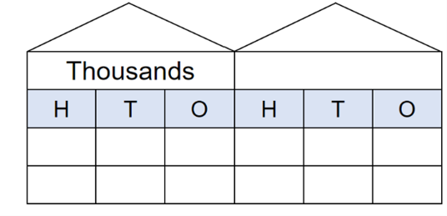

1. Ask 6 students to represent numbers by standing or squatting in front of the place value house. Students stand to represent the number one and squat to represent zero.
2. Select a student to provide a number that is made of ones or zeros. For example, 11.

**Note:** initial numbers must be limited to a maximum of 111 to ensure the larger number will fit inside the place value house.

1. To represent 11, the students in front of the 10 and ones column remain standing. All others must squat.
2. Ask the students to represent a number 100 times larger. To represent the number 1100, only the thousand and hundred students remain standing. All others squat. Ask students to explain how making a number 10, 100 or 1000 times larger changes the place value of the digits.
3. Rotate students regularly to ensure all are involved.
4. Continue making numbers with ones and zeros and numbers that are 10, 100 and 1000 times larger.

**Note:** an alternative is to form teams of 6 students. Students must allocate themselves to a column and the teams compete to create their number representations.

This table details opportunities for assessment.

|  |  |
| --- | --- |
| Assessment opportunities | Links |
| What to look for:   * Can students recognise the number of tens, hundreds or thousands in a number? **[MAO-WM-01, MA2-RN-01]** * describe how making a number 10, 100 or 1000 times as large changes the place value of digits? **[MAO-WM-01, MA2-RN-01]** | Links to [National Numeracy Learning Progressions](https://www.australiancurriculum.edu.au/resources/national-literacy-and-numeracy-learning-progressions/version-3-of-national-literacy-and-numeracy-learning-progressions/) (NNLP):   * NPV7, NPV8, NPV9.   Links to suggested [Interview for Student Reasoning](https://education.nsw.gov.au/teaching-and-learning/curriculum/literacy-and-numeracy/assessment-resources/ifsr) (IfSR) tasks:   * **IfSR-NP**: 4B.6. |

### Core lesson: Converting between units – 40 minutes

The table below contains a suggested learning intention and success criteria. These are best co-constructed with students.

|  |  |
| --- | --- |
| Core concept learning intentions | Core concept success criteria |
| Students are learning to:   * use scaled instruments to measure and compare lengths. | Students can:   * explain how many millimetres are in a centimetre * measure shapes using centimetres and millimetres * convert between centimetres and millimetres. |

1. Display the number 10 and ask students to [brainstorm](https://app.education.nsw.gov.au/digital-learning-selector/LearningActivity/Card/542) what they know about the number, recording ideas on an anchor chart to be displayed around the room and added to throughout the lesson. Ask:

* Why is the number 10 important?
* Why are we discussing the number 10 when learning about length and measuring objects?
* Our number system is called the base-10 system. Why do you think it is called this?
* How is the number 10 important in everyday life?

**Note:** guide student understanding that the base-10 system has emerged from humans having 10 fingers.

1. Explain that students will be converting measurements from millimetres to centimetres and centimetres to millimetres.
2. Ask students to [Think-Pair-Share](https://app.education.nsw.gov.au/digital-learning-selector/LearningActivity/Card/645) about what converting means.
3. Explain to students that converting is when the unit of measurement changes. For example, 23 cm can be converted to 230 mm. Make connections between making a number 10 times larger and its relationship when converting measurements.

**Note:** emphasise to students that the length is not changing, only the unit of measurement.

1. Display Resource 4: Converting units to students and ask:

* What do you notice about the difference between these units of length?
* How does this connect to the base-10 number system?
* Why is it important to understand the base-10 number system when measuring and converting lengths?
* How can this display help us to convert between millimetres and centimetres?

1. Display Resource 5: Measuring and converting and demonstrate how to measure, record and convert each answer between centimetres and millimetres (see Figure 3).

Figure 3 – Converting example

Table with headings Item, length in millimetres and length in centimetres.
4 classroom items measured with lengths recorded in both units.

The highligher's length is 103 in millimetres and 10.3 in centimetres.

The pen's length is 145 in millimetres and 14.5 in centimetres.

The binder clip's length is 26 in millimetres and 2.6 in centimetres.

The push pin's length is 15 in millimetres and 1.5 in centimetres.

Images sourced from [Canva](https://www.canva.com/) and used in accordance with the [Canva Content License Agreement](https://www.canva.com/policies/content-license-agreement/).

1. Provide students with Resource 5: Measuring and converting and a 30 cm ruler to complete the activity independently.

This table details opportunities for differentiation.

|  |  |
| --- | --- |
| Too hard? | Too easy? |
| Students do not understand that units of measurement can be converted.   * Support students to measure the object in centimetres and then again in millimetres (without converting). After, guide students to observe the pattern between the centimetre and millimetre measurements. * Revise how many millimetres are in a centimetre and support students in converting small whole centimetre measurement into millimetres. For example, 3 cm is the same as 30 mm. | Students understand that units of measurement can be converted.   * Challenge students to create their own two-dimensional shape to measure and convert. * Challenge students to write the measurements for each shape in Resource 5: Measuring and converting in metres. |

### Discuss and connect the mathematics – 10 minutes

1. Regroup as a class and summarise the lesson together drawing out key mathematical ideas. Ask:

* What measurements did you have for each object in centimetres?
* What measurements did you have for each object in millimetres?
* Did you measure the object in centimetres or millimetres first? Why?
* How did you convert the measurements?
* What challenges did you face during this activity? How did you overcome them?

This table details opportunities for assessment.

|  |  |
| --- | --- |
| Assessment opportunities | Links |
| What to look for:   * Can students explain how many millimetres are in a centimetre? **[MAO-WM-01, MA2-GM-02]** * Can students measure objects using centimetres and millimetres? **[MAO-WM-01, MA2-GM-02]** * Can students convert between centimetres and millimetres? **[MAO-WM-01, MA2-GM-02]** | Links to [National Numeracy Learning Progressions](https://www.australiancurriculum.edu.au/resources/national-literacy-and-numeracy-learning-progressions/version-3-of-national-literacy-and-numeracy-learning-progressions/) (NNLP):   * UuM8. |

## Lesson 3

**Core concept**: collections of tenths and hundredths are useful in measurement.

### Daily number sense: 10, 100 and 1000 times bigger – 10 minutes

The table below contains a suggested learning intention and success criteria. These are best co-constructed with students.

|  |  |
| --- | --- |
| Daily number sense learning intention | Daily number sense success criteria |
| Students are learning to:   * recognise and represent numbers that are made of tens, hundreds and thousands. | Students can:   * recognise and record the number of tens, hundreds, or thousands in a number. |

1. Provide each pair of students three 9-sided dice and a mini-whiteboard.
2. Ask students to draw a place value house on their whiteboard, as shown in Figure 4.

Figure 4 – Place value house



1. Students roll the dice and arrange the dice to form the smallest number possible. For example, if a student rolls a 5, 1 and 9, the dice could be arranged to form the number 159.
2. Students record the number that is 10 times larger.
3. On the second dice roll, students form the largest number possible and record the number that is 100 times larger.
4. On the third dice roll, students form any number, and record the number that is 1000 times larger.
5. Repeat this 3 times so that students can practice numbers 10, 100 and 1000 times larger.
6. Vary the task by asking students to select specific numbers, such as those that have an even hundreds digit, or an odd unit, or a number with even thousands and tens digits.

This table details opportunities for assessment.

|  |  |
| --- | --- |
| Assessment opportunities | Links |
| What to look for:   * Can students identify and record the ones, tens, hundreds and thousands in a number? **[MAO-WM-01, MA2-RN-01]** | Links to [National Numeracy Learning Progressions](https://www.australiancurriculum.edu.au/resources/national-literacy-and-numeracy-learning-progressions/version-3-of-national-literacy-and-numeracy-learning-progressions/) (NNLP):   * NPV7 |

### Core lesson: Using measuring instruments accurately – 30 minutes

The table below contains a suggested learning intention and success criteria. These are best co-constructed with students.

|  |  |
| --- | --- |
| Core concept learning intentions | Core concept success criteria |
| Students are learning to:   * recognise how the base-10 number system helps when measuring and recording length. | Students can:   * measure lengths and distances using cm and m * record lengths and distances using decimal notation to 2 decimal places * convert between metres and centimetres. |

1. Write 4.25 m on the board and ask students to [brainstorm](https://app.education.nsw.gov.au/digital-learning-selector/LearningActivity/Card/542) what they know about the number, recording ideas on an anchor chart to be displayed around the room.
2. Display Resource 6: Labelled distance and allow students to [Think-Pair-Share](https://app.education.nsw.gov.au/digital-learning-selector/LearningActivity/Card/645) what they notice. Ask:

* What place values are represented in the image?
* Why is it important to understand place value when measuring lengths?
* If you were to measure 4.25 m with a metre ruler, how many rulers would you need?
* Using your estimation skills, what is something that would be approximately 4.25 m long?

1. Display a 30 cm and a metre ruler and ask:

* What do the small lines on the 30 cm ruler measure?
* What do the small lines on the metre ruler measure?
* How can we use these lines to ensure we are measuring accurately?

1. Explain to students that measuring objects longer than the measuring instrument being used can sometimes lead to inaccuracies. Emphasise that it is important to use measuring instruments precisely to ensure accuracy.
2. Display Resource 7: Measuring a desk and explain that the desk is longer than one metre and it is being measured accurately using a one metre ruler. Ask:

* What specific part of the metre ruler should we place at the start? Why?
* When moving the metre ruler from the first end point to the next part of the measurement, what might you do to ensure the measurement is still accurate?
* How are centimetres important in this example?
* Why is it important to be accurate when measuring objects?

1. Explain to students that they will measure 3 different objects in the classroom using either a 30 cm ruler or a metre ruler.

**Note:** 30 cm rulers displaying millimetres and metre rulers displaying centimetres will be required for this activity.

1. Display Resource 8: Measuring objects and demonstrate how to measure the lengths of a different classroom objects and record in centimetres and metres. Ask:

* How many centimetres are in a metre?
* Will you have to measure the objects in centimetres and then again in metres? Why or why not?
* How can you use your knowledge of the base-10 number system to convert the measurements between centimetres and metres?

1. Provide students with metre and 30 cm rulers and Resource 8: Measuring objects to complete the activity independently.
2. Regroup students and compare recorded lengths. Ask:

* What was challenging about this activity?
* How did you use your knowledge of the base-10 number system to convert the measurements?
* What strategy did you use to measure and record objects that were longer than your measuring instrument?
* How did you ensure your measurements were accurate?
* If you had to complete this activity again, would you do anything differently? Why?

This table details opportunities for differentiation.

|  |  |
| --- | --- |
| Too hard? | Too easy? |
| Students cannot measure and record lengths to 2 decimal places.   * Support students by adjusting the objects so they are shorter than the measuring instruments. * Provide students with Resource 6: Labelled distance for them to reference when recording to 2 decimal places. | Students can measure and record lengths to 2 decimal places.   * Challenge students to measure additional objects in the classroom, recording their lengths in millimetres and centimetres. * Challenge students to place the objects in ascending and descending order according to their length. |

### Consolidation and meaningful practice – 20 minutes

1. Explain that students will use their knowledge of the base-10 number system to play conversion bingo.
2. Display Resource 9: Conversion bingo. Students draw their own bingo board on an individual whiteboard and select 9 different lengths from Resource 9: Conversion bingo and record.

**Note:** students may use their workbooks.

1. Read out cards from Resource 10: Teacher cards. If students have the converted length, they mark the box with the corresponding conversion (see Figure 5).

Figure 5 – Conversion bingo recording

Conversion bingo with instructions.
Mark an x in the box if you have the m conversion for 652 cm. 
Mark an x in the box if you have the m conversion for 976 cm. 
Mark an x in the box if you have the cm conversion for 1.89 m
Student marking on whiteboard shows if they have the corresponding number.

Images sourced from [Canva](https://www.canva.com/) and used in accordance with the [Canva Content License Agreement](https://www.canva.com/policies/content-license-agreement/).

1. The first student to have all 9 of their selected lengths marked off is the winner.

This table details opportunities for assessment.

|  |  |
| --- | --- |
| Assessment opportunities | Links |
| What to look for:   * Can students measure lengths and distances using centimetres and metres? **[MAO-WM-01, MA2-GM-02]** * Can students record lengths and distances using decimal notation to 2 decimal places? **[MAO-WM-01, MA2-GM-02]** * Can students convert between metres and centimetres? **[MAO-WM-01, MA2-GM-02]** | Links to [National Numeracy Learning Progressions](https://www.australiancurriculum.edu.au/resources/national-literacy-and-numeracy-learning-progressions/version-3-of-national-literacy-and-numeracy-learning-progressions/) (NNLP):   * UuM6, UuM8. |

## Lesson 4

**Core concept**: a straight line, a boundary or an edge can be measured.

### Daily number sense –10 minutes

1. From a class need surfaced through formative assessment data, identify a short, focused activity that targets students’ knowledge, understanding and skills. Example activities may be drawn from the following resources:

* [Mathematics K-6 resources](https://education.nsw.gov.au/teaching-and-learning/curriculum/mathematics/mathematics-curriculum-resources-k-12/mathematics-k-6-resources#catalogue_auto)
* [Universal Resources Hub](https://resources.education.nsw.gov.au/home).

### Core lesson: Length investigation – 40 minutes

The table below contains suggested learning intentions and success criteria. These are best co-constructed with students.

|  |  |
| --- | --- |
| Core concept learning intentions | Core concept success criteria |
| Students are learning to:   * measure various lengths and boundaries of objects or locations * recognise the features of a three-dimensional object associated with lengths that can be measured. | Students can:   * identify the distance around an object or location as the boundary * estimate and measure the boundary of objects or locations * identity and measure the length of features of three-dimensional objects. |

1. Write ‘what can length measure?’ on the board and ask students to [brainstorm](https://app.education.nsw.gov.au/digital-learning-selector/LearningActivity/Card/542), recording student ideas on an anchor chart.
2. Display Resource 11: Length can measure and highlight that length can be used to measure straight lines, boundaries and edges. Ask:

* Can you identify any straight lines, boundaries or edges that you have measured before?
* What units of measurement are used when measuring length?
* What are some of the measuring instruments used to measure length?
* Can length be used to measure curved or jagged lines? Why or why not?

**Note:** students need opportunities to interpret length as pertaining to a boundary as well as the straight-line distance between 2 points. Explain to students that length can also be used to measure curved and jagged lines, but these can be more challenging to measure.

1. Explain the definition of a straight line, boundary and edge and demonstrate how to measure each on classroom objects.
2. Display Resource 12: Measurement hunt and explain that students will identify objects or locations in their school and measure a straight line, a boundary and an edge. Ask:

* What measuring instruments could be used to measure straight lines, boundaries and edges?
* Would each location or object require the same measuring instrument?
* What are some straight lines, boundaries and edges in the school context that could be measured?
* How will you measure the locations and objects accurately?

1. Display 30 cm rulers, trundle wheels and metre rulers. Ask:

* How can these instruments be used to measure length?
* How do you ensure these instruments are used accurately?
* Are some instruments better suited for different objects or locations? Why?

1. Provide students with Resource 12: Measurement hunt and ask them to glue it into their workbooks. Students estimate and then measure the object or location and record the measurement using cm and/or mm.

This table details opportunities for differentiation.

|  |  |
| --- | --- |
| Too hard? | Too easy? |
| Students cannot measure straight lines, boundaries and edges by recognising the features of shapes and objects.   * Support students to select classroom objects that are familiar three-dimensional shapes. Assist students in identifying the edges that can measured. * Provide students with a printed copy of Resource 11: Length can measure to reference when investigating straight lines, boundaries and edges. | Students can measure straight lines, boundaries and edges by recognising the features of shapes and objects.   * Challenge students to measure additional locations and objects from around the classroom or school. * Challenge students to convert their measurements from centimetres to metres and record. |

### Discuss and connect the mathematics – 10 minutes

1. Regroup as a class and summarise the lesson together drawing out key mathematical ideas. Ask:

* What object or location did you choose to measure for your straight lines, boundaries and edges? Why?
* What measurements did you record for each of the locations or objects?
* What was the difference between your estimation and the recorded length?
* What is another way you can describe the term boundary?
* What challenges did you face during this activity? How did you overcome them?

This table details opportunities for assessment.

|  |  |
| --- | --- |
| Assessment opportunities | Links |
| What to look for:   * Can students identify the distance around an object or location as the boundary? **[MAO-WM-01, MA2-GM-02]** * Can students estimate and measure the boundary of objects or locations? **[MAO-WM-01, MA2-GM-02]** * Can students identity and measure the length of features of three-dimensional objects? **[MAO-WM-01, MA2-GM-02]** | Links to [National Numeracy Learning Progressions](https://www.australiancurriculum.edu.au/resources/national-literacy-and-numeracy-learning-progressions/version-3-of-national-literacy-and-numeracy-learning-progressions/) (NNLP):   * UuM7. |

## Lesson 5

**Core concept**: perimeter is the distance around the boundary of a two-dimensional shape.

### Daily number sense: Climb the ladder – 10 minutes

Daily number sense activities for Lessons 5 to 7 ‘loop’ back to concepts and procedures covered in previous units to assist students to build an increasingly connected network of ideas. These concepts may differ from the core concepts being covered by the unit.

The table below contains a suggested learning intention and success criteria. These are best co-constructed with students.

|  |  |
| --- | --- |
| Daily number sense learning intention | Daily number sense success criteria |
| Students are learning to:   * order numbers in the thousands. | Students can:   * arrange 4-digit numbers in sequence according to the value. |

1. Explain the aim of the game is to position 4-digit numbers in sequence on the ladder rungs.
2. Draw a ladder with 5 rungs on the board. Roll a 9-sided dice 4 times to form a 4-digit number and record on one of the ladder rungs (see Figure 6).

Figure 6 – Climb the ladder

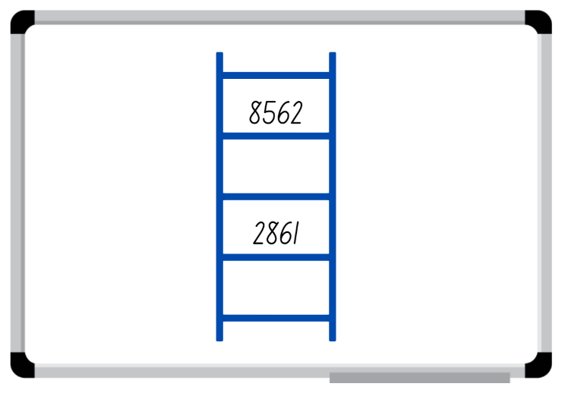

Images sourced from [Canva](https://www.canva.com/) and used in accordance with the [Canva Content License Agreement](https://www.canva.com/policies/content-license-agreement/).

1. Select a student to roll the dice again and form another 4-digit number to place on a rung of the ladder. Ask the student to explain and justify which rung they have nominated to place the number on before recording it on the ladder.
2. Continue the game until a player is unable to place their number on the ladder, then the game is over. Discuss if there were any other possible combinations that could have helped a player win.
3. The game can be adapted by adding more rungs to the ladder to order more numbers.

**Note:** the game can be played as whole class or in pairs. Use dice that have a zero as it is important to understand that the zero is a placeholder and does not have a value.

This table details opportunities for assessment.

|  |  |
| --- | --- |
| Assessment opportunities | Links |
| What to look for:   * Can students arrange 4-digit numbers in sequence according to the value? **[MAO-WM-01, MA2-RN-01]** | Links to [National Numeracy Learning Progressions](https://www.australiancurriculum.edu.au/resources/national-literacy-and-numeracy-learning-progressions/version-3-of-national-literacy-and-numeracy-learning-progressions/) (NNLP):   * NPV6. |

### Core lesson: Finding the perimeter of different shapes – 40 minutes

The table below contains a suggested learning intention and success criteria. These are best co-constructed with students.

|  |  |
| --- | --- |
| Core concept learning intentions | Core concept success criteria |
| Students are learning to:   * identify and measure the perimeter of shapes. | Students can:   * use the term perimeter to describe the distance around the boundary of shapes * estimate and measure the perimeters of quadrilaterals in centimetres and millimetres. |

1. Display Resource 13: Boundary and perimeter and explain that the perimeter of an object, shape or location is the same as the boundary. Perimeter is the length around an object, shape or location. Perimeter is calculated by combining the length of all the sides. Ask:

* Can you think of any examples of perimeter in everyday life?
* Why is it important to understand perimeter?
* What professions would use knowledge of perimeter daily?

**Note:** connect students’ thinking about perimeter to a fence around a boundary.

1. Display Resource 14: Perimeter and ask:

* What do you notice about the image?
* How would you find the missing lengths on the image? Explain your reasoning.
* How would you calculate the perimeter of the image? Explain your thinking to a partner.
* What strategy did you use to find the perimeter of the diagram? Why? Did your partner have a different strategy?

1. Model identifying the missing lengths to students using known information. For example, there are lengths of 52 m and 30 m on one side of the diagram. Adding the lengths together means the total length of the remaining side would be 82 m.
2. Label the missing lengths on the diagram and demonstrate how to calculate the perimeter of the image.
3. Display Resource 15: Measuring perimeter and explain that students will use their measuring skills to find the length of the sides of the two-dimensional shapes and then calculate the perimeter.
4. Provide students with Resource 15: Measuring perimeter and 30 cm rulers to measure and then calculate the perimeter.

This table details opportunities for differentiation.

|  |  |
| --- | --- |
| Too hard? | Too easy? |
| Students cannot identify and measure the perimeter of shapes.   * Support students by allowing them to only measure and calculate the perimeter of the regular two-dimensional shapes from Resource 15: Measuring perimeter. * Support students by providing the measurements of the sides of the regular shapes and only asking them to calculate the perimeter. | Students can identify and measure the perimeter of shapes.   * Challenge students to convert their measurements and perimeters from centimetres to millimetres. * Challenge students to place the perimeters in ascending and descending order. |

### Discuss and connect the mathematics – 10 minutes

1. Regroup as a class and summarise the lesson together drawing out key mathematical ideas. Ask:

* What unit of measurement was best suited to measure each shape? Why?
* What measurements did you record for each of the shapes?
* What strategy did you use to calculate the perimeters of each shape?
* Would you use the same strategy again? Why or why not?
* What were challenges you faced during this activity? How did you overcome them?

This table details opportunities for assessment.

|  |  |
| --- | --- |
| Assessment opportunities | Links |
| What to look for:   * Can students use the term perimeter to describe the distance around the boundary of shapes? **[MAO-WM-01, MA2-GM-02]** * Can students estimate and measure the perimeters of quadrilaterals in centimetres and millimetres? **[MAO-WM-01, MA2-GM-02, MA2-2DS-01]** | Links to [National Numeracy Learning Progressions](https://www.australiancurriculum.edu.au/resources/national-literacy-and-numeracy-learning-progressions/version-3-of-national-literacy-and-numeracy-learning-progressions/) (NNLP):   * UuM7. |

## Lesson 6

**Core concept**: standard units are an efficient way to communicate and compare lengths of time.

### Daily number sense: Where do you fit? – 10 minutes

The table below contains a suggested learning intention and success criteria. These are best co-constructed with students.

|  |  |
| --- | --- |
| Daily number sense learning intention | Daily number sense success criteria |
| Students are learning to:   * order numbers in the thousands. | Students can:   * arrange 4-digit numbers in sequence according to the value. |

1. Organise students into small groups and provide each group with four 10-sided dice.
2. Students take turn rolling the dice to create a 4-digit number. Students record the number on a sticky note and, one by one, place themselves in order from smallest to largest.
3. When each group has all members in order, combine 2 groups. Group members need to adjust their order to ensure they are still in order from smallest to largest.
4. Continue to combine groups and adjust placements until the whole class is in order.

This table details opportunities for assessment.

|  |  |
| --- | --- |
| Assessment opportunities | Links |
| What to look for:   * Can students arrange 4-digit numbers in sequence according to the value? **[MAO-WM-01, MA2-RN-01]** | Links to [National Numeracy Learning Progressions](https://www.australiancurriculum.edu.au/resources/national-literacy-and-numeracy-learning-progressions/version-3-of-national-literacy-and-numeracy-learning-progressions/) (NNLP):   * NPV6. |

### Core lesson: Time is Ticking – 40 minutes

The table below contains suggested learning intentions and success criteria. These are best co-constructed with students.

|  |  |
| --- | --- |
| Core concept learning intentions | Core concept success criteria |
| Students are learning to:   * represent and read analog time * compare duration of time in seconds and minutes. | Students can:   * recognise and compare durations of time in seconds and minutes * read analog clocks to the minute * determine the time remaining until the next hour. |

1. Explain that students will be playing the game ‘Time is Ticking’.
2. Have students sit with their eyes closed and say a duration of time. For example, one minute.
3. Students then place their hands on their head when they think that length of time has passed.

**Note:** use a stopwatch and ensure the stopwatch is not visible to students.

1. Begin the stopwatch. At the exact point of one minute pause the stopwatch. Ask:

* How did you estimate or calculate the minute?
* Was your strategy accurate? Why or why not?
* What could you change?

1. Repeat the game with different durations, for example, 30 seconds, 45 seconds, 15 seconds, 5 seconds, 2 minutes.
2. Display an [analog clock](https://toytheater.com/clock/) and ask:

* How many seconds are in a minute? How do you know?
* How many minutes are in an hour? How do you know?
* What is the difference between the minute and the hour hands? At what speed do they move?
* What do the small strokes between the numerals on the clock represent?
* What is an efficient way of calculating time, without having to count singular minutes? What benchmarks do you know? Record students answers on an anchor chart for easy reference as the lesson progresses.

**Note:** guide students to explain the concept of quarter-past, half-past, quarter-to and that between each numeral on the clock is a 5-minute interval.

1. Adjust the clock to show 7:45 and ask students to [Think-Pair-Share](https://app.education.nsw.gov.au/digital-learning-selector/LearningActivity/Card/645) what time is displayed. Ask:

* How do you know that is the time?
* What will the time be in 10 minutes from the time shown?
* What will the time be in half an hour?
* How many minutes until the next hour?

1. Repeat the process with different time on the clock. For example, 3:58 and 4:08.
2. Discuss how to describe the duration of time, highlighting the importance of using the most efficient unit. For example, the activity takes one hour, recess goes for 25 minutes.
3. Read cards from Resource 16: Duration cards and ask pairs of students to debate and justify whether the description of time duration is communicated effectively. Ensure pairs suggest reasons why or why not.
4. Pairs then take turns describing an event with their partner selecting the appropriate unit of time measurement, for example, seconds, minutes, hours.

This table details opportunities for differentiation.

|  |  |
| --- | --- |
| Too hard? | Too easy? |
| Students cannot represent and read analog time and compare duration of time in seconds and minutes.   * Support students by providing them with a hands-on clock and to manipulate the hands to show the same time is shown on the displayed clock. * Support students by providing them with a printed copy of Resource 17: Fast facts. | Students can represent and read analog time and compare duration of time in seconds and minutes.   * Challenge students to convert the scenarios that are not efficient to an efficient unit of time. * Challenge students to nominate scenarios that are not efficiently described and may include durations over 24 hours. |

### Discuss and connect the mathematics – 15 minutes

1. Regroup as a class and discuss the scenarios presented. Ask:

* Why is it important to communicate time durations effectively?
* When would you describe a time in seconds, minutes, hours, days?

1. Provide students with Resource 18: Exit ticket. Students describe 2 activities that are measured efficiently and one activity that is measured inefficiently (see Figure 7).

Figure 7 – Exit ticket example

Exit ticket example.    
Today's maths lesson goes for 1 hour.
It takes me 2 minutes to brush my teeth.
Yesterday I walked my dog for 9000 seconds.

This table details opportunities for assessment.

|  |  |
| --- | --- |
| Assessment opportunities | Links |
| What to look for:   * Can students recognise and compare durations of time in seconds and minutes? **[MAO-WM-01, MA2-NSM-02]** * Can students read analog clocks to the minute? **[MAO-WM-01, MA2-NSM-02]** * Can students determine the time remaining until the next hour? **[MAO-WM-01, MA2-NSM-02]** | Links to [National Numeracy Learning Progressions](https://www.australiancurriculum.edu.au/resources/national-literacy-and-numeracy-learning-progressions/version-3-of-national-literacy-and-numeracy-learning-progressions/) (NNLP):   * MeT3. |

## Lesson 7

**Core concept**: lengths of time can be represented using a digital time display.

### Daily number sense: Ordering game – 10 minutes

The table below contains a suggested learning intention and success criteria. These are best co-constructed with students.

|  |  |
| --- | --- |
| Daily number sense learning intention | Daily number sense success criteria |
| Students are learning to:   * order numbers in the thousands. | Students can:   * recognise, represent and order 4-digit numbers. |

1. Explain the aim of the game is to position 4-digit numbers in sequence on the gameboard. Provide pairs with four 10-sided dice and Resource 19: Ordering gameboard to each player.
2. Students roll the dice and create a 4-digit number. For example, 4, 6, 9 and zero could be recorded as 4609, 6490 or 9604. Players record their chosen number in the most appropriate position between 100 and 9999 (see Figure 8).

Figure 8 – Sample gameboard

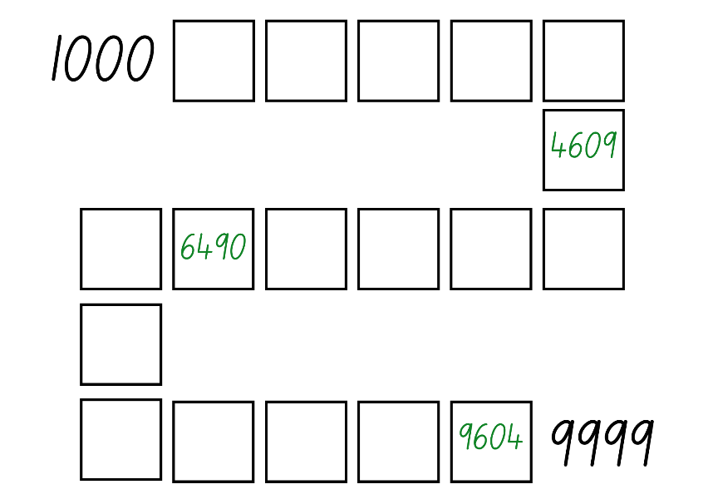

1. If numbers cannot be placed, students miss their turn. Play continues until all boxes are filled.

**Note:** the game can also be played as whole class. Use dice that have a zero as it is important to understand that the zero is a placeholder and does not have a value. Using a reusable sleeve for the gameboard will allow students to play multiple games.

This table details opportunities for assessment.

|  |  |
| --- | --- |
| Assessment opportunities | Links |
| What to look for:   * Can students recognise, represent and order 4-digit numbers? **[MAO-WM-01, MA2-RN-01]** | Links to [National Numeracy Learning Progressions](https://www.australiancurriculum.edu.au/resources/national-literacy-and-numeracy-learning-progressions/version-3-of-national-literacy-and-numeracy-learning-progressions/) (NNLP):   * NPV6. |

### Core lesson: Matching time – 40 minutes

The table below contains a suggested learning intention and success criteria. These are best co-constructed with students.

|  |  |
| --- | --- |
| Core concept learning intentions | Core concept success criteria |
| Students are learning to:   * read analog and digital time. | Students can:   * recognise that the hour is read first in a digital clock * determine the time remaining until the next hour on a digital clock * relate analog to digital time. |

1. Ask students to [brainstorm](https://app.education.nsw.gov.au/digital-learning-selector/LearningActivity/Card/542) what they know about digital time, record ideas on an anchor chart to be displayed around the room Ask:

* Where do you see digital time being used?
* Why do you think digital time is used as a way to view time?
* How is digital time different from analog time?
* Do you prefer reading analog or digital time? Why?

1. Display Resource 20: Digital clocks and model how to read digital time.

**Note:** when reading digital time, 4:00 is read as 4 o’clock not ‘four zero zero’. Emphasise to students that, when reading digital time, the hour is read first.

1. Display Resource 21: Everyday digital clocks. Students view the images and discuss the relevance to everyday life. Ask:

* Can you think of additional scenarios where you would see digital time represented?
* Why do you think digital time is being used in these scenarios?
* How many minutes are there until the next hour in each scenario?

1. Provide students with Resource 22: Time matching cards. Students cut and then match the cards to corresponding analog and digital time.

**Note:** Resource 22: Time matching cards has been designed so that a variety of additional activities can be played with the cards such as snap or memory.

This table details opportunities for differentiation.

|  |  |
| --- | --- |
| Too hard? | Too easy? |
| Students cannot read analog and digital time.   * Support students by providing them with only 4 sets of cards to match. * Support students by providing them with a model analog clock to move and manipulate when matching cards. | Students can read analog and digital time.   * Challenge students to find how long until the next hour for each matching pair. * Challenge students to arrange the matching pairs in order they occur during the day. |

### Discuss and connect the mathematics – 10 minutes

1. Regroup as a class and discuss the activity. Ask:

* Is analog or digital time easier to read? Why or why not?
* Which part of the digital time is said first?
* If the clock says 3:46, how many minutes are there until the next hour? Explain how you worked it out.
* What did you find challenging about this activity? Why? How did you overcome the challenges?

This table details opportunities for assessment.

|  |  |
| --- | --- |
| Assessment opportunities | Links |
| What to look for:   * Can students recognise that the hour is read first in a digital clock? **[MAO-WM-01, MA2-NSM-02]** * Can students determine the time remaining until the next hour on a digital clock? **[MAO-WM-01, MA2-NSM-02]** * Can students relate analog to digital time? **[MAO-WM-01, MA2-NSM-02]** | Links to [National Numeracy Learning Progressions](https://www.australiancurriculum.edu.au/resources/national-literacy-and-numeracy-learning-progressions/version-3-of-national-literacy-and-numeracy-learning-progressions/) (NNLP):   * MeT3. |

## Lesson 8

**Core concept**: times of the day can be represented in different ways.

### Daily number sense – 10 minutes

1. From a class need surfaced through formative assessment data, identify a short, focused activity that targets students’ knowledge, understanding and skills. Example activities may be drawn from the following resources:

* [Mathematics K-6 resources](https://education.nsw.gov.au/teaching-and-learning/curriculum/mathematics/mathematics-curriculum-resources-k-12/mathematics-k-6-resources#catalogue_auto)
* [Universal Resources Hub](https://resources.education.nsw.gov.au/home).

### Core lesson: Representing time – 30 minutes

The table below contains a suggested learning intention and success criteria. These are best co-constructed with students.

|  |  |
| --- | --- |
| Core concept learning intentions | Core concept success criteria |
| Students are learning to:   * read and represent analog and digital time. | Students can:   * relate the terms midday, noon and midnight to am and pm * relate analog notation to digital notation for time * represent time on analog and digital clocks. |

This activity is an adaptation of ‘Time Words’ from *Challenging Mathematical tasks: Unlocking the potential of all students* by Sullivan.

1. Display Resource 23: Midday and midnight and ask students to [Think-Pair-Share](https://app.education.nsw.gov.au/digital-learning-selector/LearningActivity/Card/645). Ask:

* What do you notice?
* What do the terms ‘midday’ and ‘midnight’ mean?
* How do the terms ‘midday’ and ‘midnight’ help understand time?

1. Explain to students that there are a range of terms used to describe times of the day. For example, morning is used to describe the part of the day before midday. Ask:

* Can you think of any other terms used to describe parts of the day?
* Can you describe where the terms would be placed on the Resource 23: Midday and midnight?
* Why do you think we use different terms to describe different parts of the day?
* Can you identify specific events that happen during the day?
* Where would these events be placed on the resource and how would you show their duration?

1. Display Resource 24: Time representation and explain that this diagram represents sunrise, lunchtime and morning as key parts of the day. Ask:

* How have sunrise, lunchtime and morning been represented on the diagram?
* What other parts of the day could be represented on the diagram?
* How would you show these parts of the day on the diagram?
* How would you show the duration of these parts of the day accurately on the diagram?

1. Provide students with Resource 23: Midday and midnight to label the different parts of their day using arrows and words.
2. Select students to share and explain their time presentations with the class.

This table details opportunities for differentiation.

|  |  |
| --- | --- |
| Too hard? | Too easy? |
| Students cannot read and represent analog and digital time.   * Support students by printing Resource 24: Time representation to reference when creating their own representation. * Support students by listing common parts of the day for reference during the activity. For example, morning, afternoon, recess and lunch. | Students can read and represent analog and digital time.   * Challenge students to identify and record the duration of the parts of their day. * Challenge students to describe parts of the day with different words. For example, dawn, dusk, evening, noon. |

### Consolidation and meaningful practice – 20 minutes

**Note:** place Resource 25: Time race in a reusable sleeve or laminate to play multiple rounds.

1. Provide each student in pairs with Resource 25: Time race and a whiteboard marker.
2. Explain to students that a 12-hour time will be called out and students race to write the stated time in analog and digital representations, then identify how long until the next hour. Once all components are completed, students place their hands on their heads.
3. Partners review and discuss their answers. The first student in each pair with their hands on their head and correct answers is the winner of the round.
4. Repeat the game with different times.

This table details opportunities for assessment.

|  |  |
| --- | --- |
| Assessment opportunities | Links |
| What to look for:   * Can students relate the terms midday or noon and midnight to am and pm? **[MAO-WM-01, MA2-NSM-02]** * Can students relate analog notation to digital notation for time? **[MAO-WM-01, MA2-NSM-02]** * Can students represent time on analog and digital clocks? **[MAO-WM-01, MA2-NSM-02]** | Links to [National Numeracy Learning Progressions](https://www.australiancurriculum.edu.au/resources/national-literacy-and-numeracy-learning-progressions/version-3-of-national-literacy-and-numeracy-learning-progressions/) (NNLP):   * MeT3, MeT4. |

## Resource 1: 10s, 100s and 1000s

Table with headings x1, x10, x100, x1000
Example of 3, 30, 300 and 3000.
2st to 5th roll for students to complete.

## Resource 2: Measurement tools

Text - What do I measure? Millimetres, centimetres, metres, kilometres.
There are images of units of measurement and measuring devices.

Images sourced from [Canva](https://www.canva.com/) and used in accordance with the [Canva Content License Agreement](https://www.canva.com/policies/content-license-agreement/).

## Resource 3: Measuring with tools

Table with headings Item: What are you measuring? Tool: What tool will you use to measure the item? and Measurement: What is the measurement of the item?

There are empty spaces under each heading for students to fill in.

## Resource 4: Converting units

Conversion graph from mm to cm to m.
10 mm = 1 cm. 100 cm = 1 m.

## Resource 5: Measuring and converting

Table with headings Item, length in millimetres and length in centimetres.

Under item there is:
Highlighter, pen, binder clip and push pin.

Images sourced from [Canva](https://www.canva.com/) and used in accordance with the [Canva Content License Agreement](https://www.canva.com/policies/content-license-agreement/).

## Resource 6: Labelled distance

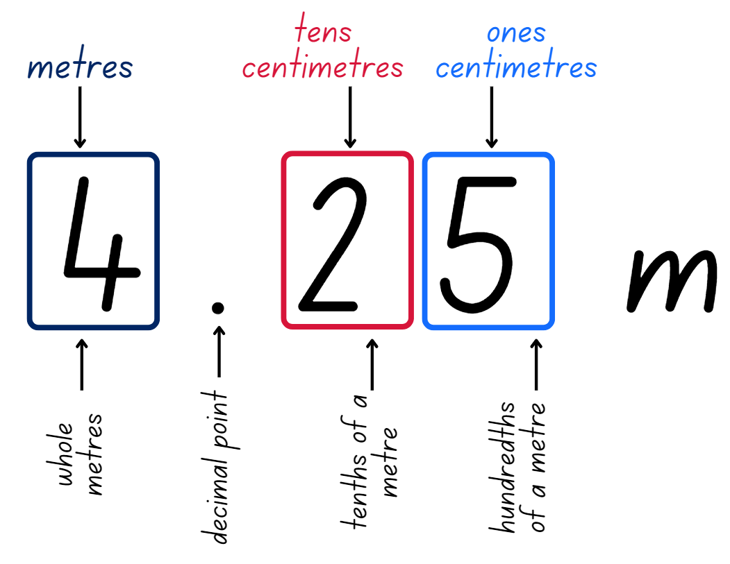

## Resource 7: Measuring a desk

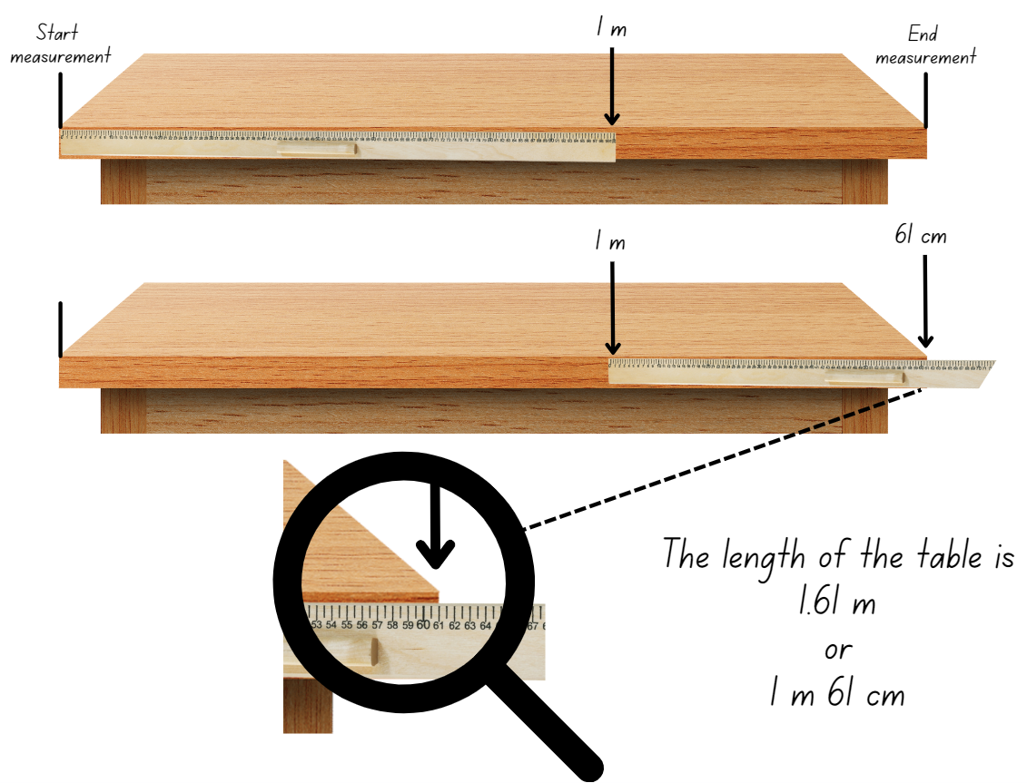

Images sourced from [Canva](https://www.canva.com/) and used in accordance with the [Canva Content License Agreement](https://www.canva.com/policies/content-license-agreement/).

## Resource 8: Measuring objects

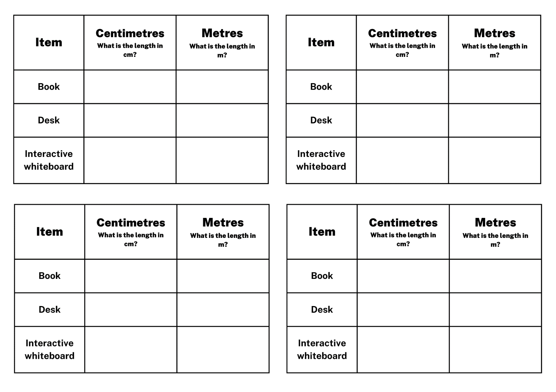

## Resource 9: Conversion bingo

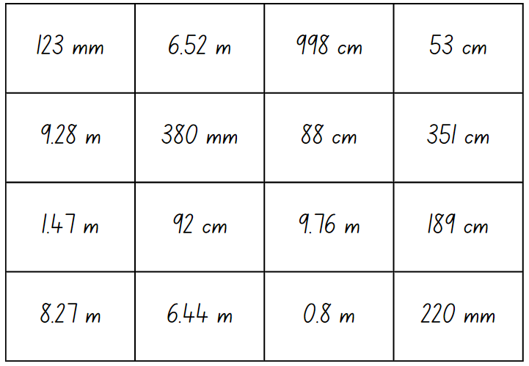

## Resource 10: Bingo teacher cards

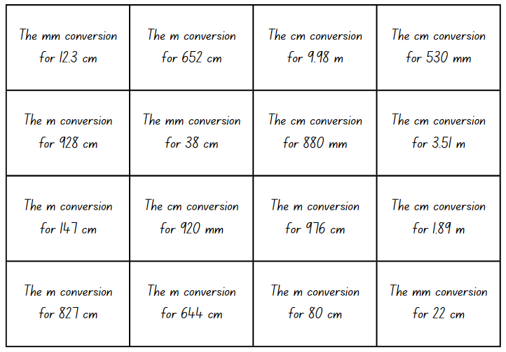

## Resource 11: Length can measure

Length can measure a straight line, boundary or an edge.
Airport with the boundary highlighted, basketball court with straight line highlighted and a cupboard with the edge highlighted.

Images sourced from [Canva](https://www.canva.com/) and used in accordance with the [Canva Content License Agreement](https://www.canva.com/policies/content-license-agreement/).

## Resource 12: Measurement hunt

2 tables with headings Item/location, Estimate length and measurement.
Boundary, edge and straight line to be measured.

## Resource 13: Boundary and perimeter

A boundary measures the total length around the outside. An airport with the boundary shown. 
Perimeter measures the total length around the outside.

Images sourced from [Canva](https://www.canva.com/) and used in accordance with the [Canva Content License Agreement](https://www.canva.com/policies/content-license-agreement/).

## Resource 14: Perimeter

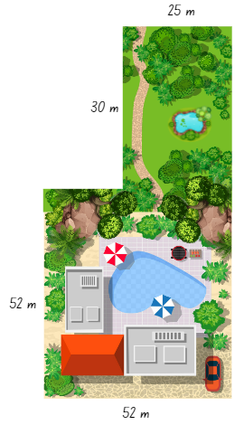

Images sourced from [Canva](https://www.canva.com/) and used in accordance with the [Canva Content License Agreement](https://www.canva.com/policies/content-license-agreement/).

## Resource 15: Measuring perimeter

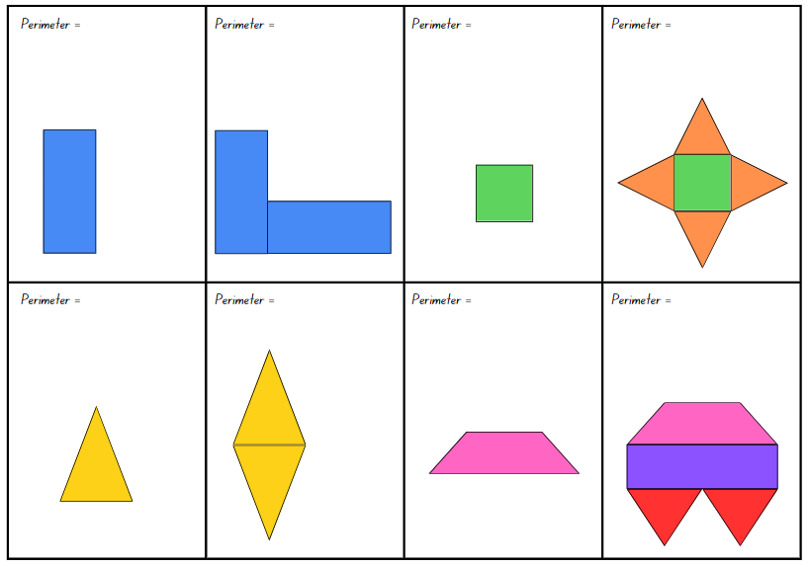

## Resource 16: Duration cards

8 duration cards.
1. John took 120 seconds to tie his shoelaces.
2. It takes Lauren 14 minutes to walk home from school.
3. Bailey's soccer match runs for 3000 seconds.
4. The party will go for 2 hours.
5. Isla completed 15 star jumps in 20 seconds. 
6. Usain Bolt holds the 
100 m sprint record of 9.58 seconds.
7. The average length of a school day is 
6 hours.
8. It takes 570 minutes to travel by car from Sydney to Brisbane.

## Resource 17: Fast facts

Fast facts
60 seconds = one minute.
15 minutes = quarter of an hour
30 minutes = half an hour
45 minutes = three quarters of an hour 
60 minutes = 1 hour
24 hours = one day

## Resource 18: Exit ticket

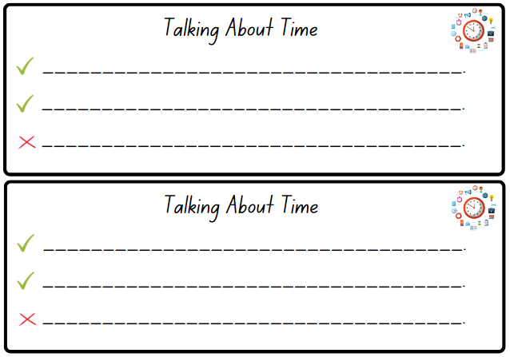

## Resource 19: Ordering gameboard

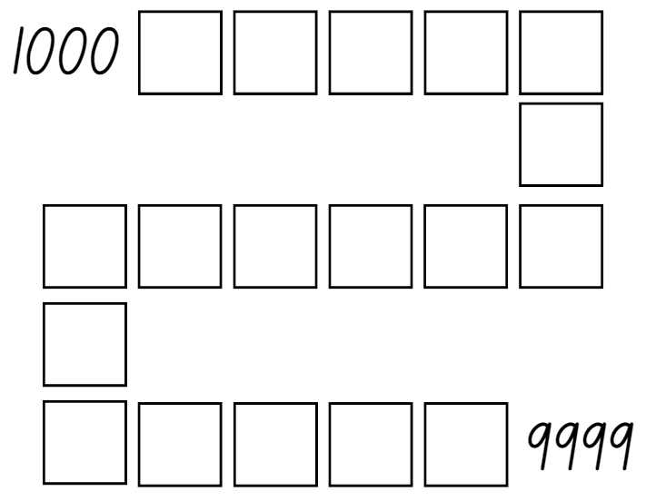

## Resource 20: Digital clocks

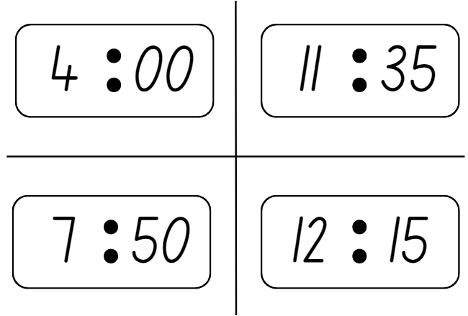

## Resource 21: Everyday digital clocks

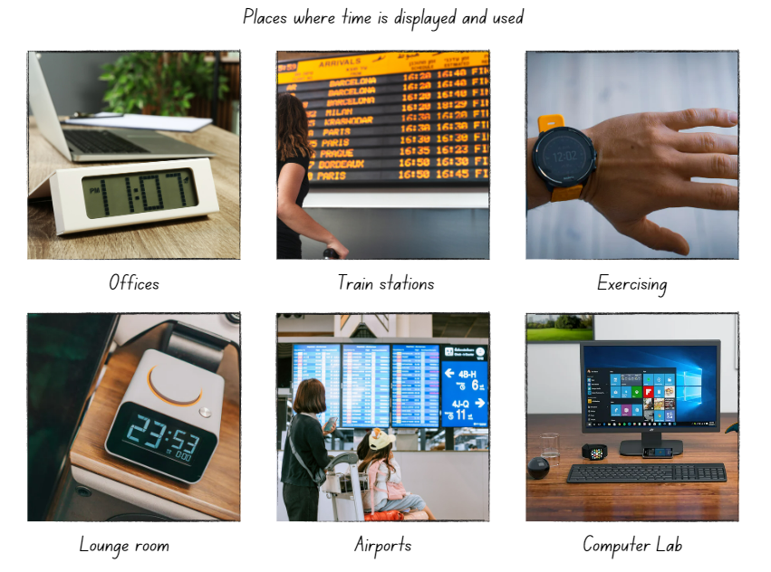

Images sourced from [Canva](https://www.canva.com/) and used in accordance with the [Canva Content License Agreement](https://www.canva.com/policies/content-license-agreement/).

## Resource 22: Time matching cards

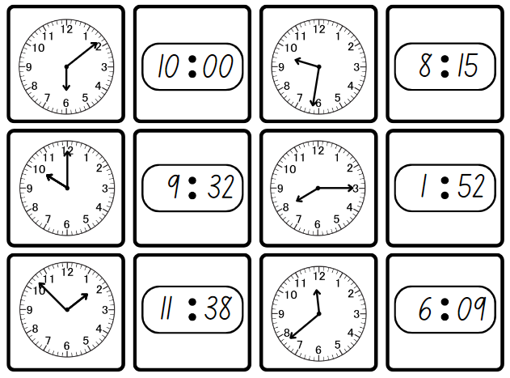

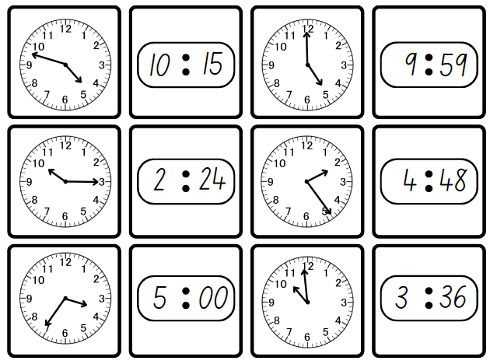

## Resource 23: Midday and midnight

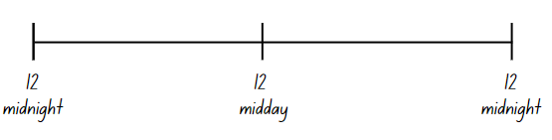

## Resource 24: Time representation

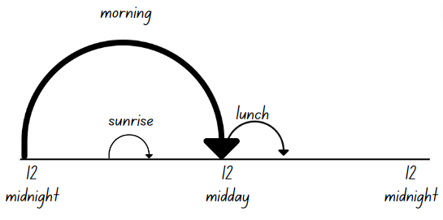

## Resource 25: Time race

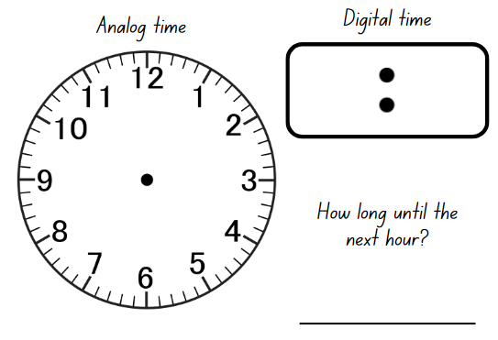

## Syllabus outcomes and content

The table below outlines the [syllabus outcomes](https://curriculum.nsw.edu.au/learning-areas/mathematics/mathematics-k-10-2022) and range of relevant syllabus content covered in this unit. Content is linked to [National Numeracy Learning Progression](https://www.australiancurriculum.edu.au/resources/national-literacy-and-numeracy-learning-progressions/version-3-of-national-literacy-and-numeracy-learning-progressions/) version (3).

|  |  |  |  |  |  |  |  |  |
| --- | --- | --- | --- | --- | --- | --- | --- | --- |
| Outcomes and content | 1 | 2 | 3 | 4 | 5 | 6 | 7 | 8 |
| **Representing numbers using place value B:** Whole numbers: Recognise and represent numbers that are 10, 100 or 1000 times as large  **MAO-WM-01, MA2-RN-01** |  |  |  |  |  |  |  |  |
| * Recognise the number of tens, hundreds or thousands in a number | x | x | x |  |  |  |  |  |
| * Describe how making a number 10, 100 or 1000 times as large changes the place value of digits | x | x | x |  |  |  |  |  |
| **Representing numbers using place value B:** Whole numbers: Order numbers in the thousands  **MAO-WM-01, MA2-RN-01** |  |  |  |  |  |  |  |  |
| * Arrange numbers in the thousands in ascending and descending order |  |  |  |  | x | x | x |  |
| * Recognise and describe how rearranging digits changes the size of a number (Reasons about relations) |  |  |  |  |  |  | x |  |
| **Geometric measure A:** Length: Measure and compare objects using metres, centimetres and millimetres  **MAO-WM-01, MA2-GM-02** |  |  |  |  |  |  |  |  |
| * Measure and record lengths and distances using a combination of metres and centimetres | x | x | x | x | x |  |  |  |
| * Estimate lengths and distances using known lengths as benchmarks, in metres and centimetres and check by measuring |  |  | x |  |  |  |  |  |
| * Compare and order lengths and distances using metres and centimetres |  | x |  |  |  |  |  |  |
| * Recognise the need for a formal unit smaller than the centimetre to measure length |  | x | x |  |  |  |  |  |
| * Identify that there are 10 millimetres in one centimetre |  | x | x |  |  |  |  |  |
| * Use the millimetre as a unit to measure lengths with a ruler |  | x | x |  |  |  |  |  |
| * Record lengths using the abbreviation for millimetres (mm) |  | x | x |  |  |  |  |  |
| **Geometric measure B:** Length: Use scaled instruments to measure and compare lengths  **MAO-WM-01, MA2-GM-02** |  |  |  |  |  |  |  |  |
| * Select and use an appropriate scaled instrument to measure lengths and distances | x | x | x | x |  |  |  |  |
| * Select and use an appropriate unit to estimate, measure and compare lengths and distances | x | x | x | x |  |  |  |  |
| * Recognise the features of a three-dimensional object associated with length that can be measured |  |  |  | x |  |  |  |  |
| * Use the term *perimeter* to describe the distance around the boundary |  |  |  |  | x |  |  |  |
| * Estimate and measure the perimeters of quadrilaterals |  |  |  |  | x |  |  |  |
| * Convert between metres and centimetres, and between centimetres and millimetres |  | x | x |  |  |  |  |  |
| * Record lengths and distances using decimal notation to 2 decimal places |  | x | x | x |  |  |  |  |
| **Two-dimensional spatial structure B:** 2D shapes: Create two-dimensional shapes that result from combining and splitting common shapes  **MAO-WM-01, MA2-2DS-01** |  |  |  |  |  |  |  |  |
| * Combine common two-dimensional shapes, including quadrilaterals, to form other common shapes or designs |  |  |  |  | x |  |  |  |
| **Non-spatial measure B:** Time: Represent and interpret digital time displays  **MAO-WM-01, MA2-NSM-02** |  |  |  |  |  |  |  |  |
| * Identify situations where duration is measured in seconds |  |  |  |  |  | x |  |  |
| * Read or set the time on digital devices to the minute or second, recognising there are 60 seconds in one minute |  |  |  |  |  | x | x | x |
| * Recognise that the hour is read first in a digital display |  |  |  |  |  |  | x |  |
| * Determine the time remaining until the next hour on a digital clock |  |  |  |  |  | x | x | x |
| **Non-spatial measure B:** Time: Use am and pm notation  **MAO-WM-01, MA2-NSM-02** |  |  |  |  |  |  |  |  |
| * Record times using the colon notation with am and pm to distinguish between morning and evening |  |  |  |  |  |  |  | x |
| * Relate the terms *midday* or *noon* and *midnight* to am and pm |  |  |  |  |  |  |  | x |
| * Relate analog notation to digital notation for time |  |  |  |  |  |  | x | x |

[Mathematics K–10 Syllabus](https://curriculum.nsw.edu.au/learning-areas/mathematics/mathematics-k-10) © NSW Education Standards Authority (NESA) for and on behalf of the Crown in right of the State of New South Wales, 2022.

## References

This resource contains NSW Curriculum and syllabus content. The NSW Curriculum is developed by the NSW Education Standards Authority. This content is prepared by NESA for and on behalf of the Crown in right of the State of New South Wales. The material is protected by Crown copyright.

Please refer to the NESA Copyright Disclaimer for more information <https://educationstandards.nsw.edu.au/wps/portal/nesa/mini-footer/copyright>.

NESA holds the only official and up-to-date versions of the NSW Curriculum and syllabus documents. Please visit the NSW Education Standards Authority (NESA) website <https://educationstandards.nsw.edu.au/> and the NSW Curriculum website <https://curriculum.nsw.edu.au/home>.

[Mathematics K–10 Syllabus](https://curriculum.nsw.edu.au/learning-areas/mathematics/mathematics-k-10-2022) © NSW Education Standards Authority (NESA) for and on behalf of the Crown in right of the State of New South Wales, 2022.

[National Numeracy Learning Progression](https://www.australiancurriculum.edu.au/resources/national-literacy-and-numeracy-learning-progressions/version-3-of-national-literacy-and-numeracy-learning-progressions/) © Australian Curriculum, Assessment and Reporting Authority (ACARA) 2010 to present, unless otherwise indicated. This material was downloaded from the [Australian Curriculum](http://www.australiancurriculum.edu.au/) website (National Literacy Learning Progression) (accessed 28 August 2023) and was not modified.

Sullivan P (2018) *Challenging Mathematical tasks: Unlocking the potential of all students*, Oxford University Press Australia and New Zealand.

Toy Theater (2001-2023) [*Dice*](https://toytheater.com/dice/), Toy Theater website, accessed 27 June 2023.

### Further reading

Siemon D, Warren E, Beswick K, Faragher R, Miller J, Horne M, Jazby D, Breed M, Clark J and Brady K (2020) *Teaching Mathematics: Foundations to Middle Years*, 3rd edn, Oxford University Press Australia and New Zealand.

Van de Walle J, Karp K, Bay-Williams JM, Brass A, Bentley B, Ferguson S, Goff W, Livy S, Marshman M, Martin D, Pearn C, Prodromou T, Symons D and Wilkie K (2019) *Primary and Middle Years Mathematics: Teaching Developmentally*, 1st Australian edn, Pearson Australia, Melbourne.

**© State of New South Wales (Department of Education), 2023**

The copyright material published in this resource is subject to the *Copyright Act 1968* (Cth) and is owned by the NSW Department of Education or, where indicated, by a party other than the NSW Department of Education (third-party material).

Copyright material available in this resource and owned by the NSW Department of Education is licensed under a [Creative Commons Attribution 4.0 International (CC BY 4.0) license](https://creativecommons.org/licenses/by/4.0/).

[](https://creativecommons.org/licenses/by/4.0/)

This license allows you to share and adapt the material for any purpose, even commercially.

Attribution should be given to © State of New South Wales (Department of Education), 2023.

Material in this resource not available under a Creative Commons license:

* the NSW Department of Education logo, other logos and trademark-protected material
* material owned by a third party that has been reproduced with permission. You will need to obtain permission from the third party to reuse its material.

**Links to third-party material and websites**

Please note that the provided (reading/viewing material/list/links/texts) are a suggestion only and implies no endorsement, by the New South Wales Department of Education, of any author, publisher, or book title. School principals and teachers are best placed to assess the suitability of resources that would complement the curriculum and reflect the needs and interests of their students.

If you use the links provided in this document to access a third-party's website, you acknowledge that the terms of use, including licence terms set out on the third-party's website apply to the use which may be made of the materials on that third-party website or where permitted by the *Copyright Act 1968* (Cth). The department accepts no responsibility for content on third-party websites.