Mathematics Stage 3 – Unit 1
Contents
Unit description and duration 4
Syllabus outcomes 4
Working mathematically 5
Student prior learning 5
Lesson overview and resources 7
Lesson 1 12
Daily number sense: Mastermind – 15 minutes 12
Core lesson 1: Ordering large numbers – 30 minutes 15
Core lesson 2: Naming large numbers – 15 minutes 17
Discuss and connect the mathematics – 10 minutes 18
Lesson 2 20
Daily number sense: Ordering numbers – 10 minutes 20
Core lesson 1: Non-standard forms of numbers – 25 minutes 22
Core lesson 2: Go Fish – 30 minutes 24
Discuss and connect the mathematics – 5 minutes 25
Lesson 3 26
Daily number sense: Decimals game – 20 minutes 26
Core lesson: Dividing one – 30 minutes 27
Consolidation and meaningful practice – 10 minutes 30
Lesson 4 32
Daily number sense – 15 minutes 32
Core lesson: Plotting decimals on a number line – 30 minutes 32
Discuss and connect the mathematics – 10 minutes 34
Lesson 5 36
Daily number sense: 101 and you’re out – 10 minutes 36
Core lesson 1: Prime numbers – 25 minutes 39
Consolidation: Factors and multiples – 25 minutes 42
Discuss and connect the mathematics – 5 minutes 45
Lesson 6 47
Daily number sense: Dicey addition – 15 minutes 47
Core lesson: Make 1000 – 45 minutes 49
Discuss and connect the mathematics – 5 minutes 52
Lesson 7 53
Daily number sense: What’s missing? – 15 minutes 53
Core lesson: Multiplying multiples – 30 minutes 54
Consolidation and meaningful practice – 15 minutes 59
Lesson 8 61
Daily number sense – 15 minutes 61
Core lesson: The area model – 30 minutes 61
Consolidation and meaningful practice – 15 minutes 67
Resource 1: Place value houses 68
Resource 2: Millions number cards 69
Resource 3: 100 dots 70
Resource 4: 1000 dots 71
Resource 5: 10 000 dots 72
Resource 6: Rewriting numbers 73
Resource 7: Go Fish cards 74
Resource 8: Straight line 75
Resource 9: Decimal number grid 76
Resource 10: Nutrition information label 77
Resource 11: Nutrient levels in food 78
Resource 12: Number chart 79
Syllabus outcomes and content 80
References 86
Further reading 87

Unit description and duration
This unit develops the big idea that our number system extends infinitely to very large and very small numbers.
In this 2-week unit students are provided opportunities to:
- name, rename, represent and order numbers up to millions
- compare, order and represent decimals
- explore the link between multiplicative thinking and place value.

Syllabus outcomes
- MAO-WM-01 develops understanding and fluency in mathematics through exploring and connecting mathematical concepts, choosing and applying mathematical techniques to solve problems, and communicating their thinking and reasoning coherently and clearly
- MA2-RN-01 applies an understanding of place value and the role of zero to represent numbers to at least tens of thousands
- MA2-RN-02 represents and compares decimals up to 2 decimal places using place value
- MA2-AR-01 selects and uses mental and written strategies for addition and subtraction involving 2- and 3-digit numbers
- MA2-AR-02 completes number sentences involving addition and subtraction by finding missing values
- MA3-RN-01 applies an understanding of place value and the role of zero to represent the properties of numbers
- MA3-RN-02 compares and orders decimals up to 3 decimal places
- MA3-MR-01 selects and applies appropriate strategies to solve multiplication and division problems

Working mathematically
In the Mathematics K–10 Syllabus, there is one overarching Working mathematically outcome (MAO-WM-01). The Working mathematically processes should be embedded within the concepts being taught. The Working mathematically processes present in the Mathematics K–10 Syllabus are:
- communicating
- understanding and fluency
- reasoning
- problem solving.
Mathematics K–10 Syllabus © NSW Education Standards Authority (NESA) for and on behalf of the Crown in right of the State of New South Wales, 2022.

Student prior learning
Before engaging in these teaching and learning activities, students would benefit from prior experience with:
- reading, representing and ordering numbers up to 6 digits
- reading, representing and writing tenths and hundredths in decimal notation
- creating and representing multiplicative structures.

In NSW classrooms there is a diverse range of students including Aboriginal and Torres Strait Islander students, students learning English as an additional language or dialect, high potential and gifted students and students with disability. Some students may identify with more than one of these groups, or possibly all of them. Refer to Advice on curriculum planning for every student for further information.

Lesson overview and resources
The table below outlines the sequence and approximate timing of lessons, learning intentions and resources.
Lesson | Content | Duration/Resources
Lesson 1  Daily number sense learning intention:  - read and represent numbers to at least tens of thousands | Lesson core concept: naming and representing large numbers is a key component of place value.  Core concept learning intentions:  - arrange numbers in the millions in ascending and descending order  - name numbers in the millions using the place value grouping of ones, tens and hundreds | Lesson duration: 60 minutes  - Resource 1: Place value houses  - Resource 2: Millions number cards  - Resource 3: 100 dots  - Resource 4: 1000 dots  - Resource 5: 10 000 dots  - Writing materials
Lesson 2  Daily number sense learning intention:  - order 4- and 5-digit numbers | Lesson core concept: numbers can be renamed in equivalent ways using place value.  Core concept learning intentions:  - represent large numbers in different forms  - recognise all forms of numbers including numerals and written standard and non-standard numbers | Lesson duration: 70 minutes  - Resource 6: Rewriting numbers  - Resource 7: Go Fish cards  - 0–9 dice, spinners or playing cards  - Sticky notes  - MAB materials  - Writing materials
Lesson 3  Daily number sense learning intention:  - compare and order decimals of up to 2 decimal places | Lesson core concept: the place value system can be extended.  Core concept learning intentions:  - divide one whole into equal parts  - express decimals as linear models | Lesson duration: 60 minutes  - Resource 8: Straight line  - Resource 9: Decimal number grid  - Cardboard  - Coloured pencils  - Metre rulers  - Small wooden sticks or toothpicks  - Writing materials
Lesson 4  Daily number sense learning intention:  - teacher identified task based on student needs | Lesson core concept: the position of each digit in a number corresponds to its size.  Core concept learning intentions:  - compare and order decimals of up to 3 decimal places  - plot decimal numbers up to 3 decimal places on a number line. | Lesson duration: 55 minutes  - Resource 10: Nutrition information label  - Resource 11: Nutrient levels in food  - Writing materials
Lesson 5  Daily number sense learning intention:  - use mental strategies for addition | Lesson core concept: prime numbers are building blocks.  Core concept learning intentions:  - model different ways to show a number as a product  - determine and compare prime and composite numbers | Lesson duration: 65 minutes  - Resource 12: Number chart  - 0–9 dice or spinners  - Counters  - Square tiles or pattern blocks  - Writing materials
Lesson 6  Daily number sense learning intention:  - select strategies flexibly to solve addition and subtraction problems of up to 3 digits | Lesson core concept: known number facts and strategies support multiplicative understanding.  Core concept learning intention:  - demonstrate a deep understanding of place value by using mental strategies to multiply one-digit numbers by multiples of 10 and 100 | Lesson duration: 65 minutes  - 0–9 dice or spinners  - 1–10 spinners or 10-sided dice  - Writing materials
Lesson 7  Daily number sense learning intention:  - complete number sentences involving additive relations to find unknown quantities | Lesson core concept: flexible methods of computation in multiplication and division involve composing and decomposing numbers.  Core concept learning intentions:  - demonstrate place value understanding by using mental strategies to multiply one-digit numbers by multiples of 10 and 100  - develop the ability to estimate the product of 2 numbers, where one is a one-digit number and the other is a 2- or 3-digit number, using multiples of 10 or 100 | Lesson duration: 60 minutes  - Writing materials
Lesson 8  Daily number sense learning intention:  - teacher identified task based on student needs | Lesson core concept: structures can support multiplicative thinking.  Core concept learning intentions:  - use the area model to solve multiplication problems  - use the distributive property to partition numbers when multiplying. | Lesson duration: 60 minutes  - Game: Goat busters  - Individual whiteboards  - MAB materials or virtual manipulatives  - Writing materials

Lesson 1
Core concept: naming and representing large numbers is a key component of place value.

Daily number sense: Mastermind – 15 minutes
Daily number sense activities for Lessons 1 to 3 ‘activate’ prior number knowledge and support the learning of new content in the unit. These activities can also assist teachers to identify the starting points for learning by revealing the extent of students’ existing knowledge.
The table below contains a suggested learning intention and success criteria. These are best co-constructed with students.
Daily number sense learning intention | Daily number sense success criteria
Students are learning to:  - read and represent numbers to at least tens of thousands. | Students can:  - read and write 5-digit numbers.
This activity is an adaptation of Mastermind (7:43) from Mathematics K-6 resources by State of New South Wales (Department of Education).
- Students play in pairs. Each player writes down a 5-digit number without showing the other player.
- Each player then creates a gameboard, consisting of a table with 3 columns. The columns are titled ‘Guess’, ‘Digits’ and ‘Place’ (see Figure 1).
Figure 1 – Mastermind example
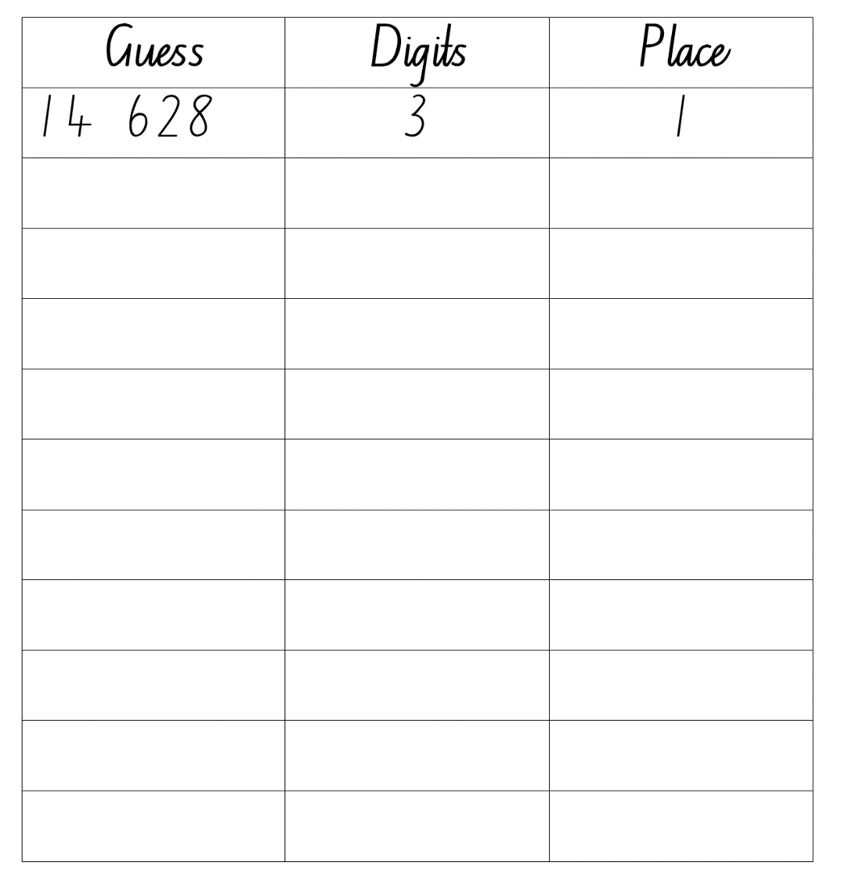
- Players take it in turns to guess their opponent’s 5-digit number. Guessed numbers should be said aloud and named correctly using place value language.
- After each guess, the player’s opponent tells them how many digits are correct and how many are in the correct place.
- Players record their guess, the number of digits that are correct and the number of digits that are in the right place. For example, if the number is 15 384 and the guess is 14 628, there are 3 correct digits and there is one digit in the right place (see Figure 1). Players then use this information to refine their guesses.
- The first player to correctly guess their opponent’s number is the winner.
- The level of difficulty can be changed by using numbers with more or fewer digits and by using numbers with internal zeros.
- After the game, ask questions such as:
- How many guesses did it take to get the correct number?
- What could you do to make it more difficult for your opponent?
- What advice do you have for someone who hasn’t played this game before?
This table details opportunities for assessment.
Assessment opportunities | Links
What to look for:  - Can students read and write 5-digit numbers? [MA2-RN-01] | Links to National Numeracy Learning Progressions (NNLP):  - NPV7.  Links to suggested Interview for Student Reasoning (IfSR) tasks:  - IfSR-NP: 4B.2, 4B.3, 4B.5.

Core lesson 1: Ordering large numbers – 30 minutes
The table below contains suggested learning intentions and success criteria. These are best co-constructed with students.
Core concept learning intentions | Core concept success criteria
Students are learning to:  - arrange numbers in the millions in ascending and descending order  - name numbers in the millions using the place value grouping of ones, tens and hundreds. | Students can:  - arrange sets of place value variation cards in ascending order  - write large numbers and read them out loud using the place value grouping of ones, tens and hundreds.
This activity is an adaptation of Place value with whole numbers from NZ Maths by New Zealand Ministry of Education.
- Discuss big numbers with the class. Ask students:
- Where do you see big numbers?
- Why are they useful?
- Where are large numbers used in real life?
- How do we name them?
- How do we write them?
- Display the place value houses (see Figure 2).
Figure 2 – Place value houses
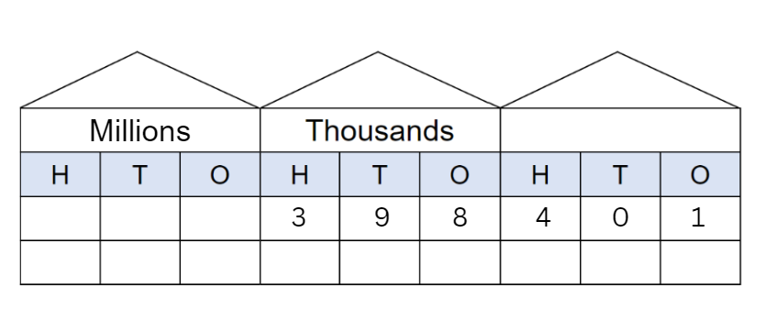
- Explain that the place value houses in Figure 2 show the number 398 401 divided into each of its place values. Each house contains a group of 3 digits. Each house has a hundreds, tens and ones column.
- Using the place value houses, write examples of numbers in the millions and model how they are named. Students repeat the numbers out loud. For example, 2 438 395 is read as two million, four hundred and thirty-eight thousand, three hundred and ninety-five.
- Repeat the process, asking students to write and name the numbers on Resource 1: Place value houses.
- Ask students to identify the place value parts in a number in the millions. For example, in the number 3 491 587 the 3 represents 3 millions, the one represents one thousand and the 9 represents 90 thousands.
- Give pairs of students Resource 2: Millions number cards. Students cut out the cards and arrange them in ascending order, reading each number aloud as they work. Have students share their thinking when ordering the set of cards.
- Students move to another group and check if the cards are ordered correctly.
- As a class, students share the strategies they used when ordering their cards. Record the ideas on the board.
This table details opportunities for differentiation.
Too hard? | Too easy?
Students cannot arrange numbers in ascending order.  - Offer sets of cards with numbers in the thousands.  - Students use place value houses to write each number and arrange in order. | Students can arrange numbers in ascending order.  - Students create another 8 cards, add them to their set and have their partner place them in ascending order.  - Students create a set of 8 cards with numbers in the billions and place these in ascending order.

Core lesson 2: Naming large numbers – 15 minutes
This activity is an adaptation of Place value with whole numbers from NZ Maths by New Zealand Ministry of Education.
- Write a 6-digit number on Resource 1: Place value houses and read it together pointing out the hundreds, tens and ones. Repeat several times with numbers that have zeros in them to emphasise the zero as a place holder.
- In pairs, students make 6-digit numbers, including at least one zero, using the place value houses for their partners, who in turn must read the number. Students then swap over and do this several times.
This table details opportunities for differentiation.
Too hard? | Too easy?
Students cannot name large numbers in the millions.  - Students practice naming numbers in the thousands and 10 thousands.  - Model making numbers on the place value houses starting with hundreds, thousands and 10 thousands. Students read these out loud. | Students can name large numbers in the millions.  - Students write numbers in the billions and read them out loud.  - Students write the numbers without the place value houses and read them out loud.

Discuss and connect the mathematics – 10 minutes
- Show students Resource 3: 100 dots. Ask what they see using words and numbers and record on the board. Answers may include 10 groups of 100, 100 lots of 10 and one hundred groups of one.
- Ask students to Think-Pair-Share what a thousand dots would look like.
- Show students Resource 4: 1000 dots. Ask students what they see using words and numbers and write this on the board.
- Ask students to Think-Pair-Share what 10 000 dots would look like.
- Show students Resource 5: 10 000 dots. Ask students what they see using words and numbers and write this on the board.
- Explain to students that in each case the number is 10 times as large.
- Summarise the lesson, drawing out key mathematical ideas about ordering numbers in ascending and descending order and naming large numbers. Ask:
- Were there any challenges when naming large numbers?
- Were there any challenges when ordering numbers in ascending order?
- What strategies worked best?
This table details opportunities for assessment.
Assessment opportunities | Links
What to look for:  - Can students arrange numbers in the millions in ascending order? [MAO-WM-01, MA3-RN-01]  - Can students name numbers in the millions using the place value groupings of ones, tens and hundreds? [MAO-WM-01, MA3-RN-01] | Links to National Numeracy Learning Progressions (NNLP):  - NPV6, NPV7.

Lesson 2
Core concept: numbers can be renamed in equivalent ways using place value.

Daily number sense: Ordering numbers – 10 minutes
The table below contains a suggested learning intention and success criteria. These are best co-constructed with students.
Daily number sense learning intention | Daily number sense success criteria
Students are learning to:  - order 4- and 5-digit numbers. | Students can:  - arrange 4- and 5-digit numbers in ascending and descending order.
This activity is an adaptation of Order! Order! (four-digit numbers) from Mathematics K-6 resources by State of New South Wales (Department of Education).
- This game may be played individually, in pairs or in small groups.
- Use 0–9 dice, a spinner or playing cards to generate 4 digits. The 4 digits are then combined to create a 4-digit number which is recorded on a sticky note. This process is repeated to make 4 different 4-digit numbers (see Figure 3.)
Figure 3 – Ordering numbers example
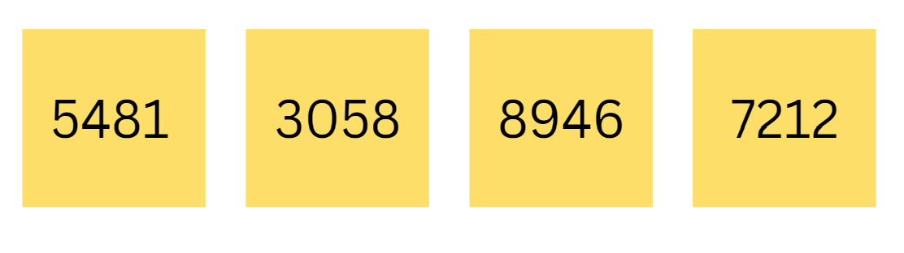
- The aim of the game is to rearrange the sticky notes so the numbers are in ascending order in the fewest moves possible, moving adjacent sticky notes only and recording the number of moves required.
- Repeat with 4 new numbers arranging the sticky notes so the numbers are in descending order.
- Observe students and ask questions, such as:
- What will your next move be? Why?
- What is the largest number?
- What is the smallest number?
- How many moves have you made so far?
- After the game, students turn and talk to compare how many moves they took.
- Repeat the game with 5-digit numbers.
- The level of difficulty can be changed by using numbers with more or fewer digits.
This table details opportunities for assessment.
Assessment opportunities | Links
What to look for:  - Can students arrange 4- and 5-digit numbers in ascending and descending order? [MO-WM-01, MA2-RN-01] | Links to National Numeracy Learning Progressions (NNLP):  - NPV5, NPV6.

Core lesson 1: Non-standard forms of numbers – 25 minutes
The table below contains suggested learning intentions and success criteria. These are best co-constructed with students.
Core concept learning intentions | Core concept success criteria
Students are learning to:  - represent large numbers in different forms  - recognise all forms of numbers including numerals and written standard and non-standard numbers. | Students can:  - represent and rename large numbers flexibly using standard and non-standard forms  - match numeral cards with corresponding non-standard partitioning number cards.
This activity is an adaptation of Place value with whole numbers from NZ Maths by New Zealand Ministry of Education.
- Display the number 8725 and ask students to say it out loud. Explain that numbers can be represented in standard place value ways for example, 8 thousands, 7 hundreds, 2 tens and 5 ones and in non-standard ways for example, 87 hundreds and 25 ones.
- Model standard and non-standard forms of 8,725 with MAB materials and have students say each one out loud. For example:
- 8 thousands, 7 hundreds, 2 tens and 5 ones
- 87 hundreds and 25 ones
- 86 hundreds and 125 ones
- 7 thousands, 17 hundreds, 2 tens and 5 ones.
- Explain to students that even though 8725 has been regrouped into different forms its value remains the same.
- Discuss another example with students suggesting non-standard partitioning and modelling with MAB materials.
- Show students Resource 6: Rewriting numbers. Students work in pairs or small groups to write each number out in standard form and then as many non-standard ways as they can. Use MAB materials to model the non-standard partitioning.
This table details opportunities for differentiation.
Too hard? | Too easy?
Students cannot model or write numbers in non-standard form.  - Model non-standard forms with 2- digit numbers using interlocking cubes and have students say each one out loud.  - Students transfer this knowledge to 3- and 4-digit numbers. | Students can model and write numbers in non-standard form.  - Students model and write non-standard forms of 5-digit numbers and explain their reasoning.  - Write non-standard forms of 5-digit numbers and greater in a systematic way, looking for number patterns.

Core lesson 2: Go Fish – 30 minutes
- Show students Resource 7: Go Fish cards and explain that they will be working in groups of 4 to play the game of Go Fish to consolidate their understanding of standard and non-standard place value forms.
- The aim of the game is to collect as many pairs of cards that show the number in numerals on one card and a form of non-standard partitioning on another card. For example, 650 and 65 tens and zero ones.
- Each student is dealt 5 cards. The remaining cards are placed face down in the middle. Provide students with MAB materials.
- Students match as many pairs as they can from their 5 cards and place them down in front of them.
- Students then find the match for their remaining cards by asking the other players if they have the matching card.
- Students ask for their matching card in different ways. For example, ‘Johnny, have you got 37 tens and 4 ones?’ or ‘Caitlin, have you got 374?’
- If the player has the card, they must hand it over so the pair can be made.
- If the player does not have the card, say ‘Go Fish’ and the player picks up a card from the pile.
- The game continues until all the cards in the pile have been used and the player with the most pairs of cards wins the game.
This table details opportunities for differentiation.
Too hard? | Too easy?
Students are unable to recognise standard and non-standard place value forms.  - Play the game with standard partitioning of numbers only.  - Use cards with only 2-digit numbers. | Students can recognise standard and non-standard place value forms.  - Students create more cards to add to the current game.  - Students redesign the cards using numbers up to one million.

Discuss and connect the mathematics – 5 minutes
- Summarise the lesson, drawing out key mathematical ideas about place value partitioning and representing numbers in standard and non-standard forms. Use cards from the game and ask:
- How can you prove to me that this number card matches with this partitioning card?
- Can you explain that the value of the number is the same after it has been partitioned in different ways?
This table details opportunities for assessment.
Assessment opportunities | Links
What to look for:  - Can students partition numbers in non-standard form? [MAO-WM-01, MA3-RN-01]  - Can students match numeral cards with their corresponding non-standard cards? [MAO-WM-01, MA3-RN-01] | Links to National Numeracy Learning Progressions (NNLP):  - NPV7.

Lesson 3
Core concept: the place value system can be extended.

Daily number sense: Decimals game – 20 minutes
The table below contains a suggested learning intention and success criteria. These are best co-constructed with students.
Daily number sense learning intention | Daily number sense success criteria
Students are learning to:  - compare and order decimals of up to 2 decimal places. | Students can:  - order decimals on a number line.
- Give pairs of students Resource 8: Straight line, Resource 9: Decimal number grid and 2 different coloured pencils.
- Students take turns picking numbers from Resource 9: Decimal number grid and marking their number down on Resource 8: Straight line.
- Students take turns until one student has recorded 3 decimals next to each other on the number line, making them the winner. Repeat.

This table details opportunities for assessment.
Assessment opportunities | Links
What to look for:  - Can students compare 2 decimals and explain which is larger? [MAO-WM-01, MA2-RN-02]  - Can students plot decimals of up to 2 decimal places on a number line? [MAO-WM-01, MA2-RN-02] | Links to National Numeracy Learning Progressions (NNLP):  - NPV6, NPV7.  Links to suggested Interview for Student Reasoning (IfSR) tasks:  - IfSR-NP: 4D.1, 4D.4.

Core lesson: Dividing one – 30 minutes
The table below contains suggested learning intentions and success criteria. These are best co-constructed with students.
Core concept learning intentions | Core concept success criteria
Students are learning to:  - divide one whole into equal parts  - express decimals as linear models. | Students can:  - divide a metre into tenths, hundredths and thousandths  - express decimals by using a linear model.
- Show students a strip of cardboard one metre in length and ask how it could be divided into equal parts. Explain that the whole length of the cardboard is equal to one.
- Students turn and talk, sharing their suggestions with the class. Record these on the board.
- Model using a metre ruler and a marker to divide the cardboard into 10 equal lengths and cut. Explain that each of these pieces is one tenth. One tenth is recorded as 0.1. Each piece is 10 cm in length.
- Ask students, ‘If we divide one of these pieces (one tenth) into 10 equal parts, what would we name them?’
- Divide one tenth into 10 equal lengths and cut.
- Explain that each of these new pieces are one hundredth. One hundredth is recorded as 0.01. Each piece is one centimetre in length.
- Show students the small wooden sticks or toothpicks and explain that because the 1 cm piece of cardboard is too small to cut into 10 pieces, they will use small wooden sticks or toothpicks to represent thousandths. One thousandth is recorded as 0.001.
- Working in pairs, students are provided with a one metre piece of cardboard and a metre ruler. They then cut this piece into tenths and hundredths (see Figure 4). Note that this image is not proportional.
Note: the best way to cut the cardboard up is to cut it into tenths, then take one of the tenths and cut that into hundredths. Thousandths shall be represented by small wooden sticks or toothpicks as the cardboard is too difficult to cut into 1 mm pieces.
Figure 4 – Dividing one cardboard example
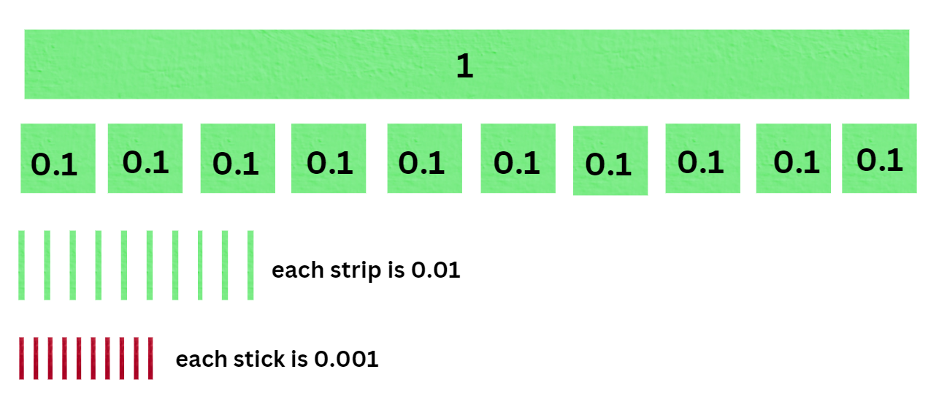
- Use the tenths, hundredths and thousandths to represent a decimal. Students write the number and say it out loud (see Figure 5). The decimal 0.332 is read as three hundred and thirty-two thousandths.
Figure 5 – 0.332 representation
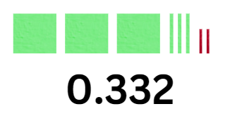
- Reverse the process, writing a decimal number and have the students represent this number using their cardboard pieces.
- Students repeat with their partners, each having a turn at creating and reading decimal numbers.
Note: to support place value conceptual understanding, 6.132 would be read as six and one-hundred and thirty-two thousandths. The word and connects the decimal fraction with the whole number and makes a link with common fractions.
This table details opportunities for differentiation.
Too hard? | Too easy?
Students cannot create and name decimal numbers.  - Model numbers with one decimal place at first (tenths), working up to hundredths and thousandths.  - Students make decimal numbers with tenths then working their way up to hundredths and thousandths. | Students can create and name decimal numbers.  - Students write all the decimal numbers they have created on pieces of cardboard and place them on a number line from zero to one.  - Students create more decimal numbers and have a peer place them on a number line from zero to one.

Consolidation and meaningful practice – 10 minutes
- Students use pictures and drawings to represent some of the decimals they have created.
- Create a blank number line. Students place a selection of decimals on the number line.
- Conclude the lesson by having the students write reflections on what they have learnt today. Discuss the challenges they encountered when trying to place the decimals on the number line.
This table details opportunities for assessment.
Assessment opportunities | Links
What to look for:  - Can students explain the relationship between tenths, hundredths and thousandths as parts of the whole? [MAO-WM-01, MA3-RN-02]  - Can students order decimals on a number line from zero to one? [MAO-WM-01, MA3-RN-02] | Links to National Numeracy Learning Progressions (NNLP):  - NPV7, NPV8.

Lesson 4
Core concept: the position of each digit in a number corresponds to its size.

Daily number sense – 15 minutes
- From a class need surfaced through formative assessment data, identify a short, focused activity that targets students’ knowledge, understanding and skills. Example activities may be drawn from the following resources:
- Mathematics K-6 resources
- Universal Resources Hub.

Core lesson: Plotting decimals on a number line – 30 minutes
The table below contains suggested learning intentions and success criteria. These are best co-constructed with students.
Core concept learning intentions | Core concept success criteria
Students are learning to:  - compare and order decimals of up to 3 decimal places  - plot decimal numbers up to 3 decimal places on a number line. | Students can:  - order decimals from one decimal place up to 3 decimal places in the correct order  - draw number lines and plot values of nutrients in ascending order.
- Write 0.190 and 0.19 on the board and ask students if these 2 decimals have the same value. Students turn and talk and share thoughts with the class. Explain that these 2 decimals have the same value and that dropping the zero or zeros at the end of a decimal does not change its value.
- Explain that when buying food at a supermarket every packet contains a panel with nutritional information. This information contains the standard serving size for each product and what nutrients are contained in that serve. It can also be very helpful for people with food allergies.
- Display Resource 10: Nutrition information label and ask students to Think-Pair-Share what they see. Explain that food contains nutrients such as protein, fat, sugars and sodium and the amounts of these nutrients are recorded on the packaging as grams per serving or per 100 g.
- Display Resource 11: Nutrient levels in food, explaining that the table shows the sodium, sugar and potassium levels of 10 different types of foods per serving. As a class, discuss the different foods and levels of nutrients in each one.
- In pairs, students draw a number line for each of the different nutrients on Resource 11: Nutrient levels in foods and plot the values. Prompt students to carefully consider the starting and ending values on the number lines.
- Students go on a gallery walk to see decimals placed on the number lines.

This table details opportunities for differentiation.
Too hard? | Too easy?
Students cannot plot decimals on a number line.  - Start with decimals that have one decimal place and progress to 2 and 3 decimal places.  - Provide number lines with the starting, halfway and ending values on their number lines. | Students can plot decimals on a number line.  - Students research the nutritional value of 10 different types of foods they can buy from the canteen.  - Students can plot these values on number lines.

Discuss and connect the mathematics – 10 minutes
- Review the example used at the beginning of the lesson. Compare 0.270 and 0.27 and ask students if these 2 decimals have the same value.
- Ask students to consider this decimal number, 0.207. Does it have the same value also?
- Summarise the lesson, drawing out key mathematical ideas when plotting decimals on a number line. Ask:
- What were some of the more challenging decimals to plot on the number line? Why?
- How did you know what the starting and ending values of the number line should be?
- How can you be sure that the decimals have been placed in the correct position on the number line? Explain.
- Are decimals with 3 decimal places larger than decimals with 2 decimal places? Use examples to convince the class.

This table details opportunities for assessment.
Assessment opportunities | Links
What to look for:  - Can students plot decimals with 3 decimal places on a number line? [MAO-WM-01, MA3-RN-02]  - Can students interpret the digit zero at the end of a decimal number? [MAO-WM-01, MA3-RN-02] | Links to National Numeracy Learning Progressions (NNLP):  - NPV8.  Links to suggested Interview for Student Reasoning (IfSR) tasks:  - IfSR-PT: 1A.5, 1A.6, 1A.7.

Lesson 5
Core concept: prime numbers are building blocks.

Daily number sense: 101 and you’re out – 10 minutes
Daily number sense activities for Lessons 5 to 7 ‘loop’ back to concepts and procedures covered in previous units to assist students to build an increasingly connected network of ideas. These concepts may differ from the core concepts being covered by the unit.
The table below contains a suggested learning intention and success criteria. These are best co-constructed with students.
Daily number sense learning intention | Daily number sense success criteria
Students are learning to:  - use mental strategies for addition. | Students can:  - use mental strategies to add 2-digit numbers.
This activity is an adaptation of 101 and you're out (2-digit-addition) from Mathematics K-6 resources by State of New South Wales (Department of Education).
- In pairs, students make a game board by drawing a table with 4 columns and 7 rows. Label the columns from left to right as ‘tens’, ‘ones, ‘number’ and ‘total’ (see Figure 6).
- Using a 0–9 die or spinner, players take turns to roll or spin.
- After every roll, each player decides whether to write the number in the tens or ones column. For example, if a 4 is rolled, players can either write it in the tens column to indicate 40 or in the ones column to indicate 4.
- The game concludes after 6 rolls or spins. The winner is the player whose sum is closest to 100 without going over.
Figure 6 – 101 and you're out example
Tens | Ones | Number | Total
4 |  | 40 | 40
 | 8 | 8 | 48
1 |  | 10 | 58
- Option: draw another gameboard and use the same numbers from the game to get a total closer to 100 than in the previous game.
Note: variations could include using a 6-sided die or spinner, having each player roll and record their own throws or spins only, having the whole class use the same rolls or spins, including a thousands column and aiming to get a sum of 1000, starting at 100 and subtracting each throw to get as close to zero as possible.
- As a class, discuss questions such as:
- What strategy did you use to try to win the game and was it successful? Why or why not?
- What might you do differently next time?
- What strategies did you use to get the total?
- Were some strategies more efficient than others? Explain.
This table details opportunities for assessment.
Assessment opportunities | Links
What to look for:  - Can students use mental strategies to add 2-digit numbers? [MAO-WM-01, MA2-AR-01] | Links to National Numeracy Learning Progressions (NNLP):  - AdS7.  Links to suggested Interview for Student Reasoning (IfSR) tasks:  - IfSR-AT: 2A.2, 3A.2.

Core lesson 1: Prime numbers – 25 minutes
The table below contains suggested learning intentions and success criteria. These are best co-constructed with students.
Core concept learning intentions | Core concept success criteria
Students are learning to:  - model different ways to show a number as a product  - determine and compare prime and composite numbers. | Students can:  - rearrange tiles to show different ways of finding a product  - identify the factors of a given number and use that information to determine whether it is prime, composite or neither.
- Provide groups of students with 24 counters. Ask students to arrange them in 2 rows of 12. Explain that this is a visual representation of 2 twelves and that the product is 24.
- Ask students to rearrange the counters into 3 rows of 8. Explain that this is a visual representation of 3 eights and that the product is also 24.
- Ask students to rearrange the counters into different arrays, showing a product of 24. For example, 4 rows of 6, 4 sixes.
- Select students to explain their thinking.
- Repeat using a different product.
This activity is an adaptation of Prime Numbers from NZ Maths by New Zealand Ministry of Education.
- Provide groups of students with square tiles or pattern blocks. Ask groups to predict how many rectangles they could build using only 6 tiles. Groups test their predictions and record their solutions.
- Ask selected groups to share their solutions.
- Show students that 2 rectangles can be made, one row of 6 and 2 rows of 3 (see Figure 7). Explain that this is a visual representation of the factors of 6. That is, one, 6, 2 and 3. The rectangles can also be rotated, which might lead some students to think they can make 4 rectangles (see Figure 8).
Figure 7 – 6-tile rectangles
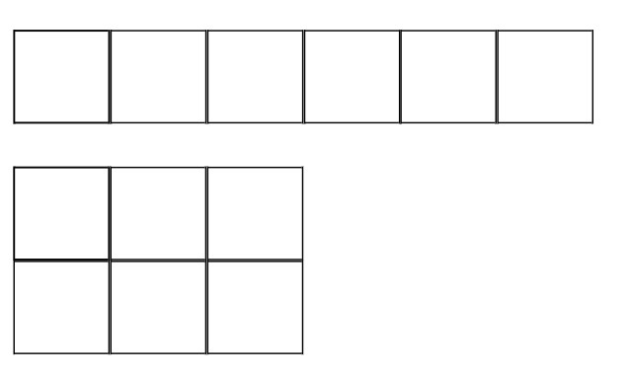
Figure 8 – 6-tile rectangles rotated
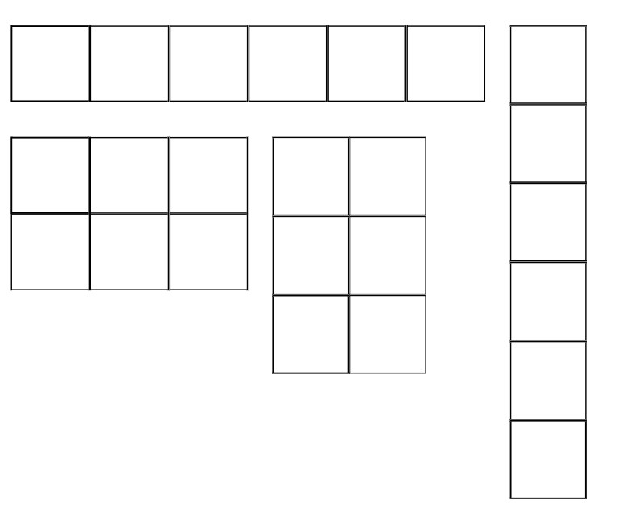
- Provide further examples if required, ensuring that students are familiar with the term ‘factor’ and how to use tiles to represent them.
- Ask students to repeat the task using 7 tiles. Explain that only one rectangle can be made (see Figure 9). Explain that this is because 7 is a prime number and that a prime number has exactly 2 factors, itself and one. Tell students that numbers which have more than 2 factors are called composite numbers.
Figure 9 – 7-tile rectangle
Prime number: a prime number is a positive integer which has exactly 2 distinct factors, itself and one. Modelled as an array it has only one row.
Composite number: a non-zero natural number that has a factor other than one and itself. For example, all even numbers besides 2 are composite numbers. Some odd numbers are composite (for example, 21) but not all are composite (for example, 11).
Factor: a number which divides another number without a remainder. For example, one, 2, 3 and 6 are factors of 6, but 4 and 5 are not.
- Ask students to predict which other numbers are prime numbers and to test their predictions using tiles. Students record which numbers are prime and which are composite.
- Ask groups to share their findings and make a class list of prime and composite numbers. Ask students what prime numbers have in common. If the number 2 has not been listed, ask students to predict if it is prime or composite and to test their predictions. Discuss the number one and zero and whether they are prime or composite. You may also choose to discuss square numbers at this point.

Consolidation: Factors and multiples – 25 minutes
This activity is an adaptation of Factors and Multiples Game from NRICH by University of Cambridge (Faculty of Mathematics).
- Explain that students are going to play a game in pairs. Give each pair a copy of Resource 12: Number chart. The first player chooses an even number less than 50 and crosses it out. The second player chooses another number to cross out; it must be either a factor or a multiple of the previous number. Numbers can only be crossed out once. Record each move on a piece of paper or a whiteboard, noting whether the number crossed out is a factor or a multiple of the previous number (See Figure 10).
Figure 10 – Factors and multiples example
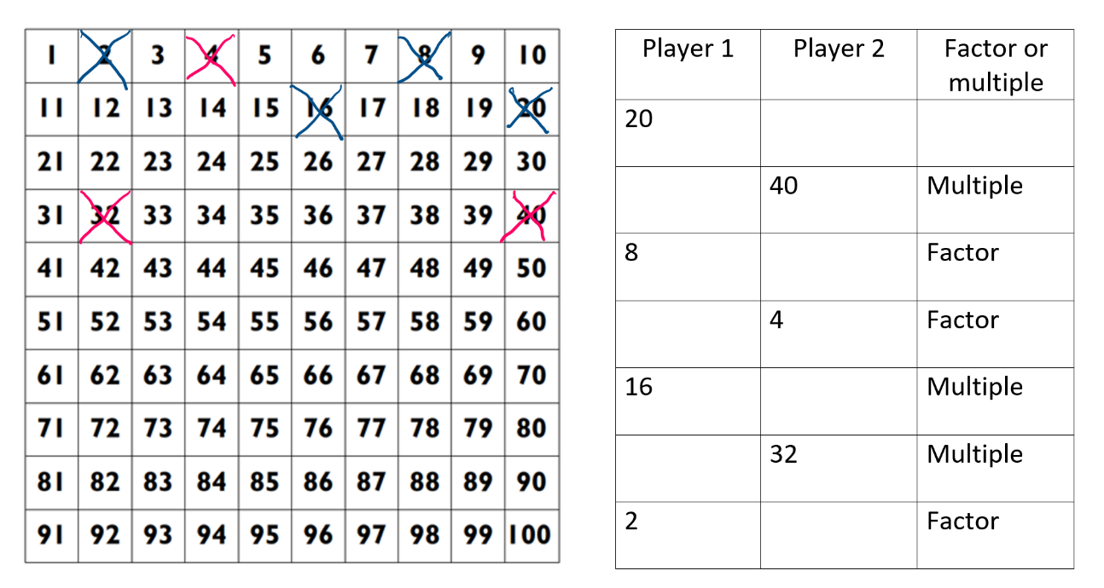
- Players continue to alternate turns, crossing out a number that is either a factor or a multiple of the previous number and recording each move. The game continues until a player is unable to cross out a number. The winner is the player who crossed out the last number. An interactive version is also available.
- Play the game again, with players alternating who goes first.
- As a class, discuss questions such as:
- How many numbers were crossed out?
- Did the number of numbers crossed out change as you played more games? Why or why not?
- Did changing which player went first affect the game? How?
- Are there any winning strategies?
- Why are less moves possible after a prime number is crossed out?
- How could you make this game easier or harder?
- Play the game several more times, with players working collaboratively to make the longest possible sequence of numbers that can be crossed out. Ask groups to share their results and discuss strategies to get a longer sequence.
This table details opportunities for differentiation.
Too hard? | Too easy?
Students cannot identify factors or multiples when playing the game.  - Provide materials such as times table charts and explain how to identify multiples and factors.  - Cover an appropriate section of numbers on the number chart. For example, 51–100. | Students can identify factors and multiples when playing the game.  - Use a number chart that goes beyond 100.  - Students aim to cross out at least half the numbers in the collaborative game.

Discuss and connect the mathematics – 5 minutes
Note: prime numbers are the building blocks we rely on when thinking about the product of whole numbers. Every whole number is either a prime or the product of primes. This property is the basis of providing security on the internet. When you multiply 2 prime numbers together, the result is a number that can only be broken down into those primes. For example, the product of the first 2 primes is 6 and the only prime factors of 6 are 3 and 2.
- Discuss the following questions:
- Are all odd numbers prime numbers? Why or why not?
- Are all even numbers composite numbers? Why or why not?
- Are all multiples of 3 prime or composite? Provide examples to support your answer.
- Are all multiples of 10 prime or composite? How do you know?
- What happens when you multiply 2 prime numbers together?
- What is the highest prime number between one and 100?
This table details opportunities for assessment.
Assessment opportunities | Links
What to look for:  - Can students rearrange tiles to show different ways of finding a product? [MAO-WM-01, MA3-MR-01]  - Can students determine factors for a given whole number? [MAO-WM-01, MA3-MR-01]  - Can students explain why a given whole number is prime, composite or neither? [MAO-WM-01, MA3-MR-01] | Links to National Numeracy Learning Progressions (NNLP):  - MuS6, MuS7.

Lesson 6
Core concept: known number facts and strategies support multiplicative understanding.

Daily number sense: Dicey addition – 15 minutes
The table below contains a suggested learning intention and success criteria. These are best co-constructed with students.
Daily number sense learning intention | Daily number sense success criteria
Students are learning to:  - select strategies flexibly to solve addition and subtraction problems of up to 3 digits. | Students can:  - use mental strategies to add 3-digit numbers.
This activity is an adaptation of Dicey addition (3-digit addition) from Mathematics K-6 resources by State of New South Wales (Department of Education).
- In pairs, students draw an identical gameboard for each player (see Figure 11). Ensure that each pair has a 0–9 die or spinner.
Figure 11 – Dicey addition gameboard
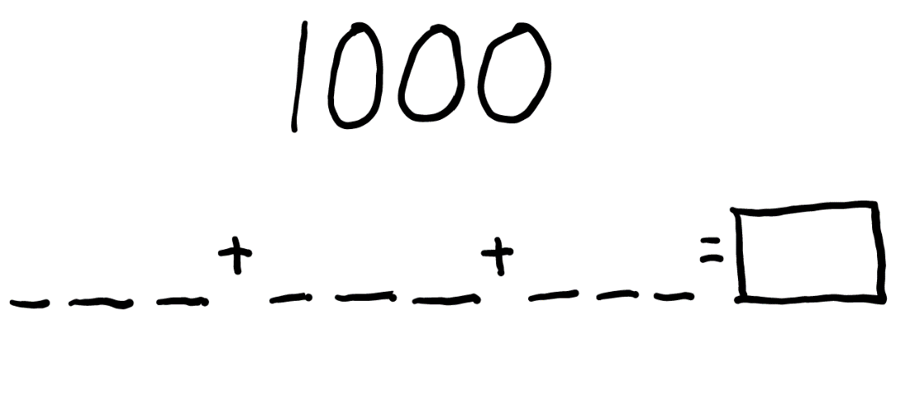
- Each player will have 9 turns.
- The player whose sum is closest to 1000 is the winner.
- Players take turns to roll the die or spin the spinner and decide where to write that digit in the equation.
- As a class, discuss questions, such as:
- Were there any challenges?
- Did you use a written or mental strategy to work out the sum of your 3 numbers?
- Why did you choose that strategy?
- Are there any other ways you could have done it?
- What strategy did you use to try to win the game and was it successful?
- How could you make the game easier?
- How could you make the game harder?
This table details opportunities for assessment.
Assessment opportunities | Links
What to look for:  - Can students use mental strategies to add 3-digit numbers? [MAO-WM-01, MA2-AR-01] | Links to National Numeracy Learning Progressions (NNLP):  - AdS7, AdS8.  Links to suggested Interview for Student Reasoning (IfSR) tasks:  - IfSR-AT: 3A.2.

Core lesson: Make 1000 – 45 minutes
The table below contains suggested learning intentions and success criteria. These are best co-constructed with students.
Core concept learning intentions | Core concept success criteria
Students are learning to:  - demonstrate a deep understanding of place value by using mental strategies to multiply one-digit numbers by multiples of 10 and 100. | Students can:  - use mental strategies to multiply one-digit numbers by multiples of 10 and 100.
- Explain that the class will play another game where the goal is to make 1000. In this game students will practise multiplying one-digit numbers by multiples of 10. A 1–10 spinner will be used to determine the one-digit number. Players must then multiply that number by a multiple of 10 of their choice. The multiple of 10 can be no lower than 10 and no higher than 60. Players record the equation and product, then repeat the process another 6 times, adding the products each time to get a progressive total (see Figure 12). The winner is the player whose total is closest to 1000 after 7 spins.
Figure 12 – Make 1000 example
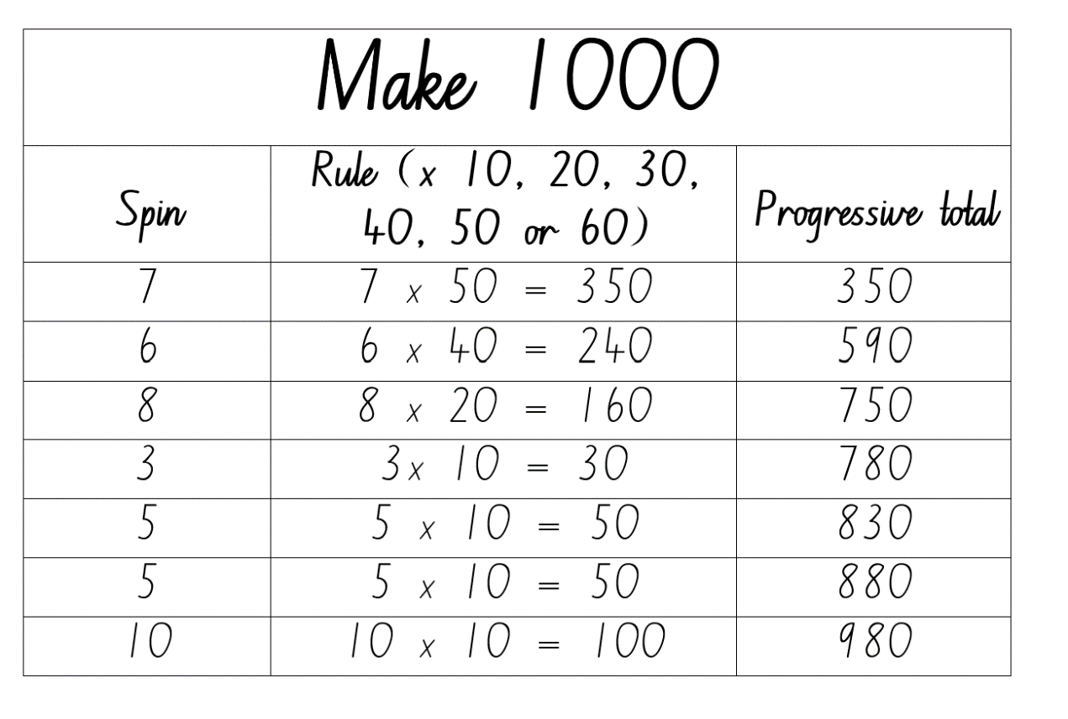
- Model the game with the class. Discuss options after each spin, demonstrating strategies to determine the product for each option before deciding which rule to apply. Ensure students understand the progressive total and how to calculate it.
- After the final total has been determined, discuss decisions made during the game and different strategies that could lead to a total closer to 1000. Remind students that the winner is the player with the total closest to 1000 and explain that sometimes the closest total might be higher than 1000.
- Students draw their own gameboard (see Figure 12). Play the game again as a class, allowing students to make their own choices and record their equations and progressive totals.
- After the first 5 spins, select students to explain their thinking and justify their choices.
- After the sixth spin, select students to share what equation would give them a final total close to 1000.
- After the seventh spin, students record their final total and work out how close they are to 1000. Select students to share their totals.
- Ask students to turn and talk and discuss choices that had a significant impact on their final total.
- Provide pairs with a 1–10 spinner or 10-sided die. Alternatively, students can use an interactive random number generator. Students create another gameboard and play in pairs.
This table details opportunities for differentiation.
Too hard? | Too easy?
Students cannot multiply by multiples of 10.  - Play in groups of 4 so that each player has a partner to assist.  - Provide multiplication grids and model using the link between multiplication facts and multiplying by multiples of 10. | Students can multiply by multiples of 10.  - Increase or decrease the target number.  - After the sixth throw, students have the option of changing the rule they applied to one of their throws and updating their progressive total before the last throw.

Discuss and connect the mathematics – 5 minutes
- As a class, discuss questions such as:
- What advice would you give to someone playing the game for the first time?
- How could you make the game easier or harder?
- What strategies did you use when multiplying by multiples of 10?
This table details opportunities for assessment.
Assessment opportunities | Links
What to look for:  - Can students multiply one-digit numbers by multiples of 10? [MAO-WM-01, MA3-MR-01] | Links to National Numeracy Learning Progressions (NNLP):  - MuS6, MuS7.

Lesson 7
Core concept: flexible methods of computation in multiplication and division involve composing and decomposing numbers.

Daily number sense: What’s missing? – 15 minutes
The table below contains a suggested learning intention and success criteria. These are best co-constructed with students.
Daily number sense learning intention | Daily number sense success criteria
Students are learning to:  - complete number sentences involving additive relations to find unknown quantities. | Students can:  - find the missing number in a number sentence involving operations of addition or subtraction on both sides of the equals sign  - explain how they found the missing number.
- Students find the missing number in the following number sentences:
- 26 + 7 = _ + 19
- 56 + _ = 34 + 49
- 65 − 18 = 83 − _
- Select students to share their thinking and as a class discuss questions such as:
- What is the role of the equals sign? The equals sign represents balance and equality.
- Which questions did you find the easiest? Why?
- Which questions did you find the hardest? Why?
- How did you find the missing numbers?
- Are there any other ways to find the missing numbers?
This table details opportunities for assessment.
Assessment opportunities | Links
What to look for:  - Can students find the missing number in a number sentence involving operations of addition or subtraction on both sides of the equals sign? [MAO-WM-01, MA2-AR-02]  - Can students explain their thinking? [MAO-WM-01, MA2-AR-02] | Links to National Numeracy Learning Progressions (NNLP):  - NPA4.  Links to suggested Interview for Student Reasoning (IfSR) tasks:  - IfSR-AT: 2A.1, 3A.1.

Core lesson: Multiplying multiples – 30 minutes
The table below contains suggested learning intentions and success criteria. These are best co-constructed with students.
Core concept learning intentions | Core concept success criteria
Students are learning to:  - demonstrate place value understanding by using mental strategies to multiply one-digit numbers by multiples of 10 and 100  - develop the ability to estimate the product of 2 numbers, where one is a one-digit number and the other is a 2- or 3-digit number, using multiples of 10 or 100. | Students can:  - use mental strategies to multiply one-digit numbers by multiples of 10 and 100  - use multiples of 10 and 100 to estimate the product of one-digit by 2- and 3-digit numbers.
- Demonstrate the link between place value and multiplicative thinking by using a number slide to multiply single digit numbers by multiples of 10 and 100. Multiple examples should be used. To aid student understanding, use language such as ‘2 by 4 tens is 8 tens’ and record the answer as 8 tens and zero ones.
Note: it is a common misconception that multiplying by 10 can be done by simply ‘adding a zero’ and multiplying by 100 can be done by ‘adding 2 zeros’. This should be avoided as it detracts from a deeper understanding of place value, multiplicative thinking and the link between them.
This activity is an adaptation of Multiply Multiples 1 from NRICH by University of Cambridge (Faculty of Mathematics).
- Display _0 × _ = _0 × _. Explain that each _ represents a missing digit and that students need to work out different ways to balance the equation. For example, 10 × 2 = 20 × 1.
- Students work in groups and record as many possible solutions as they can.
- As students are working remind them that both sides of the equation must balance. Ask how students can use their prior knowledge of multiplication facts to help them, for example 2 × 4 = 8 so 2 × 40 = 80. Ask students to explore other possible strategies such as place value partitioning, factorising and halving. Evaluate strategies by asking questions, such as:
- Which strategy or strategies did you prefer? Why?
- Which strategy was the most efficient? Why?
- Did certain strategies work better for different equations? Why?
- Select groups to share how they recorded their answers. Encourage students to record their answers systematically so that they can look for patterns and make predictions. Working systematically might involve starting with the lowest values possible, for example 10 × 1 = 10 × 1. Decide as a class if this example should be included as both sides of the equation are identical. Then move on to 10 × 2 = 20 × 1.
- Ask students if there is another way of making 20. Then try 10 × 3, 10 × 4 and so on. Alternatively, you might encourage groups to work through all the options for 10 × and then move on to 20 × 1, 20 × 2, 20 × 3 and so on. Organising results according to how many ways the equation can be balanced will support students to notice patterns and make conjectures. For example, see Figure 13.
Figure 13 – Balancing equations example
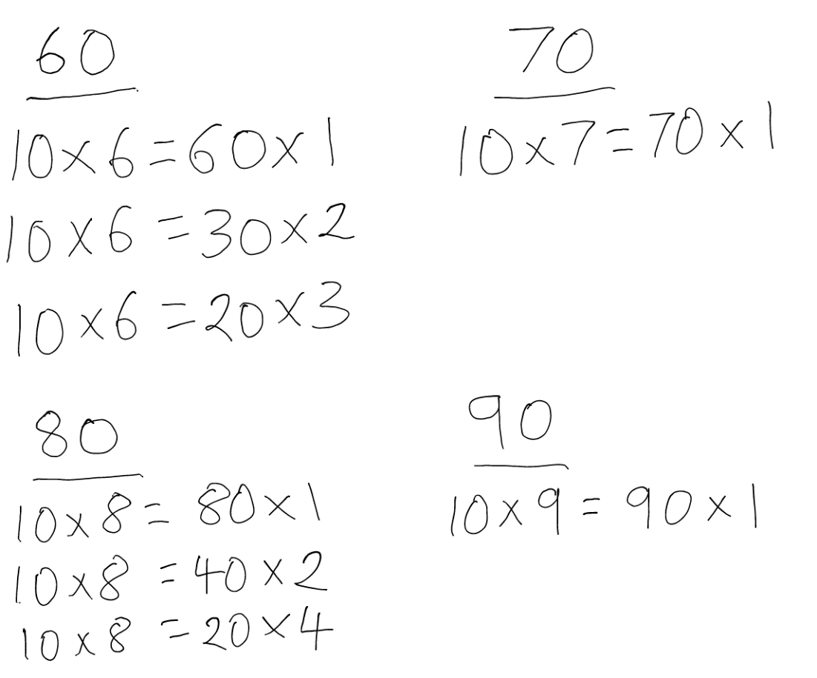
- Conduct a gallery walk and examine similarities and differences between groups’ work.
- As a class, discuss questions, such as:
- How did you record your answers? Why?
- What patterns did you notice?
- Can you explain why some equations can be balanced in more than one way, but others can be balanced in only one?
- Repeat the process with the equation _00 × _ = _00 × _. For example, 200 × 4 = 800 × 1.
- Reflect on the activity by asking questions, such as:
- How did multiplying by multiples of 10 help you when multiplying by multiples of 100?
- What patterns did you notice?
- What does the = symbol mean?
- How confident are you to multiply one-digit numbers by multiples of 10 and 100?
- How would you teach this to someone for the first time?
This table details opportunities for differentiation.
Too hard? | Too easy?
Students cannot multiply by multiples of 10 or 100 or balance the equations.  - Provide multiplication grids and a number slide and model using the link between multiplication facts and multiplying by multiples of 10 and 100.  - Provide concrete materials, such as MAB materials and equal-arm balances to assist with multiplication and balancing equations. | Students can multiply by multiples of 10 and 100 and balance the equations.  - Students repeat the process with the equation _000 × _ = _000 × _  - Students explore balancing similar equations using division. For example, 80 ÷ 4 = 100 ÷ 5.

Consolidation and meaningful practice – 15 minutes
- Explain that multiplying by multiples of 10 and 100 can be used to estimate. For example, 28 × 5 can be estimated by multiplying 5 by the nearest multiple of 10 to 28, which is 30. Remind students that estimation can be used to check how reasonable an answer is. In this example, 30 × 5 = 150; 28 is smaller than 30 so the answer to 28 × 5 must be less than 150.
- Students use their knowledge of multiplying one-digit numbers by multiples of 10 and 100 to estimate the following. Ask students to explain if their estimate is less or greater than what the exact answer would be. Students aren't expected to work on all each these questions.
- 39 × 5 =
- 48 × 8 =
- 37 × 9 =
- 52 × 7 =
- 71 × 6 =
- 492 × 4 =
- 312 × 8 =
- 507 × 6 =
- 747 × 9 =
- Select students to share their estimates and explain their thinking.

This table details opportunities for assessment.
Assessment opportunities | Links
What to look for:  - Can students use mental strategies to multiply one-digit numbers by multiples of 10 and 100? [MAO-WM-01, MA3-MR-01]  - Can students use multiples of 10 and 100 to estimate the product of one-digit by 2- and 3-digit numbers? [MAO-WM-01, MA3-MR-01] | Links to National Numeracy Learning Progressions (NNLP):  - MuS6, MuS7.  Links to suggested Interview for Student Reasoning (IfSR) tasks:  - IfSR-MT: 3A.1, 3A.2, 3A.3.

Lesson 8
Core concept: structures can support multiplicative thinking.

Daily number sense – 15 minutes
- From a class need surfaced through formative assessment data, identify a short, focused activity that targets students’ knowledge, understanding and skills. Example activities may be drawn from the following resources:
- Mathematics K-6 resources
- Universal Resources Hub.

Core lesson: The area model – 30 minutes
The table below contains suggested learning intentions and success criteria. These are best co-constructed with students.
Core concept learning intentions | Core concept success criteria
Students are learning to:  - use the area model to solve multiplication problems  - use the distributive property to partition numbers when multiplying. | Students can:  - use MAB materials to demonstrate the area model when multiplying a 2-digit number by a one-digit number  - use partitioning and number facts to multiply a 2-digit number by a one-digit number.
- Introduce the area model of multiplication by demonstrating with MAB materials or virtual manipulatives. For example, model 2 × 10 and 2 × 100 (see Figure 14).
- Explain that 2 × 10 is represented by 2 tens and 2 × 100 is represented by 2 hundreds.
- Emphasise that this representation is to scale and note the difference in size. Explain that 2 × 100 is 10 times as large compared to 2 × 10.
- Ask how students could prove this. Demonstrate, if necessary, by placing the 2 tens on top of the 2 hundreds and counting how many times it can be moved from left to right to cover another 2 tens.
- Emphasise the link to place value and the concept of ‘10 of these is one of those’. This may be repeated with multiple examples of multiplying by 10 and 100, including opportunities for renaming.
Figure 14 – Area model multiplication example
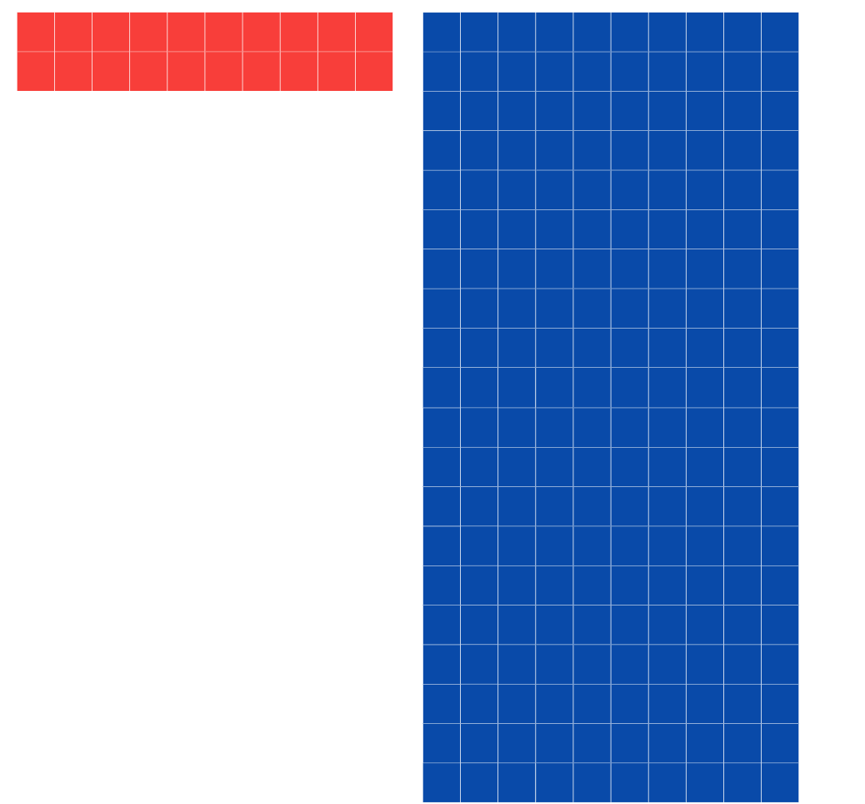
- Provide groups of students with MAB materials or virtual manipulatives. Students explore this concept by representing and recording answers to questions that promote the distributive property, such as:
- 3 × 50 =
- 5 ×30 =
- 4 × 60 =
- 6 × 40 =
- 3 × 300 =
- 3 × 200 =
- 2 × 400 =
- 4 × 200 =
- Select groups to share their thinking.
- Reflect on the activity by discussing questions, such as:
- How did you record your answers?
- How did your knowledge of multiplication facts help?
- Was renaming necessary? Why?
- What did you notice about your answers?
- Can you explain why 3 by 5 tens is the same as 5 by 3 tens?
- How is knowing this (the distributive property) helpful?
- Using MAB materials or virtual manipulatives, demonstrate that the area model can also be used to multiply 2-digit numbers that are not multiples of 10 by one-digit numbers. For example, 23 × 3 (see Figure 15). Explain that it is easier to use partition 23 into tens and ones than think of 3 twenty-threes. Remind students that their knowledge of multiplication facts can be extended to multiply multiples of 10 (and 100). For example, 3 twos are 6, so 3 by 2 tens is 6 tens.
Figure 15 – 23 × 3 area model
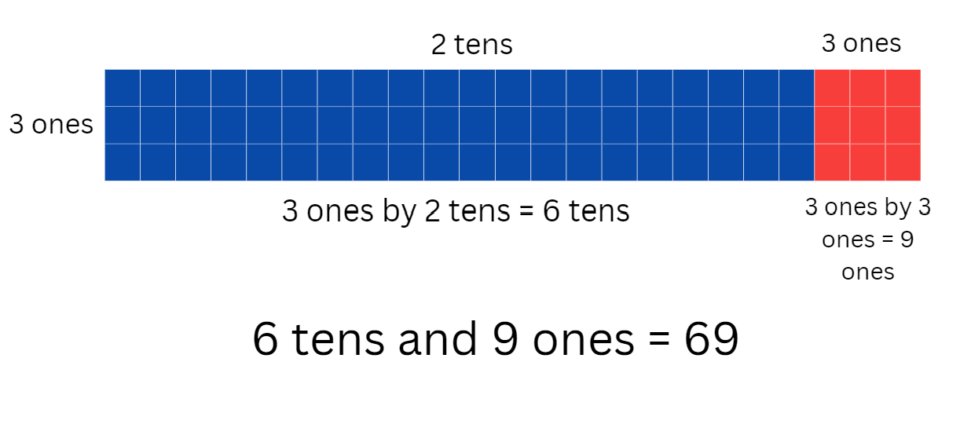
- Provide groups of students with MAB materials or virtual manipulatives. Students explore this concept by representing and recording answers to questions, such as:
- 3 × 23 =
- 4 × 32 =
- 2 × 44 =
- 5 × 38 =
- 7 × 27 =
- 6 × 28 =
- 5 × 46 =
- 8 × 26 =
- Students can create their own examples to represent their thinking.
- Select groups to share their thinking and explain their solutions.
- Reflect on the activity by discussing questions such as:
- How did you record your answers?
- How did your knowledge of multiplication facts help?
- How did partitioning the 2-digit number help?
- Was renaming necessary? Why?
- Could the area model be used to multiply 3-digit numbers? Why or why not?
This table details opportunities for differentiation.
Too hard? | Too easy?
Students cannot multiply 2-digit numbers by one-digit numbers.  - Provide materials, such as MAB materials, a number slide, number chart and multiplication grid.  - Link the area model to arrays and skip counting. | Students can multiply 2-digit numbers by one-digit numbers.  - Students create word problems that require 2-digit by one-digit multiplication for other students to solve.  - Investigate if the area model can be used for division.
This table details opportunities for assessment.
Assessment opportunities | Links
What to look for:  - Can students use MAB materials to demonstrate the area model when multiplying a 2-digit number by a one-digit number? [MAO-WM-01, MA3-MR-01]  - Can students partition a 2-digit number into tens and ones when multiplying by a one-digit number? [MAO-WM-01, MA3-MR-01] | Links to National Numeracy Learning Progressions (NNLP):  - MuS6, MuS7.  Links to suggested Interview for Student Reasoning (IfSR) tasks:  - IfSR-MT: 3A.1, 3A.2, 3A.3.

Consolidation and meaningful practice – 15 minutes
- Show students Goat busters and explain that they will playing Level 1 to practise using the area model multiply a one-digit number by a 2-digit number. Explain that the 2-digit number needs to be partitioned into tens and ones before multiplying.
- Students play the game, recording their thinking for each question on whiteboards.

Resource 1: Place value houses
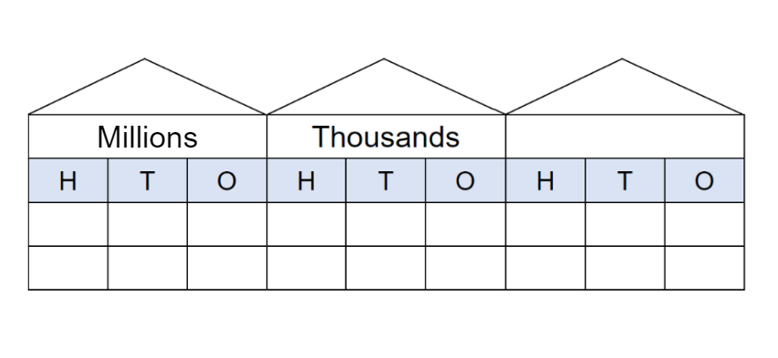

Resource 2: Millions number cards
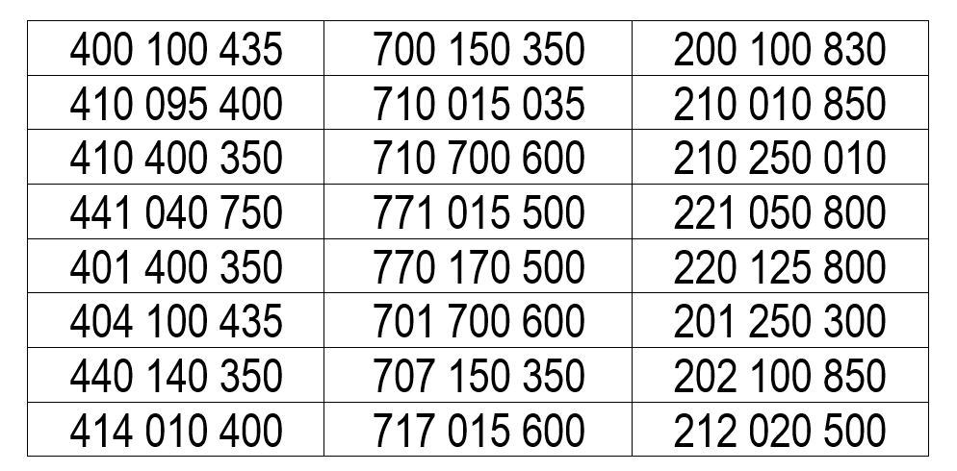

Resource 3: 100 dots

Resource 4: 1000 dots

Resource 5: 10 000 dots

Resource 6: Rewriting numbers
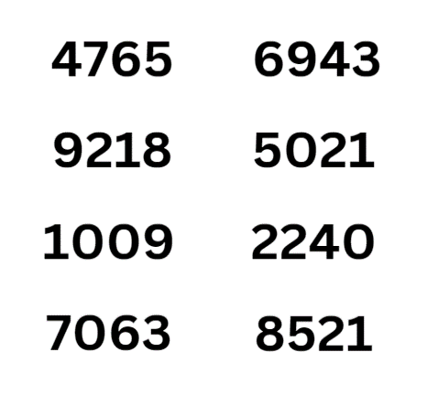

Resource 7: Go Fish cards
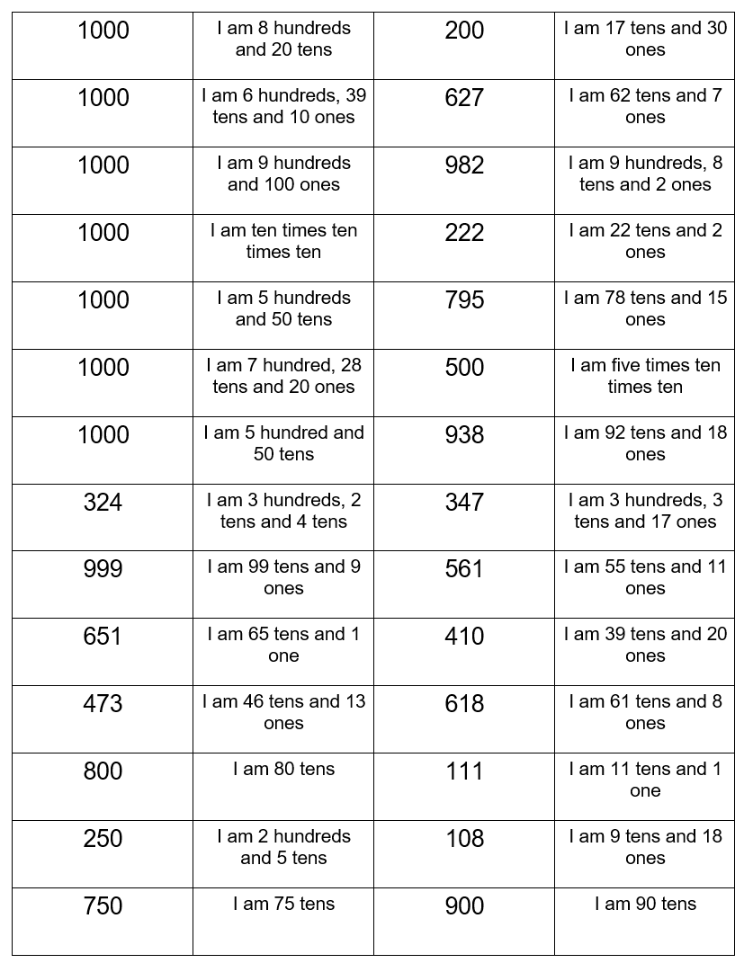

Resource 8: Straight line

Resource 9: Decimal number grid
0.15 | 0.94 | 0.9 | 0.64 | 0.72 | 0.32
0.3 | 0.75 | 0.56 | 0.20 | 0.5 | 0.28
0.25 | 0.4 | 0.38 | 0.1 | 0.6 | 0.17

Resource 10: Nutrition information label
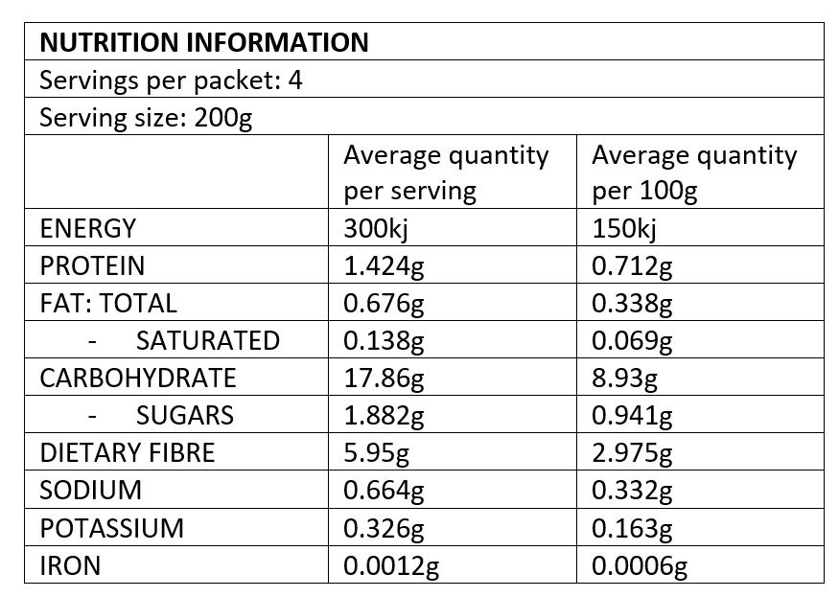

Resource 11: Nutrient levels in food
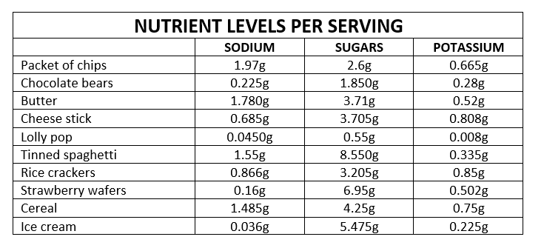

Resource 12: Number chart
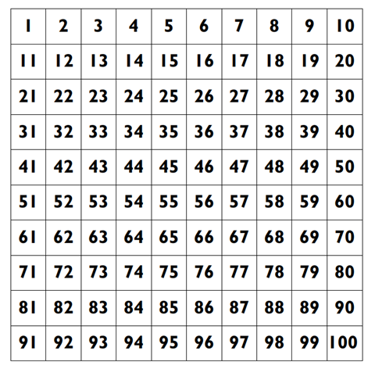

Syllabus outcomes and content
The table below outlines the syllabus outcomes and range of relevant syllabus content covered in this unit. Content is linked to National Numeracy Learning Progression version (3).
Outcomes and content | 1 | 2 | 3 | 4 | 5 | 6 | 7 | 8
Representing numbers using place value A: Whole numbers: Read, represent and order numbers to thousands
MAO-WM-01, MA2-RN-01
- Represent numbers up to and including thousands using physical or virtual manipulatives, words, numerals, diagrams and digital displays | x | x
- Read and order numbers of up to at least 4 digits | x | x
Representing numbers using place value B: Whole numbers: Order numbers in the thousands
MAO-WM-01, MA2-RN-01
- Arrange numbers in the thousands in ascending and descending order |  | x
Representing numbers using place value B: Decimals: Make connections between fractions and decimal notation
MAO-WM-01, MA2-RN-02
- Make connections between fractions and decimal notation for key benchmark values (Reasons about relations) |  |  | x
Additive relations A: Select strategies flexibly to solve addition and subtraction problems of up to
3 digits
MAO-WM-01, MA2-AR-01
- Apply known mental strategies that use partitioning to add and subtract, such as bridging the decades |  |  |  |  | x
- Compare and evaluate strategies used to solve addition and subtraction problems, reasoning which strategy may be most efficient |  |  |  |  | x
Additive relations B: Partition, rearrange and regroup numbers to at least 1000 to solve additive problems
MAO-WM-01, MA2-AR-01
- Model addition with and without regrouping and record the method used |  |  |  |  |  | x
- Use an algorithm with understanding to record addition and subtraction calculations, where efficient, involving 3-digit numbers |  |  |  |  |  | x
Additive relations B: Complete number sentences involving additive relations to find unknown
quantities
MAO-WM-01, MA2-AR-02
- Calculate missing numbers by completing number sentences involving addition and subtraction (Algebraic reasoning) |  |  |  |  |  |  | x
- Find the missing number in an equivalent number sentence involving operations of addition or subtraction on both sides of the equals sign (Algebraic reasoning) |  |  |  |  |  |  | x
Represents numbers A: Whole numbers: Recognise, represent and order numbers in the millions
MAO-WM-01, MA3-RN-01, MA3-RN-02
- Name millions using the place value grouping of ones, tens and hundreds | x
- Arrange numbers in the millions in ascending and descending order using place value | x
Represents numbers A: Whole numbers: Apply place value to partition, regroup and rename numbers to 1 billion
MAO-WM-01, MA3-RN-01, MA3-RN-02
- Recognise 1000 thousands is 1 million and 1000 millions is 1 billion |  | x
- Regroup numbers in different forms (Reasons about quantity) |  | x
- Partition numbers to 1 billion in non-standard forms |  | x
Represents numbers A: Decimals and percentages: Recognise that the place value system can be extended beyond hundredths
MAO-WM-01, MA3-RN-01, MA3-RN-02
- Express thousandths as decimals |  |  | x
- Interpret decimal notation for thousandths |  |  | x
- Indicate the place value of digits in decimal numbers of up to 3 decimal places |  |  | x
- Use place value to partition decimals |  |  | x
Represents numbers A: Decimals and percentages: Compare, order and represent decimals
MAO-WM-01, MA3-RN-01, MA3-RN-02
- Compare and order decimal numbers of up to 3 decimal places |  |  | x
- Interpret zero digit(s) at the end of a decimal |  |  |  | x
- Compare the place value of digits by determining numbers that are 10 or 100 times the original decimal number as well as $\frac{1}{10}$ or $\frac{1}{100}$times the original decimal numbers | x | x
- Place decimal numbers of up to 3 decimal places on a number line |  |  | x | x
Multiplicative relations A: Determine products and factors
MAO-WM-01, MA3-MR-01
- Use the term product to describe the result of multiplying 2 or more numbers |  |  |  |  | x
- Model different ways to show a whole number as a product (Reasons about structure) |  |  |  |  | x
- Determine factors for a given whole number |  |  |  |  | x
- Determine whether a number is prime, composite or neither (0 or 1) |  |  |  |  | x
Multiplicative relations A: Use partitioning and place value to multiply 2-, 3- and 4-digit numbers by one-digit numbers
MAO-WM-01, MA3-MR-01
- Use mental strategies to multiply one-digit numbers by 10, 100, 1000 and their multiples |  |  |  |  |  | x | x
- Estimate the product of 2 numbers (one-digit by 2- or 3-digit numbers) using multiples of 10 or 100 |  |  |  |  |  |  | x
- Use informal written strategies such as the area model to solve multiplication and division problems |  |  |  |  |  |  |  | x
- Use the distributive property with the area model to partition numbers in representing multiplication problems |  |  |  |  |  |  |  | x
- Use the distributive property with partial products to solve problems by multiplying the hundreds, then the tens and then the ones |  |  |  |  |  |  |  | x
Mathematics K–10 Syllabus © NSW Education Standards Authority (NESA) for and on behalf of the Crown in right of the State of New South Wales, 2022.

References
This resource contains NSW Curriculum and syllabus content. The NSW Curriculum is developed by the NSW Education Standards Authority. This content is prepared by NESA for and on behalf of the Crown in right of the State of New South Wales. The material is protected by Crown copyright.
Please refer to the NESA Copyright Disclaimer for more information https://educationstandards.nsw.edu.au/wps/portal/nesa/mini-footer/copyright.
NESA holds the only official and up-to-date versions of the NSW Curriculum and syllabus documents. Please visit the NSW Education Standards Authority (NESA) website https://educationstandards.nsw.edu.au/ and the NSW Curriculum website https://curriculum.nsw.edu.au/home.
Mathematics K–10 Syllabus © NSW Education Standards Authority (NESA) for and on behalf of the Crown in right of the State of New South Wales, 2022.
National Numeracy Learning Progression © Australian Curriculum, Assessment and Reporting Authority (ACARA) 2010 to present, unless otherwise indicated. This material was downloaded from the Australian Curriculum website (National Literacy Learning Progression) (accessed 29 August 2023) and was not modified.
ABC Education (2023) Game: Goat Busters (Area model for multiplication), ABC Education website, accessed 18 May 2023.
New Zealand Ministry of Education (n.d.) Place value with whole numbers, NZ Maths website, accessed 18 May 2023.
New Zealand Ministry of Education (n.d.) Place value with whole numbers and decimals, NZ Maths website, accessed 18 May 2023.
New Zealand Ministry of Education (n.d.) Prime Numbers, NZ Maths website, accessed 18 May 2023.
State of New South Wales (Department of Education) (2023) ‘101 and you’re out (2-digit-addition)’, Mathematics K-6 resources, NSW Department of Education website, accessed 18 May 2023.
State of New South Wales (Department of Education) (2023) ‘Dicey addition (3-digit addition)’, Mathematics K-6 resources, NSW Department of Education website, accessed 18 May 2023.
State of New South Wales (Department of Education) (2023) ‘Mastermind’, Mathematics K-6 resources, NSW Department of Education website, accessed 18 May 2023.
State of New South Wales (Department of Education) (2023) ‘Order! Order! (four-digit numbers)’, Mathematics K-6 resources, NSW Department of Education website, accessed 18 May 2023.
University of Cambridge (Faculty of Mathematics) (1997–2023) Factors and Multiples Game, NRICH website, accessed 18 May 2023.
University of Cambridge (Faculty of Mathematics) (1997–2023) Multiply Multiples 1, NRICH website, accessed 18 May 2023.
University of Cambridge (Faculty of Mathematics) (1997–2023) Multiply Multiples 2, NRICH website, accessed 18 May 2023.

Further reading
Siemon D, Warren E, Beswick K, Faragher R, Miller J, Horne M, Jazby D, Breed M, Clark J and Brady K (2021) Teaching Mathematics: Foundations to Middle Years, 3rd edn, Oxford University Press ANZ, Australia.

© State of New South Wales (Department of Education), 2023
The copyright material published in this resource is subject to the Copyright Act 1968 (Cth) and is owned by the NSW Department of Education or, where indicated, by a party other than the NSW Department of Education (third-party material).
Copyright material available in this resource and owned by the NSW Department of Education is licensed under a Creative Commons Attribution 4.0 International (CC BY 4.0) license.
This license allows you to share and adapt the material for any purpose, even commercially.
Attribution should be given to © State of New South Wales (Department of Education), 2023.
Material in this resource not available under a Creative Commons license:
- the NSW Department of Education logo, other logos and trademark-protected material
- material owned by a third party that has been reproduced with permission. You will need to obtain permission from the third party to reuse its material.
Links to third-party material and websites
Please note that the provided (reading/viewing material/list/links/texts) are a suggestion only and implies no endorsement, by the New South Wales Department of Education, of any author, publisher, or book title. School principals and teachers are best placed to assess the suitability of resources that would complement the curriculum and reflect the needs and interests of their students.
If you use the links provided in this document to access a third-party's website, you acknowledge that the terms of use, including licence terms set out on the third-party's website apply to the use which may be made of the materials on that third-party website or where permitted by the Copyright Act 1968 (Cth). The department accepts no responsibility for content on third-party websites.

