Mathematics Stage 3 – Unit 2
Addition and subtraction problems can be solved by using a variety of strategies

Contents
Unit description and duration 5
Syllabus outcomes 5
Working mathematically 6
Student prior learning 6
Lesson overview and resources 8
Lesson 1 13
Daily number sense – Order! Order! – 15 minutes 13
Core lesson – partitioning – 45 minutes 15
Discuss and connect the mathematics – 10 minutes 19
Lesson 2 21
Daily number sense – rounding numbers – 15 minutes 21
Core lesson – models help solve problems – 35 minutes 23
Consolidation and meaningful practice – 15 minutes 27
Lesson 3 29
Daily number sense – place value game – 15 minutes 29
Core lesson – levelling – 35 minutes 31
Consolidation and meaningful practice – 15 minutes 35
Lesson 4 38
Daily number sense – 10 minutes 38
Core lesson – constant difference – 35 minutes 38
Discuss and connect the mathematics – 15 minutes 41
Lesson 5 43
Daily number sense – colour in fractions – 15 minutes 43
Core lesson – algorithms – 45 minutes 45
Discuss and connect the mathematics – 10 minutes 52
Lesson 6 54
Daily number sense – Nicole’s walk – 10 minutes 54
Core lesson – estimating and rounding – 45 minutes 56
Discuss and connect the mathematics – 10 minutes 59
Lesson 7 60
Daily number sense – fraction problem – 10 minutes 60
Core lesson – solving problems – 30 minutes 62
Consolidation and meaningful practice – 20 minutes 64
Lesson 8 66
Daily number sense – 10 minutes 66
Core lesson – finding a solution – 40 minutes 66
Consolidation and meaningful practice – 15 minutes 68
Resource 1 – Sara’s challenge 70
Resource 2 – rounding cards 71
Resource 3 – rounding record 72
Resource 4 – soup bar model 73
Resource 5 – subtraction problem 74
Resource 6 – word problems 75
Resource 7 – consolidation task 77
Resource 8 – place value game 78
Resource 9 – race car rumble 79
Resource 10 – spinner 80
Resource 11 – fraction wall 81
Resource 12 – trading 82
Resource 13 – algorithm errors 83
Resource 14 – Nicole’s walk 84
Resource 15 – four strikes 85
Resource 16 – equation 86
Resource 17 – paper strips 87
Resource 18 – answer strips 88
Resource 19 – Green Paddock PS 89
Resource 20 – prison cells 90
Resource 21 – Frayer model 91
Resource 22 – museum visitors 92
Resource 23 – problems 93
Syllabus outcomes and content 94
References 98

Unit description and duration
This unit develops the big idea that addition and subtraction problems can be solved using a variety of strategies.
In this 2-week unit students are provided opportunities to:
- explore the connection between additive relations and place value
- recognise and explain the connection between addition and subtraction
- select and explain efficient flexible strategies when solving additive problems.

Syllabus outcomes
- MAO-WM-01 develops understanding and fluency in mathematics through exploring and connecting mathematical concepts, choosing and applying mathematical techniques to solve problems, and communicating their thinking and reasoning coherently and clearly
- MA2-RN-01 applies an understanding of place value and the role of zero to represent numbers to at least tens of thousands
- MA3-RN-01 applies an understanding of place value and the role of zero to represent the properties of numbers
- MA3-AR-01 selects and applies appropriate strategies to solve addition and subtraction problems
- MA2-PF-01 represents and compares halves, quarters, thirds and fifths as lengths on a number line and their related fractions formed by halving (eighths, sixths and tenths)

Working mathematically
In the Mathematics K–10 Syllabus, there is one overarching Working mathematically outcome (MAO-WM-01). The Working mathematically processes should be embedded within the concepts being taught. The Working mathematically processes present in the Mathematics K–10 Syllabus are:
- communicating
- understanding and fluency
- reasoning
- problem solving.
Mathematics K–10 Syllabus © NSW Education Standards Authority (NESA) for and on behalf of the Crown in right of the State of New South Wales, 2022.

Student prior learning
Before engaging in these teaching and learning activities, students would benefit from prior experience with:
- partitioning, rearranging and regrouping numbers to the thousands to solve additive problems
- completing number sentences involving additive relations to find unknown quantities
- solving addition and subtraction problems using written and mental strategies.

In NSW classrooms there is a diverse range of students, including Aboriginal and/or Torres Strait Islander students, students learning English as an additional language or dialect, high potential and gifted students and students with disability. Some students may identify with more than one of these groups or possibly all of them. Refer to Curriculum planning for every student – advice for further information.

Lesson overview and resources
The table below outlines the sequence and approximate timing of lessons, learning intentions and resources.
Lesson | Content | Duration and resources
Lesson 1  Daily number sense learning intention:  - record and order numbers in the tens of thousands | Lesson core concept: place value understanding helps solve addition and subtraction problems.  Core concept learning intention:  - apply mental strategies to solve addition and subtraction problems | Lesson duration: 70 minutes  - Resource 1 – Sara’s challenge  - 0–9 dice  - 9-sided dice  - Individual whiteboards  - Sticky notes  - Writing materials
Lesson 2  Daily number sense learning intention:  - identify the rounding digit in a given number | Lesson core concept: addition can help solve subtraction problems.  Core concept learning intentions:  - apply efficient mental and written strategies to solve addition and subtraction problems | Lesson duration: 65 minutes  - Resource 2 – rounding cards  - Resource 3 – rounding record  - Resource 4 – soup bar model  - Resource 5 – subtraction problem  - Resource 6 – word problems  - Resource 7 – consolidation task  - 0–9 dice  - Student workbooks  - Writing materials
Lesson 3  Daily number sense learning intention:  - use place value to form and order numbers in sequence | Lesson core concept: flexible methods of addition and subtraction involve decomposing and composing numbers.  Core concept learning intentions:  - apply efficient mental and written strategies to solve addition and subtraction problems  - use estimation and place value understanding to determine the reasonableness of solutions | Lesson duration: 65 minutes  - Resource 8 – place value game  - 0–9-sided dice  - Deck of cards  - Student workbooks  - Writing materials
Lesson 4  Daily number sense learning intention:  - teacher-identified task based on student needs | Lesson core concept: flexible methods of addition and subtraction involve decomposing and composing numbers.  Core concept learning intention:  - apply efficient mental and written strategies to solve addition and subtraction problems | Lesson duration: 60 minutes  - Resource 9 – race car rumble  - 6-sided dice  - Class set of calculators  - Counters  - Individual whiteboards  - Writing materials
Lesson 5  Daily number sense learning intention:  - model and represent fractions on a number line | Lesson core concept: mathematicians use algorithms to solve addition and subtraction problems.  Core concept learning intention:  - apply efficient mental and written strategies to solve addition and subtraction problems | Lesson duration: 70 minutes  - Resource 10 – spinner  - Resource 11 – fraction wall  - Resource 12 – trading  - Resource 13 – algorithm errors  - 0–9 deck of cards  - Coloured pencils or markers  - Die labelled 1, 2, 2, 3, 3, 4  - Die labelled $\frac{1}{2}$, $\frac{1}{3}$, $\frac{1}{4}$, $\frac{1}{6}$, $\frac{1}{8}$, $\frac{1}{12}$  - Student workbooks  - Writing materials
Lesson 6  Daily number sense learning intention:  - model and represent fractions to complete a whole on a number line | Lesson core concept: estimating and place value understanding helps to determine the reasonableness of solutions.  Core concept learning intention:  - use estimation and place value understanding to determine the reasonableness of solutions | Lesson duration: 65 minutes  - Resource 14 – Nicole’s walk  - Resource 15 – four strikes  - Resource 16 – equation  - Individual whiteboards  - Writing materials
Lesson 7  Daily number sense learning intention:  - identify fraction families by dividing the whole into the same total number of equal parts | Lesson core concept: mathematicians solve addition and subtraction problems with multiple steps.  Core concept learning intention:  - apply efficient mental and written strategies to solve addition and subtraction problems | Lesson duration: 60 minutes  - Resource 17 – paper strips  - Resource 18 – answer strips  - Resource 19 – Green Paddock PS  - Resource 20 – prison cells  - Paper
Lesson 8  Daily number sense learning intention:  - teacher-identified task based on student needs. | Lesson core concept: mathematicians compare and evaluate strategies used to solve addition and subtraction problems, reasoning which strategy may be most efficient.  Core concept learning intention:  - select and justify efficient strategies when solving problems | Lesson duration: 65 minutes  - Resource 21 – Frayer model  - Resource 22 – museum visitors  - Resource 23 – problems

Lesson 1
Core concept: place value understanding helps solve addition and subtraction problems.

Daily number sense – Order! Order! – 15 minutes
Daily number sense activities for Lessons 1 to 3 ‘activate’ prior number knowledge and support the learning of new content in the unit. These activities can also assist teachers to identify the starting points for learning by revealing the extent of students’ existing knowledge.
The table below contains a suggested learning intention and success criteria. These are best co-constructed with students.
Daily number sense learning intention | Daily number sense success criteria
Students are learning to:  - record and order numbers in the tens of thousands. | Students can:  - read, represent and order 5-digit numbers in ascending or descending order.
This activity is an adaptation of Order! Order! (four-digit numbers) from Mathematics K-6 resources by State of New South Wales (Department of Education).
- Provide pairs of students with markers, sticky notes and five 0–9 dice.
- Students take turns rolling the dice and creating a 5-digit number which is recorded on a sticky note. Repeat the process until there are 4 numbers formed (see Figure 1).
Figure 1 – sample sticky notes
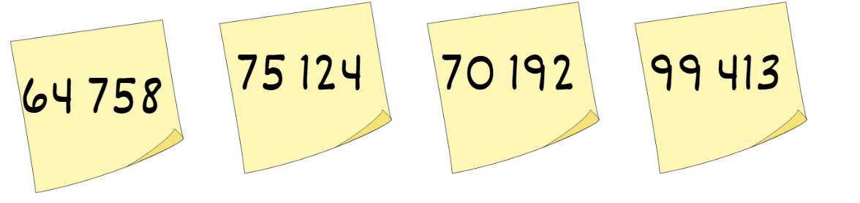
- Order the numbers from smallest to largest (ascending order) in the fewest moves possible.
- Record the number of moves required to order the numbers.
- Observe students and regroup as a class. Ask:
- What was your least number of moves?
- What strategies did you use for ordering your numbers?
- How would you place the numbers in descending order?
- Were presented with any challenges? How did you overcome them?
- Repeat the process with 6-digit numbers.
- The level of difficulty can change by increasing or decreasing the digits.
This table details opportunities for assessment.
Assessment opportunities | Links
What to look for:  - Can students arrange 5-digit numbers in ascending order? [MAO-WM-01, MA3-RN-01] | Links to National Numeracy Learning Progressions (NNLP):  - NPV6.

Core lesson – partitioning – 45 minutes
The table below contains suggested learning intentions and success criteria. These are best co-constructed with students.
Core concept learning intentions | Core concept success criteria
Students are learning to:  - apply mental strategies to solve addition and subtraction problems. | Students can:  - partition numbers into place value  - add and subtract numbers using place value.
This activity is an adaptation of Coordinating groups: Snake eyes [PDF 8.0 MB] from Developing efficient numeracy strategies (DENS) by State of New South Wales (Department of Education).
- Ask students what they know about addition and subtraction. Create a class display with student responses.
Note: encourage students to share different mathematical vocabulary. For example, add, addition, increase, plus, decrease, minus, subtract, inverse relationship.
- Display the equation 362 + 426 = ? on the board and ask students to identify some strategies they could use to solve the equation. Record students’ strategies on the board.
- Explain that partitioning can be used to add and subtract numbers as a mental strategy. Model partitioning 426 into 400 + 20 + 6. Explain that each of these numbers can be added to 362 to find the solution (see Figure 2).
Figure 2 – addition partitioning
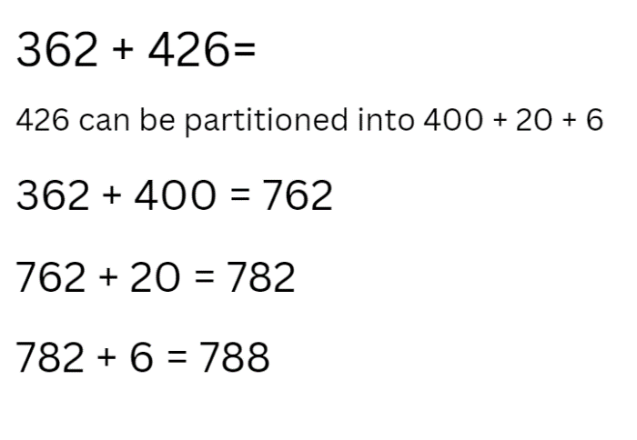
- Introduce the game ‘snake eyes’ and explain that students will be using partitioning to add numbers. The aim of the game is to get to 10 000.
- Provide pairs of students with three 9-sided dice to make a 3-digit number and a whiteboard to record their work. On the first throw the player states and records the number formed by the dice. On each subsequent throw the player states their 3-digit number then adds the hundreds, then the tens and then ones to their previous number. Players then record this on their whiteboard.
- Explain to students that for each game there is a ‘venomous’ number chosen, for example, 6. If the ‘venomous’ number is rolled on any of the dice, the player forfeits the points rolled for that turn and it is the next player’s turn.
- Explain that if students roll a ‘triple one’ (snake eyes), that player loses all their points and returns to zero.
Note: model the game demonstrating how to use partitioning to add each new number.
- After one round of the task, regroup as class and ask students:
- What worked well when using partitioning to add the numbers?
- What was challenging about using partitioning to add the numbers? How did you overcome it?
- Is partitioning always the most efficient strategy? Why or why not?
- Display the equation 586 − 279 = ? on the board and ask students to identify strategies to solve this equation. Record students’ strategies on the board.
- Explain how partitioning can be used to subtract numbers.
Note: model how 279 can be partitioned into 200 + 70 + 9 = ? Each of these numbers can be subtracted from 586 to find the solution (see Figure 3).
Figure 3 – subtraction partitioning
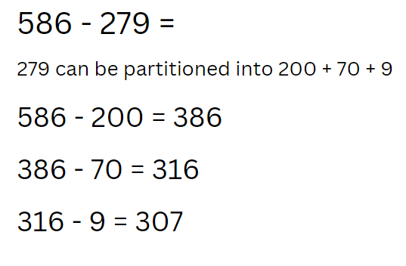
- Explain that students will be using their knowledge of partitioning to subtract numbers while playing snake eyes. The aim of the game this time is to get from 9999 back to zero. Students will start at 9999. On each throw students state their 3-digit number and subtract the hundreds, then the tens and then the ones. Player’s record this on their whiteboard.
- Students need to choose a new ‘venomous’ number for this round. The ‘triple one’ (snake eyes) rule still applies; if a student rolls this, they move back to start at 9999.
- Model the game demonstrating how to use partitioning to subtract each new number.
- After a round of subtraction ‘snake eyes’, regroup as a class and ask:
- What worked well when using partitioning to subtract numbers?
- What was challenging when using partitioning to subtract numbers? How did you overcome it?
This table details opportunities for differentiation.
Too hard? | Too easy?
Students cannot use partitioning to solve addition and subtraction questions.  - Students create 2-digit numbers.  - Students add and subtract from 1000. | Students can use partitioning to solve addition and subtraction questions.  - Students create 4-digit numbers and try to reach 100 000.  - Change the subtraction number to race back from 99 999 using 4-digit numbers.

Discuss and connect the mathematics – 10 minutes
- Display Resource 1 – Sara’s challenge and ask:
- What do you notice about Sara’s calculation?
- Do you have a different solution?
- Can you share your thinking?
- Have you thought of another way this could have been done?
- How did partitioning help you solve this number sentence?
- Could this be calculated using non-standard partitioning? For example, 3256 + 4002 = 3000 + 4000 + 258 = ?
This table details opportunities for assessment.
Assessment opportunities | Links
What to look for:  - Can students apply place value partitioning to solve addition problems? [MAO-WM-01, MA3-RN-01, MA3-AR-01]  - Can students apply place value partitioning to solve subtraction problems? [MAO-WM-01, MA3-RN-01, MA3-AR-01] | Links to National Numeracy Learning Progressions (NNLP):  - NPV6  - AdS7, AdS8.  Links to suggested Interview for Student Reasoning (IfSR) tasks:  - IfSR-AT: 3A.4.

Lesson 2
Core concept: addition can help solve subtraction problems.

Daily number sense – rounding numbers – 15 minutes
The table below contains a suggested learning intention and success criteria. These are best co-constructed with students.
Daily number sense learning intention | Daily number sense success criteria
Students are learning to:  - identify the rounding digit in a given number. | Students can:  - round numbers to a specified place value.
This activity is an adaptation of Order! Order! (four-digit numbers) from Mathematics K-6 resources by State of New South Wales (Department of Education).
- Provide pairs of students with five 0–9 dice and Resource 2 – rounding cards.
- Students take turns rolling the dice and creating a 5-digit number. Record the new number formed on a Resource 3 – rounding record and repeat the process until there are four 5-digit numbers.
- Students shuffle the cards Resource 2 – rounding cards and select one card from the pile. Students record their number rounded to the nearest 10, 100 or 1000 on Resource 3 – rounding record (see Figure 4).
Figure 4 – student sample
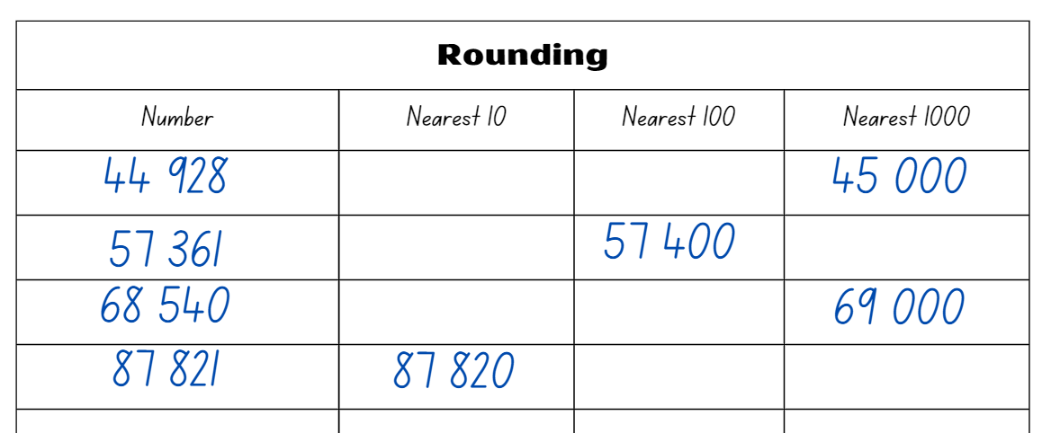
- Students take turns rounding all 4 digits.
- Once finished, students swap Resource 3 – rounding record and check each other's answers.
- Regroup as a class and ask:
- Why do we round numbers?
- How would you explain rounding to someone else?
- Can you provide examples of real-life situations where rounding is commonly used?
This table details opportunities for assessment.
Assessment opportunities | Links
What to look for:  - Can students round numbers to a specific place value? [MAO-WM-01, MA3-RN-01] | Links to National Numeracy Learning Progressions (NNLP):  - NPV6, NPV7.  Links to suggested Interview for Student Reasoning (IfSR) tasks:  - IfSR-NP: 4C.4, 4C.8.

Core lesson – models help solve problems – 35 minutes
The table below contains suggested learning intentions and success criteria. These are best co-constructed with students.
Core concept learning intentions | Core concept success criteria
Students are learning to:  - apply efficient mental and written strategies to solve addition and subtraction problems. | Students can:  - represent a problem on a tape or bar model  - solve word problems relating to addition and subtraction.
- Display the problem: A store had 315 cans of soup. They received a delivery of 421 more cans. How many cans of soup does the store have now? Ask:
- What is the problem asking you to find?
- What operation is useful to solve this problem?
- Explain how a bar model can be used to represent the part-part-whole relationship when adding numbers together.
- Display Resource 4 – soup bar model and demonstrate that the top section of bar model is where the whole or total value is shown. The bottom section is where the parts that make up the whole or total value are shown.
The table below outlines stimulus prompts to generate conversation about the topic, along with anticipated responses from students.
Prompts | Anticipated student responses
- What equation can be used to represent this problem?  - What strategies can be used to solve this equation? | - 315 + 421 = ?  - Partitioning 300 + 400 + 10 + 20 + 5 + 1 = 736  - Compensation 315 + 420 = 735 add 1 to obtain 736  - Levelling 316 + 420 = 736  - Bar model and number line  - Algorithms
- Model solving the equation and record student suggestions on the board. Refer to Resource 4 – soup bar model and ask what should be recorded on the top of the bar model.
Note: explain that parts on the bar model should be drawn to indicate the different size of the parts. It shows the whole value at the top and the parts below.
The table below outlines stimulus prompts to generate conversation about the topic, along with anticipated responses from students.
Prompts | Anticipated student responses
- In the soup problem, what makes up the parts?  - In the soup problem, what will be the whole?  - What equation can represent this problem?  - What strategies can you use to solve this equation?  - What should be recorded above the tape model? | - The soup the store already had and the soup that was delivered.  - The total amount of soup including what the store already had and what was delivered.  - 315 + 421 = ?  - Partitioning, compensation, algorithms, levelling and so on.  - 736
- Ask how many equations can be recorded for the soup problem. For example, 421 + 315 = 736, 736 – 315 = 421, 736 – 421 = 315. Explain that this is known as the complement principle. The complement principle recognises that when 2 numbers are added, subtracting either number from the total produces its complement, that is, the number required to make the group complete (see Figure 5).
Figure 5 – complement principle
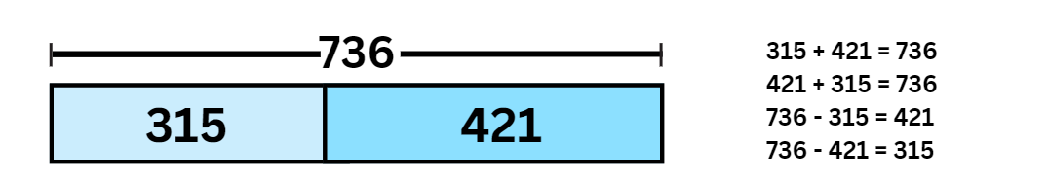
Note: this use of the complement principle requires recognising that when 2 numbers are added, subtracting either number from the total produces its complement, that is, the number required to make a group complete.
- Display Resource 5 – subtraction problem. Give students time to answer the question and then regroup as a class and ask:
- What is the problem asking?
- What operation should be used to solve this problem?
- What are the parts that make up the whole?
- What parts do you already know?
- What equation can be used to represent this problem?
- What strategies can be used to solve this problem?
- What should be recorded in the missing part of the bar model?
- Make a prediction about how the bar model might change if it were raining? Draw a bar model to explain your thinking.
- Display Resource 6 – word problems. Students select 4 problems to solve in their workbook. Remind students to represent the problems using the bar or tape model, then select an appropriate strategy to solve the problem.
This table details opportunities for differentiation.
Too hard? | Too easy?
Students cannot apply addition and subtraction strategies to solve problems.  - Provide students with word problems involving 2 digits.  - Provide students with MAB materials to model the problem. | Students can apply addition and subtraction strategies to solve problems.  - Students solve the problem using more than one strategy and justify which strategy is more efficient.  - Provide students with multi-step problems that require addition and subtraction.

Consolidation and meaningful practice – 15 minutes
- Display Resource 7 – consolidation task. In pairs students share their explanations to the following questions:
- How does this model differ from the one you have looked at before?
- Does this model help you find the answer to the question?
- What was the most challenging part of this problem for you? Why?
- Did you try different strategies to solve the problem? If so, which ones? Did any particular strategy work better for you?
- Did you encounter any patterns or relationships while solving the problem? Can you describe them?
- If you could solve the problem again, is there anything you would do differently? Why?
This table details opportunities for assessment.
Assessment opportunities | Links
What to look for:  - Can students represent a problem on a tape or bar model? [MAO-WM-01, MA3-AR-01]  - Can students solve word problems relating to addition and subtraction? [MAO-WM-01, MA3-AR-01] | Links to National Numeracy Learning Progressions (NNLP):  - AdS7, AdS8.

Lesson 3
Core concept: flexible methods of addition and subtraction involve decomposing and composing numbers.

Daily number sense – place value game – 15 minutes
The table below contains a suggested learning intention and success criteria. These are best co-constructed with students.
Daily number sense learning intention | Daily number sense success criteria
Students are learning to:  - use place value to form and order numbers in sequence. | Students can:  - recognise, represent and order numbers up to the millions.
This lesson is an adaptation of The place value game from Mathematics K-6 resources by State of New South Wales (Department of Education).
- Build student understanding of place value by forming and ordering 6-digit numbers in sequence.
- Explain the aim of the game is to position 6-digit numbers in sequence on a gameboard. Provide pairs with six 0–9-sided dice and Resource 8 – place value game to each player.
- Students roll the dice and create a 6-digit number. For example, 1, 5, 6, 6, 2 and a 9 could be recorded as 156 629, 692 615, 296 156, 165 269 and so on. Players record their chosen number in the most appropriate position between 100 000 and 999 999 (see Figure 6).
Figure 6 – sample gameboard
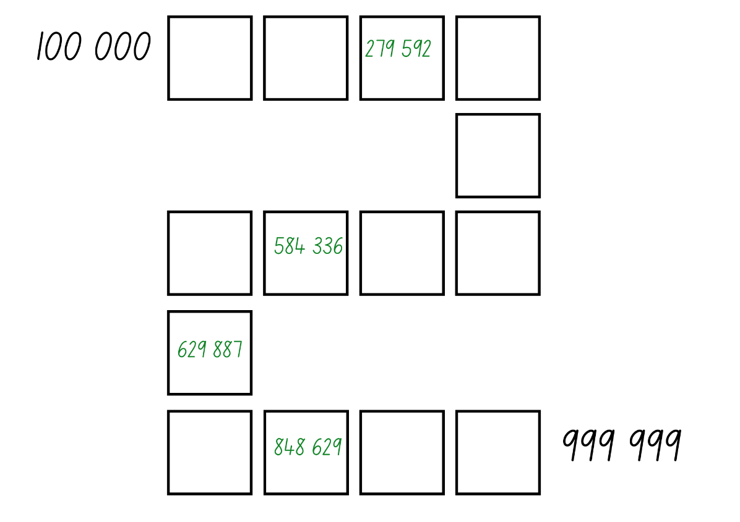
- If numbers cannot be placed, students miss their turn. Play continues until all boxes are filled.
Note: the game can also be played as whole class. Use dice that have a zero as it is important to understand that the zero is a placeholder and does not have a value. Using a reusable sleeve for the gameboard will allow students to play multiple games.
This table details opportunities for assessment.
Assessment opportunities | Links
What to look for:  - Can students recognise, represent and order numbers up to millions? [MAO-WM-01, MA3-RN-01] | Links to National Numeracy Learning Progressions (NNLP):  - NPV6, NPV7.

Core lesson – levelling – 35 minutes
The table below contains suggested learning intentions and success criteria. These are best co-constructed with students.
Core concept learning intentions | Core concept success criteria
Students are learning to:  - apply efficient mental and written strategies to solve addition and subtraction problems  - use estimation and place value understanding to determine the reasonableness of solutions. | Students can:  - apply the strategy of levelling to addition problems  - use estimation and place value understanding to solve addition problems.
This activity is an adaptation of Additive strategies: Closest to 100 (Task 5) from Stage 3 numbers and algebra by State of New South Wales (Department of Education).
- Display the equation 4998 + 955 = ? and ask students what are some of the strategies they can use to solve this equation. Record student responses on the board.
- Model the levelling strategy and ask:
- What worked well with this strategy?
- Why is levelling an efficient strategy? (See Figure 7)
Figure 7 – levelling
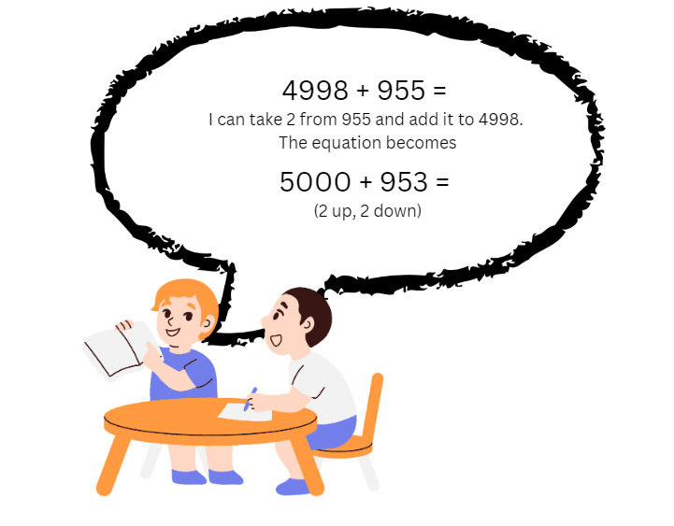
Note: explain to students that having a number on the decade is easier to solve; it makes levelling a useful strategy.
- Inform students they will be using levelling and estimating to solve addition equations in the game ‘Closest to 1000’. Students work in pairs against another pair of students to allow for mathematical conversations.
- Provide players a deck of cards and put them in a central pile. One player takes 6 cards and places them face up for everyone to see.
- The goal is to make two 3-digit numbers that when added together get as close to a total of 1000 as possible. Each card can only be used once.
Note: highlight to students that they should think about which number they use in which place value. For example, using the digits 123 + 456 will not get them as close to 1000 as 612 + 354. Students can also use estimation to check validity of solutions to add and subtract problems.
- Players score zero points if they can reach exactly 1000. Otherwise, they work out their points based on the difference between their total and 1000. For example, if a team created a total of 912, they would score 88 points.
- Players record their working out and the cumulative total of their difference to 1000 in their workbook. The winner is the team with the lowest point score at the end.
- Model the game for students using levelling to solve the equations.
- Regroup students and ask:
- What did you notice when you were playing ‘Closest to 1000’?
- What were some of the challenges?
- Is levelling always the best strategy? Why or why not?
- How did estimation help you?
This table details opportunities for differentiation.
Too hard? | Too easy?
Students cannot use levelling to solve addition.  - Change the target number to a smaller number. For example, 100.  - Students create 2-digit numbers to add.  - Use a bead string, number line or hundreds chart to empower students into the task. | Students can use levelling to solve addition.  - Change the target number to a value off the decade. For example, 956.  - Students create 4-digit numbers to add and work towards a target number of 10 000.

Consolidation and meaningful practice – 15 minutes
This activity is an adaptation of Add to 200 from NRICH by University of Cambridge (Faculty of Mathematics).
- Students draw 9 boxes. Explain that they can choose any 3 digits from zero to 9 and place them in the cells. Digits can be repeated.
- Read the three 3-digit numbers across and add them together with the aim to make a total of 2000.
- Model solving the example below (see Figure 8).
Figure 8 – example
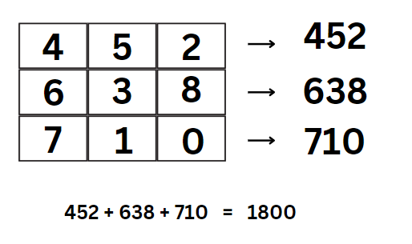
- Students complete the task in their workbook with the aim of making a total of 2000.
- Ask students to consider the following:
- Is there a quick way to tell if the total is going to be odd or even?
- How did using the strategy of levelling help solve the problem?
- Were there other strategies that were more efficient to solve the problem?
- Is it possible to make exactly 2000? Explain your thinking.
- Turn the task into a competition. Students compete against each other to find a mystery number following a set of clues or criteria. In small groups, students create the criteria to for a target number. For example, the target number is greater than 550 but less than 700. The sum of the digits in the target number is between 9 and 15. The target number is not a palindrome (a number that reads the same forwards and backwards). The winner is the student with the first correct solution.
This table details opportunities for assessment.
Assessment opportunities | Links
What to look for:  - Can students apply the strategy of levelling to addition problems? [MAO-WM-01, MA3-AR-01]  - Can students use estimation and place value understanding to solve addition problems? [MAO-WM-01, MA3-AR-01] | Links to National Numeracy Learning Progressions (NNLP):  - AdS7, AdS8  - NPV6, NPV7.  Links to suggested Interview for Student Reasoning (IfSR) tasks:  - IfSR-AT: 3A4, 3A.5.

Lesson 4
Core concept: flexible methods of addition and subtraction involve decomposing and composing numbers.

Daily number sense – 10 minutes
- From a class need surfaced through formative assessment data, identify a short, focused activity that targets students’ knowledge, understanding and skills. Example activities may be drawn from the following resources:
- Mathematics K–6 resources
- Universal Resources Hub.

Core lesson – constant difference – 35 minutes
The table below contains suggested learning intentions and success criteria. These are best co-constructed with students.
Core concept learning intentions | Core concept success criteria
Students are learning to:  - apply efficient mental and written strategies to solve addition and subtraction problems. | Students can:  - apply constant difference to subtraction problems.
- Display the equation 5009 – 3997 = ? Ask students what strategies they can use to solve this equation. Record responses on the board (see Figure 9).
- Model the strategy of constant difference and ask:
- What worked well with this strategy?
- Why is this an efficient strategy?
- When wouldn’t this be the most efficient strategy? Can you provide an example?
Figure 9 – constant difference
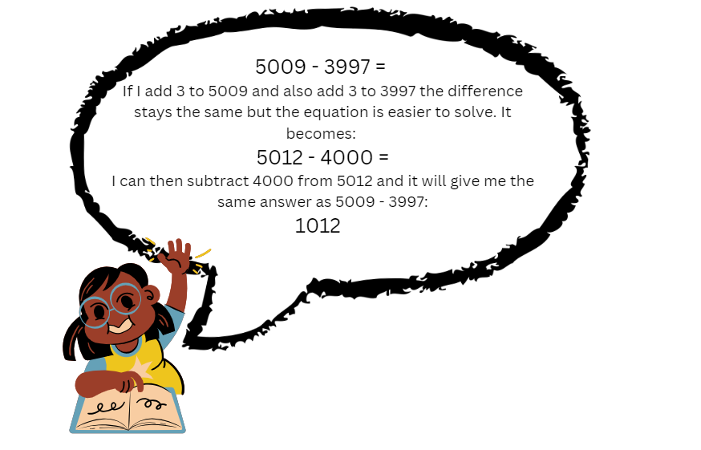
Note: explain that subtracting numbers on the decade makes the numbers easier to work with. Students can use constant difference to help create numbers on the decade that are easier to subtract.
- Provide pairs of students with Resource 9 – race car rumble, a 6-sided dice, 2 counters, whiteboard and calculator.
- Players take turns rolling the dice. They move forward the number of spaces on the dice. Players then solve the subtraction problem displayed on their whiteboard. Students use a calculator to check their partner's answer. If correct, that player remains in their place. If incorrect, they move back to their previous place.
- Model the game using constant difference to solve the equations. Players continue taking turns. The first player to reach the end of the board is the winner.
- Regroup students and ask:
- What works well when using constant difference?
- What was challenging?
- Why is constant difference an efficient strategy?
This table details opportunities for differentiation.
Too hard? | Too easy?
Students cannot use constant difference to solve subtraction.  - Students solve subtraction questions involving a 3-digit and 2-digit number.  - Provide students with a two-hundred chart to support calculations. | Students can use constant difference to solve subtraction.  - Students write a word problem for a friend to solve using constant difference.  - Students create their own gameboard.

Discuss and connect the mathematics – 15 minutes
- Display the problem: Mikaela won 2742 points on her video game on Monday. On Tuesday she played the same game and won 1439. How many more points did she win on Monday than Tuesday?
- Ask students:
- What is the problem asking us to find?
- What equation can be made to represent the problem?
- How can the strategy of constant difference be used to solve this problem?
- Why is the constant different strategy the best strategy to solve this problem?
- Record student strategies on the board. Highlight using constant difference and how this can help solve subtraction equations.
This table details opportunities for assessment.
Assessment opportunities | Links
What to look for:  - Can students apply efficient mental and written strategies to solve addition and subtraction problems? [MAO-WM-01, MA3-AR-01] | Links to National Numeracy Learning Progressions (NNLP):  - AdS8.  Links to suggested Interview for Student Reasoning (IfSR) tasks:  - IfSR-AT: 3A.4, 3A.5.

Lesson 5
Core concept: mathematicians use algorithms to solve addition and subtraction problems.

Daily number sense – colour in fractions – 15 minutes
Daily number sense activities for Lessons 5 to 7 ‘loop’ back to concepts and procedures covered in previous units to assist students to build an increasingly connected network of ideas. These concepts may differ from the core concepts being covered by the unit.
The table below contains a suggested learning intention and success criteria. These are best co-constructed with students.
Daily number sense learning intention | Daily number sense success criteria
Students are learning to:  - model and represent fractions on a number line. | Students can:  - model fractions on strips for halves, quarters and thirds  - represent fraction families by dividing a whole into equal parts  - determine the complementary part needed to complete a whole.
This activity is an adaptation of Colour in fractions from K-6 Mathematics resources by State of New South Wales (Department of Education).
- Provide students with one die labelled 1, 2, 2, 3, 3, 4 in one colour and another die labelled $\frac{1}{2}$, $\frac{1}{3}$, $\frac{1}{4}$, $\frac{1}{6}$, $\frac{1}{8}$, $\frac{1}{12}$ in another colour or use Resource 10 – spinner. Also provide students with Resource 11 – fraction wall and coloured pencils or markers.
- Players take turns to throw both dice or have a spin on their spinners. Students make a fraction, using the first die or spinner as the numerator. Students then colour the equivalent of the fraction shown. For example, if a player spins 2 quarters they can colour in:
- $\frac{2}{4}$ of one line
- $\frac{4}{8}$ of one line
- $\frac{1}{4}$ of one line and $\frac{2}{8}$ of another
- any other combination that is the same as $\frac{2}{4}$
- For each roll or spin, students should use a different colour pencil or marker. If a player is unable to use their turn, they ‘pass.’
- Players take it in turns to roll or spin and make fractions, marking them on their fraction wall. If the fraction rolled or its equivalence cannot be shaded, that player misses a turn. This becomes more frequent later in the game.
- Players are not allowed to break up a ‘brick’ on the fraction wall. To finish the game, a player must have had 18 turns or have filled their wall. A larger fraction is not acceptable to finish.
- The first player to colour in their whole wall is the winner. They should encourage the other player to keep filling their fraction wall or make the greatest number of wholes. If after 18 turns neither player has coloured in their whole wall, the player with the greatest number wins.
This table details opportunities for assessment.
Assessment opportunities | Links
What to look for:  - Can students model fractions on strips? [MAO-WM-01, MA2-PF-01]  - Can students represent fraction families by dividing a whole into equal parts? [MAO-WM-01, MA2-PF-01]  - Can students identify the complementary part needed to complete one whole? [MAO-WM-01, MA2-PF-01] | Links to National Numeracy Learning Progressions (NNLP):  - InF2, InF3, InF4.

Core lesson – algorithms – 45 minutes
The table below contains suggested learning intentions and success criteria. These are best co-constructed with students.
Core concept learning intentions | Core concept success criteria
Students are learning to:  - apply efficient mental and written strategies to solve addition and subtraction problems. | Students can:  - use place value to partition and regroup numbers to solve problems  - identify efficient and inefficient multidigit subtraction strategies.
- Display the equation 1286 + 437 = ? on the board and ask students to identify some strategies that can be used to solve the problem. Record strategies on the board.
- Revise how to do an algorithm for addition. Ask students to identify when it is efficient to use an algorithm over a different strategy.
- Model setting up an algorithm for the equation 1286 + 437 = ?. Demonstrate that the numbers in the equation are lined up according to place value. Explain that if the numbers are not correctly aligned it will significantly change the answer. For example, if not correctly aligned, the ones in 437 could sit in the tens column. Seven tens are worth significantly more than 7 ones and would provide an incorrect answer.
- Explain that, when a vertical algorithm for addition is solved, students begin by finding the sum of the ones. They should then find the sum of the tens, followed by the sum of the hundreds and the sum of the thousands. The sum of 13 ones, 110 tens, 600 hundreds and 1000 thousand is equal to 1723 (see Figure 10).
Figure 10 – long addition algorithm
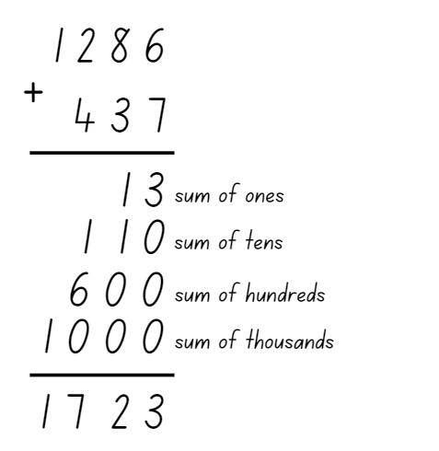
- Model and explain how to solve the algorithm using a shorter method by recording the exchange in the ones, to tens, to hundreds column during the addition to get a final answer of 1723 (see Figure 11).
Figure 11 – addition algorithm
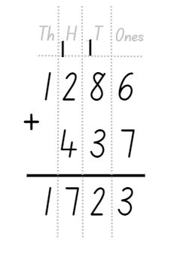
Note: explain that the exchange across each of the place value columns is recorded as a one at the top of the column.
- Introduce the activity ‘Race to 50 000’. In pairs, students require a deck of 0–9 cards and their workbook. The first player turns over 8 cards, makes two 4-digit numbers recorded as a vertical algorithm and solves the addition in their workbook.
- Player 1 needs to explain their thinking as they solve the equation. If their partner agrees then that answer becomes their new total.
- Player 2 then has their turn, repeating the process above.
- On the next go students turn over 4 cards to make a 4-digit number to add to their previous total. Players continue taking turns until someone reaches 50 000.
- Regroup as a class to discuss the following questions:
- What worked well when using an algorithm for addition?
- What was challenging about using an algorithm for addition?
- Give an example from the game where an algorithm was not the most efficient strategy? Explain why.
- Display the equation 1286 − 439 = ? and ask students to identify some of the strategies that can be used to solve this problem. Record these on the board.
Note: to increase the level of difficulty use 5- or 6-digit numbers
- Introduce an algorithm for subtraction. Model setting up an algorithm for the equation 1286 − 439 and demonstrate that the numbers are aligned correctly according to their place value. Explain when a vertical algorithm is used for subtraction sometimes, students need to exchange and regroup across the place value columns to solve the equation.
Note: solving a subtraction algorithm requires ‘trading units’, which involves partitioning and regrouping. To subtract 439 from 1286 using an algorithm, the 1286 is thought of as being decomposed into one thousand, 2 hundreds, 8 tens and 6 ones. Then one 10 is traded for 10 ones so that 1286 is represented as one thousand, 2 hundreds, 7 tens and 16 ones.
- Model solving the algorithm (see Figure 12).
Figure 12 – long subtraction algorithm
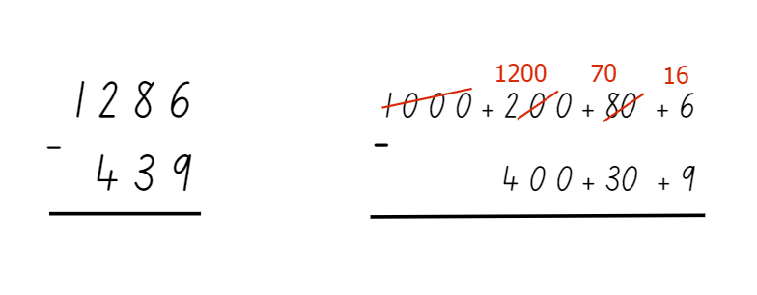
- Model and explain how to solve the subtraction algorithm in a shorter way by recording the trading and regrouping as you solve the equation. The equation is solved by recording the exchange from the thousands to hundreds, hundreds to tens and tens to ones to get a final answer. When trading across the place value columns, the original number is crossed out. Then subtract one, which will be traded across to the new column and record the new number (see Figure 13).
Figure 13 – subtraction algorithm
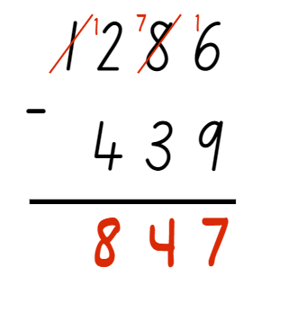
- Display Resource 12 – trading and ask the students to justify their reasoning to the following questions:
- Does the one in the working out for these problems represent the same amount? Explain your thinking.
- Why in problem A is the one added to the 5, but in problem B 10 is added to the 2?
- Provide pairs of students with a deck of cards and their workbook to play ‘Race back to 10’. The first player starts at 49 999 then turns over 4 cards. Player 1 needs to make a 4-digit number and record it as a subtraction equation in their workbook, for example, 49 999 − (the 4-digit number). Player 1 solves the problem using an algorithm and, if correct, they will begin their next turn with the new number. For example, if the problem was 49 999 – 3261 = 46 738, the player would start their next turn at number 46 738.
- Player 2 repeats this process.
Note: highlight the importance of placing the larger number on the top line of the algorithm and ensuring the numbers are aligned correctly according to their place value.
- The aim of the game is to reach the number 10. Explain that, as the numbers get smaller, students will need to create smaller numbers with the cards. For example, when the numbers become 3-digits, students will not be able to subtract a 4-digit number; players choose 3 cards and order them to create a 3-digit number that gets them to zero the quickest. The game ends when one player reaches or passes 10.
- Regroup as a class and ask:
- What worked well when using an algorithm for subtraction?
- What was challenging about using an algorithm for subtraction?
- Do you think an algorithm is an efficient strategy? Why or why not?
This table details opportunities for differentiation.
Too hard? | Too easy?
Students cannot add or subtract 3- to 4-digit numbers using an algorithm.  - Provide students with 2-digit numbers and a starting number of 99.  - Provide students with MAB materials to model the calculations. | Students can add and subtract algorithms with numbers of any size.  - Provide a starting number of 100 000 and have students create 5-digit numbers with cards.  - Provide cryptarithms for students to manipulate.

Discuss and connect the mathematics – 10 minutes
- Display Resource 13 – algorithm errors and explain that a few things happened to this algorithm, so the answer is not correct. Ask:
- What do you notice about this algorithm?
- What things might you change?
- How can we solve the algorithm to get the right answer?
- If you have to explain to a friend some rules about algorithms what would you tell them?
This table details opportunities for assessment.
Assessment opportunities | Links
What to look for:  - Can students apply efficient mental and written strategies to solve addition and subtraction problems? [MAO-WM-01, MA2-RN-01, MA3-AR-01]  - Can students demonstrate place value to partition and regroup numbers to solve problems? [MAO-WM-01, MA2-RN-01, MA3-AR-01] | Links to National Numeracy Learning Progressions (NNLP):  - AdS7, AdS8.

Lesson 6
Core concept: estimating and place value understanding helps to determine the reasonableness of solutions.

Daily number sense – Nicole’s walk – 10 minutes
The table below contains a suggested learning intention and success criteria. These are best co-constructed with students.
Daily number sense learning intention | Daily number sense success criteria
Students are learning to:  - model and represent fractions to complete a whole on a number line. | Students can:  - model fractions with fraction strips  - identify the complementary fractional part needed to complete one whole.
This activity is an adaptation of ‘How far did Nicole go?’ from Primary and Middle Years Mathematics: Teaching Developmentally, 1st edn by Van De Walle et al.
- Display Resource 14 – Nicole’s walk and explain Nicole is walking to school and the 3 number lines represents the distance she has travelled. The aim of the task is to model and describe fractions with partitions of an object (number line).
- Give students time to discuss the 3 number lines and questions. They can record their fractions and reasoning on a whiteboard. Ask:
- How far has Nicole gone?
- How do you know?
- What parts of the number line helped you answer the questions?
- Which number line represents the furthest distance travelled? How do you know?
- How far as a fraction does Nicole need to travel to get to school on each number line? (Determine the complement fractional part of each number line).
This table details opportunities for assessment.
Assessment opportunities | Links
What to look for:  - Can students model fractions with fraction strips? [MAO-WM-01, MA2-PF-01]  - Can students identify the complementary fractional part needed to complete one whole? [MAO-WM-01, MA2-PF-01] | Links to National Numeracy Learning Progressions (NNLP):  - InF2, InF3, InF4.

Core lesson – estimating and rounding – 45 minutes
The table below contains suggested learning intentions and success criteria. These are best co-constructed with students.
Core concept learning intentions | Core concept success criteria
Students are learning to:  - use estimation and place value understanding to determine the reasonableness of solutions. | Students can:  - round numbers appropriately when obtaining estimates  - use place value to add or subtract numbers with different numbers of digits.
This activity is an adaptation of Additive strategies: Four strikes and you’re out! (Task 7) from Stage 3 numbers and algebra by State of New South Wales (Department of Education).
- Display the equation 1438 + 129 = ?. Ask students what strategies can be used to solve the equation. Record strategies on the board and find the solution to the equation.
- Ask if there is a way to make a quick estimate of the answer to this question to check the reasonableness of students’ answers.
- Explain that rounding is when a number moves up or down to the nearest 10, 100, 1000 and so on (see Figure 14).
Figure 14 – rounding
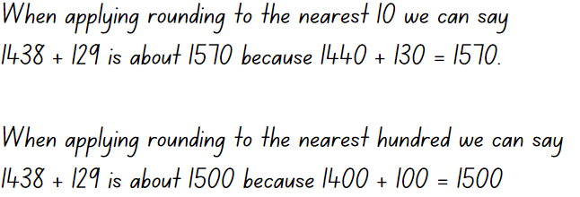
Note: highlight the importance of place value in rounding. The chosen place value determines the estimate’s accuracy. Rounding to the nearest 10 is a more precise estimate close to the actual answer. Rounding to the nearest hundred provides a less accurate estimate, but it helps verify the answer’s reasonableness.
- Model rounding to the nearest 10 and estimating the answer to the equation 1438 + 129 = ?. Check if the answer to the equation is reasonable.
- Display the equation 1682 − 427 =? Record students’ strategies of rounding on the board and find an estimation to the equation.
- Introduce the game ‘Four strikes and you're out!’ Display Resource 15 – four strikes and conceal the equation 2465 + 1232 = 3697.
- Explain that students will take turns guessing a number between zero and 9. If the number is within the problem, it will be written in the corresponding space on Resource 15 – four strikes. If the number is not in the problem, it will be a ‘strike’. To win, students need to determine all the numbers before they get 4 strikes.
Note: encourage students to think about rounding and estimating when making their guesses. For example, if presented with 3_ + _ _ = 7 _, it would be reasonable to estimate that there could be a 4 in the tens place of the second number.
- Model the game, allowing students to guess numbers from 0–9. Encourage students to explain their reasoning for selecting that number.
- In pairs, provide students with a whiteboard each. One student will be the game host and will record the equation on their whiteboard, keeping it hidden from their partner. The other will be the player and will draw the problem frame on their whiteboard. Students play ‘Four strikes and you’re out!’ Encourage students to form equations using both addition and subtraction.
- Regroup as a class and ask:
- What did you notice?
- Did you have any challenges and how did you overcome them?
- When can rounding and estimating be used?
This table details opportunities for differentiation.
Too hard? | Too easy?
Students cannot use estimation and place value understanding to determine the reasonableness of solutions.  - Provide MAB materials to model the potential equation.  - Provide equations where there is no regrouping involved. | Students can use estimation and place value to determine the reasonableness of solutions.  - Students use 5-digit number to solve the equation.  - Provide both addition and subtraction (multi-step) in the one equation.

Discuss and connect the mathematics – 10 minutes
- Display Resource 16 – equation and ask:
- Is this statement true or false?
- How can you use rounding to explain your thinking?
- What would be a more accurate estimation?
- What would be the estimation if we rounded to the nearest 10?
- What would be the estimation if we rounded to the nearest 100?
- What would be the estimation if we rounded to the nearest 1000?
This table details opportunities for assessment.
Assessment opportunities | Links
What to look for:  - Can students use estimation and place value understanding to determine the reasonableness of solutions? [MAO-WM-01, MA3-AR-01] | Links to National Numeracy Learning Progressions (NNLP):  - NPV6, NPV7.

Lesson 7
Core concept: mathematicians solve addition and subtraction problems with multiple steps.

Daily number sense – fraction problem – 10 minutes
The table below contains a suggested learning intention and success criteria. These are best co-constructed with students.
Daily number sense learning intention | Daily number sense success criteria
Students are learning to:  - identify fraction families by dividing the whole into the same total number of equal parts. | Students can:  - model fractions with fraction strips  - identify the complementary fractional part needed to complete one whole.
- Display Resource 17 – paper strips and present the following problem: Tim has folded his paper into 2 equal parts. Yani has folded his paper into 4 equal parts. Rocco has folded his paper into 3 equal parts.
- Explain that the strips of paper represent one whole. Provide each student with strips of paper and ask them to explain who has the shortest and longest strip of paper. Students can justify their reasoning by modelling each partition and comparing the whole strip. Discuss the complementary fractional part needed to complete the whole for each child (see Figure 15).
Figure 15 – student sample
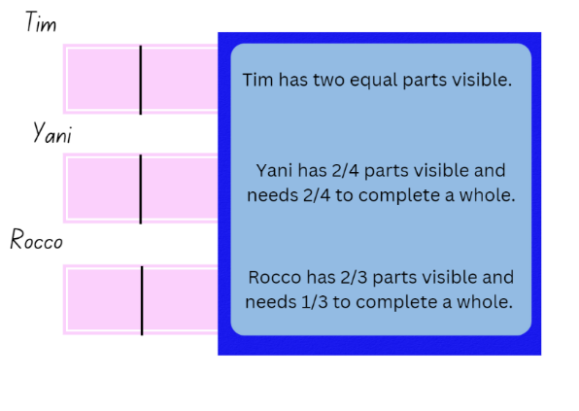
- Display Resource 18 – answer strips. Students compare their results to yours.
Note: if a student makes errors, ask if the parts are the same size. If not, ask the student to partition their strips to make the same sized parts.
This table details opportunities for assessment.
Assessment opportunities | Links
What to look for:  - Can students model fractions with fraction strips? [MAO-WM-01, MA2-PF-01]  - Can students identify the complementary fractional part needed to complete one whole? [MAO-WM-01, MA2-PF-01] | Links to National Numeracy Learning Progressions (NNLP):  - InF2, InF3, InF4.

Core lesson – solving problems – 30 minutes
The table below contains a suggested learning intention and success criteria. These are best co-constructed with students.
Core concept learning intention | Core concept success criteria
Students are learning to:  - apply efficient mental and written strategies to solve addition and subtraction problems. | Students can:  - solve addition and subtraction word problems  - solve problems with multiple steps.
- Display and read Resource 19 – Green Paddock PS.
- In pairs, students solve the problem using at least 3 different strategies and check the reasonableness of their answers using rounding. Students record working out and answers in their workbook.
- Regroup and ask:
- How many people were at the fair when the clown show started?
- How many people were at the fair after the jumping castle deflated?
- What equation could represent the first part of the problem? For example, 3827 + 1625 = 5452.
- What equation could represent the second part of the problem? For example, 5452 − 2964 = 2488 or 3827 + 1625 − 2964 = 2488.
- What strategies did you use? Explain why?
- Display and present the following: Last year, Green Paddock Public School (PS) held its annual fair in November. One hour after the fair began, there were 5201 people at the fair. Later, the school principal announced a surprise performance by a popular band, doubling the number of attendees. After the band's performance, an art contest was organised, but unfortunately, it started to rain, and 1874 people decided to leave the fair. During the final hour the fair organisers arranged a lucky draw with exciting prizes and 589 new people arrived to participate.
- Ask students in pairs to create questions for the above problem and then share them with their peers to find a solution.
- Demonstrate rounding and estimating to check the reasonableness of the answers. Ask students to discuss and justify their solutions and explain why one strategy is more efficient than another.
This table details opportunities for differentiation.
Too hard? | Too easy?
Students cannot select strategies to solve multi-step word problems.  - Provide students with an alternate problem – at the Green Paddock Public School fair, there is a petting zoo. In the petting zoo there are 32 chickens, 46 ducks and 28 goats. One of the children left the gate open and 27 of the animals escaped. Ask:  - How many animals were in the petting zoo at the beginning of the fair?  - How many animals were left after some escaped?  - Provide students with MAB materials or hundreds chart to support their working out. | Students can select efficient strategies to solve multi-step word problems.  - Provide students with alternate problem – when the Ferris wheel works at its maximum capacity, 1342 people can ride it every hour. The beginning of the carnival was not busy so only 389 people rode the Ferris wheel in the first hour. 724 people rode it in the second hour. After that, the carnival was busy and the Ferris wheel was working at its maximum capacity. In what hour will the Ferris Wheel have its ten-thousandth rider?  - Students create multi-step word problems and share them with their peers.

Consolidation and meaningful practice – 20 minutes
This activity is an adaptation of Prison Cells from NRICH by University of Cambridge (Faculty of Mathematics).
- Provide Resource 20 – prison cells and explain that there are 78 prisoners in a cell block of 12 cells. There is one prisoner in one of the cells, 2 in another cell, 3 in another, 4 in another and so on, up to 12 prisoners in one of the cells. The clever prison warden made it easy to check if the prisoners were all there by arranging them so there were 25 along each wall of the prison block. Ask how the warden did it and explain that there is more than one solution.
- Regroup and ask:
- What method did you use to solve this problem?
- What solutions did you find?
This table details opportunities for assessment.
Assessment opportunities | Links
What to look for:  - Can students solve addition and subtraction word problems? [MAO-WM-01, MA3-AR-01]  - Can students solve problems with multiple steps? [MAO-WM-01, MA3-AR-01] | Links to National Numeracy Learning Progressions (NNLP):  - AdS7, AdS8.

Lesson 8
Core concept: mathematicians compare and evaluate strategies used to solve addition and subtraction problems, reasoning which strategy may be most efficient.

Daily number sense – 10 minutes
- From a class need surfaced through formative assessment data, identify a short, focused activity that targets students’ knowledge, understanding and skills. Example activities may be drawn from the following resources:
- Mathematics K–6 resources
- Universal Resources Hub.

Core lesson – finding a solution – 40 minutes
The table below contains suggested a learning intention and success criteria. These are best co-constructed with students.
Core concept learning intention | Core concept success criteria
Students are learning to:  - select and justify efficient strategies when solving problems. | Students can:  - select strategies to solve addition and subtraction problems  - justify which strategy is most efficient when solving word problems.
- Display Resource 21 – Frayer model. Tell students they will use this model to show their thinking when solving problems.
- Explain the problem being solved goes in the centre box. In the strategy boxes, students should use 3 different strategies to solve the problem. Next, students circle the strategy that was most efficient. In the final box, students explain their reasoning to support why the circle strategy was the most efficient.
- Provide each student with Resource 21 – Frayer model and display Resource 22 – museum visitors. In pairs, students work to solve the problem, recording their strategies and thinking on the Frayer Model.
- Regroup students and ask:
- What solution did you find?
- What strategy did you find most efficient? Why?
- What strategy did you find least efficient? Why?
Note: encourage students to share reasoning for their ideas. Highlight different ideas that promote the understanding that different strategies can be more efficient for different problems.
- Display Resource 23 – problems. Provide each student with 2 printed copies of Resource 21 – Frayer model. Students work independently to solve the 2 problems and demonstrate their understanding in the Frayer Model.
This table details opportunities for differentiation.
Too hard? | Too easy?
Students cannot select efficient strategies to solve addition and subtraction problems.  - Provide students with problems involving 2-digit numbers.  - Students model 2 strategies on the Frayer model. | Students can select efficient strategies to solve addition and subtraction problems.  - Provide students with problems involving 5-digit numbers.  - Students model more than 3 strategies.

Consolidation and meaningful practice – 15 minutes
- Regroup students and explain they will create a multi-step addition or subtraction word problem for their peer to solve. Ask students to identify what should be included when writing a word problem.
- The word problems created should include clear sentences, numbers of an appropriate size and at least 2 steps.
- In pairs, students write a word problem to solve.
- Students switch word problems with another pair and solve the word problem with their partner in their workbook. Tell students to solve the problem using more than one strategy.
- Regroup students. Ask:
- What did you find challenging about creating a word problem?
- What would you do differently next time?
This table details opportunities for assessment.
Assessment opportunities | Links
What to look for:  - Can students apply efficient mental and written strategies to solve addition and subtraction problems? [MAO-WM-01, MA3-AR-01]  - Can students solve problems with multiple steps? [MAO-WM-01, MA3-AR-01] | Links to National Numeracy Learning Progressions (NNLP):  - AdS7, AdS8.

Resource 1 – Sara’s challenge
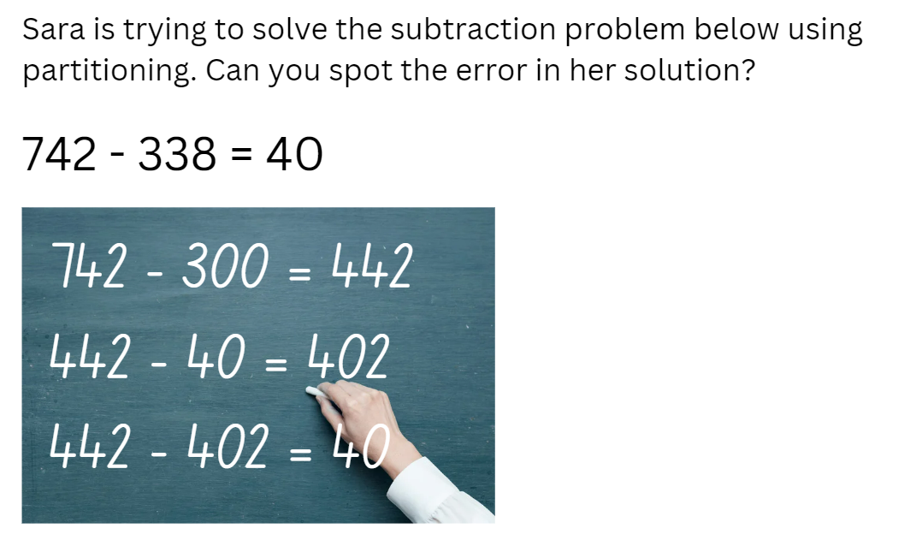

Resource 2 – rounding cards
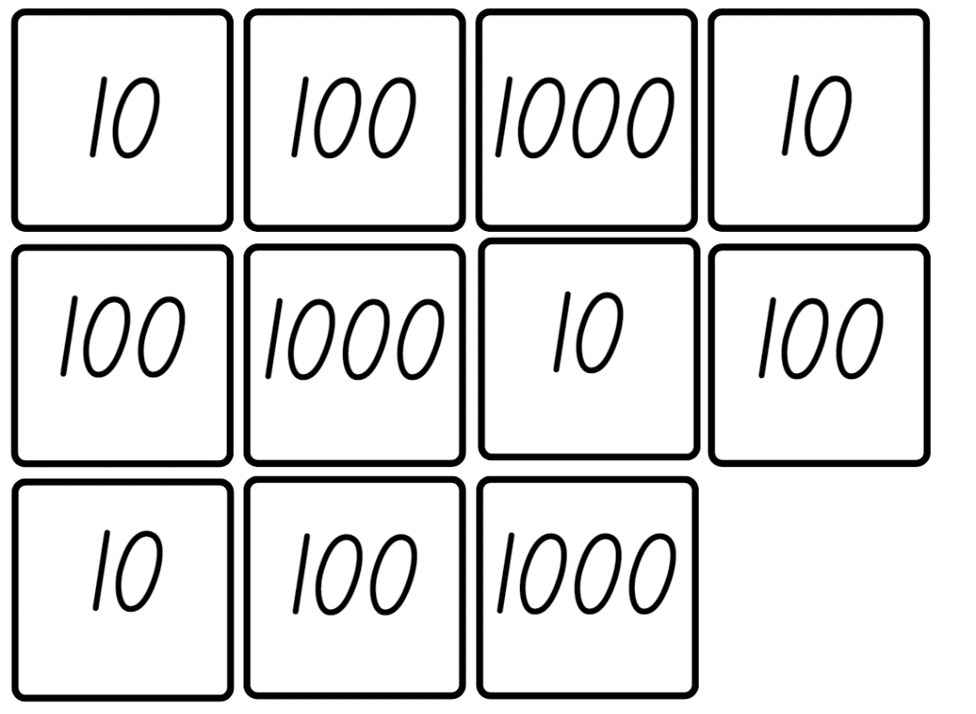

Resource 3 – rounding record
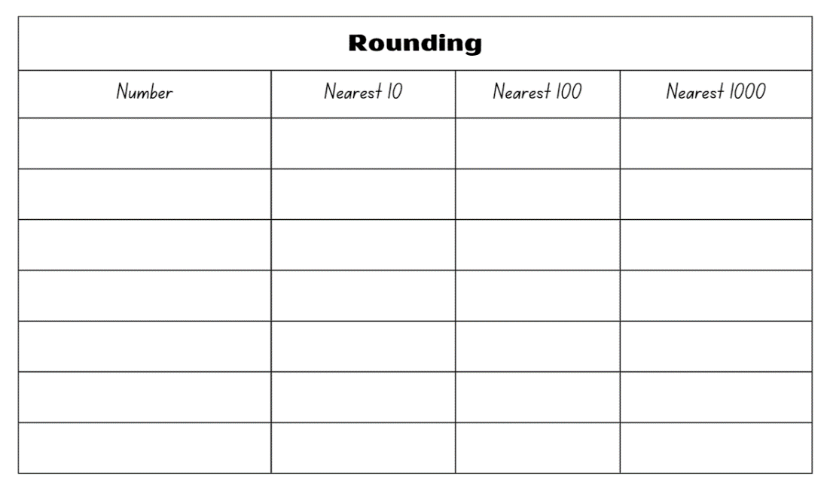

Resource 4 – soup bar model
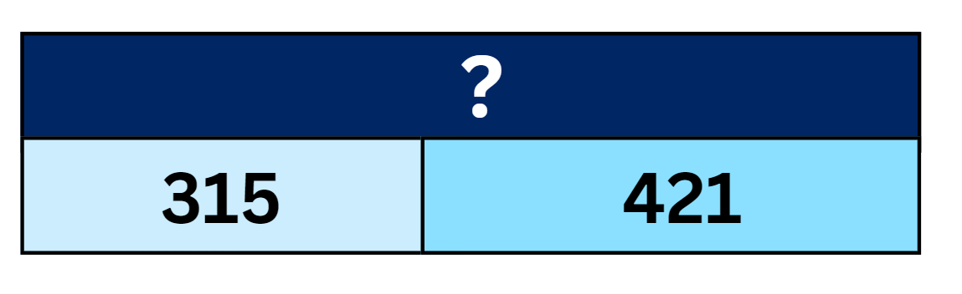

Resource 5 – subtraction problem
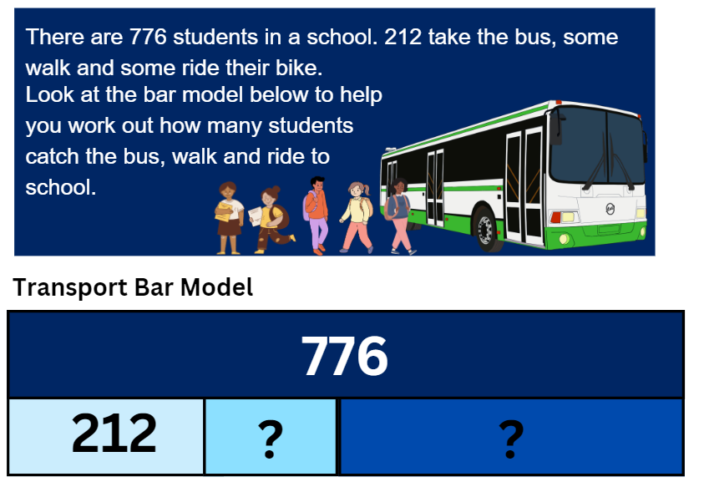

Resource 6 – word problems
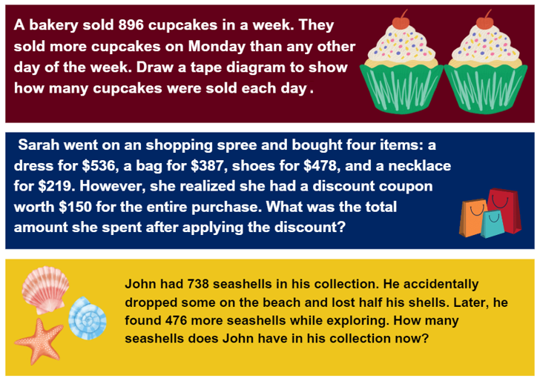
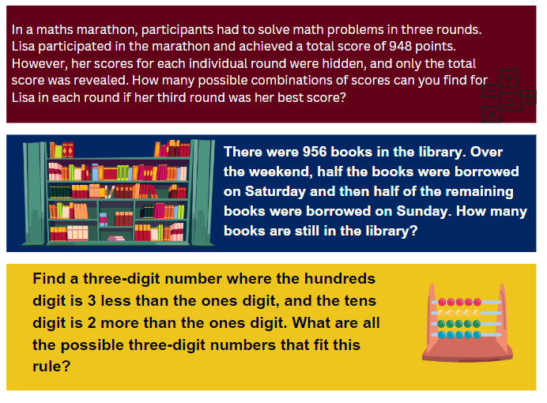

Resource 7 – consolidation task
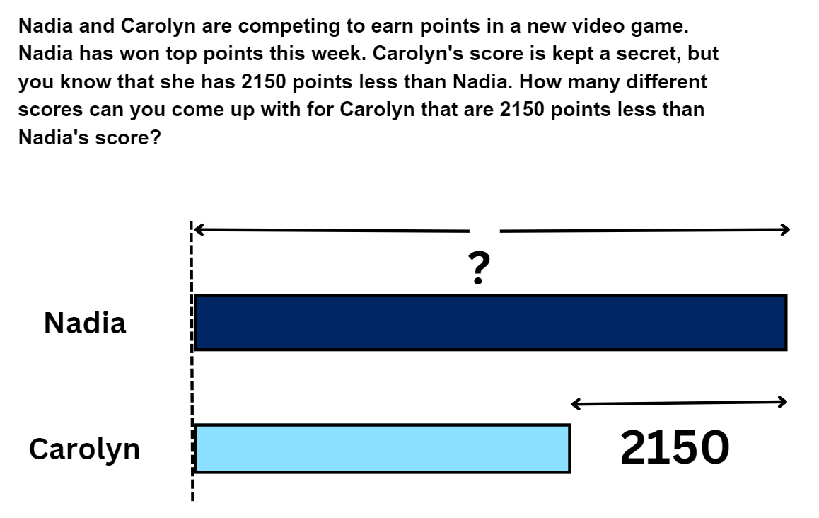

Resource 8 – place value game
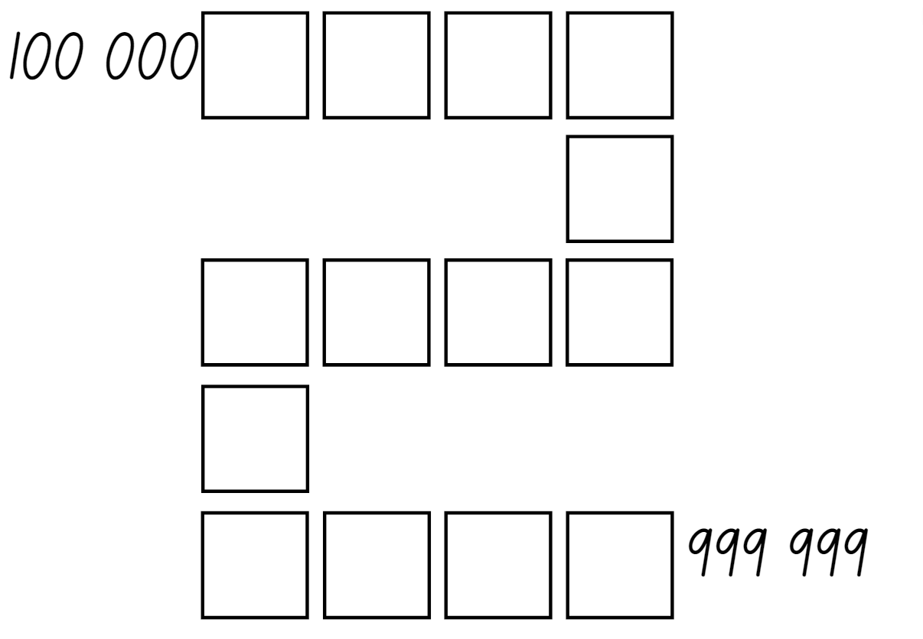

Resource 9 – race car rumble
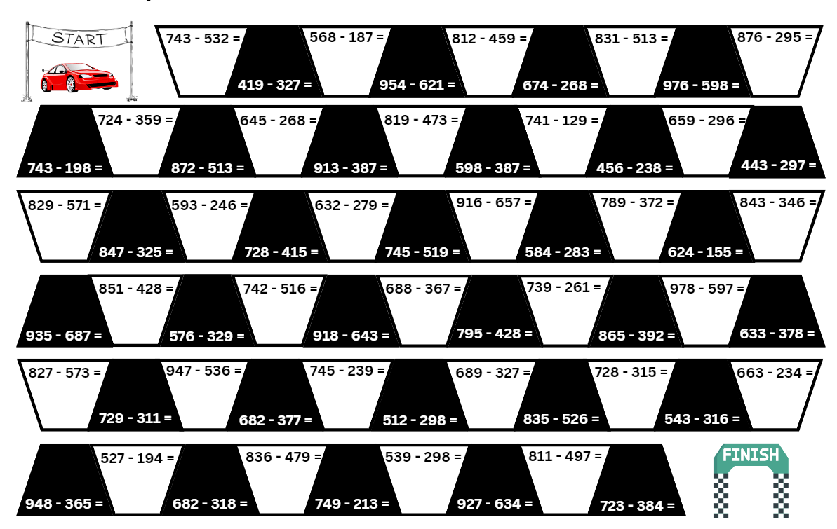

Resource 10 – spinner
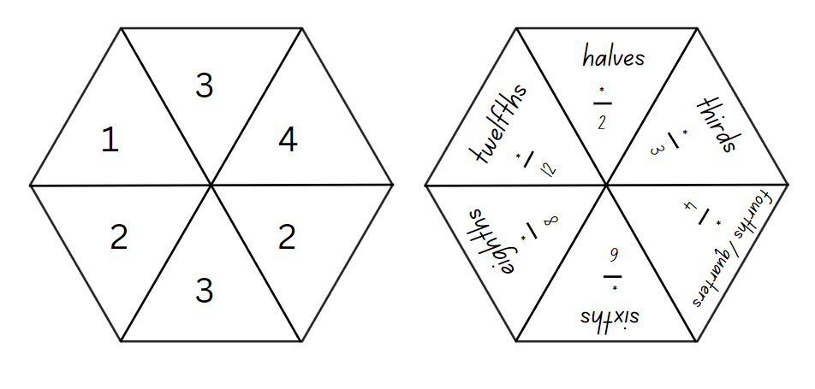

Resource 11 – fraction wall
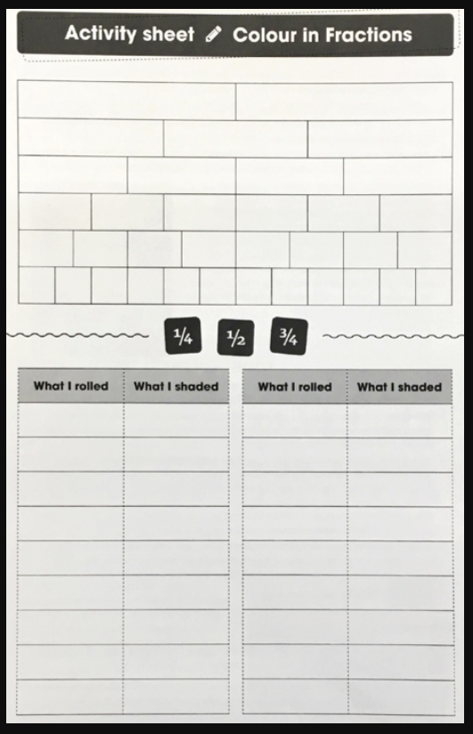

Resource 12 – trading
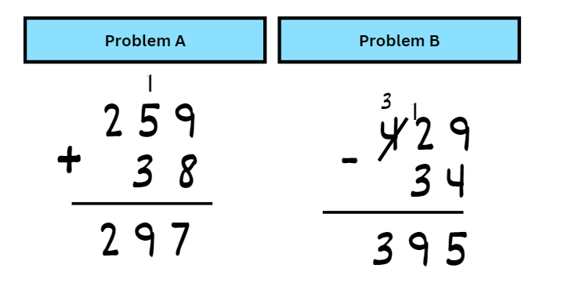

Resource 13 – algorithm errors
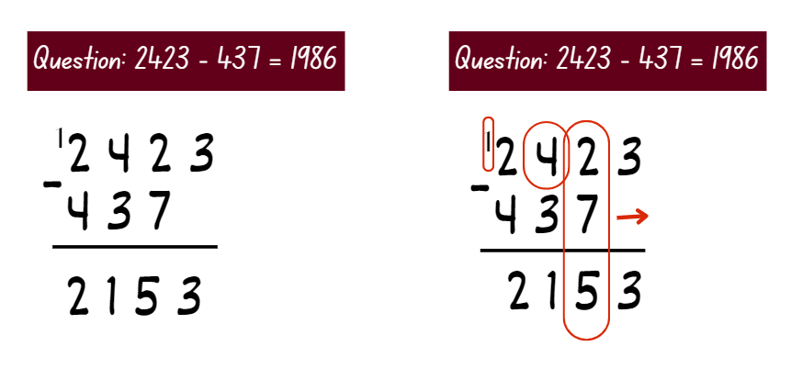

Resource 14 – Nicole’s walk
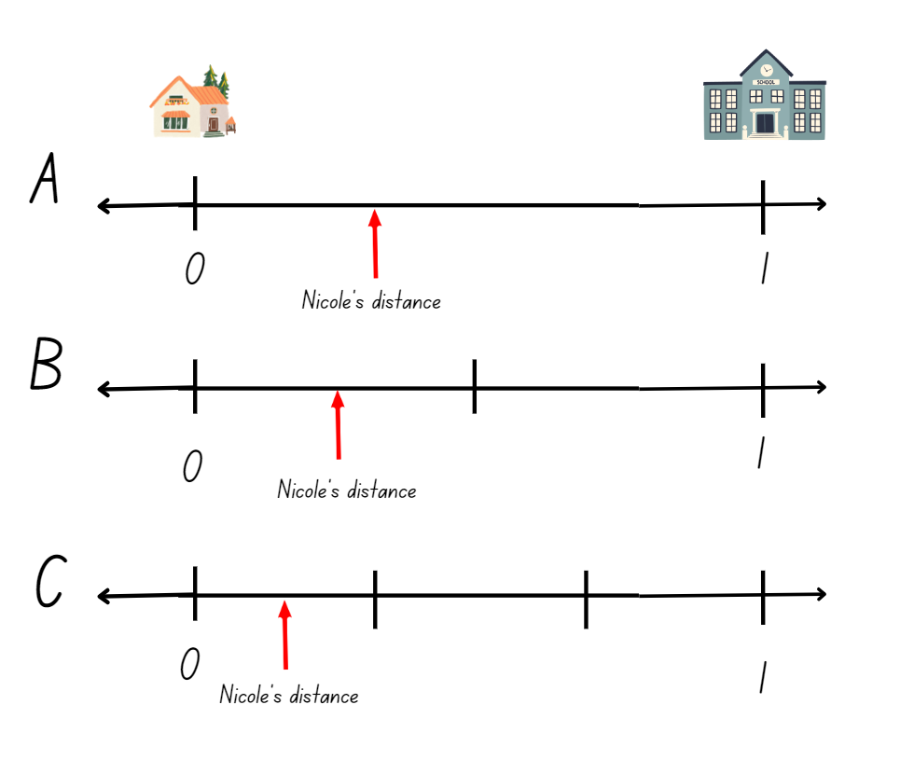

Resource 15 – four strikes

Resource 16 – equation
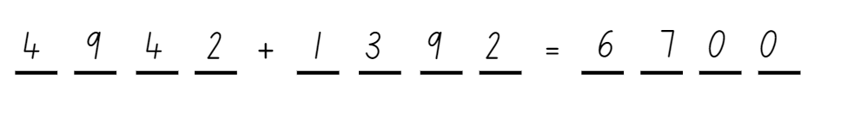

Resource 17 – paper strips

Resource 18 – answer strips
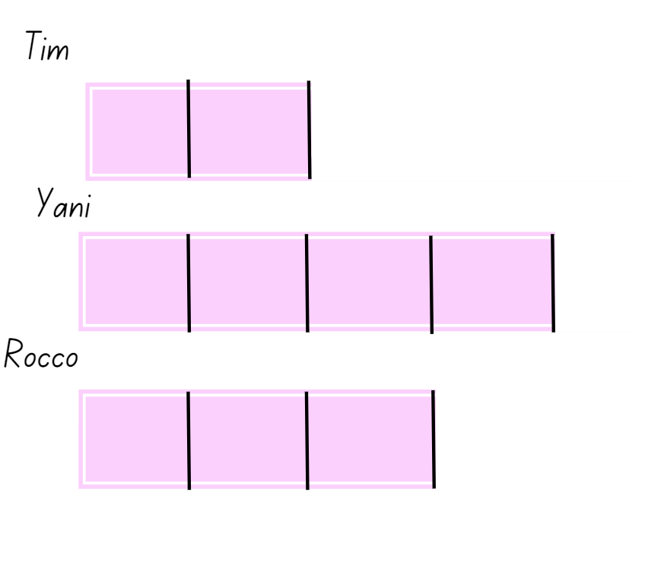

Resource 19 – Green Paddock PS
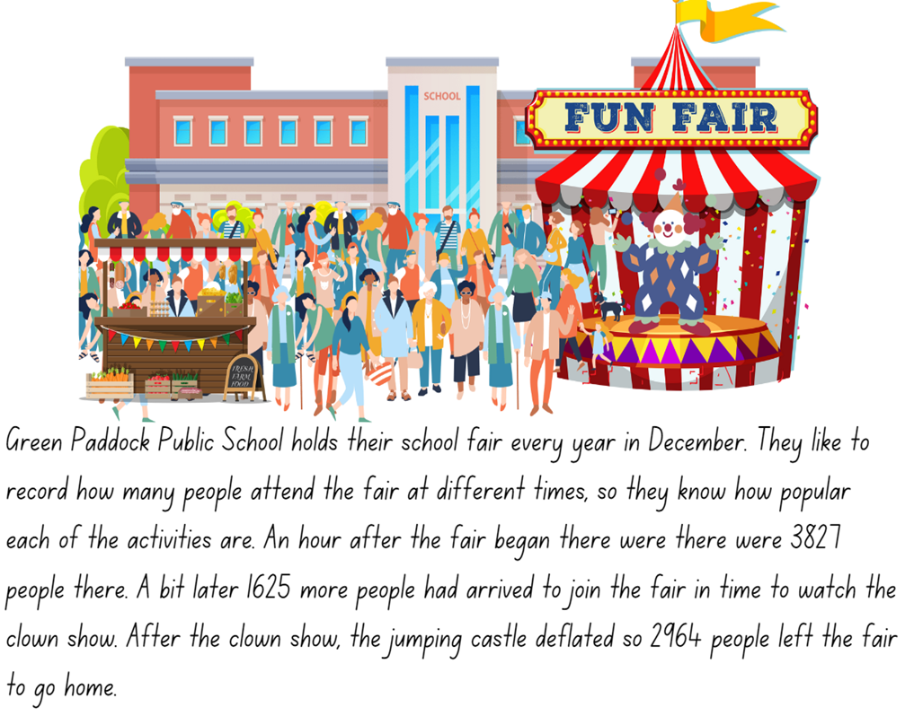

Resource 20 – prison cells
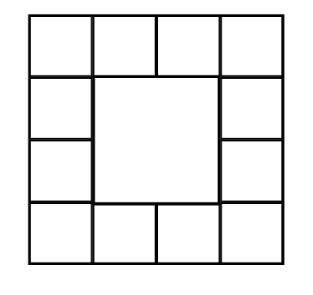

Resource 21 – Frayer model
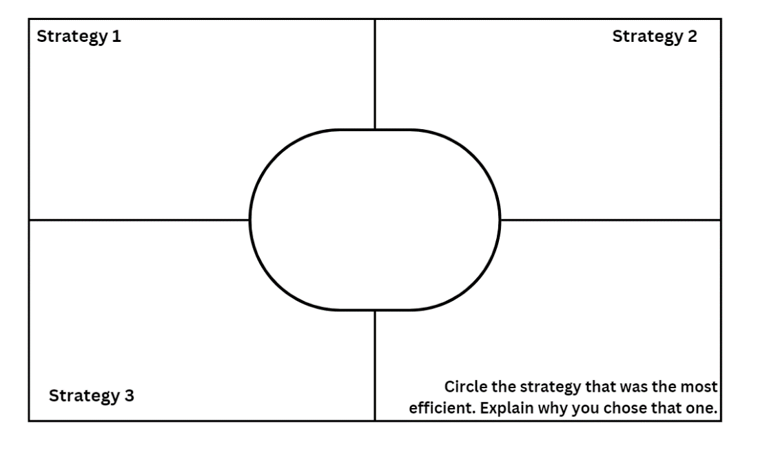

Resource 22 – museum visitors
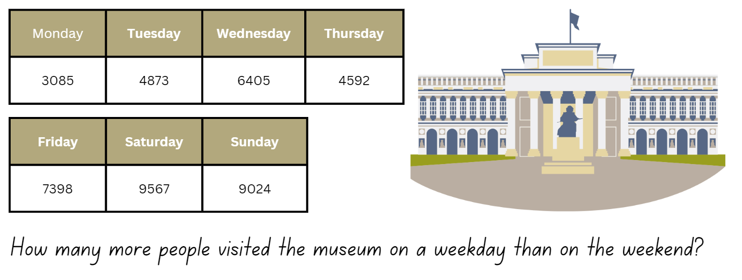

Resource 23 – problems
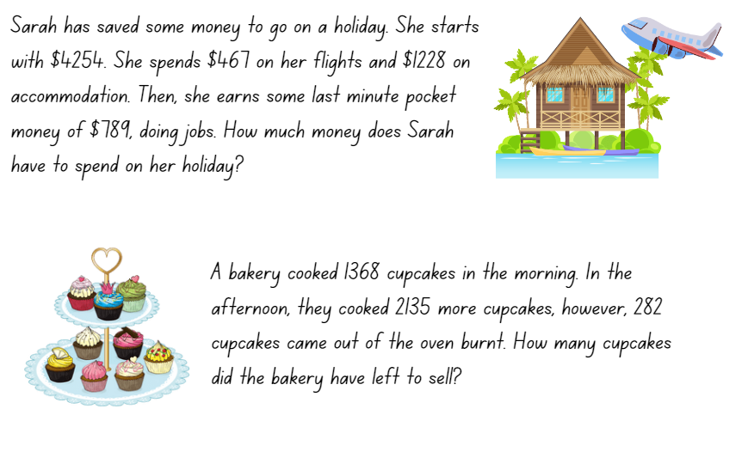

Syllabus outcomes and content
The table below outlines the syllabus outcomes and range of relevant syllabus content covered in this unit. Content is linked to National Numeracy Learning Progression (version 3).
Outcomes and content | 1 | 2 | 3 | 4 | 5 | 6 | 7 | 8
Representing numbers using place value B: Whole numbers: Apply place value to partition, regroup and rename numbers up to 6 digits
MAO-WM-01, MA2-RN-01
- Use place value to expand the number notation |  |  |  |  | x
- Partition numbers of up to 6 digits in non-standard forms |  |  |  |  | x
Partitioned fractions A: Model and represent unit fractions, and their multiples, to complete a whole on a number line
MAO-WM-01, MA2-PF-01
- Model fractions with fraction strips and diagrams for halves, quarters, eighths, thirds |  |  |  |  | x | x | x
- Determine the complementary fractional part needed to complete one whole (halves, quarters, eighths, thirds) (Reasons about relations) |  |  |  |  |  | x | x
Represents numbers A: Whole numbers: Recognise, represent and order numbers in the millions
MAO-WM-01, MA3-RN-01
- Round numbers to a specified place value |  | x |  |  |  | x
Represents numbers A: Whole numbers: Apply place value to partition, regroup and rename numbers to 1 billion
MAO-WM-01, MA3-RN-01
- Regroup numbers in different forms (Reasons about quantity) | x |  |  |  | x |  | x | x
Additive relations A: Apply efficient mental and written strategies to solve addition and subtraction problems
MAO-WM-01, MA3-AR-01
- Solve word problems, including multistep problems |  |  |  | x |  |  | x | x
- Apply known strategies such as levelling, addition for subtraction, using constant difference, and bridging (Reasons about relations) |  |  | x | x | x |  | x | x
- Use place value to add or subtract 3 or more numbers with different numbers of digits | x |  |  |  | x | x | x | x
- Identify efficient and inefficient multidigit subtraction strategies |  | x | x | x | x | x | x | x
Additive relations A: Use estimation and place value understanding to determine the reasonableness of solutions
MAO-WM-01, MA3-AR-01
- Round numbers appropriately when obtaining estimates to numerical calculations |  |  |  |  |  | x
- Use place value understanding to check for errors in calculations | x |  | x |  |  | x | x
- Use estimation to check the reasonableness of solutions to addition and subtraction calculations |  |  | x |  |  | x | x | x
Additive relations B: Choose and use efficient strategies to solve addition and subtraction problems
MAO-WM-01, MA3-AR-01
- Solve multistep word problems, including problems that require more than one operation |  |  |  |  | x |  | x | x
- Compare, evaluate and communicate strategies used to solve addition and subtraction problems |  | x | x | x | x | x | x | x
Mathematics K–10 Syllabus © NSW Education Standards Authority (NESA) for and on behalf of the Crown in right of the State of New South Wales, 2022.

References
This resource contains NSW Curriculum and syllabus content. The NSW Curriculum is developed by the NSW Education Standards Authority. This content is prepared by NESA for and on behalf of the Crown in right of the State of New South Wales. The material is protected by Crown copyright.
Please refer to the NESA Copyright Disclaimer for more information https://educationstandards.nsw.edu.au/wps/portal/nesa/mini-footer/copyright.
NESA holds the only official and up-to-date versions of the NSW Curriculum and syllabus documents. Please visit the NSW Education Standards Authority (NESA) website https://educationstandards.nsw.edu.au/wps/portal/nesa/home and the NSW Curriculum website https://curriculum.nsw.edu.au/.
Mathematics K–10 Syllabus © NSW Education Standards Authority (NESA) for and on behalf of the Crown in right of the State of New South Wales, 2022.
National Numeracy Learning Progression © Australian Curriculum, Assessment and Reporting Authority (ACARA) 2010 to present, unless otherwise indicated. This material was downloaded from the Australian Curriculum website (National Numeracy Learning Progression) (accessed 29 August 2023) and was not modified.
State of New South Wales (Department of Education) (n.d.) Coordinating groups: Snake eyes [PDF 8.0 MB], Developing efficient numeracy strategies (DENS): Stage 2, NSW Department of Education, accessed 26 June 2023.
State of New South Wales (Department of Education) (2023) ‘Additive strategies: Closest to 100 (Task 5)’, Stage 3 numbers and algebra, NSW Department of Education website, accessed 26 June 2023.
State of New South Wales (Department of Education) (2023) ‘Additive strategies: Four strikes and you’re out! (Task 7)’, Stage 3 numbers and algebra, NSW Department of Education website, accessed 26 June 2023.
State of New South Wales (Department of Education) (2023) ‘Colour in fractions’, Mathematics K-6 resources, NSW Department of Education website, accessed 26 June 2023.
State of New South Wales (Department of Education) (2023) ‘Order! Order! (four-digit numbers)’, Mathematics K-6 resources, NSW Department of Education website, accessed 26 June 2023.
State of New South Wales (Department of Education) (2023) ‘Place value game’, Mathematics K-6 resources, NSW Department of Education website, accessed 26 June 2023.
University of Cambridge (n.d) Add to 200, NRICH website, accessed 26 June 2023.
University of Cambridge (n.d) Prison Cells, NRICH website, accessed 26 June 2023.
Van de Walle J, Karp K, Bay-Williams JM, Brass A, Bentley B, Ferguson S, Goff W, Livy S, Marshman M, Martin D, Pearn C, Prodromou T, Symons D and Wilkie K (2019) Primary and Middle Years Mathematics: Teaching Developmentally, 1st Australian edn, Pearson Education Australia, Melbourne.

© State of New South Wales (Department of Education), 2023
The copyright material published in this resource is subject to the Copyright Act 1968 (Cth) and is owned by the NSW Department of Education or, where indicated, by a party other than the NSW Department of Education (third-party material).
Copyright material available in this resource and owned by the NSW Department of Education is licensed under a Creative Commons Attribution 4.0 International (CC BY 4.0) license.
This license allows you to share and adapt the material for any purpose, even commercially.
Attribution should be given to © State of New South Wales (Department of Education), 2023.
Material in this resource not available under a Creative Commons license:
- the NSW Department of Education logo, other logos and trademark-protected material
- material owned by a third party that has been reproduced with permission. You will need to obtain permission from the third party to reuse its material.
Links to third-party material and websites
Please note that the provided (reading/viewing material/list/links/texts) are a suggestion only and implies no endorsement, by the New South Wales Department of Education, of any author, publisher, or book title. School principals and teachers are best placed to assess the suitability of resources that would complement the curriculum and reflect the needs and interests of their students.
If you use the links provided in this document to access a third-party's website, you acknowledge that the terms of use, including licence terms set out on the third-party's website apply to the use which may be made of the materials on that third-party website or where permitted by the Copyright Act 1968 (Cth). The department accepts no responsibility for content on third-party websites.

