Mathematics Stage 3 – Unit 6

Contents

Unit description and duration 5

Syllabus outcomes 5

Working mathematically 6

Student prior learning 6

Lesson overview and resources 8

Lesson 1 14

Daily number sense – back and forth – 10 minutes 14

Core lesson 1 – understanding place value – 15 minutes 16

Core lesson 2 – check the clues – 25 minutes 17

Consolidation and meaningful practice – 10 minutes 18

Lesson 2 20

Daily number sense – adding numbers – 10 minutes 20

Core lesson 1 – representations of numbers – 15 minutes 21

Core lesson 2 – renaming numbers – 25 minutes 23

Discuss and connect the mathematics – 10 minutes 25

Lesson 3 27

Daily number sense – subtracting numbers – 10 minutes 27

Core lesson 1 – reading and writing thousandths – 15 minutes 28

Core lesson 2 – exploring place value of decimals – 30 minutes 30

Discuss and connect the mathematics – 10 minutes 33

Lesson 4 35

Daily number sense – 10 minutes 35

Core lesson – comparing decimals – 20 minutes 35

Consolidation and meaningful practice – 25 minutes 39

Lesson 5 41

Daily number sense – writing larger and smaller numbers – 10 minutes 41

Core lesson – comparing 2 decimals – 35 minutes 42

Consolidation and meaningful practice – 15 minutes 44

Lesson 6 46

Daily number sense – guess the number – 10 minutes 46

Core lesson – addition for subtraction – 45 minutes 48

Consolidation and meaningful practice – 10 minutes 52

Lesson 7 54

Daily number sense – reading large numbers – 10 minutes 54

Core lesson – addition and subtraction using number lines – 45 minutes 55

Discuss and connect the mathematics – 5 minutes 59

Lesson 8 61

Daily number sense – 10 minutes 61

Core lesson – choosing efficient strategies – 35 minutes 61

Consolidation and meaningful practice – 15 minutes 64

Resource 1 – check the clues 66

Resource 2 – MAB materials 71

Resource 3 – number expander 72

Resource 4 – blank houses 73

Resource 5 – decimal houses 74

Resource 6 – decimals – example 1 75

Resource 7 – decimals – example 2 76

Resource 8 – decimals – example 3 77

Resource 9 – decimals – example 4 78

Resource 10 – decimal misconceptions 79

Resource 11 – reaction times 80

Resource 12 – blank decimal grids 81

Resource 13 – comparing decimals 1 82

Resource 14 – efficient additive strategies 83

Resource 15 – codeword 84

Resource 16 – codeword answer sheet 90

Resource 17 – letters for codeword 91

Resource 18 – solution scaffold 92

Resource 19 – sushi restaurant scenario 93

Resource 20 – sushi questions 94

Resource 21 – hundred chart 95

Resource 22 – word problem 1 96

Resource 23 – word problem 2 97

Resource 24 – subtraction number sentences 98

Syllabus outcomes and content 99

References 103

# Unit description and duration

This unit develops the big idea that the number system extends infinitely to very large and very small numbers.

In this 2-week unit students are provided opportunities to:

* read, rename, represent and order numbers up to and including millions
* compare, order and represent decimals
* use place value knowledge to solve addition and subtraction problems.

## Syllabus outcomes

* **MAO-WM-01** develops understanding and fluency in mathematics through exploring and connecting mathematical concepts, choosing and applying mathematical techniques to solve problems, and communicating their thinking and reasoning coherently and clearly
* **MA3-RN-01** applies an understanding of place value and the role of zero to represent the properties of numbers
* **MA3-RN-02** compares and orders decimals up to 3 decimal places
* **MA3-AR-01** selects and applies appropriate strategies to solve addition and subtraction problems
* **MA3-GM-02** selects and uses the appropriate unit and device to measure lengths and distances including perimeters

## Working mathematically

In the Mathematics K–10 Syllabus there is one overarching Working mathematically outcome (**MAO-WM-01**). The Working mathematically processes should be embedded within the concepts being taught. The Working mathematically processes are:

* communicating
* understanding and fluency
* reasoning
* problem solving.

[Mathematics K–10 Syllabus](https://curriculum.nsw.edu.au/learning-areas/mathematics/mathematics-k-10-2022/overview) © NSW Education Standards Authority (NESA) for and on behalf of the Crown in right of the State of New South Wales, 2022.

## Student prior learning

Before engaging in these teaching and learning activities, students would benefit from prior experience with:

* reading, representing and ordering numbers up to 6-digits
* standard and non-standard partitioning of numbers up to 6-digits
* using a variety of addition and subtraction strategies.

In NSW classrooms there is a diverse range of students, including Aboriginal and Torres Strait Islander students, students learning English as an additional language or dialect, high potential and gifted students and students with disability. Some students may identify with more than one of these groups or possibly all of them. Refer to [Curriculum planning for every student – advice](https://education.nsw.gov.au/teaching-and-learning/curriculum/planning-programming-and-assessing-k-12/advice-on-curriculum-planning-for-every-student-k-12) for further information.

# Lesson overview and resources

The table below outlines the sequence and approximate timing of lessons, learning intentions and resources.

|  |  |  |
| --- | --- | --- |
| Lesson | Content | Duration and resources |
| **Lesson 1**  **Daily number sense learning intention**:   * apply efficient mental and written strategies to solve addition and subtraction problems | **Lesson core concept**: naming and representing large numbers is a key component of place value.  **Core concept learning intention**:   * recognise, represent and order numbers in the millions | **Lesson duration**: 60 minutes   * Resource 1 – check the clues * 6-sided dice * Counters * Individual whiteboards * Whiteboard markers * Writing materials |
| **Lesson 2**  **Daily number sense learning intention**:   * apply efficient mental and written strategies to solve addition and subtraction problems | **Lesson core concept**: numbers can be renamed in equivalent ways using place value.  **Core concept learning intention**:   * apply place value to partition, regroup and rename numbers to 1 billion | **Lesson duration**: 60 minutes   * Resource 2 – MAB materials * Resource 3 – number expander * 6-sided dice * 10-sided dice (0–9) * Individual whiteboards * Student workbooks * Whiteboard markers * Writing materials |
| **Lesson 3**  **Daily number sense learning intention**:   * apply efficient mental and written strategies to solve addition and subtraction problems | **Lesson core concept**: the place value system can be extended.  **Core concept learning intention**:   * recognise that the place value system can be extended beyond hundredths | **Lesson duration**: 65 minutes   * Resource 4 – blank houses * Resource 5 – decimal houses * Resource 6 – decimals – example 1 * Resource 7 – decimals – example 2 * Resource 8 – decimals – example 3 * Resource 9 – decimals – example 4 * 6-sided dice * Individual whiteboards * Student workbooks * Whiteboard markers * Writing materials |
| **Lesson 4**  **Daily number sense learning intention**:   * teacher-identified task based on student needs | **Lesson core concept**: the position of each digit in a number corresponds to its size.  **Core concept learning intention**:   * recognise that the place value system can be extended beyond hundredths | **Lesson duration**: 55 minutes   * Resource 10 – decimal misconceptions * Resource 11 – reaction times * 30 cm rulers * Individual whiteboards * Whiteboard markers * Writing materials |
| **Lesson 5**  **Daily number sense learning intention**:   * recognise, represent and order numbers in the millions | **Lesson core concept**: decimals can be compared by analysing the place values parts.  **Core concept learning intention**:   * compare, order and represent decimals | **Lesson duration**: 60 minutes   * Resource 12 – Blank decimal grid * Resource 13 – comparing decimals 1 * Writing materials |
| **Lesson 6**  **Daily number sense learning intention**:   * recognise, represent and order numbers in the millions | **Lesson core concept**: place value understanding helps solve addition and subtraction problems.  **Core concept learning intention**:   * apply efficient mental and written strategies to solve addition and subtraction problems | **Lesson duration**: 65 minutes   * Resource 14 – efficient additive strategies * Resource 15 – codeword * Resource 16 – codeword answer sheet * Resource 17 – letters for codeword * Resource 18 – solution scaffold * Individual whiteboards * Whiteboard markers * Writing materials |
| **Lesson 7**  **Daily number sense learning intention**:   * recognise, represent and order numbers in the millions | **Lesson core concept**: number lines help solve addition and subtraction problems.  **Core concept learning intention**:   * use mathematical structures to assist when adding and subtracting large numbers | **Lesson duration**: 60 minutes   * Resource 19 – sushi restaurant scenario * Resource 20 – Sushi restaurant menu * Resource 21 – hundred chart * 9-sided dice * Individual whiteboards * Whiteboard markers * Writing materials |
| **Lesson 8**  **Daily number sense learning intention**:   * teacher-identified task based on student needs | **Lesson core concept**: flexible methods of addition and subtraction involve decomposing and composing numbers.  **Core concept learning intention**:   * apply efficient mental and written strategies to solve addition and subtraction problems | **Lesson duration**: 60 minutes   * Resource 22 – word problem 1 * Resource 23 – word problem 2 * Resource 24 – subtraction number sentences * Individual whiteboards * MAB materials * Whiteboard markers * Writing materials |

# Lesson 1

**Core concept**: naming and representing large numbers is a key component of place value.

## Daily number sense – back and forth – 10 minutes

The table below contains a suggested learning intention and success criteria. These are best co-constructed with students.

|  |  |
| --- | --- |
| Daily number sense learning intention | Daily number sense success criteria |
| Students are learning to:   * apply efficient mental and written strategies to solve addition and subtraction problems. | Students can:   * use place value to add or subtract 3 or more numbers with different numbers of digits. |

This activity is an adaptation of [Tug of War](https://nrich.maths.org/5897/index) from [NRICH](https://nrich.maths.org) by University of Cambridge (Faculty of Mathematics).

1. Give pairs of students a coloured counter, three 6-sided dice and a piece of paper.
2. Students draw a number line on the paper with the values 100, 125 and 150 (see Figure 1).

Figure 1 – number line

A number line beginning at 100 and ending at 150 with a large dot halfway at 125.

1. One student is the ‘Plus’ and the other student is the ‘Minus’. Plus moves right and Minus moves left.
2. Students place the counter on the number 125 and take it in turns to roll the dice.
3. The numbers on the dice are added up and the counter is moved as many places left or right depending on whose turn it is. Students draw a number on where they have landed.
4. Students keep rolling the dice and moving until the counter either reaches 100 or 150. If it gets to 100, Minus wins and if it gets to 150, Plus wins.

This table details opportunities for assessment.

|  |  |
| --- | --- |
| Assessment opportunities | Links |
| What to look for:   * Can students use place value to add or subtract 3 or more numbers with different numbers of digits? **[MAO-WM-01, MA3-AR-01]** | Links to [National Numeracy Learning Progressions](https://www.australiancurriculum.edu.au/resources/national-literacy-and-numeracy-learning-progressions/version-3-of-national-literacy-and-numeracy-learning-progressions/) (NNLP):   * AdS7, AdS8. |

## Core lesson 1 – understanding place value – 15 minutes

The table below contains a suggested learning intention and success criteria. These are best co-constructed with students.

|  |  |
| --- | --- |
| Core concept learning intention | Core concept success criteria |
| Students are learning to:   * recognise, represent and order numbers in the millions. | Students can:   * name millions using the place value grouping of ones, tens and hundreds * arrange numbers in the millions in ascending and descending order using place value. |

1. Draw place value houses up to millions on the board.
2. Use the place value houses to explicitly model how to read and write a number up to millions (see Figure 2).

Figure 2 – place value house to millions

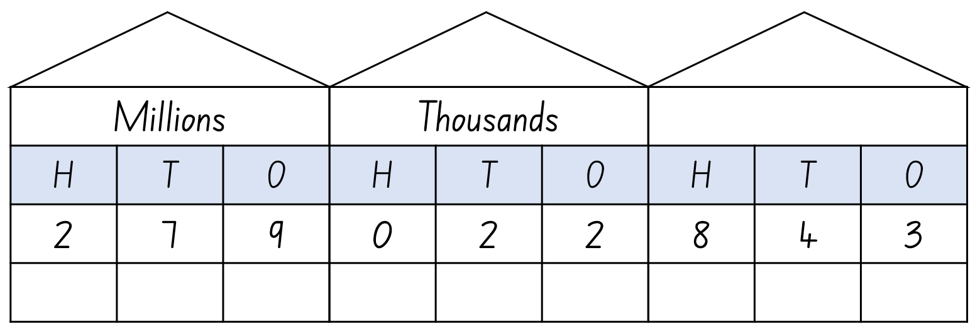

1. Ask students to write a number in the millions on individual whiteboards.
2. Ask questions to check students’ understanding of the place value system. For example, ask:

* What is the value of the digit in the hundred millions place?
* How many thousands can be found in the number?
* What is the role of the zero is the number?

1. In pairs, students [turn and talk](https://education.nsw.gov.au/teaching-and-learning/curriculum/literacy-and-numeracy/teaching-and-learning-resources/numeracy/talk-moves) to practice reading a number aloud while their partner records it on their whiteboard.
2. Partners swap roles.
3. Select 5 pairs of students to read their numbers aloud.
4. Write the 5 numbers the students have shared on the board.
5. Model how to order them in ascending and descending order.
6. Repeat the activity, inviting students to read and order the numbers.

## Core lesson 2 – check the clues – 25 minutes

This activity is an adaptation of ‘Check the Clues 5’ from A Whole School Approach to Place Value, Teaching Place Value Year 4 Whole Numbers by Dunstan and Swan.

1. Separate students into groups of 3 or 4.
2. Present each group with a copy of Resource 1 – check the clues.
3. Students take turns reading the clues aloud to their group.
4. Using the 4 options for the solutions, students work together as part of a process of elimination to determine which solution is correct.
5. Each group solves all 5 problems.
6. Students order the 5 numbers they collected during the game in ascending and descending order.

This table details opportunities for differentiation.

|  |  |
| --- | --- |
| Too hard? | Too easy? |
| Students cannot name and order numbers up to millions.   * Assist students by providing clues that are more suited to their level of learning. * Reduce the complexity of the task by providing students with clues to solve 2-digit number problems. | Students can name and order numbers up to millions.   * Challenge students to devise their own clues to a number for one of their classmates to solve. * Students to identify as many other numbers as they can that fit the clues. |

## Consolidation and meaningful practice – 10 minutes

1. Students work in groups of 3 or 4 to create their own clue cards for another group to solve.
2. Once the clues have been created, groups swap clues.
3. Students read the new clue cards created by another group and find the correct solution.
4. Students order their answers in ascending and descending order.

This table details opportunities for assessment.

|  |  |
| --- | --- |
| Assessment opportunities | Links |
| What to look for:   * Can students name millions using the place value grouping of ones, tens and hundreds? **[MAO-WM-01, MA3-RN-01]** * Can students arrange numbers in the millions in ascending and descending order using place value? **[MAO-WM-01, MA3-RN-01]** | Links to [National Numeracy Learning Progressions](https://www.australiancurriculum.edu.au/resources/national-literacy-and-numeracy-learning-progressions/version-3-of-national-literacy-and-numeracy-learning-progressions/) (NNLP):   * NPV7. |

# Lesson 2

**Core concept**: numbers can be renamed in equivalent ways using place value.

## Daily number sense – adding numbers – 10 minutes

The table below contains a suggested learning intention and success criteria. These are best co-constructed with students.

|  |  |
| --- | --- |
| Daily number sense learning intention | Daily number sense success criteria |
| Students are learning to:   * apply efficient mental and written strategies to solve addition and subtraction problems. | Students can:   * use place value to add 3 or more numbers. |

This activity is an adaptation of [Dicey Operations in Line](https://nrich.maths.org/13261) from [NRICH](https://nrich.maths.org) by University of Cambridge (Faculty of Mathematics).

1. Students draw 9 blank number cells in their workbooks.
2. Students play in pairs. Students take it in turns roll a 6-sided die and fill a cell each time with numbers they have rolled. Students keep rolling the die until they have filled in all 9 of their cells (see Figure 3).

Figure 3 – addition cells

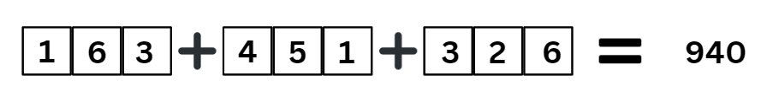

1. Students add the 3 numbers. The winner is the student that gets closest to 1000, whether the number is higher or lower than 1000.
2. Students can play multiple rounds. As students get more familiar with the game they can work more strategically and fill the cells in after they have rolled the die 9 times.

This table details opportunities for assessment.

|  |  |
| --- | --- |
| Assessment opportunities | Links |
| What to look for:   * Can students use place value to add 3 or more numbers? **[MAO-WM-01, MA3-AR-01]** | Links to [National Numeracy Learning Progressions](https://www.australiancurriculum.edu.au/resources/national-literacy-and-numeracy-learning-progressions/version-3-of-national-literacy-and-numeracy-learning-progressions/) (NNLP):   * AdS7, AdS8. |

## Core lesson 1 – representations of numbers – 15 minutes

The table below contains a suggested learning intention and success criteria. These are best co-constructed with students.

|  |  |
| --- | --- |
| Core concept learning intention | Core concept success criteria |
| Students are learning to:   * apply place value to partition, regroup and rename numbers to 1 billion | Students can:   * regroup numbers in different forms * partition numbers in non-standard forms. |

1. Draw place value houses up to millions onto the board.
2. Use the MAB material images from Resource 2 – MAB materials to represent the number 2358 in the place value house (see Figure 4).

Figure 4 – place value house to record number and represent using MAB materials

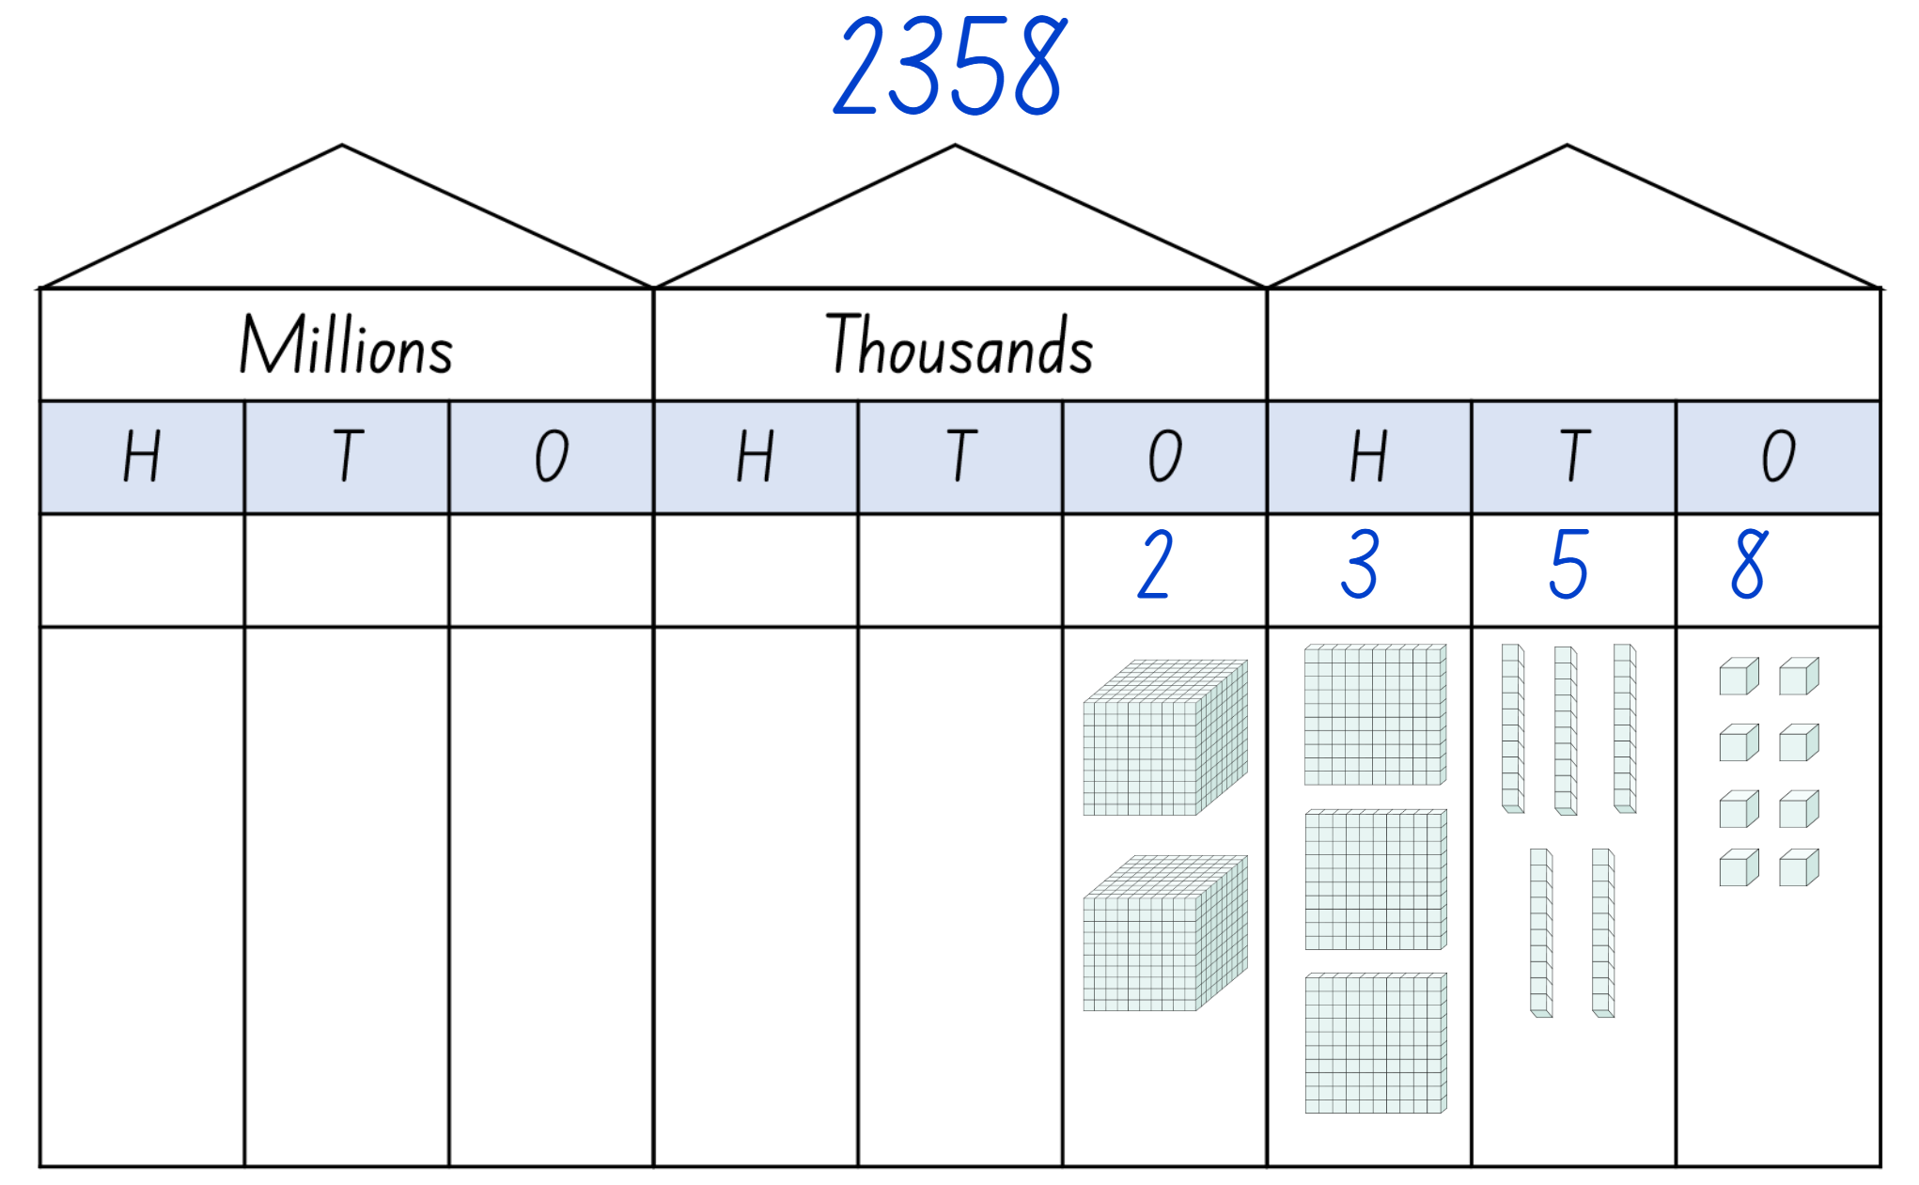

1. Pose questions to the students, such as:

* How many hundreds are in this number?
* How many thousands are in this number?
* If I only used hundreds and ones, how many hundreds would be represented in this number?
* If I only used hundreds and ones, how many hundreds would be represented in this number?

1. Give students a 4-digit number to represent using MAB materials. Repeat this process until students can confidently represent 4-digit numbers. Students may work independently or in pairs to complete this activity.

**Note**:the MAB materials used here could be physical, virtual or paper versions from Resource 2 – MAB materials.

## Core lesson 2 – renaming numbers – 25 minutes

1. Students roll a 10-sided dice 6 times to generate a 6-digit number. The same number cannot be used more than once.
2. Students record their 6-digit number on Resource 3 – number expander.
3. Students write their number on an individual whiteboard using expanded notation then break their number into its place value pieces.
4. Students use non-standard partitioning to regroup and rename their number (see Figure 5).

Figure 5 – student work example

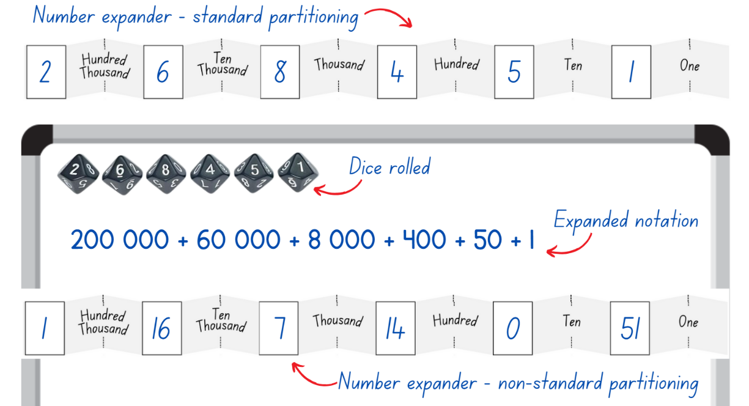

1. Students repeat this activity until they demonstrate a clear understanding of regrouping and renaming large numbers.

This table details opportunities for differentiation.

|  |  |
| --- | --- |
| Too hard? | Too easy? |
| Students cannot partition, regroup and rename numbers.   * Support students to represent larger numbers by providing access to physical, virtual and paper representations of MAB materials. * Model how to use MAB materials to represent, partition, regroup and rename larger numbers. * Assist students by reducing the size of the numbers they are using. | Students can partition, regroup and rename numbers.   * Students work in pairs. They roll six 10-sided dice to make a 6-digit number. Each student must regroup and rename this number in as many different ways as they can. After a few minutes, students compare the ways they have regrouped and renamed the number. They receive one point for each way they grouped that is different from their partner. * In pairs, students write a 6-digit number using non-standard partitioning. They challenge their partner to work out what their original number was. |

## Discuss and connect the mathematics – 10 minutes

1. Students demonstrate how they used the number expander to read, record, regroup and rename their numbers.
2. Ask students:

* What strategy did you use to help you regroup and rename your number?
* Was their more than one way to regroup and rename your number?
* Why is working flexibly with numbers important?

This table details opportunities for assessment.

|  |  |
| --- | --- |
| Assessment opportunities | Links |
| What to look for:   * Can students regroup numbers in different forms? **[MAO-WM-01, MA3-RN-01]** * Can students partition numbers in non-standard forms? **[MAO-WM-01, MA3-RN-01]** | Links to [National Numeracy Learning Progressions](https://www.australiancurriculum.edu.au/resources/national-literacy-and-numeracy-learning-progressions/version-3-of-national-literacy-and-numeracy-learning-progressions/) (NNLP):   * NPV6. |

# Lesson 3

**Core concept**: the place value system can be extended.

## Daily number sense – subtracting numbers – 10 minutes

The table below contains a suggested learning intention and success criteria. These are best co-constructed with students.

|  |  |
| --- | --- |
| Daily number sense learning intention | Daily number sense success criteria |
| Students are learning to:   * apply efficient mental and written strategies to solve addition and subtraction problems. | Students can:   * use place value to subtract numbers up to 4 digits. |

This activity is an adaptation of [Dicey Operations in Line](https://nrich.maths.org/13261) from [NRICH](https://nrich.maths.org) by University of Cambridge (Faculty of Mathematics).

1. Students draw 8 blank number cells in their workbooks.
2. Students play in pairs. Player 1 take it in turns roll a 6-sided die 8 times and records the 8 digits rolled. They then make two 4-digit numbers using the 8 digits and place their largest number into the first 4 cells (see Figure 6).

Figure 6 – subtraction cells

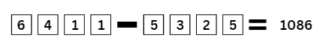

1. Player 1 subtracts the 2 numbers and records their score. The game repeats with Player 2 rolling the dice first. After one round, players compare their score and the winner is the student that gets closest to 1000, whether the number is higher or lower than 1000.
2. Students can play multiple rounds and have cumulative totals.

This table details opportunities for assessment.

|  |  |
| --- | --- |
| Assessment opportunities | Links |
| What to look for:   * Can students use place value to subtract numbers up to 4 digits? **[MAO-WM-01, MA3-AR-01]** | Links to [National Numeracy Learning Progressions](https://www.australiancurriculum.edu.au/resources/national-literacy-and-numeracy-learning-progressions/version-3-of-national-literacy-and-numeracy-learning-progressions/) (NNLP):   * AdS8.   Links to suggested [Interview for Student Reasoning](https://education.nsw.gov.au/teaching-and-learning/curriculum/literacy-and-numeracy/assessment-resources/ifsr) (IfSR) tasks:   * **IfSR-AT**: 3A.4. |

## Core lesson 1 – reading and writing thousandths – 15 minutes

The table below contains a suggested learning intention and success criteria. These are best co-constructed with students.

|  |  |
| --- | --- |
| Core concept learning intention | Core concept success criteria |
| Students are learning to:   * recognise that the place value system can be extended beyond hundredths. | Students can:   * read and write decimal notation for thousandths * compare and order decimal numbers of up to 3 decimal places * place decimal numbers of up to 3 decimal places on a number line. |

**Note**: to support place value conceptual understanding, 5.376 would be read as 5 and three hundred and seventy-six thousandths. The word ‘and’ connects the decimal fraction with the whole number and makes a connection with common fractions.

1. Write the number 5.3 on the board and ask students how they would read the number (correct answer is 5 and 3 tenths).
2. Write the number 5.37 on the board and ask students how they would read the number (correct answer is 5 and 37 hundredths).
3. Write the number 5.376 on the board and ask students how they would read the number (correct answer is 5 and 376 thousandths).
4. In pairs, students sit back-to-back.
5. Using Resource 4 – blank houses, students practise reading and writing decimals up to thousandths. For example, Student A writes a decimal in the place value house and reads it aloud to Student B. Student B writes the number in their place value house. Partners then face each other and compare their written decimals. Partners swap roles and repeat.

This table details opportunities for differentiation.

|  |  |
| --- | --- |
| Too hard? | Too easy? |
| Students cannot read and write decimal notation for thousandths.   * Support students by providing Resource 5 – decimal houses with the decimals pre-written in the correct places for them to read aloud. * Assist students by reducing the number of decimals places they are using to tenths and hundredths. | Students can read and write decimal notation for thousandths.   * Students state the number before and after each decimal they have written. * Working in pairs, students write a number that includes decimals, without showing their partner. Students take turns to ask questions about their partner’s number. For example, students could ask if their partner’s number has a 4 in the hundredths place or if the numeral in the tenths place is higher than 5. When students think they have enough information, they can try to guess their partner’s number. |

## Core lesson 2 – exploring place value of decimals – 30 minutes

This activity is an adaptation of ‘Garden Path’ from State of New South Wales (Department of Education) and ‘Decimals – Good questions’ from Open-ended Maths Activities: using ‘good’ questions to enhance learning in Mathematics by Lilburn and Sullivan.

1. Draw a number line on the board with the numbers 0–10 marked evenly along it.
2. Reads aloud the decimal number 5 and three hundred and seventy-six thousandths. Ask the students to decide where that number would be found along the number line.
3. Students [turn and talk](https://education.nsw.gov.au/teaching-and-learning/curriculum/literacy-and-numeracy/teaching-and-learning-resources/numeracy/talk-moves) with a partner to discuss where they believe the number would go, justifying their decision.
4. Display Resource 6 – decimals – example 1.
5. Explain that the decimal 5.376 is larger than 5, but smaller than 6. Highlight this range on the number line.
6. Use this opportunity to reinforce the idea that students should read 5.376 as 5 and 376 thousandths, not five point three seven six.

**Note**: students may need to revise the trailing zero at the end of a decimal. Highlight that 5 is equivalent to 5.0.

1. Display Resource 7 – decimals – example 2. Explain that if students zoom in, there are 10 parts between the numbers 5 and 6. 5.376 is larger than 5.3, but smaller than 5.4 so it sits in the range highlighted in purple.
2. Display Resource 8 – decimals – example 3. Explain that students can zoom in again to see that between these numbers there are another 10 parts. 5.376 is larger than 5.3, which can be written as 5.30, but is smaller than 5.40. This means there are 100 parts between 5 and 6.
3. Display Resource 9 – decimals – example 4. Explain that by zooming in again, students can see 10 parts between 5.370 and 5.380. There are now 1000 parts between 5 and 6, because 10 × 10 × 10 = 1000. Explain that students can now find the exact position of 5 and 376 thousandths on the number line (see Figure 7).

Figure 7 – decimal place broken down

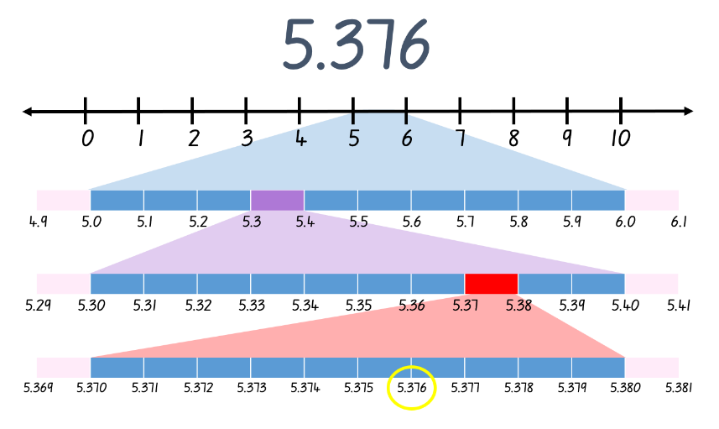

1. Display Resource 6 – decimals – example 1. Explain that a standard number line doesn’t always show all of the parts, as it would be too hard to show 1000 small parts. Alternatively, students might show 5.376 on a number line as in Figure 7.

**Note**: interpreting decimals used in different contexts can change the way that students read them. In the context of measuring timber, it is appropriate to read the decimal 2.83 as two point eight three metres. Without a relevant context, this decimal is read as two and eighty-three hundredths.

1. Write the measurement 2.125 m on the board.
2. Pose questions, such as:

* What does the 2 mean in this number?
* What does the 125 mean in this number?
* How does this affect how we deal with these numbers?

1. Discuss that 2.125 metres is 2 metres and 125 millimetres.
2. Explain that you found a pile of timber pieces that were all different lengths, but all measured between 2.1 and 2.2 m in length. Ask students how long each piece of timber might be.
3. Students work individually or in pairs to find as many solutions as they can and record these on an individual whiteboard.
4. Students compare their answers with another group or students, justifying their choices.

## Discuss and connect the mathematics – 10 minutes

1. Draw a number line and label the ends 2.1 and 2.2.
2. Invite students to place one of their answers to the timber problem on the number line and discuss its placement as a class.
3. Ask students:

* Why were we able to have so many solutions?
* Do you think we have found all the solutions?
* Knowing what we know about place value, could there be more solutions?

**Note**: if students do not come to the realisation that the place value system can be extended further by having more decimal places, highlight this during the discussion.

This table details opportunities for assessment.

|  |  |
| --- | --- |
| Assessment opportunities | Links |
| What to look for:   * Can students read and write decimal notation for thousandths? **[MAO-WM-01, MA3-RN-02]** * Can students compare and order decimal numbers of up to 3 decimal places? **[MAO-WM-01, MA3-RN-02]** * Can students place decimal numbers of up to 3 decimal places on a number line? **[MAO-WM-01, MA3-RN-02]** | Links to [National Numeracy Learning Progressions](https://www.australiancurriculum.edu.au/resources/national-literacy-and-numeracy-learning-progressions/version-3-of-national-literacy-and-numeracy-learning-progressions/) (NNLP):   * NPV7, NPV8.   Links to suggested [Interview for Student Reasoning](https://education.nsw.gov.au/teaching-and-learning/curriculum/literacy-and-numeracy/assessment-resources/ifsr) (IfSR) tasks:   * **IfSR-PT**:1A.5, 1A.7 * **IfSR-AT**: 4B.1 * **IfSR-NP**: 4D.1, 4D.4, 4D.6. |

# Lesson 4

**Core concept**: the position of each digit in a number corresponds to its size.

## Daily number sense – 10 minutes

1. From a class need surfaced through formative assessment data, identify a short, focused activity that targets students’ knowledge, understanding and skills. Example activities may be drawn from the following resources:

* [Mathematics K-6 resources](https://education.nsw.gov.au/teaching-and-learning/curriculum/mathematics/mathematics-curriculum-resources-k-12/mathematics-k-6-resources#catalogue_auto)
* [Universal Resources Hub](https://resources.education.nsw.gov.au/home).

## Core lesson – comparing decimals – 20 minutes

The table below contains a suggested learning intention and success criteria. These are best co-constructed with students.

|  |  |
| --- | --- |
| Core concept learning intention | Core concept success criteria |
| Students are learning to:   * recognise that the place value system can be extended beyond hundredths. | Students can:   * indicate the place value of digits in decimal numbers of up to 3 decimal places * compare and order decimal numbers of up to 3 decimal places * place decimal numbers of up to 3 decimal places on a number line. |

This activity is an adaptation of [Identifies, represents and compares decimals](https://resources.education.nsw.gov.au/detail/NPV-44)from [Universal Resources Hub](https://resources.education.nsw.gov.au/detail/NPV-44) by State of New South Wales (Department of Education).

1. Display and read Resource 10 – decimal misconceptions. Explain that the class need to decide which of the students from the display has written the correct answer. They must be able to justify why they have chosen that particular student.
2. Students record their answer on an individual whiteboard. Their answer must include the student’s name and why they think that choice is correct.
3. Students [[turn and talk](https://education.nsw.gov.au/teaching-and-learning/curriculum/literacy-and-numeracy/teaching-and-learning-resources/numeracy/talk-moves)](https://education.nsw.gov.au/teaching-and-learning/curriculum/literacy-and-numeracy/teaching-and-learning-resources/numeracy/talk-moves) with a partner to share and discuss their choices.
4. If they are convinced by their partner that their choice is incorrect, students can change their answer.
5. Go through each of the responses in the resource, allowing the class to discuss, challenge and justify their choices.
6. When students have had an opportunity to discuss their ideas for each student, explain why that student has the correct or incorrect answer. For example, Kate’s answer is incorrect because she has ignored the decimal point.

**Note**: NSW Mathematics K–10 Syllabus Teaching Advice outlines potential misconceptions students may have, such as:

* longer decimals are always larger decimals, for example, 0.75 is larger than 0.8
* interpreting the decimal portion as a whole number
* the decimal separator is a space between whole numbers
* when zero is in the tenths place students sometimes ignore it and treat the following digit as if it is in the tenths place, for example, 0.07 is the same as 0.7.

[Mathematics K–10 Syllabus](https://curriculum.nsw.edu.au/learning-areas/mathematics/mathematics-k-10-2022/overview) © NSW Education Standards Authority (NESA) for and on behalf of the Crown in right of the State of New South Wales, 2022.

1. Ask students if longer decimals are always larger.
2. Invite some students to share their thoughts with the class and justify their answer.
3. Display the decimals 0.752 and 0.8 on the board. In pairs, students [turn and talk](https://education.nsw.gov.au/teaching-and-learning/curriculum/literacy-and-numeracy/teaching-and-learning-resources/numeracy/talk-moves) to discuss which decimal they think is the largest.
4. Model comparing the place value of each of the digits by drawing them in a place value house and representing it on a number line (see Figure 8).

Figure 8 – Longer is larger?

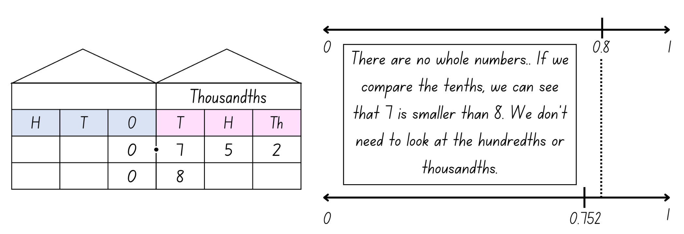

1. Explain that there are multiple ways to determine which decimal is largest. When comparing, students can see that there are no whole numbers in either decimal, so they move to the tenths. Seven tenths are smaller than 8 tenths, so students don’t need to move onto the hundredths. Students could put a zero in the empty hundredths and thousandths columns to represent that 0.8 is the same as 0.800. This would not change the size of the number; however, it helps with comparing the size of decimals. Explain that students can now see that 752 thousandths or 0.752 is smaller than 800 thousandths or 0.8, proving that the longest decimal is not always the largest.
2. Write 2 decimals on the board.
3. Students compare the decimals, order them and represent them on an empty number line.

This table details opportunities for differentiation.

|  |  |
| --- | --- |
| Too hard? | Too easy? |
| Students cannot indicate the place value of digits in decimal numbers.   * Students compare decimals with the same number of decimal places. * Students draw a place value house to write their decimals in to assist in comparing. * Provide students with decimals that are further apart to compare and place on a number line. | Students can indicate the place value of digits in decimal numbers.   * Students decrease the range of their number line. For example, if comparing 0.8 and 0.752, label the ends of their number line with 0.7 and 0.9. * Challenge students to compare 3 or more decimal numbers at a time. |

## Consolidation and meaningful practice – 25 minutes

This activity is an adaptation of [Reaction time test](https://education.nsw.gov.au/teaching-and-learning/curriculum/mathematics/mathematics-curriculum-resources-k-12/mathematics-k-6-resources/reaction-time-test) from [Mathematics K-6 resources](https://education.nsw.gov.au/teaching-and-learning/curriculum/mathematics/mathematics-curriculum-resources-k-12/mathematics-k-6-resources) by State of New South Wales (Department of Education). This activity was introduced in Stage 3 Year A Unit 5 where students recorded the results in relation to data content. Students may like to review their data collected previously and compare and improve on their reaction times.

1. In small groups, students conduct the reaction time test.
2. One student holds a ruler up at shoulder height with the zero mark at the bottom.
3. A second student places their hand around the bottom of the ruler, without touching it, ready to catch.
4. The first student drops the ruler at an unpredictable time.
5. The second person catches the ruler with their thumb and finger, recording where on the ruler their thumb lands.
6. Each student in the group has a turn and all reaction times are recorded.
7. Students use Resource 11 – reaction times to determine their reaction times.
8. Students order their group member’s reaction times on a number line.

This table details opportunities for assessment.

|  |  |
| --- | --- |
| Assessment opportunities | Links |
| What to look for:   * Can students indicate the place value of digits in decimal numbers of up to 3 decimal places? **[MAO-WM-01, MA3-RN-02]** * Can students compare and order decimal numbers of up to 3 decimal places? **[MAO-WM-01, MA3-RN-02]** * Can students place decimal numbers of up to 3 decimal places on a number line? **[MAO-WM-01, MA3-RN-02]** | Links to [National Numeracy Learning Progressions](https://www.australiancurriculum.edu.au/resources/national-literacy-and-numeracy-learning-progressions/version-3-of-national-literacy-and-numeracy-learning-progressions/) (NNLP):   * NPV7, NPV8.   Links to suggested [Interview for Student Reasoning](https://education.nsw.gov.au/teaching-and-learning/curriculum/literacy-and-numeracy/assessment-resources/ifsr) (IfSR) tasks:   * **IfSR-PT**:1A.4,1A.5, 1A.7 * **IfSR-AT**: 4B.1 * **IfSR-NP**: 4D.1, 4D.2, 4D.4, 4D.6. |

# Lesson 5

**Core concept**: decimals can be compared by analysing the place values parts.

## Daily number sense – writing larger and smaller numbers – 10 minutes

The table below contains a suggested learning intention and success criteria. These are best co-constructed with students.

|  |  |
| --- | --- |
| Daily number sense learning intention | Daily number sense success criteria |
| Students are learning to:   * recognise, represent and order numbers in the millions. | Students can:   * name millions using the place value grouping of ones, tens and hundreds. |

This activity is an adaptation from Open-ended Maths Activities: Using ‘Good’ Questions to Enhance Learning in Mathematics by Sullivan and Lilburn.

1. Write an 8-digit number on the board. Have students read the number out aloud.
2. Students to write a number that is larger than the number and a number that is smaller.
3. Both numbers must have the same number of digits as the original number on the board. Have students read their numbers out loud to a peer.
4. Record various students’ numbers on the board and ask the following questions:

* How do you know this number is smaller than the one on the board?
* How do you know this number is larger than the one on the board?

This table details opportunities for assessment.

|  |  |
| --- | --- |
| Assessment opportunities | Links |
| What to look for:   * Can students name millions using the place value grouping of ones, tens and hundreds? **[MAO-WM-01, MA3-RN-01]** | Links to [National Numeracy Learning Progressions](https://www.australiancurriculum.edu.au/resources/national-literacy-and-numeracy-learning-progressions/version-3-of-national-literacy-and-numeracy-learning-progressions/) (NNLP):   * NPV7. |

## Core lesson – comparing 2 decimals – 35 minutes

The table below contains a suggested learning intention and success criteria. These are best co-constructed with students.

|  |  |
| --- | --- |
| Core concept learning intention | Core concept success criteria |
| Students are learning to:   * compare, order and represent decimals. | Students can:   * compare and order decimal numbers of up to 3 decimal places. |

This activity is an adaptation of [Understanding place value in decimals](https://resources.education.nsw.gov.au/detail/NPV-23)from [Universal Resources Hub](https://resources.education.nsw.gov.au/home) by State of New South Wales (Department of Education).

1. Explain that 2 babies were born. One weighed 3.5 kg and other 3.25 kg. Ask the class which baby weighed less.
2. Provide students with Resource 12 – blank decimal grids to represent the problem. Use a different colour to represent each weight.
3. Students [turn and talk](https://education.nsw.gov.au/teaching-and-learning/curriculum/literacy-and-numeracy/teaching-and-learning-resources/numeracy/talk-moves) to discuss their answer.
4. As a class, students share their answers and explain their solutions.
5. Model using the language of place value to compare the decimals. For example, 3 and 25 hundredths is the smaller decimal because it has 2 tenths, which is smaller than the 5 tenths in the decimal 5 and 5 tenths.
6. In pairs, students use Resource 13 – comparing decimals 1 to compare each pair of decimals.
7. As a class, discuss the answers, inviting students to justify their thinking.

This table details opportunities for differentiation.

|  |  |
| --- | --- |
| Too hard? | Too easy? |
| Students cannot compare and order decimals up to 3 decimal places.   * Provide students with numbers that have a reduced number of decimal places to assist students to compare 2 decimals. * Encourage students to colour Resource 12 – blank decimal grids to represent each decimal to assist with comparison. | Students can compare and order decimals up to 3 decimal places.   * Students plot their answers on an empty number line. * Students pick a number in between the 2 original numbers and plot on a number line. Students justify their responses to a classmate. |

## Consolidation and meaningful practice – 15 minutes

1. Explain that the heights of 3 adults were recorded as 1.7 m, 1.27 m and 1.827 m. Ask which adult is the tallest. Order the heights in descending order.
2. Students work independently to order the heights in descending order and record their thinking.
3. As a class, students share their answers and discuss how they represented their thinking.
4. Discuss the different efficient representations used. Explain why using the decimal grid would be an inefficient representation when working with numbers of up to 3 decimal places.

**Note**: students are not expected to construct a hundredths grid. They need to be able to explain that it can be made by making another 10 squares in each of the 100 squares and then to further explain that the value is smaller. Representing the hundredths on a decimal grid is inefficient.

This table details opportunities for assessment.

|  |  |
| --- | --- |
| Assessment opportunities | Links |
| What to look for:   * Can students compare and order decimals up to 3 decimal places? **[MAO-WM-01, MA3-RN-02]** | Links to [National Numeracy Learning Progressions](https://www.australiancurriculum.edu.au/resources/national-literacy-and-numeracy-learning-progressions/version-3-of-national-literacy-and-numeracy-learning-progressions/) (NNLP):   * NPV8.   Links to suggested [Interview for Student Reasoning](https://education.nsw.gov.au/teaching-and-learning/curriculum/literacy-and-numeracy/assessment-resources/ifsr) (IfSR) tasks:   * **IfSR-PT**:1A.5, 1A.7 * **IfSR-AT**: 4B.1 * **IfSR-NP**: 4D.1, 4D.4, 4D.6. |

# Lesson 6

**Core concept**: place value understanding helps solve addition and subtraction problems.

## Daily number sense – guess the number – 10 minutes

The table below contains a suggested learning intention and success criteria. These are best co-constructed with students.

|  |  |
| --- | --- |
| Daily number sense learning intention | Daily number sense success criteria |
| Students are learning to:   * recognise, represent and order numbers in the millions. | Students can:   * name millions using the place value grouping of ones, tens and hundreds. |

This activity is an adaptation of [Mastermind](https://education.nsw.gov.au/teaching-and-learning/curriculum/mathematics/mathematics-curriculum-resources-k-12/mathematics-k-6-resources/mastermind) from [Mathematics K-6 resources](https://education.nsw.gov.au/teaching-and-learning/curriculum/mathematics/mathematics-curriculum-resources-k-12/mathematics-k-6-resources/reaction-time-test) by State of New South Wales (Department of Education).

1. In pairs, students write down a 7-digit number without showing the other player.
2. Players take it in turns to guess their opponent’s 7-digit number. Guessed numbers should be written down, said aloud and named correctly using place value language.
3. After each guess, the player’s opponent tells them how many digits are correct, how many are in the correct place and how many are incorrect by using symbols underneath the number. Students use a tick for correct number and place, a circle for correct number but not the correct place, and a cross for incorrect number. If for example, the number is 7 246 384 and the guess is 3 217 689, there are 2 correct digits in the correct place, 3 correct digits in the wrong place and 2 incorrect digits (see Figure 9). The numbers in the tens and hundred thousands place are correct, the numbers in the millions, thousands and hundreds place are in the wrong place and the numbers in the ones and ten thousands place are incorrect.

Figure 9 – mastermind

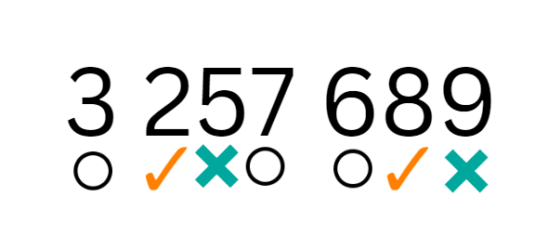

1. Players use this information to refine their guesses.
2. The first player to correctly guess their opponent’s number is the winner.
3. The level of difficulty can be changed by using numbers with more or fewer digits and by using numbers with internal zeros.
4. After the game, ask questions such as:

* How many guesses did it take to get the correct number?
* What could you do to make it more difficult for your opponent?
* What advice would you give to someone who hasn’t played this game before?

This table details opportunities for assessment.

|  |  |
| --- | --- |
| Assessment opportunities | Links |
| What to look for:   * Can students name numbers in the millions using the place value groupings of ones, tens and hundreds? **[MAO-WM-01, MA3-RN-01]** | Links to [National Numeracy Learning Progressions](https://www.australiancurriculum.edu.au/resources/national-literacy-and-numeracy-learning-progressions/version-3-of-national-literacy-and-numeracy-learning-progressions/) (NNLP):   * NPV7. |

## Core lesson – addition for subtraction – 45 minutes

The table below contains a suggested learning intention and success criteria. These are best co-constructed with students.

|  |  |
| --- | --- |
| Core concept learning intention | Core concept success criteria |
| Students are learning to:   * apply efficient mental and written strategies to solve addition and subtraction problems. | Students can:   * apply the addition for subtraction strategy * identify efficient and inefficient multidigit subtraction strategies. |

1. Display Resource 14 – efficient additive strategies and ask students:

* Which strategy is more efficient?
* How do you know?

**Note**: solving 183 − 96 by making 183 marks and then crossing off 96 before counting the remaining marks, is an inefficient strategy. This method is sometimes described as ‘counting from one 3 times’ (count one to draw the 183 marks, count 2 to cross out 96 and count 3 to count how many are left over). Although it ultimately arrives at the answer, this strategy takes too long and is prone to errors. Sometimes it is easier to use addition for subtraction than to subtract the smaller number.

1. Model using the addition for subtraction strategy to solve the subtraction problem 209 − 197 = 12 (see Figure 10).

Figure 10 – addition for subtraction example

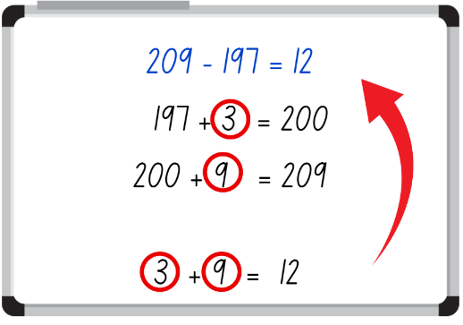

1. Display the number sentence 5481 − 1344. Collaboratively work through the steps with the students as they complete the same problem on their individual whiteboard (see Figure 11).

Figure 11 – addition for subtraction example 2

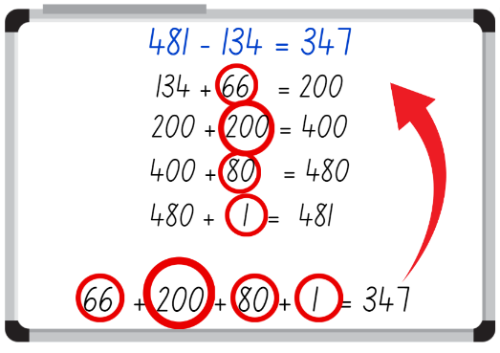

1. Repeat this process until students can confidently use the addition for subtraction strategy.
2. Using Resource 15 – codeword, students work independently to solve word problems and record responses on Resource 16 – codeword answer sheet
3. After each problem has been solved, students submit their solution and receive a letter from Resource 17 – letters for codeword.
4. Once all word problems have been solved, students use the letters to reveal a codeword.
5. Problems do not need to be solved in order. You may wish to set this activity up as stations around the classroom and allow students to work in small teams.

**Note**: Resource 16 – codeword answer sheet contains 6 letters to reveal the codeword. Letters can be handed out in any order. Resource 15 – codeword contains 3 differentiated levels to cater for student needs:

Circle. Circle: 2-digit number subtracting a 2-digit number.

Triangle. Triangle: 3-digit number subtracting a 2-digit number.

Square. Square: 3-digit number subtracting a 3-digit number.

This table details opportunities for differentiation.

|  |  |
| --- | --- |
| Too hard? | Too easy? |
| Students cannot apply the addition for subtraction strategy.   * Students complete the ‘circle’ word problems. * Assist students by providing them with Resource 18 – solution scaffold to structure their working out. | Students can apply the addition for subtraction strategy.   * Students complete the ‘square’ word problems. * Students to create own ‘codeword’ activity for a partner to solve. |

## Consolidation and meaningful practice – 10 minutes

1. Draw a bar model on the board with only one value placed on it, for example, see Figure 12.

Figure 12 – bar model example

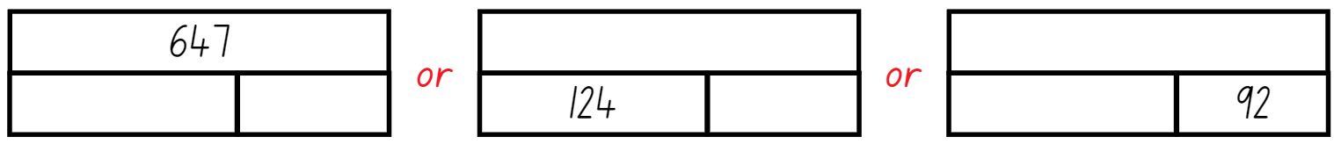

1. Ask students to suggest possible solutions to the bar model.
2. Students record their ideas on an individual whiteboard.
3. Students share their ideas with the class, justifying their decisions and choices.

This table details opportunities for assessment.

|  |  |
| --- | --- |
| Assessment opportunities | Links |
| What to look for:   * Can students apply the addition for subtraction strategy? **[MAO-WM-01, MA3-AR-01]** * Can students identify efficient and inefficient multidigit subtraction strategies? **[MAO-WM-01, MA3-AR-01]** | Links to [National Numeracy Learning Progressions](https://www.australiancurriculum.edu.au/resources/national-literacy-and-numeracy-learning-progressions/version-3-of-national-literacy-and-numeracy-learning-progressions/) (NNLP):   * AdS7, AdS8.   Links to suggested [Interview for Student Reasoning](https://education.nsw.gov.au/teaching-and-learning/curriculum/literacy-and-numeracy/assessment-resources/ifsr) (IfSR) tasks:   * **IfSR-AT**: 3A.1, 3A.4 |

# Lesson 7

**Core concept**: number lines help solve addition and subtraction problems.

## Daily number sense – reading large numbers – 10 minutes

The table below contains a suggested learning intention and success criteria. These are best co-constructed with students.

|  |  |
| --- | --- |
| Daily number sense learning intention | Daily number sense success criteria |
| Students are learning to:   * recognise, represent and order numbers in the millions. | Students can:   * name millions using the place value grouping of ones, tens and hundreds. |

This activity is an adaptation of ‘Reading large numbers’ from Teaching Mathematics Foundations to Middle Years by Siemon et al.

1. Students take it in turns to roll a 9-sided die. As each number is rolled, ask students to read out the number on the die.
2. Write a series of numbers on the board going from right to left. As each new number is added, have students read them out. For example, 7, 17, 317, 4317, 94 317.
3. Continue until a 9-digit number is written on the board.
4. Repeat the activity but this time record and say the numbers from left to right.
5. Discuss how hundreds, tens and ones are re-used to name larger numbers just as in the place value houses.

This table details opportunities for assessment.

|  |  |
| --- | --- |
| Assessment opportunities | Links |
| What to look for:   * Can students name millions using the place value grouping of ones, tens and hundreds? **[MAO-WM-01, MA3-RN-01]** | Links to [National Numeracy Learning Progressions](https://www.australiancurriculum.edu.au/resources/national-literacy-and-numeracy-learning-progressions/version-3-of-national-literacy-and-numeracy-learning-progressions/) (NNLP):   * NPV7. |

## Core lesson – addition and subtraction using number lines – 45 minutes

The table below contains a suggested learning intention and success criteria. These are best co-constructed with students.

|  |  |
| --- | --- |
| Core concept learning intention | Core concept success criteria |
| Students are learning to:   * use mathematical structures to assist when adding and subtracting large numbers. | Students can:   * apply place value knowledge to solve addition and subtraction problems * represent their strategy on an empty number line * clearly communicate reasoning for their chosen strategy. |

This activity is an adaptation of [*3-6 – Remote Maths – Edition 3* [PDF 568 KB]](https://www.mav.vic.edu.au/Tenant/C0000019/00000001/downloads/Resources/remote-learning-support/home-learning-tasks/edition-03/2020-3-6_EDITION-3.pdf) from [MAV Learning Activities](https://www.mav.vic.edu.au/Resources/Learning-Activities-Years-Prep-to-9/MAV-Learning-Activities-) by The Mathematical Association of Victoria.

1. Write the number sentence 471 + 385 on the board and draw an empty number line underneath.
2. Ask students how they would use a number line to solve this problem.
3. Select some students to share their responses.
4. Discuss the efficiency of the strategies students have shared.
5. Model using an empty number line to solve an addition problem (see Figure 13).

Figure 13 – number line addition example

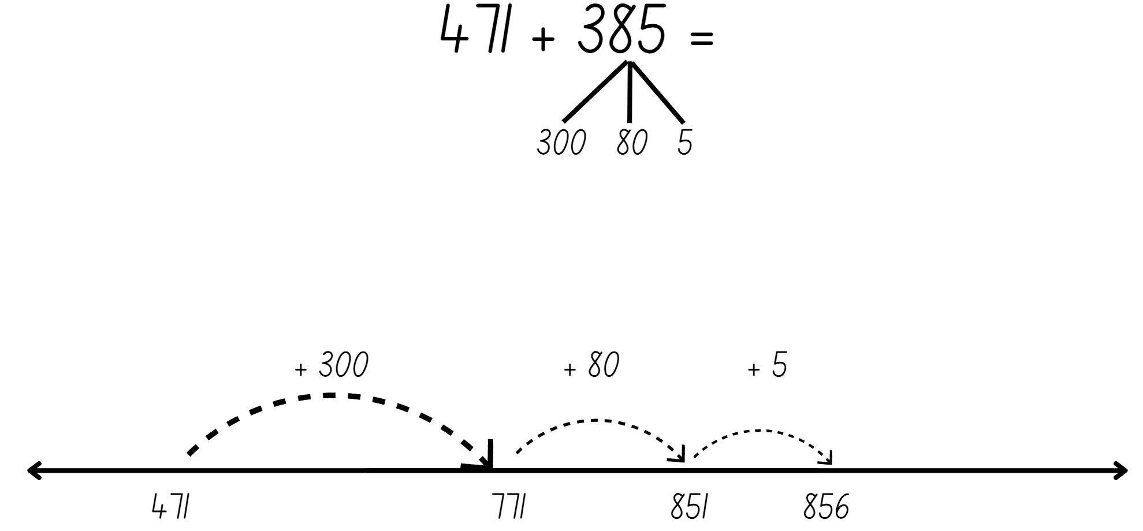

1. Ask students if they are able to use the same strategy to solve subtraction problems.
2. Write the number sentence 832 − 296 on the board and draw an empty number line underneath. Model the addition for subtraction strategy using standard and non-standard partitioning (see Figure 14).

Figure 14 – number line model of addition for subtraction

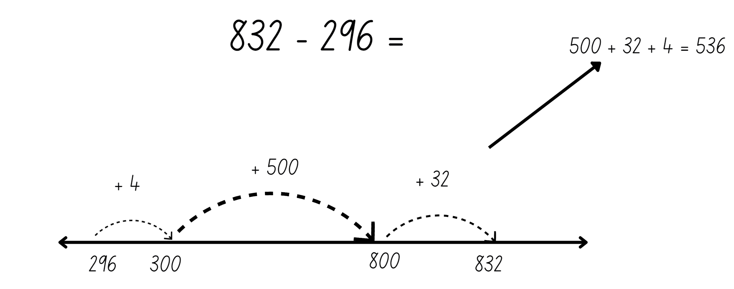

1. Write a subtraction number sentence on the board and ask students to collaboratively solve it on a whiteboard using the addition for subtraction strategy.
2. Invite students to share how they solved the number sentence.
3. Display Resource 19 – sushi restaurant scenario and read the scenario aloud to the class.
4. Students use Resource 20 – sushi questions to calculate the cost of hosting a party at a Sushi train, using their place value knowledge to solve addition and subtraction problems.
5. Students share their solutions with a partner and discuss the strategies used.
6. Provide an opportunity for students to report back to the class, justifying their decisions and reasoning.

**Note**: encourage students to use a number line as a tool to promote efficiency when they are solving this problem.

This table details opportunities for differentiation.

|  |  |
| --- | --- |
| Too hard? | Too easy? |
| Students cannot apply place value knowledge to solve addition and subtraction problems.   * Assist students by reducing their numbers to only 2 digits. * Provide Resource 21 – hundred chart for students to use to support the count. | Students can apply place value knowledge to solve addition and subtraction problems.   * Encourage students to use another efficient strategy to check their calculations. Students then convince a classmate which strategy is the most efficient. * Students demonstrate their use of place value to add or subtract 3 or more numbers with different numbers of digits. They can use the number spinners or dice to create their numbers. |

## Discuss and connect the mathematics – 5 minutes

1. Lead a class discussion to reflect on the learning from the lesson. Ask:

* Why is it important to choose an efficient strategy?
* What strategy or strategies did you use today? Were they efficient?
* Why do we use tools when solving addition and subtraction problems?
* What other tools could we use?

This table details opportunities for assessment.

|  |  |
| --- | --- |
| Assessment opportunities | Links |
| What to look for:   * Can students apply place value knowledge to solve addition and subtraction problems? **[MAO-WM-01, MA3-AR-01]** * Can students represent their strategy on an empty number line? **[MAO-WM-01, MA3-AR-01]** * Can students clearly communicate reasoning for their chosen strategy**? [MAO-WM-01, MA3-AR-01]** | Links to [National Numeracy Learning Progressions](https://www.australiancurriculum.edu.au/resources/national-literacy-and-numeracy-learning-progressions/version-3-of-national-literacy-and-numeracy-learning-progressions/) (NNLP):   * AdS7, AdS8.   Links to suggested [Interview for Student Reasoning](https://education.nsw.gov.au/teaching-and-learning/curriculum/literacy-and-numeracy/assessment-resources/ifsr) (IfSR) tasks:   * **IfSR-AT**: 3A.2, 3A.3, 3A.4. |

# Lesson 8

**Core concept**: flexible methods of addition and subtraction involve decomposing and composing numbers.

## Daily number sense – 10 minutes

1. From a class need surfaced through formative assessment data, identify a short, focused activity that targets students’ knowledge, understanding and skills. Example activities may be drawn from the following resources:

* [Mathematics K-6 resources](https://education.nsw.gov.au/teaching-and-learning/curriculum/mathematics/mathematics-curriculum-resources-k-12/mathematics-k-6-resources#catalogue_auto)
* [Universal Resources Hub](https://resources.education.nsw.gov.au/home).

## Core lesson – choosing efficient strategies – 35 minutes

The table below contains a suggested learning intention and success criteria. These are best co-constructed with students.

|  |  |
| --- | --- |
| Core concept learning intention | Core concept success criteria |
| Students are learning to:   * apply efficient mental and written strategies to solve addition and subtraction problems. | Students can:   * apply known strategies to solve addition and subtraction problems * identify efficient and inefficient addition and subtraction strategies * solve word problems involving addition and subtraction. |

1. Display Resource 22 – word problem 1.
2. Brainstorm some strategies the students could use to solve the problem, for example, levelling, addition for subtraction, constant difference, bridging the decade and inverse operations.
3. List the strategies on the whiteboard.
4. Students work independently to solve the problem using an efficient strategy of their choice.
5. Once students have solved the problem, place their solutions around the classroom and have students conduct a [gallery walk](https://app.education.nsw.gov.au/digital-learning-selector/LearningActivity/Card/555).
6. Ask students:

* What did you notice?
* Did you see the same strategy that you had used?
* Did you see a strategy you might like to try?
* Was there a strategy you didn’t understand?

1. Invite students with different strategies to share with the class and reflect on the efficiency or inefficiency of that strategy.

**Note**: if students do not demonstrate levelling, addition for subtraction, constant difference and bridging, revise as a whole class.

1. Display Resource 23 – word problem 2.
2. Ask students to solve the problem using a different efficient strategy to the one they used to solve the first problem.
3. Once students have solved the problem, place their solutions around the classroom and have students conduct another [gallery walk](https://app.education.nsw.gov.au/digital-learning-selector/LearningActivity/Card/555).
4. Students share and reflect on the strategies they observed and used.

This table details opportunities for differentiation.

|  |  |
| --- | --- |
| Too hard? | Too easy? |
| Students cannot apply known strategies to solve addition and subtraction word problems.   * Assist students to reduce the complexity of the problem by providing alternative number sentences suited to the student’s ability level. * Provide manipulatives (physical or virtual) to support students to complete the activity. | Students can apply known strategies to solve addition and subtraction word problems.   * Students write their own multistep problem to be completed by a classmate. * Students convince a partner why their strategy is more efficient than the one used by the other student. Students demonstrate their strategy’s efficiency by using it to solve a multistep problem. |

## Consolidation and meaningful practice – 15 minutes

This activity is an adaptation of [*3-6 – Remote Maths – Edition 2* [PDF 417 KB]](https://www.mav.vic.edu.au/Tenant/C0000019/00000001/downloads/Resources/remote-learning-support/home-learning-tasks/edition-02/2020-3-6_EDITION-2.pdf) from [MAV Learning Activities](https://www.mav.vic.edu.au/Resources/Learning-Activities-Years-Prep-to-9/MAV-Learning-Activities-) by The Mathematical Association of Victoria.

1. Students choose a number sentence from Resource 24 – subtraction number sentences and represent it using the following strategies:

* Word problem: Write a number story
* Visual: draw a picture
* Number line: show the problem on a number line
* Concrete materials: use (or draw) concrete materials, such as MAB materials.

1. Select students to demonstrate their chosen strategy to the class.

This table details opportunities for assessment.

|  |  |
| --- | --- |
| Assessment opportunities | Links |
| What to look for:   * Can students apply known strategies to solve addition and subtraction problems? **[MAO-WM-01, MA3-RN-01, MA3-AR-01]** * Can students identify efficient and inefficient addition and subtraction strategies? **[MAO-WM-01, MA3-RN-01, MA3-AR-01]** * Can students solve word problems involving addition and subtraction? **[MAO-WM-01, MA3-RN-01, MA3-AR-01]** | Links to [National Numeracy Learning Progressions](https://www.australiancurriculum.edu.au/resources/national-literacy-and-numeracy-learning-progressions/version-3-of-national-literacy-and-numeracy-learning-progressions/) (NNLP):   * AdS7, AdS8.   Links to suggested [Interview for Student Reasoning](https://education.nsw.gov.au/teaching-and-learning/curriculum/literacy-and-numeracy/assessment-resources/ifsr) (IfSR) tasks:   * **IfSR- AT**:3A.2, 3A.3, 3A.4, 3A.5. |

# Resource 1 – check the clues

Clue card 1.
The number has a nine in the thousands place
The number is between 10 000 and 100 000
The number is odd
The number has a 3 in the tens place
Solution cards
29 521
9921
49 935
1 669 459

Clue card 2
The number has the digit eight in the ones place.
The number in the tens place equals 20, when 50 is subtracted from it.
The number in the tens of thousands place is even.
If 200 was subtracted from 1000, the answer would be represented in the hundreds place.
Solution cards
463 878
329 775
64 978
4 934 688

Clue card 3
If you add 2000 to the number there would be a nine in the thousands place.
The digit in the tens place is more than the digit in the ones place.
The number is less than nine hundred thousand.
There are no even digits in the number.
Solution
957 416
337 551
854 153
737 315

Clue cards
The numbers has 400 in it.
If you subtract the digit in the tens of thousands place from the digit in hundreds of thousands place, it will equal the digit in the tens place.
The digit in the tens of thousands place is the same as the digit in the hundreds place.
The digit in the millions place is even.
Solutions card
6 754 568
2 827 465
8 946 456
4 641 433



Clue cards
The number in the ones place is less than 5.
The number has an internal zero.
The number in the tens place is odd.
The number in the hundreds place is 10 times smaller than the number in the thousands place.
Solution cards
571 902
397 910
809 973
620 978


# Resource 2 – MAB materials

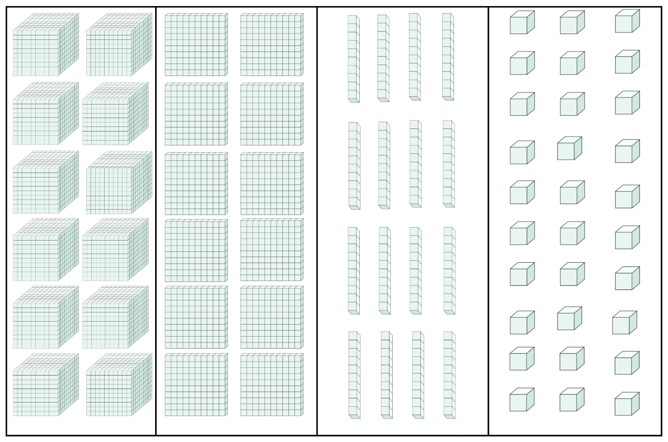

# Resource 3 – number expander

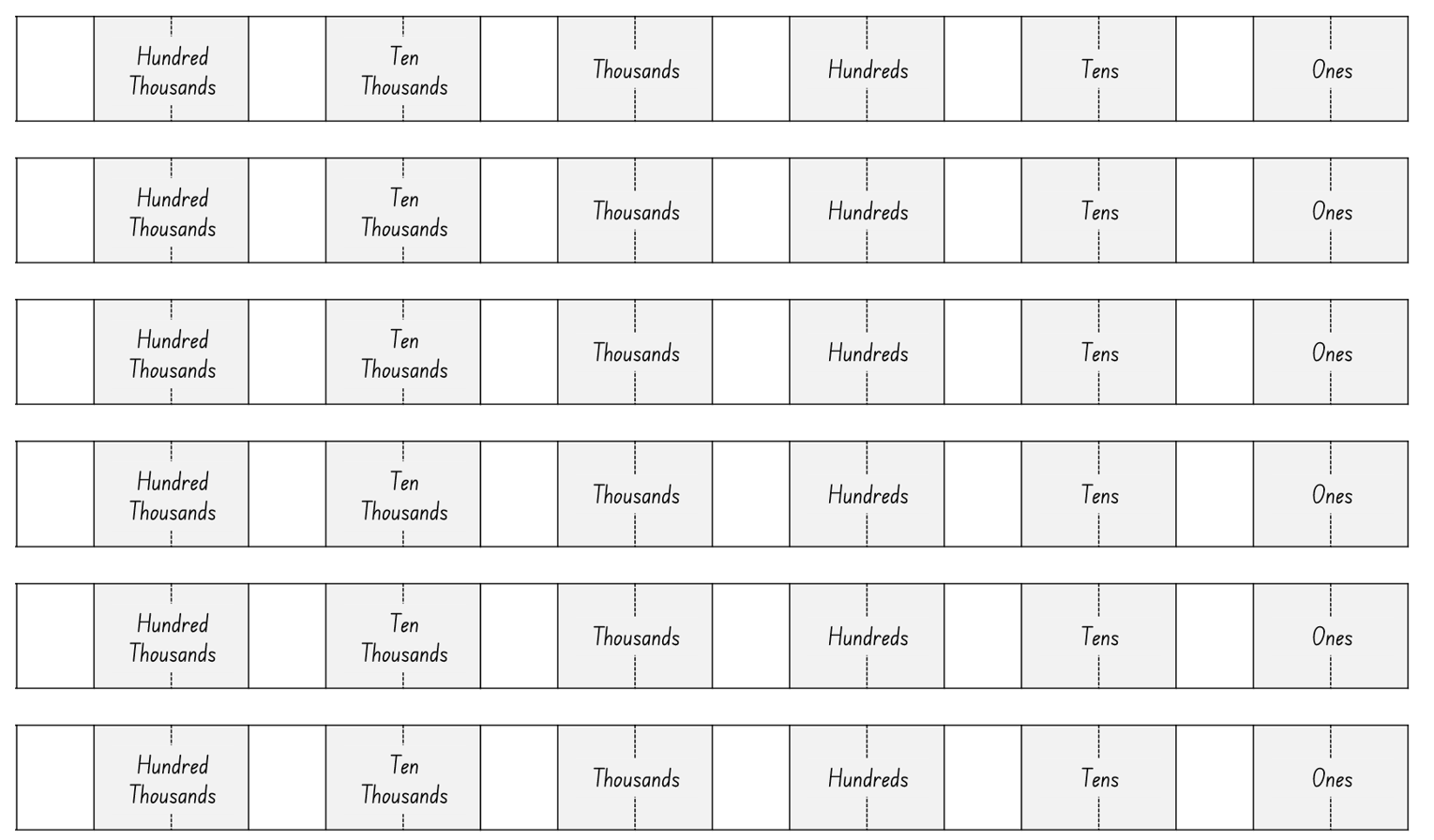

# Resource 4 – blank houses

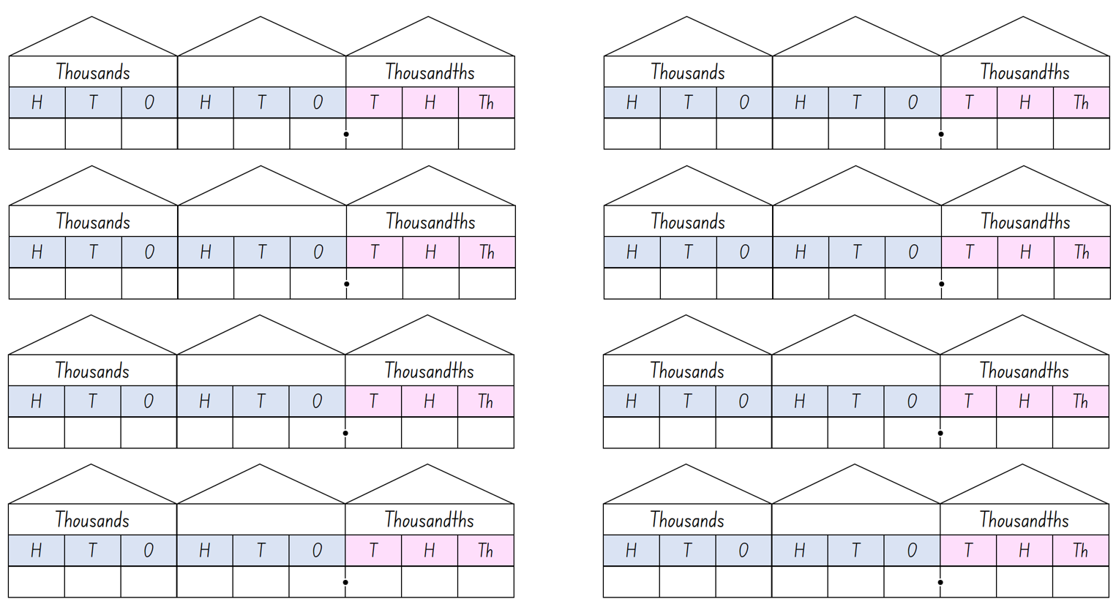

# Resource 5 – decimal houses

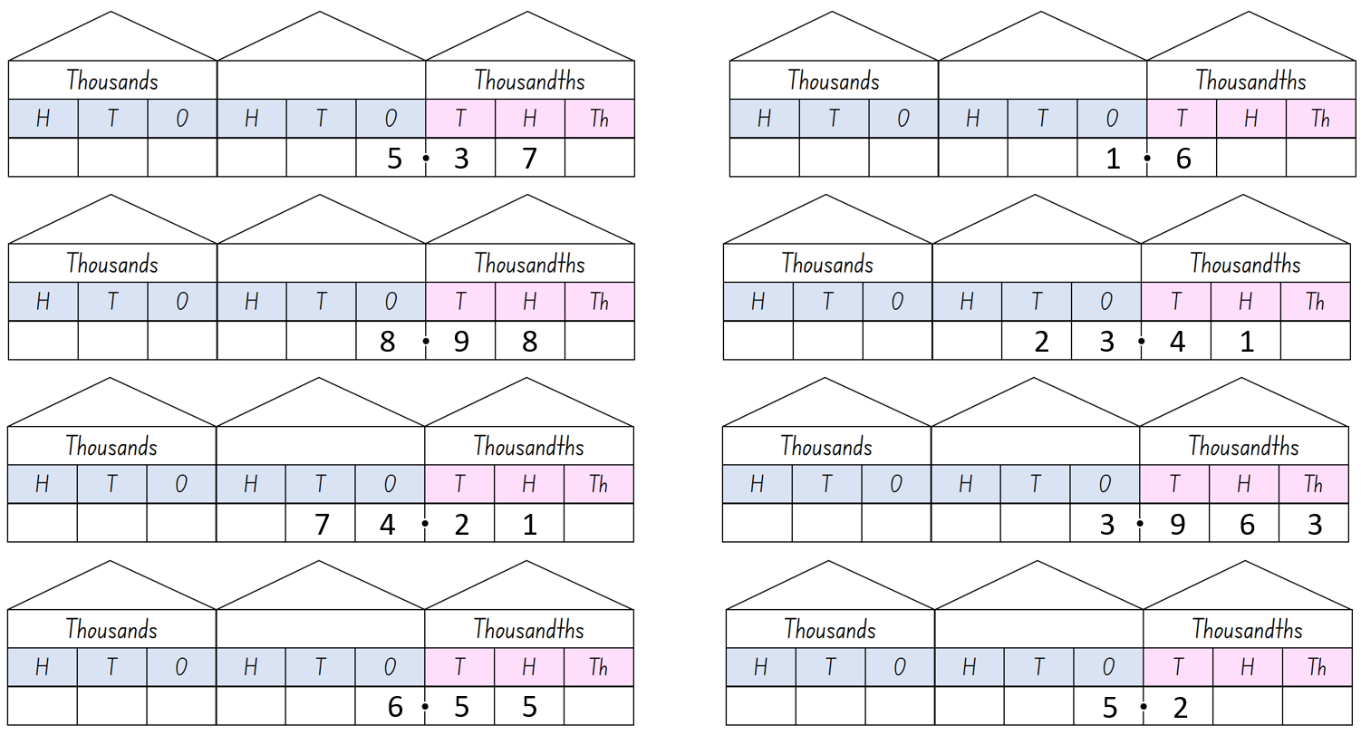

# Resource 6 – decimals – example 1

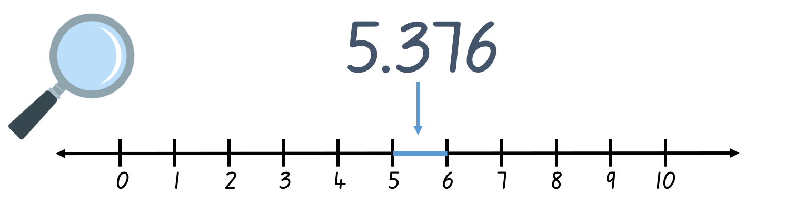

# Resource 7 – decimals – example 2

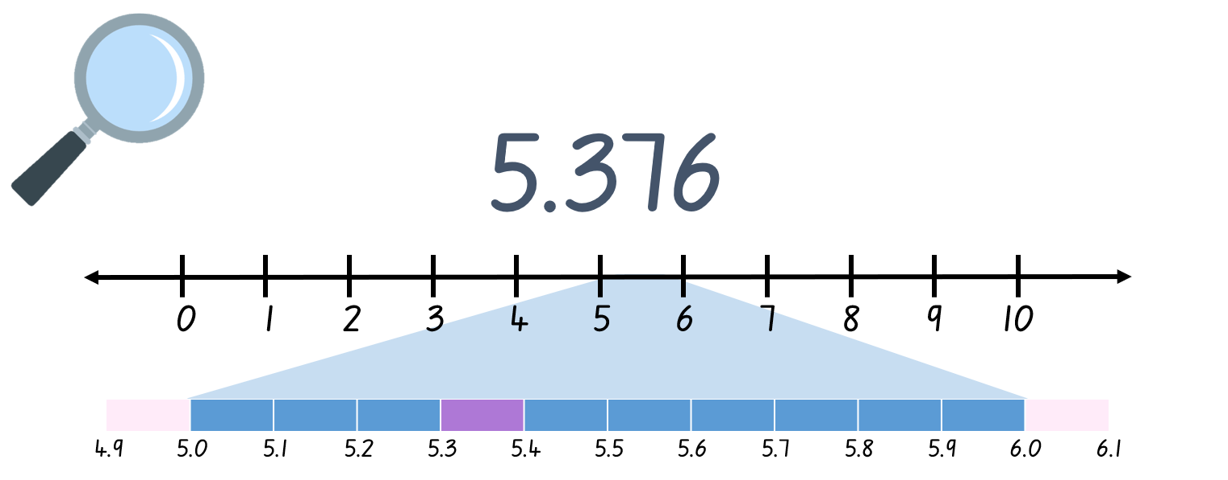

# Resource 8 – decimals – example 3

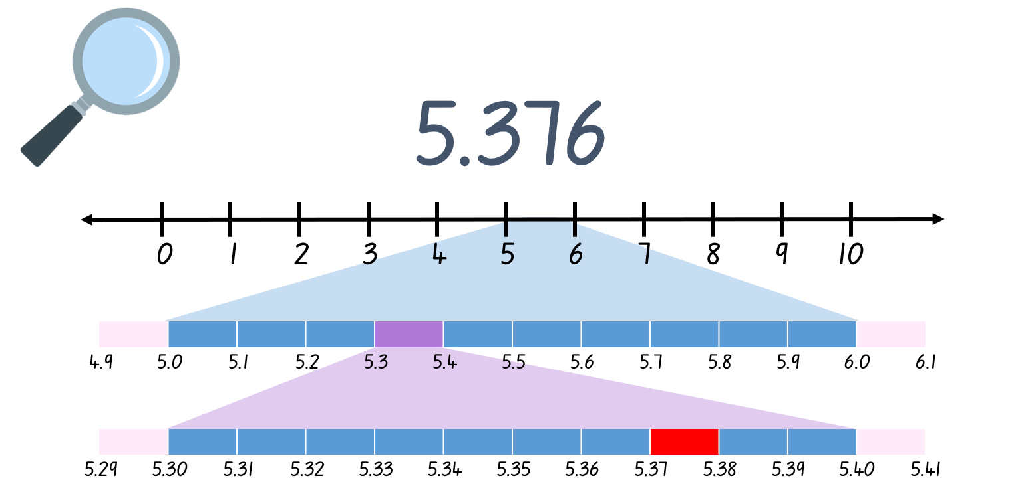

# Resource 9 – decimals – example 4

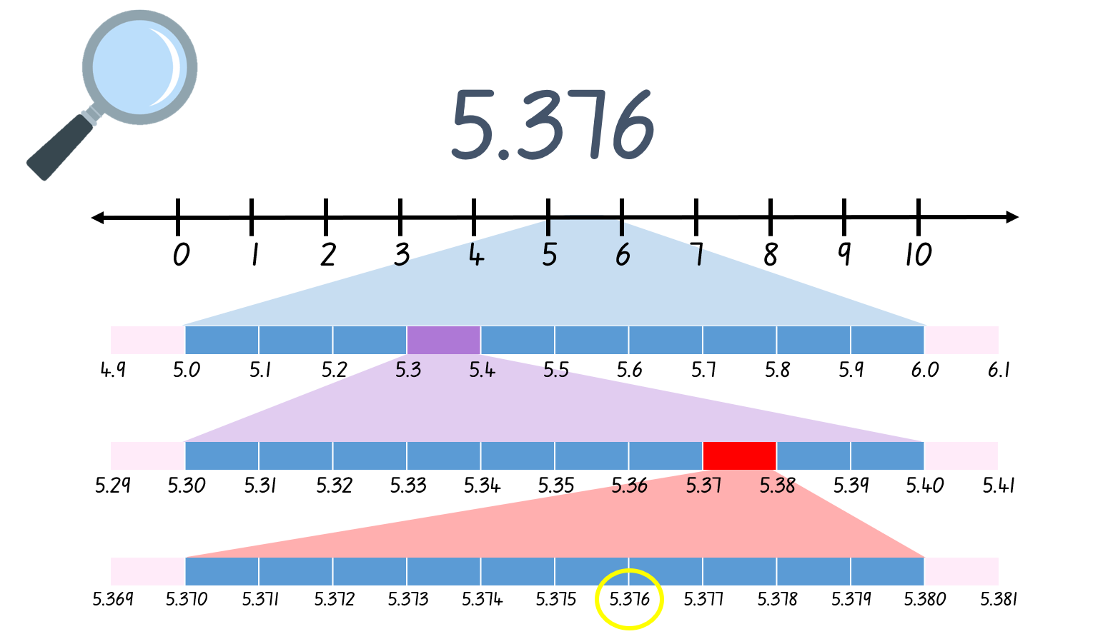

# Resource 10 – decimal misconceptions

Four students were asked to read the number 5.07. Here is what they said
Terese: five hundred and seven
Sam: five and seven hundredths
Dave: five and seven tenths
Rob: five and seven
Who is correct? How do you know?



# Resource 11 – reaction times

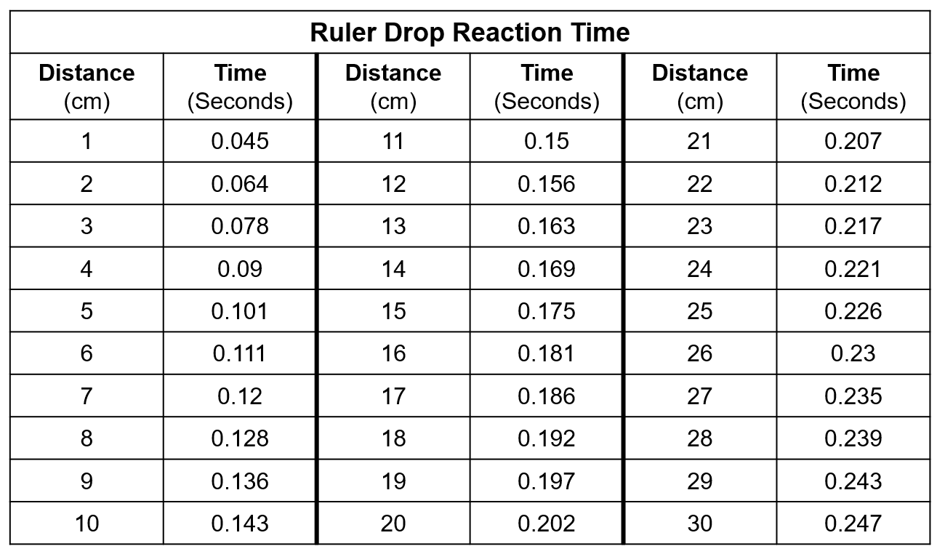

# Resource 12 – blank decimal grids

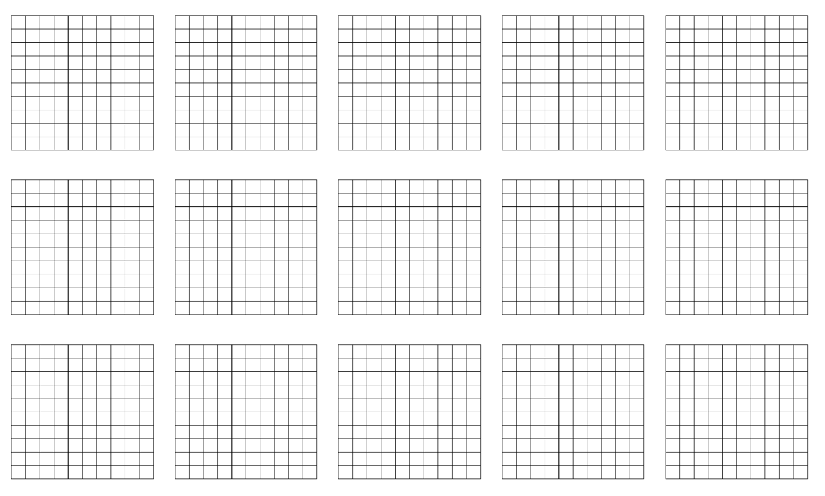

# Resource 13 – comparing decimals 1

Pictures of babies comparing weights.
Picture 1: 6.421kg or 6.34kg
Picture 2: 8.20kg or 8.125kg
Picture 3: 5.62kg or 5.930kg
Picture 4: 7.102kg or 7.316kg

# Resource 14 – efficient additive strategies

Which strategy is more efficient ? How do you know?
One student counting backwards by threes to solve the problem and the other student is using addition for subtraction strategy.

# Resource 15 – codeword

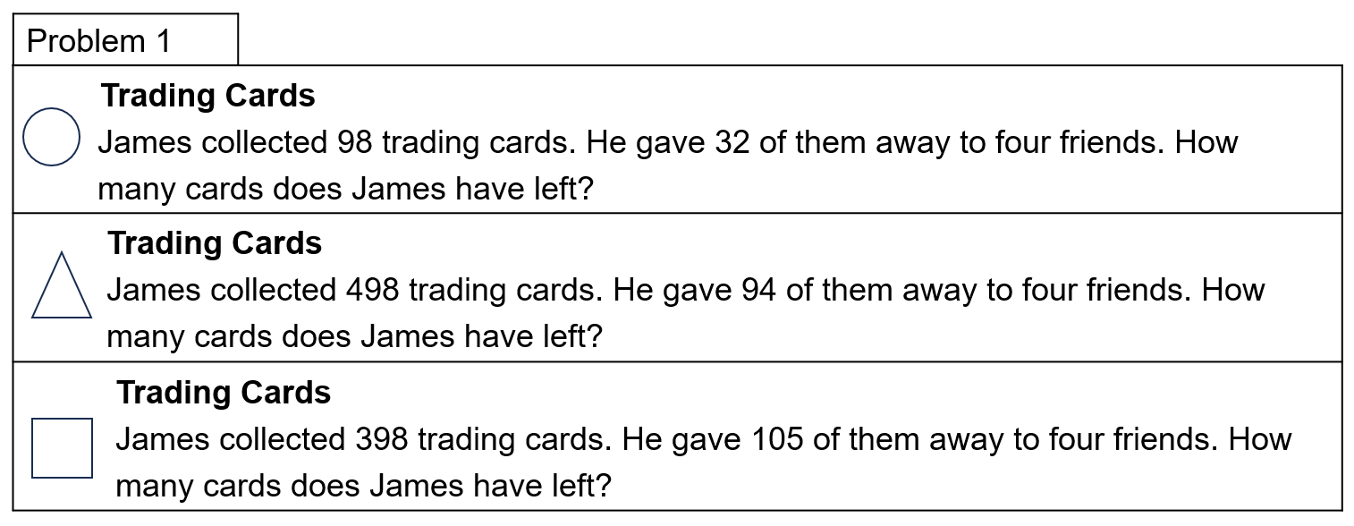

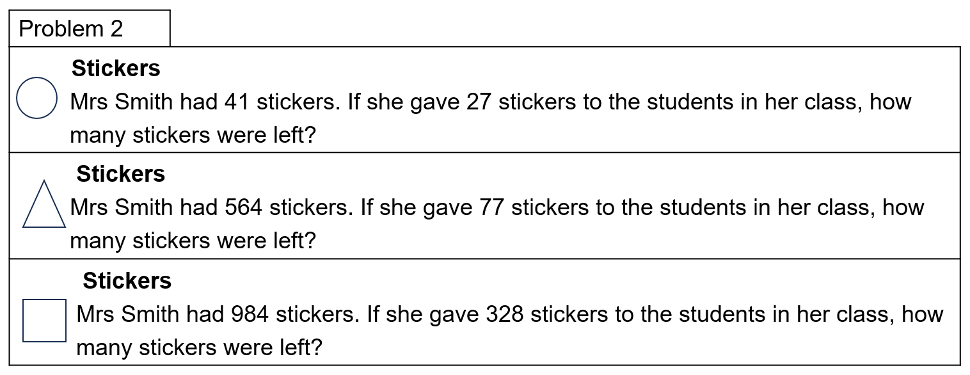

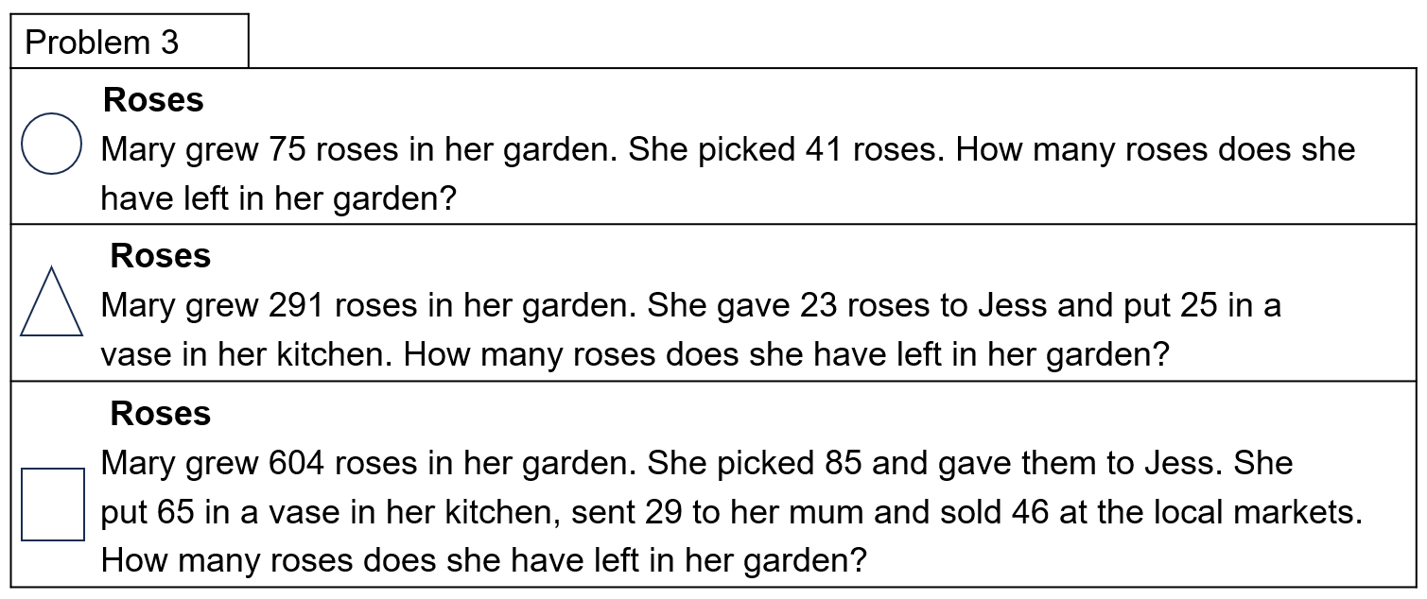

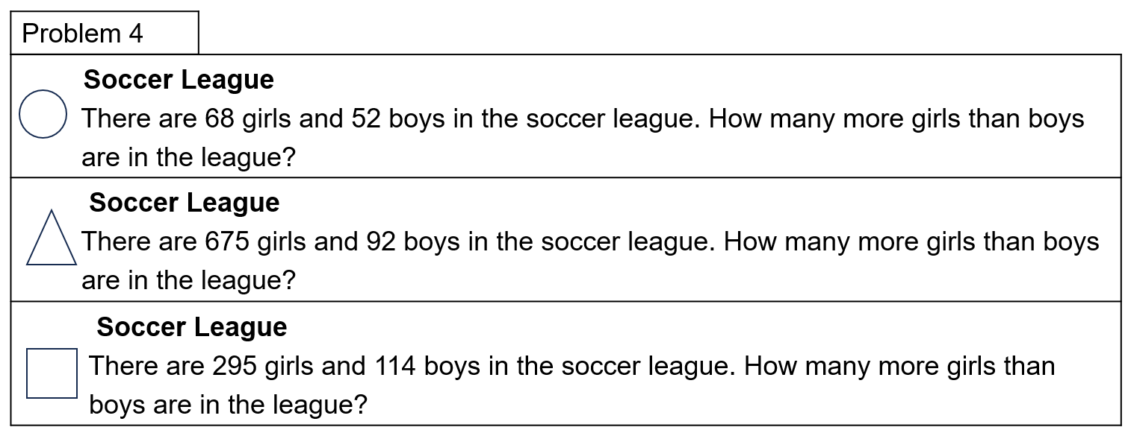

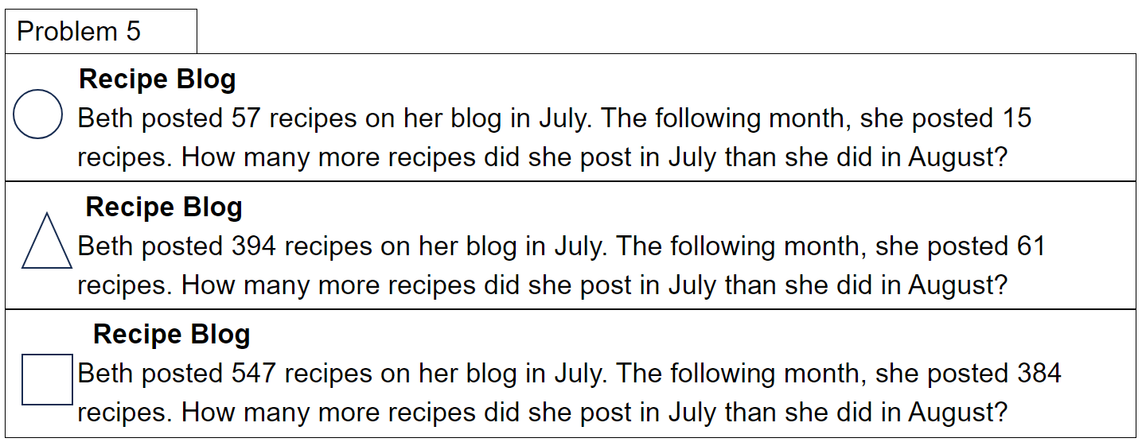

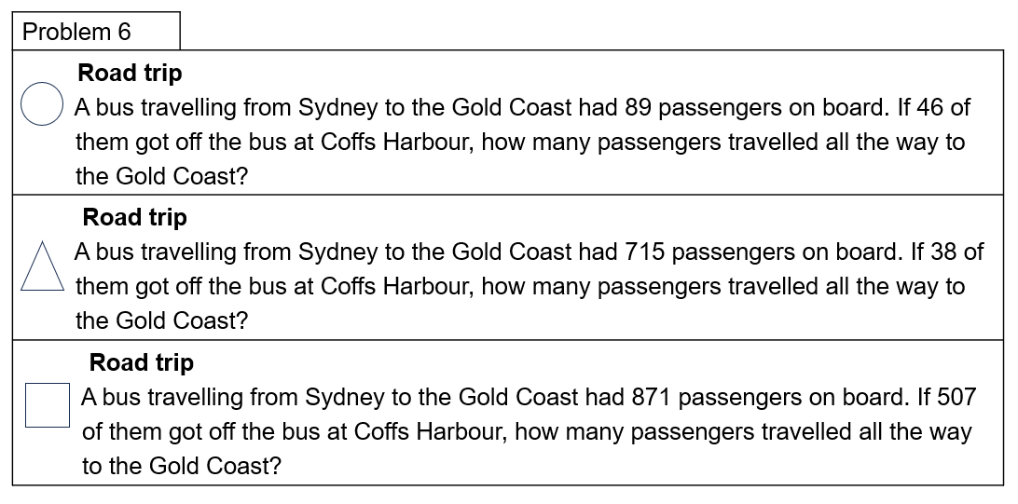

# Resource 16 – codeword answer sheet

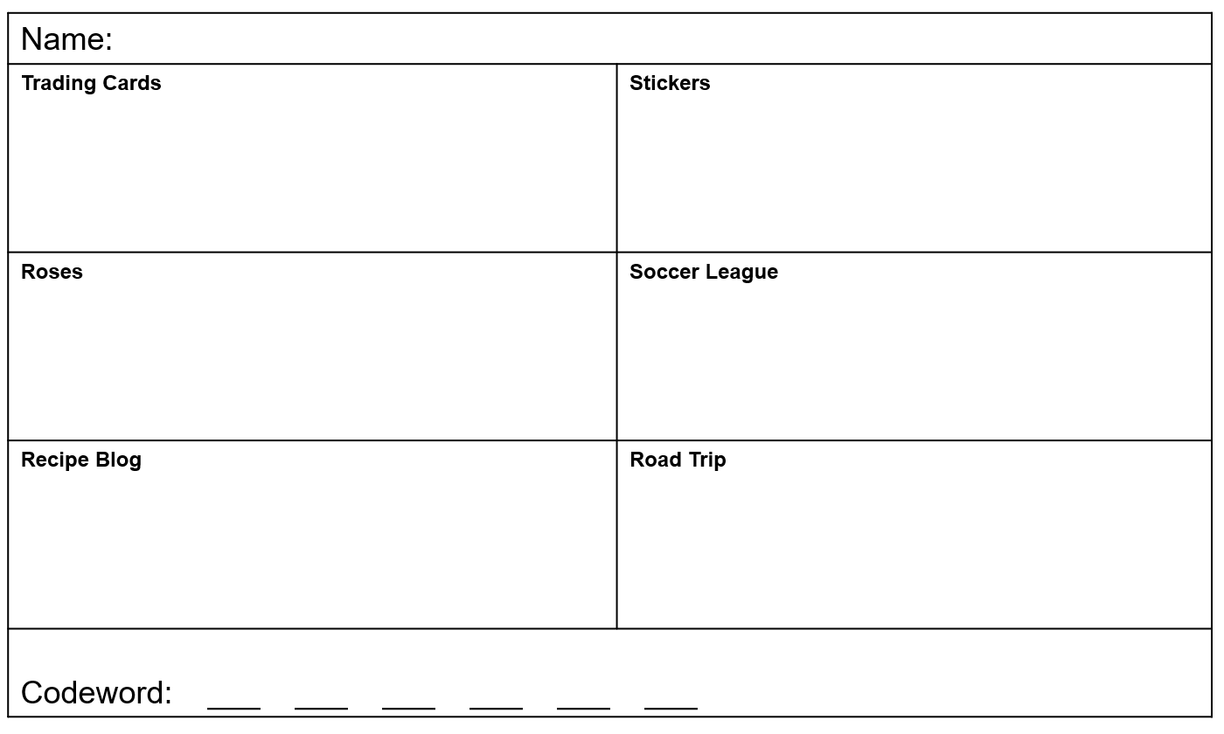

# Resource 17 – letters for codeword

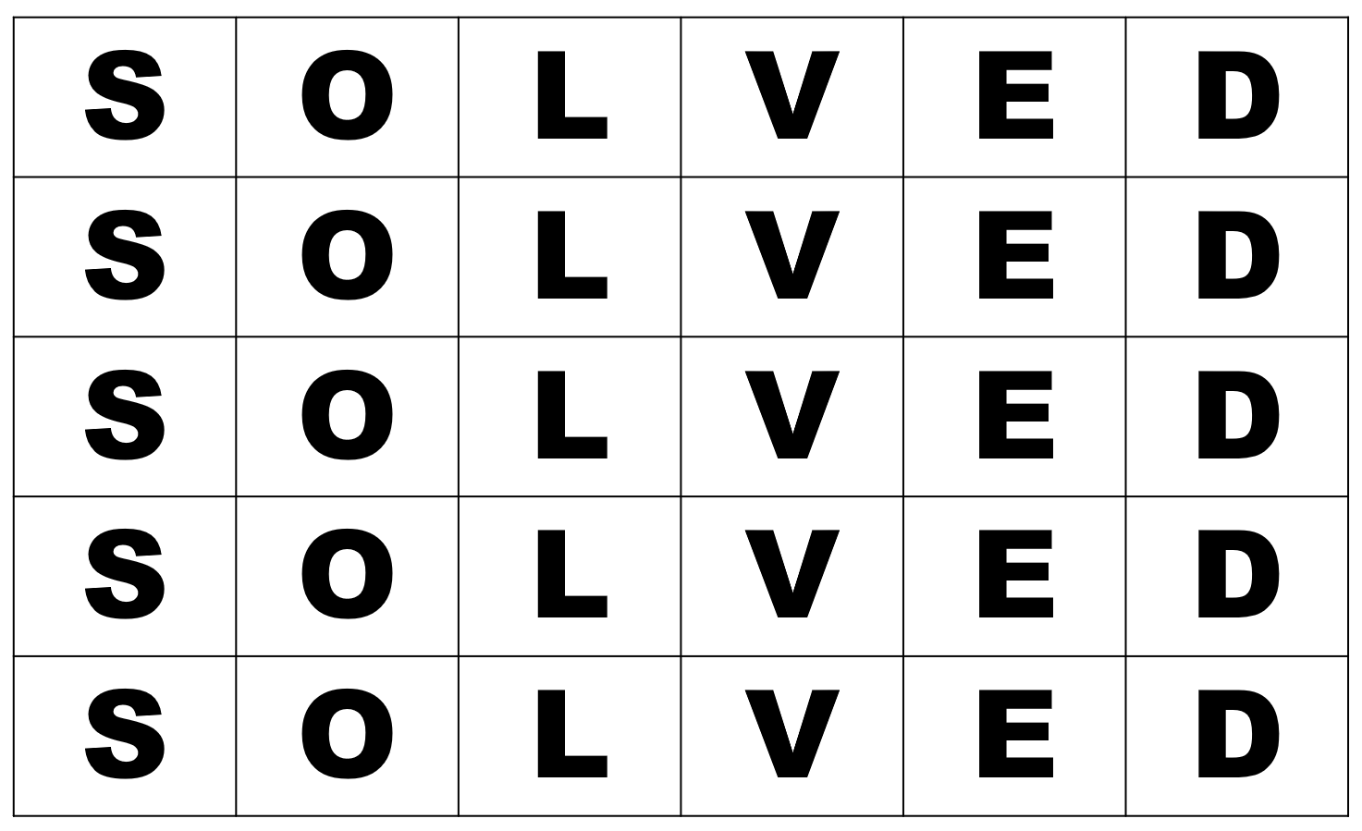

# Resource 18 – solution scaffold

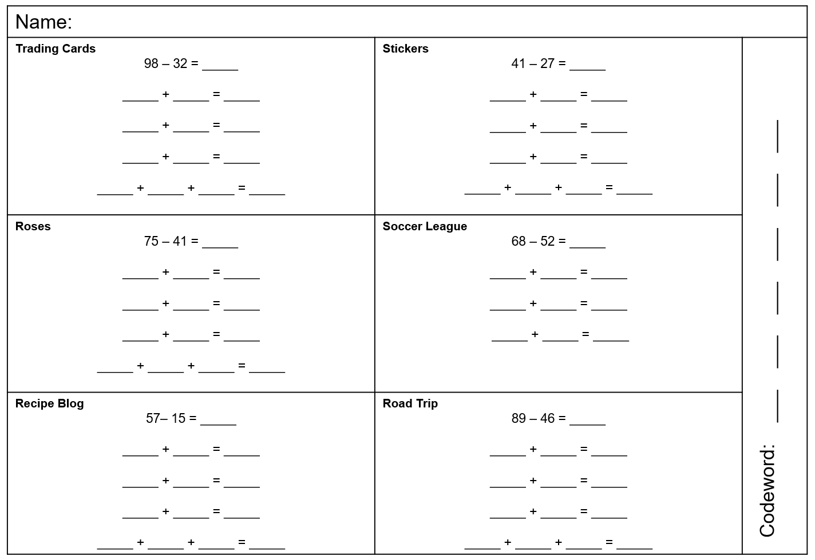

# Resource 19 – sushi restaurant scenario

Stage 3 students of Teal Public School were excitedly gathered at a local sushi restaurant for a special treat. The event was organised as a reward for their excellent academic achievements throughout the year, and all 27 students were eager to indulge in the delectable flavours of sushi.

The long table was elegantly set, adorned with vibrant Japanese decorations. As the students settled into their seats, the sushi train began to transport plates upon plates past the students. The aroma of fresh fish and the artistic presentation of the dishes made their mouths water in anticipation.

Each student was given a small notepad and pencil to keep track of the amount of sushi they devoured.  Throughout the feast, the students excitedly updated their notepads, keeping track of the sushi they had consumed. 

After an hour of savouring the sushi delicacies, the feast drew to a close. The students' appetites had been truly satisfied. They eagerly compared their sushi tallies, revealing the grand total of sushi plates consumed by the group.

The final count was an astonishing 235 plates of sushi collectively devoured by the 27 students. The achievement filled the students with a sense of pride and accomplishment. They applauded one another for their sushi-consuming prowess. As the students bid farewell to the sushi restaurant, their hearts and bellies full, they carried with them not only the taste of the delectable sushi but also cherished memories. 

# Resource 20 – sushi questions

1. Katrina ate 4 purple plates, 3 pink plates and 2 blue plates. How much did her sushi cost altogether?
2. Megan's tally showed she ate the same amount of purple plates as Katrina but ate 2 more pink plates and 3 red plates. How much was her bill? 
3. Alex ate one of each plate. How much did he spend on sushi?
4. How much more did Megan spend than Alex?
5. Katie took $500 to pay for her sushi. If she ate $387 worth of sushi. How much change did she leave with?
6. Donovan spent around $200. What is the maximum number of red plates he could have eaten?
7. These 2 note pads show Amelia's and Stephen's tally. What is the difference between their overall cost?
8. Deb ate $188 worth of sushi. What combination of plates did she eat?

# Resource 21 – hundred chart

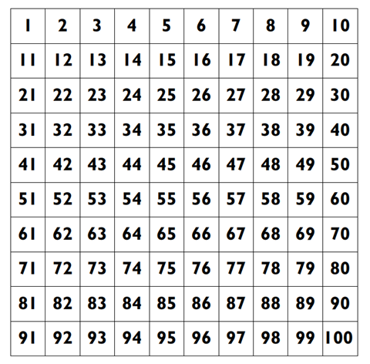

# Resource 22 – word problem 1

On the weekend 532 people went to see a movie. Halfway through the movie, 67 people left because they didn't like it. How many people watched the whole movie?

If 213 children watched the whole movie, how many adults watched the whole movie?

# Resource 23 – word problem 2

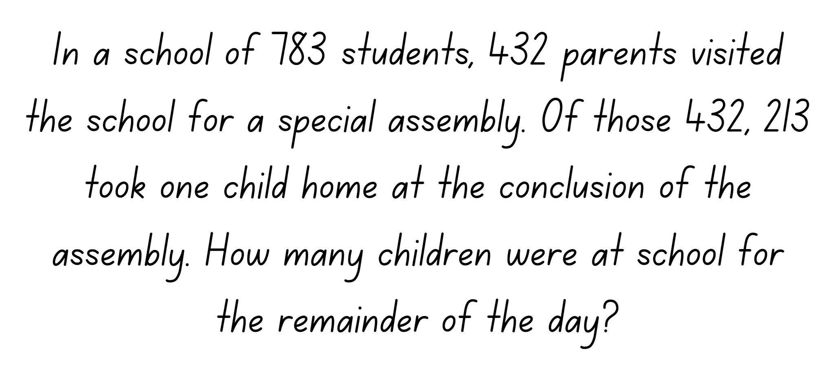

# Resource 24 – subtraction number sentences

Subtraction can be solved and represented in many ways.
Choose one of these number sentences and represent it by completing the  four different tasks below
• Worded problem: Write a number story
• Visual: Draw a picture
• Number line: Show the problem on a number line
• Concrete: Use concrete materials such as MAB (or draw them).
The number sentences are as follows:
82 - 47 = 35
818 - 503 = 
459 - 34 =
762 - blank = 628.

# Syllabus outcomes and content

The table below outlines the [syllabus outcomes](https://curriculum.nsw.edu.au/learning-areas/mathematics/mathematics-k-10-2022/overview) and range of relevant syllabus content covered in this unit. Content is linked to [National Numeracy Learning Progression](https://www.australiancurriculum.edu.au/resources/national-literacy-and-numeracy-learning-progressions/version-3-of-national-literacy-and-numeracy-learning-progressions/) version (3).

|  |  |  |  |  |  |  |  |  |
| --- | --- | --- | --- | --- | --- | --- | --- | --- |
| Outcomes and content | 1 | 2 | 3 | 4 | 5 | 6 | 7 | 8 |
| **Represents numbers A**:Whole numbers: Recognise, represent and order numbers in the millions  **MAO-WM-01, MA3-RN-01** |  |  |  |  |  |  |  |  |
| * Name millions using the place value grouping of ones, tens and hundreds | x |  |  |  | x | x | x |  |
| * Arrange numbers in the millions in ascending and descending order using place value | x |  |  |  | x |  |  |  |
| **Represents numbers A**: Whole numbers: Apply place value to partition, regroup and rename numbers to 1 billion  **MAO-WM-01, MA3-RN-01** |  |  |  |  |  |  |  |  |
| * Recognise 1000 thousands is 1 million and 1000 millions is 1 billion |  |  |  |  |  |  | x |  |
| * Regroup numbers in different forms (Reasons about quantity) |  | x |  |  |  |  |  | x |
| * Partition numbers to 1 billion in non-standard forms |  | x |  |  |  |  | x |  |
| **Represents numbers A**: Decimals and percentages: Recognise that the place value system can be extended beyond hundredths  **MAO-WM-01, MA3-RN-02** |  |  |  |  |  |  |  |  |
| * Express thousandths as decimals |  |  | x | x |  |  |  |  |
| * Interpret decimal notation for thousandths |  |  | x | x |  |  |  |  |
| * Indicate the place value of digits in decimal numbers of up to 3 decimal places |  |  |  | x |  |  |  |  |
| * Use place value to partition decimals |  |  | x |  |  |  |  |  |
| **Represents numbers A**: Decimals and percentages: Compare, order and represent decimals  **MAO-WM-01, MA3-RN-02** |  |  |  |  |  |  |  |  |
| * Compare and order decimal numbers of up to 3 decimal places |  |  | x | x | x |  |  |  |
| * Interpret zero digit(s) at the end of a decimal |  |  | x | x |  |  |  |  |
| * Approximate the size of decimals |  |  |  | x | x |  |  |  |
| * Place decimal numbers of up to 3 decimal places on a number line |  |  | x | x |  |  |  |  |
| **Additive relations A**: Apply efficient mental and written strategies to solve addition and subtraction problems  **MAO-WM-01, MA3-AR-01** |  |  |  |  |  |  |  |  |
| * Solve word problems, including multistep problems |  |  |  |  |  | x |  | x |
| * Apply known strategies such as levelling, addition for subtraction, using constant difference, and bridging (Reasons about relations) |  | x | x |  |  | x | x | x |
| * Use place value to add or subtract 3 or more numbers with different numbers of digits | x | x | x |  |  |  | x |  |
| * Identify efficient and inefficient multidigit subtraction strategies |  |  |  |  |  | x | x | x |
| **Additive relations A**: Use estimation and place value understanding to determine the reasonableness of solutions  **MAO-WM-01, MA3-AR-01** |  |  |  |  |  |  |  |  |
| * Use place value understanding to check for errors in calculations |  |  |  |  |  | x | x | x |
| **Geometric measure B**: Length: Connect decimal representations to the metric system  **MAO-WM-01, MA3-GM-02** |  |  |  |  |  |  |  |  |
| * Interpret decimal notation for lengths and distances |  |  | x |  |  |  |  |  |
| * Record lengths and distances using decimal notation |  |  | x |  |  |  |  |  |

[Mathematics K–10 Syllabus](https://curriculum.nsw.edu.au/learning-areas/mathematics/mathematics-k-10-2022/overview) © NSW Education Standards Authority (NESA) for and on behalf of the Crown in right of the State of New South Wales, 2022.

# References

This resource contains NSW Curriculum and syllabus content. The NSW Curriculum is developed by the NSW Education Standards Authority. This content is prepared by NESA for and on behalf of the Crown in right of the State of New South Wales. The material is protected by Crown copyright.

Please refer to the NESA Copyright Disclaimer for more information <https://educationstandards.nsw.edu.au/wps/portal/nesa/mini-footer/copyright>.

NESA holds the only official and up-to-date versions of the NSW Curriculum and syllabus documents. Please visit the NSW Education Standards Authority (NESA) website <https://educationstandards.nsw.edu.au/> and the NSW Curriculum website <https://curriculum.nsw.edu.au/home>.

[Mathematics K–10 Syllabus](https://curriculum.nsw.edu.au/learning-areas/mathematics/mathematics-k-10-2022/overview) © NSW Education Standards Authority (NESA) for and on behalf of the Crown in right of the State of New South Wales, 2022.

[National Numeracy Learning Progression](https://www.australiancurriculum.edu.au/resources/national-literacy-and-numeracy-learning-progressions/version-3-of-national-literacy-and-numeracy-learning-progressions/) © Australian Curriculum, Assessment and Reporting Authority (ACARA) 2010 to present, unless otherwise indicated. This material was downloaded from the [Australian Curriculum](http://www.australiancurriculum.edu.au/) website (National Numeracy Learning Progression) (accessed 5 September 2023) and was not modified.

Dunstan D and Swan P (2023) A Whole School Approach to Place Value, Teaching Place Value Year 4 Whole Numbers, A-Z Type, Australia.

Siemon D, Warren E, Beswick K, Faragher R, Miller J, Horne M, Jazby D and Breed M (2020) Teaching Mathematics: Foundations to Middle Years, 3rd edn, Oxford University Press Australia and New Zealand.

State of New South Wales (Department of Education) (2020) ‘Garden Path’, Reading and Numeracy Resources, NSW Department of Education website, accessed 22 June 2023.

State of New South Wales (Department of Education) (2023) ‘[Mastermind](https://education.nsw.gov.au/teaching-and-learning/curriculum/mathematics/mathematics-curriculum-resources-k-12/mathematics-k-6-resources/mastermind)’, Mathematics K-6 Resources, NSW Department of Education website, accessed 22 June 2023.

State of New South Wales (Department of Education) (2023) ‘[*Reaction time test*](https://education.nsw.gov.au/teaching-and-learning/curriculum/mathematics/mathematics-curriculum-resources-k-12/mathematics-k-6-resources/reaction-time-test)’, *Mathematics K-6 resources,* NSW Departmentof Education website, accessed 27 June 2023.

State of New South Wales (Department of Education) (2023) [*Identifies, represents and compares decimals*](https://resources.education.nsw.gov.au/detail/NPV-44), Universal Resources Hub website, accessed 22 June 2023.

State of New South Wales (Department of Education) (2023) [*Understanding place value in decimals*](https://resources.education.nsw.gov.au/detail/NPV-23), Universal Resources Hub website, accessed 22 June 2023.

Sullivan P and Lilburn P (2017) Open-ended Maths Activities: *Using ‘Good’ Questions to Enhance Learning in Mathematics*, Revised 2nd edn, Oxford University Press, Melbourne.

The Mathematical Association of Victoria (2020) [*3-6 – Remote Maths – Edition 2* [PDF 417 KB]](https://www.mav.vic.edu.au/Tenant/C0000019/00000001/downloads/Resources/remote-learning-support/home-learning-tasks/edition-02/2020-3-6_EDITION-2.pdf), MAV Learning Activities website, accessed 27 June 2023.

The Mathematical Association of Victoria (2020) [*3-6 – Remote Maths – Edition 3* [PDF 568 KB]](https://www.mav.vic.edu.au/Tenant/C0000019/00000001/downloads/Resources/remote-learning-support/home-learning-tasks/edition-03/2020-3-6_EDITION-3.pdf), MAV Learning Activities website, accessed 27 June 2023.

University of Cambridge (Faculty of Mathematics) (1997–2023) [*Tug of War*](https://nrich.maths.org/5897/index), NRICH website, accessed 20 June 2023.

University of Cambridge (Faculty of Mathematics) (1997–2023) [*Dicey Operations in Line*](https://nrich.maths.org/13261), NRICH website, accessed 20 June 2023

Van de Walle J, Karp K, Bay-Williams JM, Brass A, Bentley B, Ferguson S, Goff W, Livy S, Marshman M, Martin D, Pearn C, Prodromou T, Symons D and Wilkie K (2019) Primary and Middle Years Mathematics: Teaching Developmentally, 1st Australian edn, Pearson Education Australia, Melbourne.

**© State of New South Wales (Department of Education), 2023**

The copyright material published in this resource is subject to the *Copyright Act 1968* (Cth) and is owned by the NSW Department of Education or, where indicated, by a party other than the NSW Department of Education (third-party material).

Copyright material available in this resource and owned by the NSW Department of Education is licensed under a [Creative Commons Attribution 4.0 International (CC BY 4.0) license](https://creativecommons.org/licenses/by/4.0/).

[](https://creativecommons.org/licenses/by/4.0/)

This license allows you to share and adapt the material for any purpose, even commercially.

Attribution should be given to © State of New South Wales (Department of Education), 2023.

Material in this resource not available under a Creative Commons license:

* the NSW Department of Education logo, other logos and trademark-protected material
* material owned by a third party that has been reproduced with permission. You will need to obtain permission from the third party to reuse its material.

**Links to third-party material and websites**

Please note that the provided (reading/viewing material/list/links/texts) are a suggestion only and implies no endorsement, by the New South Wales Department of Education, of any author, publisher, or book title. School principals and teachers are best placed to assess the suitability of resources that would complement the curriculum and reflect the needs and interests of their students.

If you use the links provided in this document to access a third-party's website, you acknowledge that the terms of use, including licence terms set out on the third-party's website apply to the use which may be made of the materials on that third-party website or where permitted by the *Copyright Act 1968* (Cth). The department accepts no responsibility for content on third-party websites.