Mathematics Stage 4 (Year 7) – summative assessment package – sample class test

Contents
Outcomes to be assessed 3
Task description 4
Submission details 4
Sample test 5
Instructions 5
Test content 5
References 9

This document is part 2 of 3 of a summative assessment package designed to assess the outcomes from Unit 3 of the Department of Education’s Stage 4 (Year 7) sample scope and sequence [DOCX 282KB].
- Part 1: Question bank [DOCX 665 KB]
- Part 2: Sample class test
- Part 3: Annotated sample responses [DOCX 870 KB]

Outcomes to be assessed
Core outcomes being assessed:
- develops understanding and fluency in mathematics through exploring and connecting mathematical concepts, choosing, and applying mathematical techniques to solve problems, and communicating their thinking and reasoning coherently and clearly MAO-WM-01
- compares, orders and calculates with integers to solve problems MA4-INT-C-01
- represents and operates with fractions, decimals and percentages to solve problems MA4-FRC-C-01
Mathematics K–10 Syllabus © NSW Education Standards Authority (NESA) for and on behalf of the Crown in right of the State of New South Wales, 2022.
The outcomes chosen are based on this assessment being implemented during Term 2 of the Department of Education’s Stage 4 (Year 7) sample scope and sequence [DOCX 282KB], after the unit ‘Representing numbers’.
As a result, the outcomes MA4-INT-C-01 and MA4-FRC-C-01 are partially assessed, and related Stage 3 content is considered. The task is complemented by using the ‘Portfolio’ task in Term 3 to collect evidence and monitor progress in these and related outcomes.

Task description
Type of task: class test
The questions in this sample class test have been drawn from the ‘Question bank’ [DOCX 665 KB]. This test will provide opportunities for students to demonstrate their knowledge of the content points related to the included outcomes.
Sample answers with marking guidelines have been provided in the file ‘Annotated sample responses’ [DOCX 870 KB] and give examples of how to interpret responses against the Common Grade Scale (bit.ly/commongradescale).

Submission details
Students complete this task in class, under examination conditions.

Sample test

Instructions
Below is an example of instructions for this sample test. Schools should include a similar list of instructions on their school’s standard assessment cover page.
- Reading time – 5 minutes.
- Working time – 40 minutes.
- Write using a black pen.
- Calculators are not permitted in this examination.
- Students may bring an A4 page of handwritten notes into the test.

Test content
Question 1
By first circling the smallest and largest decimal from the list below, subtract the smallest decimal from the largest decimal.
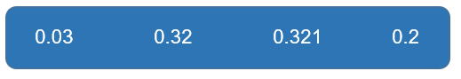
Question 2
What integer is represented by the image below? Explain your answer.
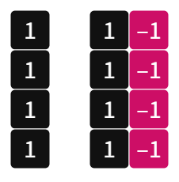

Question 3
Ari and Gabriel order pizzas from different shops. Each pizza is the same size although they have been cut differently. Ari’s pizza is cut into 6 equal pieces and Gabriel’s is cut into 8 equal pieces. Ari and Gabriel both start eating their pizza.
What is the minimum number of whole pieces that each of them needs to eat for them to eat the same amount of pizza? Explain your answer, including diagrams where appropriate.
Question 4
Which of these diagrams does not represent $\frac{3}{5}$?
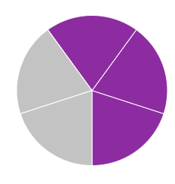

Question 5
Using the visual representation, or otherwise, round 3.89 to the nearest tenth. Explain your solution.
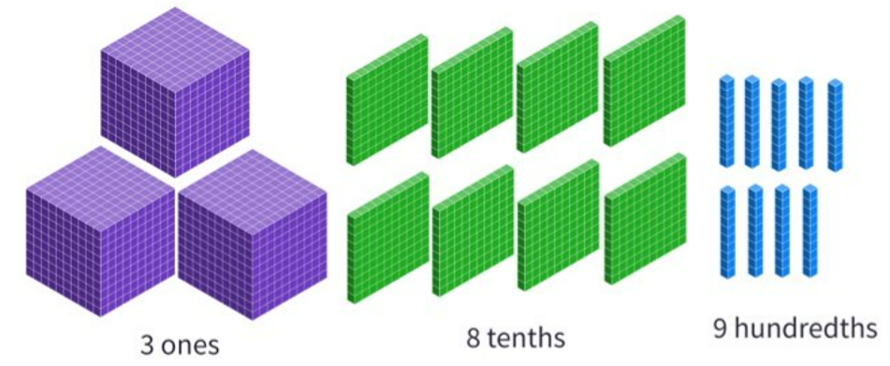
Question 6
Which integer is represented by the ‘?’ symbol? Give reasons to support your answer.
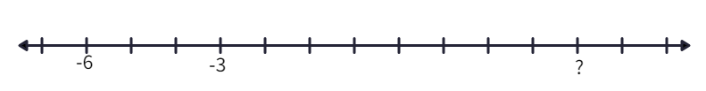
Question 7
Hiromi believes that the fractions $\frac{1}{2},\frac{2}{5},\frac{3}{8}$ are written in order of smallest to largest since both the numerator and denominators are in order from smallest to largest.
Is Hiromi correct? Justify your answer with mathematical reasoning and diagrams where appropriate.
Question 8
- Describe the temperature $-7^{o}C$ in terms of how hot or cold it is in your local area.
- Describe would happen to the temperature $-7^{o}C$ if the magnitude was increased but the direction remained the same.
- Describe what would happen to the temperature $-7^{o}C$ if the magnitude stayed the same but the direction changed.
Question 9
Show that $-5$ and 4 are 9 units apart using a visual representation.
Question 10
Consider which of the following shows a difference that is more than one half.
- $\frac{7}{8}-\frac{2}{8}$
- $\frac{8}{9}-\frac{5}{9}$
- $\frac{7}{12}-\frac{5}{12}$
Give reasons why each expression is more or less than one half. Use diagrams to support your reasoning where appropriate.

References
This resource contains NSW Curriculum and syllabus content. The NSW Curriculum is developed by the NSW Education Standards Authority. This content is prepared by NESA for and on behalf of the Crown in right of the State of New South Wales. The material is protected by Crown copyright.
Please refer to the NESA Copyright Disclaimer for more information https://educationstandards.nsw.edu.au/wps/portal/nesa/mini-footer/copyright.
NESA holds the only official and up-to-date versions of the NSW Curriculum and syllabus documents. Please visit the NSW Education Standards Authority (NESA) website https://educationstandards.nsw.edu.au/ and the NSW Curriculum website https://curriculum.nsw.edu.au/home.
Mathematics K–10 Syllabus © NSW Education Standards Authority (NESA) for and on behalf of the Crown in right of the State of New South Wales, 2022.

© State of New South Wales (Department of Education), 2023
The copyright material published in this resource is subject to the Copyright Act 1968 (Cth) and is owned by the NSW Department of Education or, where indicated, by a party other than the NSW Department of Education (third-party material).
Copyright material available in this resource and owned by the NSW Department of Education is licensed under a Creative Commons Attribution 4.0 International (CC BY 4.0) license.
This license allows you to share and adapt the material for any purpose, even commercially.
Attribution should be given to © State of New South Wales (Department of Education), 2023.
Material in this resource not available under a Creative Commons license:
- the NSW Department of Education logo, other logos and trademark-protected material
- material owned by a third party that has been reproduced with permission. You will need to obtain permission from the third party to reuse its material.
Links to third-party material and websites
Please note that the provided (reading/viewing material/list/links/texts) are a suggestion only and implies no endorsement, by the New South Wales Department of Education, of any author, publisher, or book title. School principals and teachers are best placed to assess the suitability of resources that would complement the curriculum and reflect the needs and interests of their students.
If you use the links provided in this document to access a third-party's website, you acknowledge that the terms of use, including licence terms set out on the third-party's website apply to the use which may be made of the materials on that third-party website or where permitted by the Copyright Act 1968 (Cth). The department accepts no responsibility for content on third-party websites.

