# Highest common factor of integers

Students solve problems of equally sharing different quantities to explore the concept of a highest common factor, using factor trees and Venn diagrams.

## Visible learning

### Learning intention

* To be able to establish the highest common factor between integer values.

### Success criteria

* I can use a prime factor tree to redefine a number.
* I can use prime factor trees to find all the common prime factors between 2 integers.
* I can multiply the common prime factors to find the highest common factor between 2 integers.
* I can use a Venn diagram to represent the highest common factor between 2 integers.

### Syllabus outcomes

A student:

* develops understanding and fluency in mathematics through exploring and connecting mathematical concepts, choosing and applying mathematical techniques to solve problems, and communicating their thinking and reasoning coherently and clearly **MAO-WM-01**
* represents and operates with fractions, decimals and percentages to solve problems MA4-FRC-C-01

[Mathematics K–10 Syllabus](https://curriculum.nsw.edu.au/learning-areas/mathematics/mathematics-k-10-2022) © NSW Education Standards Authority (NESA) for and on behalf of the Crown in right of the State of New South Wales, 2022.

## Activity structure

### Launch

1. Present students with the following problem of rabbits, carrots and broccoli
2. Karl has 6 pieces of broccoli and 8 pieces of carrot, and he would like to give an equal amount to each to his rabbits.
3. What is the maximum number of rabbits that Karl can equally share these pieces of vegetables between?
4. Arrange students in visibly random groups of 3 ([bit.ly/visiblegroups](https://powerfullearning.com/visible-random-groups-why-this-is-the-next-thing-you-need-to-do-for-group-work-in-your-classroom/)). Have them use counters (green and red, for example) to represent the broccoli and carrots, and draw rabbits in each square along the bottom row of large grid paper (grid paper can be generated to your specifications using ‘Mathster Graph Paper Generator website’ – [mathster.com/graphpaper/graphpaperjs/](https://mathster.com/graphpaper/graphpaperjs/)).

Figure 1 – sharing counters between 8 rabbits

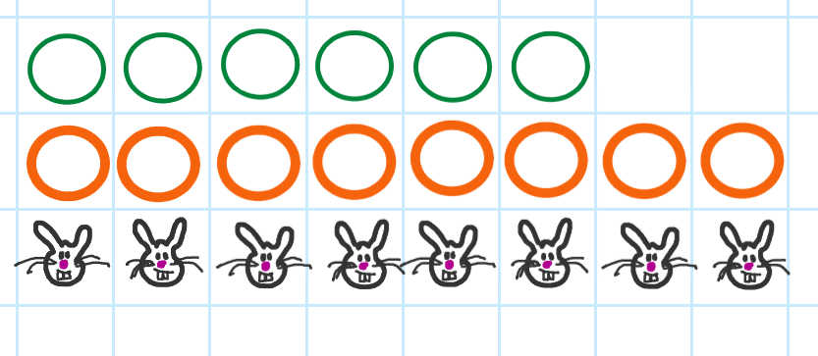

1. Students continue to manipulate the counters into the columns above each rabbit until all the ‘vegetables’ have been equally distributed (this will occur above 2 columns of rabbits).

Figure 2 – sharing counters between 2 rabbits

Depicts green counters and orange/red counters being used on graph paper, moved to show a representation of equal sharing above depictions of rabbits
Those rabbits that were not able to be included have had a red line drawn through their pictures

1. Students will participate in a Think-Pair-Share ([bit.ly/thinkpairsharestrategy](https://bit.ly/thinkpairsharestrategy)) to discuss their results.
2. Present students with a similar problem, but with a larger number of each of the vegetables:
3. This time Karl has found 84 pieces of broccoli and 112 carrots.
4. Students will quickly find that there is going to be difficulty accessing that many counters and that the sheet of grid paper is going to be too restrictive.
5. Students should be encouraged to think of alternative ways to solve the problem, while working on non-permanent vertical surfaces with students, working in small, random groups to come up with solutions to the problem.
6. Give students enough time for students to work on the problem, then have them share their solutions with the class.
7. It may be appropriate to present the ‘Greatest Common Factor (2:45)’ video (<https://www.pbslearningmedia.org/resource/muen-math-ns-greatcomfactors/greatest-common-factor/>) to the class. This video clarifies the processes undertaken to establish the highest common factor between 2 integers.

### Explore

Students will have seen the benefits and limitations of the launch activity when working with slightly larger values.

1. Using the same values from before, starting with 6 and 8, demonstrate how to represent these numbers using a prime factor tree. See Figure 3.

Figure 3 – prime factor trees for 6 and 8

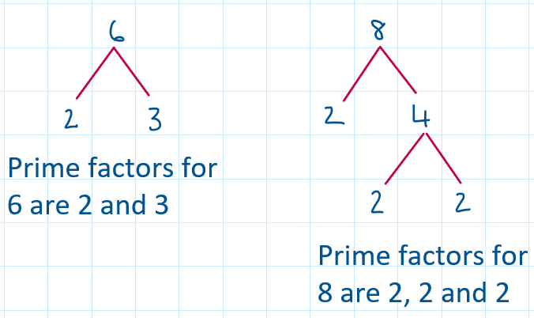

1. See if students can draw a connection between the results from the grouping activity in the Launch and the results from the prime factor tree.
2. Use correct student responses where 2 occurs as a prime factor once for 6, and at least once for 8, to demonstrate that this is the only common factor between 6 and 8.
3. Highlight to students that using factor trees allows us to represent a number as a number sentence, which multiplies all the factors together

$2×3=6$ and $2×4=8$

1. Ask students to complete prime factor trees for 84 and 112.

Figure 4 – prime factor trees for 84 and 112

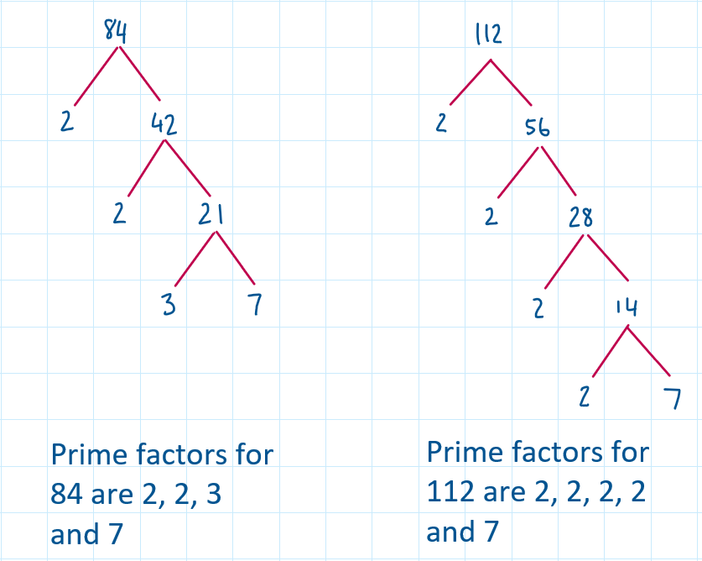

Students may have started with different values, for example 12 and 7 as factors of 84, which is perfectly acceptable as they will eventually derive the same values as factor trees.

1. In this example, we can see that the common factors between 84 and 112 are 2 and 7.
2. Have students write out the number sentences for these 2 values that showcase the factors being multiplied together:

$2×2×3×7=84$ and $2×2×2×2×7=112$

1. Pose this question to students:   
   ‘If these 2 numbers share more than one common factor, how can we determine the highest common factor?’

Students may need to be reminded that the factors of a number are related to one another through being multiplied together.

1. Knowing that the commutative property of multiplication allows students to multiply any of the factors in any order, draw students’ attention to the number sentences that they have written out already, and highlight the common prime factors in each.

Displays number sentences highlighting the commutative property of multiplication and how this applies to prime factors for the numbers 84 and 112.
Red circles have been drawn around the prime factors of 2 and 7, indicating that these are common between both 84 and 112.
When these prime factors are multiplied together to produce the number 14, this represents the highest common factor of 84 and 112

1. From the number sentences, students can explore which factors are common. Multiplying these common factors together will produce the Highest Common Factor (HCF) found between the 2 original values.
2. This can also be represented with support of a visual aid through use of Venn Diagrams. See Figure 5.

Figure 5 – Venn diagram showing prime factors

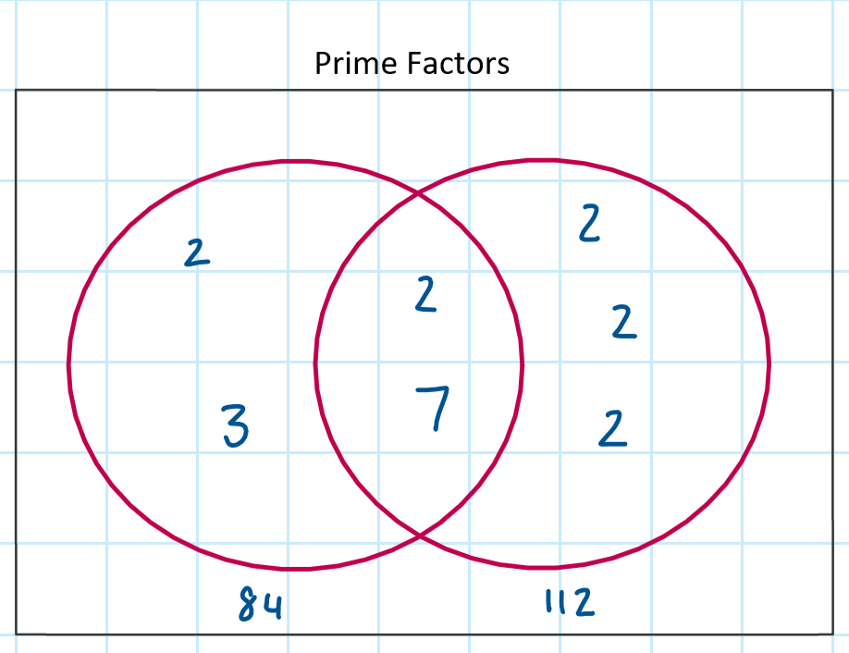

1. Display or create the image above for students to explore using a Think-Pair-Share ([bit.ly/thinkpairsharestrategy](https://bit.ly/thinkpairsharestrategy)).
2. The overlap emphasises the prime factors that each number shares, and when multiplied together, produce the highest common factor.

### Summarise

1. Have students complete the activity in Appendix A ’Highest common factor’ to reinforce the concept of determining the highest common factor between integers. Challenge questions have been included. Encourage the use of factor trees and/or Venn diagrams to derive these solutions.

If students require additional support consider using smaller values that only have distinct prime factors.  
If students need to explore more complex ideas, consider increasing the quantity of numbers being compared and the number of common factors shared

1. Students will create notes to their future, forgetful self ([bit.ly/notesstrategy](https://bit.ly/notesstrategy)) focusing on defining the concept of highest common factors and approaches to determining these for 2 integer values.
2. Students need to be able to differentiate between prime factors and highest common factor as part of their summary notes.

### Apply

1. Challenge students to create problems for their peers to solve that involve highest common factors. Students should be encouraged to use the work they have undertaken in the lesson to create questions involving 2 or more large integer values.
2. Students will need to include questions involving prime factors only, common multiples and examples where numbers share no common factors.
3. Students are encouraged to create these questions anonymously and have them displayed around the room, similar to what one would do as part of a gallery walk ([bit.ly/DLSgallerywalk](https://bit.ly/DLSgallerywalk)).
4. Once students have created these problems, they will attempt to derive solutions for those displayed around the room, working in their groups of 3 from earlier.

Mini whiteboards ([bit.ly/miniwhiteboards](https://bit.ly/miniwhiteboards)), or an alternative such as laminated pieces of paper, are encouraged for students to use throughout this activity, both for displaying the problems initially and for working on solutions

## Assessment and differentiation

### Suggested opportunities for differentiation

**Explore**

* Restricting the use of reminders and prompts throughout the exploration of establishing highest common factor would place a greater onus of responsibility on students to work through the discovery of concepts**.**
* Using numbers smaller than 84 and 112 may make this concept more accessible for some students.

**Summarise**

* Exploring the highest common factors between more than 2 integers provides opportunities to increase the level of complexity for students.
* Providing values that have only share prime factors in common reduces the complexity of succeeding with this concept.

### Suggested opportunities for assessment

**Explore**

* Student responses to Think-Pair-Share activities throughout this learning sequence can be used as a formative means to establish the level of understanding.

**Summarise**

* Student generated questions and solutions can be used to help gauge depth and breadth of student knowledge and understanding of concepts covered.

## **Appendix A**

### Highest common factor

|  |  |  |
| --- | --- | --- |
| Question | Factor tree or Venn Diagram | HCF |
| 1. Highest common factor of 18 and 28. | Venn diagram with two circles. The first circle contains factors of 18 and has a 3 and a 3 in the circle. The second circle shows factors of 28 and contains a 2 and a 7. The overlap contains the number 2 | 2 |
| 1. Highest common factor of 21 and 15. | Venn diagram with two circles. The first circle contains factors of 15 and has a 5 in the circle. The second circle shows factors of 21 and contains a 7. The overlap contains the number 3 |  |
| 1. Highest common factor of 16 and 18. |  |  |
| 1. Highest common factor of 25 and 60. |  |  |
| 1. Highest common factor of 8 and 28. |  |  |
| 1. Highest common factor of 18 and 63. |  |  |
| 1. Highest common factor of 60 and 28. |  |  |
| 1. Highest common factor of 120 and 56. |  |  |

### Challenge questions

|  |  |
| --- | --- |
| Question | Solution |
| 1. Establish the highest common factor (HCF) between 128 and 176. | $$128=2×2×2×2×2×2×2$$ $$176=2×2×2×2×11$$ ∴ HCF of and |
| 1. Establish the HCF between 64 and 88. | $$64=2×2×2×2×2×2$$ $$88=2×2×2×11$$ ∴ HCF of and |
| 1. Establish the HCF between 256 and 352. | $$256=2×2×2×2×2×2×2×2$$ $$352=2×2×2×2×2×11$$ ∴ HCF of 256 and 352 |
| 1. Establish the highest common factor (HCF) between 133 and 181. |  |
| 1. Establish the HCF between 88, 176 and 352. |  |
| 1. Establish the HCF between 64, 88, 128, 176, 256 and 352. |  |
| 1. Determine the value of 2 possible integers that share a HCF of 14. |  |
| 1. Determine the value of 3 possible integers that share a HCF of 14. |  |
| 1. Determine the value of 3 possible integers that share a HCF of 7. |  |
| 1. Establish a set of at least 5 integers that share no factors (remembering that 1 is not considered to be a factor). |  |

## ****References****

This resource contains NSW Curriculum and syllabus content. The NSW Curriculum is developed by the NSW Education Standards Authority. This content is prepared by NESA for and on behalf of the Crown in right of the State of New South Wales. The material is protected by Crown copyright.

Please refer to the NESA Copyright Disclaimer for more information [https://educationstandards.nsw.edu.au/wps/portal/nesa/mini-footer/copyright](https://aus01.safelinks.protection.outlook.com/?url=https%3A%2F%2Feducationstandards.nsw.edu.au%2Fwps%2Fportal%2Fnesa%2Fmini-footer%2Fcopyright&data=05%7C01%7CCaitlin.Pace1%40det.nsw.edu.au%7C9c2c1a9f59c94d2df30708dafa7edb23%7C05a0e69a418a47c19c259387261bf991%7C0%7C0%7C638097720042599463%7CUnknown%7CTWFpbGZsb3d8eyJWIjoiMC4wLjAwMDAiLCJQIjoiV2luMzIiLCJBTiI6Ik1haWwiLCJXVCI6Mn0%3D%7C3000%7C%7C%7C&sdata=BzQh0UsffVZE3eO22b2Xba3p0VMOBZSHfS21FGHXtZM%3D&reserved=0).

NESA holds the only official and up-to-date versions of the NSW Curriculum and syllabus documents. Please visit the NSW Education Standards Authority (NESA) website <https://educationstandards.nsw.edu.au/> and the NSW Curriculum website [https://curriculum.nsw.edu.au/home](https://curriculum.nsw.edu.au/).

[Mathematics K–10 Syllabus](https://curriculum.nsw.edu.au/learning-areas/mathematics/mathematics-k-10-2022) © NSW Education Standards Authority (NESA) for and on behalf of the Crown in right of the State of New South Wales, 2022.

**© State of New South Wales (Department of Education), 2023**

The copyright material published in this resource is subject to the *Copyright Act 1968* (Cth) and is owned by the NSW Department of Education or, where indicated, by a party other than the NSW Department of Education (third-party material).

Copyright material available in this resource and owned by the NSW Department of Education is licensed under a [Creative Commons Attribution 4.0 International (CC BY 4.0) licence](https://creativecommons.org/licenses/by/4.0/).

[](https://creativecommons.org/licenses/by/4.0/)

This licence allows you to share and adapt the material for any purpose, even commercially.

Attribution should be given to © State of New South Wales (Department of Education), 2023.

Material in this resource not available under a Creative Commons licence:

the NSW Department of Education logo, other logos and trademark-protected material

material owned by a third party that has been reproduced with permission. You will need to obtain permission from the third party to reuse its material.

**Links to third-party material and websites**

Please note that the provided (reading/viewing material/list/links/texts) are a suggestion only and implies no endorsement, by the New South Wales Department of Education, of any author, publisher, or book title. School principals and teachers are best placed to assess the suitability of resources that would complement the curriculum and reflect the needs and interests of their students.

If you use the links provided in this document to access a third-party's website, you acknowledge that the terms of use, including licence terms set out on the third-party's website apply to the use which may be made of the materials on that third-party website or where permitted by the *Copyright Act 1968* (Cth). The department accepts no responsibility for content on third-party websites.