Less than zero
In this activity, students develop a need to use negative numbers through losing points in games. Students then use paper folding to construct a number line involving negative numbers and examine and use the reflective property of negative numbers.

Visible learning

Learning intention
- To understand negative numbers as a reflection of positive numbers.

Success criteria
- I can place negative numbers on a number line.
- I can order numbers below zero.
- I can explain how negative numbers reflect the positive numbers on a number line.

Syllabus outcomes
A student:
- develops understanding and fluency in mathematics through exploring and connecting mathematical concepts, choosing and applying mathematical techniques to solve problems, and communicating their thinking and reasoning coherently and clearly MAO-WM-01
- compares, orders and calculates with integers to solve problems MA4-INT-C-01
Mathematics K–10 Syllabus © NSW Education Standards Authority (NESA) for and on behalf of the Crown in right of the State of New South Wales, 2022.

Activity structure

Launch

Equipment
- Class set of coins or two-coloured counters
- Class set of 6-sided dice
- Mini whiteboard or A4 piece of paper per student
Optional:
- Device with link to Desmos ’Game 2: Score buttons’ (bit.ly/desmosgamescore)

Method
- Students write down the number 10 in the top left corner of their mini whiteboard or A4 paper. Inform students that this is their starting score. We are aiming to get to 30.
- Give all students a dice and inform them that rolling an odd number, one, 3 or 5 means that we win that number of points. Rolling an even number, 2, 4 or 6 means that we lose this number of points.
While it is important that most of the class play with the rules above, some students could play where rolling a 2, 4 and 6 win points, to consider this in discussion questions later.
- All students roll their dice. If they roll a one, 3 or 5, they add these points to their score of 10 and write their new score on their whiteboard or paper. If they land on 2, 4 or 6, they subtract this from 10 and write their new score on their whiteboard or paper.
- Students continue this game until they reach a score of 30, or until 3 minutes has passed.
Scores can be recorded and viewed using the Desmos link in the equipment list.

Modification: change the starting score to 2 and make the target score 10. Flip a coin where heads mean a point is added, and tails mean a point is subtracted to make the game go up and down by one each turn. Students will need coins or two-coloured counters, or alternatively use the Desmos graph ’Score button’ (bit.ly/DesmosScoreButton).

Discussion questions
- Lead a discussion with the class to answer the following questions:
- How many people reached 30 points and won?
- How many people ended up below zero?
- Have students engage in a Think-Pair-Share (bit.ly/thinkpairsharestrategy) to discuss the following questions about both games.
- Do you think it is likely that a player will reach 30 points? Why or why not?
- Which out of the odd numbers or even numbers is more likely to get you to 30 points?
- What did you do to your score if you lost and went below zero? If this never happened, what would you do?

Explore

Equipment
- 2 paperclips per student
- Long strips of paper, one per student
- Mini whiteboard or A4 piece of paper per student
- One dice per student

Method
The instructions below support students using strips of paper cut longways from an A4 sheet of paper, roughly 3–5 centimetres in width.
- Students are given a strip of paper and told that this paper is going to be their number line.
- Have students fold their paper in half and then unfold, writing the number zero at the resulting crease in the paper.
Figure 1 – the strip of paper after step 2
- Students should next fold the paper back along the crease and then fold it in half a second time. Students stretch the paper to reveal a crease either side of the centre, as shown below.
Figure 2 – the strip of paper after step 3
- Ask students to suggest what number they believe should be written on the crease to the right. Use a Pause–Pose–Pounce–Bounce question strategy [PDF 200KB] (bit.ly/pausepouncebounce) to select students to contribute to the discussion.
Our hope is that students will conclude that it depends on what we are going to write at the end of the paper.
- Reveal to students that the number at the far end of the paper will be 8 and allow further suggestions of what number should be on the crease to the right of zero. Conclude that it should be 4 and have students write the number so their strip of paper looks like the image below.
Figure 3 – The strip of paper after step 5
- Students fold the paper in half 3 times. Ask students to consider what number goes on the new creases to the right of zero. Continue using the Pause–Pose–Pounce–Bounce question strategy to interrogate methods for students discovering the numbers 2 and 6 in the resulting creases to the right of the zero and either side of the 4.
Figure 4 – The strip of paper after step 6
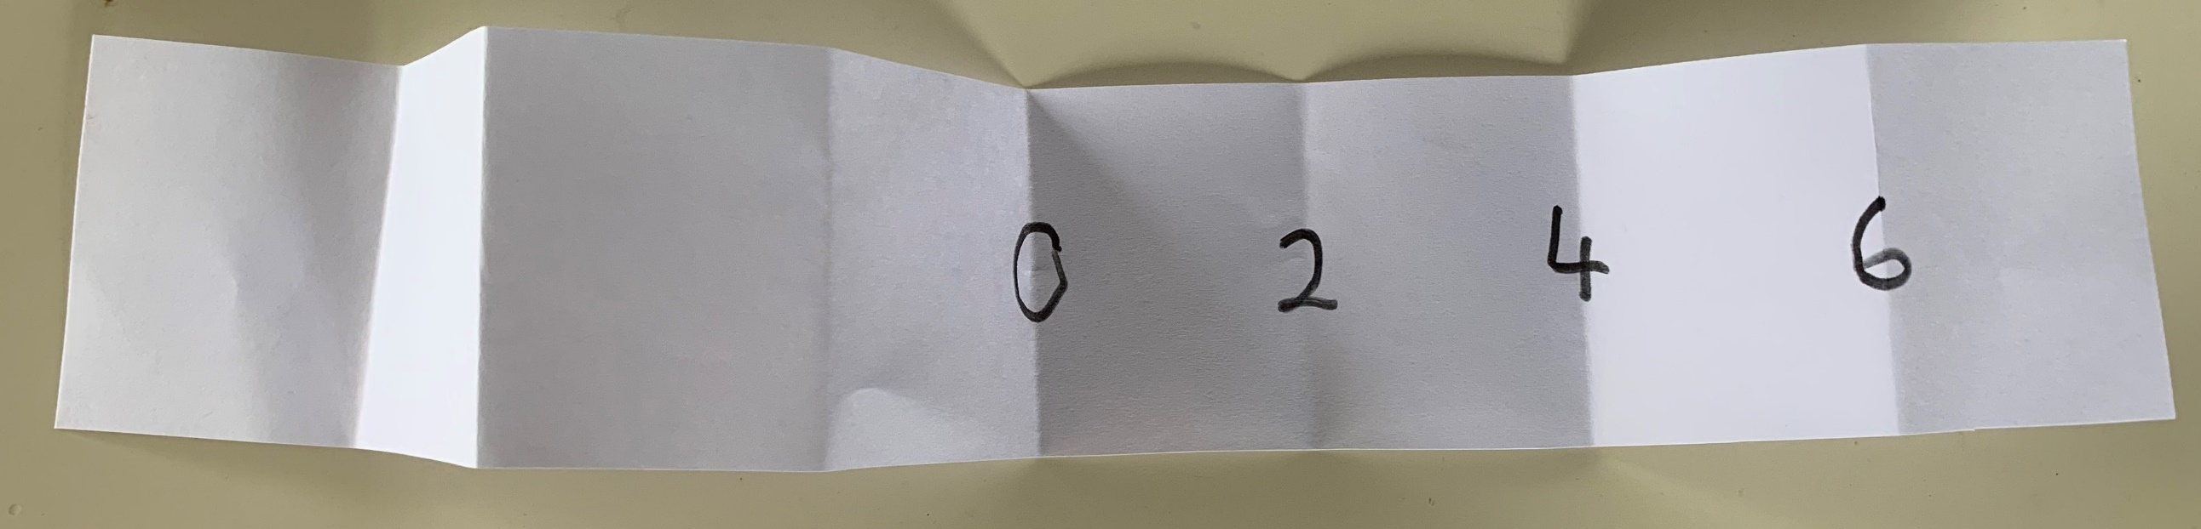
- Finally, students fold the paper 4 times, completing the numbers up to 7 on the number line.
Figure 6 – The strip of paper after step 7
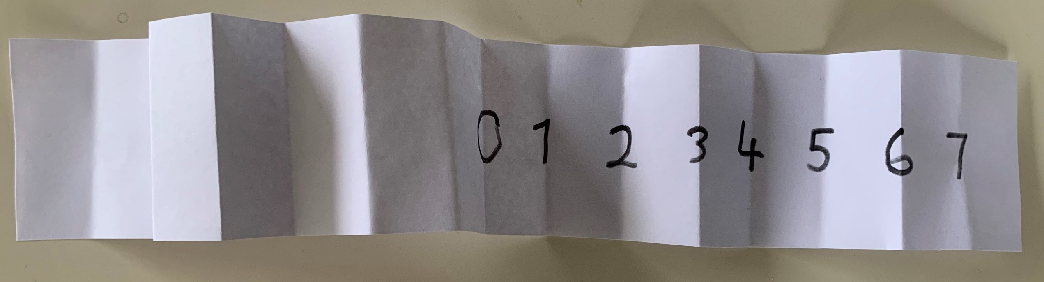
If using a longer strip of paper, for example if using paper stripping or those cut from A3 paper, teachers may choose to write 8 on the crease during step 2, then 4 and 12, followed by 2, 6, 10 and 14 before finally completing the number line up to 15.
- Have students engage in a Think-Pair-Share (bit.ly/thinkpairsharestrategy) to consider the discussion questions below and complete their number line to the left of zero. Encourage students to fold the paper to compare positions of different numbers.
- What does your number line go up to?
- How would we label the creases to the left of zero?
- What do you notice about your number line?
- Bring the class together to discuss each pair’s responses to these questions. Ensure all students have labelled their number line from −7 to 7.
- Have students compare the numbers −3 and 3. What is the same, and what is different about each of them?

Game
- Students place paper clips on the points 0 and 1. They write the number 1 on their mini whiteboard or A4 paper, noting that this is the difference between the locations of the 2 paperclips as well as how many spaces apart they are. The aim is to get the paperclips to be 10 units apart in as few moves as possible.
- Students roll their dice and move one paper clip this number of spaces. The only rule is that neither paperclip can go off the edge of the number line.
- Have students engage in a Think-Pair-Share around the following questions:
- What was the smallest number of moves in which you were able to make a distance of 10 between the paperclips?
- What made it difficult to make a distance of 10 between the paperclips?
- How many different ways can you see to make a distance of 10 between the paperclips?
- What can you do to make the difference between the paperclips larger?
- What can you do to make the difference between the paperclips smaller?
- Is this the same if one of the numbers is negative?
- Is this the same if both of the numbers are negative?
- Would this be the same if we let the paperclips continue beyond this number line?

Summarise

Using a device
- Students can complete the Desmos activity ’The Number Line Reflected’ (bit.ly/ReflectedNumberLine). Instructions on how to set up your class in Desmos activities can be found at Desmos’ help centre (bit.ly/desmosclassroomstrategy).
- Have students access the Desmos graph ’Number line’ (bit.ly/DesmosNumberLine) and find the location of points on the number line.

Without a device
- Give students a copy of Appendix A ‘Locating points on a number line’, where students use directed numbers to describe the position of the 6 points shown.

Apply
- Give students copies of Appendix B ‘Placing integers on a number line’. Students will require internet access.
- In Part 1, students place room numbers in a hotel on a vertical number line, including basements for negative numbers.
- In Part 2, students use the website ’Weather in Antarctica’ (timeanddate.com/weather/antarctica) to find temperatures in locations in Antarctica and place them approximately on the vertical number line.
- Have students consider and discuss why the floors number line ends at flat bars, while the temperature number line has arrows on the ends.

Assessment and differentiation

Suggested opportunities for differentiation
Launch
- Teachers can choose to use flipping a coin so that students can simply count forwards by one if this is more suited to their ability.
Explore
- Challenge students to construct another number line, starting with a different number instead of 4 on the first crease. Given the current number line goes from −8 to 8, students can consider what other number lines are possible using this method.

Suggested opportunities for assessment
Explore
- Review whether students are applying the concept of symmetry to understand and describe negative numbers. Are they able to identify the creases as the points where numbers lie and can they identify the largest number as 8 instead of 7?
Apply
- Using the Desmos activity ‘The number line reflected’ allows student reasoning to be recorded and reviewed.

Appendix A

Locating points on a number line
Write a number that describes the location of each letter on the number line below.
A =
B =
C =
D =
E =
F =
Figure 6 – number line
For which letters did you use similar numbers to describe their location? What is the same about those locations?

Appendix B

Placing integers on a number line

Part 1 – elevator levels
In most buildings, the ground level is considered to be level 0. In a hotel, levels above the ground level count up from number 1. Rooms are numbered with 3 digits, with the first digit being the level number. For example, room 712 means the twelfth room on level 7.
Parking levels are usually underground and count below zero, starting with −1.
Place each of the floor locations listed in the box below on the vertical number line. The first one is completed for you.
Robert is in room 607. | Sarah is on the second floor.
The lobby is on the ground floor. | Cameron parked his car on the second level of the parking lot.
Faisal has had to leave his car on the 5th level of the parking lot. | Safe Mart delivers food to the hotel by taking their truck to the first underground level.
Shaun is staying in room 1201.
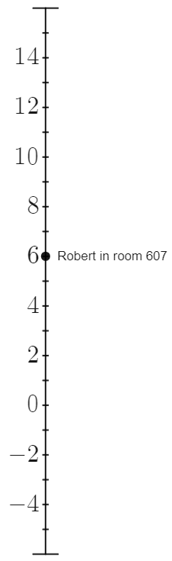

Part 2 – temperatures
Temperatures can also be described by negative numbers. The box below indicates temperatures that are either positive or else very cold and negative. Place each temperature on the vertical number line below. Pick 3 locations in Antarctica at the website ’Weather in Antarctica’ (timeanddate.com/weather/antarctica) and place these locations on the number line.
Room temperature is generally ${20}^{o}C$. | A cold day in Sydney could be approximately ${10}^{o}C$.
Water freezes at $0^{o}C$. | Your freezer is approximately ${-18}^{o}C$.
A hot day in Sydney could be approximately ${38}^{o}C$. | The summit of the tallest mountain in the world, Mount Everest, has an average temperature of approximately ${-36}^{o}C$.
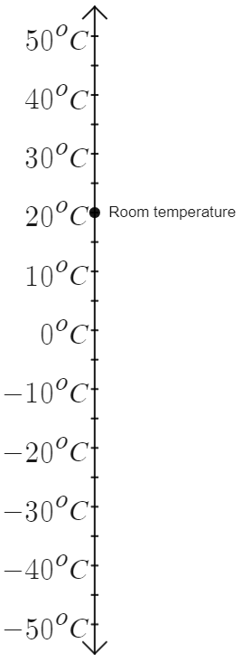

Sample solutions

Appendix A – locating points on a number line
A = 5, B = 9, C = −5, D = −2, E = −9, F = −10
C, D, E and F are all negative numbers because they are to the left.
A and C are the same number, 5 because they are both 5 strokes away from the zero, just in different directions.

Appendix B – placing integers on a number line

Part 1 – elevator levels
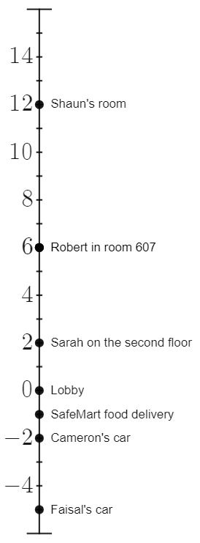

Part 2 – temperatures
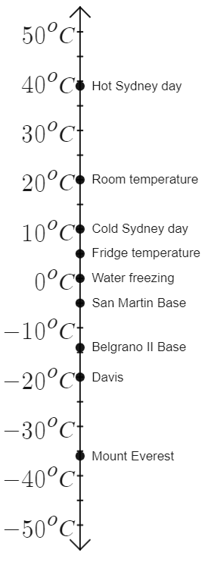

References
This [document / resource] contains NSW Curriculum and syllabus content. The NSW Curriculum is developed by the NSW Education Standards Authority. This content is prepared by NESA for and on behalf of the Crown in right of the State of New South Wales. The material is protected by Crown copyright.
Please refer to the NESA Copyright Disclaimer for more information https://educationstandards.nsw.edu.au/wps/portal/nesa/mini-footer/copyright.
NESA holds the only official and up-to-date versions of the NSW Curriculum and syllabus documents. Please visit the NSW Education Standards Authority (NESA) website https://educationstandards.nsw.edu.au/ and the NSW Curriculum website https://curriculum.nsw.edu.au/home.
Mathematics K–10 Syllabus © NSW Education Standards Authority (NESA) for and on behalf of the Crown in right of the State of New South Wales, 2022.
© State of New South Wales (Department of Education), 2023
The copyright material published in this resource is subject to the Copyright Act 1968 (Cth) and is owned by the NSW Department of Education or, where indicated, by a party other than the NSW Department of Education (third-party material).
Copyright material available in this resource and owned by the NSW Department of Education is licensed under a Creative Commons Attribution 4.0 International (CC BY 4.0) licence.
This licence allows you to share and adapt the material for any purpose, even commercially.
Attribution should be given to © State of New South Wales (Department of Education), 2023.
Material in this resource not available under a Creative Commons licence:
- the NSW Department of Education logo, other logos and trademark-protected material
- material owned by a third party that has been reproduced with permission. You will need to obtain permission from the third party to reuse its material.
Links to third-party material and websites
Please note that the provided (reading/viewing material/list/links/texts) are a suggestion only and implies no endorsement, by the New South Wales Department of Education, of any author, publisher, or book title. School principals and teachers are best placed to assess the suitability of resources that would complement the curriculum and reflect the needs and interests of their students.
If you use the links provided in this document to access a third-party's website, you acknowledge that the terms of use, including licence terms set out on the third-party's website apply to the use which may be made of the materials on that third-party website or where permitted by the Copyright Act 1968 (Cth). The department accepts no responsibility for content on third-party websites.

