Direction and magnitude
Students use distance and position as contexts to consider both the direction and magnitude of integers, investigating phrases that indicate direction.

Visible learning

Learning intentions
- To be able to describe the direction and magnitude of integers.
- To compare the size of integers based on their position on the number line.

Success criteria
- I can place integers on a number line.
- I can state the direction and magnitude of an integer presented in many forms.
- I can explain why magnitudes are always positive.
- I can compare the size of integers by placing them on a number line.

Syllabus outcomes
A student:
- develops understanding and fluency in mathematics through exploring and connecting mathematical concepts, choosing and applying mathematical techniques to solve problems, and communicating their thinking and reasoning coherently and clearly MAO-WM-01
- compares, orders and calculates with integers to solve problems MA4-INT-C-01
Mathematics K–10 Syllabus © NSW Education Standards Authority (NESA) for and on behalf of the Crown in right of the State of New South Wales, 2022.

Activity structure

Launch

Online simulation
The instructions below describe how to conduct this activity as a class. If multiple devices are available, this task could be completed in small groups.
If technology is not available at all, an alternative Launch activity is provided below this activity.
- The teacher should open the Desmos file ‘Describing point locations’ (bit.ly/pointlocations) and display it on a large screen.
- By pressing the button at the top of the screen, show students how to randomise the position of the 3 points A, B and C.
Figure 1 – button to randomise the position of 3 points
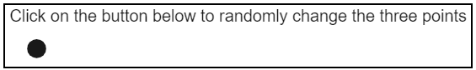
Image created using Desmos and is licensed under the Desmos Terms of Service.
- Ask one student or a group of students to turn around or close their eyes.
- Press the button to randomise the positions of points A, B and C.
- Instruct the remaining students to pay attention to the location of the 3 points.
- Press the switch to hide the location of the 3 points.
Figure 2 – switch to hide the location of the 3 points
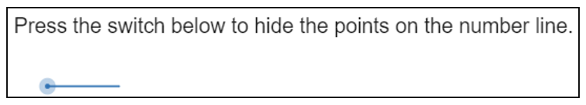
Image created using Desmos and is licensed under the Desmos Terms of Service.
- Students who have seen the location of the 3 points need to take turns describing the locations of the 3 points to the students who turned around. Students who turned around need to indicate where they think the points are on the board by placing a sticky note on the screen.
- Turn the points back on to see how close students were.
- Acknowledge the language used by students to describe the locations of the points. Students will likely have used reference points, particularly the endpoints and possibly the midpoint of the line.
- Repeat the activity, by pressing the switch to make the activity harder. This will allow points to appear to the left of the line.
- Use the switches to gradually turn on features to make the descriptions easier.
- Have students engage in a Think-Pair-Share (bit.ly/thinkpairsharestrategy) considering the following reflection questions:
- Which switch made the most difference in making it easier to describe locations?
- What language did you use to describe the location?
- What words did you use in the same way on both sides of the 0?
- What words did you use to describe the difference between the sides of the 0?

Hands on experiment
This activity replaces the previous Launch activity in the situation where technology is unavailable.

Equipment
- Cones or other markers – 3 per group of students
- Tape measures – optional

Method
- Take students to an open space, possibly outside.
- Identify existing lines in the school such as those in sporting fields and courts, or edges of walls. Each group should be assigned to one line.
- Student A from each group needs to turn away or close their eyes.
- Student B places 2 cones or markers somewhere along the group’s line, as shown in Figure 1 below.
Figure 3 – markers on a line
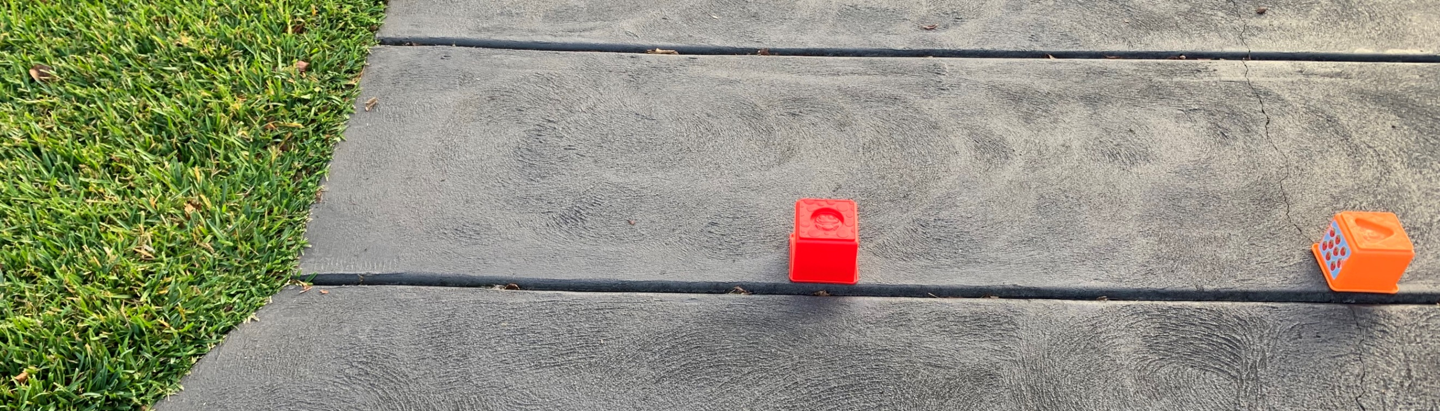
- Student C writes down a description of where the cones are. Student B then removes the cones. They may wish to take a photo on a device showing where they were or measure their distance from one end for comparing later.
- Student A returns and uses the written instructions from Student C to determine where to place the 2 markers.
- Students can then use the photo they took or their measurements to compare how close Student A was to the original marker placements.
- Repeat, swapping roles of the 3 students.
Teachers should acknowledge the use of a reference point, where students are often using the ends of the line or tape to describe the position of the 2 markers.
- Repeat the activity, giving each group a third cone or marker. Now one of the markers needs to be placed off the line, as shown in Figure 4.
Figure 4 – markers in both directions on a line
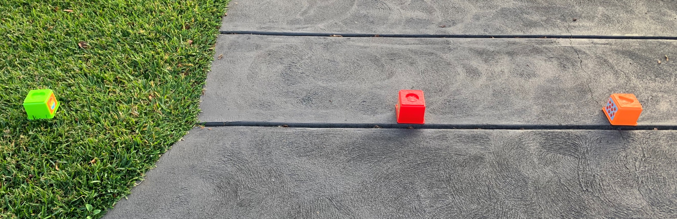
- Return to the classroom. Have students discuss the following reflection questions in their groups before sharing with the class.
- What words did you use to describe the locations?
- What words did you use to describe that the object was not on the line?

Explore
- Define direction and create a list of words that were used during the launch to describe direction. These may have included left, right, before, after or ‘the other way’.
- Ask students to consider the question ‘other than direction, what else helped us to describe where the points were?’ Take student responses that could include words like further, closer, near, far, halfway or a number of steps.
- Conclude that the words students are using all describe how far the point is from 0, which we call magnitude.
- Students complete either the Direction and magnitude with Desmos or the Direction and magnitude on a number line sections below.

Direction and magnitude with Desmos
- Open the Desmos graph ‘Number line’ (bit.ly/numbersonaline) on the teacher screen.
- Using mini whiteboards (bit.ly/miniwhiteboards) or an alternative, have students write the number of the point on the graph, holding this up on their mini whiteboard or piece of paper for the teacher to review. Demonstrate to students how to use the positive or negative switch and the magnitude slider to confirm the point.
Figure 5 – A directed number on a number line in Desmos
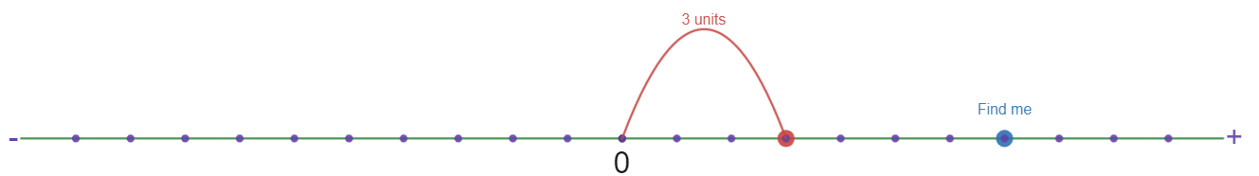
Image created using Desmos and is licensed under the Desmos Terms of Service.
- Repeat this by clicking the regenerate button on the screen.
Figure 6 – regenerate button
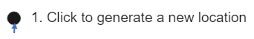
Image created using Desmos and is licensed under the Desmos Terms of Service.
- Give students the link to the Desmos graph and have them complete 10 questions. Once they have regenerated the question 5 times, a counter will appear on their screen.
- Have students engage in a Think-Pair-Share (bit.ly/thinkpairsharestrategy) around the following questions.
- What changes when you flick the ‘direction’ switch?
- What happens when you make the magnitude larger? Is this always the same, even when the ‘direction’ switch is changed?
- What happens when you make the magnitude smaller?
- Have students switch to the vertical number line by flicking the switch on their Desmos graph.
Figure 7 – vertical number line switch
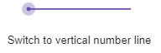
Image created using Desmos and is licensed under the Desmos Terms of Service.
- Have students regenerate and find 5 more points with the vertical number line.
- Students are then to repeat their Think-Pair-Share (bit.ly/thinkpairsharestrategy) to discuss the following questions.
- Is the direction switch still doing the same thing with a vertical number line?
- What does a larger magnitude now mean with a vertical number line? Is this always the same? Even when the ‘direction’ switch is changed?
During the ‘share’ section of steps 7 and 10, it is important for the class to conclude that the magnitude describes the distance of the point from 0 and that the direction describes if this distance is left or right, up or down.

Direction and Magnitude with number lines
- Hand students copies of Appendix A ‘Direction and magnitude’.
- Students are to complete Part 1, describing the location of points using the words positive or negative to indicate direction, and a number to indicate magnitude.
- Have students engage in a Think-Pair-Share to answer the prompts on Appendix A ‘Direction and magnitude’.
- What happens to a location if you add a negative sign to the number? What if you take a negative sign away?
- What happens when you make the magnitude larger? Is this always the same, whether it is a negative number or a positive number?
- What happens when you make the magnitude smaller?
Ultimately, we want students to conclude that adding and removing the negative symbol swaps which side of the 0 the point is on. Also, we want students to be able to describe that increasing the magnitude increases the distance of the point from 0.
- Students complete part 2 of Appendix A ‘Direction and magnitude’, describing locations on a vertical number line, similarly to part 1.
- Have students engage in a Think-Pair-Share again to discuss the reflection questions in Appendix A part 2.
- Is your description of what happens when we add or remove the negative sign still accurate for a vertical number line? If not, how would you change the description?
- Is your description of what happens when we increase the magnitude still accurate for a vertical number line? If not, how would you change the description?

Summarise
- Hand out Appendix B ‘Locations around the world’.
- Have students discuss what they believe the numbers in table 1 may mean before revealing that the numbers represent approximate altitude.
- Show students the 50 highest cities infographic (visualcapitalist.com/the-50-highest-cities-in-the-world/).
- Have students discuss in pairs and construct a notice and wonder list (bit.ly/noticewonderstrategy) regarding the meaning of the values in table 2.
These values also refer to altitude. Encourage students to consider the meaning of a negative altitude.
- Have students approximately place as many of the locations from the 2 tables in Appendix B ‘Locations around the world’ on the vertical number line (also from Appendix B ‘Locations around the world’) as they can fit.
For students who express difficulty comparing large numbers, teachers may wish to focus on the positive numbers from the first table and consider using the number expander from Appendix C ‘Number expander’, before introducing the second table.
- Have students complete the table in Appendix B ‘Locations around the world’, comparing the altitudes of the locations using the > and < symbols, using their constructed number line.

Apply

Representing directed numbers as vectors
- Use the Desmos graph ‘Direction and magnitude: vectors’ (bit.ly/directionmagnitude) to demonstrate that a directed number can also be represented as a vector.
- Give this link to students and have them regenerate 10 questions. A question counter will appear as they go.
- Have students represent the directed numbers in Appendix A ‘Direction and Magnitude’ part 1 by drawing number lines and using a vector as shown in the Desmos graph.

Comparing directed numbers Venns
- Have students also attempt the problem in Appendix D ‘Negative number Venns’. Students are to determine decimals that would fit each of the categories describing sections A, B, C and D.
- For students who are demonstrating confidence and understanding of negative numbers and Venn diagrams, have them engage with the second Venn diagram of Appendix D ‘Negative number Venns’.

Assessment and differentiation

Suggested opportunities for differentiation
Summarise
- For students who have difficulty comparing large numbers, focusing initially on the positive altitudes in the first table and using the number expander in Appendix C ‘Number expander’ to rename numbers can improve access to this task.
- Challenge excelling students to create an approximate scale when placing the altitudes of locations on their number line.

Suggested opportunities for assessment
Launch and explore
- Observe the language being used during Think-Pair-Share discussions.
Summarise
- Have students submit their number lines and tables from Appendix B ‘Locations around the world’ and review their reasoning when comparing directed numbers.

Appendix A

Direction and Magnitude

Part 1 – horizontal number line
Describe the position of each point on the horizontal number line using the word ‘positive’ or ‘negative’ and a number. The location of ‘A’ has been completed for you.
A is positive 3.
B
C
D
E
F
G
Reflection questions:
- What happens to a location if you add a negative sign to the number? What if you take a negative sign away?
- What happens when you make the magnitude larger? Is this always the same, whether it is a negative number or a positive number?
- What happens when you make the magnitude smaller?

Part 2 – vertical number line
Describe the position of each point on the vertical number line using the words ‘positive’ or ‘negative’ and a number. The location of ‘A’ has been completed for you.
A is positive 6
B
C
D
E
F
- Is your description of what happens when we add or remove the negative sign still accurate for a vertical number line? If not, how would you change the description?
- Is your description of what happens when we increase the magnitude still accurate for a vertical number line? If not, how would you change the description?

Appendix B

Locations around the world
Table 1 – cities and their altitudes 1
Location | Altitude
Adelaide, Australia | 61
Bangalore, India | 920
Copenhagen, Denmark | 10
Mexico City, Mexico | 2,216
Milan, Italy | 122
Moscow, Russia | 124
Paris, France | 34
Sydney, Australia | 35
Tehran, Iran | 1,235
Windhoek, Namibia | 1,655
Table 2 – cities and their altitudes 2
Location | Altitude
Amsterdam, Netherlands | -2
Bangkok, Thailand | 0
Caspian Depression, Kazakhstan | -132
Dead Sea and Sea of Galilee, Israel, Jordan | -423
Death Valley, USA | -86
Laguna del Carbon | -105
Lake Assal, Djibouti | -155
Lake Eyre, Australia | -15
Lammefjord, Denmark | -7
Qattara Depression, Egypt | -133
Salton Sea, CA, USA | -71
Turpan Depression, China | -154
Zuidplaspolder, Netherlands | -6

Comparing locations
Use the symbols < and > to describe which is higher when comparing the altitudes of each of the following locations. The first statement is completed for you.
Location 1 | Symbol | Location 2
Adelaide, Australia | > | Paris, France
Windhoek, Namibia |  | Moscow, Russia
Tehran, Iran |  | Mexico City, Mexico
Lake Eyre, Australia |  | Milan, Italy
Sydney, Australia |  | Salton Sea, CA, USA
Death Valley, USA |  | Turpan Depression, China
Caspian Depression, Kazakhstan |  | Amsterdam, Netherlands
Copenhagen, Denmark |  | Lammefjord, Denmark
Lake Assal, Djibouti |  | Laguna del Carbon
Moscow, Russia |  | Lake Assal, Djibouti

Appendix C

Number expander
The first 57 seconds of the Place Value Number Expander (1:13) shows how to use the number expander for integer values up to tens of thousands.
Students cut out and fold the number expander so that the white sections are folded over the blue section to hide them from view (for now).
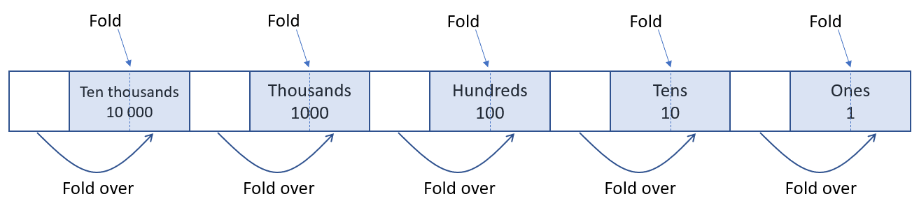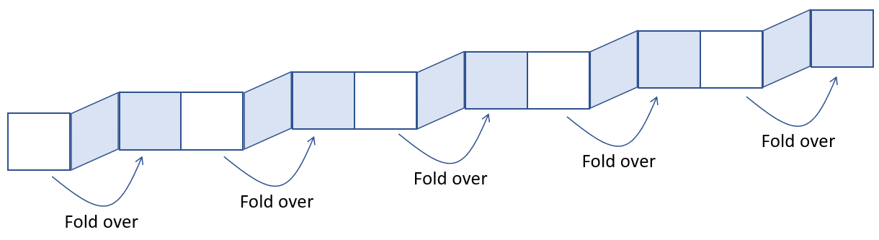

Comparing integers using a number expander
To compare 4725 and 4782, students write the digits of 4725 so that they align with the correct place value columns. That is, write 5 in the ones column, 2 in the tens column, 7 in the hundreds column and 4 in the thousands column. Write these high in the spaces, shown below, leaving enough room for other digits below.
In the same way, write the digits of 4782 underneath.
Compare the integers by comparing the digits starting with the most significant (largest) place value column. In this case the thousands column.
In this scenario, each integer has an equal number of thousands, 4 in each.
This means the digits in the next place value column need to be compared. To help this, collapse the number expander to hide the thousands label, as shown below.
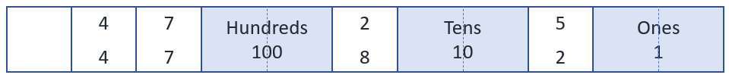
This regroups the integers to show the number of hundreds. In this case, 47 hundreds in each. Once again, the integers cannot be identified as different. Therefore, collapse number expander to hide the hundreds label, as shown below.
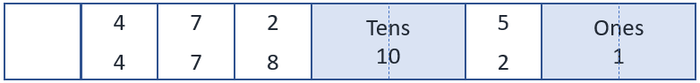
This regroups the integers, once again, to show the number of tens. In this case, 472 and 478 tens. It is at this point the integers can be identified as different. 4782 is bigger than 4 725 as it contains 478 tens compared to 472 tens.

Number expander template
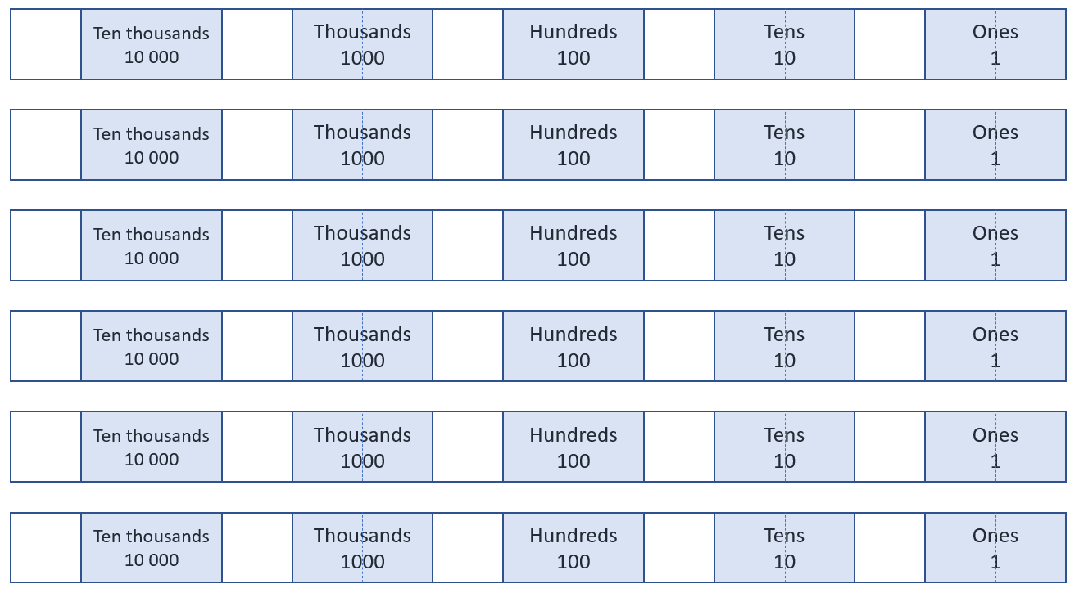

Appendix D

Negative number Venns

Part 1
Think of an integer that could belong in each region, A, B, C and D. If you think a region is impossible to fill, convince me with reasons why!
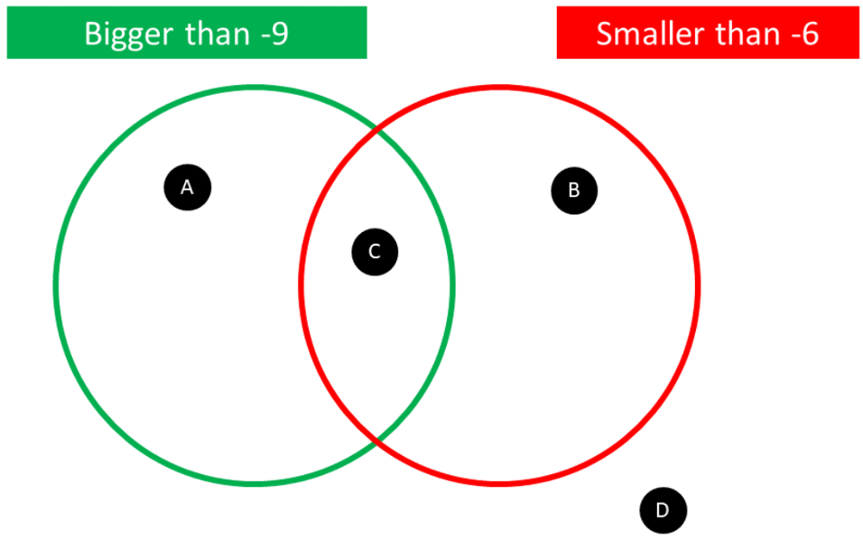

Part 2
Think of an integer that could belong in each region, A, B, C, D, E, F, G and H. If you think a region is impossible to fill, convince me with reasons why!
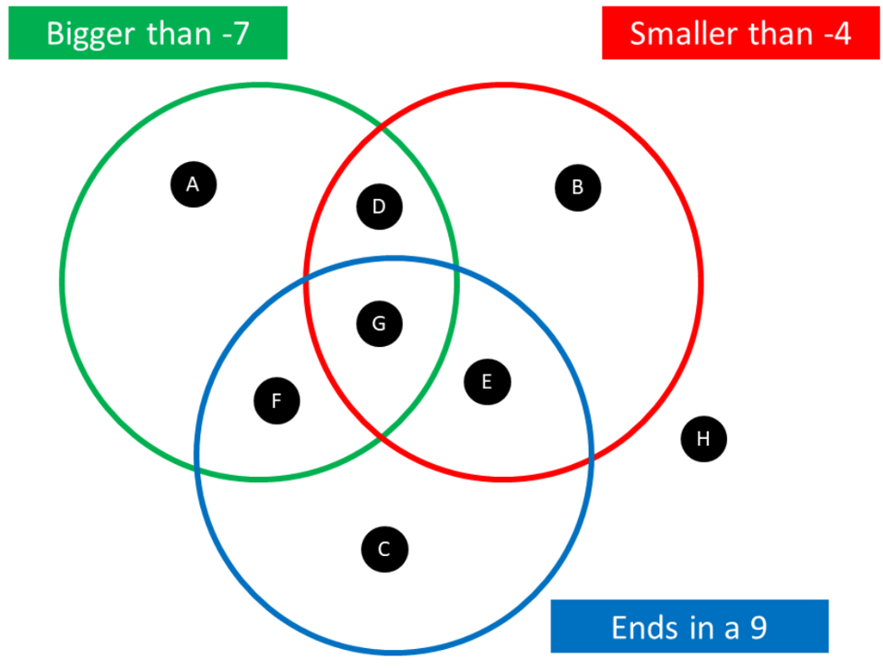

Sample solutions

Appendix A – direction and magnitude

Part 1
A is positive 3.
B is positive 7.
C is negative 1.
D is positive 9.
E is negative 4.
F is negative 8.
G is positive 1.

Part 2
A is positive 6.
B is positive 1.
C is negative 3.
D is negative 7.
E is negative 1.
F is negative 9.
G is positive 9.

Appendix B – locations around the world
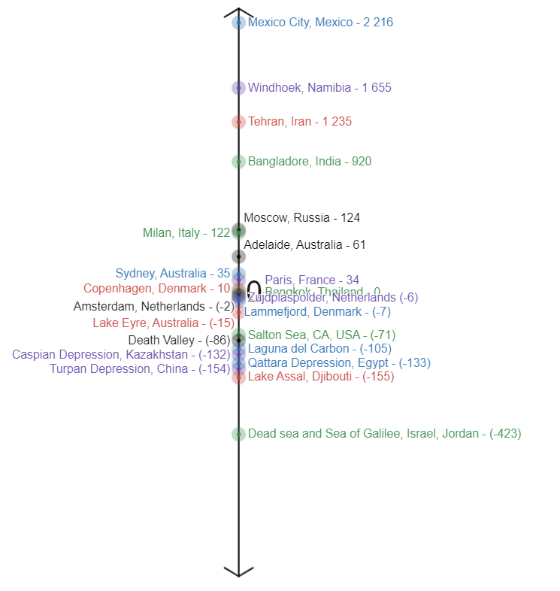

Comparing locations
Use the symbols < and > to describe which is larger when comparing the altitudes of each of the following locations. The first statement is completed for you.
Location 1 | Symbol | Location 2
Adelaide, Australia | > | Paris, France
Windhoek, Namibia | > | Moscow, Russia
Tehran, Iran | < | Mexico City, Mexico
Lake Eyre, Australia | < | Milan, Italy
Sydney, Australia | > | Salton Sea, CA, USA
Death Valley, USA | > | Turpan Depression, China
Caspian Depression, Kazakhstan | < | Amsterdam, Netherlands
Copenhagen, Denmark | > | Lammefjord, Denmark
Lake Assal, Djibouti | < | Laguna del Carbon
Moscow, Russia | > | Lake Assal, Djibouti

Appendix D – Negative number Venns

Part 1
$A=-5$, $B=-10$, $C=-9$. $D$ is not possible, there is no number less than -9 and greater than -4.

Part 2
$A=19$, $B=-19, D=-6$, $E=-9$, $F=9$, $G=-4.9$.
$C$ and $H$ are not possible, no number is smaller than -7 and larger than -4.

References
This resource contains NSW Curriculum and syllabus content. The NSW Curriculum is developed by the NSW Education Standards Authority. This content is prepared by NESA for and on behalf of the Crown in right of the State of New South Wales. The material is protected by Crown copyright.
Please refer to the NESA Copyright Disclaimer for more information https://educationstandards.nsw.edu.au/wps/portal/nesa/mini-footer/copyright.
NESA holds the only official and up-to-date versions of the NSW Curriculum and syllabus documents. Please visit the NSW Education Standards Authority (NESA) website https://educationstandards.nsw.edu.au/ and the NSW Curriculum website https://curriculum.nsw.edu.au/home.
Mathematics K–10 Syllabus © NSW Education Standards Authority (NESA) for and on behalf of the Crown in right of the State of New South Wales, 2022.

© State of New South Wales (Department of Education), 2023
The copyright material published in this resource is subject to the Copyright Act 1968 (Cth) and is owned by the NSW Department of Education or, where indicated, by a party other than the NSW Department of Education (third-party material).
Copyright material available in this resource and owned by the NSW Department of Education is licensed under a Creative Commons Attribution 4.0 International (CC BY 4.0) licence.
This licence allows you to share and adapt the material for any purpose, even commercially.
Attribution should be given to © State of New South Wales (Department of Education), 2023.
Material in this resource not available under a Creative Commons licence:
- the NSW Department of Education logo, other logos and trademark-protected material
- material owned by a third party that has been reproduced with permission. You will need to obtain permission from the third party to reuse its material.
Links to third-party material and websites
Please note that the provided (reading/viewing material/list/links/texts) are a suggestion only and implies no endorsement, by the New South Wales Department of Education, of any author, publisher, or book title. School principals and teachers are best placed to assess the suitability of resources that would complement the curriculum and reflect the needs and interests of their students.
If you use the links provided in this document to access a third-party's website, you acknowledge that the terms of use, including licence terms set out on the third-party's website apply to the use which may be made of the materials on that third-party website or where permitted by the Copyright Act 1968 (Cth). The department accepts no responsibility for content on third-party websites.

