Inventing units of measurement
Students create a unique unit of measurement with a strip of paper and use it to measure lengths of common objects. Students fold their strip of paper to create fractions to aid more accurate measurement, develop relationships between equivalent fractions and begin representing these fractions as decimals.

Visible learning

Learning intentions
- To understand the usefulness of fractions in describing what is between whole number units.
- To be able to convert common fractions into decimals.

Success criteria
- I can use fractions and decimals to describe lengths that are not exact, whole units.
- I can compare the size of fractions.
- I can convert fractions to decimals.

Syllabus outcomes
A student
- develops understanding and fluency in mathematics through exploring and connecting mathematical concepts, choosing and applying mathematical techniques to solve problems, and communicating their thinking and reasoning coherently and clearly MAO-WM-01
- represents and operates with fractions, decimals and percentages to solve problems MA4-FRC-C-01
Mathematics K–10 Syllabus © NSW Education Standards Authority (NESA) for and on behalf of the Crown in right of the State of New South Wales, 2022.

Activity structure
Please use the associated PowerPoint Inventing units of measurement to display images in this lesson.

Launch
- Show students Figure 1 and introduce the premise that we are in a world before rulers and measurement have been invented.
Figure 1 – there are no more rulers
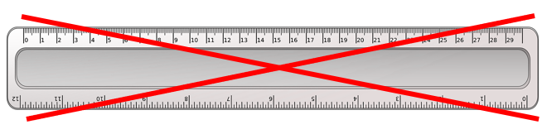
- Students are to find a common object to describe the length of their hand. Is their hand as long as a pencil? A book? A packet of chips? All answers should be encouraged and accepted, including parts of objects, such as ‘my hand is half the length of my desk’.
- Display Figure 2. Ask students to consider why we wouldn’t measure a hand with a pencil plus 2 smarties. Establish that once we have chosen to measure length in pencils, we should be counting how many pencils the length of something is.
Figure 2 – a hand that is longer than a pencil
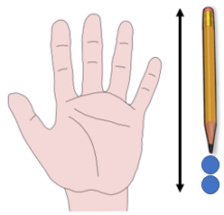

Explore
This activity is adapted from Mindset Mathematics Grade 4 (Boaler, Munson, Williams).

Creating a unit of measurement

Equipment
- Paper strips of varying lengths, one per student.

Method
- Students are each given strips of paper of different lengths, ideally between 1–2 metres long.
- State that the strip of paper represents 2 units of their own unique measurement of length. Students can make up a name for their unit of measurement. We have chosen to name ours ‘beeps’.
Figure 3 – unfolded strip of paper
- Students should fold their paper in half to indicate 1 unit of their measurement.
Figure 4 – paper strip folded once
- Students are to use their strip of paper to measure objects around the room. If a required object is not exactly 1 or 2 units of the student's measure, they need to continue to fold their paper strip to make half, quarter or more precise units as shown below.
Figure 5 – paper strips folded to quarters
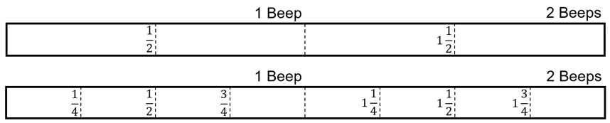
- Students could potentially measure pens, their pencil case, their desk width, the height of their chair, the width of the door, the height of the whiteboard, or any other classroom furniture.
- Bring students together to engage in a Think-Pair-Share (bit.ly/thinkpairsharestrategy) around the following questions:
- What was the smallest fraction used?
- What was the largest fraction used?
- How many folds do you need to do before you have a finished measuring device?
- What equivalent fractions can you see on your measuring device?

Comparing fractions
- Display for students a strip of paper folded to show halves. Identify that the position of one half is one section or crease from the left and that on this strip, there are 4 sections.
Figure 6 – the position of one half
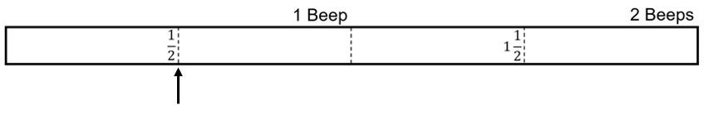
Alternatively, all students can be handed another strip of paper and label up to halves together.
- Fold the paper as per the previous instructions so that quarters are shown.
- Focus in on one half, showing it is equivalent to 2 quarters, displaying Figure 7.
Figure 7 – comparing halves and quarters
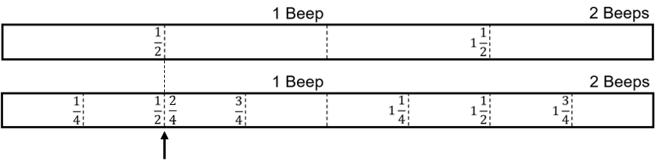
- Use a Pause-Pose-Pounce-Bounce question strategy ([PDF 200KB] bit.ly/pausepouncebounce) to ask students what has happened to the paper to make the fraction $\frac{1}{2}$ turn into $\frac{2}{4}$. Lead students to the conclusions that:
- The number of sections on the entire strip of paper has doubled. Emphasise the sections up to 1 and how this shows the denominator having doubled.
- The number of sections or creases from the left before you get to the position of $\frac{1}{2}$ has also doubled. Connect this to the numerator having doubled.
- Display Figure 8 to students.
Figure 8 – paper strip versus a ruler
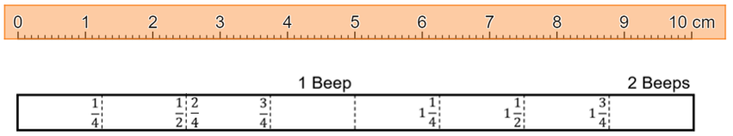
- Have students engage in a Think-Pair-Share around the following questions:
- What is different about your strip of paper and a common measuring device such as a metre ruler?
- What is the same between these 2 tools?
- Which one do you think is easier to use?
- How many folds do you need to do to the paper before it becomes the same as the ruler?
It is important here that students conclude that our common measuring tools are divided into tenths using decimals and that this will never be the case for our measuring strips, no matter how many folds we complete.

Summarise

Converting fractions into decimals

Visual representations
- Display the Desmos graph ‘Fractions to decimals’ (bit.ly/DesmosFtD) on the teacher screen.
Supporting images can also be displayed using the Inventing units of measurement PowerPoint file, slides 9–12.
- Use a Pause-Pose-Pounce-Bounce question strategy ([PDF 200KB] bit.ly/pausepouncebounce) to ask students what we need to do to the number line to find the location of decimal numbers, leading students to the conclusion that we need to divide each interval into 10 equal parts, tenths.
- Turn on the tenths using the slider on the screen, to determine whether tenths can represent the fraction $\frac{1}{4}$. Conclude with students that while it is clearly between 0.2 and 0.3, tenths is not accurate enough to display $\frac{1}{4}$.
Figure 9 – tenths slider
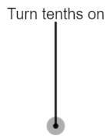
Many students will know the decimal value of $\frac{1}{4}$, so teachers should challenge students to justify why $\frac{1}{4}=0.25$ using the images they see on the screen.
- Turn on the hundredths using the slider on the screen.
- Have students silently write down, on mini whiteboards (bit.ly/miniwhiteboards) if available, and hold up the decimal value that they believe $\frac{1}{4}$ is shown to be.
- Change the denominator to 8 using the denominator slider, as shown below.
Figure 11 – denominator slider
- Have students attempt to describe the decimal value of $\frac{1}{8}$, using mini whiteboards.
- Conclude with the class that the decimal value of $\frac{1}{8}$cannot be described perfectly using only tenths and hundredths.
- Have students attempt Appendix A ‘Describing fractions with tenths and hundredths’ by constructing a list of fractions from the fraction wall that can be described using decimals up to tenths and hundredths.

Apply
- Make sure students have their original strip of measuring tape.
- Hand students a new strip of paper of the same length.
- Give students access to the Desmos graph Fractions to decimals (bit.ly/DesmosFtD).
- Using the steps from the Your turn PowerPoint and the Desmos visual representations, have students copy their existing fractional measurements from their original strip of measuring tape across to their new tape, representing them as decimals, as demonstrated in the figure below.
Figure 12 – measuring strips
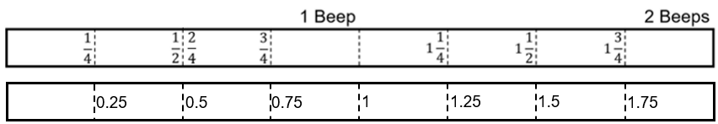
- Have students attempt to fill in common decimal measurements, such as tenths and hundredths, on their new measuring device, based on the measurements already placed on the strip.
- Students can then use their measuring device to reattempt the measurements they completed during the Explore activity.

Assessment and differentiation

Suggested opportunities for differentiation
Explore
- Using the physical measuring strip allows students to develop concepts of fractions in a concrete way.
- Students can be challenged early to consider which fractions are available using the folding method and to invent methods of their own to obtain other fractions of their measurement, such as one tenth.
Summarise
- Multiple visual representations, in this case the use of number lines and the constructed measuring tape, should support students to verify comparisons between fractions and decimals.
Apply
- Students can be challenged to construct their entire measuring strip using decimals.

Suggested opportunities for assessment
Explore
- Observe and record students’ ability to use a measurement device effectively to determine the length of common objects.
- Students’ measuring strips can be collected as evidence of their ability to interpret fractions of a whole, as well as improper fractions between 1 and 2.
Summarise and Apply
- Appendix A can be collected to assess students’ ability to visually interpret fractions as decimals.

Appendix A

Describing fractions with tenths and hundredths
By using the vertical lines behind this fraction wall and the decimal values on the number line at the top, write a list of all the fractions on this wall that can be described by tenths and hundredths.

Appendix A – Sample solutions

Describing fractions with tenths and hundredths
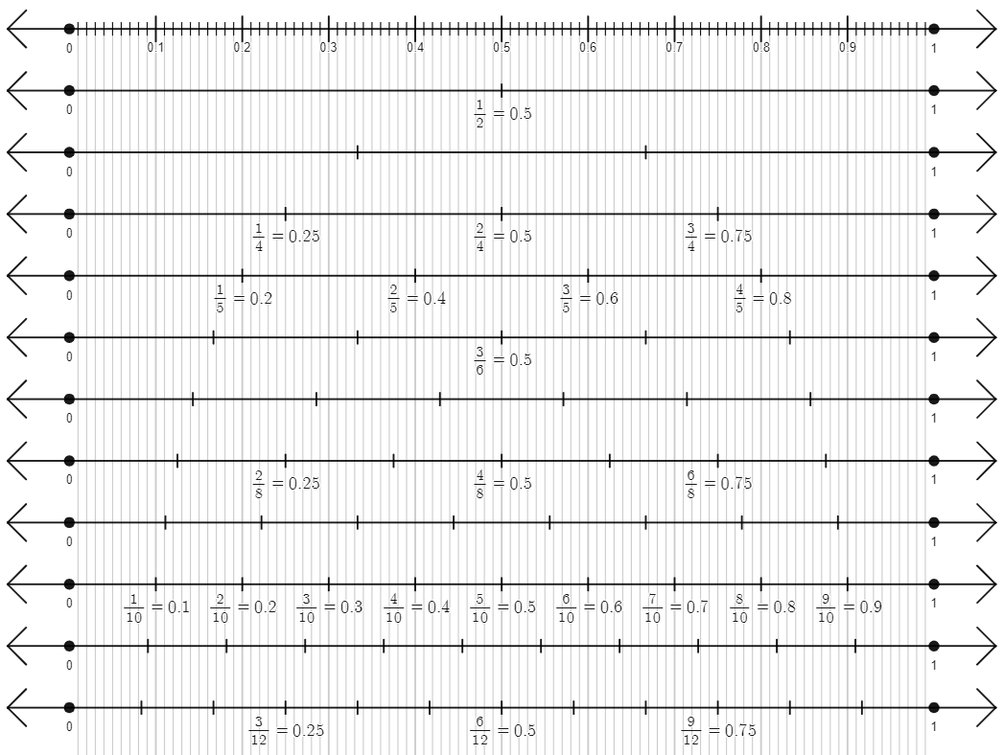

References
This resource contains NSW Curriculum and syllabus content. The NSW Curriculum is developed by the NSW Education Standards Authority. This content is prepared by NESA for and on behalf of the Crown in right of the State of New South Wales. The material is protected by Crown copyright.
Please refer to the NESA Copyright Disclaimer for more information https://educationstandards.nsw.edu.au/wps/portal/nesa/mini-footer/copyright.
NESA holds the only official and up-to-date versions of the NSW Curriculum and syllabus documents. Please visit the NSW Education Standards Authority (NESA) website https://educationstandards.nsw.edu.au/ and the NSW Curriculum website https://curriculum.nsw.edu.au/home.
Mathematics K–10 Syllabus © NSW Education Standards Authority (NESA) for and on behalf of the Crown in right of the State of New South Wales, 2022.

© State of New South Wales (Department of Education), 2023
The copyright material published in this resource is subject to the Copyright Act 1968 (Cth) and is owned by the NSW Department of Education or, where indicated, by a party other than the NSW Department of Education (third-party material).
Copyright material available in this resource and owned by the NSW Department of Education is licensed under a Creative Commons Attribution 4.0 International (CC BY 4.0) licence.
This licence allows you to share and adapt the material for any purpose, even commercially.
Attribution should be given to © State of New South Wales (Department of Education), 2023.
Material in this resource not available under a Creative Commons licence:
- the NSW Department of Education logo, other logos and trademark-protected material
- material owned by a third party that has been reproduced with permission. You will need to obtain permission from the third party to reuse its material.
Links to third-party material and websites
Please note that the provided (reading/viewing material/list/links/texts) are a suggestion only and implies no endorsement, by the New South Wales Department of Education, of any author, publisher, or book title. School principals and teachers are best placed to assess the suitability of resources that would complement the curriculum and reflect the needs and interests of their students.
If you use the links provided in this document to access a third-party's website, you acknowledge that the terms of use, including licence terms set out on the third-party's website apply to the use which may be made of the materials on that third-party website or where permitted by the Copyright Act 1968 (Cth). The department accepts no responsibility for content on third-party websites.

