Comparing using place value
Students use concrete and online manipulatives, as well as visual representations, to compare common measurements in decimal form, placing them on a number line.

Visible learning

Learning intention
- To understand the relationship between place values of a decimal number.
- To be able to place decimals on a number line.

Success criteria
- I can compare decimals using place value.
- I can represent a decimal to thousandths.
- I can place decimals on a number line to compare their size.

Syllabus outcomes
A student:
- develops understanding and fluency in mathematics through exploring and connecting mathematical concepts, choosing and applying mathematical techniques to solve problems, and communicating their thinking and reasoning coherently and clearly MAO-WM-01
- represents and operates with fractions, decimals and percentages to solve problems MA4-FRC-C-01
Mathematics K–10 Syllabus © NSW Education Standards Authority (NESA) for and on behalf of the Crown in right of the State of New South Wales, 2022.

Activity structure
Please use the associated PowerPoint Comparing using place value to display images in this lesson.

Warm up

Equipment
- Appendix A ‘Weights of object cards’ cut into cards (one per student)
- Appendix B ‘Reasoning when comparing integers’ (one per pair of students)

Optional
- Sets of base 10 blocks (one per pair of students)
- Device with internet access (one per pair of students)

Method

Base 10 blocks or Polypad
- Hand students copies of Appendix A ‘Weights of object cards’ cut into cards. Have students individually organise the weights of these objects in order from lightest to heaviest, without sharing their results.
- Display Figure 1 and have students engage in a Think-Pair-Share (bit.ly/thinkpairsharestrategy) to give a reason why one weight is heavier than the other.
Figure 1 – adult weight compared to weight of a monitor
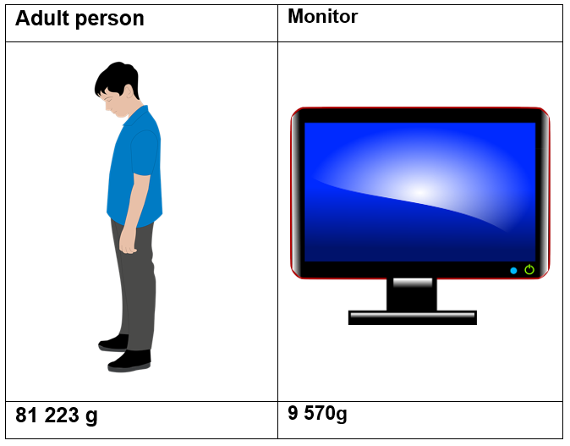
Students are likely to discuss comparing the place value digits that are furthest to the left.
- Hand students copies of Appendix B ‘Reasoning when comparing integers’.
- Demonstrate to students how to use base 10 blocks to represent and compare the weights of the Smart phone and the textbook from Appendix A ‘Weights of object cards’.
Figure 2 – representation of the weight of a smart phone
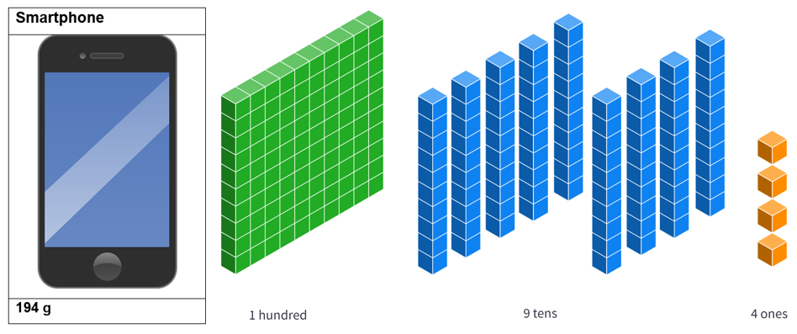
Image created using the free virtual manipulatives at Polypad.org.
Figure 3 – representation of the weight of a textbook
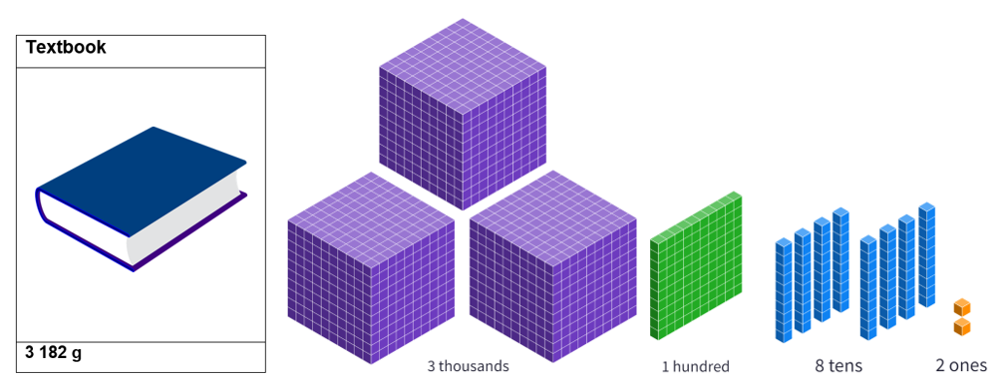
Image created using the free virtual manipulatives at Polypad.org.
- Use this Polypad illustration ‘Renaming thousands’ (bit.ly/PolypadRenameThousands) to demonstrate how to split thousands and rename the weight of the textbook to be 31 hundreds.
- To demonstrate this, click on the cubes and press the Split button.
Figure 4 – demonstration of how to use the split feature in Polypad
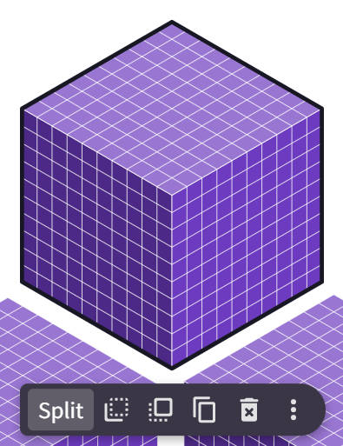
Image created using the free virtual manipulatives at Polypad.org.
Teachers should emphasise the relationship between one place value and the next, describing how 10 of one makes the whole of another.
- Students use either physical base 10 blocks or Polypad manipulatives to represent and rename the weights in the first 6 rows of the table in Appendix B ‘Reasoning when comparing integers’. Base 10 blocks can be found in Polypad under the heading Number and the subheading Number Tiles and Cubes.
Figure 5 – base 10 blocks in Polypad
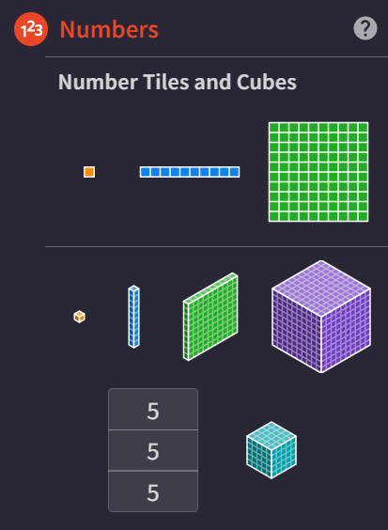
Image created using the free virtual manipulatives at Polypad.org.
For students who are familiar with base 10 blocks and their application in representing the place value of integers, drawn diagrams can replace the use of physical blocks or devices in comparisons in step 6.
- Lead a discussion with students around the limitations of this representation by focusing on the question ‘Why wouldn’t we use base 10 blocks to represent the weight of the adult person or the dog?’

Number expanders
- Using a copy of Appendix C ‘Number expander template’, demonstrate how, using the number expander, we can rename the measurements to compare the measurements as ‘81 thousands’ against ‘9 thousands’, as shown in Figure 6.
Appendix D ‘Number expander’ contains detailed instructions about how to use a number expander to rename and compare integers.
Figure 6 – number expanders from Appendix C ‘Number expander template’
- Have students write pairs of numbers on number expanders to complete the remaining rows of the table in Appendix B ‘Reasoning when comparing integers’.

Launch
- Show students Figure 7. Explain that packets of a particular brand of chips are labelled as containing 24 grams of food. This weight is never exact, and several bags have been weighed, with the results shown in the table.
Figure 7 – weights from 8 identical packets of chips
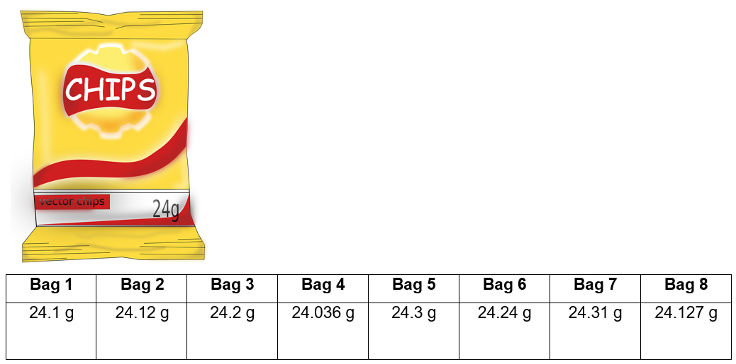
- Have students engage in a ‘Think-Pair-Share’ (bit.ly/thinkpairsharestrategy) to discuss which bag they would most like to have and why.

Explore
- Display Figure 8 to students. Inform students that we have now changed the ‘thousands’ cube to represent the number 1. Use a Pause-Pose-Pounce-Bounce question strategy ([PDF 200 KB] bit.ly/pausepouncebouncestrategy) to gather student opinions about what each of the other solids now represent.
Figure 8 – base 10 blocks where the cube represents one whole
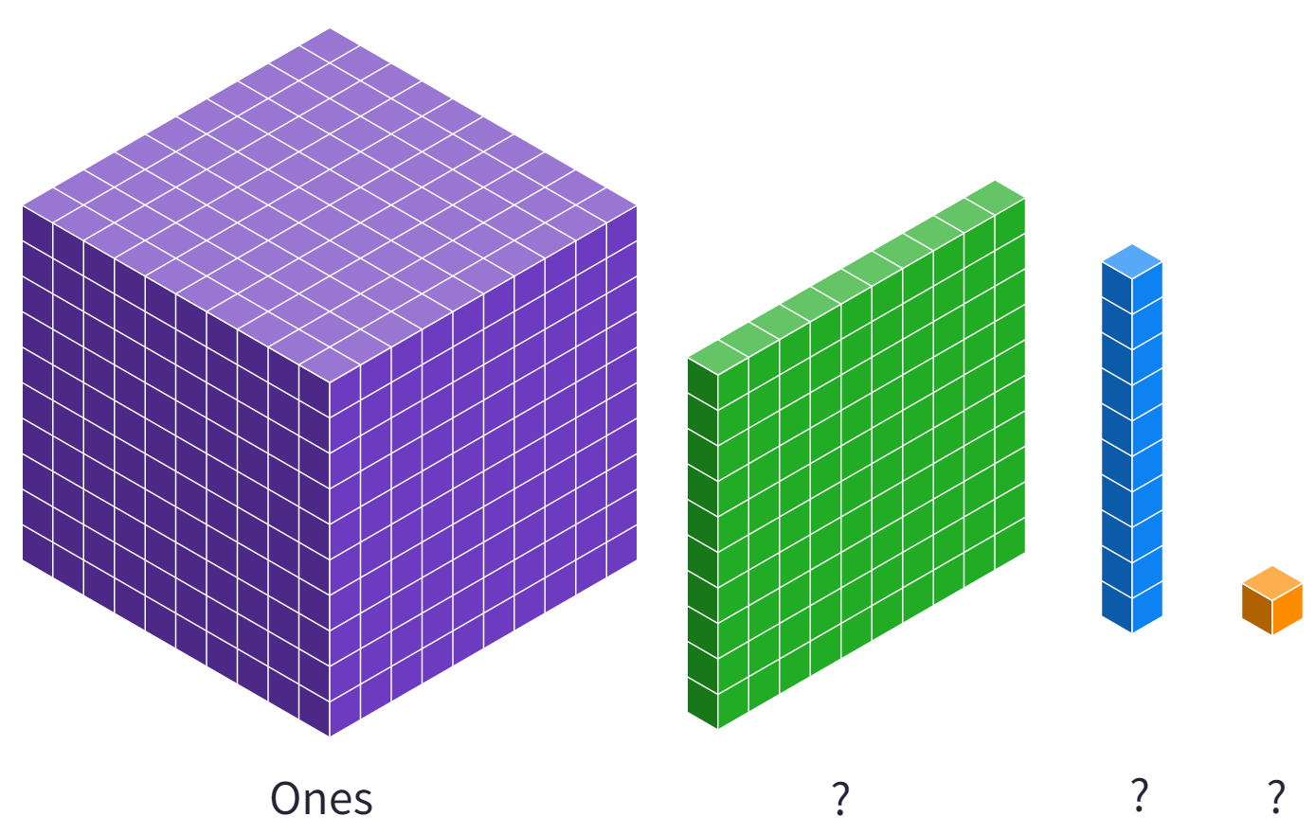
Image created using the free virtual manipulatives at Polypad.org.
- Show students Figure 9 to clarify these definitions.
Figure 9 – base 10 blocks indicating the value on the smaller blocks
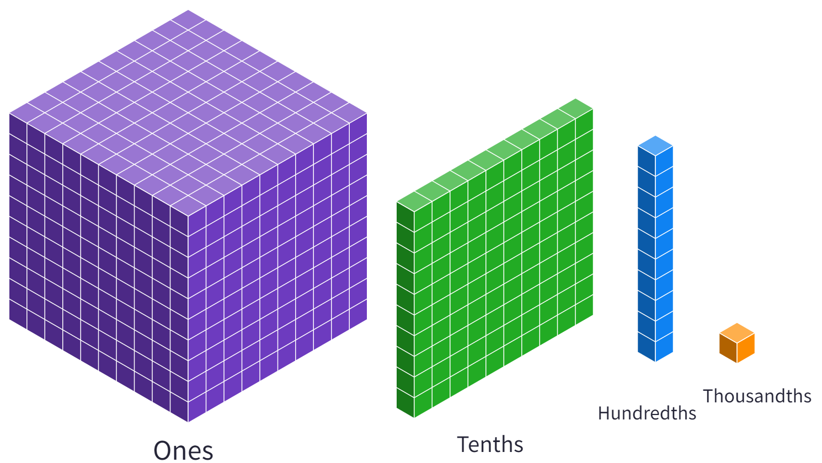
Image created using the free virtual manipulatives at Polypad.org.
- Demonstrate to students, using Polypad (mathigon.org/polypad), how to represent the number 1.1. Establish by ‘splitting’ the one, that this is the same as 11 tenths.
- Using either physical base 10 blocks, a Polypad graph or the decimal number expander in Appendix E ‘Number expander template – decimals’, students are to use these definitions to represent and compare the numbers 2.3, 2.7, 2.1, 2.15, 2.72, 2.186 and 2.715. Appendix G ‘Saving your Polypad file’ demonstrates how students can save and share their work in Polypad.
- Students should be challenged to give reasons for their comparisons.

Summarise
The instructions below use an interactive Desmos graph to engage students with worked examples. Teachers can also use the Comparing using place value PowerPoint slides 7 to 10 for explicit teaching of the skills required to place hundredths on the number line.
- Teachers are to use the explicit teaching technique ‘Your turn’.
- Reveal the question to students and its solution via the Desmos graph animation ’Placing hundredths on the number line’ (bit.ly/DesmosHundredthsNL), either on the teacher screen or sent to students to see on their own screen.
- Students read in silence.
- Students individually explain to themselves what happens in each step.
- Teachers may wish to pause the animation after it has played at least once through. To pause, go to the left of screen and press the pause symbol near the Play slider, as shown below.
Figure 10 – ‘Pause’ symbol in Desmos
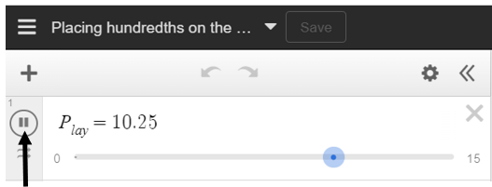
Image created using Desmos and is licensed under the Desmos Terms of Service.
- Students hold up a thumbs up to the teacher when they have finished reading and have some sort of understanding.
- Students engage in a Think-Pair-Share. Students then explain the solution to their partner.
- In pairs, students then answer the self-explanation questions. These can be turned on using the slider that appears at the bottom of the screen.

Figure 11 – ‘Turn on prompts’ slider from Desmos
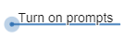
Image created using Desmos and is licensed under the Desmos Terms of Service.
- Finally, randomly select students to share their answers with the whole class.
- Students complete a ‘Your turn’ example. They will either need to draw their own number line or be handed a copy of Appendix F ‘Your turn – number lines. The example can be turned on in Desmos using the Your turn switch.
Figure 12 – ‘Move to ‘Your turn’’ slider from Desmos
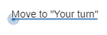
Image created using Desmos and is licensed under the Desmos Terms of Service.
- Students are to order the weights of the chip packets in the launch. The decimal number expander in Appendix F ‘Your turn – number lines’, Polypad or base 10 blocks can be used to determine the order.
- Students should also attempt to place each of the weights on the second number line in Appendix F ‘Your turn – number lines’.

Apply
- Have students attempt this ‘Open Middle’ problem (bit.ly/OpenMiddleDec), selecting where to place digits 0 to 9 in a scenario on the number line. Encourage students to consider how many solutions are possible.
- Teachers can print off Appendix H ‘Open Middle problem' for students to complete this.
- Alternatively, students can be given the Desmos Graph ‘Number line decimals: Open Middle’ (bit.ly/DesmosOMDec).
- To submit their work, students need to first ensure they have logged in, as shown in the top right corner of the screen.
Figure 13 – ‘sign-in menu’ from Desmos
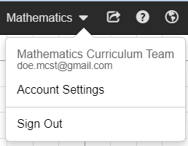
Image created using Desmos and is licensed under the Desmos Terms of Service.
- Students then click save in the top left corner of their screen.
Figure 14 – ‘save button’ in menu from Desmos
Image created using Desmos and is licensed under the Desmos Terms of Service.
- Students can then share the link found in the top right corner of the screen, as shown below.
Figure 15 – ‘share graph’ button in menu from Desmos
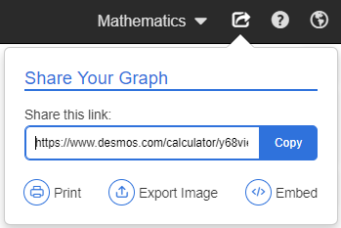
Image created using Desmos and is licensed under the Desmos Terms of Service.
- Have students also attempt the problem in Appendix I, ‘Decimals Venn’. Students are to determine decimals that would fit each of the categories describing sections A, B, C and D.

Assessment and differentiation

Suggested opportunities for differentiation
Warm up and Launch
- Images and the use of common objects should give all students an opportunity to contribute to discussions about the order of the weights in the warm up activity.
- For students who demonstrate fluency with interpreting and operating with decimals, challenge them by modifying the table to include weights below the advertised 24 grams. Ask students to represent each weight with a positive or negative number, based on its distance from the desired weight.
Explore
- Challenge students who are excelling at using representations with base 10 blocks to consider the implications of using any of the other blocks as the ‘ones’.
- Challenge students to produce individual comparisons between different weights, giving reasons for their final solution.
Apply
- The Open Middle problem in Appendix H ‘Open Middle problem’ supports all students to participate and submit their work.
- For students who find the Venn diagram activity difficult to interpret, the teacher may wish to introduce the concept using a simpler example from the Maths Venns website (bit.ly/MathsVennEasier).
- Students can be challenged by engaging with a more complex Venn diagram from the Maths Venns website (bit.ly/DecimalVenn2).

Suggested opportunities for assessment
Warm up and Launch
- This activity is an opportunity for teachers to assess students’ ability to represent integers using familiar objects. This should be monitored to determine whether students are ready to extend beyond integers.
Summarise and Apply
- Have students submit their solution to the problem in the launch, their representations of the numbers, including Appendix F ‘Your turn – number lines’ and an explanation involving the renaming of decimals by comparing their size.
- Student solutions to the Open Middle problem in Appendix H ‘Open middle problem’ gives evidence as to their ability to interpret the impact of different place values on the intervals between decimals.

Appendix A

Weights of object cards
Smart phone | Pencil | Dog
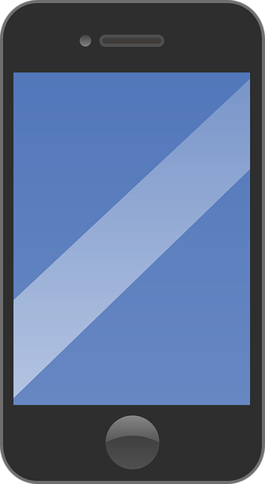 | 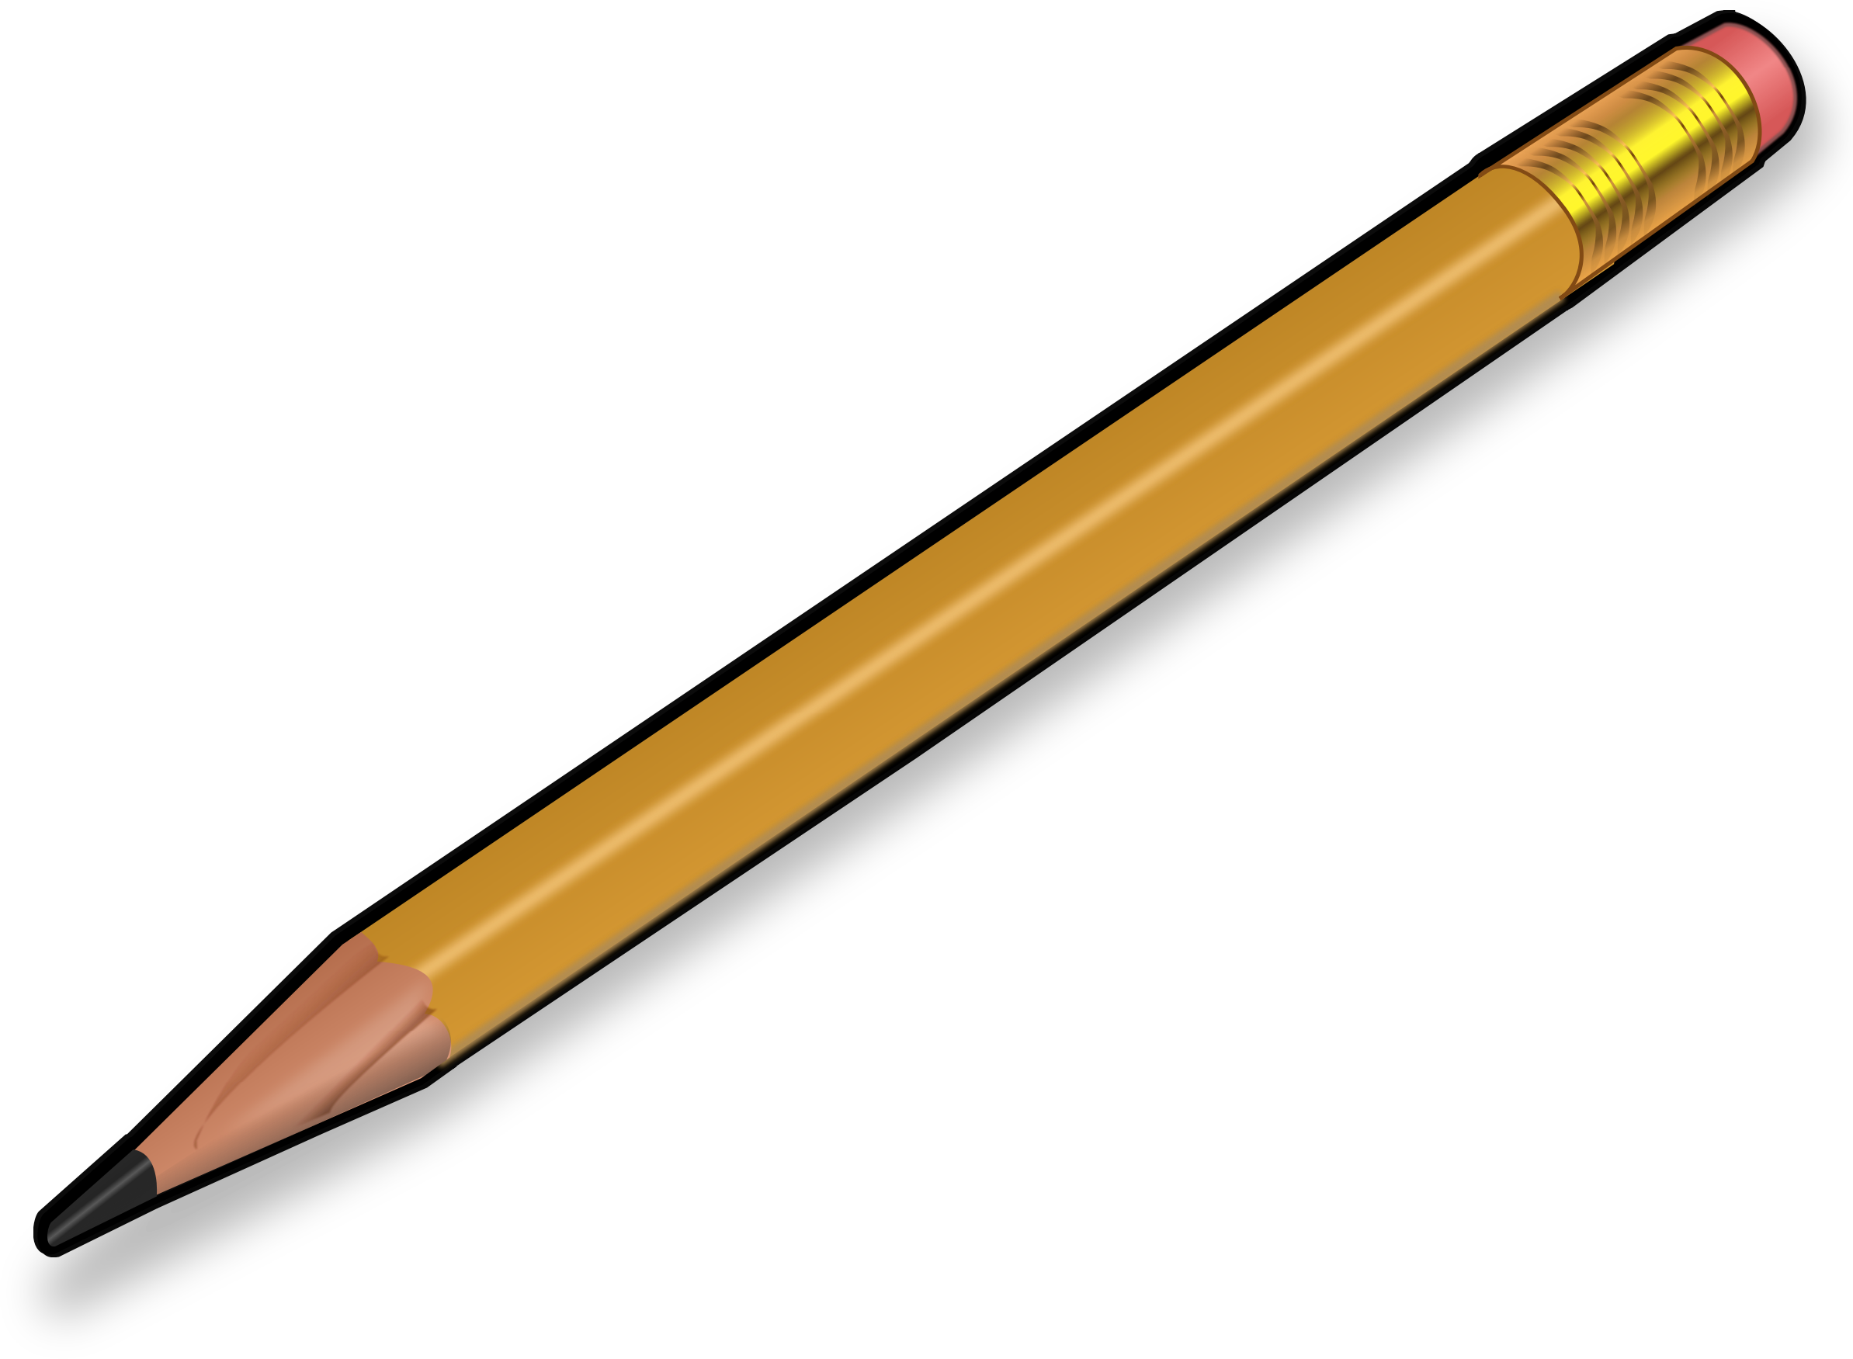
194 g | 16 g | 31 613 g
Adult person | Monitor | Textbook
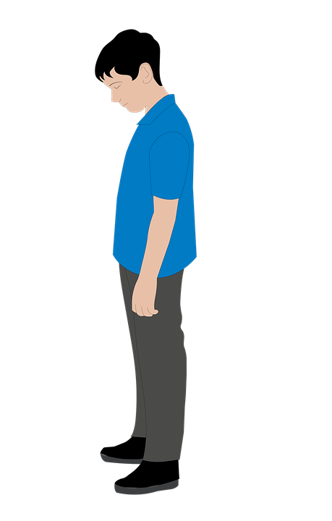
81 223 g | 9 570 g | 3 182 g

Appendix B

Reasoning when comparing integers
First object | Second object | Compare with reasoning
Smart phone 194 g | Textbook 3 182 g | The textbook is heavier than the smart phone because 31 hundred grams is heavier than 1 hundred grams.
Smart phone 194 g | Monitor 9 570 g
Smart phone 194 g | Pencil 16 g
Pencil 16 g | Monitor 9 570 g
Pencil 16 g | Textbook 3 182 g
Monitor 9 570 g | Textbook 3 182 g
Adult person 81 223 g | Monitor 9 570 g | The adult person is heavier than the monitor because 81 thousand grams is heavier than 9 thousand grams.
Adult person 81 223 g | Textbook 3182 g
Dog 31 613 g | Adult person 81 223 g
Dog 31 613 g | Monitor 9 570 g
Dog 31 613 g | Textbook 3 182 g
Smart phone 194 g | Dog 31 613 g
Smart phone 194 g | Adult person 81 223 g
Pencil 16 g | Dog 31 613 g
Pencil 16 g | Adult person 81 223 g
Appendix C

Number expander template
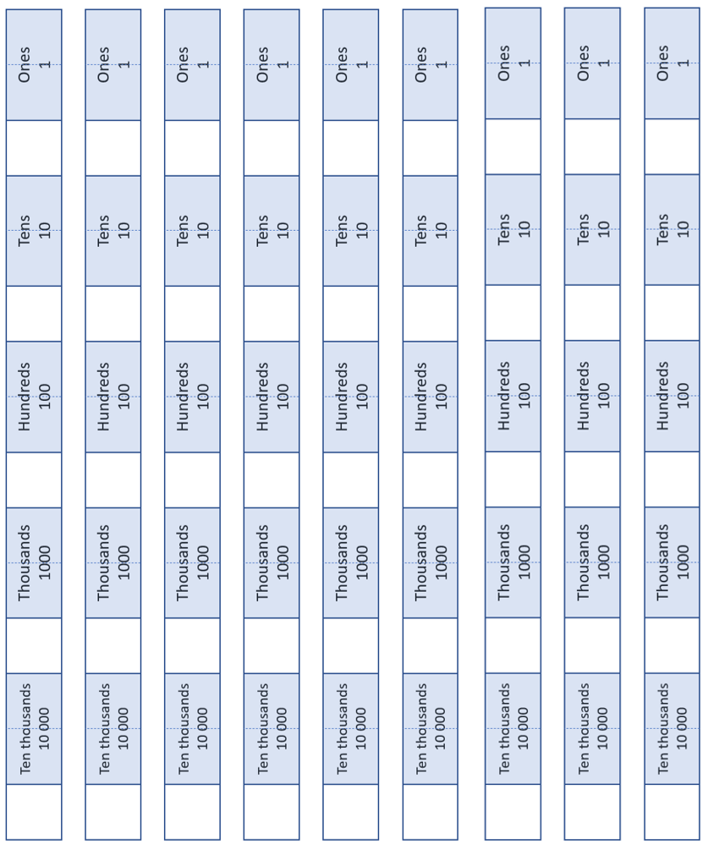

Appendix D

Number expander
The first 57 seconds of the Number expander video (1:13) on Youtube.com shows how to use the number expander for integer values up to tens of thousands.
Students cut out and fold the number expander so that the white sections are folded over the blue section to hide them from view (for now).
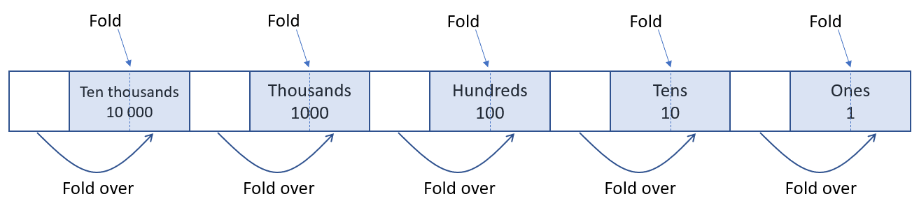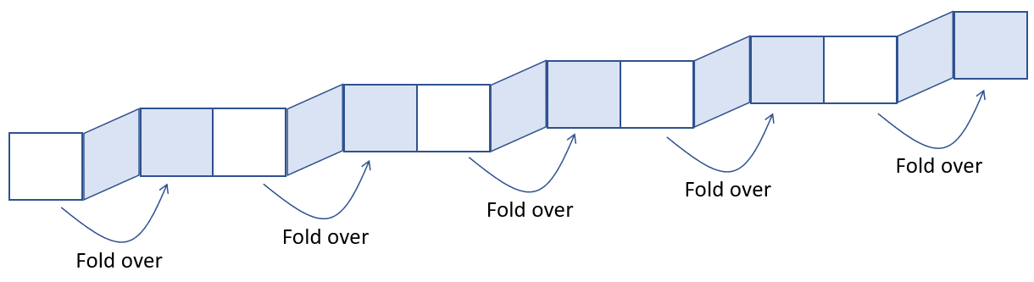

Comparing integers using a number expander
To compare 4 725 and 4 782, students write the digits of 4 725 so that they align with the correct place value columns. That is, write 5 in the ones column, 2 in the tens column, 7 in the hundreds column and 4 in the thousands column. Write these high in the spaces, shown below, leaving enough room for other digits below.
In the same way, write the digits of 4 782 underneath.
Compare the integers by comparing the digits starting with the most significant (largest) place value column. In this case, the thousands column.
In this scenario, each integer has an equal number of thousands, 4 in each.
This means the digits in the next place value column need to be compared. To help this, collapse the number expander to hide the thousands label, as shown below.
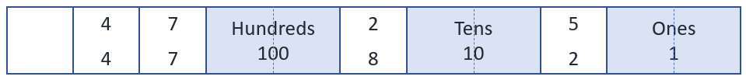
This regroups the integers to show the number of hundreds. In this case, 47 hundreds in each. Once again, the integers cannot be identified as different. Therefore, collapse the number expander to hide the hundreds label, as shown below.
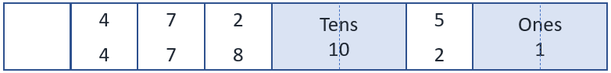
This regroups the integers, once again, to show the number of tens. In this case, 472 and 478 tens. It is at this point, the integers can be identified as different. 4 782 is bigger than 4 725 as it contains 478 tens compared to 472 tens.

Appendix E

Number expander template – decimals
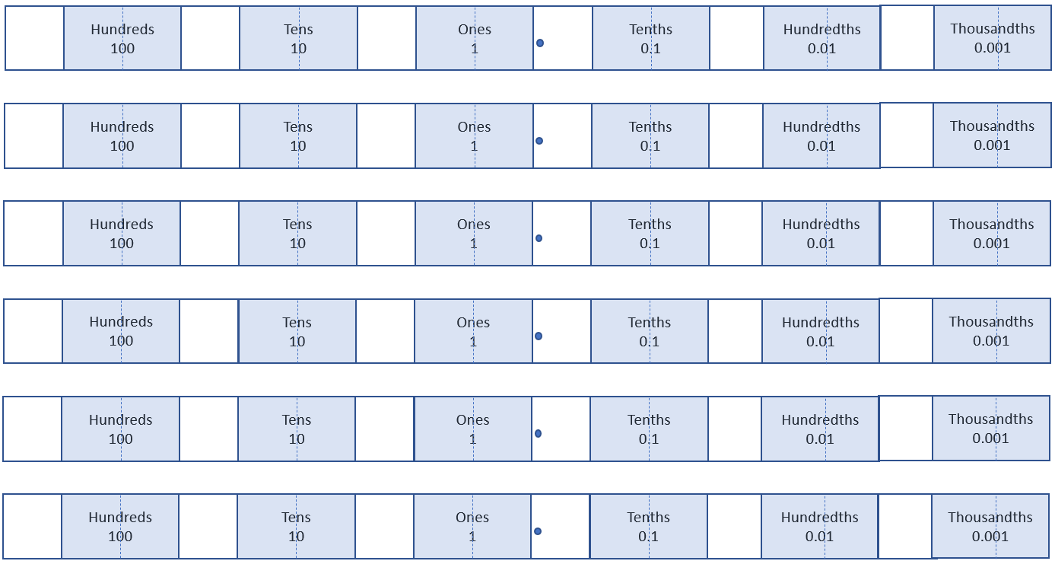

Appendix F

Your turn – number lines

Appendix G

Saving your Polypad file
- Students should ensure they are signed in using their NSW Department of Education Gmail account, ending in ‘@education.nsw.gov.au’.
Image created using the free virtual manipulatives at Polypad.org.
- Click on the file icon in the top left of the screen.
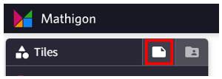
Image created using the free virtual manipulatives at Polypad.org.
- Click on the words Untitled Polypad to give the graph a title.
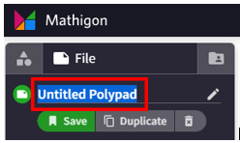
Image created using the free virtual manipulatives at Polypad.org.
- Click Save. A link will be generated that can be shared with the teacher.
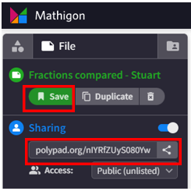
Image created using the free virtual manipulatives at Polypad.org.

Appendix H

Open Middle problem
The number line below has 3 locations represented.
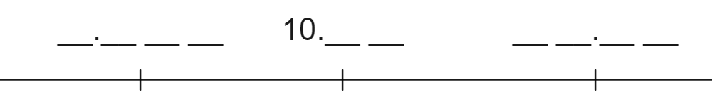
Most of the digits within each number are missing. There are 10 spots on the diagram waiting for a digit.
Use each of the digits 0 to 9 exactly once to fill the blank spaces.
Use the space below to explain why you’ve chosen to place the numbers where you have.

Appendix I

Decimals Venn
Think of a decimal that could belong in each region, A, B, C and D. If you think a region is impossible to fill, convince me with reasons why!
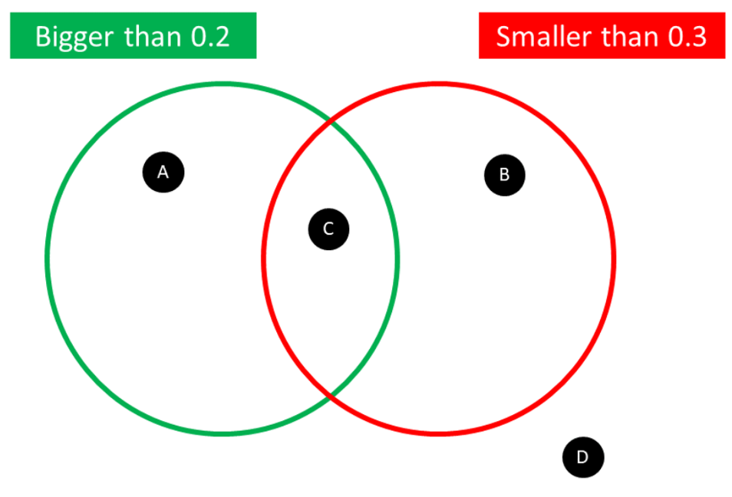

Sample solutions

Appendix A
Adult person | Dog | Monitor | Textbook | Smart phone | Pencil
81 223 g | 31 613 g | 9 570 g | 3 182 g | 194 g | 16 g

Appendix B
First object | Second object | Compare with reasoning
Smart phone 194 g | Textbook 3 182 g | The textbook is heavier than the smart phone, because 31 hundred grams is heavier than 1 hundred grams.
Smart phone 194 g | Monitor 9 570 g | The monitor is heavier than the smart phone, because 95 hundred grams is heavier than 1 hundred grams.
Smart phone 194 g | Pencil 16 g | The smart phone is heavier than the pencil, because 19 tens of grams is heavier than 1 ten of grams.
Pencil 16 g | Monitor 9 570 g | The monitor is heavier than the pencil, because 957 tens of grams is heavier than 1 ten of grams.
Pencil 16 g | Textbook 3 182 g | The textbook is heavier than the pencil, because 318 tens of grams is heavier than 1 ten of grams.
Monitor 9 570 g | Textbook 3 182 g | The monitor is heavier than the textbook, because 9 thousand grams is heavier than 3 thousand grams.
Adult person 81 223 g | Monitor 9 570 g | The adult is heavier than the monitor, because 81 thousand grams is heavier than 9 thousand grams.
Adult person 81 223 g | Textbook 3182 g | The adult is heavier than the textbook, because 81 thousand grams is heavier than 3 thousand grams.
Dog 31 613 g | Adult person 81 223 g | The adult is heavier than the dog, because 81 thousand grams is heavier than 30 thousand grams.
Dog 31 613 g | Monitor 9 570 g | The dog is heavier than the monitor, because 31 thousand grams is heavier than 9 thousand grams.
Dog 31 613 g | Textbook 3 182 g | The dog is heavier than the textbook, because 31 thousand grams is heavier than 3 thousand grams.
Smart phone 194 g | Dog 31 613 g | The dog is heavier than the smart phone, because 316 hundred grams is heavier than 1 hundred grams.
Smart phone 194 g | Adult person 81 223 g | The adult is heavier than the smart phone, because 812 hundred grams is heavier than 1 hundred grams.
Pencil 16 g | Dog 31 613 g | The dog is heavier than the pencil, because 3 161 tens of grams is heavier than 1 ten of grams.
Pencil 16 g | Adult person 81 223 g | The adult is heavier than the pencil, because 8 122 tens of grams is heavier than 1 ten of grams.

References
This resource contains NSW Curriculum and syllabus content. The NSW Curriculum is developed by the NSW Education Standards Authority. This content is prepared by NESA for and on behalf of the Crown in right of the State of New South Wales. The material is protected by Crown copyright.
Please refer to the NESA Copyright Disclaimer for more information https://educationstandards.nsw.edu.au/wps/portal/nesa/mini-footer/copyright.
NESA holds the only official and up-to-date versions of the NSW Curriculum and syllabus documents. Please visit the NSW Education Standards Authority (NESA) website https://educationstandards.nsw.edu.au/ and the NSW Curriculum website https://curriculum.nsw.edu.au/home.
Mathematics K–10 Syllabus © NSW Education Standards Authority (NESA) for and on behalf of the Crown in right of the State of New South Wales, 2022.
© State of New South Wales (Department of Education), 2023
The copyright material published in this resource is subject to the Copyright Act 1968 (Cth) and is owned by the NSW Department of Education or, where indicated, by a party other than the NSW Department of Education (third-party material).
Copyright material available in this resource and owned by the NSW Department of Education is licensed under a Creative Commons Attribution 4.0 International (CC BY 4.0) licence.
This licence allows you to share and adapt the material for any purpose, even commercially.
Attribution should be given to © State of New South Wales (Department of Education), 2023.
Material in this resource not available under a Creative Commons licence:
- the NSW Department of Education logo, other logos and trademark-protected material
- material owned by a third party that has been reproduced with permission. You will need to obtain permission from the third party to reuse its material.
Links to third-party material and websites
Please note that the provided (reading/viewing material/list/links/texts) are a suggestion only and implies no endorsement, by the New South Wales Department of Education, of any author, publisher, or book title. School principals and teachers are best placed to assess the suitability of resources that would complement the curriculum and reflect the needs and interests of their students.
If you use the links provided in this document to access a third-party's website, you acknowledge that the terms of use, including licence terms set out on the third-party's website apply to the use which may be made of the materials on that third-party website or where permitted by the Copyright Act 1968 (Cth). The department accepts no responsibility for content on third-party websites.

