Approximate measurements
Students take measurements of length, weight and time and review differences between measurements from one student to another to consider the appropriate accuracy to record. Students learn to round decimals in the process.

Visible learning

Learning intentions
- To understand why a measurement may be recorded with less decimal places than what it was measured in.
- To be able to round a measurement to a given number of decimal places.

Success criteria
- I can explain why a measurement should be rounded.
- I can explain why a measurement rounds in a particular way using a representation.
- I can round a measurement.

Syllabus outcomes
A student:
- develops understanding and fluency in mathematics through exploring and connecting mathematical concepts, choosing and applying mathematical techniques to solve problems, and communicating their thinking and reasoning coherently and clearly MAO-WM-01
- represents and operates with fractions, decimals and percentages to solve problems MA4-FRC-C-01
Mathematics K–10 Syllabus © NSW Education Standards Authority (NESA) for and on behalf of the Crown in right of the State of New South Wales, 2022.

Activity structure

Launch
- Hand each student a copy of Appendix A ‘Approximating measurements’ and have them engage in a Think-Pair-Share (bit.ly/thinkpairsharestrategy) to answer the following questions.
- Can you think of an example of something that weighs exactly one kilogram?
- What is something that is one metre long?
- What takes one second?
- What is the same about the 3 measurements in each example? What is different?
- Why do you believe the measurements aren’t the same?
- Why is it the digits on the end of the measurement that are usually so different?
- What do you believe is the actual measurement in each case? Which digits do you believe are reliable?
- Why do you think this is the actual measurement?
Encourage students to use the language of place value.
Lead students to the concept that some of the less important digits at the end of the measurement (such as milliseconds) will often vary because they are so small, meaning human error is more likely to occur when recording them.
If the concept of an average is raised, demonstrate this calculation to show that further decimal places are mostly meaningless, and that a rounded value is an appropriate approximation.
- Conclude with students that we are going to try to identify which parts of our measurements are significant and should be kept and then accurately round what is left.

Explore

Equipment
- Bathroom scales
- Tape measures
- Timer
- Class set of Appendix B ‘Measuring station group recording sheet’, printed

Method
- Set up stations around the room where students are to measure a common item.
- Examples are in the table in Appendix B ‘Measuring station group recording sheet’, which should be edited for your context and handed to students.
- Set up enough stations so that every group has something to measure. For example, if in a class of 30 you would like groups of 3, have 10 stations.
- At each station, leave a copy of Appendix C ‘Measuring station overall recording sheet’ for students to record and collect all measurements for that station.
- Students rotate around the stations, taking the required measurements and recording them in their table in Appendix B ‘Measuring station group recording sheet’, which they carry with them. They should also record their measurement in a table resembling that in Appendix C ‘Measuring station overall recording sheet’, leaving this at the station. Samples of what these 2 tables might look like by the end of the process are available in the sample solutions.

- The teacher should select one station and gather the measurements from around the classroom. An example, based on the length of the classroom in metres, is shown in Figure 1.
Figure 1 – measurements of length of classroom
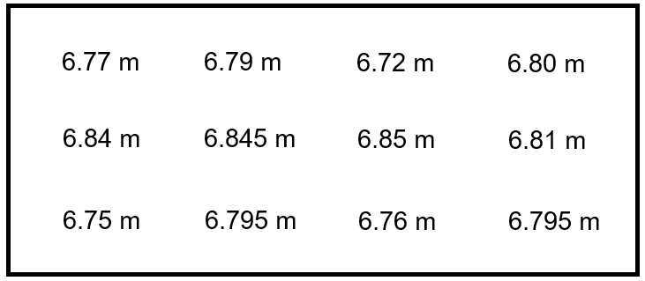
- Use a Pause-Pose-Pounce-Bounce question strategy ([PDF 200KB] (bit.ly/pausepouncebounce) to lead a discussion with students around the following questions:
Encourage the use of place value language.
- How far apart are the smallest and largest measurements?
- Are any of the measurements the same?
- Why do you believe the measurements are not all the same?
- What do you believe is the actual measurement? Why?
- Pick a single measurement, for example 6.77 metres. Which digits in this measurement do you think are reliable? Why?
- Which digits do you think are unreliable? Why?
- Do all these measurements round to the same thing?
In the example above, we want to lead students to the concept that the variation in the third digit, the hundredths, makes it unreliable and could be somewhat ignored.

- Conclude with students which digits they believe are reliable and should be kept, highlighting them as shown in Figure 2 below.
Figure 2 – classroom measurements highlighting reliable digits
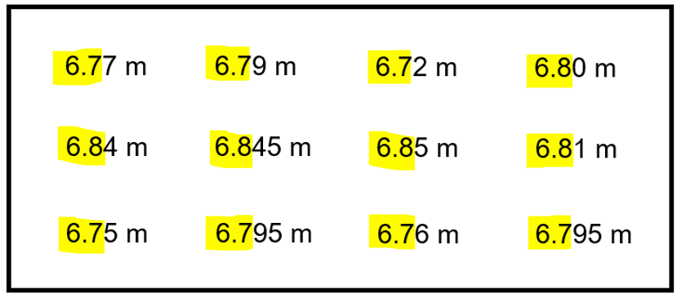

Summarise

Equipment
Any or all of the below equipment can be used.
- Base ten blocks.
- Devices with internet access.

Representing with base 10 blocks
- Have the measurements from the station analysed in the Explore section on the whiteboard.
Figure 3 – measurements of classroom showing which digits are reliable
- Ensure students are aware of how base 10 blocks can be used to represent tenths, hundredths and thousandths if the large cube is one whole, as shown in the image below.
Figure 4 – base 10 blocks
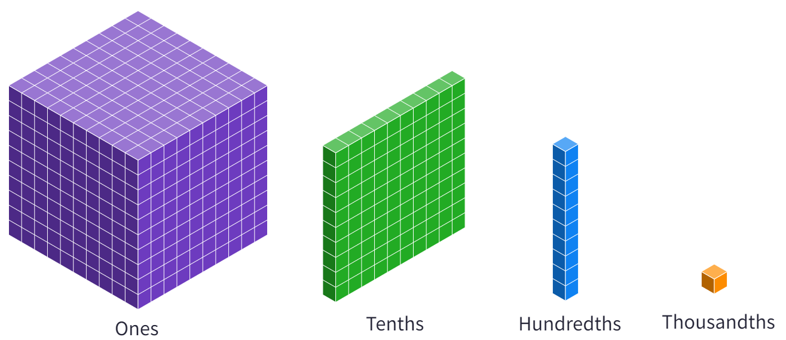
Image created using Mathigon and is licensed under the Mathigon Terms of Use.
Emphasise the language that ‘ten of these makes one of those’. This can be demonstrated in Polypad (bit.ly/PolypadNumberTiles) by using the ‘Split’ and ‘Merge’ buttons.
Figure 5 – split feature in Polypad
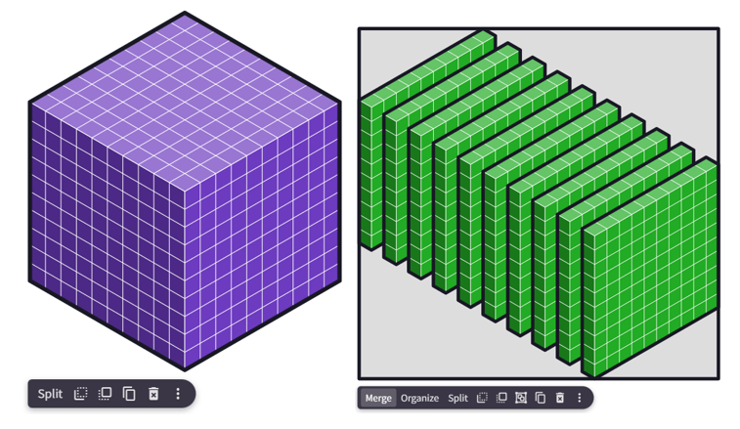
Image created using Mathigon and is licensed under the Mathigon Terms of Use.

- Represent one of the measurements from the station using base 10 blocks. This can be performed with real base 10 blocks, as a drawn diagram or using Polypad. Below is an example of 6.77 metres represented using Polypad (bit.ly/Polypad677cm).
Figure 6 – base 10 blocks showing 6.77
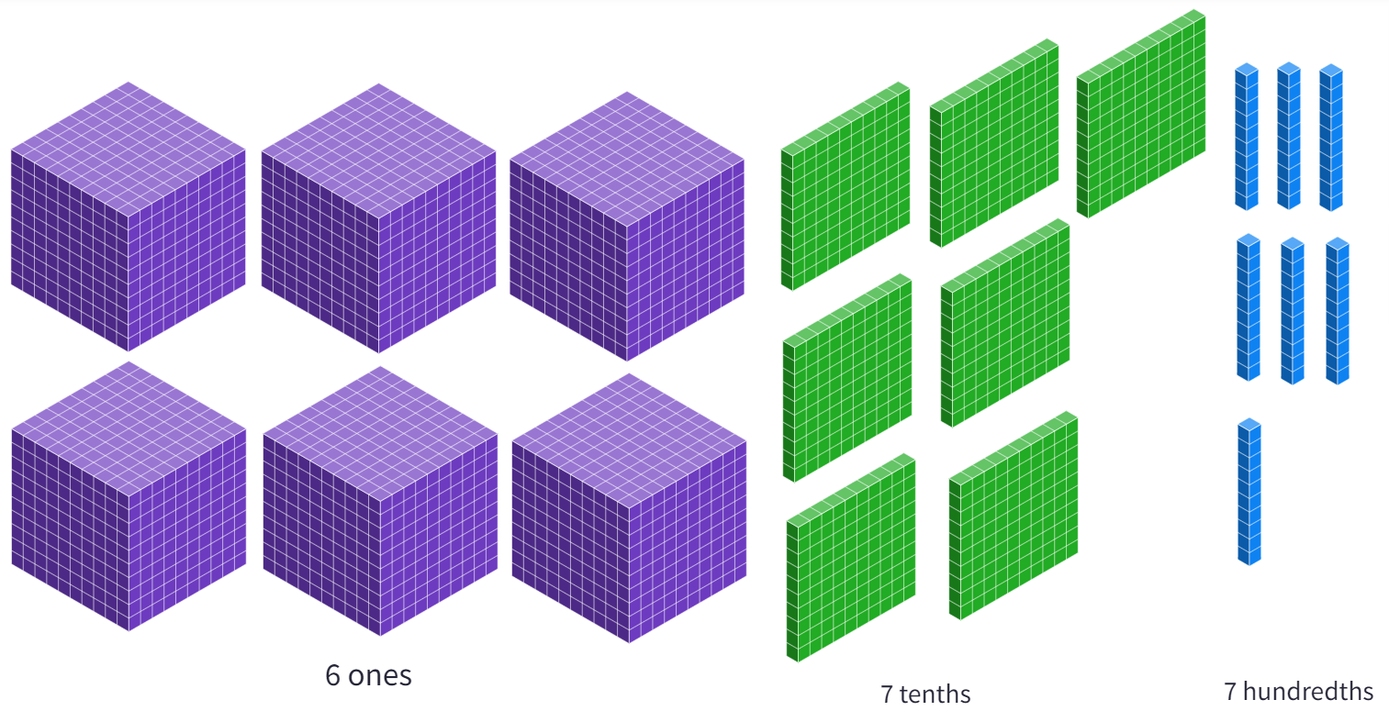
Image created using Mathigon and is licensed under the Mathigon Terms of Use.
- Acknowledge that we have agreed that the hundredths are not reliable in this measurement (modify from hundredths to suit your example). Have students engage in a Think-Pair-Share (bit.ly/thinkpairsharestrategy) with this image visible, focusing on the following questions:
- How many more hundredths do we need to make a tenth?
- Would it be more accurate to pretend these hundredths weren’t there, or to pretend that we had more hundredths, enough to make another tenth? Why?
- Conclude by writing a final statement, introducing the $≈$ symbol and defining it as ‘approximately equal to’. In this example, the statement would be $6.77≈6.8$.

Representing on a number line
- Have the measurements from the station analysed in the Explore section on the whiteboard.
Figure 7 – classroom measurements highlighting reliable digits
- Select one measurement from the board. For these instructions, we will choose the first measurement, 6.77 metres.
- Hand students a copy of Appendix D ‘Representing on a number line’ and have students write 2 integers on each of the dots, so that 6.77 will be somewhere between these 2 integers. Select students to share their integers and agree as a group.
- Instruct students to use a ruler to divide the interval between the 2 integers into 10 equal parts, adding 9 strokes as shown in Figure 8.
Figure 8 – Number line showing divisions between 6 and 7
This is an opportunity to ask students to reflect on why we are adding 9 strokes. Challenge students to predict which number will go on each of these strokes and to review why there are 9 strokes by looking at the result once the strokes are added.

- Have students engage in a Think-Pair-Share (bit.ly/thinkpairsharestrategy) to label these as tenths and to identify which 2 tenths the chosen measurement would go between.
Figure 9 – Number line labelling the tenths between 6 and 7
- Instruct students to use their ruler to divide the interval between these 2 measurements into 10 equal parts by adding 9 strokes, as shown below.
Figure 10 – Number line showing further intervals between 6.6 and 6.7
- Have students reflect on what made this easier and what made this more difficult.
- Acknowledge that these units are hundredths and that we have identified these units as being unreliable in our measurement. Have students engage in a Think-Pair-Share (bit.ly/thinkpairsharestrategy) to find the location of the measurement and explain which tenth our measurement is closer to.
If any measurements have been made accurate to a thousandth of a unit, this may be difficult to display on a number line. If this is the case, build a number line using the instructions above before acknowledging that there is really no space to go further. Then start again where the 2 large dots represent 2 consecutive tenths, in our example being 6.7 and 6.8.

Rounding at stations
- Each group returns to every station to complete the following steps:
- Consider the measurements made by the class and recorded in the table in Appendix C ‘Measuring station overall recording sheet’. Determine which digits are reliable and which are unreliable.
- Highlight the reliable digits on your measurement on your copy of Appendix B ‘Measuring station group recording sheet’.
- Repeat this at every station.
- Returning to their workspace, have students use either base 10 blocks, diagrams or Polypad to represent each of their measurements.
- Students also use Appendix E ‘Representing on number lines’ and the steps shown previously to represent each of their measurements on a number line.
- Students use this to complete and justify their rounding of their measurement, recording this rounded measurement in the final column of the table in Appendix B ‘Measuring station group recording sheet’.
- Have students engage in a Think-Pair-Share (bit.ly/thinkpairsharestrategy).

Explicit teaching
Use the Approximate measurements PowerPoint for explicit teaching of the skills required to round decimals.
The explicit teaching technique used in the PowerPoint is ‘Your turn’. The first slide is a worked example which should be displayed for the students before using the following steps.
- Reveal the question to students and its solution.
- Students read in silence.
- Students individually explain to themselves what is happening in each step.
- Students hold up a thumbs up to the teacher when they have finished reading and have some sort of understanding.
- Think-Pair-Share. Students explain the solution to their partner.
- In pairs students then answer the self-explanation questions.
- Finally, randomly select students to share their answers with the whole class.

Apply
- Students complete Appendix F ‘Reasoning when rounding measurements’, reasoning which measurements to round and to what accuracy.
- Have students engage in these 2 open middle problems, making decimals out of limited digits.
- Rounds to 5 (bit.ly/OMRound5).
- Round to the same values (bit.ly/OMSameRound).

Assessment and differentiation

Suggested opportunities for differentiation
Throughout
- Challenge students who excel to frequently use the language of tenths, hundredths and thousandths and to connect this language to units of measurement. For example, when measuring in metres, the hundredths digit represents the number of centimetres.
Explore
- Working in groups, students should be able to share expertise. Additionally, bringing the measurements together should allow students who have difficulty measuring to receive feedback about the accuracy of their measurement and to continue with learning about the skill of rounding by using the measurements of the rest of the class.
Summarise
- The use of concrete materials in base 10 blocks or Polypad, followed by visual representations of measurements via diagrams and number lines supports the natural way students learn and engage with new concepts.
- Students who express confidence and skills rounding measurements should be challenged to write explanations as to why measurements round the way they do. Can you convince someone else that this number should round up?

Suggested opportunities for assessment
Throughout
- Have students submit their work on Appendix B, E and F to demonstrate their ability to round, represent decimals on a number line and to reason why a measurement could be rounded.
Launch
- Observing and recording student responses, teachers can identify student understanding of standard units of measurement. How appropriately can students identify objects that would be one metre long?
Explore
- Observe students’ abilities to operate standard measuring tools and take appropriate readings from them.

Appendix A

Approximating measurements
For each scenario, write what you believe is the actual measurement and why.
Table 1 – approximating measurements
Situation | Actual measurement
You weigh yourself 3 times in a day and the scales show 63.1 kg, 63.7 kg and 64.3 kg.
Three people timed Johnny’s 100 metre sprint, showing times of 16.36 seconds, 16.27 seconds and 16.31 seconds.
Jane needs to replace this garden wall with thicker blocks. Jane and 2 friends each measure how long the wall is to be safe. They find the length to be 14.382 m, 14.411 m and 14.490 m.

Appendix B

Measuring station group recording sheet
Table 2 – measuring station group recording sheet
Station | Measuring tool | Your measurement | Rounded measurement
The length of the room in metres | Tape measure
The height of the door in metres | Tape measure
The length of the whiteboard in metres | Tape measure
The height of the bookshelf in metres | Tape measure
The width of your classroom window | Tape measure
The height of your chair | Tape measure
The weight of a basketball in kilograms | Bathroom or kitchen scale
The weight of 3 textbooks, 2 gluesticks and an exercise book in kilograms | Bathroom or kitchen scale
The time it takes a tennis ball to hit the ground if you drop it from eye level | Stopwatch
The time it takes an online GIF to repeat | Stopwatch

Appendix C

Measuring station overall recording sheet
Table 3 – measuring station overall recording sheet
Group | Measurement
1
2
3
4
5
6
7
8
9
10
11
12

Appendix D

Representing on a number line

Appendix E

Representing on number lines

Appendix F

Reasoning when rounding measurements
Next to each situation, explain what you would round the measurement to, giving reasons. An example has been completed for you.
Table 4 – reasoning when rounding measurements
Situation | What would you round this to?
A song was timed and lasted 3 minutes and 51.87 seconds.
A 38 year old man weighed himself and recorded a measurement of 80.35 kilograms. | The man would weigh himself to the nearest kilogram. The decimals here would change depending on the clothes you were wearing and are not accurate or reliable. In this situation, it would be 80 kg.
A newborn baby was weighed and measured 3.015 kilograms.
A builder is cutting a piece of wood to make a door. The doorway is measured to be 2.038 metres high.
The cross-country course for Year 7 students was measured to be 2.128 km.

Sample solutions

Appendix A – approximating measurements
Situation | Actual measurement
You weigh yourself 3 times in a day and the scales show 63.5 kg, 63.7 kg and 64.3 kg. | 64 kg, because all the measurements round to this.
Three people timed Johnny’s 100 metre sprint, showing times of 16.36 seconds, 16.27 seconds and 16.31 seconds. | 16.3 seconds, as all measurements are closest to this when focusing on tenths.
Jane needs to replace this garden wall with thicker blocks. Jane and 2 friends each measure how long the wall is to be safe. They find the length to be 14.382 m, 14.411 m and 14.490 m. | 14.4 m, since all measurements are still different when focusing on hundredths but are closest to 14.4 m when focusing on tenths.

Appendix B – measuring station group recording sheet
These measurements represent one of many possible solutions.
Station | Measuring tool | Your measurement | Rounded measurement
The length of the room in metres | Tape measure | 6.84 m | 6.8 m
The height of the door in metres | Tape measure | 2.12 m | 2.1 m
The length of the whiteboard in metres | Tape measure | 1.22 m | 1.2 m
The height of the bookshelf in metres | Tape measure | 1.84 m | 1.8 m
The width of your classroom window | Tape measure | 1.46 m | 1.4 m
The height of your chair | Tape measure | 0.92 m | 0.9 m
The weight of a basketball in kilograms | Bathroom or kitchen scale | 0.59 kg | 0.6 kg
The weight of 3 textbooks, 2 gluesticks and an exercise book in kilograms | Bathroom or kitchen scale | 6.34 kg | 6.3 kg
The time it takes a tennis ball to hit the ground if you drop it from eye level | Stopwatch | 0.49 seconds | 0.5 seconds
The time it takes an online GIF to repeat | Stopwatch | 1.04 seconds | 1 second

Appendix C – length of classroom example
Group | Measurement
1 | 6.77 m
2 | 6.79 m
3 | 6.72 m
4 | 6.80 m
5 | 6.84 m
6 | 6.845 m
7 | 6.85 m
8 | 6.81 m
9 | 6.75 m
10 | 6.795 m
11 | 6.76 m
12 | 6.795 m

Appendix F – reasoning when rounding measurements
Situation | What would you round this to?
A song was timed and lasted 3 minutes and 51.87 seconds. | This would best round to the nearest second. No one would notice a millisecond when listening to a song. This would be 3 minutes and 52 seconds in this situation.
A 38 year old man weighed himself and recorded a measurement of 80.35 kilograms. | The man would weigh himself to the nearest kilogram. The decimals here would change depending on the clothes you were wearing and are not accurate or reliable. In this situation, it would be 80 kg.
A newborn baby was weighed and measured 3.015 kilograms. | The weight of a newborn baby can tell us if the baby is healthy or not, so we should keep every unit here.
A builder is cutting a piece of wood to make a door. The doorway is measured to be 2.038 metres high. | It is important that this measurement is accurate. The thousandths digit here represents millimetres and this would be marked on the builder’s tape measure and is important. Therefore, I would keep all units in the measurement, 2.038 m.
The cross-country course for Year 7 students was measured to be 2.128 km. | The thousandths digit represents metres, and the hundredths represents tens of metres. When running 28 metres would be approximately 10–20 steps and would not be noticeable. The tenths digit represents 100 metres, and this is a long way. Therefore, I would round to the nearest tenth, 2.1 km.

References
This resource contains NSW Curriculum and syllabus content. The NSW Curriculum is developed by the NSW Education Standards Authority. This content is prepared by NESA for and on behalf of the Crown in right of the State of New South Wales. The material is protected by Crown copyright.
Please refer to the NESA Copyright Disclaimer for more information. https://educationstandards.nsw.edu.au/wps/portal/nesa/mini-footer/copyright
NESA holds the only official and up-to-date versions of the NSW Curriculum and syllabus documents. Please visit the NSW Education Standards Authority (NESA) website https://educationstandards.nsw.edu.au/ and the NSW Curriculum website https://curriculum.nsw.edu.au/home.
Mathematics K–10 Syllabus © NSW Education Standards Authority (NESA) for and on behalf of the Crown in right of the State of New South Wales, 2022.

© State of New South Wales (Department of Education), 2023
The copyright material published in this resource is subject to the Copyright Act 1968 (Cth) and is owned by the NSW Department of Education or, where indicated, by a party other than the NSW Department of Education (third-party material).
Copyright material available in this resource and owned by the NSW Department of Education is licensed under a Creative Commons Attribution 4.0 International (CC BY 4.0) licence.
This licence allows you to share and adapt the material for any purpose, even commercially.
Attribution should be given to © State of New South Wales (Department of Education), 2023.
Material in this resource not available under a Creative Commons licence:
- the NSW Department of Education logo, other logos and trademark-protected material
- material owned by a third party that has been reproduced with permission. You will need to obtain permission from the third party to reuse its material.
Links to third-party material and websites
Please note that the provided (reading/viewing material/list/links/texts) are a suggestion only and implies no endorsement, by the New South Wales Department of Education, of any author, publisher, or book title. School principals and teachers are best placed to assess the suitability of resources that would complement the curriculum and reflect the needs and interests of their students.
If you use the links provided in this document to access a third-party's website, you acknowledge that the terms of use, including licence terms set out on the third-party's website apply to the use which may be made of the materials on that third-party website or where permitted by the Copyright Act 1968 (Cth). The department accepts no responsibility for content on third-party websites.

