Seeing double
As a first step towards adding fractions with different denominators, students first develop the skill to transform one fraction to have the same denominator as another.

Visible learning

Learning intention
- To be able to add and subtract fractions when one denominator is a multiple of another.

Success criteria
- I can identify fractions where one denominator is a multiple of another.
- I can add and subtract fractions where one denominator is a multiple of another.
- I can use visual representations to aid in addition of fractions.

Syllabus outcomes
A student:
- develops understanding and fluency in mathematics through exploring and connecting mathematical concepts, choosing and applying mathematical techniques to solve problems, and communicating their thinking and reasoning coherently and clearly MAO-WM-01
- represents and operates with fractions, decimals and percentages to solve problems MA4-FRC-C-01
- generalises number properties to operate with algebraic expressions including expansion and factorisation MA4-ALG-C-01
Mathematics K–10 Syllabus © NSW Education Standards Authority (NESA) for and on behalf of the Crown in right of the State of New South Wales, 2022.

Activity structure

Warm up

Equipment
- One copy per student of Appendix A ‘Common multiples’
- Two 6-sided dice per pair
- Counters

Method
- Assign pairs and distribute resources to students.
- Use slide 2 from the Seeing double PowerPoint to display the instructions for students:
- The 2 dice are thrown alternately by the players.
- Look for the numbers that are common multiples of the numbers rolled.
- They place counters on those numbers on their board.
- The game ends after 5 rounds. The player with more covered numbers wins.
- Students could be challenged to consider which pair of numbers would have the most multiples.

Launch
- Assign visibly random groups of 3 (bit.ly/visiblegroups) and have students stand at vertical non-permanent surfaces (VNPS) (bit.ly/VNPSstrategy).
- Each group draws a number line on their VNPS and labels 0 and 1, as shown below.
Figure 1 – number line from 0 to 1
- Read out, or write on the board, the following list of fractions that students are to mark and label on the number line:
$\frac{1}{2}$
$\frac{1}{4}$
$\frac{1}{8}$
$\frac{1}{3}$
$\frac{1}{6}$
$\frac{3}{4}$
$\frac{3}{11}$
- Students perform a gallery walk (bit.ly/DLSgallerywalk) to see how other groups marked the fractions on their number lines.
- Pose the following questions to students, using a questioning technique such as Pose-Pause-Pounce-Bounce question strategy ([PDF 200KB] bit.ly/pausepouncebounce):
Which fractions were the easiest to mark?
Why were some fractions easier to mark?
Which fractions were more difficult to mark?
Why were some fractions more difficult to mark?
The point of this launch is for students to recognise that fractions with denominators that share a common factor are related. Knowing this fact makes marking the fractions on a number line easier. For example, by first marking $\frac{1}{2}$, students can then divide the length from 0 to $\frac{1}{2}$ to mark $\frac{1}{4}$.

Explore
- Print and distribute Appendix B ‘Examples and practice’, one sheet per pair.
- Use slides 3–8 from the Seeing double PowerPoint for explicit teaching of adding fractions where one denominator is a multiple of another, by representing the fractions on a number line.
- Students will fill in the examples and your turn examples on their Appendix B worksheet.
The explicit teaching technique used in the associated PowerPoint is ‘Your turn.’ The first slide is a worked example which should be displayed for the students and then use the following steps.
- Reveal the question to students and its solution.
- Students read in silence.
- Students individually think and explain to themselves what is happening in each step.
- Students hold up a thumbs up to the teacher when they have finished reading and have some sort of understanding.
- Think-Pair-Share. Students explain the solution to their partner.
- In pairs, students then answer the self-explanation questions.
- Finally, randomly select students to share their answers with the whole class.
- Students then work through the 2 practice questions at the end of Appendix B ‘Examples and practice’. If devices are available, they can use the bar model shown in the examples via the Desmos graph ‘Addition of fractions’ (bit.ly/additionoffractions) to verify their answers are correct.

Summarise
- Use slides 9–14 from the Seeing double PowerPoint to gather students’ strategies for generalising the approach used in ‘Explore’ to add fractions where one denominator is a multiple of another.
- Students write notes to their future forgetful selves (bit.ly/notesstrategy), annotating the ‘Your turn’ problem to explain how to add fractions when one denominator is a multiple of another.
- Print and distribute Appendix C ‘Independent practice’. Students work through these problems independently. If devices are available, they could use the bar model shown in the examples to verify their answers are correct via the Desmos graph ‘Addition of fractions’ (bit.ly/additionoffractions).
The purpose of teaching this lesson prior to adding fractions with different denominators is to establish that to add fractions they need to have the same denominator but how students achieve this should allow for flexibility and decision making, rather than teaching one method for adding all fractions.

Apply
The following game is inspired by ‘Easy fraction game’ by nzmaths.co.nz (https://nzmaths.co.nz/resource/easy-fraction-game)

Equipment
- One die numbered $\frac{1}{8},\frac{3}{8},\frac{5}{8},\frac{3}{4},\frac{1}{4},\frac{1}{2}$ (alternatively, use a random number generator, or pull the fractions from a hat)
- Class set of Appendix D ‘Fractions game’

Method
- Each student receives a copy of Appendix D. The teacher has the die labelled with fractions.
- Roll the die and call out the fraction rolled.
- Students record the fraction in one of the 2 ‘Fractions’ columns. They must write the fraction in an empty cell in one of the 2 columns. They cannot choose to not write a fraction down.
- When students have filled in all empty fraction cells (14 rolls of the die), they evaluate the answer for each row.
- They are awarded one point for each row that meets the criteria in the ‘Rules’ column.
- The player with the most points wins.

Assessment and differentiation

Suggested opportunities for differentiation
- Students may benefit from revision of Stage 3 multiplicative thinking prior to this lesson.
- Students will rely on a foundational understanding of equivalent fractions to engage with this lesson. Formative assessment should be used to determine if students require additional support with equivalent fractions.
- Retrieval questions could be posed at the beginning of the lesson to recall adding fractions with the same denominator and why fractions with different denominators don’t add the same way.
Warm up
- Let the students create their own board with numbers that they think will help them win. To make the game harder, use dice with 10 sides and make a board for that.
Launch
- Appendix A can be modified to be more challenging by selecting more complicated fractions and/or algebraic terms.
- Appendix A could be substituted with physical manipulatives such as stepping out a number line or marking a folded sheet of paper.
Apply
- Students can construct their own dice with different fractions. Some fractions may not work for the game which would be a valuable learning moment.

Suggested opportunities for assessment
- Teachers can informally assess students’ adding of unit fractions in the Warm-up game to identify students that may need additional support to consolidate adding fractions with the same denominator.
- Teachers should monitor student discussions and answers during class to assess their understanding and use of correct terminology.
- Teachers could choose to ask students to complete (using visual representations if necessary) an exit ticket containing an addition problem involving negative numbers.
- Teachers could choose to collect student activities and/or students’ notes to their future forgetful selves to assess their understanding and communication of the learning intentions of this lesson.

Appendix A

Common multiples
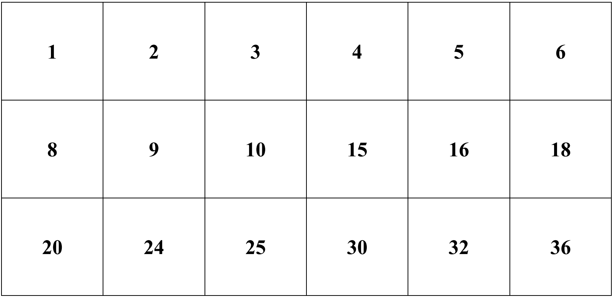

Appendix B

Examples and practice
Example 1
$$\frac{1}{4}+\frac{1}{8}$$
Your turn 1
$$\frac{1}{2}+\frac{1}{4}$$
Practice
$$\frac{2}{3}+\frac{1}{6}$$
$$\frac{8}{10}-\frac{1}{5}$$

Appendix C

Independent practice
- Evaluate each expression:
- $\frac{1}{9}+\frac{1}{3}$
- $\frac{1}{9}-\frac{1}{3}$
- $\frac{3}{5}+\frac{1}{10}$
- $\frac{3}{5}-\frac{1}{10}$
- $1\frac{1}{4}+\frac{3}{8}$
- $\frac{5}{18}-\frac{7}{9}+\frac{4}{3}$
- $\frac{5}{3}+\frac{7}{9}-\frac{1}{18}$
- $\frac{7}{16}+\frac{3}{8}+1\frac{3}{4}$
- Fill in each missing fraction to make each equation true:
- $\frac{2}{3}+\frac{}{}=\frac{5}{6}$
- $\frac{}{}+\frac{1}{3}=\frac{7}{9}$
- $\frac{2}{3}+\frac{}{}=\frac{13}{18}$
- $\frac{4}{9}+\frac{}{}=2\frac{1}{9}$
- $\frac{7}{8}-\frac{}{}=\frac{1}{2}$
- $3\frac{1}{6}-\frac{}{}=2\frac{1}{3}$
- Alinta eats $\frac{1}{5}$ of a cake. Lowanna eats $\frac{3}{10}$ of the same cake. What fraction of the cake is left?

- Medika spends $\frac{1}{6}$ of their wage on food. They spend $\frac{1}{3}$ of their wage on rent. How much of their wage does Medika have left?

- Fill in the missing blocks, so that each block is the sum of the 2 below:
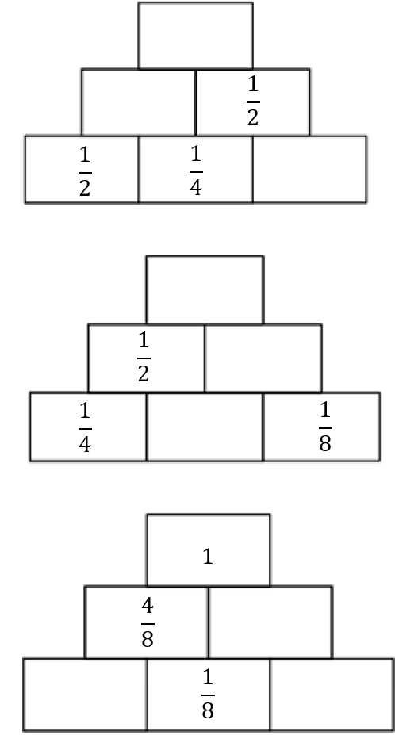

Appendix D

Fractions game
 | Rules | Fractions |  | Answer
 | Rules
1 | Sum > 1
2 | Sum < 1
3 | Sum = 1
4 | One fraction subtracted from the other is one half
5 | One fraction subtracted from the other is greater than one half
6 | One fraction subtracted from the other is less than one half
7 | The difference between the fractions is $\frac{1}{4}$
Total points

Sample solutions

Appendix B – examples and practice
Example 1
$$\frac{1}{4}+\frac{1}{8}=\frac{3}{8}$$
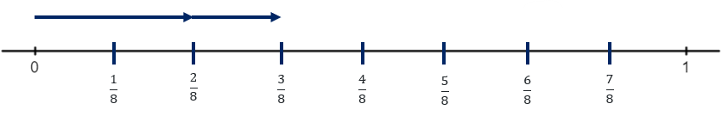
Your turn 1
$$\frac{1}{2}+\frac{1}{4}=\frac{3}{4}$$
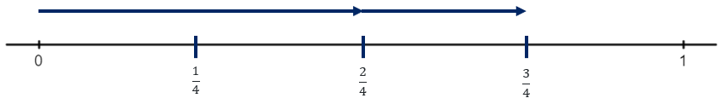
Practice
$$\frac{2}{3}+\frac{1}{6}=\frac{5}{6}$$
$$\frac{8}{10}-\frac{1}{5}$$
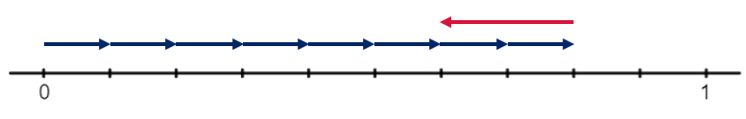

Appendix C – independent practice

- $\frac{1}{9}+\frac{3}{9}=\frac{4}{9}$
- $\frac{1}{9}-\frac{3}{9}=-\frac{2}{9}$
- $\frac{6}{10}+\frac{1}{10}=\frac{7}{10}$
- $\frac{6}{10}-\frac{1}{10}=\frac{5}{10}=\frac{1}{2}$
- $1\frac{2}{8}+\frac{3}{8}=1\frac{5}{8}$
- $\frac{5}{18}-\frac{14}{18}+\frac{24}{18}=\frac{15}{18}=\frac{5}{6}$
- $\frac{30}{18}+\frac{14}{18}-\frac{1}{18}=\frac{43}{18}$
- $\frac{7}{16}+\frac{6}{16}+1\frac{12}{16}=2\frac{9}{16}$

- $\frac{1}{6}$
- $\frac{4}{9}$
- $\frac{1}{18}$
- $\frac{15}{9}$ or $\frac{5}{3}$
- $\frac{3}{8}$
- $\frac{5}{6}$
- $\frac{1}{2}$
- $\frac{1}{2}$

Puzzle 1
Bottom row: $\frac{1}{2},\frac{1}{4},\frac{1}{4}$
Middle row: $\frac{3}{4},\frac{1}{2}$
Top row: $1\frac{1}{4}$
Puzzle 2
Bottom row: $\frac{1}{4},\frac{1}{4},\frac{1}{8}$
Middle row: $\frac{1}{2},\frac{3}{8}$
Top row: $\frac{7}{8}$
Puzzle 3
Bottom row: $\frac{3}{8},\frac{1}{8},\frac{1}{8}$
Middle row: $\frac{4}{8},\frac{4}{8}$
Top row: $1$

References
This resource contains NSW Curriculum and syllabus content. The NSW Curriculum is developed by the NSW Education Standards Authority. This content is prepared by NESA for and on behalf of the Crown in right of the State of New South Wales. The material is protected by Crown copyright.
Please refer to the NESA Copyright Disclaimer for more information https://educationstandards.nsw.edu.au/wps/portal/nesa/mini-footer/copyright.
NESA holds the only official and up-to-date versions of the NSW Curriculum and syllabus documents. Please visit the NSW Education Standards Authority (NESA) website https://educationstandards.nsw.edu.au/ and the NSW Curriculum website https://curriculum.nsw.edu.au/home.
Mathematics K–10 Syllabus © NSW Education Standards Authority (NESA) for and on behalf of the Crown in right of the State of New South Wales, 2022.
© State of New South Wales (Department of Education), 2023
The copyright material published in this resource is subject to the Copyright Act 1968 (Cth) and is owned by the NSW Department of Education or, where indicated, by a party other than the NSW Department of Education (third-party material).
Copyright material available in this resource and owned by the NSW Department of Education is licensed under a Creative Commons Attribution 4.0 International (CC BY 4.0) licence.
This licence allows you to share and adapt the material for any purpose, even commercially.
Attribution should be given to © State of New South Wales (Department of Education), 2023.
Material in this resource not available under a Creative Commons licence:
- the NSW Department of Education logo, other logos and trademark-protected material
- material owned by a third party that has been reproduced with permission. You will need to obtain permission from the third party to reuse its material.
Links to third-party material and websites
Please note that the provided (reading/viewing material/list/links/texts) are a suggestion only and implies no endorsement, by the New South Wales Department of Education, of any author, publisher, or book title. School principals and teachers are best placed to assess the suitability of resources that would complement the curriculum and reflect the needs and interests of their students.
If you use the links provided in this document to access a third-party's website, you acknowledge that the terms of use, including licence terms set out on the third-party's website apply to the use which may be made of the materials on that third-party website or where permitted by the Copyright Act 1968 (Cth). The department accepts no responsibility for content on third-party websites.

