Inverse journeys
Students use mazes and Grid Algebra to explore the addition and subtraction of algebraic terms.

Visible learning

Learning intentions
- To understand that variables are used to represent one or more numerical values.
- To identify that addition is the inverse of subtraction and vice versa.

Success criteria
- I can identify the inverse of a given number.
- I can use inverses to calculate a variable’s original value.
- I can informally solve one-step equations by using inverses.

Syllabus outcomes
A student:
- develops understanding and fluency in mathematics through exploring and connecting mathematical concepts, choosing and applying mathematical techniques to solve problems, and communicating their thinking and reasoning coherently and clearly MAO-WM-01
- generalises number properties to operate with algebraic expressions including expansion and factorisation MA4-ALG-C-01
- solves linear equations of up to 2 steps and quadratic equations of the form $ax^{2}=c$ MA4-EQU-C-01
Mathematics K–10 Syllabus © NSW Education Standards Authority (NESA) for and on behalf of the Crown in right of the State of New South Wales, 2022.

Activity structure

Launch
- Students are to work in pairs to write instructions for moving through the maze in Appendix A ‘Maze’.
- Partner 1 writes down instructions to move from the green dot to the red dot, following the given path.
- Partner 2 writes down instructions to move from the red dot to the green dot, following the given path.
- Students should compare their instructions. Have them discuss what they notice and what they wonder(bit.ly/noticewonderstrategy).
- Teacher to randomly call on pairs to share.
This task is designed to introduce the idea of inverses or opposites. Students should notice that their instructions are the opposite of each other. For instance, when partner 1 turned right, partner 2 turned left.

Explore
- Navigate to Grid Algebra (gridalgebra.com/free) and drag the file ‘Inverse journeys.json’ onto the grid. Visit the Grid Algebra website (gridalgebra.com/intro/overview) for more instructions on how to use the software.
Figure 1 – first 3 rows of the grid with various algebraic expressions
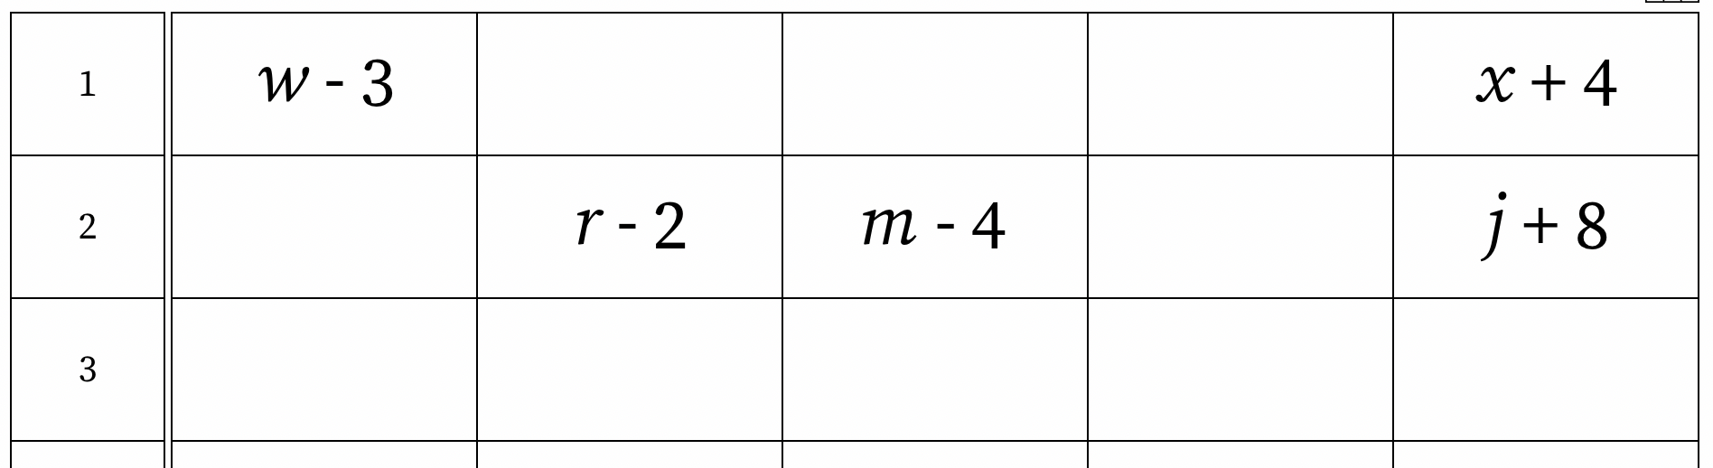
Image from Grid Algebra.
- Explain to students that this grid shows where variables ended up after being taken on a journey through the grid. Can they work out where they started?
- Use a Think-Pair-Share strategy (bit.ly/thinkpairsharestrategy) for students to discuss this question before randomly selecting students to share their thoughts.
- Test student’s theories by clicking on the inverse button and slowly clicking and dragging the variable to the cell indicated by the students. If they are correct, the variable will return to its original form.
If students have chosen the incorrect cell, click the delete expression button (cross) and then click on the appropriate cells to remove incorrect expressions. Click on the delete expression again, to toggle off the feature, before trying again.
Figure 2 – toolbar from the Grid Algebra website
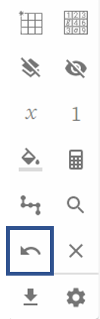
Image from Grid Algebra.
- Repeat with as many variables as students need to feel comfortable with the concept.
Introduce the terminology of ‘inverse’ and explain that addition and subtraction are the inverse of each other. You could refer-back to zero pairs where 1 and (-1) were considered a zero pair because they cancelled each other out. You could now use the terminology of inverse and explain that zero pairs are the inverse of each other.
- Students should then complete the worksheet from Appendix B ‘Back to the beginning’.

Summarise
Students should write ‘notes to their future forgetful self’ (bit.ly/notesstrategy) to summarise their learning from the explore section.

Apply
Students begin to informally look at one step equations involving addition and subtraction. In each example a letter has been taken on a journey, landing on a particular numerical cell. Students are challenged to find the numerical value of the cell that the letter started on.
- Present the following scenario to students:
‘A letter went on this journey through the grid ‘$x+3$’ and landed on the cell containing the number 7.’
Challenge students to find the value of the cell the letter started from. (For instance, 4)
- What if the letter finished on the cell containing the number 10? What about the cell containing the number 1?
- Navigate to gridalgebra.com/free.
- Watch the video Grid algebra overview (8:04) (https://bit.ly/GridAlgebraOverview) from the 5:40 minute mark, to learn how to demonstrate the above scenario using the Grid Algebra software.
- Students to complete the ‘Where did I come from?’ worksheet in Appendix C. The last few rows have been left blank for you to provide students with a challenge or for them to challenge each other.

Assessment and differentiation

Suggested opportunities for differentiation
Launch
- Students with low literacy skills could verbally explain their path through the maze, or use symbols to represent their path. For instance, arrows demonstrating the direction to turn.
Explore
- Teachers could begin by taking a number on a journey, rather than starting with variables.
Summarise
- Students may require a scaffold to help them write notes to their ‘future forgetful selves’.
Apply
- Students could be challenged by landing on a cell with a fraction or decimal value.
- Students who are struggling with the concept of a variable could work with numbers. For instance, ‘7 was taken on a journey by moving 3 places to the right and ended up on 10. How could he get back to his 7 cell?’

Suggested opportunities for assessment
- The worksheets from Appendices B and C could be collected to check for understanding.
- An exit ticket with a question from the lesson could be given to students to check for understanding.
- Teachers should monitor student language during class discussions and pair/shares to check for correct terminology usage and to identify and misconceptions.
Appendix A

Maze
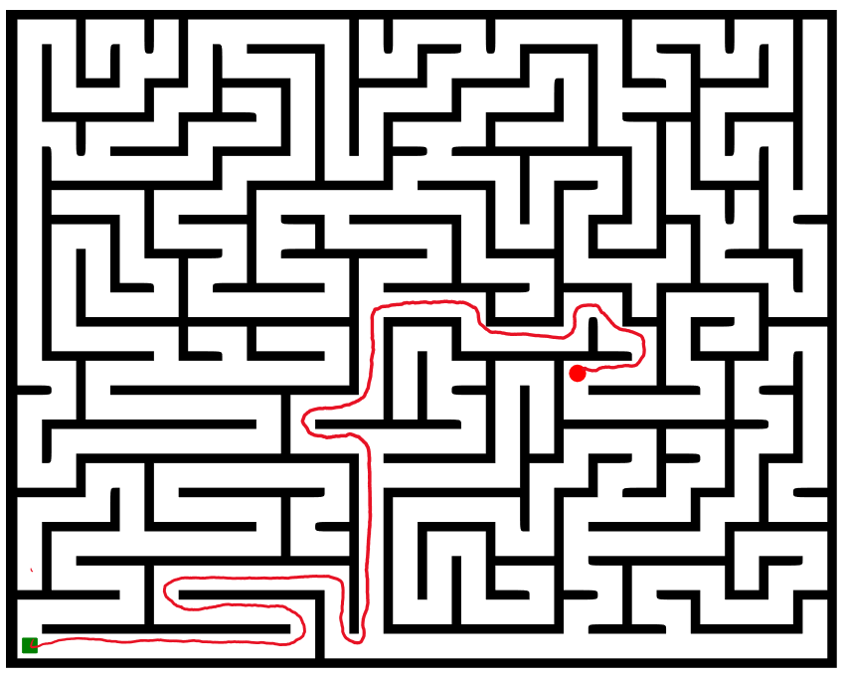

Appendix B

Back to the beginning
Each letter in the following grids has been taken on a journey. Find the cell where it started its journey. The last few grids have been left blank for your teacher to give you a challenge or for you to challenge a friend.
1 |  | $$x-3$$

1 | $$y-4$$

1 |  |  | $$k+1+1$$

2 |  |  | $$m-4+4$$

4 |  |  | $$c+4-12$$

5 |  | $$p-5-5$$

Appendix C

Where did I come from?
Can you find the number value of the cell that each letter started its journey from? The first row has been done for you. The last few rows have been left blank for your teacher to provide you with a challenge, or for you to challenge a friend.
Journey | Value of final cell | Working | Value of starting cell
$$x+3$$ | 7 | $$7-3$$ | 4
$$x+4$$ | 7
$$x+4$$ | 8
$$x-4$$ | 8
$$x+5$$ | 1
$$x-5$$ | 1
$$x-6$$ | 1
$$x-6$$ | 0
$$x+2$$ | (-1)
$$x-2$$ | (-1)

Sample solutions

Appendix B – back to the beginning
1 |  | $$x-3$$ |  |  | $$x$$

1 | $$y-4$$ |  |  |  | $$y$$

1 | $$k$$ |  | $$k+1+1$$

2 |  |  | $$m$$

4 |  |  | $$c+4-12$$ |  | $$c$$

5 |  | $$p-5-5$$ |  | $$p$$

Appendix C – where did I come from?
Journey | Value of final cell | Working | Value of starting cell
$$x+3$$ | 7 | $$7-3$$ | 4
$$x+4$$ | 7 | $$7-4$$ | $$3$$
$$x+4$$ | 8 | $$8-4$$ | $$4$$
$$x-4$$ | 8 | $$8+4$$ | $$12$$
$$x+5$$ | 1 | $$1-5$$ | $$(-4)$$
$$x-5$$ | 1 | $$1+5$$ | $$6$$
$$x-6$$ | 1 | $$1+6$$ | $$7$$
$$x-6$$ | 0 | $$0+6$$ | $$6$$
$$x+2$$ | (-1) | $$(-1)-2$$ | $$(-3)$$
$$x-2$$ | (-1) | $$\left(-1\right)+2$$ | $$1$$

References
This resource contains NSW Curriculum and syllabus content. The NSW Curriculum is developed by the NSW Education Standards Authority. This content is prepared by NESA for and on behalf of the Crown in right of the State of New South Wales. The material is protected by Crown copyright.
Please refer to the NESA Copyright Disclaimer for more information https://educationstandards.nsw.edu.au/wps/portal/nesa/mini-footer/copyright.
NESA holds the only official and up-to-date versions of the NSW Curriculum and syllabus documents. Please visit the NSW Education Standards Authority (NESA) website https://educationstandards.nsw.edu.au/ and the NSW Curriculum website https://curriculum.nsw.edu.au/home.
Mathematics K–10 Syllabus © NSW Education Standards Authority (NESA) for and on behalf of the Crown in right of the State of New South Wales, 2022.

© State of New South Wales (Department of Education), 2023
The copyright material published in this resource is subject to the Copyright Act 1968 (Cth) and is owned by the NSW Department of Education or, where indicated, by a party other than the NSW Department of Education (third-party material).
Copyright material available in this resource and owned by the NSW Department of Education is licensed under a Creative Commons Attribution 4.0 International (CC BY 4.0) licence.
This licence allows you to share and adapt the material for any purpose, even commercially.
Attribution should be given to © State of New South Wales (Department of Education), 2023.
Material in this resource not available under a Creative Commons licence:
- the NSW Department of Education logo, other logos and trademark-protected material
- material owned by a third party that has been reproduced with permission. You will need to obtain permission from the third party to reuse its material.
Links to third-party material and websites
Please note that the provided (reading/viewing material/list/links/texts) are a suggestion only and implies no endorsement, by the New South Wales Department of Education, of any author, publisher, or book title. School principals and teachers are best placed to assess the suitability of resources that would complement the curriculum and reflect the needs and interests of their students.
If you use the links provided in this document to access a third-party's website, you acknowledge that the terms of use, including licence terms set out on the third-party's website apply to the use which may be made of the materials on that third-party website or where permitted by the Copyright Act 1968 (Cth). The department accepts no responsibility for content on third-party websites.

