The ants go marching
Students calculate numerical terms with squares, cubes and other positive integer powers whilst learning how to effectively communicate about these concepts.

Visible learning

Learning intentions
- To be able to calculate numerical terms with indices.
- To be able to communicate effectively using the mathematical language of indices.

Success criteria
- I can multiply to find the square and cube of a number.
- I can multiply numbers written in index form.
- I can write and verbalise numbers in index form.

Syllabus outcomes
A student:
- develops understanding and fluency in mathematics through exploring and connecting mathematical concepts, choosing and applying mathematical techniques to solve problems, and communicating their thinking and reasoning coherently and clearly MAO-WM-01
- operates with primes and roots, positive-integers and zero indices involving numerical bases and establishes the relevant index laws MA4-IND-C-01
Mathematics K–10 Syllabus © NSW Education Standards Authority (NESA) for and on behalf of the Crown in right of the State of New South Wales, 2022.
Please use the associated PowerPoint The ants go marching to display images in this lesson.

Activity structure

Launch

Equipment
- 25 counters per pair.
- Copy of Appendix A ‘Arrays’, one per student.

Method
- Distribute Appendix A ‘Array’ to all students.
- Display slide 3 of the PowerPoint.
- Explain to students that an array is an arrangement of equal rows.
- Direct students to arrange the number of counters in the first column of Appendix A into as many arrays as they can. Draw and describe the arrays.
- Complete a Think-Pair-Share (bit.ly/thinkpairsharestrategy) to discuss the results.
- During the discussion, you may wish to pose the questions
- What do you notice?
- What do you think?
- What types of numbers only had one possible array?
- Which numbers formed a square?
- How many counters do you need to make the next number that can form a square array?
Encourage students to discuss things they see in common and things that are different between the numbers and the arrays.

Explore

Squaring a number
- Display slide 5 of the PowerPoint. Provide students with a small opportunity to discuss the song ‘The ants go marching’.
Explain to the students that using the theme of the song ‘The ants go marching’ encourages them to visualise a formation of a square array. The students aren’t required to remember the words to the song. An age-appropriate version of the song ‘The ants go marching – Lenny Pearce’ (1:37) can be viewed on YouTube (bit.ly/VideoAntsGoMarching).
- Display slide 6 of the PowerPoint and hand students Appendix B ‘How the ants march’.
- Have students complete the table in Appendix B.
Students will be able to refer to the arrays from Appendix A to complete the first half of the table. However, once students reach 6 by 6, they will need to calculate the value. Encourage students to visualise an array and use their multiplicative strategies to calculate the value. Solutions are available on slide 7 of the PowerPoint.
- Display slide 8 of the PowerPoint. Ask students to look at the images.
- Pose the questions
- What do you notice?
- What do you think?

- Display slide 9 of the PowerPoint. Use the Pause-Pose-Pounce-Bounce question strategy [PDF 200KB] (bit.ly/pausepouncebounce) to discuss the language we use with squaring a number and what the area of the square is. You might pose questions such as
- How do we know the shape is a square?
- What do you know about the area of the square?
- What is Ari’s strategy to calculate the number of squares?
- Why do you think we say, ‘5 squared’?
Students have already created a 5 by 5 array in the Launch phase of the lesson. The purpose of this part of the lesson is to link knowledge of the array with the shape and with the language of squaring a number.

Cubing a number

Equipment
- Approximately 100 centi-cubes per pair.

Method
- Distribute centi-cubes to students.
- Direct students to build a cube with edges of 4 cm.
- Display slide 10 of the PowerPoint. Use the Pause-Pose-Pounce-Bounce strategy to discuss the language we use with cubing a number and what the volume of the cube is. You might pose questions such as
- How do we know the figure is a cube?
- What do you know about the cube?
- How can we count the small blocks if we can’t see them?
- How can we easily calculate the volume of the cube?
- Why do you think we say, ‘4 cubed’?

- Assign students into visibly random groups of 3 (bit.ly/visiblegroups). Challenge students to
- Use the cubes to show what ‘2 cubed’ is.
- Build a cube that has lengths of 5?
- Determine the dimensions of a cube which has 27 centi-cubes in total.
Students should be given time to build the cubes. Use the time to visit groups of students to encourage opportunities to use the language of squaring and cubing whilst they are building. Ask the students, if they cannot build the cube with edges of 5, how many more centi-cubes they would need and how they are able to work that out?

Summarise

The language of powers
- Display slide 12 of the PowerPoint. Ask students to read the information.
- Use a Think-Pair-Share (bit.ly/thinkpairsharestrategy) to discuss what they notice, think and wonder.
- Use slides 13–14 from the PowerPoint for explicit teaching of the language we use when squaring a number.
- Display slide 15 of the PowerPoint. Ask students to read the information.
- Use a Think-Pair-Share (bit.ly/thinkpairsharestrategy) to discuss what they notice, think and wonder.
- Use slides 16–17 from the PowerPoint for explicit teaching of the language we use when cubing a number.
- Display slide 18 of the PowerPoint. Discuss the language of powers with the class.
- Use a Think-Pair-Share (bit.ly/thinkpairsharestrategy) to discuss what they notice, think and wonder and to fill in the blank spaces in the table.

Chatterbox
- Tell students they are now going to make a chatterbox.
- Students will need a square piece of paper. An A4 piece of paper can be used by cutting a strip off to create square.
Appendix C ‘Chatterbox instructions’ and Appendix D ‘Chatterbox with blanks’ can be used to assist if needed.
- Display slide 19 of the PowerPoint. Explain to the students that they are going to make a chatterbox based on the powers they have been learning about. The slide shows a template of the chatterbox. Once the students have folded the chatterbox, they can open the chatterbox back up and fill in the information shown on the slide.
Some students may remember how to fold a chatterbox. You may consider utilising the skills of those students in helping other students who are uncertain. Appendix C has instructions on how to fold a chatterbox. You may like to make some copies available in case they are needed.
- Once students have folded the chatterbox and have filled in the information shown, display slide 20 of the PowerPoint to show students how to complete the chatterbox.
- The aim of the Chatterbox activity is to encourage students to verbalise the language of powers. The following list outlines how they might be played. However, the list is not definitive.
- Ask someone to pick a word that’s written on one of the square pockets.
- Open and close the chatterbox by spelling it out or counting the number out.
- Ask them to choose one of the bases that are written inside.
- Open and close the chatterbox by counting the number out.
- Ask them to choose one of the options written inside.
- Open it to reveal the hidden message inside.
- Read the hidden message out loud to the person.

Apply

The ants go marching
- Arrange students in pairs. Student one of each pair will be the student with the higher number in their home address.
- Each pair will need a copy of Appendix E ‘Scorecard’ and the playing cards contained in Appendix F ‘Playing cards’.
- Students will be using the cards to create numerical terms to generate a score. Students are racing to the ground, to get out of the rain.
- The aim of the game is to be the first to reach their home by scoring the most points.

How to play
- Display slide 22 of the PowerPoint to demonstrate to students how to use the cards.
- Player 1 shuffles the cards and deals 2 cards to each player. Each player looks at their own cards and decides which of their cards they will use as the base and which card will then become the exponent and places the cards in that order in front of them, as shown in the example below.
Figure 1 – the layout of the cards
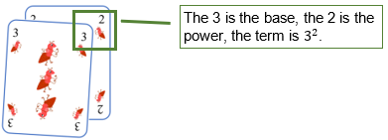
- In the example, the 3 is the base and the power is the 2, so the player would say ‘3 squared’. The player then writes the numerical term, $3^{2}$ on the scorecard and calculates the value of the term.
- The cards are then replaced in the pack of cards and it is Player 2’s turn to shuffle the cards and deal 2 cards to each player.
- The players, once again, decide on the order of their cards and fill in their scorecard, ensuring they add their score from round one to create a progressive score.
- There are 10 rounds. After the tenth round, the player with the highest score is the winner.

Assessment and differentiation

Suggested opportunities for differentiation
Launch
- Challenge students to visualise and draw arrays with a higher number of counters.
Explore
- To challenge students, ask them to calculate other square numbers.
- To challenge students, ask them to calculate other cubic numbers without the use of the centi-cubes.
- If students are comfortable with squaring and cubing positive integers, ask them to investigate squaring and cubing with negative integers or fractions and decimals.
- To challenge students, ask them to investigate the difference between ${(-3)}^{2}$ and $-3^{2}$. A calculator may be useful for this.
Summarise
- Provide students with a printed copy of Appendix D Chatterbox with blanks for students to complete.
Apply
- Challenge students to include negative numbers for some of the bases to play the game, so that a base of 3, for example, is changed to (-3).

Suggested opportunities for assessment
Explore
- Monitor student responses during discussion to assess their understanding of square numbers and cube numbers.
Summarise
- Observe whether students are correctly able to link terms, values and labels together in the Mix n Match activity.
Apply
- Monitor if students have used the power and base values to create the numerical terms in the next layer of the Chatterbox. When they are playing with the chatterbox, monitor that the students are using the mathematical language for the numerical terms.
- Monitor calculations of index terms during the ‘Ants go Marching’ game.

Appendix A

Arrays
Number of counters | Drawings | Description
4 |  | A 1 by 4 rectangle  A 2 by 2 square
5
6
7
8
9
10
12
15
16
20
25

Appendix B

How the ants marched
Formation | Number of ants
1 by 1
2 by 2
3 by 3
4 by 4
5 by 5
6 by 6
7 by 7
8 by 8
9 by 9
10 by 10

Appendix C

Chatterbox instructions
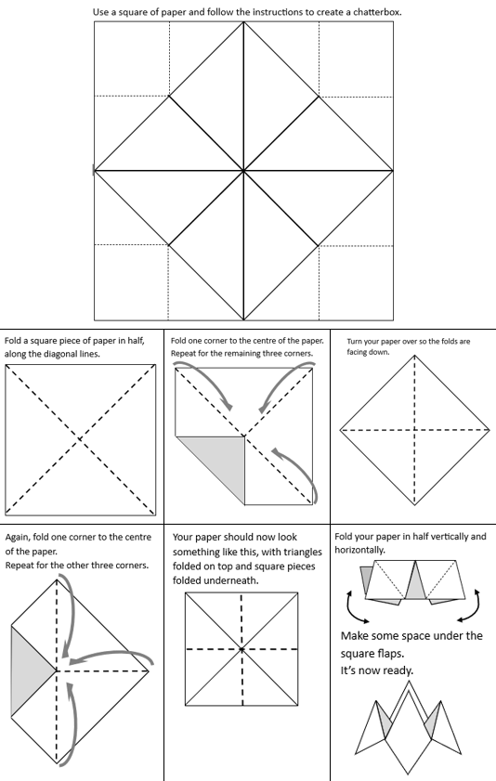

Appendix D

Chatterbox with blanks
The following template represents a chatterbox with blank spaces for students to complete.
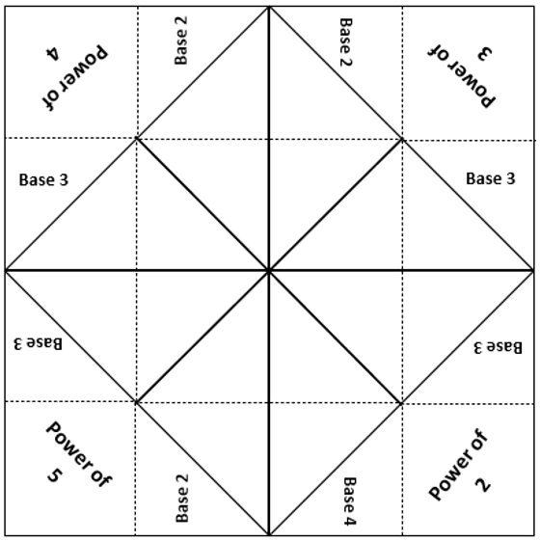

Appendix E

Scorecard
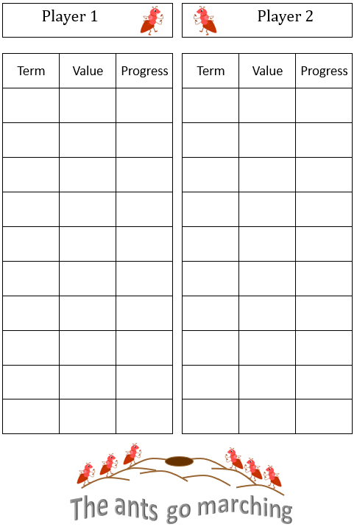

Appendix F

Playing cards
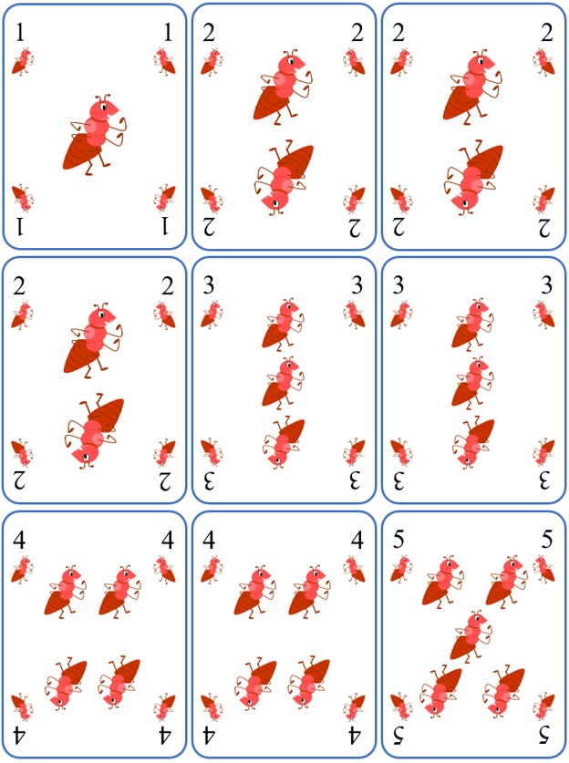

Sample solutions

Appendix A – arrays
Number of counters | Drawings | Description
4 |  | A 1 by 4 rectangle  A 4 by 1 rectangle  A 2 by 2 square
5 |  | A 1 by 5 rectangle
6 |  | A 1 by 6 rectangle  A 2 by 3 rectangle  A 3 by 2 rectangle
7 |  | A 1 by 7 rectangle
8 |  | A 1 by 8 rectangle  A 2 by 3 rectangle  A 3 by 2 rectangle
9 |  | A 1 by 9 rectangle  A 3 by 3 square
10 |  | A 1 by 10 rectangle  A 2 by 5 rectangle  A 5 by 2 rectangle
12 |  | A 1 by 12 rectangle  A 2 by 6 rectangle  A 6 by 2 rectangle  A 3 by 4 rectangle  A 4 by 3 rectangle
15 |  | A 1 by 15 rectangle  A 3 by 5 rectangle  A 5 by 3 rectangle
16 |  | A 1 by 16 rectangle  A 2 by 8 rectangle  An 8 by 2 rectangle  A 1 by 16 square
20 |  | A 1 by 20 rectangle  A 1 by 20 rectangle  A 1 by 20 rectangle
25 |  | A 1 by 25 rectangle  A 5 by 5 square

Appendix B – how the ants marched
Formation | Number of ants
1 by 1 | 1
2 by 2 | 4
3 by 3 | 9
4 by 4 | 16
5 by 5 | 25
6 by 6 | 36
7 by 7 | 49
8 by 8 | 64
9 by 9 | 81
10 by 10 | 100

Appendix C – chatterbox
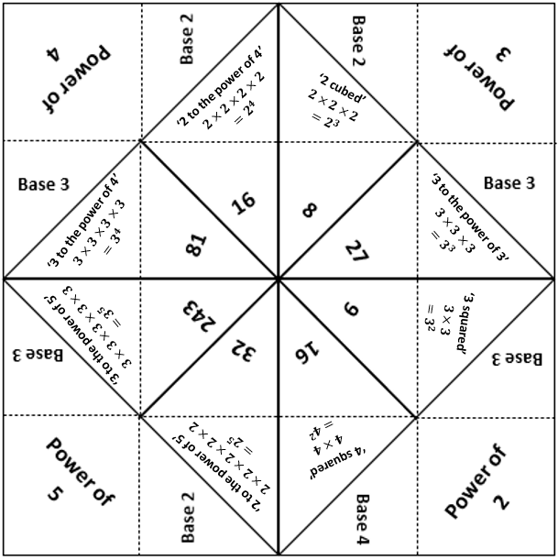

Appendix F – the ants go marching game
Possible combinations:
$1^{2}$=1, $1^{3}$=1, $1^{4}$=1, $1^{5}$=1, $2^{1}$=2, $2^{2}$=4, $2^{3}$=8, $2^{4}$=16, $2^{5}$=32, $3^{1}$=3, $3^{2}$=9, $3^{3}$=27, $3^{4}$=81, $3^{5}$=243, $4^{1}$=4, $4^{2}$=16, $4^{3}$=64, $4^{4}$=256, $4^{5}$=512, $5^{1}$=5, $5^{2}$=25, $5^{3}$=125, $5^{4}$=625

References
This resource contains NSW Curriculum and syllabus content. The NSW Curriculum is developed by the NSW Education Standards Authority. This content is prepared by NESA for and on behalf of the Crown in right of the State of New South Wales. The material is protected by Crown copyright.
Please refer to the NESA Copyright Disclaimer for more information https://educationstandards.nsw.edu.au/wps/portal/nesa/mini-footer/copyright.
NESA holds the only official and up-to-date versions of the NSW Curriculum and syllabus documents. Please visit the NSW Education Standards Authority (NESA) website https://educationstandards.nsw.edu.au/ and the NSW Curriculum website https://curriculum.nsw.edu.au/home.
Mathematics K–10 Syllabus © NSW Education Standards Authority (NESA) for and on behalf of the Crown in right of the State of New South Wales, 2022.

© State of New South Wales (Department of Education), 2023
The copyright material published in this resource is subject to the Copyright Act 1968 (Cth) and is owned by the NSW Department of Education or, where indicated, by a party other than the NSW Department of Education (third-party material).
Copyright material available in this resource and owned by the NSW Department of Education is licensed under a Creative Commons Attribution 4.0 International (CC BY 4.0) licence.
This licence allows you to share and adapt the material for any purpose, even commercially.
Attribution should be given to © State of New South Wales (Department of Education), 2023.
Material in this resource not available under a Creative Commons licence:
- the NSW Department of Education logo, other logos and trademark-protected material
- material owned by a third party that has been reproduced with permission. You will need to obtain permission from the third party to reuse its material.
Links to third-party material and websites
Please note that the provided (reading/viewing material/list/links/texts) are a suggestion only and implies no endorsement, by the New South Wales Department of Education, of any author, publisher, or book title. School principals and teachers are best placed to assess the suitability of resources that would complement the curriculum and reflect the needs and interests of their students.
If you use the links provided in this document to access a third-party's website, you acknowledge that the terms of use, including licence terms set out on the third-party's website apply to the use which may be made of the materials on that third-party website or where permitted by the Copyright Act 1968 (Cth). The department accepts no responsibility for content on third-party websites.

