A shopping plan
Students solve problems involving division of fractions. They compare fractions of foods they use daily with the quantity remaining. This leads into formally representing division of fractions.

Visible learning

Learning intentions
- To understand the division of fractions as forming sized groups.
- To be able to represent division of fractions and determine solutions from the representation.

Success criteria
- I can represent the division of fractions by comparing area models.
- I can explain the division of fractions as forming groups of a certain size.

Syllabus outcomes
A student:
- develops understanding and fluency in mathematics through exploring and connecting mathematical concepts, choosing and applying mathematical techniques to solve problems, and communicating their thinking and reasoning coherently and clearly MAO-WM-01
- represents and operates with fractions, decimals and percentages to solve problems MA4-FRC-C-01
Mathematics K–10 Syllabus © NSW Education Standards Authority (NESA) for and on behalf of the Crown in right of the State of New South Wales, 2022.
Please use the associated PowerPoint A shopping plan to display images in this lesson.

Activity structure

Launch
- Present to students the following scenario, also shown on slide 2 of the PowerPoint A shopping plan.
Ivy bakes a muesli bar slice on Monday morning and takes $\frac{1}{12}$ of the slice to work with her each weekday. By next Wednesday night, she has $\frac{1}{3}$ of the slice left.
Figure 1 – muesli bar slice with only one third left
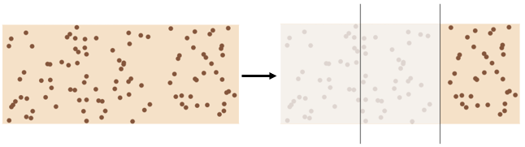
Image created using Desmos and is licensed under the Desmos Terms of Service.
How many more $\frac{1}{12}$ pieces can she make?
- Organise students into visibly random groups (bit.ly/visiblegroups) of 3 to discuss this problem.
- Use a Pause-Pose-Pounce-Bounce question strategy [PDF 200KB] (bit.ly/pausepouncebounce) to share student responses.

- Display Figure 2 and discuss the solution.
Figure 2 – four twelfths of the slice remain
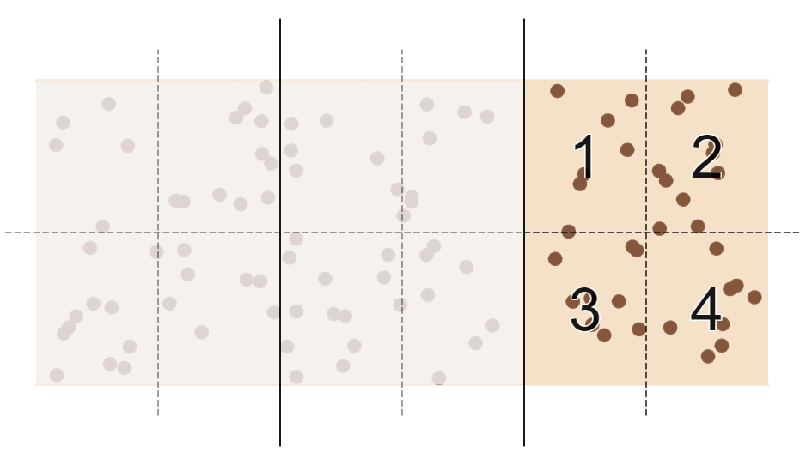
Image created using Desmos and is licensed under the Desmos Terms of Service.
- Explain to students that when we find how many $\frac{1}{12}$’s we can make from $\frac{1}{3}$ of a slice, we are calculating $\frac{1}{3}÷\frac{1}{12}$ by making specifically sized groups.
The language of ‘sized groups’ is introduced in Lesson 2, ‘Sharing, grouping and negating’ as an approach to viewing division, as opposed to ‘equal sharing’.
- Ask students to consider in their groups, if $\frac{1}{3}÷\frac{1}{12}=4$, what might $\frac{1}{5}÷\frac{1}{15}$ be equal to?
- Use a Pause-Pose-Pounce-Bounce question strategy to collect answers from students, encouraging them to explain their thinking and build upon suggestions from other students.
The intention of this discussion is to introduce the idea that we may be able to predict the result of a division of fractions, without formalising any process.

Explore
- Hand students Appendix A ‘Ivy’s lunch supplies’.
- Remaining in their groups of 3, have students use Appendix A to determine and record how many more serves of each product Ivy has left. The overall goal is to determine which product she will need to return to the shops for first.
If possible, have groups work at vertical, non-permanent surfaces (bit.ly/VNPSstrategy).

Summarise
- Use slides 5–12 from the A shopping plan PowerPoint for explicit teaching of dividing fractions.
The explicit teaching technique used in the associated PowerPoint is ‘Your turn.’ The first slide is a worked example which should be displayed for the students and then use the following steps.
- Reveal the question to students and its solution.
- Students read in silence.
- Students individually think and explain to themselves what is happening in each step.
- Students hold up a thumbs up to the teacher when they have finished reading and have some sort of understanding.
- Think-Pair-Share. Students explain the solution to their partner.
- In pairs, students then answer the self-explanation questions.
- Finally, randomly select students to share their answers with the whole class.
- Hand students a copy of Appendix B ‘Representing division of fractions’ and have students follow the given example to represent division of fractions.
For students with access to a device with internet, they can use the Desmos graph (bit.ly/DesmosDivideFrac) to construct representations of the fraction divisions.
- Have students engage in a Think-Pair-Share (bit.ly/thinkpairsharestrategy) to discuss patterns they notice in the question and again in the solution.
Processes such as inverting the second fraction before multiplying the fractions, or dividing the numerators and the denominators before simplifying can produce solutions. They do, however, run the risk of students losing connection with the visual and real concept of division. Teachers may choose to summarise processes for dividing fractions with students by noticing patterns in step 3 above, encouraging the use of visual representations to explain solutions.

Apply

Open middle problem
- Challenge students to complete the open middle problem displayed on slides 13–14 of the A shopping plan PowerPoint. This problem is also displayed in Figure 3 and is inspired by the problem at the ‘Open middle’ website (bit.ly/OMDivideFrac).
Figure 3 – open middle problem
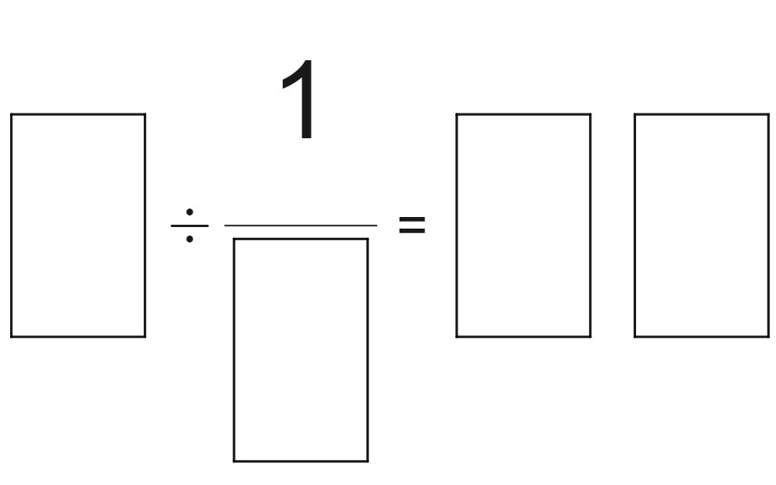
Image created using Desmos and is licensed under the Desmos Terms of Service.
- Students are to use the integers from 1 to 9 at most once to obtain the largest possible result. Teachers can print this from Appendix C ‘Open middle problem’ if desired.
- Similar open middle problems can be found at the ‘Open middle’ website (bit.ly/DivideFracOM).

Assessment and differentiation

Suggested opportunities for differentiation
Explore
- Students can be encouraged to either draw bar models or use counters to represent the quantities Ivy has and will use for each product.
Summarise
- The use of the Desmos graph for fraction division supports more students to have access to these activities and the ability to reflect on trends in results.
- Appendix B encourages students to use visual representations to perform fraction division while maintaining connection to the underlying concept.
Apply
- The general link to the ‘Open middle’ website (bit.ly/DivideFracOM) includes a range of additional problems, furthering the challenges available.

Suggested opportunities for assessment
Explore
- Student responses to Appendix B provide evidence of their interpretation of division of fractions.
Summarise
- Teachers may choose to collect Appendix C as evidence of students’ abilities to represent quantities as fractions, as well as interpreting division of fractions as forming sized groups.

Appendix A

Ivy’s lunch supplies
For each item, the table displays how much Ivy has left and how much she takes to work each day. Find how many more servings Ivy can have of all her items and record it in the final column of the table.
Item | Fraction left | Fraction required | How many more servings can Ivy have?
Muesli bar slice | $$\frac{1}{3}$$ | $$\frac{1}{12}$$ | $$4$$
Loaf of bread | $$\frac{1}{2}$$ | $$\frac{1}{10}$$
Coffee | $$\frac{1}{2}$$ | $$\frac{1}{16}$$
Watermelon | $$\frac{5}{6}$$ | $$\frac{1}{6}$$
Salad | $$\frac{2}{3}$$ | $$\frac{1}{6}$$
Nuts | $$\frac{2}{5}$$ | $$\frac{1}{10}$$
How many days will it be before Ivy runs out of something and needs to go to the shops?

Appendix B

Representing division of fractions
Calculation | Representation | Solution
$$\frac{1}{2}÷\frac{1}{8}$$ | 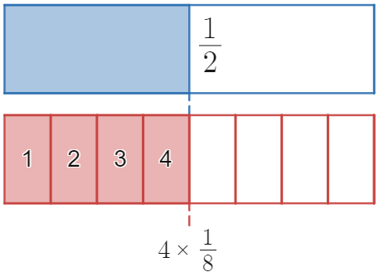
$$\frac{1}{2}÷\frac{1}{4}$$
$$\frac{3}{2}÷\frac{1}{4}$$
$$\frac{1}{2}÷\frac{2}{8}$$
$$\frac{3}{2}÷\frac{1}{6}$$
$$\frac{3}{2}÷\frac{1}{12}$$
$$\frac{3}{2}÷\frac{2}{12}$$
$$\frac{3}{2}÷\frac{1}{10}$$
$$\frac{16}{10}÷\frac{1}{10}$$
$$\frac{16}{20}÷\frac{1}{10}$$
$$\frac{16}{20}÷\frac{1}{5}$$
$$\frac{16}{20}÷\frac{2}{5}$$
$$\frac{16}{20}÷\frac{4}{5}$$

Appendix C

Open middle problem
Use the integers from 1 to 9 at most once to make a product of fractions that makes this equation correct.

Sample solutions

Appendix A – Ivy’s lunch supplies
Item | Fraction left | Fraction required | How many more can Ivy have?
Muesli bar slice | $$\frac{1}{3}$$ | $$\frac{1}{12}$$ | $$4$$
Loaf of bread | $$\frac{1}{2}$$ | $$\frac{1}{10}$$ | $$5$$
Coffee | $$\frac{1}{2}$$ | $$\frac{1}{16}$$ | $$8$$
Watermelon | $$\frac{5}{6}$$ | $$\frac{1}{6}$$ | $$5$$
Salad | $$\frac{2}{3}$$ | $$\frac{1}{6}$$ | $$4$$
Nuts | $$\frac{2}{5}$$ | $$\frac{1}{10}$$ | $$4$$

Appendix B – representing division of fractions
Calculation | Representation | Solution
$$\frac{1}{2}÷\frac{1}{8}$$ |  | $$4$$
$$\frac{1}{2}÷\frac{1}{4}$$ | 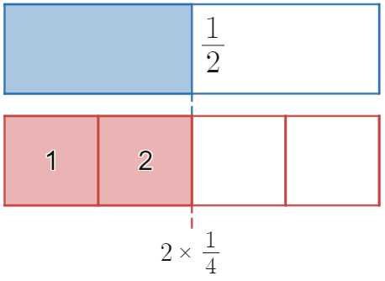 | $$2$$
$$\frac{3}{2}÷\frac{1}{4}$$ | 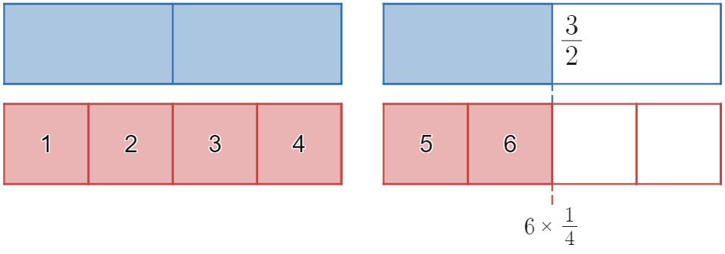 | $$6$$
$$\frac{1}{2}÷\frac{2}{8}$$ | 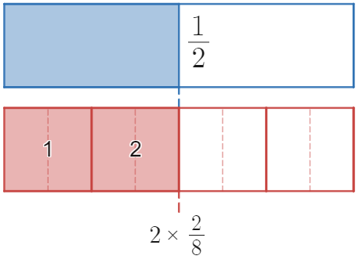 | $$2$$
$$\frac{3}{2}÷\frac{1}{6}$$ | 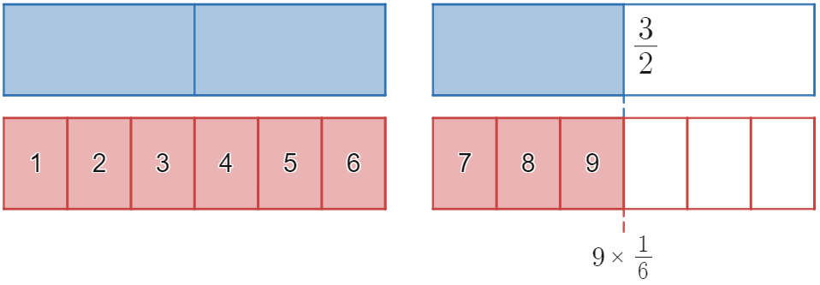 | $$9$$
$$\frac{3}{2}÷\frac{1}{12}$$ | 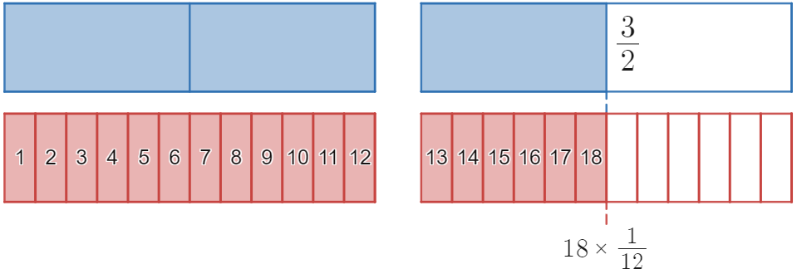 | $$18$$
$$\frac{3}{2}÷\frac{2}{12}$$ | 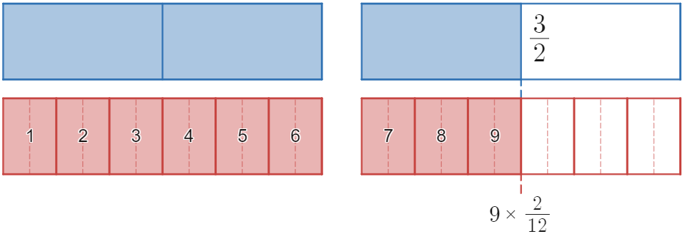 | $$9$$
$$\frac{3}{2}÷\frac{1}{10}$$ | 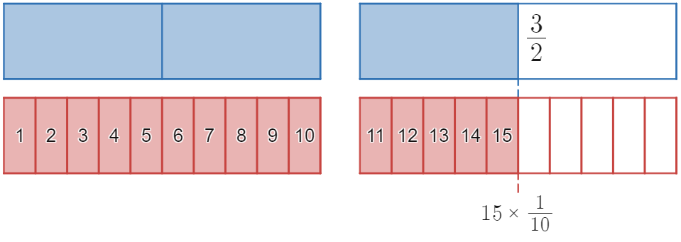 | $$15$$
$$\frac{16}{10}÷\frac{1}{10}$$ | 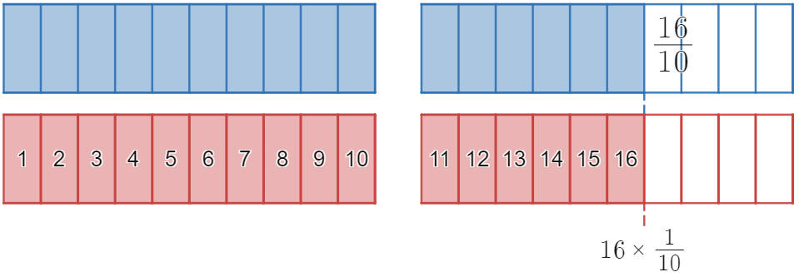 | $$16$$
$$\frac{16}{20}÷\frac{1}{10}$$ | 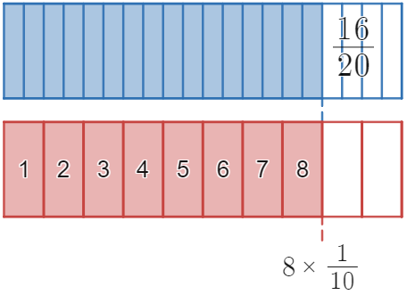 | $$8$$
$$\frac{16}{20}÷\frac{1}{5}$$ | 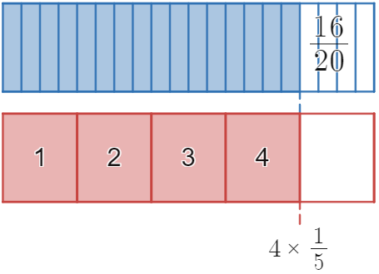 | $$4$$
$$\frac{16}{20}÷\frac{2}{5}$$ | 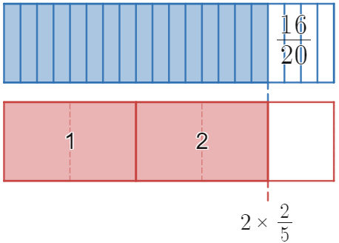 | $$2$$
$$\frac{16}{20}÷\frac{4}{5}$$ | 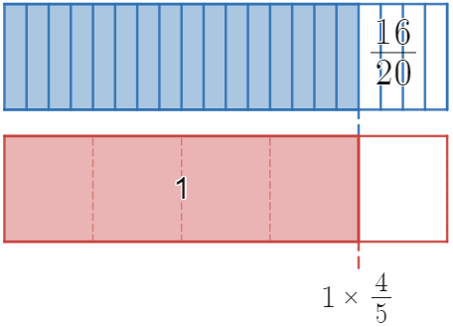 | $$1$$

Appendix C – open middle problem
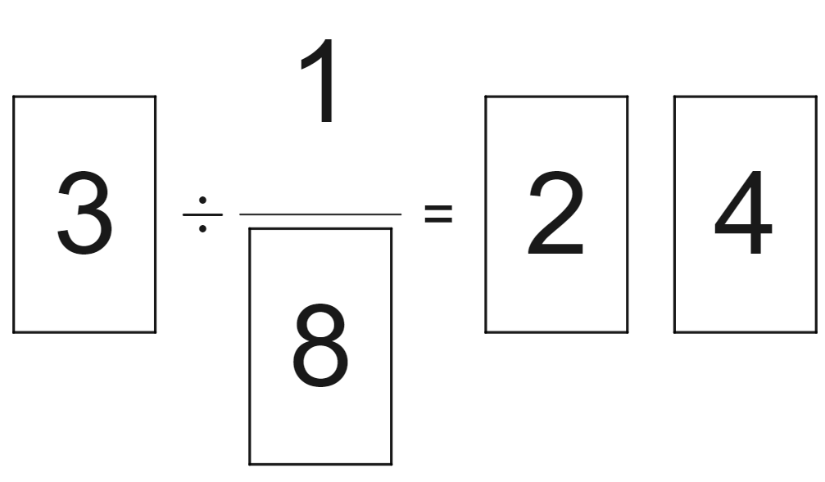

References
This resource contains NSW Curriculum and syllabus content. The NSW Curriculum is developed by the NSW Education Standards Authority. This content is prepared by NESA for and on behalf of the Crown in right of the State of New South Wales. The material is protected by Crown copyright.
Please refer to the NESA Copyright Disclaimer for more information https://educationstandards.nsw.edu.au/wps/portal/nesa/mini-footer/copyright.
NESA holds the only official and up-to-date versions of the NSW Curriculum and syllabus documents. Please visit the NSW Education Standards Authority (NESA) website https://educationstandards.nsw.edu.au/ and the NSW Curriculum website https://curriculum.nsw.edu.au/home.
Mathematics K–10 Syllabus © NSW Education Standards Authority (NESA) for and on behalf of the Crown in right of the State of New South Wales, 2022.
© State of New South Wales (Department of Education), 2023
The copyright material published in this resource is subject to the Copyright Act 1968 (Cth) and is owned by the NSW Department of Education or, where indicated, by a party other than the NSW Department of Education (third-party material).
Copyright material available in this resource and owned by the NSW Department of Education is licensed under a Creative Commons Attribution 4.0 International (CC BY 4.0) licence.
This licence allows you to share and adapt the material for any purpose, even commercially.
Attribution should be given to © State of New South Wales (Department of Education), 2023.
Material in this resource not available under a Creative Commons licence:
- the NSW Department of Education logo, other logos and trademark-protected material
- material owned by a third party that has been reproduced with permission. You will need to obtain permission from the third party to reuse its material.
Links to third-party material and websites
Please note that the provided (reading/viewing material/list/links/texts) are a suggestion only and implies no endorsement, by the New South Wales Department of Education, of any author, publisher, or book title. School principals and teachers are best placed to assess the suitability of resources that would complement the curriculum and reflect the needs and interests of their students.
If you use the links provided in this document to access a third-party's website, you acknowledge that the terms of use, including licence terms set out on the third-party's website apply to the use which may be made of the materials on that third-party website or where permitted by the Copyright Act 1968 (Cth). The department accepts no responsibility for content on third-party websites.

