A fair share
Students review situations where common totals are added or subtracted from significantly different quantities before applying common percentages to make increases and decreases ‘fair’.
Students will need at least one digital device per pair to interact with Desmos during this lesson.

Visible learning

Learning intentions
- To understand that percentage increases and decreases depend on the original quantity.
- To be able to visually represent, calculate and interpret percentage increases and decreases.

Success criteria
- I can calculate a percentage of a quantity.
- I can represent percentage increases and decreases using a bar model.
- I can compare percentage increases and decreases of different quantities.
- I can explain why percentage increases and decreases are often applied for ‘fairness’.

Syllabus outcomes
A student:
- develops understanding and fluency in mathematics through exploring and connecting mathematical concepts, choosing and applying mathematical techniques to solve problems, and communicating their thinking and reasoning coherently and clearly MAO-WM-01
- represents and operates with fractions, decimals and percentages to solve problems MA4-FRC-C-01
Mathematics K–10 Syllabus © NSW Education Standards Authority (NESA) for and on behalf of the Crown in right of the State of New South Wales, 2022.
Please use the associated PowerPoint A fair share to display images in this lesson.

Activity structure

Launch

Pay rises
- Display Table 1 on the screen for students. This table is available as an image on slide 2 of the A fair share PowerPoint. Tell students that each of these people just got a $100 pay rise per week.
Table 1 – weekly pay
A taxi driver earns $420 per week. | A teenager delivers newspapers 3 days a week and receives $130.
A teacher earns $1842 per week. | A doctor earns $3187 per week.
- Have students engage in a Think-Pair-Share (bit.ly/thinkpairsharestrategy) to discuss how each person feels after their $100 per week pay increase. Is this $100 the same for each person?
Students will hopefully contribute that the teenager’s pay will almost double, going from $130 to $230, while the doctor will barely notice the difference, going from $3187 to $3287.
- Ask students to discuss, in their pairs, a situation where everyone is taxed the same and each of the people in Table 1 is required to pay $100 tax each week.
Teachers may take this opportunity to briefly discuss what tax is and why it exists. In this situation, clearly a $100 tax would impact the teenager and taxi driver far greater than it would the teacher or doctor.

Product discounts
- Display Table 2 on the screen for students. This table is available as an image on slide 3 of the A fair share PowerPoint. Tell students that an electronics store has decided to take $100 off the price of each of these products.
Table 2 – price of electronic items
An iPad costs $549. | A washing machine costs $999.
A smart TV costs $3459. | A wireless phone charger costs $101.
- Have students again engage in a Think-Pair-Share to discuss the impact of the $100 discount on each product. Is it fair to remove $100 for each product?
Students will hopefully contribute that the wireless phone charger will be almost free, going from $101 to $1, while the price of the smart TV will barely be different, going from $3459 to $3359.
- Using a Pause-Pose-Pounce-Bounce question strategy [PDF 200KB] (bit.ly/pausepouncebouncestrategy), ask students to share how we might make the pay increases and product discounts fair in both situations.

Explore

Percentage decrease
- Inform students that one way to ensure fairness is to increase and decrease things by a percentage.
- Hand students a copy of Appendix A ‘Discount prices’.
- Explain to students that we are looking at an electronics store that sells products such as Smart TVs, tablets and laptops. Appendix A shows the prices of various items from the store.
- Read out the scenario at the top of Appendix A.
Teachers may need to define the term ‘discount’ as a reduction in the price.
- Organise students into visibly random groups of 3 (bit.ly/visiblegroups) and instruct them to find the price of each item after a 50% discount and record this in the table.
Teachers may choose to inform students that there are other familiar ways to interpret a 50% discount, such as ‘half price’ or ‘half off’. It is intended that students use any strategies they have, to find these results.
- Using a Pose-Pause-Pounce-Bounce question strategy [PDF 200KB] (bit.ly/pausepouncebounce), ask students to share their methods for finding the prices with a 50% discount.
- Open the Desmos graph ‘Percentage decrease’ (bit.ly/DesmosPerDec) on the teacher screen.
- Demonstrate the price of the blender from Appendix A by dragging the slider for the quantity to 150, as shown below.
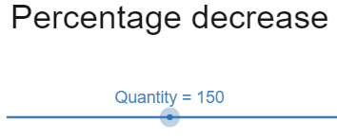
Image created using Desmos and is licensed under the Desmos Terms of Service.
- Turn on the Bar model using the slider shown below to show how we represent the total and divide it into 10 equal groups to show steps of 10%.
Image created using Desmos and is licensed under the Desmos Terms of Service.
- Lead a discussion with students about what is going on in the bar model image. Figure 1 below shows what this bar model should look like.
Figure 1 – bar model for $150
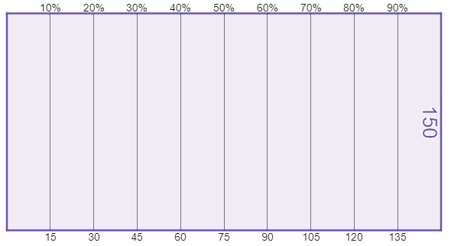
Image created using Desmos and is licensed under the Desmos Terms of Service.
- Turn on the percentage decrease imagery using the slider at the bottom of the screen, shown in the image below.
Image created using Desmos and is licensed under the Desmos Terms of Service.
- Drag the red slider to show a 10% percentage decrease. The graph should now look like Figure 2, shown below. Have students enter the result, $135 into their table in Appendix A.
Figure 2 – bar model for a percentage decrease
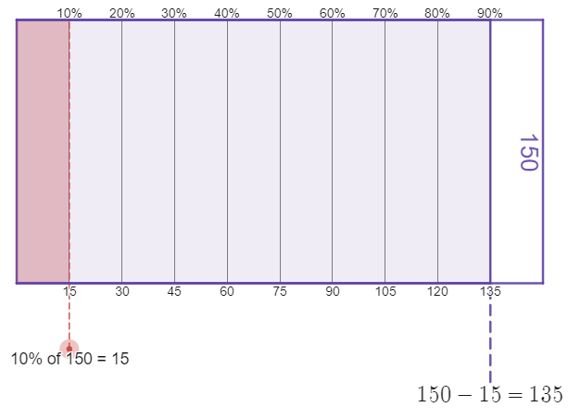
Image created using Desmos and is licensed under the Desmos Terms of Service.
- Demonstrate how to change the percentage decrease on the left of screen to find a discount of 16%.
Teachers may choose to adjust the ‘Quantity’ slider from step 8 to show that the bar model does not change size. Discussions with students that a rectangle can represent any quantity could benefit students using bar models in future.
- Have students use the Desmos graph ‘Percentage decrease’ to complete the table in Appendix A before answering the questions underneath the table and sharing as a class.
- Display the Desmos graph ‘Percentage decrease comparison’ (bit.ly/DesmosPDCompare) on the teacher screen or give the link to students to view. The current prices of the four products on the Desmos screen represent the first 4 products in the table in Appendix A.
- Switch the ‘Turn on decrease’ slider shown below.
Image created using Desmos and is licensed under the Desmos Terms of Service.
- Have students discuss the following reflection questions before sharing as a class.
- What do you notice about the change in the 4 amounts?
- What do you wonder?
- What happens when you change the percentage that you are decreasing the prices by (use the slider).

Percentage increase
- Hand students a copy of Appendix B ‘Pay rises’.
- Explain to students that the cost of living increases every year and that everyone’s pay needs to increase to keep up. Appendix B shows examples of the weekly pay of a variety of professions.
- Open the Desmos graph ‘Percentage increase’ (bit.ly/DesmosPerInc) on the teacher screen.
- Demonstrate the pay of the cleaner from Appendix B by dragging the slider for the quantity to 183, as shown below.
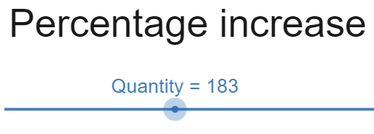
Image created using Desmos and is licensed under the Desmos Terms of Service.
- Turn on the Bar model using the slider shown below to show how we represent the total and divide it into 10 equal groups to show steps of 10%.
Image created using Desmos and is licensed under the Desmos Terms of Service.
- Lead a discussion with students about what is going on in the bar model image. Figure 3 below shows what this bar model should look like.
Figure 3 – bar model for $183
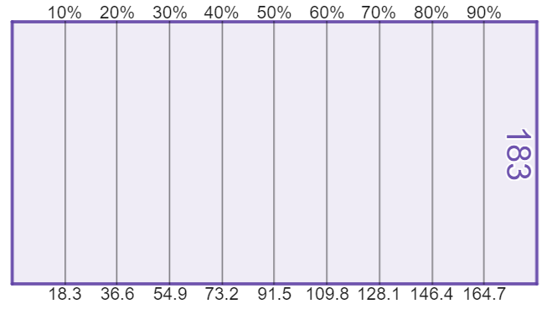
Image created using Desmos and is licensed under the Desmos Terms of Service.
- Turn on the percentage increase imagery using the slider at the bottom of the screen, shown in the image below.
Image created using Desmos and is licensed under the Desmos Terms of Service.
- Drag the red slider to show a 6% percentage increase. The graph should now look like Figure 4, shown below. Have students enter the result, $194 (rounded to the nearest whole number) into their table in Appendix B.
Figure 4 – bar model for percentage increase
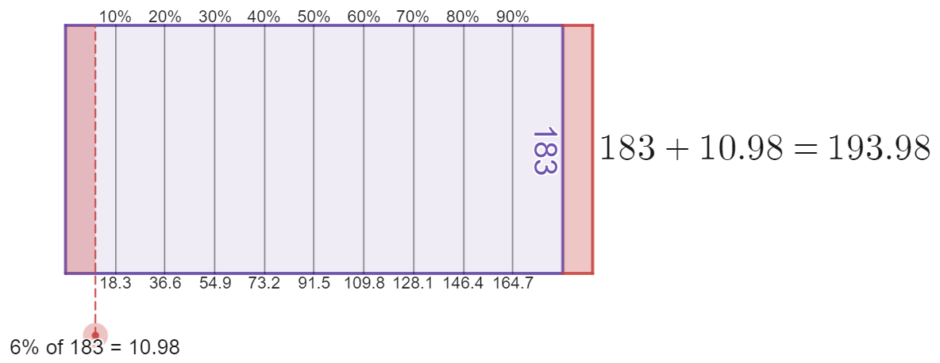
Image created using Desmos and is licensed under the Desmos Terms of Service.
- Demonstrate how to change the percentage increase on the left of screen to find a rise of 10% and then 18%.
- Have students use the Desmos graph ‘Percentage increase’ to complete the table in Appendix B before answering the questions underneath the table and sharing as a class.
- Display the Desmos graph ‘Percentage increase comparison’ (bit.ly/DesmosPICompare) on the teacher screen or give the link to students to view.
- Switch the ‘Turn on increase’ slider shown below.
Image created using Desmos and is licensed under the Desmos Terms of Service.
- Have students discuss the following reflection questions before sharing as a class.
- What do you notice about the change in the 4 amounts?
- What do you wonder?
- What happens when you change the percentage that you are increasing the prices by (use the slider).
- Conclude with students that for both increases and decreases, percentages can create ‘fairness’, as the amount we increase or decrease depends on the amount we start with.

Summarise
- Use slides 4–11 from the A fair share PowerPoint for explicit teaching of increasing and decreasing quantities by a percentage.
The explicit teaching technique used in the associated PowerPoint is ‘Your turn.’ The first slide is a worked example which should be displayed for the students and then use the following steps.
      - Reveal the question to students and its solution.
      - Students read in silence.
      - Students individually think and explain to themselves what is happening in each step.
      - Students hold a thumbs up to the teacher when they have finished reading and have some sort of understanding.
      - Think-Pair-Share. Students explain the solution to their partner.
      - In pairs, students then answer the self-explanation questions.
      - Finally, randomly select students to share their answers with the whole class.
- Have students complete Appendix C ‘Percentage change’, representing their percentage change as a bar model to aid computation.
- Have students write notes to their future forgetful selves (bit.ly/notesstrategy) on how to perform percentage increases and decreases and any identified trends to expect.

Apply

Increases and decreases
- Hand students Appendix D ‘Down and not quite back’.
- Have students work in groups of 3 to answer the questions in Appendix D.
Appendix D asks students to perform a 10% decrease followed by a 10% increase and to explain and represent why these do not arrive back at the original result.
- After a period of allowing students to consider and discuss why the decrease and increase are not equal, give groups access to the Desmos graph ‘Percentage increase AND decrease’ (bit.ly/DesmosPercDaI).
Students can use the Desmos graph and follow the switches to represent a percentage increase followed by a percentage decrease.

Assessment and differentiation

Suggested opportunities for differentiation
Launch
- By asking students to comment generally and in groups about what pay increases and product discounts feel like, this task has a low floor for access by all students.
- Some students may immediately look to discuss how the pay increases and product discounts are different by using fractions, decimals or percentages to compare. These students can be encouraged to represent the changes in as many forms as possible and to write their arguments in words.
Explore
- The Desmos graphs allow all students to complete calculations and supports students focusing on the result before moving to any abstract calculations.
Summarise
- Students can continue to use the Desmos graphs ‘Percentage increase’ and ‘Percentage decrease’ to complete Appendix C.

Suggested opportunities for assessment
Launch
- This activity is an opportunity to assess whether students are using additive or multiplicative thinking.
- These discussions provide opportunities for students to demonstrate both reasoning skills and their ability to use calculations to support their arguments. Teachers can listen and record students who are referring to fractions, decimals and percentages to justify their opinions.
Summarise
- Appendix C can be collected to assess students on both their ability to represent percentage change using a bar model, as well as their ability to apply and calculate percentage change.
Apply
- Appendix D can be collected as evidence of the students’ ability to communicate mathematically and to use both mathematical calculations and diagrams to support their reasoning.

Appendix A

Discount prices
An electronics store has 3 discount sales in a year, with everything in the store discounted by a percentage. The original prices of items for sale in the store are listed below. Write the discount price of each item for the 3 sales.
Item | Original price | Sale 1: 50% discount price | Sale 2: 10% discount price | Sale 3: 16% discount price
Screen cleaner | $14
Car charger | $20
Phone case | $68
Tablet pen | $94
Blender | $150
Microwave | $230
Fan heater | $800
Vacuum cleaner | $849
Coffee machine | $998
- In each sale, which product decreased by the most?
- Which product decreased by the least?

Appendix B

Pay rises
In the table below, the daily pay rate of 5 professions is shown. Every year each person is given a pay increase by a percentage. Write the new daily pay for each person for the three different percentage increases.
Profession | Original daily pay | Pay increase of 6% | Pay increase of 10% | Pay increase of 18%
Cleaner | $183
Shop assistant | $230
Electrician | $327
Pharmacist | $387
Doctor | $637
- Which profession gets the largest pay increase in each column?
- Which profession’s daily pay increased by the least in each column?
- Did the gap between pay for different professions get larger or smaller when they all increased?

Appendix C

Percentage change
Problem | Bar model | Result
Increase $80 by 10% | 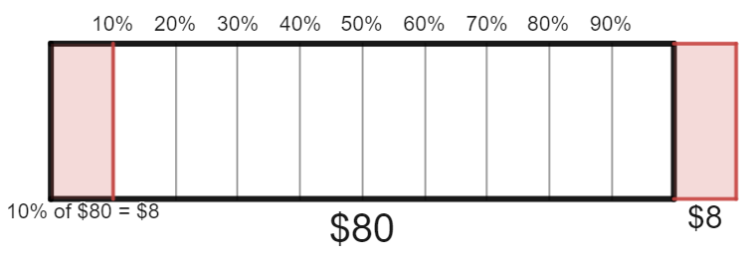 | $$80+8=\$88$$
Increase $80 by 5% | 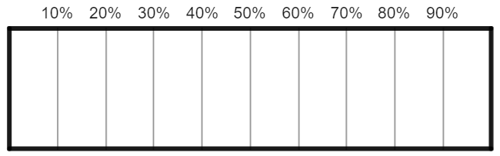
Decrease $80 by 5%
Decrease $40 by 5%
Decrease $40 by 15%
Increase $40 by 30%
Increase $40 by 10%
Increase $140 by 10%
Decrease $140 by 20%
Decrease $280 by 10%
Increase $50 by 10%
Decrease $55 by 9%
Decrease 55 kg by 9%
Increase 3.2 kg by 25%
Decrease 4 kg by 20%
Image created using Desmos and is licensed under the Desmos Terms of Service.

Appendix D

Down and not quite back
A restaurant goes through challenging times during the 2021 COVID-19 lockdowns and all staff agree to take a 10% pay cut to avoid having to shut the business. Then in 2022 when the lockdown is over, everyone is given a 10% increase in pay. The pay for 3 different people is listed in the table below.
Profession | Original daily pay | 2021 daily pay (10% decrease) | 2022 daily pay (10% increase)
Manager | $510 | $459 | $504.90
Chef | $340 | $306 | $336.60
Waiter | $260 | $234
- Complete the final cell of the table to find the 2022 daily pay for the waiter.
- Write an explanation why the 2022 pay has not returned to the original daily pay in the first column. Use a bar model representation and an example pay to help show why this has happened.

Sample solutions

Appendix A – discount prices
Item | Original price | Sale 1: 50% discount price | Sale 2: 10% discount price | Sale 3: 16% discount price
Screen cleaner | $14 | $7 | $12.60 | $11.76
Car charger | $20 | $10 | $18 | $16.80
Phone case | $68 | $34 | $61.20 | $57.12
Tablet pen | $94 | $47 | $84.60 | $78.96
Blender | $150 | $75 | $135 | $126
Microwave | $230 | $115 | $207 | $193.20
Fan heater | $800 | $400 | $720 | $672
Vacuum cleaner | $849 | $424.50 | $764.10 | $713.16
Coffee machine | $998 | $499 | $898.20 | $838.32
- In each sale, which product decreased by the most?
- The coffee machine decreased by the most in every sale.
- Which product decreased by the least?
- The screen cleaner decreased by the least in every sale.

Appendix B – pay rises
Profession | Original daily pay | Pay increase of 6% | Pay increase of 10% | Pay increase of 18%
Cleaner | $183 | $194 | $201 | $216
Shopping assistant | $230 | $244 | $253 | $271
Electrician | $327 | $347 | $360 | $386
Pharmacist | $387 | $410 | $426 | $457
Doctor | $637 | $675 | $701 | $752
- Which profession gets the largest pay increase in each column?
Doctor gets the largest pay increase.
- Which profession’s daily pay increased by the least in each column?
Cleaner gets the least pay increase.
- Did the gap between pay for different professions get larger or smaller when they all increased?
The gap between pay for the different professions gets larger with any increase.

Appendix C – percentage change
Problem | Bar model | Result
Increase $80 by 10% |  | $$80+8=\$88$$
Increase $80 by 5% | 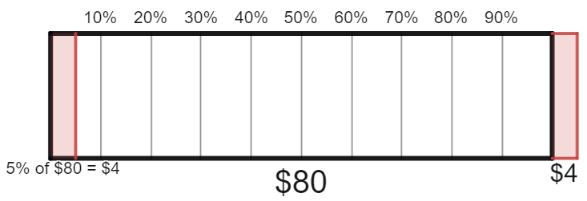 | $$80+4=\$84$$
Decrease $80 by 5% | 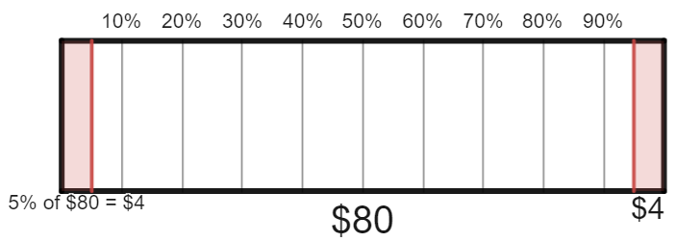 | $$80-5=\$75$$
Decrease $40 by 5% | 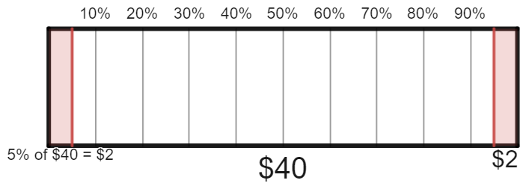 | $$40-2=\$38$$
Decrease $40 by 15% | 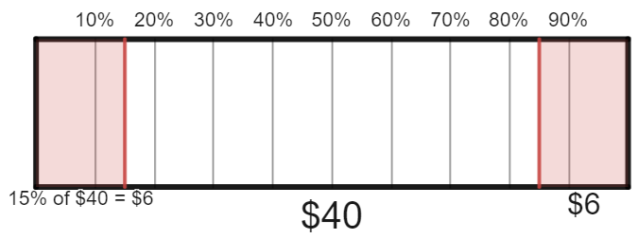 | $$40-6=\$34$$
Increase $40 by 30% | 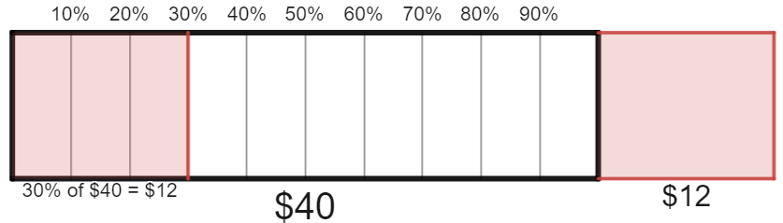 | $$40+12=\$52$$
Increase $40 by 10% | 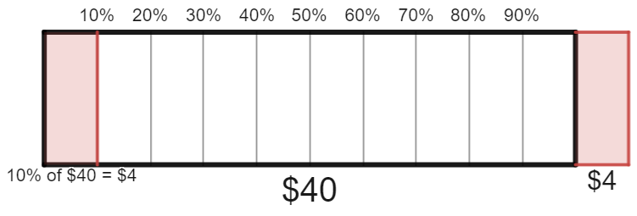 | $$40+4=\$44$$
Increase $140 by 10% | 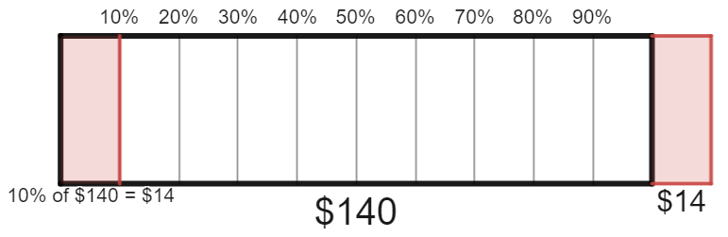 | $$140+14=\$154$$
Decrease $140 by 20% | 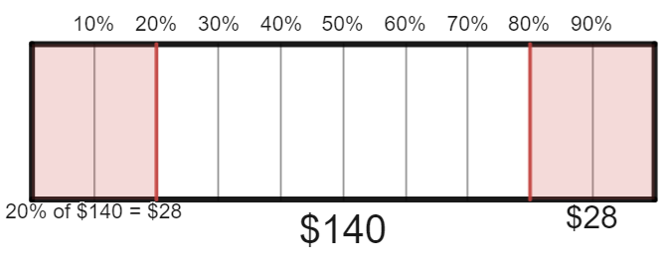 | $$140-28=\$112$$
Decrease $280 by 10% | 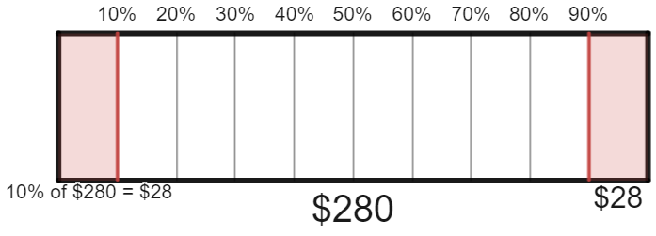 | $$280-28=\$252$$
Increase $50 by 10% | 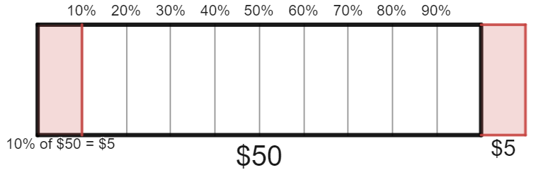 | $$50+5=\$55$$
Decrease $55 by 9% | 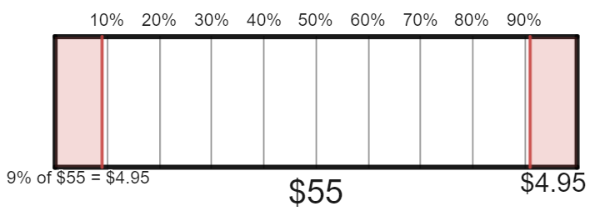 | $$55-4.95=\$50.05$$
Decrease 55 kg by 9% | 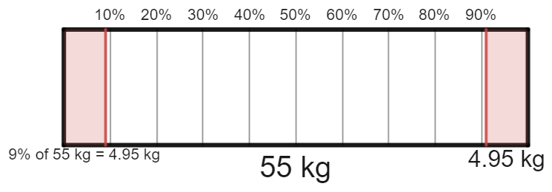 | $55-4.95=50.05$ kg
Increase 3.2 kg by 25% | 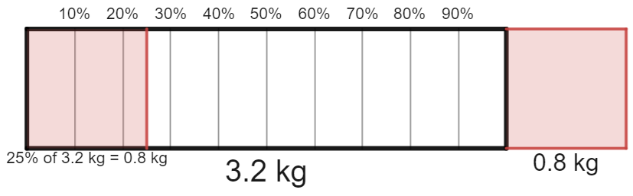 | $3.2+0.8=4$ kg
Decrease 4 kg by 25% | 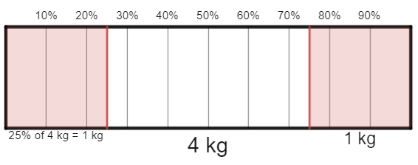 | $4-1=3$ kg
Image created using Desmos and is licensed under the Desmos Terms of Service.

Appendix D – down and not quite back
A restaurant goes through challenging times during the 2021 COVID-19 lockdowns and all staff agree to take a 10% pay cut to avoid having to shut the business. Then in 2022 when the lockdown is over, everyone is given a 10% increase in pay. The pay for 3 different people is listed in the table below.
Profession | Original daily pay | 2021 daily pay (10% decrease) | 2022 daily pay (10% increase)
Manager | $510 | $459 | $504.90
Chef | $340 | $306 | $336.60
Waiter | $260 | $234 | $257.40
- Complete the final cell of the table to find the 2022 daily pay for the waiter.
- Write an explanation why the 2022 pay has not returned to the original daily pay in the first column. Use a bar model representation and an example pay to help show why this has happened.
When everyone’s pay decreased, they went down by 10% of their original pay. When their pay was increased again, it went up by 10% of their reduced pay, which is a smaller amount.
For example, looking at the pay of the manager, in 2021 their pay went down by 10%. This was a decrease of 10% of $510, which is $51. Their new pay was $459.
In 2022, their pay went up by 10% of $459, which is $45.90. Their final pay was $459 + $45.90, which is $504.90.
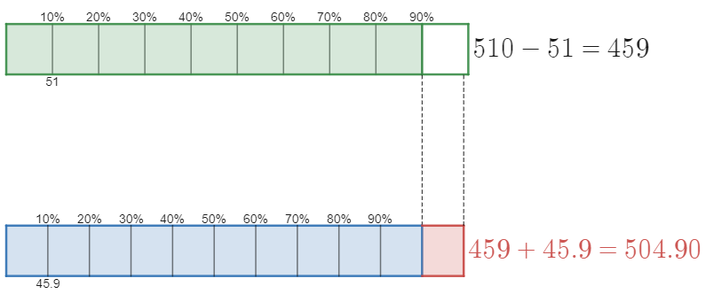
Image created using Desmos and is licensed under the Desmos Terms of Service.

References
This resource contains NSW Curriculum and syllabus content. The NSW Curriculum is developed by the NSW Education Standards Authority. This content is prepared by NESA for and on behalf of the Crown in right of the State of New South Wales. The material is protected by Crown copyright.
Please refer to the NESA Copyright Disclaimer for more information https://educationstandards.nsw.edu.au/wps/portal/nesa/mini-footer/copyright.
NESA holds the only official and up-to-date versions of the NSW Curriculum and syllabus documents. Please visit the NSW Education Standards Authority (NESA) website https://educationstandards.nsw.edu.au/ and the NSW Curriculum website https://curriculum.nsw.edu.au/home.
Mathematics K–10 Syllabus © NSW Education Standards Authority (NESA) for and on behalf of the Crown in right of the State of New South Wales, 2022.

© State of New South Wales (Department of Education), 2023
The copyright material published in this resource is subject to the Copyright Act 1968 (Cth) and is owned by the NSW Department of Education or, where indicated, by a party other than the NSW Department of Education (third-party material).
Copyright material available in this resource and owned by the NSW Department of Education is licensed under a Creative Commons Attribution 4.0 International (CC BY 4.0) licence.
This licence allows you to share and adapt the material for any purpose, even commercially.
Attribution should be given to © State of New South Wales (Department of Education), 2023.
Material in this resource not available under a Creative Commons licence:
- the NSW Department of Education logo, other logos and trademark-protected material
- material owned by a third party that has been reproduced with permission. You will need to obtain permission from the third party to reuse its material.
Links to third-party material and websites
Please note that the provided (reading/viewing material/list/links/texts) are a suggestion only and implies no endorsement, by the New South Wales Department of Education, of any author, publisher, or book title. School principals and teachers are best placed to assess the suitability of resources that would complement the curriculum and reflect the needs and interests of their students.
If you use the links provided in this document to access a third-party's website, you acknowledge that the terms of use, including licence terms set out on the third-party's website apply to the use which may be made of the materials on that third-party website or where permitted by the Copyright Act 1968 (Cth). The department accepts no responsibility for content on third-party websites.

