Groups of mysteries
Students use area models to explore conventions of simplifying algebraic expressions involving multiplication.

Visible learning

Learning intention
- To understand common conventions for writing and simplifying algebraic expressions involving multiplication.

Success criteria
- I can interpret algebraic terms involving multiplication.
- I can simplify algebraic expressions involving multiplication.
- I can construct an area model to represent the multiplication of 2 algebraic terms.

Syllabus outcomes
A student:
- develops understanding and fluency in mathematics through exploring and connecting mathematical concepts, choosing and applying mathematical techniques to solve problems, and communicating their thinking and reasoning coherently and clearly MAO-WM-01
- generalises number properties to operate with algebraic expressions including expansion and factorisation MA4-ALG-C-01
Mathematics K–10 Syllabus © NSW Education Standards Authority (NESA) for and on behalf of the Crown in right of the State of New South Wales, 2022.
Please use the associated PowerPoint Groups of mysteries to display images in this lesson.

Activity structure

Launch
- Display or read out the following scenario to students.
‘We have received 7 boxes of paper, each with 5 reams inside. Each ream has the same number of sheets of paper, but we do not know how many. How many sheets of paper do we have?’
- In a Think-Pair-Share students are to write an expression for this problem.
Variations from students may include $7×5×p$, $35×p$ or $35p$. Students may need to be prompted that they will need to use a pronumeral to represent the unknown number of sheets of paper.
- Explain to students that the use of the pronumeral makes this an algebraic expression.
- Add to the situation that we now know that the reams have 100 sheets each and ask students to calculate the number of sheets of paper.
- Use a Pose-Pause-Pounce-Bounce question strategy [PDF 200KB] (bit.ly/pausepouncebounce) to gather student responses.
- Ask students to repeat the calculation if the number of sheets per ream is now 500.
- Hand students copies of Appendix A ‘Algebraic expressions’ and instruct them to write an algebraic expression for each scenario by first identifying any unknowns and labelling them with a pronumeral.
- Bring students together and call on random students to share their responses. Direct their attention to the final question, highlighting the large expression. Identify with students that our aim is to simplify expressions while still not knowing the value of the unknowns.

Explore

Multiplication conventions
- Display the algebraic expressions below, also available on slide 2 of the Groups of mysteries PowerPoint.
$$5×p=5$$
$$1×m=m$$
$$a×b=ab$$
$$q×q=q^{2}$$
$$a×a×a×a=a^{4}$$
Students are likely to have encountered most of these abbreviations when considering addition and subtraction of terms.
- Inform students that these are shorter ways of writing expressions.
- Have students return to Appendix A and write as many expressions as they can using these simplified conventions.

Area models for multiplication
- Use slides 3–14 from the Groups of mysteries PowerPoint for explicit teaching of using area models to simplify algebraic expressions involving multiplication.
The explicit teaching technique used in the associated PowerPoint is ‘Your turn.’ The first slide is a worked example which should be displayed for the students and then use the following steps.
- Reveal the question to students and its solution.
- Students read in silence.
- Students individually think and explain to themselves what is happening in each step.
- Students hold up a thumbs up to the teacher when they have finished reading and have some sort of understanding.
- Think-Pair-Share. Students explain the solution to their partner.
- In pairs students then answer the self-explanation questions.
- Finally, randomly select students to share their answers with the whole class.
- Hand students copies of Appendix B ‘Multiplying algebraic terms’ and have them complete with peers, representing each expression as an area model.
The expressions in Appendix B use variation theory (variationtheory.com/introduction/) and increase in difficulty beyond the problems shown in the Groups of mysteries PowerPoint. Solutions to Appendix B are available at the end of this document.
Students can be arranged into visibly random groups of 3 (bit.ly/visiblegroups) and allowed to work at vertical non-permanent surfaces if available (bit.ly/VNPSstrategy).
If devices are available, students can be supported to represent their expressions using Polypad (mathigon.org/polypad).
Appendix C ‘Constructing area models using Polypad’ contains instructions of how to construct area models via Polypad. Appendix D ‘Saving your Polypad file’ contains instructions for students to save their Polypad solutions.
- Have students discuss the following reflection questions.
- Does the order of the multiplication make a difference? How do you know?
- When multiplying 3 terms, does it matter which terms we multiply first? How do you know?
- What would happen if you swapped the numbers (coefficients) of the terms in the multiplication? For example, changing $3x×5y$ to $5x×3y$.
- Using a questioning strategy such as Pause-Pose Pounce-Bounce [PDF 200KB] (bit.ly/pausepouncebounce), have students share their findings, building upon one another’s responses.
Teachers should encourage students to compare their findings with operations with numbers, such as $2×5×3$.
- Conclude with students that $a×b=b×a$, or that the order in which we multiply algebraic terms does not change the result. This is known as the commutative property.
- Conclude also with students that $\left(a×b\right)×c=a×(b×c)$, or that the pair of terms we choose to multiply first does not matter if working only with multiplication. This is known as the associative property.

Summarise
- Using a Think-Pair-Share, students discuss any patterns that they noticed or strategies they used when simplifying the expressions in Appendix B.
- Using a questioning strategy such as Pose-Pause-Pounce-Bounce, ask students to share their patterns and strategies with the class.

- Pose the following set of questions and have students write notes to their future forgetful selves (bit.ly/notesstrategy) on how to simplify each type of question. These can be displayed using slide 15 of the Groups of mysteries PowerPoint.
- $4x×3$
- $5x×2x$
- $4x×4y$
- $2ab×3a$
- Students should return to Appendix A and ensure all expressions are fully simplified.

Apply

Further algebraic multiplication
- Write the expression $4a^{2}b×{3b}^{2}c$ on the teacher board.
- Explain that for us to find a solution to $4a^{2}b×{3b}^{2}c$, we will need to know what $a^{2}b×b^{2}c$ simplifies to.
- Write the equation $a^{2}b×b^{2}c=a^{2}b^{3}c$ on the board.
- Have students engage in a Think-Pair-Share (bit.ly/thinkpairsharestrategy) to answer the following 2 questions.
- How do you believe we have arrived at the conclusion that $a^{2}b×b^{2}c=a^{2}b^{3}c$?
- What do you believe would be the result of $x^{2}y^{2}×xyz$?
- Explain to students that since $a^{2}b=a×a×b$ and $b^{2}c=b×b×c$,
$a^{2}b×b^{2}c=\left(a×a×b\right)×\left(b×b×c\right)=\left(a×a\right)×\left(b×b×b\right)×c=a^{2}b^{3}c$.
Teachers may wish to acknowledge the use of the associative law in the previous step, which has been introduced and used when considering the order of operations.
- Have students complete Appendix E ‘Further algebraic multiplication’, simplifying expressions involving multiplication of more complex algebraic terms.

Algebra pyramids
- Hand students a copy of Appendix F ‘Algebra Pyramids’.
- Students are to complete the worksheet individually or in pairs.
- Have students engage in a Think-Pair-Share to discuss what they notice about the difference between finding answers up the pyramid and down the pyramid.

Assessment and differentiation

Suggested opportunities for differentiation
Launch
- Students who are less familiar with using algebra can be encouraged to use empty boxes to represent unknowns, at which point shifting to algebraic terms could be done gradually before continuing with the lesson.
Explore
- Students can be supported to develop their skills with area models by using physical algebra tiles or using the Polypad website. These methods both support introducing students naturally to the concept of multiplication with algebra by beginning with concrete representations.
- Challenge students to explore the limits of area models by first asking them to explain why we can’t use a single area model to multiply 3 separate terms. Students can then consider why we can represent $x^{2}$ as both an area that results from $x×x$ and a length in its own right.
Apply
- Students can be challenged in Appendix F to create an algebra pyramid with the least number of cells completed. Is there a maximum you can have empty while still having a single solution? Students can also be challenged to leave extra empty cells so that there is more than one solution and then explain how many solutions are possible and why.

Suggested opportunities for assessment
Launch
- Appendix A supports teachers to gather information about students’ ability to express real situations as algebraic expressions, as well as their ability to identify relevant unknowns in written scenarios. Teachers should be prepared to support students with this skill.
Explore
- Teachers should be prepared when using the ‘Your turn’ sections of the PowerPoint to support students appropriately with interpreting given area models.
- Appendix B and E can be collected as evidence of a student’s ability to represent an algebraic expression as an area model and interpret the model to find a simplified solution.
Apply
- Appendix F is evidence for teachers of the readiness of students to begin thinking of multiplication and division as inverse operations.

Appendix A

Algebraic expressions
In each situation, identify any unknowns and name them as pronumerals. Then write an algebraic expression for the answer to the question. The first situation has an example expression completed for you.
Situation | Pronumerals | Algebraic expression
In a raffle, each child has been given 4 tickets. How many tickets are there in total? | $c$ is the number of children | $$4×c$$
I am buying 12 single yoghurt packets. How much will this cost?
All students in a class of 30 are given a pencil case at the start of the year with 4 packets of pencils. How many pencils are in the classroom?
We have 10 boxes, each containing punnets of strawberries. Each punnet has the same number of strawberries. How many strawberries do we have altogether?
A classroom has the same number of desks going across the room as it does going from the front to the back. How many desks are in the room?
Everyone in my class is given 4 boxes of chocolates. My sister’s class has the same number of students and each of them is also given 4 boxes each of the same chocolates. How many chocolates are there in total?

Appendix B

Multiplying algebraic terms
For each expression in the table below, draw an area model representation and then write down a simplified expression.
Expression | Area model | Simplified expression
$$4×3x$$
$$3×4x$$
$$6×2x$$
$$6×2y$$
$$(-6)×2y$$
$$6×(-2y)$$
$$\left(-6\right)×(-2y)$$
$$3×y×4$$
$$3y×4y$$
$$3x×4y$$
$$\left(-3x\right)×4y$$
$$4x×3y$$
$$2y×3×2x$$

Appendix C

Constructing multiplication area models using Polypad
The instructions below demonstrate how to construct an area model in Polypad (mathigon.org/polypad) to represent the expression $2x×3y$.
- Select Algebra and then Algebra Tiles on the left-hand side of your screen.
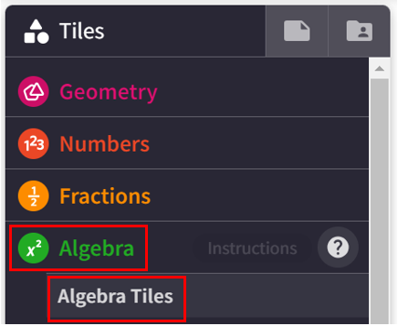
- Select and drag 2 of the horizontal $x$ tiles into the main space to represent $2x$. When you place the tiles side by side, they will lock together.
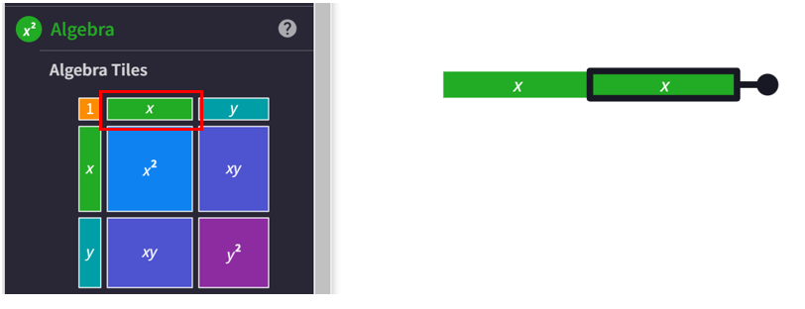

- Select and drag 3 vertical $y$ tiles into the main space to represent $3y$. Any tile can be turned by selecting and dragging the rotation handle, highlighted by the arrow in the diagram below.
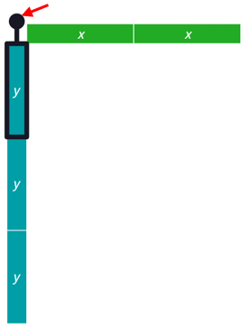
- To separate the original expression from the simplified solution, we can add a horizontal and vertical line.
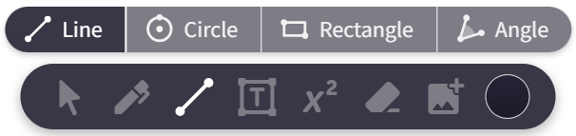
- Select where you would like to start your line and drag across to where you would like your line to end, as shown below.
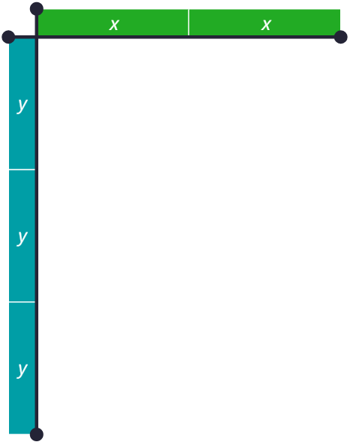
- Select and drag the appropriate $xy$ tiles into the multiplication space.
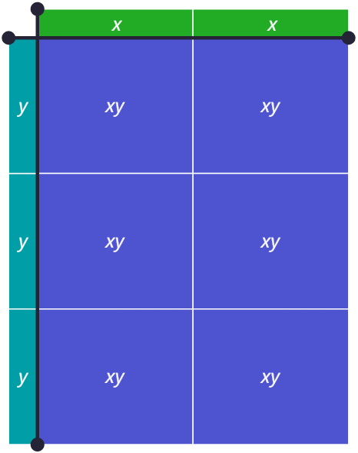
- There are 6, $xy$ tiles in the final space, indicating that $2x×3y=6xy$.

Appendix D

Saving your Polypad file
- Students should ensure they are signed in using their NSW Department of Education account, ending in @education.nsw.gov.au.
- Select the file icon in the top left of your screen.
- Select the words ‘Untitled Polypad’ to give the graph a title.
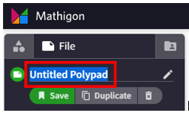
- Select save. A link will be generated that can be shared with the teacher.
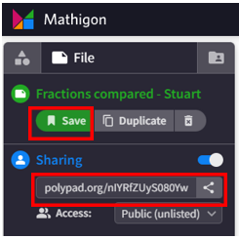

Appendix E

Further algebraic multiplication
For each expression in the table below, expand each term and then write down a simplified expression.
Expression | Expanded terms | Simplified expression
$$2a×3a^{2}$$
$$2a^{2}×3a^{2}$$
$$2a^{2}×3a^{2}b$$
$$3x^{2}y^{2}×4x^{2}z$$
$$(-3x^{2}y^{2})×4x^{2}z$$
$$5a^{2}b^{2}×3a^{2}c$$
$$3abc×5a^{3}b$$
$$\frac{3}{5}abc×5a^{3}b$$
$$\frac{3}{5}abc×\frac{1}{2}a^{3}b$$

Appendix F

Algebra pyramids
In the algebra pyramids below, 2 terms beside one another are multiplied to make the term above. Use the algebraic terms in the pyramids to fill in the blanks. The first one is an example to help you.
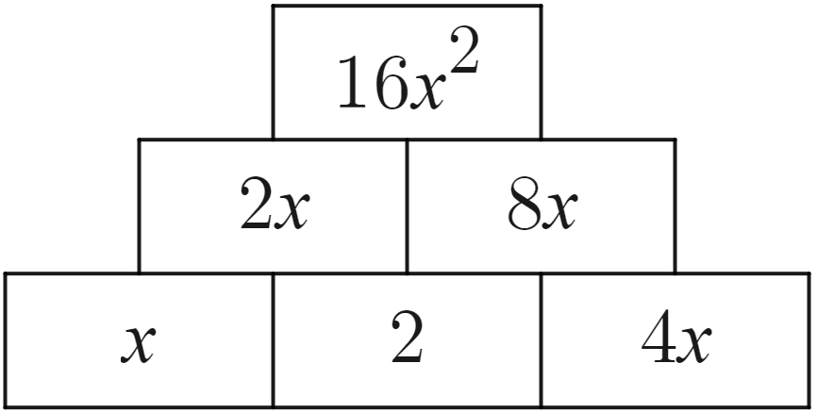 | 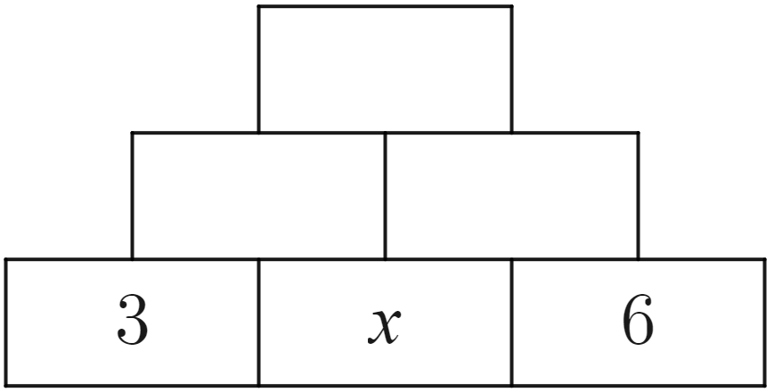
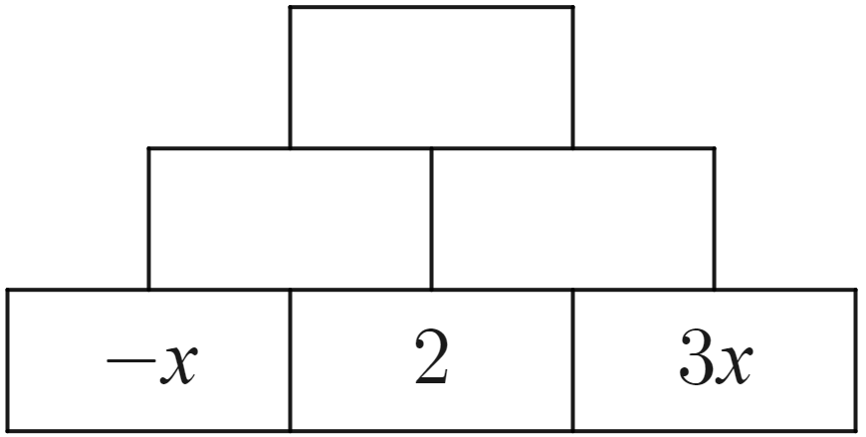 | 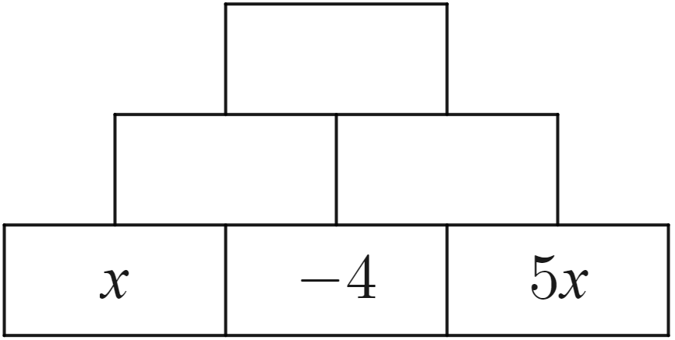
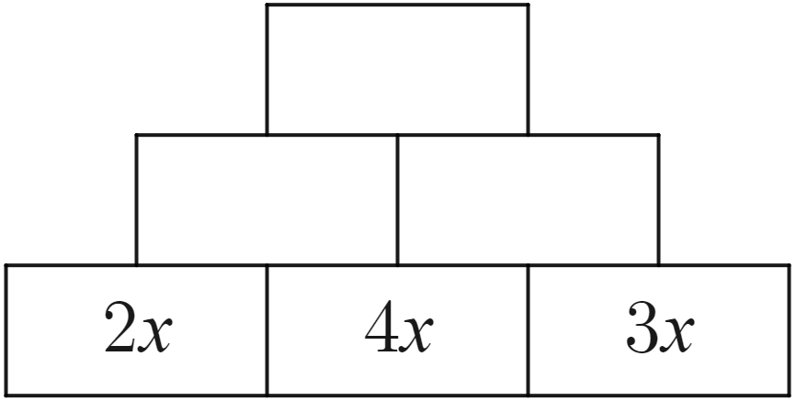 | 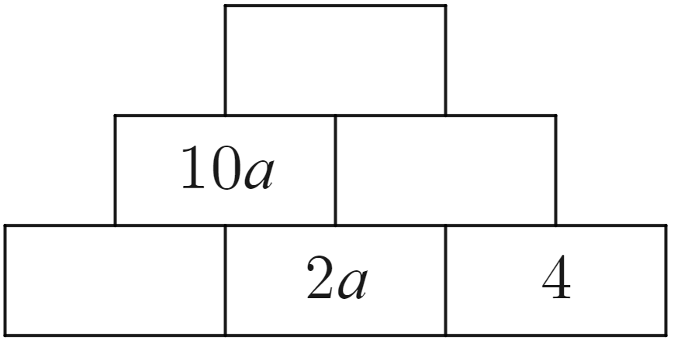
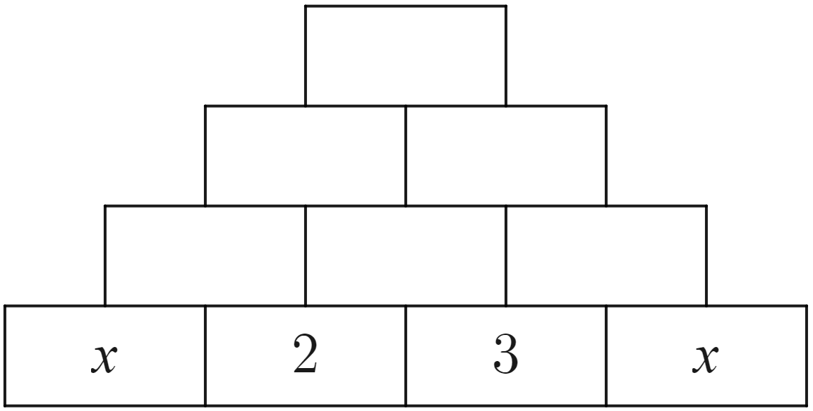 | 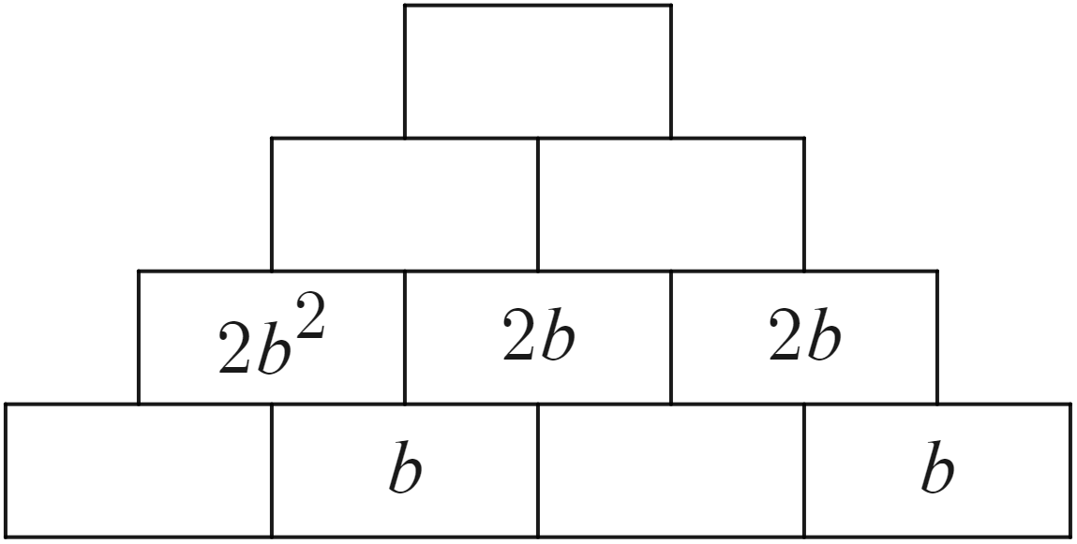

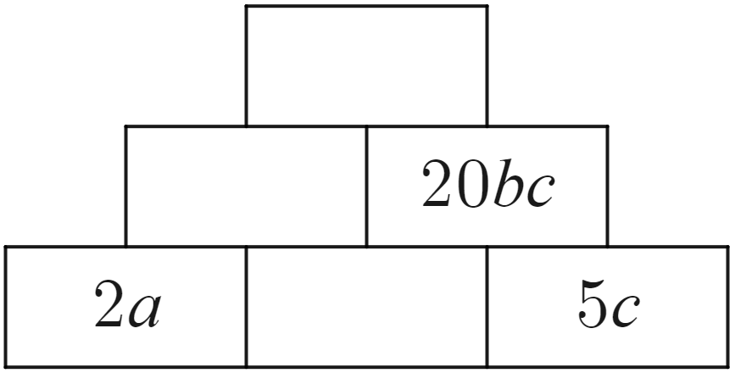 | 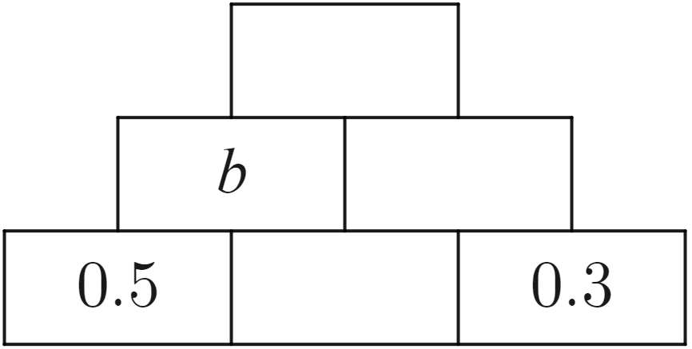
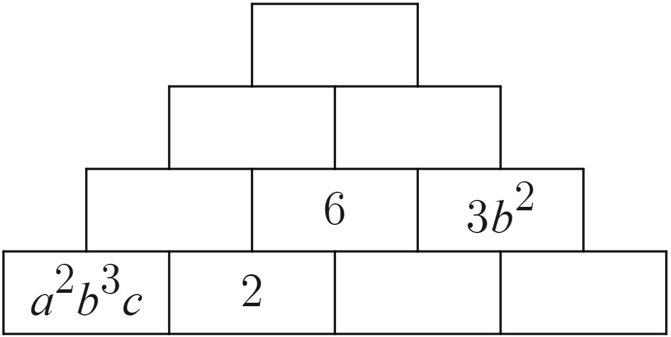 | 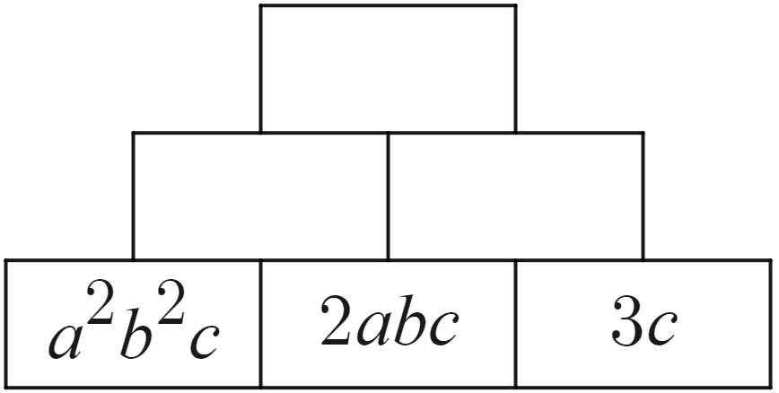
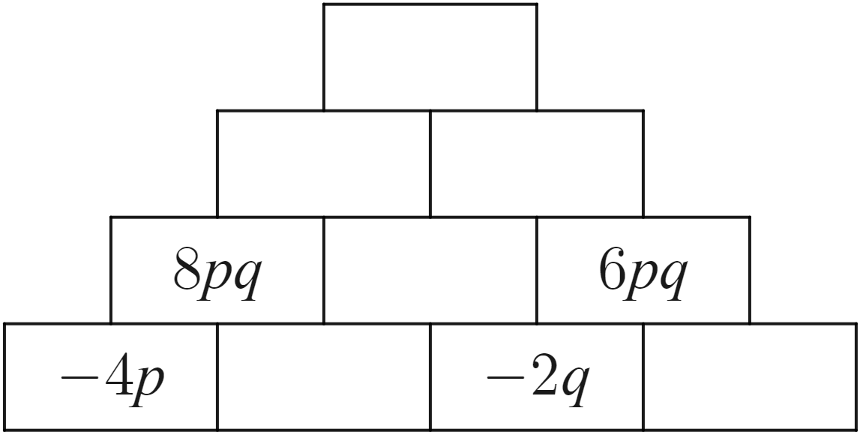 | 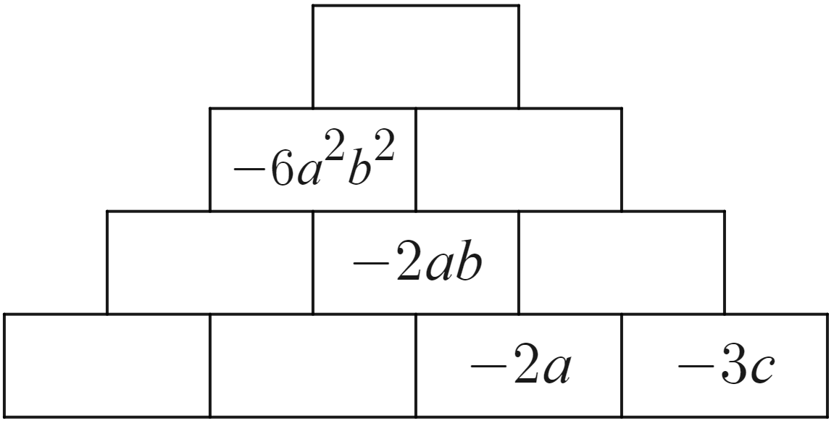
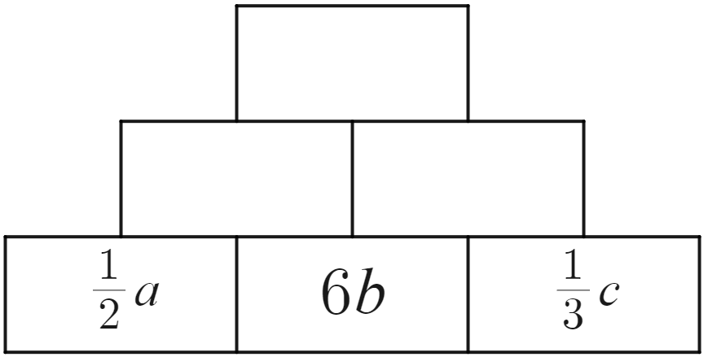 | 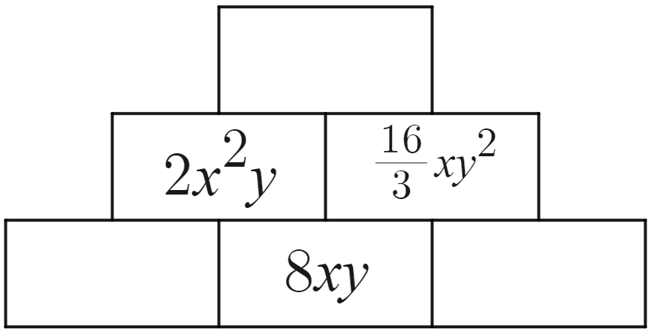
- Create your own. Fill in some cells with single algebraic terms and leave some blank.  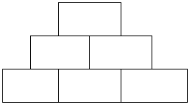 | - Create your own. Fill in some cells with algebraic expressions and leave some blank.  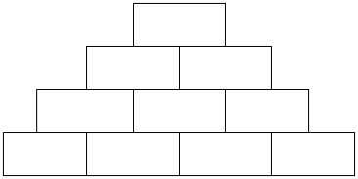

Sample solutions

Appendix A – algebraic expressions
Situation | Pronumerals | Algebraic expressions
In a raffle, each child has been given 4 tickets. How many tickets are there in total? | $c$ is the number of children | $$4×c$$
I am buying 12 single yoghurt packets. How much will this cost? | $p$ is the price of one yoghurt packet | $$12×p$$
All students in a class of 30 are given a pencil case at the start of the year with 4 packets of pencils. How many pencils are in the classroom? | $p$ is the number of pencils in a packet | $30×4×p$ or $120×p$
We have 10 boxes, each containing punnets of strawberries. Each punnet has the same number of strawberries. How many strawberries do we have altogether? | $p$ is the number of punnets in a box.  $s$ is the number of strawberries in a punnet. | $$10×p×s$$
A classroom has the same number of desks going across the room as it does going from the front to the back. How many desks are in the room? | $d$ is the number of desks across the room. | $$d×d$$
Everyone in my class is given 4 boxes of chocolates. My sister’s class has the same number of students and each of them is also given 4 boxes each of the same chocolates. How many chocolates are there in total? | $c$ is the number of chocolates in each box.  $s$ is the number of students in the class. | $$4×c×s×2$$

Appendix B – multiplying algebraic terms
Expression | Area model | Simplified expression
$$4×3x$$ | 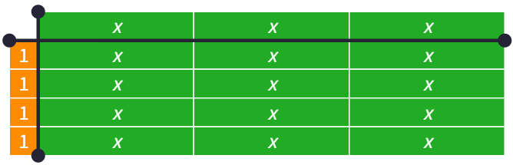 | $$12x$$
$$3×4x$$ | 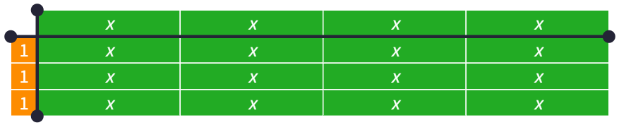 | $$12x$$
$$6×2x$$ | 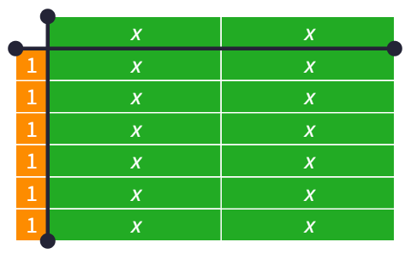 | $$12x$$
$$6×2y$$ | 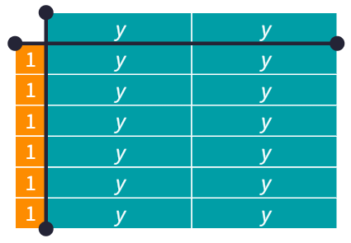 | $$12y$$
$$(-6)×2y$$ | 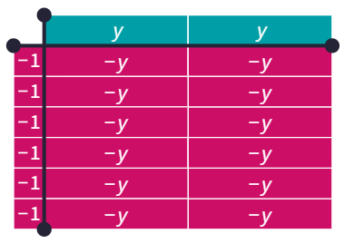 | $$(-12y)$$
$$6×(-2y)$$ | 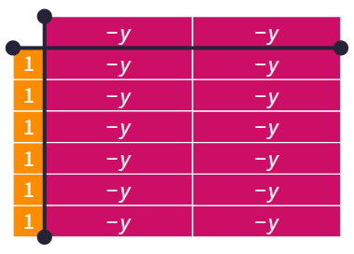 | $$(-12y)$$
$$\left(-6\right)×(-2y)$$ | 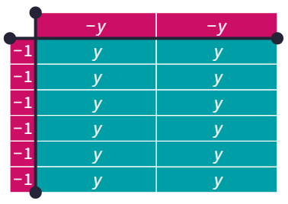 | $$12y$$
$$3×y×4$$ | 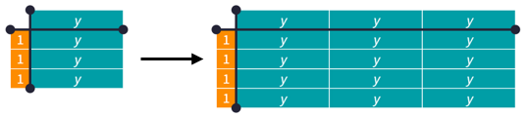 | $$12y$$
$$3y×4y$$ | 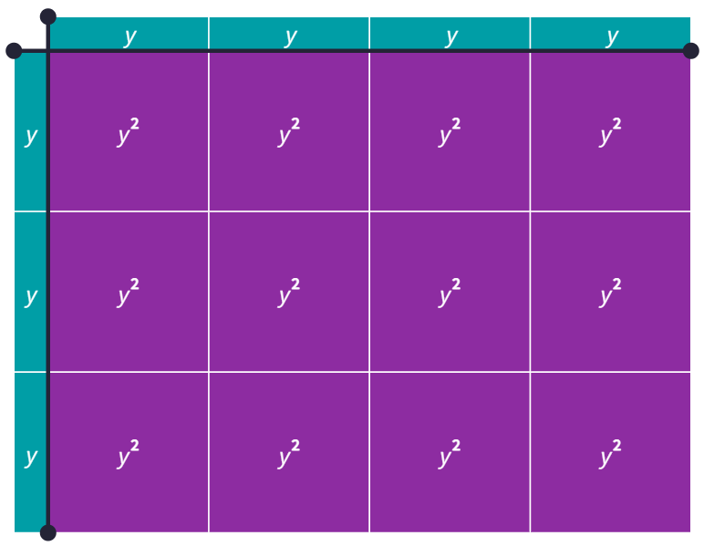 | $$12y^{2}$$
$$3x×4y$$ | 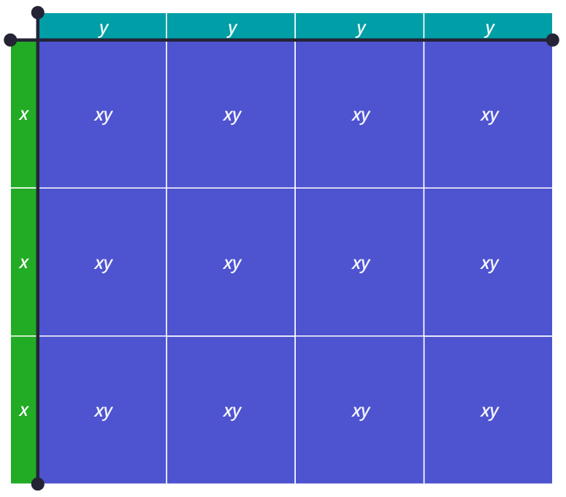 | $$12xy$$
$$\left(-3x\right)×4y$$ | 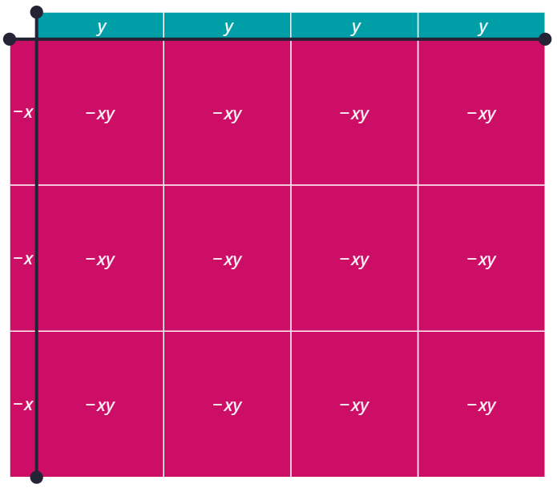 | $$(-12xy)$$
$$4x×3y$$ | 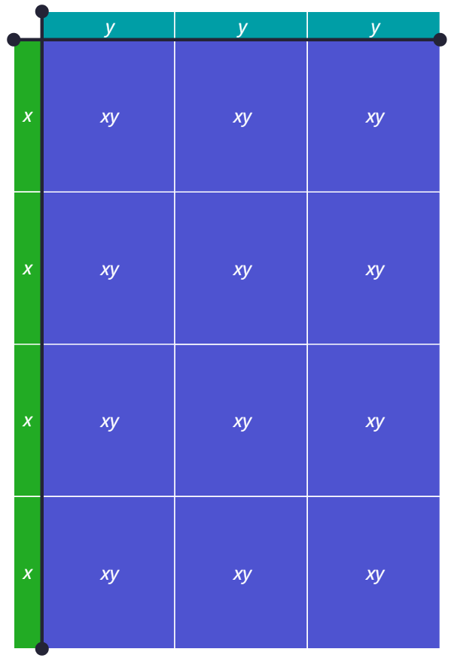 | $$12xy$$
$$2y×3×2x$$ | 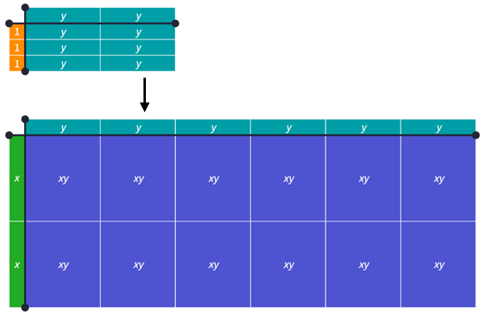 | $$6xy×2=12xy$$

Appendix E – further algebraic multiplication
Expression | Expanded terms | Simplified expression
$$2a×3a^{2}$$ | $$\left(2×a\right)×\left(3×a×a\right)=2×3×(a×a×a)$$ | $$6a^{3}$$
$$2a^{2}×3a^{2}$$ | $$\left(2×a×a\right)×\left(3×a×a\right)=2×3×(a×a×a×a)$$ | $$6a^{4}$$
$$2a^{2}×3a^{2}b$$ | $$\left(2×a×a\right)×\left(3×a×a×b\right)$$  $$=2×3×\left(a×a×a×a\right)×b$$ | $$6a^{4}b$$
$$3x^{2}y^{2}×4x^{2}z$$ | $$\left(3×x×x×y×y\right)×\left(4×x×x×z\right)$$  $$=3×4×\left(x×x×x×x\right)×\left(y×y\right)×z$$ | $$12x^{4}y^{2}z$$
$$(-3x^{2}y^{2})×4x^{2}z$$ | $$\left(-3×x×x×y×y\right)×\left(4×x×x×z\right)$$  $$=\left(-3\right)×4×\left(x×x×x×x\right)×\left(y×y\right)×z$$ | $$(-12x^{4}y^{2}z)$$
$$5a^{2}b^{2}×3a^{2}c$$ | $$\left(5×a×a×b×b\right)×\left(3×a×a×c\right)$$  $$=5×3×\left(a×a×a×a\right)×\left(b×b\right)×c$$ | $$15a^{4}b^{2}c$$
$$3abc×5a^{3}b$$ | $$\left(3×a×b×c\right)×\left(5×a×a×a×b\right)$$  $$=3×5×\left(a×a×a×a\right)×\left(b×b\right)×c$$ | $$15a^{4}b^{2}c$$
$$\frac{3}{5}abc×5a^{3}b$$ | $$\left(\frac{3}{5}×a×b×c\right)×\left(5×a×a×a×b\right)$$  $$=\frac{3}{5}×5×\left(a×a×a×a\right)×\left(b×b\right)×c$$ | $$3a^{4}b^{2}c$$
$$\frac{3}{5}abc×\frac{1}{2}a^{3}b$$ | $$\left(\frac{3}{5}×a×b×c\right)×\left(\frac{1}{2}×a×a×a×b\right)$$  $$=\frac{3}{5}×\frac{1}{2}×\left(a×a×a×a\right)×\left(b×b\right)×c$$ | $$\frac{3}{10}a^{4}b^{2}c$$

Appendix F – algebra pyramids
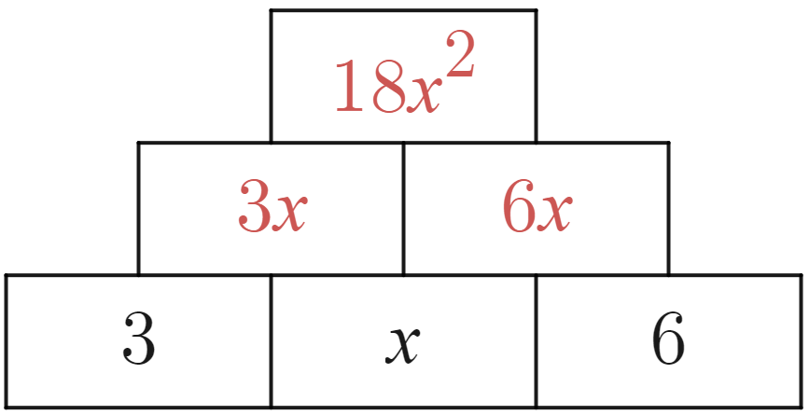 | - 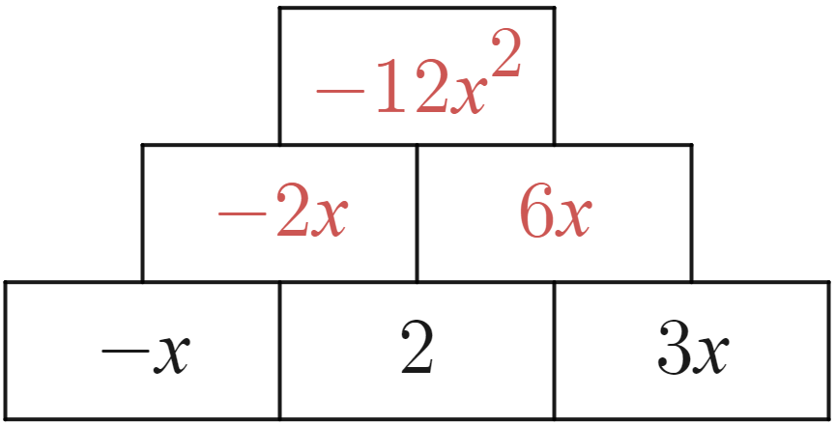 | 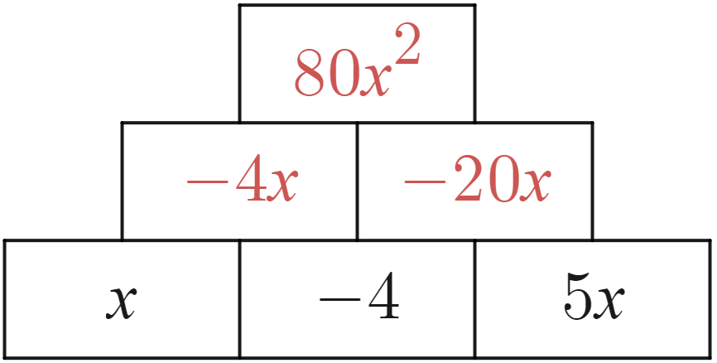
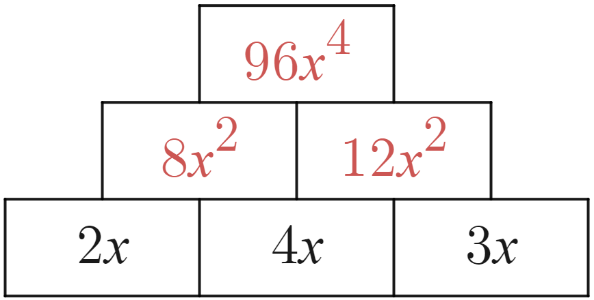 | 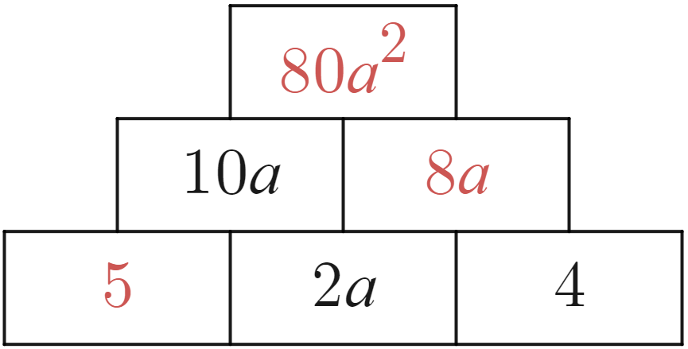 | 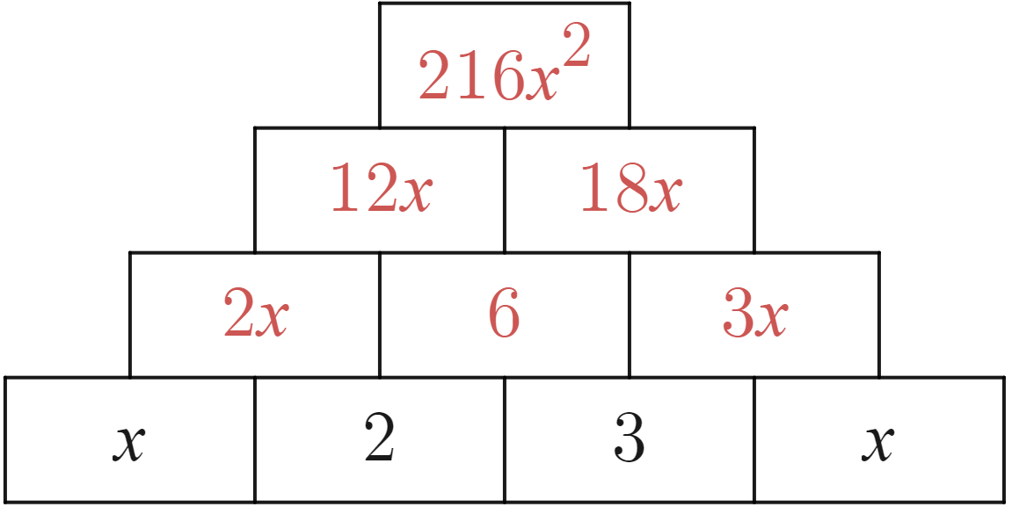
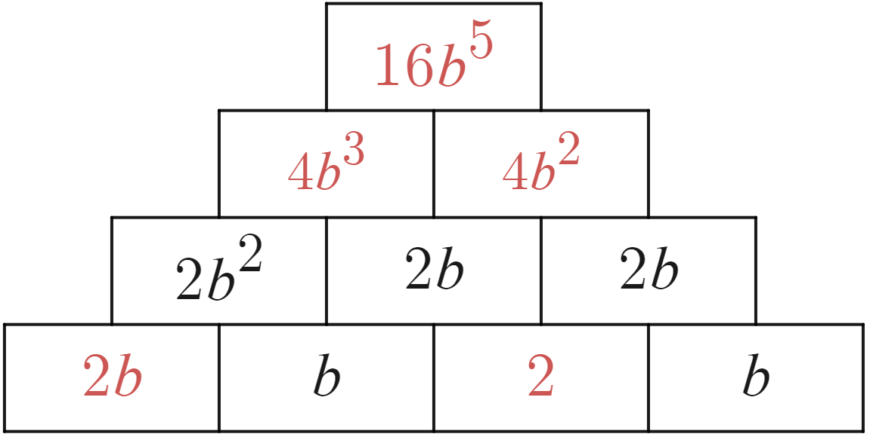 | 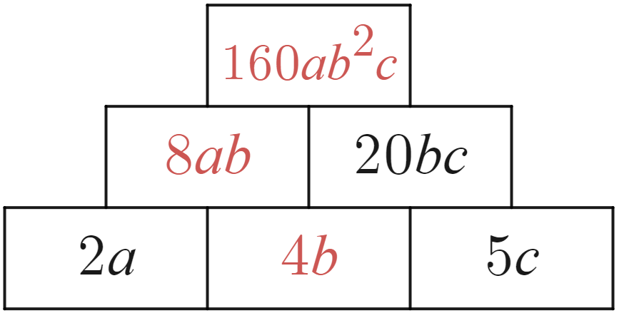 | 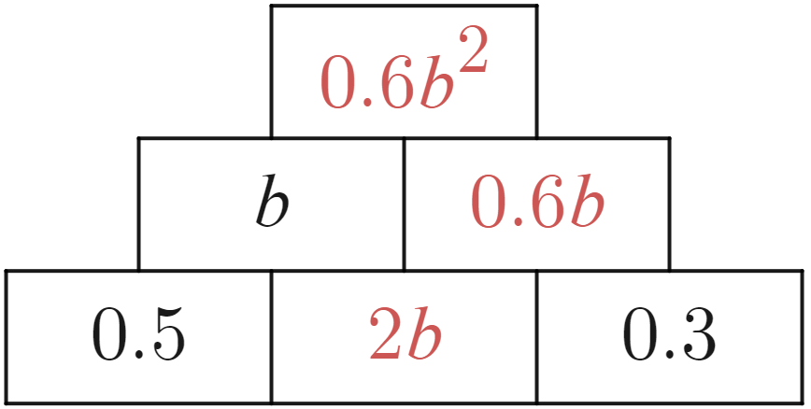
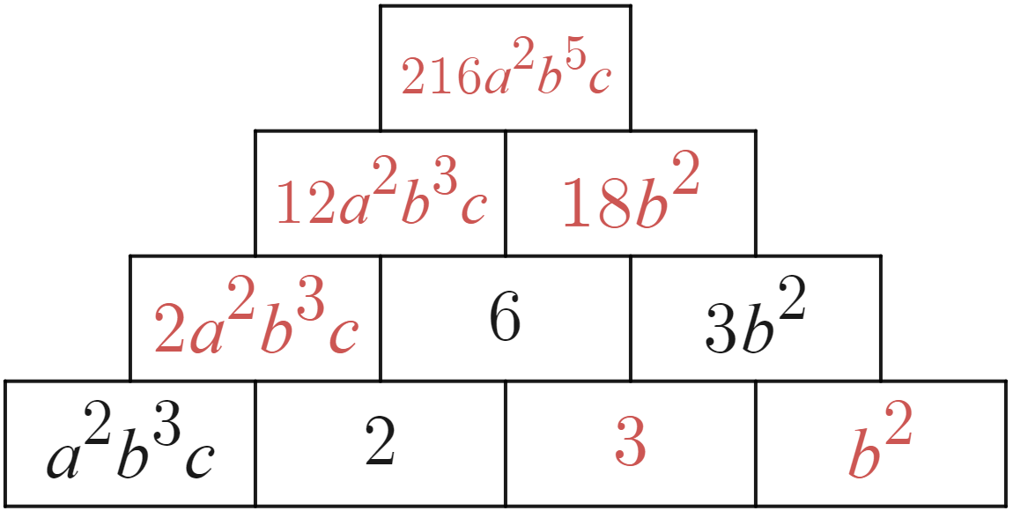 | 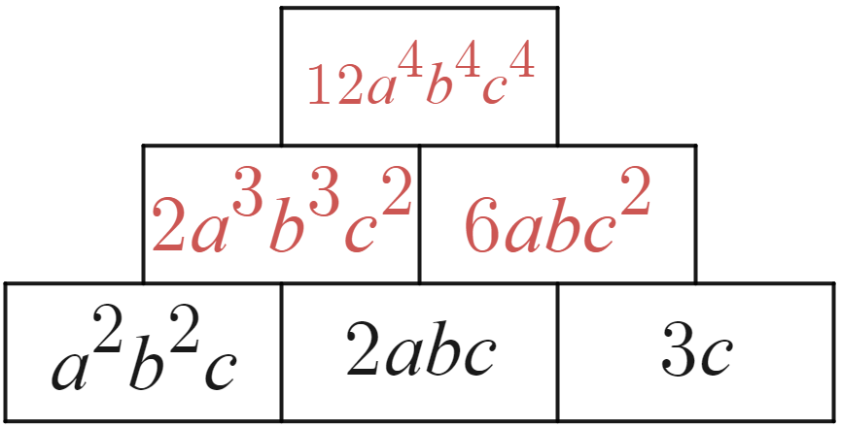 | 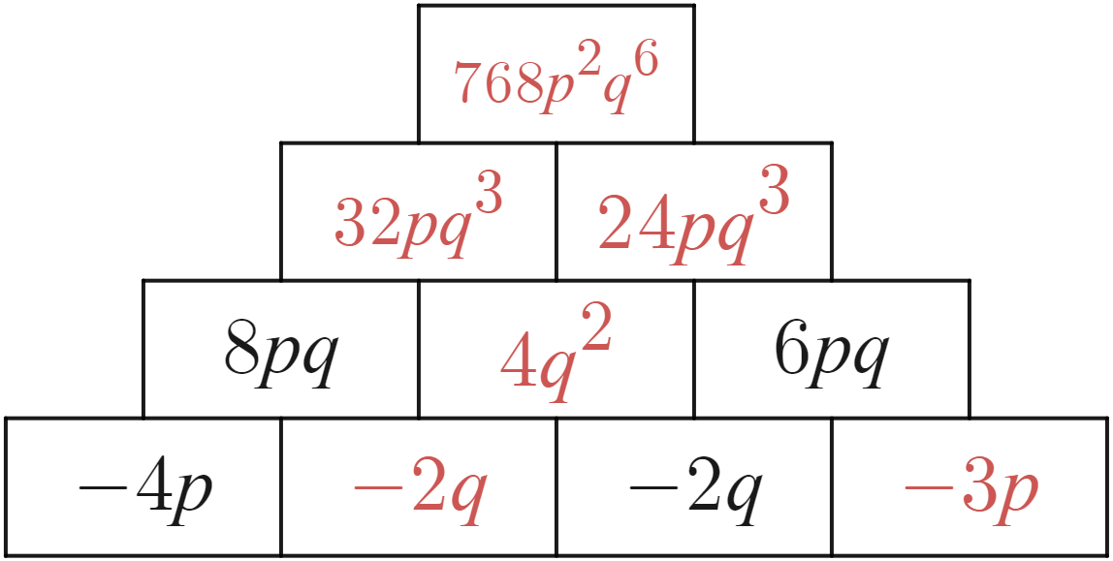
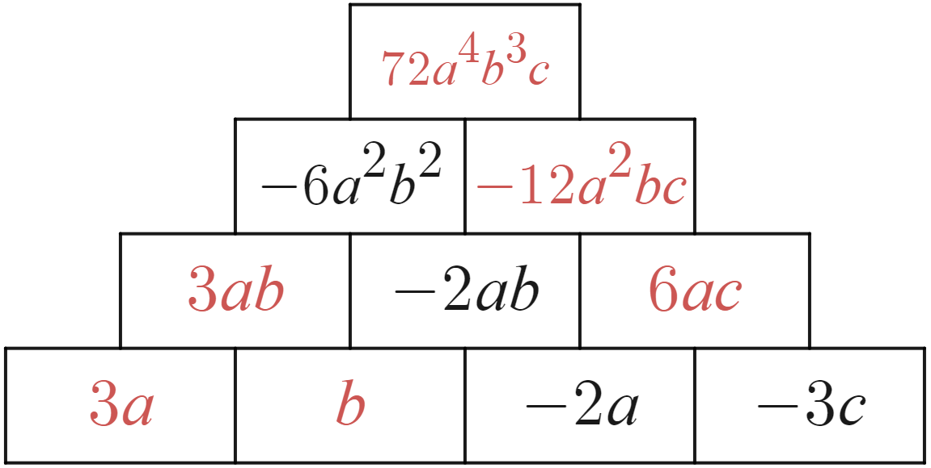 | 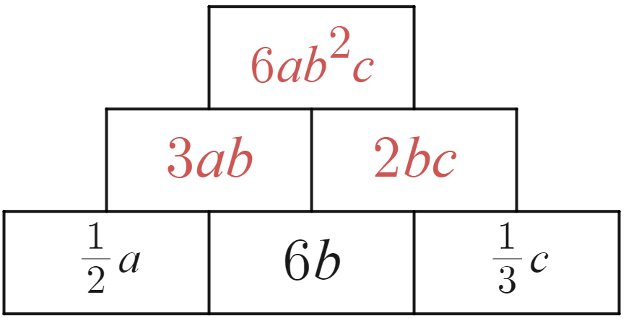 | 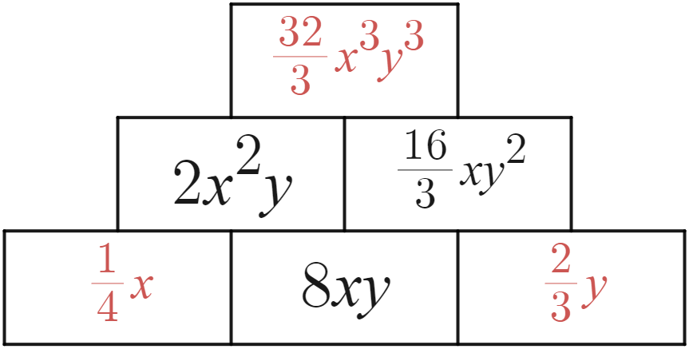

References
This resource contains NSW Curriculum and syllabus content. The NSW Curriculum is developed by the NSW Education Standards Authority. This content is prepared by NESA for and on behalf of the Crown in right of the State of New South Wales. The material is protected by Crown copyright.
Please refer to the NESA Copyright Disclaimer for more information https://educationstandards.nsw.edu.au/wps/portal/nesa/mini-footer/copyright.
NESA holds the only official and up-to-date versions of the NSW Curriculum and syllabus documents. Please visit the NSW Education Standards Authority (NESA) website https://educationstandards.nsw.edu.au/ and the NSW Curriculum website https://curriculum.nsw.edu.au/home.
Mathematics K–10 Syllabus © NSW Education Standards Authority (NESA) for and on behalf of the Crown in right of the State of New South Wales, 2022.

© State of New South Wales (Department of Education), 2023
The copyright material published in this resource is subject to the Copyright Act 1968 (Cth) and is owned by the NSW Department of Education or, where indicated, by a party other than the NSW Department of Education (third-party material).
Copyright material available in this resource and owned by the NSW Department of Education is licensed under a Creative Commons Attribution 4.0 International (CC BY 4.0) license.
This license allows you to share and adapt the material for any purpose, even commercially.
Attribution should be given to © State of New South Wales (Department of Education), 2023.
Material in this resource not available under a Creative Commons license:
- the NSW Department of Education logo, other logos and trademark-protected material
- material owned by a third party that has been reproduced with permission. You will need to obtain permission from the third party to reuse its material.
Links to third-party material and websites
Please note that the provided (reading/viewing material/list/links/texts) are a suggestion only and implies no endorsement, by the New South Wales Department of Education, of any author, publisher, or book title. School principals and teachers are best placed to assess the suitability of resources that would complement the curriculum and reflect the needs and interests of their students.
If you use the links provided in this document to access a third-party's website, you acknowledge that the terms of use, including licence terms set out on the third-party's website apply to the use which may be made of the materials on that third-party website or where permitted by the Copyright Act 1968 (Cth). The department accepts no responsibility for content on third-party websites.

