Dividing into the unknown
Students use area models to explore conventions of simplifying algebraic expressions involving division. They use dynamic and pictorial models before moving to abstract representations of division.
This lesson is based on students having had experience with using area models to represent numerical division.

Visible learning

Learning intentions
- To understand common conventions when writing and simplifying algebraic expressions involving division.
- To be able to use an area model to explain how algebraic expressions with division simplify.

Success criteria
- I can interpret algebraic terms involving division.
- I can simplify algebraic expressions involving division.
- I can construct an area model to represent division between 2 algebraic terms.

Syllabus outcomes
A student:
- develops understanding and fluency in mathematics through exploring and connecting mathematical concepts, choosing and applying mathematical techniques to solve problems, and communicating their thinking and reasoning coherently and clearly MAO-WM-01
- generalises number properties to operate with algebraic expressions including expansion and factorisation MA4-ALG-C-01
Mathematics K–10 Syllabus © NSW Education Standards Authority (NESA) for and on behalf of the Crown in right of the State of New South Wales, 2022.
Please use the associated PowerPoint Dividing into the unknown to display images in this lesson.

Activity structure

Warm up
This activity is designed to activate prior knowledge of the use of area models for division of numbers. Students demonstrating proficiency in this skill can move straight to the next section of the lesson.
- Write the following divisions on the teacher board.
- $15÷5=$
- $20÷10=$
- $120÷15=$
- $108÷9=$
- Have students attempt these individually without a calculator.
- Use the Desmos graph ‘Area model division’ (bit.ly/DesmosAMDivision) to demonstrate the solution to the first problem using an area model. The teacher can adjust the problem using the sliders ‘Dividend’ and ‘Divisor.
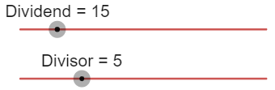
Then form the area model by dragging the areas down until the total matches the dividend.
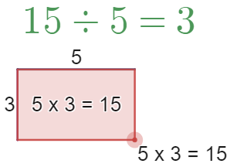
- Have students represent the 3 remaining divisions using area models. Students can complete this by either drawing area models on grid paper or by using a device with internet and the Desmos graph ‘Area model division’ (bit.ly/DesmosAMDivision).

Launch
- Display or read out the following scenario to students.
‘Some money is shared equally among 3 children. How much will each child receive?’
- In a Think-Pair-Share (bit.ly/thinkpairsharestrategy) students are to write an expression for this problem.
Variations from students may include $m÷3$ or $\frac{m}{3}$. Students may need to be prompted that they will need to use a pronumeral to represent the unknown amount of money.
- Explain to students that the use of the pronumeral makes this an algebraic expression.
- Add to the situation that we now know that the amount of money being shared was $36 and ask students to calculate the amount of money each child will receive.
- Ask students to repeat the calculation if the amount of money is now $108.
- Hand students copies of Appendix A ‘Algebraic expressions’ and instruct them to write an algebraic expression for each scenario by first identifying any unknowns and labelling them with a pronumeral.
- Bring students together and call on random students to share their responses.
Appendix A includes problems where the divisor is unknown and needs to be represented by a pronumeral. Teachers should ensure this is discussed while reviewing results.

Explore

Division conventions
- Display the expressions below, also available on slide 2 of the Dividing into the unknown PowerPoint.
- $x÷2=\frac{x}{2}$
- $ab÷c=\frac{ab}{c}$
- $\frac{y}{1}=y$
- Inform students that these are ways of writing expressions in shorter ways.
- Have students return to Appendix A and write as many expressions as they can using these simplified conventions.

Area models for division
- Use slides 3–10 from the Dividing into the unknown PowerPoint for explicit teaching of using area models to simplify expressions involving division of algebraic terms.
The explicit teaching technique used in the associated PowerPoint is ‘Your turn.’ The first slide is a worked example which should be displayed for the students and then use the following steps.
- Reveal the question to students and its solution.
- Students read in silence.
- Students individually think and explain to themselves what is happening in each step.
- Students hold up a thumbs up to the teacher when they have finished reading and have some sort of understanding.
- Think-Pair-Share. Students explain the solution to their partner.
- In pairs students then answer the self-explanation questions.
- Finally, randomly select students to share their answers with the whole class.
- Hand students copies of Appendix B ‘Dividing algebraic terms’ and have them complete with peers, representing each expression as an area model.
The expressions in Appendix B apply variation theory (variationtheory.com/introduction/) and increase in difficulty beyond the problems shown in the Dividing into the unknown PowerPoint. Solutions to Appendix B are available at the end of this document.
Students can be arranged into visibly random groups of 3 (bit.ly/visiblegroups) and allowed to work at whiteboards if available (bit.ly/VNPSstrategy).
If devices are available, students can be supported to represent their expressions using Polypad (mathigon.org/polypad).
Appendix C ‘Constructing division area models using Polypad’ contains instructions of how to construct area models via Polypad. Appendix D ‘Saving your Polypad file’ contains instructions for students to save their Polypad solutions.
- Display Figure 1 on the teacher screen, also available on slide 11 of the Dividing into the unknown PowerPoint.
Figure 1: $2x÷4$
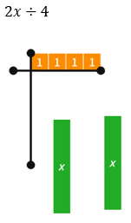
- Have students engage in a Think-Pair-Share to consider how we might answer this question, what it might look like as an area model and a simplified algebraic expression.
- Conclude with students that to find a solution to $2x÷4$, we need to use $\frac{x}{2}$ tiles as shown below in Figure 2, also available on slide 12 of the Dividing into the unknown PowerPoint.
Figure 2: Area model solution
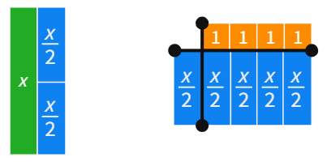
When reviewing Figure 2 as a solution, draw attention to the fact that the 4 ‘$\frac{x}{2}$’ tiles are the same as 2 ‘$x$’ tiles, or that $4×\frac{x}{2}=2x$.
- Working in their pairs, instruct students to attempt to use area models to explain the result of the following 2 problems. These problems and their solutions can be displayed using slides 13 and 14 of the Dividing into the unknown PowerPoint.
- $2x÷8$
- $3y÷9$

Summarise
- Pose the following set of questions and have students write notes to their future forgetful selves (bit.ly/notesstrategy) on how to simplify each type of question. These can be displayed using slide 15 of the Dividing into the unknown PowerPoint.
- $14x÷7$
- $-9y÷3$
- $16x÷4x$
- $6xy÷2y$
- $2x÷6$

Apply

Algebra pyramids
- Hand students a copy of Appendix E ‘Reversed algebra Pyramids’.
- Students are to complete the worksheet individually or in pairs.
- Have students engage in a Think-Pair-Share to discuss what they notice about the difference between finding answers up the pyramid and down the pyramid.

Assessment and differentiation

Suggested opportunities for differentiation
Launch
- Students who are less familiar with using algebra can be encouraged to use empty boxes to represent unknowns, at which point shifting to algebraic terms could be done gradually before continuing with the lesson.
Explore
- Students can be supported to develop their skills with area models by using physical algebra tiles or using the Polypad website. These methods both support introducing students naturally to the concept of multiplication with algebra by beginning with concrete representations.
Apply
- Students can be challenged in Appendix E to create an algebra pyramid with the least number of cells completed. Is there a maximum you can have empty while still having a single solution? Students can also be challenged to leave extra empty cells so that there is more than one solution and then explain how many solutions are possible and why.

Suggested opportunities for assessment
Launch
- Appendix A supports teachers to gather information about students’ ability to express real situations as algebraic expressions, as well as their ability to identify relevant unknowns in written scenarios. Teachers should be prepared to support students with this skill.
- Appendix A also represents an opportunity to assess students’ ability with interpreting real scenarios as division. Teachers should be prepared to discuss why equal sharing and forming specifically sized groups are 2 important types of problems that both lead to division.
Explore
- Appendix B can be collected as evidence of a student’s ability to represent an algebraic expression as an area model and interpret the model to find a simplified solution to a division problem.
Apply
- Appendix E is evidence for teachers of the ability of students to see multiplication and division as inverse operations.

Appendix A

Algebraic expressions
Identify any unknowns and name them as pronumerals in each situation below. Then write an algebraic expression for the answer to the question. The first situation has an example expression completed for you.
Situation | Pronumerals | Algebraic expression
Some money is shared equally among 3 children. How much will each child receive? | $m$ is the amount of money. | $$m÷3$$
How many teams of 5 can be made from a crowd of people? | $p$ is the number of people in the crowd.
James has $30 and wants to buy boxes of chocolates for friends. How many boxes of chocolates can he buy?
There are large tables in a classroom for 24 students. How many students should sit at each table?
In a 60-minute lesson, how long will each student have to present their speech?
How many episodes of my favourite show can I watch in 2 hours?

Appendix B

Dividing algebraic terms
For each expression in the table below, draw an area model representation and then write down a simplified expression. The first problem has been completed for you.
Expression | Area model | Simplified expression
$$4x÷2$$ | 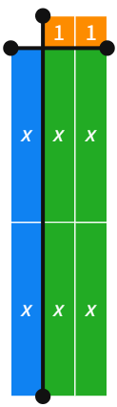 | $$2x$$
$$4x÷4$$ | 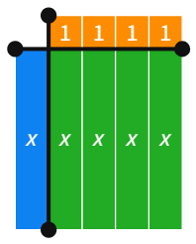
$$-4x÷4$$
$$12x÷4$$
$$\frac{12x}{6}$$
$$12x÷6x$$
$$\frac{12x^{2}}{6x}$$
$$12xy÷6x$$
$$-12xy÷6x$$

Appendix C

Constructing division area models using Polypad
The instructions below demonstrate how to construct an area model in Polypad (mathigon.org/polypad) to represent the expression $6x÷3$.
- Select Algebra and then Algebra Tiles on the left-hand side of your screen.
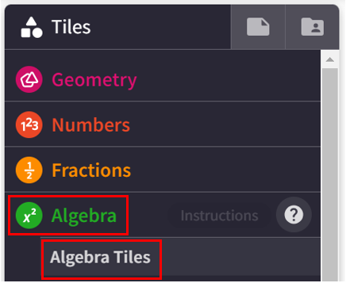
- Select and drag 6 of the horizontal $x$ tiles into the main space to represent $6x$. Place these tiles to the side.
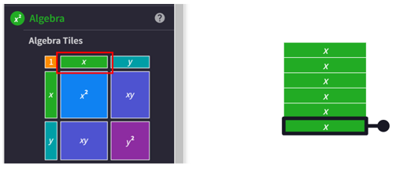
- Select and drag 3 ‘one’ tiles into the main space to represent $3$.
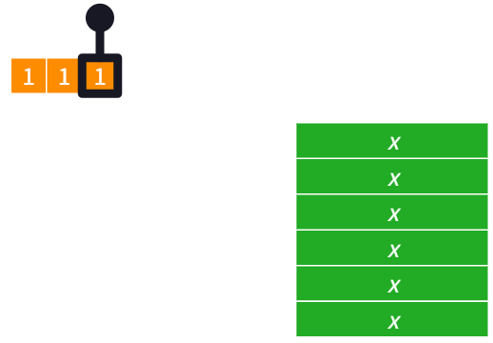
- Select and drag each of the $6x$ tiles into the multiplication space, under the 3 ‘one’ tiles to make a rectangle. Any tile can be turned by selecting and dragging the rotation handle, highlighted by the arrow in the diagram below.
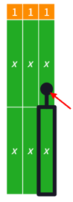
- To separate the divisor $3$ and the dividend $6x$, we can add a horizontal and vertical line.
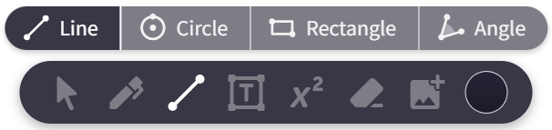
- Select where you would like to start your line and drag across to where you would like your line to end, as shown below.
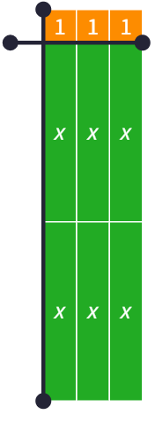
- Select appropriate $x$ tiles to fill the space on the left and complete the area model. The colour of these tiles can be changed to differentiate from the original $6x$ from the problem by selecting the tile and then selecting the colour palette in the bottom menu.
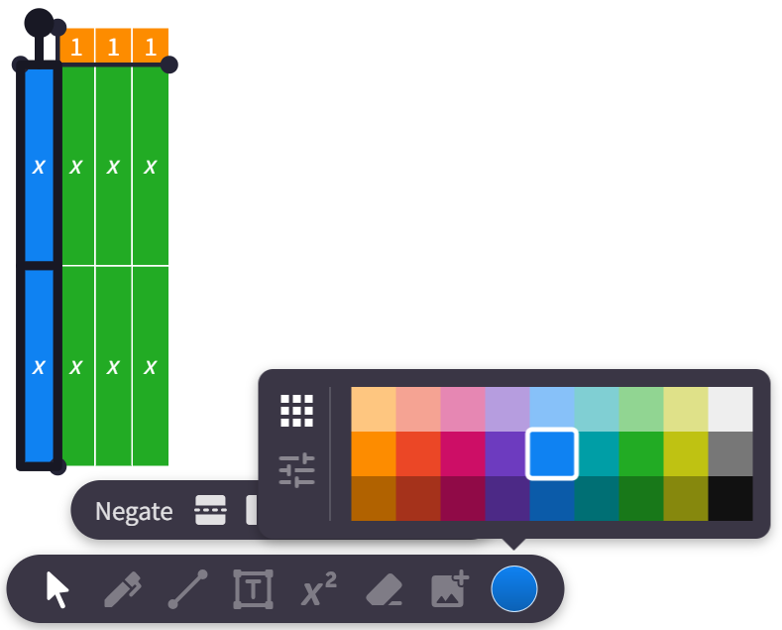
- There are 2 $x$ tiles on the left-hand side, indicating that $6x÷3=2x$.

Appendix D

Saving your Polypad file
- Students should ensure they are signed in using their NSW Department of Education gmail account, ending in @education.nsw.gov.au.
- Select the file icon in the top left of your screen.
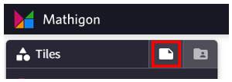
- Select the words Untitled Polypad to give the graph a title.
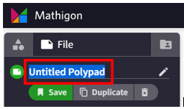
- Select Save. A link will be generated that can be shared with the teacher.
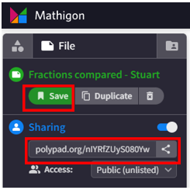

Appendix E

Reversed algebra pyramids
In the algebra pyramids below, 2 terms beside one another are multiplied to make the term above. Use the algebraic terms in the pyramids to fill in the blanks. The first one is an example to help you.
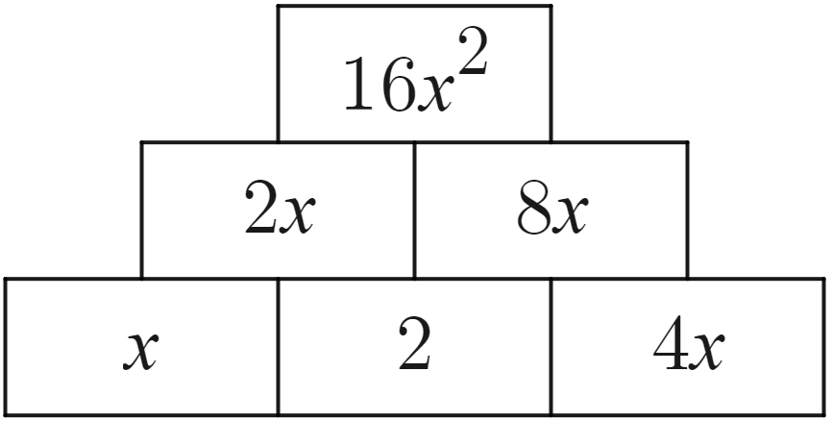 | 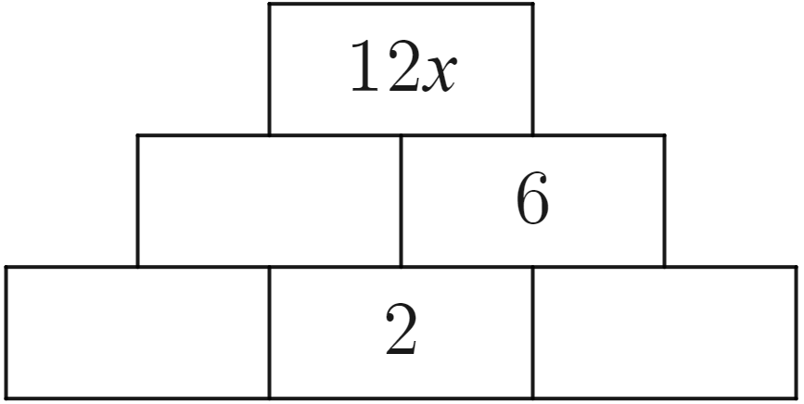
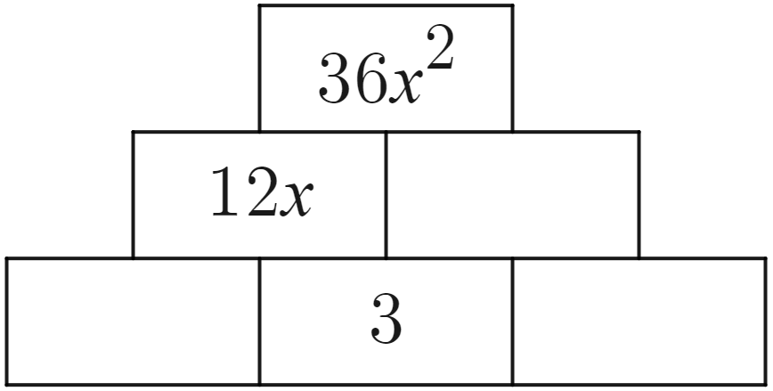 | 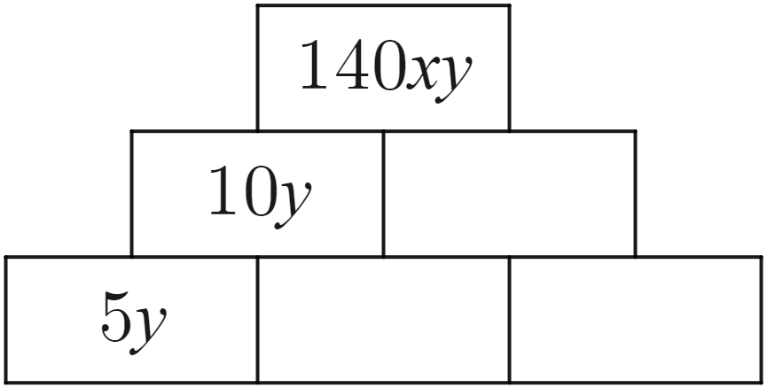
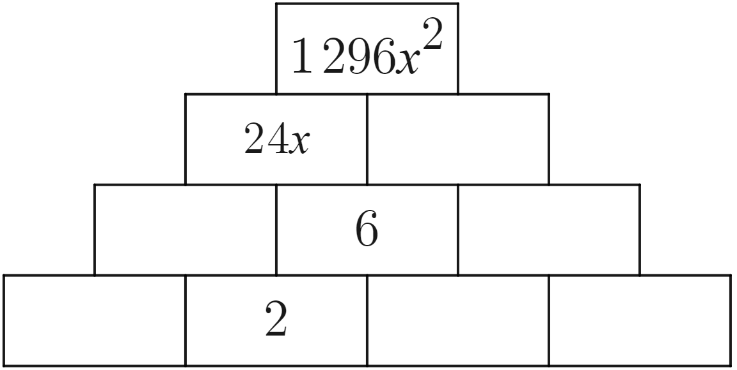 | 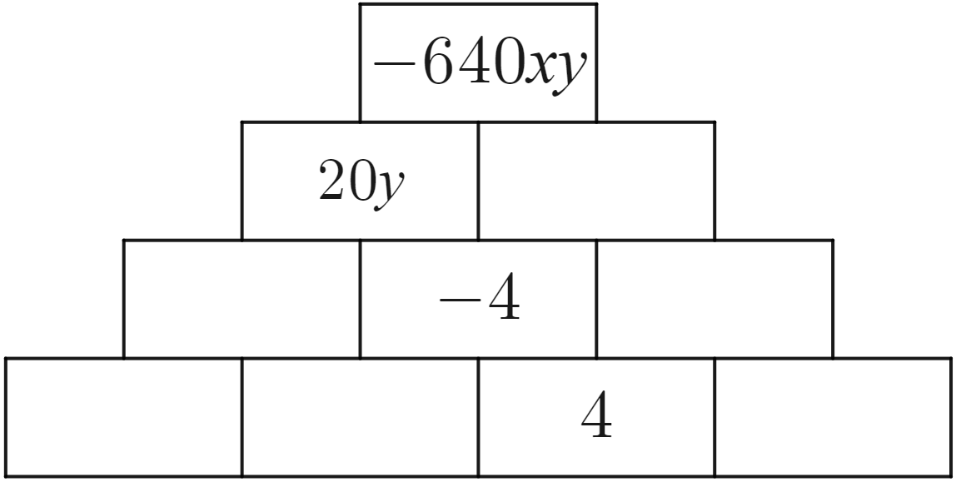
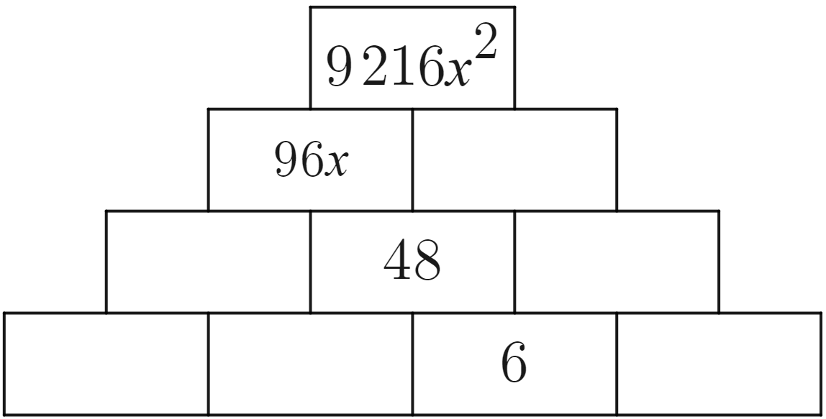 | 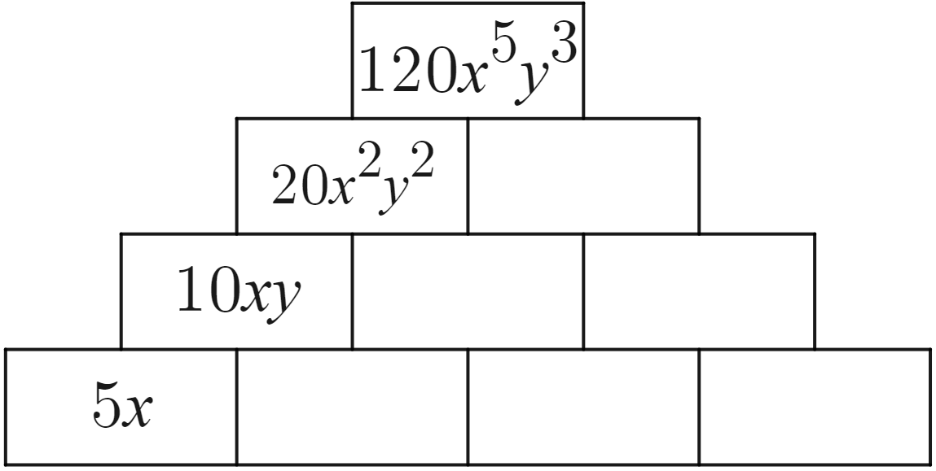

Sample solutions

Appendix A – algebraic expressions
Situation | Pronumerals | Algebraic expression
Some money is shared equally among 3 children. How much will each child receive? | $m$ is the amount of money. | $$m÷3$$
How many teams of 5 can be made from a crowd of people? | $p$ is the number of people in the crowd. | $$p÷5$$
James has $30 and wants to buy boxes of chocolates for friends. How many boxes of chocolates can he buy? | $c$ is the cost of a box of chocolates. | $$30÷c$$
There are large tables in a classroom for 24 students. How many students should sit at each table? | $t$ is the number of tables. | $$24÷t$$
In a 60-minute lesson, how long will each student have to present their speech? | $s$ is the number of students in the class. | $$60÷s$$
How many episodes of my favourite show can I watch in 2 hours? | $E$ is the length in time of an episode of my favourite show. | $$120÷t$$

Appendix B – dividing algebraic terms
Expression | Area model | Simplified expression
$$4x÷2$$ |  | $$2x$$
$$4x÷4$$ |  | $$x$$
$$-4x÷4$$ | 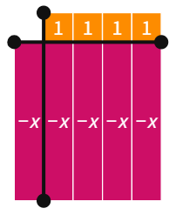 | $$-x$$
$$12x÷4$$ | 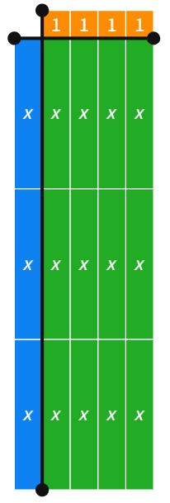 | $$3x$$
$$\frac{12x}{6}$$ | 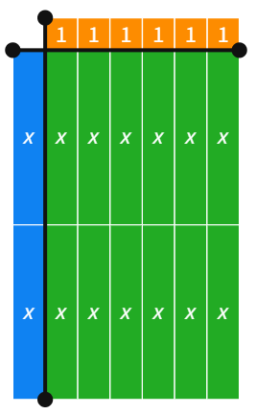 | $$2x$$
$$12x÷6x$$ | 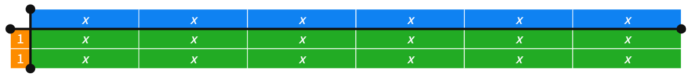 | $$2$$
$$\frac{12x^{2}}{6x}$$ | 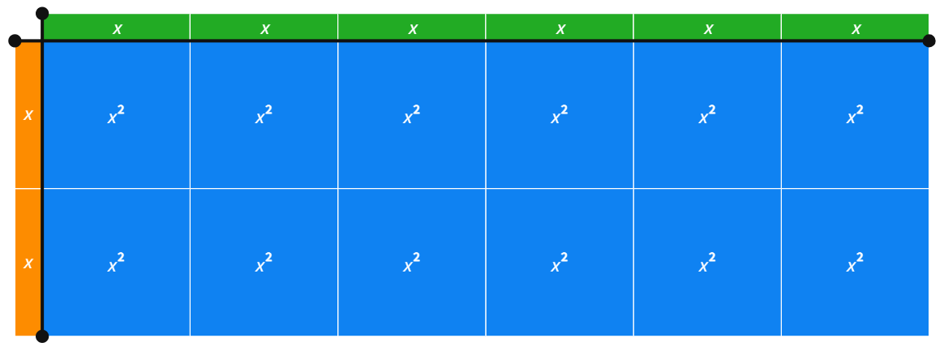 | $$2x$$
$$12xy÷6x$$ | 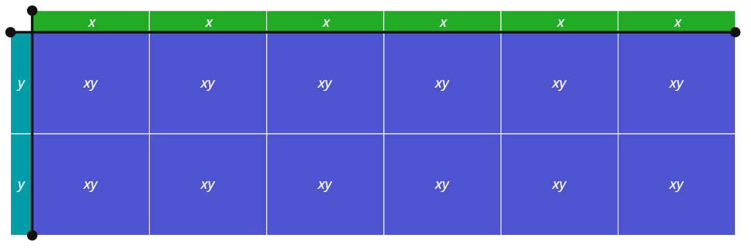 | $$2y$$
$$-12xy÷6x$$ | 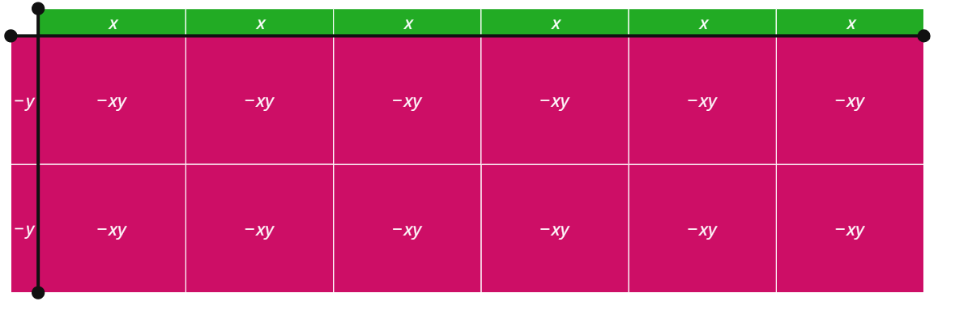 | $$-2y$$

Appendix E – reversed algebra pyramids
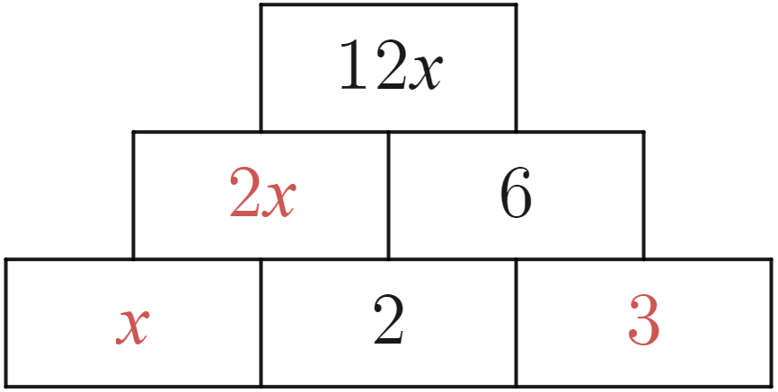 | 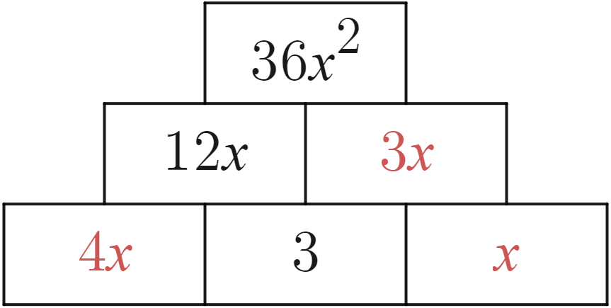 | 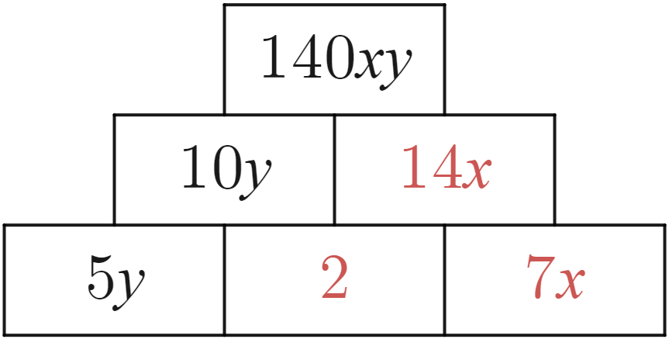
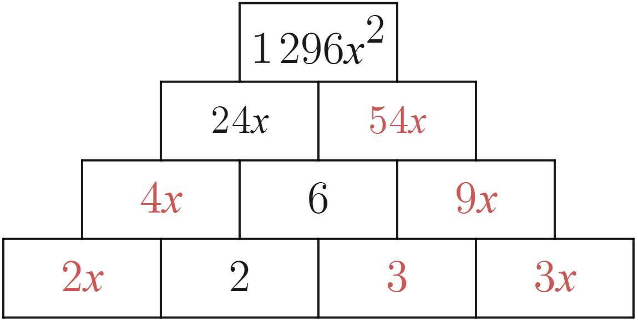 | 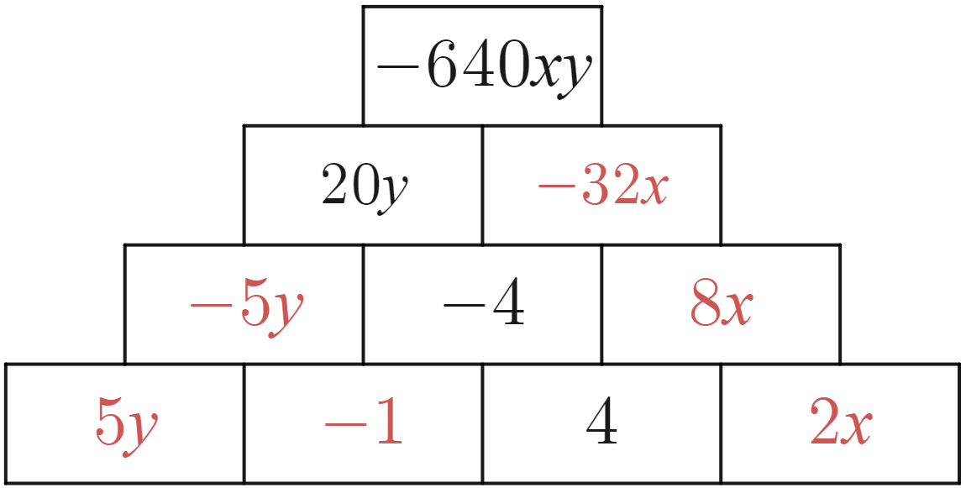 | 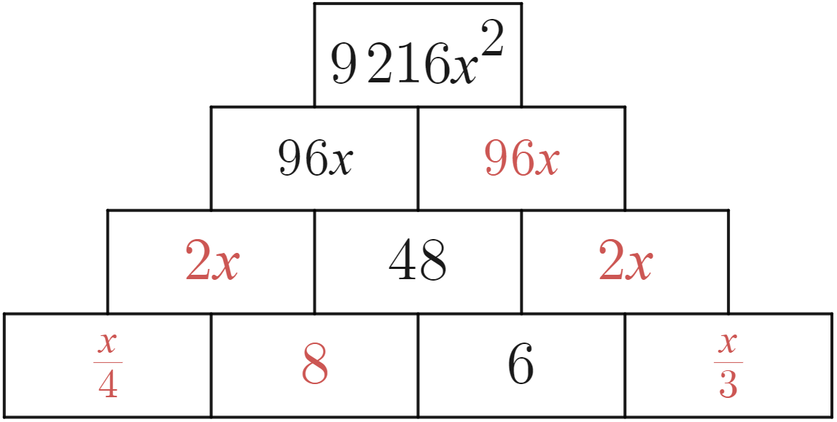
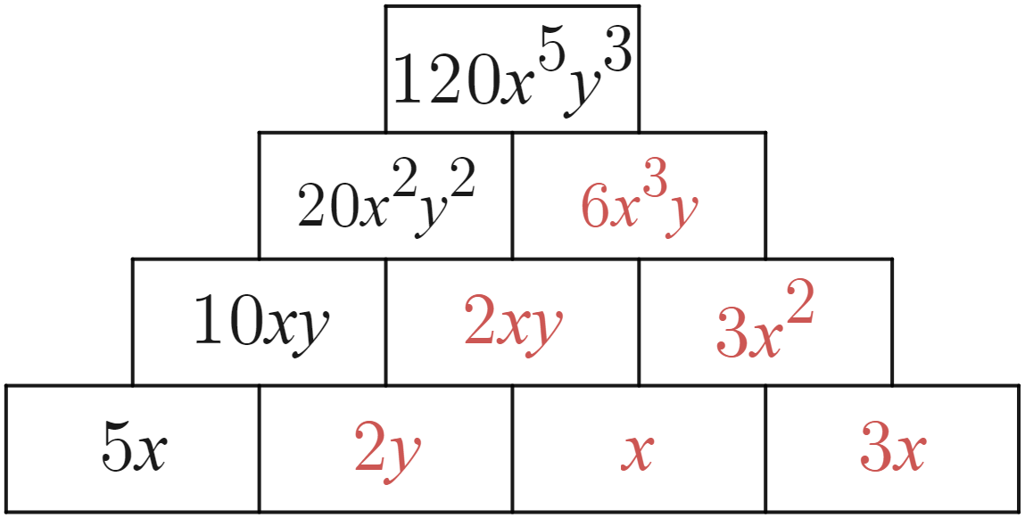

References
This resource contains NSW Curriculum and syllabus content. The NSW Curriculum is developed by the NSW Education Standards Authority. This content is prepared by NESA for and on behalf of the Crown in right of the State of New South Wales. The material is protected by Crown copyright.
Please refer to the NESA Copyright Disclaimer for more information https://educationstandards.nsw.edu.au/wps/portal/nesa/mini-footer/copyright.
NESA holds the only official and up-to-date versions of the NSW Curriculum and syllabus documents. Please visit the NSW Education Standards Authority (NESA) website https://educationstandards.nsw.edu.au/ and the NSW Curriculum website https://curriculum.nsw.edu.au/home.
Mathematics K–10 Syllabus © NSW Education Standards Authority (NESA) for and on behalf of the Crown in right of the State of New South Wales, 2022.

© State of New South Wales (Department of Education), 2023
The copyright material published in this resource is subject to the Copyright Act 1968 (Cth) and is owned by the NSW Department of Education or, where indicated, by a party other than the NSW Department of Education (third-party material).
Copyright material available in this resource and owned by the NSW Department of Education is licensed under a Creative Commons Attribution 4.0 International (CC BY 4.0) license.
This license allows you to share and adapt the material for any purpose, even commercially.
Attribution should be given to © State of New South Wales (Department of Education), 2023.
Material in this resource not available under a Creative Commons license:
- the NSW Department of Education logo, other logos and trademark-protected material
- material owned by a third party that has been reproduced with permission. You will need to obtain permission from the third party to reuse its material.
Links to third-party material and websites
Please note that the provided (reading/viewing material/list/links/texts) are a suggestion only and implies no endorsement, by the New South Wales Department of Education, of any author, publisher, or book title. School principals and teachers are best placed to assess the suitability of resources that would complement the curriculum and reflect the needs and interests of their students.
If you use the links provided in this document to access a third-party's website, you acknowledge that the terms of use, including licence terms set out on the third-party's website apply to the use which may be made of the materials on that third-party website or where permitted by the Copyright Act 1968 (Cth). The department accepts no responsibility for content on third-party websites.

