Which numbers go here? (multiplying and dividing)
Students investigate alternative representations for numbers, leading to algebraic expressions.

Visible learning

Learning intentions
- To be able to write and simplify algebraic expressions.
- To understand algebraic conventions and ways of writing expressions.

Success criteria
- I can write an expression for a number or term that appears in the row before or after a number in the grid.
- I can substitute a number into an algebraic expression.

Syllabus outcomes
A student:
- develops understanding and fluency in mathematics through exploring and connecting mathematical concepts, choosing and applying mathematical techniques to solve problems, and communicating their thinking and reasoning coherently and clearly MAO-WM-01
- generalises number properties to operate with algebraic expressions including expansion and factorisation MA4-ALG-C-01
Mathematics K–10 Syllabus © NSW Education Standards Authority (NESA) for and on behalf of the Crown in right of the State of New South Wales, 2022.

Activity structure

Launch
- Navigate to the website Grid Algebra (https://gridalgebra.com/free).
- Drag the file ‘1 to 30 grid.json’ onto the grid on the screen, as shown in Figure 1 below. (For more instructions on how to use the software, see https://gridalgebra.com/intro/overview).
Figure 1 – 1 to 30 grid
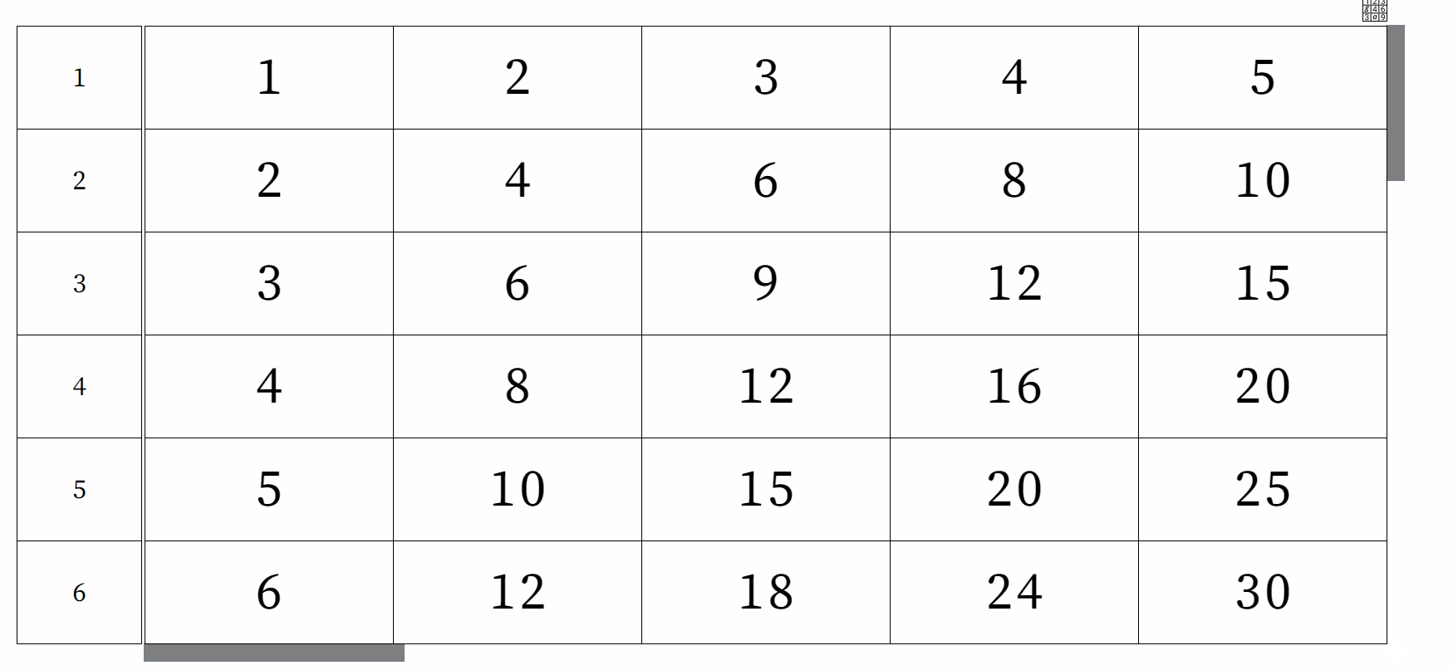
- Ask students what they notice and what they wonder about the grid (bit.ly/noticewonderstrategy).
In the previous unit we focused on the additive nature of the grid, moving across rows. In this unit, we are going to focus on the multiplicative relationships that are represented in the grid by moving up and down.
Students need to identify that the very first number in each row identifies how the numbers in the row increase as you move across the grid.
- Challenge students to predict which numbers come next if we moved down a cell to row 7. What numbers would appear if we moved up a cell, before row 1? Ask students to explain their reasoning.
- Students complete the ‘Which numbers go here?’ worksheet in Appendix A. The last row has been left blank for the teacher to provide a challenge number for their students.

Explore
- Navigate to the Grid Algebra website (https://gridalgebra.com/free).
- Drag the file ‘Multiplying and dividing with letters.json’ onto the grid/screen.
Figure 2 – Table showing variables
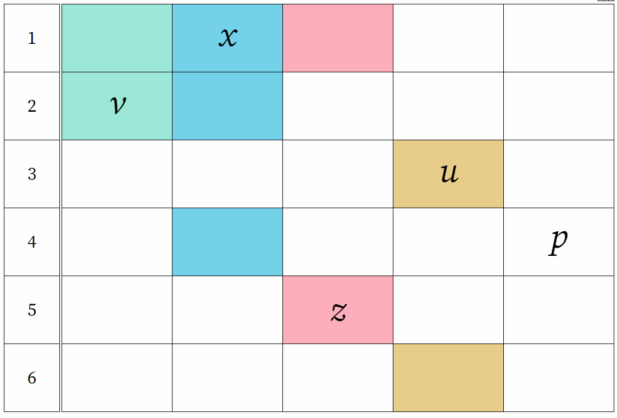
Image created using the free virtual manipulatives at Grid Algebra.
- Using their knowledge of number patterns in the grid, discuss with students what we could write in the highlighted cells if we moved each letter into its associated blank cells.
- Click on the letter $x$ and drag it to the blue cell directly below its current position, to display the correct expression.
Figure 3 – table showing what happens when $x$ is dragged down a row
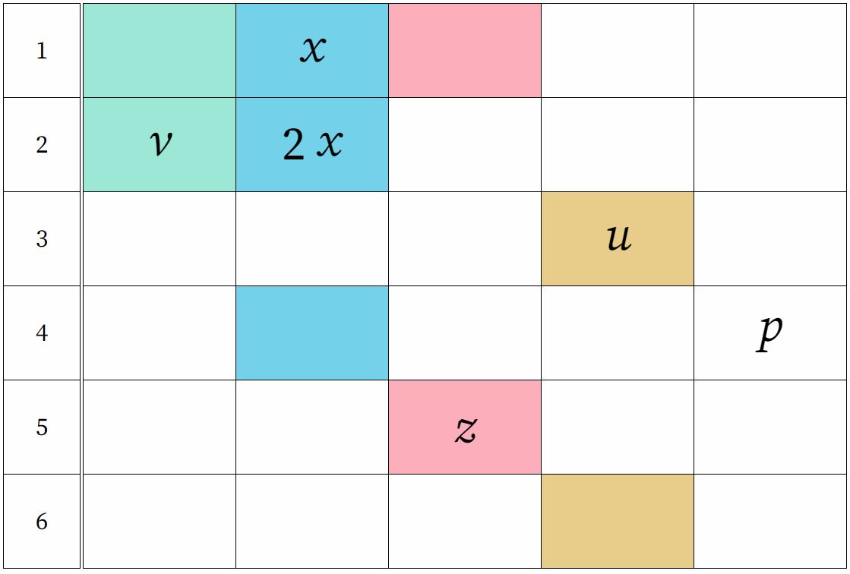
Image created using the free virtual manipulatives at Grid Algebra.
- Click on the letter $x$ again and drag it to the blue cell in row 4 to display the correct expression.
Figure 4 – table showing what happens when $x$ is dragged down to row 4
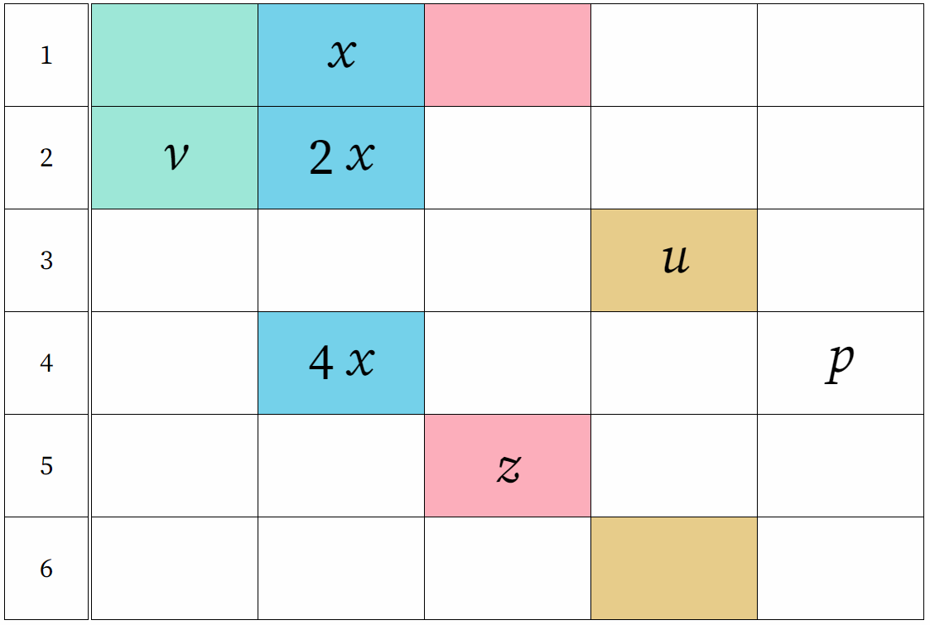
Image created using the free virtual manipulatives at Grid Algebra.
- Click on $2x$ and drag it to the blue cell in row 4. This will give an answer of $2(2x)$.
- Click on the magnifying glass and then click on the blue cell in row 4. This will display an expression pane that shows both expressions sitting in that cell.
Figure 5 – Grid Algebra menu bar with magnifying glass selected
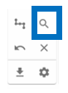
Image created using the free virtual manipulatives at Grid Algebra.
Figure 6 – Grid Algebra expression panel with the expression 2(2x) = 4x
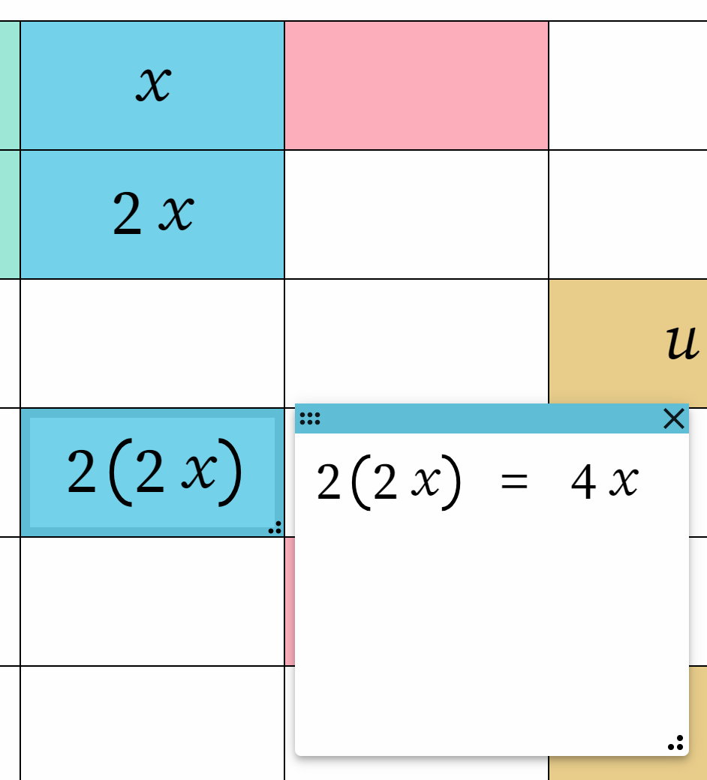
Image created using the free virtual manipulatives at Grid Algebra.
- As a Think-Pair-Share (bit.ly/thinkpairsharestrategy), ask the students to compare the 2 answers that are now sitting in the blue cell in row 4. Students need to explain why the 2 answers are equivalent.
- Randomly pick pairs to share their answers with the class, asking them to justify their reasoning.
Students will need to remember that $4x=4×x.$ We are trying to highlight that $$2\left(2x\right)=2×\left(2x\right)=2×2×x=4×x=4x$$
Teachers should revise the terms ‘variables’ and ‘expressions’ with students at this point.
- Repeat the above process with the remaining letters. The ‘p’ variable can be dragged to any appropriate squares.
Figure 7 – table showing an expression for $v$ after it has been dragged up a row
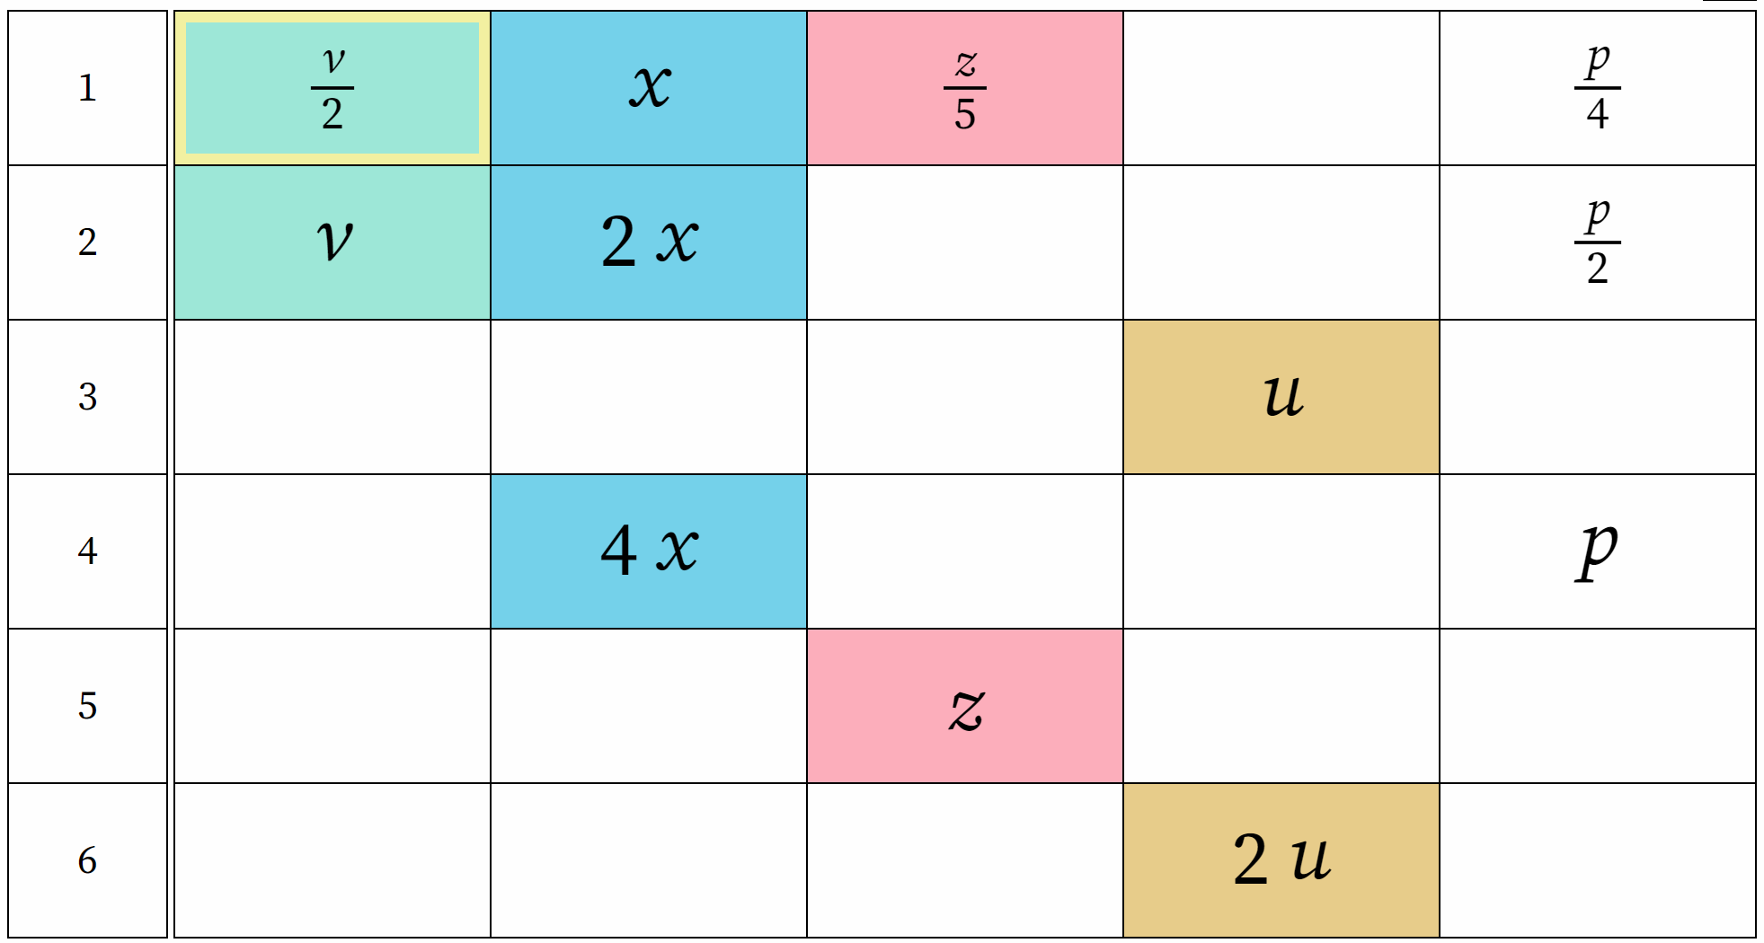
Image created using the free virtual manipulatives at Grid Algebra.
- Use a Think-Pair-Share for students to discuss how else the terms $\frac{v}{2}, \frac{z}{5}, \frac{p}{4}$ could be written.
- Invite pairs to share their answers and reasoning with the class.
The grid only works with multiplication and division of whole numbers. Dragging a variable from row 4 to row 3 is not allowed and the cell will be left blank.
- Choose a number at random to replace $x.$ Ask students to calculate what the values in the blue cells would be.
- Choose various other values for $x$ and the other letters and ask students to calculate the values in the appropriate cells.
Revise the term substitution and highlight the fact that substituting in different values results in different answers.
- Students complete the ‘Introducing letters’ worksheet in Appendix B.

Summarise
Students should write notes to their future forgetful self (bit.ly/notesstrategy) to summarise their learning from the explore section.

Apply
- If students have access to devices and the internet, ask students to navigate to the Grid Algebra website (https://gridalgebra.com/tasks).
- Students can complete task 13 ‘Meet the expression’ and task 20 ‘What is the expression?’
- Students can adjust the amount of time to complete each question and the difficulty of the task by using the sliders.
Figure 8 – task 13 on Grid Algebra
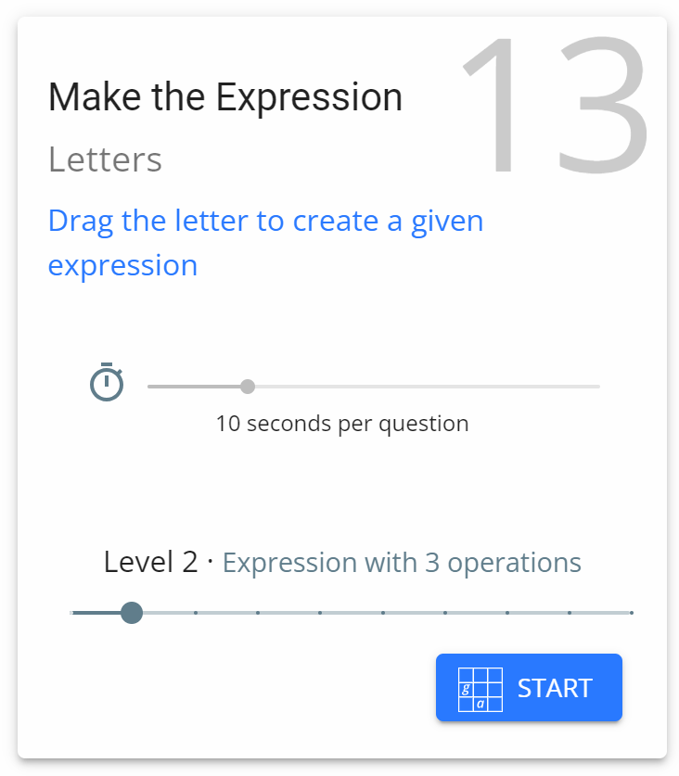
Image created using the free virtual manipulatives at Grid Algebra.

Assessment and differentiation

Suggested opportunities for differentiation
- Challenge students by considering multiplying and dividing with negative terms. For instance, moving $-x$ up and down rows.
- Challenge students by considering multiplying and dividing fractions or decimals by moving them up and down rows.
- Challenge students by substituting negatives, fractions and decimals into algebraic expression involving multiplication and division.

Suggested opportunities for assessment
- Teachers should monitor student answers during class discussions to assess their understanding.
- Teachers could choose to ask students to complete an exit ticket where they complete a table like those in Appendices A and B.
- Teachers could choose to collect the worksheets in Appendices A and B to check for understanding.

Appendix A

Which numbers go here?
Write in the numbers which should appear in the highlighted cells.
1 | 4
2
4

1 | 5
5

1 | 0
2
3
4

1
2
4 | 8

1
3 | 9
6

Combining moves
1 |  | $$2$$
2

1 |  | $$2$$
3
4

1
2
4 |  |  | 16

Appendix B

Introducing letters
Write in the expressions which should appear in the highlighted cells.
1 | $$m$$
2
4

1 | $$h$$
5

1 | $$e$$
2
3
4

1
2
4 | $$w$$

1
3 | $$a$$
6

Combining moves
1 |  | $$c$$
2

1 |  | $$b$$
3
4

1
2
4 |  |  | $$g$$

- Roll a die and use the result to replace $m$ in the first table of the worksheet. Calculate the numbers that belong in the remaining cells in the table.
- Repeat for each of the letters in the tables on the worksheet.

Sample solutions

Appendix A – which numbers go here?
1 | 4
2 | 8
4 | 16

1 | 5
5 | 25

1 | 0
2 | 0
3 | 0
4 | 0

1 | 2
2 | 4
4 | 8

1 | 3
3 | 9
6 | 18

Combining moves
1 |  | $$2$$
2 |  |  |  | 8

1 |  | $$2$$
3 | 3
4 |  |  |  | 16

1 |  | 3
2 |  |  |  |  | 12
4 |  |  | 16

Appendix B – introducing letters
1 | $$m$$
2 | $$2m$$
4 | $$4m$$

1 | $$h$$
5 | $$5h$$

1 | $$e$$
2 | $$2e$$
3 | $$3e$$
4 | $$4e$$

1 | $$\frac{w}{4}$$
2 | $$\frac{w}{2}$$
4 | $$w$$

1 | $$\frac{a}{3}$$
3 | $$a$$
6 | $$2a$$

Combining moves
1 |  | $$c$$
2 |  |  |  | $$2c+4 or 2(c+2)$$

1 |  | $$b$$
3 | $$3\left(b-1\right)or 3b-3$$
4 |  |  |  | $$4\left(b+2\right) or 4b+8$$

1 |  | $$\frac{g}{4}-1 or \frac{g-4}{4}$$
2 |  |  |  |  | $\frac{g+8}{2} or$ $\frac{g}{2}+4$
4 |  |  | $$g$$

References
This resource contains NSW Curriculum and syllabus content. The NSW Curriculum is developed by the NSW Education Standards Authority. This content is prepared by NESA for and on behalf of the Crown in right of the State of New South Wales. The material is protected by Crown copyright.
Please refer to the NESA Copyright Disclaimer for more information https://educationstandards.nsw.edu.au/wps/portal/nesa/mini-footer/copyright.
NESA holds the only official and up-to-date versions of the NSW Curriculum and syllabus documents. Please visit the NSW Education Standards Authority (NESA) website https://educationstandards.nsw.edu.au/ and the NSW Curriculum website https://curriculum.nsw.edu.au/home.
Mathematics K–10 Syllabus © NSW Education Standards Authority (NESA) for and on behalf of the Crown in right of the State of New South Wales, 2022.
© State of New South Wales (Department of Education), 2023
The copyright material published in this resource is subject to the Copyright Act 1968 (Cth) and is owned by the NSW Department of Education or, where indicated, by a party other than the NSW Department of Education (third-party material).
Copyright material available in this resource and owned by the NSW Department of Education is licensed under a Creative Commons Attribution 4.0 International (CC BY 4.0) licence.
This licence allows you to share and adapt the material for any purpose, even commercially.
Attribution should be given to © State of New South Wales (Department of Education), 2023.
Material in this resource not available under a Creative Commons licence:
- the NSW Department of Education logo, other logos and trademark-protected material
- material owned by a third party that has been reproduced with permission. You will need to obtain permission from the third party to reuse its material.
Links to third-party material and websites
Please note that the provided (reading/viewing material/list/links/texts) are a suggestion only and implies no endorsement, by the New South Wales Department of Education, of any author, publisher, or book title. School principals and teachers are best placed to assess the suitability of resources that would complement the curriculum and reflect the needs and interests of their students.
If you use the links provided in this document to access a third-party's website, you acknowledge that the terms of use, including licence terms set out on the third-party's website apply to the use which may be made of the materials on that third-party website or where permitted by the Copyright Act 1968 (Cth). The department accepts no responsibility for content on third-party websites.

