# Mathematics Stage 5 (Year 9) – summative assessment package – sample class test



Contents

Outcomes to be assessed 2

Task description 3

Submission details 3

Sample test 4

Instructions 4

Test content 4

References 9

This document is part 2 of 3 of a summative assessment package designed to assess the outcomes from Units 3 and 4 of the Department of Education’s [Stage 5 (Year 9) sample scope and sequence [DOCX 258KB]](https://education.nsw.gov.au/content/dam/main-education/teaching-and-learning/curriculum/mathematics/media/documents/mathematics-s5-sample-scope-and-sequence.docx).

* Part 1: [Question bank [DOCX 809KB]](education.nsw.gov.au/content/dam/main-education/en/home/schooling/curriculum/mathematics/mathematics-s5-assessment-question-bank.docx)
* Part 2: Sample class test
* Part 3: [Annotated sample responses [DOCX 2.3MB]](education.nsw.gov.au/content/dam/main-education/en/home/schooling/curriculum/mathematics/mathematics-s5-assessment-annotated-sample-responses.docx)

## Outcomes to be assessed

**Core outcomes being assessed:**

* develops understanding and fluency in mathematics through exploring and connecting mathematical concepts, choosing and applying mathematical techniques to solve problems, and communicating their thinking and reasoning coherently and clearly **MAO-WM-01**
* determines the midpoint, gradient and length of an interval, and graphs linear relationships, with and without digital tools **MA5-LIN-C-01**
* applies trigonometric ratios to solve right-angled triangle problems **MA5-TRG-C-01**
* solves problems involving the surface area of right prisms and practical problems involving the area of composite shapes and solids **MA5-ARE-C-01**
* solves problems involving the volume of composite solids consisting of right prisms and cylinders **MA5-VOL-C-01**

**Path outcomes being assessed:**

* describes and applies transformations, the midpoint, gradient/slope and distance formulas, and equations of lines to solve problems **MA5-LIN-P-01**
* applies knowledge of the surface area of right pyramids and cones, spheres and composite solids to solve problems **MA5-ARE-P-01**
* applies knowledge of the volume of right pyramids, cones and spheres to solve problems involving related composite solids **MA5-VOL-P-01**

[Mathematics K–10 Syllabus](https://curriculum.nsw.edu.au/learning-areas/mathematics/mathematics-k-10-2022) © NSW Education Standards Authority (NESA) for and on behalf of the Crown in right of the State of New South Wales, 2022.

The outcomes chosen are based on this assessment being implemented during Term 2 of the Department of Education’s [Stage 5 (Year 9) sample scope and sequence [DOCX 258KB]](https://education.nsw.gov.au/content/dam/main-education/teaching-and-learning/curriculum/mathematics/media/documents/mathematics-s5-sample-scope-and-sequence.docx), after the unit ‘Prisms and cylinders’.

## Task description

**Type of task:** class test

The questions in this sample class test have been drawn from the ‘[Question bank’](education.nsw.gov.au/content/dam/main-education/en/home/schooling/curriculum/mathematics/mathematics-s5-assessment-question-bank.docx). This test will provide opportunities for students to demonstrate their knowledge of the content points related to the included outcomes.

Sample answers with marking guidelines have been provided in the file ‘[Annotated sample responses](education.nsw.gov.au/content/dam/main-education/en/home/schooling/curriculum/mathematics/mathematics-s5-assessment-annotated-sample-responses.docx)’ and give examples of how to interpret responses against the Common Grade Scale ([bit.ly/commongradescale](https://bit.ly/commongradescale)).

## Submission details

Students complete this task in class, under examination conditions.

## Sample test

### Instructions

Below is an example of instructions for this sample test. Schools should include a similar list of instructions on their school’s standard assessment cover page.

* Reading time – 5 minutes.
* Working time – 40 minutes.
* Write using a black pen.
* NESA approved calculators are permitted in this examination.
* Students may bring an A4 page of handwritten notes into the test.

### Test content

**Question 1**

Eli is 3D printing a ramp to ride his scooter over. His first design is below.

Triangular prism with dimensions 600mm, 400mm and 200mm.
600 mm is the depth of the prism, 200mm is the height of the triangle and 400mm is the width of the triangle.

1. What is the volume of material Eli will need to 3D print the ramp?
2. Eli decides he wants the ramp to be twice as steep. Suggest one change he can make to the plan to achieve this and explain why you suggested that change.

**Question 2**

Consider the enclosed rectangular prism below, with width of 2 cm.

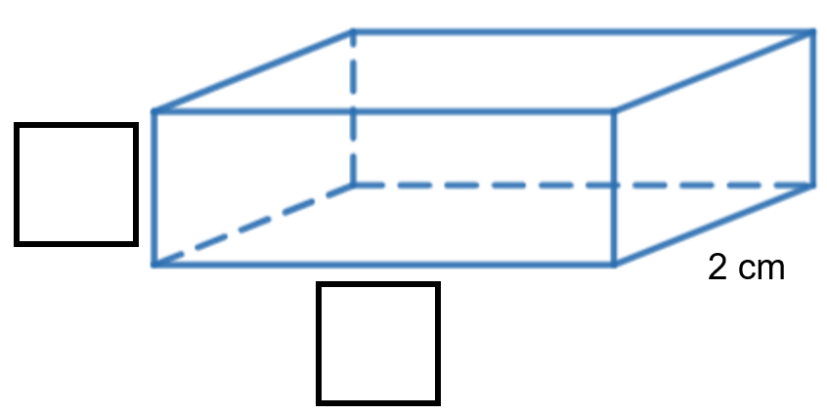

1. Label the indicated length and height edges such that the volume of the prism is 24 cm3.
2. Calculate the surface area of the solid.
3. Are there any dimensions you could have chosen in in part a where the volume would remain as 24 cm3, but the surface area would be smaller than your answer in part b? Give reasons for your answer.

**Question 3**

**Consider the statement below.**

**‘Every right-angled triangle with a ${45}^{o}$ angle will have 2 equal sides.’**

**Is this statement true? Explain why or why not.**

**Question 4**

Four small cubes, each with a surface area of 54 ${\text{cm}}^{\text{2}}$ are placed together to make the solid shown. What is the volume of the solid created?

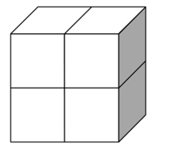

**Question 5**

**Zoe can see a plane flying and knows that it cruises approximately 10 km above ground level. She measures the angle between the ground and her line of sight to the plane to be ${25}^{o}13'$, as shown in the image below.**

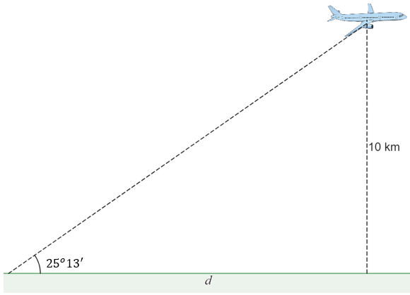

**What is the distance of the plane from Zoe, measured along the ground, $d$?**

**Question 6**

**Consider the Cartesian plane below, with the line $l$ displayed.**

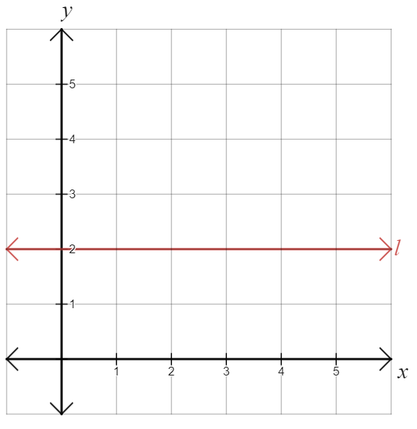

1. **Explain why the line $l$ has a gradient of 0.**
2. **Explain why all horizontal lines will have a gradient of 0.**

**Question 7**

**A marquee tent is constructed to the dimensions below.**

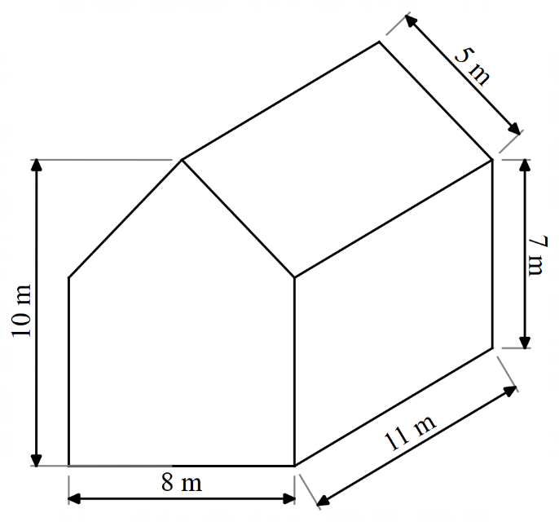

**The material for the marquee costs $45 per ${\text{m}}^{\text{2}}$. How much will the construction of this marquee cost, without a floor?**

## References

This resource contains NSW Curriculum and syllabus content. The NSW Curriculum is developed by the NSW Education Standards Authority. This content is prepared by NESA for and on behalf of the Crown in right of the State of New South Wales. The material is protected by Crown copyright.

Please refer to the NESA Copyright Disclaimer for more information [https://educationstandards.nsw.edu.au/wps/portal/nesa/mini-footer/copyright](https://aus01.safelinks.protection.outlook.com/?url=https%3A%2F%2Feducationstandards.nsw.edu.au%2Fwps%2Fportal%2Fnesa%2Fmini-footer%2Fcopyright&data=05%7C01%7CCaitlin.Pace1%40det.nsw.edu.au%7C9c2c1a9f59c94d2df30708dafa7edb23%7C05a0e69a418a47c19c259387261bf991%7C0%7C0%7C638097720042599463%7CUnknown%7CTWFpbGZsb3d8eyJWIjoiMC4wLjAwMDAiLCJQIjoiV2luMzIiLCJBTiI6Ik1haWwiLCJXVCI6Mn0%3D%7C3000%7C%7C%7C&sdata=BzQh0UsffVZE3eO22b2Xba3p0VMOBZSHfS21FGHXtZM%3D&reserved=0).

NESA holds the only official and up-to-date versions of the NSW Curriculum and syllabus documents. Please visit the NSW Education Standards Authority (NESA) website <https://educationstandards.nsw.edu.au/> and the NSW Curriculum website [https://curriculum.nsw.edu.au/home](https://curriculum.nsw.edu.au/).

[Mathematics K–10 Syllabus](https://curriculum.nsw.edu.au/learning-areas/mathematics/mathematics-k-10-2022) © NSW Education Standards Authority (NESA) for and on behalf of the Crown in right of the State of New South Wales, 2022.

**© State of New South Wales (Department of Education), 2023**

The copyright material published in this resource is subject to the *Copyright Act 1968* (Cth) and is owned by the NSW Department of Education or, where indicated, by a party other than the NSW Department of Education (third-party material).

Copyright material available in this resource and owned by the NSW Department of Education is licensed under a [Creative Commons Attribution 4.0 International (CC BY 4.0) license](https://creativecommons.org/licenses/by/4.0/).

[](https://creativecommons.org/licenses/by/4.0/)

This license allows you to share and adapt the material for any purpose, even commercially.

Attribution should be given to © State of New South Wales (Department of Education), 2023.

Material in this resource not available under a Creative Commons license:

* the NSW Department of Education logo, other logos and trademark-protected material
* material owned by a third party that has been reproduced with permission. You will need to obtain permission from the third party to reuse its material.

**Links to third-party material and websites**

Please note that the provided (reading/viewing material/list/links/texts) are a suggestion only and implies no endorsement, by the New South Wales Department of Education, of any author, publisher, or book title. School principals and teachers are best placed to assess the suitability of resources that would complement the curriculum and reflect the needs and interests of their students.

If you use the links provided in this document to access a third-party's website, you acknowledge that the terms of use, including licence terms set out on the third-party's website apply to the use which may be made of the materials on that third-party website or where permitted by the Copyright Act 1968 (Cth). The department accepts no responsibility for content on third-party websites.