Leftovers challenge
Students will investigate the size of different food containers and how their volumes compare, to fit in leftover food. Following this, students investigate which net would form a box with the largest volume.

Visible learning

Learning intentions
- To be able to construct prisms with differing volumes.
- To be able to compare prisms with differing volumes.

Success criteria
- I can compare the volume of prisms of similar size.
- I can create a net that makes a rectangular prism.
- I can determine the volume of a rectangular prism.
- I can justify my strategy for determining the maximum volumes.

Syllabus outcomes
A student:
- develops understanding and fluency in mathematics through exploring and connecting mathematical concepts, choosing and applying mathematical techniques to solve problems, and communicating their thinking and reasoning coherently and clearly MAO-WM-01
- solves problems involving the volume of composite solids consisting of right prisms and cylinders MA5-VOL-C-01
Mathematics K–10 Syllabus © NSW Education Standards Authority (NESA) for and on behalf of the Crown in right of the State of New South Wales, 2022.

Activity structure

Launch
- Play the ‘Grand Tupperware Challenge (3:10)’ clip (https://bit.ly/hamishandytupperware) for students.
- Have a brief class discussion about what was seen, for example:
- How were points awarded?
- What did Andy do to fit his chocolate cake into the container?
- What do we call the amount of space occupied by a food container? (volume)
- What do we call the amount a container can hold? (capacity)
This brief class discussion should informally bring up the difference between volume and capacity. It may be best to discuss these terms regarding the chocolate cake scenario in the Grand Tupperware Challenge clip.
- Explain to students that they are going to be shown 3–5 food containers that are of similar size. Students will need to order the containers based on which container holds the most.
- Be sure to number each container so answers can be collected from students.
- If food containers cannot be sourced, other suggestions include cereal boxes, shoe boxes and so on.
- To collect results from the students, use an online poll system such as Mentimeter (mentimeter.com).
- The teacher or students then test the most common ordering. Firstly, fill the suggested smallest container with either water, rice, or even centicubes and pour that into the suggested next largest container. If it overflows, then the ordering wasn’t correct. Continue this pattern to gain the correct ordering.

Explore
- Show students Appendix A ‘15 cm by 15 cm grid’. Explain that they are going to cut out squares from each of the 4 corners and fold up the sides to make a net for a food container with no lid.
- Pose the question to the students:
- If we want to make a food container that will fit the largest amount of leftovers, what might the net look like and what would the food container’s dimensions be?
- Students will investigate this question in pairs by creating different open prisms. Provide each student with Appendix B ‘Filling nets investigation’, as well as Appendix A ‘15 cm by 15 cm grid’. Students may need multiple copies of the grid to assist them with their exploration.
- Students will create open box nets by cutting out the same-sized square from each of the 4 corners of the grid. They are then to record and/or calculate:
- the number of squares they removed
- the number of squares that remain in their net
- the dimensions of the box they have created
- the volume of the box.
- Students will continue exploring until they believe they have found the box that has the greatest volume.
During this activity, observe which strategy the students are using to find the volume. Are they:
- counting cubes by visualising cubes inside it
- counting layers, so finding the area of the base
- multiplying all the sides.

Summarise
- Prior to discussing the results as a class, create a class display of the data students have collected by asking pairs to contribute information to the class display. Please note that solutions for Appendix B ‘Filling nets investigation’ can be found at the conclusion of this document.
- After all data has been recorded, students are to Think-Pair-Share (bit.ly/thinkpairsharestrategy) the following questions:
- What do you notice about the data?
- Do you notice any patterns? If so, what are they?
- What is the greatest volume possible? How do you know?
- What are the dimensions of the box that has the greatest volume?
- What did you notice about the relationship between the number of squares in the net and the volume of the box?
- What could the number of squares in the net represent?
- How much paper gets cut away for the box with the greatest volume?
- As a whole class these answers should be discussed by randomly selecting students to share their answers, using the Pause-Pose-Pounce-Bounce question strategy [PDF 200KB] (bit.ly/pausepouncebounce).
- From this discussion, the following should be concluded and summarised:
- The net of the box is what is called the surface area.
- A greater volume does not mean a greater number of squares on the surface of the solid.
The purpose of this task is to revise the volume of solids and discover how students calculate and think of volume, whilst introducing the concept of surface area and how it may relate to volume.

Apply
- In their pairs, students are to create graphs of the data to help them discover any patterns. This can be done using grid paper or using a spreadsheet. Students will need to select the 2 values that they are graphing. For example, they may like to firstly compare the base length of the box to the volume, or the number of squares that were cut out compared to the volume. Some sample graphs have been provided in Appendix C ‘Apply – possible graphs’ at the end of this document.
- Once students have created graphs of the data, display a few different alternatives and as a class discuss the following:
- What do you notice?
- Is there a pattern? If yes, what is it?
- Do you think that these graphs confirm the largest volume that we found as a class?
- Is there a relationship between the volume and the surface area?
- Which graphs look similar? Why could this be?
- To further extend students, ask them to explore if a greater volume could be found if the restrictions were adjusted, such as:
- What if the squares removed were not restricted to full squares and could be half squares? For example, what if a square that is 2.5 cm by 2.5 cm was removed from each of the 4corners of the grid. Would the greatest volume be different?
- What if decimals could be used to cut out the squares. For example, what if a square that is 2.1 cm by 2.1 cm was removed from each of the 4 corners of the grid. Would the greatest volume be different?
- What if rectangles could be cut out rather than just squares, would this change the results? If yes, how?
Students could also be challenged to use other types of prisms besides cubes or rectangular. Students could explore parallelograms or trapezoidal prisms.

Assessment and differentiation

Suggested opportunities for differentiation
Launch
- If multiple containers can be sourced, it may be beneficial for students to perform the experiment with water or rice themselves rather than just watching the teacher.
Explore
- Challenge the students to make a net for a food container from this grid without telling them how.
- Some students may need a review of how to find the volume of rectangular prisms.
- Some students may benefit from having some examples already done for them and they can continue to explore other dimensions and their volumes.
Apply
- This may be best completed as a whole class exploration, as some students will struggle with setting up their graphs and interpreting them.
- Alternatively, a spreadsheet template that is already set up could assist students. For example, the first sheet could have a pre-made table that they need to fill in and a graph will automatically be generated. The second sheet could have different variables that are explored.

Suggested opportunities for assessment
- Monitor student conversations in the pair activity to check for understanding.
- Monitor how students are calculating the volume of their boxes. If they are finding the volume as a product of the dimensions be sure to probe students to explain what they are multiplying and why.
- Collect and review the graphs created by students.

Appendix A

15 cm by 15 cm grid

Appendix B

Filling nets investigation
Using the provided 15 cm by 15 cm grids, cut out squares from each of the 4 corners to determine which open box will have the greatest volume.
Use the table below to record your exploration.
Number of squares initially | Number of squares removed | Number of squares remaining | Dimensions of base of the box | Height of the box | Volume of open box
$$15×15=225$$
$$15×15=225$$
$$15×15=225$$

Appendix C

Apply – possible graphs
Below are possible graphs that could be explored in the ‘Apply’ section.

Volume compared to number of squares removed
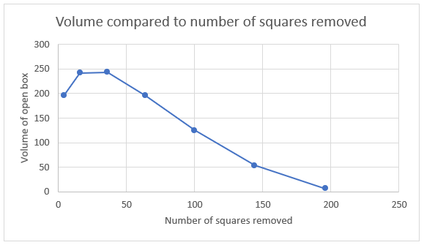

Volume compared to side length of base
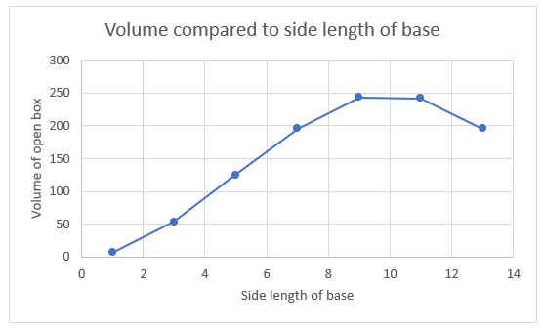

Volume compared to the height of the box
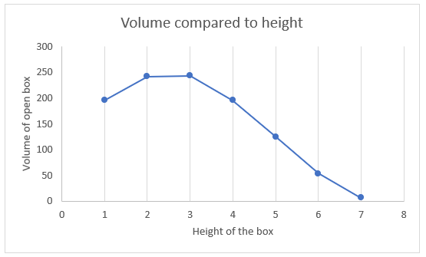

Volume compared to the number of squares remaining
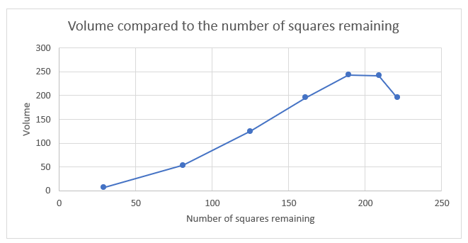

Sample solutions

Appendix B – filling nets investigation
Number of squares initially | Number of squares removed | Number of squares remaining | Dimensions of base of the box | Height of the box | Volume of open box
$$15×15=225$$ | $1×1$ squares removed from each corner = 4 squares removed | $$221$$ | 13 cm by 13 cm | 1 cm | 196 cm³
$$15×15=225$$ | $2×2$ squares removed from each corner = 16 squares removed | $$209$$ | 11 cm by 11 cm | 2 cm | 242 cm³
$$15×15=225$$ | $3×3$ squares removed from each corner = 36 squares removed | $$189$$ | 9 cm by 9 cm | 3 cm | 243 cm³
$$15×15=225$$ | $4×4$ squares removed from each corner = 64 squares removed | $$161$$ | 7 cm by 7 cm | 4 cm | 196 cm³
$$15×15=225$$ | $5×5$ squares removed from each corner = 100 squares removed | $$125$$ | 5 cm by 5 cm | 5 cm | 125 cm³
$$15×15=225$$ | $6×6$ squares removed from each corner = 144 squares removed | $$81$$ | 3 cm by 3 cm | 6 cm | 54 cm³
$$15×15=225$$ | $7×7$ squares removed from each corner = 196 squares removed | $$29$$ | 1 cm by 1 cm | 7 cm | 7 cm³

References
This resource contains NSW Curriculum and syllabus content. The NSW Curriculum is developed by the NSW Education Standards Authority. This content is prepared by NESA for and on behalf of the Crown in right of the State of New South Wales. The material is protected by Crown copyright.
Please refer to the NESA Copyright Disclaimer for more information https://educationstandards.nsw.edu.au/wps/portal/nesa/mini-footer/copyright.
NESA holds the only official and up-to-date versions of the NSW Curriculum and syllabus documents. Please visit the NSW Education Standards Authority (NESA) website https://educationstandards.nsw.edu.au/ and the NSW Curriculum website https://curriculum.nsw.edu.au/home.
Mathematics K–10 Syllabus © NSW Education Standards Authority (NESA) for and on behalf of the Crown in right of the State of New South Wales, 2022.

© State of New South Wales (Department of Education), 2023
The copyright material published in this resource is subject to the Copyright Act 1968 (Cth) and is owned by the NSW Department of Education or, where indicated, by a party other than the NSW Department of Education (third-party material).
Copyright material available in this resource and owned by the NSW Department of Education is licensed under a Creative Commons Attribution 4.0 International (CC BY 4.0) licence.
This licence allows you to share and adapt the material for any purpose, even commercially.
Attribution should be given to © State of New South Wales (Department of Education), 2023.
Material in this resource not available under a Creative Commons licence:
- the NSW Department of Education logo, other logos and trademark-protected material
- material owned by a third party that has been reproduced with permission. You will need to obtain permission from the third party to reuse its material.
Links to third-party material and websites
Please note that the provided (reading/viewing material/list/links/texts) are a suggestion only and implies no endorsement, by the New South Wales Department of Education, of any author, publisher, or book title. School principals and teachers are best placed to assess the suitability of resources that would complement the curriculum and reflect the needs and interests of their students.
If you use the links provided in this document to access a third-party's website, you acknowledge that the terms of use, including licence terms set out on the third-party's website apply to the use which may be made of the materials on that third-party website or where permitted by the Copyright Act 1968 (Cth). The department accepts no responsibility for content on third-party websites.

