Sphere’s the thing
Students show that the surface area of a sphere is 4 times the area of a circle with the same diameter through an exploration involving an orange. Students then explore a mix of routine and non-routine questions to apply the formulas for surface area and volume of spheres.

Visible learning

Learning intentions
- To be able to solve problems involving the surface area and volume of spheres.

Success criteria
- I can calculate the volume of spheres.
- I can calculate the surface area of spheres.
- I can solve routine and non-routine problems involving spheres.

Syllabus outcomes
A student:
- develops understanding and fluency in mathematics through exploring and connecting mathematical concepts, choosing and applying mathematical techniques to solve problems, and communicating their thinking and reasoning coherently and clearly MAO-WM-01
- applies knowledge of the surface area of right pyramids and cones, spheres and composite solids to solve problems MA5-ARE-P-01
- applies knowledge of the volume of right pyramids, cones and spheres to solve problems involving related composite solids MA5-VOL-P-01
Mathematics K–10 Syllabus © NSW Education Standards Authority (NESA) for and on behalf of the Crown in right of the State of New South Wales, 2022.

Activity structure

Launch
- Display screen 1 from the Desmos activity ‘What proportion of the Earth is covered by water?’ (bit.ly/saearth) for students to view. To do this, select Student Preview or select the first slide under the heading, Screens.
An alternative to the Desmos activity is to throw a globe of the Earth from student to student. Students call out whether their right thumb is on land or water when they catch the globe. Create a tally on the board of land or water.
- With the image of the map of the world displayed for students to view, ask students to consider ‘What percentage of the Earth’s surface is water?’
- Allow time for students to think independently. They can then share and discuss their prediction with a partner and then decide on an estimate as a pair.
- Move to screen 2 in the Desmos activity for the students to view.
- Click on the button New Location and the point on the map should move to a new location. Record in the table if this point has landed in water or on land.
- Repeat this 10 times and then use the table under the map to record the findings and make another prediction of what percentage of the earth’s surface is water.
- Ask each pair to compare this to their own predictions before moving to screen 3 and revealing that 71% of the Earth’s surface is water.
- Ask pairs to share with the class how they came up with their original predictions, example questions could include:
- Did you picture the Earth as a sphere or a flat map?
- What do you think the net of a sphere would look like?
- Imagine a circle with the same diameter as the Earth, how many circles do you think would wrap around the Earth?
- Explain to students that in today’s lesson they will explore how to calculate the surface area and volume of spheres so that they are equipped to solve problems involving spheres. It may be beneficial to conduct a brainstorm of where spheres are seen in real life, for example bearings, nature and design.

Explore

Surface area
Students will perform an experiment to discover the formula for the surface area of a sphere. The video ‘Surface area of a sphere with cutie (0:37)’ (bit.ly/orangepeelsphere) demonstrates the steps they will take.

Equipment
- One orange per group
- One sheet of paper per group
- One protractor and ruler per group

Method
- Assign students into random groups of 3. Explain to students that they will be peeling an orange and placing the peel onto circles that are the same size as the orange.
- Students should begin by drawing a circle that is equal in diameter to their orange. Issue each student with their orange and have them construct this circle. It is important that this circle is as close as possible to the diameter of the orange. They can do this by tracing around the orange, cutting the orange in half and tracing that circle or by using a ruler and protractor.
- Each group is to start peeling the orange, placing the peel into the constructed circle. Once they fill one circle, they are to construct a new circle to continue until the orange has no peel left. If students have a significant amount of pith (white) showing they should be challenged to consider if the pith is part of the surface area. Students can peel smaller pieces to avoid excessive pith.
- Students should end up with 4 complete circles filled with orange peel. Once groups are finished, they should do a gallery walk (bit.ly/DLSgallerywalk) to observe other groups’ results.
- Students can be shown the ‘Surface area of a sphere with cutie (0:37)’ (bit.ly/orangepeelsphere) demonstration the experiment they just did.
- Have a class discussion about what this means. The orange was a sphere and the orange peel ended up fitting into 4 circles that had the same diameter as the sphere.
- Clearly explain that the peel represents the surface area and revise the formula for the area of circle, $A=πr^{2}$. Then allow students to discuss with their partner what the formula for the surface area of a sphere is.
- Reveal to students that the formula for the surface area of a sphere is $\text{Surface area}=4πr^{2}$.

Volume
Other than verifying that the formula works by pouring water from hemispheres into a cylinder of equal diameter and height (the video ‘Develop and apply the formula for volume of a sphere (4:47)’ (bit.ly/derivingvolumeofsphere) demonstrates the concept. Methods of proving the formula require algebra beyond the scope of Stage 5.
- If equipment is available, use water pouring methods to demonstrate how the volume of a sphere is formed. Alternatively show students the video ‘Develop and apply the formula for volume of a sphere (4:47)’ (bit.ly/derivingvolumeofsphere) which derives the formula.
- Following this, explicitly show students the volume formula for a sphere is $V=\frac{4}{3}πr^{3}$.
- As a class, students can construct a Notice and Wonder list (bit.ly/noticewonderstrategy) about the formula for the volume of a sphere. Students might:
- Notice the similarities to the area of a circle formula.
- Notice that the power is 2 for a 2D circle and 3 for a 3D sphere
- Wonder where the fraction $\frac{4}{3}$ has come from.

Summarise
- Use the provided Spheres the thing PowerPoint for explicit teaching and worked examples to demonstrate how to apply the formulas for the volume and surface area of spheres.

Apply
- Randomly assign students into groups of 3 and distribute one set of questions from Appendix A ‘Spheres problems set’ per group. For example, one group will have ‘Spheres in architecture’, another will have ‘The solar system’. Students are to work on Vertical Non-Permanent Surfaces (VNPS) (bit.ly/VNPSstrategy) in their groups to solve the set of assigned problems.
- When students have finished and can’t go any further with their problem, they are encouraged to move to another group and work on their problem.
- At the conclusion, students should do a gallery walk (bit.ly/DLSgallerywalk) to view the solutions to all the problems.
- Students can then complete the following question as an exit ticket to check for student understanding. This question involves students working backwards to discover the radius and has the added challenge of writing the volume and surface area in terms of $π$.
- Given that the volume of a sphere is $562.5π cm^{3}$, find its surface area in terms of $π$.

Assessment and differentiation

Suggested opportunities for differentiation
Explore
- Students could be challenged to explore and explain the derivation of the formula for the volume of a sphere.
Summary
- Further composite solids can be provided to challenge students. For example, quarter spheres or spheres with volumes cut out.
Apply
- In the solar system questions, the answers are in scientific notation, this may require some review for some students.

Suggested opportunities for assessment
- Collect student responses from Appendix A ‘Spheres problems set’ to check for student understanding.
- Monitor student conversations to check for any misconceptions that may need to be addressed.

Appendix A

Spheres problem sets

Spheres in architecture
- Spaceship Earth, a spherical attraction at Walt Disney World's Epcot Centre, has a diameter of 50 metres. Calculate the surface area of the structure.
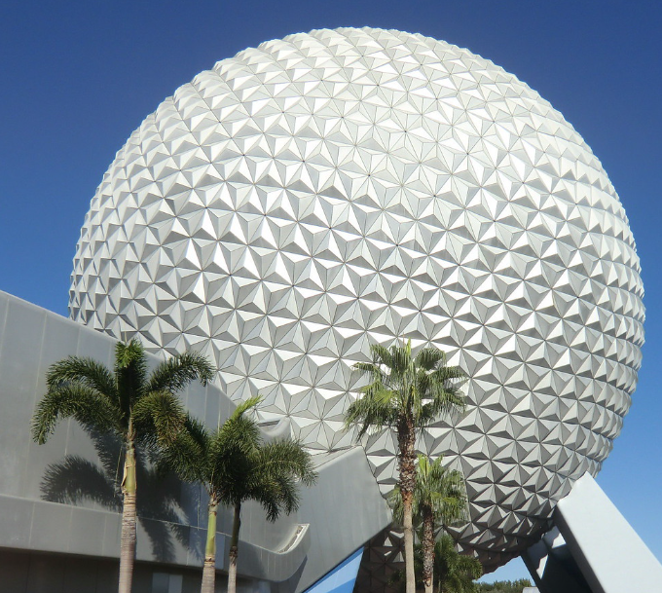
Image by Reinhard Link is licensed under CC BY-NC-SA 4.0.
- This statue of Atlas, carrying the globe on his shoulders can be found at Frankfurt Central Station in Germany.
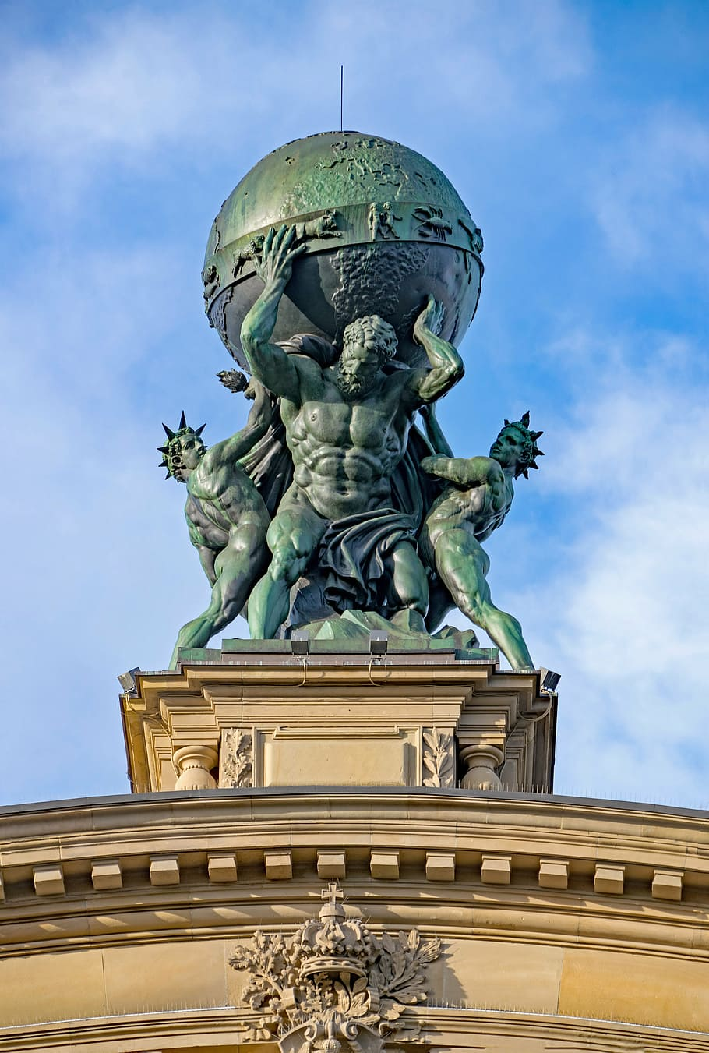
Image sourced from Wallpaper Flare and used in accordance with Wallpaper Flare Terms of Use.
Yindi has purchased a replica of the statue without the globe. They intend on 3D printing a sphere to fit in its place that can be used as a jewellery box.
- Yindi designed a sphere with a diameter of 15 cm as shown below. If they print the hollow sphere, will 800 $cm^{2}$ of plastic be enough material?
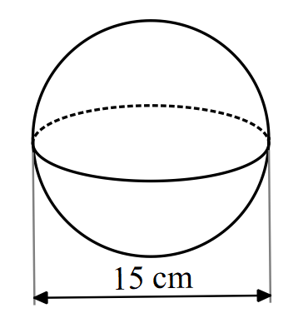
- Yindi intends on filling the bottom hemisphere with foam that they can sit a ring inside the sphere, as shown below.
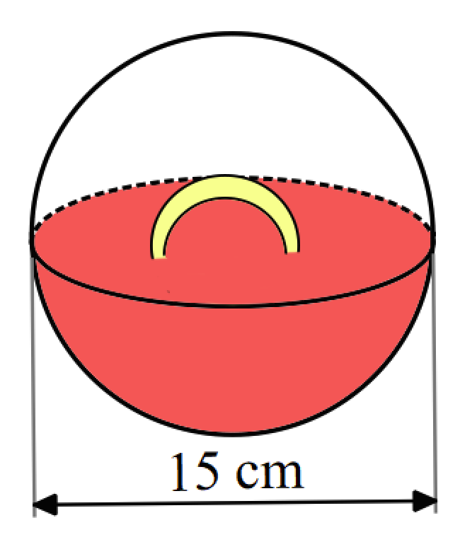
How many cubic centimetres of foam should Yindi buy?

- A silo is built by placing a dome roof on top of a cylinder as shown in the diagram below.
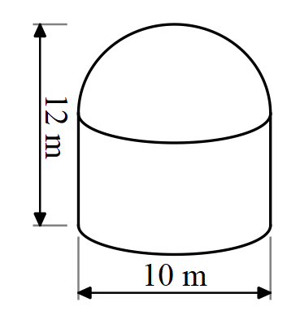
- Find the capacity of the silo in litres.
- The exterior of the silo is to be painted, find the surface area that will be painted.

The solar system
- The circumference of Earth measured around the equator is 40 075.017 km. What is the surface area of Earth, assuming it is spherical.
- The planet Neptune has a radius of 24 622 km and Jupiter has a radius of 69 911 km. How many times bigger is the surface area of Jupiter than Neptune?
- The diameter of the moon is approximately one-fourth of the diameter of the Earth. What percentage of the volume of the Earth is the volume of the moon?

Tennis balls
Round all answers to a consistent degree of accuracy.
- Some tennis balls are sold in cylinders of 3 balls that fit perfectly inside so that the height of the 3 spheres is equal to the height of the cylinder, and each ball touches the cylinder wall.
Will the height of a cylinder that holds 3 tennis balls be greater than or less than its circumference?
- Two identical spherical balls fit exactly inside a cylinder as shown below.
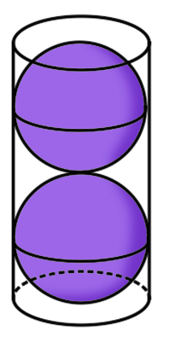
Given that the circumference of each ball is 20 cm, find the surface area of the cylinder.
- Three tennis balls of diameter 8 cm fit perfectly inside a tube so that the height of the 3 spheres is equal to the height of the tube, and each ball touches the cylinder wall.
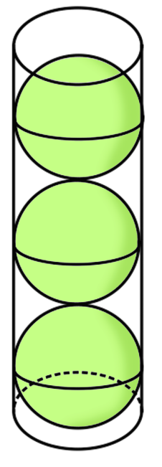
- Find the volume of the tube.
- Find the empty space in the tube.
- Calculate the percentage of the tube that is not filled. Round your answer to the nearest whole percent.

Sample solution

Appendix A – spheres problem sets

Spheres in architecture
- $SA=4πr^{2}$
$$SA=4×π×{25}^{2} \\ =7853.98m^{2}$$

- $SA=4πr^{2}$
$$SA=4×π×{7.5}^{2} \\ =706.86cm^{2}$$
Therefore, yes 800 cm² of plastic is enough material.
- $V=\frac{4}{3}πr^{3}$
$$V=\frac{1}{2}×\left(\frac{4}{3}×π×{7.5}^{3}\right) \\ =883.6cm^{3}$$

- $V=πr^{2}h+\frac{1}{2}×\frac{4}{3}πr^{3}$
$$V=π×5^{2}×(12-5)+\frac{1}{2}×\frac{4}{3}×5^{3} \\ V=811.578m^{3} \\ 1 m^{3}=1000 L \\ Capacity=811 578L$$
- $SA=2πrh+\frac{1}{2}×4πr^{2}$
$$SA=\left(2×π×5×7\right)+\frac{1}{2}×4×π×5^{2} \\ =376.99 cm^{2}$$

The solar system
- $C=2πr$
$$40 075.017=2πr \\ r=\frac{40 075.017}{2π} \\ r=6378.137 km$$
$$SA=4πr^{2} \\ SA=4×π×{6378.137}^{2} \\ =511 207 893.4 km^{2}$$
- $SA=4πr^{2}$
$$Neptune SA=4×π×24 {622}^{2} \\ =7 618 272 763 km^{2}$$
$$Jupiter SA=4×π×69 {911}^{2} \\ =6.14×{10}^{10} km^{2}$$
How many times bigger?
$$=6.14×{10}^{10}÷7 618 272 763 \\ =8.059…$$
Therefore the surface area of Jupiter is approximately 8 times larger than the surface area of Neptune.
- $radius of the Earth from Q1=6378.137 km$
$$diamter of the Earth=2×6378.137 \\ =12 756.274 km$$
$$diameter of the moon=\frac{1}{4}×12 756.274 \\ =3189.0685 km$$
$$raidus of the moon=\frac{1}{2}×3189.0685 \\ =1594.53425 km$$
$$V=\frac{4}{3}πr^{3}$$
$$Volume of the earth=\frac{4}{3}×π×{6378.137}^{3} \\ =1.08685×{10}^{12}$$
$$Volume of the moon=\frac{4}{3}×π×{1594.53425}^{3} \\ =1.6982×{10}^{10}$$
$$Percentage=\frac{volume of moon}{volume of earth}×100 \\ =\frac{1.6982×{10}^{10}}{1.08685×{10}^{12}}×100 \\ =1.56\%$$

Tennis balls
- $Let radius of spheres=r$
$$∴height of cylinder=3×2×r \\ =6r$$
$$Circumference=2πr \\ =6.283…r$$
$∴$ The height of the cylinder will be less than the circumference since $6<6.283…$
- Given that the circumference of each ball is 20 cm, find the surface area of the cylinder.
Finding the diameter:
$$C=π×D$$
$$20=π×D$$
$$D=\frac{20}{π}$$
$$D=6.3662$$
$$D=6.37 cm \left(2 decimal places\right)$$
Finding the height of the cylinder:
$$h=2D$$
$$h=12.7324$$
$$h=12.73 cm (2 decimal places)$$
Finding the surface area of the cylinder:
$$SA=2πr^{2}+2πrh$$
$$r=\frac{1}{2}D$$
$$r=\frac{1}{2}×6.3662$$
$$r=3.1831$$
$$r=3.18 cm (2 decimal places)$$
$$SA=2×π×{3.1831}^{2}+2×π×3.1831×12.7324$$
$$SA=318.31011$$
$$SA=318.31 cm^{2} (2 decimal places)$$

- Find the volume of the tube.
$$height of cylinder=3×8 \\ =24 cm$$
$$radius of cylinder=\frac{1}{2}×8 \\ =4cm$$
$$V=πr^{2}h \\ V=π×4^{2}×24 \\ =1206.37 cm^{3}$$
- Find the empty space in the tube.
$$Empty space=volume of tube-3×volume of tennis ball \\ =1206.37-3×\left(\frac{4}{3}×π×4^{3}\right) \\ =402.12 cm^{3}$$
- $Percentage=\frac{empty space}{volume of tube}×100$
$$=\frac{402.12}{1206.37}×100 \\ =33.3 \%$$

References
This resource contains NSW Curriculum and syllabus content. The NSW Curriculum is developed by the NSW Education Standards Authority. This content is prepared by NESA for and on behalf of the Crown in right of the State of New South Wales. The material is protected by Crown copyright.
Please refer to the NESA Copyright Disclaimer for more information https://educationstandards.nsw.edu.au/wps/portal/nesa/mini-footer/copyright.
NESA holds the only official and up-to-date versions of the NSW Curriculum and syllabus documents. Please visit the NSW Education Standards Authority (NESA) website https://educationstandards.nsw.edu.au/ and the NSW Curriculum website https://curriculum.nsw.edu.au/home.
Mathematics K–10 Syllabus © NSW Education Standards Authority (NESA) for and on behalf of the Crown in right of the State of New South Wales, 2022.

© State of New South Wales (Department of Education), 2023
The copyright material published in this resource is subject to the Copyright Act 1968 (Cth) and is owned by the NSW Department of Education or, where indicated, by a party other than the NSW Department of Education (third-party material).
Copyright material available in this resource and owned by the NSW Department of Education is licensed under a Creative Commons Attribution 4.0 International (CC BY 4.0) licence.
This licence allows you to share and adapt the material for any purpose, even commercially.
Attribution should be given to © State of New South Wales (Department of Education), 2023.
Material in this resource not available under a Creative Commons licence:
- the NSW Department of Education logo, other logos and trademark-protected material
- material owned by a third party that has been reproduced with permission. You will need to obtain permission from the third party to reuse its material.
Links to third-party material and websites
Please note that the provided (reading/viewing material/list/links/texts) are a suggestion only and implies no endorsement, by the New South Wales Department of Education, of any author, publisher, or book title. School principals and teachers are best placed to assess the suitability of resources that would complement the curriculum and reflect the needs and interests of their students.
If you use the links provided in this document to access a third-party's website, you acknowledge that the terms of use, including licence terms set out on the third-party's website apply to the use which may be made of the materials on that third-party website or where permitted by the Copyright Act 1968 (Cth). The department accepts no responsibility for content on third-party websites.

