Cup or cone?
This activity incorporates Path content.
Students explore finding the volume and surface area of cones through a debate of cup or cone for ice-cream. Students also explore a range of solids, comparing their volume and surface area.

Visible learning

Learning intentions
- To be able to solve problems involving the surface area and volume of cones.

Success criteria
- I can calculate the volume of cones.
- I can calculate the surface area of cones.
- I can identify the shapes that make up the surface area of a cone
- I can calculate the volume and surface area of composite solids.

Syllabus outcomes
- develops understanding and fluency in mathematics through exploring and connecting mathematical concepts, choosing and applying mathematical techniques to solve problems, and communicating their thinking and reasoning coherently and clearly MAO-WM-01
- applies knowledge of the surface area of right pyramids and cones, spheres and composite solids to solve problems MA5-ARE-P-01
- applies knowledge of the volume of right pyramids, cones and spheres to solve problems involving related composite solids MA5-VOL-P-01
Mathematics K–10 Syllabus © NSW Education Standards Authority (NESA) for and on behalf of the Crown in right of the State of New South Wales, 2022.

Activity structure

Launch
- Display Figure 1 for students to view (slide 3 from Cup or Cone? PowerPoint) and ask students to consider if they would rather have an ice-cream in a cup or in a cone.
Figure 1 – cone or cup?
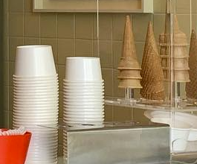
- Allow students to discuss their choice and reasoning in a Think-Pair-Share (bit.ly/thinkpairsharestrategy).
- Through a class discussion, record all reasons for students’ choices for them to view. This could be by writing it on the board or using a Mentimeter (mentimeter.com/).
It is important to record and display student reasons for their choice, as most reasons are valid and should be recognised. One reason that should be discussed is that you may get more ice-cream in one option than you would in the other. If this reason is not given by a student, use questions to prompt students to consider this.
- Ask students to consider which option would give you the most ice-cream. This should be a simple guess and students can show their choice using a finger vote, that is hold up one finger to vote cone and 2 fingers to vote cup.
- Explain to students that comparing the ice-cream cone with the cup will be the focus of the activity. Ask students to consider what information they may need to make a definite decision on which option would give the most ice-cream, cup or cone?
This should allow for a brief discussion on the volume of each option, what solid each option is, and what measurements may be required to calculate the volume. Students should recognise that they need to find the volume of a cone and cylinder.

Explore

Part 1 – volume
- Display Figure 2 for students to view (Slide 5 from Cup or cone? PowerPoint) and ask them to consider what they notice and what they wonder.
Figure 2 – cone and cup with dimensions
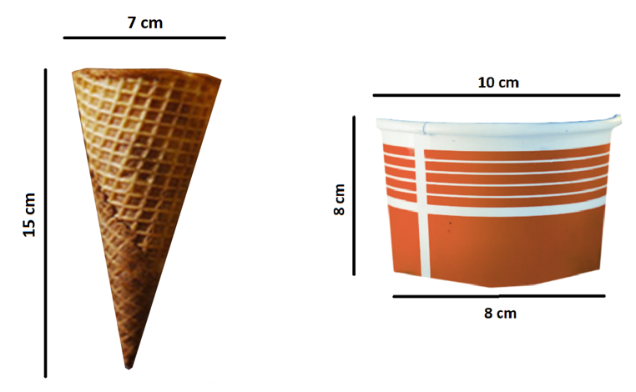
‘Ice Cream Cone S'mores’ by PersonalCreations.com is licensed under CC BY 2.0 and ‘Ice Cream and Waffle in Paper Cup’ by Jeswin Thomas is licensed under Pexels license.
Students may recognise that the cup shown isn’t a cylinder, since the base diameter is smaller than the top diameter. Students should be encouraged to explore this idea and how they may find the volume. For example, they may find the average volume between a cylinder using the base diameter to a cylinder with the top diameter. Although if this is too much of an extension for students, remove the 8 cm and assume it is a cylinder.
Students may also recognise that ice-cream usually sits above the cone and/or the cup, and this factor could also be explored using hemispheres.
- Once the students have discussed the factors that need to be considered, and decided what they will explore in terms of volume of ice-cream, use slides 6 to 10 of the Cup or cone? PowerPoint to explicitly demonstrate how to calculate the volume of a cone. Alternatively, allow students to make the connection between pyramids and cones to discover the formula on their own.
- When students are confident applying the formula for the volume of a cone to problems, assign students into random groups of 3. Students are to work at Vertical Non-Permanent Surfaces (VNPS) (bit.ly/VNPSstrategy) to calculate the volume of the cup and the cone.
- As groups begin to finish, encourage them to take a gallery walk (bit.ly/DLSgallerywalk) to compare their results with other groups.

Part 2 – surface area
- Provide students with a new consideration:
‘A store offers to coat either your cup or cone with chocolate before adding ice-cream. If you want to get the most chocolate coating possible, would you choose a cup or a cone?’
- Ask students to consider which option they would choose. This should be a simple guess and students can show their choice using a finger vote, that is hold up one finger to vote cone and 2 fingers to vote cup.
- Explain to students that comparing the ice-cream cone with the cup will be the focus of the next part of the activity. Ask students to consider what information they may need to make a definite decision on which option would give the most amount of chocolate coating, a cup or cone?
This should allow for a brief discussion on the surface area of each option, as well as what measurements may be required to calculate the surface area. Students should recognise that they need to find the surface area of a cone and cylinder.
- Using slides 11 to 17 of the Cup or cone? PowerPoint, or otherwise, explicitly demonstrate how to calculate the surface area of a cone by exploring the net of a cone and applying the formula $SA=πr^{2}+πrl$ .
- When students are confident in applying the formula for the surface area of a cone to problems, challenge students in their groups at VNPS (bit.ly/VNPSstrategy) to determine which option would give the most chocolate coating.
- As groups begin to finish, encourage them to take a gallery walk (bit.ly/DLSgallerywalk) to compare their results with other groups

Summarise
- Students will now investigate the volume and surface area of cones in relation to other known solids and composite solids.
- Issue each group with Appendix A ‘Ordering solids by volume and surface area’ which has been cut up into cards. Each card has a different solid on it.
- Ask each group to rank the cards in order from smallest to largest volume without performing any calculations. Either through a gallery walk or through questioning, discuss what students think might be the solid with the least volume and the largest volume, and their reasons why.
- Students are to test their prediction by performing the least number of calculations with the solids. For example, students may notice that the rectangular prism and the triangular prism have the same measurements, so the rectangular prism would have a larger volume than the triangular prism without any calculations needing to be performed.
- Once students have finalised their rank, the class can come together to establish the order of solids and discuss any strategies they may have taken, without resorting to using formulas.
- This task should be repeated, where students rank each solid from smallest to largest surface area.

Apply
Display or print the following problem for students to work through, either individually or in their existing groups VNPS (bit.ly/VNPSstrategy).
- A cylinder with diameter 3 cm and height 8 cm is filled with water.
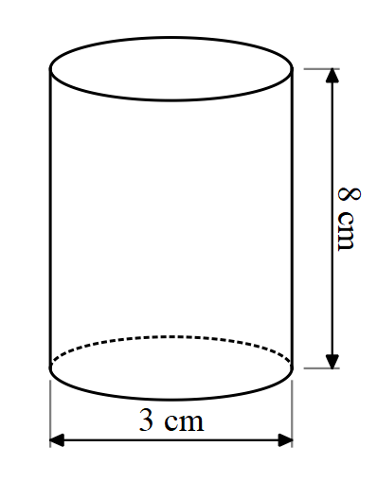
Decide which figures described below, if any, could hold all the water from the cylinder. Explain your reasoning.
- A cone with a height of 8 cm and a diameter of 3 cm.
- A sphere with a diameter of 3 cm.
- A cylinder with a diameter of 8 cm and height of 3 cm.
- A rectangular prism with a length of 3 cm, width of 4 cm and height of 8 cm.
- Bonus challenge: Can you create any figures that would hold the same amount of water as the cylinder?
- Extra bonus challenge: If you were able to cut the cylinder if anyway that you wanted, and rearrange the pieces, which of the above solids would you have enough material to make?

Assessment and differentiation

Suggested opportunities for differentiation
Explore
- If groups too quickly determine an answer to the cup vs cone problem, provide them with additional sized cups and cones to consider. (Most venues contain different sized cups and cones to cater for babies and children) What size cup do you need to purchase to get more ice-cream than in a cone?
- Students may find the volume of the cup by only considering one diameter. Students should be challenged to find the average of both diameters to calculate the volume.
- Students can be extended by investigating the average sized ice-cream scoop and considering how many spherical scoops would fit in each option
Summarise
- Some students may need some solids removed from Appendix A that are too challenging.

Suggested opportunities for assessment
Launch
- Students’ reasoning for cone or cup may highlight their understanding of geometric properties. For instance, some students might believe because the cone is taller it will hold more.
- Students highlighting the information they need to solve the problem is an important step in non-routine problem solving.
Apply
- Collect student responses to check for student understanding.
Appendix A

Ordering solids by volume and surface area
Solid 1  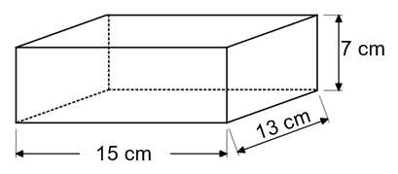 | Solid 2  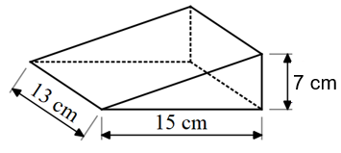
Solid 3  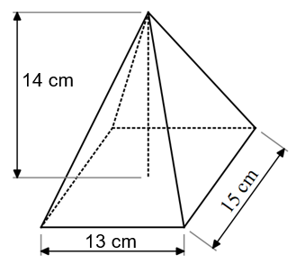 | Solid 4  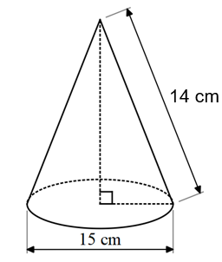
Solid 5  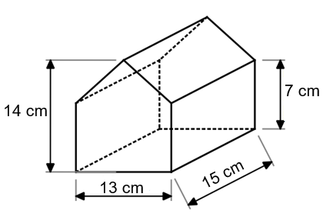 | Solid 6  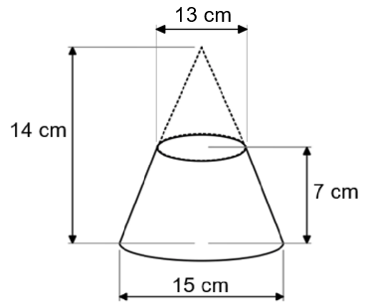
Solid 7  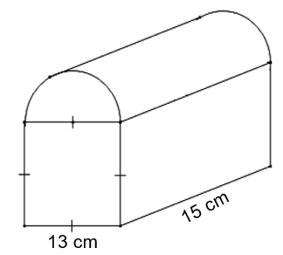 | Solid 8  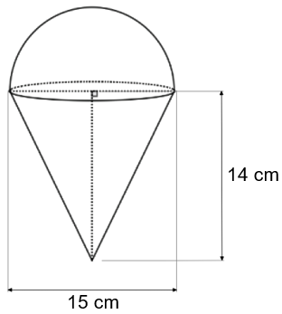

Sample solution

Appendix A – ordering solids by volume and surface area

Volume
Solid 1
$$V=13×15×7 \\ =1365cm^{3}$$
Solid 2
$$V=\frac{1}{2}×15×13×7 \\ =682.5cm^{3}$$
Solid 3
$$V=\frac{1}{3}×13×15×14 \\ =910cm^{3}$$
Solid 4
$$h=\sqrt{{14}^{2}-{7.5}^{2}} \\ =11.8$$
$$V=\frac{1}{3}×π×{7.5}^{2}×11.8 \\ =695.1cm^{3}$$
Solid 5
$$V=\left(\left(13×7\right)+\left(\frac{1}{2}×13×7\right)\right)×15 \\ =2047.5cm^{3}$$
Solid 6
$$V=\left(\left(\frac{1}{3}×π×{7.5}^{2}×14\right)-\left(\frac{1}{3}×π×{6.5}^{2}×7\right)\right) \\ =514.96cm^{3}$$
Solid 7
$$V=\left(\left(13×13\right)+\left(\frac{1}{2}×π×{6.5}^{2}\right)\right)×15 \\ =3530.49cm^{3}$$
Solid 8
$$V=\left(\frac{1}{3}πr^{2}h\right)+\frac{1}{2}×\left(\frac{4}{3}πr^{3}\right) \\ =\left(\frac{1}{3}×π×{7.5}^{2}×14\right)+\frac{1}{2}×\left(\frac{4}{3}×π×{7.5}^{3}\right) \\ =1708.24cm^{3}$$

Rank of volume from smallest to largest
- Solid 7
- Solid 5
- Solid 8
- Solid 1
- Solid 3
- Solid 4
- Solid 2
- Solid 6

Surface area
Solid 1
$$SA=\left(2×15×7\right)+\left(2×13×7\right)+\left(2×15×13\right) \\ =782cm^{2}$$
Solid 2
$$x=\sqrt{7^{2}+{15}^{2}} \\ =16.55$$
$$SA=\left(2×\frac{1}{2}×15×7\right)+\left(15×13\right)+\left(13×16.55\right)+(7×13) \\ =606.15cm^{2}$$
Solid 3
$$x=\sqrt{{14}^{2}+{6.5}^{2}} \\ =15.4$$
$$y=\sqrt{{14}^{2}+{7.5}^{2}} \\ =15.88$$
$$SA=\left(13×15\right)+2×\left(\frac{1}{2}×15×15.4\right)+2×\left(\frac{1}{2}×13×15.88\right) \\ =632.44cm^{2}$$
Solid 4
$$SA=π×{7.5}^{2}+π×7.5×14 \\ =506.58cm^{2}$$
Solid 5
$$Front face=13×7+\frac{1}{2}×13×7 \\ =136.5cm^{2}$$
$$slope of triangular prism=\sqrt{7^{2}+{6.5}^{2}} \\ =9.55$$
$$SA=\left(13×15\right)+\left(2×136.5\right)+\left(2×15×7\right)+\left(2×9.55×15\right) \\ =964.5cm^{2}$$
Solid 6
$$slant height large pyramid=\sqrt{{14}^{2}+{7.5}^{2}} \\ =15.88$$
$$slant height of small pyramid=\sqrt{7^{2}+{6.5}^{2}} \\ =9.55$$
$$SA=π×{7.5}^{2}+π×{6.5}^{2}+\left(\left(π×7.5×15.88\right)-\left(π×6.5×9.55\right)\right) \\ =488.6cm^{2}$$
Solid 7
$$SA=\left(15×13\right)+2×\left(13×13\right)+2×\left(15×13\right)+2×\left(\frac{1}{2}×π×{6.5}^{2}\right)+\left(\frac{1}{2}2×π×6.5×15\right) \\ =1362.04cm^{2}$$
Solid 8
$$Slant height of cone=\sqrt{{14}^{2}+{7.5}^{2}} \\ =15.88cm^{2}$$
$$SA=\left(π×7.5×15.88\right)+\frac{1}{2}×\left(4×π×{7.5}^{2}\right) \\ =727.6cm^{2}$$

Rank of volume from smallest to largest
- Solid 7
- Solid 5
- Solid 1
- Solid 8
- Solid 3
- Solid 2
- Solid 4
- Solid 6

References
This resource contains NSW Curriculum and syllabus content. The NSW Curriculum is developed by the NSW Education Standards Authority. This content is prepared by NESA for and on behalf of the Crown in right of the State of New South Wales. The material is protected by Crown copyright.
Please refer to the NESA Copyright Disclaimer for more information https://educationstandards.nsw.edu.au/wps/portal/nesa/mini-footer/copyright.
NESA holds the only official and up-to-date versions of the NSW Curriculum and syllabus documents. Please visit the NSW Education Standards Authority (NESA) website https://educationstandards.nsw.edu.au/ and the NSW Curriculum website https://curriculum.nsw.edu.au/home.
Mathematics K–10 Syllabus © NSW Education Standards Authority (NESA) for and on behalf of the Crown in right of the State of New South Wales, 2022.
© State of New South Wales (Department of Education), 2023
The copyright material published in this resource is subject to the Copyright Act 1968 (Cth) and is owned by the NSW Department of Education or, where indicated, by a party other than the NSW Department of Education (third-party material).
Copyright material available in this resource and owned by the NSW Department of Education is licensed under a Creative Commons Attribution 4.0 International (CC BY 4.0) licence.
This licence allows you to share and adapt the material for any purpose, even commercially.
Attribution should be given to © State of New South Wales (Department of Education), 2023.
Material in this resource not available under a Creative Commons licence:
- the NSW Department of Education logo, other logos and trademark-protected material
- material owned by a third party that has been reproduced with permission. You will need to obtain permission from the third party to reuse its material.
Links to third-party material and websites
Please note that the provided (reading/viewing material/list/links/texts) are a suggestion only and implies no endorsement, by the New South Wales Department of Education, of any author, publisher, or book title. School principals and teachers are best placed to assess the suitability of resources that would complement the curriculum and reflect the needs and interests of their students.
If you use the links provided in this document to access a third-party's website, you acknowledge that the terms of use, including licence terms set out on the third-party's website apply to the use which may be made of the materials on that third-party website or where permitted by the Copyright Act 1968 (Cth). The department accepts no responsibility for content on third-party websites.

