Concrete dreams

Visible learning
Students explore volume and surface area of composite solids through the design of a new skate park.
This lesson incorporates Path content on surface area and volume of spheres, which could easily be removed if needed.

Learning intentions
- To be able to find the volume and surface area of composite solids.
- To be able to solve problems involving composite solids.

Success criteria
- I can name the solids that form a composite solid.
- I can find the volume of composite solids.
- I can find the surface area of composite solids.
- I can solve problems involving composite solids.

Syllabus outcomes
A student:
- develops understanding and fluency in mathematics through exploring and connecting mathematical concepts, choosing and applying mathematical techniques to solve problems, and communicating their thinking and reasoning coherently and clearly MAO-WM-01
- solves measurement problems by using scientific notation to represent numbers and rounding to a given number of significant figures MA5-MAG-C-01
- solves problems involving the surface area of right prisms and practical problems involving the area of composite shapes and solids MA5-ARE-C-01
- solves problems involving the volume of composite solids consisting of right prisms and cylinders MA5-VOL-C-01
- applies knowledge of the surface area of right pyramids and cones, spheres and composite solids to solve problems MA5-ARE-P-01
- applies knowledge of the volume of right pyramids, cones and spheres to solve problems involving related composite solids MA5-VOL-P-01
Mathematics K–10 Syllabus © NSW Education Standards Authority (NESA) for and on behalf of the Crown in right of the State of New South Wales, 2022.

Activity structure

Launch
- Display Figure 1.
Figure 1 – Which one doesn't belong?
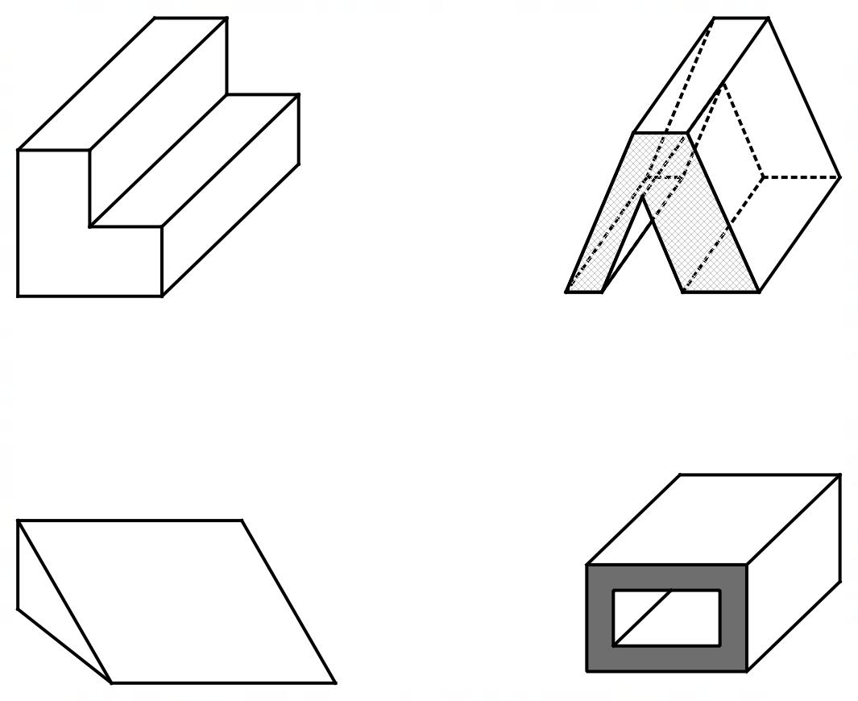
- Ask students to consider which one doesn’t belong. Students are then to Think-Pair-Share (bit.ly/thinkpairsharestrategy) which, if any, of the solids don’t belong. Encourage students to discuss their reasoning.
- Ask students if they have seen these solids in real life. What could they represent? For example, the ‘L’ shaped solid could be grandstand seats and the triangular prism could be a ramp.

Explore
This activity could be run as an assignment or an in-class activity. Each aspect of the task should be submitted together as a folio.
- Explain to students that they will be designing their own skate park. Provide students with a context for creating a skate park either within the school or in the local area. For example:
ATTENTION SKATERS!
Do you want to have a say in how your new skate park will look? The council has received a generous grant to build a skate park in _________ (local area). But we need your help to make it awesome! We want the skate park to be a fun and safe place for everyone to enjoy. That’s why we’re asking you to share your ideas on where to build it and what features to include.
To submit your proposal, you’ll need to provide:
- a location that is suitable for the skate park with a maximum area of 2000 $m^{2}$
- a sketch, model or computer design of your skate park plan
- a breakdown of the costs for each element of your skate park.
Don’t miss this chance to shape the future of your community. Send us your proposals today and let’s make this skate park happen!
Your local council
- Students are to work in pairs or individually on this task. Before starting the task, students are to brainstorm what the skate park could potentially include. This should be conducted as a Think-Pair-Share (bit.ly/thinkpairsharestrategy), even if working individually, where students can briefly discuss key design considerations.

Part A – choosing a location
Present one or both (students then select) options to students:

Option 1
Students:
- Choose a location on the school grounds where the skate park could go.
- Select a measuring tool to measure and calculate the area of the chosen location.
- Calculate the absolute error for each length measured.

Option 2
Students:
- Choose a location in the local area where the skate park could go.
- Use the Measure distance tool by right clicking in Google Maps, to draw out the chosen area. The perimeter and distance will automatically be calculated, as can be seen in the example below. Instructions on how to use this function can be viewed using the link (bit.ly/howtoGooglemeasuredistance).
- Calculate the absolute error for each length measured.
Figure 2 – Google Maps image
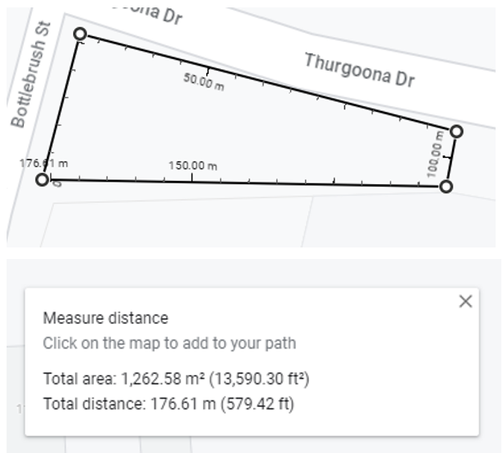
Map data © 2023 Google

Part B – designing the skate park
- Explain to students that the council has provided a guide for items that can be used in the design of the park, see Appendix A ‘Skate park items’. Although students may also add their own items to their design.
- Distribute or display Appendix A ‘Skate park items’ to each student.
Appendix A contains one solid that is Path content, a hemisphere. If Path content has not been covered, remove this item from Appendix A and replace with a new item.
- Using the supplied guide of items, students are to create their own skate park within their chosen location. Students will need to submit an image that is either drawn by hand or using a program such as AutoCAD of their final design. Students will need to make decisions, including:
- which items they will include in their skate park
- the dimensions of each item included
- the location of each item within their chosen location.
Students may find it easiest to draw a top view of the park with all items clearly labelled, and then a separate diagram that contains 3-dimensional images of each of the items with their measurements clearly labelled.

Part C – calculating materials required
- Explain to students that the local council will need to know:
- the total volume of any structures to be built so they know how much concrete is required
- the total volume of any land that needs to be removed so they know for how long to hire an excavator
- total surface area of any surfaces to be painted.

- Students will need to calculate the following:
- the volume of each item that they have included in their design, not including the bowl
- if they have included the bowl in their design, the volume of land that needs to be removed for the bowl to fit inside
- the visible surface area of each item they have included in their design that would need to be painted.

Summarise
- Students are to present their work to the class, either by displaying the images and students do a gallery walk (bit.ly/DLSgallerywalk) or by creating a presentation to the class as if they were presenting to the local council.
- The class should then vote on the best design using an online poll such as Mentimeter (mentimeter.com/) to determine the class winner.

Apply

A trip to a skate park
- If possible, students could visit a local skate park. At the local skate park, students could:
- identify the solids that make up the structures within the park
- measure and draw a sketch of some or all of the items, exploring the absolute and/or percentage error
- calculate the volume and/or surface area of each of the items.
- Students could then compare their own design and measurements to the items at the local skate park.

Assessment and differentiation

Suggested opportunities for differentiation
Explore
- Items to be built could be replaced with simpler alternatives if students are struggling with the suggested items in Appendix A.
- If students are struggling with surface area, this could be limited to the benches in the context that only the benches must be painted.
- To extend students, their images can be drawn to scale with all calculations included which links back to Unit 1: Geometrical representations.
- The ratio of the ramp can be removed for students if they are struggling. This links back to the assessment task in Unit 1: Geometrical representations.

Suggested opportunities for assessment
- Students submit their folios which could be used as a formal assessment and/or as a formative assessment tool to understand where students need further practice with surface area, volume and error.

Appendix A

Skate park items
Item | Image | Criteria
Ramp |  | - The ramp’s gradient must not exceed a gradient of $1:10$.
Bowl | 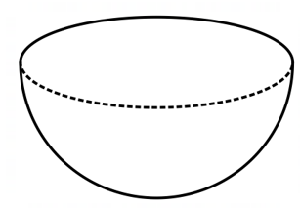 | - The bowl must have a diameter greater than 5 m  - The bowl sits in the ground, that is, a hole would need to be dug out and the bowl would be hollow.
Bench seat | 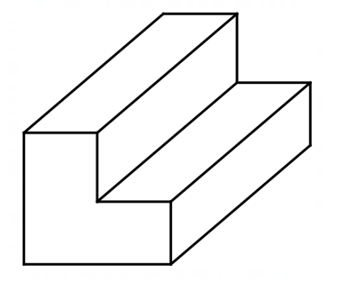 | - At least 3 bench seats must be placed within your skate park.
Half pipe | 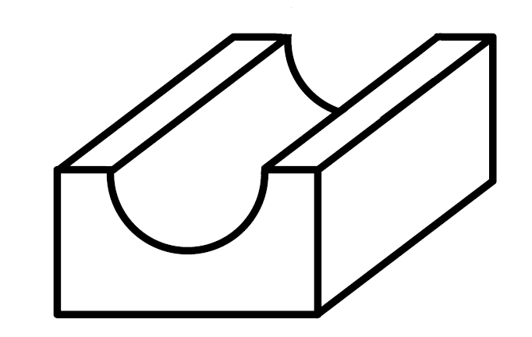 | - The half pipe must not exceed a height of 2 m.

References
This resource contains NSW Curriculum and syllabus content. The NSW Curriculum is developed by the NSW Education Standards Authority. This content is prepared by NESA for and on behalf of the Crown in right of the State of New South Wales. The material is protected by Crown copyright.
Please refer to the NESA Copyright Disclaimer for more information https://educationstandards.nsw.edu.au/wps/portal/nesa/mini-footer/copyright.
NESA holds the only official and up-to-date versions of the NSW Curriculum and syllabus documents. Please visit the NSW Education Standards Authority (NESA) website https://educationstandards.nsw.edu.au/ and the NSW Curriculum website https://curriculum.nsw.edu.au/home.
Mathematics K–10 Syllabus © NSW Education Standards Authority (NESA) for and on behalf of the Crown in right of the State of New South Wales, 2022.

© State of New South Wales (Department of Education), 2023
The copyright material published in this resource is subject to the Copyright Act 1968 (Cth) and is owned by the NSW Department of Education or, where indicated, by a party other than the NSW Department of Education (third-party material).
Copyright material available in this resource and owned by the NSW Department of Education is licensed under a Creative Commons Attribution 4.0 International (CC BY 4.0) licence.
This licence allows you to share and adapt the material for any purpose, even commercially.
Attribution should be given to © State of New South Wales (Department of Education), 2023.
Material in this resource not available under a Creative Commons licence:
- the NSW Department of Education logo, other logos and trademark-protected material
- material owned by a third party that has been reproduced with permission. You will need to obtain permission from the third party to reuse its material.
Links to third-party material and websites
Please note that the provided (reading/viewing material/list/links/texts) are a suggestion only and implies no endorsement, by the New South Wales Department of Education, of any author, publisher, or book title. School principals and teachers are best placed to assess the suitability of resources that would complement the curriculum and reflect the needs and interests of their students.
If you use the links provided in this document to access a third-party's website, you acknowledge that the terms of use, including licence terms set out on the third-party's website apply to the use which may be made of the materials on that third-party website or where permitted by the Copyright Act 1968 (Cth). The department accepts no responsibility for content on third-party websites.

