# I need more money

Students investigate how to make money from royalties and piecework through a range of real world and relevant examples including, copyright issues with music artists, Return and Earn and social media influencers.

## Visible learning

### Learning intentions

* To be able to identify and describe earnings from non-wage sources.
* To be able to calculate earnings from non-wage sources.

### Success criteria

* I can list ways of earning money that do not involve wages or salaries.
* I can calculate money earned from royalties and piecework.
* I can explain the difference between wages, salaries, piecework and royalties.

### Syllabus outcomes

A student:

* develops understanding and fluency in mathematics through exploring and connecting mathematical concepts, choosing and applying mathematical techniques to solve problems, and communicating their thinking and reasoning coherently and clearly **MAO-WM-01**
* solves financial problems involving simple interest, earning money and spending money **MA5-FIN-C-01**

[Mathematics K–10 Syllabus](https://curriculum.nsw.edu.au/learning-areas/mathematics/mathematics-k-10-2022) © NSW Education Standards Authority (NESA) for and on behalf of the Crown in right of the State of New South Wales, 2022.

## Activity structure

This lesson has been separated into 2 separate launch and explores, with a combined summarise and apply section.

### Launch 1

1. Play the music video (from 1:19) ‘Axis of Awesome - All Popular Songs Are The Same 4 Chords’ (5:26) ([bit.ly/axisofawesomesame4chords](https://bit.ly/axisofawesomesame4chords)) whilst students come into class.

It is important that you don’t play the first part before allowing students the opportunity to discover what the songs have in common.

1. Ask the students what they notice and what they wonder ([bit.ly/noticewonderstrategy](https://bit.ly/noticewonderstrategy)) about the songs. This can be done as a Think-Pair-Share ([bit.ly/thinkpairsharestrategy](https://bit.ly/thinkpairsharestrategy)) before having a brief class discussion for students to volunteer what they noticed and wondered about the video.
2. Show students the video ‘Axis of Awesome - All Popular Songs Are The Same 4 Chords’ (5:26) ([bit.ly/axisofawesomesame4chords](https://bit.ly/axisofawesomesame4chords)) from the start. This explains what the songs all have in common.
3. Prompt another class discussion with students, using questions such as:

* Who owns these 4 chords?
* Why would it be important to identify the owner of the chords?

The aim of this discussion is to introduce royalties to students and get them to consider any issues without providing a formal definition yet.

1. Show students the video ‘Ed Sheeran Shows on His Guitar How He Won His Copyright Lawsuit’ (3:34) ([bit.ly/edsheerancopyright](https://bit.ly/edsheerancopyright)) up until 1:34.
2. Ask students to consider why musicians are so concerned about other artists copying their songs. This should lead into a discussion about how musicians earn money.

You may need to provide students with some background information before playing the video. Ed Sheeran was accused of copying the musical building blocks of Marvin Gaye’s song, not the lyrics or overall feel. It started in 2014 and went for 8 years. Marvin Gaye believed that Ed Sheeran’s song ‘Thinking Out Loud’ breached the copyright laws of his song ‘Let’s Get it On’.

### Explore 1

1. Show students the video ‘The Police – Every Breath You Take (Official Music Video)’ (3:48) ([bit.ly/thepoliceeverybreathyoutake](https://bit.ly/thepoliceeverybreathyoutake)) only up until 0:50.
2. Straight after this show students the video ‘Puff Daddy [feat. Faith Evans & 112] – I’ll Be Missing You (Official Music Video)’ (4:31) ([bit.ly/puffdaddyillbemissingyou](https://bit.ly/puffdaddyillbemissingyou)) only up until 1:45.
3. Ask students, in a Think-Pair-Share, what they notice and what they wonder. You may need to play each music clip again while they do this. Specifically ask students to consider what makes these songs different than the songs in the launch that were the same 4 chords.

Students should notice that it is not the chords that are the same. Sections of the song by The Police are taken to make the other song. The teacher may need to play the relevant sections of the songs again for students.

1. Select a few non-volunteer students to share what they noticed with the class.
2. Display the headline and image from the news article, ‘Diddy admits he still pays Sting an eye-watering sum each day for sampling hit song’ ([bit.ly/commissiondiddy](https://bit.ly/commissiondiddy)). This article states that Diddy (previously Puff Daddy) pays Sting $5000 a day for sampling his hit.
3. Ask students to individually calculate how much Diddy must pay Sting from The Police each week, year, 10 years? How long will it take before Sting has $1 000 000 from Diddy?
4. Define royalties to students as a payment made to an individual or company for the use of their asset or creative work.
5. In a Think-Pair-Share, ask students to consider, besides musicians, who else could be paid a royalty? Students could brainstorm and research on their own, or alternatively, below are 4 different examples that could be provided to students. Each pair could be given a different profession that they need to explore and report back to the class.

Table 1 – professions that attract royalties

|  |  |
| --- | --- |
| Profession | Article with link |
| Inventors | * ‘Royalties for Gatorade Trust surpass $1 billion: “Can’t let it spoil us”’ ([bit.ly/gatoradeinventor](https://bit.ly/gatoradeinventor)) |
| Actors | * ‘10 Celebs That Earn Millions As Royalties’ ([bit.ly/royaltiescelebrities](https://bit.ly/royaltiescelebrities)) |
| Authors | * ‘The Salary of a Bestselling Author’ ([bit.ly/salarybestsellingauthors](https://bit.ly/salarybestsellingauthors)) * ‘Anh Do had help on prize-winning book’ ([bit.ly/anhdohelpwithbook](https://bit.ly/anhdohelpwithbook)) |
| Audio books | * ‘How Do Publishers Get Royalties for Audio Books?’ ([bit.ly/audiobooksroyalties](https://bit.ly/audiobooksroyalties)) |

The aim of this activity is to get students thinking of the different ways of earning money, specifically royalties, and discover which professions earn money from royalties. If devices are not available, the teacher could present the information and facilitate a classroom discussion.

### Launch 2

1. Display Figure 1 for students, asking if they have seen this and know what it is.

This is an image that appears on many bottles and cans in Australia, stating that there is a 10-cent refund at collection depots/points in participating state/territory of purchase.

Figure 1 – 10c refund

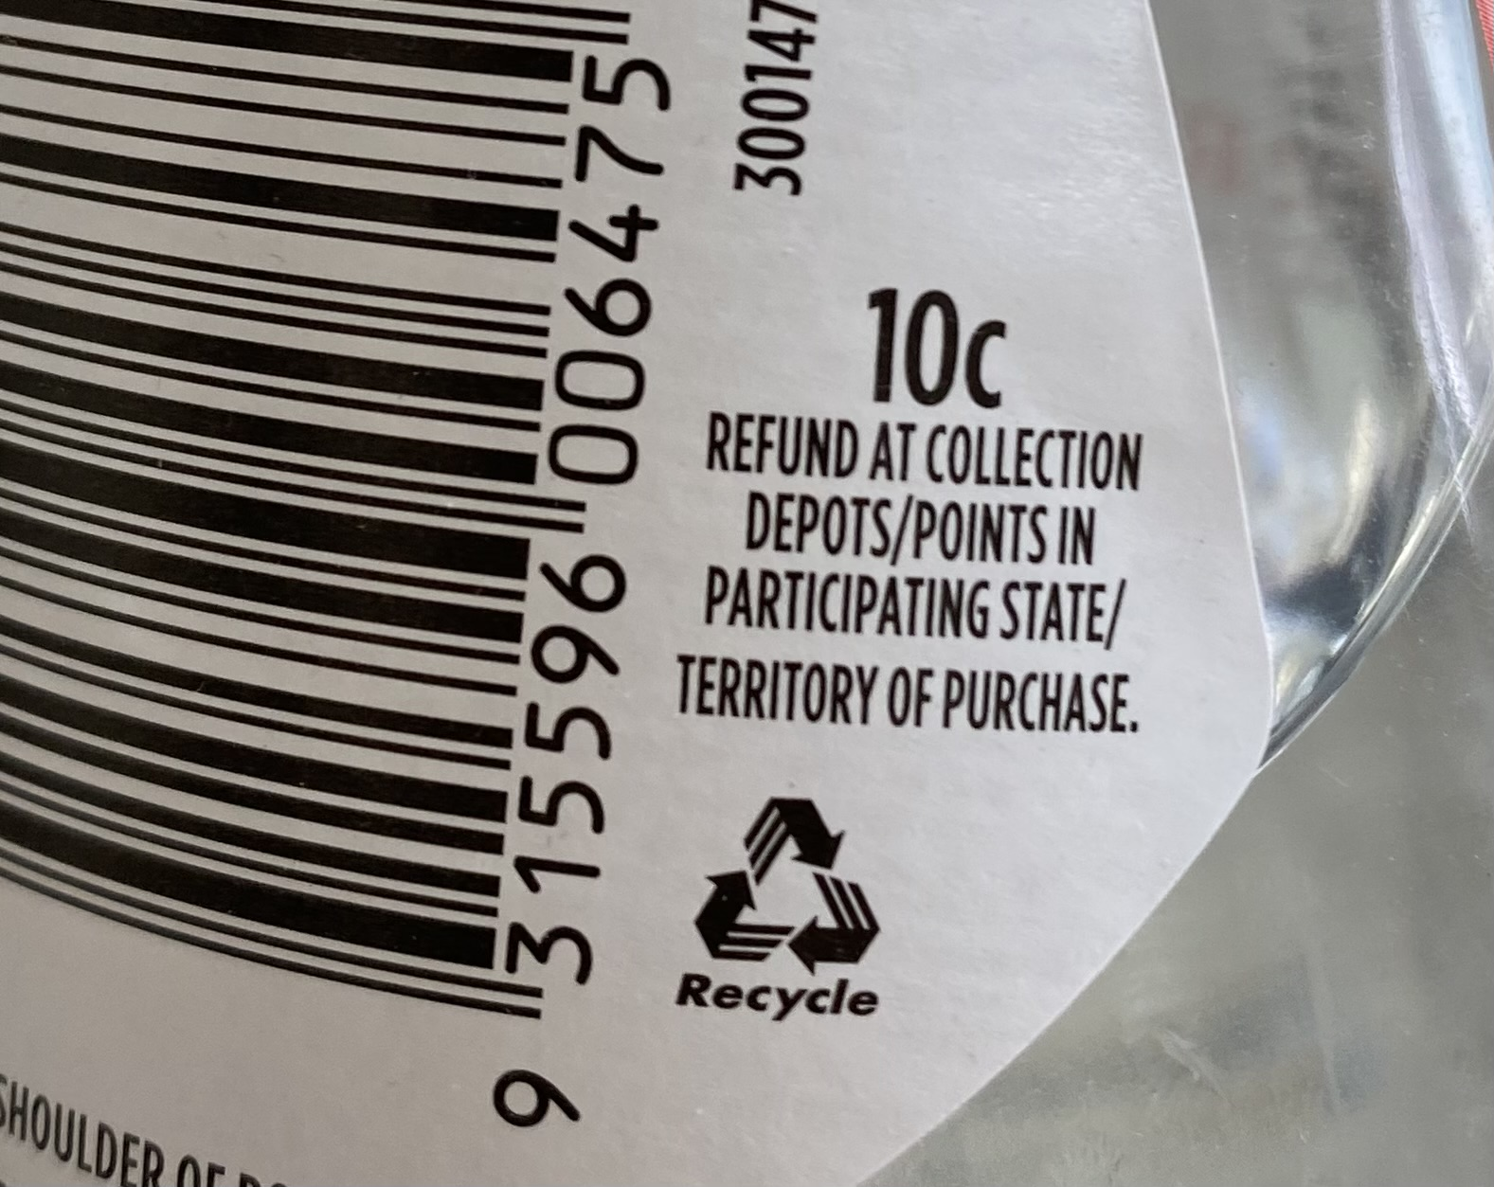

1. Following from the image stimulus, ask students to put their hand up if they know about ‘return and earn’?

Students who are not familiar with return and earn may benefit from watching this short video, ‘How to Return and Earn’ (0:45) ([bit.ly/howtoreturnandearn](http://bit.ly/howtoreturnandearn)).

1. Select a non-volunteer student to give a brief outline of ‘return and earn’.
2. Ask students to put their hands up if they have ever gone to a ‘return and earn’. Select a non-volunteer student and ask them what is the most they made in one visit?
3. Ask the students if anyone has made more? Keep going with this discussion until you have the highest amount per visit to the return and earn.
4. Prompt a classroom discussion using the following questions.

* Is there a limit to what you can earn? How many bottles could you feasibly collect and return in a day?
* What are the benefits of earning money this way?

### Explore 2

1. Allow students time to read the following news article ‘From $10 to $15,000: Who are Australia’s Instagram influencers, and how much do they get paid?’ ([bit.ly/asutraliasinstagraminfluencers](https://bit.ly/asutraliasinstagraminfluencers)). This article looks at how much influencers are paid in Australia.
2. Using the Think-Pair-Share strategy, have students discuss the question ‘What influences how much an Instagram influencer earns?’.
3. Select a few non-volunteer students to share their discussion and reasoning with the class.
4. Show students the video ‘Piecework Animation’ (3:58) ([bit.ly/pieceworkanimation](https://bit.ly/pieceworkanimation)), which is an animation explaining piecework. Allow time for questions after viewing this video in case further explanation is required.
5. Define piecework as employment where a worker is paid a fixed rate for each item produced or action performed regardless of the time taken.
6. Appendix A ‘Piecework Professions’ has a list of professions that may receive piecework payments. Allow students time to complete the table outlining what each profession is paid for. For example, a taxi driver is paid per kilometre.
7. Students will then research in pairs or as a class, a few of the profession’s rates to determine how many pieces they would need each week to earn a decent amount.

### Summarise

1. Students should make notes to their future forgetful self, ([bt.ly/notesstrategy](https://bit.ly/notesstrategy)) defining both royalties and piecework and listing jobs that get paid this way using examples from the lesson.
2. Pose the following questions to students:

* Would you rather earn money per piece of work or per hour worked?
* Would you rather pay an employee per piece of work or per hour worked?
* Would you rather be paid a fixed amount or per hour worked?
* Would you rather pay an employee a fixed amount or per hour worked?

1. Have students discuss the questions above using the Think-Pair-Share strategy, emphasising that they should discuss the reasoning for their choice and not just which one they would rather.
2. Select a few non-volunteer students to share their choice and reason with the class.

### Apply

1. Allow time for students to read the article, or go through the article as a class, ‘Michael Jordan went from projecting $3m in 4 years to earning $3m every 5 hours’ ([bit.ly/MJordanarticle](https://bit.ly/MJordanarticle) ). Some students may already be aware of Michael Jordan’s story if they have watched the movie ‘Air’.
2. Have students complete Appendix B ‘Michael Jordan case study’.
3. Once students have completed the questions from Appendix B pose the following question: ‘Does Michael Jordan receive payments through royalties or piecework?
4. Using a Think-Pair-Share strategy ask students to discuss the question above explaining their reasoning for their decision.
5. Select a few non-volunteer students to share their thoughts with the class.

This is an open question with no specific answer. Students are encouraged to form an opinion based on their knowledge of piecework and royalties and justify their choice.

## Assessment and differentiation

### Suggested opportunities for differentiation

**Explore**

* Students may need assistance reading the articles as some are quite lengthy.
* Students could research different musicians to discover what affects their earnings. Another good example is Kanye West and his reduction of income in recent time.
* Students could research the amount of income revenue people receive from ads, sponsors and the like from YouTube.

**Apply**

* Students may need to revise percentages prior to completing Appendix B.
* Students could use a bar model to help them answer these questions.
* Questions could be adjusted so students are working with smaller numbers if necessary.

### Suggested opportunities for assessment

**Explore**

* Collect Appendix A to check for student understanding.
* Monitor student conversations in class discussions and Think-Pair-Share activities to check for student understanding.

**Summarise**

* Review student notes to their future forgetful self, to ensure correct definitions and examples have been included by the students.

**Apply**

* Collect Appendix B to check for student understanding.

## Appendix A

### Piecework professions

1. Complete the table below by filling in what the unit of pay would be in each case. For example, a fruit picker may get paid per basket of fruit that they collect.

Table 2 – professions and units of pay

|  |  |
| --- | --- |
| Worker | What might be the unit of pay? |
| Olive picker |  |
| Editor |  |
| Blogger |  |
| Taxi driver |  |
| Delivery driver |  |
| Product tester |  |
| Freelance photographer (Paparazzi) |  |
| Seamstress |  |
| Hairdresser |  |
| Fruit packer |  |
| Writer |  |

1. It is known that taxi drivers earn approximately $2.80 per kilometre driven. Calculate how many kilometres a taxi driver would need to drive to earn a decent wage in a week. Justify why your amount is a ‘decent wage’?
2. Research another profession, either from the list above or of your own choosing, and investigate how much work they would need to do to earn a decent wage in a week?

## **Appendix B**

### Michael Jordan case study

As seen in the movie ‘Air’, Michael Jordan receives 5% of every sale associated with his Jordan brand.

1. How much will he receive from a pair of shoes sold for $200?
2. In the first year of sales, Nike sold $126 million worth of Air Jordans. How much did he receive?
3. It is reported that Michael Jordan earns $3 000 000 every 5 minutes. How much Jordan brand merchandise must be sold every 5 minutes for him to earn this amount?

## Sample solutions

### Appendix A – piecework professions

Table 3 – solution to Table 2

|  |  |
| --- | --- |
| Worker | What might be the unit of pay? |
| Olive picker | Per bucket of olives |
| Editor | Per word or article |
| Blogger | Per blog |
| Taxi driver | Per kilometre |
| Delivery driver | Per delivery or weight of delivery |
| Product tester | Per test |
| Freelance photographer (Paparazzi) | Per photo |
| Seamstress | Per item of clothing made |
| Hairdresser | Per haircut, colour, etc |
| Fruit packer | Per crate |
| Writer | Per chapter or book |

1. The average weekly earnings for individuals aged 20 and under in Australia is $383 ([bit.ly/averagesalaryaustralia](https://bit.ly/averagesalaryaustralia)).

kilometres

A taxi driver would need to drive approximately 137 kilometres in a week, to earn an average income for an individual aged 20 and under.

### Appendix B – Michael Jordan case study

1. $3 million is equivalent to 5%.

$60 million of Jordan brand merchandise is sold every 5 minutes.

## References

This resource contains NSW Curriculum and syllabus content. The NSW Curriculum is developed by the NSW Education Standards Authority. This content is prepared by NESA for and on behalf of the Crown in right of the State of New South Wales. The material is protected by Crown copyright.

Please refer to the NESA Copyright Disclaimer for more information <https://educationstandards.nsw.edu.au/wps/portal/nesa/mini-footer/copyright>.

NESA holds the only official and up-to-date versions of the NSW Curriculum and syllabus documents. Please visit the NSW Education Standards Authority (NESA) website <https://educationstandards.nsw.edu.au/> and the NSW Curriculum website <https://curriculum.nsw.edu.au/home>.

[Mathematics K–10 Syllabus](https://curriculum.nsw.edu.au/learning-areas/mathematics/mathematics-k-10-2022) © NSW Education Standards Authority (NESA) for and on behalf of the Crown in right of the State of New South Wales, 2022.

**© State of New South Wales (Department of Education), 2023**

The copyright material published in this resource is subject to the *Copyright Act 1968* (Cth) and is owned by the NSW Department of Education or, where indicated, by a party other than the NSW Department of Education (third-party material).

Copyright material available in this resource and owned by the NSW Department of Education is licensed under a [Creative Commons Attribution 4.0 International (CC BY 4.0) licence](https://creativecommons.org/licenses/by/4.0/).

[](https://creativecommons.org/licenses/by/4.0/)

This licence allows you to share and adapt the material for any purpose, even commercially.

Attribution should be given to © State of New South Wales (Department of Education), 2023.

Material in this resource not available under a Creative Commons licence:

* the NSW Department of Education logo, other logos and trademark-protected material
* material owned by a third party that has been reproduced with permission. You will need to obtain permission from the third party to reuse its material.

**Links to third-party material and websites**

Please note that the provided (reading/viewing material/list/links/texts) are a suggestion only and implies no endorsement, by the New South Wales Department of Education, of any author, publisher, or book title. School principals and teachers are best placed to assess the suitability of resources that would complement the curriculum and reflect the needs and interests of their students.

If you use the links provided in this document to access a third-party's website, you acknowledge that the terms of use, including licence terms set out on the third-party's website apply to the use which may be made of the materials on that third-party website or where permitted by the *Copyright Act 1968* (Cth). The department accepts no responsibility for content on third-party websites.