Now or later?
Students explore different options of paying for an item, including buying on terms, ‘buy now, pay later’ and short-term loans through fictional items and payment plans. Students will discover the advantages and disadvantages of these payment methods and decide if it is better to pay now or pay later.

Visible learning

Learning intentions
- To understand the advantages and disadvantages of various payment options.

Success criteria
- I can calculate the costs and associated fees of using a payment option.
- I can list different payment options.
- I can analyse and compare different payment options.

Syllabus outcomes
A student:
- develops understanding and fluency in mathematics through exploring and connecting mathematical concepts, choosing and applying mathematical techniques to solve problems, and communicating their thinking and reasoning coherently and clearly MAO-WM-01
- solves financial problems involving simple interest, earning money and spending money MA5-FIN-C-01
Mathematics K–10 Syllabus © NSW Education Standards Authority (NESA) for and on behalf of the Crown in right of the State of New South Wales, 2022.

Activity structure

Launch
- Assign students into visibly random groups of 3 (bit.ly/visiblegroups). Give all groups the same scenario below, by verbally reading it out.
Oh no! You’ve dropped your phone too many times and now it won’t turn on. You need a new one and you will need to pay for it outright.
Your parents are refusing to replace your phone as they only just bought it for you a few months ago.
You started your casual job last week, where you work 6–8 hours a week at $14.50 per hour.
How can you afford the phone you want now?
- Explain to students that in their groups they are to select the phone that they want to buy by researching the cost of buying a mobile phone outright.
If devices are not available, a few options of mobile phones and their costs could be supplied to the class, and each group could then choose the phone they want to buy.
- Once the group has decided on a phone and the cost of the phone, they will create a deal of how they will pay for the phone so they can take it home today. They need to have mathematical reasoning to support their deal and how they can make the deal work for the company selling the phone. For example, they may pay a deposit and then equal monthly instalments, or they may pay nothing up front and the full amount with additional interest at a later date.
- Once the group has finalised their proposed deal, have 2 groups join to share their ideas. Between them they will need to decide which group has the better deal to put to the class.
- To explore and debate which deal is best, students will use the Six Thinking Hats strategy (bit.ly/strategy6thinkinghats) where each group member is assigned one of the thinking hats.
- To assign students one of the 6 thinking hats you could have students place themselves in alphabetical order by first name and then assign as follows:
Table 1 – six thinking hats strategy
Order | Thinking hat | Lens of thinking | Description
1 | White | Logic | What do I know?  What do I need to find out?
2 | Red | Emotion | How do I feel about the impact of the decision?  What do I like/don’t like about each deal?
3 | Black | Caution | What are the negative aspects of each deal?
4 | Yellow | Optimism | What are the positive aspects of each deal?
5 | Green | Creativity | What new ideas are possible?  Can I create something new?
6 | Blue | Control | What thinking is needed?  What decision can be made?
- Each pair of groups should now have one deal that they believe is best. They need to their proposed deal to the seller (that is the teacher).Students should try to convince the seller that their deal is the best option. To do this, students should prepare a 30–60 second pitch that refers to each of the six lenses from the Six Thinking Hats strategy. That is:
- The logic behind the deal
- The optimism and possible caution to be had with the deal.
- And anything else to add that will sway the seller to choose their deal.
- The teacher will then select which deal is the best option. As the seller, try to negotiate with the groups and convince them to give you even more money if they really want this phone.

Explore
- Students are to remain in their original groups of 3 and will explore whether it is best to save for an item or to utilise a ‘buy now, pay later’ payment options.
- Give each group the 4 cards from Appendix A ‘buy now, pay later cards’. Each card contains an item, its price and an outline of the ‘buy now, pay later’ conditions.
- Ask each group to rank the cards in order from best to worst deal. Encourage the groups to discuss why they have placed each card in that order.
- Conduct a brief class discussion to discover what the general consensus was with the best and worst deals by using a questioning strategy such as, Pause-Pose-Pounce-Bounce question strategy [PDF 200KB] (bit.ly/pausepouncebouncestrategy).
- Issue each group 4 copies of Appendix B ‘Analysing Buy now, pay later’. This will be used to analyse each of the 4 cards from Appendix A ‘Buy now, pay later cards’. Students will need to discuss the advantages and disadvantages for each payment plan, using relevant mathematical reasoning.
This task could be completed on vertical non-permanent surfaces (bit.ly/VNPSstrategy) rather than students writing on Appendix B. Alternatively, Appendix B could be enlarged onto A3 paper and then placed in an A3 plastic sleeve to turn it into a vertical non-permanent surface.
- Conduct a class discussion of each of the four cards using a questioning strategy such as Pause-Pose-Pounce-Bounce with each group sharing some advantages and disadvantages of each payment option.
- Continue the class discussion to ask students if they think it is best to wait and save up for an item or to use these payment plan options. Ensure that students are sharing their reasoning and justifications.

Summarise
- Students are to make notes to their future forgetful self (bit.ly/notesstrategy) on the advantages and disadvantages of:
- Buying items on terms, that is a deposit followed by equal instalments.
- ‘Buy now, pay later’.
- Short term loans.
- Following this, students can create a Venn diagram to compare the similarities and differences of each of the 3 payment methods above using Appendix C ‘3-circle Venn diagram template’.

Apply
- In their original groups of 3, students are to recall the mobile phone they wanted to buy earlier in the lesson and record its cost.
- Students are to research companies that offer a ‘buy now, pay later’ option for their chosen item.
- They will need to look at how the cost of the item is split into repayment amounts as well as other costs and penalties that are associated with the purchase if they cannot make repayments on time.
Appendix B could be handed out to groups to help them record and consider the different options for making the purchase using a ‘buy now, pay later’ option.
- Students then decide if they would recommend the payment option or wait and save for the item.

Assessment and differentiation

Suggested opportunities for differentiation
Launch
- Students may need to be provided with prompting questions to get started on this activity, such as, what if the item was paid off over time.
Explore
- Students may need to revise simple interest and finding percentages of quantities prior to commencing this activity.
- An explanation of ‘service fees’ and ‘late fees’ may need to be provided.
- For some classes, only one card may be explored and then students can join another group that had that same card and have a further discussion about the advantages and disadvantages, rather than each group exploring all 4 cards.

Suggested opportunities for assessment
Explore
- Monitor student discussions to check for understanding and to address any misconceptions.
- Collect Appendix B to use as formative assessment.

Appendix A

‘Buy now, pay later’ cards
TV costing $999  ‘Buy now, pay later’ conditions:  - 10% deposit is required.  - Followed by 4 equal payments of the remaining balance to be paid monthly.  Fees:  - $9.95 monthly account service fee  - A fee of 25.9% of the outstanding balance is charged if a payment is missed. | New clothes costing a total of $460  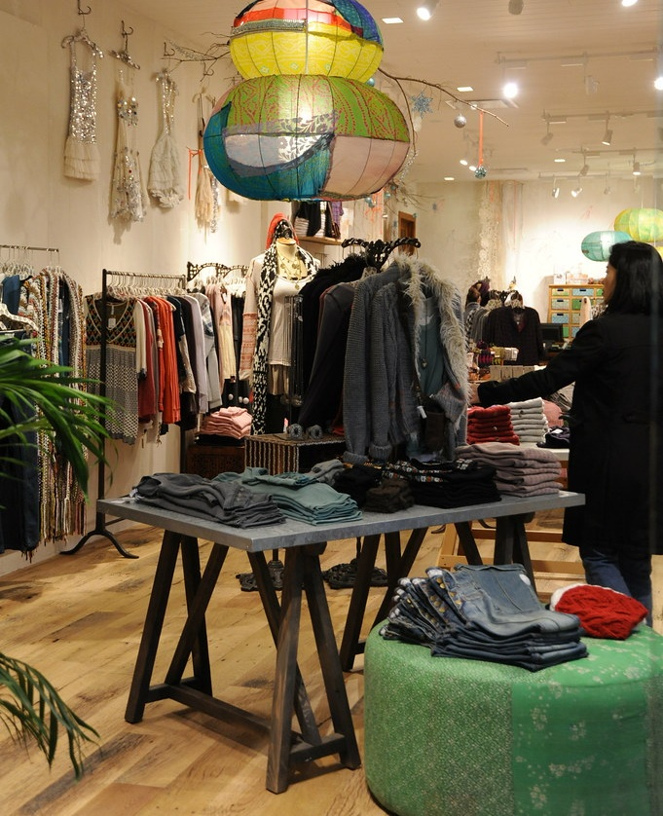  ‘Buy now, pay later’ conditions:  - No deposit  - 4 equal repayments over 6 weeks.  Fees:  - No account service fees.  - A fee of 25% of the purchase price or $68, whichever is less if a payment is missed.
Lounge costing $1459  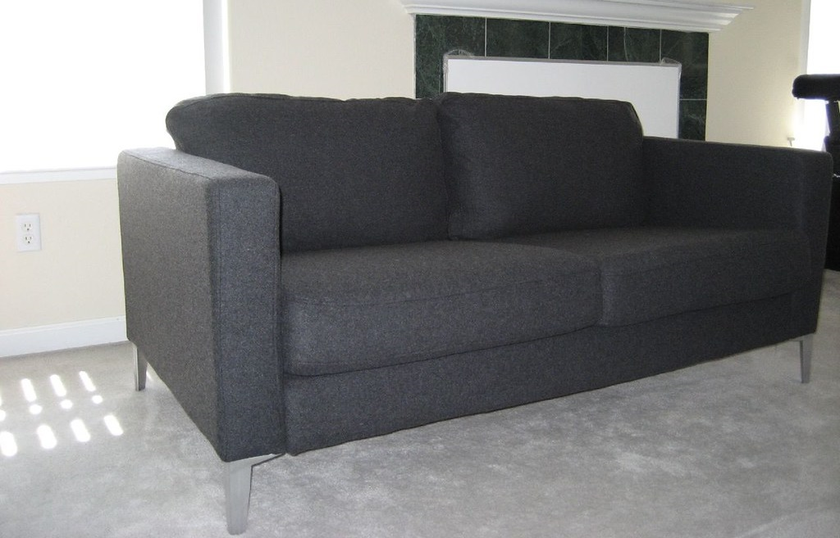  ‘Buy now, pay later’ conditions:  - No deposit.  - Equal monthly payments over 12 months.  Fees:  - $5.95 monthly account service fee.  - Simple interest charged at a rate of  8.9% p.a.  - A fee of 15% of the purchase price is charged if a payment is missed. | Fridge costing $1793  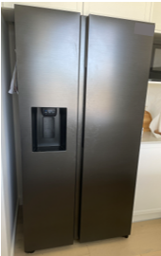  ‘No buy now, pay later’ option.  Short term loan must be taken out:  - An establishment fee of 20% of the loan amount  - Fees of 4% of the initial loan amount paid monthly.  - Short term loan to be repaid in 9 months.
‘Flat TV Vector’ by VideoPlasty is licensed under CC BY-SA 4.0. ‘Christmas shopping, woman's clothing store, ethnic lamp, University Village, Seattle, Washington, USA’ by Wonderlane is licensed under CC BY 2.0. "New sofa" by a rancid amoeba is licensed under CC BY-SA 2.0.

Appendix B

Analysing ‘buy now, pay later’
Information | Answers and calculations
Item
Cost of item
Fees (not including missed payment fees)
Total cost paid for the item using the payment option.
Compare the cost of the item with the total paid using the payment option.
If one payment is missed, what is the extra fee charged?
Advantages of this payment plan
Disadvantages of this payment plan
Advice, would you use this payment option?

Appendix C

3 circle Venn diagram template
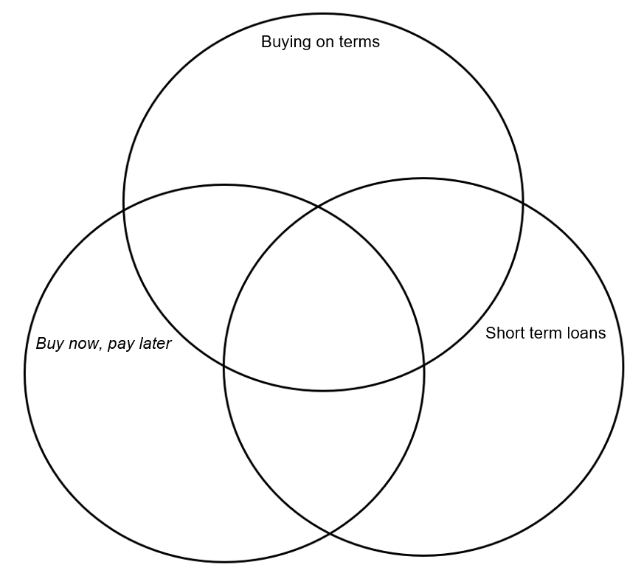

Sample solutions

Appendix B – analysing ‘buy now, pay later’

TV
Information | Answers and calculations
Item | TV
Cost of item | $999
Fees (not including missed payment fees) | $9.95 per month.  $$Total fees for 4 months=9.95×4 \\ =\$39.80$$
Total cost paid for the item using the payment option. | $$Deposit=10\%×999 \\ =\$99.90$$  $$Remaining balance paid over 4 months=999-99.90 \\ =899.10$$  $$Total cost=99.90+899.10+39.80 \\ =\$1038.80$$
Compare the cost of the item with the total paid using the payment option. | The payment option means that an extra $39.80 is paid on top of the original cost.  This is considering all fees are paid on time.
If one payment is missed, what is the extra fee charged? | 25.9% of the outstanding balance.  If the first payment is missed,  $$Extra fee=25.9\%×899.10 \\ =\$232.87$$

New clothes
Information | Answers and calculations
Item | New clothes
Cost of item | $460
Fees (not including missed payment fees) | nil
Total cost paid for the item using the payment option. | No deposit  $$Total cost=\$460$$Total cost to be paid in 4 equal repayments, $460÷4=\$115$ over 6 weeks.
Compare the cost of the item with the cost paid using the payment option. | The payment option means that no extra cost is charged.  This is considering all fees are paid on time.
If one payment is missed, what is the extra fee charged? | 25% of the outstanding balance or $68, whichever is less.  If the first payment is missed,  $$Extra fee=25\%×460 \\ =\$115$$  Therefore $68 would be charged as an extra fee.

Lounge
Information | Answers and calculations
Item | Lounge
Cost of item | $1459
Fees (not including missed payment fees) | $5.95 per month.  $$12 months=5.95×12 \\ =\$71.40$$  $$Simple interest=1459×8.9\%×1 \\ =\$129.85$$  $$Total fees=71.40+129.85 \\ =\$201.25$$
Total cost paid for the item using the payment option. | $1459 split over 12 equal monthly payments  $$Total cost=1459+201.25$$  $$=\$1660.25$$
Compare the cost of the item with the cost paid using the payment option. | The payment option means that an extra $201.25 is paid on top of the original cost.  This is considering all fees are paid on time.
If one payment is missed, what is the extra fee charged? | 15% of the outstanding balance.  If the first payment is missed,  $$Extra fee=25.9\%×899.10 \\ =\$232.87$$

Fridge
Information | Answers and calculations
Item | Fridge
Cost of item | $1793
Fees (not including missed payment fees) | $$Establishment fee=20\%×1793 \\ =\$358.60$$  $$Fee=4\%×1793×9$$  $$=\$645.48$$
Total cost paid for the item using the payment option. | $$Total cost=1793+358.60+645.48$$  $$=\$2797.08$$
Compare the cost of the item with the cost paid using the payment option. | The payment option means that an extra $1004.08 is paid on top of the original cost.  This is over 50% more than the total cost of the fridge.
If one payment is missed, what is the extra fee charged? | No information is given on late fees.

References
This resource contains NSW Curriculum and syllabus content. The NSW Curriculum is developed by the NSW Education Standards Authority. This content is prepared by NESA for and on behalf of the Crown in right of the State of New South Wales. The material is protected by Crown copyright.
Please refer to the NESA Copyright Disclaimer for more information https://educationstandards.nsw.edu.au/wps/portal/nesa/mini-footer/copyright.
NESA holds the only official and up-to-date versions of the NSW Curriculum and syllabus documents. Please visit the NSW Education Standards Authority (NESA) website https://educationstandards.nsw.edu.au/ and the NSW Curriculum website https://curriculum.nsw.edu.au/home.
Mathematics K–10 Syllabus © NSW Education Standards Authority (NESA) for and on behalf of the Crown in right of the State of New South Wales, 2022.

© State of New South Wales (Department of Education), 2023
The copyright material published in this resource is subject to the Copyright Act 1968 (Cth) and is owned by the NSW Department of Education or, where indicated, by a party other than the NSW Department of Education (third-party material).
Copyright material available in this resource and owned by the NSW Department of Education is licensed under a Creative Commons Attribution 4.0 International (CC BY 4.0) licence.
This licence allows you to share and adapt the material for any purpose, even commercially.
Attribution should be given to © State of New South Wales (Department of Education), 2023.
Material in this resource not available under a Creative Commons licence:
- the NSW Department of Education logo, other logos and trademark-protected material
- material owned by a third party that has been reproduced with permission. You will need to obtain permission from the third party to reuse its material.
Links to third-party material and websites
Please note that the provided (reading/viewing material/list/links/texts) are a suggestion only and implies no endorsement, by the New South Wales Department of Education, of any author, publisher, or book title. School principals and teachers are best placed to assess the suitability of resources that would complement the curriculum and reflect the needs and interests of their students.
If you use the links provided in this document to access a third-party's website, you acknowledge that the terms of use, including licence terms set out on the third-party's website apply to the use which may be made of the materials on that third-party website or where permitted by the Copyright Act 1968 (Cth). The department accepts no responsibility for content on third-party websites.

