Money matters
By exploring financial options, students discover different ways to represent linear relationships and the power that each representation holds, including equations, graphs and tables of values.
Students will need at least one digital device per pair to interact with Desmos during this lesson.

Visible learning

Learning intention
- To understand the connections between representations of linear relationships.

Success criteria
- I can substitute values into an equation to complete a table of values.
- I can graph linear relationships given the equation and table of values.
- I can explain the advantages and disadvantages of each representation.

Syllabus outcomes
A student:
- develops understanding and fluency in mathematics through exploring and connecting mathematical concepts, choosing and applying mathematical techniques to solve problems, and communicating their thinking and reasoning coherently and clearly MAO-WM-01
- determines the midpoint, gradient and length of an interval, and graphs linear relationships, with and without digital tools MA5-LIN-C-01
- solves linear equations of up to 3 steps, limited to one algebraic fraction MA5-EQU-C-01
Mathematics K–10 Syllabus © NSW Education Standards Authority (NESA) for and on behalf of the Crown in right of the State of New South Wales, 2022.

Activity structure
Please use the associated PowerPoint Money matters to display images in this lesson.
It is assumed that students completing this lesson have knowledge of earning money and the simple interest formula.

Launch
- Display the activity ‘What would you rather?’ on slide 2 of the Money matters PowerPoint.
- By working in visibly random groups of 3 (bit.ly/visiblegroups) on vertical non-permanent surfaces (bit.ly/VNPSstrategy), ask students to discuss and justify which scenario they would prefer.
Students will most likely calculate the interest earnt in each scenario for one year, however the purpose of the activity is for students to realise that the outcome changes over time. Teachers may need to prompt students to consider how much they have in total after 5 or 10 years.
- Place a box around each different strategy that students use in approaching this problem.
Students can use a range of problem-solving strategies such as:
- guess and check or guess and improve
- drawing pictures and diagrams
- lists or tables
- using algebraic strategies.
- By selecting different strategies one by one, ask random students (not involved in the group) to explain the approach that the group has used.
The focus is on their mathematical approach, not their answer of what investment option they picked. Conversation should be steered towards strategies such as guess and check, visual representations, and algebraic techniques.
The reason for highlighting the different strategies is so students can increase their flexibility and problem-solving skills towards more non-routine problems.

Explore
- Display slide 3 from Money matters PowerPoint.
- Working in their groups, ask students to list the amount of money that Emilo will have each year, for the first 6 years. Have them consider how this could best be presented.
- Using the simple interest formula, students are to create an equation to find the total amount of money Emilio will have each year.
Students should start by considering what stays the same each year and what changes. They could then verbalise a general rule before progressing to an equation using variables. Suggest that students use $A$ for total amount of money and $N$ for years. The students should arise at $A=300N+5000$.
- Display slide 4 on the board from the Money matters PowerPoint. This slide shows a linear relationship represented as an equation, table of values and graph. In their groups, have students discuss what they notice and wonder (bit.ly/noticewonderstrategy).
The representations are presented with specific colourings to highlight the connection between them. This can be used as a prompt for teachers to promote student thinking.
- Use the Pose-Pause-Pounce-Bounce question strategy [PDF 200KB] (bit.ly/pausepouncebouncestrategy) to share student responses.
- Tell students we have looked at 3 different ways to represent the same situation, that is, the first investment Emilio could have picked.
- Using the representations, ask students to find when Emilio’s money has doubled.
- Ask non-volunteer students which representation their group used to solve the problem.
- Use the Pose-Pause-Pounce-Bounce question strategy [PDF 200KB] (bit.ly/pausepouncebouncestrategy) to ask students if they would change how they approached the ‘Would you rather’ question and why.

Summarise
- Use slides 5–8 in the PowerPoint Money matters, for the explicit teaching of graphing a linear relationship by creating a table of values from an equation.
The explicit teaching technique used in the associated PowerPoint is ‘Your turn.’ The first slide is a worked example which should be displayed for the students and then use the following steps.
- Reveal the question to students and its solution.
- Students read in silence.
- Students individually think and explain to themselves what is happening in each step.
- Students hold a thumbs up to the teacher when they have finished reading and have some sort of understanding.
- Think-Pair-Share. Students explain the solution to their partner.
- In pairs, students then answer the self-explanation questions.
- Finally, randomly select students to share their answers with the whole class.
- Still working in their groups of 3, students are to complete Appendix A ‘Matching linear functions’. Students need to match the related equations, tables of values and graphs.

Apply
- Still in their groups of 3, students are to complete Appendix B ‘Would you rather?’ This activity explores the Emilio’s second option and asks students to make a choice between the 2 options and justify their answer.
- Use slide 9 from the PowerPoint Money matters. This poses a statement that a point is on a line. Have students work in their groups to prove whether the statement is true or false.
- Students are to complete Appendix C ‘Money woes’. In this activity, students complete tables of values and graph earning scenarios to decide the best working conditions.
- Students are to complete an Exit ticket (bit.ly/exitticketstrategy) by responding to the question, ‘If you were to get rid of one representation, which one would you get rid of and why?’

Assessment and differentiation

Suggested opportunities for differentiation
Explore
- To assist students, you can provide the equation and ask them where the values have come from.
- To extend students, you can ask them to use the graph or equation to find when his investment tripled.
Summarise
- Horizontal and vertical lines could be removed from the matching activity and introduced in a later lesson.
Apply
- To enable students, you can give them the table of values to fill out for Appendix A.
- If struggling with the graph, teachers can give students an amended Cartesian plane with the scale already labelled on the $x$- and $y$-axis.

Suggested opportunities for assessment
Launch
- Use the ‘Would you rather?’ activity to gauge students’ prior knowledge and understanding of different representations of problems.
Summarise
- Students show their ability to use tables of values, graphs and equations in the matching activity.
Apply
- Teachers can assess students’ ability to check their solutions to equations when they try to disprove the statement.
- How students’ move between representations to solve problems in Appendix B ‘Money woes’ can establish their confidence in graphing using tables of values.

Appendix A

Matching linear functions
Cut out and match the graphs with their equation and table of values.

Graphs
A  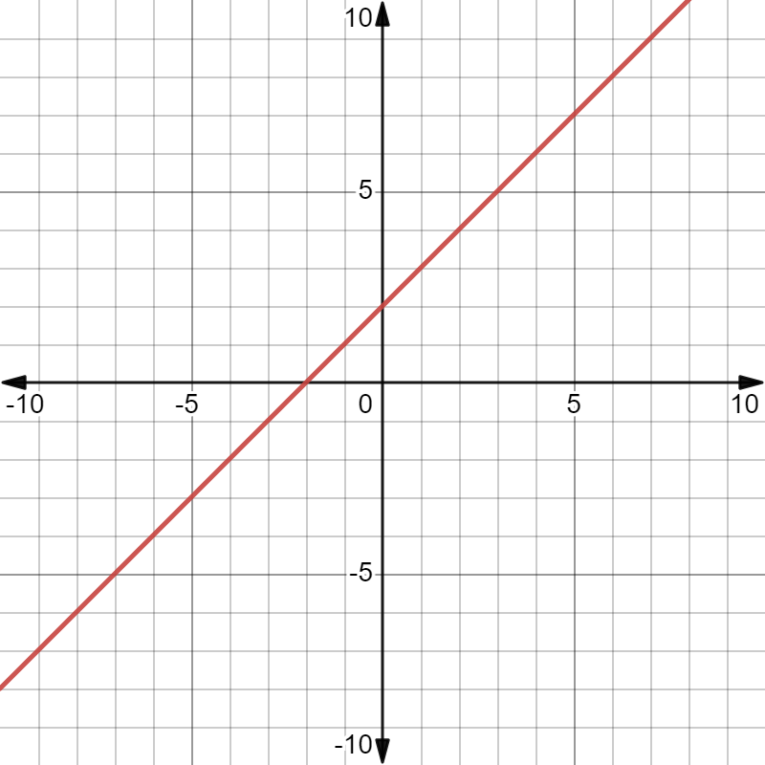 | B  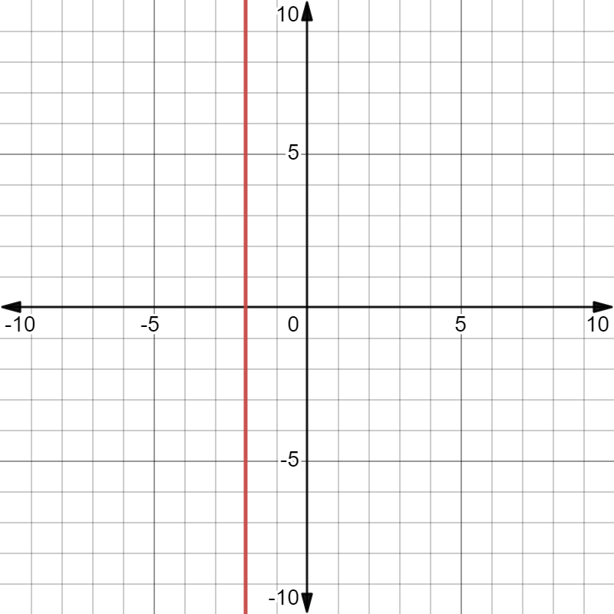
C  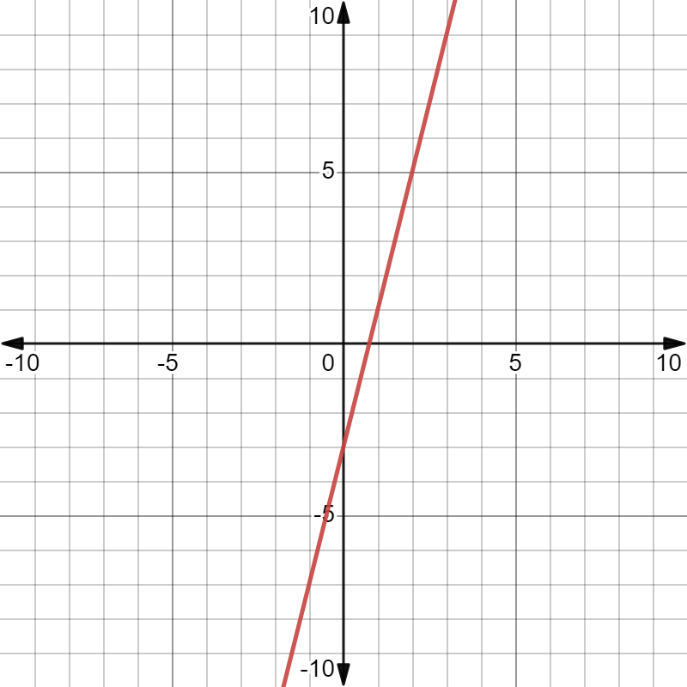 | D  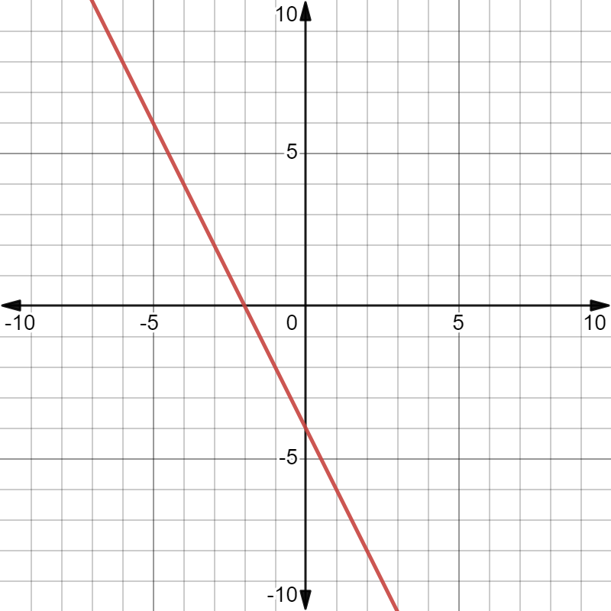

E  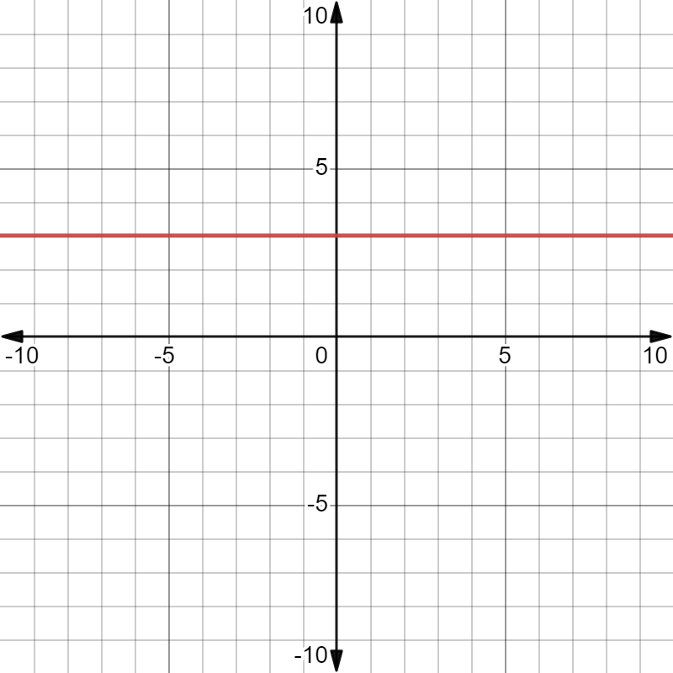 | F  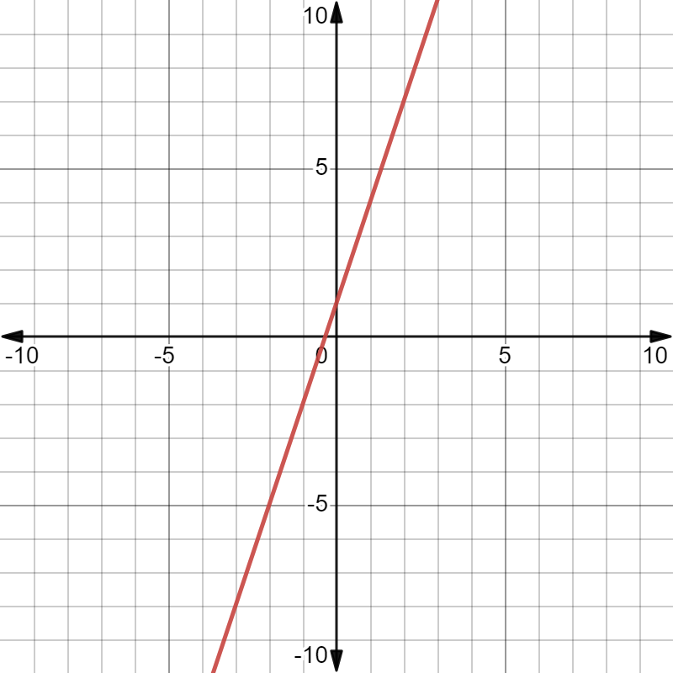

Equations
$$y=3x+1$$ | $$y=3$$
$$y= -2x-4$$ | $$x=-2$$
$$y=4x-3$$ | $$y=x+2$$

Tables of values
$$x$$ | -2 | -1 | 0 | 1 | 2
$$y$$ | -5 | -2 | 1 | 4 | 7

$$x$$ | -2 | -1 | 0 | 1 | 2
$$y$$ | 3 | 3 | 3 | 3 | 3

$$x$$ | -2 | -2 | -2 | -2 | -2
$$y$$ | -2 | -1 | 0 | 1 | 2

$$x$$ | -2 | -1 | 0 | 1 | 2
$$y$$ | 0 | -2 | -4 | -6 | -8

$$x$$ | -2 | -1 | 0 | 1 | 2
$$y$$ | -11 | -7 | -3 | 1 | 5

$$x$$ | -2 | -1 | 0 | 1 | 2
$$y$$ | 0 | 1 | 2 | 3 | 4

Appendix B

Would you rather?
Below is the equation, table of values and graph to represent Emilio’s first option of investing $5000 into a bank account that earns 6% p.a.
$$A=\left(5000×0.06\right)N+5000$$
$$A=300N+5000$$
$$A$$ | 0 | 5 | 10 | 15 | 20
$$N$$ | 5000 | 6500 | 8000 | 9500 | 11000

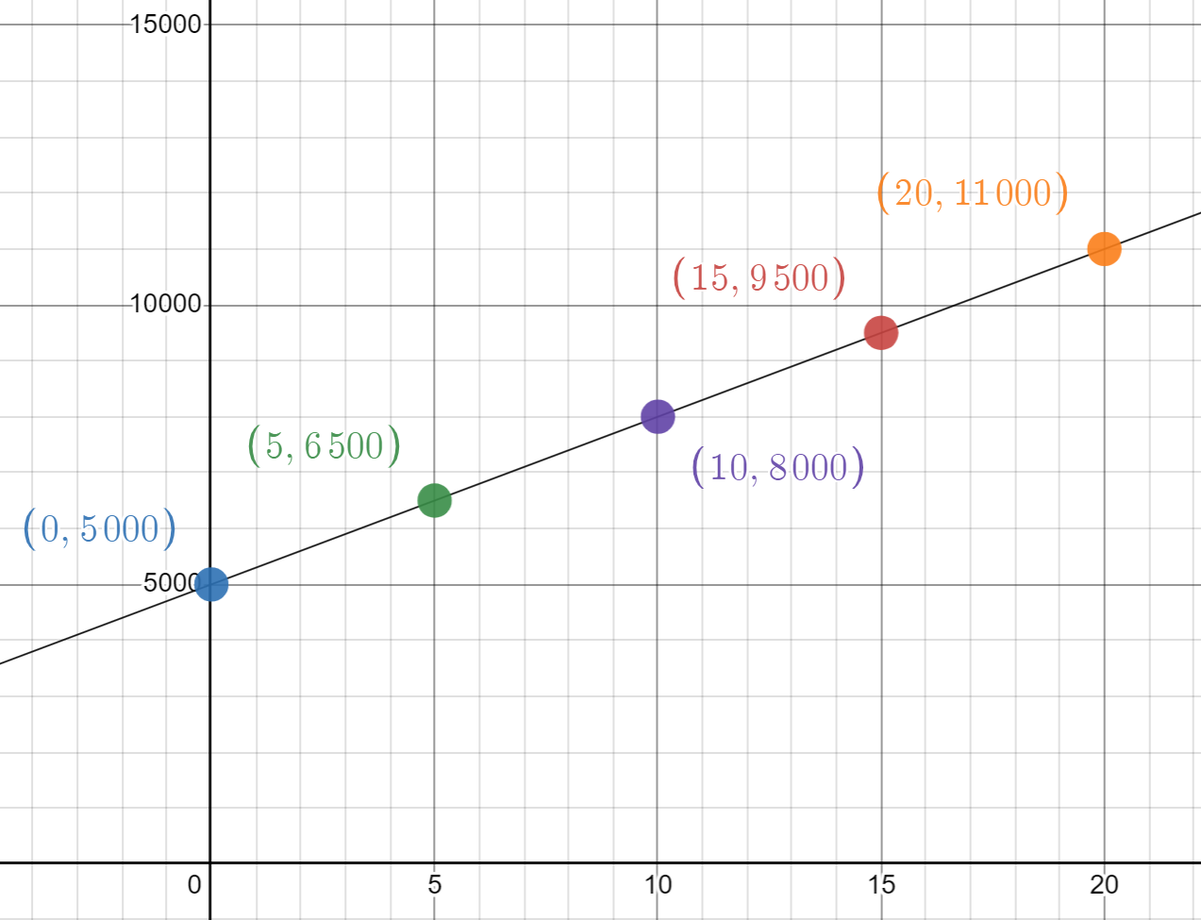
- Emilio thinks that the equation for his second option, where he invests $5000 at 6.8% but must pay a $200 establishment fee is represented by the equation
$$y=5000×0.068x+4800$$
but his friend Peta thinks it should be
$$y=4800×0.068x+4800$$
Who do you think is right? Justify your choice.
- Create a table of values to represent Emilio’s second option.
$$x (years)$$ | 1 | 2 | 3 | 4 | 5
$$y (total amount)$$
- On the same set axis as the graph on the previous page, graph your table of values.
- What investment option would you choose? Justify your answer.

Appendix C

Money woes
Emilio will be working 38 hours per week at his new job. He has been given a choice of payment. They are as follows:
- Option 1: Earns a wage of $21.50 an hour.
- Option 2: Earns a salary of $40 000 a year but receives a $2000 signing bonus.
Both jobs can be represented by the following equations:
- Option 1: $y=21.50×38×T$
- Option 2: $y=2000+\frac{40000}{52}T$
where T is equal to weeks.
- Complete the table of values for each option.
$$x$$ | 0 | 5 | 10
$$y$$

$$x$$ | 0 | 5 | 10
$$y$$
- Do you think the data in these tables of values gives you enough information to make an informed decision on which payment option method Emilio should choose? Why?

- Graph the 2 scenarios on the Cartesian plane.
- Write a paragraph to inform Emilio which payment option he should choose, with all relevant information included.

Sample solutions

Appendix A – matching linear functions
Complete the table by matching the graphs, equations, and tables of values.
Graph | Table of values | Equation
A | 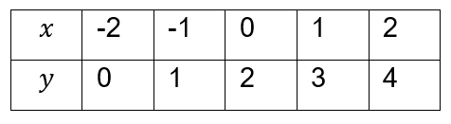 | $$y=x+2$$
B | 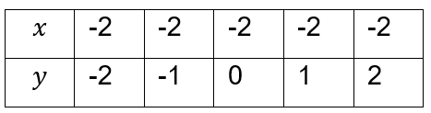 | $$x=-2$$
C | 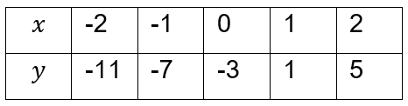 | $$y=4x-3$$
D | 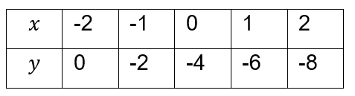 | $$y=-2x-4$$
E | 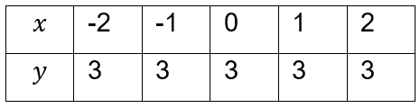 | $$y=3$$
F | 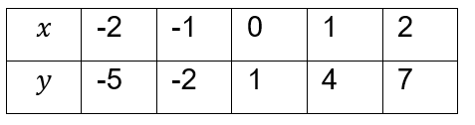 | $$y=3x+1$$

Appendix B – Would you rather?
- $y=5000×0.068x+4800$
$$x$$ | 1 | 2 | 3 | 4 | 5
$$y$$ | 5140 | 5480 | 5820 | 6160 | 6500
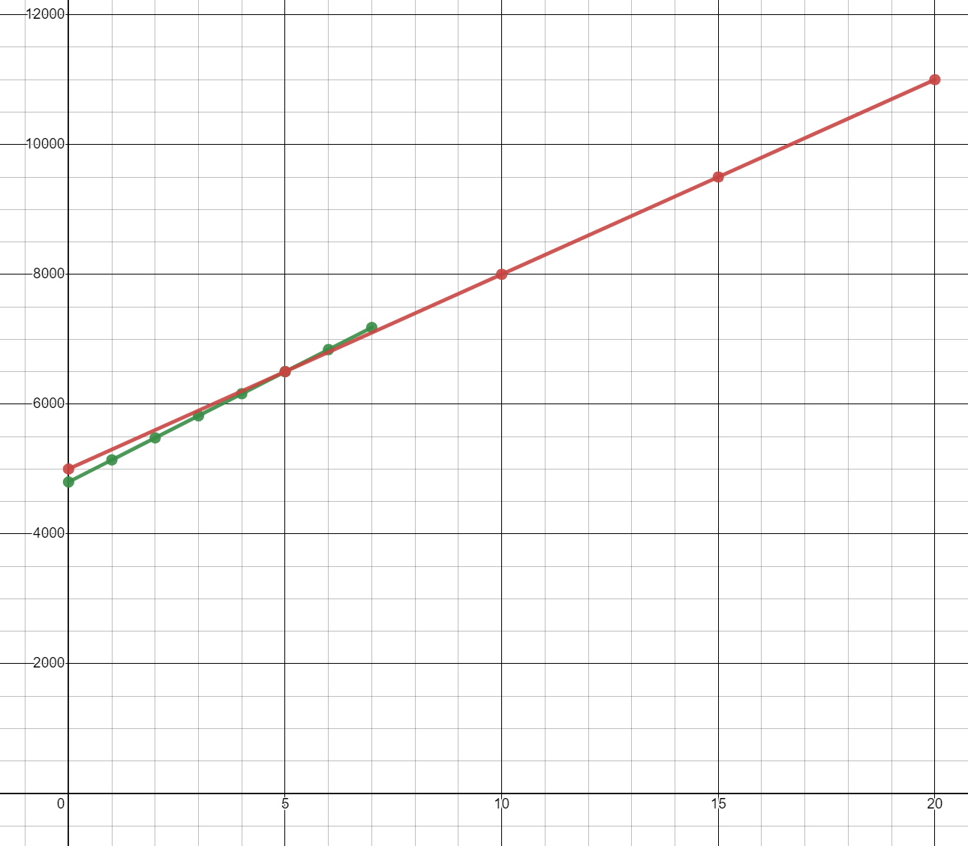
- The bank account is the better option if investing for less than 5 years. Anything longer than that Emilio should go with the term deposit.

Appendix C – money woes
- Complete the table of values for each option.
$$x$$ | 0 | 5 | 10
$$y$$ | 0 | 4085 | 8170

$$x$$ | 0 | 5 | 10
$$y$$ | 2000 | 5846.15 | 9692.31
- No as they could change what scenario earns more later, and this is only 10 weeks and Emilio will probably work longer than that.
- Graph the 2 scenarios on the Cartesian plane.
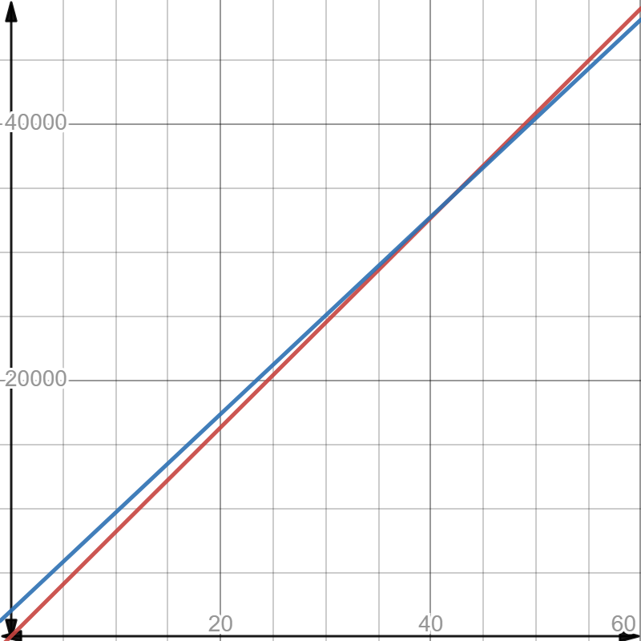
- Emilio should take the option of getting paid through wages as after 41 weeks he will earn more money. Alternatively, Emilio should consider a salary as he may get more benefits such as sick leave and holiday leave loading and that may only be for a small loss each year.

References
This resource contains NSW Curriculum and syllabus content. The NSW Curriculum is developed by the NSW Education Standards Authority. This content is prepared by NESA for and on behalf of the Crown in right of the State of New South Wales. The material is protected by Crown copyright.
Please refer to the NESA Copyright Disclaimer for more information https://educationstandards.nsw.edu.au/wps/portal/nesa/mini-footer/copyright.
NESA holds the only official and up-to-date versions of the NSW Curriculum and syllabus documents. Please visit the NSW Education Standards Authority (NESA) website https://educationstandards.nsw.edu.au/ and the NSW Curriculum website https://curriculum.nsw.edu.au/home.
Mathematics K–10 Syllabus © NSW Education Standards Authority (NESA) for and on behalf of the Crown in right of the State of New South Wales, 2022.

© State of New South Wales (Department of Education), 2023
The copyright material published in this resource is subject to the Copyright Act 1968 (Cth) and is owned by the NSW Department of Education or, where indicated, by a party other than the NSW Department of Education (third-party material).
Copyright material available in this resource and owned by the NSW Department of Education is licensed under a Creative Commons Attribution 4.0 International (CC BY 4.0) license.
This license allows you to share and adapt the material for any purpose, even commercially.
Attribution should be given to © State of New South Wales (Department of Education), 2023.
Material in this resource not available under a Creative Commons license:
- the NSW Department of Education logo, other logos and trademark-protected material
- material owned by a third party that has been reproduced with permission. You will need to obtain permission from the third party to reuse its material.
Links to third-party material and websites
Please note that the provided (reading/viewing material/list/links/texts) are a suggestion only and implies no endorsement, by the New South Wales Department of Education, of any author, publisher, or book title. School principals and teachers are best placed to assess the suitability of resources that would complement the curriculum and reflect the needs and interests of their students.
If you use the links provided in this document to access a third-party's website, you acknowledge that the terms of use, including licence terms set out on the third-party's website apply to the use which may be made of the materials on that third-party website or where permitted by the Copyright Act 1968 (Cth). The department accepts no responsibility for content on third-party websites.

