How efficient is my car?
Students explore fuel efficiency and circles to understand the concept of direct variation.
Students will need at least one digital device per pair to interact with websites during this lesson.

Visible learning
This lesson incorporates Path content, although teachers may choose to omit the language around direct variation to suit students working with Core content.

Learning intentions
- To be able to understand direct variation.
- To be able to solve problems involving direct variation.

Success criteria
- I can identify a direct relationship.
- I can find the value of the constant of variation.
- I can explain the meaning of the constant of variation in a given context.
- I can model and solve real-world problems with a direct relationship.

Syllabus outcomes
- develops understanding and fluency in mathematics through exploring and connecting mathematical concepts, choosing and applying mathematical techniques to solve problems, and communicating their thinking and reasoning coherently and clearly MAO-WM-01
- graphs and interprets linear relationships using the gradient/slope-intercept form
MA5-LIN-C-02
- identifies and solves problems involving direct and inverse variation and their graphical representations MA5-RAT-P-01
Mathematics K–10 Syllabus © NSW Education Standards Authority (NESA) for and on behalf of the Crown in right of the State of New South Wales, 2022.

Activity structure
Please use the associated PowerPoint How efficient is my car to display images in this lesson.

Launch
- Show students the video ‘Car Vs Bike: Which Is More Efficient | GCN Fuel Economy Challenge!’ (15:12) (https://bit.ly/Car_vs_Bike) until the 2:02 mark.
- Display slide 2 of the PowerPoint How efficient is my car? Ask students to read the points on the slide.
The video states that 5 L of fuel for a car is equivalent to an energy intake of 40 843 calories for a person.
Calorie is a measure of energy using the metric system, whereas, the kilojoule (kJ) is an International system of units (SI) measurement.
The number of calories stated in the video has been converted into kilojoules for the PowerPoint by multiplying by 4.184.
- Working in visibly random groups of 3 (bit.ly/visiblegroups) at a vertical non-permanent surface (bit.ly/VNPSstrategy), ask students to work out how far they think a car and bike can travel on the same amount of ‘fuel’? They should also consider the positives and negatives of each mode of transport.
- As students are working, place a red rectangle around interesting strategies you will later share with the rest of the class.
- Gather all students to stand in front of the surface with the first strategy you wish to discuss. Ask a student who wasn’t involved in the work to explain what strategy they have used. Follow the same method to share other interesting strategies.
- Tell students that cars that are more fuel efficient are cheaper to run. Ask students to suggest features of cars that would make them more fuel efficient.
Students may consider different aspects of a car that alter fuel efficiency such as fuel type, size of car and thermal efficiency.

Explore

Fuel efficiency
- Direct students to open the Green Vehicle Guide (http://greenvehicleguide.gov.au/) and demonstrate how to navigate the website.
- Students are to complete Appendix A ‘Fuel efficiency’ for a chosen car.
- Teachers may choose to assign each student a car to investigate, or allow students to select their family car or a car of their choice.
- Select the year, make, model and variant of the chosen car using the drop-down menus and then select Search. Scroll down the page to access the table.
- The value needed from the table to complete the worksheet is the combination fuel consumption which can be found in the ninth row. Teachers might like to discuss the difference between urban, extra and combination fuel consumption. Information can be found at http://greenvehicleguide.gov.au/pages/ToolsAndCalculators/FuelConsumptionLabel
Figure 1 – Green Vehicle Guide
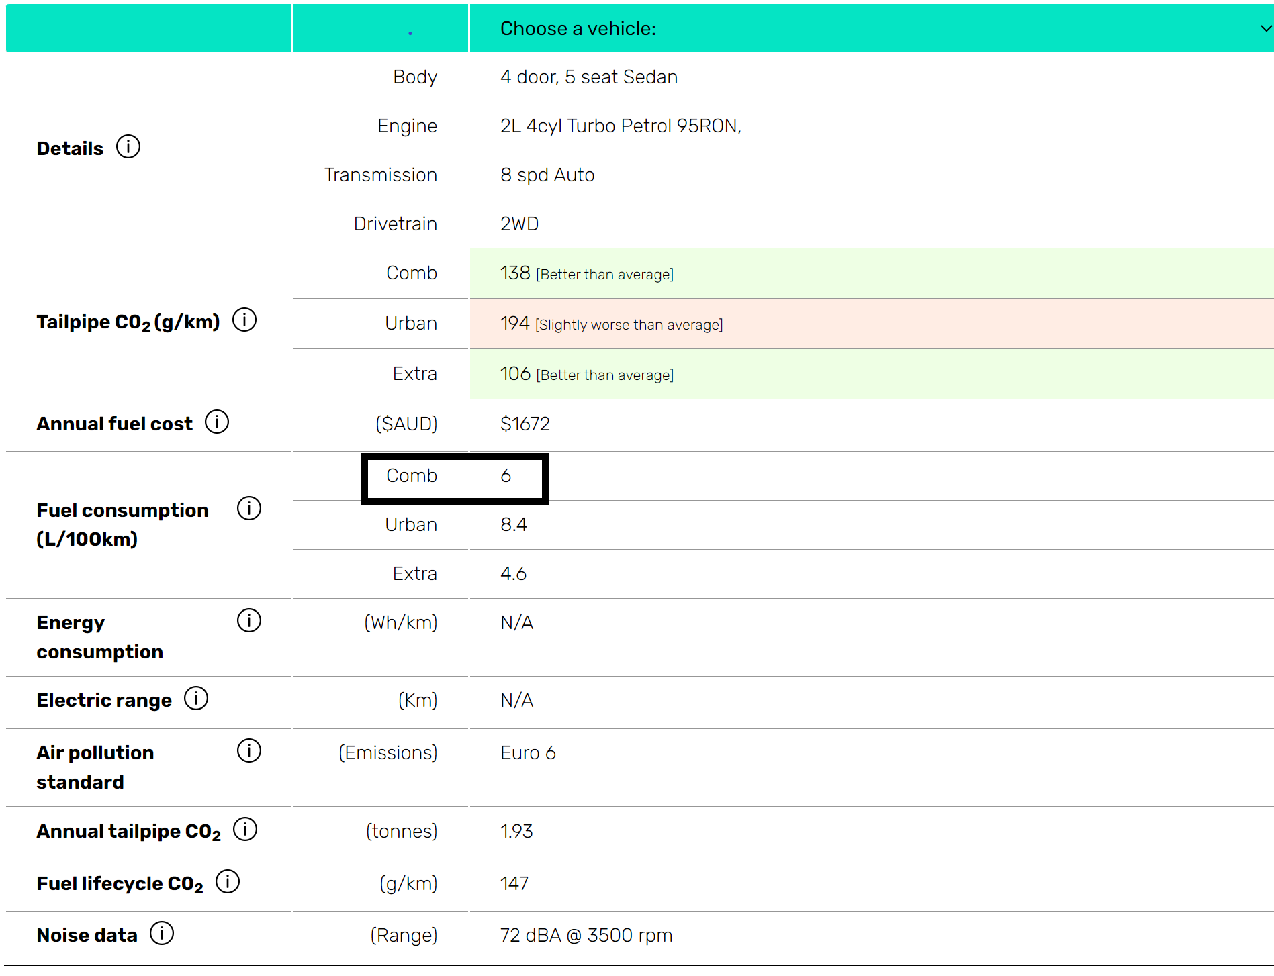
Screenshot from ‘Green Vehicle Guide’ by Commonwealth of Australia is licensed under CC BY 4.0.
In question 4 of Appendix A, students are asked to graph the fuel consumption. Ensure that students are guided towards not making the scale 1:1 between the axes, but rather 1:100 to better reflect the rate of fuel consumption.
- Using the data from another student’s table of values, plot their car’s fuel consumption on the same graph as your car.
- Use a Think-Pair-Share (bit.ly/thinkpairsharestrategy) to ask students to find similarities and differences between the graphs.
- Combine 2 pairs together and ask them to find the similarities and differences between all 4 graphs.
Students should notice that all graphs go through the point (0, 0). They may also notice the graphs have positive gradients since, as the number of kilometres increases, the amount of fuel used also increases.
This would be a good time to discuss with students why there are no negative numbers on the graph’s axes.
- Use a Pose-Pause-Pounce-Bounce [PDF 201 KB] (bit.ly/pausepouncebounce) questioning technique for students to share the relationship between the distance travelled and the amount of fuel consumed.
- Tell students that most cars are sold when they have driven around 100 000 km. Ask students to discuss in a Think-Pair-Share how they would find the difference in the amount of fuel consumed, between their 2 cars, over that distance.

It’s going around
- Distribute Appendix B ‘It’s going around’ to students. Students will investigate the relationship between the distance a car travels and the number of revolutions of a wheel.
- Use a Think-Pair-Share (bit.ly/thinkpairsharestrategy) for students to discuss the similarities and differences between the graphs they drew in the ‘Fuel efficiency’ activity and the ‘It’s going around’ activity.

Summarise
- Display the slides 3-5 from the PowerPoint How efficient is my car? to introduce the concept and terminology of ‘direct variation’.
- Hand out Appendix C ‘Variation statements’ to practise the language of variation. Ask students to complete the missing cells in the table.
- In a Think-Pair-Share, have students explain what the constant of variation represents in the scenarios presented. They record this in the last column of the table.
- Use slides 6-9 of the PowerPoint How efficient is my car? to explicitly teach how to solve direct variation problems.
The explicit teaching technique used in the associated PowerPoint is ‘Your turn.’ The first slide is a worked example which should be displayed for the students and then use the following steps.
- Reveal the question to students and its solution.
- Students read in silence.
- Students individually think and explain to themselves what is happening in each step.
- Students hold up a thumbs up to the teacher when they have finished reading and have some sort of understanding.
- Think, pair, share. Students explain the solution to their partner.
- In pairs students then answer the self-explanation questions.
- Finally, randomly select students to share their answers with the whole class.
- Students are to complete the faded worked examples (bit.ly/fadedexamplesstrategy) in Appendix D ‘Variation problems’. These have been separated into 2 tables as the steps to solve the problems differ depending on if you are finding the dependent or independent variable as your unknown.
- In pairs, students are to write notes to their future forgetful self (bit.ly/notesstrategy), on a vertical non-permanent surface (bit.ly/VNPSstrategy). They should include a definition of a direct relationship and explain how we can identify them in graphs, tables of values and equations.
- Have students do a gallery walk of the notes on the vertical non-permanent surfaces. They should take note of any tips, tricks or examples they find useful.
- Students individually write their own notes to their future forgetful selves by using any of the information on the vertical non-permanent surfaces around the room.

Apply

Electric vehicles
- Direct students to use the Green Vehicle Guide (http://greenvehicleguide.gov.au/) to complete Appendix E ‘Electric efficiency’. Students will compare the Wh/km of 2 electric cars.
Wh/km stands for watt-hour per kilometre. Watt-hours measure the energy consumed by a device over a certain period of time.

Direct relationships
- Ask students to brainstorm other scenarios that could represent a direct relationship.
Some examples may include height and weight, hours worked and amount of pay, and the amount of food needed for the number of people in a house.
- Students are to research values that represent the brainstormed scenarios and use these values to prove a direct relationship by finding the value of the constant of variation.
Students should be of reminded of accuracy of measurements explored in Unit 3 – prisms and cylinders, as the values students find for the constant of variation ($k$) could be similar enough to assume they create a direct relationship when modelling.
- Students are to create 3 problems related to a scenario that they brainstormed. Their problems should require someone to find the value of the constant of variation and use it to solve the problem.

Assessment and differentiation

Suggested opportunities for differentiation
For students working on Core content, the language of direct variation could be omitted and students study the same examples and scenarios using linear relationship language.
Launch
- All students should be able to contribute to the discussion on positives and negatives of travelling in a car versus a bike.
Explore
- Teachers may choose to assign each student a car to investigate or allow students to select their family car or a car of their choice.
- Students can be encouraged to change the scale of their graph to see how it impacts the line. For instance, what would happen if they used a scale of 1:1000?
- Students can research the circumference of tyres to establish the direct relationship rather than using the given table.
Summarise
- Separate finding the value of k from solving problems for students who need more time to understand the concepts.
Apply
- Teachers may choose to assign each student cars to investigate or allow students to select their family car or a car of their choice.
- Challenge students to find the cost of electricity required to run the car for certain trips and compare to the current cost of fuel in a car.
- Students can be given a choice of direct relationships scenarios to create and solve problems for.

Suggested opportunities for assessment
- Teachers should monitor student discussion to check for understanding.
- The activities from the appendices can be collected and used as formative assessment.

Appendix A

Fuel efficiency
- Use the Green Vehicle Guide (http://greenvehicleguide.gov.au/) to complete the table below.
Detail | Information
Vehicle (year, make, model, variant)
Comb Fuel consumption (L/100 km)
- Fill in the table of values to show the total amount of fuel used after each 100km.
Kilometres (km) | 0 | 100 | 200 | 300 | 400
Litres (L)
- Explain how you completed the table of values.

- Graph the fuel consumption of your car on the graph.
- Using your graph, find:
- How much fuel you would use if you travelled 150 km.
- How far you travelled if you use 60 L of fuel.
- The gradient of your graph.
- An equation for your graph.
- Explain the relationship between distance travelled and the amount of fuel consumed.

Appendix B

It’s going around
The number of revolutions made by a wheel and the distance the car travels are recorded in the table below.
Revolutions ($r$) | 0 | 5 | 10 | 20 | 50 | 80
Distance ($D, m$) | 0 | 7 | 14 | 28 | 70 | 112
- Graph the data from the table of values.
- Describe the relationship between the number of revolutions and the distance travelled.
- What is the gradient of your graph?
- What does the gradient tell you in this context?
- Write an equation for your graph. Test your equation by calculating the distance travelled for 100 revolutions.
- Use your graph or equation to find how far you can travel over 250 revolutions.
- Use your graph or equation to calculate how many revolutions would be needed to travel a distance of 21 metres.

Appendix C

Variation statements
Scenario | Variation statement 1 | Variation statement 2 | Meaning of constant of variation
Tyre revolutions | The number of revolutions of a tyre is directly proportional to the distance travelled. | The distance travelled varies directly with the number of revolutions. | The number of revolutions per kilometre
Fuel efficiency | is directly proportional to | varies directly with
Cost of apples
Wages

Appendix D

Variation problems 1
Find the constant of variation and use it to solve the given problem.
Fuel efficiency | Cost of apples | Wages
The amount of fuel used varies directly with the distance travelled.  Given you can travel 100 km on 5.6 L of fuel, find how much fuel you would need to travel 68 km. | The number of apples bought is directly proportional to the cost.  Given that you can buy 8 apples for $3.20, find how much it would cost to buy a bag of 5 apples. | Your pay varies directly with the number of hours you work.  You earn $594 when you work 22 hours. How much would you earn if you worked 37 hours?
Fuel (F) ∝ distance (d) | Cost (C) ∝ number (n)
$$F∝d$$ | $$C∝n$$
$$F=kd$$ | $$C=kn$$
$$5.6=k×100$$ | $$3.20=k×8$$
$$k=\frac{5.6}{100}$$
$$k=0.056$$
$$F=0.056×d$$ | $$C=0.4n$$
$$F=0.056×68$$
$$F=3.808 L$$

Variation problems 2
Find the constant of variation and use it to solve the given problem.
Fuel efficiency | Cost of apples | Wages
The amount of fuel used is directly proportional to the distance travelled.  Given you can travel 100 km on 7.2 L, find how far you can travel with 49 L. | The cost of apples varies directly with the number of apples bought.  Given that you can buy 15 apples for $4.80, find how many apples you can buy with $2. | Your pay varies directly with the number of hours you worked.  You earn $337.50 when you work 15 hours. How many hours do you need to work to earn $500?
Fuel (F) ∝ distance (d) | Cost (C) ∝ weight (w)
$$F∝d$$ | $$C∝w$$
$$F=kd$$ | $$C=kw$$
$$7.2=k×100$$ | $$4.80=k×15$$
$$k=\frac{7.2}{100}$$
$$k=0.072$$
$$F=0.072d$$ | $$C=0.32w$$
$$49=0.072d$$
$$d=\frac{49}{0.072}$$
$d≈680.6$ km (rounded to 1 decimal place)

Appendix E

Electric efficiency
- Use the Green Vehicle Guide (http://greenvehicleguide.gov.au/) to complete the table below.
Detail | Car 1 | Car 2
Vehicle (year, make, model, variant)
Energy consumption (Wh/km)
- Fill in the table of values to show the amount of energy used for each 100 km travelled.
Kilometres (km) | 0 | 100 | 200 | 300 | 400
Car 1 (Wh/km)
Car 2 (Wh/km)

- Graph the fuel consumption of both cars on the graph.
- Find the value of the constant of variation for each car.
- Explain what the constant of variation means in this context.
- State the equation of the lines.
- Find how much energy you would save if travelling 60 km to work.
- Electricity costs about 29c per kilowatt-hour (1000 Wh = 1 kWh). How far would you have to drive to save 10 kilowatt-hours?

Sample solutions

Appendix A – fuel efficiency
- Complete the table below.
Detail | Information
Vehicle (year, make, model, variant) | sample car
Comb Fuel consumption (L/100 km) | 6
- Fill in the table of values to show the amount of fuel used after each 100 km.
Kilometres (km) | 0 | 100 | 200 | 300 | 400
Litres (L) | 0 | 6 | 12 | 18 | 24
- Since you use 6 L for 100 km, I kept adding on 6 L.
- Graph the fuel consumption of your car on the graph.
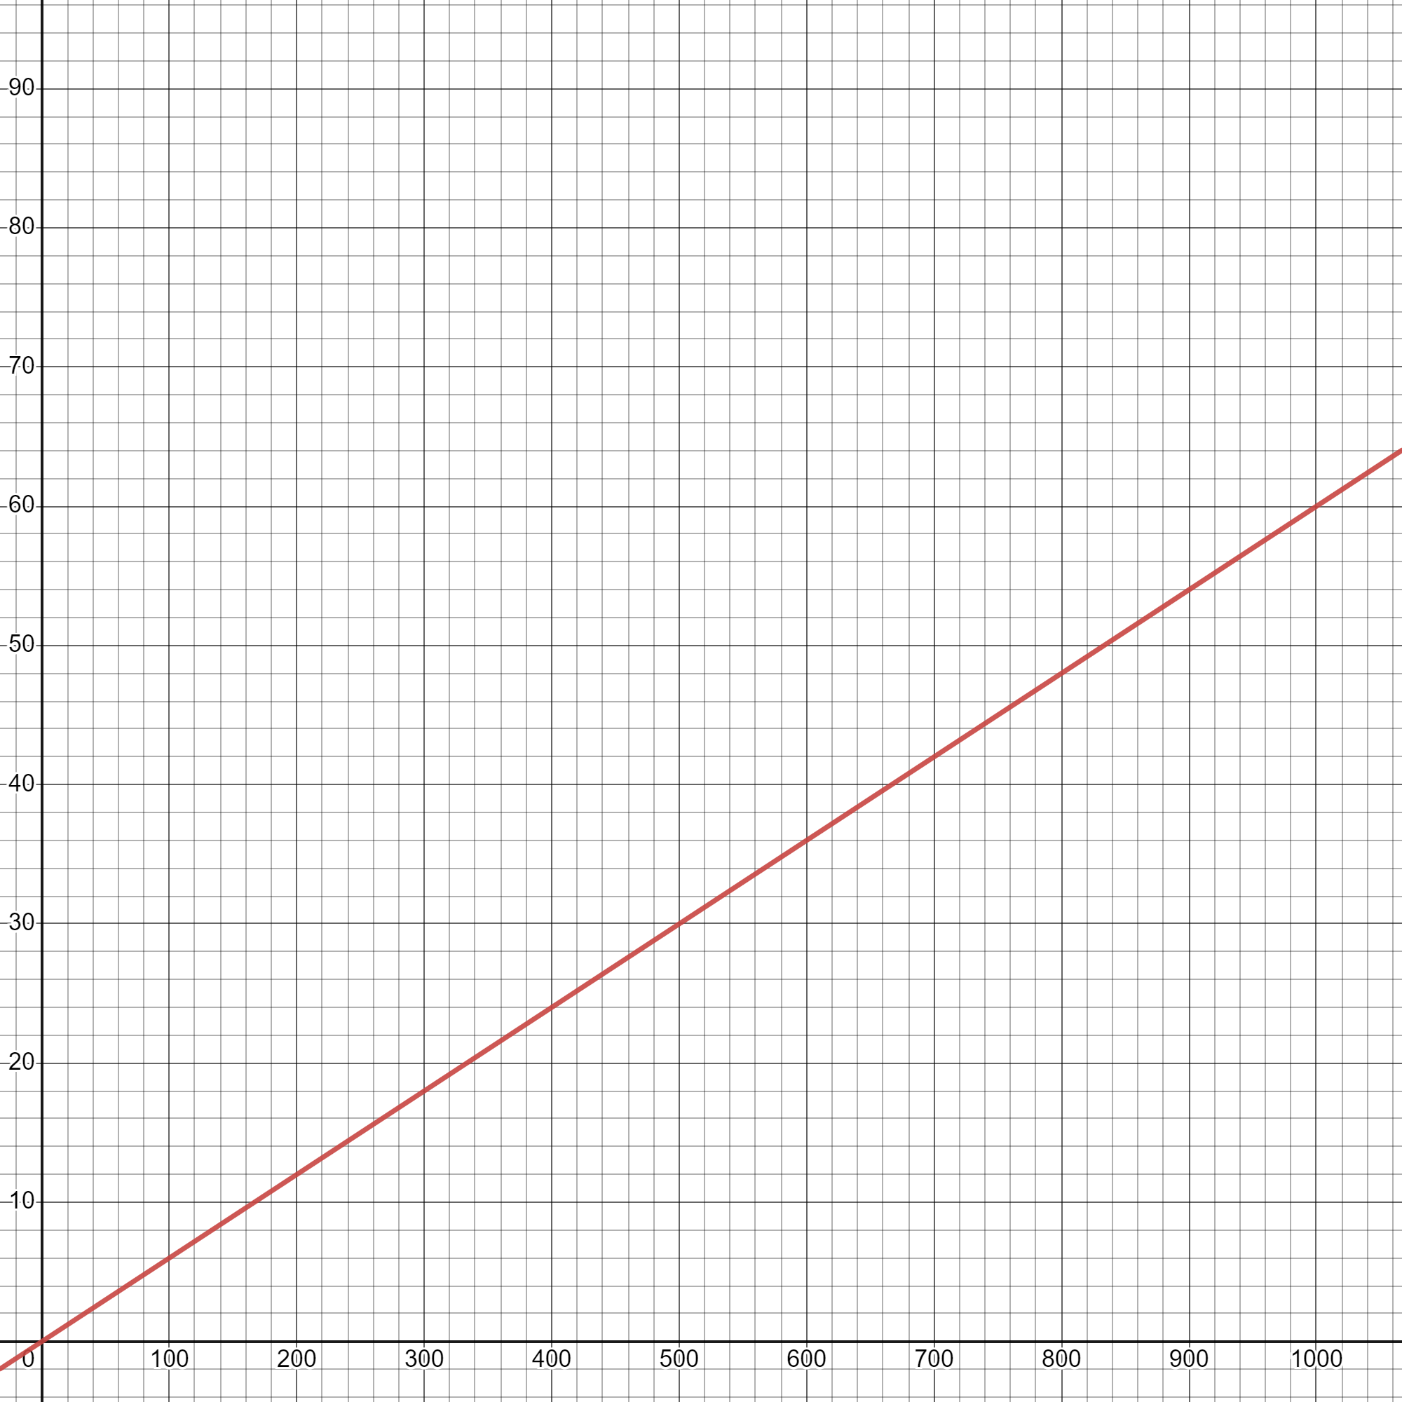
- Using your graph, find:
- 9 L
- 1000 km
- $m=\frac{6}{100}=0.06$
- Fuel = 0.06 × distance
- It is a linear relationship. As the distance increases, the amount of fuel increases.

Appendix B – it’s going around
- Graph the data from the table of values.
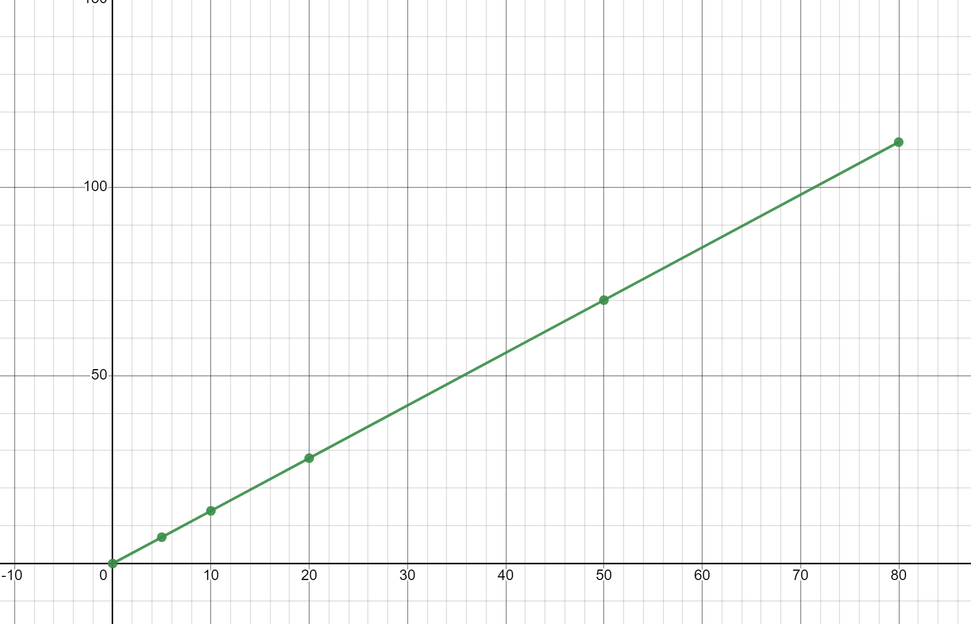
- It is a linear relationship. As the number of revolutions increases, the distance travelled increases.
- $m=\frac{70}{50}=\frac{7}{4}=1.4$
- How far the car travels with one revolution, which will be the circumference of the tyre.
- Equation
$$D=1.4 ×r$$
$$D=1.4 × 100=140m$$
- $D=1.4 ×250=350m$
- $21=1.4 ×r$
$$r=21÷1.4$$
$r=15$

Appendix C – variation statements
Scenario | Variation statement 1 | Variation statement 2 | Meaning of constant of variation
Tyre revolutions | The number of revolutions of a tyre is directly proportional to the distance travelled. | The distance travelled varies directly with the number of revolutions. | The number of revolutions per kilometre
Fuel efficiency | The distance travelled is directly proportional to the fuel used by a car. | The fuel used by a car varies directly with the distance travelled. | How much fuel is used per kilometre.
Cost of apples | The weight of total apples is directly proportional to the cost. | The cost of apples varies directly with their weight. | The cost of an apple per gram.
Wages | The hours worked is directly proportional to the wages earned. | The wages earned varies directly with the hours worked. | How many dollars per hours worked.

Appendix D – variation problems 1
Find the constant of variation and use it to solve the given problem.
Fuel efficiency | Cost of apples | Wages
The amount of fuel used varies directly with the distance travelled.  Given you can travel 100 km on 5.6 L, find how much fuel you would need to travel 68 km. | The number of apples bought is directly proportional to the cost.  Given that you can buy 8 apples for $3.20, find how much it would cost to buy a bag of 5 apples. | Your pay varies directly with the number of hours you worked.  You earn $594 when you work 22 hours. How much would you earn if you were to work 37 hours?
Fuel (F) ∝ distance (d) | Cost (C) ∝ number (n) | Pay (P) ∝ hours(h)
$$F∝d$$ | $$C∝n$$ | $$P∝h$$
$$F=kd$$ | $$C=kn$$ | $$P=kh$$
$$5.6=k×100$$ | $$3.20=k×8$$ | $$594=k×22$$
$$k=\frac{5.6}{100}$$ | $$k=\frac{3.20}{8}$$ | $$k=\frac{594}{22}$$
$$k=0.056$$ | $$k=0.4$$ | $$k=27$$
$$F=0.056d$$ | $$C=0.4n$$ | $$P=27h$$
$$F=0.056×68$$ | $$C=0.4×5$$ | $$P=27×37$$
$F=3.808$L | $$C=\$2.00$$ | $$P=\$999$$

Appendix D – variation problems 2
Find the constant of variation and use it to solve the given problem.
Fuel efficiency | Cost of apples | Wages
The amount of fuel used is directly proportional to the distance travelled.  Given you can travel 100 km on 7.2 L, find how far you can travel with 49 L. | The cost of apples varies directly with the number of apples bought.  Given that you can buy 15 apples for $4.80, find how many apples you can buy with $2. | Your pay varies directly with the number of hours you worked.  You earn $337.50 when you work 15 hours. How many hours do you need to work to earn $500?
Fuel (F) ∝ distance (d) | Cost (C) ∝ number (n) | Pay (P) ∝ hours(h)
$$F∝d$$ | $$C∝n$$ | $$P∝h$$
$$F=kd$$ | $$C=kn$$ | $$P=kh$$
$$7.2=k×100$$ | $$4.80=k×15$$ | $$337.50=k×15$$
$$k=\frac{7.2}{100}$$ | $$k=\frac{4.8}{15}$$ | $$k=\frac{337.5}{15}$$
$$k=0.072$$ | $$k=0.32$$ | $$k=22.5$$
$$F=0.072d$$ | $$C=0.32n$$ | $$P=22.5h$$
$$49=0.072d$$ | $$2=0.32×n$$ | $$500=22.5h$$
$$d=\frac{49}{0.072}$$ | $$n=\frac{2}{0.32}$$ | $$h=\frac{500}{22.5}$$
$d≈680.6$km (rounded to 1 decimal place) | $$n=6.25$$  6 apples can be bought for $2 | $h≈22.2$ hours

Appendix E – electric efficiency
- Complete the table below.
Detail | Car 1 | Car 2
Vehicle (year, make, model, variant) | Sample car | Sample car
Energy consumption (Wh/km) | 138 | 167
- Fill in the table of values to show the amount of energy used each 100 km.
Kilometres (km) | 0 | 100 | 200 | 300 | 400
Car 1 (Wh/km) | 0 | 13800 | 27600 | 41400 | 55200
Car 2 (Wh/km) | 0 | 16700 | 33400 | 50100 | 66800
- Graph the fuel consumption of your car on the graph.
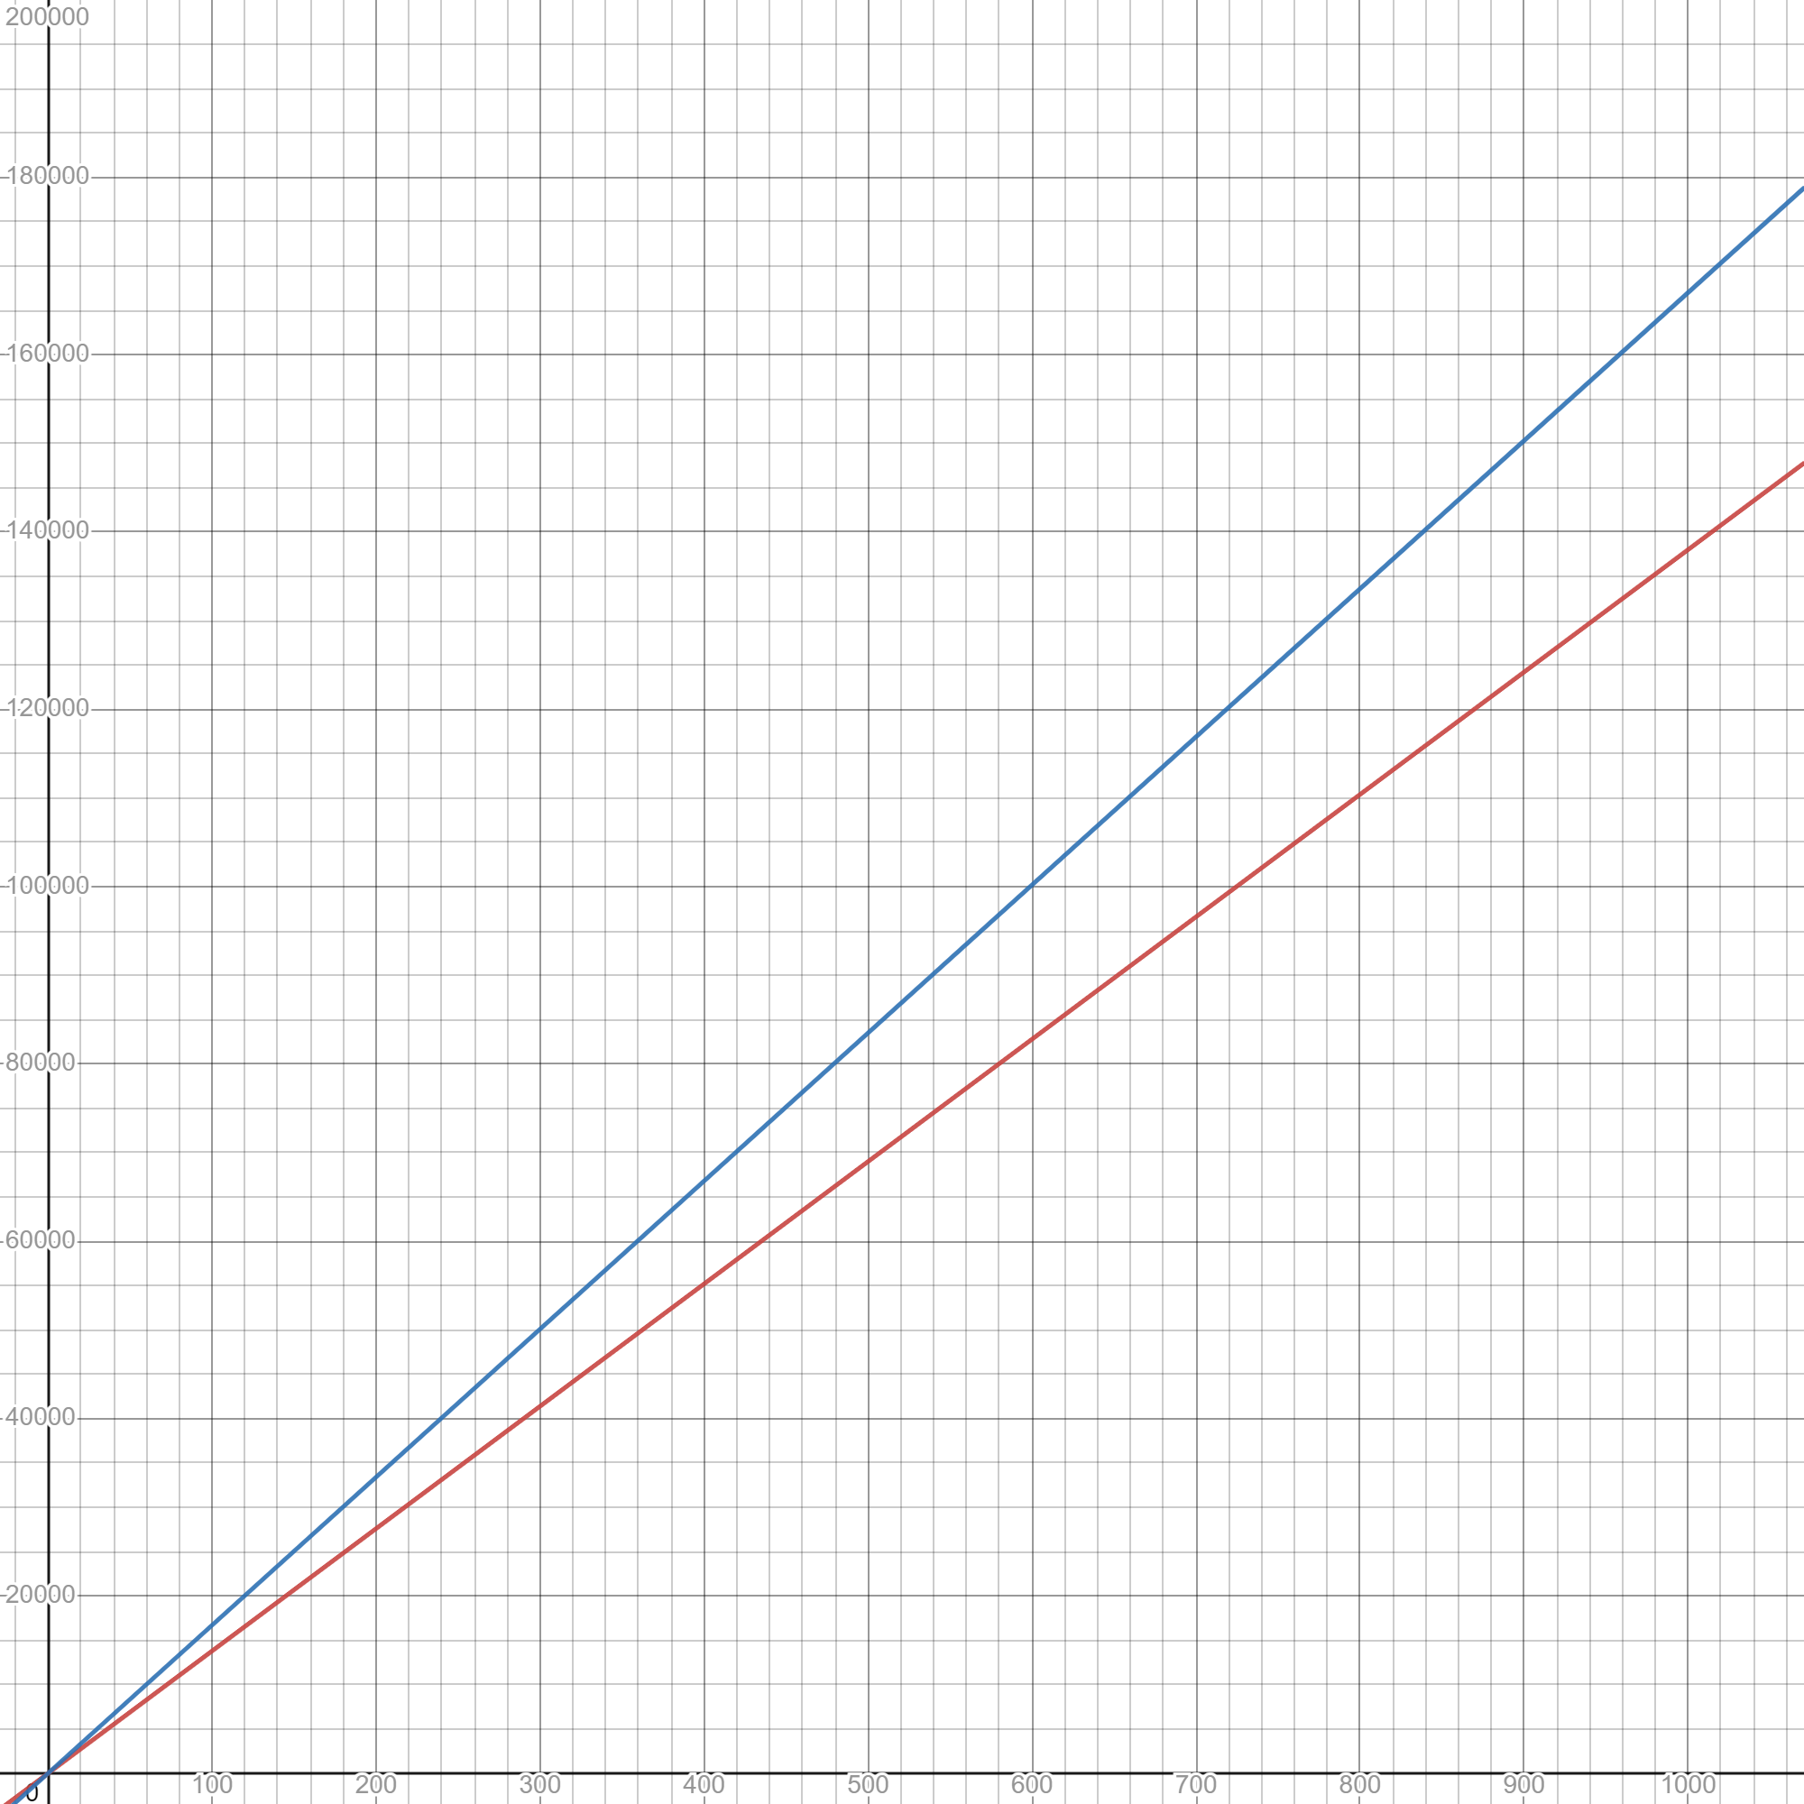
- 138 and 167.
- The amount of energy used each kilometre you travel.
- $E=138d$ and $E=167d$
- 8280 Wh and 10 020 Wh
- Around 180 km

References
This resource contains NSW Curriculum and syllabus content. The NSW Curriculum is developed by the NSW Education Standards Authority. This content is prepared by NESA for and on behalf of the Crown in right of the State of New South Wales. The material is protected by Crown copyright.
Please refer to the NESA Copyright Disclaimer for more information https://educationstandards.nsw.edu.au/wps/portal/nesa/mini-footer/copyright.
NESA holds the only official and up-to-date versions of the NSW Curriculum and syllabus documents. Please visit the NSW Education Standards Authority (NESA) website https://educationstandards.nsw.edu.au/ and the NSW Curriculum website https://curriculum.nsw.edu.au/home.
Mathematics K–10 Syllabus © NSW Education Standards Authority (NESA) for and on behalf of the Crown in right of the State of New South Wales, 2022.

© State of New South Wales (Department of Education), 2023
The copyright material published in this resource is subject to the Copyright Act 1968 (Cth) and is owned by the NSW Department of Education or, where indicated, by a party other than the NSW Department of Education (third-party material).
Copyright material available in this resource and owned by the NSW Department of Education is licensed under a Creative Commons Attribution 4.0 International (CC BY 4.0) license.
This license allows you to share and adapt the material for any purpose, even commercially.
Attribution should be given to © State of New South Wales (Department of Education), 2023.
Material in this resource not available under a Creative Commons license:
- the NSW Department of Education logo, other logos and trademark-protected material
- material owned by a third party that has been reproduced with permission. You will need to obtain permission from the third party to reuse its material.
Links to third-party material and websites
Please note that the provided (reading/viewing material/list/links/texts) are a suggestion only and implies no endorsement, by the New South Wales Department of Education, of any author, publisher, or book title. School principals and teachers are best placed to assess the suitability of resources that would complement the curriculum and reflect the needs and interests of their students.
If you use the links provided in this document to access a third-party's website, you acknowledge that the terms of use, including licence terms set out on the third-party's website apply to the use which may be made of the materials on that third-party website or where permitted by the Copyright Act 1968 (Cth). The department accepts no responsibility for content on third-party websites.

